**Special Issue: Towards Pluriversality: Decolonising Design Research and Practices**

**Indigenous Relations: Craft, Vernacular Materials and Cultural Assets in Borneo**

**Authors**

Professor Lynn-Sayers McHattie*, The School of Innovation and Technology, The Glasgow School of Art, Glasgow, Scotland

Wendy Teo Boon Ting, The Borneo Laboratory, Kuching, Malaysia

*Corresponding Author [l.mchattie@gsa.ac.uk](mailto:l.mchattie@gsa.ac.uk)

**Abstract**

This article explores Indigenous relations to craft, vernacular materials and cultural assets in Borneo to raise awareness around the complexities, entanglements and precarity surrounding natural resources and craft practice(s) located within Indigenous communities. The authors present two case studies based in Sabah and Sarawak, Malaysia from the Cultural-Assets and Vernacular Materials project and in so doing highlight the role ancestral wisdom and embodied knowledge play in the cultivation, conservation and crafting of natural materials towards situating craft as a living, ecological and regenerative practice. We locate an expanded notion of craft whereby the intimate relations to materials - growing, harvesting, preparing - are integral to materialities of place as site-specific, place-based and communal bodies of knowledges that reside within Indigenous communities. We position an ontological framing of design research as a set of practices that broaden the ways craft can advance new ways of understanding, becoming and doing. In such a reframing design-led innovation approaches are cognisant of and informed by the plurality of contexts that reside within and emerge from Indigenous communities as sites of situated knowledges.

**Keywords:** Borneo; craft; Indigenous communities; materialities of place; vernacular materials.

This is an original manuscript of an article published by Taylor & Francis in CoDesign on 07/07/2024, available at: <https://doi.org/10.1080/15710882.2024.2317233>.

**Introduction**

We begin by introducing ourselves as the authors Wendy Teo Boon Ting and Lynn-Sayers McHattie. Initially writing in the first person as (I) Wendy and (I) Lynn respectively, when we use ‘we’ or ‘our’, we are referring to ourselves as authors and make it explicit that we are not speaking on behalf of Indigenous peoples. Rather, we are seeking through our long-term collaboration to raise awareness around the complexities, entanglements and precarity surrounding natural resources, vernacular materials and craft practice(s) located within Indigenous communities in Borneo. Drawing on Tuck and Yang (2012, 3) together we strive to be transparent concerning our positionality, our world view and the inherent tensions in undertaking such cross-cultural research collaborations. We layout our reasons and motivations for undertaking this research. Equally, our ongoing conversations grapple with the notions that surround Indigeneity - who is qualified and as such legitimised to undertake this work - the implications of racial and political identity [in Borneo] and the tensions both implicit and explicit that exist against the legacy of colonisation. The following question foregrounds and guides our collective endeavours**:** How can craft as a living, ecological and regenerative activity create new ways of understanding, becoming and doing and make a meaningful contribution to Indigenous communities?

The article proceeds to present the Cultural-Assets and Vernacular Materials programme undertaken across Borneo with craft practitioners from Indigenous communities. We set out the Bornean cultural and geopolitical context, which informs the theoretical perspectives, methodological orientation and research design. We introduce the fieldwork and draw out the key themes that underpinned the showcasing of the 11 community-based craft projects before describing the Serumpun: Crafts across Borders Exhibition at the Borneo Cultures Museum, Kuching in December 2022. We then present two participants’ narratives from Sarawak and Sabah that explore Indigenous practitioners’ relations to place, natural resources and communal ways of working. We position a framing of design research as a set of design-led innovation practices that broaden the ways craft within Indigenous communities can advance new ways of knowing as understanding, being as becoming and doing as collective action. We conclude by reflecting on our learnings and seeking to contribute to design research and craft practice.

**Positionality and Research Motivations**

‘… *the most fruitful approach is to identify, rather than define indigenous peoples. This is based on the fundamental criterion of self-identification as underlined in a number of human rights documents’* (UN 2023).

I (Wendy) am a Bornean, multilingual (English, Chinese, Bahasa Melayu), female, educated in Taiwan and the UK (ARB/RIBA architect). I describe myself as a craft activist growing up in the political environment of Malaysian Borneo where the weight of one's deeds was oftentimes overshadowed by the prominence of racial identity. My cultural heritage is Bornean-Chinese, born into a Borneo-based Malaysian family with deep ties to Kalimantan. On my paternal side, my great-grandfather established his roots in Singkawang, whilst my grandfather embarked on a journey to Kuching in his youth, seeking a fresh start and a new life. The exploration of my roots has always been a sensitive and thought-provoking journey and whilst I am non-Indigenous within the traditional understanding of Indigeneity my strong links and connections to territories, Indigenous communities and the surrounding natural resources confer to a more progressive and modern understanding of Indigenous identity (UN, 2023). Like many young individuals, I departed from the cultural backdrop of my family to pursue professional education that bore little resemblance to my ancestral heritage. This journey led me to spend 15 years away from home, forming the bedrock of my career before founding the Borneo Laboratory in Kuching. My worldview is informed and inspired by the rich craft language and diversity of natural materials abundant in the landscapes and cultural heritage of Borneo. I am committed to highlighting community dynamics in participation with the natural world in my multidisciplinary practice ‘Wendy Teo Atelier’. As a practitioner, I believe that an innovative and cutting-edge approach to design can revitalise crafts across the Borneo region. Fundamentally, I am committed to socio-cultural dialogue as the driving force behind my design and research pursuits whilst fully acknowledging the complexities and tensions that surround Indigenous identity in Borneo.

*‘We cannot help to come to almost any research project already “knowing” in some ways, already inflected, already affected, already “infected”’* (Clarke 2005, 12).

I (Lynn) am a white, Scottish, female, who is a first-generation educated academic, design researcher and craft practitioner. My father and his family were displaced from Benquhat, a mining village in South West Scotland, in the 1950s, which has underpinned my enduring concerns surrounding land and community rights. In the context of this work, I describe myself as a non-Indigenous researcher. I acknowledge my personal positioning and “knowing” and seek to mitigate against any negative impacts by adopting a relational mode of research whereby I understand and make explicit that my experiences are one among many perspectives. My research is located at the nexus between design and craft domains that are co-constituted between the human and material world (including nonhuman entities). My worldview is underpinned by a set of epistemological (*materialist* social constructionism) and ontological assumptions that relate to the nature of being and the mutability of culture. My place-based interests are located within geographically distributed and Indigenous Island communities. Working with communities in the Northern and Western Isles of Scotland and Borneo, I explore craft practices as ‘cultural assets’, which are intimately connected to the landscape of communities. I aim to better understand situated knowledges through paying attention to place-based narratives, practices and tacit wisdom aligned to particular cultural and ethical sensitivities.  Furthermore, it is intended that by revealing the heterogeneous complexities that surround craft practice my work may support ongoing multi-agency discourses ensuring that these play a central role in strengthening and sustaining community-based Indigenous practices. I am committed to ensuring that as a researcher I am both visible and accountable in and through my research allowing for multiple meanings and tensions to be revealed including those that are challenging or uncomfortable in order that we may become answerable to what we ‘see’.

Together, we are cognisant that Indigeneity is a contested term and that craft practices are located in specific cultural contexts, which directly relate to Indigenous identity and place-based natural resources. Our motivations are based on the belief that at a fundamental level craft practice can co-exist with new developments and innovative approaches towards informing a wider socio-cultural research agenda around craft as a living process located in Indigenous Bornean communities. Next, we present the Cultural-Assets and Vernacular Materials project, the relationship(s) to the Indigenous communities we worked with and the rationale for selecting particular craft practitioners including the ethical permissions and cultural protocols required to engage within this research context.

**Cultural-Assets and Vernacular Materials**

Cultural-Assets and Vernacular Materials (C&VM) is an ongoing research collaboration between the Borneo Laboratory, Kuching, Malaysia and the School of Innovation and Technology, The Glasgow School of Art, Scotland, funded by the British Council. Our partnership was seeded during ‘Crafting Futures’ (2017 - 2021) an international programme of research funded by The British Council. The initial phase of the C&VM research, which is the focus of this article, took place between March 2022 and March 2023 and the follow-on C&VM project traces the impact narrative of the research and specifically how the assets generated from the project can be used by communities to celebrate, enhance and sustain their craft practices. C&VM worked with 11 craft communities across Borneo’s Malaysian and Indonesian geographies to explore cultural assets as a mode of expression that articulates intangible and tangible cultural heritage, which extends to mythology, beliefs, traditions, languages, vernacular materials, rituals, dreams and craft practices located in Indigenous communities. The 11 communities comprised Sabah: Kampung Bau Lunguyan; Keningau; Kota Kinabalu; Sarawak: Betong; Kuching; Long Moh; Miri; Central Kalimantan: Gunung Purei; West Kalimantan: Jagoi Babang; Sambas; Singkawang (Figure 1). For the purposes of this article, we have centred on two Indigenous communities Long Moh, Miri, Sarawak (Ref. #1 on Map) and Keningau, Sabah (Ref. #6 on Map).

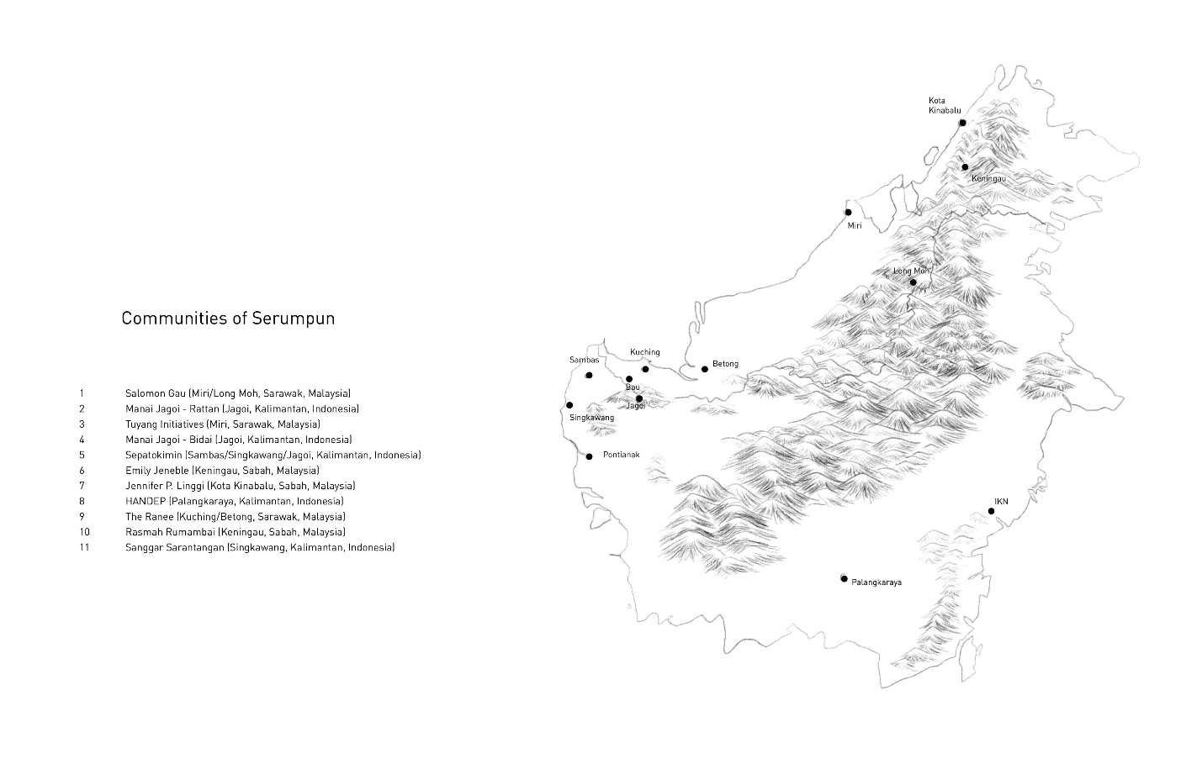

Figure 1: Borneo Island Map. Illustration Credit: Wendy Teo @ Borneo Laboratory (2023).

**A Phased Research Approach**

The C&VM programme’s aims were to support the strengthening of practitioners’ creativity, the sharing of craft skills and foster opportunities for innovation. C&VM followed a phased research approach: scoping; stakeholder engagement; participant recruitment; workshops; practitioners’ making; fieldwork notes; participatory film; Serumpun exhibition and Gotong Royong plenary; evaluation; and impact. Recruitment of the Indigenous communities was predicated on a network-of-networks approach through mobilising the C&VM teams extensive contacts across

Malaysia and Indonesia. Two community-based stakeholders agreed to act as gatekeepers to advise and guide on the Indigenous communities’ cooperation and practitioner recruitment. Jennifer P. Linggi, who is Indigenous Kadazan Dusun, the largest ethnic group in Sabah and Juvita Tatan Wan, who is Kenyah from Long San, Baram, (although non-Indigenous Bornean-Chinese as conferred by traditional nomenclature). Juvita is Co-director of the Tuyang Initiative a community-led organisation committed to the cultural continuity of Indigenous communities in Sarawak. An open call for participation was facilitated and supported by the gatekeepers, which invited craft practitioners and artisans to highlight their interest in joining the C&VM programme.

Ethical permissions and cultural protocols, for example, language(s) and dialect(s) were considered and accommodated throughout all correspondence, documentation and materials. Cultural considerations were guided by the stakeholders including initiating the project within the wider *kampung* (village) through setting up community events to explain the intention of the C&VM project to craft practitioners, other interested parties and the village head. These events were important to show respect to the village and engender trust within the community in order that appropriate cultural nuances were embedded within the C&VM research design. As an integral part of the informed consent process, a Participation Agreement was drawn up, which detailed funding dedicated to supporting time and material costs. This informed the scope and scale of the practitioners’ project briefs and importantly acknowledged the ownership of the project outputs - ensuring these remained with the craft practitioners - and how the C&VM team would document and report on individual project processes and collective outputs and outcomes.

**Borneo: Cultural and Geopolitical Context**

We now lay out the Bornean cultural and geopolitical context, which informs both the theoretical positioning and methodological orientation. We then move to discuss the extraction economies that have resulted in the exploitation of both land and natural resources across Borneo. We go on to consider *Adat* (Indigenous traditions) against the legacy of colonisation.

**Borneo Island: Malaysia and Indonesia**

Borneo Island is the third largest island in the world - primarily mountainous with dense areas of forest - covering an area of approximately 287,000 square miles (Sada et al 2019) with a population of around 23 million people. Borneo Island comprises the Malaysian states of Sabah, Sarawak and the country of Brunei Darussalam and the five provinces of Kalimantan in Indonesia. Although the island is divided geographically and into separate political domains there are fundamental similarities in culture that pre-date the political boundaries that were imposed by colonial powers in the late 19th Century.

**Nusantara: Indonesia’s New Capital City**

It could be contended that the implementation of ‘development’ agendas and policies in Kalimantan are remnants of colonisation (Pradipta 2022; Li and Semedi 2021). This includes Indonesia's plan to move the capital city from Jakarta to Borneo Island with the new capital *Nusantara* (archipelago) positioned to drive more equitable growth from Java to Kalimantan. In addition to symbolically centralising the government, which is perceived as being Java-centric, despite Kalimantan providing the natural resources for Java’s economic development. The Indonesian capital relocation perpetuates the narrative of Borneo as a ‘vacant’ island, the myth of ‘free’ natural resources, the ‘nation’ and the ideology of nationalism and the use of ‘development’ to normalise the push for extraction (Pradipta 2022) furthering the legacy of neo-colonialism. Besides the profound environmental concerns (Amir 2023), the

Nusantara project is predicted to bring millions of people to the island (van de Vuurst and Escobar 2020) that risks socio-cultural issues around displacement and the marginalisation of the island’s Indigenous communities (Gokkon 2023; Pradipta 2022).

**Extraction Economies: Ecological Issues**

Borneo is largely an extractive economy (Goh 2020). Forest degradation in Borneo has been fuelled primarily by land concessions to extractive industries such as palm oil, mining and oil and gas sectors. Kalimantan’s forests, including protected areas, are vulnerable to large-scale deforestation by foreign mega-corporations (Li and Semedi 2021; Pradipta 2022). Accordingly, Borneo has been facing serious environmental degradation that contributes to climate crisis inasmuch as its rich natural resources including land have been plundered and commoditised. Goh (2020) argues that this large-scale exploitation of land and natural resources in the pursuit of ‘development’ has resulted in systemic environmental challenges and ecological issues. Li and Semedi (2021) used Ann Stoler’s (2016) concept of ‘imperial debris’ to describe the political technologies of colonial rule, whereby the concept of plantation continues to maintain colonial positions as extractive regimes that appropriate land and extract natural resources. This highlights Indigenous communities' concerns regarding the preservation of natural resources. Amidst the promise of ‘growth’ and the notion of ‘progress’ that these plantation and palm oil industries have offered the rural economies of Borneo large numbers of the community still maintain traditional practices, including craft practices, as their main subsistence. Land is an important natural, cultural and economic asset; it is inseparable from Indigenous communities’ identity as well as an important source of livelihood. The geographer and philosopher Katherine Yusoff (in Ladha and Murphy 2022, 140) reminds us that the attempt to absolve the positionality of Western colonial knowledge and extraction practices, while simultaneously reinforcing and resettling communities in a new territory indicates a desire to overcome coloniality without a corresponding relinquishing of the power in terms of who gets to formulate, implement and speak to/of the future. However, against the vast oil palm plantations that have altered the landscape of many villages and communities across Borneo, traditional land cultivation systems still exist such as the practice of slash-and-burn agriculture and rotational farming. *Hutan Adat* (customary forest) is still preserved as well as *tembawang* (community forest), which are maintained collectively, whereby Indigenous communities forage for fruits, wild plants and vernacular craft materials such as rattan, pandanus leaves, bamboo and *bemban* (Donax Canniformas),which is a fibre used for *Anyaman* (webbing/braiding) in artisanal weaving and matt making.

**Indigenous Communities: Borneo**

Cultural narratives across Borneo can be linked to Malaysian centralised government conservation policies and processes that oftentimes marginalise and neglect ethnic, religious and Indigenous communities. Borneo is home to the Indigenous people collectively called Dayaks (Tanasaldy 2007). The term Dayak was first employed by Bornean Malays and gained traction in the early 20th century to designate native groups in Borneo. Dayak, or ‘people of the interior,’ loosely describes more than two hundred heterogeneous tribal groups living in distinctive longhouses that define the social organisation of each community. Dayaks are diverse in culture as well as language with similarities between sub-ethnic groups, for example, Iban, Kantuk and Mualang (Sada et al 2019). Moreover, language is not an obstacle to interaction between sub-tribes. The Indigenous Dayak population was concentrated in the forest, hills, valleys and riverbanks of the highland and hinterland of Borneo. Tanasaldy (2007; 2012) notes that Dayak culture has undergone rapid erosion since the introduction of Islam and Christianity, with Indigenous communities abandoning their perceived ‘antiquated’ traditions, including animism. To date, the influence of religious belief such as Christianity among Dayak people remains strong, shaping communities’ socio-cultural values and their material culture (Sellato 2016; 2017), which reflect the construction of Indigenous communities' ethno-cultural identity. Whilst a large population of Dayaks have converted to Christianity, they maintain their traditional practices and beliefs. Traditional knowledge fluctuates between varying levels of use, adaptation and precarity in Indigenous communities (Allred et al 2022). Craft practice in Southeast Asia, particularly Borneo, is not solely for commercial purposes. Craft objects serve as vehicles for conveying messages, preserving ancestral wisdom and engaging in animistic (Conty 2022) and spiritual practices (Foor 2017) acting as tangible links to the past. Personal, family and community affairs are regulated by *Adat*, which is a body of social and cultural norms, traditions, laws, ceremonies and rituals (Hauser-Schäublin 2013). *Adat* is founded on and intertwined with animist belief (Noor Muhammad 2018; Thomson 2000). Accordingly, it is based on a worldview that consists of tangible (physical) and intangible (spiritual) elements whereby there is a mutual influence between these physical and spiritual realms (Thomson 2000).

**Relations between Design and Craft**

Whilst a full discussion surrounding design and craft is beyond the scope of this paper, we seek to clarify the relations between design, craft and the specific Bornean geo-political and cultural context. Traditionally, when compared to design, craft was perceived as an inferior practice in terms of the use of technology, mass-production, related economic value and possible functionality (Niedderer and Townsend 2014, 627). Adamson (2013, 172) positions craft as a mode of working whereby the knowledge exists in the practice through which tacit and practical knowledge are transformed into material form and are a “*living”* part of a larger system. This approach contrasts with design’s historical engagement with nature, which attempts to bridge and compromise to fulfil the needs of production and economics (Fletcher et al, 2019). Recently, the relationship between design and craft has become within the purview of design discourses in-part related to the decolonisation of design debates (Smith et al, 2020) tied to the cultural reception and radical interdependencies that exist within craft. Derek Walcott cautions (in Stoler, 2013) us to be attentive to the ‘psychic weights’ of colonial processes that entangle people, soil and things. These entanglements relate to ‘imperial debris’ (Stoler, 2016), which paradoxically co-exist with *Hutan Adat* (traditional land cultivation systems and rituals) that remain prevalent within Indigenous communities. Paying attention to these complex dynamics that exist within design discourses and craft practice in relation to Indigenous communities are integral to developing a deeper understanding of the situated knowledges that reside within place-based materialities whilst at the same time binding cultural practices.

**Theoretical Perspectives**

We now set out our theoretical perspectives and methodological orientation, which consider the relationship between design research and craft as a ‘living’ practice in Borneo. We draw on Escobar’s description of ecological design, ‘Ecological design changes the old rules about what counts for knowledge and who counts as a knower’ suggesting that sustainability is a cultural process (Escobar 2017, 44). We position ontological design as ‘conversations for action’ whereby the multiple perspectives that relate to ontology (objects, things, matter, materials, process) resonate with a design approach that emphasis the engaged, experimental and open-ended practices of design research’ (Escobar 2017, 112-3) as emergent. Design in this manner is ontological in that it is a conversation about possibilities (Escobar 2017, 110). Thus, allowing for a reimagining of uncertainty (Barad 2007) as a means to explain not only what is but what could be. This situates the intra-connections between ethics and aesthetics (non-separation) and the heterogeneous multiplicity of things as we seek to deepen our understanding, frame belief(s) and action(s) through discourse and reflective contemplation (Dixon 2022). In attempting to do so, we pay attention to relational practices - as they occur in particular temporal and spatial moments as spaces for dialogue - within culturally sensitive research (Smith et al 2020; 2021). Australian-based design researchers Yoko Akama and Nicola St John’s (2022) notion of onto-epistemes indicate pluralistic forms of knowledge emerge through ethical and participatory processes that are mediated by custodianship, cultural knowledge and community responsibilities. WhilstAmerican feminist scholar Karen Barad (2007) whose theory of agential realismsuggests ethico-onto-epistemology that what is in the world (ontology) and how we know what is in the world (epistemology) and how we navigate ethics and morality amongst being and knowing are not separate, but emerge materially in an ongoing dynamic (Ladha and Murphy 2022). Thus, the nature of reality, knowledge and ethics are intertwined - onto-epistemes that cannot be divorced - from geographical and Indigenous place-based contexts.

**Methodological Orientation**

The research inquiry followed a participatory approach (Vaughn and Jacquez 2020) where the underpinning methodology, whilst informed by principles of action research (Fahlberg 2023), remained emergent. The methods of participation were framed around the key tenets of Participatory Design (Kambunga et al 2023; Smith et al 2021; Smith and Iversen 2018), which can be described as engagement with people and communities that promotes collaborative ways of working as the means by which new knowledge emerges and is exchanged (Bannon and Ehn 2012; Manzini 2016). Such approaches, predicated on participation and co-creation (Predan 2021; Sanders and Stappers 2006), are underpinned by an ethos that recognises practitioners and stakeholders as experts of their own experiences (Frauenberger et al 2015; Sleeswijk Visser 2009) that are contextually bound. Accordingly, we endeavour to be cognisant of the plurality in the ways knowledge(s) and practice(s) reside in the lived and felt experiences of practitioners situated within their cultural landscapes (O’Donnell 2023). Here, *vernacular* offers spaces of possibility whereby creative projects integrate vernacular materials in relation to place and landscapes towards ecological restoration in order to deal with the serious problems concerning livelihoods while reinvigorating communities (Escobar, 2017). The methodological approach was grounded in design-led innovation. Design-led innovation foregrounds the discursive capacity of ‘knowledge artefacts’ as a form of practice within the innovation process as a context for design-led enquiry through engagement with others. This extends to the design method(s) and process(es), which ‘give form’ to cultural assets and vernacular materials tied to the domains of socio-cultural and material innovation.The following methodological principles and salient qualities guided our inquiry: endeavoring to pay attention to place-based situated contexts; asset valuing; community empowerment; self-actualisation; building sustainable capacity; conversations for action; mutual learning; reflexivity (rigour through); emergence (of insights, consequences, actions) and insights for the long term (policy). In so doing, this approach is open to learning from Indigenous communities and highlights the significance of place-based vernacular resources as particularities of specific socio-cultural contexts.

**Research Design and Participation**

As previously noted, the research design was based on a phased approach (scoping; stakeholder engagement; participant recruitment; workshops; practitioners’ making; fieldwork notes; participatory film; Serumpun exhibition and Gotong Royong plenary; evaluation; and impact) including developing context-led methods that supported conversations for action whereby innovation can emerge to positively contribute to the wellbeing of the whole (Sheehan 2011, 70). In collaboration with the stakeholders Jennifer Linggi and Juvita Wan, we hosted a two-day C&VM residential workshop at the Borneo Laboratory in Kuching, Malaysia. We invited the practitioners from the 11 Indigenous communities (some of whom had never travelled outside their villages) that comprised the C&VM cohort (Figure 2). The workshop and residency provided an opportunity for the cohort to meet in-person and share experiences and insights from their respective craft practices and local contexts.

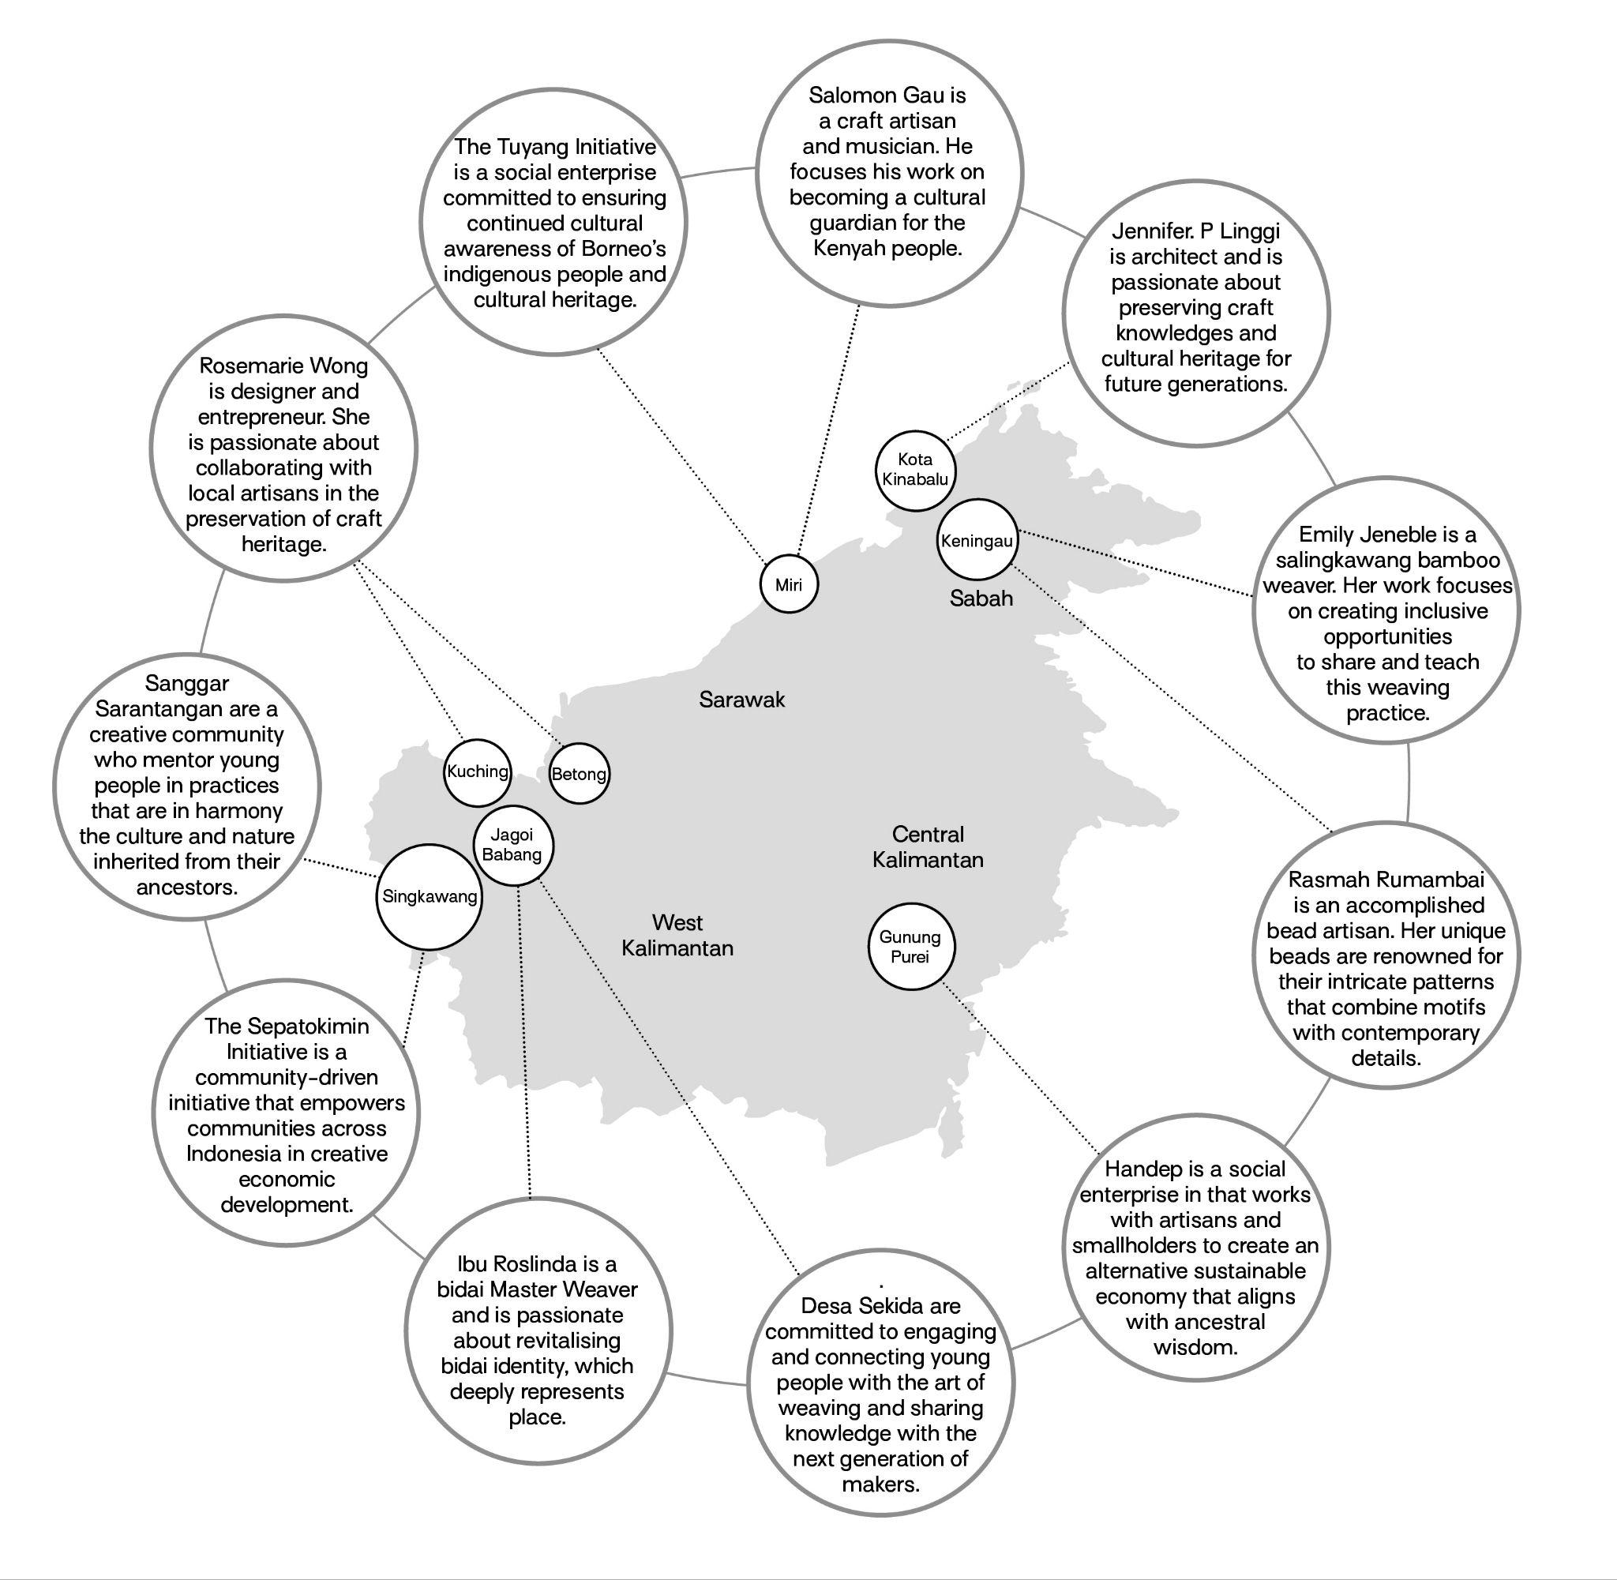

Figure 2: The C&VM Cohort (2023).

*‘It was such a valuable experience to be able to exchange stories, listening to other practitioners’ experience mobilising their craft and their community as well as learning about their challenges. It feels like we really bonded and formed new friendships’*

(Herkulanus Edo, Sanggar Sarantangan, Evaluation Interview, February 2023).

The workshop followed a design-led innovation approach where bespoke tools were used to identify creative networks, share individual and collective opportunities, motivations and map contextually located challenges. These were aligned to climate emergency including the environmental impact and sustainability challenges facing craft practices – in part due to climate

change and the deforestation of Indigenous landscapes – guided by participants’ interests. The methods included: sharing and mapping participant stories and journeys; tools to support defining project briefs and planning; and reflective journaling. In addition, the participants were supported by dedicated one-to-one mentoring sessions with the C&VM team to co-develop and refine their project briefs. This extended to identifying place-based natural resources, vernacular materials and craft practices as community-based cultural assets. This approach centred on embedding opportunities for participants to develop their craft practice, supported practitioners in pursuing individual and collective priorities and mutual learning to occur within and outwith the cohort. Each project had a £1500 share of the programme budget for time and material costs, which informed the scope, scale and duration of the work (additional funds were allocated to logistics, travel and accommodation costs to facilitate in-person participation). Embedded within C&VM was an awareness of procedural ethical considerations (for example practical concerns surrounding accessibility, safeguarding and supporting in-person inclusion and participation) and equally towards ethical and relational engagement.

**C****&VM Field Work: Borneo Participatory Film**

I (Wendy) coordinated the logistics of the fieldwork in liaison with the two key stakeholders Jennifer and Juvita. The C&VM team visited each of the 11 community-based projects to support the opportunities being explored in the practitioners’ projects and to capture work-in-progress through conducting both semi-structured interviews and employing the method of participatory filmmaking (Bezzina 2022; Milne et al 2012). The technique of participatory filmmaking engaged practitioners to explore their craftwork through participation in the co-production of a film that narrated their journey. Participatory film can be used as a device to inform and influence a range of audiences and has been applied as an approach that challenges traditional filmmaking practices that narrate stories about rather than create stories with protagonists (Lenette 2019 in Sarria-Sanz et al 2023). The filming became a collaborative process as the participants developed their documentary and storytelling skills and co-produced their narratives through storyboarding.

*‘Through the project, [we] had the opportunity to produce […] short documentary films. It was our very first time making a documentary without professional or formal training [...] so much new knowledge has gained from the process; from preparing interview questions, developing storyboards and other technical aspects we learned along the process* […] *through making the film we learned about the stories linked to our cultural identity’* (Petrola Veni, Herkulanus Edo and Januarius Feby, Evaluation Interview, February 2023).

In addition to the participatory film, data was collected from the 11 practitioners' projects: including individual maps of participant stories, creative networks and connections; contextually located challenges, vernacular materials and project briefs; transcribes from the series of semi-structured interviews and collaborative conversations; reflective journaling captured in field notes; and evaluation interviews. The data from the fieldwork was synthesised and analysed by the C&VM research team and through a process of thematic analysis (Braun and Clarke 2012) revealed emergent insights. These informed the key thematics: Changing Landscapes and Material Scarcity; Artisanal Trade; Innovation; Youth Engagement and Education; and Documentation (Figure 3) and formed the basis of curating the Serumpun: Crafts across Borders Exhibition.

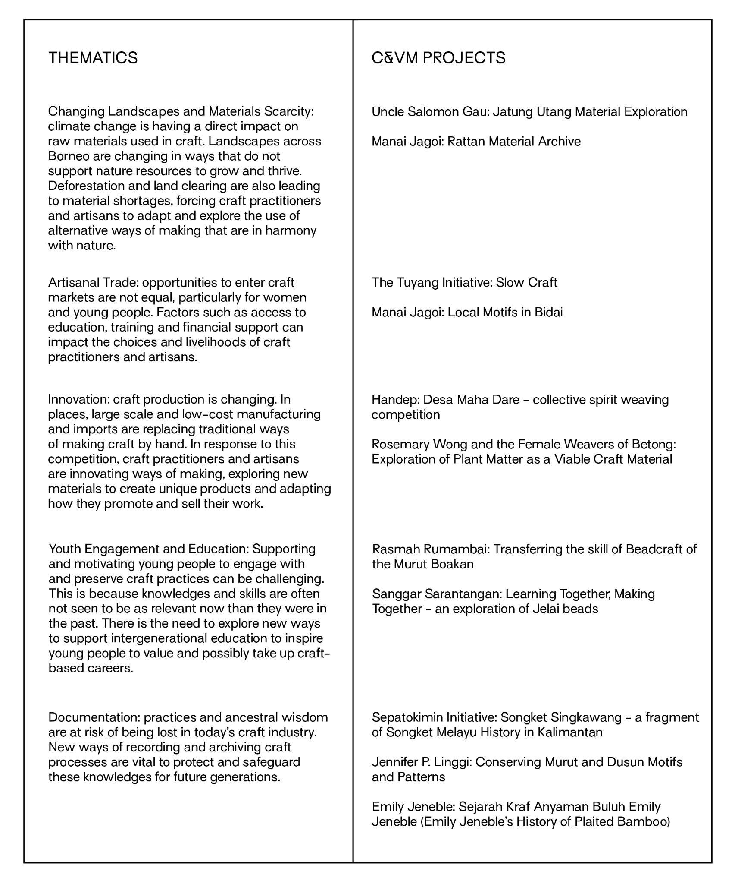

Figure 3: C&VM projects and Corresponding Themes (2023).

The Serumpun: Crafts across Borders Exhibition at the Borneo Cultures Museum showcased the outputs and outcomes from the 11 projects along with the participatory film. The title of the exhibition *Serumpun* (a bundle of grass that shares the same root*)* was informed by Sujianto, the *Ketua Kampong* (Village Chief) of the Sekida Village in Jagoi Babang who shared that ‘before the colonial governments came, we used to be Serumpun’. Serumpun articulates how knowledges, wisdom and material cultures across the borders of Kalimantan, Sarawak and Sabah connect as part of a wider ecosystem. It is worthy of note that this Indigenous

community-based exhibition of ‘living’ craft practice(s) was the first of its kind hosted at the Borneo Cultures Museum. Alongside the exhibition, a programme of conversations, events, craft workshops and fora were held over four days. The Serumpun exhibition attracted more than 2500 in-person visitors, and for many of the C&VM cohort, this was their first-time sharing work in a public forum. In addition, the team hosted the *Gotong Royong* (cooperation in community), which brought together the practitioners with key stakeholders, collaborators, activists and advocates in a plenary-style forum. The Gotong Royong fostered a safe and reflective space for the cohort to consider their journeys, resonances with other practitioners’ projects and explore opportunities for the future. We now go on to present two cases and practitioners’ narratives from Sarawak and Sabah that explore Indigenous practitioners’ relations to place, natural resources and communal ways of working.

**Uncle Salomon Gau, *Jatung Utang*: Material Exploration**

Uncle Salomon Gau is a musician and craft artisan based in Miri, Sarawak. He is committed to preserving Miri’s tangible and intangible heritage as a cultural guardian for the Indigenous Kenyah people. Uncle Salomon has dedicated 20 years to researching, understanding and honing his craft practice through undertaking apprenticeships with elders and studying vernacular materials. Uncle Salomon explored alternative timbers to the conventional use of *Apo* and *Baa’tilang* (Kenyah for timber types) sourced around the city of Miri to enable the making of the *Jatung Utang* (gong and stick), which is a traditional wooden xylophone (Figure 4). Uncle Salomon shares the story of the Jatung Utang and the journey he takes in harvesting the timber, which follows certain moon phases affecting the glucose level in the wood. Uncle Salomon also shared his process of tuning the timber as a way of ‘building the tune of our Kenyah songs’. Whilst the optimum timber for the *Jatung Utang* is mostly found in the interior of upper Long Moh (Baram) Uncle Salomon also highlights the precarity of this raw material.

*‘Based on tradition, on elders’ experiences is the specific wood for making the Jatung Utang, we must stick to the advice of the elders [and] only take the wood at the correct moon phase. So, this is through my experience, every time I have to look at the sky and the moon. Maybe in the near future, in 50 years-time, we don’t know if there will be any wood still available… that’s why I invest my time to find out how to get the resources, what is the next alternative. Why not we continue this tradition, this culture so it can bring joy to people and at the same time we will not forget how to do [it] and how to play this special instrument of ours. Anything is possible as long as we put effort in*’ (Uncle Salomon Gau, December 2022).

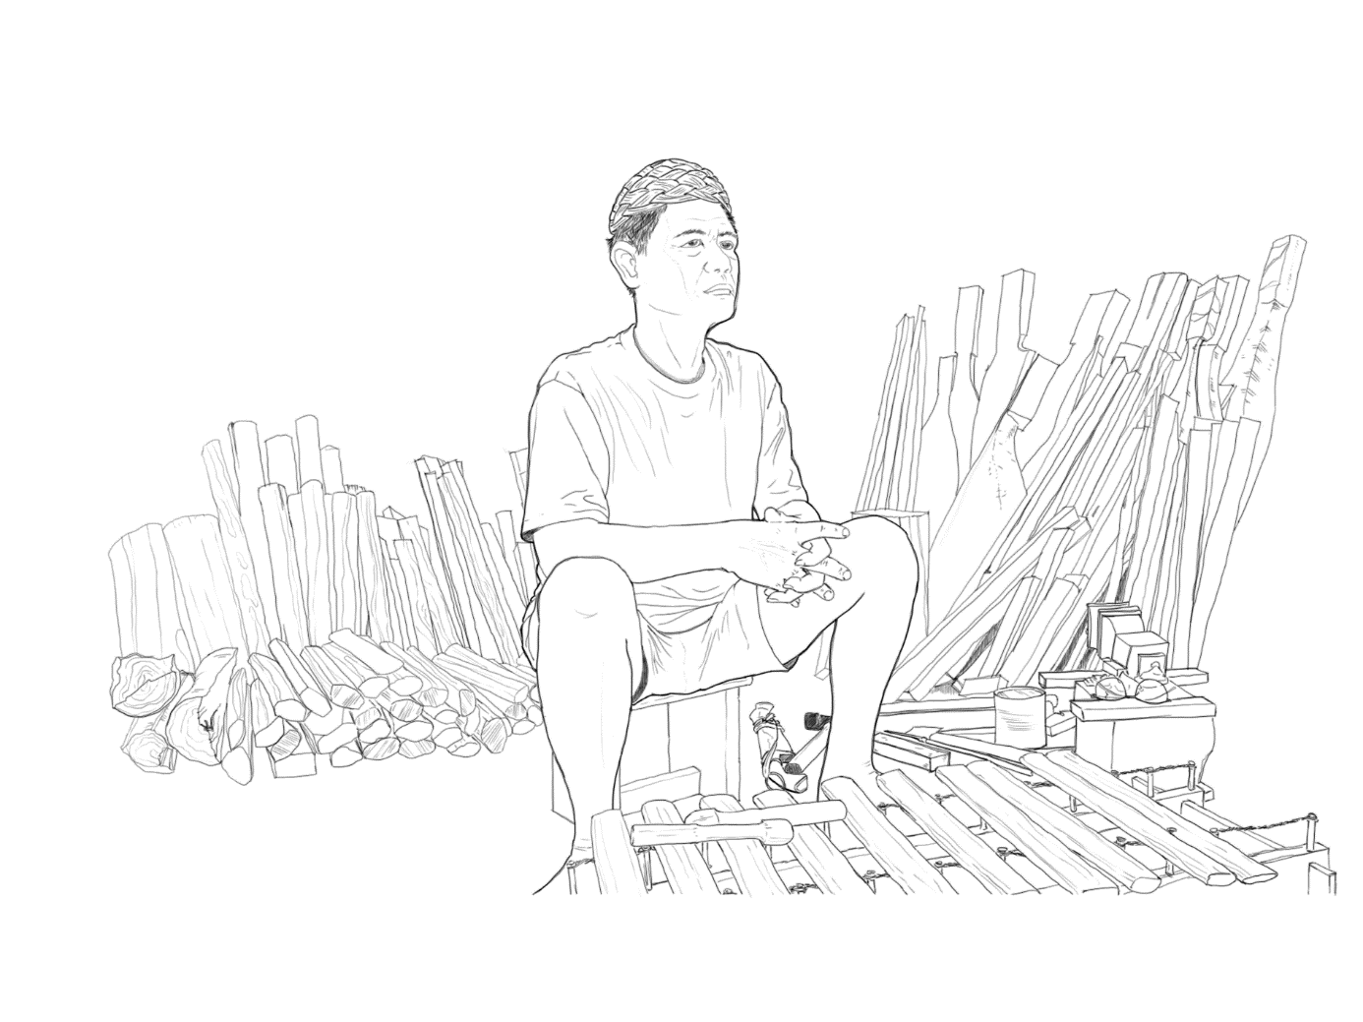Figure 4: Uncle Salomon Gau. Illustration Credit: Chia-Wei, Kang @ Borneo Laboratory (2023).

Uncle Salomon goes on to explain the rituals surrounding the moon phases - our ancestors’ traditions were based on their experience and knowledge - that was handed down from generation to generation. This includes which moon phase is good for hunting and not so good for hunting and guidance for when to plant *padi* (rice), durian, banana, papaya, corn, *ubi kayu* (yam), amongst others to bear good crops and fruits. The experience and knowledge of elders’ guide when is the best time to collect and harvest rattan, bamboo, tree bark and other jungle products. Conventionally, Jatung Utang needs to be made with the timber harvested from Ulu Baram area, where certain specific types of timbers are available. For example, *Kayu Papaa/Kayu Jelapa* (Papaya Wood/Coconut Wood) are the types of timber being used for Uncle Salomon’s Jatung Utang and the attendant use of specific and specialised tools (Figure 5). The following handmade tools (Figure 6) *Baeng* and *Pu’e* (no direct English translation) are honed to work in harmony with the raw materials and in communion with the craft practitioner, for example, the *Pu’e* is for a right-handed person since the blade is concave on the left side and concave on the right side of the blade. This is a special and unique design from ancestral times, which is used for cutting and trimming wood.

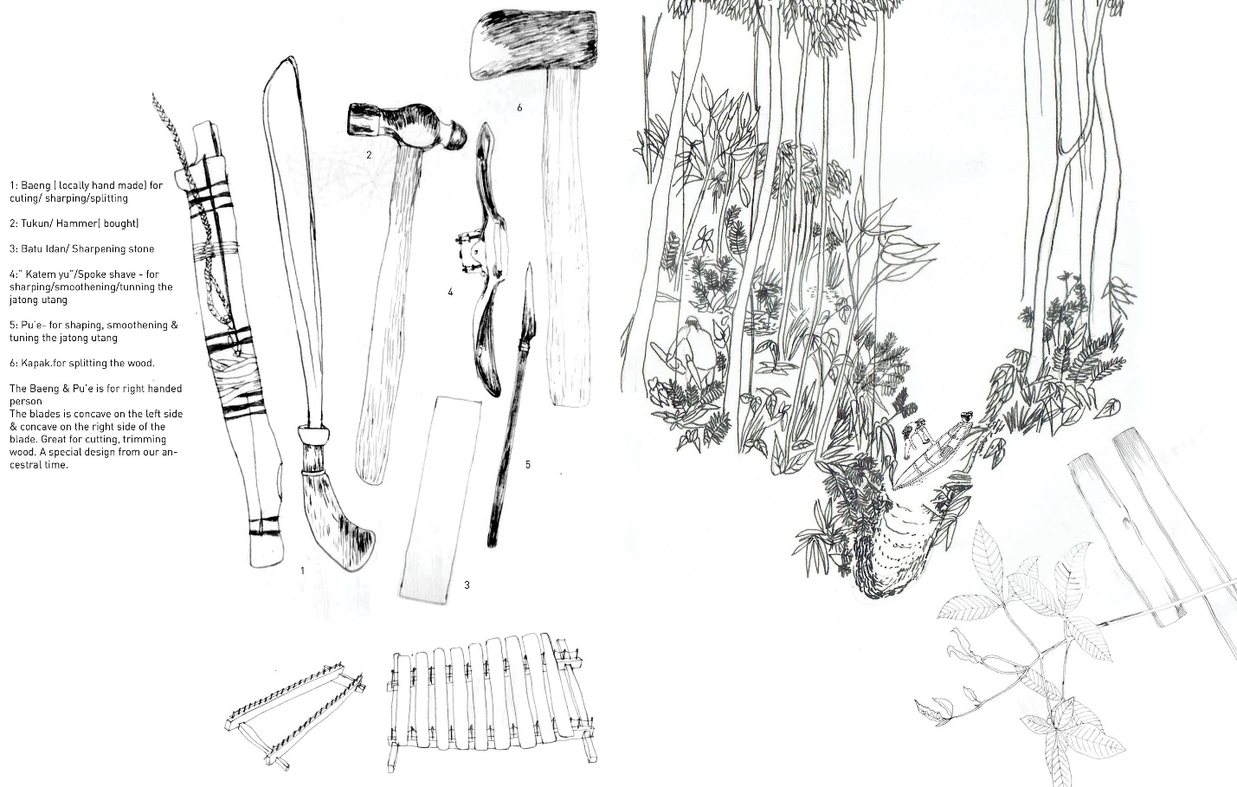

Figure 5: Jatung Utang Tools for Honing Vernacular Materials. Illustration Credit: Wendy Teo @ Borneo Laboratory (2023).

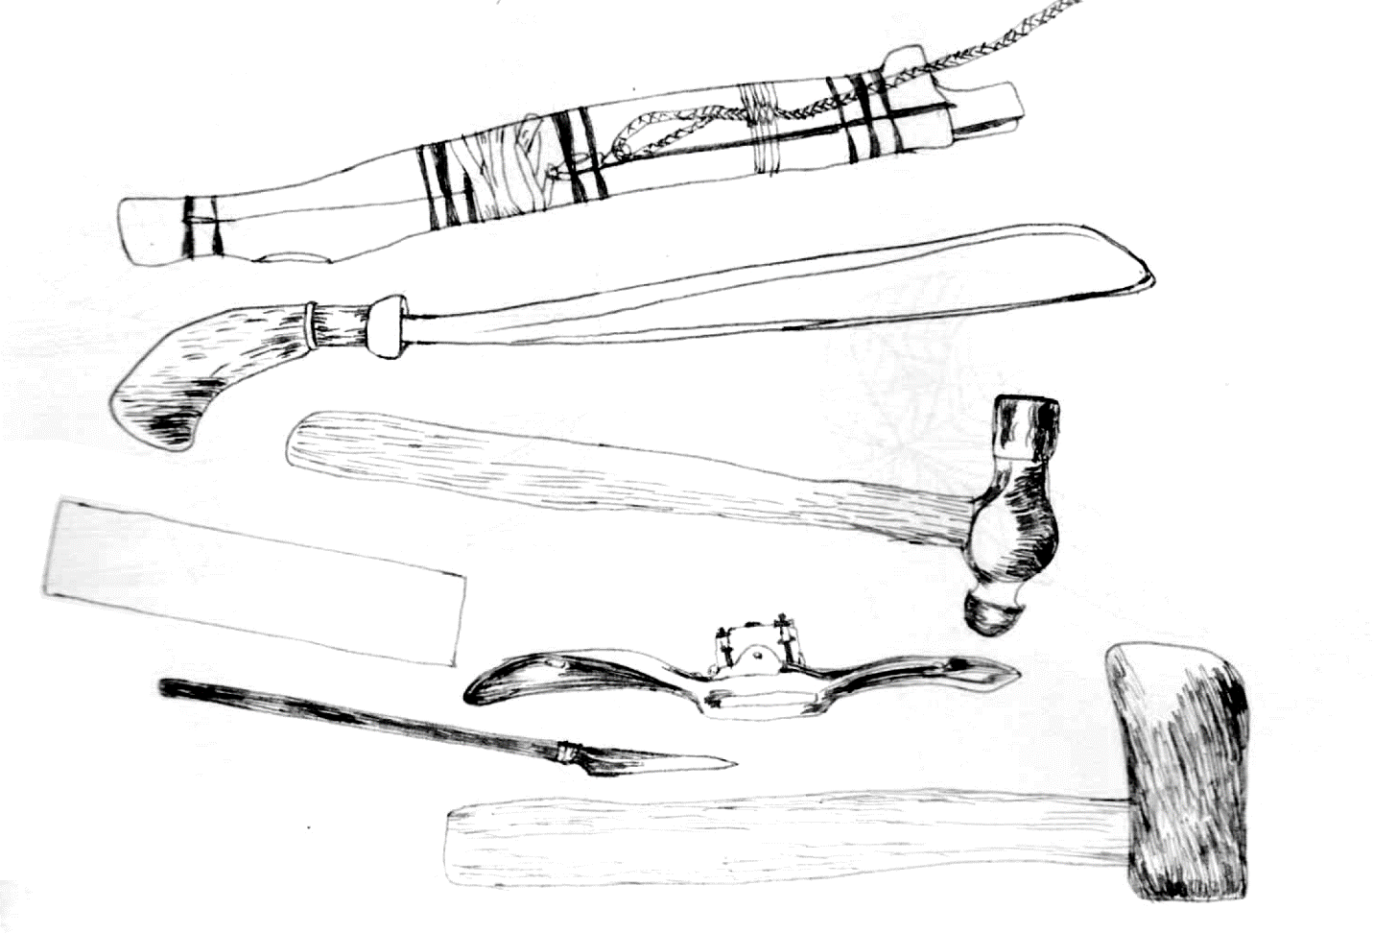

Figure 6: Tools (top to bottom). Illustration Credit: Wendy Teo @ Borneo Laboratory (2023).

*Baeng* for cutting, sharpening and splitting: locally handmade

*Tukun* Hammer

*Batu Idan* Sharpening stone

*Katem yu* for shaping, smoothing and tuning the Jatung Utang

*Pu’e* also for shaping, smoothening and tuning the Jatung Utang

*Kapak* for splitting the wood.

**Emily Jeneble,** **Keningau, Sabah: A Collaborative Community-based Model**

Emily Jeneble has developed a collaborative community-based entrepreneurial model that supports female artisans and the education of young people across 10 villages in Keningau, Sabah. The tradition of crafting began in the 1960s with Emily’s grandmother a traditional artisan from the Dusun Minikok ethnic group in the interior region of Sook, Keningau. Crafting became a family tradition, passed down from generation to generation, allowing Emily to witness how raw materials were gathered from the forest, carefully selected and prepared until the craft products were completed. These natural resources were abundant during the times of her elders; however, they are becoming increasingly perilous with Emily having to travel deep into the interior to harvest and process raw materials. Whilst there are approximately 60 bamboo species in Malaysia, Emily’s craft work is primarily based on *Poring* (Bamboo in the Dusun dialect)and *Pus and Lias Bembang (*Kadazan dialect*)* bamboo species. Traditionally, there were only three types of crafted products: *bubu* (fish traps); *nyiru* (rice sifters); and *sirung* (sun hats). These crafts were made to meet specific needs, such as *nyiru* for sifting rice or *bubu* for fishing and *sirung* for protection from the sun or for use in celebrations like *Kaamatan* (Harvest Festival in Sabah) or weddings. Emily’s collaboration with communities started from her village, Kampung Batu Lunguyan. Initially, crafting these products required skilled labour including the knowledge and understanding of how to grow, harvest and prepare bamboo and rattan for the natural dye processes: *Ubi Kayu* (Cassava) tuber-tree timber bark extracted for colour sealant; *Tamgud-kessoot/Arang* black mineral/powder for black dye; *Ubi Kayu* Tuber-tree juice for processing/fixing tin following burning overnight to mordant (used in natural dyeing to fix the colour) (Figure 7).

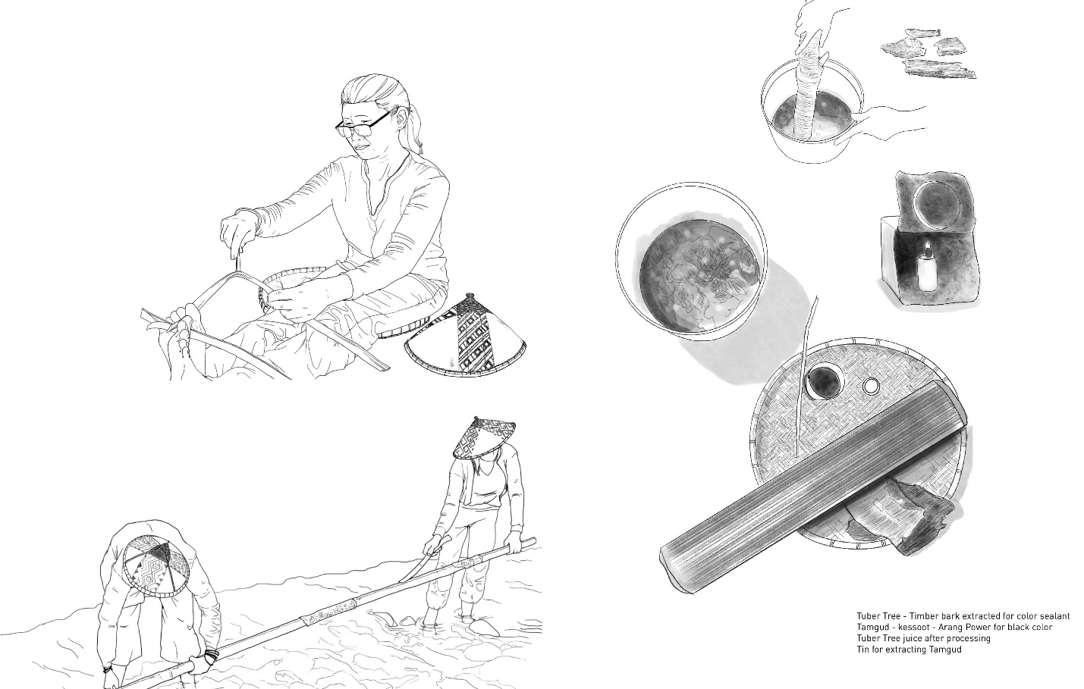

Figure 7: Growing, Harvesting, Processing and Natural Dyeing Bamboo. Illustration Credit: Chia-Wei, Kang and Tsai-Yu, Chou @ Borneo Laboratory (2023).

As demand for raw materials such as bamboo and rattan for craft products increased – Emily decided to train housewives, youths and craft enthusiasts – she initiated efforts for villages to specialise in various aspects. Kampung Batu Lunguyan focused on producing and selling products, Kampung Sinaron supplied bamboo strips, whilst Kampung Sinua supplied rattan, Kampung Senang contributed to traditional bamboo weaving and Kampung Tinura supplied woven pieces. Originally, Emily crafted at home and training also took place at her home until 2010 when Yayasan Sabah built a 20x30 foot craft workshop in Keningau with sewing machines and storage facilities. The workshop required running and maintenance costs that Emily bore herself whilst providing opportunities for villagers to learn and use the workshop facilities to develop expertise:

*‘… Each individual [community] has their expertise. Kampung Batu Lunguyan has exceptional craft makers skilled in bamboo weaving, from gathering raw materials in the forest to finishing the products. I serve as an inspiration to the villagers. Other entrepreneurs in the village are also skilled and instead of competing we always collaborate to promote the craft industry in our village, making it known throughout the country…’* (Emily Jeneble, September 2023).

Emily was awarded a Ministry Grant to expand her workshop and her work has been recognised by the World Craft Council and endorsed with an Award of Excellence. As part of the C&VM project, Emily narrated her story in a Book entitled *Sejarah Kraf Anyaman Buluh* (History of Plaited Bamboo). The book covers three main aspects: the first covers the stories of her grandmother and parents who are bamboo craft makers from whom Emily learned her skills; the second covers the different bag designs that helped to build her reputation for innovation; the

third section covers how Emily expanded her craft business through a collaborative model with other craft communities in Sabah:

*‘In the past, working as a craftsperson was seen as a low-status occupation. However, today, it is the preferred choice in our village. I will do my best to ensure that the heritage of traditional crafts continues to be passed down from our ancestors […] I will continue to strive to advance the craft industry, seeking opportunities to collaborate with artisans across Malaysia and beyond’* (Emily Jeneble, September, 2023).

**Discussion**

**Indigenous Relations: Craft, Vernacular Materials and Cultural Assets in Borneo**

As we have illustrated in the practitioners’ accounts and the accompanying drawings craft practitioners’ narratives are directly connected to traditional wisdom found in Indigenous communities passed on by elders from generation to generation. Together, these represent an innate sense of belonging through a symbiotic relationship with land, nature and the wider ecology. Oftentimes these forms of wisdom are ineffable – transferred orally or through apprenticeship – as a body of knowledges that inhabit the ‘lived and tacit’ experience of artisans as cultural guardians of both place-based natural resources and traditional skills. These intimate material and craft narratives reveal layers of biography founded on familial and ancestral wisdom whereby Indigenous communities ‘celebrate the traditions of their predecessors’. Undoubtedly, climate change and its effects are having a direct impact on the raw and vernacular materials utlised in craft practice, for example, the timber(s) Uncle Salomon uses for the *Jatung Utang* (gong and stick), which are becoming increasingly precarious. Uncle Salomon’s reiterates ‘We must stick to the advice of elders and harvest timber during the correct moon phase’ respecting the antecedent nature of rituals and craft practice conducted in cooperation with nature rather than depleting natural resources. This is echoed by Emily Jeneble regarding the bamboo and natural dyeing processes she incorporates in her craftwork. Emily learned from her forebearers how vernacular materials, such as bamboo were grown, identified and gathered with each particular bamboo genus having a particular ‘character’ and purpose when transformed into craft products.

**Innovation within Indigenous Craft Traditions**

In this next section, we interweave the key thematics: Changing Landscapes and Material Scarcity; Artisanal Trade; Innovation; Youth Engagement and Education; and Documentation that emerged from the C&VM research and how this relates to innovation within Indigenous craft work. Emily has developed an innovative collaborative community-based model that supports female artisans and the education of young people across 10 villages. Her focus on documenting bamboo processes maintains traditional skills and mobilises the value of craft work as both a cultural practice and an economic activity. These innovative approaches and frameworks are positioned to respectfully and responsibly support artisans and craft makers to adapt and augment their practices, for example, alternative and viable natural resources or collaborative and collective community-based networks and processes. As demonstrated within the practitioner narratives innovative approaches underpin Uncle Salomon’s exploration of alternative timbers in response to climate change and the precarity surrounding vernacular materials. Uncle Salomon made small-scale *Jatung Utang* utilising alternative raw materials in order to document the process of making *Jatung Utang* as a knowledge artefact, which preserves the unique cultural heritage of Kenyah songs and rituals for future generations.

**Innovation Frameworks**

Whilst antithetical within the ubiquitous conception of globalised innovation frameworks with their focus on ‘development’, progress, transferability, scale and economic output Indigenous innovation oscillates between the past, the present and the future. Design-led innovation as a set of dialogical and relational practices broaden the ways craft within Indigenous communities can inform the way we understand phenomena as experience, expand, facilitate and reflect on how information is gathered towards advancing new ways of understanding, becoming and doing. These approaches informed by ancestral wisdom (the past) shape future possibilities, which foreground the continuation of cultural heritage beyond the economic imperative. Culturally located place-based innovation connects to intangible and tangible cultural assets, which are inextricable from a particular locale, for example, vernacular materials, history, skills and Indigenous traditions. Innovation takes form through leveraging the shared stock of assets as a form of collective cultural capital enmeshed within the complex socio-cultural relationships in Indigenous communities. Relationships to place-based craft production engenders innovation through the ways practitioners mediate these socio-cultural relationships to develop new creative expressions. From this, it can be asserted that in addition to seeing craft as a list of attributes, these relations rooted in local cultural heritage contribute to a mode of innovation, that protects, strengthens and sustains Indigenous craft traditions as a ‘living’ process.

**Craft as Knowledge Artefacts**

Design-led innovation approaches foreground the discursive capacity of ‘knowledge artefacts’ within the innovation process through engagement with Indigenous practitioners and in participation with nonhuman entities as we have described in the two practitioner case studies. In this conceptualisation of innovation, we challenge the boundaries of who is considered the ‘knower’ and the attendant dichotomies between expert/non-expert. Being cognisant of the complexities that surround design and craft research with participants from Indigenous communities the *Gotong Royong* revealed insights around the recuperation of Indigenous craft work and overlooked practices that recognise plurality as multiple ‘ways of doing and being’ aligned to alternative value systems: social; cultural; ecological; and collective wellbeing that locate cultural memory as a body of place-based and situated Indigenous knowledges intimately related to place. Thus, knowledge artefacts, as demonstrated in the Serumpun Exhibition can activate conversations, which are located in specific cultural contexts, yet are universal in embodying Indigenous knowledge(s) that have the capacity to resonate across political boundaries and geographic borders.

**Reflective and Reflexive Practitioners**

We now return to reflect on the methodological framing including the grounding of design-led innovation in contexts that enmesh the multiple experiences and ambitions of diverse research participants and craft practices. The research design deepened our understanding of the complex geographic, social, cultural, environmental, and overarching political discourses that reside in Indigenous communities. This framing is further developed through our ongoing discussions around Indigeneity as - the social values and practices - that are collaboratively produced and cultivated by a community (Manzini 2016) created in reciprocal rhythm with constellations of people working together towards a shared goal. In such a framing pluriversal design ontologies (Escobar 2017) are cognisant of and informed by the plurality of knowledges including who is the ‘knower’ that emerge from Indigenous communities. Inundertaking cross-cultural collaborations, we acknowledge the tensions both implicit and explicit that reside in working with craft practitioners in Indigenous communities. These extend to the wider political economy of craft, the preservation and cultivation of raw material and the cultural protocols that encompass the nuancing of Indigenous identity indelibly bound to materialities of place.

**Limitations of the Research**

Whilst we have a commitment to our ongoing collaboration academic, institutional and funding mechanisms can inadvertently cause an asymmetry in how we share, exchange knowledge and undertake this work. Together, through our collaborative approach we blend our expertise in design and craft in concert with local knowledge, language(s) and dialect(s). The limitations of this approach were that focussing on craft as a ‘living’ process undertaken by artisans and informed by ancestral wisdom constrained the investigation of complimentary cultural practices, rituals and animistic traditions. Whilst local artisanal production can be conceptualised as having a concern with the complexities, conflicts and challenges of contemporary society and culture, there are limitations to the extent to which Indigenous voices are heard, craft practices valorised and equitable and inclusive models of support implemented for Indigenous communities.

**Personal** **Learnings**

We now move to reflect on our personal learnings - both pragmatic and philosophical - that could be of benefit to future research and researchers. I (Wendy) believe that undertaking the scope of the fieldwork within C&VM required building trust and reciprocity with the communities we worked with. Cross-cultural collaborations and cross-regional projects that engage with Indigenous practitioners require relationships to be sustained over time. It is necessary to have adequate time for planning and organisation commensurate with the flexibility required when undertaking work of this nature. Oftentimes timeframes and delivery milestones are dictated by funding budgets and mechanisms driven by external agendas. This required us to be somewhat agile whilst navigating particular situations. It is therefore important to remain alert to our observations and the unpacking of the layers of complexities we found, for example, colonial legacies that have encroached into communities causing the loss of ancestral wisdom and practices. Accordingly, we need to acknowledge that many situations have persisted within communities before our project began therefore it is important to be humble and non-judgmental. I (Lynn) have noticed that Indigeneity has become increasingly under the purview of the West. However, there is a risk of reductionism about what counts for knowledge and who counts as a knower (Escobar, 2017). Asking complex questions, yet, the expectation is binary answers, for example, Indigenous/non-Indigenous; colonised/post-colonial; innovation/exnovation; development/extraction; nature/culture. Whilst we both identify as non-Indigenous within the context of Bornean-Malaysia and normative classifications we are committed to opening up the ‘silent spaces’ that exist within complex research contexts as a counterpoint to dominant discourses. It is then incumbent on us as researchers to reveal these tensions particularly within cross cultural research respecting the boundaries of our experience and knowledge. This calls for the need - rather than rigid definitions - to hold the notion of juxtaposition at the forefront of our ongoing process of learning. And in doing so remaining open to possibilities to create new ways of understanding, becoming and doing that make a meaningful contribution to Indigenous communities. In this manner, C&VM enabled practitioners and communities to bring to bear their diverse voices, hopes and desires within craft as a ‘living process’ and in doing so enrich its outcomes.

*‘We learned so many things from the projects, but the most meaningful one from our reflection about the craft documentation is no matter how good the cultural documentation project is presented, it loses its meaning when the locals are not actively engaged in the process...’ (Yohanes Arya of Sepatokimin Initiative. Evaluation Interview, February 2023).*

**An Expanded Notion of Craft**

*Craft as a way of telling is in correspondence with tools, materials and environment […] not imposing form on matter but finding the grain of things and bending it to an evolving purpose’* (Ingold, 2019, 10).

Following Escobar (2017) we hold that no Indigenous group holds the key to the future, rather we have to make that future through dialogue and conscious action. We conclude by offering our modest contribution to the field of design research and craft practice as a mode of cultural research that alters the traditional dynamics and conventions of research as a rapprochement between non-Indigenous and Indigenous as a way of shaping a future that is in harmony with the natural ecology. Craft objects as cultural assets are important sources of cultural appreciation, personal meaning and contextually located knowledge and resources. Ancestral wisdom and the intimate relations to natural resources and vernacular materials reside within Indigenous communities as place-based, site-specific and communal bodies of knowledges. This entails identifying place-based natural resources, vernacular materials and craft practices as community-based cultural assets, the relationship craft makers have to their local context and how they relate to the material world through embedded and embodied materialities of place. We position an expanded notion of craft whereby the relations to vernacular materials - growing, harvesting and processing – are indelibly connected to the natural ecosystem. This expanded view of craft as an ecological activity acts as a fulcrum that connects artisanal practice to collective models, which affords a space to deepen our understanding of how Indigenous knowledges can inform design domains and raise consciousness to Western audiences.

**Acknowledgments**

The C&VM team would like to express their deepest gratitude and appreciation to each of the practitioners, artisans and communities who participated in, and supported, the programme. Thanks to Yasmin and Asnida Iman from the Borneo Cultures Museum, Think & Tink and Borneo Coffee Lodge for their generous support and hospitality. Thank you to Dato Hii Chang Kee (Permanent Secretary of Sarawak Tourism Department - Arts and Cultures) for opening the Serumpun Exhibition. We extend thanks to the Borneo Laboratory in particular Asa Esa Film Group, Kang Chia-Wei, Chou Tsai Yu, Kinai Wong, Jason Lim, Abigail Langgi, Valerie Juliet and Reening Lau. We are especially grateful to Gamia Dewanggamanik and Dr Marianne McAra for their contribution to the Cultural-Assets and Vernacular Materials Project and Florence Lambert, the British Council for her ongoing support.

**Funding Details**

This work was supported by the British Council under the British Council’s International Collaboration Grants, which are designed to support UK and overseas organisations to collaborate on international arts projects.

**Disclosure Statement**

The authors report there are no competing interests to declare.

**References**

Adamson, G. (2013). The Invention of Craft. London: Bloomsbury.

<https://doi.org/10.5040/9781350036123>

Akama, Y., and St John N. 2022. “Reimagining Co-design on Country as a Relational Transformational Practice”. CoDesign 18 (1): 16-31. <https://doi.org/10.1080/15710882.2021.2001536>

Allred, S., Harris R., Zaman T., Kulathuramaiyer N., and Jengan G. 2022. “Cultural Resilience in the Face of Globalization: Lessons from the Penan of Borneo.” Human Ecology 50 (3): 447-462. <https://doi.org/10.1007/s10745-022-00319-3>

Amir, S. 2023. "Scrutinising Nusantara: The Making of an Authoritarian City.” LSE Research Online Documents on Economics 119201, London School of Economics and Political Science, LSE Library. <http://eprints.lse.ac.uk/id/eprint/119201>

Bannon, L.J., and Ehn P. 2012. “Design: Design Matters in Participatory Design.” In *Routledge International Handbook of Participatory Design*, edited by Simonsen, J., and Robertson T. 37-63. New York: Routledge. <https://doi.org/10.4324/9780203108543>

Barad, K. (2007). *Meeting the universe halfway; Quantum physics and the entanglement of matter and meaning.* Duke University Press.

Bezzina, L. 2022. “Using Participatory Video in Researching Livelihoods in the Global South: The why and Wherefore.” In *The Routledge Handbook on Livelihoods in the Global South*, edited by Nunan, F., Barnes C., and Krishnamurthy C. 134-146. London: Routledge. <https://doi.org/10.4324/9781003014041>

Braun, V., and Clarke, V. 2012. “Thematic Analysis.” In *APA Handbook of Research Methods in Psychology, Vol. 2. Research Designs: Quantitative, Qualitative, Neuropsychological, and Biological*, edited by Cooper, H., Camic, P. M., Long, D. L., Panter, A. T., Rindskopf, D., and K. J. Sher. 57–71. American Psychological Association. Washington DC. <https://doi.org/10.1037/13620-004>

Clarke, A. 2005. *Situational Analysis*. Sage Publications. London.

Conty, A. 2022. “Animism in the Anthropocene.” Theory, Culture and Society, 39(5): 127-153. <https://doi.org/10.1177/02632764211039283>

Dixon, B. 2022. *Dewey and Design*. Springer. Switzerland.

Escobar, A. 2017. *Designs for the Pluriverse: Radical Interdependence, Autonomy and the Making of Worlds*. London: Duke University Press. ISBN: 978-0-8223-7105-2

Fahlberg, A. 2023. “Decolonizing Sociology through Collaboration, Co‐Learning and Action: A Case for Participatory Action Research 1.” Sociological Forum 38 (1): 95-120. <https://doi.org/10.1111/socf.12867>

Fletcher, K., Pierre, L.S. and Tham, M. 2019. *Design and Nature: A Partnership*. London: Routledge & CRC Press.

Frauenberger, C., Good J., Fitzpatrick G., and Iversen O.S. 2015. “In Pursuit of Rigour and Accountability in Participatory Design.” International Journal of Human-computer Studies 74: 93-106. <https://doi.org/10.1016/j.ijhcs.2014.09.004>

Foor, D. 2017. “Ancestral Medicine: Rituals for Personal and Family Healing” Bear and Company, Vermont.

# Goh, C.S. 2020. “Transforming exploitative land-based economy: The case of Borneo.” Environmental Development, Elsevier.

Gokkon, B. 2023. “As Indonesia’s New Capital takes Shape, Risks to Wider Borneo Come into Focus.” Mongabay, March 08 2023. <https://news.mongabay.com/2023/03/as-indonesias-new-capital-takes-shape-risks-to-wider-borneo-come-into-focus/>

Hauser-Schäublin, B. 2013. *Adat and Indigeneity in Indonesia: Culture and Entitlements between Heteronomy and Self-Ascription*. Universitätsverlag Göttingen. Göttingen. <http://library.oapen.org/handle/20.500.12657/32549>

Ingold, T. 2019. Of Work and Words: Craft as a Way of Telling. *European Journal of Creative Practices in Cities and Landscapes.* Vol. 2 No. 2. Bologna. <https://cpcl.unibo.it/article/view/10447>

Kambunga, A.P., Smith R.C., Winschiers-Theophilus H., and Otto, T. 2023. “Decolonial Design Practices: Creating Safe Spaces for Plural Voices on Contested Pasts, Presents, and Futures.” *Design Studies* 86: 101170. <https://doi.org/10.1016/j.destud.2023.101170>

Ladha, A. and Murphy, L. 2022. *Post Capitalist Philanthropy: Healing wealth in the time of collapse*. Transition Resource Press, New York.

Li, T.M. and Semedi, P. 2021. *Plantation Life: Corporate Occupation in Indonesia's Oil Palm Zone*. Durham: Duke University Press. ISBN 7981478022237

Manzini, E. 2016. “Design Culture and Dialogic Design.” Design Issues 32 (1): 52-59. [10.1162/DESI_a_00364](https://doi.org/10.1162/DESI_a_00364)

Milne, E.J., Mitchell C. and De Lange N. 2012. *Handbook of Participatory Video*. Plymouth: Rowman and Littlefield.

Niedderer, K. and K. Townsend. 2014. Designing Craft Research: Joining Emotion and Knowledge. *Design Journal*, vol. 17 (4), pp. 624-648.

Noor Muhammad, S. J. 2018. “The Influence of Animism on the Customs and Culture of the Iban Community.” International Journal of Humanities and Social Science 8: 763-774. DOI: 10.6007/IJARBSS/v8-i8/4631

O’Donnell, P. M. 2023. “Cultural Landscapes: Integrating Culture and Nature to Uplift Global Sustainability Through the Lenses of the UN SDGs 2030 Agenda.” In *Placemaking and Cultural Landscapes. Advances in Geographical and Environmental Sciences*, edited by Singh, R.P.B., Niglio, O., and Rana, P.S. Singapore: Springer. <https://doi.org/10.1007/978-981-19-6274-5_4>

Pradipta, L. 2022. “Kalimantan's Warning: The Intertwined Dynamics of Environmental Degradation and Internal Migration.” New Naratif, October 18 2022. <https://newnaratif.com/kalimantans-warning/>

Predan, B. 2021. “A Discussion of Processes to Create a Curriculum and Handbook for Co-Creation and Active Implementation of Co-Design with the Aim of Stimulating Collective Creativity.” The Design Journal 24(4): 589-609. <https://doi.org/10.1080/14606925.2021.1930933>

Sada, C., Alas Y., Anshari M., and L Geraghty. (2019). “Indigenous People of Borneo (Dayak): Development, Social Cultural Perspective and its Challenges.” Cogent Art and Humanities 6(1): 1665936. <https://doi.org/10.1080/23311983.2019.1665936>

Sanders, E.B.N. and Stappers P.J. 2008. “Co-creation and the New Landscapes of Design.” CoDesign 4(1): 5-18. <https://doi.org/10.1080/15710880701875068>

Sarria-Sanz, C., Alencar A., and Verhoeven E. 2023. “Using Participatory Video for Co-production and Collaborative Research with Refugees: Critical Reflections from the Digital Place-makers Program.” Learning, Media and Technology 1-14. <https://doi.org/10.1080/17439884.2023.2166528>

Sellato, B. 2016. “Recent Material Culture Studies on Borneo.” Moussons Recherche en Sciences Humaines sur l’Asie du Sud-Est 27: 163-172. <https://doi.org/10.4000/moussons.3593>

Sellato, B. 2017. “Material Culture Studies and Ethnocultural Identity.” In *Borneo Studies in History, Society and Culture*, edited by King, V. T., Zawawi I., and Hassan N.H. 57-78. Institute of Asian Studies: Springer.

Sheehan, N.W. 2011. “Indigenous Knowledge and Respectful Design: An Evidence-based Approach.” Design Issues 27(4): 68-80. <https://doi.org/10.1162/DESI_a_00106>

Sleeswijk Visser, F. 2009. *Bringing the Everyday Life of People into Design.* Delft, The Netherlands, University of Technology. ISBN 978-90-9024244-6

Smith, R.C., and Iversen O.S. 2018. “Participatory Design for Sustainable Social Change.” Design Studies 59: 9-36. <https://doi.org/10.1016/j.destud.2018.05.005>

Smith, R. C., Winschiers-Theophilus H., Paula Kambunga A., and Krishnamurthy, S. 2020. “Decolonizing Participatory Design: Memory Making in Namibia.” In Proceedings of the 16th Participatory Design Conference 2020 Participation(s) Otherwise (1): 96-106. <https://doi.org/10.1145/3385010.3385021>

Smith, R.C., Winschiers-Theophilus H., Loi D., de Paula R.A., Kambunga A.P., Samuel M.M., and Zaman, T. 2021. “Decolonizing Design Practices: Towards Pluriversality.” In Extended abstracts of the 2021 CHI Conference on Human Factors in Computing Systems (85): 1-5. <https://doi.org/10.1145/3411763.3441334>

Stoler, A.L. 2013. *Imperial Debris* (Editor). USA: Duke University Press.

Stoler, A. L. 2016. *Duress: Imperial Durabilities in Our Times*. USA: Duke University Press. https://doi.org/10.2307/j.ctv125jn2s

Tanasaldy, T. 2012. *Regime Change and Ethnic Politics in Indonesia; Dayak Politics of West Kalimantan.* Brill. DOI: 10.26530/OAPEN_421239

Tanasaldy, T. 2007. Ethnic Identity Politics in West Kalimantan. In *Renegotiating Boundaries in Post-Suharto Indonesi*, edited by Nordholt, H.S., and van Klinken G. 362–71 Leiden: KITLV Press.

Thomson, L. K. 2000. “The Effect of the Dayak Worldview, Customs, Traditions, and Customary Law (adat-istiadat) on the Interpretation of the Gospel in West Kalimantan, Indonesian Borneo.”

PhD diss., Acadia University. <https://scholar.acadiau.ca/islandora/object/theses:2804>

Tuck, E. and Yang, K. W. 2012. Decolonization is not a metaphor. Decolonization: Indigeneity, Education & Society. Vol. 1, No. 1. 1-40

Van de Vuurst, P., and Escobar L, E. 2020. “Perspective: Climate Change and the Relocation of Indonesia’s Capital to Borneo.” *Frontiers in Earth Science* (8):5. <https://doi.org/10.3389/feart.2020.00005>

Vaughn, L. M., and Jacquez F. 2020. “Participatory Research Methods – Choice Points in the Research Process.” Journal of Participatory Research Methods (1): 1. <https://doi.org/10.35844/001c.13244>