Trace Evidence

Cairo, December 2017. I had been invited to a small arts centre two floors up in an old art deco building. The stylish elevator and the ornate ironwork on the stairs gave me a sense of a hidden Cairo, an alternative to the hot, crowded streets beyond. The tall windows looked out on the street below where there was an old, equally stylish, petrol station doing brisk business.

While I was waiting for the event to begin I sat by one of the windows watching the night fall. A man approached me, wearing an earphone that was attached to a small suitcase in his left hand. He introduced himself and, finding I lived in Glasgow, started a conversation about the Egyptian national team playing Scotland in 1990. It was a friendly apparently and Egypt won 3-0. While he was talking one of the event organisers came up to me and said they needed to speak to me privately. Outside, in the corridor, they explained that the man with the case was secret police and his presence was part of an ongoing surveillance of the centre.

When I gave my talk, there he was in the audience, earphone still attached to the suitcase on his knee, pointing my direction. The subject was archives, their uses and flaws, the gaps in our knowledge and the fictions or facts that can emerge from an inevitably incomplete collection of documents and objects. I think I argued that a loss of information could be as fertile as the conservation of material: I would have mentioned the blitz bombing of London from 1940 to 1941 and the subsequent destruction of whole streets, churches by Christopher Wren and other cultural landmarks. I’m sure I would have pointed not only to the tragedy of these losses but to the way in which those gaps also freed people from past history and provided opportunities to remake an alternative future. Though I can’t remember exactly what I said, that certainly seems likely to have been my train of thought.

I am certain though that I concentrated mainly on the story of Ester Kumbachová, a Czech screenwriter, costume and set designer and film director who was suppressed by the Czechoslovakian authorities between 1970 and 1991. Having worked on several key films in the Czech new wave movement in the 1960s her punishment was stark. The film A Report on the Party and Guests (1966) was central to this. Directed by her husband Němec, it was first banned in Czechoslovakia from 1966 to 1968 for its implicit attack on the regime (the plot revolved around a small group on a picnic who are suddenly surrounded by men who begin to interrogate them). Shown briefly during the Prague Spring, it was then banned again, this time for twenty years. In 1974, director Jan Němec who had divorced Ester Kumbachová in 1968, was forced to leave the country. Kumbachová remained, living in relative seclusion in a suburb of Prague. There she constructed a retreat comprised of lovers, many cats, a small jungle of house plants and domestic magic.

Those years were essentially lost to the world. In 1991 the government awarded her a ‘certificate of rehabilitation’ and she worked on one final film before she died in 1996. In 2017, however, the contents of Kumbachová’s apartment were handed over to two curators in Prague - Edith Jeřábková and Zuzana Blochová – and this material became the basis of an archive. Consisting of books, documents, photographs, drawings, pieces of furniture used as props in films and clothes that had been customised, the collection provided a series of clues that could be used to reconstruct, at least partially, Kumbachová’s life during those invisible years.

This is the point at which archive work becomes detective work: the methods are very similar, beginning with the attempt to work out a chronology of events and identifying protagonists within a potential narrative. It also involves interviewing those who knew the deceased – in this case Kumbachová’s known friends, old colleagues from the film world, people mentioned in her papers etc It also requires an almost forensic examination of the objects and photos she left behind. Among the most intriguing are a small collection of necklaces and a series of torn up letters, ripped into small squares and preserved in plastic bags.

The necklaces are made from recycled scraps of jewellery and antique fabrics – leather, feathers rosary beads, costume jewels and baked pieces of modelling clay. A list identifies them as amulets, some made for sale in a local gallery, others custom made for friends to ward off trouble or to address a particular problem. An isolated dust jacket offers another clue for a missing book called Amulett und Talisman (1977) while ripped out images scattered through the papers and photographs point to the fate of the volume. Yet another loose piece of paper records ‘recipes’ indicating the ingredients needed for the making of certain amulets. Finally, buried in a mass of letters, one piece of correspondence thanks Kumbachová for the amulet sent to her after a meeting and describes how useful it has been to the owner, a film maker and artist from Sweden. Tracing the artist via internet reveals more amulets given to her over the years by Kumbachová and useful information on their shared belief in the objects’ powerful magic. From all of this it’s possible to conceptualise her practice and the element of resistance built reflected in its’ defiantly DIY aesthetic, both proto-feminist and political. While the personal interviews help to identify the chronology of the fabrication of the amulets, many still remain undated and the nature of the aesthetics at play make it difficult to place them all in a stable timeline.

Another confounding aspect of the emerging archive is the collection of ripped-up letters that Kumbachová wrote to friends but never sent. Friends recall how she would type long letters and slip them under the door of a recipient who might only be in the next room. She also, though, wrote a considerable number of letters that never reached their intended reader. Commenting on this Krumbachová herself said:
These letters were written in quite bad times, but I think that there is a great desire to talk to someone in them.
Such long letters are written mainly when you aren’t in your own skin… This isn’t a joke – you write and write and write, really, even as you want to scream and explain to the other person why you are screaming.
She goes on to explain the origin of these strange additions to her archive:
One way or the other – some letters you immediately rip up into small pieces and toss and others, that you’re still thinking could be sent in a week or so once they mature, stay sitting in the drawer and you bury them under socks and pour out your ashtray over them – but somehow you don’t have the strength to destroy them, you only want to not see them.

This archive is full of such mysteries. To solve them it’s necessary to employ the procedures of a detective: in the case of the letters, they can be pieced together and their intended recipients can be tracked down or researched to construct a context for their content. It is oddly similar to the work that was carried out in East Germany in the mid 1990s when teams started assembling the shredded files of the Stasi Record Office.

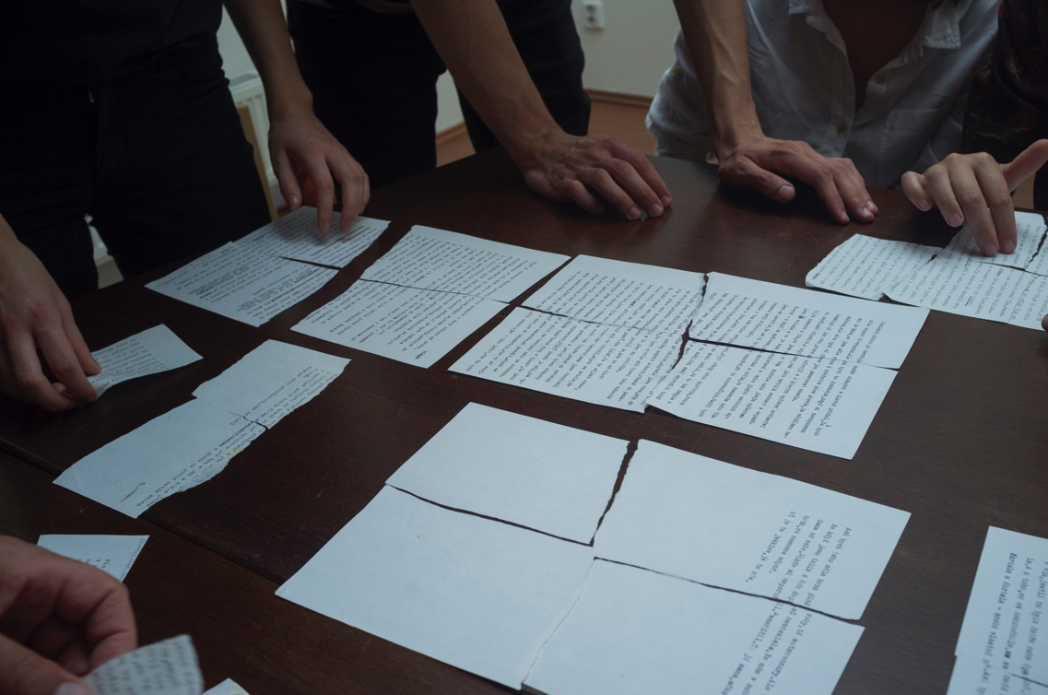
Krumbachová letter reconstruction, Prague

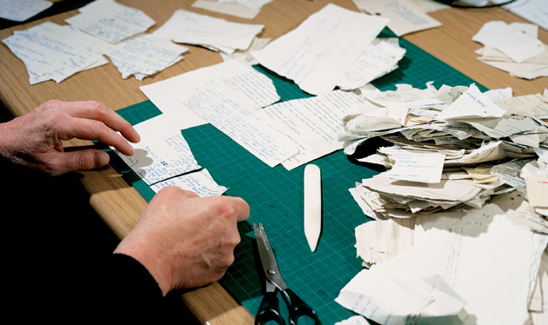
Stasi file reconstruction, Berlin

Even when some aspects of the material appear well organised they conceal stories beyond the visible. Collections of drawings and photographs arranged chronologically turn out to be sections of a portfolio Kumbachová assembled to apply for member ship to various art and design unions. It is only interviews with peers that reveal the backstory and the consequent humiliation by the regime as she is rejected for entry to any union. Deemed not good enough.

This persistent low-level harassment may have been the residual effect of Kumbachová’s perceived misdemeanours in the 1960s. When Němec worked on A Report on the Party and Guests (1966) Kumbachová did in-depth research on key secret police figures in Czechoslovakia to add detail to the satirical attack. That activity would not be forgotten.

Her work on Daisies (1966) with Věra Chytilová was also attacked as the film was condemned as having wasted the people’s food, referring to the climactic scene where the two protagonists ruin a banquet. By 1969 when Kumbachová directed a movie herself – The Murder of Mr Devil – it was hard not to see the action on screen as a reflection of an oppressive world closing in on her. The action all takes place in the home of a woman, played by an actress who looks unnervingly like Ester Kumbachová at that time. The only other protagonist in the film is a manipulative man, the devil in fact, who is only defeated when he is lured into a sack of raisins and beaten to death by the woman. Perhaps the director foresaw her fate, trapped in an apartment surveilled by the authorities, a perpetual existential battle for survival.

As Kumbachová’s research becomes entwined with and mirrors the methods of the police at the time, it seemed only natural to investigate what files might survive on her. The Security Services Archive has preserved one file, logging observations that would have been contained in folders that have since been destroyed. A pdf of the file is downloadable, however, and it demonstrates how regular the surveillance of Krumbachová was in the period around the making of A Report on the Party and Guests (1966):
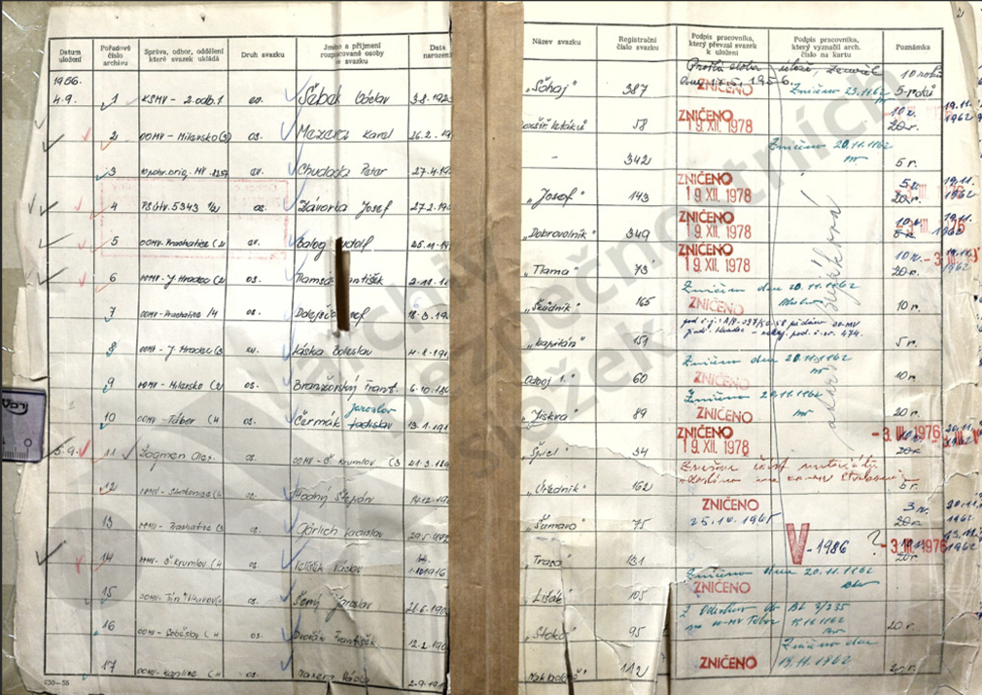

A 1997 article on Timothy Garton Ash – ‘Notes from my Stasi file’ - gives us an idea of the type of content that those Krumbachová files most likely contained. As a student and journalist in East Berlin during the 1970s and 1980s he was under Stasi surveillance and he describes what he found when he later accessed his file:
Here, for example, is an observation report describing a visit I apparently paid to East Berlin on 06.10.79 from 16.07 hours to 23.55 hours. The alias given me by the Stasi at this date was, less romantically, “246816”.
16.07 hours: “246816” was taken up for observation after leaving the Bahnhof Friedrichstrasse frontier crossing. The person to be observed went to the newspaper stand in the upper station concourse and bought a Freie Welt, a Neues Deutschland and a Berliner Zeitung. Then the object [that’s me] walked questingly around the station.
16.15 hours: In the upper station concourse, “246816” greeted a female person with handshake and kiss on the cheek. This female person receives the code-name “Beret”. “Beret” carried a dark brown shoulder-bag. Both left the station and went, conversing, to the Berliner Ensemble on Brechtplatz.
16.52 hours: “246816” and “Beret” entered the restaurant, Operncaf, Berlin-Mitte Unter den Linden. They took seats in the caf and drank coffee.
18.45 hours: They left the caf and went to Bebelplatz. In the time from 18.45 hours until 20.40 hours, they both watched with interest the torchlit procession to the thirtieth anniversary of the GDR. Thereafter, “246816” and “Beret” went along the street Unter den Linden [and] Friedrichstrasse to the street Am Schiffbauerdamm.
21.10 hours: They entered there the restaurant Ganymed. In the restaurant they were not under observation.
23.50 hours: Both left the gastronomic establishment and proceeded directly to the departure hall of the Bahnhof Friedrichstrasse frontier crossing, which they (23.55 hours) entered. “Beret” was passed on to Main Department VI for documentation. The surveillance was terminated.
Person-description of object “246816”
SEX: male. AGE: 20-25 years. HEIGHT: c. 1.75m. BUILD: slim. HAIR: dark blond, short. DRESS: green jacket, blue polo-neck pullover, brown cord trousers.
Person-description of connection “Beret”
SEX: female. AGE: 30-35 years. HEIGHT: 1.75m-1.78m. BUILD: slim. HAIR: medium blonde, curly. DRESS: dark blue cloth coat, red beret, blue jeans, black boots.

Studying his file in the archive, Garton Ash was struck by the biographical power of the surveillance observations and their impact on his own memories:
I sit there, at the plastic-wood table, marvelling at this minutely detailed reconstruction of a day in my life. I remember the slovenly gilt-and-red Ganymed, the plush Operncaf and the blue-shirted, pimpled youths in the 30th-anniversary march-past, their paraffin-soaked torches trailing sparks in the misty night air. I smell again that peculiar East Berlin smell, a compound of the smoke from domestic boilers burning compressed coal- dust briquettes, exhaust fumes from the two-stroke engines of the little Trabant cars, cheap East European cigarettes, damp boots and sweat.
What a gift to memory is a Stasi file. Far better than Proust’s madeleine.
This may all seem part of the past, even a kind of cold war nostalgia, but the lessons learned by governments indicate that the archival research methods that underpinned the secret service have pointed the way towards a new form of policing. An article on today’s Parisian Police Force suggests that they are now ‘knowledge workers…devoted to the anticipation of various kinds of risks. … Indeed, police officers are pushed by their hierarchy to collect information about risky places or activities and to communicate with vulnerable social groups in order to minimise crime opportunities.’

Inadvertently the increasing use of surveillance techniques in all areas of our lives is creating a biographical apparatus that documents the minutiae of our daily activities, details that past biographers could only dream of in their research. Whether this is a gift or a curse remains to be seen and, most likely, it will turn out to be both. The additional details give us much greater accuracy but that may reduce the room for productive speculation or wider thought around the context of any situation. Walter Benjamin famously berated fact-finding in journalism as one of the key reasons for the decline of storytelling. Perhaps the amassed details of surveillance will serve the same purpose. On the other hand, we should not necessarily trust the accuracy of the surveillance or the immediate conclusions it prompts us to accept. Watchers, even machines, cannot always understand what is behind the visible scene while data can be skewed in various directions depending on the desired result.

From the available data on Krumbachová it seems like all surveillance stops after she has been isolated in Prague’s cultural community. While she lives in this impoverished world even the watchers turn their back on her, the ultimate punishment being complete neglect. Depriving the archive of further information on her also deprives potential biographers of information that could be vital in reconstructing her circle of friends or her daily activities. While that data is not the only available source, the refusal to document potentially becomes another attempt at long term oppression.

I’m not certain I reached such grand conclusions in Cairo though there may be a recording that would clarify my position on that day. Whatever the outcome, when I finished the man with the suitcase came up to me and thanked me personally for my talk, leaving me to ponder what I had just done.

Andrew Curry, ‘Piecing Together the Dark Legacy of East Germany's Secret Police’, Wired, Jan 18, 2008.
In ‘The Secret Lives and Files of Stasi Collaborators: Reading Secret Police Files for Identity and Habitus’ Alison Lewis points out that: According to Paul Ricoeur, life stories, whether historical or fictional, “become more intelligible when what one applies to them are the narrative models or plots borrowed from history or fiction.” With careful interpretation, therefore, the secret police dossiers of Stasi informants can be repurposed to offer up valuable insights into the secret lives of the regime’s collaborators…. Reading the files, however, we soon discover that in this context, no amount of detail is redundant or superfluous, since any snippet of information can reveal itself later to be an important piece of intelligence. The individual entries in Stasi files were like jigsaw puzzle pieces waiting to be pieced together into a meaningful pattern by a perceptive officer or even a discerning informer. Some pieces didn’t fit into any pattern, but this neither stopped informers from offering up tidbits of gossip to their handlers nor deterred officers from filing irrelevant information. Lewis’ essay is published in Eds. Corina L. Petrescu, Valentina Glajar, Secret Police Files from the Eastern Bloc: Between Surveillance and Life Writing, Cambridge University Press, 2017.
Anaik Purenne, ‘Police and surveillance in Paris: are the French Police becoming knowledge workers and risk managers?’, 2012, https://hal.archives-ouvertes.fr/hal-01782680
In a recent article in e-flux, Steve McQueen commented on his work End Credits (2012–22), an audio-visual installation displaying thousands of digitized FBI files scrolling slowly up a large-scale screen over twelve hours and fifty-four minutes: Documenting a document, as you put it, allows for honoring the practice of resistance that we witness in the documents while at the same time analyzing the violence from a distance. Documenting a document activates an estrangement effect, perhaps. e-flux Issue #136, May 2023 https://www.e-flux.com/journal/136/537354/on-end-credits/

