Figures and Tables
Table 1.1 A summary of the software used and their purpose in creating the AR recipe book application
Software | Company | Reason for use
  Vuforia Engine | PTC, Inc  https://www.ptc.com/en | This software is compatible and user-friendly with Unity 3D and android devices.
Unity 3D   | Unity Technologies  https://unity.com/ | To build augmented reality applications and features.
Visual Studio   | Visual Studio  https://visualstudio.microsoft.com/ | To create C# scripts
3DF Zephyr Lite  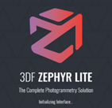 | 3DFLOW  https://www.3dflow.net/ | To generate a 3D model, using multiple photographs (more than 50).
3DF Zephyr   | 3DFLOW  https://www.3dflow.net/ | To clean and refine sparse point cloud, dense mesh cloud, mesh and textured mesh of 3D models.
ZBrush   | Pixologic Inc  https://pixologic.com/ | Retopology, Method 1:  To convert a high dense mesh with a high polycount into low poly meshes using the software retopology tools and create UVs to apply the textures onto the low poly version and create normal maps.
Blender   | Blender Foundation  https://www.blender.org/about/foundation/ | This software was used to create UVs to apply texture and baking.
Instant Meshes   | Interactive Geometry Lab  https://igl.ethz.ch/ | Retopology, Method 2: To generate an automatic clean mesh of the original model, with a reduced poly count, while preserving the high details.
Canva  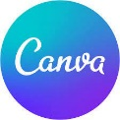 | Canva Pty Ltd  https://www.canva.com/ | To design a recipe book and edit raw videos captured from my android mobile device.
Epidemic Sound   | Epidemic Sound  https://www.epidemicsound.com/music/featured/ | Copyright © Epidemic Sound, 2022  To access royalty-free soundtracks to add to YouTube videos and Unity.
Clideo   | Softo  https://softo.co/ | To speed up video clips taken from the Samsung android mobile device.
Procreate   | Savage Interactive  https://savage.si/ | To create illustrations of the brain, lungs and intestines. This application was useful as it contains many artistic tools and is compatible with the iPad Pro, 4th generation and iPad pencil.
YouTube   | Google LLC  https://about.google/ | To share recipes with the public and to view additional comments and feedback from the wider public.

Type | Asset | Copyright &Link
Audio Source  Epidemic Sound   | Soundtracks imported into Unity:  ES_Anyone_Maiwan  ES_Backyard Stories-Sum Wave  ES_Be Mine for a While- Blue Topaz  ES_Into the distance – Guustavv  ES_ Oat City-Sarah the illustrumentalist  ES_Round on Me_Just normal  ES_Summer Forever_Sum Wave  Soundtracks for YouTube Videos:  HOW TO MAKE A LUNG CAKE  https://www.youtube.com/watch?v=6e6NUtpij_A  HOW TO MAKE CINNAMON ROLL INTESTINES  https://www.youtube.com/watch?v=J7cge0OO7wk  HOW TO MAKE A BRAIN CAKE  https://www.youtube.com/watch?v=_9-EjPTbMQo  ES_Up & Down - Toby Tranter  ES_Your Vibe - Yomoti  ES_TNT_BLUE STEEL  ES_Tell Me Again What I'm Missing - Oomiee  ES_Should We Not - Jerry Lacey  ES_Wake Up in the Morning (Instrumental version) – Siine  ES_Intertwined (Instrumental version) -Ray  ES_What About Trust_ (Instrumental Version)-Mindme  ES_Purpose of Love (Instrumental Version) - Eden Maze  ES_Bother Me - Hallman  Es_Instinct - STRLIGHT  ES_Comes Back Around (Instrumental) - Mindme | Copyright © Epidemic Sound, 2022  https://www.epidemicsound.com/music/featured/
3D Model | 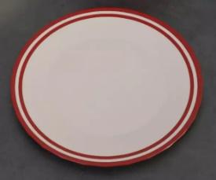  Plate01 in file ‘Mugs, Bowls and Plates’ | ROBOT SKELETONS  https://assetstore.unity.com/publishers/40977
Fonts | Alphabetized cassette tapes:  Maybury Demo Regular:  The Philip Deno Regular: | https://www.1001fonts.com/
Graphics | 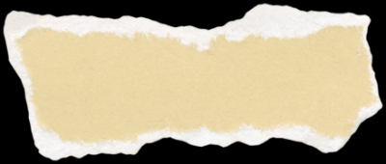  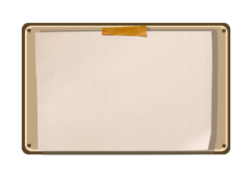  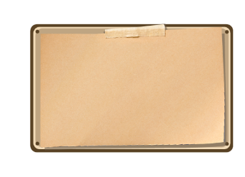       | https://www.freepik.com/
Sprites |    | GSA Logo:  From Dr Matthieu Poyade  UoG Logo: https://www.gla.ac.uk/myglasgow/staff/brandtoolkit/brandelements/logo/
Scripts | Rotate with UI Button  Scale with UI Button  Change Scenes with UI Button  Video Playback  Video Controller | https://www.youtube.com/watch?v=1UUb0vzmc0w&ab_channel=DenysGamersTutorial  https://www.youtube.com/watch?v=Js04An85Xh4&ab_channel=DenysGamersTutorial  https://www.youtube.com/watch?v=EMo-MaKkP9s&ab_channel=Hooson  https://www.youtube.com/watch?v=JyNatFqYHK8&ab_channel=CreatinnoTechSolutions  https://www.youtube.com/watch?v=JyNatFqYHK8&ab_channel=CreatinnoTechSolutions

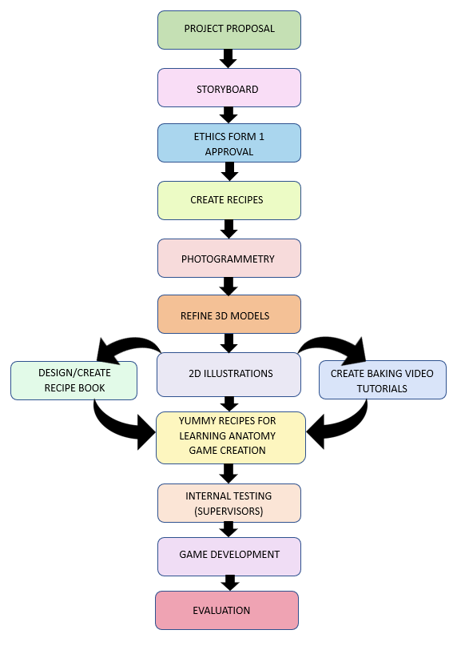

Fig 1: Workflow Diagram


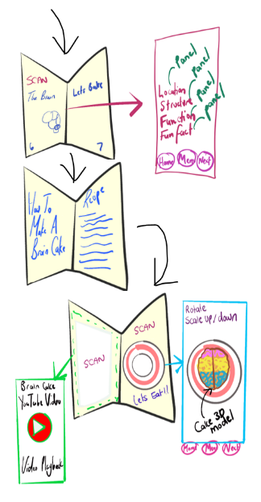
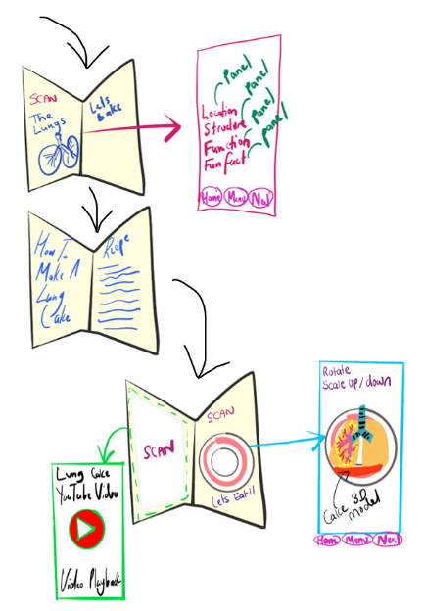
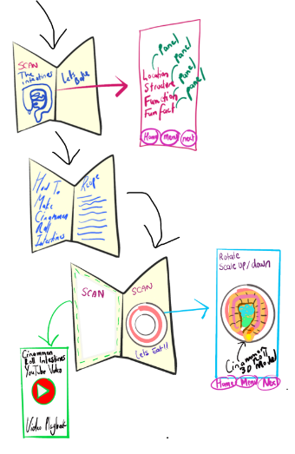
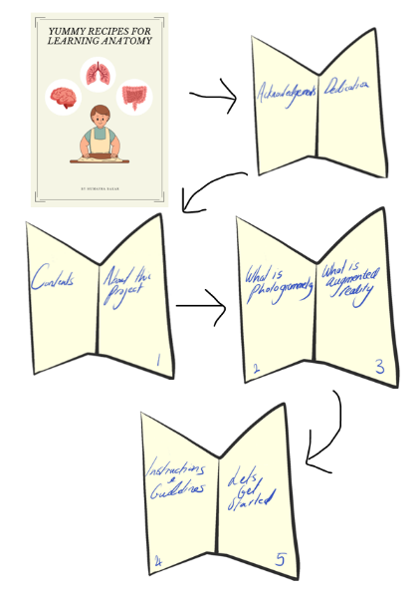

Fig 2: Storyboard

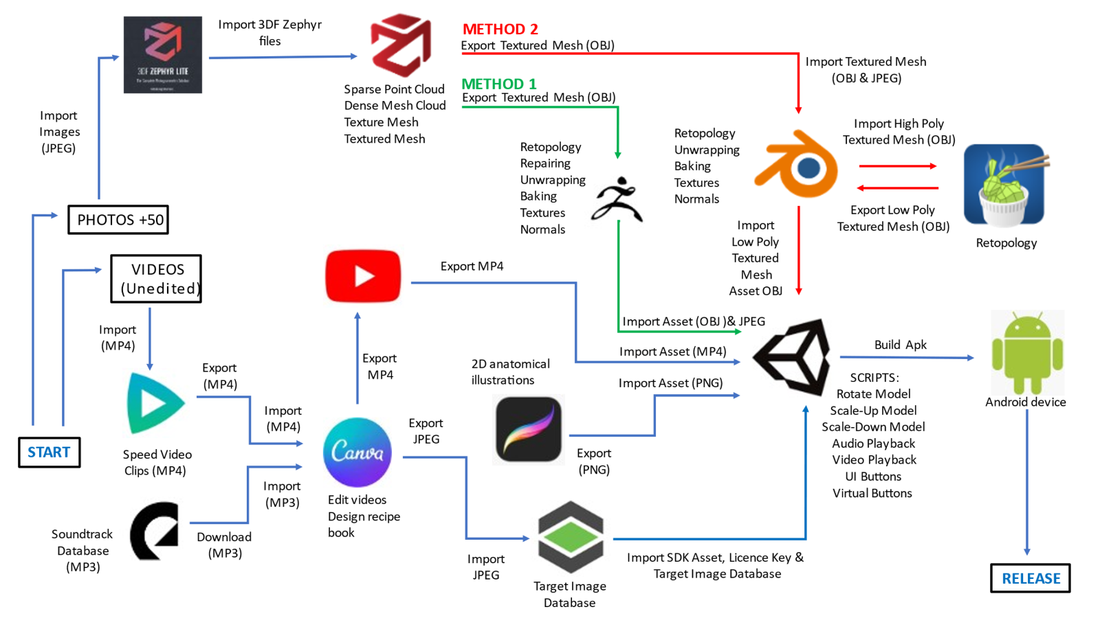

Fig 3: Application Workflow Diagram
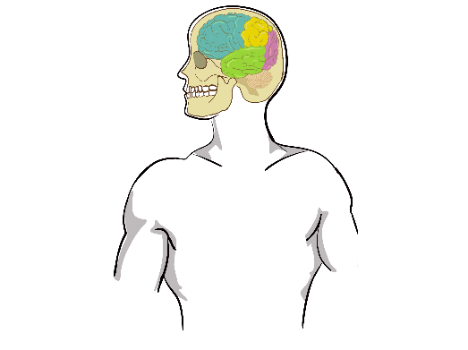
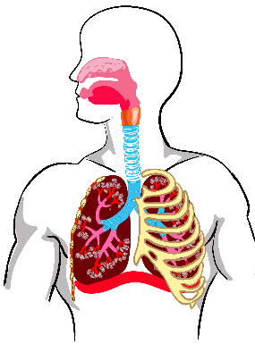
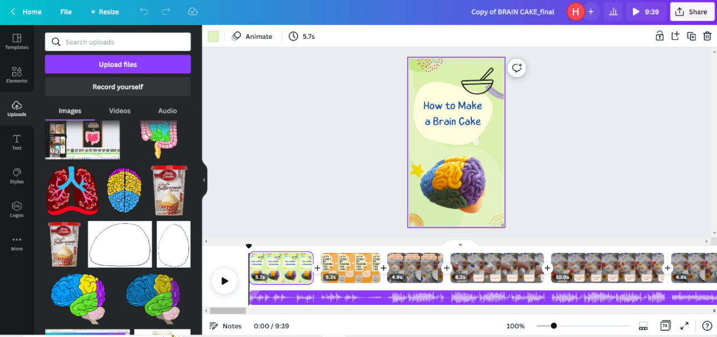

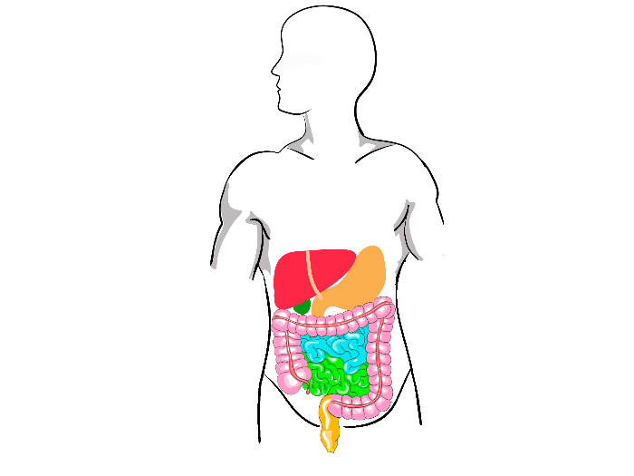

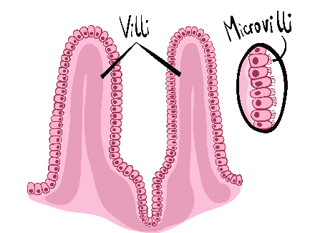

Fig 4: Video editing in Canva

Fig 5: Illustrations created in Procreate

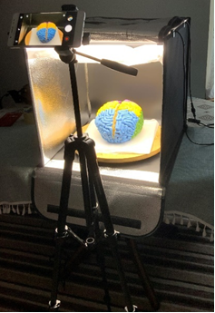

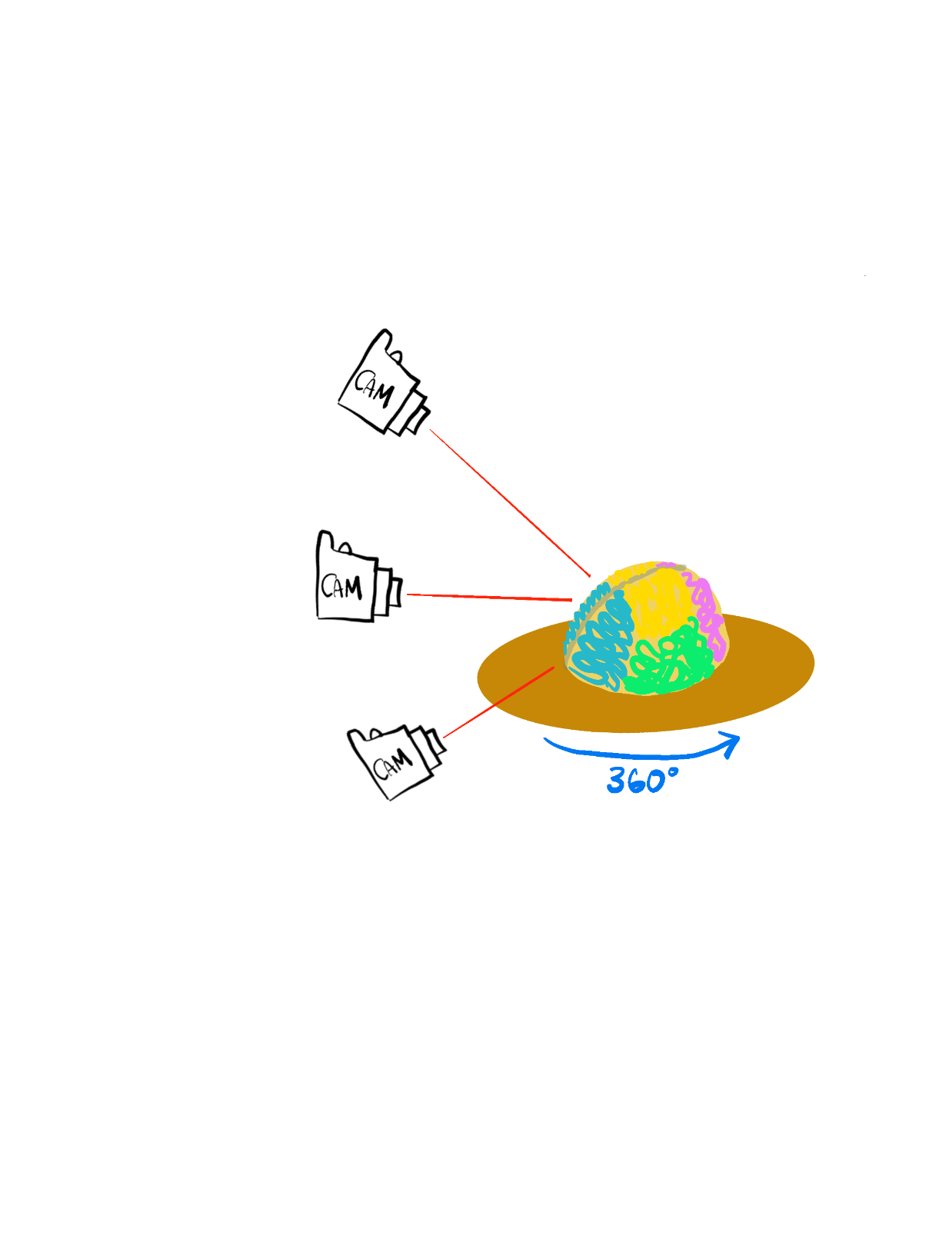

Fig 6: Photogrammetry set-up and shooting technique

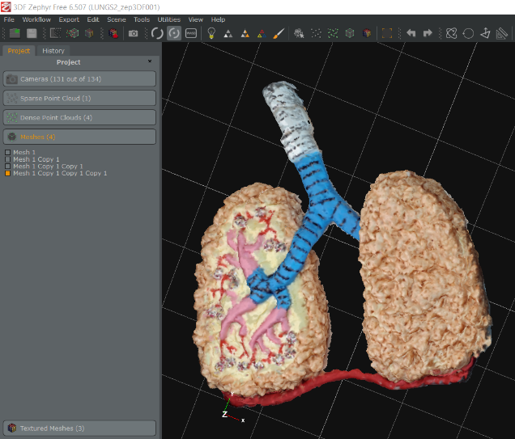
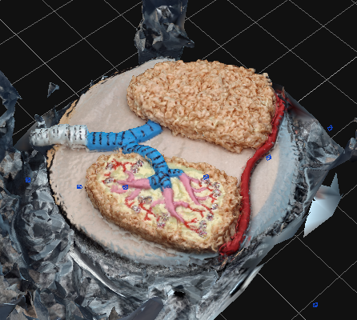
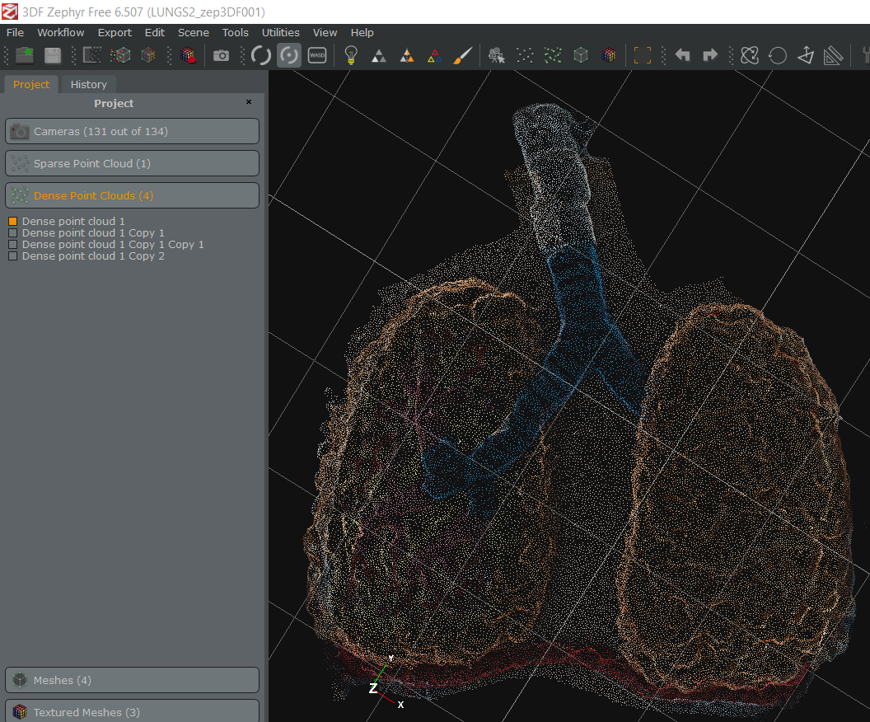

Fig 7: Dense point cloud of lung cake Fig 8: Mesh of Lung cake before (left) and after (right) using the lasso tool

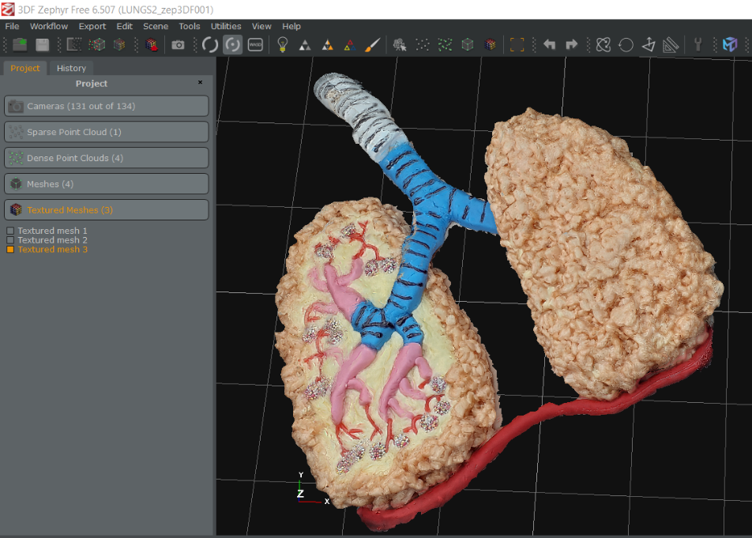
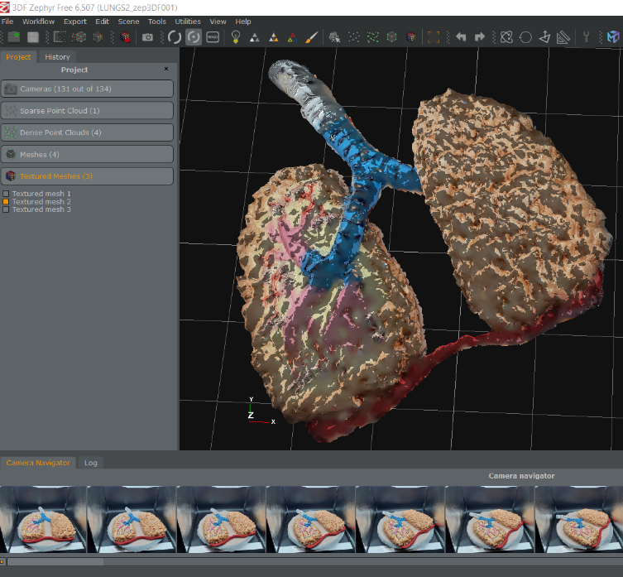

Fig 9: Low poly textured mesh (left) and high detail textured mesh (right)

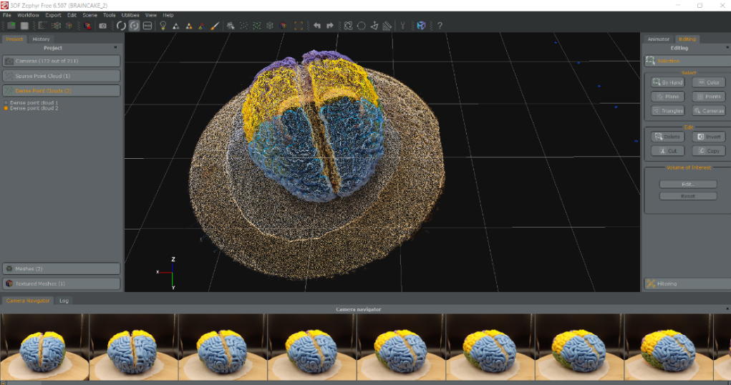
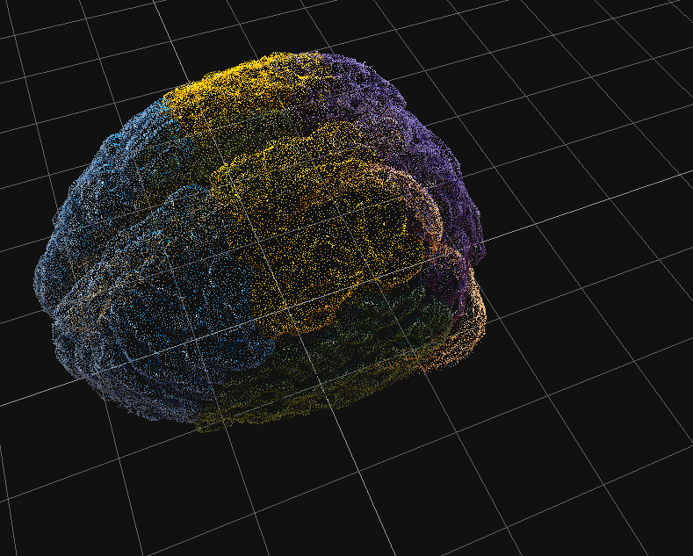

Fig 10: Dense point cloud of brain cake

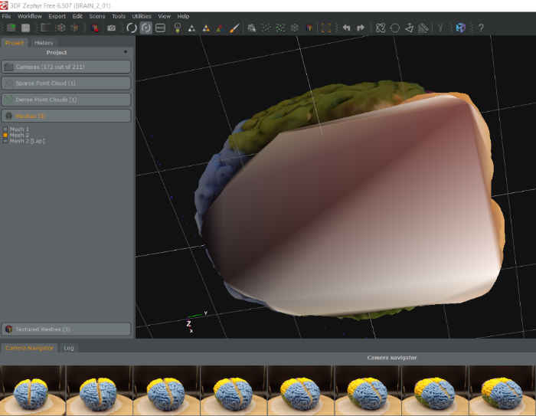
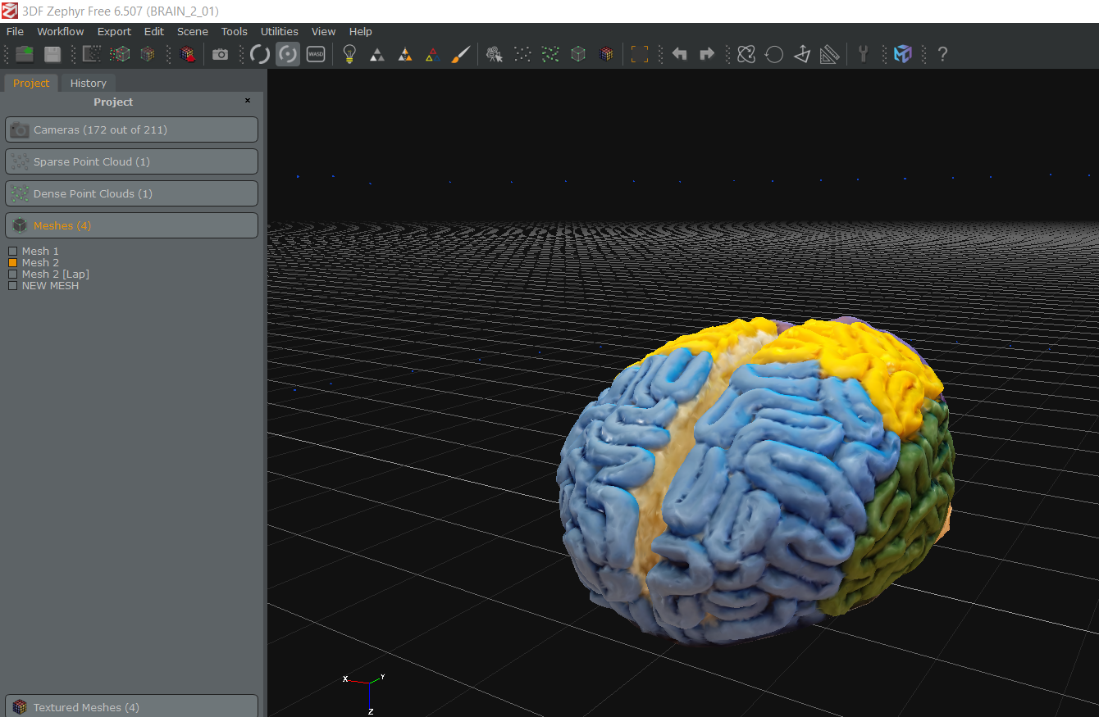

Fig 11: Mesh output of the brain cake after using the lasso tool and fill holes tool

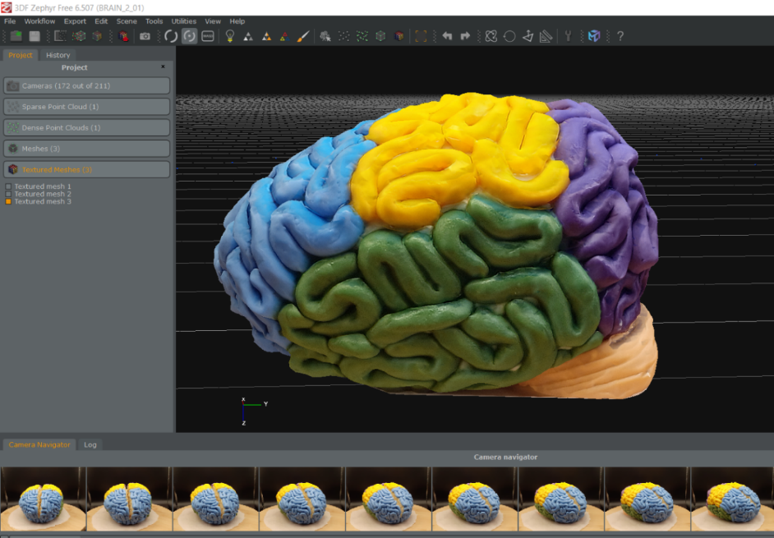
Fig 12: Textured mesh of brain cake

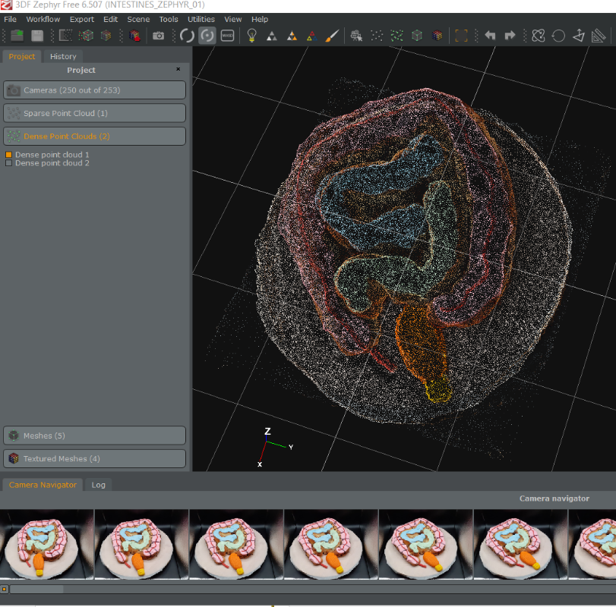
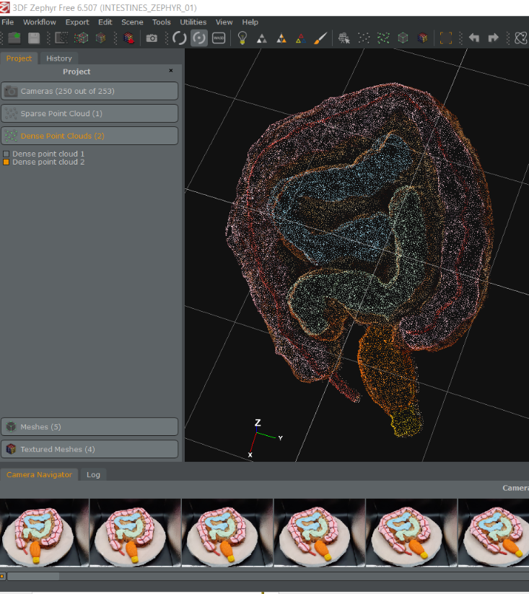

Fig 13: Dense point cloud of intestines cinnamon roll before editing (left) and after editing using lasso tool (right)

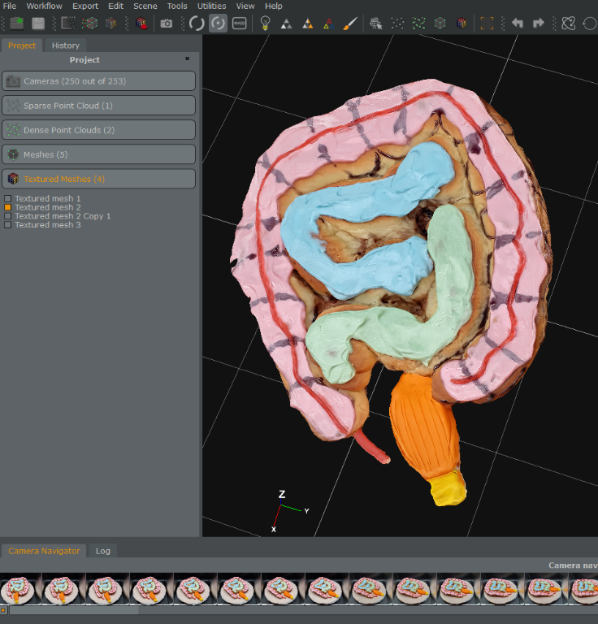
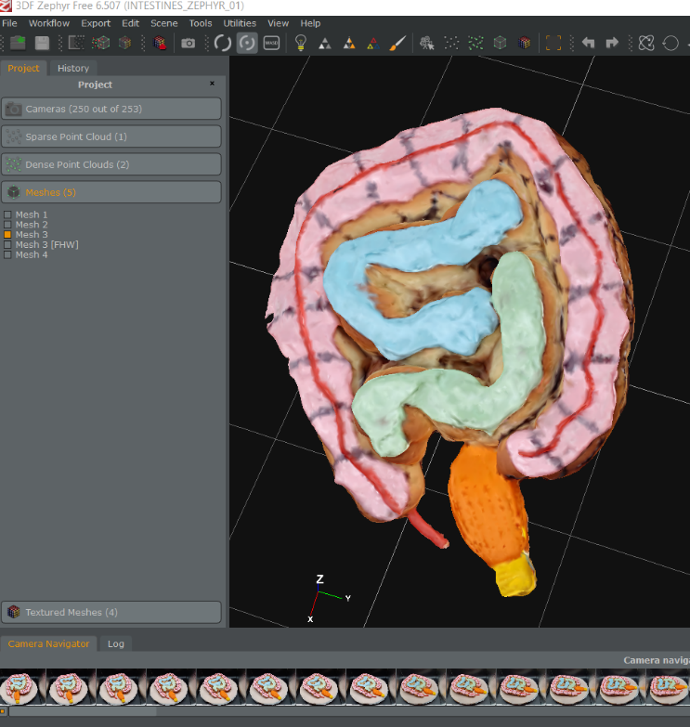

Fig 14: Mesh (left) and textured mesh (right) of intestines cinnamon roll

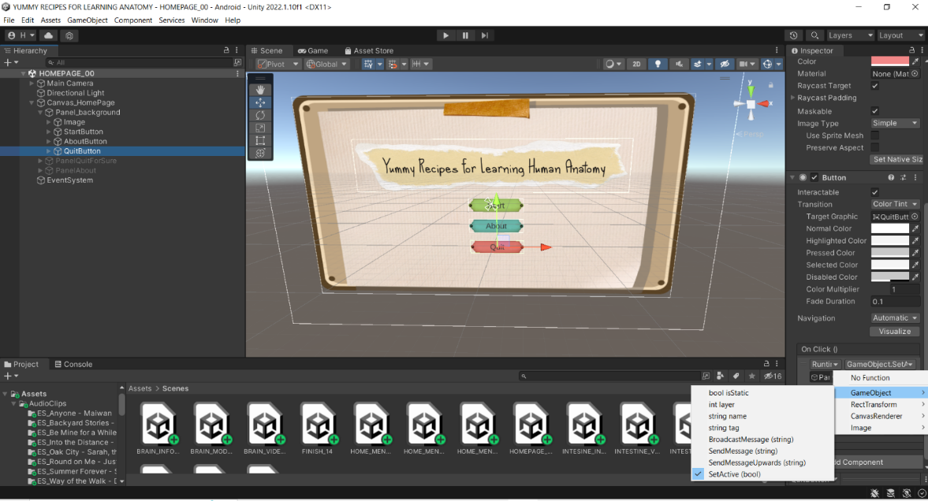

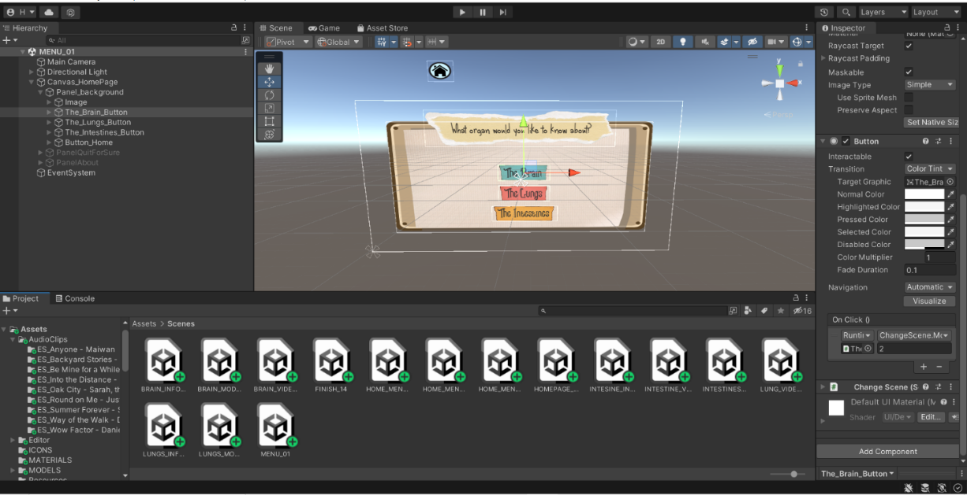

Fig 15: Homepage scene and menu page of app created in Unity
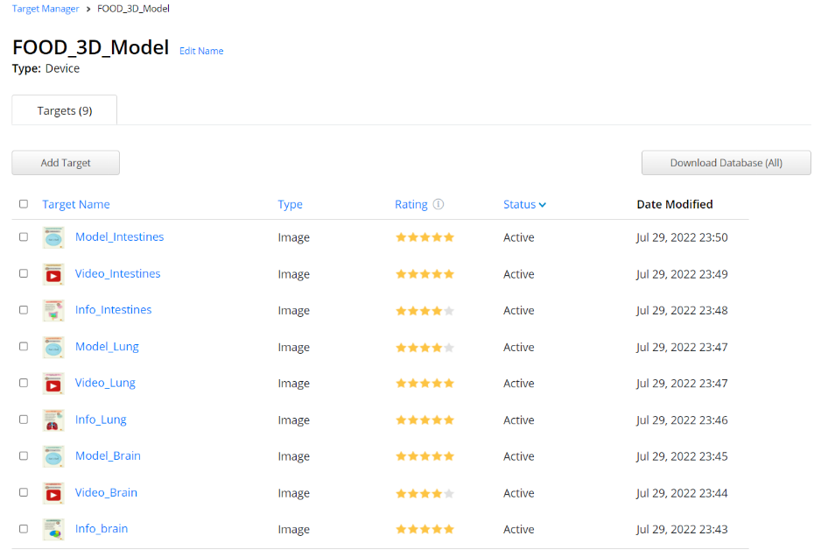

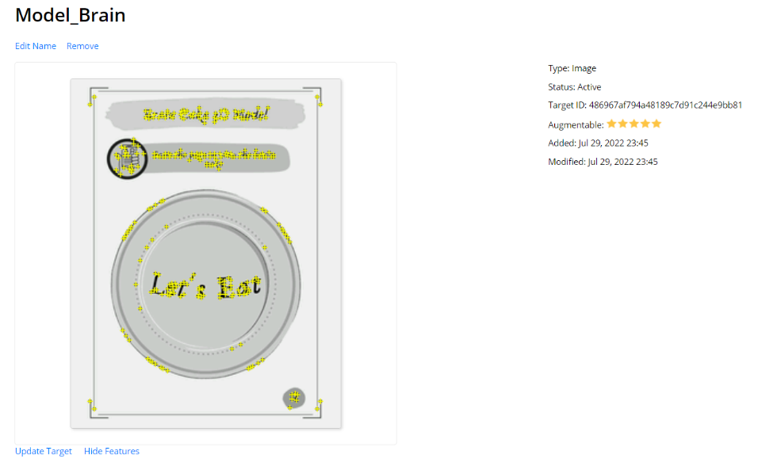

Fig 16: Image targets in Vuforia, displaying quality of images and digital markers

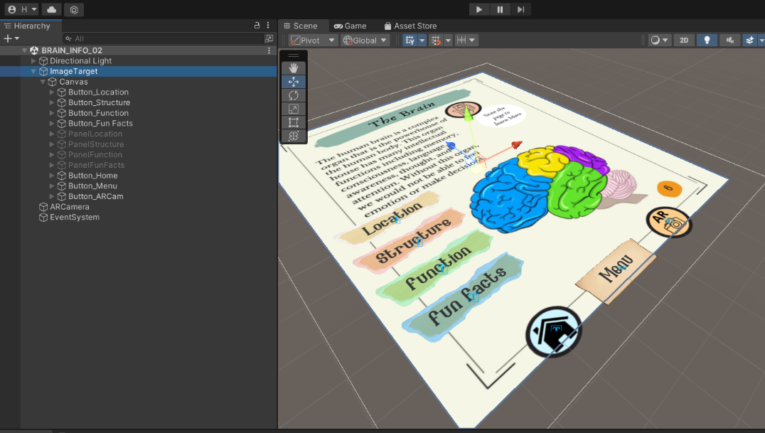

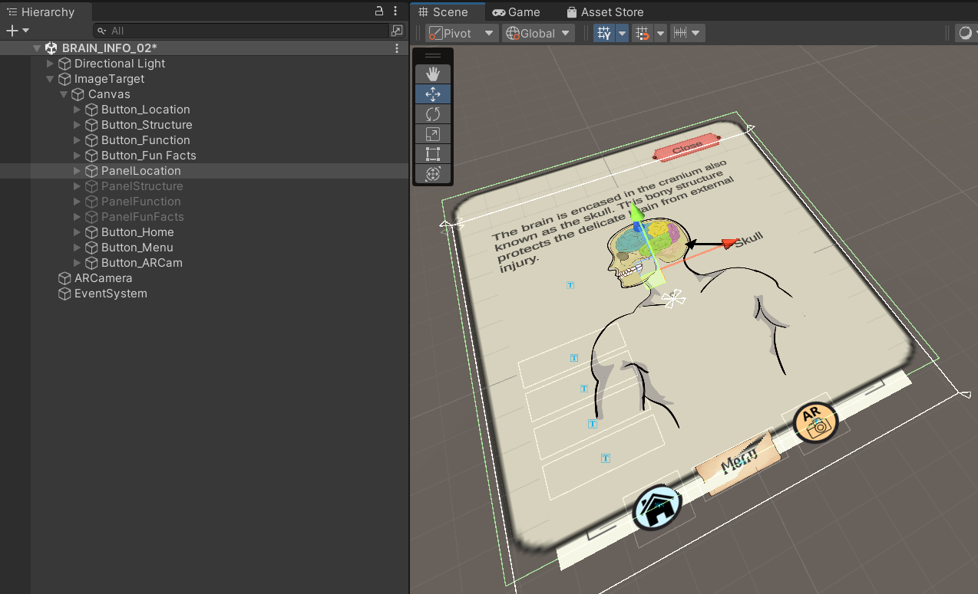

Fig 17: AR content created over image targets in Unity

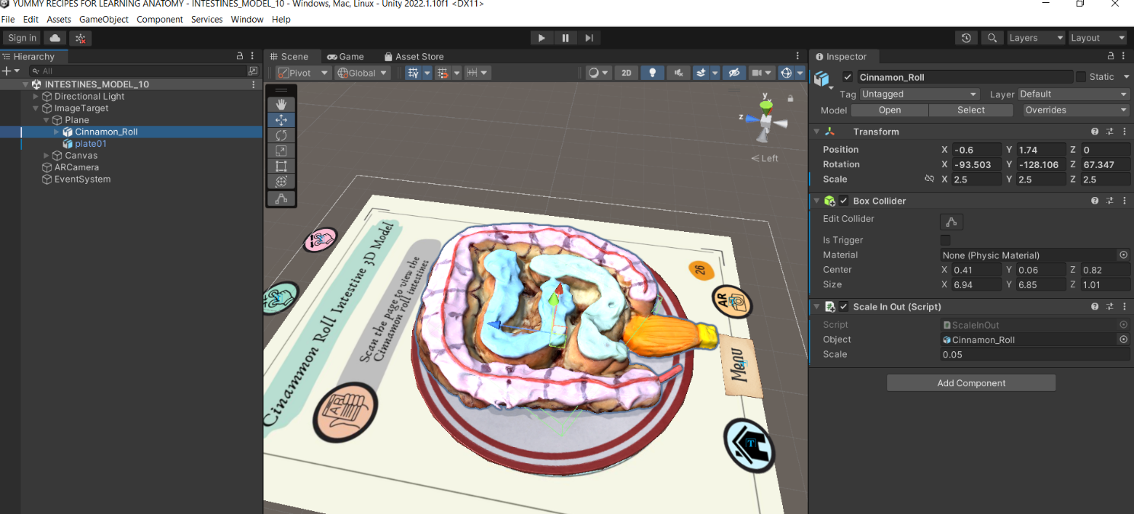
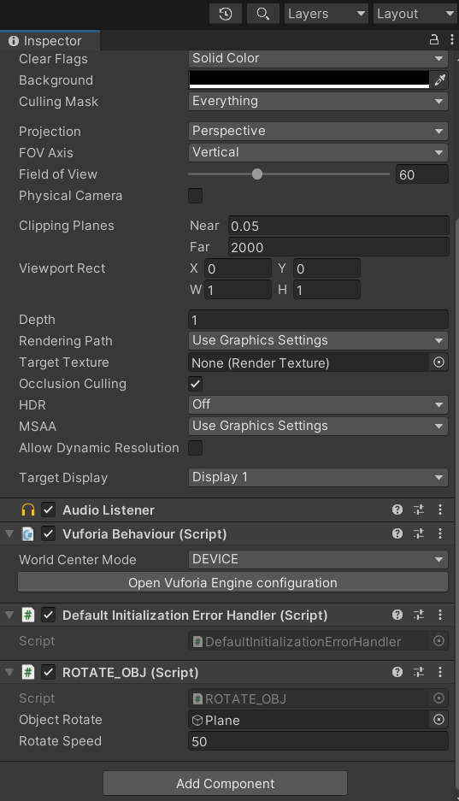

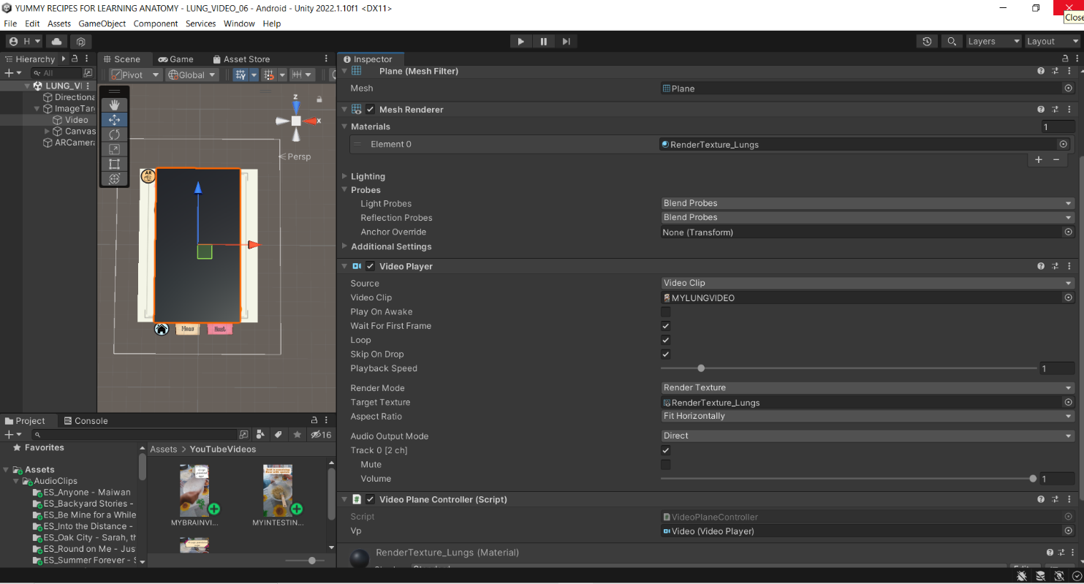
Fig 18: Food model attached with a box collider and scripts as shown on the inspector module

Fig 19: Video clip settings in Unity

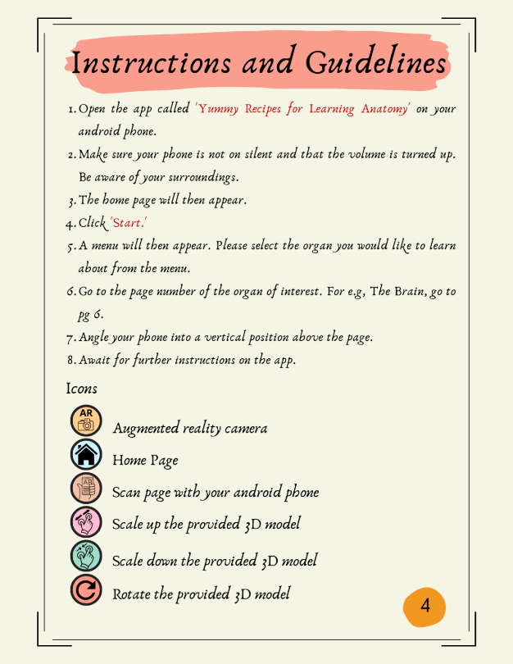
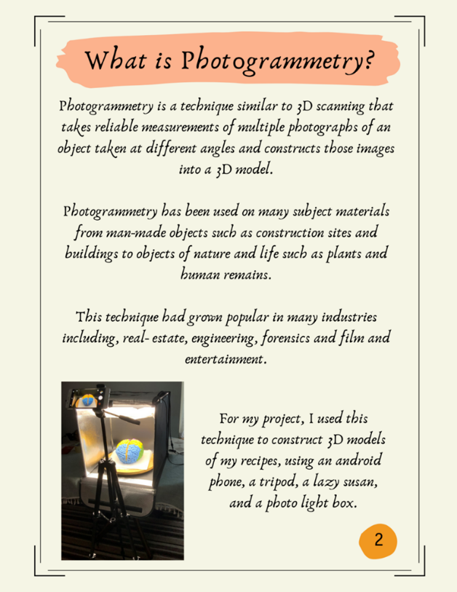
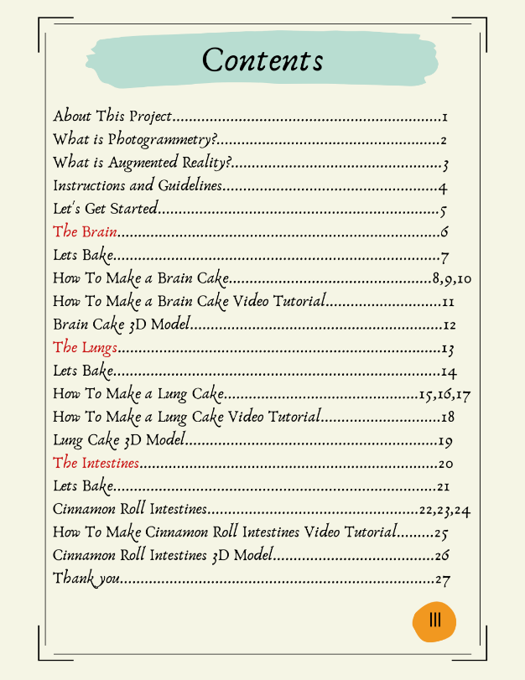
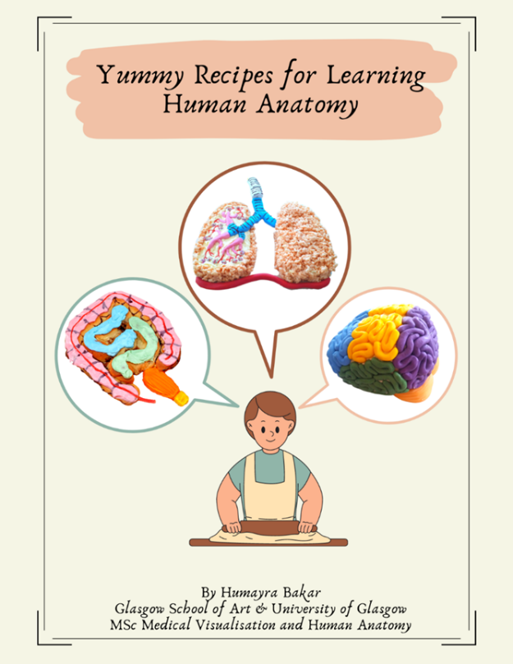
Fig 20: Pages of the recipe book

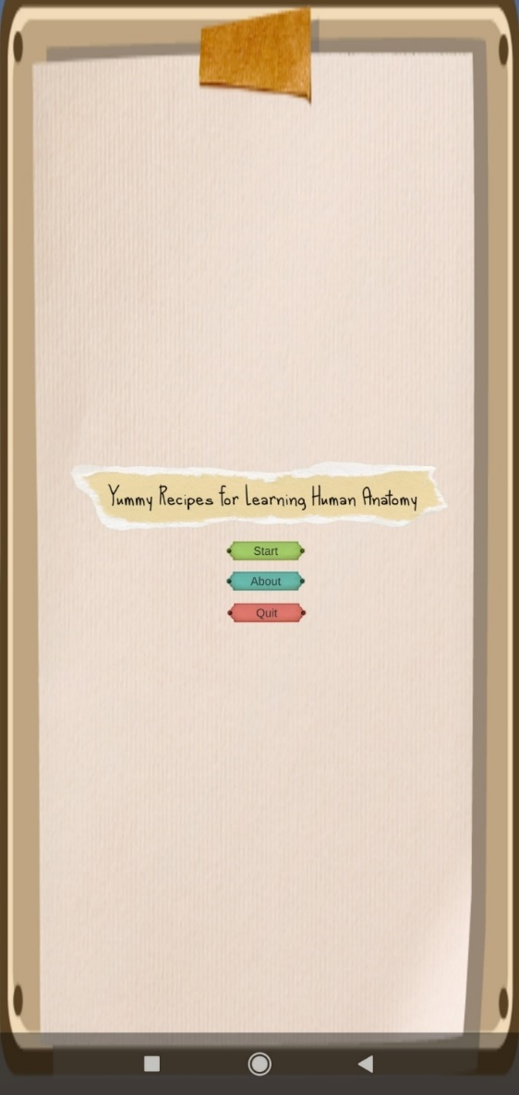
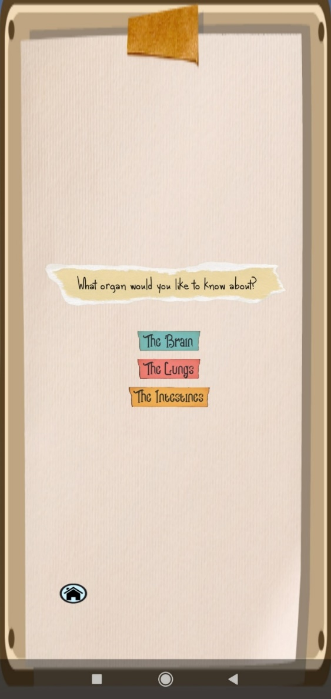

Fig 21: Homepage and main menu of the AR app

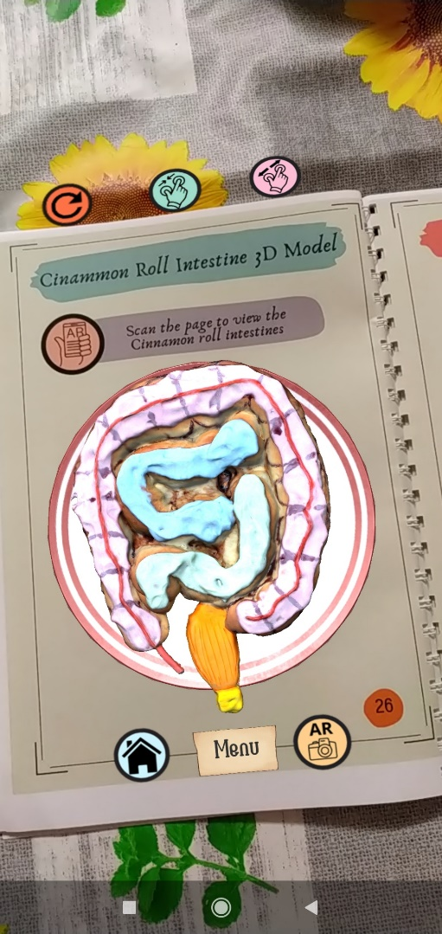
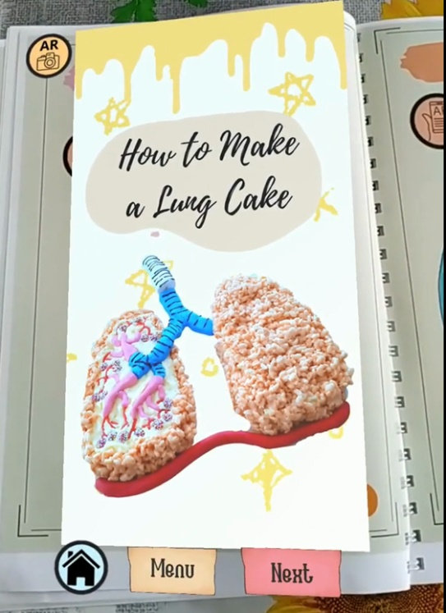
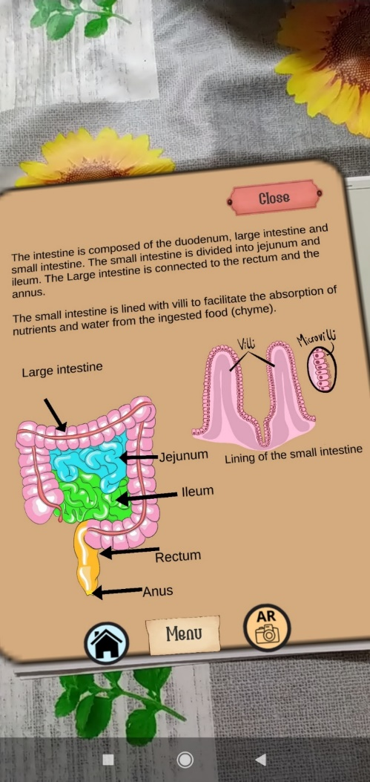
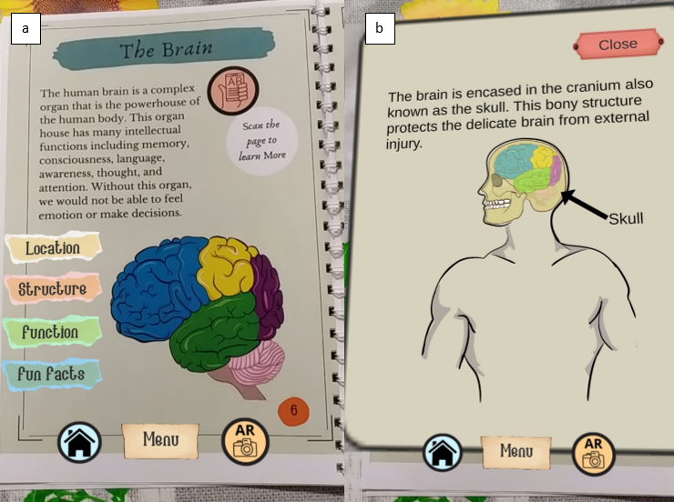
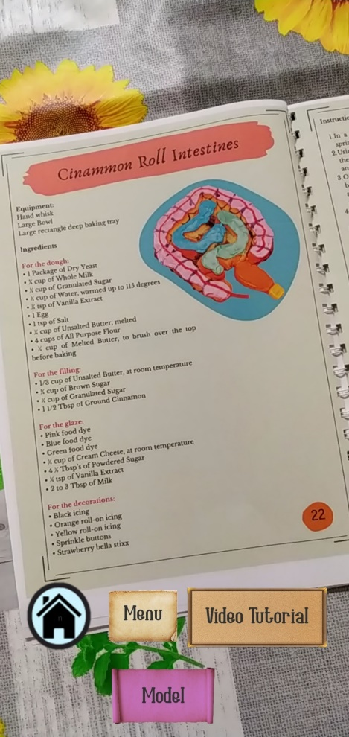
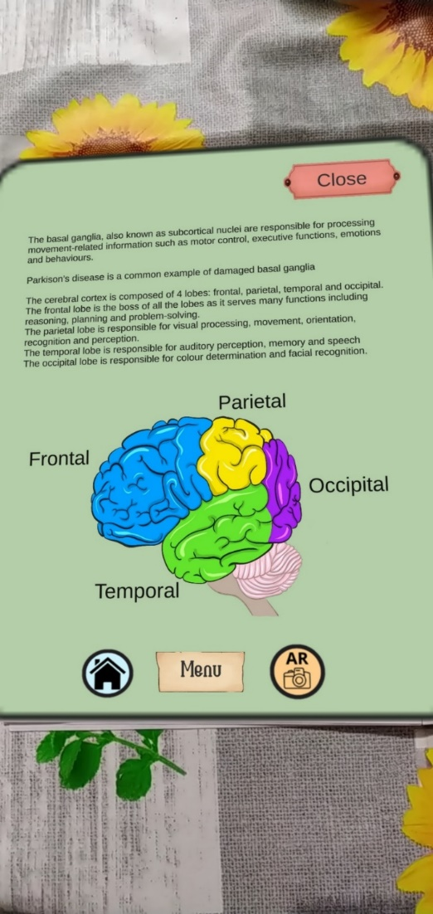

Fig 22: AR content displayed over image targets in the real world through the app which includes subtopics of each organ, video tutorials and 3D interactive food models

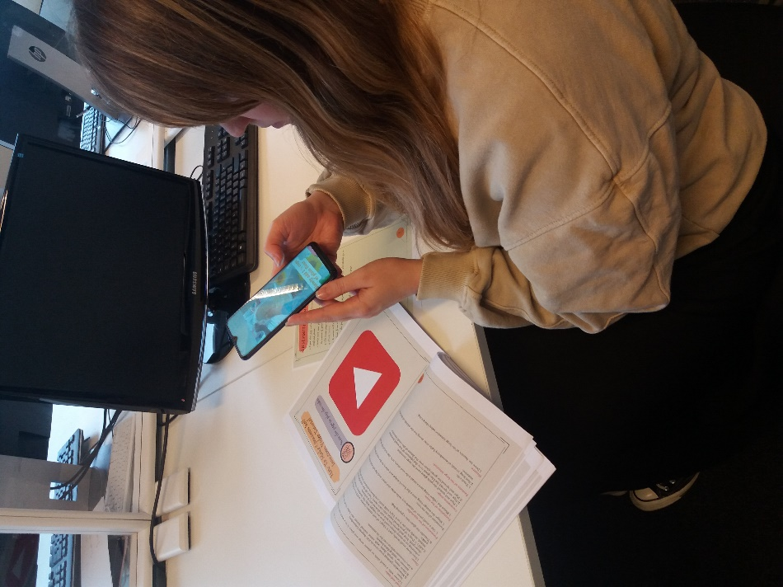

Fig 23: Experimental set-up

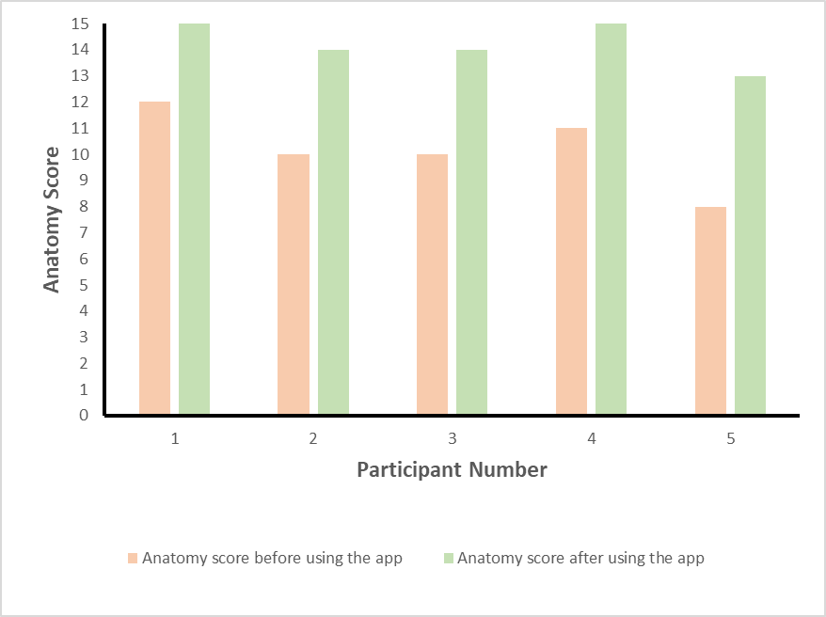

Fig 24: Anatomical knowledge questionnaire results

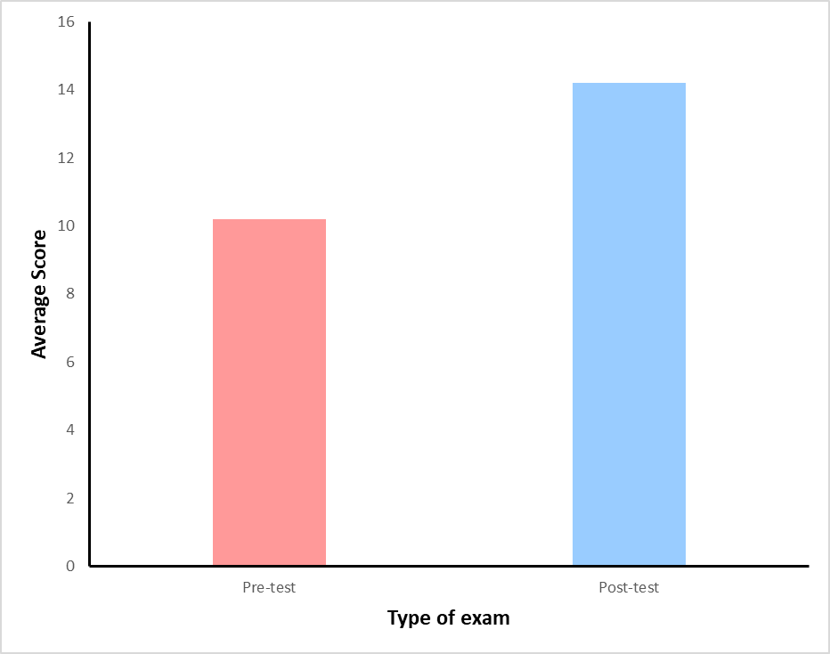
Fig 25: Average Anatomical knowledge questionnaire results

Participant ID | SUS1 | SUS2 | SUS3 | SUS4 | SUS5 | SUS6 | SUS7 | SUS8 | SUS9 | SUS10 | X | Y | X0 | Y0 | SUS | Grade | Average SUS | Grade
P1 | 4 | 2 | 4 | 3 | 4 | 2 | 5 | 2 | 3 | 3 | 19 | 12 | 15 | 13 | 70 | B | 70.5 | B
P2 | 4 | 2 | 4 | 3 | 4 | 2 | 4 | 2 | 4 | 1 | 20 | 10 | 15 | 15 | 75 | B
P3 | 3 | 3 | 4 | 1 | 4 | 2 | 4 | 3 | 4 | 1 | 19 | 10 | 14 | 15 | 72.5 | B
P4 | 3 | 2 | 4 | 2 | 4 | 2 | 4 | 2 | 4 | 2 | 19 | 10 | 14 | 15 | 72.5 | B
P5 | 3 | 2 | 3 | 2 | 4 | 3 | 4 | 3 | 3 | 2 | 17 | 12 | 12 | 13 | 62.5 | D
Table 1.3: Participant SUS Scores and Grade SUS
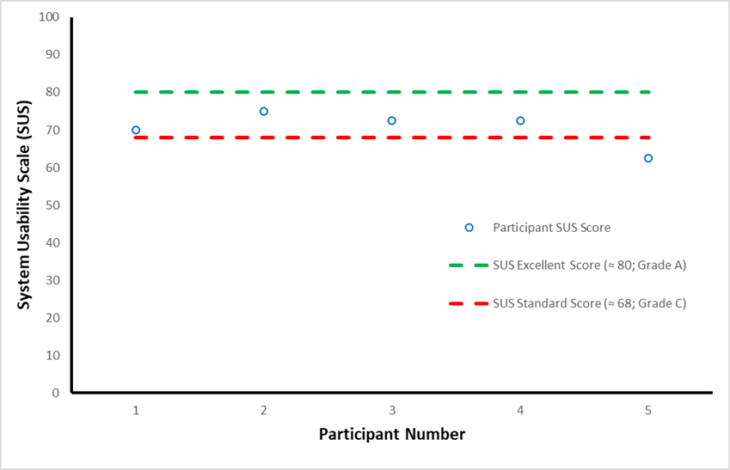

Fig 26: AR system usability scores
Participant ID | IMMS_1 (ATT) | IMMS_2 (ATT) | IMMS_3 (REL) | IMMS_4 (REL) | IMMS_5 (REL) | IMMS_6 (CON) | IMMS_7 (CON) | IMMS_8 (SAT) | IMMS_9 (SAT) | IMMS_10 (SAT) | Total
P1 | 4 | 4 | 4 | 4 | 4 | 4 | 4 | 4 | 4 | 4 | 40
P2 | 4 | 4 | 3 | 5 | 5 | 5 | 5 | 5 | 5 | 4 | 45
P3 | 5 | 4 | 3 | 5 | 5 | 5 | 4 | 3 | 4 | 4 | 42
P4 | 5 | 4 | 4 | 5 | 5 | 4 | 5 | 3 | 4 | 5 | 44
P5 | 3 | 4 | 4 | 4 | 4 | 4 | 4 | 3 | 4 | 5 | 39
Variances | 0.7 | 0 | 0.3 | 0.3 | 0.3 | 0.3 | 0.3 | 0.8 | 0.2 | 0.3 | 6.5
Table 1.4: IMMS (ARCS) Survey Scores

Table 1.5: IMMS (ARCS) Average Survey Scores
 | ATTENTION | RELEVANCE | CONFIDENCE | SATISFACTION | TOTAL MOTIVATION
Mean | 4.1 | 4.27 | 4.4 | 4.07 | 4.21
SD | 0.59 | 0.55 | 0.55 | 0.66 | 0.59

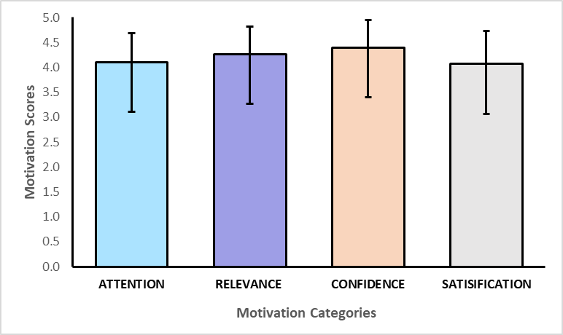
Fig 27: AR system usability scores

