DOUBLE-TAKE
Forgery and fraud in vitreous enamel.

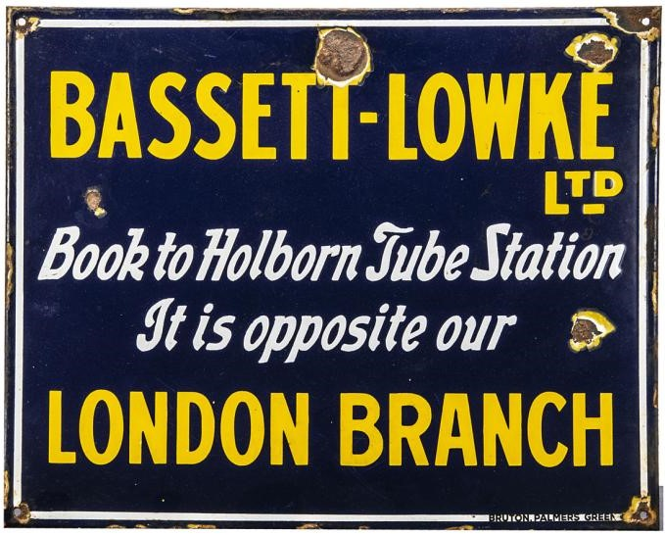
Fraudulent enamel sign, c2021, purporting to be issued by Bassett-Lowke Ltd and made by Bruton & Co in the inter-war period. It is based on a tin-printed miniature. Sold as Lot 708, Special Action Services, 14 Dec 2012:
A rare early 20th Century full-size original Bassett-Lowke enamel Advertising Sign, measuring approx 20" x 16" and manufactured by Bruton of Palmers Green, the legend in yellow and white on deep blue ground, presumably from a London area railway station, G-VG, several chips to front face and edges but most are clear of the wording, some rust spotting to rear.
Estimate: £300 - £400. Winning bid: £380 (9 bids)
To many, forgery and fraud is something associated with fine art and antiquities, or fiscal instruments, but this paper looks at somewhere it flourishes and is ever-expanding, unchecked by any authorities, the world of vitreous enamel signs. Enamel signs have been collected since the 1960s, when their currency diminished and their use had very visibly contracted, particularly in advertising. As ‘collectors’ items’ their popularity has risen, fallen and, at present, is at a high again. Much of the original collector interest in them was based on a principle of ‘they don’t make them like that any more’. How wrong that was.

This paper plots the rise of the fraudulent enamel. From reproduction to forgery. It looks at the cultural context enamel signs occupy, how it encouraged the rise of the fraud, the technologies employed, and the implications of thousands of forgeries entering the market. Historically interesting? Certainly. Amusing? Probably. Ethically acceptable…?

----------------------------------------------------------------------------------------------------------------

Nicholas Oddy is Head of Design History & Theory at Glasgow School of Art. He is an inveterate collector of objects of low cultural capital, has written widely on them for both academic and collector-enthusiast audiences, acted as consultant to a number of major auction houses for ‘collectors’ items’ and currently edits The Train Collector magazine.

DOUBLE TAKE

Old enamel signs began to attract collectors in the 1960s. As with many new ‘collectibles’ at this time, collectors responded to rapid loss as urban environments were rebuilt and a wave of popular modernism deemed almost all old things of their kind ‘junk’. Many early collectors saw themselves on a rescue mission, acquiring items from site for little or nothing. However, trading between them was a different matter, like many other collectibles monetary value structures were quick to develop amongst those ‘in the know’. The publication of Andrew Baglee and Andrew Morley Street Jewellery in 1978 consolidated enamel sign collecting as something worthy of publication, while this and later publications drew in many new collectors who were more far more reliant on purchasing in the secondary market than the first generation had been, further expanding it and more clearly defining value structures.
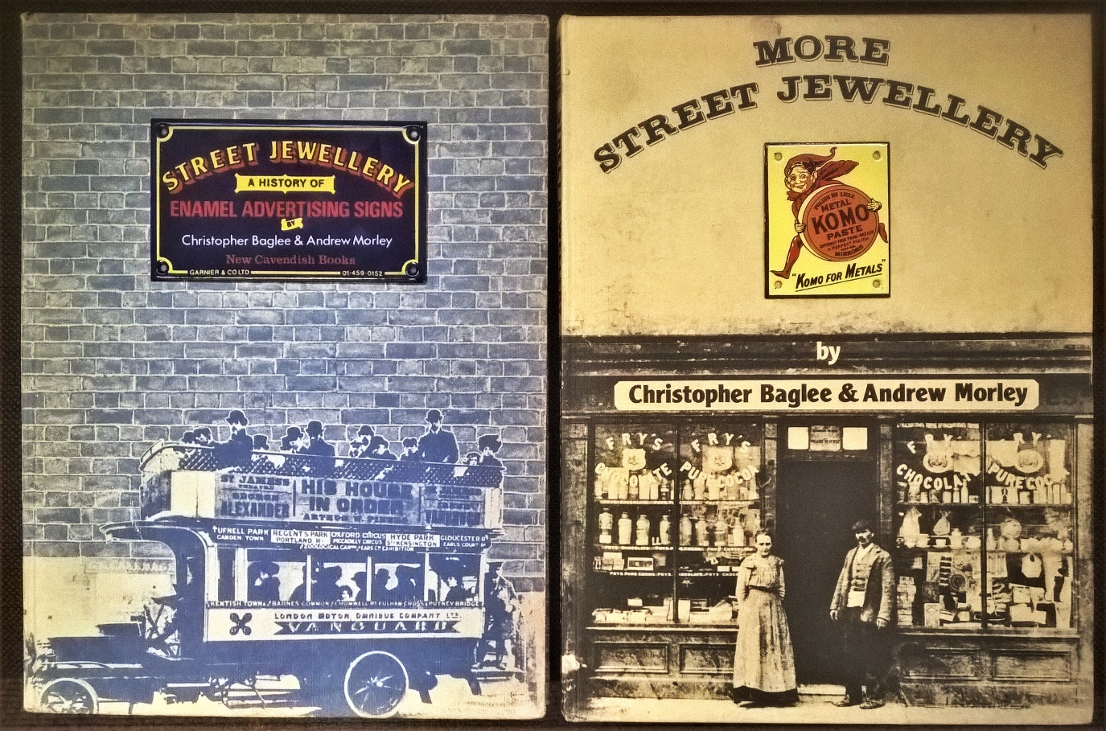
Andrew Baglee and Andrew Morley Street Jewellery (1978) and More Street Jewellery (1988) published by New Cavendish (London).
They went on to publish The Art of Street Jewellery, again through New Cavendish, in 2006. (The miniature signs are by Garnier).

This period began to see the production of reproduction and retro-styled enamel signs for those who liked the look, but did not want the vagaries, of dealing with originals. A key player here was Elizabeth Farrell’s ‘Dodo Design’ working out of Westbourne Grove in London. As well as commissioning a number of signs from Garnier & Co, one of the few sign makers to weather the contraction of the business in the 1950s and 60s, Dodo set up their own manufacturing business. Dodo’s signs were different from the originals in being screen printed, rather than using the more traditional methods of stenciling, bat and hand application, giving a thinner, more precise, but ‘flat’ look, easily differentiated from the originals they mimicked.

This did not stop some dealers from ‘enhancing’ reproduction signs by judicious ‘weathering’ involving hammers, hydrochloric acid and leaving in a damp sack for a few weeks, before claiming them to be originals. But, the actual making technique was against them. The term ‘they don’t make them like they used to’ could be truly applied to this time.

Hand round Dodo OXO and STUDIO CIGARETTES
The Dodo OXO has all the feel of screen printing, flat and precise; it is on steel with a blue-black ground coat. As with many reproductions it is relatively small, a nice ‘domestic’ size that can easily fit in a kitchen (the favoured room for display). Original advertising signs tend to be larger; so, small ones carry a premium per superficial foot because of their domestic size and are often dearer than their larger brethren. This is advantageous to fraudsters. Studio Cigarettes is similarly small. I would be unsurprised to see such a sign sell for £300; while a similar one, but larger, sell for £200. Early 20th century, its ground coat tells us it is later than it looks, early steel, probably 1920s or even into the ‘30s. The thick application of red enamel is by stencil (the sharp eye will detect the divisions) and very difficult to achieve by screen print.
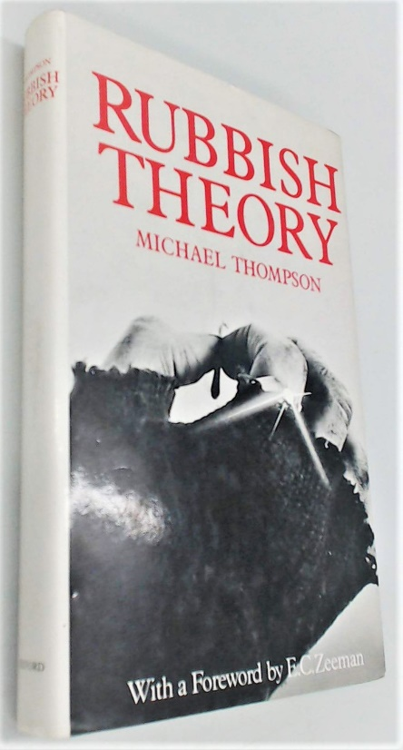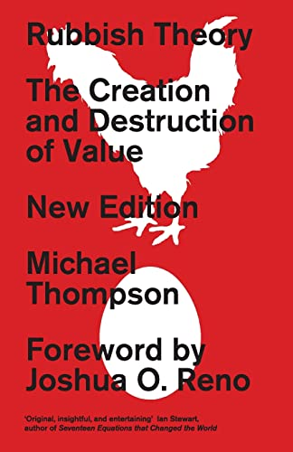
Michael Thompson: Rubbish Theory 1979, 2nd Edition with Afterword, Pluto, 2017.

In 1979 Michael Thompson published his seminal Rubbish Theory in an effort to understand the way in which everyday things went through a cycle of ‘transience’ after their first currency, losing value, before being deemed ‘rubbish’, whereupon some began to move upwards in cultural capital, to finally be seen as ‘durable’ through having antique value. Thompson was interested in the processes of what made something move into the durable category. Anecdotally, I remember inviting the Marketing Director of Beamish Museum to give a lecture in 1990 where he bemoaned that many of the items on display, such as enamel signs, which he specifically quoted, were no longer ‘bygones’ rescued from the skip and which could be appreciated as such by social groups C2/C1 (the museum’s intended audience), but now had moved into being ‘antiques’ appreciated by social groups B2/B1, distanced from the intended audience by their increasing age, and, equally importantly, their monetary value. This was a magnificent vindication of Thompson’s work.

However, what Thompson had not considered was market saturation and generational shift. Like many ‘collectors’ items’ at this time, the market for enamel signs were largely supported by nostalgia in an ageing demographic. During the 1990s the market shrank as collectors began to die or become inactive, values for many fell. Some collectors’ items began to slip toward being ‘rubbish’ once again. Enamel signs, though, have come out the other side of this stronger than ever. First, they appealed to ‘hipster’ interior design in the early 2000s, their decorative quality continues to appeal and as ‘decorator’ items they are assessed on values different from traditional definitive collecting. Here a nicely weathered sign can be seen as beautiful, rather than just ‘poor condition’. There is also a strong demand for ‘mid-century modern; also allied to fashion trends.

Hand round SPRATTS fraud and real
Here are original and weathered reproduction SPRATTS signs. The original series dates from the 1950s and, ironically, is screen printed, while the reproduction is stenciled, with thick enamel and far less precise. The accuracy to the original is further compromised by the reference number at the lower right. However, this is all with the benefit of having the original in front of you and being ‘in the know’. To most there is nothing about this sign that would be questionable. The most common is the dog version, here. In the condition of this one it is worth about £400 in the current market. There are also cat, bird and fish versions. The cat version carries a significant premium because of the legend. An original in this state would likely be double that of a similar dog version, or more.

But, the strongest areas are those where signs are allied to other collectibles, particularly transport, where high cash value is a norm and collecting is still largely dominated by traditional definitive values. It is here that forgeries abound, but also where connoisseurship of the originals is strongest.
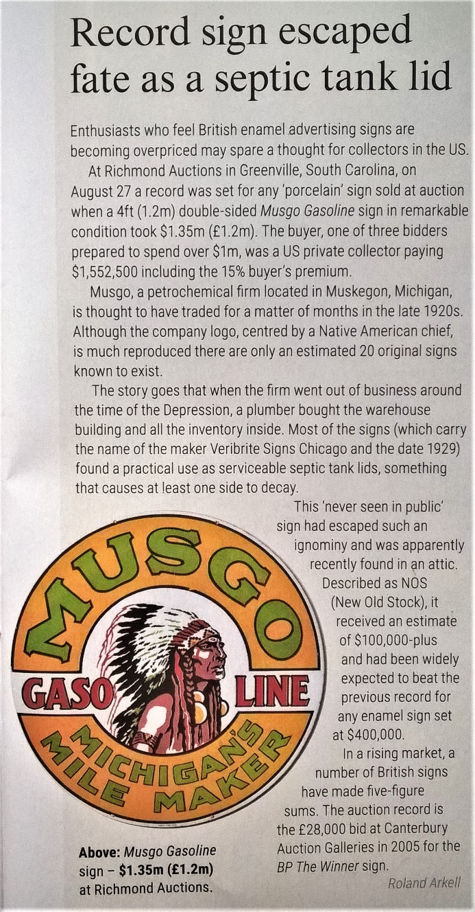
Antiques Trade Gazette No 2563, 15 October 2022 p11.
MUSGO double sided 48 inch roundel, five separations on white, Veribrite, Chicago, 1929. $1,350,000 hammer, Richmond Auctions, Greenville, South Carolina, 27 Aug 2022.

So, with the recent rise of enamel signs, just what sort of price do they command? At the very top end, prices are now moving into the realms of the high decorative arts. Returning to Thompson, we can question just how durable these are; but, I suspect they will serve to encourage forgeries of a high level of verisimilitude. Here, the Antiques Trade Gazette reports a recent sale of a MUSGO Gasoline double-sided 4ft diameter roundel, knocked down for USD 1,350,000 (1,552,500 including commission). Meanwhile, just a week ago a British Railways ‘totem’ CRIANLARICH LOWER fetched £30,000 hammer.
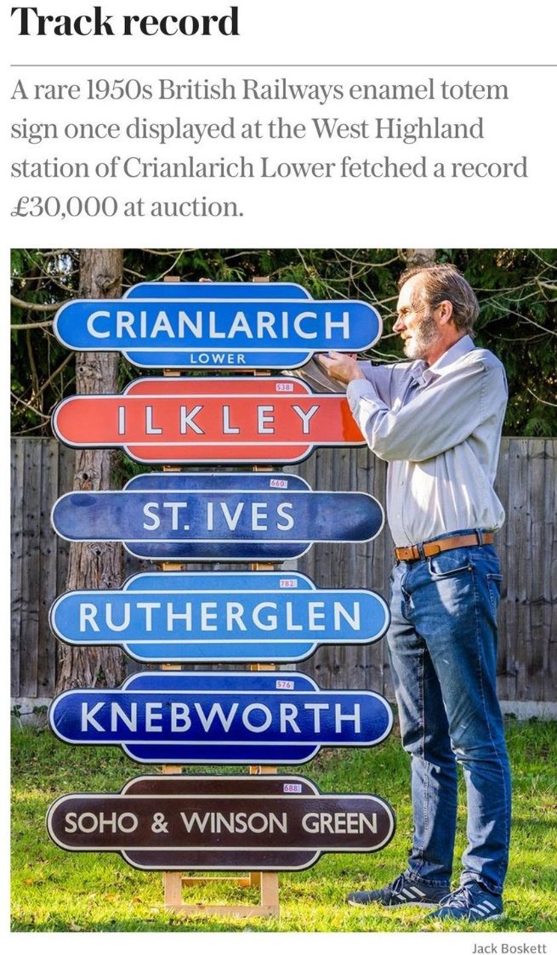
Daily Telegraph 15 November 2022.
Simon Turner with CRIANLARICH LOWER, BR (Scottish Region) totem, single colour on white, 1949-62. £30,000 hammer. Great Western Railwayana Auctions, Pershore,12 Nov 2022. The others were knocked down for 3,400; 2,400; 900; 1,000 and 1,300 respectively.

These may be portents, or exceptions, but ‘good’ signs will sell well into four figures and few are worth less than three. The majority sit in the low to mid hundreds and this is where market activity is greatest. From the point of view of the dishonest, a reproduction sign, presented and sold as an antique one will be a matter of at least £100 and probably a good bit more over what it might achieve as a reproduction, a strong incentive. Why not go for the high flyers when the production cost is the same but the potential profit far greater? The scrutiny applied to a sign at £200 will be less that that applied to one at £1,000 and much less than that applied to one at £10,000. To go for the familiar is also to go for comparative anonymity ‘under the radar’ of serious repercussions. However, as prices rise, it is surely only a matter of time before fraudsters go up-market.

The potential for a convincing forgery has also increased thanks to the development of CAD, since the millennium, which can produce complex adhesive stencils at little cost. These allow a ‘depth’ of each separation by spray, dust or swill application that is so much a part of antique signs, but almost impossible to achieve by screen-print. This has resolved the greatest difference between an antique sign and a modern one. Here, a HUDSONS SOAP sign, ostensibly from 1928, displays a magnificent thickness of enamel, indeed it is too thick; but it makes the point.
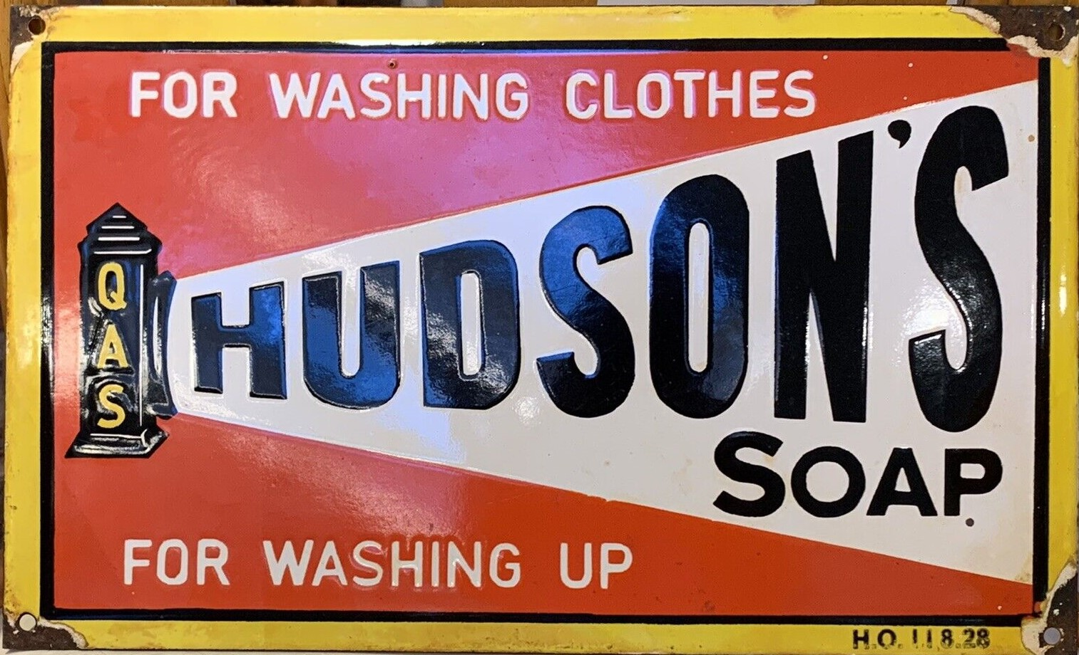
HUDSON’S SOAP 15”x9” single sided, three separations on white. Dated 11.8.28, but actually a deliberately damaged ‘weathered’ modern copy.

Technically, then, using modern technology, it is now relatively easy to produce a reproduction of forgery level, at least on the sign’s face. On the back, however, things are different. Pre-Great War all sign makers used malleable iron sheet, not steel, which demands a ground (or ‘swill’) coat that is an inconsistent mid-grey. During the inter-war period steel replaced iron, its ground coat fires to a much more consistent and very different blue-black. This would be key in the past, when valuable signs were largely of the pre-1914 period, but with current fashion focusing items from the post great war era, and often post-1945, the similarity of material demands considerable expertise to separate the reproductions and forgeries based on items from this period.
BASSETT-LOWKE LTD 20”x16”. Single sided, two separations on white, marked for Bruton, Palmers Green. In fact, a modern forgery, anonymous.

A good example would be the sign that I have used to head this paper. Ostensibly advertising the model makers (and commissioner of Charles Rennie Mackintosh and Peter Behrens) Bassett Lowke. I have written an article on this sign, available on GSA Radar; so, will not go into great detail here; it has all the ‘right’ qualities for an original dating from the 1930s, sold at auction for £380 hammer it represents a tidy profit over cost, but is not so valuable as to present the likelihood of legal action. Were it pretending to be earlier, the ground coat would give it away. To spot it as ‘wrong’ one needs to call upon a good number of contextual factors, expertise in terms of trade marking, and know the ways in which forgers set about ‘weathering’ signs.

A question arises as to how many of these signs are actually forgeries by intent? The Bassett Lowke sign is not based on a real enamel sign, but a toy one.
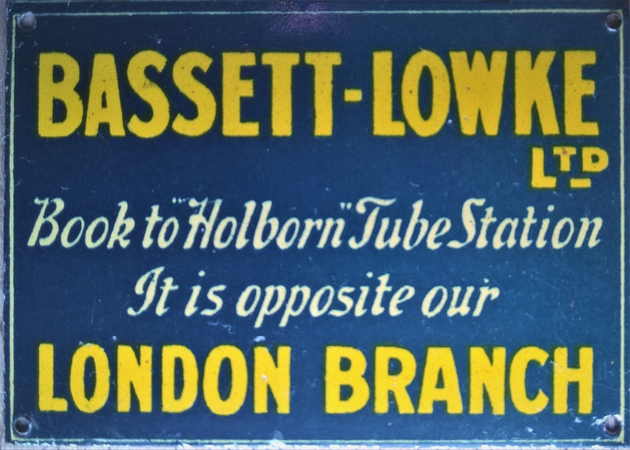
BASSETT-LOWKE LTD 2⅛” x 1½”, Single sided litho tinplate, two separations on white, c1930, for use on model railways.

I suspect the leap of imagination to realise it and the fact that all those that I have heard of are ‘weathered’ and being sold as antique, suggest this one is created as a fraud. But what about those that seem honestly supplied by companies such as Air-Cooled Accessories (easily found on eBay)? Here the retailer offers signs both in ‘as new’ or ‘weathered’ condition.
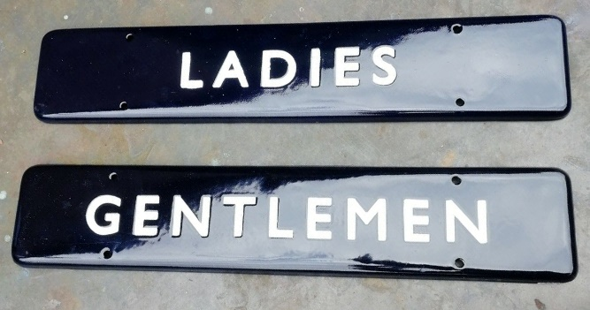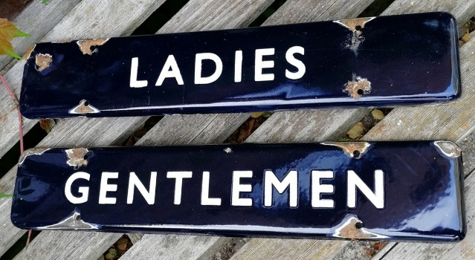
LADIES and GENTLEMEN door plates. Single sided, folded edge, single colour on white in the manner of those issued by British Railways (Eastern Region) 1949-62.
Currently available from Air-Cooled Accessories Vintage Retro Shop £100, or £145 ‘weathered’.

Interestingly, the customer pays a considerable premium to have the sign rusted and damaged. Bizarrely too, some of the pricing suggests collecting value structures.
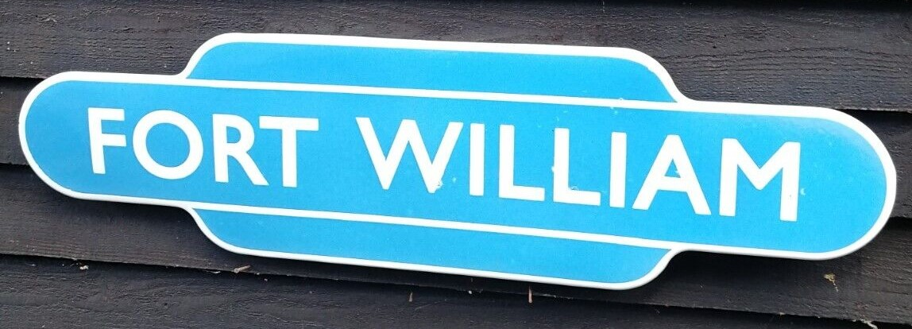
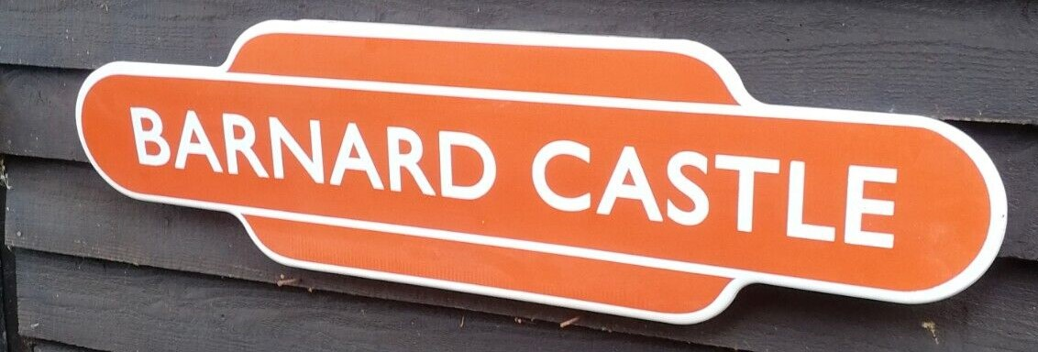
FORT WILLIAM and BARNARD CASTLE
Single sided, folded edge, single colour on white in the manner of those issued by British Railways (Scottish and North-Eastern Regions) 1949-62. Currently available from Air-Cooled Accessories Vintage Retro Shop: £315 (FORT WILLIAM), or £160 (BARNARD CASTLE).

A ‘desirable’ station name ‘totem’, FORT WILLIAM is £315, while others are £160. Neither price is in any way representative of current monetary values for the antique, which are far higher, and I will leave it to the audience here to work out what they represent as profit over cost. While described as ‘used’, further down one reads that ‘This is a high quality new replica enamel sign made using porcelain on a steel plate. Handmade using traditional enamel process.’
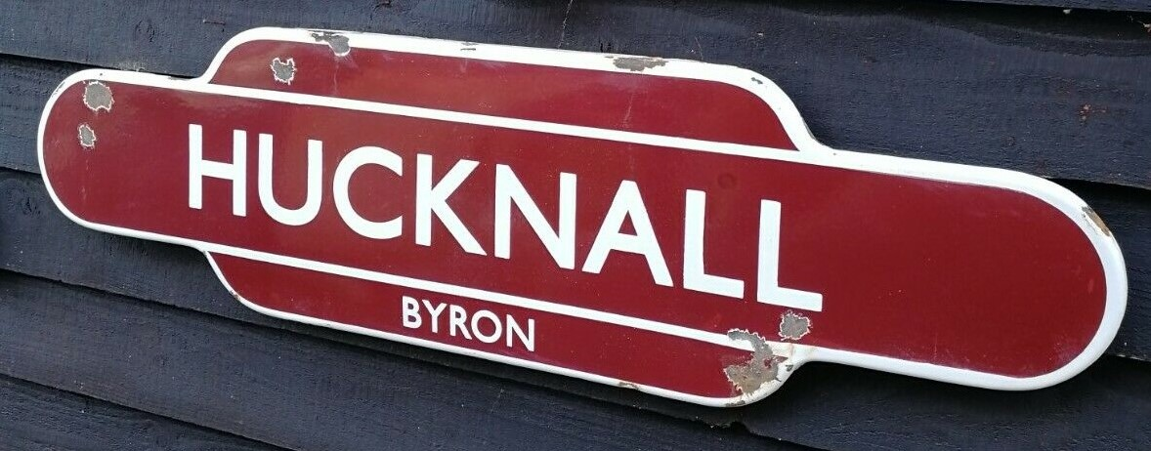
HUCKNALL (BYRON)
Single sided, folded edge, single colour on white in the manner of those issued by British Railways (Midland Region) 1949-62 ‘…authentic replica with chips and rust for vintage feel and look.’ Currently available from Air-Cooled Accessories Vintage Retro Shop.

While Air-Cooled Accessories are not in breach of any law, the ambiguity of the descriptions and prices are highly suggestive of potential deceptive capacity. Trawl eBay and auctions and you will see many that are being sold as antique, or in such a way as to suggest they may be antique.

What is interesting to me is that, in spite of all the technologies available, most modern signs are still different in detail from the antiques they are based on. I see no reason why a maker could not produce a sign that is almost impossible to differentiate; so, why is this? It may be that the commissioning agents are not the makers and, while the makers will do fair replicas, they will not go to the trouble of perfect reproductions. It could be that by introducing minor differences the signs could be defended as different, were any action to be raised against them. It could be that the maker is not aiming at expert buyers, but those who have not developed the knowledge to tell the difference, it could be all three. However, out there, somewhere, someone will be tempted to go the full way…at $1,350,000, who would blame them?

