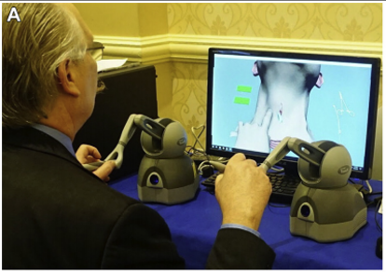
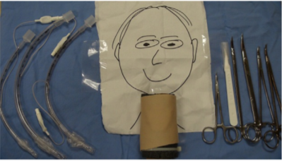
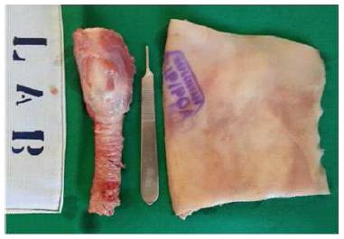
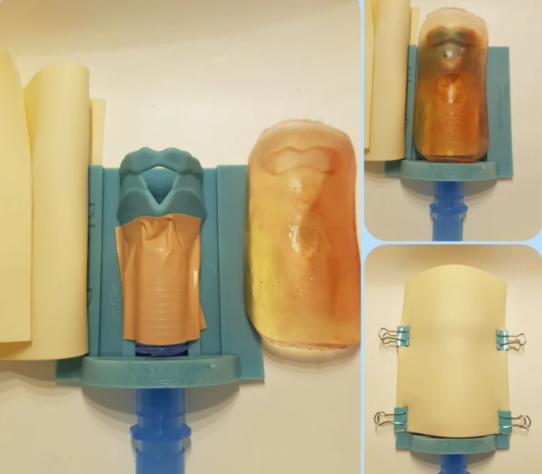
Fig.1 Different cricothyroidotomy models. (a) VAST- CCT using haptic controllers to perform CCT, Qi et al., 2020. (b) Porcine model with skin specimen, Netto et al., 2015 (c) MedtrinaStore cricothyroidotomy trainer £200 from Etsy.com (d) low fidelity Cricothyroidotomy task trainer from Aho et al., 2015.
B
C
D

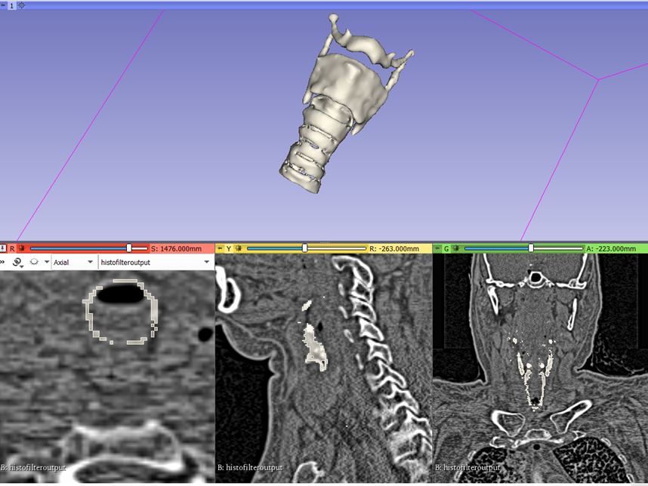

Fig 2. 3D model created through segmentation of DICOM data of female patient ‘Eve’

Fig 3. 3D model created using 3Ds max ready for 3D printing

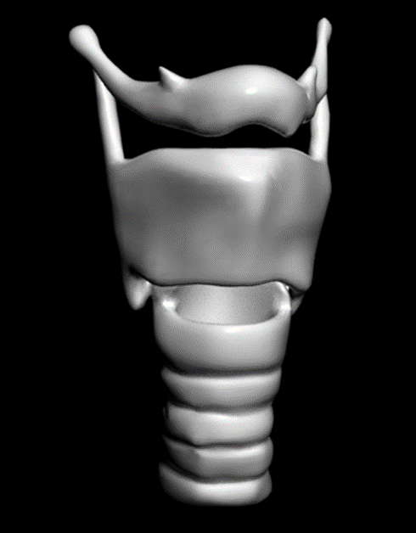

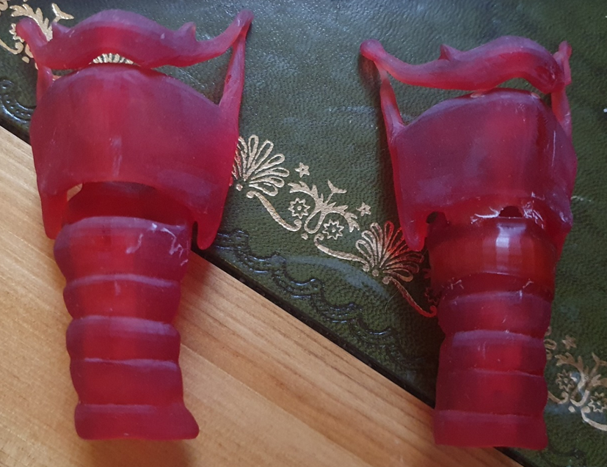

Fig 4. Although anatomically correct (for a female) measuring approximately 11cm in height and 5 cm in maximum width, with the cricothyroid interval 5-6mm.
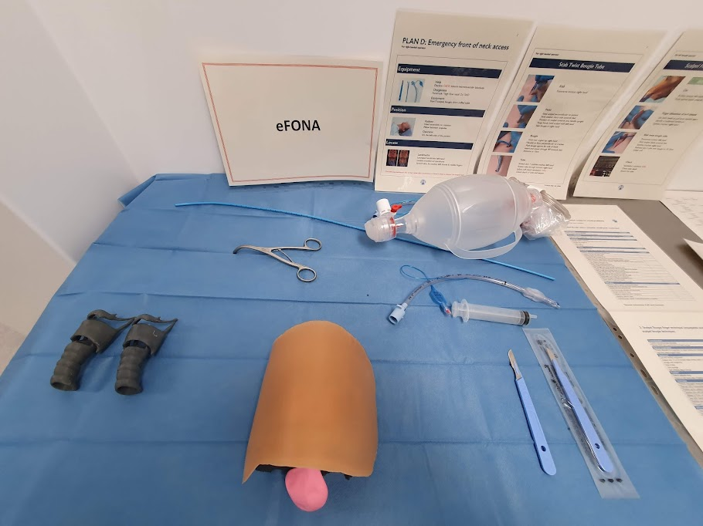

Fig. 5 Completed model used during airway teaching day with surrounding pictorial representation of the procedure
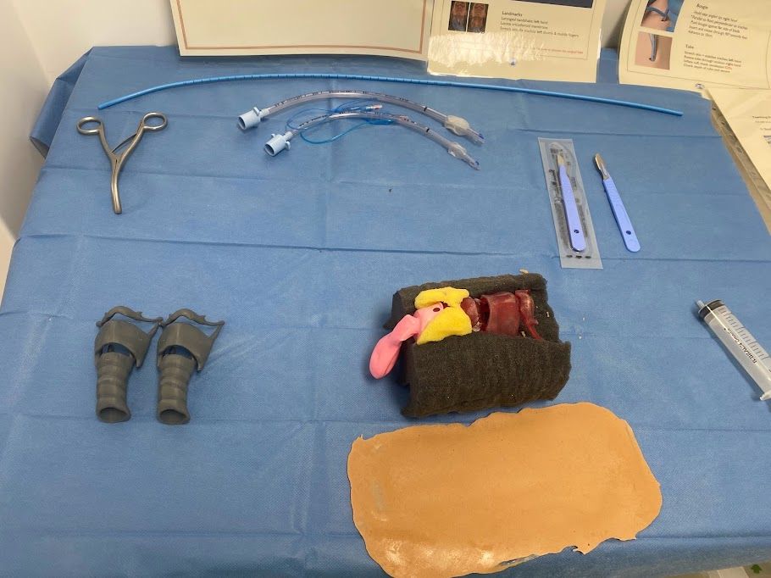

Fig 6. Re-useable skin removed to demonstrate the foam neck mould and larynx in situ.

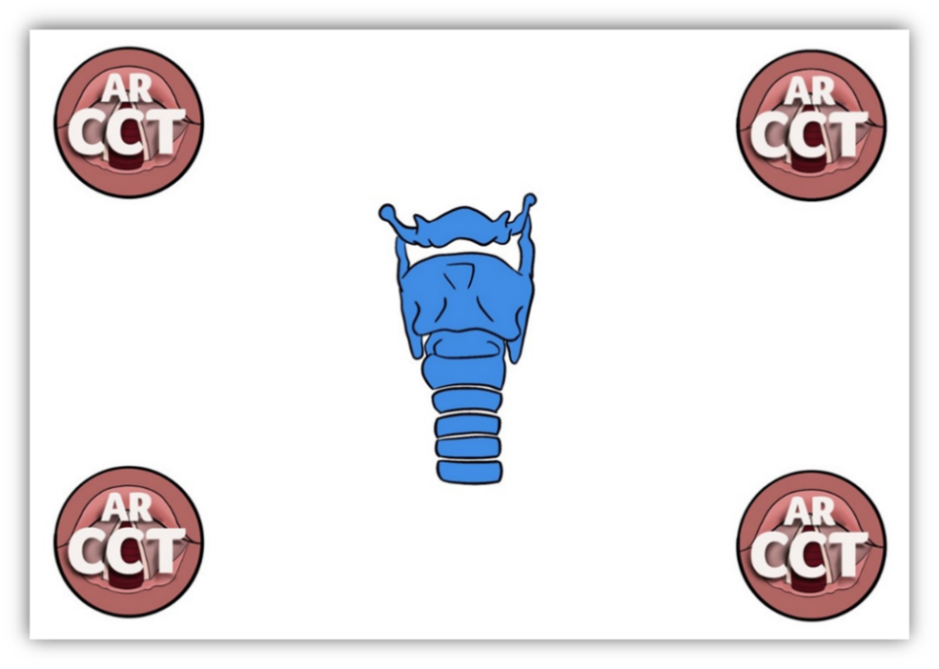
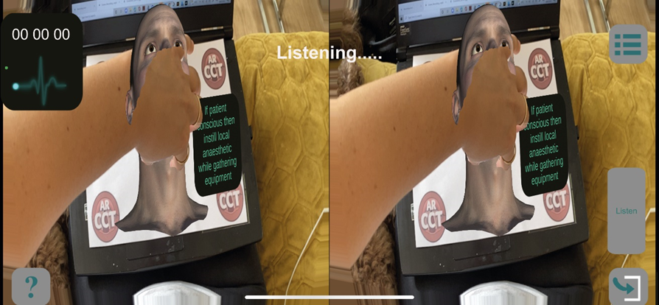
Fig 7. Target image created in Procreate
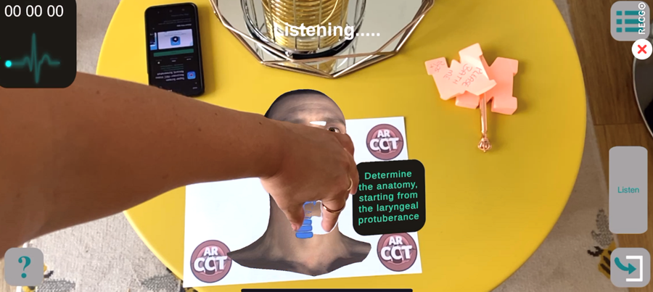
Fig 8. Poor hand occlusion in stereoscopic scene
Fig 9. Intermittent functional hand occlusion technology, on iPhone, giving hope for future development

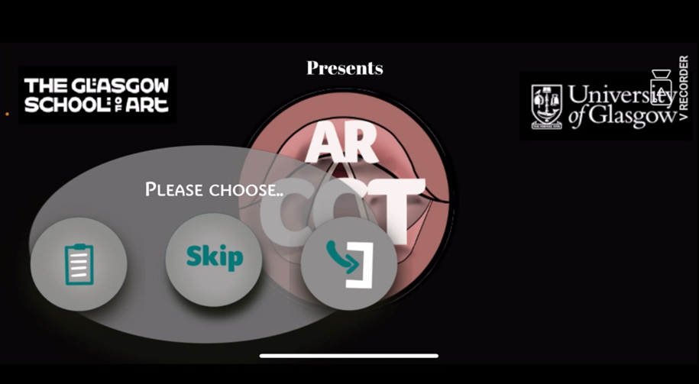
Fig 10. Opening scene of mobile application
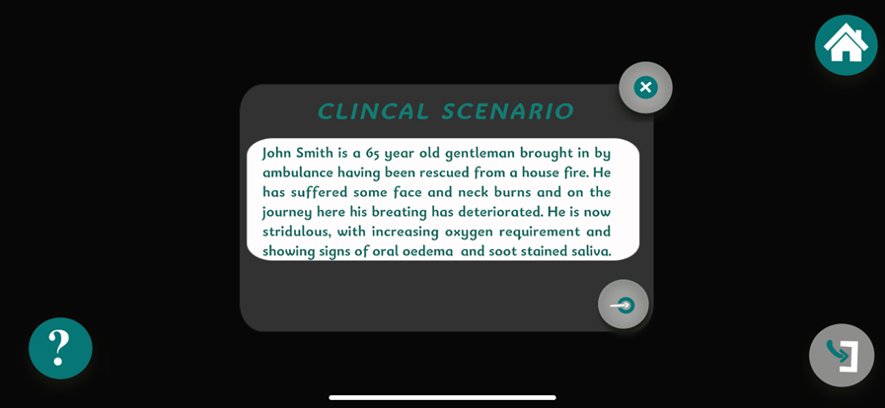
Fig 11. Clinical scenario scene

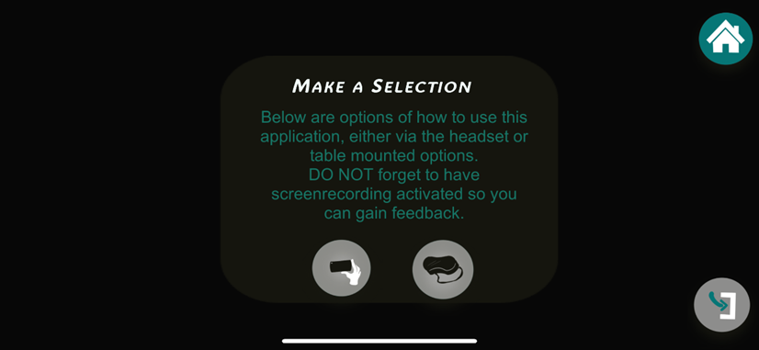
Fig 12. Option scene to select head-mounted or table-mounted options

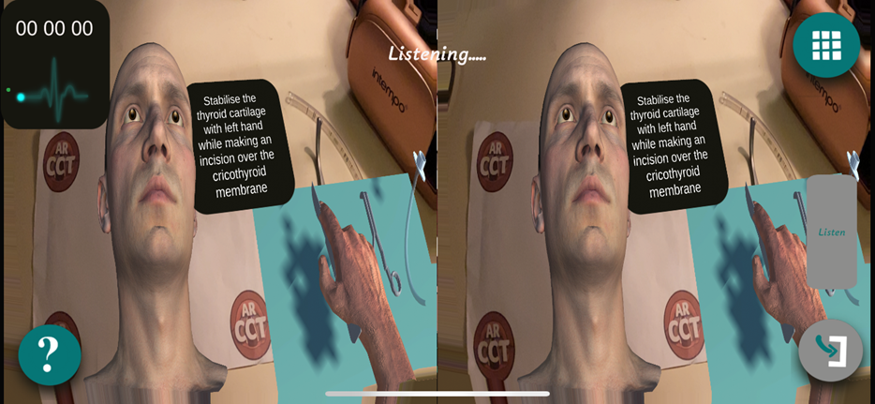
Fig 13. Stereoscopic view for head-mounting in goggles, also shown in figure
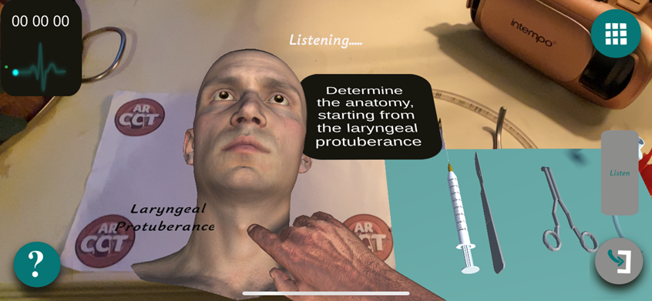

Fig 14. Table mounted scene showing animated hands and text descriptions

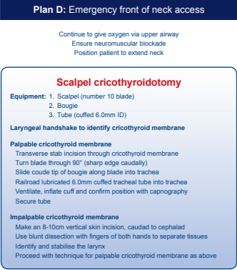
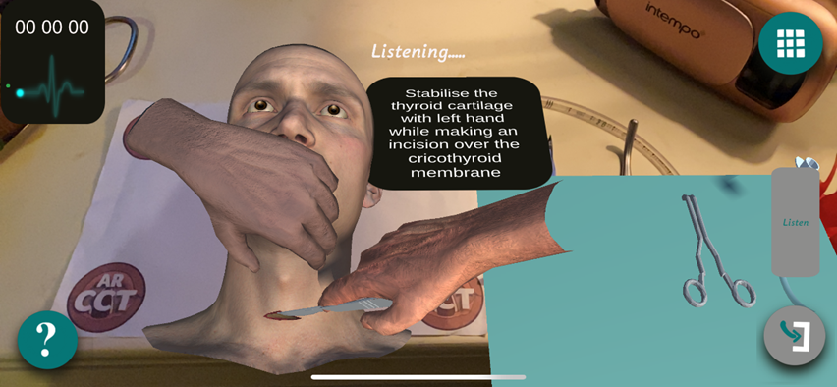
Fig 15. AR animation during incision over the cricothyroid membrane
Fig 16. DAS guideline procedure 2015

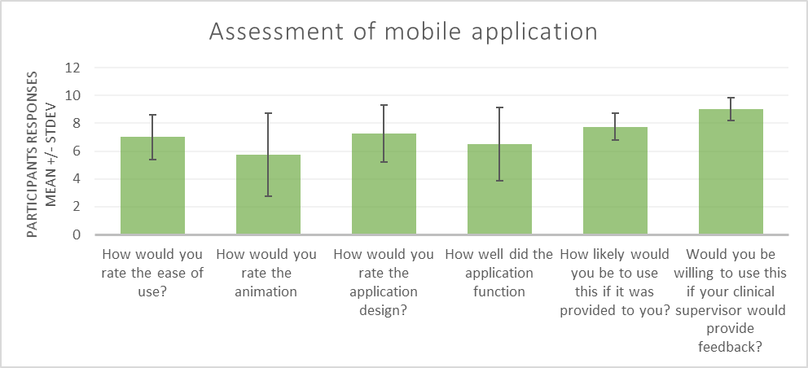
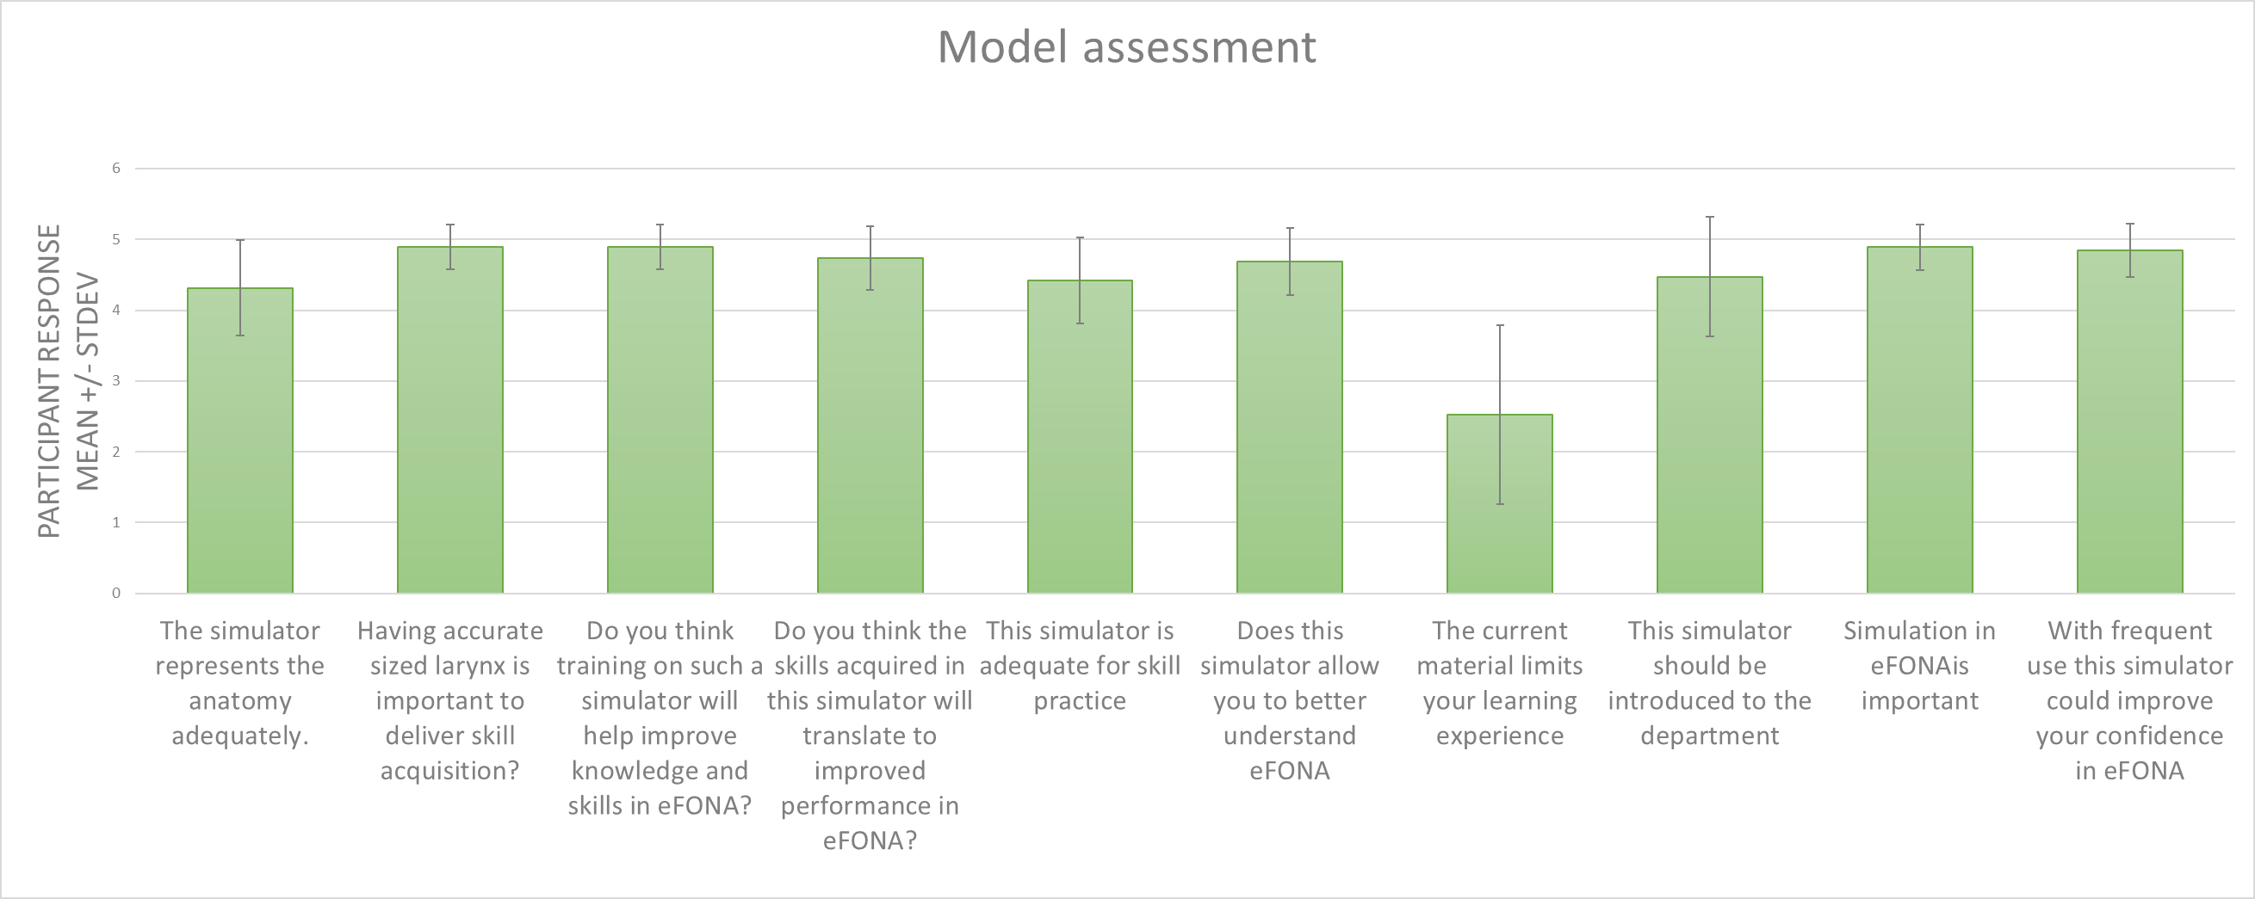
Graph 1. Questions for model assessment

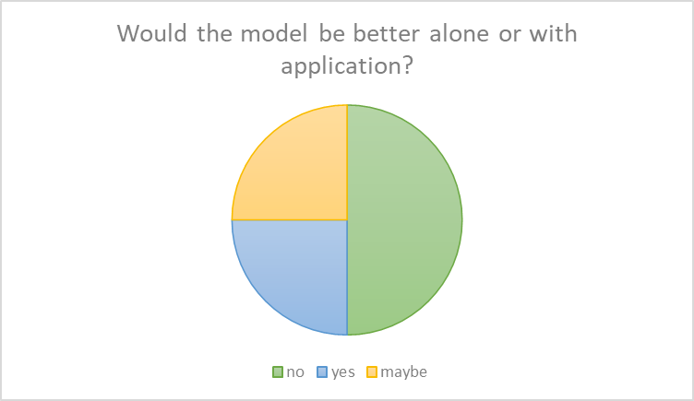
Graph 2. Questions pertaining to mobile application
Graph 3. Use of application and model as a combination

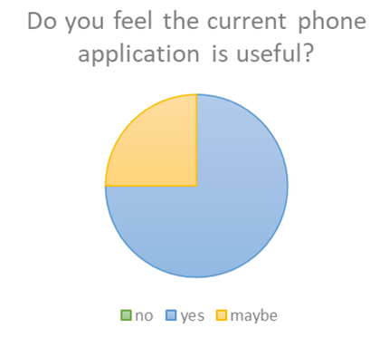
Graph 4. Usefulness of mobile application

