BIN 2020: Designing for play in new Nordic Childhood

Call for Abstract: Play in children’s everyday life / Playful in institutional settings

Playing through clothes: Clothes as a creative tool in the School environment
An explorative approach of the role of clothing in the public primary education,
in Scotland (UK) and France.

Dr Aude Le Guennec, Heriot-Watt University, School of Textiles and Design, Scotland

Abstract
Led by the French National Museum of Education and Heriot-Watt University (UK), “Dressed for School” involves a group of interdisciplinary researchers, educators and design practitioners, aiming to analyse the interactions between children and their clothes at school. As part of this project, a series of case studies focuses on the functional and creative impact of children’s clothing at school. This paper presents the findings gathered at an intermediary stage of an interdisciplinary project ongoing until 2022, and their evaluation thanks to cross-disciplinary and mixed anthropological methods with and on school aged children. Placing the child at the heart of the process, in well identified contexts, this research provides educationally impactful pilots where clothes are considered as legitimate components of a “Learning through play” approach. Beyond the sole context of the United-Kingdom (Scotland) and France, this research highlights the need for more consideration of children as users and co-designers of their own clothes. Using the COVID-19 “opportunity” to observe children in unprecedented experiences, this impactful project invites industry and policy makers to place a different perspective on clothing. Indeed, this project questions clothing as a support for learning, a socialising and creative tool, and as having a legitimate role to play in children’s education. This innovative research could inspire educational experimentations towards the development of participative learning and co-creation in design, en oeuvre in Nordic countries.

Key words
Clothing, fashion, co-design, participative design, design anthropology, childrenswear.

Biography
Design Anthropologist, Aude leads the programme “Future Heritage” at Glasgow School of Art – Innovation School (Scotland). From her academic background as Fashion director at the School of Textiles and Design (Heriot-Watt University, Scotland) and first career as a Museum director, Aude has developed a specific interest in the way fashion informs the society. Specialising in Children’s material culture, she has completed a PhD addressing the socialisation of children through clothing from the 18th century onwards (Sorbonne University). As a curator and consultant for the heritage and fashion industry, Aude explores innovative approaches towards participative, sustainable and educational childrenswear. Specialising in Children’s material culture, Aude publishes extensively and shares her research on inclusive, participative and sustainable children’s fashion internationally.
To know more about her: https://www.linkedin.com/in/audeleguennec/

Introduction

At the corner of the classroom, stands a rail of fancy dresses. Their shiny materials appeal to the eyes of dreamy pupils. Suddenly, all the stories to be imagined jump into their constantly stimulated minds. “Playing through clothes” invites itself into the classrooms... The creative child, as modelled by Maria Montessori (1912) is constantly interacting with everyday material culture. Defined as a being and a becoming (Prout, 2005), acting and interacting with their environment (Quentel, 1997; Qvortrup, 2005), children manipulate, create, and dream. Through their activities and games, they reveal their spontaneous approach to the world. In this process, clothing and fashion have a major role to play...
The daily manipulation of their clothes is a fundamental aspect of children’s life and a major challenge for the carers, helpers and educators in a school environment. Arriving at school, children take off their coats, put their slippers on; dress up again to go into the playground or for an outdoor learning session; they change into their gym kit; and the young ones get themselves comfortable for a nap. Fastening buttons, closing zips, manoeuvring an awkward sleeve, tying the shoelaces, making decisions regarding what to wear and how to wear it: these are all the activities that, from an early age, children have to do in a social environment. Children are introduced to the norms and the rules of a society where fashion shapes own identity (Balut, 2013; Le Guennec, 1998). Parents encourage children to shape their sense of clothing: not being allowed to go to school in a super-hero outfit; having to dress up for a party; having to keep a jacket on not only because it’s too cold but because it’s not appropriate to take it off. Understanding fashion as a social tool is as crucial as using clothing to develop children’s technical ability and leading them towards more independence. Most of the time, children in their early years are helped and guided in these tasks by their carers. Their progress and autonomy in what needs to be considered as a daily learning process, is encouraged. Encouraged, but not often considered as a valuable [and official] creative learning tool for children to know more about themselves and their environment.
In fact, historical, anthropological and educational resources on creativity, and experiments towards participative design of children’s material environment, hardly ever mention fashion and clothes as a support for learning and creating. This topic, despite its everydayness, seems absent from the literature and policies on education across Europe, Nordic countries and the United Kingdom. The preparation of the projet “Dressed for School”, investigating the Scottish context particularly inspired by Nordic approach to education, has evidenced a similar lack of interest for clothing (Scottish Curriculum for Excellence, 2019; Play@Home, 2014; Ready, steady, toddler, 2007). Equally, the notion of clothes as a factor in the child’s socialisation is hardly ever mentioned in the field of childhood studies and research on childrens’ material culture. When analysed, it’s almost never from a child’s perspective (Arleo & Delalande, 2011; Sirota, 2006; Cook, 2004).
Moreover, none of the current debates on childrenswear look at children themselves and at the way they appropriate the clothes made for them by the adults via daily manipulation (Winnicott, 1971). The capacity for the child to act as co-designer of their clothes and to have a voice in the way they dress is undermined. The capacity for clothes to act as an educational and creative tool remains a marginal matter for domestic dressing-up arguments. Therefore, considered as anecdotal, children’s fashion is the neglected partner of children’s everyday life.
A group of interdisciplinary European researchers (anthropology, sociology, history) and fashion practitioners led by the French National Museum of Education (Munae, France) and Heriot-Watt University (UK), and coordinated by the author, have designed the research project “Dressed for School”. As part of the research leading to an exhibition and publication in 2023, the relationship between children and clothing is analysed through a series of case studies and design projects focusing on the functional and creative approach of childrenswear. Addressing the current gap in the research on children’s education and material culture, this paper presents a selection of these experiments questioning children’s interactions with clothing at various stages in their primary education. The main points leading to the design of these activities were based on the following questions: why has fashion been excluded from children’s education despite its influence on the definition of children’s social identities? Why has clothing not been considered as an educative and creative medium?
This field work addresses the need to gather children’s views and to encourage them to express their ideas and opinions on clothes and clothing. This has been done thanks to a comparative approach between Scotland and France. Scotland is known as a pilot country for the embedding of learning through play in preschool and primary education; and France presents a school curriculum based on a more traditional teacher-led approach. The contrast between a country where school uniforms are the norm and an education system where the dress code is less formal, however implicitly embedded in social life, reflects dual approaches to clothing at school in Northern European countries. This research leads to meaningful conclusions on the role of clothing in childhood and contributes to broader reflexion in relation to the educational potential of children’s material culture, which could inspire policy makers, and practitioners beyond these local contexts.
In order to reach the aims of the research undertaken as part of “Dressed for School”, the following objectives have been set:
- To collect children’s views on clothing, to monitor their interpretation of dress codes and to stimulate their awareness of the functionality of clothes;
- To observe and record the direct interactions between children (as individuals and in peer groups) with their clothes ;
- To investigate a variety of contexts and cultures;
- To encourage the embedding of clothing in primary school education, as a medium for learning about otherness and the social environment;
- To create an original collection of data gathering children’s perspectives on fashion and clothing.

Methods
Based on the original scope of this research, the creation of bespoke multi-disciplinary and heuristic research methods was deemed necessary to inform children’s approach of clothing from a variety of angles and to involve children in the process. Crossing the definition of the child as a socialising individual (Quentel 1997), capable of demonstrating agency (Qvortrup 2005), and developing their own culture (Arleo, Delalande 2011) with the concept of fashion and clothing as a socialising medium (Balut 2012), helped in defining the paradigms of the research. A field work focusing on Pre-school and primary school children in France and in Scotland gathered under the banner “Playing through clothes”, aimed to adopt a child’s perspective on clothing and fashion. Active observation of children’s clothing behaviours, visual analysis of children’s drawings, object-based research of children’s clothes and practice-led research in fashion design contributed to the generation of insightful data and first-hand prototypes to be evaluated by children.

Playing through clothes: case studies

- From children to students: How can fashion designers create more participative, functional and playful school uniforms?
To portray the current approach that children aged 6-8 have towards their school outfits, we prioritised interactions between the fashion industry, children and practitioners. In September 2020, the childrenswear company Jacadi (ID.Kids) expressed an interest in understanding the evolution of the dress code of primary school children in France. The students from the BA Hons Product Design (Diplôme Supérieur d’Arts Appliqués) of the French Design School Olivier de Serre (Ecole Nationale Supérieure des Arts Appliqués et des Métiers d’Arts, Paris) were involved in this partnership over the academic year 2020-21. They received a brief inviting them to design a school uniform for nursery and primary school pupils, taking into account the necessary functionality of pupils’ clothes and the potential for these uniforms to support their learning. This practice-based research intertwined with anthropological methods, involved the active observation of children in their school environment and was broken down into three phases ensuring a robust framework to their projects. Firstly, the students were introduced to an anthropological analysis of children’s clothes (Le Guennec, 2018). This emphasised the role of clothes for learning and socialising as well as creative tools and helped students to adopt an analytical framework to develop their designs. This theoretical support was completed by an introduction to anthropological work with children and the opportunity to work from the innovative approach of the childhood anthropologist Julie Delalande and her cutting-edge work on playground life (Arleo, Delalande, 2011). Finally, needing to create commercially viable products, the students also conveyed their understanding of the role of the child as a co-consumer (Cook, 2004) and their analysis of the constraints of the children’s market. The evaluation of their products was part of the design process, ensuring the impact of a project addressing children’s perception of clothing as well as the requirements of the childrenswear industry. Conveying autobiography and emotional design (Norman, 2004), and recalling their experience as school children, students used their own perceptions to guide the evaluation of their prototypes which have been tested by children. They have also been assessed by fashion industry partners invited in a project ethically framed by Heriot-Watt University. This research and development opportunity has led towards innovative solutions for students to focus on the functionality and practicality of clothes, with exploration of the creation of learning outfits.
Amongst the fifteen prototypes designed by this group of students, most reflect current challenges for children in their everyday life and at school. Outdoor learning, mobility, adapting to activities and to the weather, getting changed, academic learning and creative learning have been identified as the main points in the development of school overalls and outdoor clothes. The functionality of garments was explored through the facilitation of handling and fastening, the sourcing of sustainable and durable materials, and the design of clothes adapted to the physical and physiological abilities of children who have to self-dress in a meaningful manner. This project has led to very impactful examples of gender neutral clothes adapted to pupil’s lives, taking into account children’s views, and including daily learning through play activities.
Two projects have been particularly significant and insightful as facilitating the learning and playing through functional clothes:
- “Bis” (Robin Navari,Camille Lauron, Julie Amira, D.S.A.A.1, E.N.S.A.A.M.A. OLIVIER DE SERRE, FRANCE, 2021) (Fig. 1): a foldable and versatile outdoor hi-vis overall, with removable sleeves adapted to children’s outdoor play, providing a good protection against adverse weather.
- “Oups” (Paul Seiller, Agathe Michaud, Marie Vincent, D.S.A.A.1, E.N.S. A.A.M.A. Olivier de Serre, France, 2021) (Fig. 2): Analysis of the “mistakes” of children when drawing and painting and how this could be interpreted as prompts in garment designs for overalls designed to host the pencils and paint brushes in-between craft classes.
These prototypes were evaluated by children who have utilised these outfits in real life conditions. These trials were filmed by the students who have reflected on this initial manipulation of clothes to recommend further adaptations (https://youtu.be/VgxIitkILmw)

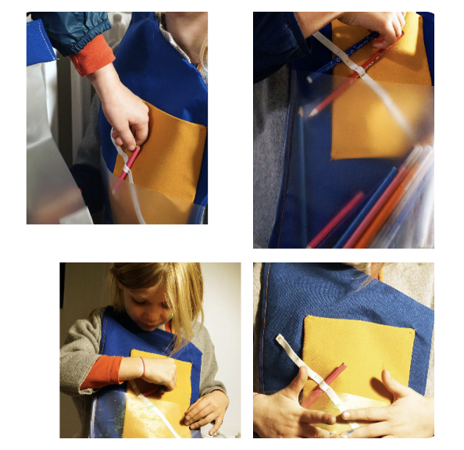
Fig. 1 Paul Seiller, Agathe Michaud, Marie Vincent, D.S.A.A.1, E.N.S. A.A.M.A. Olivier de Serre, France, 2021

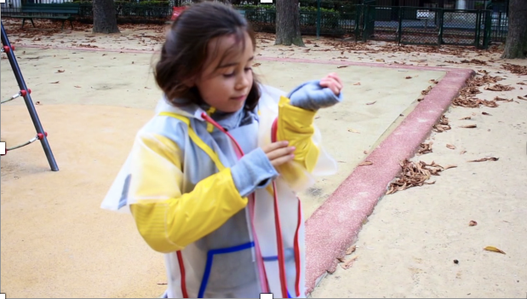
Fig. 2 Robin Navari,Camille Lauron, Julie Amira, D.S.A.A.1, E. N.S.A.A.M.A. OLIVIER DE SERRE, FRANCE, 2021.

- My uniform and me: when children reflect on the social and environmental impact of clothes
St Peter’s Primary School is a Scottish state institution settled in a rural environment and teaching pupils from a variety of backgrounds in Galashiels, Scottish Borders. This School is acting as a pilot in the promotion of the Scottish “Learning through play” curriculum. Therefore, St Peter’s PS has been identified as the ideal field for an analysis of the perception of fashion and clothes in a country where school uniform is the norm. The interactions between children mostly at the senior school level (9-10 years old) and their clothes have been evaluated via a series of child- led activities planned for August-September 2020. The question “My uniform and me” based on design activities, invited 26 children to reflect creatively on the way clothes and fashion can support their understanding of their environment and construction of their social identities. This brief has been developed in partnership with the main teacher of the class as part of the school “Enrichment” programme.
Due to the disruption of the COVID-19 pandemic, this project has had to be broken down into different phases and adapted to online delivery, which, in places, has impacted the evaluation of the findings. For example, due to the closure of Scottish schools to persons from outside the school community the online workshop for this brief had to be provided as an asynchronous activity by the teacher to a group of home schooled pupils. This change was mitigated by the opportunity to have full class online discussions where the projects drawn by the pupils were presented and analysed.
Following the brief “My uniform and me”, the children were invited to describe their ideal school uniforms using the medium of their choice: mostly via drawing. The children were given a brief presentation on fashion as a social medium and looking at examples of uniforms in the past and the present. In order to avoid any stigma in a group gathering children from a variety of backgrounds, the exercise was based on a reflection on the dress codes of their ancestors in the 19th century and early 20th century. The visual analysis of family photographs gathered by the children has led to questions building children’s understanding of the socialising power of fashion. In parallel, a reflection on life at school invited children to story map their daily activities and the necessary changes of clothes. The purpose of these two online workshops was to lead children towards an understanding of the functional and socialising power of fashion through dress codes. The pupils then worked individually at describing their ideal uniform through the medium of drawing on A4 sheets (or whatever was accessible in their homes) (Fig. 3-7). Paradoxically, the answers of this group of 9-10 years old evidenced both conformism and an ability to address the functionality of their outfits.
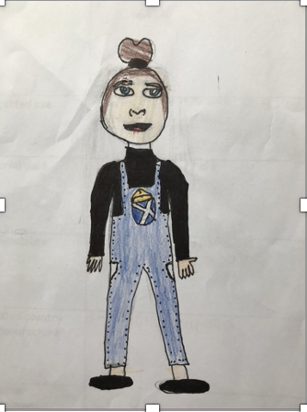

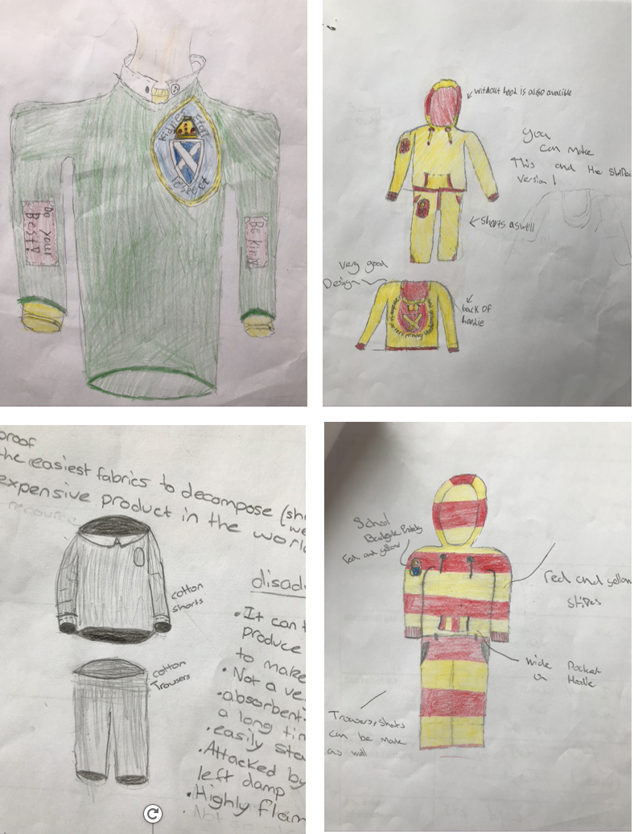
Fig. 3-7 St Peter’s Primary School, P6 children, November 2020, Galashiels, Scotland.

As part of a second phase of this project, the pupils have also been encouraged to gather some information about school uniforms around the globe to then analyse in more depth the style and make of these outfits. With the same group, an investigation of fashion apparel has been undertaken, to develop an awareness of environmental issues in fashion and a sustainable approach to clothing. The research on pupils’ clothing experience around the world has encouraged some children to choose a country to focus on, some of them deciding to work from their country of origin. After the presentation of the documentary and content from the Fashion revolution network, ”Who made my clothes” (fashion revolution network), the children investigated their selected school clothes manufacturing processes via the analysis of the garment labels. They then produced story boards narrating the journey of the outfit (Fig. 8-9). Children were left free to decide the final format of this output as well as the medium used to communicate their findings. This project emphasized the environmental consciousness gained by these pupils inspired by the current debate on climate change. It also demonstrated the interest in using fashion as a learning tool to discover more about themselves and the society in which they live.

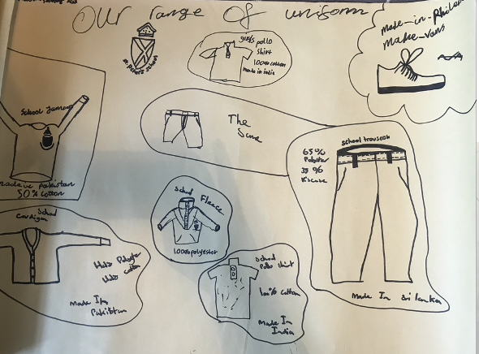

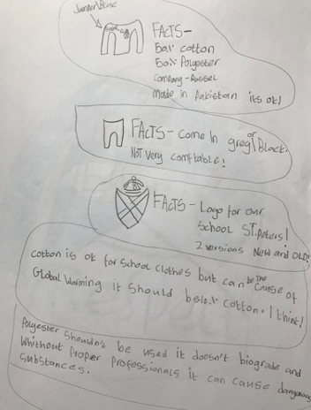
Fig. 8-9 “My uniform and me: who made my clothes?”, from 9-10 years old pupils of St Peter’s Primary School, Galashiels, Scotland.

- Dressed for Home-schooling

While the COVID-19 pandemic has disrupted the “Playing through clothes” research project, it has also provided opportunities for unexpected insights into children’s interactions with their material culture. Indeed, home-schooling has had unexpected impacts on children’s everyday life, including their daily clothing routine. Therefore, we have investigated children's dress codes in the context of the lockdown in spring 2020 in the United-Kingdom and in France. How did this new lifestyle and social distancing affect children's and pre-teen's clothing behaviours? Did they choose to wear their school uniforms while at home in the UK? How did they dress up for a chat with friends or an online meeting with teachers?
The objectives of this research were set as:
- To capture children’s clothing behaviour during an extraordinary time of home-schooling and family isolation.
- To document children’s dress code while at home
- To understand the impact of peer interactions and school activities on children’s dress behaviour
- To identify the reality of the influence of the fashion industry on children’s dress codes
- To compare children’s clothing behaviours between France where school uniform has been banned since the 1960s and the UK, a country where school uniform is the norm.
- To record children’s voice on their material environment and to convey original ways to capture it.
In order to document children’s clothing behaviour during this unprecedented experience and to reach the objectives of this research, we designed three research tools to foster children’s participation in both countries.
Firstly, we invited children aged 8-9 to keep a “clothing diary” during the lockdown. Children from St Peter’s School in Galashiels (Scotland) were invited to describe their daily outfits using keywords, drawings and photographs to record the memory of the day. The entries contributed to a better understanding of the fashion views of children usually in school uniforms. By reflecting on their learning journey outside the physical boundaries of the school and the requirements to wear functional clothes adapted to their school activities, they offered an insight into their perception of fashion and clothing. For most children amongst the 26 boys and girls who participated in this exercise, sports and comfortable outfits were the norm of a day alternating between outdoor activities and online learning experiences.
Following this pilot, a larger questionnaire was launched in France and in the UK on 18th May 2020, also known in the UK as “National Uniform Day”. This allowed a comparative approach from two countries with diverse clothing cultures. Thanks to the support of pilot parents from IDKids Community and the Scottish Borders school community, we have gathered 230 responses and photographs of children’s preferred homeschooling outfits across countries. This research was conducted exclusively online and some of the respondents were recruited through partnership with stakeholders. No particular sampling strategy was employed, only the willingness of families and children particularly interested in fashion to contribute to this project. We collected fifty seven responses in the United Kingdom and one hundred and sixty responses in France through online surveys with open questions. Some children were also invited to take pictures of their daily outfits: they were translated into survey responses. We analysed the questionnaire both qualitatively, for the frequency of waering specific garments they wore during lockdown, and qualitatively, for children’s social identities and relations connected to/ expressed through clothing.
The aim of the quick questionnaire "Dressed for Home-schooling" was to provide a snapshot of the current looks of self-isolated pupils and to reflect on their tweaks in the usual dress codes. The questionnaire was dedicated to children aged 6 to 12 years who were invited to respond to the questions with their parents. As an optional final stage of this questionnaire, the respondents were invited if they wished, to take a picture of the child's favourite outfits: the one worn for home-schooling, the one worn at week-ends, or during the holidays; and to send these pictures to the PI via Instagram using the hashtag created for the project #Habillespourlecole (Fig. 11)
The data were analysed thanks to mixed quantitative and qualitative methods. Based on a pragmatic epistemology, which philosophically believes in conducting research that is applicable for particular research problems (Kaushik & Walsh, 2019), we employed mixed methods (Tashakkori & Teddlie, 2010) to carry out this research. Mixed methods is more than a bridge that connects the quantitative and the qualitative traditions; it is considered a third paradigm that incorporates the strengths of both methodologies (Johnson & Onwuegbuzie, 2004). Pragmatism and mixed methodology embraces whatever methods work to investigate a research problem.
Along with Johnson & Onwuegbuzie, we understand that mixed methods research is defined as “the class of research where the researcher mixes or combines quantitative and qualitative research techniques, methods, approaches, concepts or language into a single study” (p. 17). It is a pluralistic, inclusive, eclectic and practice-oriented approach. It collects multiple forms of data using different approaches, which results in a combination of results with complementary strengths. Through mixed methods of data collection, we provide stronger evidence to our conclusions and produce more complete and complex knowledge to tackle real-world problems, and inform theory and practice. This, combined with a particular focus on visual analysis as a recurring and obvious way to collect children’s views (Margolis & Pauwels 2011) provided the opportunity for the development of original and insightful research methods (Fig. 10).
Children’s testimonials about their outfits were coded following a robust typology of clothes, colours, textures, styles, implying a final translation phase to ensure the possibility of a comparative approach between France and the UK. The translation was based on the utilisation of the thesaurus accessible from the database https://www.linguee.com allowing a contextualisation of the terms from industry and marketing perspectives. Some words such as “Onesie” (a piece of loungewear worn as a pyjamas by children at home) and words created by children to identify a specific garment were object to a cross-cultural interpretation by the researchers during this analytic pahse. Thus, the visual analysis of the photographs, based on similar categories allowing a cross-analysis of the gathered data, facilitated the process. The importance of testing new ways of conveying and analysing children’s voices led to this original approach as well as the exploration of the potential of word clouds as an innovative method at the crossroad between visual and written analysis.
The coding phase implied for the researchers to be able to overcome the problems related to the vocabulary used by children, their description of clothes using vernacular or distorted words, and their tendency to use comparative or default answers to describe the changes in their habits: for example, “whatever clothes are in hand” / ”I don’t wear the same as at school” (without any indication of what is worn at school)... Therefore, thanks to the contextualisation of the answer and comparative approach with the visual information, further interpretation has been possible.
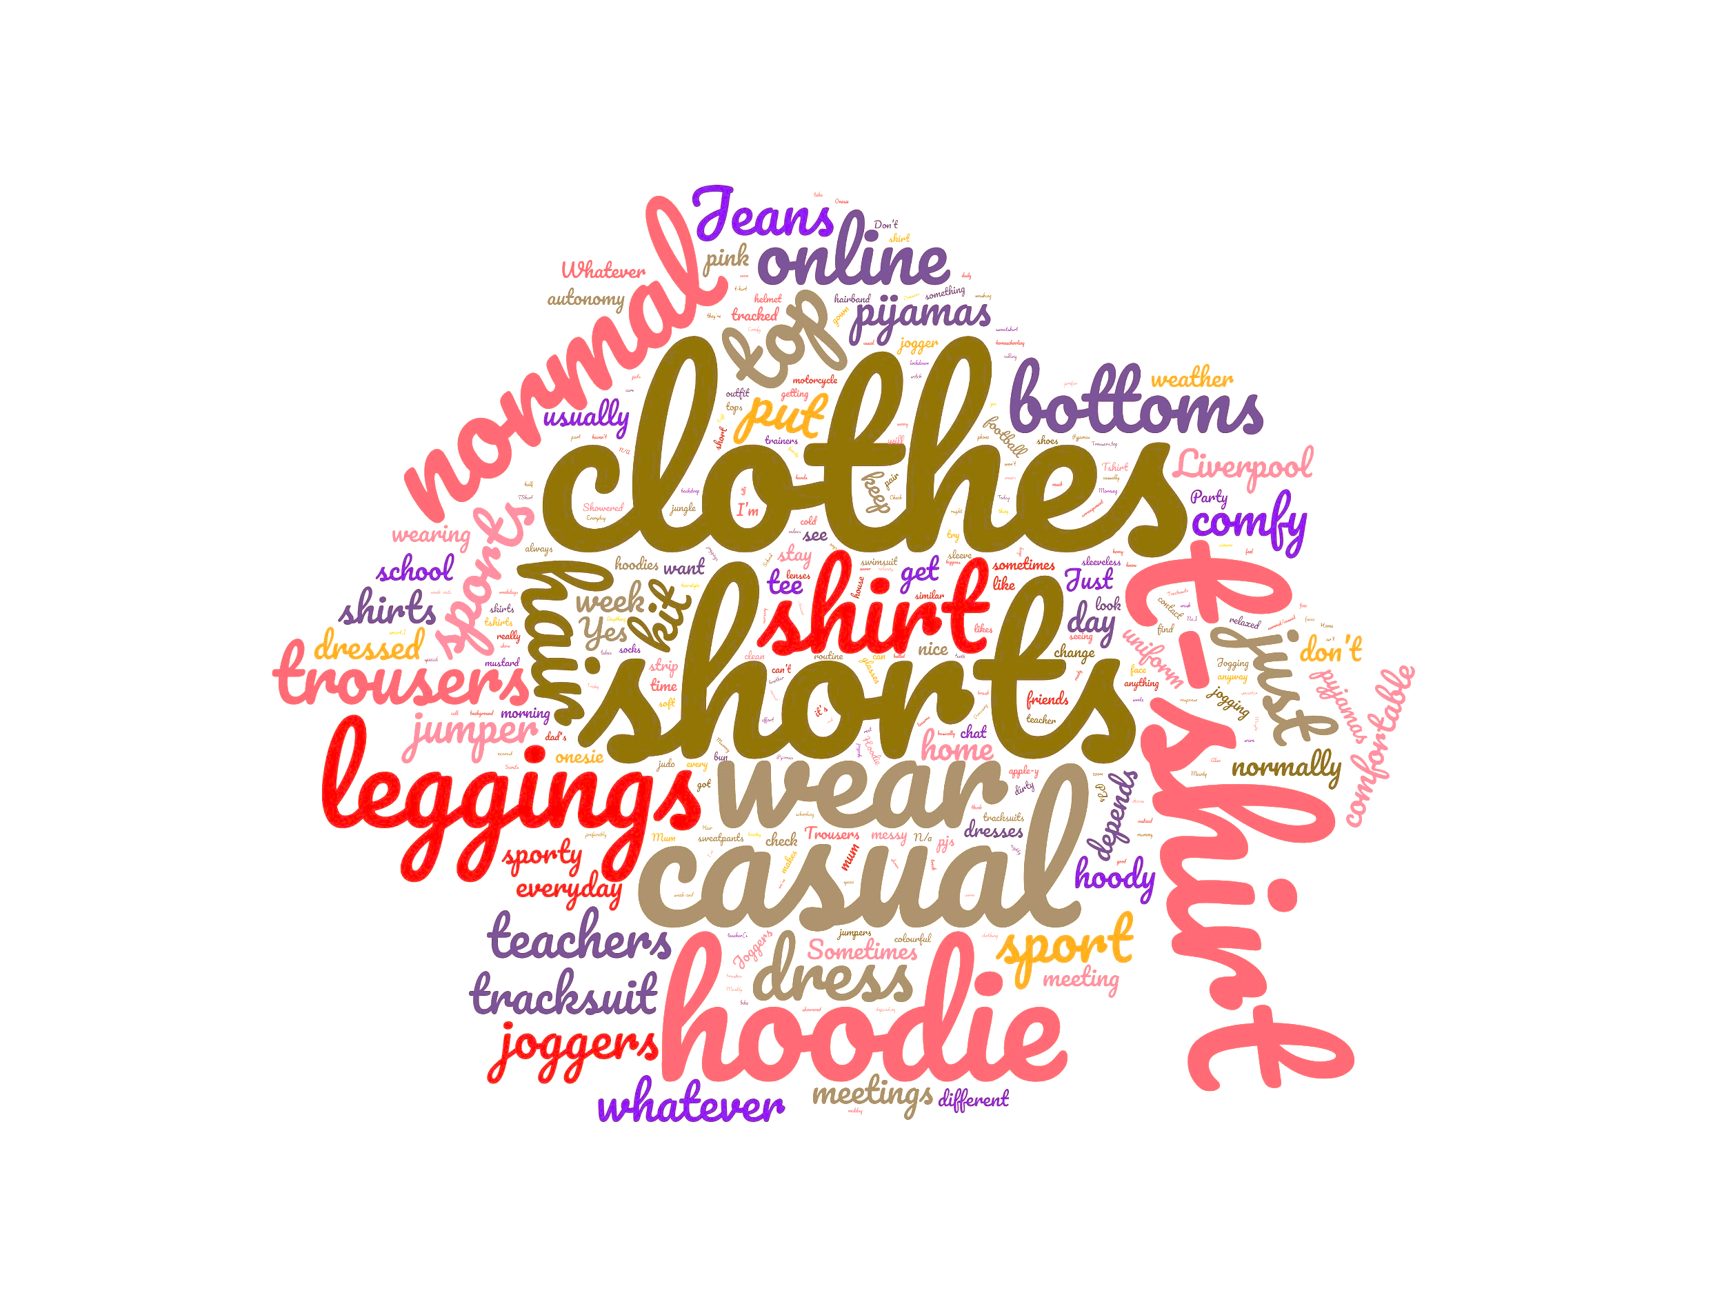
Fig. 10 Word cloud from the questionnaire “Dressed for Home-schooling”, April-June 2020, 6-12 years old.

Fig. 11 My preferred home-schooling outfit, from a 12 year old girl, France.
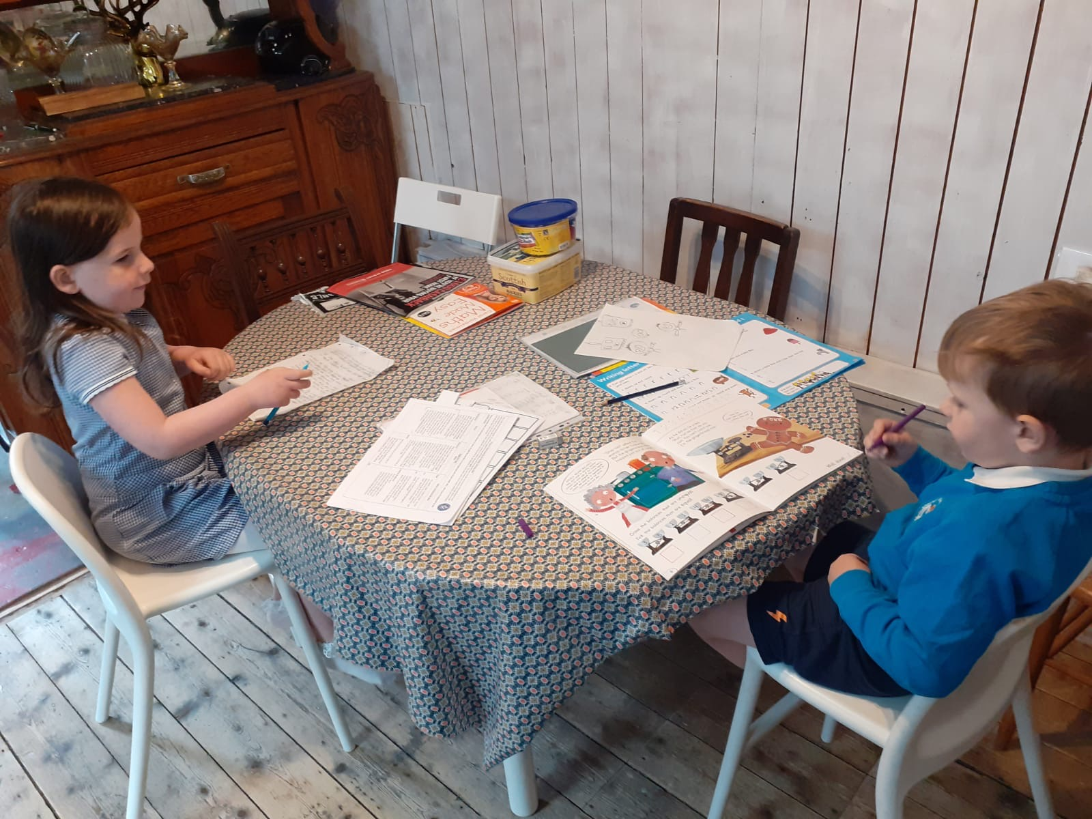
Fig. 13 Children dressed for home-schooling in their School uniforms, May 2020, Galashiels, Scotland.

Three themes were identified in the analysis of this survey:
Theme I: functionality (comfort, adaptation to activities, weather)
The first theme that came up from the survey analysis was comfort. During lockdown, children were choosing clothes they feel comfortable with. They dressed according to what makes them feel cosy, comfy, relaxed and casual. There is a huge contrast between their school uniform which is strict and the clothes they wear at home, even during home-schooling or with online chats with their teachers. Some children decided to wear pyjamas or onesies the whole day, others explicitly mentioned their outfit as casual and comfortable. These included t-shirts, sleeveless shirts, tracksuit bottoms, shorts, skirts and hoodies.
Theme II: shaping my Identity
The second theme from the survey is identity. We found children were choosing their outfit according to what relates to their personality, interests, and tastes. These included football kits or other sports clothes, colourful pieces and fruit patterns. For some children it also involved dressing up, especially for their online calls with friends or teachers. As they chose what to wear, these clothes improved children self-perception, self-awareness and self-care. In their answers, children also communicated about what they liked, their favourite looks and tastes when they are not ruled by the School’s dress codes. Interestingly, in a country where the School uniform is not the norm (France), the conformist and functional approach to dress codes influences a uniformity at school subtly interpreted through the adaptation of similar categories of outfits (sports outfits, trousers for all, casual tee-shirts). If some children preferred wearing their school uniforms to focus on their work while at home (Fig 13), during the lockdown on both sides of the Channel, the pre-conceived or normative dress codes as described by Vinel (seem to disappear for more playful and personal expressions for the younger children (6-8) who, in their own words, mention their appetite for more imaginative ways of dressing up.
Theme III: Interactions with the adults / parents - autonomy
The third theme that emerged from the dataset was autonomy. On the one hand, most children developed their sense of self-rule through deciding which clothes to wear. Children jump into another type of uniformity which is particularly emphasised in the UK (French kids highlighted their preferences in relation to fashion trends but not UK pupils). These could involve some direct mentions of their freedom to choose not to change their pyjamas or decided to wear a specific piece. On the other hand, a few younger children mentioned how their parents, especially their mothers, gave some directions on what to wear either to develop a sense of routine or to look nice for the camera. The older children both in France and the UK mentioned the importance of being washed, looking fresh and clean with hair done when speaking to their friends online. Coming from a variety of middle and upper middle class backgrounds, some children expressed the constraints related to personal care and the fact that they had to wash themselves even when they are not leaving the house. Certainly a point of argument with the adults particularly cautious with regard to hygiene and self-care during the pandemic.
Presented in its short version as one of the activities developed in the “Playing through clothes” programme, the survey “Dressed for homeschooling” is a crucible for further analysis of children’s voice in relation to their clothes. Beyond a simple description of their daily preferences, the analysis of their vocabulary, reveals how children appropriate and interpret fashion in their own ways, outside the fashion system ruled by the adults. Further analysis of this substantial survey is needed to clarify this. Furthermore, the data evidence the ability of children to maneuver their dress codes sensibly and subtly to adapt to contexts and social commitments. As an insight into children’s interpretation of fashion and clothes, this research shows their ability to interpret the world and to reveal their understanding of their social environment through their clothing agency. Fashion acts as a learning tool for socializing children between storytelling and construction of the self.

Conclusion

This paper presents the findings gathered at an intermediary stage of an interdisciplinary project in progress until 2022, and their evaluation thanks to original research methodology aiming to convey children’s voice in the analysis of their material environment. The social impact of clothes as a medium shaping their own identity and understanding of the environment has been explored in the initial stages of a research which could inspire a “clothing” focus in the participative and co-creative approach of Nordic European Primary education.
However due to the COVID-19 pandemic, the last step focusing on the embedding of clothing in the School curriculum to foster children’s creativity and interaction with their social environment has been kept at a developing stage. Inspiring pilot experiments such as the workshops led by Studio Abi (Anne-Charlotte Hartman, https://www.studioabi.fr ) provide a first insight into the mechanisms involved in the sensorial, artistic and social interpretation of clothes by children aged 3-6. Using story-telling techniques, Studio Abi invites children to create their own clothes inspired by fine arts, and collects their collaborative and individual interpretations. This echoes the concept “The convertibles” (“Puzzleware”) developed by Maija Nygren (https://www.almaborealis.com ), where children are the co-creators of their wardrobes. They are introduced to basic sewing techniques and work alongside the adults to build their own final garments, learning skills from and with the adults in moments of emotional co-creation. These two experiments demonstrate the immense potential of clothing as a learning, socialising and imaginative tool, which remains to be explored.
The creation in 2020 of the International and Interdisciplinary Network for the Research on Children and Clothes (IN2FROCC), gathering together researchers and creative practitioners across social sciences, humanities, heritage and education, supports the development of this major aspect of the project “Dressed for School” via innovative participative experiments focusing on children’s interpretation of clothing (https://acorso.org/in2frocc-enfance-et-vetements/ ). Placing the child at the heart of the process, in well identified contexts, this wider research network provides educational pilots where clothes are considered as the legitimate components of a “Learning through play” approach. Despite this early stage, we can anticipate that this research will allow better consideration for children as users, co-consumers and co-designers of their own clothes. Work in progress using the COVID-19 “opportunity” to observe children in unprecedented experiences, this impactful research project invites the clothing industry and policy makers to identify clothing as a support for learning, a socialising and creative tool, having a legitimate role to play in children’s education. The exhibition “Dressed for School”, presented in 2023 at the National Museum for Education, Rouen (France), will showcase these examples, experiments and latest progress, while engaging the public in a wider self-reflection on the learning and playing power of clothing. To be continued…

Acknowledgments:
A particular thank you to Thiago Bogossian, University of Surrey (UK) for his collaboration in the analysis of the results of the survey “Dressed for Homeschooling”.
Thank you to Dr Clare Rose for her careful and wise proof-reading.

References:

Arléo, A., Delalande, J. (ed.) (2011): Cultures enfantines, Universalité et diversité, P.U.R.: Rennes.
Balut, P.-Y. (2013): Théorie du vêtement, L’Harmattan, Paris.
Cook, D. T. (2004): The Commodification of Childhood: The Children's Clothing Industry and the Rise of the Child Consumer, Durham, N.C.: Duke University Press.
Diasio, N., Vinel, V.: La préadolescence : un nouvel âge de la vie ?. Revue des sciences sociales, No 51: 2014. http://journals.openedition.org/revss/3344 ; DOI : https://doi.org/10.4000/revss.3344.
Johnson R.B., Onwuegbuzie AJ. (2004): Mixed Methods Research: A Research Paradigm Whose Time Has Come. In: Educational Researcher. Nr33: 7, 14-26. doi:10.3102/0013189X033007014
Kaushik, V., and Walsh, C. A. (2019): Pragmatism as a Research Paradigm and Its Implications for Social Work Research. In: Social Sciences 8, no. 9: 255. https://doi.org/10.3390/socsci8090255
Le Guennec, A. (2018): Du musée à la thèse : vers un modèle d’étude du vêtement d’enfant. In: Tétralogiques, Nr23,115-142. http://www.tetralogiques.fr/spip.php?auteur54
Margolis, E. & Pauwels, L. (2011): The SAGE Handbook of Visual Research Methods London: SAGE Publications Ltd doi: 10.4135/9781446268278.
Montessori, M. (1912): The Montessori Method: Scientific Pedagogy as Applied to Child Education in “The] Children's Houses” with additions and revisions by the author. New-York: Frederick A. Stokes Company.
Norman, D. (2004): Emotional design, New-York: Basic books.
Nygren, M. (2018): The convertibles, a study of knitted circular knitwear fashion through consumer engagement. MA Knitwear design, Heriot-Watt University, School of Textiles and Design, Galashiels (UK).
Play@Home, Glasgow: NHS Scotland, 2014
Prout, A. (2005): The future of childhood. Oxon: Routledge
Quentel, J.-C. (1997): L’enfant, problème de genèse et d’histoire, De Boeck Université, Paris-Bruxelles, first ed. 1993.
Qvortrup, J. (2005): Studies in modern childhood: society, agency, culture, Palgrave Macmillan.
NHS Scotland (2007). Ready, Steady, Toddler. Glasgow: NHS Scotland.
Scottish Book Trust, http://www.scottishbooktrust.com, last accessed 12/02/2019.
Scottish curriculum for Excellence, https://www2.gov.scot/resource/doc/226155/0061245.pdf, last accessed 12/02/2019
Sirota, R. (ed) (2006): Éléments pour une sociologie de l'enfance, Rennes: P.U.R.
Tashakkori A, Teddlie C. (2010): Putting the Human Back in ‘“Human Research Methodology”’: The Researcher in Mixed Methods Research. In: Journal of Mixed Methods Research. Nr4: 4, 271-277. doi:10.1177/1558689810382532
Winnicott, D. W. (1971). Playing and reality, London-New-York: Routledge.

