Chapter 8

Heritage and contemporary children’s fashion:
Case study - The repositioning of the socio-cultural values of the brand Jacadi Paris
(2006-2010)

Dr Aude Le Guennec

Abstract:

Echoing adult’s memories of childhood, the concept of nostalgia is intimately related to children’s material culture in the Global North. Children are educated in an environment referring to their family history and that way, they shape their own identity. As a socialising medium, children’s dress code is used to reinforce this linkage and contributes to the specificity of children’s fashion. This is reflected in contemporary childrenswear, where a lineage of brands offers a cyclical reinterpretation of a timeless repertoire inspired by centennial styles. As part of this landscape of “heritage” labels, Jacadi was created in 1976 and joined the holding IDKids.Community in 2005. This milestone coincides with a rebranding aiming to strengthen the D.N.A. of this company. This chapter presents the process undertaken to establish Jacadi’s anchorage in the history of children’s fashion, thanks to the repositioning of its socio-cultural values and the identification of its imagined heritage. The articulation between storytelling, visual analysis, and object-based research led to the creation of a consistent collaborative tool reinforcing the legacy of the brand. This reveals how consistent scientific methods can be used by the fashion industry to ground an emotional approach of children’s dress code aiming to bond the generations.

Key words:
Childrenswear; nostalgia; storytelling; branding; fashion history, Jacadi.

Biography
Design Anthropologist, Aude is a Research and Teaching Fellow at the Innovation School, Glasgow School of Art, where she leads the programme Future Heritage. From her academic background and first career as a Museum Director, Aude has developed a specific interest in the way fashion informs the society. As the Director of Fashion Studies at Heriot-Watt University (2013-2019), she has educated students to the creative potential of heritage in fashion ideation. Specialising in Children’s material culture, she has completed a PhD addressing the socialisation of children through clothing from the 18th century onwards (Sorbonne University). As a curator and consultant for the Fashion industry, Aude explores innovative approaches of an inclusive, sustainable and participative concept of heritage, with a specific interest in its creative interpretation. Championing Public Engagement, Aude focuses on users and communities as the active catalysts of groundbreaking and impactful research projects.

Dr Aude Le Guennec
Glasgow School of Art, Innovation School
Scotland
e-mail: A.le-guennec@gsa.ac.uk

Introduction

In 2005, IDKids.Community purchased the reputable brand Jacadi, well known in France for its timeless preppy collections and its network of retail franchises in the high streets of cities and medium size towns across the territory. Despite its popularity amongst middle class families, the brand created in 1976 had been through a difficult economical challenge in the late 1990’s. This context has affected the style of the collections, as well as its socio-cultural values. In the early 2000, it was crucial to rethink the identity of the brand lost in a nebula of high street and high-end competitors, equally identified with their nostalgic and vintage styles. In the words of Jean Duforest (C.E.O. of IDKids.Community until 2020), while created in 1976, Jacadi appeared as a legitimate heritage brand in its capacity to constantly reimagine the traditional features and shapes associated to nineteenth and twentieth centuries bourgeois fashion. Jacadi could, better than other, personify this heritage of children’s fashion. However, this could only be reached thanks to a consistent and thorough interpretation of the well identified heritage of children’s fashion, to allow the ideation of the collections and to contribute to the legacy of Jacadi. With this strategy in mind, and in an original manner, the management team of IDKids.Community contacted the author to provide an expertise in children’s fashion history which then led towards the development of a rigorous design and educational framework supporting the reshaping of the identity of the brand. Starting from the analysis of the concept of nostalgia and the place of the heritage in childrenswear, this chapter, conceived as a case study, will explore the role of the reference to the heritage of childhood to define the values of an only forty years old label. It will demonstrate the benefits of a carefully considered reference to fashion history and the role of the archives to ensure the original development of a heritage brand. It will present the outcomes generated from a heuristic methodology rigorously developed in the context of this project, mixing storytelling, visual analysis and object-based research to progress towards a new definition of the identity of Jacadi. It will finally question the fortune of an original branding model developed by a high street childrenswear company, which can be identified by the customers and aiming to reinforce the reputation of a label in a contemporary landscape of nostalgic, timeless and vintage childrenswear. Ultimately, it will demonstrate the benefits of the unexpected alliances between the academic research in fashion history and the fashion industry to provide the necessary conditions for a critical reflection as well as further research and development opportunities, for an impactful approach of the heritage of fashion.

- Nostalgia and transmission in contemporary children’s fashion.

The sense of history, as a core element of children’s fashion, echoes the position of children as a link between the past and the future (Quentel 1997). Fashion shapes the identities of the wearer, reinforces the social position and reveals the connections between the user and the society thanks to the adoption of specific styles (Balut 2014): for children new to the world but baring the memory of the family and shaping own history, clothing draws these social connections. Therefore, the nostalgia, “facilitating the continuity of identity” (Sedikides et al. 2008) between the older generations and their heirs, imbues children’s material culture, bonds the generations mirroring each other through their styles and allows children’s socialisation by the appropriation of this past in fashion (Levy 2013).
This is reflected in the history of the contemporary western childrenswear. Indeed, perusing the past of children’s fashion seems like scrolling a timeline which, since the middle of the nineteenth century, plays with the repetition of similar shapes, features and patterns. This timeless repertoire recurs from decade to decade and contributes to the connection between the generations sharing common memories of pristine white dresses and preppy breeches (Le Guennec 2013). This is incarnated in outfits sometimes transmitted amongst the members of a family and worn for milestones events, where the role of the child in the group is acknowledged: for example, the careful choice of the Christening gown as exemplified by the British Royal Family in recent events, is particularly meaningful and reveals how clothing contributes to the socialisation of the child. Thus, the similarity of dress codes reinforcing the socio-cultural identification of individuals (Simmel 1904), contribute to the reinforcement of children’s belonging to the family, revealing them as an extension of the self (Belk 1988) and positioning them as members of the lineage.
The ‘memory’ outfits are not limited to occasional dresses. The analysis of the evolution of the French children’s fashion from the nineteenth century onwards, reveals the specificity of a style recurringly inspired by past trends. Surprisingly, the inspirations come mostly from the times where the children’s dress code was distinct from adult’s style in terms of shapes and embellishments and are inspired by the aristocratic and bourgeois trends. For example, the aristocratic British style of the late nineteenth century extensively spread in the media thanks to the exposure of the British Royal Family. This constitutes the ideal crucible for the creation of a timeless repertoire influencing European children’s dress codes up until today: occasional dresses, school uniforms, romper suits, Peter Pan collar and breeches, are elected as the iconic shapes of a chic dress code. The textures: tweed, woollen or white cotton cloth, patterns and embellishments – liberty, gingham, tartan, cross-stitches, French embroidery… - are associated to a colour palette inspired by the black, white and sepia family photographs and muted tones of the representations of the past. This classic repertoire gathers together decades of childrenswear designs putting the emphasis on the reproduction of past styles and feeding the inspirations of an increasing market since the democratisation of children’s fashion in the 1960’s. Culminating as a posh and preppy style in the middle of the nineteen-eighties, this trend led to the flourishing of well-known French brands specialising in a nostalgic childrenswear: Tartine et Chocolat, Cyrillus, Bonpoint, Sergent Major... These brands aimed towards middle-class customers gained a reputation based on their reinterpretation of the iconic shapes of nineteen-thirties and nineteen-fifties childrenswear and a long lasting fortune which led towards their position as iconic brands in today’s childrenswear (Join-Diéterle 2001). As one of them, Jacadi dresses the ‘neo-chic’ tribes in the codes of the bourgeoisie. The beginning of the twenty-first century witnessed the revival of a vintage trend in fashion and placed the emphasis on the collections of these brands and their timeless styles. Conservative by essence, the childrenswear style is particularly responsive to these moments in fashion history where the past inspires and vintage goes trendy. However, for children’s dress codes, the connection to the past goes beyond the trends.
Thus, the children’s fashion apparel is the contemporary warrant of this nostalgia and a medium in the transmission of these memories incarnated in the style, dress codes and features of children’s clothes. The childrenswear market is particularly challenging: dressing up the child, children’s fashion targets the adults as co-consumers. Indeed, the adult, as the maker, carer and educator, has the final say in the purchase of clothes worn by children (Cook 2004). Furthermore, this adult focus is particularly embedded in the concept of heritage brands whose communication and collections are based on the transmission of a traditional approach to dress codes and the perpetuation of a style mirroring the ascendant’s dress code during childhood. The vision of the child dressed up in this style remains a projection of the adult’s memories of own childhood (Quentel 1997).

- Heritage brands: a trend or a characteristic of the childrenswear market?

This fascination for vintage collections and the valorisation of the past in childrenswear, leads to the question of the nature and provenance of these inspirations. Children’s fashion has not benefited from the same interest as adult’s fashion in terms of collection, conservation and curation in heritage institutions. In fact, children’s fashion has hardly ever been collected and the interest of fashion historians for this movement has been sparse. The hidden gems of children’s fashion which have reached the museums’ storages are the poor reflection of the everyday life of children across the society in the past centuries (Le Guennec 2018). Therefore, the crucible of inspirations comes from the representation of children’s clothes in Arts, photographs and family archives, which is a limited and distorted vision of the past. Amongst other examples, the catalogue of the exhibition Les enfants modèles at the Musée de l’Orangerie in Paris (Bréon 2016), demonstrates the difficulty to interpret secondary sources resulting from the vision of an artist for the depicted reality. The necessity to create this pool of historically accurate references is intimately connected to the ideation of innovative but nostalgic collections, and this despite the difficulty to access the witnesses of this past material culture.
In this context, the question remains: where to identify the sources of inspiration? This may be obvious in adult’s fashion. Centennial luxury houses have shown the way by collecting and curating their own archives, investing in the conservation and communication of their past, and have contributed to the knowledge of the history of fashion. This has inspired companies across the sector, which, from high street to high-end, are investigating their past to reinforce their image. Everyday Adult’s fashion has been mostly collected by the heritage institutions since the nineteenth century in Europe and has been subject to extensive research and publications particularly since the nineteen-eighties and the institutionalisation of the fashion heritage. The knowledge on fashion and the documentation of the museums’ collections is supported by the information communicated in the specialised press since the late nineteenth century. However, children’s fashion has not benefited from the same interest in Europe. Considered wrongly as the miniaturisation of adult’s fashion, children’s fashion has rarely been subject to consistent collections except for the V&A Bethnal Green Museum of Childhood (United Kingdom), or more recently the Musée de la Mode et du Textile (Cholet, France). Thus, the “little Fashion”, developing mostly from the nineteen-thirties, has not been involved in a consistent movement of conservation and valorisation.
This limited breadth of available vintage references places the emphasis on heritage brands which, thanks to a long-lasting history, might have been more inclined to benefit from a conservation of the memory of their production. Beyond their potential archives, these brands can claim a legitimacy justified by their foundation date. This seniority in the field establishes their reputation. The reinforcement of the heritage strategy of these houses, has been particularly vivid in the first decade of the twenty-first century and benefited the reputation of centennial luxury to high street labels. For example, this is the case of the Haute Couture House Jeanne Lanvin, who originally started in 1907 as a dolls’ and girls’ dresses tailor prior to developing her female fashion collection. This heritage has been nurtured and reinterpreted by Alber Elbaz from 2012, in a series of vintage childrenswear and dolls collections. Similarly, although not conceived at the same time as the Haute Couture House, Baby Dior, created in 1967 by Marc Bohan to dress the jet set and aristocracy of the late 1960’s, offered an original multi-generational approach in an adult-led luxury world (Jeauffroy-Mairet 2009: 26-29). Therefore, with labels mostly created after the Second World War, in the form of ready to wear brands to dress up the baby boom generations, and a poor representation in luxury fashion, the childrenswear landscape counts only a handful of well-established reputational brands who can build on a centennial heritage to legitimate their inspirational collections.
As a result, children’s ready-to-wear labels can be broken down into two categories: the heirs of companies created in the nineteenth and twentieth centuries prior to the expansion of the childrenswear market in the late nineteen-sixties, who can claim their categorization as heritage brands; and the nostalgic labels inspired by a reinvented past, looking to tell their pretend story to address the need for timeless collections in childrenswear. The heritage brands, like the knitwear company Petit Bateau, created in 1893 (1920 for the children’s underwear), legitimately state their motherhood on specific shapes and clothes like the popular knickers whose centenary was celebrated by the Hosiery Museum in Troyes (France) in 2018. The vast majority of ready-to-wear brands responding to the increasing demand in childrenswear, have been created in the late nineteen-seventies and early nineteen-eighties, and demonstrate a particular taste for timeless styles inspired by late nineteenth and early twentieth century children’s dress code, addressing the trend of the time and the specificities in children’s fashion. These brands, whose names are inspired by the nostalgic past of a dreamt childhood, are the direct competitors of Jacadi and need to look beyond their own history to find the inspiration for their nostalgic collections. Actually, for these children’s fashion brands evolving in a contemporary market where the past is valued and a centennial heritage treasured as a guarantee of reputation, emphasizing timeless inspirations and a long-lasting history is a continuous quest.

- Tradition, transmission and narration: the core features of a heritage brand

Created in 1976 by Patrick and Christina Hamelle (respectively C.E.O. and Head of Design), Jacadi is a French brand dedicated to children aged 0-14 years, supplying fashion (clothing and shoes), childcare and furniture products. From its creation, Jacadi has been inspired by the nostalgic and preppy style of upper-class children in the early twentieth century Europe and incarnated a timeless “Chic à la française” which has contributed to its reputation (Le Guennec 2016) (fig. 8.1). 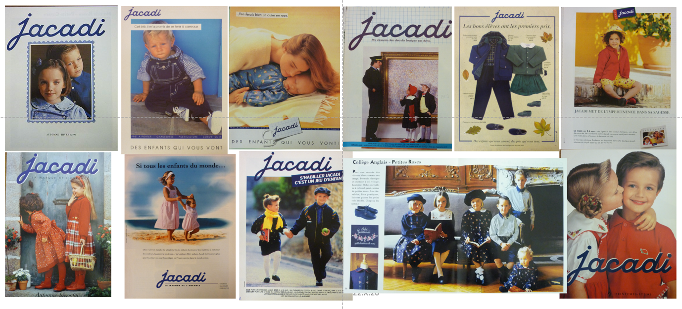
Fig. 8.1. Adverts of Jacadi, 1980-1994, private collections

In 2005, Jacadi joined the group IDKids.Community, and undertook a thorough reflection on its branding, including the need to rethink the narrative of the collections, the communication and retail style. At this point in its history, this brand was struggling to find an identity, lost in a melting-pot of inspirations, diverse interpretations of the notion of tradition and nostalgia in fashion, and unfocused creative directions to fight against the drop of prices in the context of the rise of fast fashion labels (Mandraud 1996).
For IDKids.Community, the education and socialisation of a child aware of her role in the society, considered as a ‘being and a becoming’ is key (Prout 2005). The motto of the company – ‘To make the world progress in the service of the growing child’ (https://corporate.idkids.com) – is applied across all the labels of the group. The respect of children as consumers but more importantly as users and future adults is a priority in the definition of the brand promises of the group.
In this approach of the social responsibility of ID.Kids Community towards the creation of a better future for children, the notion of sustainability is embedded in the group’s strategy: for Jacadi, a brand targeted towards traditional middle-class families, the reduction of the over-consumption is part of what the target market values as core to the domestic economy. Most of Jacadi’s clients prioritise the quality of clothes towards their price and consider the “Made in France” as a guarantee of quality. The purchase is most of the time multi-generational, and the visit to the shop a nice opportunity to share clothing memories between children and their ascendants. This approach towards the consumption and the material culture is particularly vivid in the social group targeted by the company. The notion of durability is therefore intimately linked with the conservative approach of this heritage brand. The genuine notion of transmission for these customers, is embedded in the timeless style of clothes which are transmitted from sibling to sibling, from generation to generation and selected by the adult purchaser as a reminiscence of their own childhood. To echo Kate Fletcher (2019), the biography of these garments becomes the cement between the users and the generations before them who have worn similar styles, dress codes and ultimately clothes. The concept of transmission is embedded in the strategy of the brand, which includes regular swapping events, second-hand markets in their retail and impactful charity projects with local communities of makers via the Foundation of the group Act for Kids. The strategy of the brand doesn’t rely solely on the nostalgic style as a trend, but on this concept as a sustainable recipe, where the creation of timeless collections creates the emotion and fosters the bond between children and their clothes, as the incarnation of their family history (Norman 2004).
Therefore, defined by its nostalgic approach of childhood and by the sense of transmission, Jacadi is legitimately anchored in a reenchanted past. The purpose of IDKids.Community to focus on the story-telling of the label, defines the brand and differentiates Jacadi from its direct competitors, whether heritage or nostalgic.
If the notion of heritage brand was blooming at the start of this collaboration, such an appetite to undertake a rigorous academic process to secure the legacy and positioning of a range dedicated to the overlooked children’s ready-to-wear was unusual. Undertaken between 2008 and 2010, with preliminary pilot phases between 2006 and 2008, the repositioning of Jacadi’s values and identity, aimed to identify an original and durable methodology to create a branding tool, to inspire the artistic direction and to be identifiable by the targeted high-end customers. This research focused on the needs for consistent inspirations for product design had also to be echoed in the communication and the retail style. It addressed the necessity to gather together a repertoire of traditional features supporting the renewal of the collections. This collaborative research contributed to the definition of a made-up centennial heritage for an only forty years old children’s fashion brand, which was looking at establishing its reputation and at gaining more legitimacy in a competitive market.
The position of Jacadi in a global sector was also a central aim of this heritage strategy. The worldwide representation of France and Paris as the cradle of luxury fashion was identified as the unique selling point that this approach of fashion heritage could contribute towards. Working from the clichés spread across Fashion history, helped to outline the style of the collections and communication. However, the notions of traditions and authenticity had to be grounded in a consistent and original approach to reinforce the character of this brand, despite its recent history.
Ultimately, this approach aimed towards the creation of a common brand culture for all the collaborators of the company, accessible to the customers and reinforcing the position of Jacadi as a premium high-street French heritage brand for children. The author stood as an expert advisor in children’s fashion history and worked alongside a core project team strategically gathering the senior management of the brand (Director), Head of Design and Style coordinator.
To reach these aims, a series of objectives were set:
- To respond to the concept of nostalgia in childhood and to connect with the target customers through the development of a childrenswear brand, based on the concepts of tradition, transmission and heritage;
- To create a heritage-based brand culture for Jacadi, spread across the brand promise to all collaborators and perceivable by the customers;
- To identify the appropriate methodology to create a branding tool and story-telling inspired by the heritage of children’s fashion and clothing.
A brand promise was written at the very beginning of the story between IDKids.Community and Jacadi. To provide further clarification on the phrasing of this poetic motto, ‘Jacques a dit’ is a game equivalent to the British ‘Simon says’ played by generations of children. The name of the brand refers to this timeless childhood game, which sounds like a statement for a company looking at reaffirming its identity:
‘Jacadi a dit…: Renouveler et transmettre aux jeunes générations partout dans le monde le patrimoine authentique et intemporel de la mode enfantine de tradition française.
Jacadi Paris : La marque contemporaine, élégante et raffinée, respectueuse des valeurs de la famille, attentive à la tendresse et à la fraîcheur de l’enfance.’
[“Jacadi said…: to renew and transmit to the young generations across the word, the authentic and timeless heritage of the French tradition children’s fashion. Jacadi Paris: the contemporary, elegant, and refined, respectful of the family as a value, aware of the tenderness and freshness of childhood.”]
The key words in this promise could suffice to define the contours of the collections and to imagine the ideal child targeted by this label. However, to the eyes of the management of the brand, these words had to be supported by a visual interpretation, echoing the story that the collections had to tell and embarking the teams in a consistent and inspiring vision of the brand.

- Towards a pretend heritage: methodology

The rebranding project started with the definition of the core values of the brand and their contextualisation in history. At this stage of the project, the necessity to create own methodology to ensure a consistent branding was expressed by the management team. Acting as an advisor within the project team, the author brought her expertise in children’s fashion history and research methods to reach the aims of this branding project. The object-based analysis of children’s material culture in the collections of European fashion museums, combined with the visual analysis of the representations of nineteenth and early twentieth centuries childhood in the arts, literature and family archives and the cultural environment of the time led to the collection of a corpus of objects and images. This corpus was analysed using an original coding defined in conjunction with the strategy of the brand. This corpus was interpreted and combined in a functional way, to form the grounding of the story of the brand and to establish its creative signature. This original semiotic approach combined visual analysis (Van Leeweun and Jewitt 2010) and object-based research in fashion and textile heritage collections (Kim and Mida 2015), with elements of design anthropology and story-telling.
This collaborative process was broken down into a series of stages held between 2008 and 2010 (with a pilot phase from 2006 to 2008), aiming to define the brand, to constitute its corpus of inspiration and to transform this into a durable corporate culture. The steps were as follows:
- To define and write the story behind the collections in relation with the brand promise;
- To identify the brand as a persona, setting a first set of inspirations through imagery;
- Creative platform: collections and communication directions gathered in a brand baseline and embedded in the brand platform;
- Team training: to organize a series of workshops to foster the corporate culture and provide guidance on the brand baseline and design charts.
- Interpretation of seasonal trends and presentation of the collections: written and visual communication directions, archive research…

  - The pretend story: which story to tell?

At the time of its adjunction to the group IDKids Community, Jacadi’s headquarters were located at the heart of the lively retail area of the Grands Boulevards in Paris. The flagship, situated boulevard des Capucines, in the historical cradle of the Haute-Couture and Department stores, stands at a stone’s throw from the Opéra and in the heart of the Paris capital designed by the Baron Hausman in the eighteen-sixties. Via this symbolic location, the brand reflected the vibrant and contrasted Imperial city of Napoleon III: the capital of an urbanising country where the modernisation of the industry, the changes in lifestyles, the apparition of what Guy Debord defined as the Society of the Spectacle (1970) and paradoxically the strengthening of the familial bonds in the growing and powerful bourgeoisie, were mirrored by the Imperial Family and their heir (Join-Diéterle, Tétart-Vittu 2008). During this period referred to as the Second Empire in France, the consideration for the child was revealed, not only in the design of bespoke nurseries in the well heated appartements of the wealthy families, but also and certainly consequently, by the creation of a growing childhood culture in books, lullabies, toys (Becchi and Julia 2004). These luxury goods were made available in the Department Stores where could also be found an increasing offer of clothing, whether casual or occasional, for all ages in childhood. The trends were inspired by the European Royal and Imperial Families which, as dress code prescribers as well as good patriots, were widely represented in the emerging press of the time (Join-Diéterle, Tétart-Vittu 2001).
This context, where children were considered as the heirs of their familial heritage and wealth, were nurtured, and equipped, in the traditional settings of well-established families, inspired Jacadi for its resonance with the values of the brand. Echoing the international representation of Paris as the Hausmanian Fashion capital, and electing the Opéra as its flagship, Jacadi settled in this reenchanted past and took it as the context in which the story of the brand could flourish.

  - Questionnaire de Proust: drawing the portrait of the brand.

A personality test inspired by the British game Confessions, the questionnaire created by the French novelist Marcel Proust in 1886, is a way to convey own perceptions of life via the creation of analogies and intimate reflections (Carter and Servat 2005). In order to reinforce the pretend story of Jacadi, and to provide a visual interpretation of the brand, this popular questionnaire was adapted to allow the generation of visual answers. Indeed, the objective being to gather a corpus of inspirations, the priority had to be given to the tangible illustration of the persona of the brand. However, the definition of the context in which these images and objects were selected was key in the drawing of a consistent portrait: it was decided that Paris and the Second Empire were the relevant and common contexts for the selection of the images illustrating the answers to the Proust’s questionnaire.
A set of questions was defined: if Jacadi was a location; a season; a time; a house; a room; a book; an object, a story, a moment in life, memories of childhood, a feeling, an ambiance, a texture, a colour…
Each answer led to the careful selection of a group of three images illustrating the answer in context; the visual interpretation of the context; the interpretation of this context from a product perspective via an object. The three answers are inter-related and define Jacadi’s branding territory. The iconography has been selected in the historical context defined in Jacadi’s pretend story, to allow a consistent approach. The important point of the selection of visual sources is that they represent a dressed-up child, or children in action illustrating each item of the questionnaire. Each image is therefore related to the childhood culture in context.
Ultimately, an investigation of childhood’s culture from the eighteen-sixties until the early twentieth century has allowed the collection of stories, poems, nursery rhymes, songs and illustrations referring to the everyday environment of children in wealthy families. Here again, the analysis of the objects and illustrations referring to this category allowed the identification of a specific aesthetic inspiring the products conceived by the creative team.
From this initial stage, a corpus of eighty images inspired by the contextualised childhood culture was conveyed and helped to inform the development of a design platform via a consistent and systematic visual analysis. In parallel, the careful study of the written style on these archives provided a grounding for the brand communication. Combined with a research on the glossary of the retail catalogues carefully edited by the department stores over the second half of the 19th century, the expression of a pretend heritage brand started to take shape (Fig. 8.2). The final selection of visual and written sources, consensually decided by the project team from a short-list advised by the author, was presented in a portfolio shared to the creative and communication staff of the company in the dissemination phase of the project (see section 4.6).
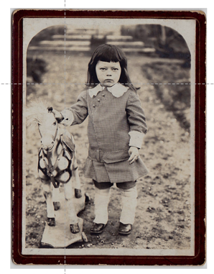
Fig. 8.2. Answer to the question: “If Jacadi was farm animal” – a horse. Anonymous, Portrait of a young boy, photograph, c.1890, private collection

4.3. Object-based research: From the archives to the shop – ‘Les Emblématiques’

In its quest for legitimacy as a heritage brand, Jacadi is looking at the appropriation of iconic outfits from nineteenth and early twentieth centuries children’s fashion. Here again, the context set by the pretend story of the brand (Paris and the French Second Empire), as well as the willingness to focus on the most representative children’s clothes, set the boundaries of the investigation. This initial experimental phase was piloted in 2006 for the development of a more structured heritage strategy. Most of the iconic pieces were suggested by the items identified in the corpus analysed in the ‘Référentiel des collections’ presented as a digital portfolio. Further research into the museum’s collections and the archives of the production (retail catalogues and department stores archives) provided the list and looks of iconic garments which could be appropriated by the French Jacadi. As a brand anchored in the history of children’s fashion, Jacadi found its legitimacy equally in the adjunction of a repertoire of emblematic and highly symbolic garments as the highlights of the seasonal collections.
However, the modernisation of these vintage pieces by the design team requested a careful interpretation to avoid the sole copy and paste of original archives identified in European museums’ collections. Furthermore, the modernisation and adaptation of the textures and shapes to contemporary functions had to be envisaged to ensure the commercialisation of these items and meet the business targets of this childrenswear label. In parallel, some of these items related to a certain age range might not be relevant to today’s children: for example, this is the case for the ‘esquimeau’ (eskimo), a popular woollen romper suit for the five years old boys in the nineteen-twenties, worn by the babies in contemporary fashion. This garment, knitted in a cashmere yarn to meet the requirements of the target market of the brand with regard to the high-end knitwear, has been adapted for the winter new-born collection in 2010 and is reedited on a regular basis. The interpretation of these iconic witnesses of the past is subject to contextual adaptations to meet the need of contemporary markets.
From collaborative sessions between the design team and the fashion historian, a repertoire of garments, shoes and childcare products, the ‘Emblématiques’ identified in the archives of children’s material culture, provided genuine information regarding the original texture, material, colour, shape and features of these vintage outfits. The thorough observation methods as presented in The Dress Detective (Kim and Mida 2012), guided the analysis of the objects identified in the textile and fashion collections across Europe. To ensure the contemporary interpretation of these signature items, the variation of these outfits through the times, whether in terms of shape, composition with other garments, context and usage, age of the user and season, were informed extensively. The contextualisation of these garments has been possible thanks to the archive of the production, the photographic archives and alternative illustrations of the garments worn by children. This provided further information to the design teams, which emphasises the narrative of these collections. In the case of Jacadi’s collections, the story to tell is key in the transmission of the nostalgia surrounding these vintage objects. (fig 8.3).
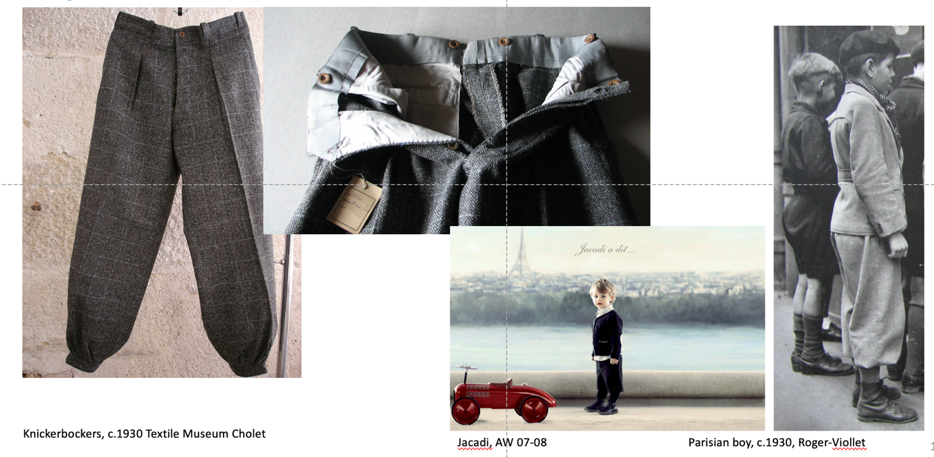
Fig 8.3. Archive research for the breeches, from the archive to the final product and advert, 2006, © Musées de Cholet, © ID.Kids, © Private collection (dr)

In parallel, between 2007 and 2009, Jacadi’s communication teams undertook a reflexion on the transmission of these iconic pieces and their related stories to the customers. The creation of shop’s windows focusing on historical emblematic silhouettes and providing the historical definition of garment, patterns or embellishments, used this dictionary presentation as a reference (Autumn-Winter 2007-2008) (Fig.8.4). This was echoed by the digital and printed communication publishing the stories of the ‘Emblématiques’ in an encyclopaedic manner, reinforcing the historical approach of the brand.

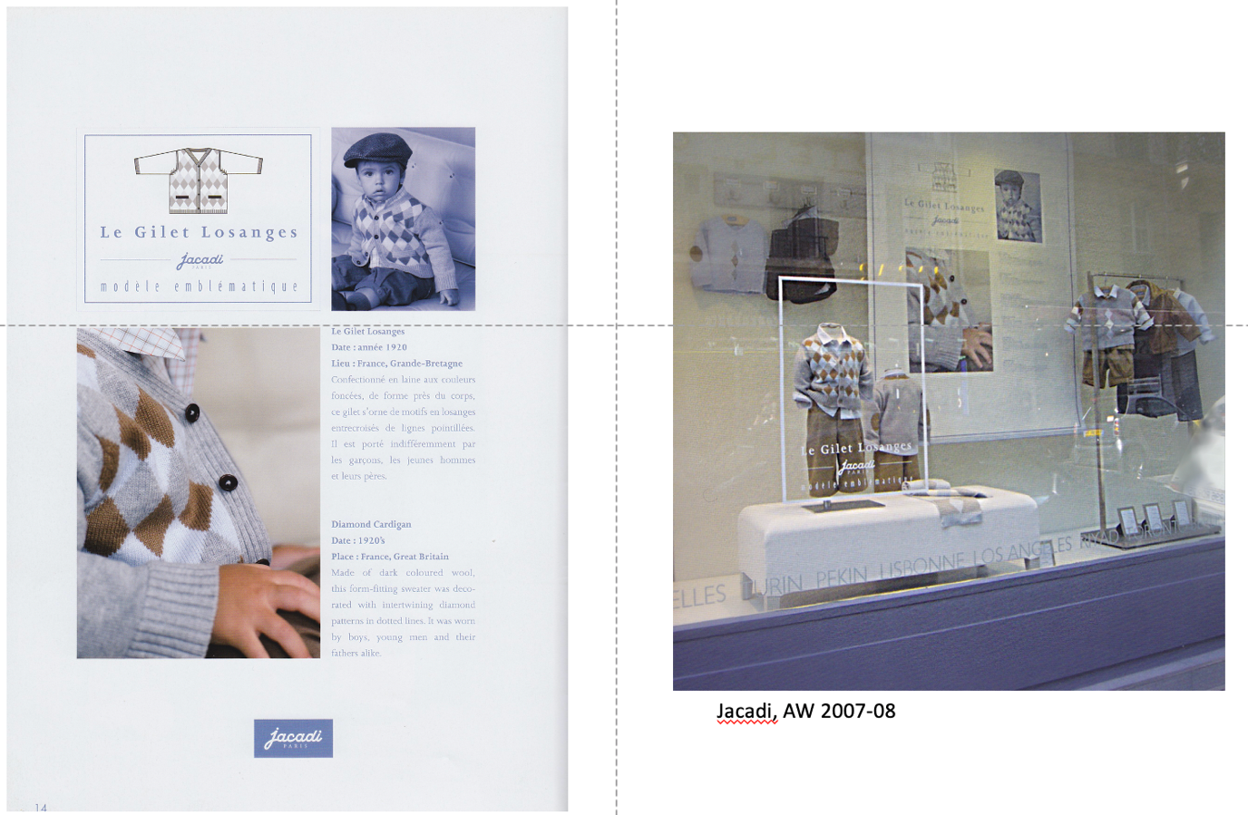
Fig 8.4. Communication and retail: focus on the ‘Emblématiques’, autumn-winter 2007-2008, © ID.Kids.

  - Visual analysis

The visual interpretation of this corpus of archives, objects and images, was based on the content analysis of the visuals following a specific framework presented below and compiled during a collaborative workshop with the creative teams. This framework has been extensively discussed between the author and the project team as described above, to ensure the efficiency of this tool feeding into the design platform of the brand. The creation of a digital database collecting the features, shapes, textures, sensorial emotions, staging, and effects presents in these images was prioritised to inspire the design of the comprehensive collections of Jacadi, from clothing to shoes, from furniture to toys (Fig. 8.5).
Each image in the corpus has therefore been deciphered using this framework. Each feature, identified on the documents has then populated a large template categorising all visual details and providing illustrated examples to the design teams. This digital document, known as the ‘Référentiel des collections’ was also used by the communication team as a baseline for the creative direction, from the sale catalogues to the adverts and the digital marketing.
Archive
Fig. 8.5. Visual analysis of the archives, framework, © Aude Le Guennec, 2009

  - Telling the story: the role of the visual communication

The work around the iconic pieces of children’s fashion history emphasised the reality of the inspiration, borrowing from the past a series of features which are identifiable as vintage in the present. However, the link to the past sometimes relies mostly on the construction of this inspiration thanks to a carefully edited communication. This is particularly the case for Jacadi. When the garments are not a straightforward interpretation of children’s fashion, the reenchanted past appears in the staging of the adverts, in the colour palette inspired by the camaieu of sepia of old-fashioned photographs, or in the posture of the child mimicking the stillness of the heir on a wealthy family portrait. To follow a consistent and nostalgic story-telling, the first advert campaign were strongly inspired by the criteria identified in the ‘Référentiel des collections’. The abstract backgrounds, the silence, quietness and refined style of the models, the limited number of accessories referring to the past, were selected from the visual analysis of the corpus of illustrations, to create the ambiance of this heritage brand. Similarly, the wording in the communication of the brand reinforced this originality via a glossary of terms very carefully identified and enhancing the distinct style of the French timeless elegance.
This database has developed into a consistent repertoire designed for the teams in charge of the creation of the collections, the communication and the retail. The ‘Référentiel des collections’ has been digitalised and categorised in a series of files, for ease of utilisation. As the root of a solid corporate culture, this heritage platform has been used upstream to secure a consistent approach to the narrative of the collections, and downstream to communicate this story to the customers, to the children as users and their parents as buyers. However, this phase of the project would require further development to adjust to available online database systems, and to create a versatile, durable and user’s friendly tool. This provides further areas of improvement for the future of this project (Fig.8.6).

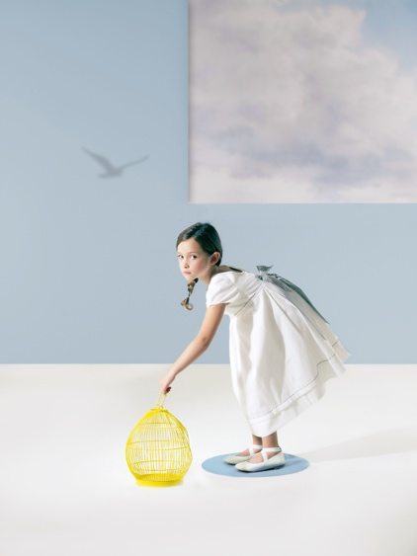
Fig. 8.6. Advert, Jacadi, Spring-Summer 2012. © ID.Kids

  - Spreading the word: training of the collaborators of the brand

The objective of this branding project was to ensure that all the collaborators of the brands had a similar approach to the identity of Jacadi and a consistent interpretation of its heritage. As mentioned previously, the concept of nostalgia is related to the child remaining in each adult. The childhood experiences differ from individual to individual, due to the variation of backgrounds, contexts, education, and ultimately life. In a fashion company, the creative team is made of the amalgamation of personal stories, autobiographies which inspire, affect and interact with the ideation process. For one, Jacadi’s motto might refer to the enchanted childhood of the nineteen-sixties, when another will combine this understanding of fashion history with own childhood in the nineteen-nineties. These tiles of life interfere with the message, pretend story and incarnation of the brand. The objective of this work was therefore to ensure the consistency of the interpretation of Jacadi as a heritage brand in a team already aware of the nostalgic approach of the creative process in childrenswear.
Therefore, the investigation and analysis undertaken in this long-winded mission were mostly collaborative. From Proust’s questionnaire to the compilation of the “Référentiel des collections”, regular brainstorming sessions ensured the total involvement of the teams from the selection of images to their analysis. Contextualised children’s fashion archives gathered by the expert (author), were fully discussed and interpreted in the light of the current trends by the design team, prior to their inclusion in the collections of the brand. During a thorough process held each season during this project, concessions were made in the historical features of these heritage items to meet the needs of the global high-end target customers. Finally, the restitution and synthesis of the work after nine long months of core analysis were organised with the support of carefully considered thesauri which were synthesised to allow a formative presentation to the brand collaborators. More than the actual content, the methodology of archive analysis, their selection in a specific context and the comparative approach of the archives had to be understood by the team. Therefore they had to embed this learning process to shift the ideation of the collections. The communication to the wider community including the retail teams and the preparation of the message transmitted to the customers, was one of the main outcomes of these seminars. The documents prepared by the communication and marketing teams for the annual presentation of the collections emphasised the written and visual identity of Jacadi as a heritage brand. Ultimately, the consistent approach, from the pretend story to the ‘Réferentiel’, feeding into the creative and communication processes, secured the legacy of Jacadi and contributed to its signature as a compelling heritage label anchored in a well-identified past, echoing its brand promise.

Conclusion: a story to be continued…

In 2021, Jacadi prepares its fourty-fifth anniversary. Following a long reflective process and overtaking the issue of the difficult access to the sparse archives of children’s fashion, this collaborative work on the pretend story and elected heritage of the brand has led to the structuration of an internal virtual museum gathering the references and inspirations for the collections and beyond. The archive inspiring durable collaborative tools to develop the consistent signature of a well-established heritage brand was envisaged during this long but necessary process. Indeed, this allowed a thorough design ideation based on the modernisation of vintage clothes, legitimating Jacadi as a brand anchored in the history of children’s fashion and securing its legacy. This database was developed in articulation with the strategic positioning of the brand in a competitive market, to ensure the originality and strengthen the signature of this house. The creation of a strong and consistent identity based on the values of tradition, nostalgy and French elegance, thanks to this thorough investigation into the heritage of a well identified childhood, transformed Jacadi into a refined high-end label. From the perspective of the company, the creation of a branding and creative tool, not only ensured a more sophisticated approach of the notion of heritage going beyond the copy and paste, but allowed further in-depth interpretation and connection with the customers of this heritage House. From the point of view of the author, this project contributed to the research on the contemporary interpretation of past children’s fashion in the creative process and the embedment of the concept of nostalgia in fashion. This case study was included in a wider ongoing research leading to comparative approaches amongst contemporary brands.
The creation of the virtual museum of Jacadi and the following ramifications leading to a refined approach of the ideation of heritage-based collections, demonstrated the impact of a consistent methodology on the communication to the target market and ultimately children as users. The reflection on the notions of tradition and transmission are core in the creation of Jacadi’s legacy. By creating collections perpetuating the representation of a well-defined childhood of the past, by contextualising their creation in a story told consistently, Jacadi reinforces the bonds between the brand and its customers. Each season, a new chapter explores the memories of this re-enchanted past. Each season, parents and grand-parents purchase a piece of memory which will be worn by the children and bond the generations. This wouldn’t be possible without the strong support of an impactful methodology, which enhances the importance for museums to interact with the fashion industry more closely. At the heart of the creative process, museums play a part in the creation of clothes created from the memories of their customers, and therefore emotionally connected to their users, the children.
Going beyond the sole collections and products ideated from the inspirations generated from the past, the notion of transmission could be explored from a different angle: children could become the actors of this creative process by learning how to sew, how to stitch, how to embellish and appropriate these clothes imbued by the stories of the past. Children could actively participate in the creation of the autobiography of nostalgic heritage clothes. The teaching of these timeless needlework skills could take the form of a different engagement between the company and its customers, a relationship where the heritage is not passively passed from generation to generation, but embedded, learned and told. In a post-pandemic world, the relationships between children and their parents have been profoundly moved into more organic interactions, where learning, education and fulfilment are intimately linked. Thus, involving children in the perpetuation of their family stories becomes, in a sense, a shared responsibility with the fashion industry. This is maybe the next chapter for Jacadi.

References

Ariès, Philippe. 1975. L’enfant et la famille sous l’Ancien Régime. Paris: Hachette.
Balut, Pierre-Yves. 2014. Théorie du vêtement. Paris: L’Harmattan.
Barrère, Christian. 2013. Heritage as a basis for creativity in creative industries : the case of taste industries. In Mind & Society: Cognitive Studies in Economics and Social Sciences, Springer: Fondazione Rosselli. 12(1): 167-176.
Becchi, Egle and Julia, Dominique. 2004. Histoire de l'enfance en Occident : du XVIIIème siècle à nos jours. Paris: Seuil.
Belk, Russell W. 1988. Possessions and the extended self. Journal of Consumer Research, 15, 2: 139–168. https://doi.org/10.1086/209154.

Breon, Emmanuel. 2016. Les enfants modèles. Paris: R.M.N.
Carter, William C.and Servat, Henri-Jean. 2005. The Proust questionnaire. New York: Assouline.
Cook, Daniel T. 2004. The commodification of Childhood and the rise of the child consumer. Duke University Press.
Debord, Guy. 1970. The society of the spectacle. London: Black and Red.
Fletcher, Kate. 2019. Clothing and the natural world. London: Natural books.
Graham, Brian and Howard, Peter. 2008. The Ashgate research companion to heritage and identity. Farnham: Ashgate Publishing.
Jeauffroy-Mairet, Barbara. 2009. Dior, les années Bohan. Versailles: Art Lys.
Jin Byoungho et al. 2017. Fashion Branding and Communication, New York : Palgrave Macmillan.

Join-Diéterle, Catherine and Tétart-Vittu, Francoise. 2001. La mode et l’enfant: 1780-2000. Paris: Paris Musées.
Join-Diéterle, Catherine and Tétart-Vittu, Francoise. 2008. Sous l’empire des crinolines. Paris: Paris Musées.
Kim, Alexandra and Mida, Ingrid. 2015. The dress detective: a practical guide to object-based research in Fashion. London: Bloomsburry.

Le Guennec, Aude. 2013. Enfance vintage : quand le passe inspire. In Villelongue, M. (ed.) Défier le temps, une affaire de mode. Lyon: Editions Lyonnaises d’Art et d’Histoire.
Le Guennec, Aude. 2018. Du musée à la thèse : vers un modèle d’étude du vêtement d’enfant. Tétralogiques, 23: 115-142.
Lévy, Pierre. 2013. Beyond kansei engineering: The emancipation of kansei design. International Journal of Design. 7(2): 83-94.
Mandraud, Isabelle. 1996. Jacadi se retrouve sur la paille. In Liberation. October 4. https://www.liberation.fr/futurs/1996/10/04/jacadi-se-retrouve-sur-la-paille_184984/ (last accessed 22/07/2021).
Norman, Donald A. 2004. Emotional Design: Why we love (or hate) everyday things. New York: Basic Books.
Prout, Alan. 2005. The future of childhood. Oxon: Routledge.
Quentel, Jean-Claude. 1997. L’enfant, problème de genèse et d’histoire. Paris-Bruxelles: De Boeck Université.
Sedikides, Constantine. et al.2008. Nostalgia as an enabler of self-continuity. In Sani, Fabio (ed.). Self-continuity: individual and collective perspectives. New-York: Psychology Press. 227-237.
Simmel, Georg. 1904. Fashion. International Quarterly 10 (1): 130-155.
Van Leeuwen, Theo and Jewitt, Carey (ed.). 2010. The handbook of visual analysis. London: Sage.

Websites:
https://corporate.idkids.com/en/group/our-vision/
https://www.jacadi.co.uk/brand

This paper is based on the work undertaken by the author as a cultural advisor with the company Jacadi, between 2006 and 2010. This commissioned work which has been supported by a research on children’s fashion history (Le Guennec 2018), contributes to a wider ongoing research on nostalgia in contemporary children’s fashion, and has provided the ideal context for the experimentation and evaluation of an original mixed methods.
All data and information regarding this strategical project, sales and marketing information, are subjects to confidentiality and retained by IDKids.Community. Hence, these data are not published in this paper.
The corporate history of Jacadi can be found here: https://www.jacadi.fr/maison-jacadi [last accessed 25th March 2021].
The “Emblématiques” can be seen here: https://www.jacadi.fr/emblematiques [last accessed 25th March 2021].

