Points in the Ambience – Travels with Archaeologists and Artists in Orkney:
The document of a journey and one-day dérive from Happy Valley to Billia Croo.
Susan Brind & Jim Harold, Alex Hale, Daniel Lee, Antonia Thomas

Introduction
In a dérive one or more persons during a certain period drop their relations, their work and leisure activities, and all their other usual motives for movement and action, and let themselves be drawn by the attractions of the terrain and the encounters they find there. (Debord 1956: 2)

While this opening quote from Guy Debord’s Theory of the Dérive offers a guiding image for one of our days spent journeying through the Orkney landscape, where Debord considered the pure notion of the dérive (drift) to be an act located very much in relation to the urban, our day’s dérive – let us now call it that – in the mainland of Orkney moved from the urban to the rural. We began in Stromness, on the west coast, moving through the rural landscape to the Loch of Stenness, to Happy Valley, and via Tingwall to Birsay Moor and Burgar Hill, then back west to the coastal topography of Billia Croo and the Atlantic Ocean. Our dérive, therefore, deviated from Debord’s purely urban spirit but like other traveller/writers we wandered, both literally and psychogeographically, through the rural environment to natural sites, reflecting upon how they become subject to human activity.
Our itinerary took us between points on the map by coach. We walked, singly or in groups, at each stopping point, where our encounters were subject to unconscious and chance factors, mediated both by the reality of place and the contemporary archaeological and environmental histories of energy generation in Orkney. We conceded to Debord’s views on the ordinariness of life and experience that could become remarkable and subversive by turns (Careri 2017: 87). As a consequence our mode of walking became a creative act that seemed to both make and unmake itself.
Given the differing needs of our subject areas, art and archaeology, our approaches to the dérive, its images and traces – their use and application – was and continues to provide fruitful grounds for discussion. Each photograph, an archive of sorts, is a reflection from the world of experience and a catalyst for dialogue about representations of the material world and the photographs’ relation to the archive.
As we travelled between locations we noted the landscape itself was an archive of historical and contemporary remains, ruins and traces that are both tangible and intangible. Amongst these we observed place names that referenced the Old Norn language of Orkney and Shetland, Orkney legends, past visitors’ inscribed graffiti, and concrete conservation works or abandoned wind turbine plinths. Our images, texts and memories, in this paper, have become the physical or metaphoric articulations of the immanence of a series of vanishing points that allude to Debord’s vision for Art as disappearance. An ephemeral state that begs a documentary and a poetic form that resolves, and subsumes itself, thereby eluding the fixity of the archive.
Disruption of fixity and the authoritative voice is a strategic device within this text which comprises collectively written vignettes that speak to, respond or initiate tangential meanings across our disciplinary approaches: our differing currencies (currents) of the image and trace. Our use of the pronouns “I”, “my”, “we” and “our” is used to suggest a multivalency of voices that acknowledge individual subjectivity while asserting the analytic and poetic as having equal significance. This paper also acknowledges multiple perceptions of time as non-linear, subject to the past, present, and future, as it becomes entangled by and in our experiences and in the archive.

“… don’t forget your camera”, the American sculptor, Robert Smithson, urged those following his own tour, a dérive, of urban or industrial relics – ruins as mirror which he identified as monuments – besides the Passaic River, New Jersey in 1967 (Smithson/Flam 1996: 68-74).

Journeys …
September 2018: Our journey in Orkney this time began in Edinburgh at 10:20 GMT on Friday, September 7, 2018. I had received an email about submitting a funding application to the Royal Society of Edinburgh (RSE). The application was successful, we were charged by the RSE to aggregate, energise and explore. We developed four research workshops, under the title of #3M_DO_2019, that would bring together artists, archaeologists, anthropologists, heritage practitioners, students and community participants. The aims were to explore interdisciplinary approaches to contemporary archaeology in Scotland; to consider practices, roles and opportunities for contemporary archaeology, its relation to other disciplines and how, by undertaking contemporary archaeology, communities can engage with current major cultural and social issues, including sustainable energy in Scotland. Our journey was a continuation of others.

The view from Orkney: The Orkney trip was the third of the four workshops, and the best attended – everyone wants to come to Orkney. Our connections with the dérive sites trace back through a network of visits, inhabitations, memories and mental maps. Some go back over a decade, others are of things-yet-to-come; plans made, mappings envisioned, but not yet realised. I have a future relationship with these places that is still emerging, tentatively finding its way forward. My personal histories of these places have been formed by multiple visits, alone and with others. The tempo is irregular. Each time, of course, something new comes to my attention; I understand things in a different way. Either focusing on specific tasks and exploration, or seeing with the help of others. This journey, this dérive, was also an opportunity for us to share some of our favourite places with the group. For us, these sites were familiar and well-trodden, even ordinary, waypoints from a decade and a half in Orkney as resident archaeologists – or should that be archaeologists-in-residence? But with a new group of visitors, and new sets of eyes, our favourite places became once again remarkable and subversive. It was an opportunity for us to reflect on our role in the creation of the stories and archives of these places, to think about our own journey to this point in time and space. As archaeologists-in-residence, we wondered where we resided, in a disciplinary as well as geographical sense. Where did we belong, as incomers? On this particular journey, we were the locals.

September 2019: My journey to Orkney began at 06:34 GMT on Monday, September 2, when the taxi took me to the airport for Loganair flight 391 to Kirkwall. Some of us gathered in departures, others flew in from Glasgow and we joined people in Orkney. Previously, we had met in Glasgow in March, Aberdeen in April, and we had Edinburgh to look forward to in early December. My and our journey, though, began long before this one …

September in the Neolithic: In fact, our journey began over 5,000 years ago during the Neolithic, the New Stone Age in that antiquarian scheme of classifying monuments, artefacts and cultures: Unstan cairn in Stenness provided our fieldtrip with a beginning in linear time. It had been excavated in 1884, by local landowner, Robert Stewart Clouston, revealing a fine Neolithic stalled cairn built from quarried drystone masonry, standing testament to the skills of its builders. Afterwards the tomb lay open to the elements until the 1930s when it was re-excavated and taken under the protection of the Ministry of Works, who restored damaged stonework, and encased the tomb’s chamber. Unstan’s architecture now is a curated assemblage of turf and concrete, stone and gravel. No Neolithic markings can be seen on the stone walls, but the tomb shelters 120 years of messages carved since its 19th century excavation (Thomas n.d.). Their serif fonts are all that remains of past visitors and fieldtrips, some official, some illicit: a stone-written archive of tourists and archaeologists, lovers and vandals. The intimate traces of hands, thoughts, feelings and deeply felt, maybe unconscious, urges that are a “form of trace and a manner of performing one’s presence” (Frederick 2009: 213). Our journey partially awakens our urges; did we leave a mark?

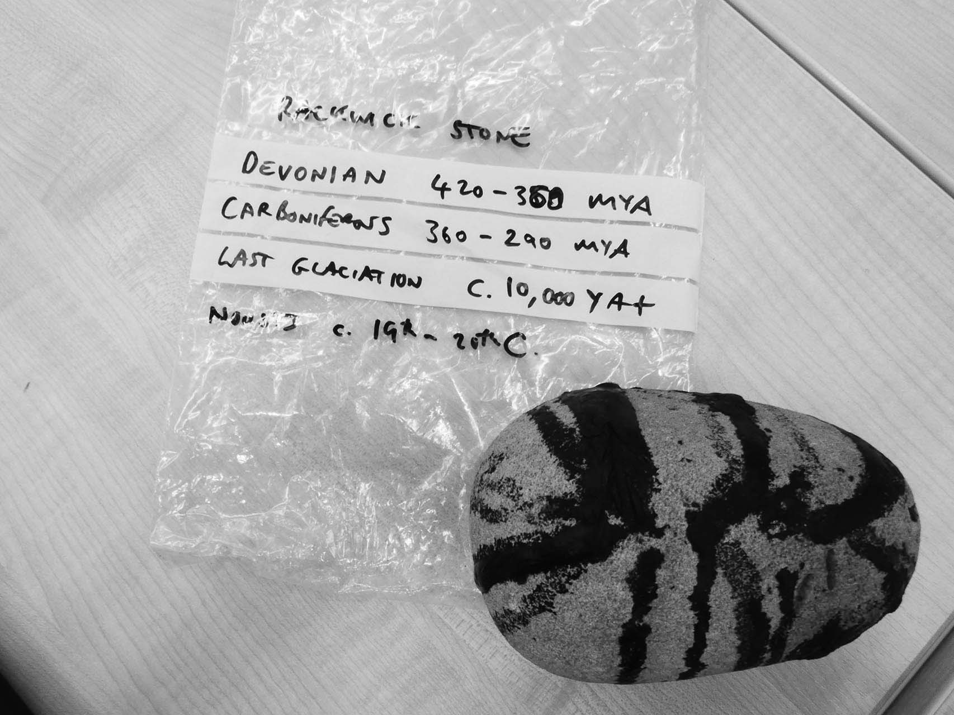
Figure 1: “… stones for experiences that cannot be transmitted” (Kaufmann 2006: 117), 2019. (Photo: Susan Brind)

If you want to think about deep time, hold this stone, or if you can’t, hold the idea of this stone. Its story starts in the silty accumulation at the bottom of Lake Orcadie, some 360 million years ago in the Devonian period. This warm lake with its resulting sandstone, then located near the equator, now makes up much of the landmass of Caithness, Orkney and the southern part of Shetland, cut through by the Pentland Firth and Fair Isle Straits. This stone, having taken many millions of years to solidify from the sandy silt, was at last released from the vast cliffs along the west coast of the isle of Hoy, near Rackwick (Wreckage Bay in Old Norse, stone wreckage in this case), perhaps sometime during the last period of glaciation when huge glaciers creaked up the Hoy valleys. Judging by its roundness, this stone has been rolling around for many hundreds if not thousands of years on the shores of Rackwick Bay. But before then, deep in the forests of the Jurassic period, rich organic deposits eventually transformed into coal, tar and petroleum. Many thousands of years later, probably in the late 19th or early 20th century, the tar you can see and smell on this stone found its way through forgotten trade networks to seal the small fishing boats – open rowing boats and yoles – that supported the Rackwick community. This stone happened to be below one of the boats as the hot tar dripped down from the hull. Several patches of tar splattered stones are still visible along the shore. The tarring of boats would have pre-dated WW2 and the last boats were held in the noust in the 1970s (Lee 2016: 25).

… a stone passed around … Peter Maxwell-Davies mentioned … his Hoy … a clifftop survey … the Old Man of Hoy … contemporary archaeological practices in Orkney … photographs from a recent survey … related notes and inventories … we discussed empathy … with the past … rational analysis v. that of the empathetic … the archive’s detachment for better or not … a shared sense of human aspirations evident in artefacts … craft … likely usage … human endeavour … shared ideals across time …

Our discussions played across a range of topics: the nature of research, the visual nature of both our disciplines, the value of data, of archive and experience and the possibility for dynamically different forms of empathy between our separate subjects. Of particular interest were those fertile border territories, the edgelands and verges of our subjects where intention and practice rub conveniently or troublingly against one another. Indicated, perhaps, as that dichotomy that might be considered to operate between a Cartesian view of the real and that suggested by the romantic imaginative, if faithful, rendering of a thing or place in art. It also touched on the particulars of agency and photographic usage, and of the value of the image itself as either a transparent window, a pictorial and atmospheric document and witness (Shanks 1997: 73) – become component within the archive – or as a trace of experience (McFadyen/Hicks (2019)). The distinctive qualities of archaeology and photography are not considered here in a reductive and analogous sense as parts in: “a mirror game of subject and object […] signifier and signified” (ibid: 3). Rather, they are considered as mutually supportive interventions into the world of experience and meaning.
In 1978 the American photographer and curator, John Szarkowski curated the exhibition Mirrors and Windows at MOMA, New York in which he enfolded disparate photographic practices from the 1960s through to the late 1970s into what he viewed to be a workable thesis. Put simply, Mirrors and Windows laid out an argument for two approaches to the photograph: the window opened a view onto the world through the camera’s frame, offering a method of external exploration; the mirror reflected back towards the maker and the viewer, and opened a dialogic space of photographic self-expression (Szarkowski 1978: 11). This was a simple enough characterisation of a polarity of approaches to the world as might be understood by looking through the camera lens or assessing post-production work in the darkroom. But while attempting to orchestrate a photographic zeitgeist, Szarkowski’s thesis actually asserted the traditional distinctions that lay between the photograph as evidential tool or document, and that which touched upon the poetic and the imagination.
This duality may be viewed as having its origins in the 19th century materialist conception of the photograph as a means faithfully to record – and fix – the semblance of a subject present before the lens: to render it as a conveniently portable stand-in and intermediate stage between the referent and the viewer, that held all the visual qualities of the original. It was not devoid of poetry, but that was secondary to it referential qualities. Photography’s easy adoption as a document within survey work, whether topographic or archaeological, has allowed it to become a vital element within the ever-burgeoning world of the archive. We think too of André Malraux’s virtual Musee Imaginaire or Museum without Walls (1967) that consisted entirely of photo-documents of art works. Documents, but not dry materialities. Rather, they were to be viewed as both window and mirror; as structures shaped by and through metaphor that inhabit artifice (Salmon 2020: 199). This was not to literally fuse the real with the romantic, the objective with the subjective, where image, word and world coincide, but to acknowledge the overlapping foundational value of the documentary and the poetic as rhetorical systems that together reflect an entangled reading.

… the first night spent in the body of a whale … the Orca hotel … a group of Jonahs … artists and archaeologists … breakfasted… disgorged onto Stromness’ main street … a narrow, semi-pedestrianised lane … parallel with the shore … today the midges have returned on the quayside … even the fishermen are troubled by them … broken cloud … periods of sun …

… A dérive
September 2019: Our dérive, in Orkney began at 08:00 GMT on the morning of Tuesday, September 3. On this journey we would conduct like charged particles rotating within Orkney’s dynamo landscape; our fieldtrip, one of individual and collective flux. We were single atoms charged with energy, collectively arriving at places on a map and individually moving to spaces within those places. Our journey took us on routes across the West Mainland, routes that scored lines on landscapes, attracted and repulsed by ruins of 20th century wind power and home-made hydro schemes. The carcasses of electricity generating projects, plinths of demolished wind turbines and talk of armoured under-sea cables stuck in my craw, made me sleep uncomfortably, disturbed by how much power we consume, waste, want. Our fieldtrip becomes a talisman of our affects.

… food from the local Co-op by the water’s edge … we gather … bus to Loch Stenness … a bit beyond … off the main road … Happy Valley … more midges under the trees … a monkey puzzle curiously out of place … a centre piece … the other trees orbit …

oak
lime

beech

ash whitebeam
rowan

monkey puzzle

yew
holly
elm
willow

apple

a nursery become
a grove

Happy Valley, a fiction of a name, conjured up to describe a plot of land that borders a section of the Russa Dale burn, which races off the hills and away to the north.

peat-oiled water

a deep tobacco

and
where the sunlight touches

the colour not so much that of whisky

as of a rich bloody claret

The place is a relatively small patch of earth, with an attendant small croft (Bankburn), that is now well camouflaged by a verdant covering of maturing trees, some indigenous but most imported – like us, a mixture of locals and incomers. What was once a typically open and treeless Orkney valley was planted and nurtured with what feels like a visionary zeal – certainly a passion – over a 40-year period by Edwin Harrold. Harrold, who died in his 90s in 2005, was laid into the ground, as he wished, in a coffin originally made for Ian Sellar’s mystical and visionary film about beauty and imagination, “Venus Peter” (1989). He was a character and a man of all trades: a farmworker, a road-builder, a worker for the Forestry Commission, a watch-mender and finally an employee of the, then, Ministry of Works (Gibbon 2012: 24-25). He brought electricity to the croft by altering the course of the burn, creating a serpentine waterway (maybe an echo of the landscape garden tradition) and built a dam to control its flow, and to drive a small 12V dynamo that fed into a heavy-duty battery. The generator sluice, which still flows, could be operated from the house, by means of a cable, allowing a degree of comfort control. The small wooden generator shed was demolished a few years ago, perhaps without thought for its innovation in the Orkney energy story. It was, however, recorded during an archaeological survey in 2011 (Lee/Hollinrake 2011: 36-37). The concrete base of the generator shed remains, once providing a modest supply of energy sufficient for his needs and no more.

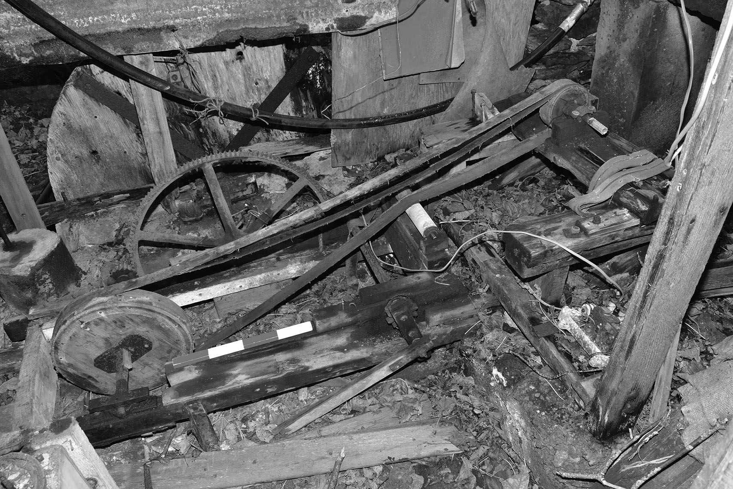
Figure 2: Edwin Harrold’s home-made generator, Happy Valley, 2011. (Photo: Andrew Hollinrake, Copyright: ORCA)

The charge that flowed for years and helped to make the croft viable as a home has, since Harrold’s death, ceased to flow and Bankburn has slipped from an idiosyncratic dwelling with attendant arboreal haven back to a protected shell. The croft is, sadly, emptied of his possessions (now reduced to artefacts listed on an inventory). The rooms, become spaces and voids, permit little that might suggest the vitality of their former occupant, were it not for the archaeological survey (ibid). Memory now resides in that photographic record, each image accompanied by a constant measure, a short red/white/red/white scaling rod and an exhaustive inventory. Preservation by archive …

evidence of a life
no longer
there

Figure 3: Looking through window into the croft. Bankburn, Happy Valley, 2020. (Photo: Antonia Thomas)

The glaze of reflections now seen on the croft’s grimed window panes made looking in to the interior difficult and the face on the glass was one’s own: window as mirror that became a poem to absence.

… this was his world … his imagination writ onto the landscape we walk … that walk of the stranger … away and towards one another … Debord’s “lost children” … in a lost Eden of sorts … each following their own curiosity … their own sight-lines … take photographs … among the trees … his planting … to the burn … along its bank … some cosmetic work … artist interventions … idealize a working vision … make of it a venue … a dismembered vole … head, stomach and intestines … one small kidney as red as a ruby … the only remains … on the boardwalk through meadow … over marsh … amongst grasses … back at the bus … individual reflections, sightings … discrete images merge … unspoken but held – within the larger narrative of the day …

Saturday, January 2, 2021: A New Years’ walk and a time to return, just two of us this time. A time to reflect, on the past year, and on change. The burn was lower than it had been the autumn before when we visited as a group, the paths drier and less muddy underfoot. In a neuk in the walled seating area we spotted a plastic tub, set waiting to be found. Inside a small notebook, with a handwritten invitation: “Take something and leave something”, and the responses of five visitors. The archival impulses of strangers… Take something and leave something.

… via Tingwall … no boat at the pier … across the water … islands cluster … flat calm … a library … Betty’s Reading Room … not a soul in sight … we drift on …

Burgar Hill, towards the northern tip of the Mainland, is a remote highpoint that has, since 1983, become a centre for wind energy testing and development. Its peripheral location has drawn urban infrastructure into the rural landscape, and into what has been termed by some as the “edgelands” (Farley/Roberts, 2011: 193). It is also the location of a high moorland environment and cluster of lochans that are now part of a RSPB nature reserve and home to rare species including: red-throated divers (loons) and hen harriers. The lochan, open moorland and the wind farm – realms, with two imposed designations – are, of course, oblivious of any such definitions.
Elements within contemporary nature writing seem to drift through these hinterlands where the present is haunted by its folk and literary past, cultural tropes, and images. I recall that in his essay, Formulary for a New Urbanism (1981 [1958]), Chtcheglov (alias Ivain) had suggested that any passage through space and time, and the intensity of phenomenal encounters, has also to be haunted by traces of the past; by geology, for example, or in the magic lands of folklore (ibid: 2) – felt as much as seen here through an intangible archive of sorts. The view onto the sea and outlying islands, Egilsay among them, acting as a reminder of the poet George Mackay Brown’s invocations of the Orkney lands, the Orkneyinga traditions: his retelling of St Magnus Erlendsson’s death and martyrdom on that island (Mackay Brown 2019 [1973]: 44-45). Of other Orkney-born creatives: the poet Edwin Muir, and the filmmaker and poet Margaret Tait as she felt her embodied relation with all her Orkney ancestors, the “… Doers and undoers” (Mayer 2019). Or, Kathleen Jamie’s essay of drifting sand dunes and an archaeological survey at the Links of Noltland on Westray’s Atlantic shore (Jamie 2019: 107-173); the island visible across the water. We move between memory, reflection, reminiscence and the day.

under a luminous sky
liquid -
silver

high and broad here
and
still
at this latitude

last night’s rains
become
vapour
saturate
the distant air
wash the light
invite quietude
detachment

and in that
pictorialize this view

As well as a number of turbines, the moor is host to a group of single-story buildings that mark the end of the metalled roadway. These buildings, once the nerve centre for research then a visitor centre, are now locked and unused. In the race for renewable energy Orkney is among those places that are setting the pace and, since the construction of this and other windfarms, has become self-sufficient in energy. The problem now, given the viability of wind here in the north, is how to store the extra production (efficiency) and how to develop a grid system that would allow the spare production to be sent to the Scottish mainland (commerce). Orkney, frequently perceived as an outlier, on the edge and at the periphery, is again at the centre of a cultural and renewable engineering revolution (Watts 2018: 108). Laura Watts talks about the “Orkney electron”; not physically different from other electrons, but with an added social value (ibid: 27). A few volts to power a light bulb or two was all that vernacular visionary Edwin Harrold needed at Happy Valley.
Peering through the visitor centre’s glass walls proved to be a fruitless project. Again our various gazes stalled at the surface of the windows become mirror, that not only bounced our images back to us but also absorbed in its surface the spectre of the landscape behind. The window, rimed with sea salt, dust and condensation reflected a landscape that had also become a form of non-landscape. Where one could once have physically entered the space, the view of an image was all that could now be gleaned; and that, in a mirror image as a spectacle of inversion. By shifting one’s angle of view in relation to the glass wall, Szarkowski’s more static conception of the image framed – its fixity and remoteness too – became a series of compellingly magical, if unsettling, perspectival recessions (Chtcheglov 1981 [1958]: 2) that were not static, but in this context, as image and reflection, they became a continuum of fluid spaces and temporal disorientations. To look towards these images and to see what is behind one, in effect, placed the viewer at the centre of two vanishing points. I was no longer looking through the images as if they were either window or mirror, but as a series of vanishing points; Western perspective’s optical vanishing point alongside its metaphoric and poetic equivalent. In the process it was as if I, too, had become dislocated, just one more vanishing point in this terrain that disrupted the insidious and panoptic structures (Kaufmann 2006: 115) that haunt perceptions and representation.

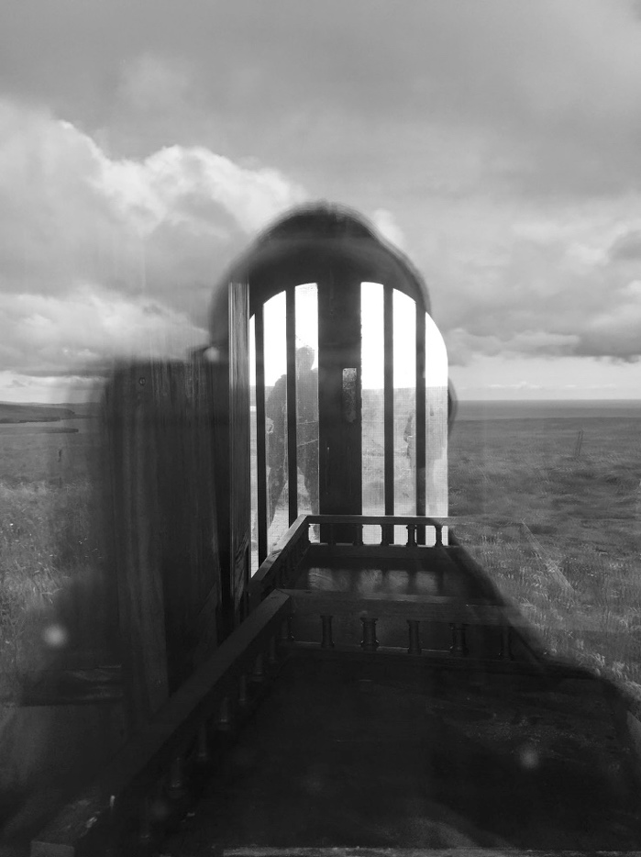
Figure 4: Burgar Hill visitor centre, 2019. (Photo: Alex Hale)

How might such a space or spaces be mapped, represented and opened-out? Could one, as Chtcheglov had done in his essay, list the places passed in walking, the swimming pool, police station, hotel, clinic, bars, cafés, etc (Chtcheglov 1981 [1958]: 1). Places and things whose equivalences in our present location would be: the metalled road, the gravel trackways, coarse stunted grasses and reeds, the different qualities of the moorland, the demarcation lines, human detritus, buildings, wind turbines, etc. But would such a listing of things be enough to carry the physicality and the poetry of this place? Things taken for their intrinsic qualities as things, a beautiful and fluid inventory viewed and poetically enacted – or photographically documented – in their own terms and moment, much as the American poet William Carlos Williams had advocated (Hinton 2017: 40). Could the record of place be that simple? Or, given the deep entanglement of things, that complex?
Debord co-opted the image of “lost children” to infuse all dérives with the qualities of non-attachment to place or time: to things and their absence. His lost children were not conventionally lost, but they were wanderers, shorn of attachments and drawn, in Debord’s terms to experience and encounter, and most significantly to disappearance (Kaufmann 2006: 14). A state of non-attachment and disappearance that acknowledged a certain level of nostalgia while positing a present of all action devoid of memory: another vanishing point. His lost children, in effect, released from their selves, “melt[ed] into the landscape, disappear[ed] behind the drawings, maps […] photographs” (ibid: 117) and all such representations and reflections.

… our reflections and a vague indication of sky on rimed glass … we wander uncertainly … what are we looking at? …windows as mirrors … a panorama of sea and islands … gravel and rock under foot … moorland … a large area of concrete … two perfect rectangular forms conjoined … how deep is the mass of concrete? … how much local earth was removed? … where are the blades and column now? … from here you can see the tiny island of Egilsay where St. Magnus was beheaded (circa 1117) … another slicing blade … the rocky spot where he was buried became verdant, it is said … look away from the concrete and windmills … a small loch and bird-observatory … a few ducks … but there can be hen harrier or loons here … just the hiss of wind and the slice of blades through the air today …

In Karen Barad’s terms “the past is not passed” (2018: 206), and traces linger however indistinctly or elusively above, in and on the earth. Barad’s apparently simple yet rhetorically potent phrase relates directly to the inevitable and lingering traces of deadly nuclear particles (fall out) that persist on the land and in our atmosphere as a result of historical and continued nuclear weapons testing and military usage. Her statement, as specifically focused as it is, seems equally applicable to a general overview of all actions in the environment. Most evident, here at Burgar Hill and within the moorland expanse, was the trace of former wind turbines whose absence was still evidenced by the concrete bases that remain post- their removal. Areas of rock and earth excavated and filled with however many tonnes of concrete aggregate are now no longer used, but the footprint is sunk deep into the Orkney ground. The expenditure of energy to get to this point – extraction, mixing, filling, setting – but not in removal or repair is evident as a “… mica encrusted / tomb” (Watts 2018: 107). Geometric forms set into the fluidity of the land, not yet worn away by environmental forces, become just one more element of the legacy of concrete in terms of the longer geological record (Farrier 2020: 64) – a thin few millimetres of strata amongst the many other layers. Thinking back to Unstan cairn: will the tomb’s concrete encrusted roof, installed in the 1930s directly on top of Neolithic walls, outlive the stonework it sits on?

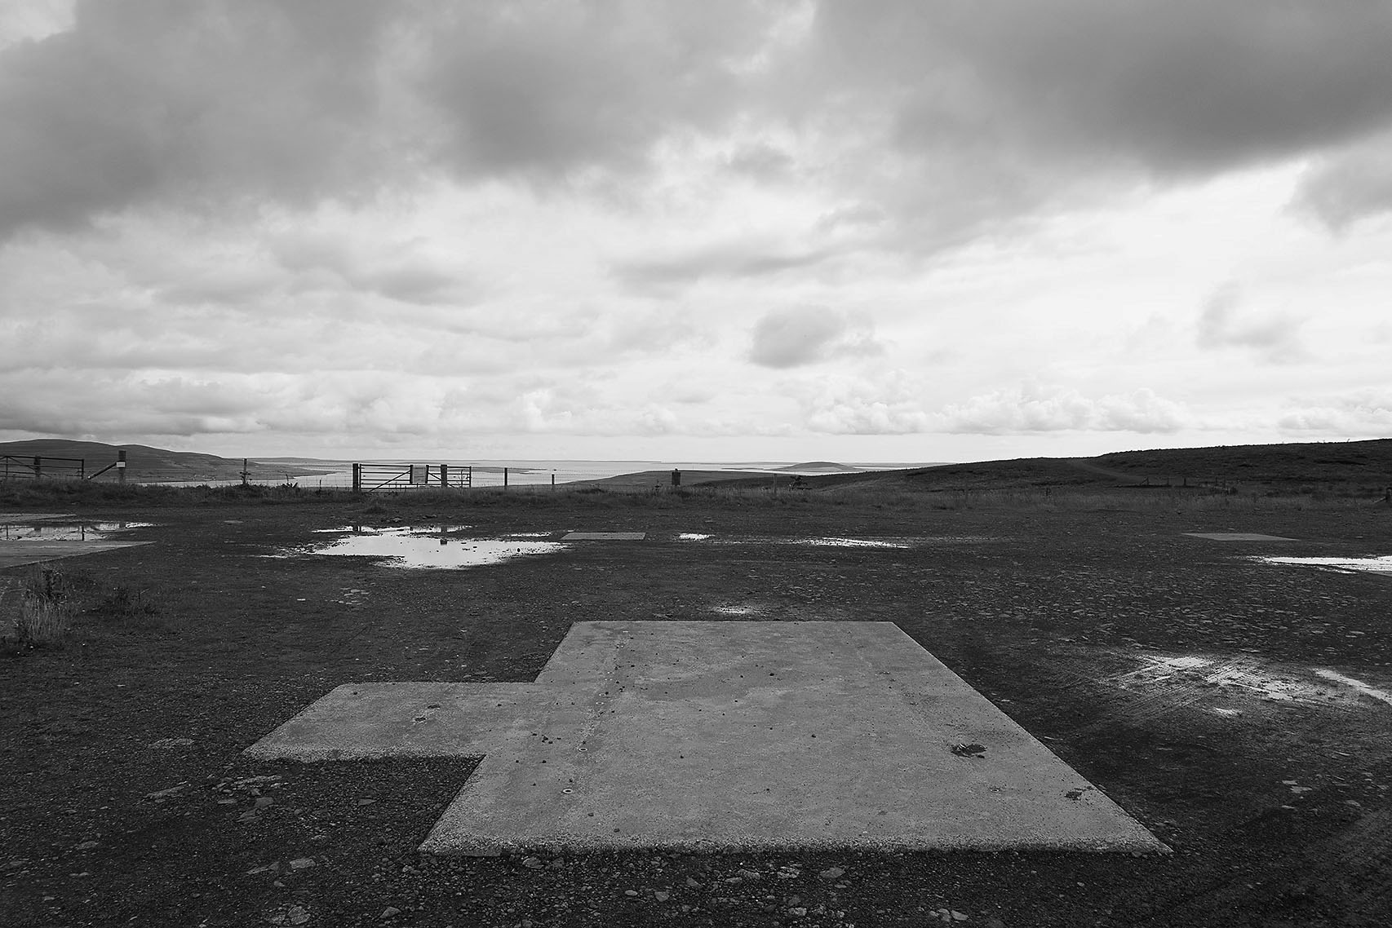
Figure 5: Site of former wind turbine, Burgar Hill, 2019. (Photo: Jim Harold)

… we cross the moors … pass past peat workings … archaeology of peat … the social distribution of cutting rights … on to Twatt village … the sound wall … we eat … silence … listen … WWII airfield remains on an adjacent rise … a dished landscape … marshland and loch … geese … some take to the air … silver-clouded light … on to the coast and Skara Brae … the Ness of Brodgar … the season’s excavations closed and covered over… black plastic sheeting and tractor tyres … thousands of them … to protect the archaeology … a perverse darkening of what has been brought to the light …

We drifted west and south this time, towards Billia Croo. The place name is somewhat obscure, but the first element perhaps hints at a long-lost personal name. The Croo part is clearer, a derivation from the Old Norse word krókr, for a small yard or enclosure, usually surrounded by walls for growing vegetables or keeping animals. The name Croo or Creu still appears across the landscape in Orkney (and indeed Shetland) today, just one of many ways in which the past is not passed in this Norse-inflected landscape. It still appears in common usage amongst local gardeners as planticru, a walled shelter for growing plants. Apart from the name there is no longer any trace at Billia Croo of such enclosures. Just a group of functional buildings huddled together in the voided space of an old quarry.
At the European Marine Energy Centre (EMEC) established in 2003, we huddle together out of the wind beside the monitoring station.

… in late afternoon light … the track down towards the Atlantic edge … a small quarry … a research site … EMEC … out to sea … nothing to see … distant view of Hoy … its tops lost under cloud … inside we look at photographs of research projects (past) … meter needles twitch … a pervasive background hum …a mantra of sorts … Microsoft … testing data storage here … nurturing data … fucking data … cooled by the cold sea … powered by it … sites deep in the arctic ice and now off Orkney’s coastline … the quest for cool … keep the system from over-heating … the quest for isolated places – virgin lands (that troubling term) … remote … discrete … out of the way … but not really … spaces and places that we refuse to understand on their own terms … the geese don’t care … but what of the whales … the orca that frequent the seas here … sensitive to sound frequencies … magnetic fields … their sonic communication compromised … navigation confused … overridden? … the Atlantic chill returned … we shuddered … at the desire to hold it all … data as power … another current … another currency …

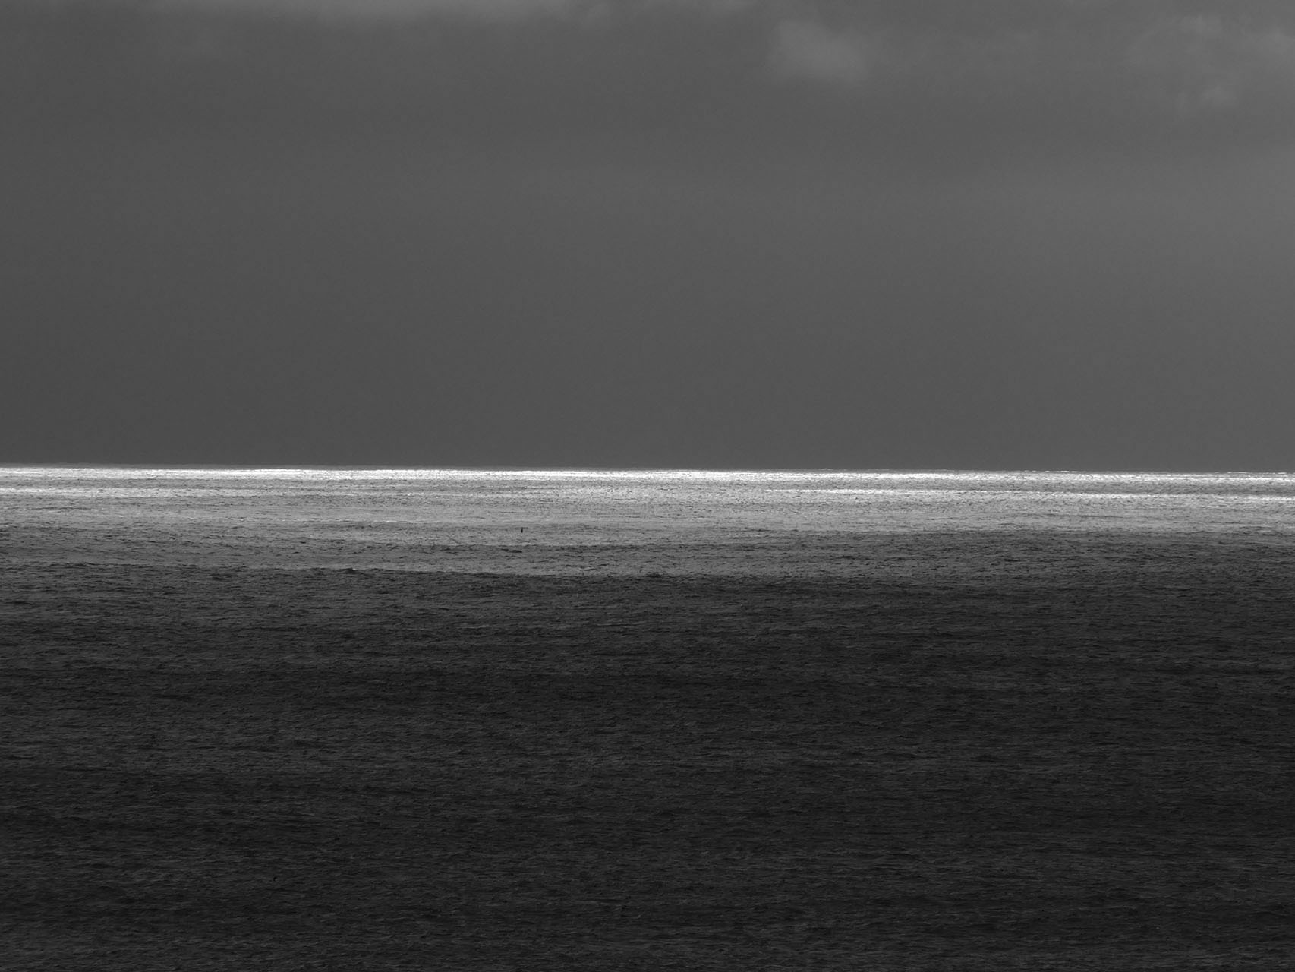
Figure 6: Westward from Billia Croo, 2019. (Photo: Susan Brind)

Standing above the shoreline at the Atlantic’s edgelands our EMEC guide relayed information about the elemental power and energy before our eyes: our experience of place and our feeling of ambient space were being reduced to plans and statistics, graphs and data. We found ourselves looking onto the sea’s surface and towards the horizon at the same time as hearing about what had been going on within its depths that we couldn’t see. While I listened, I was looking westward and could see an exquisite sliver of silver light defining the horizon. I wanted to be able to see it closer but of course it would always slip beyond me. I would never be able to see what it was defining; never be able to reach it. I knew this, yet there was a yearning within me to drift across the sea’s surface: grey and agitated; to drift, another dérive, towards an elusive point. To vanish.
Under the surface, just out there in the bay EMEC were working with Microsoft to ascertain the viability of undersea storage modules for digital data; a high-tech planticru sheltering data from the elements. An archive that, as we were told later, could store the equivalent of 5,000,000 feature films. I wondered, might “Venus Peter” be among them? Or as a companion noted, might it be 5,000,000 copies of “4 Weddings and a Funeral”? We shuddered not just in the Atlantic chill but at the desire to hold on to it all.

… storage … an archive … a sort of inertia … going forward while gathering the past … its stuff … the weight … the energy expended to save it … new technologies of storage … while the material itself wants to degrade … to absent itself … held by an obsession … document and hold … but is it everything or certain things? … we move inside … EMEC’s domain … no windows or mirrors here …

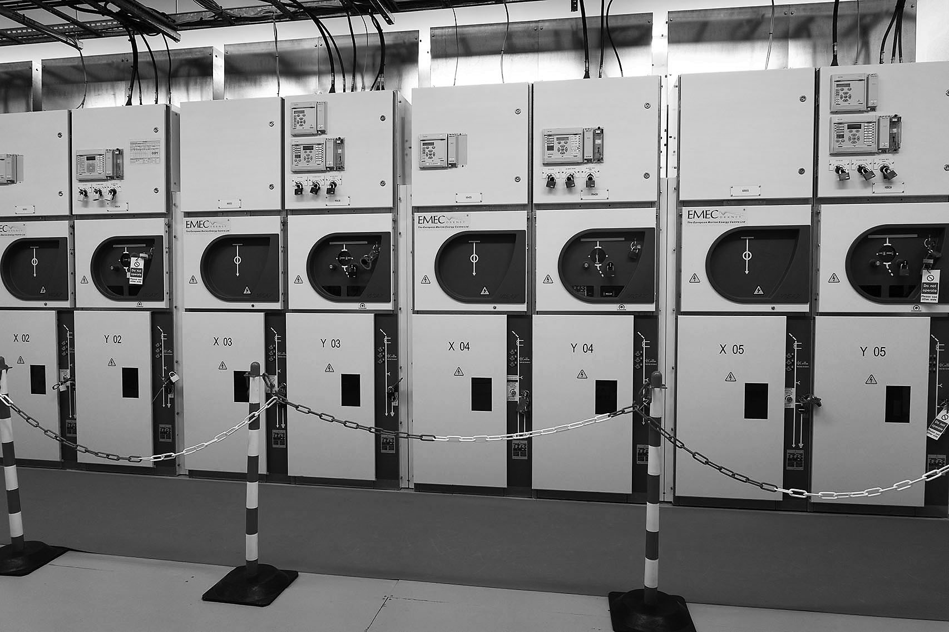
Figure 7: Monitoring room, EMEC, Billia Croo, 2019. (Photo: Jim Harold)

We have stepped inside an enclosed functional cube, the switching room, with twitching dials and a low mechanical hum: curiously soothing. I’ve been shown a cross section of a cable. A beautiful thing. Fascinating, shiny, a complex arrangement of metals and insulation that, in sliced form, becomes a mandala of sorts; a pattern of ever-increasing circles held within a circle, held within a circular stainless-steel casing for ease of display. I’m totally seduced by the beauty of it. For a moment I can hold this small section in one hand but, in reality, this cable is a huge snake of a thing lying on the ocean floor, an unseen sea serpent lurking in the deep, transmitting through its wires and cables more digital information than you and I could possibly imagine; more than we might ever need, all our nonsense along with vital information; all of which Microsoft now need to find the means to store. We are filling vast data storage containers with our digital litter. Once taking up landscape and real estate, we and sea creatures now face the prospect of them filling our ocean floor. It’s cheaper and supposedly more ecological for the storage to be cooled by the ocean but who knows what the real cost of that might be? And to what or to whom?

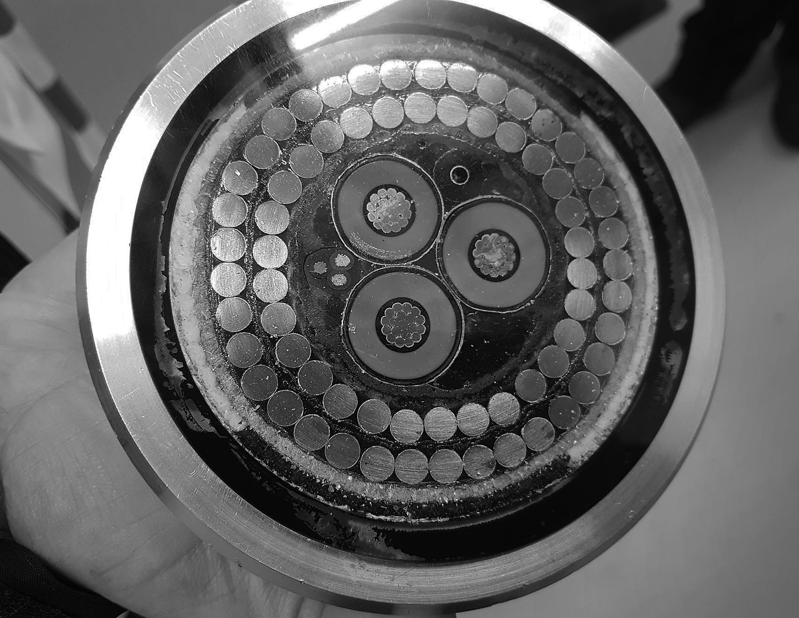
Figure 8: EMEC subsea cable, EPR Insulated, double wire armoured with fibre optic and pilot cores,
Billia Croo, 2019. (Photo: Daniel Lee)

I find myself thinking about how modest, in comparison, Marconi’s notion was to transmit, in 1901, the sound of a single voice through the air, by wireless, across the Atlantic. Or the earlier messages sent by telegraph across the seabed. Those voices and Marconi’s transmission beacons have disappeared into thin air, though their concrete bases can still be traced. The seabed, however, contains its own kind of archive of our desire to communicate across oceans. Where once we were prepared to wait weeks to get a message to the Americas, by 1956, when the first transatlantic telephone cable system had been laid between Scotland and Newfoundland, the speed of communication was more rapid. Old signal houses and cables from the war are all that is left of once thriving communications networks, which linked Orkney with the wider Atlantic world. Now we have come to expect instantaneous communication, wherever we are. But that speed comes at a price. Around 80,000 miles of cables, largely owned by Google, now criss-cross our ocean floors.

… where were we in this? … heart amongst the geese … feet on the ground … but listening to commentary from experts … move through space … between places … alien and local … silent moments … listen to the land ... the sea … the air … the creaturely lessons … exhale and inhale … enact as we walk and talk … follow the map … the time of day … walk … breathe at the limit … the breaching of space …

In this Orkney landscape, just a short distance away from EMEC’s windowless buildings and back on the cliffs that mark the land’s limit and the ocean’s open expanse, it was as if we were at a truly creative “Verge” (Kyger, 2016: 254) that seemed, in the ebb and flow of the waves – the oscillation of currents – to come to life through an acknowledgement of the vanishing point as a moment of “creative extinction” (ibid: 254). For Debord and Chtcheglov the idea of disappearance was not only an effacement of artistic ego, but it was also a desire to step away from acts of creation in the traditional sense: towards an art that makes and unmakes itself, such as sound or projection, leaving little in the way of a trace. The equivalent of filmmaker/poet, Margaret Tait’s Orkney doers and undoers.

… ambiguous points in a mesh … myth and legend … land and sea … hear George Mackay Brown’s voice on the wind … in the sea … the “tremble of life in it” (Mackay Brown 2019 [1997]: 170) … TB in his lungs … breathes … speaks … writes … a few drinks … back then, not now … and the spirit of the divine … his last words … an autobiography … the web of creation … of entanglements …

Conclusion
In the darkening light at Billia Croo we were confronted with a new and other model for disappearance, not just in the terms of the submerged technology below us, under the waves, but in the terms of an excess. An excess of data, as Paul Virilio predicted, that would lead through image and textual overload to an accelerated sense of individual and cultural disappearance, where speed evens out difference rendering appearances as a continual aesthetic blur: “… the succession of pictures […] the world in the process of passing and succeeding itself […] disappears progressively [… making of us] tourists of the extraordinary, of ruins and events …” (Virilio 1991 [1980]: 47). The reality implied in the poet Joanne Kyger’s phrase, creative extinction, where living and dying play out equally in the real, at the speed of the breath, is lost in an archival blizzard of images become data: become remains. Remains that are less of a trace and more an indexicality: an immaterial set of digital figures held – inert and out of sight – within a watertight planticru. An out of sight, if not out of mind, contrast to the remains that we daily encounter in the landscape(s) that provide the evidence, however tentative, for a line and link through time with the material, the stuff and matter of existence and non-existence. Like the carved graffiti at Unstan, Microsoft’s digital storage is an archive of another sort, one that indicates a more intangible archaeology, another ecology.
The architectural group, STALKER, re-energising Debord’s approach in the 1990s considered that the only viable, if intangible, archive was that produced through experience gained during the unmediated, and perhaps reflective, practice of walking (the dérive), which they returned to as the only viable form for mapping our relationship with the world of entangled phenomena (STALKER Manifesto in: Careri 2017: 166-167). Or as Timothy Morton might add: “…exposing our conceptual fixations and exploring the openness of the mesh […] enacting or experiencing an intrinsic interconnectedness” (Morton 2010:127). In this light we begin to read the archives held in the cairn and graffiti at Unstan, Harrold’s croft and ‘arboreal haven’ and the concrete bases and empty visitor centre at Burgar Hill. They become the entangled traces and vanishing points of experience: windows as mirrors, mirrors as windows …

… labyrinths … mazes … only clearly seen in the salt rimed window panes of derelict buildings … peripheral glimpses … inverted … poetry brought into the lived experience … held through the lens … both eye and camera … the one transient, memory’s trace, the other fixed … analogue positive/negative or digital … through walking … through movement … an a-systematised quartering of the ground … alone … in small groups … to discover differences in ambience or atmosphere … always on the periphery of things … processes … not solutions … images that hint at the entanglement of meanings … silver halides in flux – fixed but not fixed … digital traces that coalesce on the screen … to dissolve into the electrical labyrinth … and become invisible … a memory …

Afterword
Other Septembers in Orkney: In our SARS-CoV-2 world ravaged by pandemic, disrupted by political shenanigans and greed, I reflect on multi-scalar actions. Within the archaeological imagination we recognise past effects of damaging actions, endeavours and ambivalence. My final journey to Orkney takes place at 06:35 GMT on Sunday, September 2, 2091. This journey is a dialogue with people, landscapes and performances through servers, semiconductors, hazardous gases, deionized water and precious metals, all combined into my iPhone (Maxwell/Miller 2013: 705). I don’t leave my chair for this journey, but my immersive experience, provided by retinal implants and enhanced through Bio-sensory chips enables me to pass through temporal zones and landscapes. I meet Edwin at Bankburn in 1953, by which time he had dammed the Russa Burn and was playing a tune under a light powered by his hydro system. I lifted stones from the nearby quarry and placed them into Unstan cairn. We were working with a collective goal of creating a home for our ancestors through which we could feel time. I watched it all happen as I flew over the landscape, embodying Rookie, Edwin Harrold’s companion crow. On this journey I felt the wind on my wings and the rain illuminated my eyes as I tasted peat and salt.
Journeys through time and space in Orkney require substantial amounts of power. I attempted to estimate the cost of power required to write this chapter. If we are all using 60W laptops and we each take 4 days to write our contributions, using 6 hours per day and the power is charged at £0.12 per kWh, it will have cost, in monetary terms, £2.88 per person and totalled £14.40 for all of us. This only illustrates how cheap electricity per kilowatt hour currently is, it doesn’t consider the cost of power generation, some sustainably hopefully, some very dirty, undoubtedly, such as the future-disturbing, nuclear-power generating waste time bombs. With half-life decay rates varying from 211,000 years to 15.7 million years, depending on the isotopes used to generate electricity, we are leaving future inhabitants with insurmountable problems. The artists and archaeologists of the future may well look upon our fieldtrips and excavate our archives with well-deserved critique (Wall/Hale 2020: 777-779, Derrida 1995: 9-11).
So how do we enact journeys into disturbed ecologies through art and archaeological practices (Thomas et al 2018)? As we learn more about our damage to the planet, can we begin to make connections between previously illuminating events, such as the radiocarbon revolution that enabled archaeologists to date past lives with increasing accuracy, to potentially catastrophic future-orientated waste materials, in order to date a piece of Prehistoric organic matter or power our laptops? As we participate in these disturbances, often with scant knowledge of their future impacts, hopefully we can begin journeys that include reflecting on the effects of our energised demands through mirrors and windows.

REFERENCES

Barad, Karen (2018): “Troubling Time/s and Ecologies of Nothingness: Re-turning, Re-membering, and Facing the Incalculable”. In: Matthias Fritsch/Philippe Lynes/David Wood (eds.), Eco-Deconstruction: Derrida and Environmental Philosophy (Groundworks: Ecological Issues in Philosophy and Theology), New York: Fordham University Press.

Careri, Francesco (2017): Walkscapes: Walking as an Aesthetic Practice, Ames: Culicidae.
Chtcheglov, Ivan (alias Gilles Ivain) (1958). “Formulaire pour un Urbanisme Nouveau”. In: Knabb, Ken (ed. and trans.) (1981): Situationist International Anthology, Berkeley: Bureau of Public Secrets.
Debord, Guy (1956): “Théorie de la dérive”. In: Les Lèvres Nues 9 (November 1956). In: Internationale Situationniste 2 (December 1958). English translation and pdf: (https://www.cddc.vt.edu/sionline/si/theory.html) [Accessed November 18, 2020].
Derrida, Jacques (1995): “Archive Fever: A Freudian Impression”, Diacritics 25/ 2 (Summer, 1995), pp. 9-63.
Farley, Paul/Roberts, Michael Symmons (2011): Edgelands: Journeying into England’s True Wilderness, London: Vintage Books.
Farrier, David (2020): Footprints: In Search of Future Fossils, London: 4th Estate.
Frederick, Ursula (2009): “Revolution is the New Black: Graffiti/Art and Mark-making Practices”. In: Archaeologies: Journal of the World Archaeological Congress 5/2, pp. 210-237.
Gibbon, Sarah Jane (2012): Happy Valley Archive Project, Orphir: Research Orkney.
Hinton, David (2017): The Wilds of Poetry: Adventures in Mind and Landscape, Boulder: Shambala.
Jamie, Kathleen (2019): Surfacing, London: Sort Of Books.
Kaufmann, Vincent (2006): Guy Debord: Revolution in the Service of Poetry, (trans. Robert Bononno), Minneapolis: University of Minnesota Press.
Kyger, Joanne (2016): The Japan and India Journals, 1960-1964, New York: Nightboat.
Lee, Daniel (2016): Hoy and Walls Landscape Project: Rackwick Survey 2014-2015, Hoy, Orkney. Enhanced Archaeological Walkover Survey. Data Structure Report. ORCA Project Nos 495 & 586.
Lee, Daniel/Hollinrake, Andrew (2011): Happy Valley, Stenness, Orkney. Archaeological Building Survey. Orkney Research Centre for Archaeology report. Project No 300.
McFadyen, Lesley/Hicks, Dan (2019): Archaeology and Photography: Time, Objectivity and Archive, London: Bloomsbury.
Mackay Brown, George (2019) [1997]: For the Islands I Sing. Edinburgh: Polygon.
Mackay Brown, George (2019) [1973]: Magnus. Edinburgh: Polygon.
Malraux, André (1967): Museum Without Walls. London: Secker & Warburg.
Mayer, So (2019): “Margaret Tait’s Disappearing Trick”. In The Poetry Review, 109, 3.
(https://poetrysociety.org.uk/essay-on-margaret-taits-disappearing-trick/) [Accessed January 10, 2021].
Maxwell, Richard/Miller, Toby (2013): “The Material Cellphone.” In Paul Graves-Brown/Rodney Harrison/Angela Piccini (eds.), The Oxford Handbook of the Archaeology of the Contemporary World, Oxford: Oxford University Press.
Morton, Timothy (2010): The Ecological Thought. Cambridge, Mass: Harvard University Press.
Salmon, Peter (2020): The Event, Perhaps: A Biography of Jacques Derrida, London: Verso.
Shanks, Michael (1997): “Photography and Archaeology.” In: Brian Leigh Molyneaux (ed.), The Cultural Life of Images: Visual Representation in Archaeology, London: Routledge, pp. 73-107.
Smithson, Robert (1996) [1967]: “A Tour of the Monuments of Passaic, New Jersey (1967).” In: Jack Flam (ed.), Robert Smithson: The Collected Writings, Oakland: University of California Press, pp. 68-74.

STALKER Manifesto. In: Francesco Careri (2017). Walkscapes: Walking as an Aesthetic Practice, Ames: Culicidae.

Szarkowski, John (1978): Mirrors and Windows: American Photography Since 1960. New York: MoMA.
Thomas, Antonia (n.d.): Unstan cairn, Stenness, Orkney: Survey of Internal Stonework, Unpublished report produced for HES.
Thomas, Antonia/Lee, Daniel/Frederick, Ursula/White, Carolyn (2018): “Beyond Art/Archaeology: Research and Practice after the ‘Creative Turn’.” In: Journal of Contemporary Archaeology 4/2, 121-129.

Virilio, Paul (1991) [1980]: The Aesthetics of Disappearance, Philip Beithman (trans.). New York: Semiotext(e).
Wall, Gina/Hale, Alex (2020): “Art & Archaeology: Uncomfortable Archival Landscapes.” In: The International Journal of Art and Design Education 39/4, pp. 770-787. (https://doi.org/10.1111/jade.12316) [Accessed February 18, 2021].
Watts, Laura (2018): Energy at the End of the World: An Orkney Islands Saga, Cambridge, Mass: MIT.

7984 words

Brief CVs
Susan Brind is a Reader in Contemporary Art based in the Department of Sculpture & Environmental Art at Glasgow School of Art where she also co-leads GSA’s Reading Landscape Research Group with Dr Nicky Bird. Her independent and collaborative works have been widely exhibited in Europe and the UK, and her praxis embraces curatorial and publishing projects. Published works include The State of the Real: Aesthetics in the Digital Age (co-edited with Sutton, D / McKenzie, R), London: IB Tauris, 2007; and Curious: Artists’ research in expert culture (ed.), Glasgow: Visual Art Projects, 1999.

Dr. Jim Harold is an artist based in Glasgow. He has exhibited nationally and internationally and has work in public collections, including the V&A and the Arts Council of England. Published works include: “Caesura: Cyprus–Kibris–Kypros”, Interstices, The Drouth, Issue 54, Winter/Spring 2016; “Witnessing the Momentous: Crowds, Stones and Images, Silent Witnesses” in Leighton, T / Büchler, P (eds.), Saving the Image: Art after film, Glasgow & Manchester: CCA/MMU, 2003; “Andres Serrano: The Sea of Possibility” in Sci-Fi Aesthetics, Art & Design Magazine No. 56, London, 1997; and Desert, Southampton: John Hansard Gallery, 1996.

Susan Brind & Jim Harold work collaboratively. They are members of the Creative Centre for Fluid Territories: People, Places, Processes (formed in 2016) comprising inter-disciplinary practitioners and theorists from England, Scotland, Norway and South Cyprus, whose research, individually and collectively, considers the nature of peripheral and contested spaces within Europe and Scandinavia. Their recent collaborative writings are published in: Fluid Territories, Norway: University of Bergen, 2020; “Coffee Letters” in Armarólla, Issue V, Summer 2020; “At the limits of reliable information”: Finland’s Arctic borders with Sweden, Norway and Russia in Goldie, Chris and Darcy White (eds.) Northern Light: Landscape Photography and Evocations of the North, Germany: Transcript, 2018.

Dr. Alex Hale is a Senior Archaeology Researcher at Historic Environment Scotland. He undertakes research into Scottish heritage landscapes, ranging in scale from historic and contemporary graffiti, to climbing heritage landscapes. His work attempts to be collaborative, practice-based, creative and research focused. He was recently awarded a Royal Society of Edinburgh research workshop grant with the aim to explore archaeological perspectives to the political, economic and environmental challenges facing Scotland in the present day. Alex is a Member of the Chartered Institute of Archaeologists.

Daniel Lee is an archaeologist living in Orkney, Scotland. His research explores archaeological cartography and experimental field practice, which he has applied in a number of collaborative projects. His Art/Archaeology portfolio includes a number of residencies, films, collaborative/independent projects and workshops, and also conference attendance, conference speaking and publication output. He is employed at the UHI Archaeology Institute (ORCA) as Lifelong learning and Outreach Archaeologist, where he designs, manages and delivers a range of community archaeology projects and short courses across the region. He teaches on several undergraduate and postgraduate modules, including the MA programme in Contemporary Art and Archaeology. Dan is a member of the CHAT (Contemporary & Historical Archaeology in theory) standing committee.

Dr. Antonia Thomas is an archaeologist based in Orkney, Scotland. Her work explores the intersection of art, archaeology, and heritage at a range of scales. Recent projects have explored a number of aspects of material and visual culture, including graffiti and mark-making, prehistoric art, artefacts and architecture, the relationship between contemporary art and archaeology, and the politics of heritage. She has been involved in and directed a number of interdisciplinary art/archaeology projects and collaborative residencies. She is also a lecturer and researcher at the University of the Highlands and Islands, where she developed and leads the innovative online MA programme in Contemporary Art and Archaeology.

Orkney’s energy generation is currently the focus of the Orkney Energy Landscapes Project, led by Daniel Lee and the Orkney Research Centre for Archaeology (ORCA), UHI Archaeology Institute, and Dr Richard Irvine of the Department of Social Anthropology, University of St Andrews. See: https://archaeologyorkney.com/2020/02/17/orkney-research-centre-for-archaeology-receives-10000-national-lottery-support-for-orkney-energy-landscapes-project/ [accessed 15th January 2021]
https://orkneydictionary.scot/

