GeoWeek 2022 Symposium
Communication Measures to Bridge 4.543 billion years

University of Cumbria, Institute of Arts, Brampton Road Campus.
Carlisle, Cumbria. CA3 9AY.

Symposium: Thursday May 12th & Friday May 13th 2022 LR2
Exhibition at The Vallum Gallery, Brampton Road: 9th - 13th May 2022

The University of Cumbria Institute of Arts’ Arts Research Initiative (ARI) in partnership with Tullie House Museum for the national event GeoWeek* offers a free public symposium at our Brampton Road Campus in Carlisle. The event aims to explore themes of cultural engagement with the geologic, particularly through the interpretations of artists and cultural practitioners. The Cumbrian region has a rich history of such investigations from luminaries such as Wordsworth, Turner, West, Martineau, Southey, Atkinson, Graves, Nicholson, Harrison and Fell. This Symposium will present 18 papers over two days which respond to different aspects of GeoWeek, focusing on themes such as the Anthropocene, Deeptime, strata, underworlds, crystals and landforms, seen through the lens of contemporary art and cultural interventions. Keynote speakers include American artist Bryan McGovern Wilson and Glasgow based artist Ilana Halperin. Additionally, the Institute’s Arts Research Group of doctoral researchers (ARG) will also present artworks and films at The Vallum Gallery at the Brampton Road Campus throughout GeoWeek 9-13th May.

Dr Penny Bradshaw’s GeoWeek workshop at Brantwood on Geology and Identity in Cumbrian Literature, will take place on Monday May 9th 10:30-12:30
EventBright tickets for the workshop: https://www.eventbrite.co.uk/e/geology-and-identity-in-cumbrian-literature-tickets-307486298797?utm_campaign=post_publish&utm_medium=email&utm_source=eventbrite&utm_content=shortLinkNewEmail

Brantwood: https://www.brantwood.org.uk/

Contact: Professor Robert Williams: robert.williams@cumbria.ac.uk

EventBright Tickets for the Symposium Available:

Day 1: https://www.eventbrite.co.uk/e/communication-measures-to-bridge-4543-billion-years-geoweek-2022-day-1-registration-318697361387

Day 2: https://www.eventbrite.co.uk/e/communication-measures-to-bridge-4543-billion-years-geoweek-2022-day-2-registration-318707230907

Live Streaming available via YouTube: https://youtu.be/etjTXVaf70g

* https://earth-science.org.uk/geoweek/find-event/

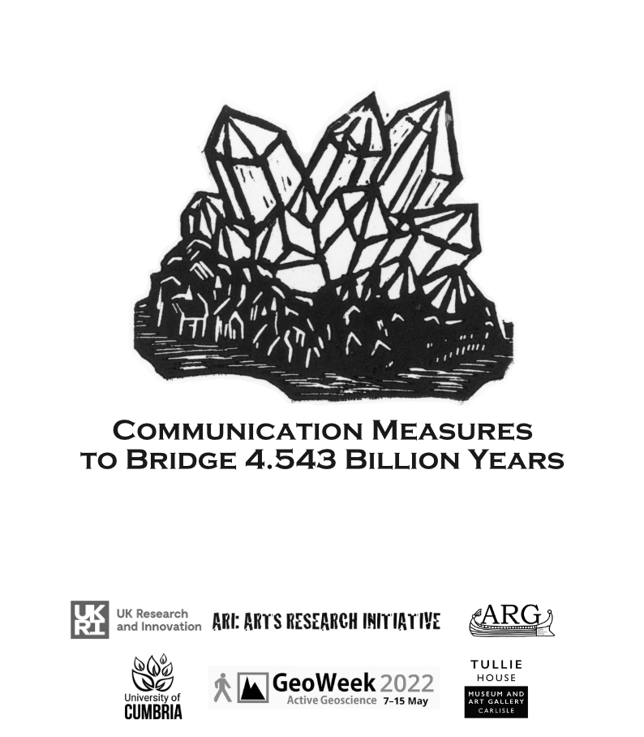

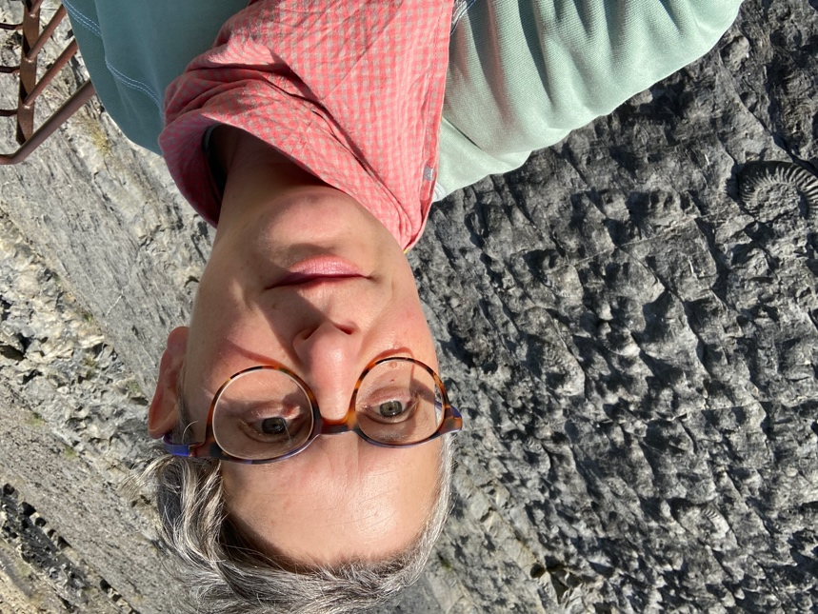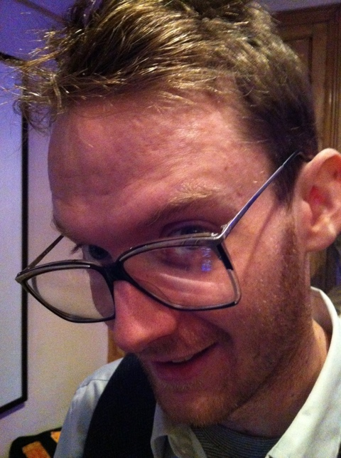
Ilana Halperin Bryan McGovern Wilson

