Creating Interactive Three-Dimensional Applications to Visualise Novel Stent Grafts That Aid in the Treatment of Aortic Aneurysms
Authors:
Contact Author: Caroline Walker - (cmwalker@my.milligan.edu)
Sara Bakalchuk - (sarabakalchuk@gmail.com)
Gillian Moffatt – Glasgow School of Art, Department of Design (G.Moffatt@gsa.ac.uk)
Dr. Matthieu Poyade – Glasgow School of Art, School of Simulation and Visualisation (M.Poyade@gsa.ac.uk)
Louise Hill – Terumo Aortic (L.hill@terumoaortic.com)
Dr. Craig Daly - University of Glasgow, School of Life Sciences (Craig.Daly@glasgow.ac.uk)

Abstract
Thoracic Endovascular Aortic Repair (TEVAR) and Fenestrated Endovascular Aortic Repair (FEVAR) are both tried and tested minimally invasive surgical methods for treating thoracic aortic aneurysms and abdominal aortic aneurysms, respectively. The Terumo Aortic Custom Relay Proximal Scalloped stent graft, and Fenestrated Anaconda stent graft, were both designed specifically for these procedures, but it can be difficult to visually communicate to clinicians and patients in simple terms how these devices work. Therefore, we have developed two interactive applications that use 3D visualization techniques to demonstrate how these devices function and are implemented. The objective of these applications is to engage both clinicians and patients, therefore demonstrating that the addition of anatomically accurate 3D visualizations within an interactive interface would have a positive impact on public engagement, while also ensuring that clinicians will have the best possible understanding of the potential uses both devices, enabling them to exploit their key features to effectively broaden the treatable patient population.
Detailed anatomical modelling and animation was used in order to create realistic and accurate rendered videos showcasing both products. These videos were integrated into an interactive application within a modern, professional graphic interface that allows the user to explore all aspects of the device. The resulting applications were broken down into three modules: deployment, clinical performance and features. Following development, these applications were evaluated by professionals in the field. Overall, positive feedback was received regarding the user-friendly nature of the apps and highly effective animations to showcase the products. The clinical applications and features modules were particularly successful, while the deployment modules had a neutral response. Applications such as these show great potential for communicating the key features of both devices and promoting discussion between clinicians and patients, but further testing needs to be conducted on a larger group of participants in order to validate these preliminary results.

Key words: Abdominal Aortic Aneurysms, Thoracic Aortic Aneurysms, Interactive Application, 3D Modelling, Medical Animation, Medical Communication

Introduction
Communicating novel medical devices in a visually logical and innovative way is essential in the changing healthcare climate, specifically for diseases with alternative treatment options that healthcare professionals may not be aware of. The methodology described in this paper outlines the use of cutting-edge technologies to visualise treatment approaches that clinicians can use to enhance treatment of aortic aneurysms.
Aortic aneurysms can be subcategorized into Abdominal and Thoracic aneurysms, depending on the location of the swelling and site of rupture. Aortic aneurysms are leading causes of death globally. While both TAA’s and AAA’s contribute to this, abdominal specifically are the tenth leading cause of death globally (Howard et al., 2015). Although advanced treatment options can help reduce mortality rates, it is essential to increase the awareness of clinicians about novel stent grafts that can reduce the risk of rupture and help treat both AAA’s and TAA’s with complex aortic anatomy (Filardo et al., 2015).
Thoracic Endovascular Aortic Repair (TEVAR) and Fenestrated Endovascular Aortic Repair (FEVAR) are tried and tested minimally invasive surgical methods for treating TAA’s and AAA’s with novel stent grafts. It can be difficult to visually communicate to clinicians how these stent grafts work; thus, the visualisations created would subsequently benefit patient outcome specifications through a series of 3D animations embedded into interactive applications. These applications will ensure that clinicians have the best possible understanding of the potential uses of the devices, enabling them to exploit key features to effectively broaden the treatable patient population of both AAA’s and TAA’s. Thus, the resulting applications should have a positive impact while ensuring that clinicians understand the potential uses and customisations of the two visualised stent grafts- the Fenestrated Anaconda Stent Graft and the Relay Proximally Scalloped Stent Graft to treat AAA and TAA, to treat juxtarenal aneurysms and thoracic aneurysms involving the arch, respectively.
Advances in understanding stent graft surgical techniques and options have led to the need for the creation of interactive applications to engage healthcare workers and increase their knowledge of alternative devices for better treating patients. This research explores the methodology of creating anatomically correct models and animations for an interactive application. Through collaboration with Terumo Aortic, two applications were generated through the creation of multiple 3D medical animations from anatomically accurate models for use in public and medical engagement outreach. Various 3D modelling and animation techniques, as well as application development software were utilised in order to produce the animations that would showcase the most important characteristics of the Fenestrated and Relay devices. The approach used to create scientific animations was unique and is discussed throughout the paper. The research and methodologies used to create these scientific animations and corresponding applications, show a useful way of communicating advanced medical devices through cutting-edge, intuitive, technological methods.

2.0 Background
This chapter reviews the global problem of Aortic Aneurysms in the elderly population and explores the surgical interventions and technology needed to visualise surgical techniques thus generating understanding and awareness.

2.1 Aortic Aneurysm Background
An aortic aneurysm can be defined as a swelling or bulging at any point along the aorta. An aneurysm is most likely to occur in the section of the aorta where the wall is weakened and lost its elastic properties, as it doesn’t return to its normal shape after the blood has passed through (British Heart Foundation). Aortic aneurysms can be subcategorized into Abdominal and Thoracic Aortic Aneurysms, depending on the location of the swelling. Approximately 75% of aortic aneurysms occur in the abdomen; the remainder are thoracic aneurysms (Kuivaniemi et al., 2015). The aneurysm requires close monitoring or treatment once detected as the aortic wall will continue to weaken over time and be unable to withstand the pressing blood pressure forces and result in rupture (Filardo et al., 2015). The level of stress on the wall is directly proportional to an increase in aortic diameter so is considered to be a significant factor in the growth rate of aneurysms. Aortic aneurysms are classified by small and large, 3-5 cm and > 5 cm respectively (Powell et al., 2011). An aneurysm is a blood vessel that results in a permanent dilation by at least 150% of the regular vessel diameter (Shaw et al., 2020). If the dilation is left untreated, vessel wall degeneration progresses, leading to an increase in swelling and thinning of the vessel wall. The risk of rupture is directly correlated with the increase of aneurysm diameter (Avishay and Reimon, 2020).

2.1.1 Thoracic Aortic Aneurysms
Thoracic Aortic Aneurysms (TAAs), make up approximately 25% of aneurysms (British Heart Foundation), and are characterized by swelling or bulging of the aorta within the region of the chest. Thoracic aneurysms may involve one or more aortic segments, either the aortic root, ascending aorta, arch, or descending aorta. Sixty percent of thoracic aortic aneurysms involve the aortic root and/or ascending aorta, 40% involve the descending aorta, 10% involve the arch, and 10% involve the thoracoabdominal aorta (with some involving >1 segment) (Isselbacher, 2005). The treatment of thoracic aneurysms differs for each of these segments. If the aneurysm were to rupture, immediate surgery is required to repair the aorta with numerous possible surgical interventions depending on the severity and progression. While open surgery used to be the industry standard for this type of procedure, it is becoming increasingly common to perform minimally invasive endovascular operations using a custom stent graft (Ben Abdallah et al., 2016).

2.1.2 Abdominal Aortic Aneurysms
Abdominal Aortic Aneurysms (AAA) is a life-threatening condition that affects the aorta. AAA’s are often detected incidentally due to their asymptomatic nature (Kuivaniemi et al., 2015). Abdominal Aortic Aneurysms (AAA) are responsible for approximately 5,000 deaths in the UK every year, and more than 175,000 deaths globally (Howard et al., 2015). 1% of deaths in men over 68 are attributed to ruptured AAA, coming in as the 10th leading cause of death in older men (Avishay and Reimon, 2020). The mortality rate of a ruptured AAA is over 80% ; thus early diagnosis, monitoring, and treatment are critical before the aneurysm’s rupture (Howard et al., 2015). Undetected, untreated AAAs result in expansion, rupture, haemorrhage and often death.

2.2 Surgical interventions for AAA’s and TAA’s.

2.2.1 Open Surgery Repair and Endovascular Aneurysm Repair of AAAs
Treatment of large Abdominal Aortic Aneurysms is changing over time to include more advanced surgical techniques for higher risk patients. Treatment is suggested when the aneurysm reaches 5 cm to 5.5 cm to prevent rupture and its corresponding high mortality rate. Treatment options include open surgical repair (OSR), Endovascular aneurysm repair (EVAR) and FEVAR (Wang et al., 2018).
Open surgical repair (OSR) has been the traditional clinical method for AAA (Wang et al., 2018). While rupture has an 80% mortality rate (Dueck et al., 2004) (Heikkinen et al., 2002), (Ashton et al., 2002), elective surgical repair of unruptured AAA has only a 2-6% 30 day mortality rate (Brown et al., 2012), (Cosford and Leng, 2007). Endovascular aneurysm repair (EVAR) is a recommended surgical substitute for AAA higher risk patients who are unsuitable for open repair (De Bruin et al., 2010). However, up to 45% of individuals with AAA are not suitable for EVAR. Advanced AAA cases such as patients with juxtarenal, thoracoabdominal, and pararenal aneurysms, or short, angulated, or reversed aortic neck anatomy, cannot be treated by EVAR endografts (Dijkstra et al., 2014). This percentage of AAA’s unsuitable for EVAR surgery can safely undergo fenestrated endovascular aneurysm (FEVAR) device surgery. FEVAR treatment is a minimally invasive surgery that allows the aorta to be repaired in the patients groin or arms while preserving blood flow to major arteries. (Park et al., 1996). EVAR treatment with a fenestrated endovascular aneurysm (FEVAR) device was introduced in 1996 to combat complex aneurysms (Park et al., 1996). Custom-made devices for FEVAR are now utilized in patients that are higher risk for open repair surgery. These stent grafts allow clinicians to accommodate renal and mesenteric vessels by inserting custom devices where disease progression has occurred, higher up in the aorta (Davies, 2016). FEVAR has since shown high technical success rate and low mortality, short, intermediate, and long-term complication rates (Bungay et al., 2011). As a result, Terumo Aortic has developed a fenestrated graft stent system, the Fenestrated Anaconda™ as seen in Figure 1.
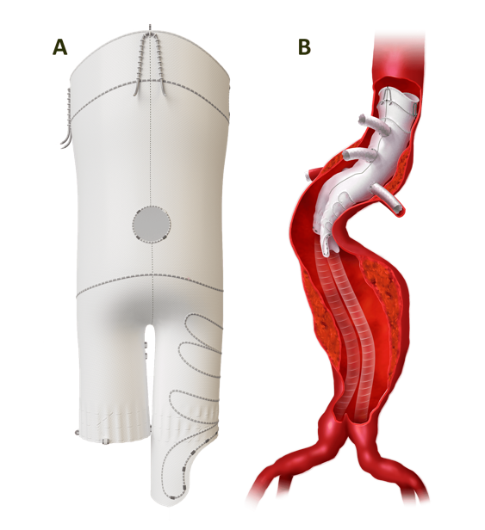
Figure 1 - A) Fenestrated Anaconda Stent Graft B) Anaconda Fenestrated device and aneurysm with angulation device stents and legs (Vascutek Lmtd, 2020).

2.2.2 Open Surgery Repair and Endovascular Aneurysm Repair of TAAs
In order to decide whether to perform elective, pre-emptive aneurysmectomy, one needs to estimate their specific risk versus benefit from resection, which ultimately depends on the surgical method chosen (Elefteriades, 2002). Open chest surgical repair using prosthetic graft interposition has been the conventional treatment for TAAs (Abraha et al., 2009). However, despite improvements in surgical procedures, perioperative complications remain significant. The alternative option of thoracic endovascular aneurysm repair (TEVAR) is considered a less invasive and potentially safer technique, with lower morbidity and mortality compared to open surgical repair, making it an appealing therapeutic option (Alsafi et al., 2014). Fortunately, this approach is becoming increasingly common, as both acute and chronic traumatic lesions of the descending aorta can be treated via an endovascular approach in specialized centres, with low morbidity and mortality rates (Kato et al., 1997). Endovascular repair is particularly attractive for treating patients whose associated injuries or comorbid conditions put them at greater risk for the open chest repair surgery (Kasirajan et al., 2003).
The main advantages of the endovascular procedure include shorter time and lower operative risk. If the patient is not affected by other high priority life-threatening injuries, endovascular repair should be performed first before any other surgical treatment in order to eliminate the risk of sudden aortic rupture (Ferrari et al., 2006). Another benefit acquired from this technique is the absence of cardiopulmonary bypass and the low-dose systemic heparinization (Ferrari et al., 2006). Despite great achievements from endovascular stent grafts, several complications of endovascular stenting have remained. Although complications do not occur frequently, endoleak, stent collapse, subclavian occlusion, stroke, embolization, bronchial obstruction, implant syndrome, dissection, migration, and paralysis may develop (Karmy-Jones et al., 2009). When the treatment segment of the thoracic aorta, most commonly the aortic arch, present certain anatomical challenges, technically complex stent-graft designs are sometimes needed. Therefore, endovascular treatment of aortic arch disease may require a custom-made endograft to maintain the patency of the supra-aortic trunks (SATs) in the event of a short healthy proximal aortic neck (Fernández-Alonso et al., 2018). In specific cases such as these, the Custom Terumo Aortic Relay proximal scalloped stent graft has been particularly successful (Figure 2). Consequently, anatomically accurate and interactive 3D visualizations of this product would be helpful for communicating its correct usage and other various benefits to both patients and clinicians.
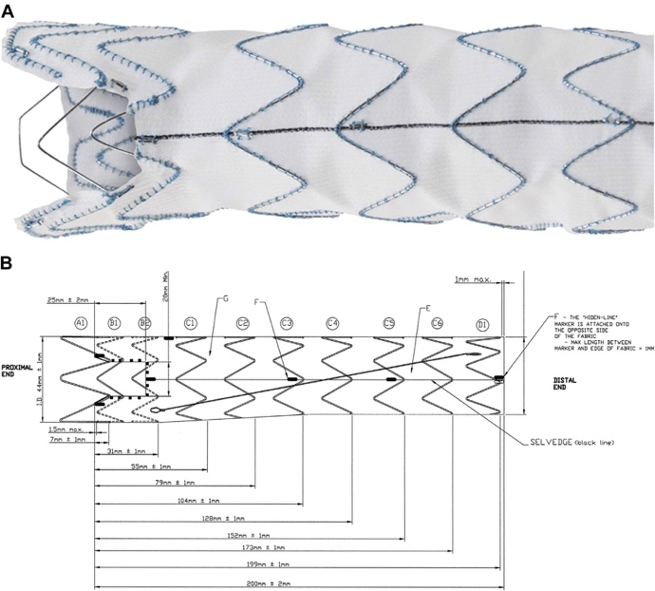
Figure 2 - a) Terumo Aortic Relay Proximal Scalloped Endograft. B) Schematic showing a scalloped stent graft with the radiopaque markers used during positioning (Alsafi et al., 2014)

2.3 Potential of medical visualisations for surgical techniques

2.3.1 Imaging Modalities in a Healthcare Setting
In today’s clinical setting, medical imaging is an essential component of the entire health-care continuum, from wellness and screening, to early diagnosis, treatment selection, and follow-up. Some of the most common imaging modalities used today are Computed Tomography (CT) and Magnetic Resonance Imaging (MRI) (Liu et al., 2007). CT imaging allows for clinicians to gain high levels of detail for anatomical structures and soft tissue, while MRI [T1 and T2] can assess not only morphology, but also metabolic function detected by changes in blood flow. Advancements in computer graphics have allowed for fast, real time medical imaging interpretation, giving radiologists the ability to process huge amounts of data, compare prior studies, and create multiplanar and three-dimensional image reconstructions. This is done through very thin (fractions of a millimetre) slices obtained, for example, in the DICOM image format, and subsequentially segmented in an editing software such as 3DSlicer, Amira, MITK, ITK and Osirix. The 3D volume generated from these imaging modalities allows for accurate and efficient visualisation of the patient’s anatomy and physiology (Bercovich and Javitt, 2018). CT and MRI visualisation combined with interactive technology allowing for 3D reconstructions will continue to further the understanding of human disease and allow a personalized approach to treatment plans.
To convert medical imaging into 3D visualisations, the process follows a general imaging pipeline (Figure 3). A summary of this pipeline are as follows: acquiring data, analysing, and visualising medical images for use in diagnosis, education, or research purposes. Medical imaging is especially useful to help guide surgical procedures and enable correct spatial accuracy visualisation in connection with understanding cardiac related complications. Advanced cardiac CT visualisation technology such as Coronary CT angiography (CTA) is an innovative clinical imaging tool that allows a non-invasive and highly specific approach for cardiac diagnosis and treatment (Saremi, 2017; Coelho-Filho et al., 2013; Burt et al., 2014). As aforementioned, generation of a 3D model from a CT scan, can be used for many reasons to increase patient understanding, surgical planning, and informing clinicians understanding of medical devices for specific patient treatment (Bercovich and Javitt, 2018).
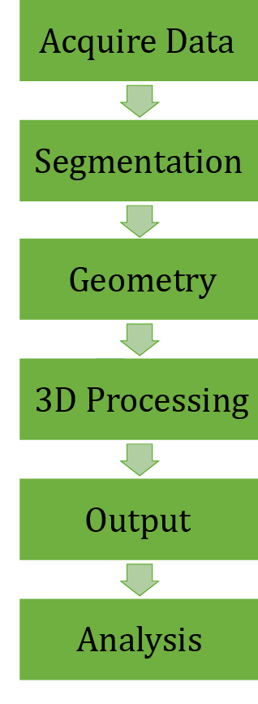
Figure 3 - Imaging Pipeline

2.3.2 Public Engagement for Medical Visualisation
When examining 3D visualisation for education, it is also important to consider how well these technologies are able to educate or otherwise engage a broader audience (Holliman et al., 2009). Public engagement with science is an important aspect of society at a number of levels (Taylor and Wessels, 2019). The ability for the public to understand healthcare information is particularly important, as it has been shown that adults without sufficient health literacy are twice as likely to be hospitalized as those with an adequate understanding (Baker et al., 1998; Baker et al., 2002). Furthermore, public engagement with science is vital to scientific progress as well, as the advent of new media technologies has increased the opportunities available for scientists to engage the general public in understanding their work (Holliman et al., 2009). Previous work has shown the use of mobile technology or tablets to access information and learning materials from anywhere and at any time is particularly effective for this type of engagement (Ford and Leinonen, 2009). This allows for the user to learn at their own pace and time, following whatever information they find interesting, and therefore building a broader knowledge base (Traxler, 2007). These research findings define the need for producing a means of visualising various surgical methods to treat Aortic Aneurysms to clinicians, patients, and the general public.
Overall, the use of imaging modalities in healthcare to better treat and diagnose diseases show the value that visualisations bring to understanding and educating about medical conditions. This displays the need for a public engagement tool for aortic aneurysms that are frequent in the elderly population. These research findings define the need for producing a means of visualising various surgical methods to treat Aortic Aneurysms to clinicians, patients, and the general public. This informative application, surrounding two different types of aneurysms, will generate awareness regarding surgical methods, customizable treatment options, clinical performance success statistics, risk factors, and awareness of innovative stent grafts for AAA and TAA cases.

3.0 Methods
The purpose of this project was to create clear, informative, and anatomically accurate interactive applications that communicate the important facts and figures concerning both aforementioned stent grafts. Specifically, 3D animations and anatomical models will be utilised to highlight the key features of the product, its deployment, and its clinical performance. The above sections will demonstrate to patients how these products work and will help to ensure that clinicians have the best possible understanding of the potential uses of the devices. Therefore, these applications will enable clinicians to have an understanding of the alternative medical devices and exploit their key features to effectively broaden the treatable patient population.

3.1 Conceptual Development (storyboard/outline)
This stage commenced with conceptual ideation, which subsequently leads to the creation of a storyboard and mood board. A contact at Terumo Aortic was consulted regarding exactly what they were looking for within the applications, and their specifications were used to create a storyboard and mood board in keeping with their desires and graphic style. The storyboard specifically, allowed for a clear idea of the flow of the applications, as well as identifying the key features to be highlighted. The storyboards for both applications are depicted in Figure 4 and Figure 5 below.
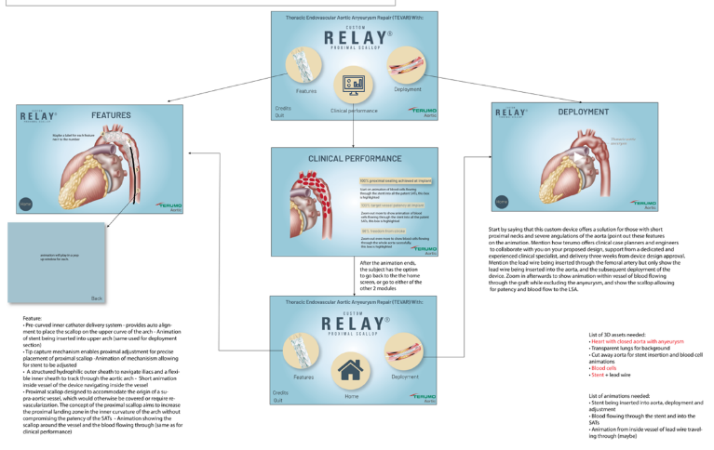
Figure 4 - TAA Application Storyboard
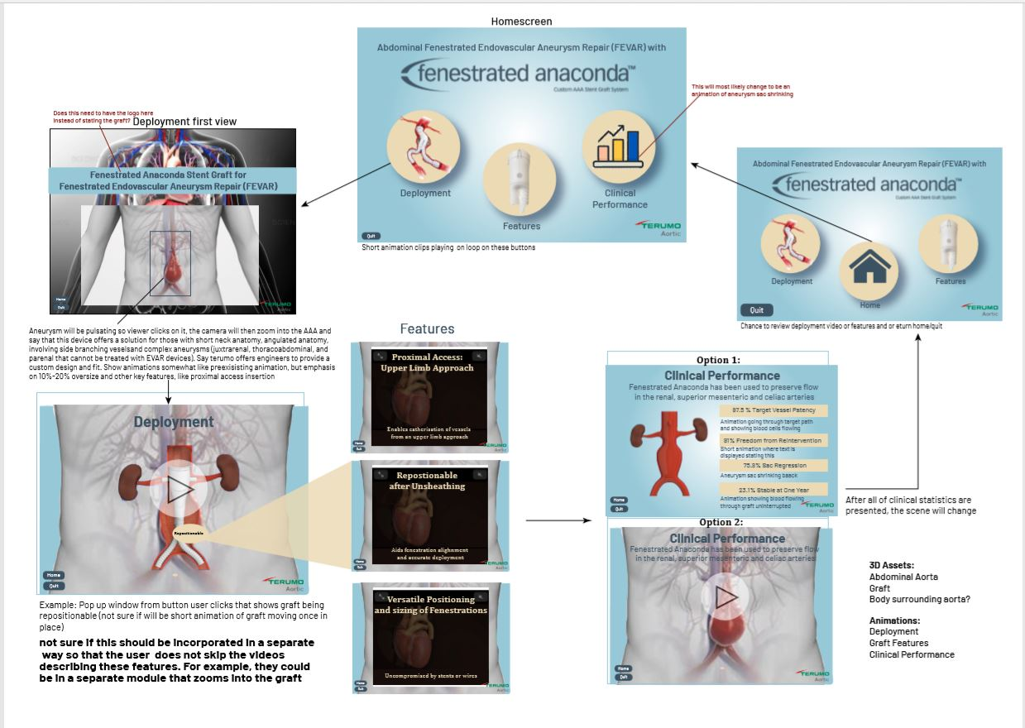
Figure 5 - AAA Application Storyboard

3.2 Digital 3D Content Production
Once the flow of the applications was developed, 3D content production began for both applications. This was comprised of segmentation, retopology, 3D modelling, and texturing. These assets were then used to create animated videos and integrated into the 3D applications within Unity.

3.2.1 Segmentation of Aorta, Kidneys, and Associated Vessels
Open-source software 3D Slicer for medical image informatics and three-dimensional (3D) visualisation was utilised to segment the aorta and surrounding anatomy that were to be incorporated into the 3D animations. Contrast and brightness were manipulated to allow visualisation of distinct anatomical structures; this allowed for precise segmentation from medical data. Segmentation was completed by using the Editor module and utilising the paint brush tool with a threshold of 100 to 1000. Segmentation was repeated, moving through every slide of the dataset, and manually segmenting the needed organs. Once the models were created, they were decimated by 20% to reduce the polycount. Models were then exported in OBJ format for use across Autodesk platforms. The same segmentation process was repeated for the kidney, renals, and celiac vessels.
The lung model for the TAA application followed a similar pipeline. It was first created in slicer based off the CT chest pre-set. The Fast-Marching tool within the editor module was utilized to segment the lungs, while the threshold paint tool was used to segment the trachea and bronchi. The Surface toolbox was then used to smooth the model and fill the holes. Figure 6 shows the segmentation process and the final model rendered within 3D Slicer.
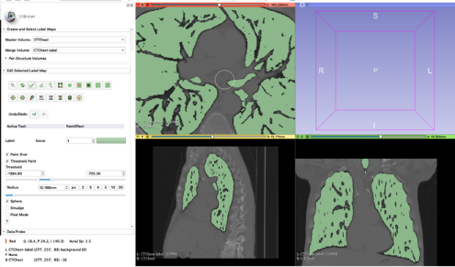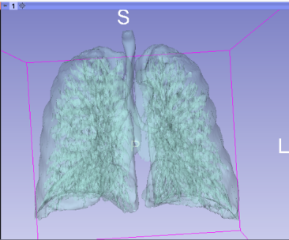
Figure 6 - Fast-March Lung segmentation

3.2.2 Bifrost Visual Programming
Voxel Volume Remeshing Using Bifrost Graph Editor
Bifrost Graph is a new visual programming framework Maya plug-in that generates voxel volumes from 3D graphics. This was used due to the complexity of the generated segmented models from 3D Slicer; the models were unable to be retopologised automatically with the high polygon count generated in Slicer. The step-by-step process can be found in Figure 7, the images describe the Bifrost workflow utilised to achieve the desired new Maya mesh. This process was applied to all 3DSlicer models, so that they had manageable poly counts in Maya. The end result is a new model with clean Maya mesh; voxelating and rebuilding the mesh in Bifrost fixed the holes in the mesh, lamina faces and nonmanifold geometry. It was important to perform Bifrost Visual Programming Framework to these models from Slicer, so Autodesk would function properly, and the resulting animations would be able to render at quick speed.

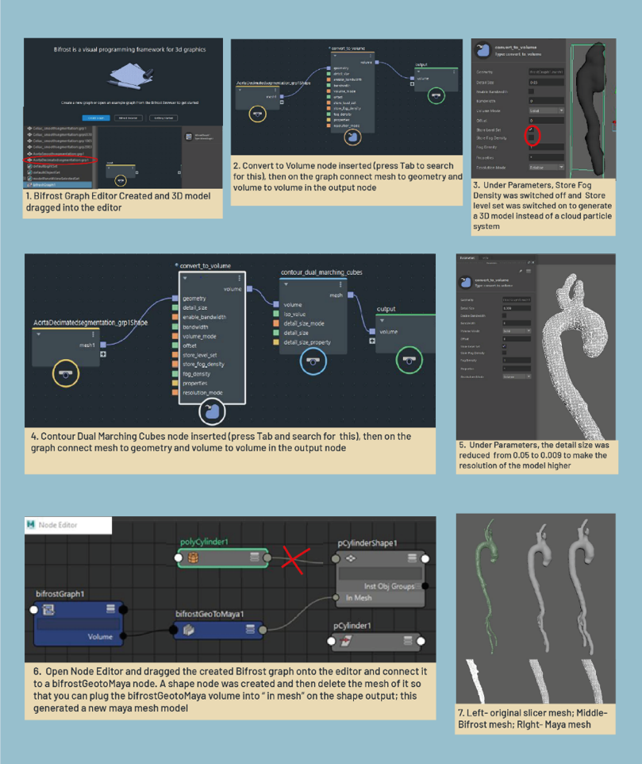
Figure 7 - Bifrost Visual Framework Workflow

3.2.3 Retopology and Sculpting
Once the 3D Slicer models were converted to usable Maya mesh, they were retopologised to change the mesh from triangular to quadrilateral mesh and ensure full Maya functionality in the modelling and animation editors. See Figure 8 for retopology and remesh workflow. Automatic retopology allowed a lower polygon count by 50-75%, which helped to maintain a clean Maya workspace that did not crash. Retopologising also allowed the model to be sculpted, textured, and animated effectively using quadrilateral mesh. All 3DSlicer models were retopologised after undergoing the Bifrost process.
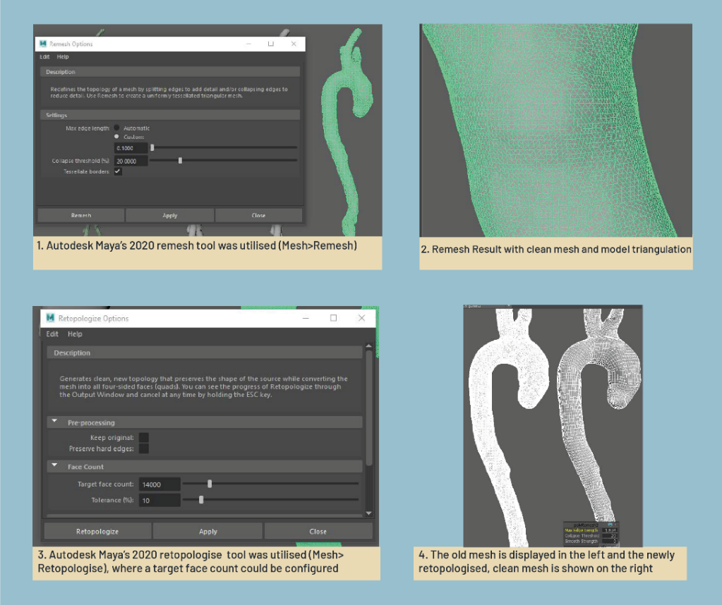
Figure 8 - Remesh and Retopology Workflow
After the structures were successfully retopologised, sculpting occurred on the models. This involved using Maya’s sculpt tools to smooth and adjust the models. Figure 9 shows the various sculpting tools and a selection of the models before and after being sculpted in Autodesk Maya. A similar process was carried out for the lungs in the TAA application.
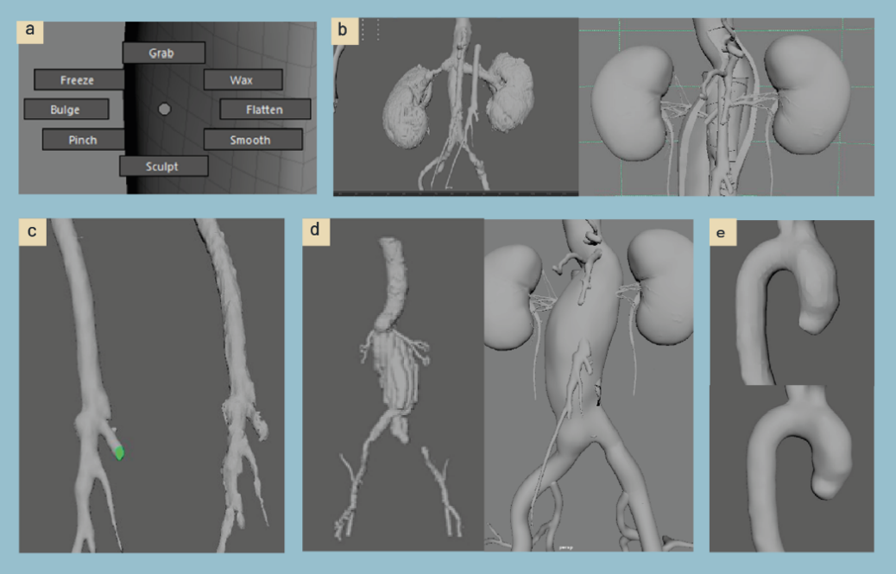
Figure 9 - a) Autodesk Maya 2020 Sculpting tools used b) Kidney before and after smoothing c) Superior Mesenteric Artery Before and after smoothing d) Abdominal Aortic Aneurysm before and after smoothing e) Top Aorta before and after smoothing

3.2.4 Modelling of the Heart
The heart was modelled manually in Maya with anatomical references. As a reference, the 3D heart model on BioDigital.com as used, as this website is very reliable and is highly noted for its anatomical accuracy (Qualter et al., 2012). The model was created in Autodesk Maya, by first sculpting a primitive cylinder against the reference images, and then extruding a portion of the mesh for the atriums and extruding the various blood vessels. The same process was used for modelling the thoracic aorta and the branch vessels. The thoracic Aorta was manually cut open in the area of the aneurysm to reveal the inner layer of the vessel and then subsequentially attached to the abdominal aorta. See Figure 10 for the untextured model and the polygon mesh of the heart and aorta.
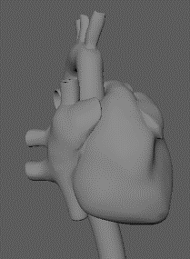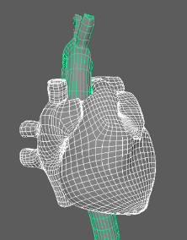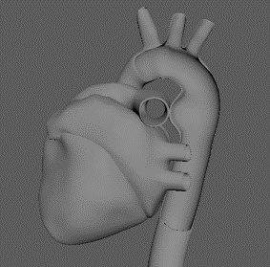
Figure 10 - Final Heart Mesh for use in Animation

3.2.5 Modelling of Relay Endograft
The Relay stent graft was modelled using a process of both photogrammetry and manual retopology. First, multiple photographs of the stent graft were taken and imported into Agisoft Metashape for automatic photogrammetry. The photogrammetry process is illustrated in Figure 11. Through this process, a rough mesh was achieved, that while unsuitable for automatic retopologising, contained an accurate representation of the stent, which was used as a reference to model from.
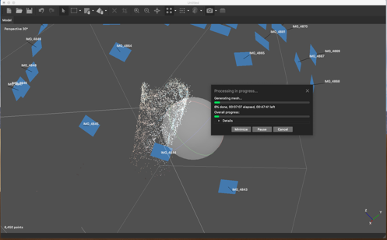
Figure 11 - Stent photogrammetry in Agisoft Metashape. This still depicts the automatic process by which the application converts a point cloud generated from image data to a polygonal mesh.

To create the model within Maya, the surface of the photogrammetry mesh was made live and the CV curve tool was used to trace along the outline of the imported mesh to create an accurate representation of the springs comprising the structure of the stent. Once the springs were traced, duplicated, and aligned, the quad draw tool was utilized to model the fabric connecting each row of wires. Figure 12 depicts the process of using the photogrammetry mesh as a reference for creating the shape of the stent using the Maya retopology tools, as well as the resulting model from this process.
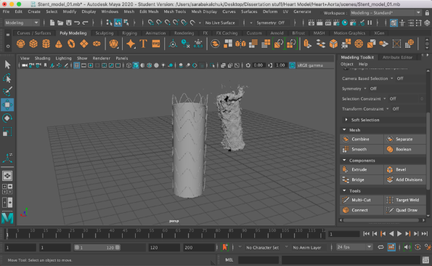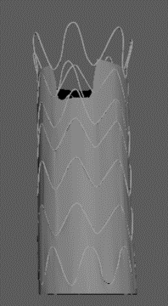
Figure 12 - a) Process of creating stent based off of photogrammetry mesh. b) Final untextured model of Relay stent

3.2.6 Modelling of Fenestrated Anaconda Endograft
Terumo aortic provided a physical Fenestrated Anaconda stent to reference for modelling a four-fenestration stent graft (Inchinnan, Scotland, UK). Measurements of the physical stent were taken and three cylinders created in Maya and taken into Illustrator and measured using the ruler tool to ensure acurate model dimensions; this process is seen in Figure 13.
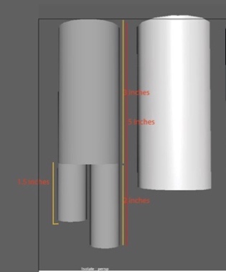
Figure 13 - Process of Measurements for Stent graft starting with base cylinders
Wires and Stitching of Stent Graft
After the Stent base mesh was created, the CV curve tool was used to depict the wires on the stent. The wires and stitching of the Fenestrated Anaconda needed to be depicted as rolling curves that were perfectly smooth; this was extremely important to depict as wires that had a slight bend, or were not perfectly even, could cause fractures or occlusion in patients. Dimensions were provided by Terumo Aortic (Figure 14) so the peaks and valley features were accurately modelled as well as the wires. The valley and legs modelled off of the provided dimensions are seen in Figure 14 and Figure 15. Once the stent body and wires were recreated, stitching was applied to the model. The stitching for the seams of the stent graft was completed using Maya Plugin, MASH; the process is seen in Figure 16.
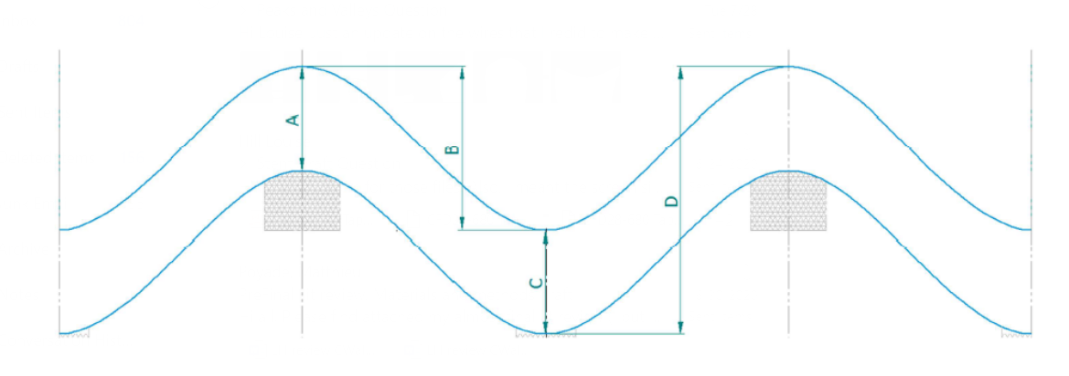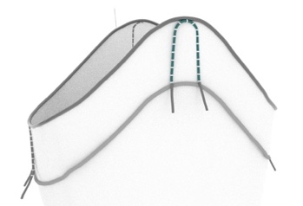
Figure 14 – Dimensions Provided and resulting modelled peak and valley
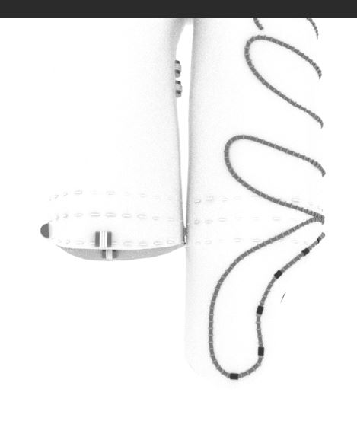
Figure 15 - Smooth Rolling Wire Curve
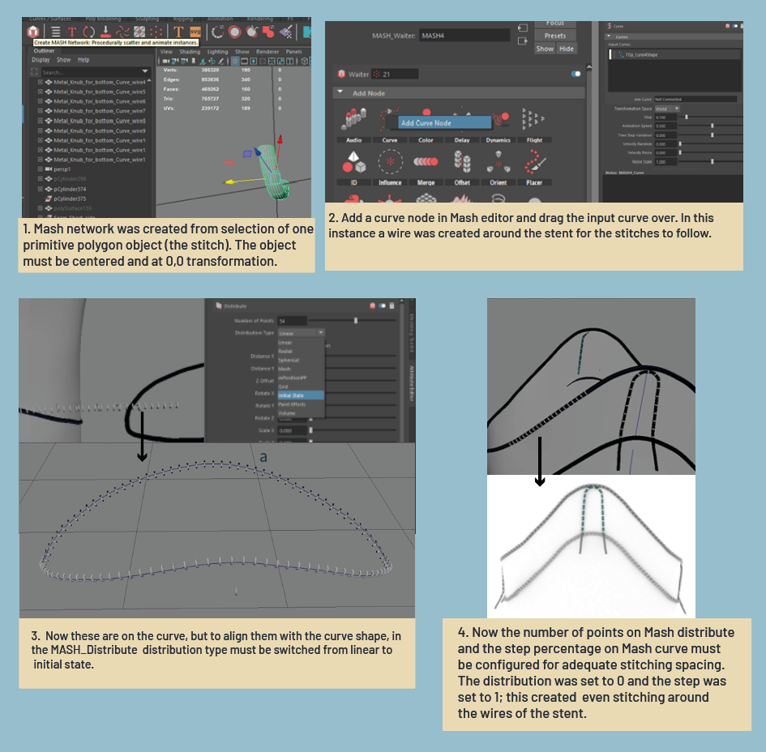
Figure 16 - MASH process for creating the stent's stitching
Stitches and Fine details of graft
To replicate the seams, small cylinders and torus shapes were added to the stent graft; this can be seen in Figure 17. These were assigned AiStandardSurface materials.
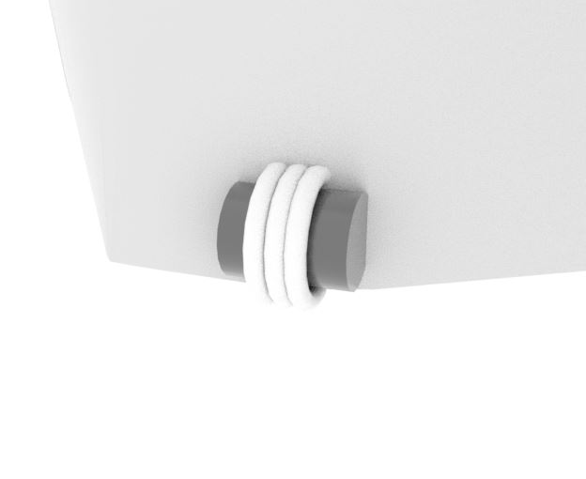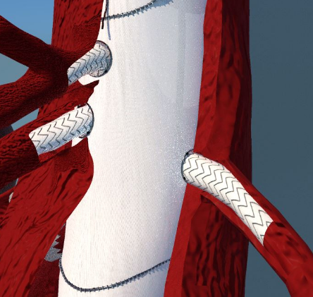
Figure 17 - Stitching details: Close up and far away on rolling curve wires
Additional Stent Body Models
Additional models were needed that are used during deployment. Figure 18 shows the Iliac Leg model designed in Autodesk Maya by creating a cylinder and then selecting every other edge and inverting the model. Edge loops were applied on either side of this model to create a smooth look and allow for colouring of the wire to be applied to the model.
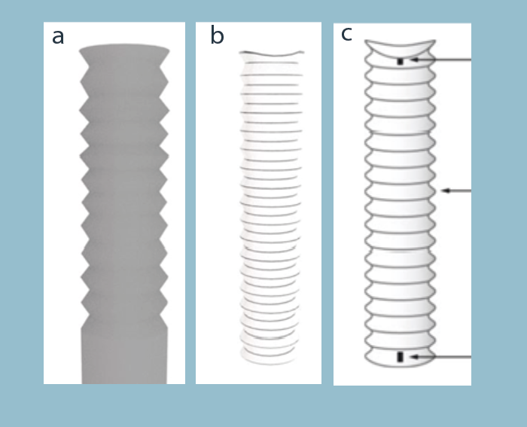
Figure 18 - Anaconda™ Iliac Leg (a,b) created based on the Terumo Iliac leg photograph (c).
Deployment Devices:
Deploying the stent required use of five additional models which can be found in Figure 19. These were created on Maya through a series of modelling and referring to the surgical manual for FEVAR surgery.

Figure 19 - Deployment Devices a) All deployment Devices together b) Iliac legs used after Fenestrated Anaconda deployed to connect to associated vessels c) Sheath used for deployment of the stent d) Deployment tube e) deployment wires for guiding the sheath f) Sheath aid tip

3.2.7 Texturing in Substance Painter
The application Substance Painter was used in the case of the TAA application to paint realistic textures onto the 3D assets created. For the heart model. Once the mesh was completed, it was exported into Substance Painter to automatically unwrap the UVs, and paint on various texture maps with a Wacom tablet. This application was utilized not only to paint the texture of the heart muscle, but also to paint on all the coronary arteries. Figure 20 shows the painting process, as well as the finished product created on substance painter. The resulting texture maps were then exported into Maya and attached as bitmaps onto various channels on an Arnold AiStandard shader material. Figure 21 shows a map of the Arnold texture utilized.
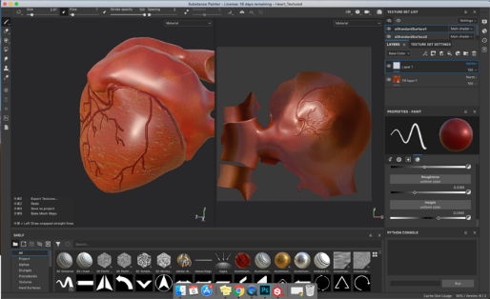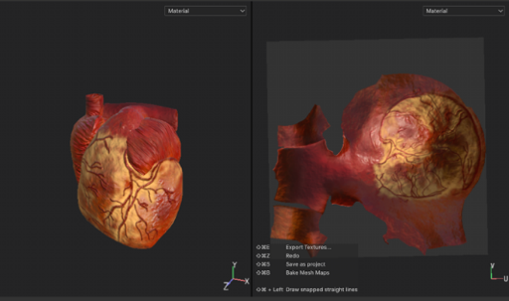
Figure 20 - Textured heart in Substance Painter: process (a) and final texture map (b)
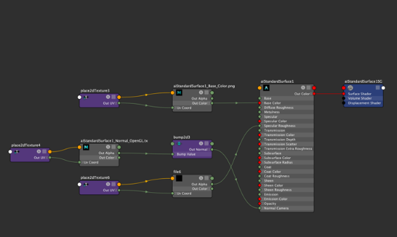
Figure 21 - Graph of Ai Standard Arnold texture settings
The lungs were also exported into Substance Painter for UV unwrapping and manual generation of texture maps. An assortment of the application’s default brush settings were used to paint a texture onto the surface of the model, as well as the bump map paint brushes to make the surface of the lungs appear more realistic. Figure 22 depicts the manual brushwork and texturing performed within Substance Painter, and a final rendering of the lungs once exported back to Maya.
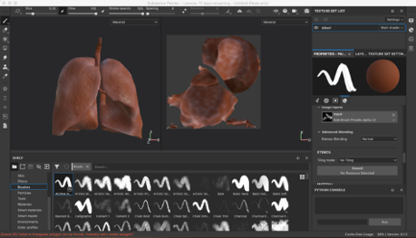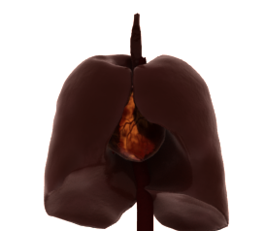
Figure 22 - Lung texturing process in Substance Painter, and rendering of the textured model in Maya
Finally, the stent graft was brought into substance painter to add textures and fine details within the stent. This included stitching, wires, and a number of other important markers featured on the device. Additionally, a fabric texture was created for the body of the stent and a metal texture for the wires. Figure 23 depicts the process of texturing the model within substance painter, as well as the finished product created.
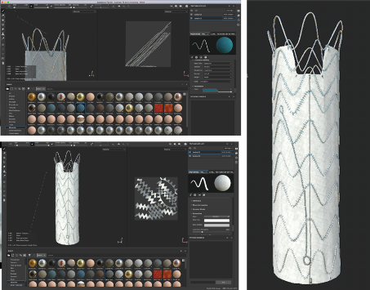
Figure 23 - Texturing the Relay stent in Substance Painter: process and final rendering

3.2.8 Informational Animations
The following headlines outline the methodology implemented to generate a series of animations to visualise FEVAR and TEVAR surgical technique for AAA and TAA patients, respectively and clinical successes after inserting the stents. Six different animations per stent were produced for the three modules: Deployment, Features, and Clinical performance.
Animations for the Fenestrated Anaconda Stent Graft
Manual sculpting and modelling adjustments to the aorta and associated vessels had to be made for different animations. The faces on the front side of the aorta and renal arteries were manually selected and detached from the main mesh. As a result, a realistic view of the aorta was created to allow for femoral access to be visualised.
All of the deployment tools were animated using the Curve Warp deformer in Maya. The deformer firstly allows for objects to be deformed along a curve path and enables manipulation of the length scale and offset of the 3D object; this made animating quite a challenge given the factors, such as scale, rotation and smoothed movement, considered when setting keyframes. A lattice and cluster system was used to animate the deployment and unsheathing of the stent. Each cluster was animated, and keys set individually to control scaling, position and rotation of the stent unsheathing and expanding. A visualisation of the lattice, clusters and twist handle is seen in Figure 24.
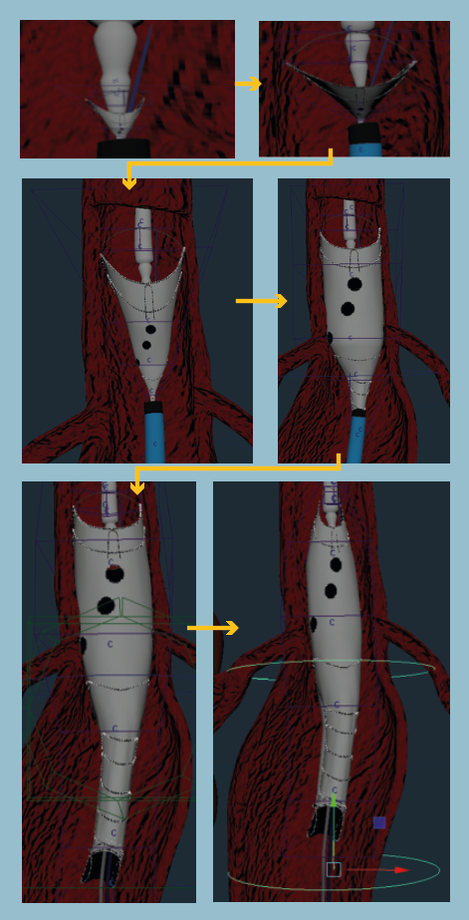
Figure 24 - Stent animation process by lattice, cluster and twist handle
The proximal access animation for the Feature module was created animated by using the curve warp deformer. By creating an opaque stent, the camera was able to zoom in and out of the stent to show access from the upper aorta and down into the fenestration. The repositioning animation required the camera to be animated in various positions in order to depict a close-up visualisation of the stent moving, rescaling and inflating after unsheathing, one of the key competitive features of the Fenestrated Anaconda. The versatility animation was also created by animating a camera around the stent to show the various positions and sizes of the fenestrations and how they are uncompromised by stents or wires (Colgan et al., 2018; Dijkstra et al., 2014; Midy et al., 2017). Figure 25 shows resulting stills from these two animations.
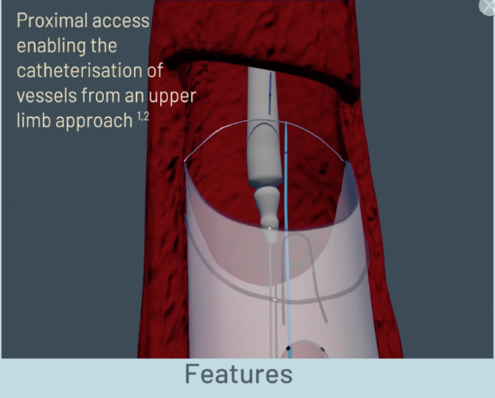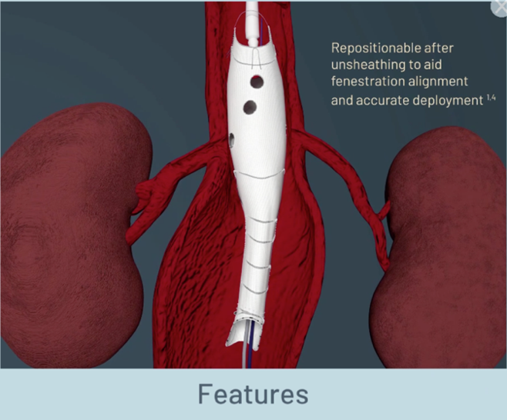
Figure 25 – Proximal and Repositionable Animation stills to visualise the benefit of these custom surgical techniques
Terumo Aortic required four clinical performance statistics about this specific graft to be showcased in the animations. For this, the Maya plugin ‘Mash’ was utilised to animate red blood cells (RBCs) going through the stents and into the vessels. This was an easily accessible system to use and apply changes to such as animation speed, distance apart, randomness, and rotation. The process of creating a Mash network for the RBC animation portion is discussed in more detail later.
Animations for the Proximal Relay Stent Graft
The animation process began by animating the delivery system. To animate the stent lead wire, a cylinder was created and the curve warp tool was utilized to animate the wire moving along a curve going up the length of the aorta. This was done so that the wire can be portrayed climbing through the aorta and into the aortic arch. Next, the sheath was animated by creating a larger cylinder that follows the same path of the lead wire and lands within the aortic arch. This animation was created by animating the max length of the sheath with the curve warp deformer, and repeated so that there was both an inner and outer sheath portrayed. In order to animate the stent deployment, the curve warp deformer was utilized to allow the stent to be deployed along the curve, followed by a flare deformer, which allowed for the stent to be scaled up as it is deployed. A separate flare deformer was used for the top springs of the stent, to portray them detaching from the tip capture mechanism after the stent is fully deployed. After this, the same curve warp method was used to reverse the direction of the wires and the sheath comprising the delivery system, in order to demonstrate how these components exit the aorta. Figure 26 shows the set up for the delivery system, as well as the flare deformer and curve warp deformer settings utilized for this animation. 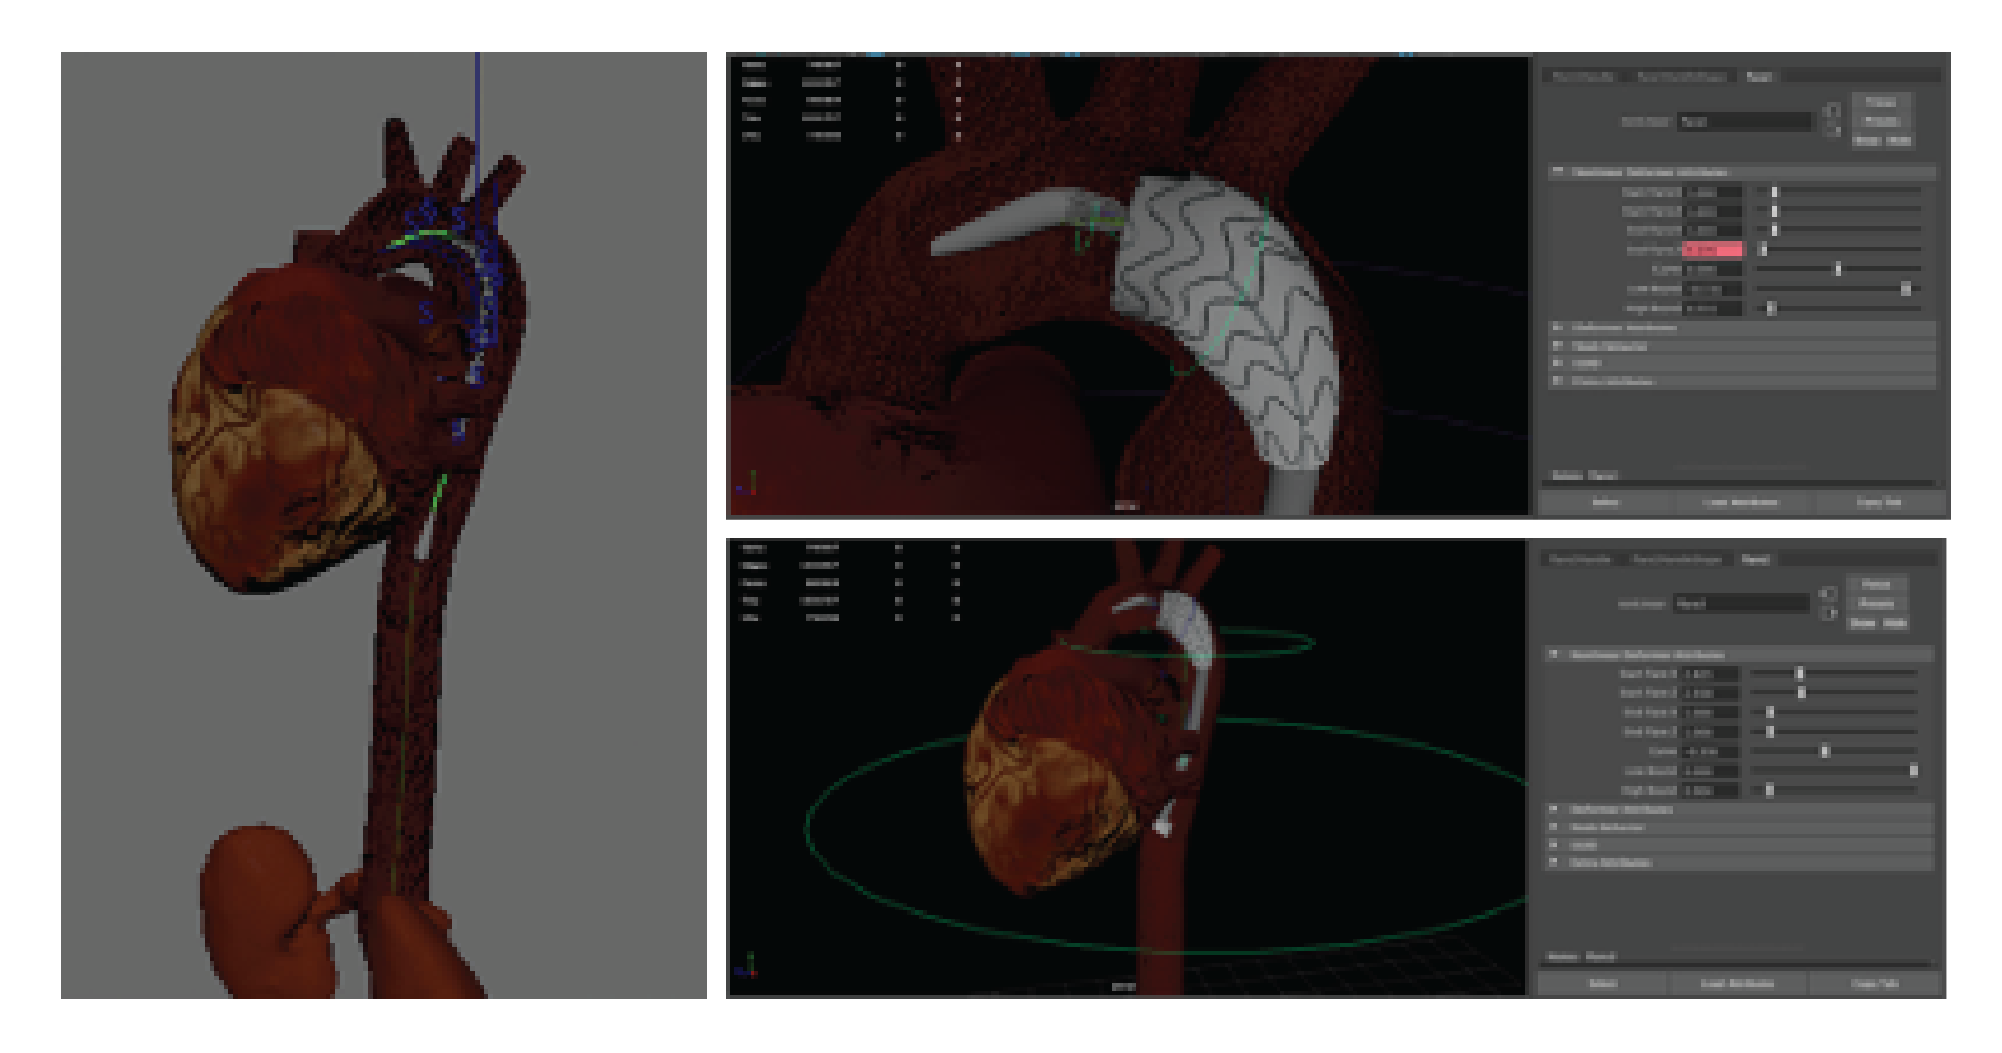
Figure 26 - Depiction of stent deployment animation process for TAA animations
In order to animate the heart beating, multiple lattice deformers were used on each part of the heart in a synchronized loop. This loop made it so that three different parts of the heart were expanded and then shrunk in synchrony. Figure 27 portrays the lattice deformers and graph editor utilized for this animation within Maya. 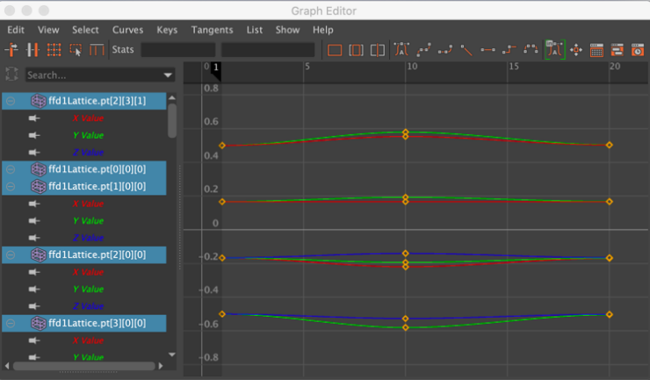 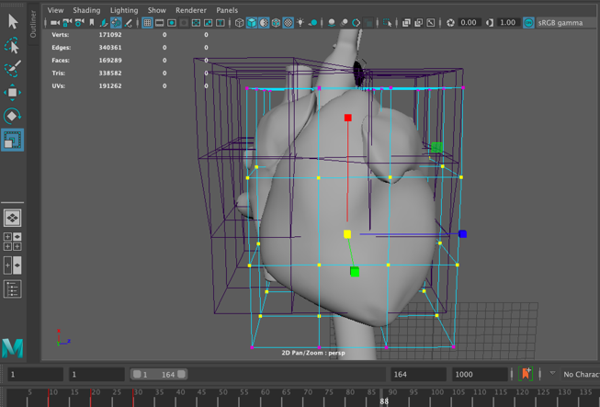
Figure 27 - Lattice deformers utilized for heart beat animation
Red Blood Cell Flow Animations
To create the animation of the blood cells flowing through the aorta, the MASH tool was used on the previously modelled red blood cell to create a network of particles that flow along predetermined curves. A CV curve was fashioned for each potential RBC path, and a corresponding MASH network for each of the four paths was created. The paths and the mash network settings can be seen in Figure 28. A randomness node was also added to the MASH settings so that the rotation and orientation of the cells would be varied.

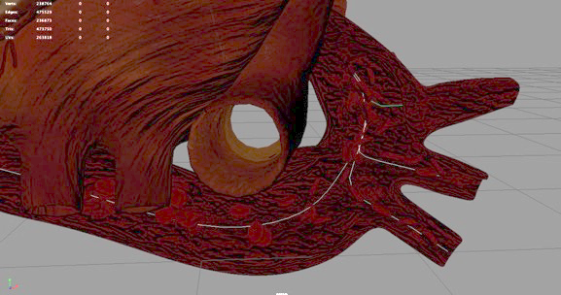
Figure 28 - MASH network set-up for TAA blood flow animations
Post Processing
The application Adobe After Effects was used to compile the multiple series’ of still images rendered into videos. In order to create the compositions in After Effects, the rendered PNG sequence was selected for each video, and then imported as a composition into the software. Once all of the videos were compiled, various features of the application were used to add unique text and graphics.

3.2.9 Application Development

3.2.9.1 Home screen
Construction of the home screen required combining three relevant renderings in photoshop with a standard background circle provided by Terumo Aortic to create buttons. These buttons lead the user to the three main sections of the applications: features, deployment, and clinical performance. In addition to the home screen buttons, a number of other custom UI features were created that appear within the applications. All of these were designed to fit the Terumo aortic graphic style, while still remaining intuitive and simplistic. Figure 29 depicts the home screen for both applications.
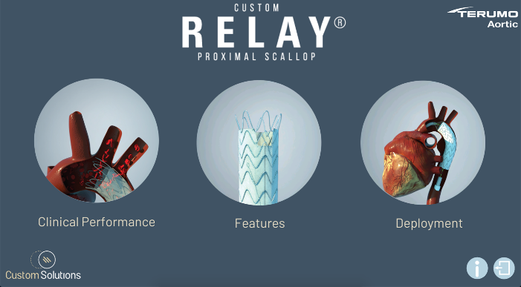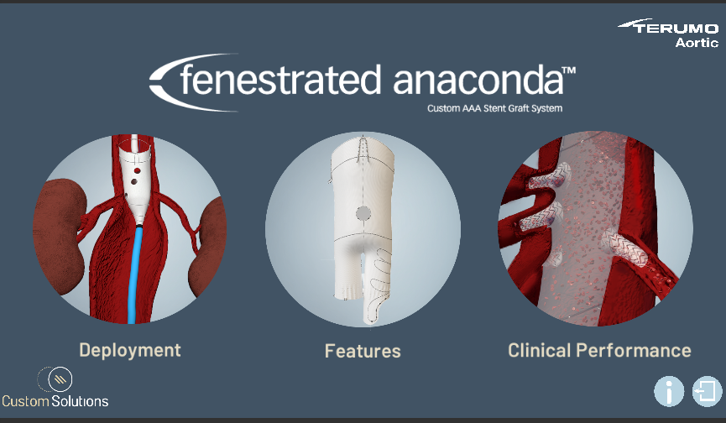
Figure 29 - Home screen for TAA application (left) and AAA application (right)

3.2.9.2 Features section
To create the interactive applications, all the 3D models required were imported into Unity. These were all exported as FBXs with their corresponding textures and imported into the features section of the applications. A corresponding icon was added to a portion of the model for each feature, and the buttons were coded so that a specific video would come up when the user clicked on a feature. Figure 30 shows the “Features” unity scene for both applications with the imported models and custom UI.
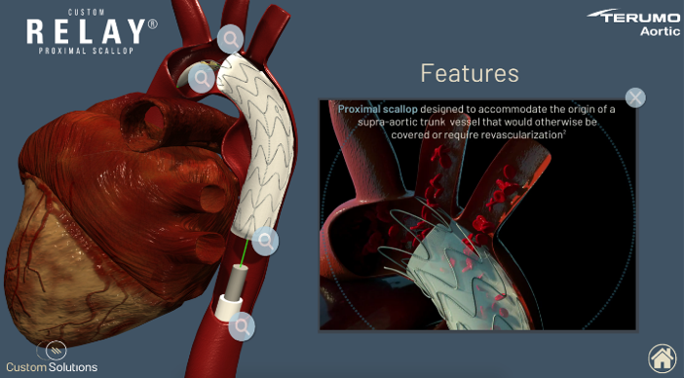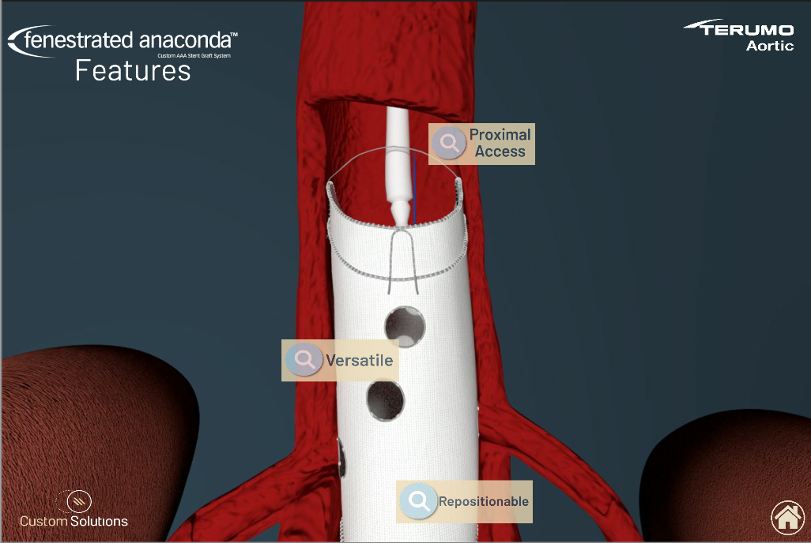
Figure 30 - Features section of TAA application (left) and AAA application (right)

3.2.9.3 Clinical Performance and Deployment Sections
For the clinical performance and deployment modules, the rendered MP4s and relevant UI were imported into the scene. The videos were then placed onto a raw image with a render texture, so that they played seamlessly on the screen. Simple scripts were added in order to create a play button, a pause button, and a replay button. Additionally, a script for a progress bar was created with the help of supervisor Dr. Matthieu Poyade. This feature was created underneath the video so that the user can track the video progress and interact with the bar to fast forward or rewind the video. Figure 31 depicts the video interface created within Unity for both deployment modules, while Figure 32 depicts the video interface created for both clinical performance modules.

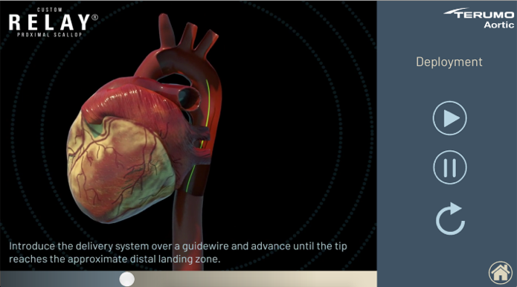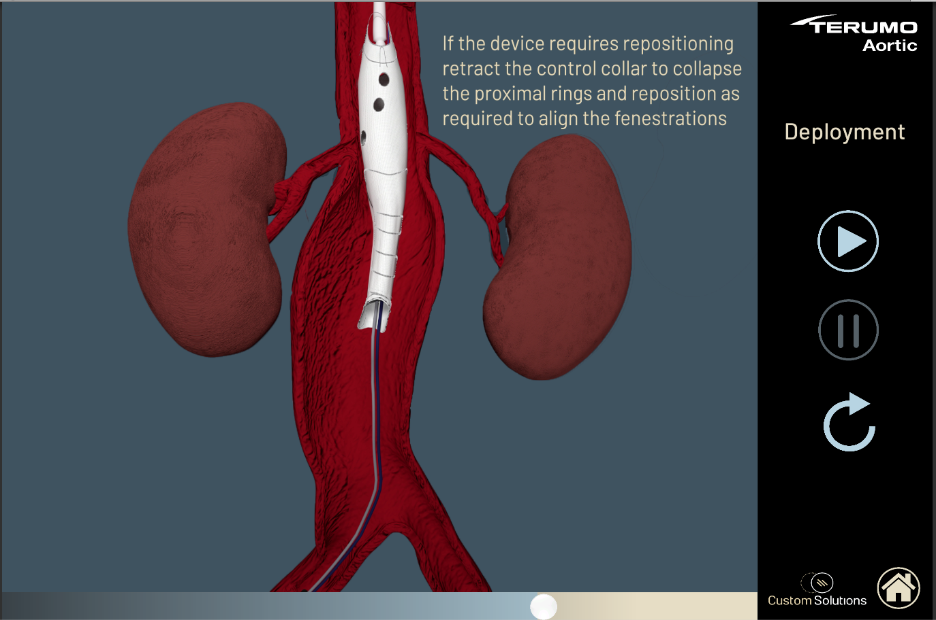
Figure 31 - Deployment section of TAA application (left) and AAA application (right)
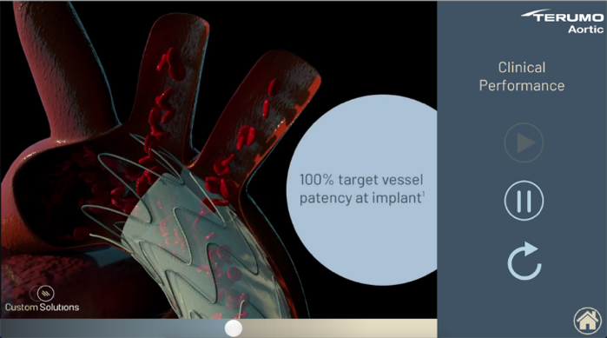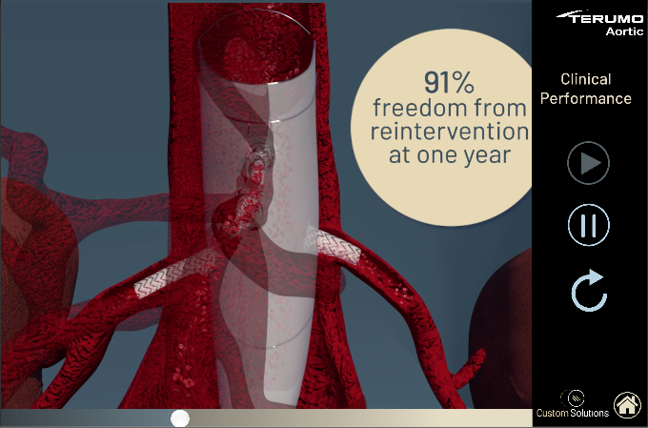
Figure 32 - Clinical Performance section of TAA application (left) and AAA application (right)

4.0 Results

4.1 Outcomes from evaluating the finished application with clinical professionals.
Following application development, both products underwent a process of evaluation by clinical professionals at Terumo to assess their effectiveness in communicating the key features of the devices to a broader medical audience. For the most part, this evaluation process provided valuable feedback about the effectiveness of these applications. Both received high ratings for face validity and content validity across all three sections of the application. However, it was reported that the deployment models and animations within the TAA app could have been improved. Similarly, the Iliac Leg stent used for completing the FEVAR technique in the AAA app could have been improved in modelling and texturing techniques. Additionally, the blood flow simulation animations were reported to be distracting with the texturing of the aorta and red blood cells. There was an overall consensus that the applications were easy to use and very intuitive to figure out. In general, both applications effectively communicated the most important aspects of the device, while the deployment section of the TAA and AAA apps could benefit from a few improvements to enhance its accuracy. In the future, an updated version of these applications could be created that contains a more detailed and accurate depiction of the stents. While future testing still needs to be conducted, these preliminary results offer a valuable starting point to indicate how these applications will be received by professionals in the field. Moreover, the research and methodologies used to create these scientific animations and corresponding applications, show a useful way of communicating advanced medical devices through cutting-edge, intuitive, technological methods.

5.0 Discussion
The aim of this project was to create two user friendly interactive applications with various 3D visualizations of the two corresponding stent grafts. These visualisations would demonstrate to clinicians how these products function, and aid cardiac patients to understand the key features, and surgical process of the stent deployment.

5.1 Discussion of development process
The development process of these applications was simplified by the fact that Terumo Aortic had a clear idea of what they wanted out of the applications, and what information to include. The ideation and co-design process with the company lead to the joint conclusion that both apps should be broken down into three modules: deployment, features and clinical performance. Once this became clear, designing the layout of the applications and determining the required UI and 3D assets came naturally. The data extraction, modelling, animation, and application development each came with their own limitations. Slicer 3D was utilised only to segment the medical data, so this was a fairly quick process. On the other hand, the modelling, specifically of the stent, was a prolonged, capricious process due to multiple factors, including limitations to resources and time. This was especially challenging because not only did the structure of the stent have to be exactly like the Terumo Aortic model, but it also had to be constructed in a manner that allowed for it to be animated. However, modelling of the surrounding anatomy, specifically the heart, aorta, lungs and kidneys was an enjoyable and exciting learning process. The texturing process for the TAA application was one of the most rewarding aspects of the whole development procedure, as the application Substance Painter made it quite easy to paint hyper realistic and detailed textures directly onto the models. This was especially necessary due to the small coronary arteries in the heart, and the many small stiches on the stent.
The animation process was the most challenging by far for both applications, particularly the deployment animations. In the case of the AAA app, the discovery of a technique to animate the stent unsheathing provided a successful final outcome, while the TAA application was slightly less accurate, as the curved shape of the stent meant that the aforementioned stent unsheathing technique would not work. The blood flow animations were created seamlessly with the user friendly and intuitive MASH toolkit within Maya. For the AAA app specifically, the MASH network created a nice outcome for the RBC’s to be seen flowing through the Fenestrated Anaconda, Advanta V12 Balloon stent, and Iliac leg stents. In retrospect, this type of project could have been approached differently given the time constraints and feedback received. Nonetheless, the 3D models and animations concluded with a positive outcome.
Much troubleshooting had to occur to produce Arnold renders that were both high quality but also reflective of the time allocated for rendering. Difficulties with the lighting and quality of the rendering versus time to render each frame, were considered and render sequences were divided up amongst computers. Rendering was a time consuming, but ultimately rewarding, process.
The application creation process was rather simple on the other hand, as the deployment and clinical performance scenes consisted mainly of imported videos. Scripting the video interface started off reasonably simple as well, as the coding required for adding a start, stop and replay button was fairly minimal. However, the process of adding the scroll bar was much more difficult. While more complex, the features scene was quite intuitive to set up as well. Once all the models were imported and textured, it was quite simple to import the rendered videos and integrate them into the application. The design of the app was a back-and-forth process with the graphics team at Terumo, which ended up being quite laborious. While the creation of these applications was a very long and difficult process at times, it was also extremely worthwhile.

5.2 Discussion of application feedback
The feedback received for these applications was predominantly positive, in that most participants agreed that the models were realistic and accurate, but the delivery system models could have used some adjustments. The clinical performance animation and the features animations got mostly positive feedback, while the feedback for the deployment animation was more neutral. The content validity was rated highly for all three modules of the applications, as participants generally agreed that the key facts and figures were communicated effectively. In regard to the applications as a whole, the participants found them very easy to use, and very informative. It is important to keep in mind however, that the cohort utilized for testing were all highly skilled professionals and extremely knowledgeable concerning this device, more so than the target audience would be. Therefore, any negative feedback received from this group would not necessarily indicate bad results. If there was more time, it would have been beneficial to test these applications on more participants so that the data received would be more reliable.

5.3 Benefits and drawbacks of the application/3D visualisation technique
In addition to creating a valuable application for professionals in the surgical device industry, the methodology used for this application, presents a novel 3D visualisation technique, which uses a combination of highly realistic anatomical model creation, and simple, intuitive application design. This innovative methodology can be adapted for many different uses, within many different fields, and therefore marks a significant contribution to the realm of biomedical visualisation. The new techniques, however, do come with a set of benefits and drawbacks that must be considered before adapting this methodology to future projects. For instance, it was widely stated that certain aspects of the application could have been more realistic, most commonly, the medical devices. Additionally, this technique can also be more time consuming and expensive than a simpler 2D animation. Thus, there are significant benefits to such techniques as well. For instance, the high level of detail and realism provided by a 3D application makes a complicated topic quite easy to understand and visualise for a broad audience. Additionally, the integration of these visualisations within an interactive application makes the animations more widely accessible and more easily viewed by the subject.

5.4 Limitations
The most apparent limitations to this project were caused by the current Covid-19 pandemic. Most notably, all work had to be done remotely, and no work could be conducted which involved meeting people in person or working with clinicians. These factors made it so that the time for development was limited. For the AAA application specifically, it was understood that the stent model would be provided in an OBJ format, because the Fenestrated Anaconda is a highly intricate device with key features. Therefore, these applications were not completed to the full potential that they would have been if allotted more time or resources. The lack of time also made it so that we were unable to recruit as many participants as originally planned. Overall, despite all of these shortcomings, a great deal was learnt about modelling intricate models, Autodesk plugins, animation networks, and final renders to create high quality animations.

5.5 Further development
There are many ways in which this application could be advanced. Most notably, the applications could be further developed to incorporate some feedback from the participants. Regrettably, the time constraints of the project and COVID-19 precautions meant that testing at a medical conference could not occur. Fortunately, ample feedback was provided throughout collaboration by professionals of Terumo Aortic that ensured anatomical and stent graft accuracy during the development process. Once more refined, it could be very beneficial to create applications such as this for other Terumo products, so that the company can effectively communicate the key features of their products to clinicians and patients in a more appealing way. The lack of engaging visualisations and medical interactive applications for clinical specialists, supported in the literature, show an obvious need for these applications to be shown to clinicians to positively impact their choices in treating complex aneurysms.

6.0 Conclusion
Advances in understanding stent graft surgical techniques and options have led to the need for interactive applications to engage healthcare workers so they can exploit its key features to effectively broaden the treatable patient population. Overall, the demonstrated methods in this project were successful in creating animations for interactive applications that showcased new features of novel stent grafts. The series of animations for both the Fenestrated Anaconda and the Relay device made up a practical interactive application that works to inform both the physician and patient of various surgical device options for treating rare, complex anatomical Aortic Aneurysm cases. These in turn provide resources for the physician to visually explain the surgical procedure and long-term benefits to a patient. Subsequently, this improves the discussion between patient and physician, providing a deeper understanding and patient-centred surgical approach in elderly patients who suffer from aortic aneurysms.
Although these applications require additional testing, and still have a few areas that necessitate further refinement, these preliminary results show great potential for the creation of an application that can utilize 3D visualization techniques to successfully engage both physicians and patients. The interaction with a surgical device company to create the anatomical and surgical models, textures, animations, and final application development provides an innovative approach to visualising surgical processes, generating awareness about medical conditions, and facilitating treatment discussions between the physician and those with aortic aneurysms. Given the range of positive interactions, as supported in the literature, of the general public with emerging visualisation technologies, the applications created provide a valid visualisation tool to engage clinicians, as well as the general public, about new medical devices, treatment alternatives and research pertaining to healthcare an easily accessible visual format (Baker et al., 2002; Ford and Leinonen, 2009; Traxler, 2007). The creation of these application also establishes a methodology for building informative surgical tools and positively influences the healthcare field through accurate dissemination and communication of surgical procedures and associated statistics.

References
Abraha I, Romagnoli C, Montedori A, et al. (2009) Thoracic stent graft versus surgery for thoracic aneurysm. Cochrane Database Syst Rev. Epub ahead of print 2009/01/23. DOI: 10.1002/14651858.CD006796.pub2.(1): Cd006796.
Alsafi A, Bicknell CD, Rudarakanchana N, et al. (2014) Endovascular treatment of thoracic aortic aneurysms with a short proximal landing zone using scalloped endografts. J Vasc Surg 60(6): 1499-1506.
Baker DW, Gazmararian JA, Williams MV, et al. (2002) Functional health literacy and the risk of hospital admission among Medicare managed care enrollees. Am J Public Health 92(8): 1278-1283.
Baker DW, Parker RM, Williams MV, et al. (1998) Health literacy and the risk of hospital admission. J Gen Intern Med 13(12): 791-798.
Ben Abdallah I, El Batti S, Sapoval M, et al. (2016) Proximal Scallop in Thoracic Endovascular Aortic Aneurysm Repair to Overcome Neck Issues in the Arch. Eur J Vasc Endovasc Surg 51(3): 343-349.
Bercovich E and Javitt MC (2018) Medical Imaging: From Roentgen to the Digital Revolution, and Beyond. Rambam Maimonides medical journal 9(4): e0034.
British Heart Foundation: Thoracic aortic aneurysms - Causes, Symptoms & Treatments. (accessed 28/05).
Burt JR, Zimmerman SL, Kamel IR, et al. (2014) Myocardial T1 mapping: techniques and potential applications. Radiographics 34(2): 377-395.
Coelho-Filho OR, Rickers C, Kwong RY, et al. (2013) MR myocardial perfusion imaging. Radiology 266(3): 701-715.
Elefteriades JA (2002) Natural history of thoracic aortic aneurysms: indications for surgery, and surgical versus nonsurgical risks. Ann Thorac Surg 74(5): S1877-1880; discussion S1892-1878.
Fernández-Alonso L, Fernández Alonso S, Martínez Aguilar E, et al. (2018) Endovascular Treatment of Aortic Arch Lesions Using Scalloped Endografts. Vasc Endovascular Surg 52(1): 22-26.
Ferrari E, Tozzi P and von Segesser L (2006) Thoracic aorta emergencies: is the endovascular treatment the new gold standard?☆. Interactive CardioVascular and Thoracic Surgery 5(6): 730-734.
Ford M and Leinonen T (2009) Mobile Learning: Transforming the Delivery of Education and Training. pp.195-214.
Holliman R, Whitelegg L, Scanlon E, et al. (2009) Investigating Science Communication in the Information Age: Implications for Public Engagement and Popular Media.
Isselbacher EM (2005) Thoracic and abdominal aortic aneurysms. Circulation 111(6): 816-828.
Karmy-Jones R, Jackson N, Long W, et al. (2009) Current management of traumatic rupture of the descending thoracic aorta. Curr Cardiol Rev 5(3): 187-195.
Kasirajan K, Heffernan D and Langsfeld M (2003) Acute thoracic aortic trauma: a comparison of endoluminal stent grafts with open repair and nonoperative management. Ann Vasc Surg 17(6): 589-595.
Kato N, Dake MD, Miller DC, et al. (1997) Traumatic thoracic aortic aneurysm: treatment with endovascular stent-grafts. Radiology 205(3): 657-662.
Liu J, Ma W, Liu F, et al. (2007) Study and Application of Medical Image Visualization Technology. Berlin, Heidelberg: Springer Berlin Heidelberg, 668-677.
Qualter J, Sculli F, Oliker A, et al. (2012) The biodigital human: a web-based 3D platform for medical visualization and education. Studies in health technology and informatics 173: 359-361.
Saremi F (2017) Cardiac MR Imaging in Acute Coronary Syndrome: Application and Image Interpretation. Radiology 282(1): 17-32.
Taylor AM and Wessels Q (2019) Using Technology to Engage the Public in Biomedical Sciences. Adv Exp Med Biol 1171: 127-135.
Traxler J (2007) Defining, Discussing and Evaluating Mobile Learning: The moving finger writes and having writ. The International Review of Research in Open and Distributed Learning 8(2).

