Visualising the Link Between Carpal Bones and their Etymologies
Abstract
It has been observed through published studies, as well as anecdotally, that medical students struggle with retention of anatomical knowledge. Studies have found that having an established understanding of classical Greek or Latin languages, which underpin medical terminology, can result in higher anatomy test scores by medical students. It has also been established that three-dimensional (3D) visualisation tools can aid in student learning. This chapter will examine the research conducted at the University of Glasgow which focused on the creation of a mobile application that visualises the etymology of the carpal bones for the purpose of aiding medical students in their learning and retention of knowledge of the anatomy. The chapter will first build a body of knowledge by reviewing previous studies in which a carpal bone test was used as a measure of medical students’ anatomy knowledge, as well as the relevance of etymology in medicine and its use in the study of anatomy, and the current teaching methods of anatomy, with a focus on how 3D visualisation tools can aid learning. It then outlines a methodological and technical framework to create anatomically accurate 3D models of the carpal bones and develop the final mobile application. It also discusses the methodology used to carry out suitable user testing and collect user feedback. This chapter concludes discussing the results of user testing, where feedback was analysed to improve the mobile application design for further use in anatomy teaching. Limitations and future outlooks of the study, along with the future of integrating 3D visualisation tools as teaching methods to aid in student learning of anatomy are also explored.
Keywords: Medical Visualisation, Carpal Bones, Etymology, 3D Models, Educational Application
Other possible titles: Visualising etymology: how building an app that links carpal bones anatomy to their etymology aids medical students in their learning. Visualising carpal bones and their etymologies. How visualising the etymology of carpal bones helps medical students learn them.

Theoretical Background

Introduction
The many years of education that medical students complete are largely focused on learning the thousands of terms and concepts of human anatomy, which can be quite a daunting task. Moreover, much of the anatomical terminology with which they need to be familiar is derived from ancient Greek and Latin, presenting additional challenges akin to learning a new language. Many students struggle to learn the terms through heavy reliance on rote learning methods, a repetition-based memorisation technique (Mayer, 2002; Brown, 2014; Ebenezer and Mohanraj, 2020). Specifically, it has been observed through published studies, noting comments from senior doctors, as well as anecdotally from University lecturers, that medical students struggle with retention of anatomical knowledge, which could be caused by factors such as, reduced teaching times and less access to physical dissection, and may be adding to the reliance on rote learning methods (Spielmann and Oliver, 2005). A proposed solution for students to overcome the challenges presented from learning medical terminology through memorisation techniques is to establish a link between the anatomy and their respective etymologies, the study of the origins of words. Studies have found that having an understanding of a word’s etymology enhances students’ learning and recollection, as it is a form of meaningful learning - a type of learning connected to prior learning, more highly retainable and generalizable - making it superior to simple rote learning of vocabulary (Pierson, 1989).
This chapter will first explore the study of etymology and its use in medicine, the influence understanding etymology has on learning anatomy, and the benefits of the use of digital technology in learning.

Why Carpal Bones?
There have been multiple studies conducted to assess medical students’ knowledge of anatomy in recent years, a common method of assessment among them being the use of a carpal bone test. The reasoning behind the carpal bones being chosen as a benchmark of basic anatomical knowledge is that they have clinical relevance to a variety of different specialties, and they are easy to objectively examine. They also make up a significant component of the upper limbs, as they are important to the movement and use of the hands. A 2005 study conducted by Spielmann and Oliver provides some insight on medical students’ and junior doctors’ knowledge of anatomy by using a carpal bone test (Spielmann and Oliver, 2005). Fifty questionnaires regarding the labelling of the eight carpal bones were administered to a cohort of 25 medical students, 15 pre-registration house officers (PRHOs) and 10 senior house officers (SHOs). Out of the 50 participants, only 15 could correctly name all eight carpal bones, seven of them being SHOs. Similarly, in a 2012 study by Valenza et al., a carpal bone test was used to assess the anatomical knowledge of third year medical and physical therapy students, and the results held consistent with the Spielmann and Oliver study (Valenza et al., 2012). A group of 134 students were allotted five minutes to identify and label each of the eight carpal bones on the test. It was found that only 39 students (29%) correctly identified all the eight carpal bones, and 36 physical therapy students (66%) correctly identified 5 or more carpal bones as compared with only 26 medical students (32.5%). The results of both studies have portrayed that the level of anatomical knowledge of entry-level medics is far from ideal. They also specifically emphasised the lack of carpal bone anatomical knowledge possessed by medical students, which further warranted the creation of an aid to help them learn and remember the bones to a higher degree of excellence.

The Study of Etymology and its Use in Medicine

1.3.1 The Study of Etymology
Etymology is briefly defined as “the scientific study of the origins and history of the changing meanings and forms of words” (Ross, 1969). It is essentially the breakdown of words into their prefixes, suffixes, and root words, and the process of linking them to their classical origins, in order to give meaning to the words. As an academic specialty, it is usually taught as part of post-graduate English literature studies, therefore it is unlikely that many medical students have sufficient knowledge in etymology, or classical Greek and Latin languages (Pierson, 1989).

1.3.2 Relevance of Etymology in the Medical Field
The use of classical Greek and Latin language is extremely prevalent within medical terminology, the language used by medical professionals. However, an issue is presented when physicians use complex medical terminology when interacting with their patients, as it can cause a communication barrier (Sevinc, Buyukberber and Camci, 2005). Medical terminology is useful as a standard form of communication between professionals in the field but may not be understood by patients. This disconnect in communication and understanding between patient and physician can cause the patient to feel intimidated and overwhelmed (Sevinc, Buyukberber and Camci, 2005). As classical Greek and Latin courses are currently not required to fulfill a medical degree, many medical students and professionals in the field rely on rote learning methods, in conjunction with observation, dissection, and other hands-on learning techniques, when learning anatomy and medical terminology (Brown, 2014; Lewis et al., 2014; Murgitroyd et al., 2015). As memorisation plays a major role in these typical learning methods, many of these individuals will go through their training and experience without having sufficient etymological knowledge of the anatomy being learned. One study found that no house officers or medical students (n = 52) could translate common abbreviations used in medical practice (Drury, Powell-Smith and McKeever, 2002). Another study found that in an emergency department, the percentage of patients who did not recognise analogous terms such as bleeding and hemorrhage was 79%, and broken and fractured bone: 78%; while for non-analogous terms diarrhea and loose stools: 37%, for example (Lerner et al., 2000). The patient-physician communication barrier occurs when physicians use terminology in which the patient does not understand, and the physician does not have the ability to translate or explain. When there is no depth in understanding of the classical origins of these terms, it makes it much more difficult for communication to be had between people in the medical field and others not so well-versed, like patients. It is therefore considered useful for the physician to have background knowledge in anatomical and medical etymology, as it would allow them to explain in simple and relevant terms what the words being used with their patients actually mean.

The Link Between Knowledge of Etymology and Successful Learning of Anatomy in Medical Students
Numerous studies have been conducted to explore the influence of understanding etymology on learning human anatomy (Spielmann and Oliver, 2005; Smith et al., 2007; Pampush and Petto, 2011; Ebenezer and Mohanraj, 2020). In order to understand this, one must first understand how the process of learning new information works.

How Do We Learn? Three Learning Outcomes
The different ways in which we approach new information being presented can be categorised into three groups: no learning, rote learning, and meaningful learning (Mayer, 2002). Each of these learning outcomes results in a difference in the way new knowledge is stored and used. Consider a scenario in which new information is skimmed over quickly, without taking time to analyse and understand the content. It would likely be found that little to no information could later be recalled, only few key points may be remembered, and the individual would not be able to use the information that had been provided to solve problems (Mayer, 2002). This would be categorised as “no learning”.
Rote learning and meaningful learning are the second and third learning categories. They differ in the regard that individuals are able to recall most of the newly learned information, however, individuals that have achieved meaningful learning are also able to transfer and apply their knowledge to new learning scenarios and problems, unlike individuals whom have only achieved rote learning (Mayer, 2002). In the case of learning the anatomy of carpal bones, the heavy reliance on repetition-based memorisation rote learning methods may be one of the reasons that medical students struggle. It could be helpful to use meaningful learning methods instead when it comes to the carpal bones, as students would be able to recall information about the structural anatomy, but also transfer and apply their knowledge of the etymology of the bones, in order to help them identify each bone correctly.

1.4.3 How Etymological Understanding Aids Anatomical Learning in Medical Students
The influence of knowledge of etymology on how medical students learn human anatomy has been thoroughly studied over the years. One study looked at first year medical students who were given a basic etymology pre-test before taking a gross anatomy course to evaluate students’ familiarity with the roots, prefixes, and suffixes of anatomical terms rather than the anatomy itself (Smith et al., 2007). The course then defined etymologies during lectures and dissection laboratories, and explanations of etymologies were provided for each section of anatomy. After completing the course, the students were given the same etymology test used as the pre-test. The results were in line with the hypothesis, in that students scored significantly higher on the post-test than the pre-test, by an average of 6.2%. They also found that previous exposure to medical terminology enhances scores; students with exposure to medical terminology scored significantly higher on the pre-test than students with no exposure to medical terminology, by an average of 8.7%. Finally, they found that knowledge of etymology enhances gross anatomy learning and enjoyment, based on the result of qualitative questionnaires administered to the students.
Another study published in 2020 by Ebenezer and Mohanraj draws parallels to these results (Ebenezer and Mohanraj, 2020). In this cross-sectional study, 214 preclinical medical students were randomly separated into two groups. The first group was taught osteology of the skull with etymology while the control group was taught the same topic without etymology, using the classical teaching method. The results mirrored the findings of the Smith et al. 2007 study: a positive correlation between learning etymology and higher test scores was found. The students taught osteology of the skull with the addition of etymology scored twice as high as the students taught without etymology.

Use of Digital Technology in Learning

1.5.1 Current Teaching Methods
Traditionally, teaching methods for anatomy are based on gross dissection and group lectures with the help of 2D atlas images, anatomical models, and clinical cases (Murgitroyd et al., 2015). Various studies have explored the views that students hold on the different teaching methods teachers use during lectures, and an almost universal conclusion has been found that students are not engaging with didactic lecture material as much as they should be (Gilbert, 2004; Teoh and Neo, 2007). In their 2007 study, Teoh and Neo reported that their respondents had claimed it was boring to hear the lecturer talking in front of them, and that an integration of technologies in their lectures would aid them in their learning process.
Students generally find subjects in the field of science to be abstract and require a depth of prior understanding and visualisation skills (Gilbert, 2004). A large problem with the current teaching method of students attending lectures arises when disengagement in conjunction with the learning of new, difficult and abstract subject matter causes difficulty in understanding concepts well; this leads to the formation of misconceptions (Saidin, Halim and Yahaya, 2015). Misconception can then interfere with students’ learning of new concepts, as it goes on to cloud understanding and warp how new information is being retained. As students seem to struggle with carpal bone anatomy, it may be helpful to incorporate a digital learning aid into lessons and lectures to help engage students in the material to a higher degree. This, in turn, might yield higher retention of knowledge of the wrist anatomy.

1.5.2 How Visualisation Techniques Aid in Student Learning
A study conducted in 2016 explored the effect of etymological elaboration, pictorial elucidation, and a combination of these two strategies on the learning of idioms, which are words or phrases that aren't meant to be taken literally, like the expression “having cold feet,” which refers to feeling nervous or lacking confidence in a planned action (Haghshenas and Hashemian, 2016). The researchers found that all three strategies yielded significantly higher post-test results than the control, and that combining etymology and their corresponding explanations with visuals was most effective in aiding idiom learning. This same principal can be applied to medical students in their efforts in learning the carpal bones.
The use of 3D visualisation techniques in conjunction with anatomy learning has been explored in multiple studies, where the general consensus has been that they aid in student learning through enhanced acquisition of knowledge and increased learning enjoyment (Nicholson et al., 2006; Brewer et al., 2012; Murgitroyd et al., 2015; Pujol et al., 2016). In 2012, a study tested whether the use of 3D visualisation techniques would improve trainee understanding of brain anatomy, orientation, visualisation, and navigation, in comparison with current teaching methods (Brewer et al., 2012). The study found that a 3D digital lab in addition to traditional dissection can improve learning for new students in the field of neuroanatomy (Murgitroyd et al., 2015). In 2006, Nicholson et al. carried out a study to test the educational effectiveness of a computer-generated 3D model of the middle and inner ear (Nicholson et al., 2006). The post-test scores of the intervention group were significantly higher than that of the control group (83% vs 65%), showing that the use of 3D visualisation techniques enhanced students’ anatomy learning. In a more recent study, experiments were conducted to demonstrate the feasibility and benefits of developing innovative teaching modules for anatomy education of first-year medical students, by using 3D models of anatomical structures (Pujol et al., 2016). Written task material and qualitative review by students suggested that the use of the 3D models led to a better understanding of the shape and spatial relationships among anatomical structures and helped illustrate variations in structural anatomy from one body to another. The study showed that using 3D visualisation techniques, such as 3D models of anatomy, aids first-year medical students in learning human anatomy (add in Pujol ref here – just to make it clear you are still referring to the same study).

1.5.3 Benefits of E-Learning and Digital Technology Use in Learning
In addition to 3D visualisation techniques enhancing student learning through improving knowledge acquisition and student enjoyment, digital technologies are playing a key role in the evolution of learning methods in the ever-advancing world. With the arrival of Covid-19, a global pandemic has rocked life as it has always been known. With the introduction of nation-wide lockdowns, educational facilities across the globe were urged to close, forcing many institutions to move their curriculum online in place of in-person learning. E-learning has now taken over as the main teaching method on a global scale; lessons are being taught by educators over digital meeting applications like Zoom, and whole curriculums have been converted into PDF, PowerPoint, and web-module formats. While there are inconveniences with not being able to learn in face-to-face settings, digital learning has brought many benefits as well.
The current generation of students have been surrounded by technology at home and in the classroom from an early age and are more competent with technology use than previous generations (Bice et al., 2016). There is a plethora of digital learning tools, like mobile applications, that are now widely available and cater to enhancing student learning and engagement. A 2016 study looked at whether the use of a general learning assistance mobile application focusing on the skeletal system improved student performance on examinations (Bice et al., 2016). The results of the study found a positive correlation between mobile application use and high test scores; student test scores were significantly higher with the application use compared to test scores with no application use, by an average of 6.65%. These results demonstrate that the use of a form of digital learning technology in addition to normal teaching methods enhances student learning and their abilities to remember and recall correct anatomical information, more than current teaching methods alone.

1.6 Conclusion
It has been established by published studies as well as observation from anatomy lecturers, that medical students struggle to learn the anatomy of carpal bones. However, with the supplementation of etymology and digital learning technologies, such as web-modules and mobile applications, learning, remembering and recollection can be enhanced in students. There have not yet been studies conducted exploring whether a digital learning aid focused on visualising the link between carpal bones and their etymologies will aid medical students’ learning and retention of knowledge of wrist anatomy; this study will aim to answer this research question. It is hypothesized that the use of a digital learning aid that visualises the link between carpal bones and their etymologies will improve learning and retention of carpal bone anatomy in medical students.

Aims and Hypothesis
This project aimed to effectively bridge the gap between the origins of the names of the carpal bones and their structural anatomies using a mobile application, and to test whether the application will improve learning in medical students. It was hypothesised that the creation of an application that provides a visual link between the carpal bones and their etymologies would have a positive impact on learning and retention of knowledge of carpal bone anatomy.
  - Research Questions
The following questions were proposed prior to the start of testing, based on two main aspects: mobile application usability and usefulness.
1. Is the mobile application entertaining and easy to use?
2. Does the mobile application help medical students learn carpal bone anatomy?

Materials and Methods
  - Materials
Table 1 lists all the software, hardware, data and resources used to create and develop the mobile application used in this research study. The purpose of use for each, and the publishers or source of each, are provided in the corresponding columns and rows.
Table 1: List of software, hardware, and data used for this research project
Software | Purpose | Publisher
Slicer  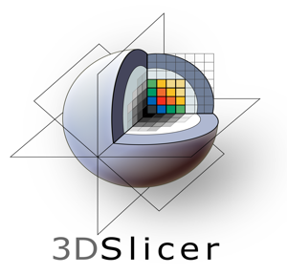 | 3D visualisation and manual segmentation of medical imaging data | Open source platform from BWH and 3D Slicer contributors (BWH, 2019) Available at: www.slicer.org
Autodesk 3DS Max | 3D modelling software used to cap holes in mesh after retopologizing in Mudbox | Autodesk, Inc., New York, USA (Autodesk, 2019)
Autodesk Mudbox | Organic 3D sculpting software used for separating imported bones from Slicer, model refinement, capping holes in mesh, and retopologizing models | Autodesk, Inc., New York, USA (Autodesk, 2019)
Unity | Games and app development engine | Unity Technologies, California, USA (UnityTechnologies, 2019) Available at: unity3d.com
Visual Studio | C# scripting platform in collaboration with the Unity game engine | Microsoft; California, USA (Microsoft, 2019)  Available at: https://visualstudio.microsoft.com
Adobe Photoshop | Digitisation of illustrations and graphic design of the user interface components and mood board | Adobe Systems, Inc., California, USA (Adobe, 2019)
Android SDK | Android Studio Software Development Kit (SDK) used to build an executable application to Android device | Google, Inc., California, USA (Google, 2019) Available at: developer.Android.com/studio/index.html
Hardware | Use | Publisher
Samsung Galaxy Tablet S2 | Tablet device to test the application during development and evaluation stages. Running Android OS, v6.0.1 (Marshmallow) operating system with an aspect ratio and screen resolution of 2048x1536 | Samsung Group, Seoul, South Korea (Samsung, 2019)
Data & Resources | Use | Source
Visible Human Project CT Datasets | Used pelvic scans to segment wrist bones in order to create the carpal bone models | Visible Human Project (https://mri.radiology.uiowa.edu/visible_human_datasets.html)
All forms and quizzes | Created and distributed quizzes, participant information and consent forms, and questionnaires, and collected data | JISC Survey Platform
Microsoft Yi Bati Font | Font used for all custom UI elements in mobile application | Adobe Photoshop
Arial Font | Font used for all text in mobile application | Unity
3D Carpal Bone Models | Used these 3D carpal bone models for reference when creating carpal bone models for the mobile application | Sketchfab, Artist: ajlieurance  https://sketchfab.com/ajlieurance
Methods
    - Design and Development
A flowchart was created to map the workflow for application design and development. The process was easily categorized into 10 stages, as seen in Figure 1.
Figure 1 Diagram displaying mobile application creation workflow
      - Concept
With the research question in mind, an idea for a mobile application was conceived, and a mood board and storyboard (Figure 2) were created. Medical students are the intended audience for the application, which guides each user through three different educational exercises: a guided educational module, 3D models of the carpal bones, and a flashcard game.
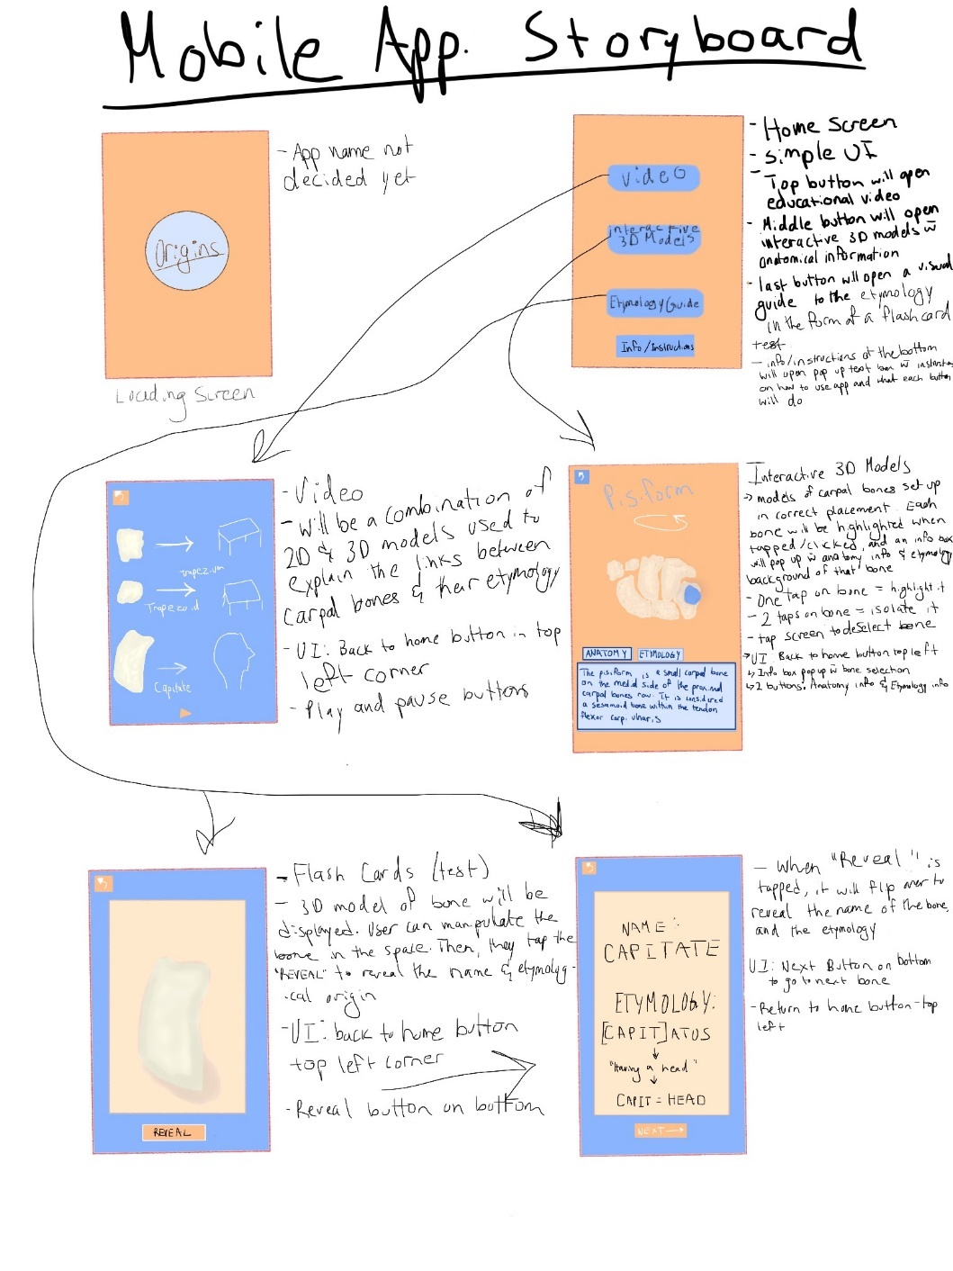
Figure 2 Storyboard created to plan the scenes and UI element placements for the mobile application
      - 3D Bone Model Production
Computerized tomography (CT) scans and 3D modelling software were used to produce the 3D bone models of the wrist, which was the first step in the application development process.
Segmentation
Using the software 3D Slicer, a dataset of DICOM CT scans of a wrist from an adult female patient were used to segment the eight carpals, the distal ulna and the distal radius for the creation of the 3D bone models. The CT scans were filtered using the Laplacian Sharpening Image Filter to enhance the contrast between the bones and the surrounding tissues, easing the anatomical structures edge recognition during the segmentation of the bones, as seen compared to the original scans in Figure 3. The Crop Volume module was then used to crop the scans to only include the hand and wrist, using a Region of Interest (ROI) bounding box, displayed in Figure 4. The ThresholdEffect tool in Slicer uses the Hounsfield Unit (HU) of tissue density to inform the selection of pixels from the scans, which makes it the ideal tool for the segmentation of bones, as they have high densities, especially compared to surrounding tissues. As indirect volume rendering techniques in Slicer favour the contrast between high and low densities, it was the ideal method of segmentation of the carpal bones. A threshold of 200.00 to 1530.00 was set for use by the PaintEffect tool to paint the bones slide by slide, while only including the values that fell inside the boundaries of the threshold. Once the bones were painted, the threshold was expanded to include all values, ranging -1024.00 to 1530.00 to allow for the holes in the paint to be filled. This would make sure that the bone models built from the segmentation would be solid and contain very few holes in the structures, if any. The EraseLabel tool was then used to erase any paint connecting one bone to another; this would allow for each bone to be separate when imported into the 3D modelling software, and would save time from having to delete faces, edges, and vertices from each of the bone models in order to manually separate them from each other. The before and after of this process can be seen in Figure 5. Once segmentation was complete, the Merge and Build tool was used to build the bone models, portrayed in Figure 6. After examination of the models for satisfaction with the general shapes of the bones, they were exported as an obj file to be later imported into a 3D modelling software for refinement, including sculpting, smoothing, and retopology.
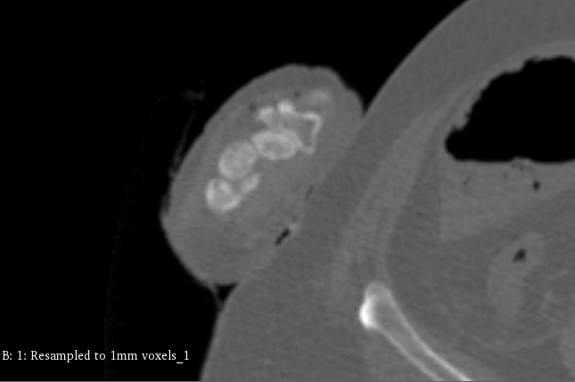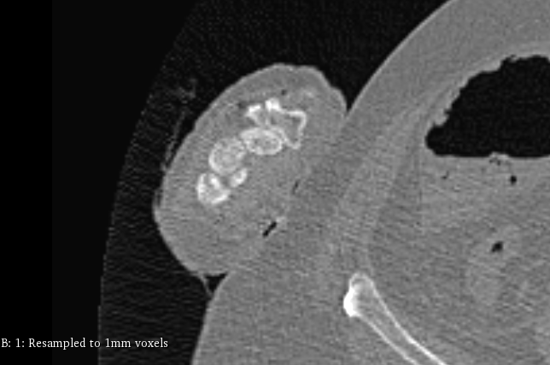
Figure 3 CT DICOM dataset viewed in axial plane before and after Laplacian Sharpening Image Filter was applied.
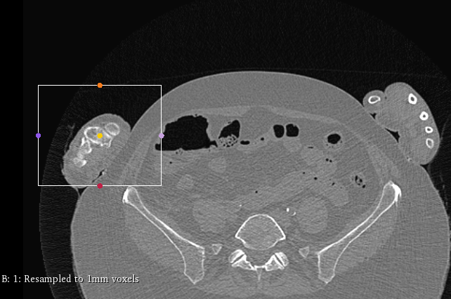
Figure 4 CT DICOM dataset viewed in axial plane, showing the ROI bounding box encasing the patient's right wrist.
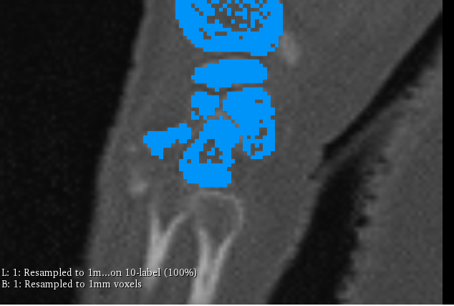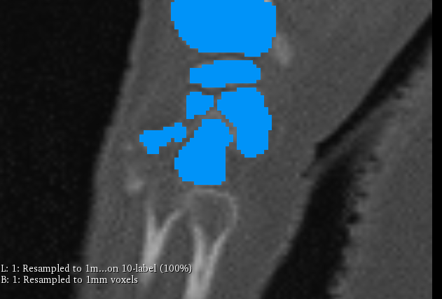
Figure 5 Sagittal Plane: (left) Segmentation of the carpal bones and distal radius using threshold 200 - 1253. (right) Threshold -1024 - 1530, and EraseLabel tool applied.
Figure 6 3D bone models created from segmented carpal bones, distal ulna and distal radius.
Refinement of 3D Bone Models in Adobe Mudbox
The obj file from Slicer was imported into Mudbox, where the raw models created from Slicer segmentation were refined and retopologised. Free-floating objects that came in with the eight carpal bones, distal ulna and distal radius were deleted from the file, leaving only ten bone models in the scene. Each of these bones were first inspected for holes in the meshes which were patched to ensure continuity, which would allow for functionality in real-time engines like Unity during application development. An example of this process can be seen in Figure 7. Once all the holes were patched, each bone was refined using the sculpting tools, harsh edges were smoothed, and articulating surfaces were defined. Photos of the carpal bones, found in Chapter 13 of the Human Bone Manual (White and Folkens, 2005), along with 3D models of the carpal bones found on Sketchfab, were used as references when refining the bone models, as access to real bones were not available. A before and after of the modelling process in Mudbox can be seen in Figure 8. When the models were finally satisfactory, the “Reduce Mesh” tool was used to lower the polycounts of each bone model by 95-98%, deeming them suitable for import into Unity (Figure 9). After mesh reduction, the bone models were exported to 3DS Max for a final check of the meshes and poly counts.
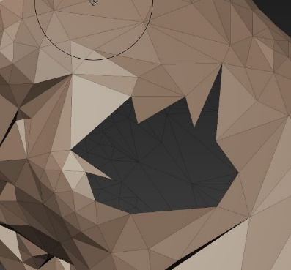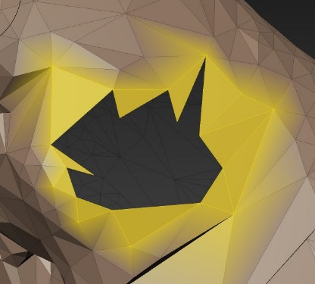
Figure 7 Process of finding holes in a model's mesh and patching them. First, a hole is identified in the model’s mesh (left). Then, the border of the hole is selected using the border selection tool (middle). Finally, the patch function is used to cap the hole
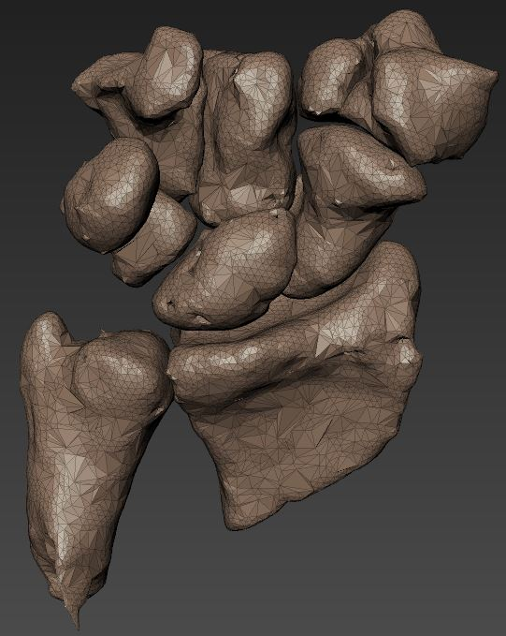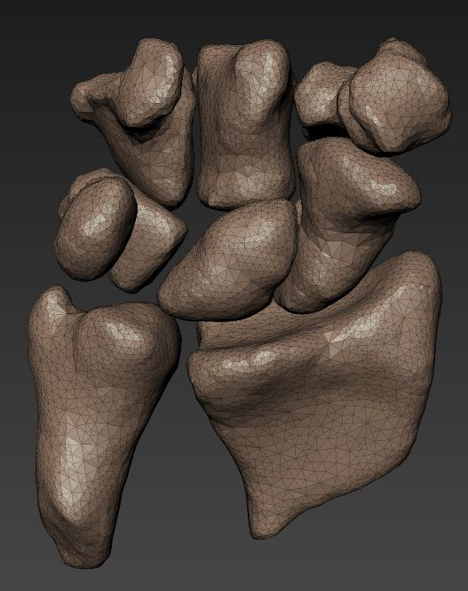
Figure 8 Before and after refining of bone models imported from Slicer in Mudbox.
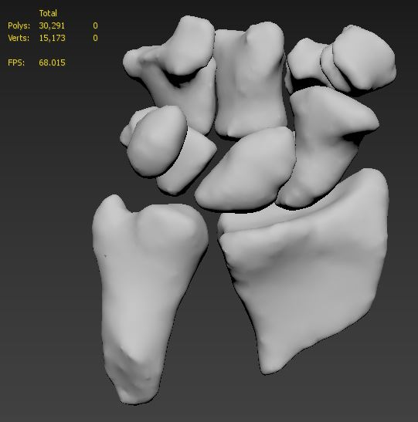
Figure 9 Bone model obj files exported from Mudbox into 3DS Max to do a final check of the meshes and poly counts.

      - Application Development
In total, the application holds 12 interactive scenes: the first being the main menu, followed by nine contributing to the educational module, one being the 3D bones scene, and one being the flashcard test. A schematic map of the scene flow is given in Figure 10. C# scripts were coded for interactive use of the application in each scene, and animations of 3D models and UI elements were created using the Animation and Animator Controller tools in Unity and were triggered by C# scripts or event triggers with box or mesh colliders.
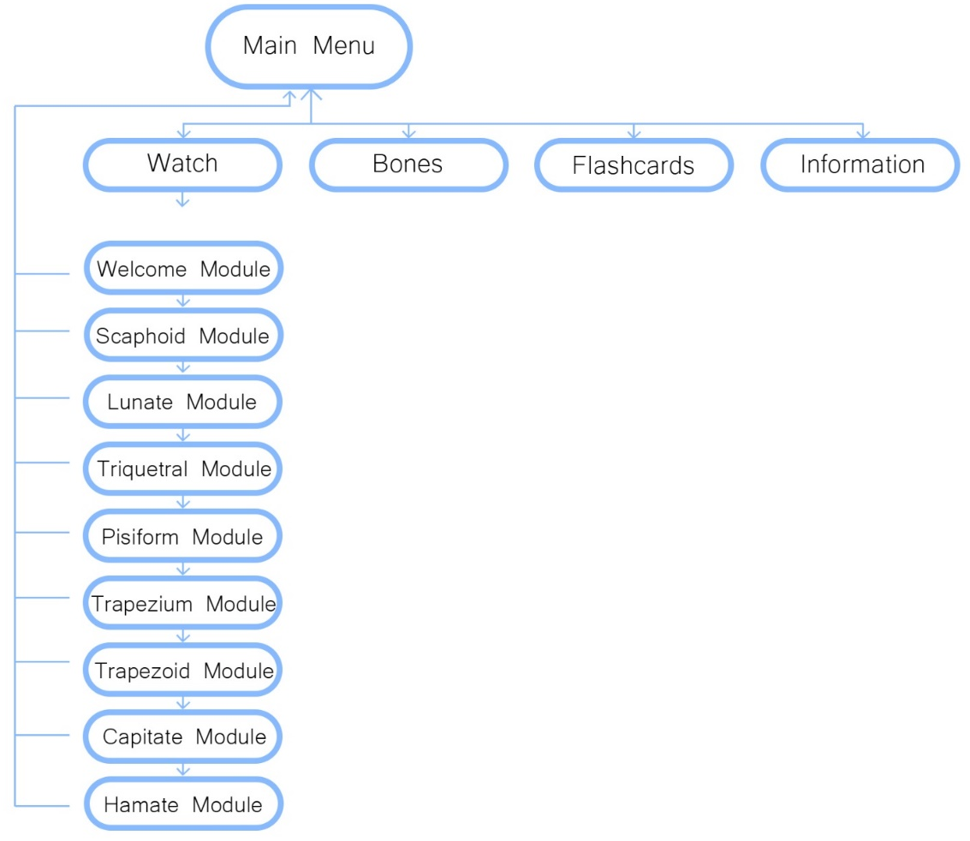
Figure 10 Map of mobile application scene flow.
The first scene built was the main menu (Figure 11). This included the addition of a canvas and panel, and the placement and anchoring of four UI buttons, each directing the user to either a new scene, or the information window. The buttons were placed from top to bottom in the intended order of play by the user. It would be ideal for the user to start off their application experience by first going through the educational module (top button), followed by the interaction with the 3D bone models (middle button), and finally finish with the testing of their knowledge with the flashcard game (bottom button). An information button is at the very bottom of the main menu screen if direction for use of the application should be needed.
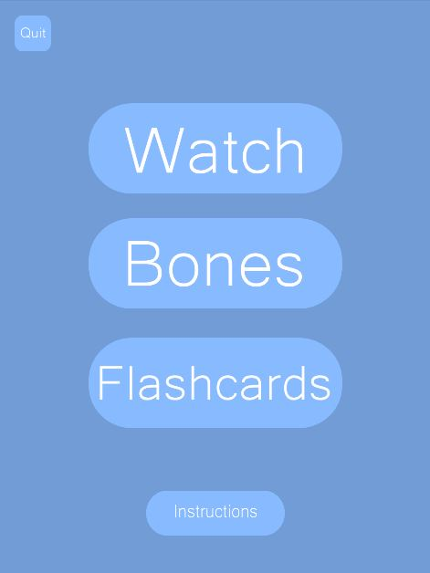
Figure 11 User interface for the main menu scene of mobile application in Unity.
The goal of the educational module was to introduce each carpal bone and visualise how the etymology of its name is linked to the shape of the bone. Each bone module begins showing the entire wrist and distal ulna and radius bones, which then disappear to reveal the placement of the bone in the context of all the others. The bone is then enlarged and rotated while a script of the anatomy and articulations of the bone is sounded via voice over, and finally, an illustration of the etymology visualisation is shown beside the bone for comparison. The interactive features of these scenes are the home button to return to the main menu, scrolling script for accessibility purposes, and the next button to move on to the next bone.
The Bones scene allows the user to explore the carpal bones’ anatomies and etymologies at their own pace, and in the context of their placement relating to their surrounding structures. The user can read about each carpal bone’s anatomy and etymology by selecting from the tabs in the information panel which will appear once a bone is selected. The selected bone will be highlighted in blue, allowing the user to identify which bone is being studied, and where that bone is placed in the context of the surrounding bones. An example of this can be seen in Figure 12, where the lunate bone is selected.
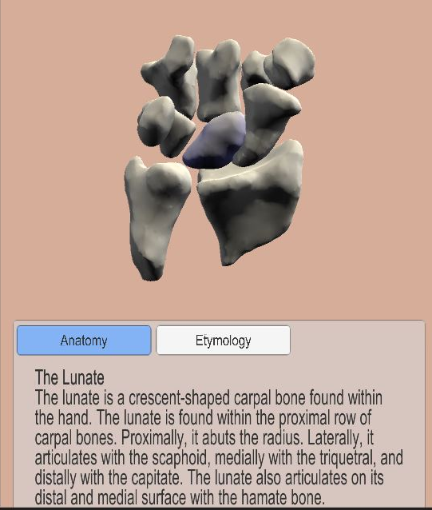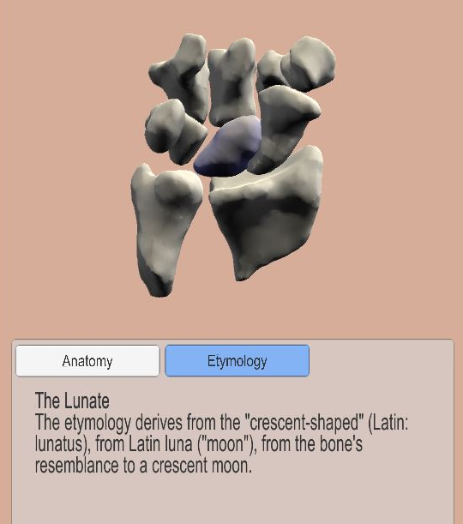
Figure 12 User Interface and interactions with the 3D bone models. The top left image shows the lunate bone selected and highlighted in the colour blue. The top right image shows the anatomy tab of the lunate information panel selected. The bottom image shows the etymology tab of the lunate information panel selected.
The main goal of the application is to improve medical students’ learning and retention of carpal bone anatomy, and the flashcards allow them to test their knowledge in-app after going through the educational module and 3D bones scene. The scene consists of eight flashcards displaying the 3D models of the carpal bones on the fronts of the cards (Figure 13). When the “begin” and “next” buttons are tapped, a new flashcard will appear on the screen. The user can manipulate each bone by rotating it in place to view its different angles. When the “flip” button is selected, it reveals the name of the bone, as well as its etymology.
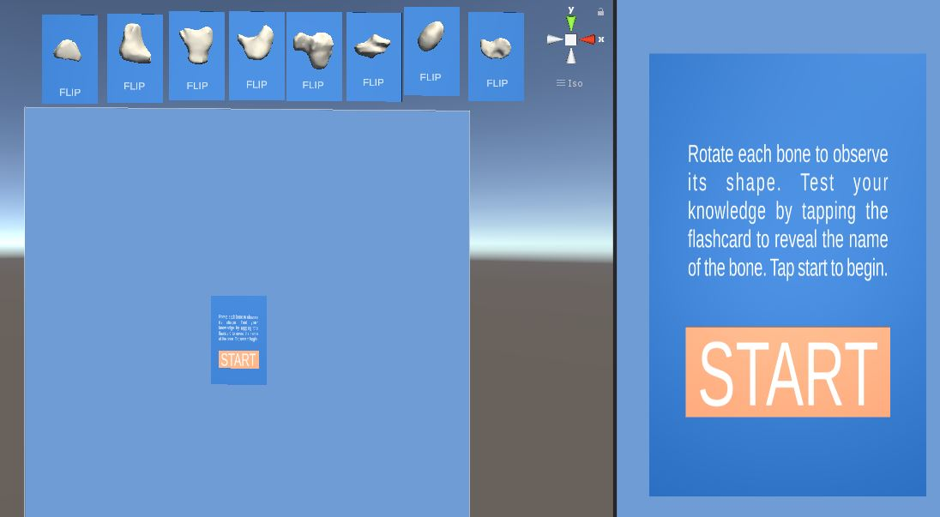
Figure 13 Set of all eight carpal bone flashcards in Unity.
- Evaluation
Medical students tested the mobile application and completed pre- and post-tests, as well as a participant questionnaire at the end of the testing sessions. Testing was conducted to assess the educational aspect of the application and to validate the design and development process. User feedback was collected and analysed, and later implemented into the application to make final improvements.
  - Research Evaluation Methods
    - Materials and Methods
Access to the participant group was granted by the University of Glasgow Undergraduate Medical School. Students in the first and second year of the MBChB degree at the University of Glasgow were invited to participate in the study. All participants were required to have access to an Android device and complete a participant consent form before taking part in the study. Testing sessions were hosted remotely via video meetings on Zoom. In the testing sessions, each participant was first given a carpal bone pre-test, then asked to use the mobile application on their own android device and finished with a carpal bone post-test and participant questionnaire. The mobile application was developed for and tested on different models of Android devices. JISC Online Survey service was used to create and collect data from the Participant Information and Consent form, pre and post-test Carpal Bone Test, and the Participant Questionnaire. A USE-type questionnaire allowed participants to rate their experience and their thoughts on the mobile application on a scale of one to seven; these scores are defined in Table 2.
Table 2 Participant Questionnaire number scores and their corresponding meanings.
Score | Score Meaning
1 | strongly disagree
2 | disagree
3 | somewhat disagree
4 | neither agree nor disagree
5 | somewhat agree
6 | agree
7 | strongly agree
Two participant screening questions were given at the start, concerning the establishment of any previous anatomical or etymological knowledge. The results collected from the testing sessions, specifically, the results from the pre-test, post-test, and Participant Questionnaire, were analysed using Microsoft Excel.
    - Experimental Protocol
      - Carpal Bone Pre-Test and Post-Test
The participants were given a link to an online carpal bone test created by the researcher. They were tasked with identifying each of the eight carpal bones from individual photographs. The students were given five minutes to complete and submit the test and were not allowed to use additional resources outside of their own knowledge of anatomy. After testing the application, participants completed the same carpal bone test as a post-test, to assess their knowledge of the bones. The same parameters were applied; they were given five minutes and were not allowed any additional resources.
      - Mobile Application Use
After the pre-test, the participants began using the mobile application on their mobile device. They went through each of the scenes, including “Watch”, “Bones”, and “Flashcards” while still on the video call with the researcher.
      - Usability Questionnaire
At the end of the testing session, they completed a usability questionnaire, which was inspired by the Usefulness, Satisfaction, and Ease of use (USE) questionnaire (Lund, 2001), consisting of 20 questions focused on the user’s experience and thoughts on the mobile application. After this questionnaire was completed and submitted, the researcher asked if the student had any more questions or concerns before the video call was ended.
    - Ethics Approval
Ethics approval for this study was granted by the Glasgow School of Art. All data collected in this study was collected and kept anonymous by the researcher.
- Results
  - Participants
Two participants accessed the application using a Samsung device, and one used a Huawei device. All three participants used mobile phones instead of tablets. Due to their background in anatomy, the graduate teaching assistant (GTA) tested the application and provided qualitative feedback, which was only used to implement changes into the mobile application for the final version. They did not complete the pre- and post-test quizzes. It is important to note that the testing pool of medical students was extremely small (n=2). Two testing sessions were held in total, each hosting one medical student and the lead researcher of the study. The GTA did not attend a testing session.
  - Carpal Bone Pre-Test and Post-Test Results
Two carpal bone pre-tests were completed prior to mobile application use. Participants correctly identified two and three bones respectively. Both participants correctly identified the lunate with one participant also identifying scaphoid and the other identifying hamate and pisiform. On average, the medical students were only 31.25% successful in correctly identifying the eight carpal bones in the pre-test. After using the mobile application, the post-test results showed that both participants had correctly identified all eight carpal bones (100%), resulting in a 68.75% increase from the average pre-test results. The results of the post-test compared to the pre-test are portrayed in the double bar graph in Figure 14. The frequency of correct identification of each carpal bone in the post-test compared to the pre-test is displayed in Figure 15.

Figure 14 Double bar graph displaying the results from medical students' pre-tests and post-tests.

Figure 15 Double bar graph displaying the frequencies of correct identification of the carpal bones in the pre-test and post-test.
  - Application Use
Although the researcher was present on the video calls to answer any questions or provide guidance, in both cases, the students did not need to consult with the researcher during their use of the application. The duration of the application experience took approximately 12 minutes for each participant.

  - Participant Questionnaire Results
The results of the questionnaire are divided into four categories: Usefulness, Ease of Use, Ease of Learning, and Satisfaction. In these results, there are three participants included, as the GTA had completed the qualitative questionnaire in order to give feedback about the application.
    - Screening Questions
Two out of three participants stated that they had previous knowledge of anatomy; one had three years of experience, while the second had four years of experience. All three participants indicated they had previous knowledge of medical terminology, while one also indicated an established knowledge of Latin. One participant had one semester or less of experience, while two participants had four years of experience.
      - Usefulness
This section included four questions regarding the usefulness of the mobile application, the results of which are displayed in Figure 16. In general, the results for this section were high, with all statements being at least somewhat agreed with. The final statement had the most variance; one somewhat agreed, another agreed, and the final participant strongly agreed that the application helped them remember carpal bone anatomy by using etymology.

Figure 16 Bar graph showing the average questionnaire results for the Usefulness section. Error bars represent standard deviations.
      - Ease of Use
This section included four statements regarding the ease of use of the mobile application, the results of which are displayed in Figure 17. All participants somewhat agreed to strongly agreed that the app was useful.

Figure 17 Bar graph displaying the average results of the Ease of Use section of the Participant Questionnaire. Error bars represent standard deviations.
      - Ease of Learning
This section consisted of three statements regarding the ease of learning of the application, and the results are displayed in Figure 18. Participants agreed or strongly agreed that the app was easy to learn to use.

Figure 18 Bar graph displaying the Ease of Use average results from the Participant Questionnaire. Error bars represent standard deviations.
      - Satisfaction
Four statements regarding user satisfaction were included in this section, and the results are displayed in Figure 19. The participant scores were generally high, and all agreed or strongly agreed that the application made learning anatomy easy and enjoyable.

Figure 19 Bar graph displaying the average results from the Satisfaction section of the Participant Questionnaire. Error bars represent standard deviations.
    - Qualitative Comments
The final sections of the participant questionnaire included three prompts for any additional open-text comments from the participants. These included the questions:
- What did you like most about the app?
- What did you like least about the app?
- Any additional comments?
The comments left by the participants were generally positive, a general consensus was that the application made distinguishing between the carpal bones easy and aided them in their learning. The participants suggested that adding elements such as arrows to the animations would better indicate which parts of the bones were being discussed during the modules.
- Discussion
  - Summary of Findings
The sample size of the study was very limited due to the application only being available for Android devices. Many medical students had expressed interest in participating in the study and had signed up, but only two whom had signed up had access to an Android device and were therefore able to participate in the study, while the rest had IOS (Apple) devices. Therefore, adapting the application for use on IOS devices would benefit future studies by increasing the scope of possible participants. Although limited in number, the analysis of student pre- and post-test scores provides support for the project hypothesis. It had been found that the mobile application aided medical students in their learning and retention of knowledge of carpal bones. They were able to understand and retain the information given in each educational scene in the application and managed to easily navigate the application without help, stating that the app was easy to use and made learning carpal bone anatomy simple and entertaining. The graphic design of the application was commended for its simple and minimalistic aesthetic, which contributed to the ease of use and learning.
When comparing the pre-test and post-test results, a clear, upwards trend can be recognised between the test scores. In the pre-test, medical students were only able to correctly identify an average of 31.25% of the carpal bones, with their individual quiz scores being 25% and 37.5%. Previous studies that have also used the carpal bones test to establish anatomical knowledge in medical students have yielded similar results (see section 1.2: Why Carpal Bones?). An average increase of 68.75% in test scores was observed in the post-test, where both participants were 100% successful in correctly identifying the eight carpal bones. These results suggest that the mobile application does, in fact, aid medical students in their learning and retention of knowledge of the carpal bones.
The Participant Questionnaire to collect feedback used a Likert scale to gage participant responses on a scale of 1 to 7, allowing the participants to record their responses to a high degree of accuracy. There was a general consensus of user satisfaction of the mobile application, and no negative feelings towards the validity of the application as an aid to anatomical learning. However, one must note that there is a possibility of bias that could have influenced the participants’ questionnaire answers. For example, if the participant knew the desired outcome of the study, this could have skewed their results, either knowingly or unknowingly. Taking the results of the Participant Questionnaire as an indication of the success of the application, it can be assumed that the application has carried out its intended purpose, and can be used as evidence to support the hypothesis of the study.
  - Limitations
The process of designing and developing the mobile application followed a logical and pragmatic approach, outlined in Figure 1, allowing the timeline of the project to be well managed, while avoiding any unnecessary time loss, despite the many challenges.
Due to obstacles presented by the COVID-19 pandemic, time constraints and limited access to real specimens, caused a delay in the development and design process. Access to carpal bones held within the University of Glasgow Anatomy Facility was not possible due to COVID-19 related restrictions, so photos of the carpal bones were used from textbooks, specifically, Chapter 13 of the Human Bone Manual, and 3D models from Sketchfab (White and Folkens, 2005). Because of the lack of real reference bones, modelling the carpal bones proved to be time consuming, as reference for the shapes of each had to be taken from photographs. Another limitation of the study was the inaccessibility of the university campus, where all the specialty equipment for developing applications, like computers, mobile devices, etc, are kept. Because there was no access to a Macintosh computer, the application was only able to be developed for Android. This caused a large decrease in the participants eligible to test the application on their own mobile devices, as most of the medical students who had signed up only owned Apple products. The limitations proposed by small participant numbers are the insignificance of the results obtained from the study. Although promising, the results cannot be considered significant without having tested on a larger participant pool.
  - Post Evaluation Modifications
The results from Participant Questionnaires were analysed, and the feedback given was used to implement changes into the application for further improvement. The most significant changes made concerned UI elements of the application, for example, the placements of the UI elements, specifically the home buttons, next buttons, and information buttons, were adjusted so that they would appear more clearly on smaller mobile phone screens; this was not found to be an issue on larger tablet screens used during development. There were comments regarding the animations, claiming that adding arrows or highlighting the parts of the bone being talked about as each voiceover played in the modules would help student’s follow along with the modules. Given more time, this would have been another change implemented into the application.
  - Future Development
The results from the study are promising and can therefore provide reason to develop the research project further in the future. As discussed in the beginning of the chapter, previous studies regarding the impact of understanding etymology on learning anatomy have resulted in similar findings to this study. New cohorts of medical students entering the field of medicine could benefit from more research into this topic, as it could provide insight into new methods of learning anatomy that are simple and enjoyable. According to previous studies, preliminary feedback from anatomy instructors, and the participant feedback from this study, there seems to be a scope for an application such as the one created in this research project as a teaching and study tool for medical students. Further, mobile devices are extremely common among today’s population, including medical students, making a mobile application like this one extremely accessible and easy to use. It is therefore important that further studies are conducted on this topic to further understand how teaching anatomy to medical students can be improved through use of etymology and digital learning tools.
- Conclusion
The creation and evaluation of this mobile application with medical students has demonstrated the potential that digital learning tools can have in improving learning and retention of knowledge of complex anatomical concepts, like that of the carpal bones. The mobile application in this research project was developed with a clear concept in mind: to aid medical students in learning carpal bone anatomy by visualising the links between the bones and their etymologies. The use of animations, illustrations, and 3D models in addition to anatomical and etymological information allowed for medical students to improve their learning and retention of knowledge of the carpal bones, which was demonstrated through the pre-test and post-test results. The positive results in this study can therefore justify the scope of etymology visualisation through digital learning tools in the field of medical teaching. Mobile applications for teaching and learning anatomy can benefit medical students by providing anatomy content that is simplified, entertaining, and accessible.
The research field would benefit from further study into the feasibility of mobile device integration into medical education and testing sessions with larger participant pools. The results presented in this chapter support the use of a mobile application that visualises the link between carpal bones and their etymologies to aid medical students in their learning and retention of knowledge of carpal bone anatomy.

References
Bice, M. R. et al. (2016) ‘The Use of Mobile Application to Enhance Learning of the Skeletal System in Introductory Anatomy & Physiology Students’, 27(1), pp. 16–22.
Brewer, D. N. et al. (2012) ‘Evaluation of neuroanatomical training using a 3D visual reality model’, Studies in Health Technology and Informatics, 173, pp. 85–91. doi: 10.3233/978-1-61499-022-2-85.
Brown, A. O. (2014) ‘Lexical access, knowledge transfer and meaningful learning of scientific terminology via an etymological approach’, International Journal Of Biology Education, 3(2). doi: 10.20876/ijobed.92616.
Drury, N. E., Powell-Smith, E. and McKeever, J. A. (2002) ‘Medical practitioners’ knowledge of Latin’, Medical Education, 36(12), p. 1175. doi: 10.1046/j.1365-2923.2002.01369.x.
Ebenezer, D. A. and Mohanraj, S. (2020) ‘UNDERSTANDING ETYMOLOGY : AWARENESS AMONG DOCTORS AND A TOOL IN SUCCESSFUL MEDICAL EDUCATION’, 7(1), pp. 8–11.
Gilbert, J. K. (2004) ‘Models and modelling: Routes to more authentic science education’, in International Journal of Science and Mathematics Education. doi: 10.1007/s10763-004-3186-4.
Haghshenas, M. S. M. and Hashemian, M. (2016) ‘A Comparative Study of the Effectiveness of Two Strategies of Etymological Elaboration and Pictorial Elucidation on Idiom Learning: A Case of Young EFL Iranian Learners’, English Language Teaching, 9(8), p. 140. doi: 10.5539/elt.v9n8p140.
Lerner, E. B. et al. (2000) ‘Medical communication: Do our patients understand?’, American Journal of Emergency Medicine, 18(7), pp. 764–766. doi: 10.1053/ajem.2000.18040.
Lewis, T. L. et al. (2014) ‘Complementing anatomy education using three-dimensional anatomy mobile software applications on tablet computers’, Clinical Anatomy, 27(3), pp. 313–320. doi: 10.1002/ca.22256.
Mayer, R. E. (2002) ‘Rote Versus Meaningful Learning’, Theory Into Practice, 41(4), pp. 219–225. doi: 10.1207/s15430421tip4104.
Murgitroyd, E. et al. (2015) ‘3D digital anatomy modelling - Practical or pretty?’, Surgeon. Elsevier Ltd, 13(3), pp. 177–180. doi: 10.1016/j.surge.2014.10.007.
Nicholson, D. T. et al. (2006) ‘Can virtual reality improve anatomy education? A randomised controlled study of a computer-generated three-dimensional anatomical ear model’, Medical Education, 40(11), pp. 1081–1087. doi: 10.1111/j.1365-2929.2006.02611.x.
Pampush, J. D. and Petto, A. J. (2011) ‘Familiarity with Latin and Greek anatomical terms and course performance in undergraduates’, Anatomical Sciences Education, 4(1), pp. 9–15. doi: 10.1002/ase.189.
Pierson, H. D. (1989) ‘Using etymology in the classroom’, ELT Journal, 43(1), pp. 57–63. doi: 10.1093/elt/43.1.57.
Pujol, S. et al. (2016) ‘Using 3D Modeling Techniques to Enhance Teaching of Difficult Anatomical Concepts’, Academic Radiology, 23(4), pp. 507–516. doi: 10.1016/j.acra.2015.12.012.
Saidin, N. F., Halim, N. D. A. and Yahaya, N. (2015) ‘A review of research on augmented reality in education: Advantages and applications’, International Education Studies. Canadian Center of Science and Education, (13), pp. 1–8. doi: 10.5539/ies.v8n13p1.
Sevinc, A., Buyukberber, S. and Camci, C. (2005) ‘Medical jargon: Obstacle to effective communication between physicians and patients’, Medical Principles and Practice, 14(4), p. 292. doi: 10.1159/000085754.
Smith, S. B. et al. (2007) ‘Latin and Greek in gross anatomy’, Clinical Anatomy, 20(3), pp. 332–337. doi: 10.1002/ca.20342.
Spielmann, P. M. and Oliver, C. W. (2005) ‘The carpal bones: A basic test of medical students’ and junior doctors’ knowledge of anatomy’, Surgeon. Royal College of Surgeons of Edinburgh and Royal College of Surgeons in Ireland, 3(4), pp. 257–259. doi: 10.1016/S1479-666X(05)80087-3.
Teoh, B. and Neo, T.-K. (2007) ‘Interactive Multimedia Learning: Students’ Attitudes and Learning Impact in an Animation Course.’, Online Submission.
Valenza, M. C. et al. (2012) ‘Comparison of third-year medical and physical therapy students’ knowledge of anatomy using the carpal bone test’, Journal of Manipulative and Physiological Therapeutics. National University of Health Sciences, 35(2), pp. 121–126. doi: 10.1016/j.jmpt.2011.12.005.
White, T. D., & Folkens, P. A. (2005). The human bone manual. Amsterdam, Elsevier Academic.

Patient data from the Visible Human Project (https://www.nlm.nih.gov/research/visible/applications.html) were used for research purposes.

