Interior Archipelago – Postcards from Our Islands

Patrick Macklin, School of Design, The Glasgow School of Art
Lois Weinthal, School of Interior Design, X University/Ryerson University
Wen Liang, Academy of Arts & Design, Tsinghua University

Preparing to cross the threshold between interior and exterior is prolonged. As well as keys, scarves, phone, also check for masks, hand-sanitser and surgical gloves – money is risky, contactless payement preferred. On return, the process is reversed, everything is left at the door in a new quarantine zone where gloves, masks, purse, bags, mail, and hands washed in the way a medic would. Timing is everything, new rituals are formed.

The ease at which we cross thresholds between private and public realms intensified as we turned inward in the first-wave pandemic. The interior became an obsessive position heightened after the intensity of multiple lock-downs. Now, fresh genres of interiors are forming within traditional types of space. We are looking inside like we never have before. Our ability to travel at will has been interrupted, replaced with drifting from one room to another. Postcards recall prior experience of travel while acting as souvenirs. This chapter frames souvenirs from lock-down in the form of postcard-sized works from design communities spanning twelve hours across the globe. Beijing – Glasgow – Toronto. The distance across these continents and countries provide views into how people shape their interiors and represent them during stretches inside.

Interior Archipelago–Postcards from Our Islands is an international design project that captures the familiar interior transformed during this time. It was first proposed in March 2020, close to when the virus was given its name, COVID–19. The design studio’s in the three participating institutions were each experiencing impacts, lockdowns and prohibitions of varying durations and differing intensities, the moment of harvesting contributions was subject to appropriate delays. Time had become elastic within a broader global context of restriction, false-dawns and anxiety.

This collection of postcard-sized images began forming in December 2020 as a second wave and new-variants were emerging. A communal and public website is the repository for these. Contributors were asked to share their interior representations, descriptions and locations. These near-sighted perspectives draw into focus emerging issues previously blurred. Contributions show how new areas of the interior have come to the foreground eg micro-quarantine spaces in vestibules; workspaces squeezed into domestic environments; a yoga mat on the floor to define an activity, and the rearrangement of furniture to make sub-rooms. The confined interior also reveals the desire for having space to one’s self when constantly surrounded by others, or the need to have others around when constantly alone. The interior is not only defined by the size, measurement, view, sound, smell, and so on, but by the frequency of absence.

A selection of postcards (see attached) from this project will accompany this chapter and reveal changes from the ordinary and familiar, such as windows framing views of empty exteriors, or interiors that fold into new internal volumes. Contributors referenced wording associated with postcards, and used craft as a form of documenting rooms, through these the creative process will be explored. Views inward are amplified, rescaled and refocused to create new worlds as interiors are heightened in the era of COVID-19.

https://padlet.com/pmacklin4/qqqw8w89hu3sp7ly (Password ‘archipelago21’)

Selected images below from Interior Archipelago below

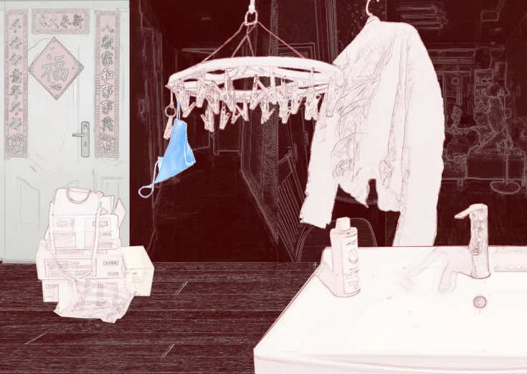

Contributor from Beijing
Chinese people are returning to their daily life just like nothing has happened. But [somethings] will never be able to be restored.

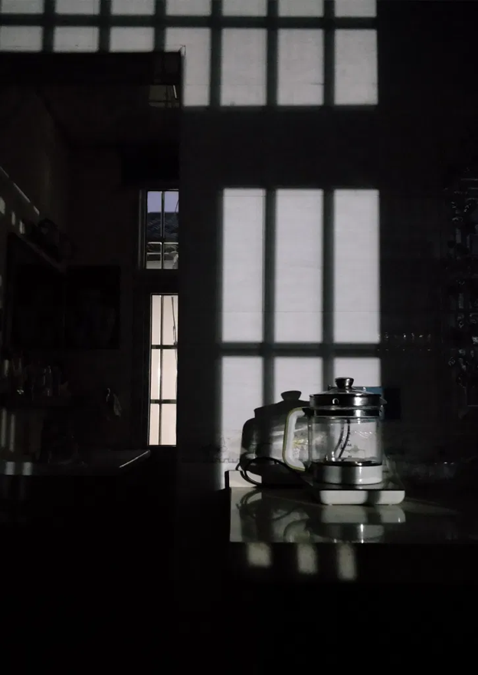
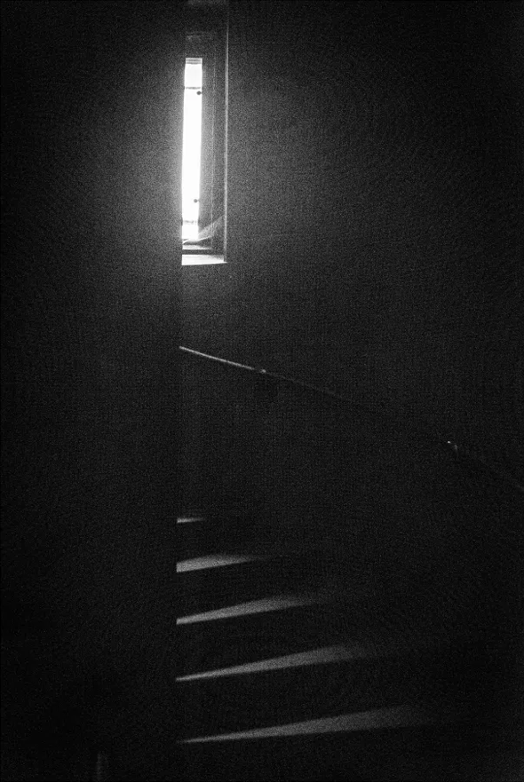

Contributor from Glasgow Contributor from Beijing
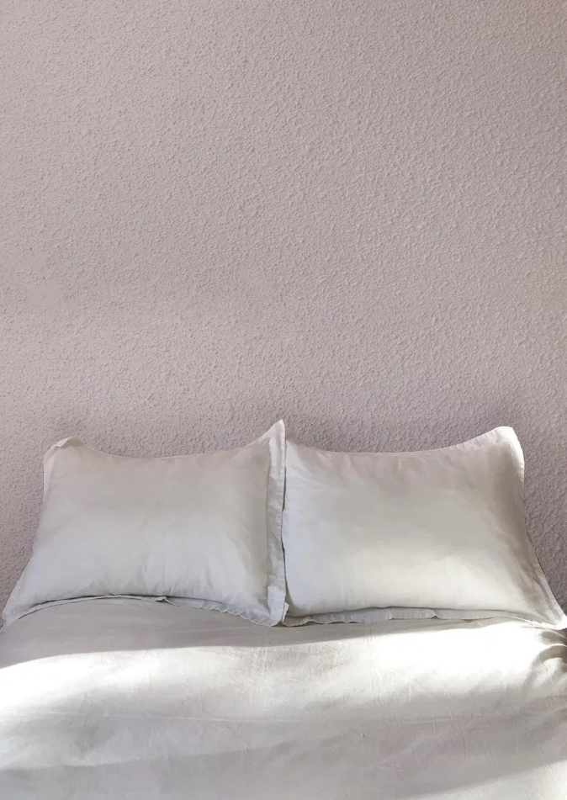
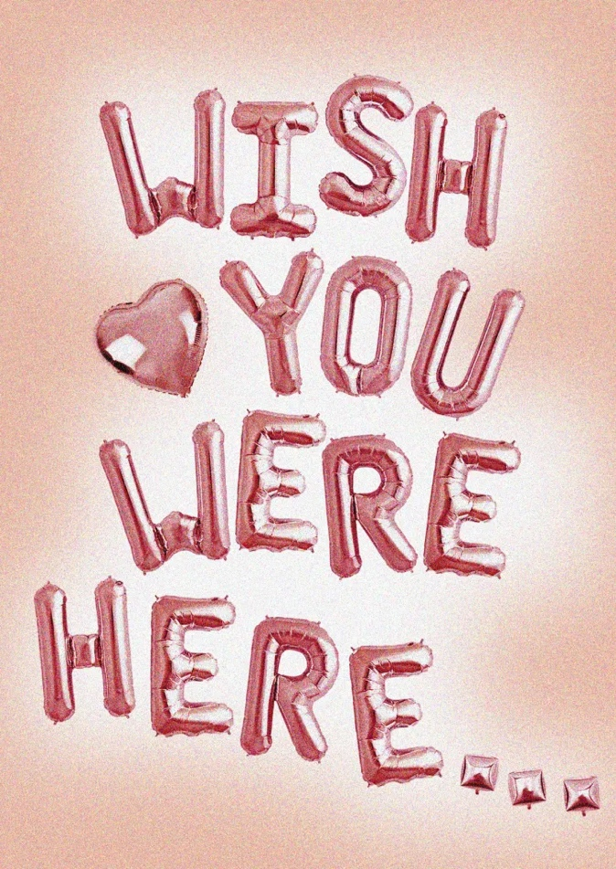
Contributor from Toronto Contributor from Toronto
‘wish you were here’ is a narrative typically used in the
language of postcards and recently echoed in the shift to
remote living.

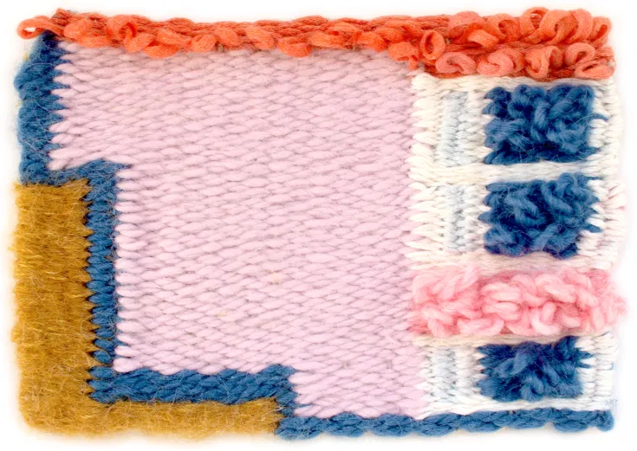

Contributor from Glasgow
Woven kitchen floorplan

