Engaging People with Lived Experience in Co-design of Future Palliative Care Services
Tara French and Sneha Raman
The Innovation School, The Glasgow School of Art, UK
Corresponding author: Tara French, The Glasgow School of Art, Blair’s Farm Steading, Altyre Estate, Forres, IV36 2SH, t.french@gsa.ac.uk
Engaging People with Lived Experience in Co-design of Future Palliative Care Services
For people living with a life-limiting condition it is challenging to contribute to the design of future services due to limited research foregrounding meaningful engagement of ‘vulnerable groups’ in co-design. This paper shares findings and critical reflections on sensitively engaging people with lived experience of palliative care transitions, and making their lived experiences visible and legitimate in the co-design process. The paper presents an asset-based approach for reframing ‘vulnerability’, and visual and narrative tools to facilitate participation. Sharing critical reflections on the design tools and methods, the paper discusses future considerations for engaging ‘invisible communities’ in co-design of public services.
Keywords: vulnerability; invisible communities; co-design; palliative care; lived experience

Introduction
Co-design and co-production are both approaches intended to increase citizen participation and sharing of power in the context of public services (Selloni, 2017), and the past decade has seen a surge in recognition and development of these methods in the UK (Kimbell, 2015; Trischler et al, 2019). However, their application has been found to be limited when engaging with sensitive topics or ‘vulnerable groups’ (Aldridge, 2014). Individuals may be reluctant to engage or not perceive themselves as suitable contributors to service ideas, and the absence of appropriate approaches and support hampers participation (Trischler et al, 2019). There is an urgent need to develop co-design approaches that are inclusive and tailored to enable participation from diverse groups, including those perceived as vulnerable, recognising people are ‘experts’ of their lived experience.
‘Vulnerable’ people have historically been described in ways that signify “weakness’, “dependency” and' “victimhood” (Wisner, 2016). There is a need to challenge the negative assumptions related to ‘vulnerability’ and shift from a “problem-focussed” view to considerations of capabilities (ibid). Further, developing “novel and distinct forms of collaboration” (Rehfeld et al, 2015) are also required to engage vulnerable groups meaningfully in co-design. In participatory and social innovation contexts, ‘vulnerable groups’ commonly refers to those “who are not able to fully participate in the economic, social, political and cultural life of the society” (Selloni & Rossi, 2019); and ‘invisible communities’ refers to “geographically, culturally or socially isolated and underrepresented groups or communities” (Sertić & Purg, 2018). Both provide a problem-based definition, with the former implying a lack of participation from the group, and the latter highlighting the gap in representation of these groups. The authors wish to highlight a lack of appropriate approaches to support involvement of people living with life-limiting conditions which make their perspectives largely ‘invisible’ in research (Chambers et al, 2019); and focus on framing the lived experiences from an asset-based perspective to make their voices ‘visible’. Participants are referred to as ‘people with lived experience’ (of palliative care or PCT), emphasising their expertise through lived experience. Aiming to move the focus beyond existing problem-based labels, this paper draws attention to asset-based ways to support, empower and enable currently ‘invisible’ communities to engage in co-design and make visible the value and legitimacy of lived experience. Recognising the challenges of meaningful and sustained participation (Mulvale et al, 2019) and the need to develop tailored approaches and frameworks (Dietrich et al, 2017), the approach discussed in this paper aims to support individuals and groups to share experiences through creating a safe space and building trusting relationships.
The work discussed in this paper focuses on the co-design process, building on a Participatory Design tradition that has become widely recognised in public spheres (Björgvinsson et al, 2010). Participatory methods ‘lend themselves more readily’ by being adaptive and flexible to the participant’s needs and sensitivities (Aldridge, 2014). The authors, similar to Selloni (2017), focus on foregrounding the co-design process when engaging with ‘vulnerable groups’ rather than the results and view this as an important pre-condition to co-production by preparing the ground and creating the conditions for collaboration. The paper responds specifically to the special issue call for methodological highlights on “how to engage vulnerable populations” by focusing on the methods, tools, learnings and reflections related to ways of engaging people with lived experience of palliative care transitions (herein, PCT). The paper offers an asset-based perspective on vulnerability and on metaphors in the palliative care context to support engagement; and articulates the value and legitimacy of lived experience in the co-design process, and the role of visual and narrative methods in making lived experiences ‘visible’. Finally, the paper presents a discussion on emerging focus areas towards supporting the development of a set of guiding principles and generating dialogue on implications for future co-design and co-production with other ‘invisible communities’.

Legitimising lived experience in co-design with ‘invisible communities’
There is a significant positive shift towards including and legitimising lived experience in the design of future services, and engaging early and meaningfully to inform development of the right outcomes rather than engaging to evaluate and validate outcomes designed through other means. Currently few studies exist, however, that have actively involved or included people living with a life-limiting condition in the co-design of palliative care services (c.f. Borgstrom & Barclay, 2019). This is largely attributed to ethical risks particularly around vulnerability, consent (Casarett & Karlawish, 2000) and the potential risk of distress and emotional burden (Borgstrom & Barclay, 2019). However, this creates a tension by keeping out the voices and experiences that are legitimate and deserving of recognition instead of enabling the choice to engage in shaping the future.
The value of visual and narrative methodologies has been well documented in the context of palliative care research as a way to communicate outcomes of traditional research (Lark, 2014), access personal worlds and perspectives of patients and carers (Thomas et al, 2019), construct meaning (Romanoff & Thompson, 2006), and create empathy and connection to others through stories (Stanley & Hurst, 2011). Visual participatory methods lend themselves to developing narratives that focus on lived experience by overcoming the challenges of interpretation by others and generate evidence that can ‘speak for itself’ (Aldridge, 2014). Such experiential and narrative data has been proposed as an ‘evidence base as valid as evidence-based medicine’ (Graham-Pole & Lander, 2009). However, the value of narratives in communicating experiences in palliative care is distinct from allowing exploration and generation of insights (Bingley et al, 2008). Therefore, there is a need to move beyond merely communicating experiences through traditional journeys or service ‘blue prints’ towards visuals and stories that support insight and reflection on the experiences.
Metaphoric communication supports sensitive subjects to be explored allowing people to create new ways of viewing their situations and opens up the possibilities of new coping strategies (Southall, 2013). In addition, metaphors can also contextualise and translate inaccessible experiences and help to create shared meaning (Harrington, 2012). Evidence from previous studies suggest that metaphors and analogies enhance communication in the context of conversations that are perceived to be difficult near the end of life (Casarett et al, 2010), particularly in the context of hope (Olsman et al, 2014). However, metaphors can elicit both positive and negative effects resulting from the metaphor and imagery used, and military and journey metaphors frequently used in palliative care research are often negative (Harrington, 2012; Southall, 2013). Therefore, developing an asset-based use of metaphors is important when engaging people with lived experience of palliative care in co-design.

Context of this work
The engagements with people with lived experience of palliative care discussed in this paper were situated within a wider programme of knowledge exchange (KE), which aimed to explore the future of PCT in Scotland (French et al, 2019). Palliative care is defined by the World Health Organisation (WHO, 2004) as ‘an approach that improves the quality of life of patients and their families facing the problem associated with life threatening illness, through the prevention and relief of suffering (…)’. Scotland’s national action plan states that palliative care is about ensuring quality of life at ‘every stage of the disease process from diagnosis onwards’ (Scottish Government, 2008). This journey could include functional transitions such as moving from one service to another (e.g., from children’s to adult’s services), and a range of changes (e.g., psychological, social, physical) that can occur when someone is diagnosed with a life-limiting condition (Fringer et al, 2018).
The KE programme involved a series of design-led engagements to inform future care and preferable scenarios for PCT across the life course towards identifying key policy and practice priorities to achieve person-centred care. The programme brought together a diverse range of participants (researchers, practitioners, policy makers, people with lived experience and the wider public) to explore and roadmap future PCT (French et al, 2019).

Materials and methods
The design of engagement methods and tools focused on enabling people with lived experience of palliative care to participate directly in co-design in a way that was meaningful and allowed future practice and policy to be led by these voices (Table 1). Decisions around the engagement context, methods and tools were informed by discussions with programme partners experienced in palliative and end of life care contexts, highlighting factors that contribute to participation such as: the importance of familiarity in relation to the location and setting of the engagement, duration, and language/terminology.
The programme was approved by The Glasgow School of Art Research Ethics Subcommittee, and written informed consent obtained from participants.
Table 1. Engagement of people with lived experience in co-design

Interview tool design
The methodology involved lived experience interviews followed by a focus group that brought together all the interview participants. The interviews were designed to support the sharing of individual experiences through an emergent process that was responsive and sensitive to the nature of the topic. A visual interview tool (Figure 1 and Table 2) allowed participants to tell their unique story and communicate their experiences through visual expression, which is of particular importance when words can be limiting or the stories emotionally difficult to tell. The tool was designed to find a narrative that met everyone’s story, balancing the need to allow for expressing a range of experiences whilst providing a ‘structure’ to enable insights to emerge and draw out recurring themes. The design of the tool evolved from recognising a gap in the current use of metaphors and ‘language’ in palliative care research which were negative and challenge-based, and tended to focus on nature-, journey- and military-based scenarios (Southall, 2013). The present work focused on creating a visual interview tool that was asset-based allowing people to positively reflect on their personal experiences and imagine how their own transitions and those of others could be supported in the future. The design of the tool had to consider sensitivities related to the nature of the topic and emotional experiences for the person, whilst also acknowledging the additional sensitivities that present when discussing the ‘future’ with someone living with a life-limiting condition.
The visual interview tool used the analogy of a journey weaving reality with creative elements of abstraction to allow participants to express sensitive and personal thoughts and feelings (Figure 1). The tool consisted of visual stamps to illustrate the types of transitions people have experienced (e.g. personal, social and health), laser-cut shapes (see Table 2) to represent their experiences, and a plain base on which to create their narrative.
Figure 1. A completed visual interview depicting the experience of palliative care transitions using the laser cut visual metaphors described in Table 1. Credit: Louise Mather
Table 2. Shapes and metaphors used in the visual interview tool

Participants and engagement setting
The authors worked with programme partners to identify and invite potential communities or existing support groups to engage with people with lived experience of PCT across the life course. Seven people volunteered to take part - six adults (five over 65 years old and one under 65 years old) with a life-limiting condition and one carer providing support to a young person with a life-limiting condition. Each lived experience interview lasted for approximately one hour and were audio recorded. The interviews took place at a local palliative care support centre and were organised to align with the participant’s regular drop-in session, ensuring the setting was accessible, familiar and comfortable. In contrast to large-scale activities planned for the wider KE programme, these engagements provided an intimate and sensitive context that was more appropriate for people to share their personal experiences. The interview setting also allowed the authors to be more attuned to individual needs and be responsive to the sensitivities of the discussion, devoid of facilitating or managing the dynamics in a larger group setting. Participants were introduced to the visual interview tool and the purpose of the programme. They were invited to share their experience of PCT - as little or as much as they felt comfortable sharing. Each interview began with capturing the person’s care circle (‘Russian dolls’), and describing what supports their wellbeing now (‘magic potions’). This provided a natural flow for participants to describe transitions they have experienced and how their life had changed since being diagnosed with a life-limiting condition (‘doors’ and ‘keys’). The final part of the interview focused on participants’ reflection on the visual narrative capturing the transitions they experienced, and using this to share their future hopes and aspirations (‘rainbows’).
Engaging with participants individually and the insights gained allowed the authors to understand how to support people to engage in a group setting and uncover shared experiences. A focus group session was designed to bring participants together to collectively reflect on the key insights emerging during the interviews and capture priorities to inform the wider programme. This took place in the same venue three weeks following the interviews. A smaller group of researchers and practitioners from the wider KE programme were also invited to attend to begin to share the evidence from lived experience that would inform the direction of the programme. Participants worked in two groups and one participant was also joined by a family member. A visual canvas was created (Figure 2) to structure and capture group discussions.
Figure 2. Focus group visual canvas to capture themes relating to challenging and supportive experiences of PCT, people and tools supporting transitions and wellbeing, and aspirations for the future. Credit: Sneha Raman

Capturing insights and experiences
The visual canvas (Figure 2) facilitated a process of analysis with the group to synthesise the key insights from the interviews. This was translated as a visual summary drawing together themes and priorities from the focus group (Figure 3).
Figure 3. Focus group visual summary of lived experiences of PCT. Credit: Tessa Mackenzie

The narratives captured using the visual interview tool were also translated into a collection of vignettes to communicate lived stories of transitions. The ‘Stories of Transitions’ (Figure 4) provided a way to bring the participants’ voices into a co-design workshop organised as the final event of the wider KE programme.
In addition to the collaborative synthesis of insights with participants using the visual canvas (Figure 2), a co-analysis session was organised with programme partners. This session focused on clustering and synthesising insights from lived experience alongside insights from the wider KE programme activities to reveal emerging and recurring themes.
Figure 4. ‘Stories of Transitions’ guiding co-design. Credit: Louise Mather

The ‘Stories of Transitions’ ensured that ‘voice’ of people and their lived experience was embedded into the co-design process and placed at the heart of collaboratively developing ideas for future PCT. The co-design workshop with over 40 participants with a range of experience and expertise responded to the emerging themes from the interviews to design future PCT. The workshop activities were designed to allow participants to learn from the lived experience stories and permeate into everyday practice, as well as to roadmap priorities for future practice and policy through identifying key actions.

Findings on ways of engaging people with lived experience in palliative care
The overall findings of the interviews provided insights on people’s experience of PCT, and an opportunity to reflect on the conditions and approaches that enabled the engagements. The key insights and themes that emerged on PCT included: the impact of negative perceptions related to existing language and terminology on social and personal transitions, and lack of early support for clinical transitions at the point of diagnosis; the lack of understanding and support for personal and psychological transitions such as shifting identities of the person and their family; the role of the wider community and volunteers in supporting social transitions; the gap in inclusion of all voices and aspirations in the planning and delivery of services especially of those with lived experiences; and the need for increased support for personal and psychological transitions to create meaning and legacy at the end of life (French et al. 2019). The outcomes developed as part of the programme included future scenarios and concepts responding to these insights, building on the lived experience stories. Key priorities and a roadmap for practice, policy and research in PCT were generated to support over twenty organisations and services who were involved in the programme towards developing and implementing future services. The findings and outcomes are published in full in a publicly available report (ibid).
Feedback shared by some participants and programme partners not directly involved in the design of the activities highlighted the value of the breadth and depth of engagement in successfully capturing and communicating genuine experiences through the lived experience stories. The ethos of participation was observed to have fostered open and trusting relationships, with a programme partner highlighting a ‘most refreshing absence of concern for status, ego, political positioning’ during engagements.
In line with the scope of this paper, findings below focus on the ways of engaging people with lived experience in a sensitive context such as palliative care. The authors further analyse and reflect on the design of the process, tools and methods in supporting people with lived experience of palliative care to engage in co-design.

Extended preparation and engagement design
The time spent preparing for the engagements by working with partners experienced in supporting people with lived experience of palliative care and an understanding of their needs was crucial. In parallel, the authors reviewed existing literature on approaches and learnings on engaging with people in a palliative care context. Learning from practitioners and a critical review of current approaches involving metaphors and narrative-based methods highlighted in the introduction, helped in designing the appropriate methods and tools, and create the conditions to enable participation.
The sequence and structure of the activities played a key role in enabling participation and foregrounding lived experience in the wider programme. The tension between the need for a deeper level of engagement with people with lived experience and the ethical concerns around an appropriate platform to facilitate sensitive sharing informed the decision to structure the process of interviews followed by the focus group. This supported both the time and space to build trust in an intimate and safe setting during interviews, and to allow people to share and learn from each other’s experiences and develop new ideas together during the focus group. Working in two smaller groups ensured that each participant had the opportunity to safely share their stories, researchers and practitioners engaged meaningfully with these, and key insights and themes were reviewed collectively.
Positive responses from participants during the interviews and sustained participation in the focus groups indicate that the intent to create an emergent, responsive and sensitive process that supported individuals to share their experiences at a pace comfortable to them was attained. A formal evaluation of the experience of participation was not in the scope of this programme. However, the positive reactions from participants in the sessions, sustained engagement and informal feedback from service practitioners based on participants’ reflections on the therapeutic benefit following these engagements suggest there is value in this approach for future work. For example, feedback highlighted the nature of the metaphors used as ‘gentle despite touching some very sensitive areas of living with and facing transitions related to ill health, this allowed a safe structure around sharing of some deep experiences and thoughts’.
The programme intended to engage with people with lived experience of palliative care across the life course. However, there were challenges in getting participation from young people. Approaching potential participants through a gatekeeper resulted in participation from the seven adults and had been successful with young people in previous research, however, the gatekeepers reported they were unable to recruit young people to take part in this programme. Alternative venues (including a home setting if appropriate), different days and times, as well as the option to take part in either an interview or a focus group rather than both, to make participation as accessible and easy as possible were offered. However, these attempts were also unsuccessful and reflections on how this limitation may be overcome are suggested under ‘Discussion’.

Role and value of the visual interview tool
The visual interview tool was successful in allowing participants to communicate their experiences and structuring the conversation by beginning in the present, reflecting on the past and building on these experiences to talk about the future. Participants were able to relate to the analogy of the journey and the laser-cut shapes to capture their narrative. The use of the visual metaphors to guide, prompt and capture participant’s narratives provided a safe structure and positive way to share in-depth personal experience and thoughts despite touching on sensitive areas related to PCT. The laser-cut representations of the metaphors provided structure and supported flow during the engagement. The different size of laser-cut shapes offered participants the choice to depict the ‘scale’ of the challenge/experience and provided a way to illustrate the impact/importance of this on their journey. For example, one of the participants described their journey of many interactions with different health professionals in obtaining a diagnosis as ‘a very strong solid door that nobody knew how to open’. Participants also chose different sized rainbows to share their hopes and wishes for the future with one participant describing walking their daughter down the aisle as a ‘big rainbow’. Participants interacted with the tool in different ways, predominantly with one of the authors leading the ‘making’ of the visual story, except one interview participant who led the ‘making’ of their story. The process led to the creation of a visual representation of participant’s individual journeys and the same participant who led the ‘making’ of their story expressed interest to keep this at the end of the programme as a memento.
Reintroducing the visual narratives produced from the interviews during the focus group provided both a memory aid for participants to talk about their own experiences, as well as make this accessible to the other participants. The visual canvas used during the focus group session to capture the group conversations allowed patterns of insight and emerging themes to be highlighted to support discussion around prioritising important points from participants’ perspectives.

Communicating the legitimacy and validity of lived experience
The vignette-style ‘Stories of Transitions’ that translated participants’ narratives helped to place their experiences at the centre of the co-design process during the final programme event. The ‘Stories of Transitions’ enabled empathetic story-telling and communication to the wider group, who may not have direct experience in palliative care, and helped to take forward the ideas and priorities. The choice to make it a collection of stories helped to shift away from more traditional ‘user persona’ based outputs which can be stereotypical and abstract, often losing the characteristics of real people and experiences. The stories provided a way to represent individual priorities and important moments in participants’ journeys, rather than only communicating ‘standard’ features such as challenges, needs and design criteria. The stories were able to communicate how participants defined their own identities through tailoring their personal narratives to express the things they found joy in or considered as their achievements rather than being based on their condition. For example, two of the participants chose ‘Limeflower’ and ‘The Writer’ as their pseudonyms for the lived experience stories to denote positive wellbeing experiences (e.g. aromatherapy) and social transitions (e.g. blogging to reach out to people). The stories were illustrated using the same analogy and visual language as the interview tool which further protected participants’ identity, whilst providing a realistic characterisation that celebrates individual personalities, experiences and needs.

Discussion
The two key contributions of this paper are the need to support ethical responsibility towards practicing a rights-based approach to participation that reframes ‘vulnerability’ from being problem-based to capacities-focused; and the creation of asset-based metaphors and personal narratives that can sensitively engage and challenge stereotypes associated with sensitive topics such as palliative care. Furthermore, the findings presented in this paper offer emerging focus areas to inform future work on evaluating and refining a set of guiding principles for engaging ‘invisible communities’ in the co-design of public services.

Reframing perspectives on vulnerability
This paper offers a perspective on ‘vulnerability’ that moves beyond labels that reinforce problems and deficiencies and instead focuses on ways of recognising and reinforcing agency, choice and power of ‘invisible communities’. The approach discussed in this paper illustrates how ‘invisible communities’ can be empowered to make their lived experiences visible and participate in a co-design process in a way that is meaningful for the participants and the context of engagement. Whilst recognising the ambiguity, risks and tensions around involving groups who may be perceived as vulnerable in research (Casarett & Karlawish, 2000; Aldridge, 2012), the focus of this work was to overcome these challenges and develop strategies and ways which ensured that the expertise and the lived experiences of people with life-limiting conditions was at the heart of the process. Similar to the findings of Borgstrom and Barclay (2019) this paper provides further evidence that people with life-limiting conditions can be included through approaches that “enacts good ethical practice and does not overly emotionally burden those involved”. The approach discussed has demonstrated that it is possible for ‘invisible communities’ to be engaged ‘on their own terms’ and have their ‘voice’ remain central to the decision-making process through careful translation to ensure representation. Therefore, this paper advocates for a rights-based approach to participation where ‘invisible communities’ deserve, and should have the choice, to be included. Whilst acknowledging the difficulties researchers face in engaging groups who may be perceived as vulnerable and the lack of resources and support available institutionally, it is proposed that researchers ought to make an ethical choice on whether or not to engage with these groups (Aldridge, 2014). However, the rights-based approach presented here advocates for the recognition of people’s right to be involved and the ethical responsibility of the researchers to develop new ways to support this. Similar to Selloni and Rossi (2019), this paper illustrates that focussing on the co-design process itself and not only the results is necessary in order to develop approaches that support inclusion and meaningful participation that moves beyond achieving ‘representation’ and gathering data.

Sensitively engaging ‘invisible communities’
Recognising that current co-design approaches used more widely in public service design offer limited ways of engaging groups who may be perceived as vulnerable (Trischler et al, 2019), the authors aimed to develop a design-led approach to support meaningful engagement with ‘invisible communities’. Building on the need to create novel and ‘distinct’ forms of engagement (Rehfeld et al, 2015), the methods and tools presented demonstrate the way in which this approach creates the conditions for participation by adapting and structuring the process to challenge current barriers and mindsets. The findings illustrate how the approach can ensure people feel valued in the process and offers ways to engage those who may feel they do not have anything significant to offer (Trischler et al, 2019). In addition, the visual interview tool discussed in this paper demonstrates a method to sensitively approach conversations and sharing of experiences in the context of life-limiting conditions, which may be adapted to other sensitive contexts.
A key contribution of this paper is the use of asset-based metaphor which moves beyond the traditional use of metaphors and analogies in the palliative care context (Bingley et al, 2008) to create connections and meaning with those participating in a way that is tailored to their experience. Combining the use of metaphors and narratives in the approach, whilst abstract, brought together the strengths of these methods and illustrates that this integrated approach can allow participants to engage sensitively and reflectively with the topic. In addition, this paper highlights the importance of dedicating time and resource to build an understanding of context in order to find the elements of individual meaning and personalisation that support the preparation for meaningful engagement in sharing lived experience.

Implications for co-design of public services
This paper illustrates how lived experiences can support in building an evidence base placing the people at the heart of developing policy and future services in a co-design process. By translating and collectively validating the lived experiences of those living with life-limiting conditions through artefacts such as the visual interview tools and ‘Stories of Transitions’, the process ensured that these voices underpinned further roadmapping of future services with the wider communities of practitioners and decision-makers. Furthermore, individual stories and an asset-based narrative ensured that the co-design process was led by real needs and aspirations that can transform people’s lives rather than generic personas that often tend to reinforce negative stereotypes of ‘vulnerability’ and support a problem-fixing approach to improve existing services (Turner & Turner, 2011). The use of ‘voice’ and lived experience to shift power from “those in the room” to “those who matter” can thus act as a catalyst for negotiating new meanings and directions in organisations undergoing change (Aldridge, 2014). However, while focused studies like the one discussed in this paper continue to build the case for experiential/narrative data (Graham-Pole & Lander, 2009), the challenge remains that policy makers and practitioners are less receptive to this type of evidence for larger scale transformations, which impacts implementation (Aldridge, 2014). As a result, this paper calls for further exploration of strategies and approaches similar to the step-by-step development and translation of lived experiences through one-to-one engagements, focus groups and co-design at scale, retaining the focus on lived experience across research and co-design activities to influence implementation (French et al, 2019).
Referring to the review by Borgstrom and Barclay (2019), the authors are not aware of any existing work that employs the level of in-depth preparation and tailoring for meaningful engagement discussed in this paper. While acknowledging the difficulty in developing bespoke approaches related to time and resource, the authors argue the need to move beyond a ‘tool-kit’ process when seeking to engage ‘invisible communities’ and groups who may be perceived as vulnerable. The findings of this paper suggest that engaging early and building a contextual understanding in collaboration with key stakeholders is pertinent. Thus, with co-design deemed as a pre-condition to co-production of public services (Selloni, 2017), this paper posits that by investing more in exploring ways of engaging ‘invisible communities’ in a shared ‘creative’ process through co-design there is scope to further benefit from extending participation and creating ownership towards shared production of services.

Towards a set of guiding principles for engaging ‘invisible communities’
The reflections on the process of engaging people with lived experience offer learnings that support ways of engaging and emerging focus areas for co-design in the context of palliative care (Table 3).
Table 3. Emerging focus areas for co-design in palliative care

These emerging focus areas can inform future work to evaluate and refine a set of guiding principles for engaging ‘invisible communities’ in the co-design of public services.
There are a number of implications related to the value of lived experiences when involving ‘invisible communities’ for the wider communities of research and practice in co-design and co-production of public services. Firstly, when undertaking large scale co-design in a public programme, there is a need to ensure that the outcomes can be valuable to those who did not actively participate in the process. Secondly, co-design should not imply that people need to be brought together in the same physical space. The findings of this paper suggest that co-design itself needs to adapt and communities of research and practice should be open to exploring different ways to co-design that are more attuned to the context and the people they seek to involve. The authors recommend opening the discussion to challenge perceptions of what is understood and accepted as valid in relation to co-design. It is recognised that this requires support from policy makers and funders to support this agenda alongside research and practice communities considering how to engage better with decision-makers and governments to place lived experiences at the centre of decision-making processes.

Limitations and future work
This paper presents an approach for engaging people with lived experience in co-designing services in a palliative care context and offers learnings that can inform and be adapted by researchers and practitioners. Future work will involve developing a framework for engaging ‘invisible communities’ that provides key principles, applications and recommendations for wider research and practice communities. This will involve reviewing methodological examples to critically evaluate engagement approaches across different contexts leading to the development of a conceptual framework to clarify concepts, understand relationships and support theory development for application in practice.
Several limitations should be considered related to the approach presented and discussed in this paper. Aligned to limitations highlighted by Mulvale et al. (2019), the approach is resource and time intensive, particularly in relation to the preparatory scoping and exploration as part of developing the engagement tools. However, as discussed previously, this paper argues that this is essential in supporting and enabling engagement when working with ‘invisible communities’ in order to find ways to connect with and include participants. The intention to engage with young people with experience of PCT, however, proved unsuccessful and despite extended efforts to support recruitment to participate it was not possible to explore other channels within the timescale and structure of the programme. It is recommended that future work explore ways to build a deeper understanding of young people’s participation needs and aspirations in order to ensure that the prospect of engagement can offer value (e.g. considering other formats including digital).
It is acknowledged that recruiting through existing palliative care services limited participation to people currently accessing services and does not include the voice of those who are not reached by existing services. Future work should consider additional methods during preparation and scoping in order to extend the opportunity to all groups.
The metaphors used within this project offered a way for participants to share and communicate their lived experience through the lasercut shapes representing different elements of their experience. However, it is recognised that participants had to work within the realms of this metaphor to describe their experience. Future work could explore co-creation of metaphors with participants to represent lived experience.
The paper presents findings from a single project context (palliative care), which limits the understanding of how the approach and findings can be applied to other ‘invisible communities’. However, the approach discussed has been informed by and builds on learnings from shared practice across a programme of work spanning over 5 years in the health and wellbeing context, specifically involving ‘invisible communities’ across a range of areas (e.g. learning disabilities practice, women’s wellbeing). Future work will explore the parallels across these projects in order to compare and contrast, as well as review wider literature across contexts towards developing a conceptual framework for engaging ‘invisible communities’.

Conclusion
This paper provides evidence that it is possible to engage ‘invisible communities’ in a co-design process. Reframing perspectives on ‘vulnerability’ with an asset-based position on engaging ‘invisible communities’, the paper highlights the importance of bespoke, tailored methods in order to support meaningful engagement and advocates for a shift in investment in co-design from a focus on results to a foregrounding of early engagement and preparation that allows for a deeper understanding of context. Asset-based metaphors and narratives to enable participants to share lived experiences as part of co-design offers a novel approach that provides flexibility in engaging ‘invisible communities’ sensitively and safely whilst capturing their ‘voice’ as evidence for co-designing public services at scale. These learnings can be adapted and developed by wider research and practice communities in order to further understand and create ways to engage ‘invisible communities’ in other contexts. Future work of the authors will build on the findings of this paper to explore parallels across different projects and sensitive contexts to synthesise principles for developing a conceptual framework for engaging ‘invisible communities’.

Acknowledgments
We would like to thank all our participants for their valuable time to take part in the interviews and focus group, and for the support of staff who helped to organise these events. We are also grateful for support from the Scottish Universities Insight Institute who funded the programme, our programme partners for their generous collaboration, and to Tessa Mackenzie for supporting the creation of the ‘Stories of transitions’.

References

Aldridge, J. (2012). The participation of vulnerable children in photographic research. Visual Studies, 27(1), 48-58.

Aldridge, J. (2014). Working with vulnerable groups in social research: dilemmas by default and design. Qualitative Research, 14(1), 112-130.

French, T., Raman, S., & Jindal-Snape, D. (2019). Future transitions in palliative care: Care across the life course for people with life-limiting conditions. Scottish Universities Insight Institute.

Bingley, A. F., Thomas, C., Brown, J., Reeve, J., & Payne, S. (2008). Developing narrative research in supportive and palliative care: the focus on illness narratives. Palliative Medicine, 22(5), 653-658.

Björgvinsson, Erling, Pelle Ehn, and Per-Anders Hillgren. "Participatory design and "democratizing innovation"." In Proceedings of the 11th Biennial participatory design conference, pp. 41-50. 2010.

Borgstrom, E., & Barclay, S. (2019). Experience-based design, co-design and experience-based co-design in palliative and end-of-life care. BMJ supportive & palliative care, 9(1), 60-66.

Casarett, D. J., & Karlawish, J. H. (2000). Are special ethical guidelines needed for palliative care research?. Journal of pain and symptom management, 20(2), 130-139.

Casarett, D., Pickard, A., Fishman, J. M., Alexander, S. C., Arnold, R. M., Pollak, K. I., & Tulsky, J. A. (2010). Can metaphors and analogies improve communication with seriously ill patients?. Journal of palliative medicine, 13(3), 255-260.

Chambers, E., Gardiner, C., Thompson, J., & Seymour, J. (2019). Patient and carer involvement in palliative care research: An integrative qualitative evidence synthesis review. Palliative medicine, 33(8), 969-984.

Dietrich, T., Trischler, J., Schuster, L., & Rundle-Thiele, S. (2017). Co-designing services with vulnerable consumers. Journal of Service Theory and Practice, 27(3), 663-688.

Fringer, A., Hechinger, M., & Schnepp, W. (2018). Transitions as experienced by persons in palliative care circumstances and their families–a qualitative meta-synthesis. BMC palliative care, 17(1), 22.

Graham-Pole, J., & Lander, D. (2009). Metaphors of loss and transition: An appreciative inquiry. Arts & Health, 1(1), 74-88.

Harrington, K. J. (2012). The use of metaphor in discourse about cancer: a review of the literature. Clinical journal of oncology nursing, 16(4), 408.

Kimbell, L. (2015). Applying Design Approaches to Policy Making: Discovering Policy Lab. Discussion Paper. University of Brighton, Brighton.

Lark, E. (2014). Making Space for Dying: Portraits of Living with Dying.

Lynch, T., Connor, S., & Clark, D. (2013). Mapping levels of palliative care development: a global update. Journal of pain and symptom management, 45(6), 1094-1106.

Mulvale, G., Moll, S., Miatello, A., Robert, G., Larkin, M., Palmer, V. J., ... & Girling, M. (2019). Codesigning health and other public services with vulnerable and disadvantaged populations: Insights from an international collaboration. Health Expectations, 22(3), 284-297.

Olsman, E., Duggleby, W., Nekolaichuk, C., Willems, D., Gagnon, J., Kruizinga, R., & Leget, C. (2014). Improving communication on hope in palliative care. A qualitative study of palliative care professionals' metaphors of hope: grip, source, tune, and vision. Journal of pain and symptom management, 48(5), 831-838.

Rehfeld, D., Terstriep, J., Welschhoff, J., & Alijani, S. (2015). Comparative Report on Social Innovation Framework. Deliverable D1. 1 of the project" Boosting the Impact of Social Innovation in Europe through Economic Underpinnings" SIMPACT.

Romanoff, B. D., & Thompson, B. E. (2006). Meaning construction in palliative care: The use of narrative, ritual, and the expressive arts. American Journal of Hospice and Palliative Medicine®, 23(4), 309-316.

Selloni, D. (2017). CoDesign for public-interest services. Berlin: Springer International Publishing.

Selloni, D., & Rossi, M. (2019). Design for social innovation within a vulnerable group. lessons learnt from the experimentation vivicalusca in Italy. In 3rd LeNS world distributed conference (Vol. 2, pp. 564-569). Edizioni POLI. DESIGN.

Sertić, I., & Purg, P. (2018). PAIC, Participatory art for invisible communities. Univerza v Novi Gorici.

Southall, D. (2013). The patient’s use of metaphor within a palliative care setting: theory, function and efficacy. A narrative literature review. Palliative medicine, 27(4), 304-313.

Stanley, P., & Hurst, M. (2011). Narrative palliative care: a method for building empathy. Journal of social work in end-of-life & palliative care, 7(1), 39-55.

Thomas, C., Reeve, J., Bingley, A., Brown, J., Payne, S., & Lynch, T. (2009). Narrative research methods in palliative care contexts: two case studies. Journal of pain and symptom management, 37(5), 788-796.

Trischler, J., Dietrich, T., & Rundle-Thiele, S. (2019). Co-design: from expert-to user-driven ideas in public service design. Public Management Review, 1-25.

Turner, P., & Turner, S. (2011). Is stereotyping inevitable when designing with personas?. Design studies, 32(1), 30-44.

Wisner, B. (2016). Vulnerability as concept, model, metric, and tool. In Oxford Research Encyclopedia of Natural Hazard Science.

Disclosure statement
No potential conflicts of interest are noted by the authors.

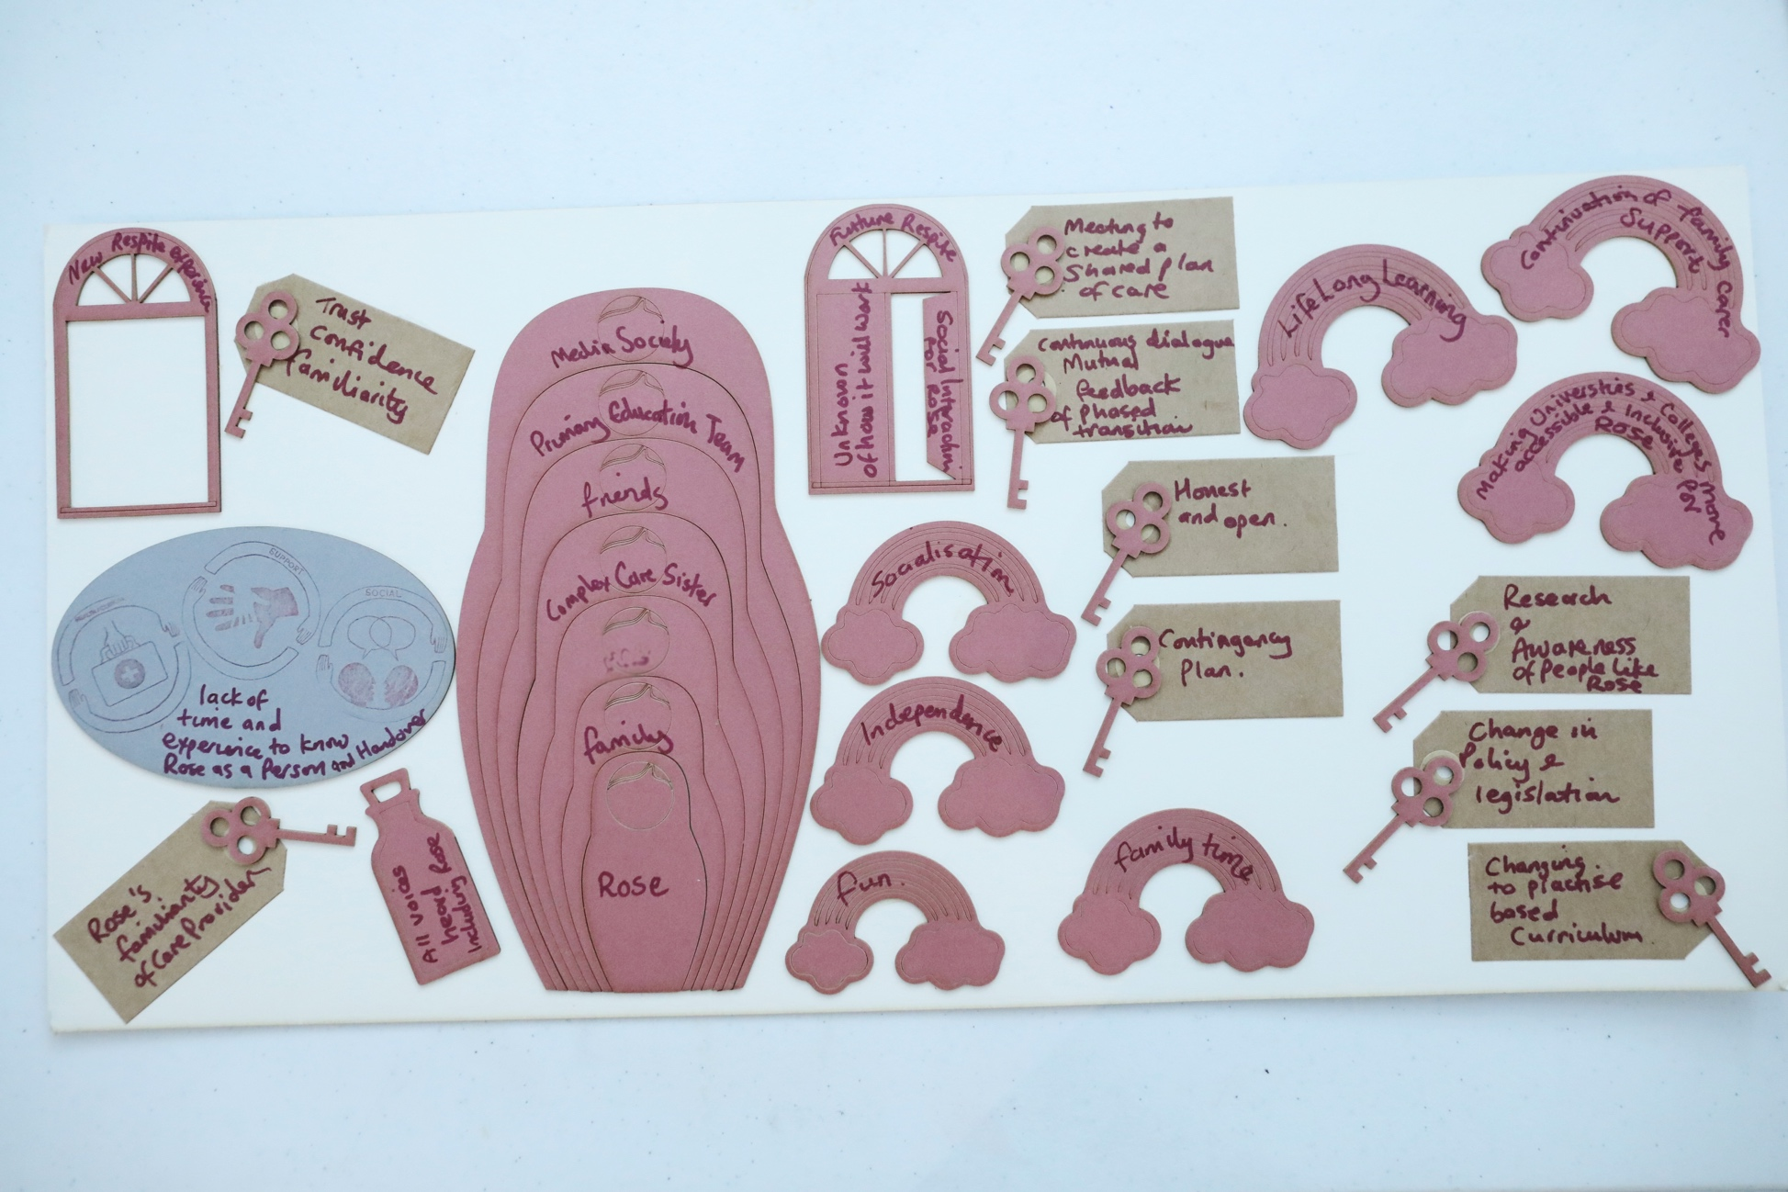
Figure 1. A completed visual interview depicting the experience of palliative care transitions using the laser cut visual metaphors described in Table 1. Credit: Louise Mather

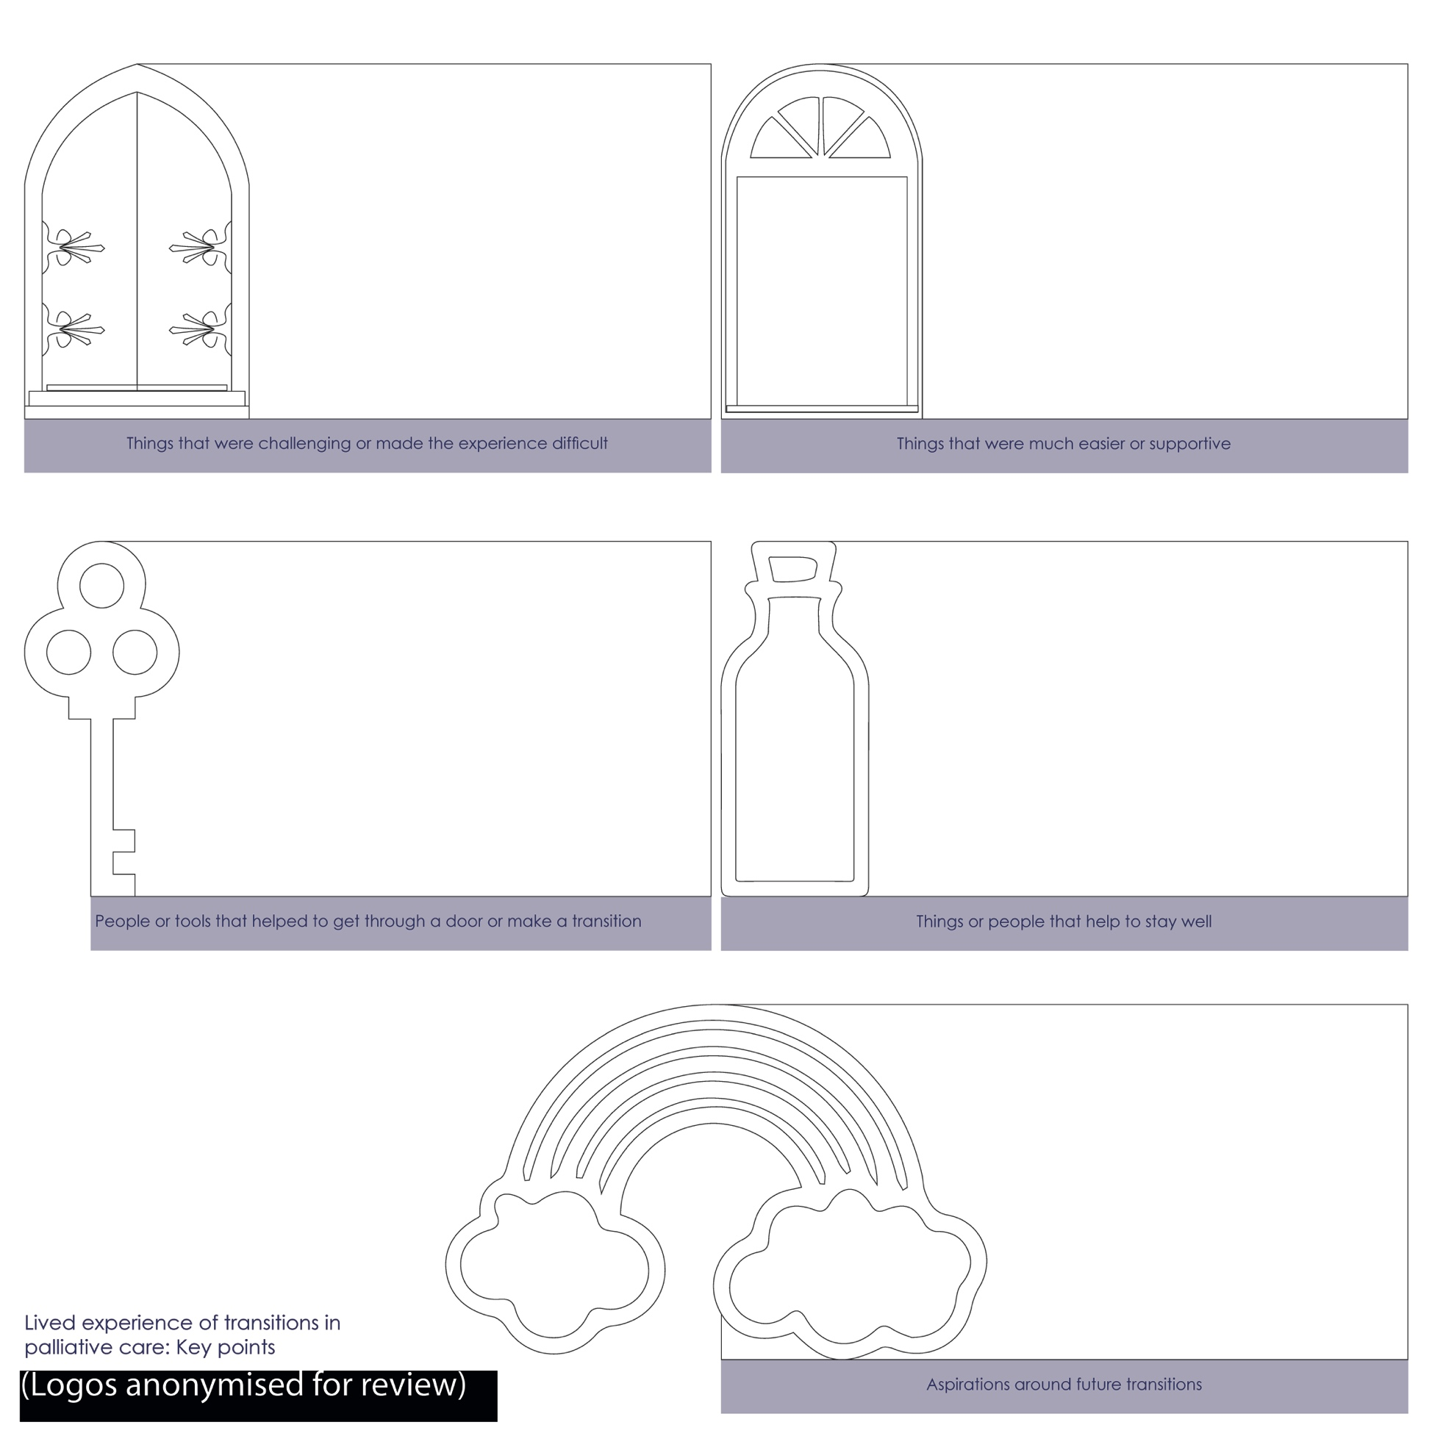
Figure 2. Focus group visual canvas to capture themes relating to challenging and supportive experiences of PCT, people and tools supporting transitions and wellbeing, and aspirations for the future. Credit: Sneha Raman

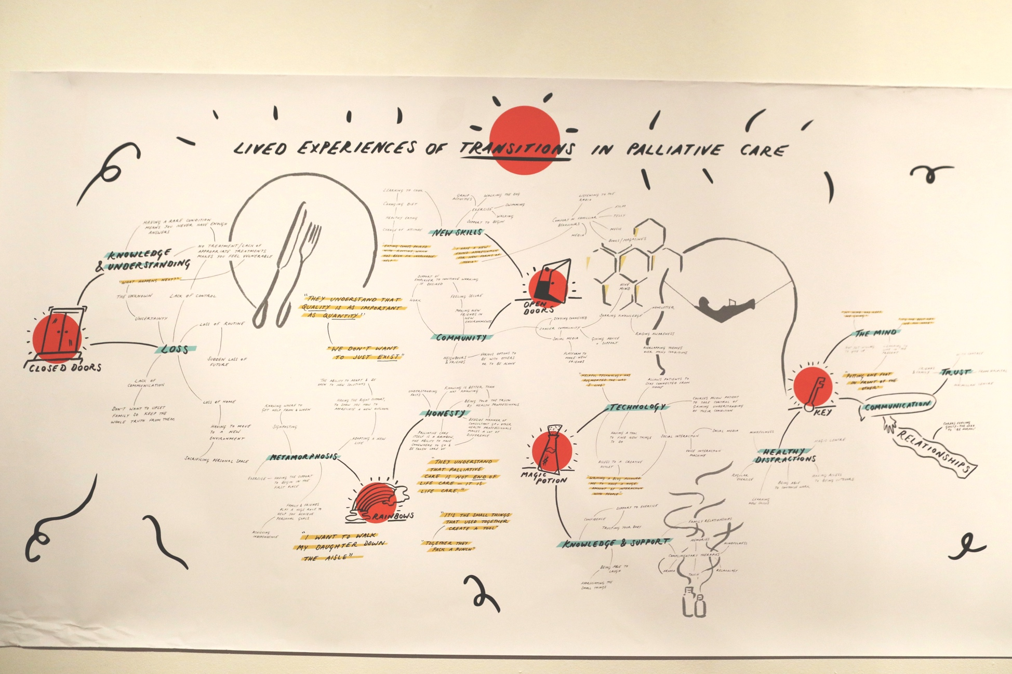
Figure 3. Focus group visual summary of lived experiences of PCT. Credit: Tessa Mackenzie
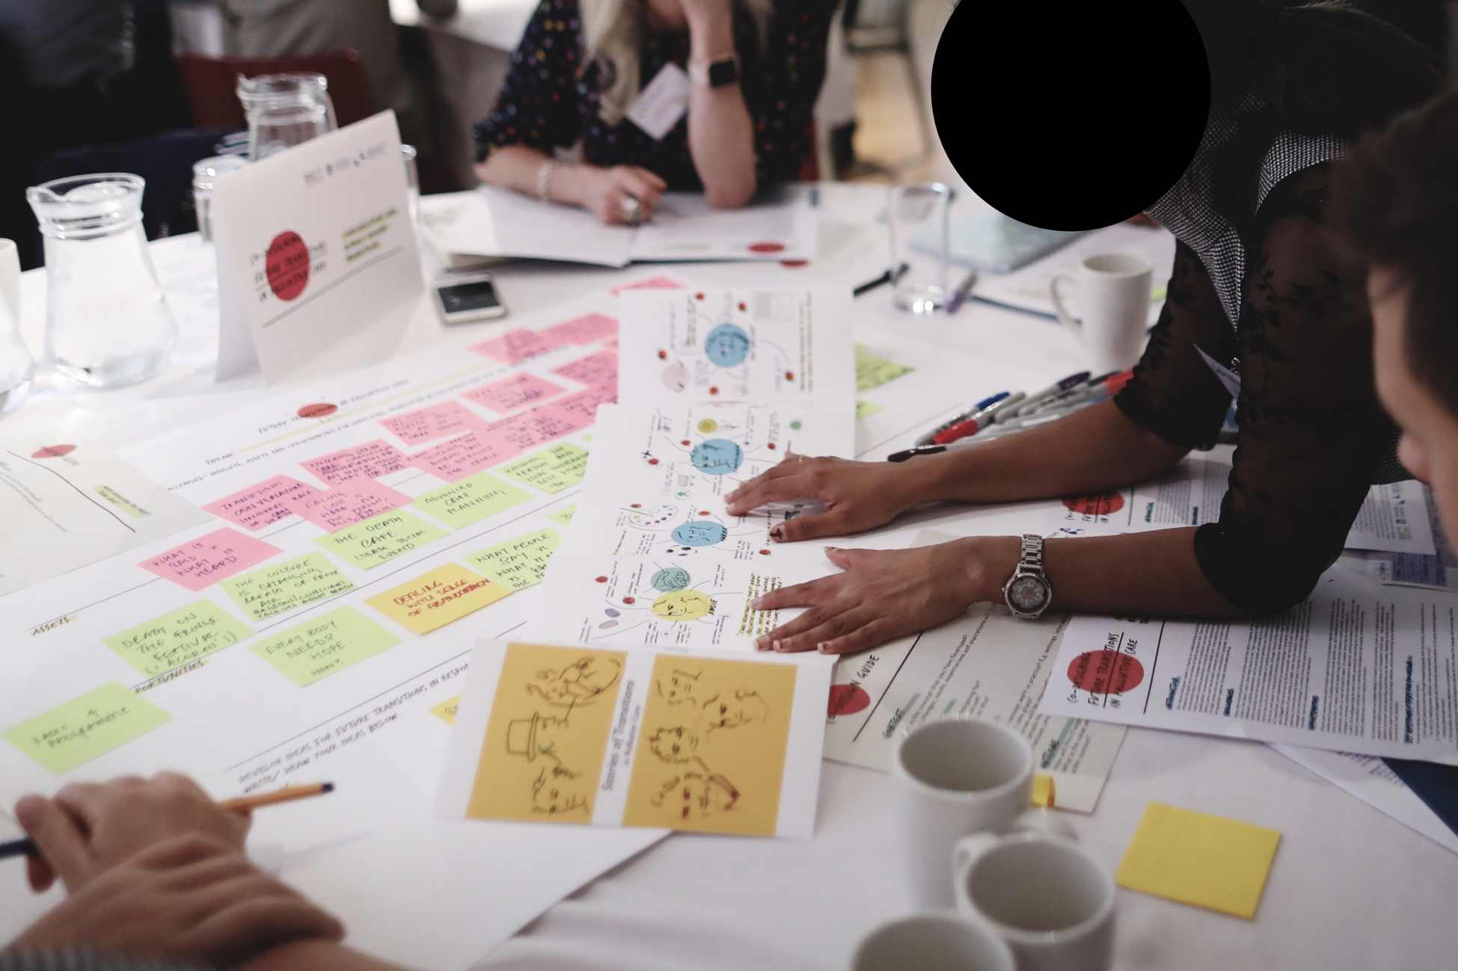
Figure 4. ‘Stories of Transitions’ guiding co-design. Credit: Louise Mather
Table 1. Engagement of people with lived experience in co-design
Purpose | Methods and tools | Outcome
Understanding individual experiences of PCT | Lived experience interview with visual interview tool | Lived experience map depicting individual experiences of transitions and aspirations for future PCT (Figure 1)
Collective reflection on shared experiences of PCT and identifying priorities for future transitions | Focus group with visual canvas (Figure 2) to structure themes and priorities | Emerging themes and priorities for future PCT (Figure 3)
Integrating lived experiences and priorities to co-design future PCT with wider stakeholders | Co-design workshop with wider stakeholders with the ‘Stories of Transitions’ ensuring foregrounding of lived experience during workshop activities | Refined themes and concepts for future PCT (Figure 4)

Table 2. Shapes and metaphors used in the visual interview tool
Laser cut shape | Purpose
Russian dolls | To build a picture of participants’ care circle which may include family, friends, health and social care professionals and others providing support.
Doors | A range of different shapes and sizes, and opened, closed or ajar to allow participants to express their experience of navigating and accessing support during transitions.
Keys | To ‘unlock’ doors or challenges and capture new ways of supporting transitions.
Magic potion bottles | To express what enables participants to overcome challenges associated with their health and care and supports them to live well.
Rainbows | To express participants’ hopes and aspirations for their future and for future transitions.

Table 3. Emerging focus areas for co-design in palliative care
Emerging focus area | Description
Emphasising capacities | Reframing notions of vulnerability, emphasising the expertise of participants through their lived experience and their contribution to the co-design process.
Ethical responsibility to enable choice | Making the commitment to engage people in co-design, giving them choice about their involvement and to engage on their own terms.
Context sensitisation and deep understanding | In depth preparation for tailoring engagement through relationship building and early engagement to generate deeper understanding of the context.
Identifying and creating a positive engagement setting | Identifying a setting that reinforces and creates a positive environment that is a precondition to creating a safe space for conversations that facilitate trust.
Asset-based narratives and metaphors | Enabling positive conversations around sensitive topics by creating tools that support positive reflection on individual experiences and factors that contribute to living well, challenging stereotypes.
Bespoke engagement using visual tools | Creating tailored tools to support engagement sensitive to the topic and building on participant capacities enabling reflection for participant and researcher as well as making voices of lived experience ‘visible’ to wider audiences.

