Animated Guide to Represent A Novel Means of Gut-Brain Axis Communication
Hana Pokojna
The Glasgow School of Art,
The University of Glasgow
Dr Daniel Livingstone
School of Simulation & Visualisation, The Glasgow School of Art
Dr Richard Burchmore
Institute of Infection, Immunity and Inflammation, College of Medical, Veterinary and Life Sciences, University of Glasgow
Dr Daniel Wall
Institute of Infection, Immunity and Inflammation, College of Medical, Veterinary and Life Sciences, University of Glasgow

Abstract

Key words: animation, visual aid, microbiome, gut-brain axis, abstract concepts, communication, 2D and 3D models

Novel scientific concepts must be made understandable to allow their further development, highlighting the need for better communication of abstract ideas that these discoveries are built on. This project focused on visually communicating the discovery of microbiome-derived molecules that play a major role in microbiome-gut-brain axis communication through multimedia learning.
A 4-minute animated video that was segmented and used a combination of 2D and 3D models was created. It communicated the important information about the process of discovering the molecules in mouse models, their production by bacteria and their potential implications for human health. The animation was then provided to a scientific audience, alongside a short answer survey and a Likert scale, to assess how visual aspects accompanied with narration compare to learning and comprehension of the same content if it is read.
The findings are based on the total of 15 participants, 9 of which were exposed to the information via animation (Group A), and 6 who were given information in a form of written narrative (Group B). It was found that Group A scored average M=15 (out of 25) on the post assessment compared to Group B with an average of M=7. Higher scores correlated with higher rating on questions about perceived understanding through animated media. Additionally, the animation scored higher on helpfulness in learning abstract ideas, especially having to do with structure and spatial navigation. This indicates that scientific abstract concepts are likely comprehended are needed in order to make definite conclusions.

Glossary
- ASD: Autism Spectrum Disorder
- FAO: Fatty Acid Oxidation
- 3M-4TMAB: 3-methyl-4-(trimethylammonio)butanoate) 4-TMAP: (4-(trimethylammonio)pentanoate) 3D: 3- dimensional
- 2D: 2-dimensional
- SPF: Specific Pathogen Free (mouse)
- GF: Germ Free (mouse)
- MIA: Maternal Immune Activation
- GI: Gastrointestinal
- VLE: Virtual Learning Environments
- MGB: Microbiome-Gut-Brain (axis)

Introduction
Understanding novel scientific concepts is very important, especially when it is concerned with ideas that are difficult to understand. This is especially true when their understanding could improve the future of health care. With the increasing amount of scientific research into the human body, the concepts become more abstract as we consider occurrences unobservable to the human eye. A series of complex procedures must be carried out to infer conclusions and make predictions, upon which scientists then make hypotheses. These can be then taken further and applied in real-life, for example in medicine. The understanding of the mechanisms, however, is the first and crucial step in order to enable progress.
Because of this, the concept must be conveyed in a concise way so that it is understandable and can serve as a template for future applications. Visualisation is particularly useful in presenting abstract science as it gives face to concepts. This research projects focused on the explanation of an abstract idea, specifically on the discovery of two bacterial molecules, which are involved in microbiome-gut-brain (MGB) axis communication. The novel discovery of molecules underpins communication between the much studied, yet not very well understood gut-brain axis. While this phenomenon was researched in recent years, the experiment shows the production and effect of the molecules on chemical and physical level. The animation showed the practical application of molecules to human model, where they are produced in the gut, travel to the brain, and visualise their effect in carnitine-based function. This molecular mimicry to carnitine is essential as the new molecules act as Fatty Acid Oxidation (FAO) inhibitors due to their structure. This animation was then tested on a sample of participants who have a background in biochemical field to determine whether abstract ideas can be successfully conveyed through multimedia learning. Determining the animation success was tested with survey and answers compared between the animation group and a control group given the same information in the form of written narrative without the visual and auditory aid.
The aim of this project was to show the novel discovery of microbial communication between gut and brain with two specific bacteria-produced molecules that effect mitochondrial FAO in the brain, pinpointing communication at a specific cellular level.

1.1 Rationale
While a lot of previous literature focuses on this phenomenon, the details of the MGB-axis remain a research frontier. Much of this literature is focusing on other means of communication, such as via the vagal pathway and adrenergic nervous system as a means of communication.
The resulting animation was intended for use as a learning tool for understanding of this relationship between microbes in the gut and the mammalian brain. This research focused on the very first step of understanding a complex process, as its understanding has implications to the future of healthcare.
The discovery of the molecules differs to other current strands of research on this topic. Much of this research focuses on the potential for intervention strategies, including in many neurological disorders, yet there is to date scant evidence of microbial causality and identification. That is why the discovery of novel molecules that travel from the gut microbiome to the brain, such as those discovered here, is incredibly important. However equally important is the dissemination of these findings both to other researchers to help drive further scientific findings, and also to the public to ensure the findings are not misinterpreted. By competing with pathogens in the gut, the microbiome protects against infection but more recently changes in gut microbiome composition have been linked to obesity, cancer, asthma, diabetes, arthritis, multiple sclerosis, Parkinson’s autism spectrum disorders (ASD), Alzheimer’s and chronic fatigue syndrome, amongst others. Disturbance of the gut microbiome during development have been linked to anxiety, development and behaviour, in both, mice and human. Following these discoveries, the bi-directional communication between the gut and the brain was recognised as an important mediator of neurological health. Some early findings found bacterial supplements, or probiotics, can have positive effects on certain neurological disorders and can potentially be used as therapeutic interventions in certain conditions. However, the mechanisms behind such positive effects are still unknown increasing the importance of understanding the MGB-axis. First step in doing so, is understanding the underpinnings.
Hulme et al. again provide conclusive evidence showing the gut microbiome and brain physically communicate. Previous research into animation and aids in decreasing cognitive load point to visual representation accompanied with auditory stimulation as very successful in memorising and understanding. The resulting animation has a potential to not only aid the understanding for the general public but would be also the first animation to visualise a novelty finding, serving as a presentational learning tool in the scientific community that can contribute to healthcare with follow-up findings.

1.2 Research Aim
The overall aims are to visually explain a complex interaction across the MGB-axis as two novel gut microbiome-derived molecules competitively inhibit the fatty acid breakdown in mitochondria. Critically they do this in white matter cells of the brain by travelling from the gut to the brain, decreasing energy generation there. This aim took an abstract concept of a novel discovery and used it to test whether a visual representation through animation will help with its understanding in adults with background in biology and chemistry.
Aims:
The aim was to create an animated visual representation of MGB-axis communication based on pre-clinical research in mice showing MGB-axis communication and evaluate whether the animation helps with understanding of the concept.
Objectives:
1) Understanding current research into a) visual communication and
b) MGB-axis communication
2) determining key points crucial for understanding the MGB-axis communication (basis for animation)
3) creating animation
4) testing animation
5) statistically determining to what extent is animation helpful as a learning tool in understanding abstract concepts
Additionally, the animation’s objective is to be implemented beyond the scope of this final project, for example in teaching and conferences.

2. Literature review

2.1 The Microbiome-Gut-Brain (MGB) axis
2.1.1 Connecting the gut and the brain
The MGB-axis has long been suspected of having an impact on moods, behaviour and well-being. Its importance was observed by doctors as an area to research as early as 1840s in France, as discussed in recent talk by Dr Manon Mathias at her talk “Auto-intoxication and historical precursors of the microbiome-gut-brain-axis" (Mathias, 2019). The impact of MGB communication became even more researched in recent years due to its importance in some previously unsuspected cause behind numerous health conditions. As suggested by Dr John Cryan at his talk More Than A Gut Feeling: Microbiome as a Key Regulator of Brain & Behaviour (Cryan, 2016), neuroscientists were mainly focusing on the head and neck as the brain is attributed control centre for feelings. Specifically, people often have a “gut feeling” or “butterflies in their stomach” which literally goes beyond of said feelings in head to other parts of the body. Therefore, brain disorders are a whole-body co-morbidity (Cryan, 2016). To just begin to understand the processes behind MGB communication, one must look at the small processes underlying them such as energy generation through fatty acid oxidation (FAO) and the molecules that play key roles such as carnitine.

2.1.2 Microbiome-derived carnitine mimics (Hulme et al., n.d.)
Given the importance of the MGB axis and its potential impact on health, research was undertaken to detect microbial molecules mediating communication across the MGB axi. Two novel carnitine-like molecules that inhibit mitochondrial FAO were identified. Their similarity to carnitine was speculated to result in their binding by carnitine interacting enzymes, enzymes essential to energy generation in mammalian cells.
A series of multi-disciplinary approaches was carried out to identify the structure, origin, localisation and function of these molecules. First, the presence of the novel microbial metabolites was detected by mass spectrometry imaging (MSI) in both gut and brain of specific pathogen free (SPF) mice while being absent in germ free (GF) mice. Because they were absent in GF mice, they were hypothesised to have microbial origin. The putative microbial molecules were abundant in the white matter of SPF mice; in the medulla, corpus callosum, and cerebellum (arbour vitae), as well as being found systemically in the blood, liver, kidney, lung, spleen, intestine, testes and heart. MSI screening of intestinal stains from the murine gut microbiota detected production of the novel molecules in two closely related bacterial anaerobes; Clostridium clostidioforme and Clostridium symbiosum.
To confirm the bacterial and murine brain molecules were identical, they were fragmented by tandem mass spectrometry (MS/MS). This demonstrated that the signal from each source had a matching molecular fingerprint indicating they were identical.
Initially it was unclear that two molecules had been detected as a single mass to charge (m/z) was detected through MSI. Such a signal is normally, but not always, due to the presence of a single molecule. However here as the structure of the putative molecule could not be determined it was speculated that more than one molecule of the same size and charge might be presence. Clostridium symbiosum was subjected to Nuclear Magnetic Resonance (NMR) Correlation Spectroscopy an advance technique for determining structure of a molecule, or mixture of molecules. This indeed showed that a mixture of two structural isomers was present, differing by the position of a methyl side chain being on either C3 or C4. These molecules bore striking structural similarity to carnitine and its precursor gammabutyrobetaine.
3-methyl-4-(trimethylammonio)butanoate) (3M-4TMAB) had methyl chain on C3 while 4-(trimethylammonio)pentanoate (4-TMAP) had methyl chain on C4. MSI was next used to determine co-localisation of 3M-4TMAB and 4-TMAP with carnitine in SPF mouse brain slices. The idea being that if they had similar structures, they may also be transported to similar brain regions. A statistically significant overlap between carnitine and 3M-4TMAB /4-TMAP signals was detected in the brain indicating that significant spatial co-localisation was occurring between the bacterial molecules and carnitine in the brain.
Due to their co-localisation and structural correlations, further tests for their function in disrupting carnitine function in FAO was tested. Murine white matter cells were fed defined substrates and oxygen consumption was used as a measurement of FAO. Results showed that FAO was significantly reduced by both 3M-4TMAB and 4-TMAP, both at concentrations similar to those found in the brain or in direct competition with carnitine.
Through the application of a novel imaging approach to the MGB axis here new insights into the molecular means of communication across this axis were identified. This has resulted in the first description of molecular exchange between bacteria in the gut and mitochondria in the mammalian brain resulting in FAO inhibition.

2.2 Learning Science with Animations

2.2.1 Why animation?
Animated movies provide people with the chance of accessing information in a different way, and by that help them understand new concepts and learn. Living in digital age where cell phones and other portable electronics are easily accessible allows access to information and different ways of comprehending them. Free video platforms such as YouTube make this even easier. Schools often rely on technology and animated movies to teach science. The popularity of combining technology and teaching is appraised by teachers around the world, for example in ICT Practice online journal, where they can discuss their experience with technology in classroom. In terms of animation, it is said to be popular as it keeps the students’ interest while visually giving them concrete things to focus on. It is further valued for its success with visualising abstract STEM concepts, for example in physics (Bedrina, 2016).

2.2.2 Multimedia Learning
Multimedia learning is learning from words and pictures that has cognitive processes involved in learning. According to Cognitive Theory of Multimedia Learning (CTML), it involves selecting relevant information, mentally organising it incoherent organisation and integrating it with relevant prior knowledge activated from long-term (Mayer, 2005). Memorising information shown with multimedia and storing it in long-term memory involves several processes of memorising that work on specific assumptions.
According to CTML, there are three processes of memorisation used:
1) Essential processing is making sense of the presented material, which uses cognitive capacity to select, organise and integrate the words and images.
2) Incidental processing are cognitive processes that are not required for making sense of the presented material but are primed by the design of learning task.
3) The representational holding refers to cognitive processes aimed at holding a mental representation in working memory over a period of time. This can lead to cognitive overload when total intended processing exceeds the learner’s cognitive capacity.
In addition to three types of learning, there are three assumptions of how the mind works in multimedia learning, in accordance to CTML:
1) Separate systems assumption- human information has two separate channels are responsible for processing information; the auditory/verbal that deals with auditory input and verbal representation.
2) Limited capacity assumption- each of the channels has a limit to the cognitive capacity it processes.
3) Active-processing assumption- meaningful learning requires cognitive processing in both channels and their interaction.

The transfer of knowledge from multimedia into long-term memory according to CTL is illustrated in Figure 1 below.
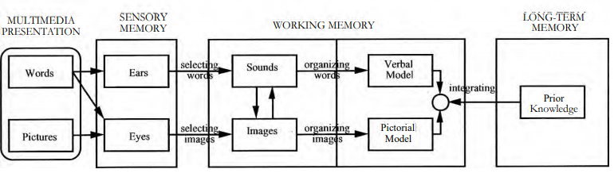
Figure 1-information processing from multimedia into long-term memory (Cognitive Theory of Multimedia Learning, Mayer, 2005)

2.2.3 Pros and cons of animation as a learning tool
Animation is successful as a learning tool as shown by a recent meta-analysis. It consisted of 140 pair-wise comparison studies between animated vs static graphic visualisations showing overall positive effect of studying with animations (Berney and Bétrancourt, 2016). They attribute the overall strength to animation’s benefits in memorising and understanding dynamic systems, such as biological processes, due to its change over time. This meta-analysis has shown that animation is more useful in learning and memorisation compared to static images.
A major disadvantage of animation as a learning tool is providing too much information, causing cognitive overload as specified by Mayer (2005). An effective animation must create a virtual leaning environment that has to have as little new and distracting compounds as possible. The complexity must be handled in a way where the navigation is simple enough to understand, but not over-simplify the aspects. Learner will search and evaluate information and integrate it multiple representation- image and sound, to build a coherent knowledge of the concept. The question of the appropriate environment can be solved by animated pictures, as it can be used to support 3D perception by showing an object from varying perspectives and used to direct the learner’s attention. This is supported by study (Solomon, 1994) that found that animations could have a helpful effect when they help learner perform a cognitive process that they could not otherwise perform with external support.
Further research investigated animation types and knowledge-specific benefits (Schnoz and Rash, 2005). It has shown that manipulation of pictures has enabling function for individuals with learning necessities and simulation pictures had a facilitating function for individuals with low learning necessities. However, the facilitating function was not beneficial for learning because learners were prevented from performing relevant cognitive processes of their own. They also define in which ways animated pictures, compared to static pictures, prove additional information that seems to have different functions for learning. Schnoz and Rash made a point that animations enlarge the possible cognitive processes that can contribute to performing more processing, that they would otherwise not be able to perform with static pictures, giving it an enabling function.
On the other hand they argued that animation can trigger dynamic cognitive schemas that make specific cognitive processes easier, known as facilitating function of animation. Individuals with high learning necessities seem to benefit primarily from the enabling function whereas individuals with low learning perquisites seem to be affected primarily by the facilitating function of animations.
Animation is very helpful in providing dynamic information, which enhances understanding (Lowe, 2003). However, the learning and memorisation can be inhibited as it provides many other information that require understanding. In order to build mental models from animation, thematically relevant information must be extracted and incorporated into already exiting learning structures. The following information explains of how to overcome the discussed disadvantages and bring forward its benefits as a learning tool.
2.2.4 Using animation efficiently
Several studies concerned with effectiveness of animation in learning have identified a series of problems having to do with cognitive over load (Mayer and Moreno, 2003) or due to the lack of motivation (Mares, 2014). These studies serve as a template for this project to create an animation that is as useful learning tool as possible. All theories are applied while using Mayer and Wittrock’s (1996) definition of “multimedia learning” as learning from words and pictures. “Meaningful leaning” is also defined as deep understanding of material, which is affected in ability to apply what was learned.
The experiments conducted over 12 years (Mayer and Moreno, 2003) identified the causes behind cognitive over load in multimedia learning and offered a solution to each. Their ways of improving animation are based the Cognitive Theory of Multimedia Learning (Mayer, 2005) and Cognitive Theory of learning (Sweller, 1994).
The previously mentioned assumptions of functionality of the channels and the types of processing cause five types of identified cognitive overload listed below, alongside suggestions of how to overcome them:
Type 1 overload:
This problem occurs when one channel is overloaded with essential processing when reading a text at the bottom of the screen but cannot view the animation. A solution is off-loading from the visual channel onto the verbal channel to distribute the cognitive effort.
Type 2 overload:
The problem is occurring when both channels are overloaded with essential learning when the learner is watching a narrated animation, and both are heavy with essential learning. If there is not enough time to select relevant words and images from one segment, the beginning of another segment cuts off the time needed for deeper processing. This causes cognitive overload where needed cognitive capacity is not available. To prevent a situation, segmenting the presentation into smaller chunks will allow learner to integrate and organise of the selected ones
Type 3 overload:
This problem occurs when one or both channels are overloaded with essential and incidental processing. An example of the combination of the two would be adding sound effects to relevant part of the animation to enhance the learning, however serving as an extraneous variable. This can be solved by making giving the information in concise and coherent way by omitting extraneous variables.
Type 4 overload:
Type 4 also occurs when one or both channels are overloaded by the combination of essential and incidental processing demands but as a result of confusing presentation. This could be presenting important information in animation and placing essential information in form of relevant labels at the bottom of the screen. Solution is integrating presentation by aligning words and pictures results in aligning and the learner will not have to use limited cognitive resources to visually scan the graphics in search of the corresponding part of the picture.
Type 5 overload:
This occurs when the system is overloaded with the need to hold information in working memory for future reference in order to undergo meaningful learning. The solution is to synchronise the visual and the verbal information so the holding of either of them while the other happens consecutively doesn’t deplete the learner’s capacity in engaging in the cognitive process of selecting, organising, and integrating. This situation minimizes cognitive load, so the working memory doesn’t take up
additional cognitive capacity. This is called a temporal contiguity effect when understanding occurs from learning simultaneously rather than consecutively.
Mayer and Moreno’s (2003) ways of reducing cognitive load were further supported by Ayeres and Paas (2007), who have identified similar problems and suggested similar ways of avoiding them.
Additional factor preventing meaningful learning through multimedia is the lack of motivation (Mares, 2014). Motivation can be enhanced by adding appealing graphics (Magner et al, 2013) or challenging scenarios (D’mello, 2013). While adding attractive components puts learner at the risk of cognitive overload, focused approach, which, can be achieved with attractive visuals, proved to be most helpful. This is as long as the attractive parts do not overwhelm and distract from the aim but are there just enough to prime learning and motivate it. Simultaneously, the animation has to be direct and consistent (Mayer,2018).

3. Materials and Methodology
3.1 Introduction
This section summarises the materials and methods used for this project, specifically focusing on the rationale, development and components for the generation of animation.
3.2 Materials
3.2.1 Computer software
Several computer software packages were used for the creation of 3D and 2D models. Afterwards software from Adobe suite were used for putting together the animation. The software applications are listed and described in Figure 2 below:
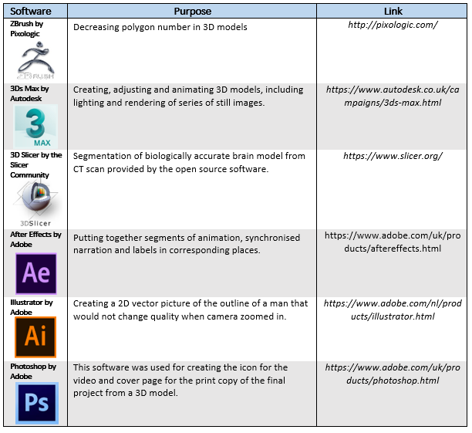
Figure 2- list of software packages used

3.2.2 Online platforms
An online website Turbosquid was used to purchase a 3D model that was modified and put into animation. YouTube was used as an online video platform for the participants to view the animation. The platforms are summarised and described in Figure 3 below.
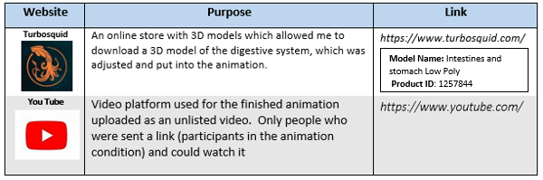
Figure 3- list of online websites and platforms used
3.2.3 Audio
Narration was recorded by a fellow colleague with a Zoom Handy Recorder H4 microphone in the Sound Studio in the School of Simulation and Visualisation (The Glasgow School of Art).
3.3 Methods
Figure 4 below lays out the framework for the design of the animation, as further detailed in the following sections. It visually lays out the workflow and connects stages of development (blue boxes).
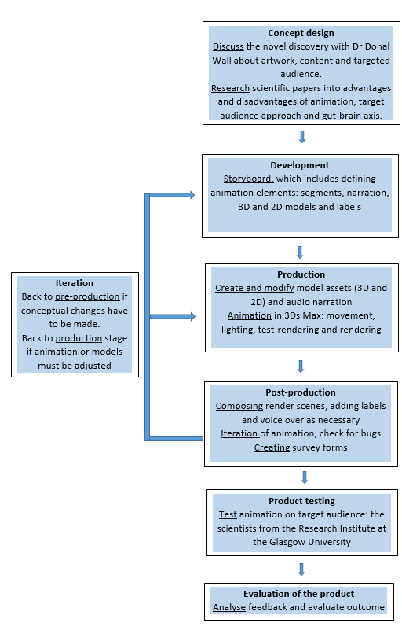
Figure 4-representation of workflow for animation: Concept, Design, 3D Modelling and Animation development

3.2 Design
3.2.1 Concept
From the paper “Microbiome-derived Carnitine Mimics as Novel Mediators of Gut-brain Axis Communication”, the first challenge in developing an animation was deciding on the core concepts and ideas and how to visually represent them in a concise yet informative manner.
The process of picking out the key concepts involved 1) background research into previous gut-brain axis communication so the information is not repeated. This was followed by 2) research into the methodology of the process of how the molecules were discovered. While the scientific paper states the process, it does not explain the basis of function of the complex technology used. Afterwards, 3) discussion with the lead researcher on the project, established what is different about this specific research.
As the aim of the animation is to be used as a learning tool to bring words and numbers into more understandable state through moving images. Essentially, the research paper itself served as the script for instructions in the animated video. The key concepts that must have been included are as follow:
- Discovery of two molecules that play a role in the communication - found molecules correlate
- Molecules are structurally similar to carnitine- they only differed in the presence and location of methyl chain on either C3 (instead of a hydroxyl group) or C4
- Molecules are therefore structurally similar to carnitine which affects FAO in white matter
- Specifically, they have an inhibitory function on FAO, as shown in murine white matter cells - these tests showed that mitochondrial respiration was affected by presence of these molecules with a decrease in measured oxygen consumption rate which is indicative of mitochondrial basal respiration
- Abundance of molecules in white matter in pathogen free mice, compared to sterile germ-free mice
- Bacterial origin of metabolites= NMR analysis showed that they were produced by the bacteria in the gut in the SPF mice, bacteria found in the SPF mice were part of Lachnospiraceae family- Clostridium clostridioforme and Clostridium symbiosum C. clostridioforme was collected and MS/MS carried out, this metabolite was proven to be a mixture of 2 structural isomers, as shown by NMR
- Abundance in the body of metabolites - MSI of multiple organs showed presence of 3M-4TMAB /4-TMAP systematically across all organs and in blood. Levels were lowest in the testis and in the ileum while the highest levels were in the colon and the heart tissue
3.3 Development
After defining the key concepts, it was necessary to implement cognitive theories of multi-media learning (as discussed in Section 2), to foster generative processing- making sense of what is being learned and is based on learner’s effort to learn. This was done by breaking information into manageable parts. The animation was divided into five segments based on the groupings of key concepts:
- Background research into MGB-axis
- Details of in vivo murine experimentation
- Results
- Implementation on human model
- Future research
3.3.1 Storyboarding
Creating the storyboard involved pairing of the key concepts and segments with visual representations. These were based on the decision-making between 2D and 3D models, then grouped into scenes, and then further grouped into corresponding segments (Figure 5). Movement of the camera was installed in a way where the viewer could see the 3D aspects of desired models which pointed their attention to them.
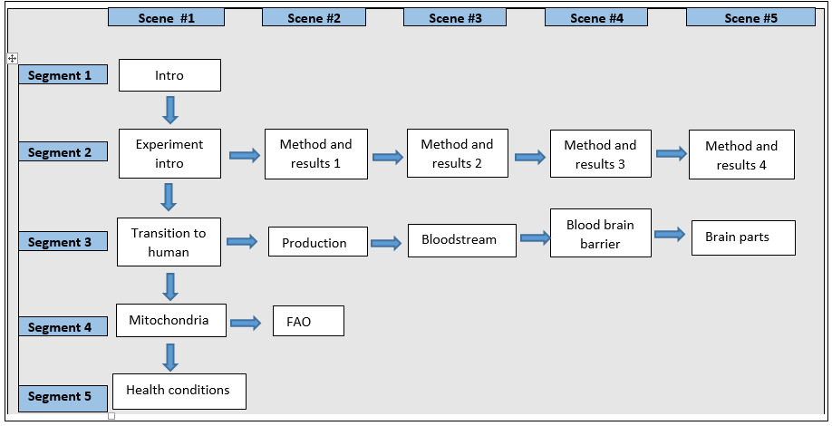
Figure 5- flow of scenes grouped into segments

3.3.1.2 Segments
Segment 1: Background research into MGB-axis
Consisted of introduction page with a logo and name of the research
A model of gut and the brain while narration to give time for narration about the background of this phenomena. 3D model was used to highlight the importance of these two organs.
Segment 2: Process of experiments on mice and results
This segment included a scene briefly introducing the experimental process. The following scenes focused on explanation of methodology and results. This included one of the most crucial findings- a structural comparison between three microbiome-derived molecules. To highlight their importance, they were the only 3D models in this section.
Segment 3: Implementation on human model
Focus on implications for human health. Consisting of transition scene with 2D outline of a man serving as a context and drawing attention to the 3D models of gut and brain, where camera zoomed in.
Scene of 3D molecules being produced appeared followed by 3D scene of said molecules traveling through blood stream, also 3D to highlight the means of transportation, eventually leaving crossing the blood barrier in human brain. This is followed by 3D model of a brain changing opacity and turning to show spatial importance of molecule abundance of respective brain parts.
Segment 4: Fatty Acid Oxidation
Focus on the biochemical effect of 3M-4TMAB and 4-TMAP on brain. First scene consists of 3D model of mitochondria as a location for this process while giving time for narration and explanation in the background. Followed by a 2D animation of FAO that occurs. 2D media was chosen due to complexity of this process and hence so the models do not distract from the process.
Segment 5: Future research
After explanation of the science, this segment focused on conclusions and possibility of future research. A 2D model of a man was chosen to stress future research aimed at humans and labels with health conditions with relation to this discovery.

3.4 Production
3.4.1 Models
The animation had a 2D, 3D and a combination set of models created specifically to focus on given aspect. The 3D models were created, using Z-brush, Slicer, and 3Ds Max software. The 2D models created in Adobe Illustrator, Adobe Photoshop and Adobe After effects. Figure 6 gives an example of how the anatomically correct brain model was segmented in 3D Slicer, and Figure 7 how it was converted into a low poly 3D model in 3Ds Max that was used in the animation
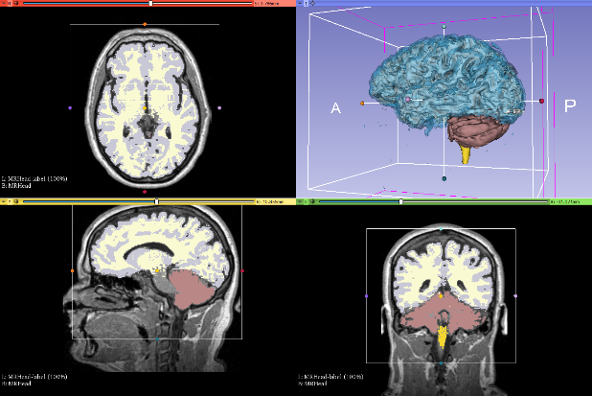
Figure 6-showing the segmentation of medulla (orange), white matter (white), grey matter (blue) and cerebellum (red) in Slicer software
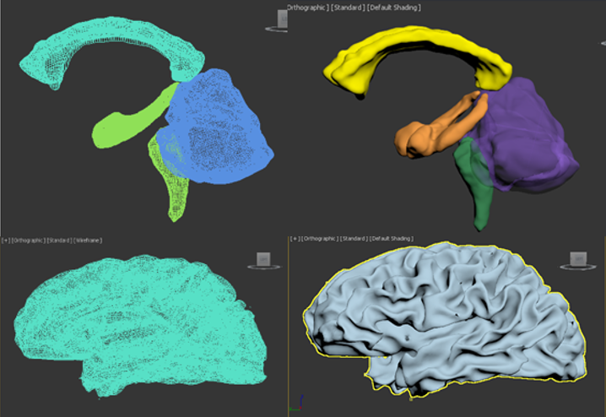
Figure 7- polygon structure of the inner brain structures; Hippocampus (yellow), corpus callosum (orange), medulla (green), cerebellum (purple).
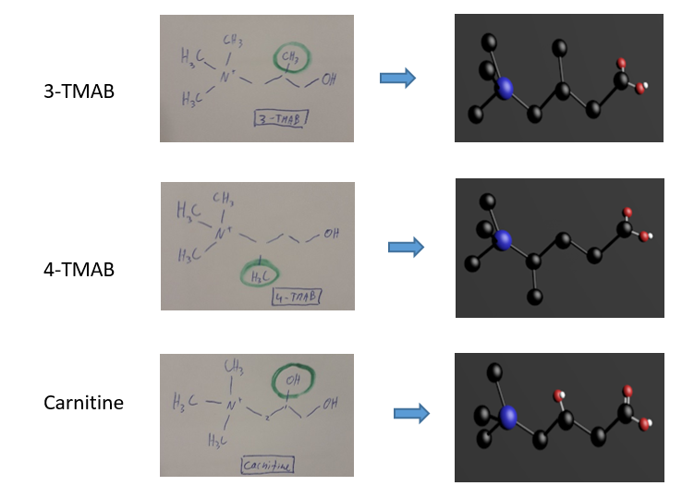
The structure of the molecules was one of the key findings of the study, which contributed to their function. The models were made based on chemical script into 3D models from present shapes cylinders and spheres and grouped into respective objects (Figure 8).

Figure 8-chemical scripts of molecules which served as a template for the 3D models of Carnitine, 3M-4TMAB and 4-TMAP

3.5 Animation
The animation was created in 3Ds Max since it allowed for a suitable way of moving models, setting up lights and use of camera, whether stationary or following a path. The animation used Scanline renderer at 300 FPS (Figure 9).

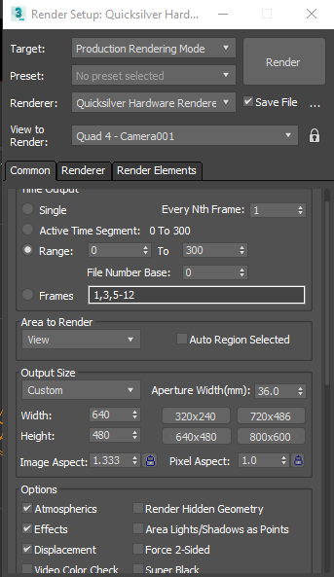
Figure 9-Scanline renderer settings

3.6 Audio
Narration to the animation was recorded using Zoom Handy Recorder H4 microphone. This was recorder in the Sound Studio in The School of Simulation and Visualisation (GSA) by a fellow colleague, who signed a media release form. A sample rate of 48 k.Hz was used. All recordings were saved as wav. files. Adobe AfterEffects software was used to edit the voice recordings into smaller mp3. files to be used in post-production and eventually exported as an mp4. file with visual animation from Adobe Effects.

3.5 Post-production

3.5.1 After-effects
Adobe After Effects was used to animate rendered pictures from 3Ds Max that were imported as OBJ. files. The narrated audio was added and cut into segments, which corresponded with the visual scenes. Afterwards, descriptive labels were added. Finally, the finished animation was exported in the form of mp4. file that lasted 4 minutes and 9 seconds.
3.5.2 Survey design
The survey was designed for two groups. The animation group (Group A) and the control group (group B), who would read the narration of the animation without any visual stimuli. The questionnaires consisted of three parts 1) short answer questions about the knowledge from each media, 2) Likert scale about understanding of the concept conveyed in each respective condition and 3) Likert scale about likability of conveying information from each respective media.
The basis for each questionnaire was identical for both conditions and differing only in naming the media that they were subjected to.
The first part of questionnaire consisting of fourteen questions and possibility of attaining 25 correct answers tested for new knowledge learned from the media.
The correct number of short-answer questions answered correctly, and non-negotiable, indicated the transmitted knowledge from the media to the viewer.
The second part of the questionnaire with six questions used five-point Likert scale and tested for perceived understanding of the concepts conveyed by the participant in respective media.
The third part consisting of ten questions used five-point Likert scale and tested for likability and possible improvement of the given media.
Likert scale was used as it is a universally approved testing tool for animations.

3.6 Product testing
3.6.1 Participants
The target group for testing was aimed scientists and researchers with background knowledge of biology and chemistry. Reaching out to them was achieved through convenience sampling with the help of Dr Wall, who is the head of a lab at the Institute of Infection, Immunity and Inflammation at the Glasgow University. The surveys and either animation or the narrative was sent to the participants by survey. Their filled-out questionnaires were then forwarded to the research project conductor (myself), via email.
3.6.2 Animation distribution
While sending the narrative (group B) was easy due to its small file size as a Word document, the animation was of a larger size. The finished animation was uploaded as an mp4. on You Tube platform as Unlisted video. This allowed for selected participants from Group A to click on a link, which would take them directly to the video, but this video would not appear in any searches on YouTube or search engines.

4. Results

This section will focus on the final version of the animation presented and explained scene by scene.

4.1 Animation design
The animation produced lasted 4 minutes and 4 seconds. The voiceover lasted throughout the whole animated movie except for the introduction scene with still image and title of the animation. The final mp4. Was uploaded to YouTube as an unlisted video at: https://youtu.be/RGXbAEc2d94

4.1.1 Introduction scene
This initial screen also contains a picture of gut and brain and the two novel molecules (Figure 10).
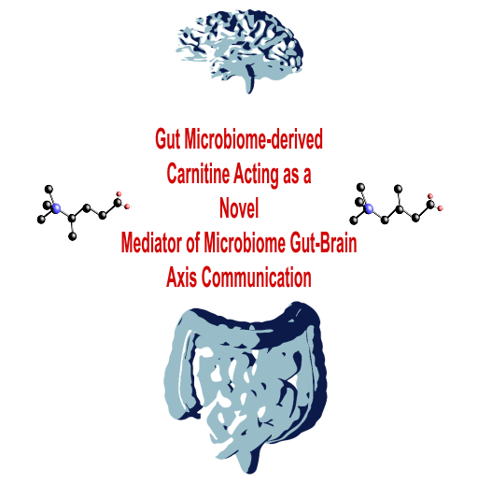
Figure 10- Introduction scene

4.1.2 Segment 1: Background research into MGB-axis
The first segment of the animation consists of introducing the topic of research into the gut-brain axis and the scene is a still image of a 3D model of the brain and gut (Figure 11).

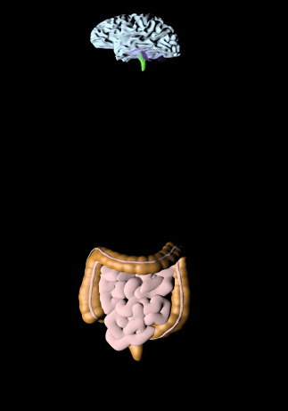
Figure 11-gut and brain 3D models in introduction

4.1.3 Segment 2: In vivo murine experimentation and results
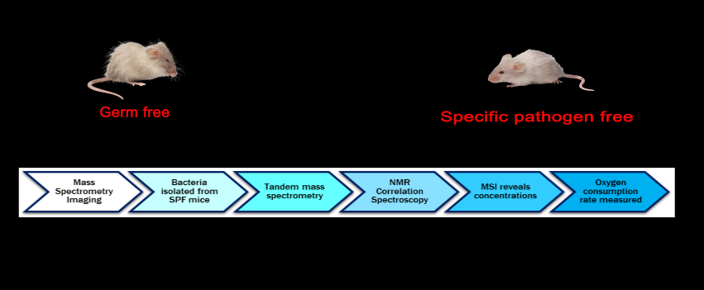
This segment consisted of 5 scenes. The first one was a still image giving an introduction to the series of experiments (Figure 12).
Figure 12-scene 1 of segment 2
The second scene (Figure 13) in the segment showed the results from the bacteria abundancy.
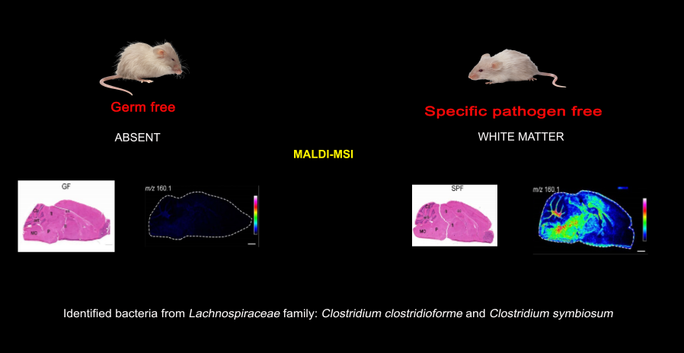
Figure 13-scene 2 in segment 2

The third scene (Figure 14) showed the structural comparisons of discovered 3M-4TMAB and 4-TMAP to carnitine.
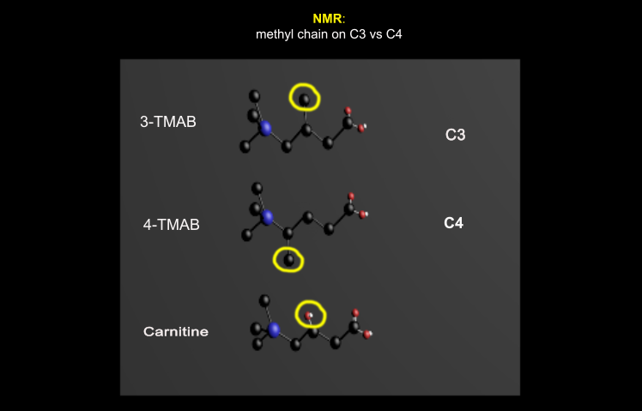
Figure 14-- structural comparison between the molecules

The fourth scene in this segment showed overlap of co-localisation between 3M-4TMAB and 4-TMAP and carnitine (Figure 15).
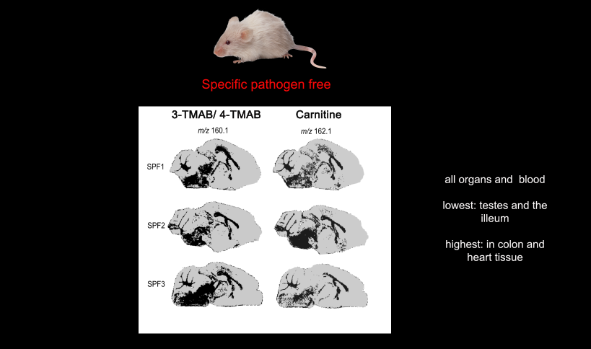
Figure 15- overlap of molecular localisation in the murine brain
The last scene (Figure 16) in this segment showed the results of the experiment measuring FAO.
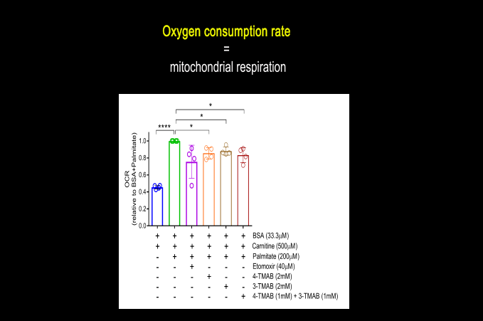
Figure 16-scene 5 in segment 2

4.1.4 Segment 3: Implementation on human model
The third segment consisted of six scenes that showed the assumption of outcomes from the experiment done on mice implemented on human model, since future researchers aims to improve human health. This transition between mice and humans is explained in the first scene (Figure 17) where the camera zooms in on the 3D model of the gut.
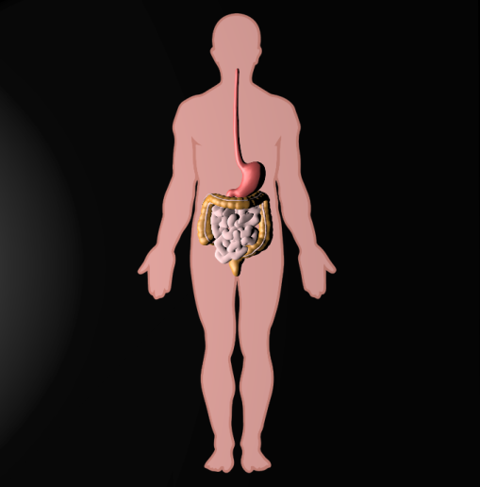
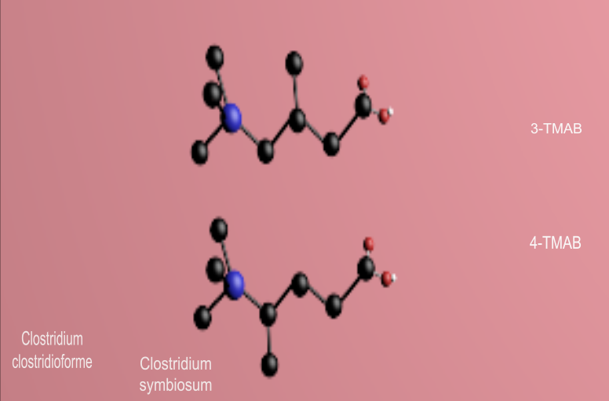
Figure 17-gut and brain 3D models with human outline for context. The second scene shows the two molecules being produced in the gut by the bacteria and entering the blood stream (Figure 18).
Figure 88-bacterial production of molecules in the gut

This scene (Figure 19) in the segment shows the 3M-4TMAB and 4-TMAP molecules traveling alongside the red blood cells in the blood stream.
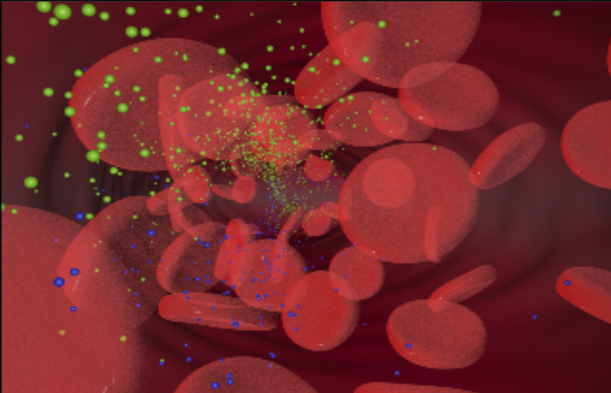
Figure 199- bloodstream animation

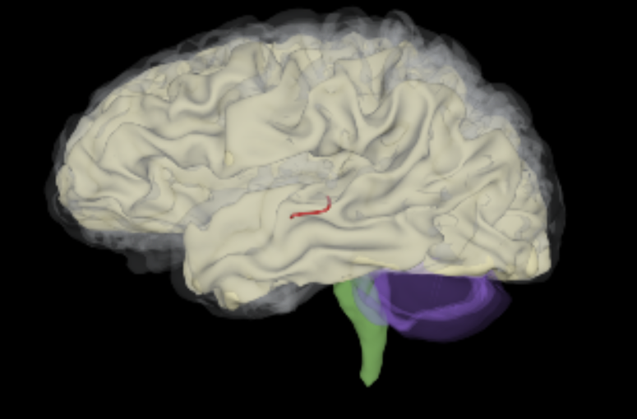
The next scene connects the means of travel of the molecules in blood and them entering the brain through the blood brain barrier (Figure 20).
Figure 20- blood brain barrier crossing

Scene four shows the brain turning 180 degrees while the outer parts decrease in opacity, so the innermost structures are visible (Figure 21). The scene finishes with the human brain having labels of the brain parts with the abundancy of the metabolites.
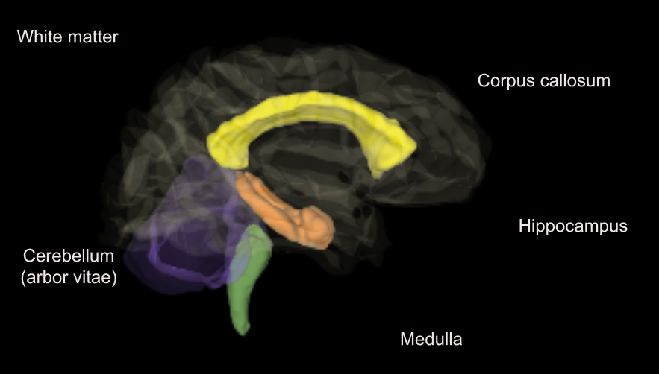
Figure 21- brain model with labels and low opacity on white matter to see innermost structures

4.1.5 Segment 4: Fatty Acid Oxidation
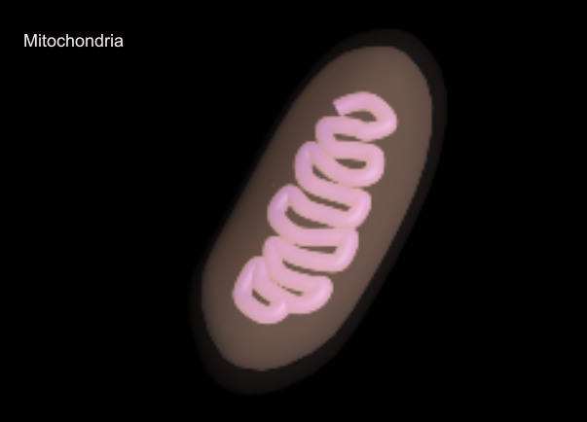
This segment consists of two scenes. The first shows a 3D model of mitochondria and in the narration talks about FAO and its importance (Figure 22).
Figure 22- mitochondria model
The second scene shows animated FAO in three different conditions, depending on which molecule was interacting with the fatty acid chain. It started with normally functioning carnitine shuttling a fatty acid across the mitochondrial membrane, then continued to show FAO inhibition by 3M-4TMAB (Figure 23), followed by inhibition by a potentially comparable known inhibitor aminocarnitine. This section ended with a comparison of the molecules.
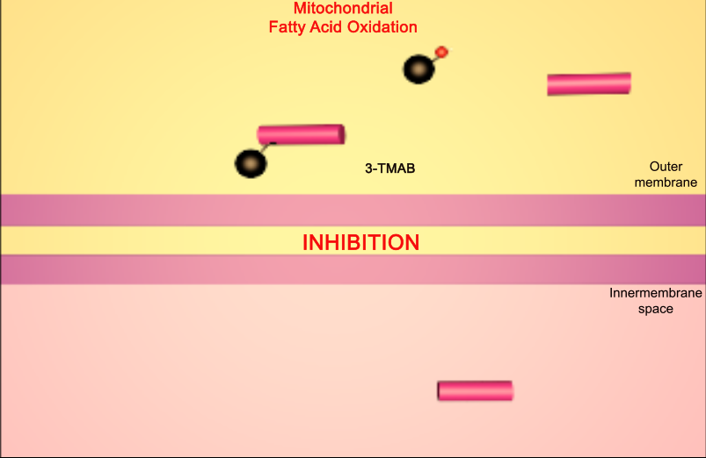
Figure 23- FAO inhibition by 3M-4TMAB

4.1.6 Future research
The last segment consists of one simple scene with 2D model (Figure 24) and discusses future research that can be based on the finding of the metabolites.
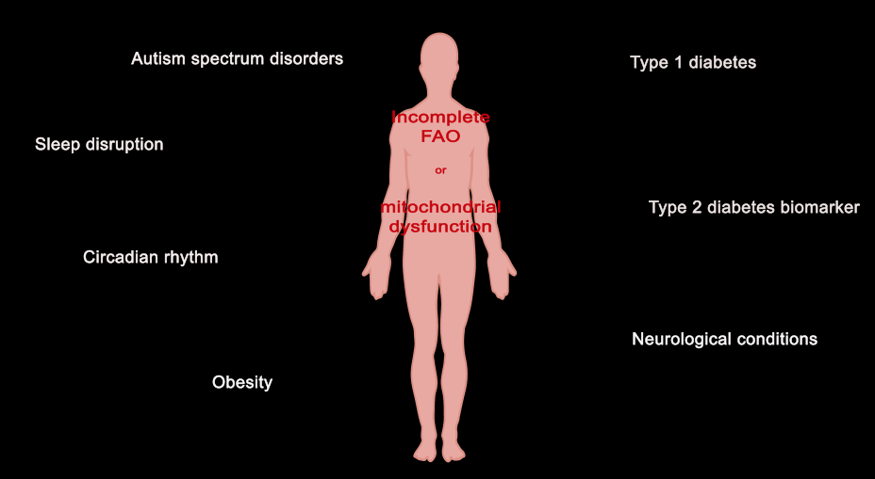
Figure 24- health conditions and future research

5. Evaluation

5.1 Introduction
The animation was completed based on background research and used techniques to make it most suitable for meaningful learning. To test for the success of doing so, the test consisted of questionnaire given to the participants after the information was given to them. The set of 30 questions were designed to test for 1) information learned, 2) perceived learning experience and 3) helpfulness of media in learning.
The background research suggested that abstract ideas are better learned through visual stimuli. In this specific case, an animation using combination of 2D and 3D models was used to help with learning of spatial context in the body, structure of the molecules and understanding the methods and results of the experiment. This was done in a way where the learner’s cognitive load is not exceeded. Therefore, the hypothesis of the study was as follow:
H₁= participant in the animation group will score higher on the correctness of information learned
H₂= Participants in the animation group will perceive higher learning experience
H₃₌ participants in the animation group will rate their media as highly helpful

5.2. Methods

5.2.1 Manual use
The final animation was statistically significant in meaningful learning. The success is attributed to the animation conveyed all the important points discussed with the expert and using visual stimuli effectively without overloading the cognitive load. From the development point of view, some of the future improvements can be made. The first one is narration with improved pronunciation since the animation uses difficult scientific terms. Another improvement would be models of better quality, specifically the grey matter of the brain, to include less mesh that sticks out. These changes do not change the efficiency of the animation, just its aesthetics.
5.2.2 Participants
The target demographic for testing were people with background in biology and chemistry. Participants were collected using a snowball sample, meaning that a person who had access to the target group has asked them to participate. In this case it was one of the lead researchers at the Institute of Infection, Immunity and Inflammation who had randomly send email to other scientists within the building containing questionnaires and animation or sheet (depending on animation vs written narrative condition). The data was collected from total 15 participants, 9 in Group A (animation) and 6 in Group B (written narrative). All the participants had academic background and knowledge in biology; PhD students, postdoctoral research fellows, research assistants, technical staff, professors, readers and lecturers. No participants were excluded from the study.
5.2.3 Apparatus
The materials used were the animation and the article. Each was, sent as an e-mail to randomly selected participants alongside the questionnaire.

5.2.4 Design and procedure
First, the participants of the target demographic were asked to participate. Then they were randomly allocated to Group A or Group B. Corresponding with this, they either received a link to an animation with a questionnaire to be filled afterwards or Group B, who received an article with questionnaire to be received afterwards. Their answers were filled out and sent back electronically to be analysed.
The questionnaires were divided into three sections; Knowledge learned, perceived learned knowledge and helpfulness of animation in learning. The knowledge learned section had identical questions for both test groups and used short answer questions based on the information provided in botch conditions. Perceived learning section had minor differences in wording between the groups and was measured using 5-point Likert scale rated from “strongly disagree” (1) to “strongly agree” (5). The third set of questions focused on helpfulness of the media format in conveying the abstract information using a 5-point Likert scale rated from “strongly disagree” (1) to “strongly agree” (5), with small differences in wording between the groups.

5.2.5. Results
5.2.5.1 Knowledge
Mean average calculated from possible 25 correct answers that were identical between the test groups. Group A (animation) mean average of correct answers was 15 out of 25, or 60% average correct answers. Group B (Written narrative) had mean average score of 7 out of 25, or 47% correct. The results were significantly different (p= 0.04), using standardised one-tailed z-test. The results are presented in the Figure 25 below.
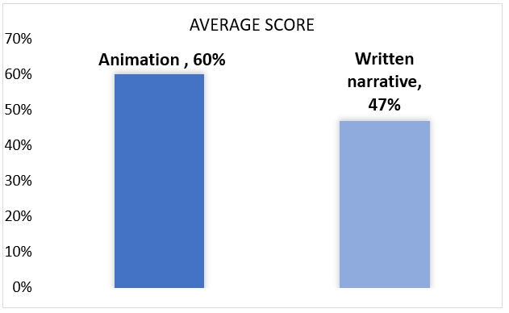
Figure 25- showing significant difference in average number of correctly answered questions between the groups. Group A (animation) scoring 15 (60%) points and Group B (written narrative) =7 (47%) points

5.2.5.2 Perceived understanding
Six questions measuring the perceived understanding of the content. The questions were rated on a 5-point Likert scale. The test of significance used match-paired design between questions to compare mean average scores scored on the Likert scale. The difference was calculated 2-tailed standard z-test with assumed unequal variance, which was calculated beforehand. The results are presented in Figure 26 below.
Figure 26- significant difference in Q16 and Q17 perceived understanding through two types of media
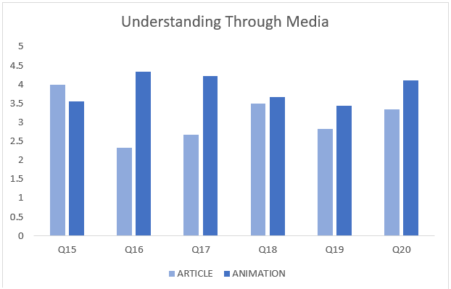
The results showed significant difference in question 16 and 17. Question 16 Group A score was M= 4.33 and Group B M=2.33, making the results significantly different (p= 0.023). Question 17 had mean score in Group A M=4.22 and Group B M= 2.67, making the results highly significantly different (p= 0.01).
The remaining 4 questions had no significant difference. Meaning that their p> 0.05.

5.2.5.3 Helpfulness of media
A 5-pont Likert scale measured ten questions testing for helpfulness of media in presenting the content. The questions were rated on a 5-point Likert scale. The test of significance used match-paired design between questions to compare mean average scores. The difference was calculated 2-tailed standard z-test with assumed unequal variance, which was calculated beforehand. The results are shown in the Figure 27 below.
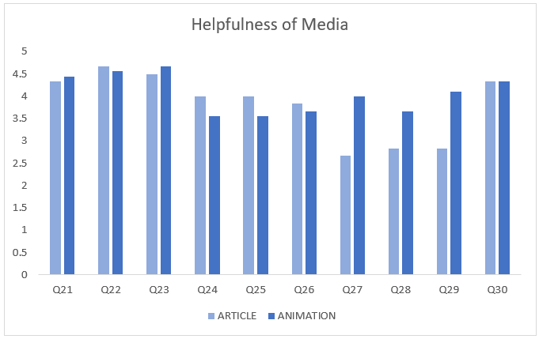
Figure 27- significant difference in Q27 and Q29.
The results showed high significant difference in question 26 and 29. Question 26 Group A score was M= 4.0 and Group B M=2.67, making the results significantly different (p= 0.002). Question 29 had Group A mean score M=4.21 and Group B means score M= 2.83, making the results significantly different (p= 0.05).
The remaining 8 questions had no significant difference. Meaning that their p> 0.05.
5.4. Discussion
All participants were considered in the final results. No participants were disqualified before or after as outliers for post-hoc test.
5.4.1 Knowledge
The results look at the correctness measured by short answer questionnaire were an effective way of measuring perceived information learned in each media. The questionnaires were identical in both groups and the significant difference (p= 0.04) in Group A achieving higher score clearly shows that animation confirmed H₁₌ = participant in the animation group will score higher on the correctness of information learned.
5.4.2 Perceived understanding
The results look at the perceived learning measured by a 5-point Likert scale. The questions were identical and between Group A and Group B. They referred to specific information that was mentioned. The mean of score from each question from Group A was matched and compared with the mean score of the same question from Group B. The questions were structured in the “I understand how…” manner, meaning that higher score on the Likert scale corresponded with higher perceived understanding of the concept. Therefore, questions with significant difference show that one of the groups had lower perceived understanding of the concept. Significant difference was fund in Q16 and Q17. The discrepancy in the scores in these two questions confirmed the second hypothesis H₂= Participants in the animation group will perceive higher learning experience. These two questions dealt with structural concept (Q17) and abstract concept of reactions (Q16), suggesting that animation is highly efficient as a learning tool related to abstract concept specifically to do with structural and spatial aspects.
16) “I understand how the molecules interact with fatty acids in the mitochondria”
Group A had scored mean average M= 4.33 and Group B mean score M=2.33. The result had high significant difference p=0.023.
17) “I understand the difference between 3M-4TMAB, 4-TMAP and carnitine molecules”
Group A scored mean average M= 4.22 and Group B M= 2.67, giving the results high significant different (p= 0.01).
5.4.3 Helpfulness of media
The results look at the perceived learning measured by a 5-point Likert scale. The questions were not identical between Group A and Group B. Group A sked about the likability of the animation and the models. Group B was asked the same types of questions but with “written narrative” instead of animation and “would be helpful” statements in regards to models. The mean of score from each question from Group A was matched and compared with the mean score of the same question from Group B. The questions were structured in a way where higher score on the Likert scale corresponded with higher enjoyment and helpfulness of animation/ narration, or hypothetical use of animation. Significant difference was fund in Q27 and Q19. The discrepancy in the scores in these two questions confirmed H₃₌ participants in the animation group will rate their media as highly helpful. As the average means indicate, higher score in answers to this evaluation indicate helpfulness in understanding the content because of its presentation. The remaining 8 questions were rated higher because of the significant difference; the third hypothesis was confirmed H₃₌ participants in the animation group will rate their media as highly helpful
26) “The models were not distracting from the information” (Group A) versus “The written text was too boring to not distract from the information it tried to convey” (Group B)
Question 26 Group A score was M= 4.0 and Group B M=2.67, making the results significantly different (p= 0.002).
29) “I have enjoyed watching this animation” (Group A) versus “I have enjoyed reading this informational sheet” (Group B)
Question 29 had Group A mean score M=4.21 and Group B means score M= 2.83, making the results significantly different (p= 0.005).
The rest of the questions did not have significant difference p=4.33, which in this case means that the participants from both groups agreed on the statements. This was especially important in Question 30, as it confirmed that animation was (Group A) or would be very helpful (Group B) in presenting the abstract concepts regarding gut-brain axis.

5.5 Conclusion
Future research would aim to investigate animation as a learning tool. While previous research supports animation as a suitable learning tool, finding an appropriate balance between under stimulation and overloading the cognitive load with animation is difficult to define. Therefore, as previously discussed in Section 2, animation can be both help and obstacle in learning.
This specific study focused on teaching abstract novelty ideas to people with relevant background. To improve this study, it would be helpful to test this animation on the general public without such knowledge and compare their results. As mentioned before, some literature supports that people with previous knowledge benefit more from interactive animations while people who are learning things from new field benefit more from animated movie, such as this one.

6. Discussion and Conclusion
The data collected support the hypothesis that animation that provides visual and auditory stimulation is more helpful in teaching abstract scientific concepts, compared to reading a text providing the same information. These were rooted in background research in how animation can be used as a learning tool and how specifically it should be used to be effective in doing so. This section will focus on summarising the key findings of the study, its contribution to research, limitations to be considered in application of results, and directions for future work.

6.1 Key findings
The results showed that people in the animation group scored higher on knowledge tests regarding the new information presented in either of the conditions. In terms of perceived understanding between the two groups, people in the animation group scored higher on the 5-point scale showing that they felt like they understood more, which correlates with the actual knowledge results. These were found especially in the more complex concepts regarding structure and visual representation of chemical reactions in cellular mitochondria. The testing for enjoyment and helpfulness of each media has shown that visual representation would be helpful in learning abstract concepts.
6.2 Contributions
A vast majority of small-scale experiments testing for effectiveness of animation as a learning tool like this one use general population as their target audience. While it is very helpful, research into specific demographic helps to contribute to more niche aspect of this research field. Using target audience- people with specific background has shown which parts of the animation were done correctly and which could be improved.
A specific contribution of this project is carrying a project not only on a target audience but also on the abstract concept. As mentioned before, the scientific concepts and reactions are all not visible to the human eye; therefore, their visualisation is very important as it helps with building the bigger picture that depends on it.
The MGB-axis is an area of microbiology that intrigued scientists in the recent years but its vague principles remained a frontier. The research paper cited here has managed to find evidence for a function of microbiome that plays a major role mammalian cell function. The visualisation of the key concepts within this whole field is very important, as it will help direct future research into microbiome and how to improve human health more effectively. It is also an area of intense public interest, highlighting the need for tools to aid in understanding by the general public of often-detailed scientific concepts.

6.3 Limitations
6.3.1 Population validity
Overall, the shortcoming of this research was the small sample size. While 15 participants serve as a good number for a pilot study, especially with a target audience, more participants would yield results with higher population validity. Therefore, despite the findings supporting the initial hypothesis, these should be interpreted with caution due to the small sample size.
6.3.2 Construct validity
While the measurement of effectiveness of animation was correctly compared to a control group, the written narrative group, it retained some shortcomings. First of all, some studies testing for the effectiveness of animation use still images as references alongside the written article they provide. This study has only used a written narrative and by that made the retention of abstract information more difficult.
Secondly, there were shortcomings in the questionnaire measuring the effectiveness between the two media. Some of the answers pointed to questions being unclearly written. Question 13 “What is the name of the reaction in FAO?” referred to the Esterification reaction. Only two participants out of total 15, compared to the rest who stated either “oxidation” or “FAO”, gave this answer.
Questions that had higher point score were the questions where participants in both groups lost the most points. Question 9 “What areas of the brain are the molecules most abundant in?”
Only one participant managed to get all 5 marks. The same participant who gained the 5 marks was the only one to gain marks in Question 11 “What health conditions are effected by FAO inhibition or mitochondrial dysfunction (7)?”. This is compared other 11 participants who have answered with 1-3 responses, except for 2 answers (one participant from each group), stating “I don’t remember” indicating that they were not paying attention to the content. This shows the individual differences between the participants and how much attention they have paid to the content.
Some other shortcomings of the animation were pointed out by participants’ s comments. An example is a comment that suggested to have more clear labels/ comments:
1) “it ‘d be clear to have some key points written in subtitles because narration was quite long and it needed to carefully listen to get the key messages”. This project specifically did not use subtitles and only narration and the most important labels to eliminate cognitive overload as mentioned in previously discussed guides. However, this response showed that preventing cognitive overload by omitting subtitles might not be always efficient and it prevents intake of the information.
2) “some important points, for example the flow and connection of the mitochondrial oxidation to brain were shown in very short time”. This clearly suggest giving more time to explain ideas that are more complex
3) “This part took too long”. While using 3D models was rated with 4 points in terms of helping to understand, the creator of the animation should be more careful with making decisions about not making models too distracting and not get away from the important information to be learned
Moreover, a comment section was not included in either of the questionnaires but because some of the participants took the time to make suggestions for future improvement, an improvement of the study of itself would be to include comment section so all participants have the option to write future pointers for improvement, not just the ones who deemed absolutely necessary.
6.3.3 Content validity
This study used different measures to determine relationship between the knowledge and perceived understanding. However, adding a new dimension to this study would be a discussion afterwards with fellow people to determine higher understanding in practice outside of pre-set short-answer knowledge questions.
6.3.4 Ecological validity
This study was effective in transmitting knowledge through animation. However, they mean of testing the knowledge is not how it would be tested in real life. Because this study was aimed at scientists who have the potential to learn these findings and use them real life to make further discoveries, not to answer short questions and scales about how they found it helpful in understanding
6.3.5 Concurrent validity
The concurrent validity of this study is considered to be high based on the fact that the hypothesis, which was based on previous research, was confirmed with the data collected. Being, that the animation is more effective as a learning tool in relation to abstract concept. However, it can be argued that it is low due to small sample size and the phrasing of the questions of measurement of the effectiveness.
6.3.6. Pre-testing
Pre-testing is useful as it determines the baseline knowledge of participants before teaching them about a given concept, regardless of test group. Determining baseline knowledge on the topic and additionally comparing it to tests after they were exposed to the information increases reliability and validity of the research experiment. Because it was omitted in this project, the internal validity of the test decreased.

6.4 Future research
As mentioned in previous section, this study has several limitations. Despite that, the data points to the right direction in research of animations in teaching abstract ideas. This is thanks to the previous research done which pointed out the key concepts of how to make animation more effective in terms of not overloading cognitive load. This experiment served as a pilot study and the identified limitations can be improved in future research.
The small sample size of the participants limited the extent to which the results can be generalised to wider population. This should be increased to effectively establish the connection between people being tested and the people who are not tested yet whose behaviour/ learning could be predicted. Another crucial improvement is the improvement of questionnaires. The questions should be very specific and worded in a way to prevent leading questions or questions that may seem confusing to the participants. This can be done by using a standardised questionnaire for usability testing for computer animations. To make it more specific, use knowledge questionnaire, as was done, and add a comment section. To establish clearer contrast between the animation and text differences, future research should contain a group with static images. In accordance with previous research, testing the difference of animation’s usefulness in learning, control groups usually contained a narrative with static images. This can be done by including screenshots from the animation, especially with difficult concepts such as the structures of the molecules.
Despite previous research that has suggested that including subtitles can lead to exhausting the cognitive load, one of the participates suggested including them alongside the narration. Upon further consideration, inclusion of well-paced and synchronised subtitles with may be helpful in retaining and organising this information. The subtitles could further improve the narration of events on screen, as solely hearing scientific words is more difficult to process than seeing them written.
To increase ecological validity and ideal study would test the participants’ knowledge by applying it to real-life tasks that go beyond answering questionnaires, for example discussing how it applies to current research.
Some of the shortcomings of this research were due to time constrains, for example, pre-testing. In the future, more time should be spent on ensuring internal validity which can be increased with pre-testing.

6.5 Conclusion
This experiment consisted of taking abstract concepts and transformed them into a visual representation. It tested the effectiveness of using visual stimuli, specifically animated movie as a means of learning tool. Based on previous research and the Cognitive Learning Theory in multi-media, the animation was composed in a way where it aimed to limit as cognitive overland and foster meaningful learning as possible. Taking recent research into the MGB-axis as the abstract concept was great choice for the concept, as the importance of this discovery is important for future research in human health. Quicker understanding of these concepts if therefore beneficial in real life.
The experimental results have confirmed the hypothesis, such as the participants in the animation condition scored higher on the knowledge tests, had higher scores on the perceived higher scores of understanding that correlated with the knowledge. Specifically, the significant differences were found in questions having to do with spatial and structural understanding. These are the strengths of animation that narration does not have as improvise the learners with visual stimuli which helps them to remember the information more easily. On the helpfulness scale and enjoyment questions, the participants in the animation have scored significantly higher than participants in the article condition. The questions that were not significantly higher were indicating agreement on models’ visual representations, specifically 2D and 3D models to be helpful and hypothetically helpful in conveying abstract idea. These results have therefore confirmed the hypothesis which was that animation is a significantly helpful in teaching abstract images than a narrative article alone. These findings are useful as a pilot study due to the limitations of the study, however future improvements should be made and research into learning abstract ideas through animation should be continued. Animation is a powerful tool for which it is difficult to identify the right balance between how much stimuli should be used for it not to become too distracting. This can be especially challenging in conveying novelty scientific discoveries as they are full of complex principles invisible to human eye and a lot of information must be shown, but organisation if it is crucial and while it cannot teach everything, it can serve as a building block to which additional information can be then established upon relation.

References
Ayeres, P., & Paas, F. (2007). Making instructional animations more effective: A cognitive load approach. Applied Cognitive Psycholpgy, 21, 695-700 (this issue). DOI: 10.1002.acp.1343
Bedrina, O. (2016). Teaching with Animation: from Theory to Practice - ICT in Practice. [online] ICT in Practice. Available at: http://www.ictinpractice.com/teaching-with-animation-from-theory-to-practice/ [Accessed 1 Aug. 2019].
Berney, S. and Bétrancourt, M. (2016). Does animation enhance learning? A meta-analysis. Computers & Education, 101, pp.150-167.
Careaga, M., Murai, T. and Bauman, M. (2017). Maternal Immune Activation and Autism Spectrum Disorder: From Rodents to Nonhuman and Human Primates. Biological Psychiatry, [online] 81(5), pp.391-401. Available at: https://www.ncbi.nlm.nih.gov/pmc/articles/PMC3068755/ [Accessed 10 Mar. 2019].
Celland, C.D., Choi, M., Romberg, C., Clemenson, G.D., Jr., Fragniere, A., Tyers, P., JEssberger, S., Saksida, L.M., Barker, R.A., Gage, F.H., et al. (2009). A functional role for adult hippocampal neurogenesis in spatial pattern separation. Science 325, 210-213
Christian, K.M., Song, H., and Ming, G.L. (2014). Functions and Disfunctions of adult hippocampal neurogenesis. Annu. Rev. NEurosci. 37, 243-262.
Collins, S. and Bercik, P. (2009). The Relationship Between Intestinal Microbiota and the Central Nervous System in Normal Gastrointestinal Function and Disease. Gastroenterology, 136(6), pp.2003-2014.
Cryan, P 2016, The Physiological Society Annual Public Lecture 2016, video recording, YouTube, viewed 18 April 2019, <https://www.youtube.com/watch?v=Me3BAGaR1io&t=215s>.
Cryan, J. and Dinan, T. (2012). Mind-altering microorganisms: the impact of the gut microbiota on brain and behaviour. Nature Reviews Neuroscience, 13(10), pp.701-712.
D’Mello, S., Lehman, B., Pekrun, R., & Graesser, A. (2013). Confusion can be beneficial to learning. Learning and Instruction, 29, 153- 170.
Hulme, H., Meikle, L. M., van der Hooft, J. J. J., Strittmatter, N., Swales, J., Bragg, R. A., Villar, Hv. H., Ormsby M., Barnes, S., Brown, S. L., Dexter, A., Kamat, M. T., Komen, J., Walker, D., Milling, S., Osterweil, E., MacDonald, A. s., Tardito, S., Bunch, J., Dounce, G., Edgar, J., Edrada-Ebel, R., Goodwin, R. J. A., Burchmore, R., Wall, D.M. [unpublished]. Microbiome-derived carnitine mimics as novel mediators of gut-brain axis communication
Hsiao, E., McBride, S., Hsien, S., Sharon, G., Hyde, E., McCue, T., Codelli, J., Chow, J., Reisman, S., Petrosino, J., Patterson, P. and Mazmanian, S. (2013). Microbiota Modulate Behavioral and Physiological Abnormalities Associated with Neurodevelopmental Disorders. Cell, 155(7), pp.1451-1463.
Knobloch, M., Pilz, G., Ghesquière, B., Kovacs, W., Wegleiter, T., Moore, D., Hruzova, M., Zamboni, N., Carmeliet, P. and Jessberger, S. (2017). A Fatty Acid Oxidation-Dependent Metabolic Shift Regulates Adult Neural Stem Cell Activity. Cell Reports, 20(9), pp.2144-2155.
Lowe, R.K. (2003) Animation and learning: Selective processing of information in dynamic graphics. Learning and instruction, 13, 157-176
Magner, U. I. E., Schwonke, R., Aleven, V., Popescu, O., & Renki, A. (2013). Triggering situational interest by decorative illustrations both fosters and hinders learning in computer-based learning environment. Learning and Instruction, 29, 141-152.
Matthias, M., (2019). Auto-intoxication and historical precursors of the microbiome-gut-brain-axis, talk at the Royal College of Physicians and Surgeons in Glasgow, January 17.
Mayer, R.E. ed., 2005. The Cambridge handbook of multimedia learning. Cambridge university press.
Mayer, R. E. (2018). Thirty years of research on online learning. Applied Cognitive Psychology, [online] 33(2), pp.152-159. Available at: https://onlinelibrary.wiley.com/doi/full/10.1002/acp.3482 [Accessed 5 May 2019].
Mayer, R. E. and Moreno, R. (2003). Nine Ways to Reduce Cognitive Load in Multimedia Learning. Educational Psychologist, 38(1), pp.43-52.
Mayer, R.E., and Wittrock. M. C., (1996). Problem-solving transfer. In D. Berliner & R. Calfee (Eds.), Handbook of educational psychology (pp. 45-61). New York: Macmillan
Nava, C., Lamari, F Heron, D., Mignit, C., Rastetter, A., Keren, B., Cohen, D., Faudet, A., Bouteiller, D., Gilleron, M., et al. (2012). Analysis of the chromosome X exome in patients with autism spectrum disorders identified novel candidate genes, including TMLHE. Transl. Psychiatry 2, e179
Rojal, (2017), Rat, Mouse PNG Icon 99959 [ONLINE]. Available at: <https://webiconspng.com/ icon/13025> [Accessed 27 June 2019].
Rossignol, D.A., and Frye, R.E. (2012). Mitochondrial dysfunction in autism spectrum disorders: a systematic review and meta-analysis. Mol. Psychiatry 17, 290-314
Schnotz, W., and Rash, T. (2005) Enabling, facilitating and inhibiting effects of animations in multimedia learning: Why reduction in cognitive load can have negative results on learning. Educational Technology and Research Development, 53(3), 47-58.
Solomon, G. (1994). Interaction of media, cognition, and learning. Hillsdale, NJ: Erlbaum
Spalding, K.L., Bergmann, O., Alkass, K., Bernard, S., Salehpour, M., Huttner, H.B., Bostrom, E., Westerlund, I., Vial, C., Buchholz, B.A., et al. (2013). Dynamics of hippocampal neurogenesis in adult humans. Cell 153, 1219-1227.
Strijbis, K., Vaz, F.M., and Distel, B. (2010). Enzymology of the carnitine biosynthesis pathway. IUMBM Life 62, 357-362
Sweller, J. (1994). Cognitive load theory, learning difficulty, and instructional design. Learning and Instruction, 4(4), pp.295-312.
Tillisch, K., Labus, J., Kilpatrick, L., Jiang, Z., Stains, J., Ebrat, B., Guyonnet, D., Legrain–Raspaud, S., Trotin, B., Naliboff, B. and Mayer, E. (2013). Consumption of Fermented Milk Product With Probiotic Modulates Brain Activity. Gastroenterology, 144(7), pp.1394-1401.e4
Unknown, (2019), Mouse Animal Png- Transparent Mouse [ONLINE]. Available at: <https://www.trzcacak.rs/imgm/JmihJx_mouse-animal-png-transparent-background-transparent-mouse/> [Accessed 27 June 2019].
Vadimmmus, (2019), Vector - Male body outline. Vector illustration [ONLINE]. Available at: https://www.123rf.com/photo_11660601_male-body-outline-vector-illustration.html [Accessed 2 June 2019
Waisbren, S.E., Landau, Y., Wilson, J., and Vockley, J. (2013). Neuropsychological outcomes in fatty acid oxidation disorders: 85 cases detected by newborn screening. Dev. Disabil. Res. Rev. 260-268.
Xie, Z., Jones, A., Deeney, J., Hur, S. and Bankaitis, V. (2016). Inborn Errors of Long-Chain Fatty Acid β-Oxidation Link Neural Stem Cell Self-Renewal to Autism. Cell Reports, 14(5), pp.991-999.

