Beyond Vicarious Learning: Embedding Dialogic Learning into Educational Games
Daisy Abbott
The Glasgow School of Art, Glasgow, UK
d.abbott@gsa.ac.uk

Abstract: Dialogic learning has a substantial overlap with the characteristics of multi-player game-based learning (GBL). Both dialogic and game-based learning are proposed to be beneficial methods for postgraduate learning contexts with higher order cognitive and skill-based outcomes. Research skills and critical thinking are widely shown to be crucially important but very challenging to deliver effectively. This paper uses three case studies of existing tabletop games to consider how modification to include dialogic learning can improve learning outcomes in a postgraduate context. Games were analysed using gameplay loops and characteristics of dialogic games are identified with recommendations of specific Learning Mechanic – Game Mechanic mappings. Learning Mechanics proposed to encourage dialogue were identified as: Plan, Analyse, Reflect, and Consolidate, typically associated with the following Game Mechanics: Stategy/Planning, Design/Edit, Match, Measure, and Feedback. Game Mechanics which may inhibit dialogic learning are Time Pressure, Competition, and Dexterity. An interaction model is presented with recommendations for dialogic game design which is proposed to increase dialogic learning which can increase student ownership, confidence, and consolidation of knowledge. This contributes to the current research gap for dialogical interactions within GBL.

Keywords: Dialogic learning; game-based learning; pedagogy; serious games; educational games; dialogue

Introduction
Dialogic learning arises from exposure to (and participation in) multiple, equal perspectives within learning environments and the process of learners actively co-constructing knowledge and meaning (Alexander, 2008). Dialogic learning has been shown to be beneficial across a wide range of learning contexts, however, dialogue and construction of meaning are, naturally, affected by the characteristics of the learning environment (Wells, 1999). Multiplayer games and game-based learning (GBL) typically provide characteristics which map directly to those identified as fruitful for dialogic learning. Games are: active; collective (co-operative, collaborative, competitive, or a mixture of these); provide reciprocal, dynamic interactions; purposeful/goal directed; and use feedback to cumulatively build towards a goal (see Alexander, 2008, p. 28; Tobias, Fletcher and Wind, 2014, p. 177 for good definitions of the characteristics of dialogic learning and game-based learning respectively). Due to their inherently social and structured nature, non-digital tabletop games in particular provide a range of opportunities for creating dialogue supporting learning. Despite this potential, dialogical interactions within GBL has been identified as a research gap (Arnseth, Silseth and Hanghøj, 2018). GBL dialogue tends to take place in an unstructured, informal way, or outside the context of the game itself for example in a debrief activity. Whilst this is certainly valuable, ‘out game’ dialogue requires further facilitation and the focus on the facilitator may undermine a truly egalitarian dialogue. If dialogic learning is embedded into game rules however, it is proposed that it is approached more collectively as part of the active and experiential participation in the game by players.

One of the learning contexts that seems to particularly benefit from dialogic relationships between teachers and students is postgraduate study, in particular, the teaching and learning of high-level functional outcomes such as research skills which combine knowledge with skills to produce the overall competencies required at postgraduate level. This paper uses three tabletop game case studies to reflect on how an existing serious game designed to teach a particular research skill might be improved by the explicit inclusion of dialogic interactions to foreground multiple perspectives and complementary knowledge and to further increase player confidence and ownership over the topic. These theoretical reflections lead to a preliminary proposal for mappings between Game Mechanics and Learning Mechanics (Arnab, Lim, Carvalho, Bellotti, Freitas, et al., 2015) which are likely to lead to fruitful dialogue, and how this dialogue might be managed in terms of both ‘in game’ and ‘out game’ interactions (Guardiola, 2016).

Research context
Postgraduate research skills combine knowledge, competencies, and aptitudes and therefore require an approach that incorporates both constructivist and experiential pedagogies where knowledge is both embedded and applied to a context relevant to the student. Serious games are widely recognised to have the capability to both train skills and impart knowledge, due to the provision of a ‘safe’ but relevant environment where the student engages directly with an experience allowing affective arousal and implicit delivery of information through play mechanisms (McGregor and Bartle, 2019), leading to goal-directed learning behaviours. Huo analyses game mechanics in relation to behaviourism, cognitivism, and constructivism, showing variation across subjects and for differing knowledge structures and intended knowledge and competency outcomes (Huo, 2019) showing how games can enhance both knowledge and competencies. It has been shown that dialogue helps to improve this tacit knowledge arising from serious games as students are encouraged to review and exchange knowledge with one another (e.g. Camilleri and Camilleri, 2019) and of course is a core element games which encourage co-construction of knowledge and teamwork for collaborative problem-solving (Kang et al., 2019; Sun et al., 2020). This combination of pedagogic approaches to combine knowledge and skills can be seen in various games for specific educational purposes (particularly where skill training is very resource intensive e.g. clinical applications) but as is seen below, has not yet been applied in dialogic academic research skills training.

The challenges of teaching research skills
It is widely accepted across the literature that critical thinking and research skills are essential capabilities for students to master in order to progress both in their studies and in the workplace. This is borne out by the prevalence of courses within programmes of study, devoted solely to developing students’ higher order thinking. However, the effectiveness of these courses and motivation of students undertaking them has been shown to be commonly problematic (Earley, 2014). According to one study focussing on research methods teaching, “Students consistently underperform and give low ratings in [research methods] module evaluations” (Ryan et al., 2014, p. 88) and students struggle to link academic research skills with their need and desire to undertake practical problem-solving in a real world context (ibid.) Another study bluntly presents the research methods course as “one that instructors hate to teach and students hate to take” (Kollars and Rosen, 2017, p. 333). Other studies also note the difficulty of linking research skills courses to workplace contexts and a student perception of irrelevance, leading to a lack of motivation and engagement with learning content (for example: Waite and Davis, 2006, p. 406; Kirton, Campbell and Hardwick, 2013; Hamnett and Korb, 2017, p. 449). This issue is particularly relevant to the postgraduate context where students are increasingly expected to swiftly develop and practise higher order thinking skills and undertake independent research as part of their programme of study. The transition from undergraduate to postgraduate academic contexts has been noted to present particular challenges (O’Donnell et al., 2009, pp. 35–37; Burgess, Smith and Wood, 2013, p. 4). Across various disciplines, a range of responses by teachers can be seen which aim to increase active learning and constructivist pedagogies with overall positive results for both increased cognition and engagement in students (Burgess, Smith and Wood, 2013; Kirton, Campbell and Hardwick, 2013; Rahman et al., 2014; Ryan et al., 2014; Hamnett and Korb, 2017; Kollars and Rosen, 2017; Kernan, Basch and Cadorett, 2018). This is in line with the main recommendation from a 2014 synthesis of the literature on research methods education that “teachers need to use active learning approaches to teaching the course in a way that provides hands-on exposure to research methods” (Earley, 2014).

Increasingly, teachers in Higher Education are considering the potential of game-based learning (GBL) to deliver constructivist approaches in the teaching and learning of research skills. A strong case for “the potential of games to alleviate the anxiety and lack of motivation methods students report” is made by Kollars & Rosen who draw on a wide range of literature to suggest “that games can help mitigate some of the problems of the standard research method course” (Kollars and Rosen, 2017, p. 335). Despite the barriers for Higher Education implementations of this method noted by Whitton & Moseley (2012), a variety of research is emerging which uses GBL to contribute to the learning and teaching of critical thinking, research skills, and graduate attributes (e.g. Cicchino, 2015; Hannan and Neame, 2017; Kollars and Rosen, 2017; Abbott, 2019a; Barr, 2019; Limniou and Mansfield, 2019) along with a range of playable ‘research games’. However, studies and games focussed on postgraduate research skills are still rare, and, as noted above and in O’Donnell et al. (2009), these higher order learning outcomes and expectations of student independence in research activities create particular difficulties for teaching and learning in this context.

Dialogue as fruitful method for learning research skills
In order to address these particular challenges, a dialogic approach may be fruitful. Dialogue to build critical thinking is a widely accepted tactic and several scholars have acknowledged the value of dialogue specifically in postgraduate teaching and learning, typically focussing on the student-supervisor relationship (e.g. Morton, Storch and Thompson, 2014; Benade, 2015). It is difficult to find studies that focus specifically on dialogic learning within postgraduate research training; for example, Pipere and Salite focus on research skills but within teacher training (Pipere and Salite, 2006). Nevertheless, it is proposed that encouraging dialogue is likely to be productive in improving student engagement with research skills courses and their confidence and ownership of their learning journeys.

Existing GBL for research skills that include dialogue
Games have been noted as useful tools to prompt discussion within research skills training (Limniou and Mansfield, 2019) and several recent examples of (face-to-face) games for critical thinking or academic skills result in discussion (Abbott, 2015; Hannan and Neame, 2017; Pun, 2017; Lane, 2018). However, a review of GBL for research topics or critical thinking failed to find any games that explicitly include dialogic learning within their gameplay and none yet encountered by the author convincingly embody all five of Alexander’s defined characteristics of a dialogic learning environment: collective, reciprocal, supportive, cumulative, and purposeful (Alexander, 2008, p.28). This reflects the overall position of games within dialogic learning contexts; namely, despite the clear potential of games as a fruitful method “there is a lack of knowledge of how teachers and students can utilize games and features of games as relevant tools for talk and learning” (Arnseth, Silseth and Hanghøj, 2018, p. 1). Therefore, the inclusion of game mechanics that require or encourage dialogue as part of GBL approaches in teaching research skills addresses a gap in the existing research and is a promising avenue for further investigation.

Design and development of game prototype
In response to observed barriers in students learning how to undertake a literature review research task as part of a postgraduate course in academic research skills, a prototype serious game called On the Shoulders of Giants was previously developed by modifying a commercially available tabletop game. As described in detail in Abbott (2019b), students’ lack of familiarity with literature search and critical writing skills, coupled with the scale of the task, led to many of them feeling overwhelmed. This lack of confidence at the overall complexity of synthesising information into a literature review format acted as a barrier to learning, exacerbating student anxiety and impairing cognition. The overall strategy for On the Shoulders of Giants was to break down the overall learning and behavioural outcomes into manageable sub-tasks and to focus on the playful elements of the game format to dissipate unease about engaging with the learning content. Iterative development led to game mechanics being added specifically to maximise vicarious learning by requiring players to read out their own game cards to the group (Abbott, 2019b, pp. 9–10) and demonstrate their knowledge in an active, performative, final round (Abbott, 2019b, p. 10). Dialogic learning, however, was not explicitly included in the game itself as more than a suggestion, and is proposed more as a debrief and/or ‘out game’ activity. Full rules are available (Abbott, 2018).

Further analysis of the prototype indicated that there could be a potential benefit to including dialogic learning as explicit interactions within the game, and adapting the game mechanics to require or encourage egalitarian dialogue where possible (as opposed to the current model of tutor-as-expert presenting complementary information to students during gameplay). Furthermore, as part of the development of On the Shoulders of Giants, two other commercially available tabletop games were analysed in detail for their potential to contribute to GBL approaches in research skills teaching and learning. These existing analyses provide a baseline for focussed case studies on the possibilities of dialogic gameplay in existing games, which may have fruitful lessons for future dialogic game design.

Game analysis for dialogic learning

Theoretical framework
GBL takes place within a broadly constructivist instructional framework and is almost always situated within a wider instructional context, playing its part within a larger system. The wider instructional context is of course socioculturally mediated, a fact too often overlooked in GBL theory and of relevance when considering how to explicitly integrate dialogue into games. Despite advances in GBL research, recent critiques of serious game design methodologies claim that there is still a lack of “proper consideration of the relationship between learning mechanics and game mechanics” (Czauderna and Guardiola, 2019, p. 208; see also Huo, 2019) and advise an approach which more explicitly links learning design with game mechanics, recognising that play and learning are not so far separated as has been previously proposed (Arnab, Lim, Carvalho, Bellotti, De Freitas, et al., 2015; Czauderna and Guardiola, 2019, p. 209; Westera, 2019). In order to attempt a design process which genuinely unifies gameplay with dialogic learning, this paper adopts the gameplay loop methodology as described in Guardiola (2016) combined with the Learning Mechanic – Game Mechanic (LM-GM) framework (Lim et al., 2013). This approach allows for a formal description of how learning happens through gameplay interactions at a micro level, and enables the identification of specific interactions where dialogic learning can be prompted within (as opposed to alongside) GBL.

Gameplay loop analysis
All three case study tabletop games analysed (Meeple Circus, Blueprints, and Best Treehouse Ever) are based on the overall mechanic of constructing structures or arrangements from game components (cards or pieces) with varying amounts of physical dexterity required. This was seen as a suitable overall metaphor for the process of learning how to ‘build up’ a literature review (Abbott, 2019b). Furthermore, all three are ostensibly competitive games with one winner. These characteristics make identifying points for dialogue an interesting design challenge as it could be considered that competition and concentration on physical dexterity inhibit dialogic learning. Nevertheless, these games make interesting case studies as fully-fledged game systems (as opposed to much less-structured games, which function more as discussion tools (e.g. Fairness Toolkit (Lane, 2018)) or are structured primarily around the Role Play game mechanic. It should be noted that highly structured, turn-taking games fit the definition of “logical dialogue games” in formal dialogue theory (Pilkington, 2015). As such, an analysis of existing tabletop games offers the potential to identify precisely which game mechanics could be exploited for dialogic learning (and which may not).

Figures 1 – 3 show each game represented as a gameplay loop, annotated with both Learning and Game Mechanics at each point in the gameplay, and with darker background annotations showing places where game modifications for educational purposes could lead to further Learning Mechanics (LMs) being added. Gameplay elements considered particularly suited to dialogic learning have been marked with a circled letter D.

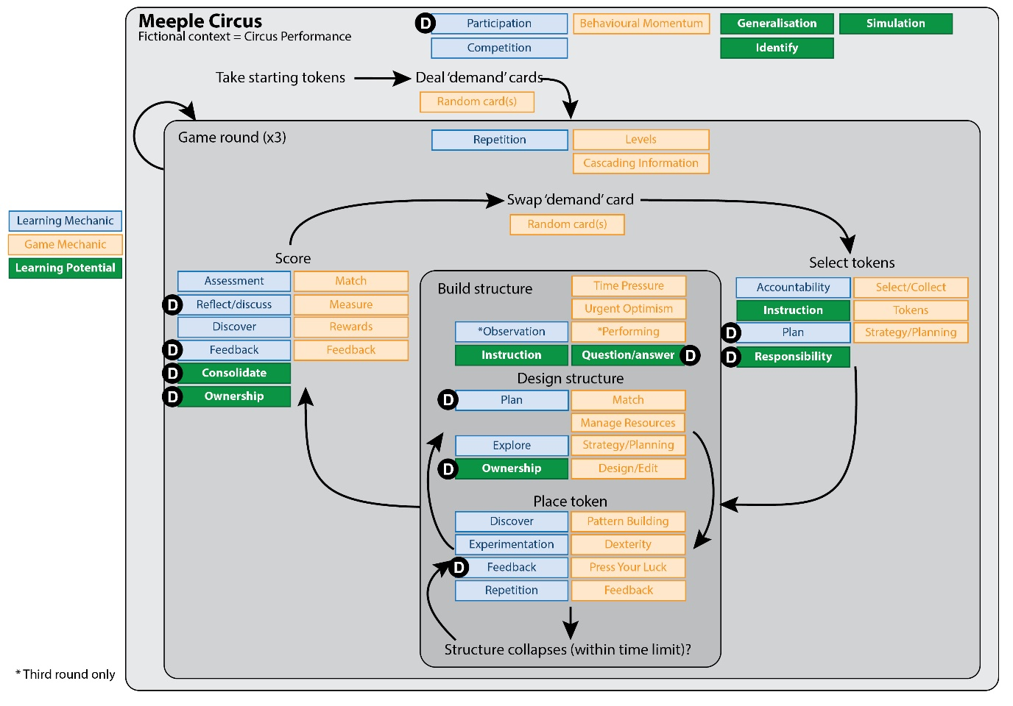
Figure 1 - Meeple Circus: annotated gameplay loop showing Learning Mechanics, Game Mechanics, and potential for dialogue

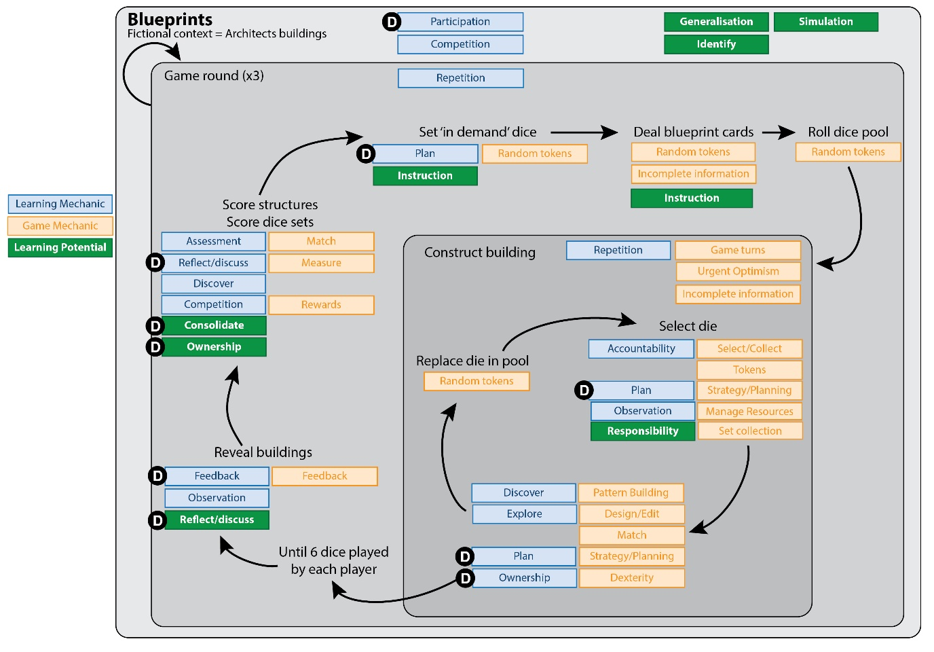
Figure 2 - Blueprints: annotated gameplay loop showing Learning Mechanics, Game Mechanics, and potential for dialogue

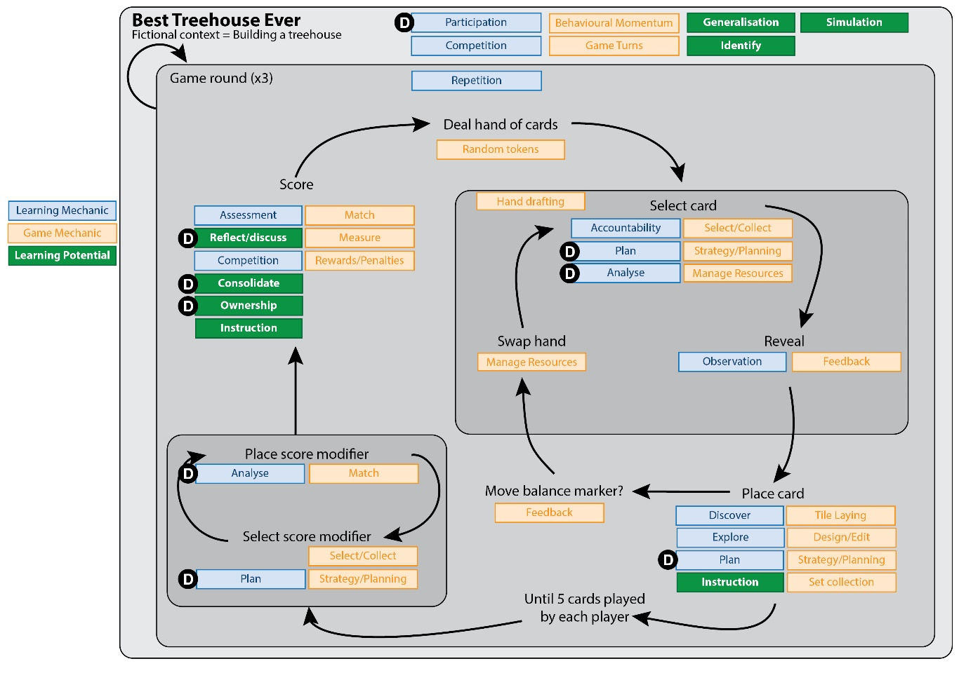
Figure 3 - Best Treehouse Ever: annotated gameplay loop showing Learning Mechanics, Game Mechanics, and potential for dialogue

The LM as identified by Arnab et al. (2015, p. 397) closest to ‘dialogue’ is Reflect/Discuss. As can be seen, this LM is identified typically within the scoring phase of each game and is associated with the Match, Measure, and Feedback Game Mechanics (GMs). In On the Shoulders of Giants (gameplay loop shown in Figure 4, previously published in Abbott (2019b)), there is a great deal of focus on Reflect/Discuss in the ‘out game’ interactions (i.e. it takes place during the duration of the game but is not directly caused by a particular GM) and here it is closely associated with the Guidance (from the tutor) LM. There is clear potential here for such ‘out game’ discussions to move towards a more egalitarian dialogue and to further consolidate understanding.

It is clear, however, that dialogic learning could also play a part in other LMs, most obviously Plan and Analyse (closely associated with the Strategy/Planning GM, and in some cases with the Design/Edit GM) but that this would require dialogue between players collaborating towards a goal, and therefore needs players to be working together in teams in a competitive game context, or playing an entirely collaborative game. Other LMs which could include an element of dialogue are Ownership, Responsibility, and Consolidate. In the three case studies shown here, Ownership and Responsibility arise largely from the overall Participation in the game itself, in making and enacting gameplay decisions. Asking students to verbalise, justify, question, and consider these decisions in a dialogic way has the potential to strengthen their Ownership and Responsibility over the learning content as well as Consolidating learning within and across different teams of players. In this way, vicarious learning caused by observation and analysis of other players’ actions can instead become dialogic participation in gameplay for the self, the team, and competitors.
Finally, where the Instruction LM or the Question&Answer GM have been identified, it is useful to consider if these could be replaced in full or part by dialogue.

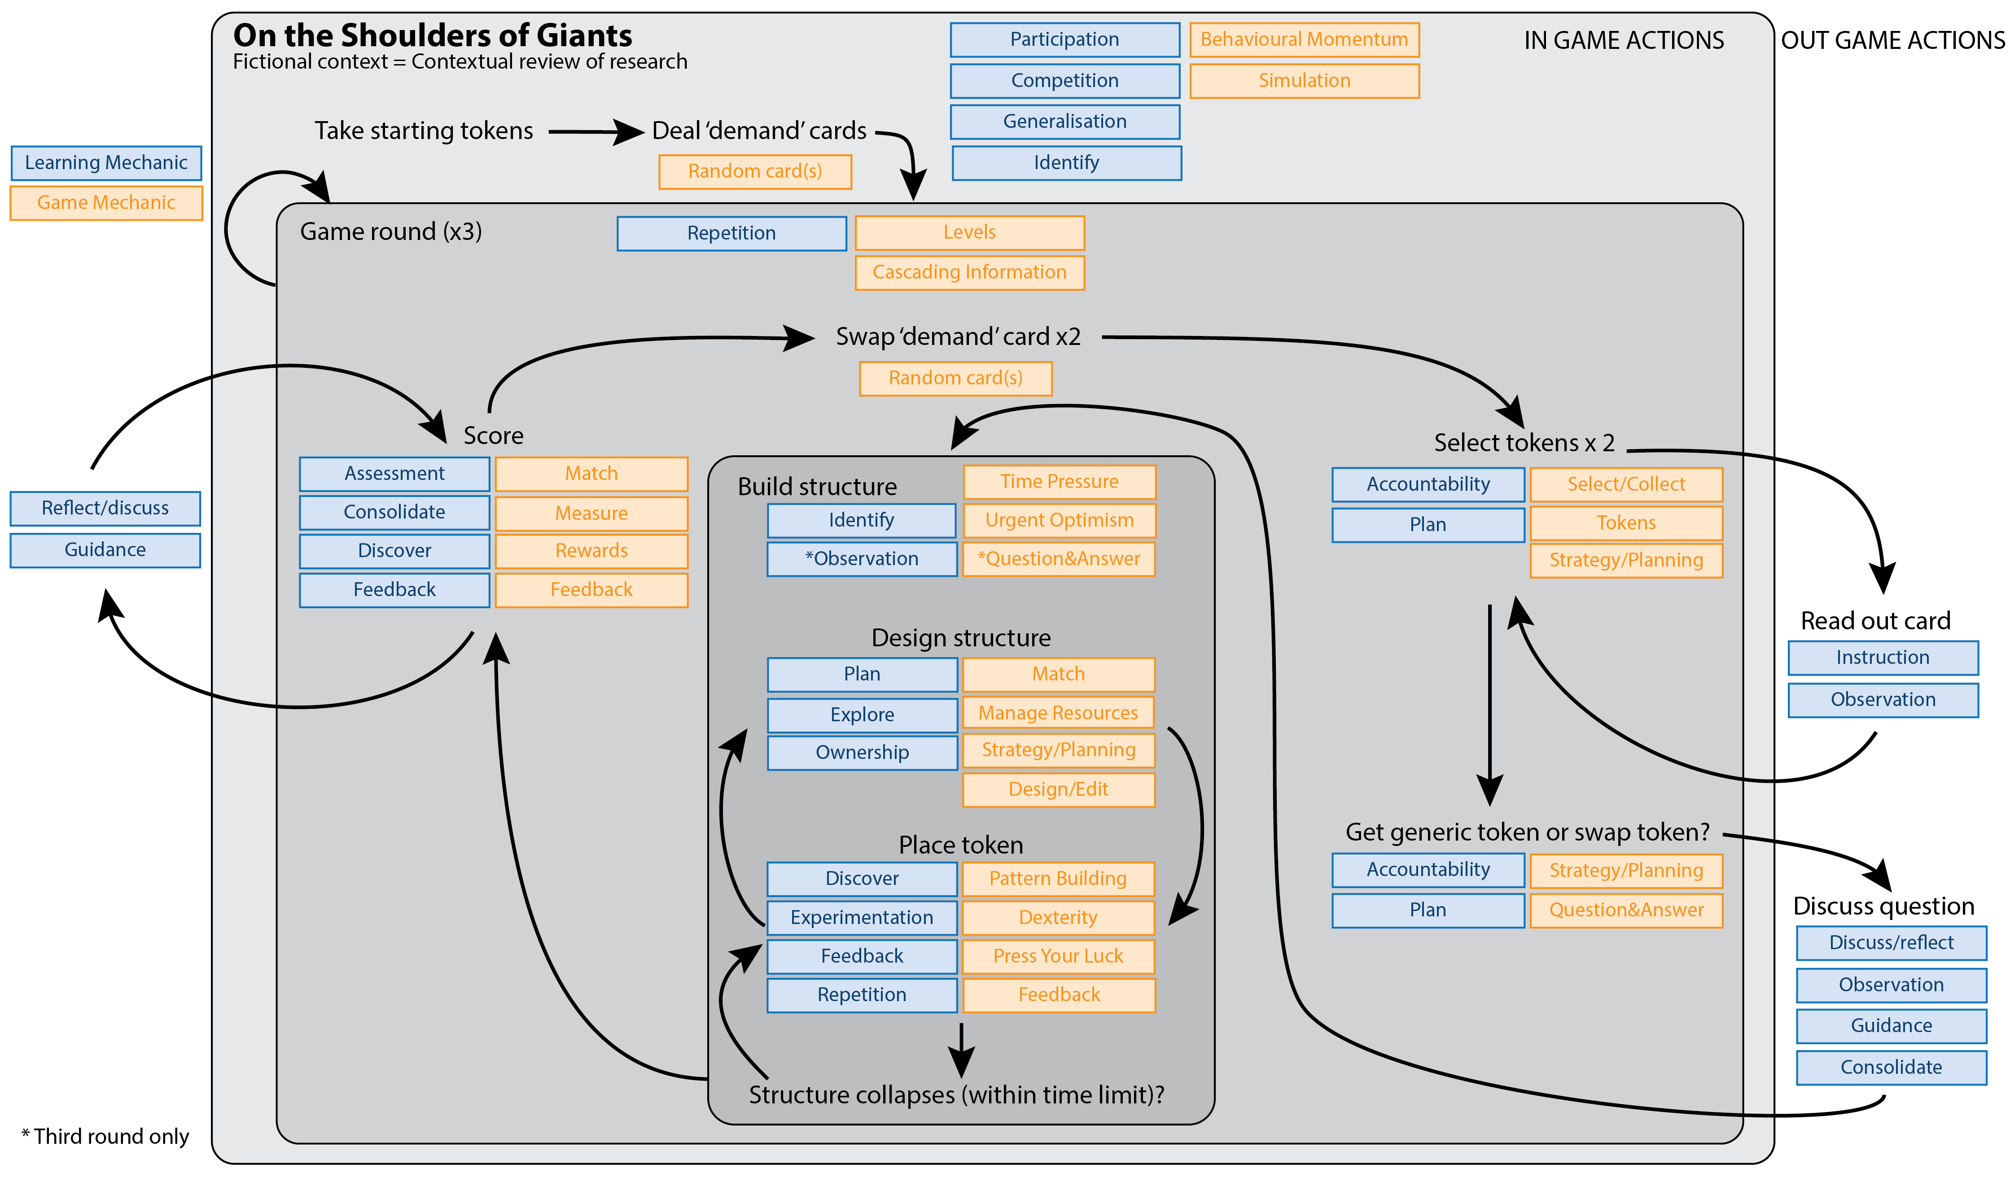
Figure 4 - gameplay loop for On the Shoulders of Giants, an educational mod of Meeple Circus

Analysis of dialogic learning within the LM-GM framework
Within the limitations of this narrow genre of construction-themed tabletop games, it can be seen that there is no simple one-to-one interaction between GMs, LMs, and dialogic learning. A preliminary proposition of three categories is suggested: GMs which either prompt or inhibit a number of initial dialogic LMs, which then themselves can prompt subsequent LMs (which may or may not also include dialogue). For the purposes of this model, shown in Figure 5, the LM Reflect/Discuss has been separated into Reflect and Dialogue, acknowledging that Dialogue could take place across all of the identified LMs, if the circumstances encourage it.

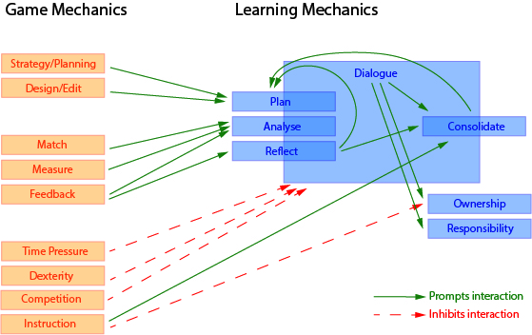

Figure 5 - interaction mapping between GMs, initial LMs, and subsequent LMs derived from three construction-themed tabletop games.

The first major feature to note with this model is that whilst many LMs can include an element of dialogue, this tends not to arise from the GM itself – as can be seen, no GM present here directly prompts Dialogue, rather the GMs prompt cognitive interactions such as Plan, Analyse, Reflect, and Consolidate which may include Dialogue but do not have to. Some of these LMs then prompt further LMs. Some GMs however do inhibit Dialogue, typically due to competing cognitive loads, it is difficult to engage in dialogic learning whilst under time pressure, for instance.

What then, prompts dialogic learning as an ‘in game’ interaction? As hinted at above, fruitful dialogue between learners requires communal goal-directed behaviours which are absent in most games where players compete in teams of one. Collaborative discussion tends to take place only as ‘out game’, reflective interactions, borne out by the analysis of On the Shoulders of Giants in Figure 4. Whilst Tobias et al. include Competition as a core characteristic of an effective educational game (2014), in this case, Competition as a GM is actively detrimental to this type of learning, considered suitable for postgraduate research skills. Instead, to encourage dialogue alternative GMs such as Collaborate, Cooperate, Communal Discovery, and Role Play could be the focus. Does this mean, then, that highly structured, competitive games should not be considered as GBL tools within this context? This author proposes that the advantages for student engagement and motivation – excitement, novelty, desire to win, turn-taking ensuring that all learners get a chance to participate – not to mention a clearly structured rules set for the teacher to use, maintain competitive games as a worthwhile approach for higher order learning outcomes, provided that Dialogue-prompting GMs can also be effectively included. The following overall principles are suggested for modifying game rules to increase dialogic learning.
- Where Competition is a core game mechanic, group students so that they compete as a team. Depending on the exact game rules, teams of 2-4 are recommended to ensure every learner participates. (This has the added advantage of increasing the number of players the game supports, a noted limitation when using tabletop games for GBL).
- Ensure that Plan, Analyse, and Reflect LMs are dialogic as much as possible. For example, Plan dialogue could take place within teams whereas Reflect could involve dialogue across all teams. If possible and appropriate, GMs not typically seen in this genre of game could be included, for example, players could be asked to Role Play during the scoring phase to critique their own or others’ strategies in order to deepen understanding.
- The tutor/game facilitator’s input should be minimised. Where possible, Instruction and Guidance should be restricted to how to play the game, or to prompt dialogue where needed. This encourages egalitarian dialogue between all participants which increases focus on the Ownership and Responsibility LMs. Instruction can then further consolidate learning during the ‘out game’ debrief, if necessary.
- If the game includes GMs that inhibit dialogue, split the cognitive load between team members, where possible. For example, each round one team member could focus on Dexterity interactions whilst the others engage in dialogue that formally complements the actions involving physical game pieces. Alternatively, a Turn Taking GM could be added to ensure all team members engage in the different types of interactions. Time Pressure can inhibit dialogue, however it can also increase excitement and focus. Time Pressure should be carefully balanced with other GMs to maximise the learning.

Dialogic modifications for On the Shoulders of Giants
In line with the analysis above, modifications for dialogic learning will now be presented for the primary case study: On the Shoulders of Giants. These modifications should be read alongside the full game rules (Abbott, 2018).

Rule change | Justification
Require players to play in teams of 2 or 3. All actions which refer to a player now involve the whole team. | Introduces new GMs: Collaborate and Communal Discovery whilst maintaining Competition. Team limited to 3 to ensure Participation is maintained.
Formalise Turn Taking within teams when drawing game components. | Ensures all individuals maintain Participation.
When game cards are read out to the group, the team to the left of the active team has a very brief dialogue and then responds with a question, comment, or real-life example. | Replace the ‘out game’ Instruction and Observation (see Figure 4) with an ‘in game’ formal Analyse and Dialogue LM.
In the Using Sources phases, one team member builds whilst remaining team members discuss ideas, real-world examples (or if stuck, ask questions) about the type of component being placed. | Requires Communal Discovery GM. Introduces Discuss and Analyse LMs to the build phase. Separates cognitive load.
When choosing a ‘star’ resource in the second round, each team discusses and contextualises their resource for the other teams. The tutor should only provide Guidance where absolutely necessary but can provide dialogic prompts if needed. | Moves the focus from Guidance and Instruction to Dialogue.
The final round should be performed as previous Using Sources phases with one team member building whilst the other(s) perform the Question/Answer interactions. Observing teams make notes. After each team has performed a short formal dialogue (using Turn Taking) consolidates the learning for all teams. | Splits cognitive load and provides further Consolidate interactions through Dialogue between teams. Turn Taking ensures brevity and participation.

Conclusion
This research has provided theoretical reflections on a particular genre of tabletop games and their suitability for modification to include dialogic learning. Within the LM-GM framework, three games were analysed using gameplay loops and particular interactions were identified as having potential for increasing dialogue. Useful Learning Mechanics for dialogue were identified as Plan, Analyse, Reflect, and Consolidate, which, when combined with Dialogue (which was separated from the Reflect/Discuss mechanics identified by Arnab et al. (2015) for the purposed of this analysis) have subsequent benefits for Ownership, Responsibility, and Consolidate. The gameplay loops indicated that the Game Mechanics which lead to these LMs are likely to be Stategy/Planning, Design/Edit, Match, Measure, and Feedback. Therefore, when designing or modding games to encourage dialogic learning, these GMs could be made central to gameplay to achieve the learning behaviours desired. The analysis also identified some GMs that can be detrimental to dialogic learning, namely Time Pressure, Competition, and Dexterity and suggested some ways in which their counterproductive effects for dialogue may be reduced. It is proposed that games which already encourage informal dialogue can be adapted to move away from Observation (i.e. vicarious learning) and Guidance towards full participation in the ‘Dialogue’ Learning Mechanic.

Limitations are that these propositions are based only on a particular type of tabletop game, those that were initially shortlisted for modding for a specific educational purpose; building knowledge and confidence for postgraduates undertaking a literature review. Therefore these games include game mechanics that might inhibit dialogic learning and the modifications proposed may not be as effective as designing a dialogic learning game from scratch. Nevertheless, game modding can be a fruitful approach as it greatly reduces the time and expertise needed to design an educational game and is particularly suitable for educators who are not also experienced game designers. The GMs and LMs identified as productive or counterproductive for dialogic learning are limited to the scope of the game genre being analysed here and should not be considered to be a comprehensive list. Wider recommendations beyond these case studies could be achieved by analyses that cover a range of different game genres.

A further limitation is that this analysis is untested. The research methods initially included testing and co-design with students; this was made impossible due to COVID19 restrictions, therefore this paper concentrated instead on theoretical analysis. Empirical testing is needed to establish if dialogue is actually encouraged in the ways suggested and furthermore if that dialogue does in fact lead to the outcomes proposed. Therefore these results should be taken as preliminary until further validation has occurred.

References

Abbott, D. (2015) How to Fail Your Research Degree. Available at: http://howtofailyourresearchdegree.com/ (Accessed: 11 April 2020).
Abbott, D. (2018) On the Shoulders of Giants. Available at: http://blog.gsofasimvis.com/index.php/research/games/on-the-shoulders-of-giants/ (Accessed: 13 April 2020).
Abbott, D. (2019a) ‘Game-based learning for postgraduates : an empirical study of an educational game to teach research skills’, Higher Education Pedagogies, 4(1), pp. 80–104. doi: 10.1080/23752696.2019.1629825.
Abbott, D. (2019b) ‘Modding Tabletop Games for Education’, in Gentile, M., Allegra, M., and Söbke, H. (eds) Games and Learning Alliance. Springer Lecture Notes in Computer Science, 11385, pp. 318–329. doi: 10.1007/978-3-030-11548-7_30.
Alexander, R. J. (2008) Towards dialogic teaching: Rethinking classroom talk. York: Dialogos.
Arnab, S., Lim, T., Carvalho, M. B., Bellotti, F., De Freitas, S., et al. (2015) ‘Mapping learning and game mechanics for serious games analysis’, British Journal of Educational Technology, 46(2). doi: 10.1111/bjet.12113.
Arnab, S., Lim, T., Carvalho, M. B., Bellotti, F., Freitas, S. de, et al. (2015) ‘Mapping Learning and Game Mechanics for Serious Games Analysis in Engineering Education’, British Journal of Educational Technology, 46(2), pp. 391–411. doi: 10.1111/bjet.12113.
Arnseth, Hans Christian, Silseth, K. and Hanghøj, Thorkild (2018) ‘Games as Tools for Dialogic Teaching and Learning: Outlining a Pedagogical Model for Researching and Designing Game-Based Learning Environments’, in Arnseth, H. C. et al. (eds) Games and Education: Designs in and for Learning. Leiden: Brill. doi: 10.1163/9789004388826_008.
Barr, M. (2019) Graduate Skills and Game-Based Learning : Using Video Games for Employability in Higher Education. Palgrave MacMillan. doi: 10.1007/978-3-030-27786-4.
Benade, L. (2015) ‘Postgraduate research supervision as a partnership in the context of Freire’s dialogical pedagogy’, Knowledge Cultures, 3(5), pp. 102–115.
Burgess, H., Smith, J. and Wood, P. (2013) Developing peer assessment in postgraduate research methods training: HEA Social Sciences strategic project 2012 -13 Teaching research methods in the Social Sciences. Leicester. Available at: https://s3.eu-west-2.amazonaws.com/assets.creode.advancehe-document-manager/documents/hea/private/resources/leicester_1568037223.pdf.
Camilleri, M. A. and Camilleri, A. C. (2019) ‘Student-Centred Learning Through Serious Games’, in 13th Annual International Technology, Education and Development Conference Proceedings. Valecia: International Academy of Technology, Education and Development (IATED), pp. 2043–2052. doi: 10.21125/inted.2019.0578.
Cicchino, M. I. (2015) ‘Using Game-Based Learning to Foster Critical Thinking in Student Discourse’, Interdisciplinary Journal of Problem-Based Learning. doi: 10.7771/1541-5015.1481.
Czauderna, A. and Guardiola, E. (2019) ‘The gameplay loop methodology as a tool for educational game design’, Electronic Journal of e-Learning, 17(3), pp. 207–221. doi: 10.34190/JEL.17.3.004.
Earley, M. A. (2014) ‘A synthesis of the literature on research methods education’, Teaching in Higher Education. Taylor & Francis, 19(3), pp. 242–253. doi: 10.1080/13562517.2013.860105.
Guardiola, E. (2016) ‘The Gameplay Loop: A Player Activity Model for Game Design and Analysis’, in Proceedings of the 13th International Conference on Advances in Computer Entertainment Technology. Osaka. doi: 10.1145/3001773.3001791.
Hamnett, H. J. and Korb, A. S. (2017) ‘The Coffee Project Revisited: Teaching Research Skills to Forensic Chemists’, Journal of Chemical Education, 94(4), pp. 445–450. doi: 10.1021/acs.jchemed.6b00600.
Hannan, E. and Neame, C. (2017) SOTL Research Methods Game. Available at: http://www.celt.mmu.ac.uk/games/researchmethods/ (Accessed: 8 April 2020).
Huo, Y. (2019) ‘A pedagogy-based framework for optimizing learning efficiency across multiple disciplines in educational games’, International Journal of Information and Education Technology, 9(10), pp. 704–709. doi: 10.18178/ijiet.2019.9.10.1290.
Kang, J. et al. (2019) ‘Collaborative problem-solving process in a science serious game: Exploring group action similarity trajectory’, in EDM 2019 - Proceedings of the 12th International Conference on Educational Data Mining, pp. 336–341.
Kernan, W. D., Basch, C. H. and Cadorett, V. (2018) ‘Using Mind Mapping to Identify Research Topics: A Lesson for Teaching Research Methods’, Pedagogy in Health Promotion, 4(2), pp. 101–107. doi: 10.1177/2373379917719729.
Kirton, A., Campbell, P. and Hardwick, L. (2013) Developing applied research skills through collaboration in extra-academic contexts: HEA Social Sciences strategic project 2012 -13 Teaching research methods in the Social Sciences. Liverpool. Available at: https://www.heacademy.ac.uk/sites/default/files/resources/Liverpool.pdf.
Kollars, N. and Rosen, A. M. (2017) ‘Who’s Afraid of the Big Bad Methods? Methodological Games and Role Play’, Journal of Political Science Education. Taylor & Francis, 13(3), pp. 333–345. doi: 10.1080/15512169.2017.1331137.
Lane, G. (2018) Fairness Toolkit, UnBias. Available at: https://unbias.wp.horizon.ac.uk/fairness-toolkit/ (Accessed: 11 April 2020).
Lim, T. et al. (2013) ‘Strategies for Effective Digital Games Development and Implementation’, in Baek, Y. and Whitton, N. (eds) Cases on Digital Game-Based Learning: Methods, Models, and Strategies. Hershey, PA: IGI Global, pp. 168–198. doi: 10.4018/978-1-4666-2848-9.ch010.
Limniou, M. and Mansfield, R. (2019) ‘(Game-Based) Student Response Systems Engage Students with Research-Teaching Nexus Activities and Support Their Skills Development’, Creative Education, 10(01), pp. 36–47. doi: 10.4236/ce.2019.101003.
McGregor, G. and Bartle, E. (2019) ‘The creation and trial of a serious game to support teaching and learning of professional psychology competencies in postgraduate programs’, Australasian Journal of Educational Technology, 35(5), pp. 15–28. doi: 10.14742/ajet.4237.
Morton, J., Storch, N. and Thompson, C. (2014) ‘Feedback on writing in the supervision of postgraduate students: Insights from the work of Vygotsky and Bakhtin’, Journal of Academic Language & Learning, 8(1), pp. 24–36.
O’Donnell, V. L. et al. (2009) ‘Transition to postgraduate study: Practice, participation and the widening participation agenda’, Active Learning in Higher Education, 10(1), pp. 26–40. doi: 10.1177/1469787408100193.
Pilkington, R. (2015) Discourse, Dialogue and Technology Enhanced Learning. London: Routledge.
Pipere, A. and Salite, I. (2006) ‘Educational Action Research In Teacher Education: Fostering Research Skills’, in Full papers of APERA International Conference. Hong Kong. Available at: http://edisdat.ied.edu.hk/pubarch/b15907314/full_paper/83022604.pdf.
Pun, R. (2017) ‘Hacking the Research Library: Wikipedia, Trump, and Information Literacy in the Escape Room at Fresno State’, The Library Quarterly, 87(4), pp. 330–336. doi: https://doi.org/10.1086/693489.
Rahman, S. et al. (2014) ‘The use of metacognitive strategies to develop research skills among postgraduate students’, Asian Social Science, 10(19), pp. 271–275. doi: 10.5539/ass.v10n19p271.
Ryan, M. et al. (2014) ‘Improving Research Methods Teaching and Learning in Politics and International Relations: A “Reality Show” Approach’, Politics, 34(1), pp. 85–97. doi: https://doi.org/10.1111/1467-9256.12020.
Sun, C. et al. (2020) ‘Towards a generalized competency model of collaborative problem solving’, Computers and Education. Elsevier, 143(October 2018), p. 103672. doi: 10.1016/j.compedu.2019.103672.
Tobias, S., Fletcher, J. D. and Wind, A. P. (2014) ‘Game-based learning’, in Handbook of Research on Educational Communications and Technology: Fourth Edition. doi: 10.1007/978-1-4614-3185-5_38.
Waite, S. and Davis, B. (2006) ‘Developing undergraduate research skills in a faculty of education : motivation through collaboration’, Higher Education Research and Development, 25(4), pp. 403–419. doi: 10.1080/07294360600947426.
Wells, G. (1999) Dialogic inquiry: Towards a socio-cultural practice and theory of education. Cambridge University Press.
Westera, W. (2019) ‘Why and How Serious Games can Become Far More Effective : Accommodating Productive Learning Experiences , Learner Motivation and the Monitoring of Learning Gains’, Educational Technology & Society, 22(1), pp. 59–69.
Whitton, N. and Moseley, A. (eds) (2012) Using games to enhance learning and teaching: A beginner’s guide. London: Routledge.

