982.2. Using novel visualisation methods to combat infection risk during clinical practices

Alastair S. Macdonald¹, Mark A. Chambers², Roberto La Ragione², Kayleigh Wyles², Matthieu Poyade¹, Andrew Wales², Naomi Klepacz², Tom R. Kupfer³, Fraje Watson⁴ and Shona Noble¹
¹Glasgow School of Art, UK
²University of Surrrey, UK
³Vrije Universiteit Amsterdam, Netherlands
⁴ University College London, UK

ABSTRACT. CONTEXT: Effective infection prevention and control (IPC) is essential for tackling anti-microbial resistance (AMR). The update of appropriate IPC is heavily influenced by human risk perception and consequently how humans interact within a healthcare environment. A referral veterinary practice provided the site for the development of an IPC training intervention. AIM: To provide an appreciation of infection risk in the veterinary surgical environment by designing and piloting a novel training intervention supported by a 3D digital simulation tool which ‘makes the invisible, visible’. The ultimate goal is to motivate changes in perception and ultimately behaviour needed to reduce risk of infection. METHOD: A mixed-methods approach was informed by: video data to determine workflow actions and interactions between people, animals and the practice environment; evaluation of risky procedures and behaviours associated with infection transmission; iterative prototyping of the 3D tool allowing normally invisible bacteria to be ‘seen’ as they spread via contact between actors in the environment; four co-development workshops; and deployment in a UK veterinary school. DEVELOPMENT: The 3-D digital tool comprised a surgical preparation area with avatars (3 clinical staff, 1 canine patient) [figure 1], enabling users’ attention to focus on visual cues showing contamination sources, their spread, and IPC. The grey-based monochrome model enabled enhanced visibility of IPC and contamination information. A red-shaded ‘contamination’ layer was added, showing the potential transfer of microbes during the sequence of procedures in the preparation stage [figure 2], and which interacted with the green-shaded IPC elements showing barriers and sanitised equipment typically used in good veterinary practice [figure 3]. These layers could be switched on and off as required during delivery of the intervention. OUTCOME: At deployment, a total of 51 practice staff participated in 9 separate sessions, experienced and evaluated the intervention.
Keywords: infection prevention and control, co-design, digital modelling, visual software, veterinary practice training

Acknowledgements
The authors gratefully acknowledge the support of the Arts and Humanities Research Council (grant number AH/R002088/1) and also the substantial assistance from Fitzpatrick Referrals Ltd for this work .

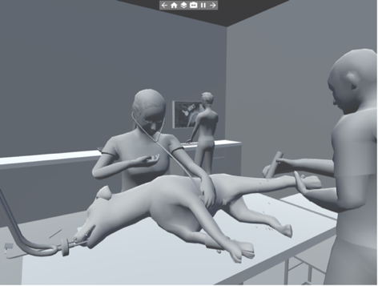
Figure 1: Layer 1 showing the pre-surgical procedure with in-built risky behaviours.

Figure 2: Layer 2 ‘switched on’ to show transfer of ‘invisible contamination between animal, veterinary staff, surfaces and equipment during a pre-surgical procedure if proper infection control methods are not being properly observed.

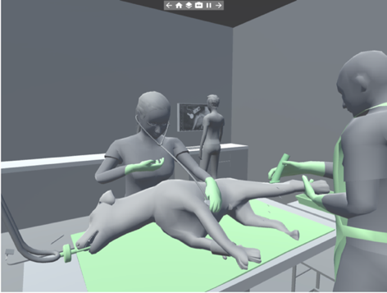
Figure 3: Layer 3 ‘switched on’ showing infection prevention and control (IPC) measures in place.

