Life Class: from academic drawing to ergonomic body

Influences and empathy from the life room

C 2000 words

6-8 photos
To draw something is to engage with the process of coming to an understanding of it. By drawing, I mean really looking at something and then trying to explain it in visual terms. To do so from the life, that is in front of the actual object is really to get to know it. From first-hand experience, be it a building, aircraft or person—photographs—though very useful, simply do not, maybe cannot, tell you the whole story... To draw something is to own it, for your drawing of it gives you a kind of ownership. (from Dugald Cameron ‘Drawing’ statements)

Cameron’s archive of drawings is an important resource that gives insight into his student training in the late 1950s, into his creative development through drawing and also, as seen in the opening chapters of this publication and exhibition, how these contributed to the form and configuration of the first commercial ultrasound obstetric scanning equipment. But this archive also gives us some understanding of how designers have used drawings to see and feel.

There are two equally important parallel streams of drawings in the GSA Cameron archive: life drawing, and industrial designs—from first sketches through to fully realised presentation drawings. In the 1950s, GSA embraced the life room and its close study of human anatomy in an art school tradition that goes back to the art academies in the Renaissance. Students such as Cameron attended traditional academic drawing classes every morning in their first two years of study on the General Course. In Cameron’s archive we see how tradition meshed with innovation as these established approaches to the study of the human form ran alongside new ergonomic techniques of design drawing, and the ways in which industrial designers were re-visualising the body.

In both kinds of drawing we see many unexpected similarities. Overall Cameron’s drawings are concerned with the lucid exposition of how outer and inner forms and structures work together in three-dimensional objects, through the two-dimensional medium of marks on paper.

In a successful life drawing, as in Figure 1, the outer contours tell us how three dimensional forms sit in space; they also give a clue about some of the hidden anatomical structures of the body. In Figure 1 we can see both the gently turning cylindrical form of the upper arm and the more boxlike upper torso. We can also clearly see indications of the interior structures of the body, for example the complex bony hinges around the elbow, knee and ankles, or that little dent at the top of the leg where the gluteus medius muscle is attached to the pelvic crest.
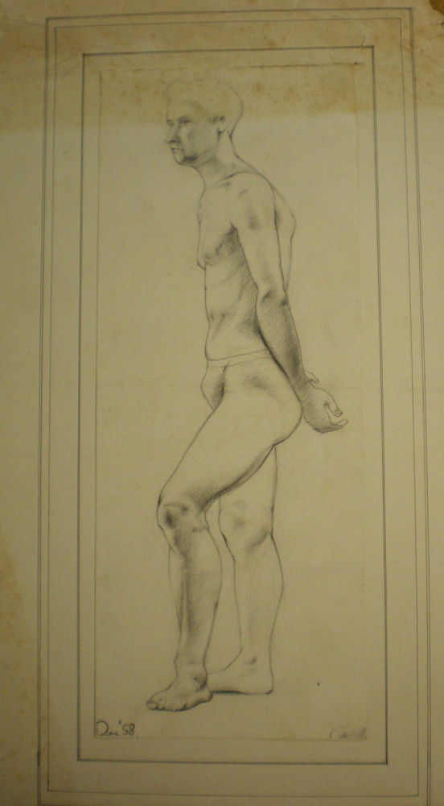
Figure 1: Life drawing. Dugald Cameron, 1958, The Glasgow School of Art

Nude study was central to academic drawing, with a highly cultured emphasis on both classical learning and cutting edge scientific information. That is why every self-respecting art school in Europe gave classes in artists’ anatomy while also filling its corridors with casts of famous Greek statues such as the Apollo Belvedere, the Venus de Milo, or the ‘Gladiator’. Academic technique was largely demonstrated through the production of tonal and linear drawings on paper, and by the start of the twentieth century focused on three modes of drawing: the life room, perspectival and mathematical drawing, and architectural practice. In Cameron’s drawing classes still life sessions were designed to bring direct observation and accurate perspectival rendering into alignment. Figure 2 shows a striking and elegant group made up from the simplest units of studio furniture: two high plinths, topped by a drawing stool, a ‘donkey’ with its easel prop at one end, and flanked by jars, barrels and a circular bath. When drawing human bodies and artefacts shaped for the body’s use, there is a focus on accurate observation and rendering of three-dimensional structure, dimension, and articulation conveyed by a two-dimensional linear or tonal drawing made by the most economical of means such as charcoal, pen or pencil. As Albert Boime has observed, the discipline and constant exercise of academic drawing training had the ‘virtue of instilling in the pupil an unshakeable confidence in his drawing ability, and allowed him to tackle complicated subjects’.
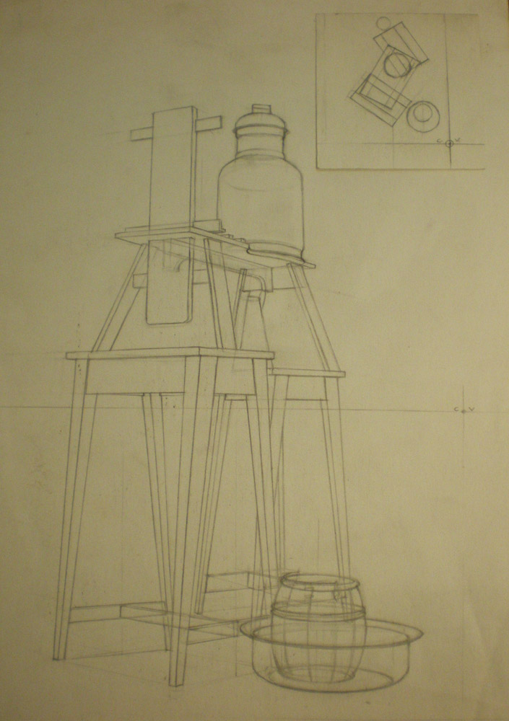
Figure 2: Still life perspective. Dugald Cameron, 1957, The Glasgow School of Art

Intense life room work at GSA was intended to equip students to be art teachers in secondary schools as this was the main route into employment for the majority of art students at the time. Memory drawing was also developed as a transferable and useful skill in life class, as a way of capturing forms and structures from first hand observation. In Figure 3 we see how the linear envelope around the nude form holds together an almost abstract composition of elements balanced in a vertical/ horizontal space.
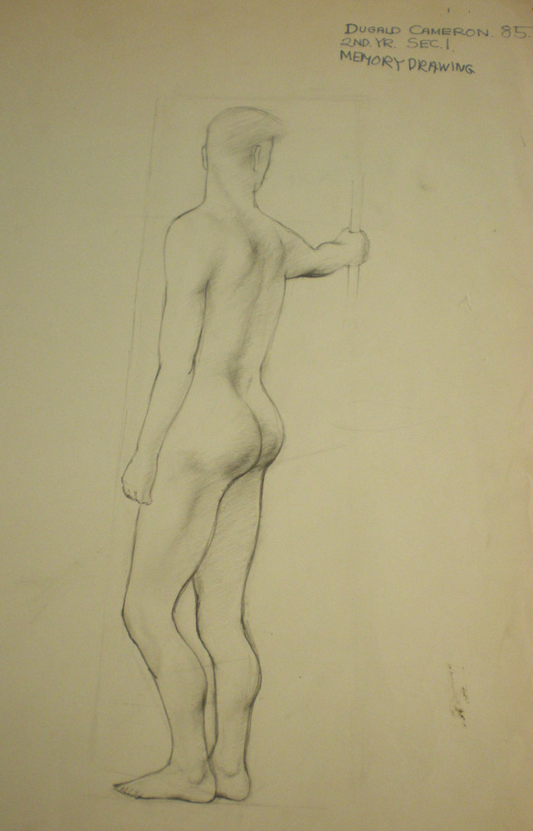
Figure 3: Life drawing from memory. Dugald Cameron, 1958, The Glasgow School of Art

GSA, founded as one of the nineteenth century state-funded Government Schools of Design, also had a duty to its manufacturing hinterland. Mechanical and technical drawing and design had always featured, but was strengthened by a new emphasis after the Second World War on industrial design, Cameron’s specialism in his final years as a student. Technical and mechanical drawing carries a ghost presence of the human form, even though figures almost never appear. During industrialisation the tool and the machine, became a substitute for the human body in manufacturing. Mechanical engineers and industrial factory masters carried out minute analyses of skilled worker actions, and then translated these into banks of machines tended by human minders. In fact every tool or artefact, even the simplest, recalls the human frame and its capabilities in some way—from the ‘donkey’ that art students sit at to draw, through to the handle of a pair of scissors, a pencil, or a screwdriver (Figure 4).

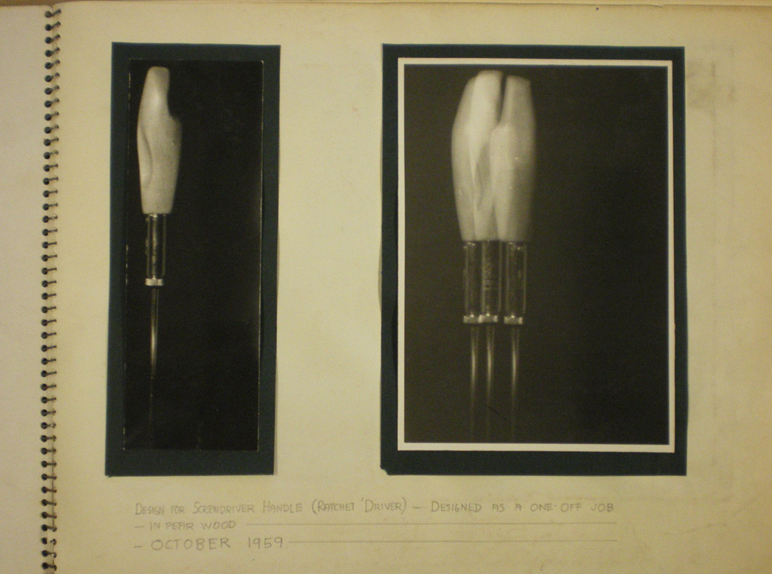
Figure 4: Design for a screwdriver handle. Dugald Cameron, 1959, The Glasgow School of Art

Figure 4 shows a screwdriver handle designed after an investigation of ‘grip’ in the hand of the worker, achieved by squeezing a modelling medium and taking a cast of the inner hand space during tool work. This is another way of recording and feeling into a hidden interior space that is crucial for the design, and reflects
Cameron’s ergonomic, human-centred aims in design.

Ergonomics, or ‘human factors’ is a twentieth century technique for attempting to reconcile humans and machines, coming to prominence in the same period that Cameron was a student in the period after the Second World War. Human bodies started to come back in to technical drawings and specifications in a more detailed way. Initially this was intended to address worker stress and productivity in factories. During the Second World War, with the rapid development of military equipment and machinery, the complexity and operating speeds of e.g. weapons or aircraft subjected the human operators to stress they could not deal with. The emphasis was firmly on the working environment imagined as a ‘closed loop servo-system’ aiming for a man-machine system with ‘maximum efficiency’, describing the human body as a kind of input-output machine of physical exertion.

Cameron was influenced in ergonomic approaches and design style by American industrial designers. In ergonomic manuals and guides the body is treated in a kinematic manner, an idea taken from mechanical engineering as an understanding of the possible movements of a body or system of bodies in space—in ergonomics there are also added physiological and stress factors constraining the body (see Figure 5).
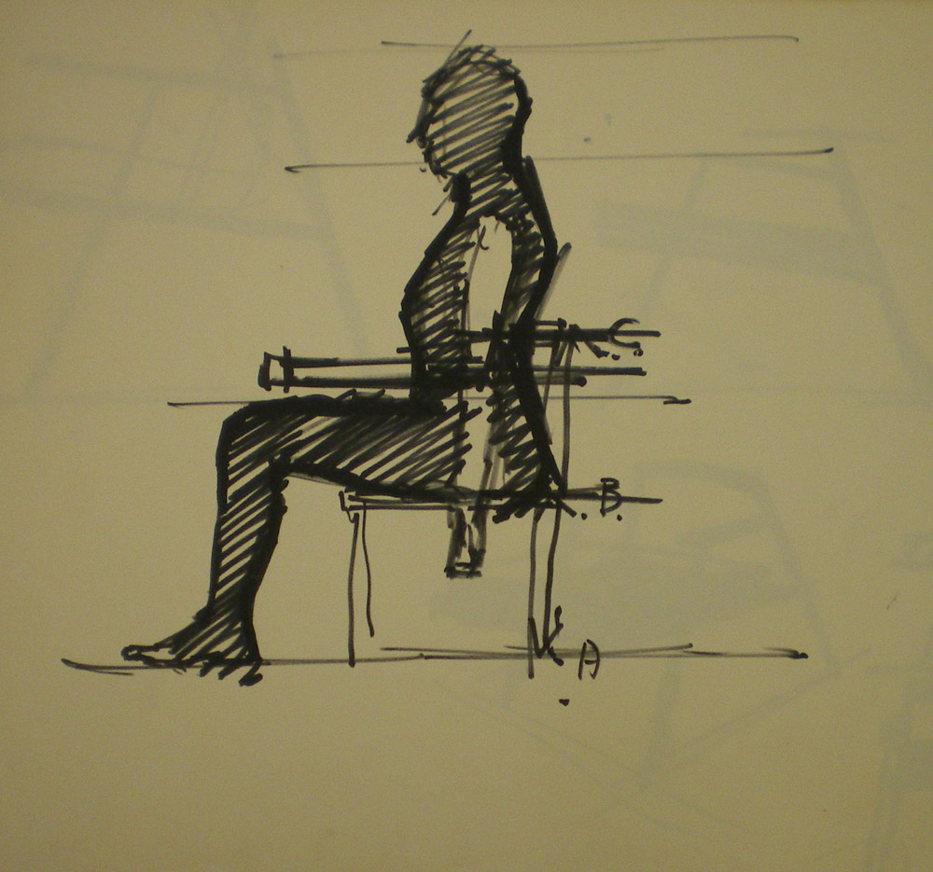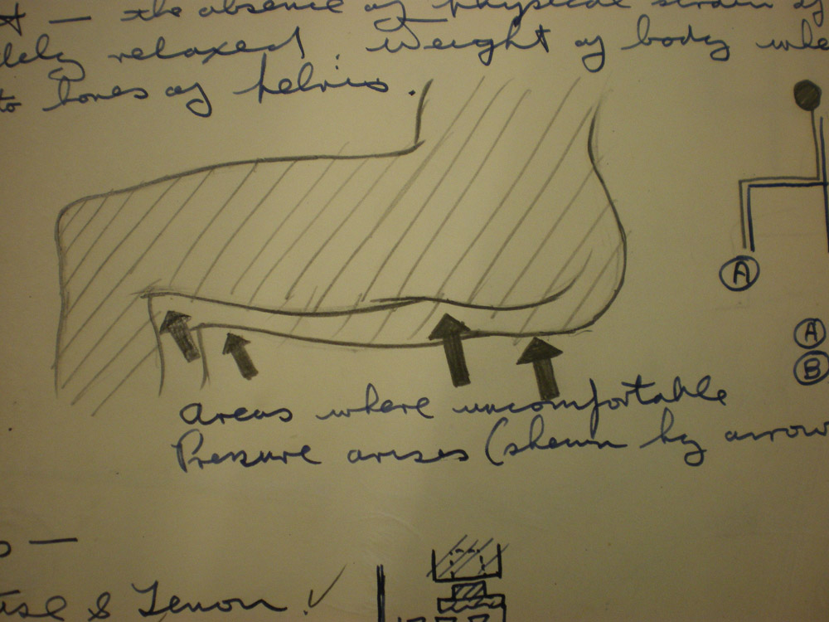
Figure 5: Design notes on ergonomic factors in seating from student sketchbooks. Dugald Cameron, 1959, The Glasgow School of Art

Cameron has two styles of drawing, one very exact and detailed—expressed as either technical and specification drawings, but also as finished ‘presentation’ drawings—through these are usually rendered as paintings, in hyperreal of photoreal style. His favoured medium for these was either gouache or, at a more minute level, Humbrol enamels which are the kind of paints used in model making. The other style Cameron used for design drawings is more gesturally energetic, partly because he is himself is an energetic and active personality, but also to show a process of thinking, with a sense of trying out speculative forms to get the right configuration, and give a sense also of the moveable quality of the object.

Cameron’s drawings and design practice has developed from close observational drawing, and from the developed skill of visualising both the outside and inside of three-dimensional forms simultaneously. This was the purpose of academic drawing training that was becoming discredited and obsolete in art schools during Cameron’s career. Although these intensive drawing practices were often viewed as cold or hard by their detractors—‘academic’ in the derogatory sense, the immersive practice of really getting inside the subject developed empathy and structural understanding. However, this mode of visual learning has been supplanted and often dislodged by new technologies of vision and new approaches to art and design have gained more traction now.

The ultrasonic project is an example of the complex issues of what is being seen, what is allowed to be seen, and who the viewers might be. Ultrasonic imaging has had a momentous social impact because it can visualise the fetus. Before this technique was developed, doctors relied on patient spoken testimony, on dissection of cadavers, and on a painstaking personal knowledge gained though long patient contact, as doctors had to learn to ‘read’ the body of a pregnant women and the status of the fetus through palpation—seeing through feel, through the hand. Second wave feminists regarded the ultrasound scanner with suspicion, accusing the technology as an impersonal mechanical intrusion into the intimate realm of childbearing. In part this was because it brought forward the doctor and the fetus as agents (ultrasound and similar visualisation techniques helped to drive publicity for the so-called ‘pro-life’ anti-abortion movement), and pushed away pregnant women and midwives from control of what was happening in that inner realm of the womb.

By contract to observational and anatomical methods, the ultrasound image is built up from echoes coming from various hidden masses in the body, and is an adaptation of techniques used in military applications for underwater submarine detection developed during the First World War (and later during the Second War as radar). ‘Sonar’ as Ian Donald preferred to call ultrasound (acronym for ‘sound navigation and ranging’ –the technique and use—conjured links in the minds of commentators such as Donald between the ‘fetus in utero and a submarine at sea’. This is a powerful image, and it conjures powerful emotions in the way it joins together techno-enthusiasm for a wartime military invention with the decision to observe the inner workings of the pregnant womb. As we see in the sweep of this exhibition, these powerful currents of representation and control still call up a disturbing range of responses to these hidden realms, and they demand the fullest range of thought. Turn back to the questing line, reflective space, and careful consideration of what to include in the Self-Portrait shown on page X of this publication. Cameron’s drawings from life show that close sustained engagement with the figure, and nuanced sensibility about mark making, judgement and observation are still of value as we face the human in design.

Bibliography
Brown, T.G. (1999) Development of ultrasonic scanning techniques in Scotland 1956-1979, Personal recollections by T. G. Brown and Virtual Reality in Ultrasonic Imaging: a project out of time? T. G. Brown 1999. Available at http://www.ob-ultrasound.net/brown-on-ultrasound.html

Christie, D.A. and Tansey, E.M (2000) Looking at the unborn: historical aspects of obstetric ultrasound. Wellcome Witnesses to Twentieth Century Medicine Volume 5 – January 2000 A Witness Seminar held at the Wellcome Institute for the History of Medicine, London, on 10 March 1998. Accessed 21 April 2017. Available from www.histmodbiomed.org/sites/default/files/44827.pdf [Wellcome Witness Seminars, 1993-1999, ‘Obstetric ultrasound: historical perspectives’ organisers Dr. Malcolm Nicolson and Dr. E.M. Tansey]

Freedgood, Elaine (2003) Factory production in nineteenth century Britain Oxford: Oxford University Press

Goldstein, Carl (1996) Teaching art: academies and schools from Vasari to Albers Cambridge: Cambridge University Press

The History of Modern Biomedicine. Interview with Dugald Cameron, 28 May 2014, Glasgow Art Club. Accessed 21 April 2017. Available from http://www.histmodbiomed.org/article/dugald-cameron

Hale, Robert Beverly (1991) Master class in figure drawing, compiled and edited by Terence Coyle New York: Watson-Guptill

Lane, Denicola (2017) ‘The digital as para-world: design anthropology and information technologies’ in Clarke, Alison J., ed. (2017) Design anthropology: object culture in the 21st century New York: SpringerWien: 202-211

Murrell, K.F.H (1965) Ergonomics: man in his working environment London: Chapman and Hall

Nicolson, Malcolm and John E. Fleming (2013) Imaging and imagining the fetus: the development of obstetric ultrasound Baltimore: The John Hopkins University Press

Oakley, Ann (1984) The captured womb: a history of the medical care of pregnant women Oxford: Blackwell

Petherbridge, Deanna (2010) The primacy of drawing: histories and theories of practice New Haven and London: Yale University Press

Tilley, Alvin R. (1993) The measure of man and women: human factors in design New York: The Whitney Library of Design

GSA Archives Records relating to Dugald Cameron in the period 1957-2003 are available at: GB 1694 DC 091. In addition to this substantial archive of visual material, Cameron retains a further and even more extensive personal private archive of work, some of which he has generously shared during research for the exhibition and publication.
Cameron’s teacher in both artists’ anatomy (with classes once a week) and life drawing (every morning) was W. Drummond Bone. Cameron writes: ‘Drawing was all from piles of boxes for perspective, the antique and, primarily from life… There is hardly a day goes by, nearly fifty years on, that I do not bless Willie Bone and his disciplined teaching’. Current students and this author instead will normally find their own way around the body with printed guides such as Master Class in Figure Drawing and landmark directions cited here, Hale 1991: 36-7.
Petherbridge 2010: 221-222
Goldstein 1996: 54; Boime 1971: 24-5; Elkins 2001: 16-27, and see Glasgow School of Art 2018 blog entry that discusses the now-defunct cast collection (the second fire at GSA outdid the mild scorching from the first fire with complete destruction of the collection) at ‘Visualising Laocoon’ https://gsaarchives.net/2019/01/visualising-laocoon/
Goldstein 1996: 54; Boime 1971: 24-5; Elkins 2001: 16-27. For further examination of life drawing teaching methods in post-War period see Coldstream, William (1908-1987) Principal of the Slade School of Art from 1949, promoting a distinctive style of life drawing based on direct observational measuring by eye at arms length with thumb and pencil or brush, laying down a web of reference points, based on interlocking units of length contained within the composition (for example, from a landmark point such as the end of the clavicle to some other visual marker) Petherbridge 2010: 231-232.
Boime, Albert (1971) The academy and French painting in the nineteenth century New Haven and London: Yale University Press
The control and cool atmosphere of these life room drawings hides an important emotional dimension of student training. As Cameron recalls it, entering the life classes as was a testing moment, not only a new and challenging activity for art students, but the conventionally shocking act of observing and drawing from the nude would be taking place in a mixed sex group—boys and girls thrown suddenly into an unfamiliar group of peer and potential partners.
Many alarmed commentators such as Thomas Carlyle warned of ‘iron fingers’ that would supplant the skilled hands of human workers, see Freedgood 2003.
Forerunners to ‘ergonomics’ were scientific work efficiency studies around the time of the First World War, for example the Industrial Fatigue Research Board (IFRB) in Britain (Murrell 1965: vii) and similar ‘time and motion’ investigations in the United States by Taylor or Gilbreth.
Under Second World War conditions laboratories were set up in the UK at the Universities of Oxford and Cambridge and in also the US (The Psychology Branch, Aero-Medical Laboratory, Dayton, Ohio) who all collaborated with the various Armed Forces (who also carried out their own experiments). After the War the Ergonomics Research Society was formed using a new word was coined to embrace this field of enquiry, ergonomics, from ergos= work and nomos= natural laws.
As the British investigator of factory work, Murrell, put it, the useful parts of the worker body were ‘two major systems of levers –arms and legs—joined by an articulated column’, the spine (Murrell 1965: 16).
See interview with Dugald Cameron, Glasgow Art Club, 28 May 2014. Cameron cites American industrial designers such as Harold Van Doren, Henry Dreyfuss and his book The Measure of Man and Walter Dorwin Teague. From the UK, after the War, Douglas Scott (1913-1990) teaching at Central St. Martin’s designer of the AEC routemaster bus, and the AGA cooker, founder member of the Society of Industrial Artists, 1930. For life drawing Cameron mentions William Drummond Bone, see footnote 2 and also GSA Archives DC 047/1/2 art history and DC 047/1/4 drawings of face and figure for life drawing.
As in nineteenth century engineering, very highly finished presentation drawings—for example of the Sunden ultrasound scanning equipment—were used as substitutes of ‘representatives’ of the actual items—as these were made and sent over because manufacturing the new and innovative actual equipment was taking a bit longer than estimated.
We can see this mixture of drawing styles in star engineers going back to the nineteenth century, for example in the work mechanical engineer James Nasmyth—where he used energetic clouds of lines when he was thinking through how to design a railway transport bed component in his sketchbooks, but with public drawings prepared in parallel in an exact and minute finished style for publicity and contractual purposes.
Fifty years ago, the unborn human being was hidden, enveloped within the female abdomen, away from the medical gaze’. The fetus was understood by doctors only through the medium of the women’s verbal testimony, but then due to ultrasound scanning, the developing human being became for the first time in its history, a clinical entity, a patient in its own right… it now gained a ‘public presence, a social identity’. This new person was quickly recruited by pro-life campaigners during debates about abortion. At the same time, the latter half of the twentieth century also saw a transformation in the British way of birth. Before 1950, most confinements took place at home; after the setting up of the National Health Service (NHS) in 1948, this situation changed, by the 1970s, most births took place in hospital… ‘the ultrasound scanner was both a major agent for and a potent symbol of the medicalization of childbirth’. (Nicholson and Fleming 2013: 1-2). Evidently, reproduction and the medical practices surrounding it are essentially contested domains. As the feminist writer Ann Oakley notes, the rise of ultrasound from unknown procedure to routine use illustrates the essential use of technological innovation in health care’ (Oakley 1984: 156).
Dr. James Willcocks recalls forming an ‘image of the fetus with the hands via abdominal palpation, p. 30 Wellcome Witness Seminars.
Nicholson and Fleming 2013: 11; Oakley 1984
Nicholson and Fleming 2013: 157
You can add the section title and page number here please, Editor

