The Curated Representation of Saga Norén: Interweaving Narratives of Fashion and Interiors
Pamela Flanagan
Glasgow School of Art
January 2020
Introduction
It is rare for a female fictional TV character to capture the collective imagination which translates across borders, demographics and gender. Saga Norén (Sofia Helin) is one of those characters who has challenged the traditional representation of female detectives. The creators of Bron/Broen (The Bridge 2011-18), successfully convey Saga’s character through a meticulous curation of costume and spatial constructs which are entwined in the series narrative. The particular visual language of Bron /Broen manifests in a subtle assertion of a muted colour palette that extends from Saga’s androgynous apparel, the olive-green vintage Porsche and the interiors of her apartment and workplace. Through an analysis of clothing and interior space I seek to dissect the representation of Saga Norén through the lens of Interior Design, examining how Saga tacitly navigates the boundaries of her private and professional identity through home and the workplace in order to consider how this can offer an alternative understanding of the complexities of her character.

Saga is a fascinating character who does not conform to traditional gender structures and narratives represented within the genre of crime dramas, historically dominated by male characters and the male gaze. Throughout the four seasons of Bron /Broen it is implied, but never declared outright, that Saga is on the autistic spectrum which is subtly revealed via her social and spatial interactions with colleagues, in particular with her Danish detective counterparts Martin Rhode (Kim Bodnia, Seasons 1-2) and Henrik Sabroe (Thure Lindhardt, Seasons 3-4). She challenges pre-existing and normative expectations and allows us to contemplate how a female protagonist transforms the crime detective character from its masculine dominance into a new territory to redefine the representation of female characters and the fictional spaces they occupy.

Interior spaces support narratives through a visual language and a room can convey a multitude of information through its scale, decoration and contents to construct mise-en-scenes (Whiteread, 2018, Andrews et al, 2016) which help the viewer to unravel the narrative. In this examination of the interior geography of Saga we can understand interior spaces as contested spaces which are transformed through layout, personal items (or lack of), occupation and human relations. These spaces are points of vulnerability, power, autonomy and contest traditional gendering of the interior.

The Rise of Nordic Noir and Female Protagonists
How did Saga Norén come into our small screen fiction obsessed world and how has this opened up the opportunity for female protagonists? The start of the 21st Century witnessed a literary phenomenon for Nordic Noir crime novels by Stieg Larsson, Jo Nesbø and Karin Fossum to name a few, with Larsson’s The Millenium Trilogy estimated to have sold over 40 million copies worldwide. The lonely, imposing and beautiful landscapes of the Nordic countries of Sweden, Denmark, Norway, and Finland, formed the atmospheric backdrops for the psychological thrillers, which transcended geographical borders to become global best sellers (Timeshift, 2010). The ensuing resonance of politics of post-war Scandinavia’s utopian-socialist welfare state provided a revisitation of the 1970’s novels and subsequent TV adaptations of Maj Sjöwall and Per Wahlöö’s Beck (1997-) and Henning Mankell’s Wallander (2005-13) which created the precedents for the translation of Nordic Noir beyond their collective borders. This overriding sense of disillusionment with a failed utopian vision created narratives with a sense of realism, cynicism and a darkness which challenged the outside impression of these liberal Scandinavian countries (Stougaard-Nielsen, 2016, Creeber, 2015)

The evolution of Nordic Noir fiction provided a platform for female protagonists central to the narratives (Bergmen 2014 , Forshaw 2015, Hochscherf & Philipsen 2017). A key character who set the tone for Nordic female lead characters was Lisbeth Salander, the anti-heroine of Stieg Larsson’s Millennium Trilogy, who represented the antithesis of normative gender expectations and portrayed someone who did not fit into the conventions set by the world she occupies. The TV adaptation and subsequent cinematic translation of Larsson’s trilogy presented Nordic Noir to a new geographical audience and it exemplified a new noir aesthetic that was to become pivotal. Through the structures led by public Danish television provider DR (Danmark Radio), the creation of a cross media production scaffolding approach distinctly located in the Nordic countries sought to engage audiences with narratives of cultural and philosophical provocations enshrouded in storytelling but with cinema aesthetics (Hochscherf & Philipsen, 2017). Under the direction of Danish Production Designer Niels Sejer (1963-) the notable stylistic tone, mood and atmosphere of The Girl with The Dragon Tattoo (2009) and Millennium (2010), contributed to the establishment of the distinct Nordic Noir aesthetic which was adopted to create the distinct visual language in Bron /Broen (Timeshift, 2010). The Danish landscapes, motifs and interiors were presented to a world of non-Nordic audiences who were enchanted by the realism of multi-layered stories, slow paced dialogue, and the duality of a familiar and yet unfamiliar amongst the aesthetic of a constant ‘hibernal mood’(Hochscherf & Philipsen, 2017:54) .

As the genre developed, female protagonists began to take the helm of Nordic Noir TV dramatizations with Sarah Lund (Sofie Gråbøl) in Forbrydelsen (2011-14), Birgette Nyborg (Sidse Babett Knudsen) in Borgen (2010-13) and Saga Norén in Bron /Broen. By February 2014 Bron /Broen had been sold to 174 different countries demonstrating a global appetite for an alternative to male protagonist crime dramas (Hochscherf & Philipsen, 2017:54). Women began to disrupt the traditional domain providing a turning point for the prominence of women in small screen dramas, albeit admittedly a world of white European women. An acknowledgment of the existing diversity of Northern Europe has been endorsed in Midnight Sun’s (2016-) Kahina Zadi (Leïla Bekhti) and Alf Rybjerg (Thomas Hwan) in Bedrag (Follow the Money /2016-) playing central roles. The success of Nordic Noir within the UK has been observed in part to the geographical closeness, however as Jacob Stougaard-Nielsen (2016) argues ‘a cultural appropriation of the accessibly different, as rooting ethnic identities in the UK by exotification or Nordientalism’. Saga’s blonde hair, light eyes and fair skin epitomise the stereotype genetic physique of Sweden and association of beautiful women, however her character is a critique of such preconceptions of otherness (Collins, 2013, Bondebjerg, 2018).

We can also examine the importance of the geographical loci as the genre has evolved to become distinctly defined by atmospheric aesthetics and socio-political narratives, can Nordic Noir translate boundaries of place to be located elsewhere? In the UK alone, drama producers have been eager to ride the wave of the appetite for Nordic Noir adapting the aesthetics and narrative structures with varying degrees of emphasis and success of strong female leads; The Fall (2013-) located in Belfast with the emotionally cold London detective played by Gillian Anderson, Marcella (2016-) set in London with Anna Friel as the psychologically damaged (an in my opinion inferior) hybrid of Sarah and Saga, and Hidden (2018-) attempts to capture the dual language and lone pursuits of DI Cadi John (Sian Reese-Williams). Shetland (2013-) and Hinterland (2013-) rely on the troubled loner male protagonist but adopt the rural, lonely landscapes of Scotland and Wales to emulate the romanticism of Nordic bleakness. Through Nordic Noir we might say traditional methods of representation of gender, belonging and place are challenged and translated for new audiences in new ways of viewing breaking the boundaries dominated by American formats and from a male perspective (Hochscherf & Philipsen, 2017, Creeber, 2015).

From Film Noir to Nordic Noir
The aesthetics of Nordic Noir are now recognised as a look to many audiences across the world, however the curation of the components associated with Nordic Noir:
‘Open forlorn spaces, muted lighting, eccentric, characters, limited dialogue, monochromatic colour design and studied moments of reflection’ (Hochscherf & Philipsen, 2017:17), were not initially recognised by the original creators. Bo Tengberg, a cinematographer for Forbrydelsen, noted the term appeared after the programmes were made and the distinct aesthetic look emerged as Scandi or Nordic, however as Tengberg states in an interview in 2015, the references of American dramas were translated into a Danish context ‘[...]we definitely do not use the expression ‘Nordic look’, because we are not aware that we have one. [...] Maybe retrospectively we can say that this is a Nordic look” (Hochscherf & Philipsen, 2017:53). Contemporary Nordic dramas appeared to touch on a new televisual aesthetic, whether from Denmark, Sweden or Norway, each production has an individual signature however, it feels they belong to the same family who share a collective visual language for storytelling through the combination of costumes and interiors as well as the atmospheric components.

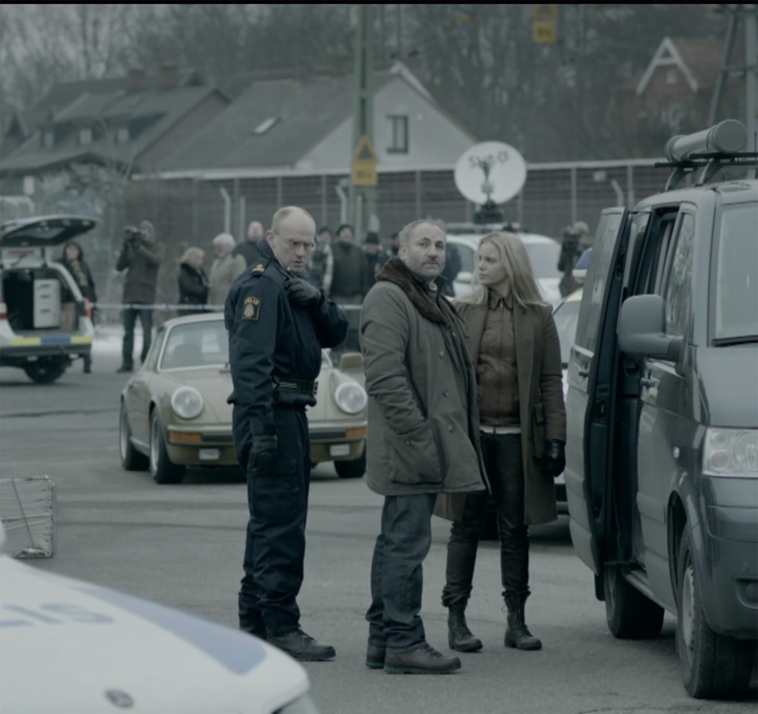
Figure 1: Realism and Authenticity with filming taking place in real locations in Denmark and Sweden. DVD screengrab.
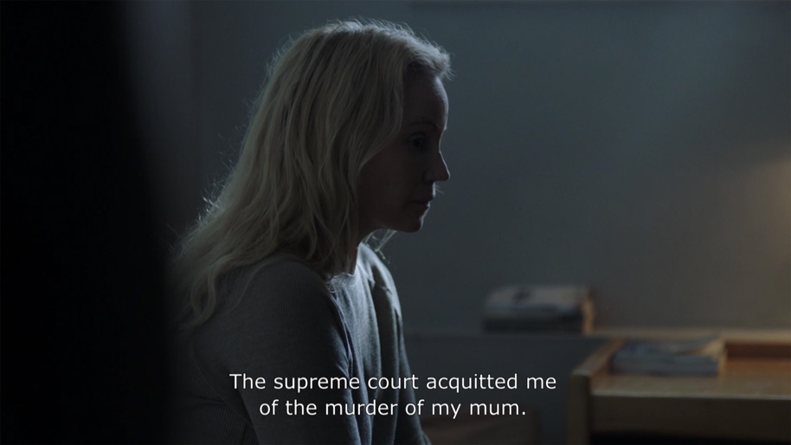
Figure 2: Emphasis of light and shadow emulating the Nordi Noir look. DVD screengrabs.

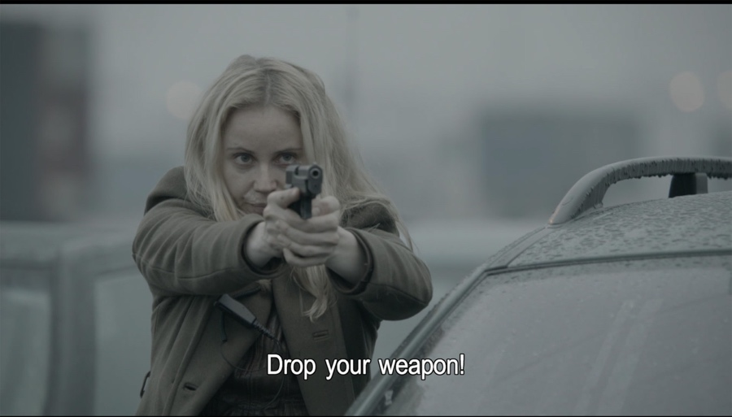
Figure 3: Re-imagining the female protagonist and challenging gender normatives. DVD screengrab.

As Tengberg motioned reference to contemporary American drama we can observe a relation to America’s Film Noir movement of the 1940’s through the particular atmospheric representations of Nordic Noir. As Film Noir was a rejection of certain aspects of American society, so too it could be interpreted that Nordic Noir was also a rejection and commentary on global politics as well as a re-assertion of cultural identity. The style and atmospheric quality of Bron /Broen can be assessed to acknowledge how the key principles of Film Noir, defined by Paul Schrader’s Notes on Film Noir (1972), have been reinterpreted in a new era and context. There are four aspects which are pertinent to this analysis to define the relationship between the shared storytelling aesthetics. Firstly, the backdrop of the storylines align with overarching societal problems such as the Great Depression, World War II and Post-war disillusionment in American culture contrasted to the contemporary disillusionment of the post-welfare state in a United Europe, the global collapse of financial institutions and the political movement to the right in Northern Europe.

Secondly, a particular desire to reveal a sense of realism and authenticity to the settings, which is conveyed through a real-life perspective and to expose the gritty and the uncomfortable aspects American and Nordic society. These are not saccharine productions with sentimental romantic filters, which are often portrayed in Hollywood. For Nordic Noir the employment of interweaving narratives; societal issues, the establishment, criminal underground, corruption, form the constructs of a contemporary representation of 21st Century Northern Europe. Importantly the narratives are located in real locations over studio sets, an approach adopted from the 1990s Dogma movement evolved as a shared vision of Danish Realism in the 2000s (Creeber 2015, Hochscherf & Philipsen 2017). The importance of lighting as a conveyer of mood and tone acts as a key aesthetic of the narrative . The light and stylistic schemas move on from the Film Noir term chiaroscuro (Schrader, 1972), a term to be re-interpreted as a play of light and shadow framed in the context of cold, ambivalent atmospheres, with monochromatic palettes merging into austere muted colour palettes predominantly situated in the depths of the long dark Northern European winters. Finally, the Hard-boiled protagonist is reimagined for the 21st Century. The tough, cynical male lead and the ubiquitous alluring femme fatale is reconceived, allowing the female protagonist to step into the main frame (Creeber, 2015). She is not attempting to mirror her male predecessors, in fact she seeks to challenge the patriarchal structures in pursuit of autonomy and above all professional duty, contesting the perceived attributes of bravery, integrity and ‘having backbone’ as male only (Collins, 2016). In contrast to Film Noir, the character dynamics of Nordic Noir confront the conventions of gender relations creating narratives which are not predicated on a sex-love-power narrative as exemplified with Saga and Martin.

Setting the Tone & Identity through Fashion
Saga Norén and Sarah Lund reset the fictional landscape of the detective. Until the rise of Nordic Noir, the female detective had rarely been at the centre of the action therefore the semiotics of the accepted masculine aesthetics had to be reimagined. The dissolution of the masculine uniform opened up a new visual representation of women on screen embodied through clothing and interiors. Through an analysis of Saga’s iconic look, we can consider how the curation of her apparel borrows from and broadens the semiotics of the detective outfit into the 21st century challenging associations of gender towards the ‘virtually coterminous’ (De Laruretis, 1971). It is useful reference historical aesthetic representation of the detective to understand how the complex signifiers of clothing creates a deeper understanding of character and how this enriches the narrative (Bruzzi, 1997). The novels of Sjöwall & Wahlöö 1970s detective Martin Beck portray a flawed detective whose existential approach blurred the boundaries of his work and private life (Gregersdotter, 2016). Beck’s on-screen sartorial look (1998-) presented a contemporary version of the dishevelled male detective in a trench coat layered over an ill-fitting suit, reflecting the look first established in the portrayal of Raymond Chandler’s fictional character Philip Marlowe in The Big Sleep (1946). Current TV representations of male detectives reinforce the signature overcoat; the beige trench coat of Kurt Wallander (2015-13), the grey tweed Chesterfield coat worn by John in Luther (2013-), and Jimmy Perez’s navy Peacoat in Shetland (2013-), reinforcing representation of the prerequisite detective overcoat as synonymous with authority, law enforcement and an emotionally closed character. The coat becomes a signifier, a statement, and as Bourdieu (1930-2002) sought to describe as a ‘portable habitus’ (Burman, 2003:85). Thus, the costume is ‘a crucial ‘storytelling’ element (Gilligan, 2013:134) and acts to reveal more about a character beyond the verbal. Saga wearing of a masculine overcoat challenges the attire as male and consequently the interwoven privilege which warrants professional mobility and the semiotics of the assumed masculine aesthetics had to be reimagined. The opportunity to decode a traditionally masculine domain created an alternative visual representation of women embodied through clothing and interiors.

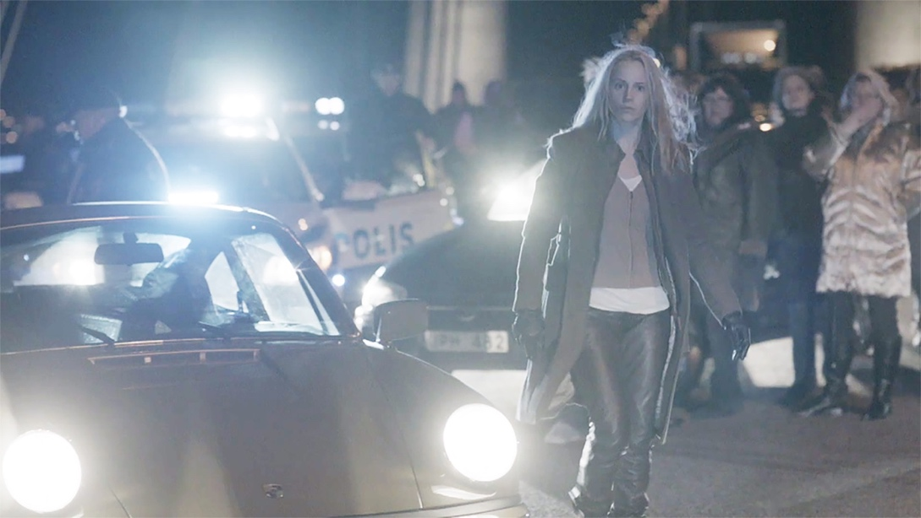
Figure 4: The first shot of Saga Noren in Episode 1, Season 1 establishing her iconic look. DVD screengrab.

Saga’s identity is intrinsic to her inferred uniform, which over the course of the four seasons of Bron /Broen, remains consistent. Her look is striking in its form, colour and associated semiotics. It is a hybrid of aesthetics affiliated with authority, command and masculinity, yet Saga’s apparel is reconfigured to mute the gendering of the clothing. The androgynous manifestation of Saga’s look intentionally speaks of an ambivalence of gender assumptions and preconceived gender hierarchy within crime narratives. The assimilation of military and police regalia are conspicuous in the infamous sage green woollen overcoat, a colour associated with army uniforms and camouflage. It forms a protective outer shield concealing her contours deflecting the male gaze on the female for sexual objectification. Tailored police uniforms or suit jackets for female characters are traditionally adjusted to emphasize the waist and breasts. Saga’s coat contradicts the shaping of the body by draping evenly over her torso and hips, there is no cinching in or binding of her torso, certainly no fetishization of her body. Her boxy overcoat enables the physicality of her profession; drawing her weapon, apprehending suspects, running, driving serving a performative purpose as well as a protective skin in her role as a defender state. Her collar is upturned, a styling etiquette associated with masculinity, to concealing the intimate interstitial space of body and world (Gilligan, 2013), which is additionally protected by her blonde mane which she always wears down. The coat is buttoned at the top to a fixed open position, creating permanent lapels down the full length of the overcoat. She never has her coat closed over, which given the general inclement weather of Sweden and Denmark during the Autumn and Winter months, is a notable metaphor for her non-conformist attitude.

The tailoring offers further military connotations with the double-breasted detail and pronounced bellow side pockets, which refute the necessity for Saga to bear the burden of a handbag. The pockets provide adequate compartments for Saga’s personal items; her police ID, gun, phone and car keys. There is no requirement for frivolous accessories to be contained and transported in a handbag; such as make-up, hairbrush or purse, these irrelevant feminized items play no part in Saga’s every day. The 19th Century semiotics of the overcoat and pockets were gendered; these masculine details signified a ‘compartmentalisation of sexuality and power’ (Burman, 2002:85) with the omission of pockets in women’s clothing forcing dependency upon men or accessories to carry personal items. The pocket disrupts the silhouette, breaking the definition of the waist and hips, key attributes for the objectification of the female form. The pocket liberates Saga of this forging of the female form, therefore her look begins to disentangle gender and clothing. Layered underneath Saga’s overcoat is a collarless brown leather jacket, a thick knitted zip-up cardigan and a final layer of a vest or t-shirt completes the protective armour. There is no display of breasts or cleavage with clothing terminating above or on the collarbone. It is not that she is ashamed of her body as she does not perceive her physique to preclude her professional capabilities, as demonstrated when she changes her top in the open plan office revealing her bra. Saga rips the rule book up, she renders the female stereotype as unreadable.

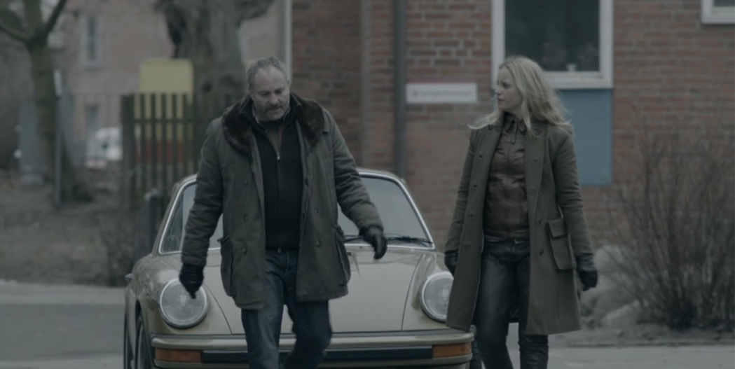
Figure 5: The complimentary muted tones of Saga and Martin’s costumes. DVD screengrab.

Similarly, the overcoats worn by Martin and Henrik offer a dissection of their characters. Martin goes against the traditions of the male trench coat by wearing a number of different jackets in the series some with fur lined collars. His jackets are complementary to Saga with muted tones of green and brown, and constructed from softer materials of cotton denim mix. Therefore, the jackets sit upon his more rotund frame in a less rigid fashion, indicative of his more relaxed persona and professional approach to rules and regulations. He also possess the look of dad fashion, a thrown together look that is functional and comfortable but not quite on trend complemented by worn in boots and an unkempt beard. Martin’s layering is similar to Saga with woollen zip up cardigans, checked flannel shirts and casual t-shirts. He has the same disregard for his outward appearance and how this might affect other people’s perceptions of him as he is comfortable in his skin. Henrik in contrast presents a more coherent, curated and streamlined look with his tailored dark overcoat which assumes a more serious contemplative representation of his character, and is a nod to the traditional detective trench coat. He wears a shirt and tie with a waistcoat, exemplifying the masculine dress code and reflecting his professional status topped off with a lux padded gilet, polished shoes and manicured goatee. Unlike Saga and Martin, Henrik appears to exert control over his emotional instability through his structured appearance. Simone De Bouvoir (1908-1986) commented ‘A man’s clothes, like his body, should indicate his transcendence and not attract attention’ (Bruzzi, 1997:133), we have been conditioned to see men in this manner therefore Saga allows the viewer takes new ownership of the pre-conditioned expectations of both male and females.

Saga’s brown leather trousers are tucked into her sturdy, scuffed lace-up boots which sit on the mid-calf, breaking the silhouette of the leg as a further contradiction and resistance to normative femininity. The worn appearance of her leather boots is testimony to her active field participation in her line of duty. Leather trousers are a sensual choice of attire particularly on the female body to which tends to cling to curves, drawing the gaze to eroticise the legs, however Saga does not draw attention to her body through her sartorial choices. The material properties of leather softens with time, the rigidity of the fabric begins to mould to the body effectively to become a secondary skin, which we can read as symbolic of the audience’s developing relationship with Saga. As leather trousers are not an object to wash the very DNA of you becomes embedded in the fabric and forms part of the unique patina of the additional skin. We can take her uniform to be pragmatic and to allow her some degree of anonymity, to blend into the spaces and landscapes of her work.

Saga’s further renouncement of gender expectation is evident in her natural unstyled hair and no make-up, forcing the viewers to reimagine gender bias of female characters as a sexualised body for the male gaze and erotic impact of a female’s appearance for her ‘to-be-looked-at-ness’ (Mulvey, 1975:62). We are conditioned to expect the perfect, made-up woman on screen but the creators of Saga did not envisage her subscribe to this form of representation or displayed as an object. She doesn’t use her gender as a masquerade to attract or manipulate. Sarah Lund also rejects the looked-at-ness with her no-make up and pragmatic attire of the infamous knitted jumper, straight leg blue jeans and inconspicuous practical black jacket. Contrastingly in The Fall, Detective Superintendent Stella Gibson re-appropriates the trouser suit and is often seen commanding her space with her hands placed in her pockets and spreading her legs whilst seated like her Nordic contemporaries. Stella portrays a highly sexualised character, she wears her silk blouse open to reveal cleavage drawing attention to her breasts, her womanliness deliberately commanding a power hold over her looked-at-ness. Saga, however, does not seek to be looked at or stand out. She wears the same outfit throughout with minor variations so we don’t associate her with the normative of female characters and multiple costumes, thus we can see how the sartorial representation of Saga is intrinsically linked to the spaces she occupies; she fits into the landscape, the interiors, the car, she is embodied within her environments.

The now iconic look associated with Saga is incredibly powerful in terms of identity and this is demonstrated in Season 4 Episode 2, when Saga discharges herself from hospital. Through a series of intimate camera shots, we watch her getting dressed; tentatively slipping into her leather trousers, putting on her many layers, and stepping into her scruffy boots then finally pulling on her infamous coat. Saga is back where she belongs - in the line of duty.

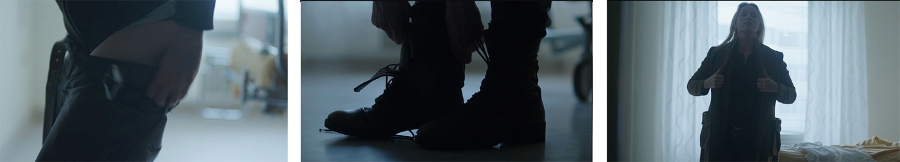
Figures 6, 7 & 8: Close up shots of Saga dressing as she returns to the line of duty in Episode 2, Season 4. DVD screengrab.

Spaces of Saga: The Car & The Bridge
Exemplifying the visual look of Nordic Noir, the aesthetic tone of Saga is further manifest in the muted colour palette of the interiors which she occupies. The distinctive olive green 1977 Porsche is equally synonymous with Saga as her infamous overcoat and reasserts Saga’s uniqueness through its beguiling, elusive and intriguing appearance. For Saga the car is a personalised interior which is individually controlled, mobile and owned by her. It is another form of Bourdieu’s term ‘portable habitus’. Like the overcoat, the car is a masculine realm which she has re-appropriated. It offers an additional protective shell, and is somewhat removed from the larger world that she is unable to control. It is a poignant interior space which serves as a sanctuary for her, and as a mediated space for her relationships with Martin and Henrik, who are the only people we see with her in the car’s protective environment. The interior of her car, therefore becomes an intimate space in which she can assert control over where she goes and also whom she permits to cross the threshold into her world. The car is an appendage to her character, reliant and constant in her somewhat chaotic life.

The olive-green colour of the car presents a consideration of perception, interpretation of the colour is subjective as is the audience’s understanding of Saga’s personality and undisclosed condition. Why the particular use of green for the car may stem from green’s historical association as a complex colour; capricious, evil, yet the colour green is also closely associated with fertility and strength (St Clair, 2016). A series of contradictions which concur with the reading of Saga’s character. The upholstered tan leather interior of the car, a masculine material applied to a traditionally male space, is laden with sexual connotations and phallic symbolism. Yet again Saga throws these conventions in the air contravening preconceived gender associations of everyday objects, mobility and ownership. She neutralises the occupation of the car in her similarly muted palette of clothing. The stitching detail in the upholstery design complements the formal tailoring of her coat, neither are pristine showing subtle signs of weathering. Both are pragmatic and intrinsic to her life; thus, the interior of the car becomes part of her camouflage and desire retreat to the margins, clearly linking her identity to the interior.

The interior of the car provides a backdrop to her closest relationships and through the intimacy of the small interior the audience are invited into her protective shell. It is through the car that we witness the most delicate moments of her relationship with Martin. Their relationship does not conform to the normal narratives of the male protagonist trajectory, or to erotic desires as defined in feminist film theory as the Odephial trajectory (Chaudhuri, 2006). She doesn’t fall in love with him, and in return Martin does not lust after her. Rather, in lieu of the absence of male-female tropes, they develop an emotional bond which has familial undertones. Saga does not appear to have any close friendships; her sister is dead and she has a tense relationship with her mother. Her kinship with Martin attempts to fill these voids in her existence. Their relationship inverts the normal patriarchal order; Martin is family oriented, has five children and openly displays his emotions challenging male normative. Whilst Saga does not conform to female normatives or narratives; she is not a mother, emotional, nor is she objectified by her male colleagues. Martin does not display the tropes of hard-boiled detectives; masochistic, loner or unable to separate himself from the job (Schrader, 1972), some of these qualities Saga does exhibit but it would be unfair to class her as masochistic as she does not wish to cause harm to herself or others despite her palpable lack of empathy.
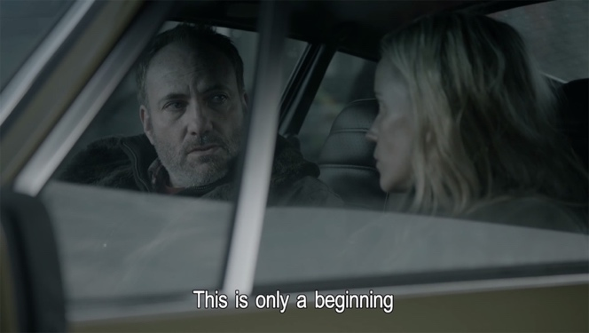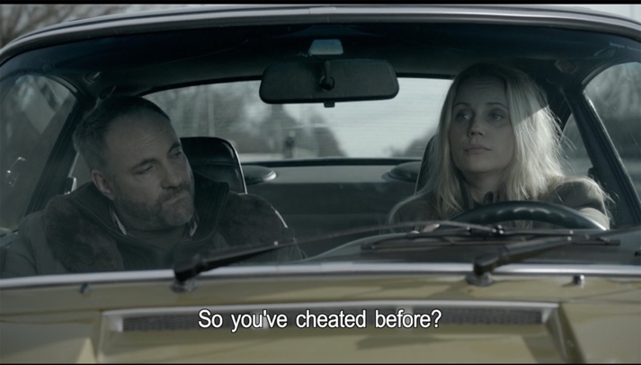
Figures 9 & 10: Saga and Martin’s relationship evolves in the intimate space of her car, with conversations confronting the boundaries of social etiquette. DVD screengrabs.

The Øresund Bridge which connects the two countries of Denmark and Sweden through the cities of Copenhagen and Malmö is a contested space of transition and of ownership. It is a threshold and boundary of a state of in-between (Simmel, 1994). For Saga and Martin, the car and the bridge provide a nonpartisan space that allows them to circumnavigate the boundaries enforced by work, borders and nationality. Both spaces create opportunity through dialogue to confront the embedded cultural conventions and challenge social niceties, from assumptions around gender stereotypes to dynamics of marriage. Saga cannot comprehend why Mette calls Martin in work time to just chat, to her this is inconvenient and unnecessary. Equally, Martin has to climatize to Saga’s abrupt and sparse capacity for conversation out with the sphere of work. In one particular poignant moment the confidential nature of the car interior is conveyed as Martin breaks down in tears following the death of his eldest son whilst driving over the Øresund Bridge. Unequipped to deal with the emotional fall out Saga resorts to turning up the radio to fill the metaphorical space of apprehension, nonetheless the gesture is received as compassionate demonstrating they accept each other. The relationship is fundamentally human and evolves into genuine affection mediated by the intimacy the car as they transfer between each other’s worlds, physically and metaphorically. The dramaturgical use of the bridge as a ‘meta-generic element’ (Hochscherf & Philipsen, 2017;133) of transnational relationships and framing the car interior as a metaphorical space reinforces these two key components as a point of reflection for the main characters throughout the series. In their contrasting characters and lifestyles this odd partnership complement each other, which is particularly important for Saga to be accepted for who she is without the need to compromise or conceal her personality traits. When the producers were creating Saga, Anders Landstrom said they did not seek to reinforce stereotypes of either country rather ‘It was more that we invented Saga and then wanted someone a little bit opposite’ (Frost, 2012). And it is into this bi-national couple whom the audience buys into (Frost, 2012), their open, sincere kinship and individual flaws is emotionally reciprocated by the audience’s investment in them.

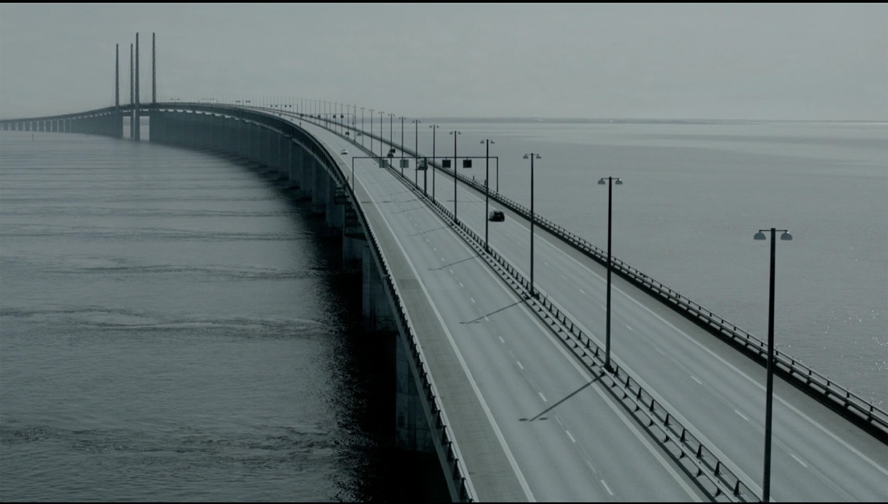
Figure 11: The Øresund Bridge, the symbolic in-between space. DVD screengrab.

The bridge is a threshold between his/ her world, utopia/reality, a passage from and to, personal and public. It becomes a connection between their countries, which are intrinsically linked through geography and shared culture, but the bridge is somewhere else, an intersection which ruptures their everyday by blurring boundaries and disrupting the sense of time and space (Massey,1994). Even the name of the show is in dual language, placing an emphasis on the duality of place and people. The interstitial space of transition on the bridge is key to our understanding of the essence of the series as it presents a rejection of the traditional roles - male/ control and female/ comforter by using Saga’s car as a space which permits new roles and new identities. The car is a discrete space in which we become privy to Saga’s way of seeing and negotiation of the world around her, allowing moments to be contemplative and pensive as a solitary moment, a place for dialogue. The final scenes demonstrate the significance of the car as her life as a detective draws to a conclusion; driving towards the bridge her decision brings a genuine smile of happiness to her face and she pulls over halfway between Malmo and Copenhagen to throw her police ID into the water, then back in the car she answer a call in her final dialogue with a simple ‘Saga Noren’. The car embraces her in some of her lowest moments, it allows her to be human and to be relatable.

Spaces of Saga: The complexity of workplace
We are habituated to female roles on-screen as being passive and two dimensional, meanwhile historically the male role is active and demands a three dimensional space as the primary figure physically dominating the landscape of the screen. In contrast Saga is not a backdrop or compliant, nor the spectacle of a sexual gaze (Chaudhuri, 2006). Saga openly confronts the male gaze with her behaviour in the open plan office. She assumes occupation of space within the open plan office, we watch as she moves through the office with confidence, entitlement and belonging within the space. During his first encounter at Saga’s workplace, Martin is exposed to her unconventional behaviour literally, when she changes her top in full view of the open plan office, exposing her off-white unembellished t-shirt bra without concern. Her underwear, like her is functional not predicated on sensual want. He looks bewildered and checks to see everyone else's reaction but no-one bats an eyelid, this is just how Saga rolls. The manner of how the scene is framed does not suggest to the viewer to view Saga for her ‘looked-at-ness’ (Mulvey, 1975). In these particular scenes Saga becomes the dominant figure occupying space through the three dimensional physical action and by shedding her outer garments she compliments the unglorified monochrome office. Her occupation of the spatial landscape continues whilst sitting, Saga does not contort her physique in at her desk to occupy less space than her male counterparts, she embraces her territory through body and space, in a self-assured yet unassuming manner. Taking up space is a proclamation of belonging as a woman and an equal. In contrast, we see Martin struggling to locate himself in Saga’s territory as his expectations and unconscious male privilege are confronted in this new professional relationship. He is unsure how to position his body. Does he sit, is he invited to sit? Or should he stand to state his authoritative role? His discomfort is also physical as he is recovering from a recent vasectomy, he is emasculated, metaphorically castrated from his male privileges as he confronts a world where the power dynamics are being contested (Butler, 1990).

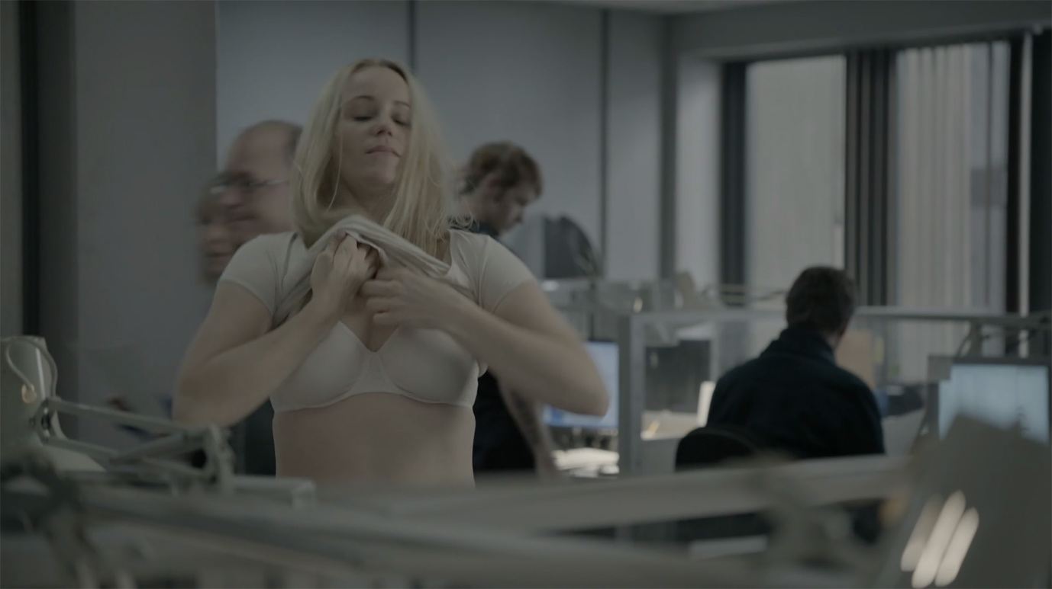
Figure 12: Challenging the workplace etiquette. DVD screengrab.

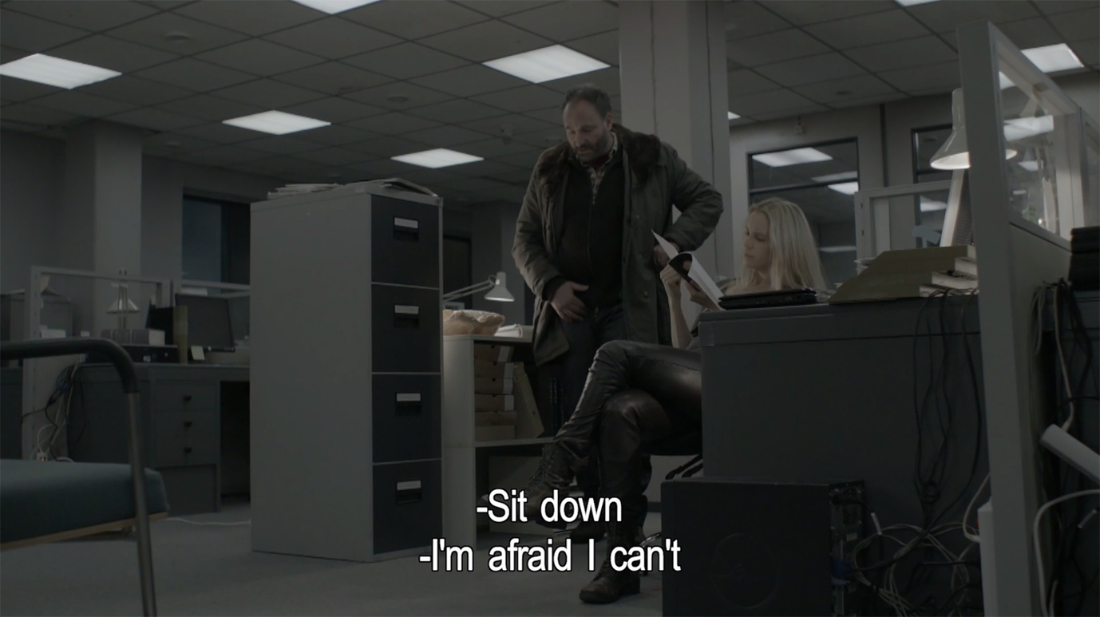
Figure 13: Changing male-female workplace dynamics. DVD screengrab.

We can observe Saga beyond the ocular to consider the oral space she occupies. Saga commands autonomy of her voice, she speaks directly and without hesitation subverting the association of the female vocal to bodily emotions such as crying, screaming, and panting (Silverman, 1988). Historically within the workplace a male governed space in which women are expected to blend into the background. Saga refutes the shy, subservient female attributes. She is notorious for her formal introduction of herself and position even to those she knows well. She has no capacity or patience for gentle chit chat and when she tries she often misreads the room, one such example being when she discloses her period started to her male colleagues. Saga is bold; she claims control, she is matter of fact, makes decisions without consultation and resists subordination. Effectively what men have been able to do without question, and confronts expectations of her femaleness through her physical occupation within the normally gendered hierarchies of work and space.

In Season 4, as Saga returns to work after her prison sentence, her uncertainty and anxieties are visible through her physical vulnerability. She returns to Malmo Police HQ and is reacquainted with her Police ID and appointed a new case to work on with Henrik. In total disregard of her colleague she is straight to work laying out her files on their desk. However, on arrival at the Copenhagen Police HQ the hot desk format catches does not sit comfortably with her requirements. Previously, she was able to negotiate the parameters of her territory and relationships in her static desk in Malmo and her reliant co-worker Martin. But her world has been turned inside out; Hans has died and Martin is imprisoned. The new structures and spatial boundaries are out with her control. She cannot comprehend how to inhabit this new complex social space as it conflicts with her familiar territory and rules of the workplace (Massey, 1994). She is bewildered by the allocation of a basket to hold her files and tentatively places it on an empty desk. This could be interpreted as a metaphor for the recurring otherness, both as an individual and as a Swede, trying to position herself within the metaphorical other space. The tension and dichotomy of place and space is conveyed through her initial hesitant posture, but the uncertainty soon dissipates as the reassuring space of the investigation wall gives her the confidence to situate herself on the edge of her safe confines and enter a new frontier.
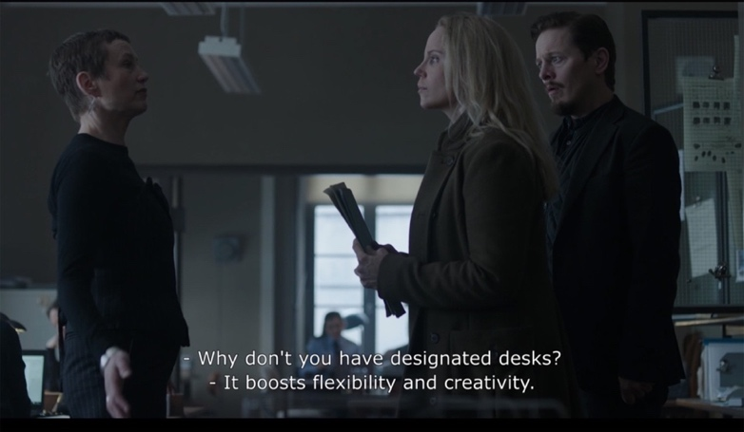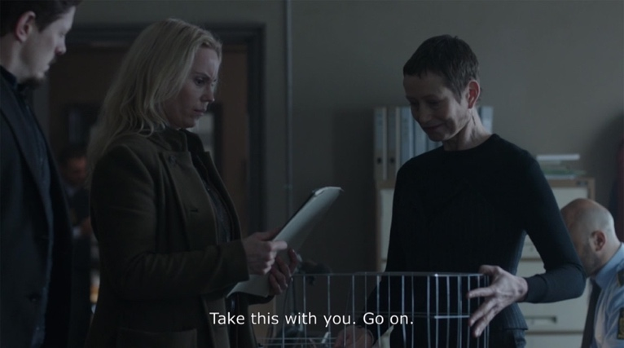
Figures 14 & 15: Saga’s discomfort at the new hot-desk format. DVD screengrab.

The mortuary is one of the few interiors, other than her car, in which we witness a smile and sense of being at ease from Saga. It is a structured space, static, silent and certain, where the only social negotiation is an intellectual dialogue which provides her with a little competitive challenge with the forensic scientist. At least she does not have to negotiate any niceties with the cadavers. She appears to thrive in this environment which embodies a monotone aesthetic; a cool palette graduating from blue-grey to stark white, flat fluorescent lighting, stainless steel and ceramic surfaces devoid of patterns and textures. Ironically, the detached clinical interior is a space of comfort which befits Saga’s predisposition.

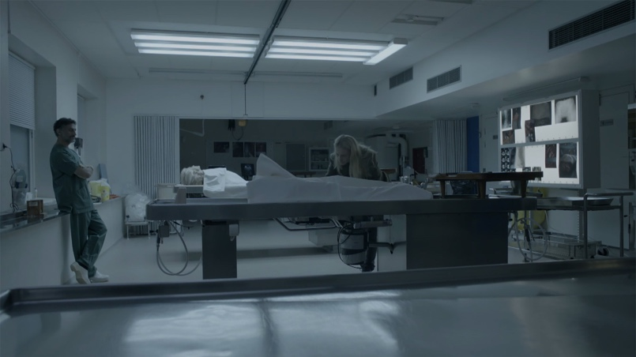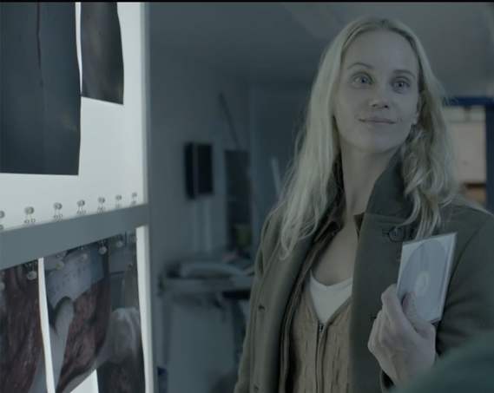
Figures 16 & 17: The Mortuary a place of sanctuary. DVD screengrabs.

Spaces of Saga: Home as Self
The rise of Nordic Noir drama coincided with a rise in interior trends for the Nordic look and the commercialisation of Danish hygge. Home Interior magazines were awash with how to mimic the look, perceived as an exemplar of minimalist domestic utopia in interiors; tonal whites and greys, classic mid-century Scandinavian furniture, and the ubiquitous low pendant designer lights over the centre of a dining table. The Nordic look was presented as a cross-cultural appropriation of an aesthetic which aspired to echo the desire of Scandinavian lifestyle, an idealised interpretation of other cultures consumed through interiors and ways of living (Stougaard-Nielsen, 2016, Majbritt & Marit, 2013). The Nordic lifestyle phenomenon represented ‘a conscious citizen with personal surplus for the practicality of smart details, authentic values, or environmental concerns’ (Sandbye, 2016). However, the domestic interiors of Bron /Broen subvert the fantasy of this Scandinavian archetype. The homes exhibit the tropes of Scandi living juxtaposed with a compositional tension, framed against backdrops of gloomy, dark winter days with pockets of atmospheric lighting. A set of ingredients adding to the intensity and discord, fracturing the perception of Nordic ways of living and being (Creeber, 2015, Majbritt & Marit, 2013) The overarching stylistic character and inclusion of notable Scandinavian design was proving desirable to the middle class viewers of the UK; ‘Scandi interiors-porn: lovely lamps in Saga's flat. And a whole house I'm coveting over at the Rohde residence. No wonder he can't take time off. (Well, that and the five kids …)’ (Frost, 2012).

The interior of Saga’s apartment provides us with a deeper insight to her identity. Her home does not epitomise the idealised Nordic ways of being as depicted by Ikea or hygge. It brings to question the outsider’s perception of the commercialisation of hygge to be inclusive of all Nordic countries, does Saga’s anti-hygge occupation of home endeavour to declare the cultural differences between Sweden and Denmark? Traditionally it is accepted home is a space which embraces warmth and comfort through soft furnishings, flourishes of pattern and colour, and personal objects curated to embody the personality of the homeowner (Serres, 2008). Home is a place of attachment, which shares to others our intimate values, memories and tells the story of ourselves contained within the protective shelter (Bachelard,1994). Within Saga’s home there are iconic Nordic design items; an Eero Saarien Tulip table (1959), a mismatch of mid-century chairs, several beautiful angle-poise desk lamps placed within the living-dining space, and a sculptural fibreglass moulded chair in the bedroom. The placement of the furniture is unconventional, as individual items blend into the disorganised chaos of the space and it is unclear if they are selected for their cultural design value, or it is just a happenstance of inherited objects.
The studio apartment is divided notionally into four spaces: living & dining, kitchen, bedroom and bathroom. Saga appears to negate the interior architectural boundaries of the defined functions of each space, which is evidenced in the blurring of her work-life boundary. All available surfaces of tables, chairs and the floor are overloaded with stacks of paperwork and books, ironically the Tulip Table was designed in response to ‘ugly, confusing, unrestful world’ (Saarien, 1956) to create a more streamlined way of living. There are three tables, of varying size and finish, in the apartment whose implied function are relative to her work rather than eating and socialising. A mid-century grey fabric sofa sits awkwardly upon the threshold of two spaces, disregarding the primary purpose of the living room as a relaxing and sociable territory of home. There is no sense of a considered configuration of furniture and objects to create a domestic hierarchy. This might appear to be dysfunctional, but represents a physical manifestation of Saga’s behaviour into the layout to demonstrate her ambiguous occupation of social situations. The home becomes an extension of work which in itself is an extension of self (Weinthal, 2011), and thus home for Saga is a different sense of sanctuary. Although Saga appears to have no close friends or family, she happily sits outside the female stereotype (Collins, 2015), she may be a lone wolf but she is not lonely. Therefore, her home is not space for others, nor a space to entertain and it certainly does not pertain to the assumed domestic female roles of mother, wife, or entertainer. In correlation with her car, home is solely Saga’s domain, it is a space which is governed and defined by her alone.
Concealed sliding pocket doors, located in a semi-open state form a submissive boundary to close the kitchen off from the bedroom, however one can anticipate Saga would be unlikely to reconfigure the interior layout. The utilitarian kitchen is functional and economical in its size with blue-grey tiles forming the backdrop of the monotone kitchen units, in the familiar style of Ikea. The countertop is filled with an array of kitchen utensils, pans and opened food packaging in a disorganised manner. Overhead a shelf is laden with stacks of books and on the tiled wall a lone yellow post-it note stands out against the blue tile. Saga’s unconventional mannerisms are evidenced as she scoops water from a pot to drink with a cup, then sits upon the countertop engrossed in her research without concern for the conventional hygiene rules of the kitchen.
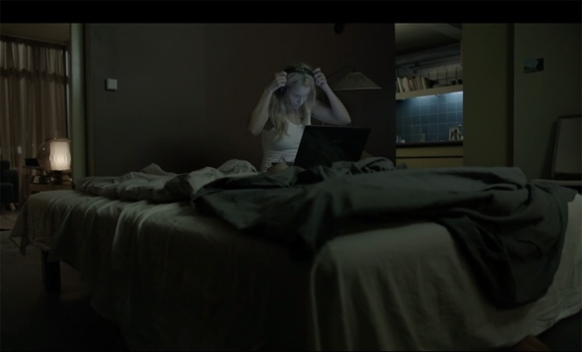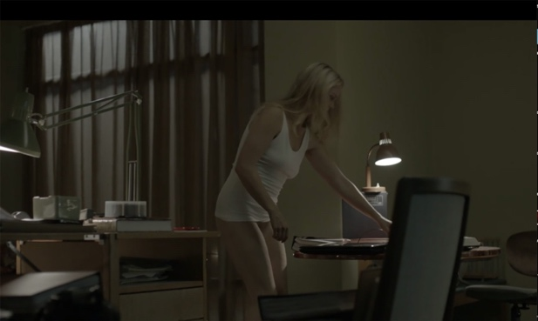
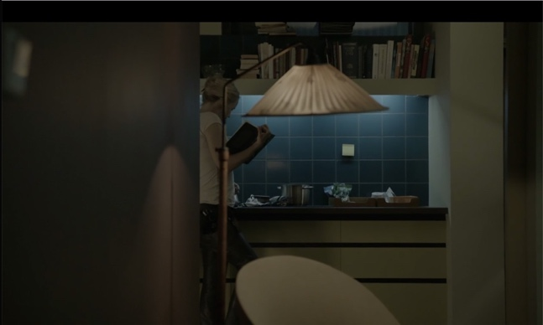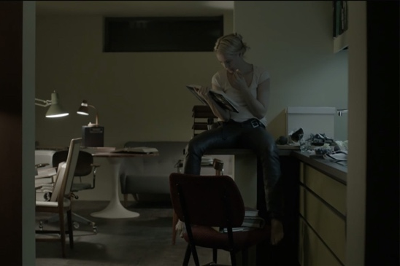
Figures 18-21: The anti-hygge living of Saga. DVD screengrabs.

Her bedroom is not an enclosed chamber or feminized with embellishment of soft, patterned or sensual decoration. There is no female ‘gentle touch’ (Collins, 2016: 112) in Saga’s professional or personal demeanour. A disregard of normal domestic semblance can be interpreted in the unmade bed, layered with creased sheets and woollen blankets. This is a place for sex, sleep and work in equal measure. There is one hint of a personal item in the lonely postcard of an unidentified city monument on the wall. There are many gaps in Saga’s backstory, so this personal item prompts a curiosity as to where this is, what it represents, what meaning or memory it contains, and ultimately reminds us of the absence of personal objects or memorabilia within the apartment. The interior is devoid of pattern and bright colours, and it aligns with the same muted colour palette of her clothing and car. The only contrasting colour is found in the red bathroom tile and pink wall which forms the backdrop when Saga becomes aroused and decides to go out to pick up a guy for sex. Saga challenges preconceived notions of female desire which is effectively constructed through the male desire concealed in the cinematic or screen gaze. She goes out to a local bar to pick up a man to satisfy her present desire in a no strings attached sexual encounter. The sex scenes are not glamourized for audience eroticism, she keeps her top on throughout and is concerned with reaching her sexual gratification, not foregoing this to satisfy the man. The traditional fetishism of the naked female form is dictated by and for the male gaze (Doane, 1991), however her it is refuted as the camera creates an interior panning of Saga as she walks around her apartment in a state of undress with no pants and a t-shirt, reinforcing to the spectator this is not about her sexual appearance to be looked-at-ness, but rather simply about a woman at ease in her own space inhabiting her own rules for living.
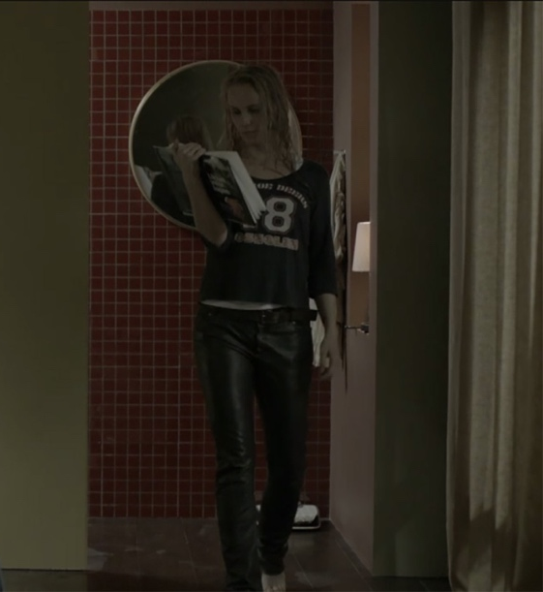
Figure 22: The partial view of the bathroom provides one a detraction from the muted palette. DVD screengrab.

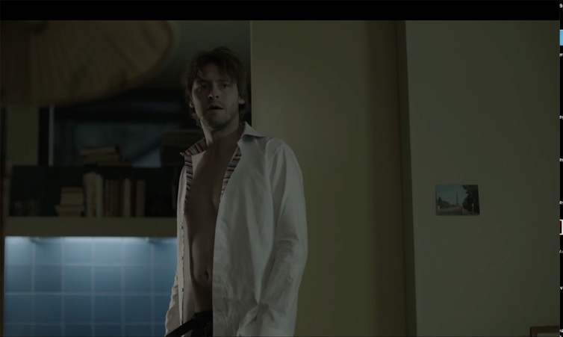
Figure 23: The isolated postcard on the wall is one of few visible personal items within Saga’s home. DVD screengrab.

The significant absence of particular interior spaces of the home are noted in the unseen thresholds of the entrance door, the bathroom and closets. We also do not see Saga undertake the associated rituals of femininity and grooming. There are no shots within the bathroom, no pauses with the mirror to apply make-up, fix hair or provide an existential moment. There is no appearance of a wardrobe which confounds the association of women and fashion, whereby the wardrobe is a container of identity formed through the metaphorical skin of clothing and curated performance of self (Urbach, 1996). Is the absence of a wardrobe a gesture to Saga’s backstory; a past locked away as another invisible threshold where the omission of the private chambers declares a tension between the physical and psychological, private and public persona? The layout of the threshold between inside and outside is unclear as we do not see Saga enter or leave via the door of her apartment, could this antechamber be read as a metaphor for the distance Saga’s maintains in her daily life, a place of undisclosed sadness which becomes apparent in the final season. Yet to contrast this point, she is not afraid of revealing herself to others by the means of her window in the bedroom. The sheer curtains parted allow clear visibility into her interior world, the curtain mediates the body through this semi-transparent skin of outside/inside, public/private (Serres, 2008, Hollander, 1978), and similar to the configuration of the apartment the curtains are not purposefully framed in this semi-open position, they are opened disproportionately from one another creating an imbalance through asymmetry. There is also an absence of lingering or lustful shots framing her looking out from the window, she is not caged within the boundary of the interior.
Saga’s home might not represent a collective depiction of home, and it certainly does not play to gender normatives. It looks dysfunctional and chaotic, but to her perhaps not so. The sense of the desired Scandi home is emulated in Martin’s more fashionable family home, where there is a clear delineation of space and function. There is order, colour, pattern, a myriad of personal objects, a warm atmosphere and other people. In contrast Henrik’s suburban home presents a sense of his personal void notable in its absence of people. His home evidences some desirable components of the Nordic look; Louis Poulson lights, mid-century furniture and minimalist ornamentation, however the sparse atmosphere translates a palpable sense of pain and distance from its occupant. It is not a place of happiness. His daughters’ room is a shrine to the past, a constant reminder of his loss. His home, like his considered and professional presentation of self, does not seek disclose anything beneath the surface.
The integration of Saga and home is established in relation to others (work, society and relationships), and the sense of enclosure created through the interiority of home as an interior of one’s own (Massey, 1994). For me the interiors humanise Saga and provide a greater insight into the complexity of her character by challenging our preconceptions of what is to be a female detective.
Conclusion
The success of Bron /Broen and other Nordic Noir dramas can be measured in the surge of dramas which borrow from the emerging stylistics of Nordic Noir by other nations, demonstrating how the genre and style transcends the geographies of place. Nordic Noir has provided a platform for the unique visual aesthetics to be replicated and reinterpreted within different contexts and countries. The emergence of a new character type of female detectives which sits alongside the established dishevelled male detective. Despite enjoying these new female leads it is concerning there is an emerging trope of the psychologically damaged female detective, whereas the male detective tends to have suffered a bereavement as the backstory. This questions the political and gendering of psychological or mental health as a female trait thus creating a new means to reinforce gender stereotypes in the patriarchal hierarchy (Mulvey, 1975).
The synthesis of interior and fashion play an important role in either reinforcing or challenging the representation of women on screen. The success of the Nordic model is based equality of gender and place. It acknowledges the particulars of the transcultural joint venture between Denmark and Sweden, which seeks through a scaffolding approach to collectively create multi-layered narratives with engaging themes of global and parochial importance. Each programme develops a design manual which assembles the core concepts; atmosphere, colour, mood, layout, as a shared aesthetic artefact for all contributors (from writers, directors, production design, costume design, lighting design) to share the ‘one vision’ of the production (Hochscherf & Philipsen, 2017:91). The value placed on the visual narrative, from costume to interiors, is crucial to maintain the status and commitment to the unique audience experience on the small screen setting an exemplar of how design and designers play key roles in storytelling.
Small screen fiction presents hermetically sealed worlds which play on our voyeuristic phantasies. Bron /Broen and the genre of Nordic Noir contests traditional gendering of space representation as the gaze challenges the romanticised stereotype representation of female (and male) characters. In this analysis of the relationship between character and space we observe how the boundaries of Saga’s private and professional identity are interwoven through the representation of her clothing, home, car and workplace. Throughout the four seasons of Bron /Broen, the audience builds an emotional bond with Saga through the multi-layered dramaturgy that engages the fundamental components of recognition, alignment and allegiance with characters (Smith, 1995:73). Saga’s occupation of space disrupts established perceptions of how women are represented via the interior on screen to precipitate the importance of how the construct of interiors and fashion communicate profound philosophical meaning.
Saga can be misinterpreted as enigmatic, perhaps she is the embodiment of the real world and finally an authentic representation of modern womanhood for the 21st Century?

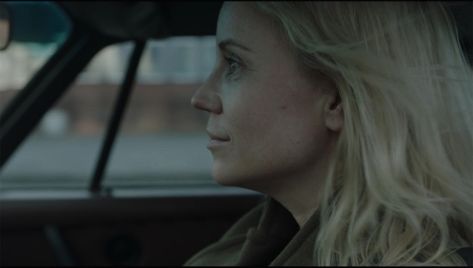
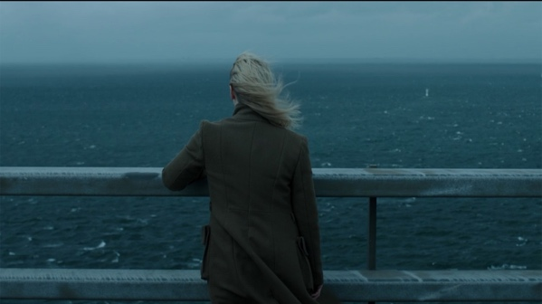
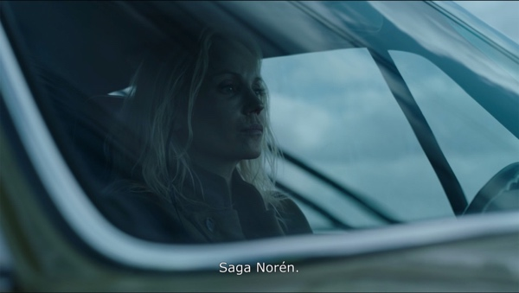
Figures 24-26: Saga’s final scenes in Season 4. DVD screengrabs.

Chiaroscuro was a term to describe the use of light and shadow in Film Noir.
Previous female detectives from the 1980s Cagney and Lacey dynamic NYPD duo a hard working mum and the other single female both faced sexism. Miss Marple and Murder She Wrote (1984-96) Jessica Fletcher presented the old grandmother or spinster archetype. However, DCI Jane Tennison in Prime Suspect (1991-2006) was precedent for the today’s female detective as a strong female lead who had to fight institutional sexism for her position.

