Making design education (even more) complex: exploring complexity for an amplified mindset of design

Mafalda Moreira
The Glasgow School of Art, Glasgow, UK
m.moreira@gsa.ac.uk

ABSTRACT
An Amplified Mindset of Design (AMD) has emerged from recent research on emerging design practices, as designers are once again re-inventing their identity to include an adaptability to uncertainty and paradox. However, this is not yet visible in what design education offers. As designers intervene in complex contexts and embrace participatory, collaborative and interdisciplinary practices informed by strong ethical and sustainability concerns, design education must adjust and expand its scope to include, for example, collaboration, cross-cultural and interdisciplinary skills, and a way of being in the world through design. In this paper, I argue for the formal introduction and exploration of social complexity in design education to assist the development of an AMD in design students. Boundaries, dependence on context, edge of chaos, emergence, and organisation were identified as key qualities of complex systems to introduce to students. Embodiment and visualisation techniques were used as the most appropriate vehicles for such an endeavour.
In this paper, I discuss the results of a qualitative research informed by action research in which I explore ways of teaching complexity to design students.
The inquiry was driven by the following core research question: How can complexity can be taught in design education using visual and embodiment methods to encourage the development of an Amplified Mindset of Design?

KEYWORDS: design education, complexity, teaching methods, embodiment, visualisation, amplified mindset of design

1. INTRODUCTION
In previous research looking at an expansion of designers’ activities to complex contexts such as public health, policy-making and social care, I have developed the conceptual framework of an Amplified Mindset of Design to synthesise yet another moment of expansion in design. This research has stimulated a need to include the exploration of complexity in the design curriculum.
In this paper, I present results from a qualitative research aimed at exploring the qualities of complex systems in design education to develop an amplified mindset in students. The principal vehicles I claim to be appropriate for such an endeavour are visualisation and embodiment methods. This research is driven by a core research question: How can complexity can be taught in design education using visual and embodiment methods to encourage the development of an Amplified Mindset of Design?

2. CONTEXT

2.1 AN AMPLIFIED MINDSET OF DESIGN AS CATEGORIES OF EDUCATIONAL DEMAND
Figure 1 shows the conceptual framework of an Amplified Mindset of Design (AMD) which includes four elements: championing the art of making visual, being adept at building and working within networks, mastering social skills and, following a human-centred and synergistic worldview. An AMD is defined as “an emerging integral position in design, oriented to addressing complex scenarios through collaborative approaches to generate sustainable ways of working and living. [It] comprises core design skills (amplified by), a set of behaviours, attitudes and beliefs about design.” (Moreira 2018, 257).

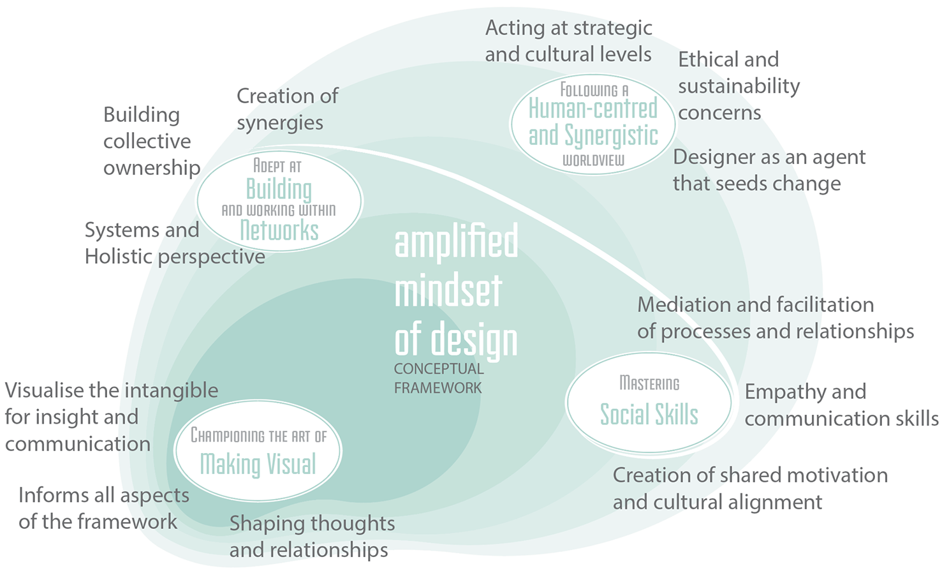
Figure 1 - Amplified Mindset of Design; a conceptual framework. Source: Moreira (2018)

Examples of an AMD can be found in the variety of worldwide cases offered by Yee, Jefferies and Tan (2013). These cases exemplify changes in design practices which are adapting to global complexity with approaches that are increasingly collaborative, participatory, and interdisciplinary informed by strong ethical and sustainability concerns.
‘Design is what we do to shape the world around us. Hence, as advances in technology and knowledge cause the world to change so the methods by which we design must also change.’(Brown, in Yee et al. 2013).
Following Brown’s (2013) line of thought in the quote below, the same change must be observed in design education, as it is often the birth place of future designers. In Table I below, I describe the four elements that comprise the AMD (Moreira 2018, 284), which I also interpreted as categories of educational demand in response to a documented need for models of design education to become more flexible, networked and beyond disciplinary boundaries (Furniss 2015; Martin 2010; McAra-McWilliam 2007; McArthur 2010; McWilliam and Haukka 2008; Mendoza and Matyók 2013).

1. Championing the art of making visual:
The strategic use of 2D and 3D visualisation techniques to foster dialogue and insight.
2. Being adept at building and working within networks:
An all-encompassing approach informed by systems and holistic perspectives, seeking cross-fertilisation between agents and the exploration of boundary spaces as creative sites of action.
3. Mastering social skills:
With a particular focus on the mediation and facilitation of processes and relations, and on the creation of shared motivation and cultural alignment between the stakeholders of a project.
4. Following a human-centred and synergistic worldview:
Represents an expansion from user-centred design towards a focus on human beings as part of the natural, economic and social spheres. By acknowledging the interplay and synergies between these different dimensions, it seeks sustainability in processes and outcomes.
Table I – Description of the four elements of an Amplified Mindset of Design

Additionally, I have identified that the exploration of complexity in the design curriculum is key for the development of an amplified mindset in design students. In these terms, an exposure to foundational theory and concepts of complexity contributes to the development of more mature epistemological perspectives in students, which support and are required for interventions in a global complex scenario (Moreira 2018, 265). Thus, this paper presents my exploration to update and adapt teaching methods for the development of an AMD by resorting to theories of complexity.

2.2. A FOCUS ON SOCIAL COMPLEXITY
A social complexity framework is appropriate to explore the social skills, networked ways of working, and the human-centred and synergistic worldview found in the AMD. To educate for an AMD it is relevant to look at aspects of inclusion, ethics and participation, and also at the development of a level of adaptability to deal with uncertainty and paradox, which is offered by a social complexity framework.
Here, I argue that complexity constitutes a transdisciplinary framework for understanding (Morin 2007, Haggis 2008). It is also a position situated at a paradigmatic level (Emmeche 1997) in which a complexity-lens acts as a basis to build models and constructs about issues in general (Byrne and Callaghan 2014). This approach is open enough to be applied to complex ever-changing conditions—such as the territories in which designers with an AMD intervene—and to be used in design education for the development of an amplified mindset in students. Encouraging the students’ exploration of complexity during their studies is expected to contribute to developing their resilience to complex contexts, and their ability to thrive in it.
This paper’s focus on exploring complexity in education settings resonates in other fields. For example, from the field of social work, Cox (2012), and Stevens and Cox (2008) explored the use of principles from complexity science to gain a deeper understanding of research processes retrospectively, and inform future research practice. In this paper, I focus instead in exploring teaching methods to introduce a complexity framework to students as a starting point.
From the literature on complexity (Byrne and Callaghan 2014; Cilliers 1998; Emmeche 1997; Haggis 2008; Morin 1999; Morin 2007) we can identify key themes and qualities of complexity:
- boundaries,
- dependence on context,
- edge of chaos,
- emergence, and,
- organisation.
For this research I have explored these themes with a unique blend of embodiment and visualisation techniques, in educational activities aimed at the development of an AMD in students.

2.3. EDUCATING FOR COMPLEXITY IN DESIGN: VISUALISATION AND EMBODIMENT
To explore experiential, tacit and theoretical knowledge of complexity, I have developed visualisation and embodiment activities, and it is my intention to test these parameters in the following discussion.
According to Norman (2013) learning about complexity requires an epistemological shift, and it can be a challenging topic to engage with (especially for other disciplines) unless the learning activities are bounded to familiar methods to students. For design—a discipline of embodied imagination (Abbs 2003, 57) and thinking through making (Brown 2008) to develop meaning visually (Lawson 2006, Park et al. 2006)—learning should be facilitated using the designers’ language as a form of interpretation, development and appropriation of new knowledge. The abstract nature of the key themes of complexity identified above, and the practical hands-on approach of designers, evidenced a need for design students (and educators) to see and feel complexity in order to understand it (Moreira 2018). Visualisation and embodiment techniques provide this tangibility. However, more is needed for the learning to be effective, and as we will go on to discuss, these qualities of complexity should be explored in relation to a specific context.
VISUALISATION
Given the intricacy and openness of design briefs tackled by emerging design practices, visualisation and diagrams have the potential to become generative tools (Baule, Ciuccarelli, Ricci and Scagnetti 2007). In this sense, the generation of visuals not only expresses and brings together different types of information which complement written or spoken communication (Moreira 2018), but it is especially suited to explore complexity and generate insights. Visualisation (2D-3D-4D) supports the analysis, observation and understanding of complex systems (Baule et al. 2007; Scagnetti 2011), which one advantage of (design) students who are well versed in visual thinking and practice.
EMBODIMENT
As embodiment activities are facilitated by our sensorimotor system (Lakoff 1999) and by metaphorical thinking, students can access the tacit and, at times, ineffable dimension of complexity. Here, I follow Lakoff and Johnson’s (1980) argument that “abstract concepts are based on metaphors grounded in bodily experience/activity” (in Ziemke 2003, 1306). Metaphorical representations of complexity (Byrne and Callaghan 2014), thus, act as prompts and tools to help students unlock and thrive in complex contexts.

Lastly, the combination of embodiment and visualisation methods, as explored here, served two purposes. First, they improve the students’ motivation, involvement and communication levels (Moreira 2018, 286). Second, they facilitate a better grasp of the qualities of complexity by accessing varied ways of knowing and of generating insight which go beyond linear and objective thinking (Kelan 2010).

3. METHOD
The method I will now detail, presents results from a qualitative research informed by principles of action research (Denscombe 2010; Kemmis and McTaggart 1998; Reason and Bradbury 2008) to advance my approach to teaching for an AMD.
The research was conducted in the context of an off-site international research workshop entitled ‘Research Synergies’, with Masters students from four Universities worldwide, and delivered as part of a Masters Programme in Design Innovation. The action research process I followed, included a pilot workshop with ten students and a final workshop with 36 students, all of whom gave their informed consent to take part in this research analysis.
In the workshop I explored ways to look into design projects from an AMD using key themes and qualities of complexity: boundaries, dependence on context, edge of chaos, emergence, and organisation.
As stated in the research question guiding this paper, I use visualisation and embodiment activities to support the students’ exploration of complexity.
My approach also included principles of ethnographic inquiry because this is a comprehensive methodology to explore people and their contexts: both complex systems themselves. Embedding the principles of immersion in context and reflexivity (Crang and Cook 2007; Hammersley and Atkinson 1995) in visualisation and embodiment activities, my aim was to facilitate the students’ immersion in social and experiential complexity, and to provide them with the tools to reflect on it. The connection between complexity and ethnography I have used in this paper is not unique. From the field of social work, Cox (2012, 584) has also identified this close connection.
Despite this being conscious, I chose not to formally introduce ethnography—a popular methodology in emerging design practices—to the students since the objective of my workshop was to explore complexity when investigating people and place. I have also followed an experiential learning cycle (Kolb 1984), so that the students could focus on practical tasks first, leaving time afterwards for reflections on their experience, and a particular focus on the conceptualisation of complexity. As for the students’ active experimentation, Kolb’s fourth phase of the experiential learning cycle, this was left unexplored in this research, leaving to the students the choice to transfer the acquired knowledge to their future projects.

3.1 SETTING UP THE MINDSET
The workshop followed a sequence of activities starting from an icebreaker through to group forming, two main tasks, and a final reflective discussion.
With the ice-breaker activity, and the following dynamic to form groups, I have set up the mindset for the session, and the expected attitudes from the students during the workshop. I will explain these in more detail now.
Through playing with a chatterbox, a traditional children’s game, during the icebreaker activity the students were able to introduce themselves while practicing synergistic thinking, metaphorical thinking, and the creation of forced analogies. Sitting in a circle, the students answered to the questions found in the chatterbox, such as:
- What is common between a spider web and the universe?
- What type of stairs would you be?
- What is the relationship between a road and a cloud?
- What does a candle believe in?
The experience of sitting in the floor in an informal circle (only possible in the pilot workshop due to space constrains) while playing a game intended to bring the body to a relaxed position, and seed a positive attitude without perceived hierarchies (see Figure 2).

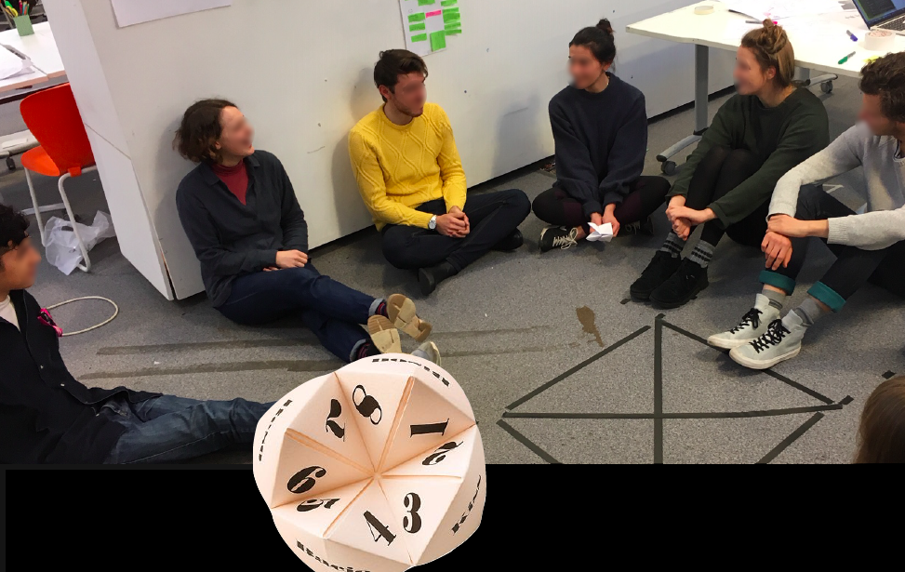
Figure 2 – Icebreaker activity during the pilot session and chatterbox image.

What followed was group forming. First, I have introduced Fuller’s (1975) definition of synergies as the main guiding principle for the students’ attitudes in the session, and then asked the students to stand up so that we could form working groups using Wood’s (2007) four collaborative synergy roles. Each student positioned itself in relation to a matrix resembling the one in Figure 3, created with tape and thread on the floor. Based on their preferences, the students positioned themselves close to one collaborative role or between two or more of roles. This activity allowed the students to get acquainted with these synergistic roles and their interdependence, and reflect on their preferences within the bigger group. Initially, students were reluctant to move in the space (performing in front of their peers) but what slowly emerged was a series of negotiated reflections and spatial positioning which led to the formation of four groups. At the end of the workshop, and to consolidate the learning, the topic of synergies was revisited and reflected upon.
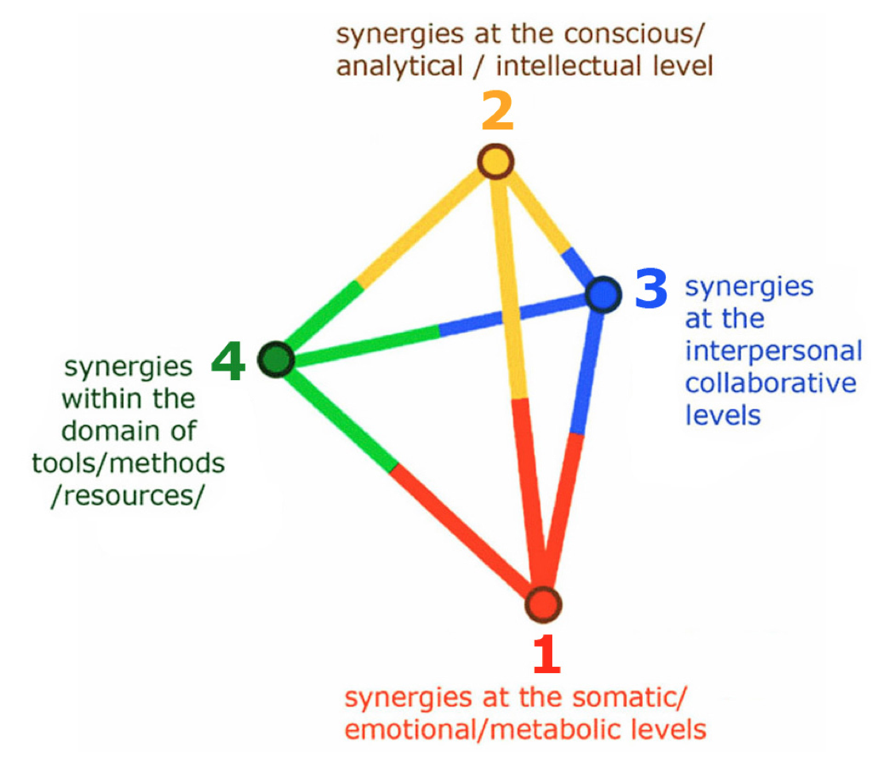
Figure 3 – Four collaborative roles. Source: Wood 2007, 11.

To conduct the main activity of the workshop I have used an overlap of comprehensive frameworks developed previously (Moreira 2018) to brief the students to look at a research context from a complexity stance. Figure 4 shows the overlap of the Rose Window model (McAra-McWilliam 2010; 2015) looking into the modalities of the design activity, the Integral Quadrants (Esbjörn-Hargens 2010; Wilber 1997; Wilber 2006; Fleming 2013) from Integral Theory, and the Quadruple Bottom Line (QBL) of Sustainability (Fleming 2013; Sherman 2013). Each dimension of these frameworks have close relationships with the others and its representation in separate quadrants serves only to facilitate comprehension.
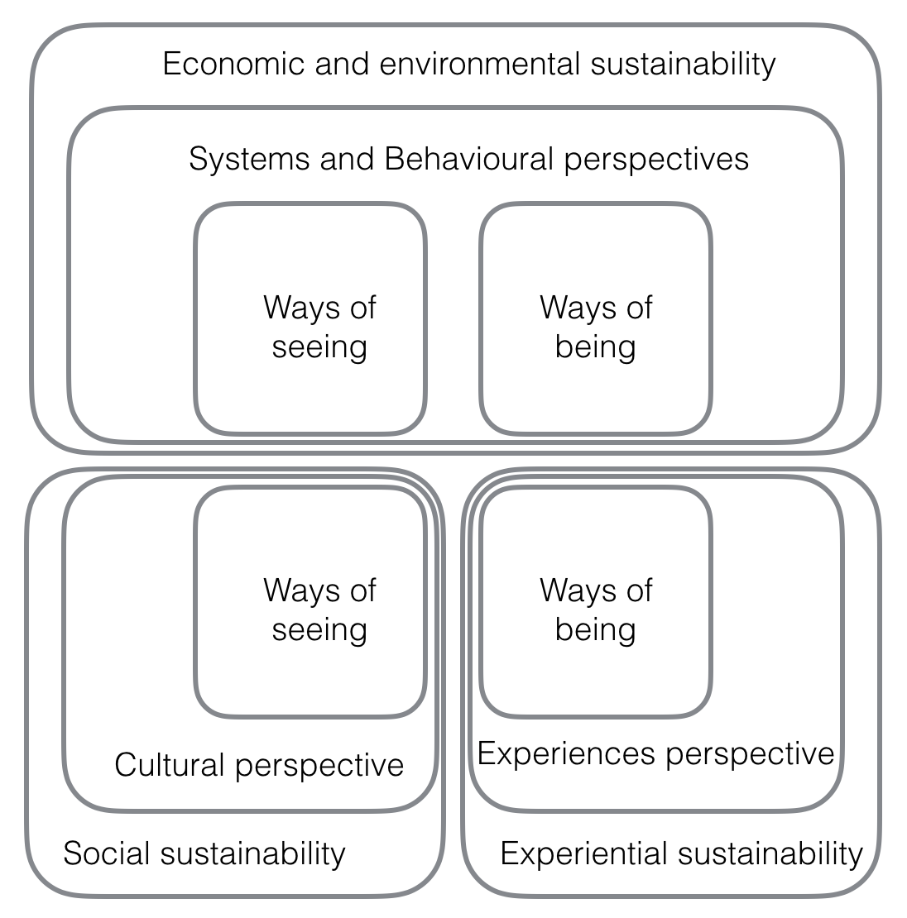
Figure 4 – Overlap of the three frameworks used in the workshop. Source: Moreira 2018

3.2 DISCUSSING THE DYNAMIC: RESEARCHING PEOPLE AND CONTEXT
To each group I have assigned a colour to distinguish the perspectives from which they looked at two main tasks in the workshop: develop a fictional world, and develop strategies to inquire it. The students were expected to build a comprehensive understanding of a context in its wider sense (systemic, geographical, economic, social, and experiential), identify and generate synergies between groups.
In the first task, each group worked separately to develop one aspect of a fictional world which would be used in the second task as a context to inquire qualitatively. Task-one followed a creative thinking dynamic so that students become more familiar with each other and work collaboratively in response to a prompt question (see Table II).
Each group used flip-chart sheets to record their ideas in the form of a poster, and present them to their peers during a plenary discussion. At the end of each presentation the other groups suggested more ideas to enrich what was presented. As illustrated in Figure 5, every new suggestion was recorded on the wall using coloured threads and post-it notes highlighting the emergence of new ideas and synergies between the groups.

Red Group: experiential perspective, ways of being
Task 1 prompts | Create a rich persona-designer to investigate this world
Task 2 prompts | How would your persona investigate this world? Which challenges would they face?
Research discussion | How the researcher and context impact each other?
Blue Group: systems perspective, ways of thinking
Task 1 prompts | How does this place looks, and feels like? Fauna, flora, geography, weather, …
Task 2 prompts | Use the QBL to looking at the possibilities of the systems at play in this context
Research discussion | Identify and map, and analyse different systems
Green Group: behavioural perspective, ways of making
Task 1 prompts | The activities of the people in this place: jobs, hobbies, …
Task 2 prompts | What type of designerly approaches and tools would you use to inquire this world?
Research discussion | Workshops, engagement tools and cultural probes
Yellow Group: cultural perspective, ways of seeing
Task 1 prompts | Characterise the people of this place
Task 2 prompts | Imagine yourself entering this world to research its culture. Which challenges would you face, and how would you solve them?
Research discussion | Access, ethics, interviews, observation, reflexivity
Table II – Focus of each working group and research issues debated

During the workshop, the posters, post-it notes, and thread had a performative role (see Figure 5) in revealing the progression from group-led ideas into an interconnected whole. These were used as knowledge artefacts to guide the students’ learning process (Richter and Allert 2011). By building, creating and manipulating these artefacts the students created new knowledge and worked towards new insights. At the end of the plenary discussion in this first task, the world that emerged from separate groups had many overlaps and coincidental themes, resulting in a cohesive whole.
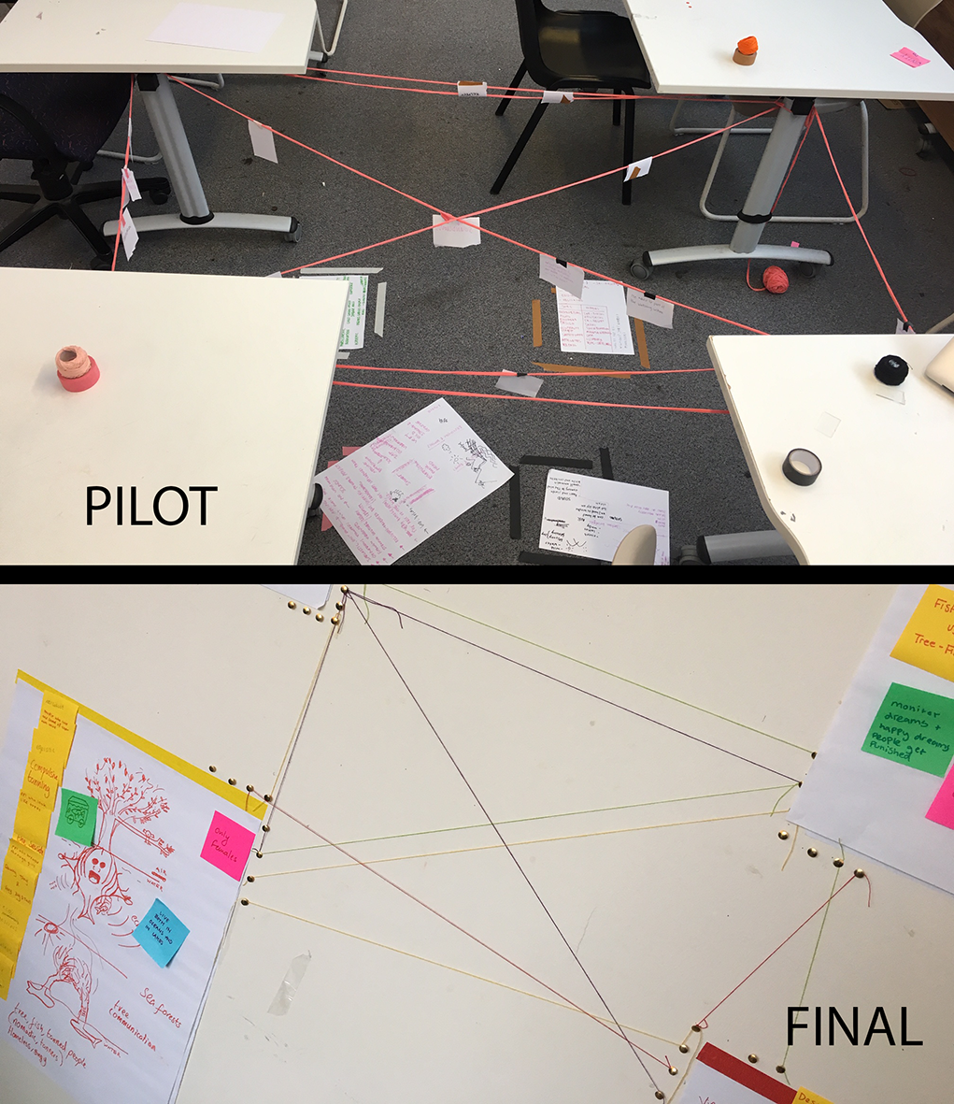
Figure 5 – Knowledge artefacts used in the workshop

For the second main task, I have prompted the students to come up with research strategies to inquire the fictional context they have created. As in the previous task, each group focused on a particular perspective (see Table I). However, this separation was by no means intended to lead students to take an either-or approach but to help them learn first-hand (within their group) and second hand (from other groups) about all-inclusive frameworks to investigate complexity. As with the previous task, the groups worked separately, created a poster with their insights and presented it to theirs peers. During the plenary discussion that followed all suggestions and ideas were recorded with thread and post-it notes. In comparison with the plenary discussion in task one, this time the discussion went beyond ways to improve the research methods presented to include a debate on the possibilities and limitations of each research method.
Throughout the workshop, the visualisation and embodiment activities can be labelled as visual diagrams and performed diagrams (see Baule et al. 2007). This is to say, the students not only created visual diagrams in their posters and in the wall but also behaved as a diagram—observed in their spatial movement, and in the choreography of the session between separate work and plenary discussions—in a pulsing-and-lensing motion (credits of this expression got to Dr. Emma Murphy and Professor Seaton Baxter).

3.3 QUALITIES OF COMPLEXITY IN PRACTICE
To close the workshop, we discussed how the activities of the workshop and the suggested approaches exemplified the key qualities of complexity and synergistic behaviour. This discussion, which I summarise next, is foundational to increase the students’ awareness of how complex systems work in practice, and the attitudes and behaviours which should be cultivated to navigate complexity and generate synergies.
BOUNDARIES
The concept of boundaries was explored in this research by bringing the students’ awareness to the purposive formation of groups from a specific collaborative role, and the group tasks framed by particular perspectives (as depicted in Figure 3, and in Table I). These boundaries were intermittently stretched and negotiated in the plenary discussions with the creation of synergies between the groups, and within each group with the negotiation of individual perspectives. Here, the concept of team-consciousness from synergistic behaviours (Nieuwenhuijze and Wood 2006; Wood 2007) was observed as the students and their groups refreshed their assumptions, and even challenged their expectations at times.
DEPENDENCE ON CONTEXT
To speak about dependence of context without a context would be too abstract for students. Therefore, with the creation of a fictional world, I aimed to motivate the students to playfully engage with new research frameworks, and explore (although in a staged manner) the concept ‘dependence of context’. Also, each student’s views and each group’s ideas were discussed by acknowledging that their personal context and life experiences have an important role in how they look at things.
EDGE OF CHAOS
The choreography of the workshop between separate group work and plenary discussions formed a repetitive cycle—not-knowing to knowing, back to not-knowing to knowing, and so forth—which exemplifies the concept: edge of chaos. During the workshop the students had to trust the process and welcome uncertainty to then flourish with knowledge that allowed them to access further layers of unclear variables. For example, in the task to investigate the fictional world, the students co-created a high volume of diverse information—a type of chaos—, which was disentangled by our final reflective discussions to unpick the challenges and possibilities of relevant elements of the inquiry. The edge of chaos was observed in the following dynamics of this task:
  - from each group’ separate discussions, written notes and diagrams which started loosely and unorganised and took shape as a coherent outcome;
  - from the mix of different ways to inquire a context to the identification of overlaps between groups. Examples include, the Red group’s focus on the mutual impact between researcher and context, the Green group’s focus on engagement with the culture, and the Yellow group’s focus on access to people and place;
  - from the lively debate across groups in the creation of synergies through to a portfolio of approaches we can use in qualitative inquiry.
EMERGENCE
Here, emergence ties in with the synergistic behaviour of co-creating and purposive innovation where new meanings emerge (Nieuwenhuijze and Wood 2006; Wood 2007). These synergies were observed in the workshop through exposure and contact with a variety of theories and opinions, and an overall goal to look for critical combination rather than separation. The students were exposed to a variety of situations and tasks which encourage emergence to manifest. These include:
  - interacting in space with others (for example, in group forming, and group discussions);
  - interacting in space with artefacts (such as chatterboxes, posters, post-it and thread);
  - exploring, connecting and negotiating individual contributions during group work;
  - connecting each group’s outcomes into an whole during the plenary discussions as individual authorship faded.
During the workshop, for example, the students who were expecting a world populated by humans were surprised by the Fish-Trees— a social and intelligent life-from—suggested by the group responsible for defining the world’s habitants. This changed the whole dynamic of the plenary session, and encouraged the creation of more synergies. Additionally, novelty emerged during the icebreaker activity which was full of unknown variables such as:
  - the dynamic of playing with a chatterbox where a number was not chosen by the student answering the question;
  - the randomness of the questions found in the chatterbox, and;
  - the students’ answers.
What was described above, led the students to understand the importance of observing, experiencing, experimenting, and adapting as fundamental behaviours for synergies to emerge.
ORGANISATION
Organisation in complex systems is highly dependent on the elements discussed previously, which are themselves interdependent. The design of the main tasks of the workshop aimed to stage this concept from a complexity stance. The students received partial briefs and worked as interconnected autonomous agents to learn and move forward. In the final reflective discussion I have emphasised that in a complex system (such as people and place) organisation has a fluid structure. Depending on the frame—and context—we use to look at it we see different things with different hierarchies. It is in the edge of chaos and in the constant negotiation of boundaries which lead to the emergence of new structures, that new insights are generated and innovation happens. This way, approaching qualitative research from an AMD has the potential of generating even deeper insights.

4. FINDINGS AND REFLECTIONS
The workshop lasted for three hours and resembled an intense sprint-like session to offer students a stimulating and memorable learning experience.
Reflecting back, and comparing the pilot session with the final session, the two biggest challenges to deliver the final workshop were related to the layout of the room (long and narrow) and bigger size of the second group. In general, this process worked better with a smaller group since the level of involvement was higher allowing more time for in-depth discussion. However, in terms of the number of students in each session (pilot and final), the synergies created in the final workshop were richer, particularly during the creation of the context due to the higher number of participants.
A few adaptations had to be made in terms of the general choreography of the session. For example, due to the number of participants the icebreaker in the final session was not done as a whole but within sub-groups, which limited the potential of the activity.
In both sessions, the plenary discussions were heavily facilitated, so that students could train where to look and what to question. However, more development needs to be done to improve this so that the students take the lead of the discussion. In the future, I want to explore different methods and briefs to encourage students to autonomously seek for the creation of synergies. From my experience this might require, for example, more time devoted to practice creative thinking.
At the end of the workshop all students were handed a feedback form to express their thoughts about their learning experience. As expected, and due to a diversity of learning styles and expectations, group work was pointed out as the most and the least popular aspect of the workshop. The majority of the 36 students found the activities adequate to the content being taught, with two students thinking otherwise; six students abstained from providing an answer. What the students most liked about this workshop, in order of importance, include:
- overall process of the session;
- group dynamics and cooperation between groups;
- content (in other words, the frameworks underpinning the activities), and;
- development of the fictional world, the group forming, and the surprise effect (the unexpected format and outcomes of the workshop).
On the other hand, the aspects least appreciated by the students, also in order of importance, included:
- creating of consensus to form groups, and working within the groups;
- the length of the session (the space layout and temperature of the room influenced the experience);
- the theoretical contextualization, and;
- group work.

CHALLENGES AND LIMITATIONS
Having presented the results of my qualitative inquiry to explore ways to teach complexity to design students to encourage the development of an AMD, I will now discuss its main limitations. These include the contentious use of embodied learning approaches, the time it takes to develop a mindset, and the ungraspable character of a complex system.
First, the use of embodied learning remains contentious (Skulmowski and Rey 2018) and under-researched (Kelan 2010) in the literature in terms of a direct causal relationship between the amount of bodily engagement in teaching activities and learning performance. However, it is not this paper’s intention to evaluate learning performance but to explore potential approaches to explore complexity in design education. Many design educators can perceive an embodied approach to teaching and learning as risky and uncomfortable to facilitate, and students might resist stepping outside their comfort zone and disciplinary ways of working by engaging in exercises that require the to move through space with others instead of making artefacts.
Second, we cannot expect to develop a mindset in a three-hours workshop, but we can certainly offer students the knowledge and tools to seed its growth. The exposure to the qualities of complexity in a staged environment served as a window into new possibilities to look at people and place. However, it will always be the students’ responsibility to seek for and welcome potential epistemological shifts (Norman 2013) in their academic path. This shift is key to engage with complex systems, and this workshop intended to be a starting point in that direction.
Lastly, one of the basic challenges of exploring complexity in education is to make it tangible. As referred to by Cilliers (2001), any model that we produce of complex systems will never apprehend its whole. Framing a complex system will inevitably introduce distortions (Cilliers 2001) because it is dependent on our context (Emmeche 1997) and our perception of it (Byrne and Callaghan 2014). Besides, in order to communicate and make complexity tangible there’s a need for models or representations. These representations are not fundamental truths that can be generalised or tools to predict and control behaviours (Cilliers 2001), but metaphors (Byrne and Callaghan 2014) that help us unlock and thrive in a complex context. In this line of thought, designers are very well equipped to explore complexity as they are well acquainted with using visual representations and metaphors to make the intangible graspable. In my educational approach I used tools familiar to designers, added the body as another tool to improve understanding, and introduced in the final plenary discussion the issues of dependence on context and the distortions resulting from framing complex systems (as found in ethnography and reflexivity, for example).

5. CONCLUSION
This paper represents a first attempt in exploring ways to introduce complexity in the curriculum of design (design innovation, in particular), as a topic with the potential to encourage the development of an AMD.
By introducing the students to the qualities of complexity through experiential learning using visualisation and embodiment activities, my educational approach provides the tangibility needed to provide a better grasp of complexity. Students familiar with the ways of complexity, are more likely to develop more mature epistemological states and resilience which are needed to operate in complex contexts, and enhance their ability to unlock complexity and thrive in it.
The combination of embodiment and visualisation methods I put forward in this paper, aims to encourage other design educators to keep feeding this methodological experimentation with theories of complexity for the development of an amplified mindset of design.

Mafalda Moreira is a Lecturer in Research Methods at the Innovation School from the Glasgow School of Art. With a PhD in Design Innovation from the Glasgow School of Art, an MSc in Innovation and Technological Entrepreneurship from the Engineering Faculty of Porto University, and a degree in Interior Design from ESAD-Escola Superior de Artes e Design (Matosinhos, Portugal). Mafalda has an international and interdisciplinary background that combines design, innovation, entrepreneurship, professional training and higher education. Her research interests include pedagogical methods to bridge knowledge exchange between disciplines, visual mapping, visual research tools and embodied learning. Her current research looks at introducing theories of complexity in teaching design innovation. Contact: The Glasgow School of Art, Institute of Design Innovation, 167 Renfrew Street, Glasgow, United Kingdom G3 6RQ. Email: mafalda.moreira@gmail.com

6. REFERENCES
Abbs, P. (2003) Against the flow: Education, the arts, and postmodern culture. London: Routledge Falmer.

Baule, G., Ciuccarelli, P., Ricci, D. & Scagnetti, G. (2007). Reshaping communication design tools. Complex systems structural features for design tools, In Emerging Trends in Design Research. IASDR Conference Proceedings, pp. 1-20.

Brown, T. (2008). Design thinking, Harvard business review, Vol. 86, No. 6, pp. 85-92.

Byrne, D. & Callaghan, G. (2014) Complexity Theory and the Social Sciences. The State of the Art. London: Routledge.

Cilliers, P. (1998) Complexity and Postmodernism. Understanding complex systems. London: Routledge.

Cilliers, P. (2001) Boundaries, Hierarchies and Networks in Complex Systems, International Journal of Innovation Management, Vol. 5, No.2, pp. 135–147.

Cox, P. (2012) Complexity Science: Understanding Research Processes and Improving Research Practice, Journal of Social Service Research, Vol. 38, No. 5, pp.582-590.

Crang, M. & Cook, I. (2007) Doing Ethnographies. London: SAGE.

Denscombe, M. (2010) The Good Research Guide: for small-scale social research projects. 4th ed. Maidenhead: Open University Press.

Emmeche, C. (1997) Aspects of Complexity in Life and Science, Philosophica, Vol. 59, No. 1, pp. 41-68.

Esbjörn-Hargens, S. (2010) An overview of Integral Theory. In Esbjörn-Hargens, S. (ed.) Integral theory in Action. New York: Suny Press, pp. 33-61.

Fleming, R. (2013) Design education for a sustainable future. New York: Routledge.

Fuller, R. B. (1975). Synergetics: Geometry of Thinking. Macmillan Publishing Company.

Furniss, L. (2015) Beyond Discipline: Design Practice and Design Education in the 21st Century. Report. Strategic Creativity Research Lab.

Haggis, T. (2008) ‘ Knowledge must be contextual’: exploring some possible
implications of complexity and dynamic systems theories for educational research,
Educational Philosophy and Theory, Vol. 40, No. 1, pp 159-176.

Hammersley, M. & Atkinson, P. (1995) Ethnography: principles in practice. 2nd ed. London: Routledge.

Kelan, E. (2010) Moving Bodies and Minds : The Quest for Embodiment in Teaching and Learning, Higher Education Research Network Journal, Vol. 3, pp. 39-46.

Kemmis, S. & McTaggart, R. (1988) The action research planner. 3rd ed. Victoria : Deakin University.

Kolb, D. A. (1984) Experiential learning: Experience as the source of learning and development. Englewood Cliffs, NJ: Prentice-Hall.

Lakoff, G. & Johnson, M. (1999) Chapter 3: The embodied mind. In Philosophy In The Flesh: The Embodied Mind and Its Challenge to Western Thought. New York: Basic Books, pp. 16-44.
Lawson, B. (2006). How designers think: the design process demystified. 4th ed. London: Routledge.
Martin, P. (2010). Making space for Creativity. Brighton: University of Brighton.

McAra-McWilliam, I. (2007). Impossible Things? Negative Capability and The
Creative imagination. In Creativity or Conformity? Building Cultures of Creativity in higher Education. Cardiff, 8th-10th January. Cardiff: University of Wales Institute. [no pagination].

McAra-McWilliam, I. (2010) The Rose Window: Design and the Creative Imagination. Unpublished.

McAra-McWilliam, I. (2015) The Rose Window [Lecture]. Studio 2. The Glasgow School of Art, Institute of Design Innovation, Reid Building Auditorium, 13th April 2015.

McArthur, I. (2010) Creating culturally adaptive pedagogy. In Cumulus Conference
Proceedings: young creators for better city and better life. Shanghai, 6th-10th September. Shanghai: School of Art and Design, Aalto University, pp. 119-126.

McWilliam, E. & Haukka, S. (2008) Educating the creative workforce: new
directions for twenty-first century schooling, British Educational Research Journal,
Vol. 34, No. 5, pp. 651-666.

Mendoza, H. R. & Matyók, T. (2013) Designing Student Citizenship: Internationalised Education in Transformative Disciplines, The International Journal of Art & Design Education, Vol. 32, No. 2, pp. 215-225.

Moreira, M. (2018) The emergence of an amplified mindset of design: distinct approaches to postgraduate design education. PhD thesis, The Glasgow School of Art.

Morin, E. (1999) Seven complex lessons in education for the future. Paris: Unesco.

Morin, E. (2007) Restricted complexity, general complexity. In Carlos Gershenson, C., Aerts, D., Edmonds, B. (eds.) Worldviews, Science and Us: Philosophy and Complexity. Singapore: World Scientific Publishing, pp. 5-29.

Nieuwenhuijze, O. & Wood, J., (2006) Synergy and Sympoiesis in the Writing of Joint Papers; anticipation with/in imagination, International Journal of Computing
Anticipatory Systems, Vol. 10, pp. 87-102.

Norman, C. D. (2013) Teaching systems thinking and complexity theory in health
Sciences, Journal of Evaluation in Clinical Practice, Vol. 19, pp. 1087–1089.

Scagnetti, G. (2011) Visual epistemology for communication design education.

Skulmowski, A. & Rey, G. D. (2018). Embodied learning: introducing a taxonomy based on bodily engagement and task integration, Cognitive research: principles and implications, Vol. 3, No. 1, pp. 6.

Park, J. A., Kim, Y. S. & Cho, J. Y. (2006). Visual reasoning as a critical attribute in design creativity, In Proceedings of International Design Research Symposium. Available at: https://pdfs.semanticscholar.org/ee33/e2584f87f995d6f6e6079425dd0371d25c37.pdf.

Reason, P. & Bradbury, H. (2008). Editorial, Action Research, Vol. 6, No.1, pp. 5–6.

Richter, C. & Allert, H. (2011) The epistemic role of artefacts in creative design and knowledge creation. In DS 69: Proceedings of E&PDE 2011, the 13th International Conference on Engineering and Product Design Education. London, 8th-9th September.

Sherman, A. (2013) Quadruple Bottom Line. Thesis, Faculty of Philadelphia University.

Stevens, I. & Cox, P (2008) Complexity Theory: Developing new understandings of child protection in field settings and in residential care, British Journal of Social Work, Vol. 38, No. 7, pp.1320-1336.

Wilber, K. (1997) An Integral Theory of Consciousness, Journal of Consciousness
Studies, Vol. 4, No.1, pp. 71-92

Wilber, K. (2006) Introduction to Integral Theory and Practice, Journal of Integral
Theory and Practice, Vol.1, No. 1, pp. 1-38.

Wood, J. (2007) Win-Win-Win-Win: Synergy Tools for Metadesigners. In T. Inns
(ed.) Designing for the 21st Century: interdisciplinary questions and insights. Aldershot: Gower, pp. 114-28.

Yee, J., Jefferies, E. & Tan, L. (2013) Design Transitions. Amsterdam: Bis Publishers.

Ziemke, T. (2003). What’s that thing called embodiment? In Proceedings of the annual meeting of the cognitive science society, Vol. 25, No. 25, pp.1305-1310.

