Royal Scottish National Orchestra & GSA: The Vienna Connection
Wednesday 2 October 2019 7:30pm, French Institute for Scotland

Saturday 5 October 2019, 3.00PM at Glasgow Royal Concert Hall
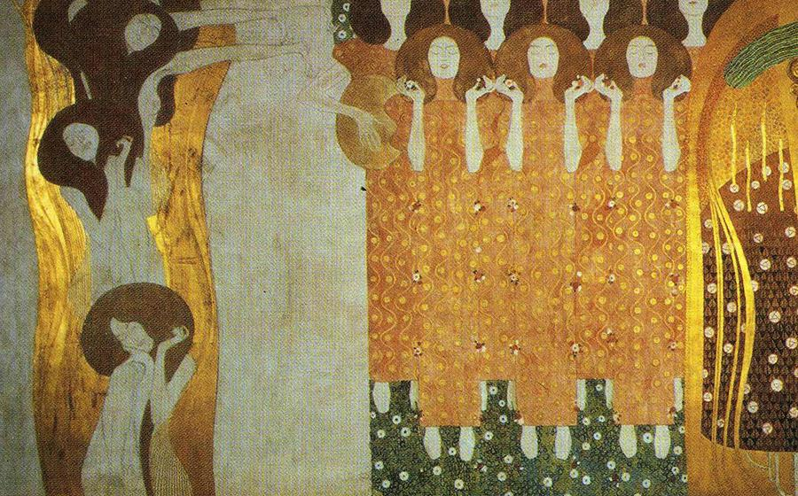
Thomas Søndergård RSNO Music Director
Prof Johnny Rodger Glasgow School of Art
Bill Chandler RSNO Director of Concerts and Engagement
Join Thomas Søndergård and guests for a round-table discussion with film, recordings and live music as they uncover the fascinating context in which the Romantic movement of Beethoven and Goethe reached its pinnacle and gave birth to the modern. In Focus: The Vienna Connection launches our journey through the golden age of this vibrant city with a virtual gallery of works by Gustav Klimt; a tour through the architecture and designs of Otto Wagner; an exploration of the great Charles Rennie Mackintosh and his exhibitions in Vienna; and even an encounter with Sigmund Freud!
https://www.glasgowlife.org.uk/event/1/rsno-201920-delve-deeper-in-focus-the-vienna-connection

