Title: Innovative education and engagement tools for Rheumatology and Immunology Public Engagement with Augmented Reality

Timea Kosa^{1,2}, Louise Bennett¹, Daniel Livingstone², Carl Goodyear¹, Brian Loranger²
1 University of Glasgow
2 The Glasgow School of Art
Abstract
Rheumatoid arthritis (RA) affects around 1% of the population, which places a heavy burden on society and has severe consequences for the individuals affected. The early diagnosis and implementation of disease-modifying anti-rheumatic drugs significantly increase the chance of achieving long-term sustained remission. Therefore, raising awareness of RA amongst the general public is important in order to decrease the time of diagnosis of the disease.
Augmented reality (AR) can be tremendously valuable in a teaching and learning context, as the coexistence of real and virtual objects aids learners in understanding abstract ideas and complicated spatial relationships. It has also been suggested that it raises motivation in users through interactivity and novelty.
In this chapter we explore the use AR in public engagement, and detail the design, development and evaluation of a blended learning experience utilising AR. A set of informative printed posters was produced, enhanced by an accompanying interactive AR application. The main user testing was conducted with 27 participants at a science outreach event at the Glasgow Science Centre. Findings report mean positive attitudes regarding all aspects of the study, highlighting the potential of AR for public engagement with topics such as RA.

Introduction

The National Co-ordinating Centre for Public Engagement (NCCPE) defines public engagement as:

“The myriad of ways in which the activity and benefits of higher education and research can be shared with the public. Engagement is by definition a two-way process, involving interaction and listening, with the goal of generating mutual benefit.” (NCCPE, 2018)

The idea of a two-way conversation in the engagement process is crucial to the success of the engagement. This change from thinking that we must fill a deficit in public understanding to a meaningful and two-way dialogue is now recognised by scientists, funders and policy makers (Stilgoe et al 2014). However, keeping the information that we wish to discuss with the public accessible and understandable to a wide range of audiences can be challenging.
Even today, there are regrettably still some in the STEM professions that do not appreciate the importance of public engagement. In response, NCCPE have laid out five guiding principles of public engagement that also help emphasis why engagement with the public matters. Firstly, we are accountable for the public funding that we receive, with the UK government investing over £10 billion annually into research and development over the last 5 years (Office of National Statistics, 2018), and we must be transparent in how this money is spent. Secondly, Universities conduct research with the ultimate aim of benefitting both the local and wider communities, and as such we have a responsibility to explain this research and its implications to those communities. At times, the long-term benefits of some forms of research (such as basic science) can be hard to see directly, and so we must be effective in helping the public to understand our motives, the downstream effects of research, and our ultimate end goals. It is easy to lose sight of these values when there is a massive drive for Research Excellence Framework within the university setting, which often leads to engagement being overlooked as a meaningless or pointless activity. However, the NCCPE have encouraged us to make public engagement a core value of the University, and to use the dialogue in engagement to help to get back to what drives us as researchers in the first place. Thirdly, in a climate which is increasingly hostile to a perceived academic elite, building trust between the public and academic institutions is of the utmost importance. We are no longer able to function solely on the terms of the academic institute; instead we must now listen to the opinions of the wider community. The public engagement dialog can help the wider community to develop informed opinions about what we do and ultimately build trust in our work and research. Fourthly, if we are responsive to the comments of the wider public and respond positively to them, the relevance and impact of our research is improved significantly. A well-developed public engagement strategy is the best way to build this relationship and the subsequent dialogue. Finally, we must be relevant in the manner in which we engage, not only with the content of our engagement and how our research can be integrated into the world that we currently live in, but also in the means by which we communicate. Today’s world has a wealth of communication modalities beyond the traditional didactic lecture. This ranges from social media platforms, podcasts, and online videos, to newer, more interactive mediums such as augmented and virtual reality tools. We must ensure that we are using the most effective and relevant media to engage with our target audience.
New Ways to engage with the public.
Engagement is not a new concept and there are many examples of good engagement activities and different forms of media that we can use to engage the public. In today’s age of fast paced technology advances, it is important to stop and explore new media that are available as engagement tools, such as augments and virtual reality, as these may offer more effective means of engagement for wider audience groups.
New technologies can now allow for easier visualisation and comprehension of complex scientific information. In 1997 Azuma defined augmented reality (AR) as a system that allows real time interaction in a combined and accurately aligned blend of virtual and real environments (Azuma, 1997). Due to these unique attributes of AR, we can help to breakdown complex scientific concepts such as immunological relationships in Rheumatological disease states and this merging of real and augmented realities together can also add new dimensions to learning. There are two types of AR: “location-based” and “image-based”. its name suggests, location-based AR uses a location (such as GPS or Wifi connection) as a marker to overlay relevant augmented information for the users. Alternatively, image-based AR relies on an image to trigger augmented information. This image can be a pre-made marker for a specific application, such as a symbol on a poster (marker-based) or it can rely on makers that already exist in the real world (such as a human face). AR is fast becoming a popular tool in public engagement and this is perhaps partly due to the lack of ‘high tech’ equipment that is required, as an AR program can be loaded onto a tablet, smartphone or smart glasses.
Another advantage in using AR as an educational tool is its potential to reduce cognitive overload, caused by presenting an individual with too much information at once or having information in multiple places in which the user has to switch focus from the task to read instructions for the next step of their given task (Bower, et al 2014). Using markers or anchors, the designer can choose when extra information is given, ensuring that only information that is relevant to that precise moment or situation can be seen by the user, reducing the risk of cognitive overload. In addition, by giving the user the option to choose to see additional information or information of increasing complexity, the risk of cognitive overload can also be reduced. (Bower, et al 2014).
Wu et al., (2013) identified 5 distinct features of AR that can complement learning and teaching. These are: learning about 3D content and being able to manipulate it; collaboration with the AR environment; a sense of presence and immersion in a subject; visualising invisible content; and bridging formal and informal learning. These features are all sought after in science education, especially in the fields of anatomy and medicine. (Evidence showing AR in formal education). In principle, they also lend themselves to public engagement, though the efficacy of AR remains relatively unexplored in such an informal setting. One study of the use of augmented reality to improve learning in a science museum supported the idea that the use of digital augmentations helps the development of scientific knowledge (Yoon et al 2012), suggesting that continued exploration of the use of AR for public engagement could be worthwhile.

Why do we need new tools for Rheumatology Public Engagement?
Public engagement can be challenging, especially where the scientific material is complex. In the field of immunology, for example, most of the subject matter is at the microscopic level and is based on many complex relationships. This can be hard to convey through traditional media and risks leading to cognitive overload. By using the aspects of the real environment overlayed with AR, we can help to break down these complex components and concepts. Take, for example, an immune reaction that causes inflammation within the body. In the real world environment, we can identify inflammation caused by an immune reaction due to its painful, red and swollen appearance. With the use of AR, however, we could see beyond this outward appearance and look under the skin, looking down a “virtual microscope” at the immune cells and molecules that drive inflammation. Similarly, in a disease such as rheumatoid arthritis, the joints affected can be identified as being swollen and stiff, but the microscopic drivers of the disease and the complex interactions that potentiate the inflammation cannot be seen without additional resources. Due to the failing of other forms of media to the convey complex nature of autoimmune disease states such as rheumatoid arthritis, we must now turn to new technologies that have been shown to be promising for this educational purpose.

Engagement with regards to rheumatoid arthritis is often difficult, as the wider public have misinformed opinions that have become an accepted norm. Several studies have shown that the general public believe that RA is benign and only associated with aging and the elderly, when in fact it is a disease that can affect anyone at any age and severely affects quality of life, but can be successfully treated if identified early. Changing these engrained attitudes and opinions is challenging. To this end, the European League Against Rheumatism (EULAR) launched a campaign called ‘Don’t Delay, Connect Today’ (DDCT) that aimed to raise awareness of rheumatological conditions, encouraging people to be aware of the early warning signs and the need for early diagnosis and treatment of these conditions. This campaign is especially important in younger individuals who often believe that arthritis will not affect them, or who feel embarrassed that they have symptoms that are commonly associated with the elderly. Engagement is also important for patients already diagnosed with RA. A study conducted by Walker et al. (2007) showed that if patients were given an information booklet about the disease they not only gained significantly more knowledge about their disease but were also less anxious and depressed than those who did not receive the booklet.

It is well established that there is a great need for effective methods in raising awareness of the importance of early diagnosis in RA, as missing the 12 weeks ‘window of opportunity’ can result in worse remission rates (van der Linden et al., 2010). Adequate outreach has proven to decrease diagnosis delay over time (Zafar et al., 2012). Implementing innovative ways of informing the public could result in greater engagement with RA, and therefore shorter periods before diagnosis. AR presents itself as an ideal method for achieving greater engagement, as it enables the explanation of complex ideas in adaptable ways and may raise motivation in users through interactivity and novelty (Bacca et al., 2015).

However there remains a wide lack of awareness of RA, and accordingly a need to investigate other methods of engaging and informing the public on RA. As noted above, prior work on Augmented Reality has rated highly for being engaging and effectively supporting knowledge transfer, and accordingly we set out to create a Public Engagement application for RA using AR.

Interactive Print
Combining AR with printed material presents itself as an ideal method for public engagement. The familiarity of printed educational material combined with the novelty of AR can promote the intrinsic motivation for exploration of a subject (Liarokapis and Anderson, 2010). These materials are referred to as interactive print.

Large quantities of virtual information can be added to these printed pages, which risks negatively impacting on the cognitive load of the reader. Accordingly materials should be designed with this risk in mind, allowing free exploration where learners can decide the amount of content they consume, thus reducing the risk of cognitive overload (Nadolny, 2017). Some studies suggest that irrelevant material should be omitted altogether (Mayer, 2010). Presenting learners with additional unnecessary information may over load cognitive processing capacity and thus learners might not achieve the expected learning outcomes.

Rheumatosphere
Rheumatosphere is a research group at the University of Glasgow, which organises public engagement events on a regular basis (Rheumatosphere, 2018). One frequent venue for events is the Glasgow Science Centre, a science museum, open to the public, where a diverse range of people can be reached. Therefore, the design of the applications and print material had to cater to a wide age range and fit into a science centre environment. It was established that the final products must be easily portable, as Rheumatosphere organises outreach events all over Glasgow and Scotland.
Interactivity, ease of use and quick access were important principles during the conceptual design process. The initial idea was a small booklet with an accompanying AR application, that shares information on the nature of RA, its symptoms and causes, as well as the importance of early diagnosis. The concept of a booklet was later revised to be a series of posters, as the poster format lends itself to a more explorative way of use with the AR application in a public engagement setting for a number of reasons. First, there is no strict narrative throughout the posters, allowing participants can explore the elements that interest them, and at the pace and order of their liking – rather than following the order imposed by leafing through a booklet. Large format, image-heavy posters also stand out more in a busy exhibition environment and presented greater prospects of getting people more interested in the content.
The implementation of AR could also promote intrinsic motivation for the exploration of the subject, as it is still a relatively novel technology that can raise interest in the general public. AR also allows for including large amounts of information without overwhelming the reader, as the amount of interaction is defined by the user (Nadolny, 2017).

Rheumatosphere AR

A series of five augmented posters were designed and a companion tablet AR app developed. The first poster provided basic information on the project, highlighted common symptoms of RA and encouraged participants to seek medical advice if they experienced some of the early signs. This poster was not augmented. The remaining four posters all included augmented content, and are detailed below.
The second poster (Figure 1) describes in greater detail the symptoms, causes, and the toll the disease exerts on the individual and society. This poster triggers augmented reality content (Figure 2) in the companion app.

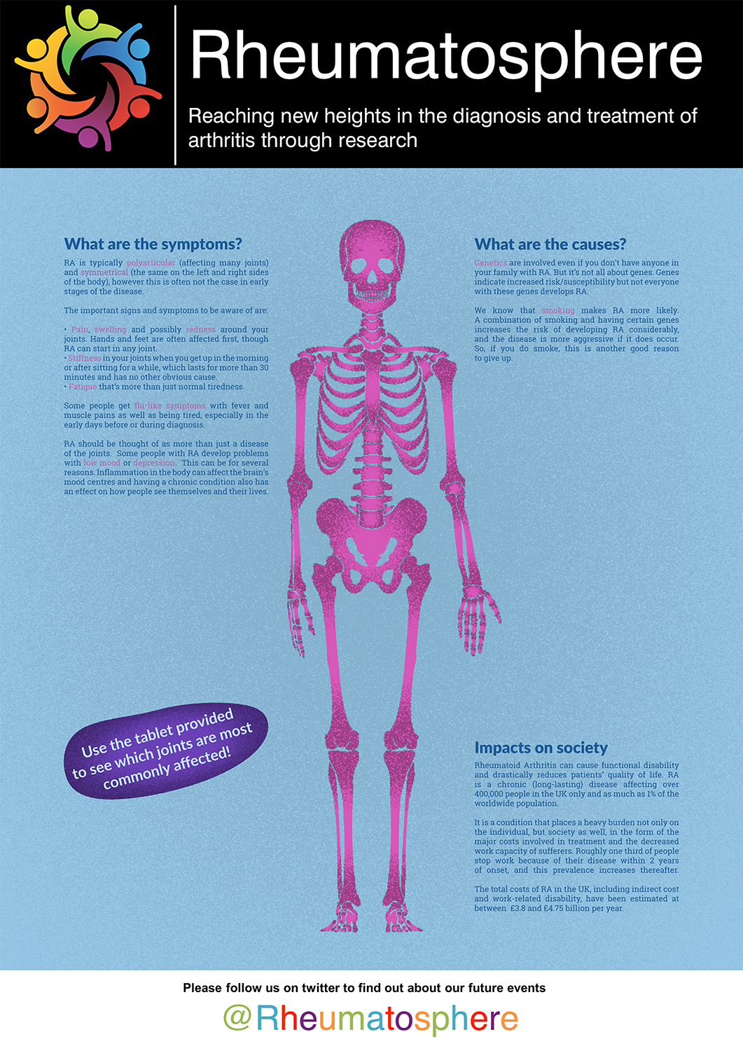
Figure 1. The second of five posters, and the first to have augmented reality content linked through the companion app.

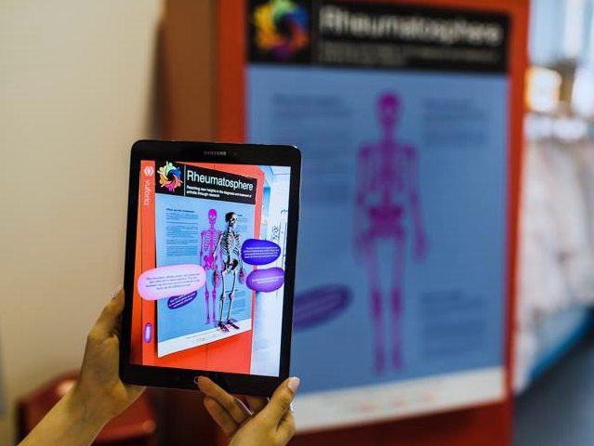
Figure 2. Using the companion app, a 3D skeleton model and additional information is overlaid over the second poster. Image: Glasgow Science Centre.

The AR content for this poster shows a 3D model of a human skeleton and additional information in the form of a set of text pop-up bubbles. By rotating the skeleton, users can see joints that can be susceptible to RA, including some spinal joints, highlighted.
The third poster (Figure 3) shows a diagram of a healthy joint explaining the structures found in the synovium and a short explanatory text on how synovial joints work. A second diagram depicts a joint affected by RA and describes the changes the disease causes inside the joint capsule. The two diagrams trigger two different AR instances.
An image of a healthy joint triggers the display of a 3D model of the metacarpophalangeal joint. Users can zoom in on this, and click on parts of the joint to find out the name of the structures. The image of the RA affected joint triggers a similar 3D model, this time showing inflammation of the synovium and destruction of the cartilage and bone.
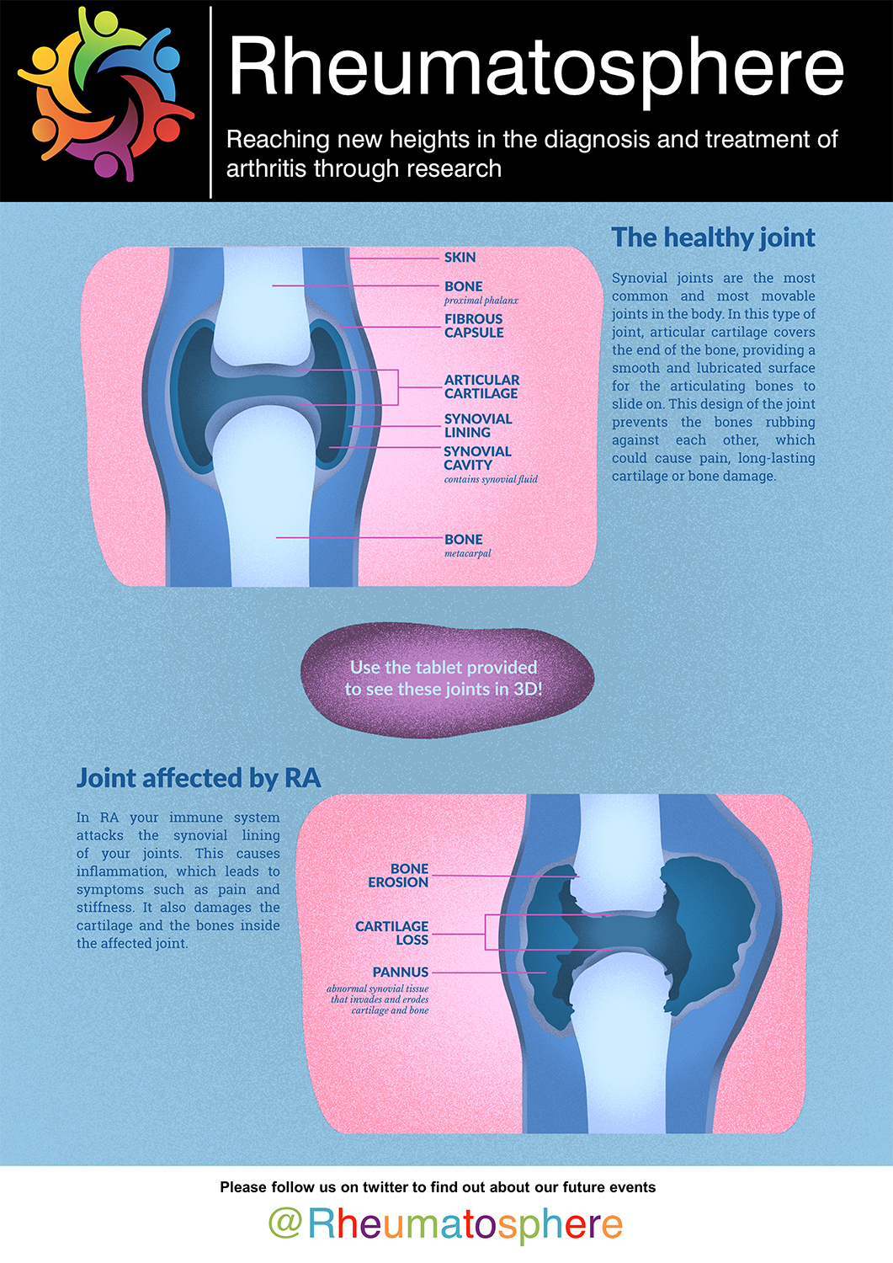
Figure 3. The third poster features two different diagrams, each of which has augmented content in the companion app.

The fourth poster (Figure 4) is printed with a diagram of the cells active inside the RA joint, as well as some links for people wanting to find more out about the disease. The diagram triggers an AR scene with the cells depicted in 3D and with animated arrows showing the relation between each immune cell. A small information text panel is shown for each cell, explaining their role and how they stimulate each other in the disease.

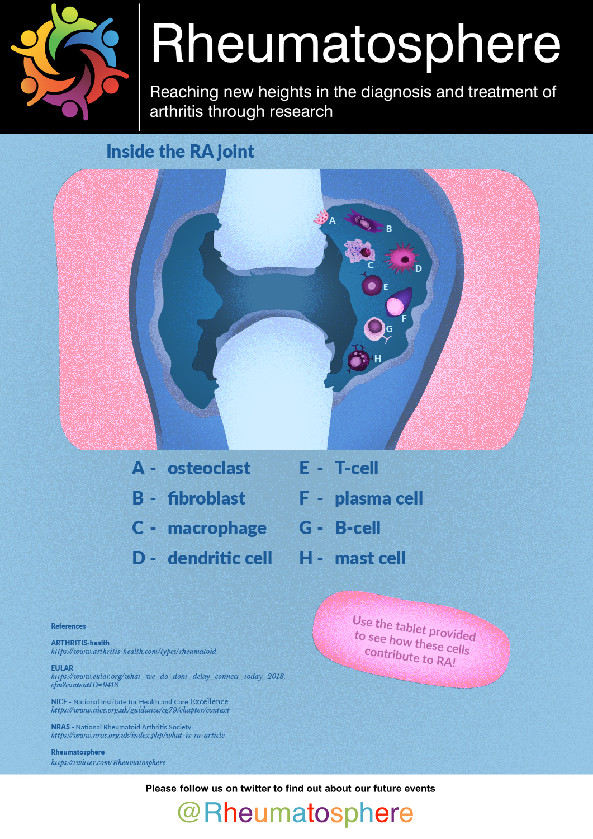
Figure 4: The fourth poster has a single diagram and matching AR content

The fifth poster (Figure 5) shows the bones and joints of a healthy hand and describes the complications RA can have on bone structure. It was designed to be displayed horizontally, as it requires physical interaction (putting one’s hand on the purple hand sign) to trigger the AR component assigned to the poster.

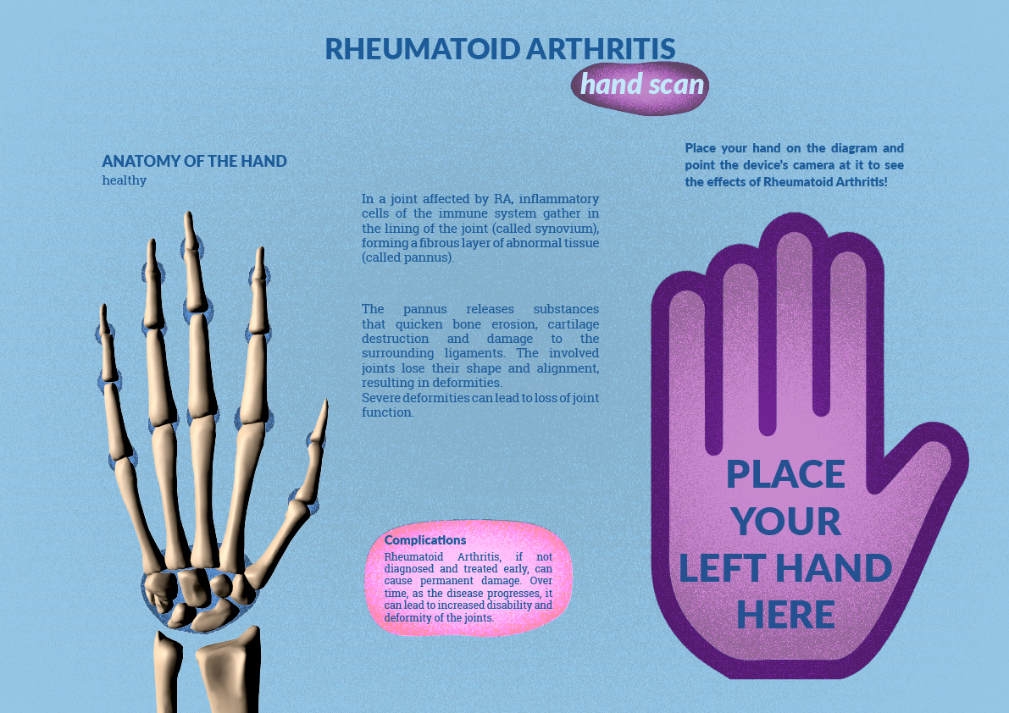
Figure 5. The fifth poster is printed as a smaller scale for display on a table, and is designed to display AR content over a visitor’s hand

Pilot Study
The posters were displayed at a public engagement event at The Glasgow Science Centre – ‘Science Lates: Move’. This took place in early August 2018. During the evening, 27 visitors used the app and completed a survey. The app on was made available on Samsung Galaxy S2 tablets with the application preloaded that were set up ready for visitors to use. This avoided any requirement for visitors to download the app for their own devices.
Visitors were recruited to participate during the event and were able to opt-in after reading the participant information sheet and signing a consent form. Visitors choosing not to participate in the study were still allowed to explore the posters and AR content. All visitors were able to take as much time with the application as they wanted and access as much of its content as they wished. When finished, participants completed a questionnaire about their experience.

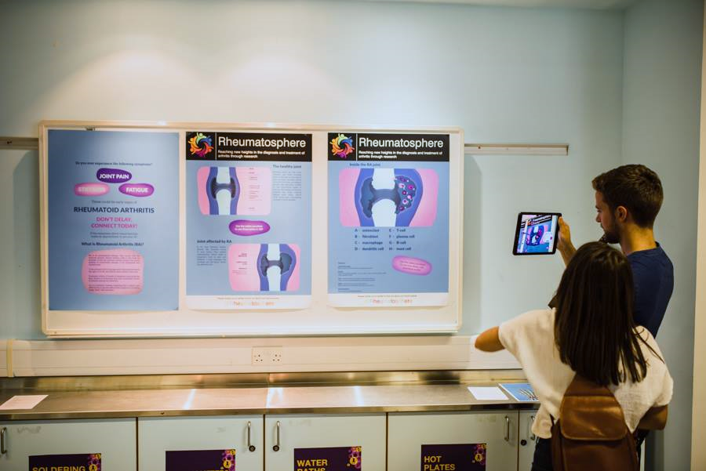
Figure 6. Visitors at the Glasgow Science Centre using the application to view augmented reality content over the posters. Image: Glasgow Science Centre.

Results
A majority (16) of the (n = 27) participants were in the 25-34 years age group. A large number of participants also had at least an undergraduate degree in a life-science - 8 of the 16 participants in the 25-34 years age group, 3 of the 5 in the 18-24 years age group and just 1 of the 6 in the 35 plus age group. This may be indicative of the audience which attends the Science Lates events, which will naturally attract visitors with a strong interest in science. Three of the participants reported that they had a diagnosed musculoskeletal condition. Less than half of the participants (44%) had used AR before, with younger participants more likely to have previous experience.
The application was rated very strongly in all aspects related to usability. For example, the participants found the application easy to use (89% agree/strongly agree), and thought that most people would be able to learn to use the application quickly (96% agree/strongly agree), and there were no negative responses related to ease of navigation and understanding.
Similarly, participants found the application engaging, with users with no prior AR experience giving slightly more positive response here – potentially showing a ‘novelty’ factor, although the difference was not statistically significant. Again, there were no negative results on the question “I found the AR component fun and interesting”, and the vast majority of participants (92%) stated that they would like to use similar applications in the future.
Finally, the AR experience also scored very highly for helping participants learn about RA and the human body (again, 92% agreement), and over half of participants stated that they would let friends and family know about the risks, symptoms and diagnosis of RA – an important result for effective public communication, potentially multiplying the direct impact from reaching attendees at the event itself.

Conclusions
The engagement experienced with Rheumatosphere AR was very strong, with a very positive response from visitors. This alone is highly encouraging, and we aim to continue the use of AR in our ongoing public engagement activities. The experience was particularly popular with visitors who had no prior experience of AR, and was well received overall. From our experience, we summarise the advantages of interactive print posters for public engagement as:
- The AR poster plus app format allows for rich and detailed content while reducing the need for the posters themselves to be overloaded with text and information, resulting in more visually attractive posters
- The AR app attracted visitors to engage with the exhibit
- Visitors were very positive about the AR experience, but this did not overshadow the content with visitors stating that they had learned from the experience
The limitations in comparison to traditional posters are that:
- Additional development costs and time to create app as well as poster
- As users become more familiar with AR there may be a diminishing return as people may be less attracted to the novelty of using AR to explore educational / informational content
There were some additional limitations that were observed during the study. It was noted that some visitors would skip over text and focus purely on the AR enhanced diagrams, potentially missing much useful information. Potentially audio narration could be used, to be played while users view 3D models and animations. Playing or presenting information after relevant interactions may also be a more effective means of embedding information in the app.
Finally, we recognise that the design of the study presented here is limited. A more comprehensive and larger study might have compared the engagement and impact of traditional versus interactive print versions of the Rheumatosphere posters. However, we found the strong and highly positive engagement very promising and feel that the project highlights the potential that augmented reality can have in public outreach and for raising awareness of medical conditions.

References

Azuma, R.T., 1997. A Survey of Augmented Reality. Presence: Teleoperators and Virtual Environments 6, 355–385. https://doi.org/10.1162/pres.1997.6.4.355

Bacca, J., Baldiris, S., Fabregat, R., Graf, S., Kinshuk, 2014. Augmented Reality Trends in Education: A Systematic Review of Research and Applications. Educational Technology & Society 17, 133–149.

Bower, M., Howe, C., McCredie, N., Robinson, A., Grover, D., 2013. Augmented reality in Education — Cases, places, and potentials, in: 2013 IEEE 63rd Annual Conference International Council for Education Media (ICEM). Presented at the 2013 IEEE 63rd Annual Conference International Council for Education Media (ICEM), pp. 1–11. https://doi.org/10.1109/CICEM.2013.6820176

Liarokapis, F., Anderson, E.F., 2010. Using Augmented Reality as a Medium to Assist Teaching in Higher Education, in: Eurographics 2010 - Education Papers. Presented at the Eurographics 2010, The Eurographics Association. https://doi.org/10.2312/eged.20101010

van der Linden, M.P.M., le Cessie, S., Raza, K., van der Woude, D., Knevel, R., Huizinga, T.W.J., van der Helm-van Mil, A.H.M., 2010. Long-term impact of delay in assessment of patients with early arthritis. Arthritis Rheum. 62, 3537–3546. https://doi.org/10.1002/art.27692

Nadolny, L., 2017. Interactive print: The design of cognitive tasks in blended augmented reality and print documents. British Journal of Educational Technology 48, 814–823. https://doi.org/10.1111/bjet.12462

NCCPE, n.d. What is public engagement? [WWW Document]. URL https://www.publicengagement.ac.uk/about-engagement/what-public-engagement (accessed 10.01.19).

Office for National Statistics, 2018, Government expenditure on science, engineering and technology (UK) [WWW Document]. URL https://www.ons.gov.uk/economy/governmentpublicsectorandtaxes/researchanddevelopmentexpenditure/bulletins/ukgovernmentexpenditureonscienceengineeringandtechnology/2016 (accessed 3.12.19).

Stilgoe, J., Lock, S.J., Wilsdon, J., 2014. Why should we promote public engagement with science? Public Underst Sci 23, 4–15. https://doi.org/10.1177/0963662513518154

Walker, D. et al. (2007) ‘Patient education in rheumatoid arthritis: The effectiveness of the ARC booklet and the mind map’, Rheumatology, 46(10), pp. 1593–1596. doi: 10.1093/rheumatology/kem171.

Walker, D., Adebajo, A., Heslop, P., Hill, J., Firth, J., Bishop, P., Helliwell, P.S., 2007. Patient education in rheumatoid arthritis: the effectiveness of the ARC booklet and the mind map. Rheumatology (Oxford) 46, 1593–1596. https://doi.org/10.1093/rheumatology/kem171

Wu, H.-K., Lee, S.W.-Y., Chang, H.-Y., Liang, J.-C., 2013. Current Status, Opportunities and Challenges of Augmented Reality in Education. Computers & Education 62, 41–49. https://doi.org/10.1016/j.compedu.2012.10.024

Yoon, S., Anderson, E., Lin, J., Elinich, K., 2017. How Augmented Reality Enables Conceptual Understanding of Challenging Science Content. Journal of Educational Technology & Society 20, 156–168.

Zafar, S., Badsha, H., Mofti, A., Delosantos, A., Altares, J., Matudio, G., Kong, K.O., 2012. Efforts to increase public awareness may result in more timely diagnosis of rheumatoid arthritis. J Clinical Rheumatology 18, 279–282. https://doi.org/10.1097/RHU.0b013e3182676975

