Supporting students’ self-directed experiences of studio learning in Communication Design: The co-creation of a participatory methods process model

Lorraine Marshalsey
Griffith University, Australia

Madeleine Sclater
Glasgow School of Art, Scotland, UK

This interdisciplinary paper discusses the meaning of open, critical, communal, and discursive learning spaces in higher education. It draws on recent research (Marshalsey, 2017) that illuminates the relationship between sensory affect and learning in studio education. It focuses on the extension and development of new learning configurations in the design studio, augmented by technology enhanced learning. Sensory affect is a form of feedback that can be used by learners to analyse and interpret the impact of the learning environment around them. This study used sensory affect as a lens through which to understand students’ experiences of practice-based learning in Communication Design spaces in two distinct higher education settings in the United Kingdom and Australia.

The evolution of specialist design studio learning spaces, from physical studios to a blend of virtual and online educational environments, has led to significant debate about how to design, use and evaluate learning spaces for practice-based design disciplines. The paper uses the methods process model, based on participatory design tools (Marshalsey, 2017; Sanders

- Stappers, 2008). The MPM supports students and educators to qualitatively interpret and critique their learning spaces more explicitly within their design education.

Introduction

Technological advancements and widening participation in higher education are factors directly influencing students’ experiences of and orientation to design studio education today (Marshalsey & Sclater, 2018). The gradual evolution of specialist design studio learning spaces from conventional physical studios to a blend of virtual and online educational environments is a development that has led to significant debate about how to design, use as well as evaluate learning spaces – not least for practice-based subjects such as Communication Design. This design discipline was traditionally studio-based, and today Communication Design retains conventional processes derived from graphic design, photography and illustration. This discipline communicates information to people using visual and non-visual media, and it embraces a broad range of analogue and digital tools and techniques. Communication Design employs a different set of skills, applications, practices, and functions than those used in other design disciplines. Its project-based framework focuses on team working, client-driven projects, social interactions, and creative collaborations.

This paper investigates the co-creation of a participation framework (referred to as a methods process model (MPM)) with Communication Design students as participants, from an earlier doctoral study (Marshalsey, 2017). The outcomes of the intervention-based research study, discussed in this paper, aim to support students to self-direct, manage and plan their optimal conditions for learning (learning-how-to-learn) within their practice-based education. The MPM was originally constructed through the identification and development of a set of participatory design (PD) ethnographic tools and techniques used across two case studies in the United Kingdom and Australia (Marshalsey, 2017; Sanders & Stappers, 2008). This framework enabled the participants to qualitatively reflect upon their learning spaces and to explore and work with their experiences of learning spaces more explicitly within their design education.

This interdisciplinary paper endeavours to discuss what is meant by open, critical, communal, and discursive spaces in higher education. This is achieved by drawing on recent research that illuminates, in particular, the relationship between sensory affect and learning in studio education in which technology enhanced learning is used to augment, extend and develop new learning configurations in the design studio (Marshalsey & Sclater, 2018). Sensory affect is that which we perceive through our senses and is a particular form of feedback that can be used by learners to analyse and interpret the impact of the

environment around them. Employing sensory affect as a lens helped to focus the research with design students to support their self-directed experiences and accounts of their everyday studio learning spaces.

The paper specifically discusses the context of the doctoral investigation (Marshalsey, 2017) with reference to the role of the studio in contemporary learning spaces, the challenges currently facing studio education and the original research aims and questions. We then move on to a brief review of the studio as a learning space and as a site for learning, and the need for a sense of place in studio-based learning today. In relation to the research methodologies and methods, participatory action research (PAR) (Kemmis, McTaggart, & Nixon, 2014) and its relationship to PD is outlined and the visual, sound and sensory ethnographic methods are discussed. The paper concludes with a brief examination of the findings and the potential future directions of the MPM research investigation.

The role of the studio and the current challenges affecting studio learning environments

Art and Design education appears to have seen a shift from closed classrooms to open-plan, live-in to drop-in, and, to some extent, physical to digital learning and teaching. In recent decades, studio learning has become fashioned by activities and events rather than the space itself, with students, in some institutions, attending the studio space solely for necessary critiques, group work, project launches, or assessment purposes (Boddington & Boys, 2011; Boling, Schwier, Gray, Smith, & Campbell, 2016; Scott-Webber, Branch, Batholomew, & Nygaard, 2014). Today, Communication Design practice and learning often spans the formal educational (studio) environment of institutions, informal environments of home and non-owned spaces, such as museums and cafés, and physical and digital forms of learning space. Therefore, because studio pedagogy is perceived and practised in various formal and informal spaces and embedded in a wide range of curriculum programmes, the character and delivery of studio activities can vary. Students are now experiencing the studio without a consistent sharing of studio features or attributes in an irregular landscape of provision (Boling et al., 2016). In consideration of these changes, recent literature now points to studio learning as being dissimilar to traditional studios. It is not uncommon, therefore, for educators nowadays to have a “received understanding” of studio rather than first-hand experience (Boling et al., 2016, p. 5).

Today, it is becoming increasingly difficult to align qualitative student-centred pedagogy with the modern campus and its repertoire of physical learning spaces (van Merriënboer, McKenney, Cullinan, & Heuer, 2017). Specifically, technological developments and widening participation in higher education have directly influenced students’ and educators’ experiences of Communication Design studio education. These transformations affect teaching and learning innovation, as more teaching for less is expected in visually pleasing, formal and informal physical, virtual and online learning spaces designed to accommodate technology and peer collaboration for large numbers of students (Swart, 2017; Vignoles & Murray, 2016). It is clear that Communication Design education cannot return to previous modes of purely physical studio learning due to larger student year groups combined with the widespread use of technology enhanced learning. Several studies question the acceptance and effectiveness of technology enhanced learning in higher education, and the extent to which it is contributing to an enhancement of the student learning experience (Bayne, 2015; Kirkwood & Price, 2014).

Research aims and question

The original doctoral research investigation had the following three aims:

- explore the different ways in which participants qualitatively interpret a range of sensory experiences within the shifting boundaries of virtual, technology-rich, and physical (studio and studio-based) learning spaces;

- develop Participatory Design (PD) research methods that can be used to capture what participants say about their lived experiences of their studio environment; and
- consider how Communication Design studio pedagogy can be adapted in order to take account of and work with sensory affect more explicitly using PD methods.

This research study was concerned with exploring and developing methods that can be used to understand and capture what the participants said about their lived experiences of their studio environment and how to approach the development of these methods to investigate these

experiences. In a methodological sense, the central research question asked: What is the relationship between sensory affect and learning?

Comparing this research investigation to previous studies in this field

A review of the studio as a learning space and as a site for learning

Higher education institutions are increasingly creating large active learning classrooms to replace traditional learning environments such as lecture halls (Lee, Morrone, & Siering, 2018). Generally, there appears to be a shift from formal craft and skill-related workshop instruction, where students occupy their own personal studio desk space within the studio, to informal, blended, online, peer-led and classroom-based teaching approaches common in modular delivery (Ghassan & Bohemia, 2015; Scott-Webber, Branch, Batholomew, & Nygaard, 2014). Moreover, hot-desking is common (where students work in whatever free unallocated desk spaces they find) and increasingly no-desking (where students work in whatever free unallocated place they find) arrangements have become widespread in design education, encouraging a reliance on digital skills and communication (Mokhtar Noriega, Heppell, Segovia Bonet, & Heppell, 2013). Boys (2008) suggests that the formal/informal divide hides more than it reveals about the complex relationships between learning and the spaces in which learning takes place. The manner in which a space is organised in studios is vitally important to students’ learning and community of practice within these environments, and the resulting latticework of relationships and actions that supposedly create conducive experiences there (Woolner, 2010). The differing studio space definition and provision between the specialist art school and the broader, modern university campus is presently leading to an unstable partnership with Communication Design education (Marshalsey & Sclater, 2018).

A sense of place

Place may be considered as being continually sensed, revealing more of itself as we encounter and inhabit a particular space since the body and environment shape and develop each other (Ingold, 2002; Malnar & Vodvarka, 2004) . The strongest sense of place experience is what Relph (2008, p. 55) terms “existential insideness”. This is a situation of deep, unselfconscious immersion in place and the experience most people know when they are at home or in their own community. The opposite of existential insideness is what he labelled existential outsideness: a sense of strangeness and alienation (Relph, 2008). Developing an understanding of a sense of place in higher education is important in order for students to foster a deep immersion in learning spaces, to mediate the feelings they experience in these spaces, and to understand how these might impact on their learning and engagement (Boling et al., 2016; Harrison & Hutton, 2014; Rappaport, 2013). Developing a sense of place is aligned to both the conscious and unconscious ways in which students are enabled to work, guided by their senses as an integral part of their learning. This is also closely linked to the degree to which learners are actively embedded in the communities of practice they occupy. Undeniably, the relationship between learning and a learning space is complex (Ellis & Goodyear, 2016).

There is a marked need to create a communal sense of place in a diverse variety of learning spaces designed for larger numbers of transient students. But how can a sense of place be achieved in the context of contemporary Communication Design studio education, especially within models of delivery that include both virtual and real settings (Davidts & Paice, 2009, p. 10)? This search for authenticity of place surfaces from our perceptual experiences of learning spaces imitating studios can be momentary, unremarkable or disconnected, and feelings of boredom or anxiety may surface in educational environments often containing a high turnover of people on a daily basis (Csikszentmihalyi, 1975; Malnar & Vodvarka, 2004; Relph, 2008; Sharp, Hemmings, & Kay, 2016). Acts of place-making can assist the ways in which students relate and interact with the specificity of place as well as with each other through objects and actions. Students use creative or memory-laden artefacts, such as ready- made posters, self-initiated artwork, personal objects, and associated comforts to project their ownership of space within a space (Vyas, van der Veer, & Nijholt, 2013). These artefacts can be viewed as psychological and sensory tools that help learners inhabit place, as Bloomer and Moore (1978, p. 54) indicate: “By maintaining recognisable artefacts at key points along the boundaries and in the centre of public places the identity of the human can be projected outward into the community or back into it”. The subjective actions of populating a studio with artefacts may be limited in classroom-based learning spaces due to the reduction of wall space, small or temporary personal work areas and insecure boundaries. Furthermore, it is challenging to support a critical sense of ownership in hot-

desking and no-desking educational environments. Contemporary design studio learning has also become increasingly transient and fluid, with a less visibly defined footprint in which to create an anchored identity in the studio.

Methodologies and methods

What is PD?

In recent years, the advancement of design research has seen the individual end user (or in this case, student) become central in the co-creation of value throughout the research process (Sanders & Stappers, 2008). As stakeholders are now essential for the collaborative co-design of data, institutions may no longer be considered central to the design process (Ramaswamy & Ozcan, 2014). PD has three main characteristics: the theoretical underpinnings and historical development of PD; the methods and tools for facilitating the PD process in a variety of contexts; and the descriptive and analytical dialogue emerging from the processes and outcomes of applying PD to real-world projects (Sanya, 2016, p. 62). This study was concerned with PD as a set of tools, methods and processes that related directly to the actors in this setting. They were used to elicit what meaning participants attributed to their lived experiences within their learning environments and to understand the nature of their participation as they engaged in the research activities. The values that underline this study involved the students as participatory co-researchers in the research process, where they had the opportunity to direct the research as well as to direct the management of the data (Richards, 2011, p. 1). To understand the component parts of studio learning, sensory affect was analysed via a range of PD practice-led methods, with sensory affect acting as the conduit through which to investigate aspects of the learning experience within the two international case studies (UK and Australia). Within the studio, the participants’ inputs into the intersubjective framework of PD allowed them to display and share their various views and experiences through visual methods, workshop activities, interviews, and focus group transcripts.

Educational PAR and its relationship to PD

Kemmis et al. (2014) and and Reason and Bradbury-Huang (2005) describe action research as an active approach to researching social experiences. PAR refers to research in communities that is directly participatory and active, and in the context of this study is applied to studio learning groups. PAR and PD are participation frameworks directed towards understanding and assisting communities. When used in synergy, both have distinct benefits for the participants: PAR and PD enable ways for the participants to actively become involved in the research and design activities that directly impact upon them (Given, 2008). Therefore, PD and its relationship to educational PAR was, in this study, appropriate to gain a better understanding of the participants’ experiences of studio education. The participants applied a range of facilitated PD methods in their real-life community-based contexts to iteratively research and reflect upon their day-to-day experiences of studio learning. In this study the role of the researcher changed in that the participants were supported in the articulation of their experiences “by providing tools for ideation and expression” (Sanders & Stappers, 2008, p. 8). Looking beyond this study, the consequences of this change for the education of designers are vast, particularly because research into education has a long history and much of the current literature that relates to design education pays particular attention to a co-operation – “learning by or through doing” (Lyon, 2011, p. 7).

Visual ethnographic methods

Situated in the field of social anthropology, visual ethnography is considered invaluable for generating interpretative research from data via visual methods, such as video and photography. To understand the experiential fabric of the participants’ studio or studio-based classroom life, the lead researcher (Marshalsey) and participants developed a variety of ethnographic methods together. In doing so, we generated research data from a process grounded in subjective experience using a variety of emergent and established research methods (Kolb, 1983). Ethnographic methodologies, in these two cases, were used to analyse and understand the complex, shared studio culture among participants as the community members, and our observations of self and others (Prosser & Trigwell, 1999). For example, the participants were asked to participate in a student -led visual activity that was also, of itself, an ethnographic method known as Photovoice. Photovoice is a form of arts-based visual ethnography in action. It elicits responses from individuals as an image-based discovery and action method of story-telling (Delgado, 2015; Kramer,

Schwartz, Cheadle, & Rauzon, 2012). Consequently, social media and GoPro® filming research methods, as a form of Photovoice, were integral to the research design. The Case Study 1 participants used head, chest and wrist harnesses with the GoPro® cameras to capture formal and informal studio behaviours and socialisation (Figure 1). Studio members who were not directly involved in this case study also began to respond to the participants cameras (Figure 2).
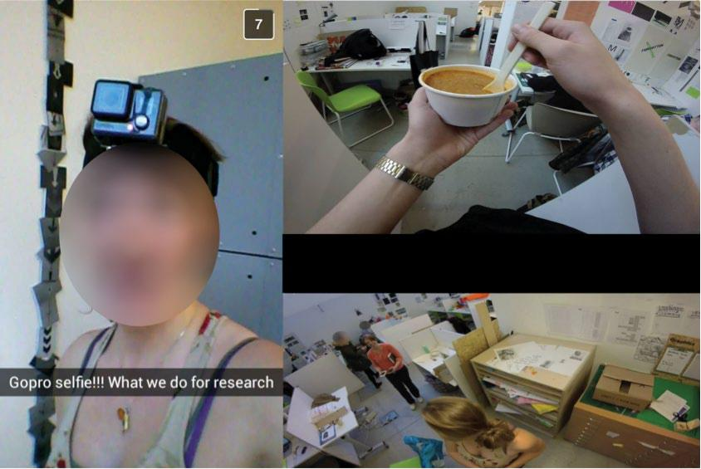

Figure 1. The Case Study 1 participants sharing video cameras in the GoPro® filming activity
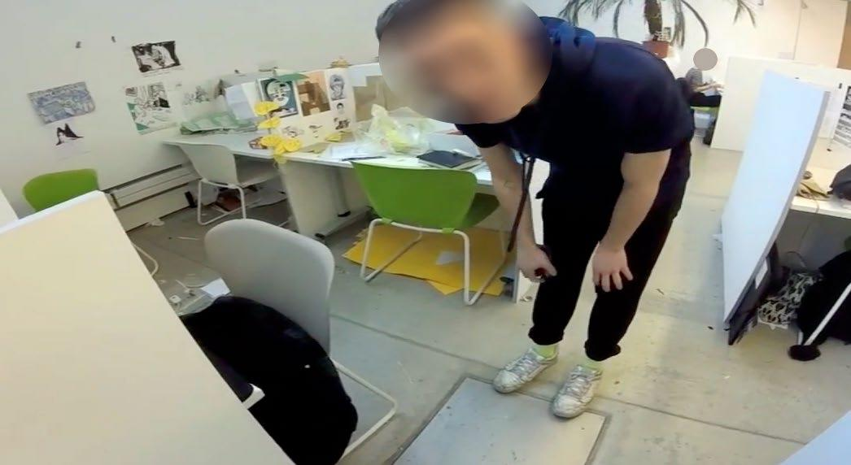

Figure 2. Peripheral studio members in the vicinity of the filming

Sound and sensory ethnographic methods

According to Pink (2009, p. 7), sensory ethnography offers new potential when attending to the senses in ethnographic research, and this study considered the ideas of Pink (2009, 2014) and drew upon them to elicit student experiences of sensory affect in contemporary Communication Design studio learning. Sensory ethnography challenges, revises, and rethinks core components of the ethnographic framework, stressing the numerous ways that smell, taste, touch, and vision can be interconnected and interrelated within research. Consequently, sensory-based ethnographic drawing methods (both digital and hand-driven) and sonic mapping via artefacts, have been used in this research study to critically examine the participants’ own interpretations of studio learning using sensory affect (Marshalsey & Sclater, 2018). For example, participants contributed to an analogue logo drawing process, which explored the notion of capturing sensory affect within their studio in a logo design (Figures 3 and 4).

Then, when launching the sonic-mapping activity with the participants, it was assumed by the lead researcher (Marshalsey) that the participants would record sound digitally and then construct an infographic using technology to map the sounds present in their studio. However, two participants created analogue artefacts. One participant created a hand -drawn, haphazard coloured visual map of sound waves, and another produced a clay cube, hollowed in the centre as an expression of sound. Only one participant chose to integrate technology for this task as they created an animated gif with slow and fast animation to represent the intensity and frequency of sound generated by other students within the studio.
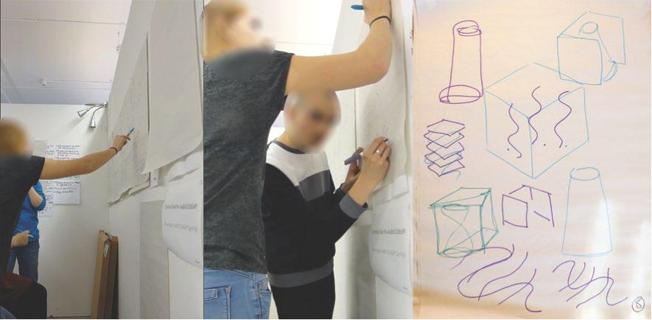

Figure 3. Participants contributing to the logo drawing workshop. Using a drawing process normally used for designing business-orientated logo and branding concepts, the participants were instead asked to design a logo that captured sensory affect within the studio. The participants methodically and chronologically documented a series of drawn visual marks and codes.
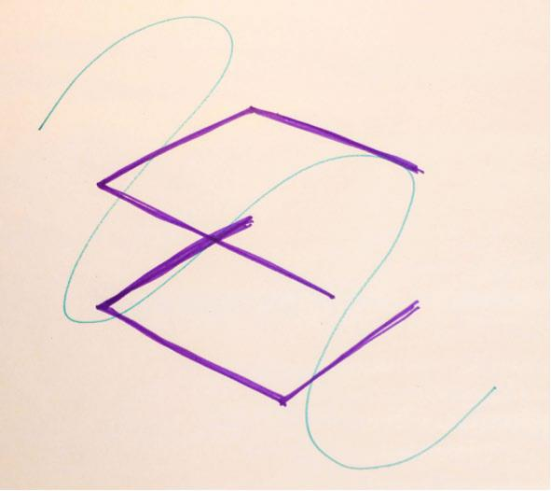

Figure 4. The participants agreed that the final logo design represented sensory affect within the studio environment.

Limitations of the methodologies and methods

The range of exploratory ethnographic research methods enabled participants to unpack their collective experiences of studio learning within the two higher education institutions (UK and Australia). However, it is important to critique the issues arising from the use of the selected methodologies and reflection-in-action methods. Firstly, the participants were actively encouraged to reflect on the differing experiences and phenomena in question as insiders. The analysis was iterative and the distinctly different ways of experiencing the phenomena were discussed collectively and not individually (Prosser & Trigwell, 1999, p. 57). Since the thematic qualities of studio are likely to be experienced in qualitatively different ways by different practitioners, multiple participants were required in this study to maintain rigour (Shreeve, 2010, p. 693).

As the study progressed, the researchers’ individual exploration of the investigation, to a degree, naturally evolved into a collaborative and reflective partnership with the participants. Because the researchers considered reflective practice in the research activities, the participants were also encouraged to think about theirs. This was a reflexive process for the participants, as the participants made explicit the opportunities to engage in mutual dialogue to examine what we were thinking, feeling, and experiencing in the case studies. The participants developed insights, as they became critical reflective co-researchers in their own right both as group participants and as reflexive individuals. As reflective practitioners, the participants gained valuable knowledge and understanding via the selected research methodologies framework, which helped them to engage and adapt their senses in studio learning. As the lead researcher, Marshalsey had assumed that reflection was evolving naturally and that the participants were becoming aware of their studio learning by participating in the research activities (Depraz, Varela, & Vermersch, 2003). However, there may have been potential weaknesses in the reliability of the subjective accounts from the participants as they gave personal accounts of studio events (Depraz et al., 2003, p. 61). Additionally, group think can interfere with individual expression and the opinions or dominant views of others may sway participants (De Groot, Endedijk, Jaarsma, van Beukelen, & Simons, 2013). This might have been, in part, due to their not wishing to appear different from the other participants in the research, or indeed to remain silent and not communicate their true perspectives and viewpoints.

Gathering data

Ethical considerations

The negotiation of the relationships in this study meant that we, as researchers and educators, worked with small groups of participants from two differing institutions. Inclusion in the case studies depended on being a student undertaking an undergraduate degree and majoring in Communication Design. In the UK, the three participants were in the third year of their four-year degree. It was considered appropriate that the first- and second-year Communication Design students were excluded from the study, as they were reasonably new to undergraduate studio education. In Australia, the seven participants were in the final year of their three -year bachelor degree. Therefore, all the participants were drawn from a third-year group of students in the context of two differing degree structures. Full ethical permission was obtained from the ethics committees within both case study institutions prior to the research activities.

The participants from the two case studies in the UK and Australia were invited to participate in the research through two methods: via a verbal introductory group presentation on the research study and by the physical distribution of ethically approved individual consent forms to each prospective volunteer. During this presentation, it was clearly stated to the student participants that their involvement would comply with the Data Protection Act 1998 (UK), British Educational Research Association Guidelines, the Queensland Information Privacy Act 2009 (Australia), and Excellence in Research for Australia, and that the research team required their permission before we could conduct research involving them. The introductory presentation ensured all participants in the research understood the process in which they were to be engaged, including why their participation was necessary, how it would be used and how and to whom it would be reported. The participants were informed that the research data would not be used for any other reason than for confidential PhD research purposes and they would remain anonymous throughout the study or otherwise be assigned pseudonyms.

The consent form stated that participation was entirely voluntary and that participants could opt out of the study in whole, or parts, without giving a reason. The students fully consented to participating in this research study when signing their consent form. The participants could make contact with the lead researcher (Marshalsey) at any point with questions or concerns. Consent forms were also distributed to the peripheral participants resident within the studio, who may not have been actively participating in the case study activities but who may have been in the immediate environment at the time of the research activities being conducted, and who may appear unknowingly in the data.

Case Study 1: A conventional studio environment

The research activities of Case Study 1 spanned 8 weeks (this is not inclusive of the additional week arranged for the recruitment of participants) in a conventional studio environment (Figure 5). Further data was collected in the weeks and months after the conclusion of the study as the participants offered extra research contributions. The participants had unrestricted access to their studio at all times and to a wide repertoire of digital and non-digital resources, tools and processes. The case study activities took place between the hours of 9am and 5pm during the working academic week, Monday to Friday.
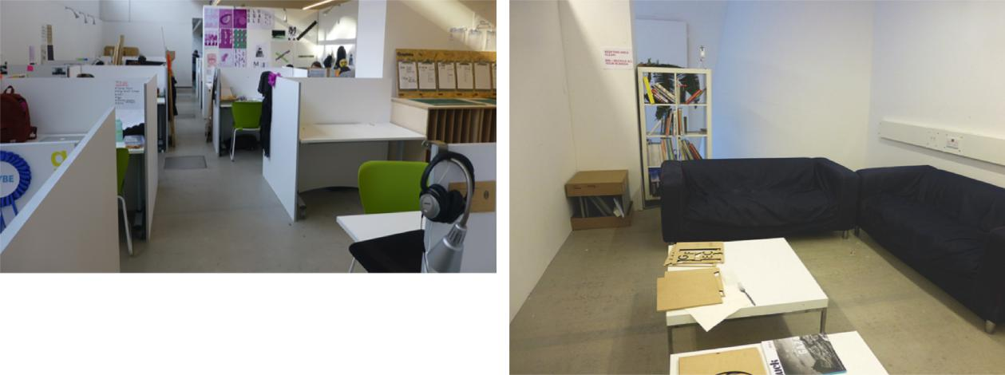

Figure 5. The conventional studio environment of Case Study 1. The research workshops and activities took place in the informal sofa area within this studio.

Case Study 1’s investigative methodologies are shown in chronological order below. The methodologies focused on both the participatory group workshops and the individual reflexive activities throughout the case study at the art school in the UK. The workshops and activities mostly took place in the informal sofa area within this studio and were not pre-planned as a logical sequence of events (Figure 5). Instead, each activity was devised based on the previous week’s data and the preliminary ongoing analysis of each activity as the pertinent patterns emerged, and to support the participants’ developing insights of studio learning.

- Week 1: Questionnaire (the structured questioning investigated responses to experiences in the studio, and to isolate potentially recurrent issues surfacing from the questionnaire to be explored in later research activities).

- Week 2: Focus group on the questionnaire responses

- Week 3: Focus group on place-making (the participants each brought items from their studio desks to explore how they had tried place-making within the studio. They then engaged in an open-ended discussion of how studio affects them in terms of their learning and the steps they take to inhabit their place within the wider studio context).

- Week 4: Logo drawing workshop (using a drawing process normally used for designing business-orientated logo and branding concepts, the participants were instead asked to design a logo that captured sensory affect within the studio. The participants methodically and chronologically documented a series of drawn visual marks and codes, as shown in Figures 3 and 4).

- Week 5: Sonic-mapping (the participants each produced and delivered a sonic map, that is, to map the sound phenomena present within the studio. The final construction and format would be

entirely of the participants’ own choosing in order to elicit their own interpreted sound investigation).

- Week 6: GoPro® filming and reflection (using body, head, and wrist harnesses while filming, the participants were tasked to represent the DNA of the studio through the video footage, as shown in Figures 1 and 2).
- Week 7: Reflective rug (a 25-metre long research rug, which chronologically documented the data from the research activities in the previous weeks and used as a form of critical event recall (De Laat & Lally, 2004). Technology helped the researcher to collate the data in a central file structure, yet the research rug reflected the data back to the participants in the physical environment in which it was collected, using printed versions of the interviews, photography, workshop drawings, etc. This allowed the participants to make clearer connections between the data and the educational environment in which the data was collected, for reflection.

- Week 8: Participant-led drawing activity (a participatory and sensory ethnographic drawing workshop led by the participants with their student peers).

Creative group activities, such as these, offered a framework for reflection, encouraged participants to begin thinking critically about their experiences, and helped to engage the participants’ interest. The small group fostered a sense of collegiality between us, allowing each person to actively participate and speak openly in a non-threatening environment. Through exposure to a variety of viewpoints, the participants improved their ability to reflect on their experiences of sensory affect and studio learning using a range of visual and sensory ethnographic methods (Leitch & Day, 2000; Moon, 2006). Throughout the case study video and sound equipment recorded the opinions, events, and discussions in the reflective group workshops. This approach authentically documented the collected experiential data used to augment the research transcript texts from which the thematic analysis was formed.

Case Study 2: A studio-based blended classroom environment

The research activities of Case Study 2 spanned 8 weeks. The participants had restricted access to their classroom-based studio spaces and to a wide repertoire of digital and non-digital resources, tools and processes. The case study activities were held on a Friday every week between the hours of 12 noon and 1pm. No further data was collected in the weeks and months following the study, as the participants did not volunteer extra research contributions. Supplementary to this, it should be noted the participants of Case Study 2 did not have desks allocated to them. The workshops and activities took place in their formal classroom-based studio environment and were pre-planned as a logical sequence of events (Figure 6).
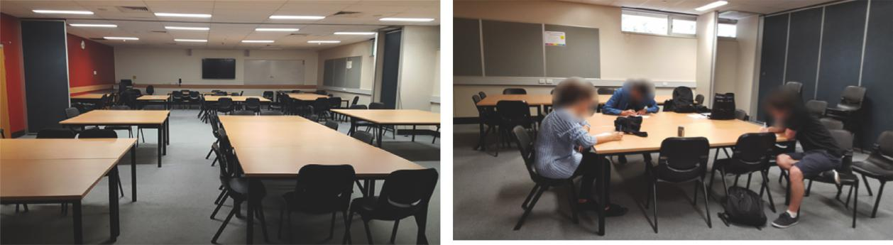

Figure 6. The classroom-based studio environment of Case Study 2. The research workshops and activities took place in this classroom.

The reflective activity-based workshops in Case Study 2 remained fundamentally the same as Case Study 1 in the opening weeks. Modifications to the methodological framework occurred as the participant responses were reflectively analysed and as the research activities started to draw out their experiences of sensory affect. For example, a smell and taste workshop and an ethnographic sound drawing exercise were introduced. This was because early in the investigation, the researchers realised that the participants in Case Study 2 were already acutely aware of the limitations of their learning spaces. Therefore, it was decided to modify the existing ethnographic methods for Case Study 2 to capitalise on this awareness. Case Study 2 was also conducted over 8 weeks and its investigative methodologies are shown in chronological order below.

- Week 1: Questionnaire

- Week 2: Focus group on the questionnaire responses and digital drawing activity (the participants engaged in a digital drawing exercise using an iPad®. Each student took turns to interpret three photographs of their current studio-based classrooms on the iPad®, using mark-making with a digital stylus to demonstrate how they felt about each space using different textures and colours on each of the three images. Each participants’ interpreted set of images were saved and stored for reflective discussion).

- Week 3: Focus group discussion on place-making and a cross case reflection of Case Study 1 data via a laptop, which played Case Study 1’s photographic data on a loop. The aim was to review the Case Study 2 participants’ initial reactions of the participants’ assigned workspaces in Case Study 1. Their reactions and subsequent discussion were recorded using video and audio devices.

- Week 4: Sound drawing workshop (to assess the participants’ perceptions of the sounds affecting their studio learning by using sound clips as the stimulus for analogue drawing).

- Week 5: Touch journals (critical event recall of physical, paper touch journals and documented visual codes).

- Week 6: Video filming using mobile phone devices and a cross case reflection of Case Study 1’s GoPro® filming data (to gather the participants’ reactions to their counterparts’ educational studio environments and to compare these observations immediately after viewing their own footage). Their reactions and subsequent comparison of the differing recording equipment used in each case study were recorded using video and audio devices.

- Week 7: Smell and taste workshop (critical event recall on smell and taste present in the studio using physical artefacts, paint and paper).
- Week 8: Manifesto task (as a method to stimulate reflection on the data produced as individuals and as group participants throughout the 8-week case study). Critical manifesto themes drawn from the data were identified by the participants and written onto large sheets of paper.

Case Study 2 further explored the category themes from Case Study 1 using an iterative, ongoing action research approach. The activity-based group workshops and individual research tools (a mix of analogue and digital techniques) evolved with some modifications to the methods following the reflective analysis that included students’ opinions, narratives, and responses.

Discussion of findings and their practical significance

Decoding emergent categories from the interviews, focus groups, and workshop transcripts comes from reading, re-counting and reflecting on the stories and experiences drawn from the participants and the researcher at each of the case study sites. The first steps of the four-stage process of analysis consisted of capturing data, transcribing, reading and annotating the narrative data to form the preliminary categories. The research activities were recorded via audio and video data, which were then transcribed into written form, and the questionnaires responses collated for the two case studies. These files were transcribed manually, which fostered a greater understanding of and immersion in the data.

Analytical techniques

The analysis began by reading and highlighting the key words and phrases in each case study transcript that related to a potential category. Reflective handwritten notes and digital comments were written in the margins of each page to aid the cross-matching of related topics and to distinguish and craft the initial categories. This process of analysis helped to illuminate the relationship between the research questions (informed by the issues identified from the research literature) and the interpretation of data used to answer these questions. For example, the identification of studio mess in the transcript helped to form the preliminary category studio environment (mess). This also aided an understanding of the role that studio played in the teaching of Communication Design. This analysis procedure is similar in nature to the analytic strategy devised by Huberman and Miles (1994).

Numerous insights were identified from the storied patterns, as they evolved from reflectively analysing the within-case data. Metaphors and meaning were made from the detailed and descriptive narratives drawn from individual participants and from the group activities (Huber, Caine, Huber, & Steeves, 2013).

Reflective analysis is the capacity to reflect on action (Moon, 2006); this process enabled the participants to learn from their stories of previous actions, critical events, and experiences in order to inform their practice and community within the studio. The value of socialising together and informally discussing projects became noted as important aspects of practice as one student, Robyn, verified post-case study: “Even though we were not actually doing any work, we were up and about, talking, making tea, socialising”. The individual personalities being researched may, to a degree, be dependent upon the socialisation processes and practices in and around their educational environments. In terms of researching informal socialisation, this may be seen to play a certain role in research. Participants may alter their comprehension of reality during the data collection stage as they acquire knowledge that might conflict with views that are already present in their minds, through independent reflection, or through diverse encounters with others (Given, 2008). Moreover, this process provides strategies to bring pertinent themes out into the open. Deliberate and conscious reflective analysis, as a form of mental processing, prompted questions and revealed things the participants may not have known. Taking the time to reflect was critical in order for the participants to feel in active control over their daily studio environment.

Adapting tools and techniques

The iterative PAR research approach adopted in this study facilitated the development of the PD tools and techniques. The tools implemented in this investigation were formed in accordance with the cyclical plan

– act – observe – reflect approach rather than from a recognised, pre-determined set of research tools. The findings at each stage of the case study process fed directly into the development of the following iteration of research methods. The insights drawn from the participants’ feedback arose from the application of the tools and techniques in the group workshop and individual activities. This navigation aided the adaptation of the selected range of PD methods, and also enabled a robust development process from which to draw out the rich experiential and narrative data. The intention was to create a transferable PD methodological framework (the MPM). This could be used by other educators and adapted as necessary, depending on the formal or informal educational environment, to establish the most effective methods for differing studio circumstances. The varying degrees of detail and complexity of each method can be adjusted more or less, depending on the variables present in the studio community, environment, and organisational structure.

Reflecting on the PD research approach

The research design allowed a holistic analysis of the relationships, practices, and processes occurring in the natural social setting of the studio environment. This investigation used an explorative yet flexible PAR case study approach. The reflective PD workshops and reflexive activities provided rounded, detailed illustrations of the experiential phenomena across two case study sites, with a balance of theoretical and empirical qualitative data.

In particular, the workshop format evolved and developed across the 8-week case study schedule and we, the researchers, now considered what could have been done differently and for greater benefit. Initially, we envisaged running controlled workshops in formats similar to our regular, everyday educational design workshops. We had not comprehended how much open-ended control of the workshops should be given to the student participants. Thus, participants in the two case studies participated differently. For example, we gave the Case Study 1 participants more control, and the Case Study 2 participants less control of the developing research process. We assumed the role of researchers more easily with the Case Study 1 participants, who kept pace with the progressing participatory activities, which meant we could transfer the development of the PD methods to them. The participants in Case Study 2 appeared to be less forthcoming in their participation, and we sought to retain control of the developing PD methods. This approach was not intentional but rather unconscious. Marshalsey’s subjective, ontological position as a design educator and the lead researcher meant that we had distinctly different expectations of how each set of participants from the two case studies would take control of the research activities. In hindsight, there may be a better way to engage with the participants as co-researchers as we subconsciously wrestled with the practicality of this notion of educator as researcher control. Future research studies may investigate and address the relational ethics between the participants and researcher more thoroughly beyond the limited time available in this study to support the continued development and evaluation of this research investigation.

The MPM

The MPM discussed in this paper demonstrates the chronology of methods that may be used when investigating the experiential impact of a range of educational environments in contemporary Communication Design studio and studio-based education. The overall purpose of the MPM is to provide a transferable framework of methods, from which to explore various iterations of studio learning via its implementation and to survey the results of its application as a flexible model in differing studio contexts. In a current funded study, several iterations of this model are being tested in higher education institutions delivering studio learning. In this paper, the MPM is described as one model of overall best practice participatory methods, which is based on the findings of the doctoral research from each of the two case studies and the limited number of participants (Figure 7).

Snapchat® is a popular mobile phone application, which was familiar to the participants as a social media platform. Snapchat® can capture photos and then easily send them to other users, and occasionally with captions and drawings added to the photos. Using Snapchat® in this way enabled the participants to voice their instant and momentary studio experiences from their own, empowered view (Delgado, 2015). This method generated a flowing narrative of unbiased images and captured studio life as it happened around them and with them during the entire 8-week duration of the research activities. As a research method, the main researcher was the sole recipient of the Snapchat® images. The image data was subsequently screen-grabbed and saved anonymously for future analysis and creative output. The Snapchat® images were then returned en masse to the participants to reflect upon. However, the main disadvantage of this method was its sporadic use at times and its reliance on regular participant engagement). Snapchat® bypassed the need for expensive equipment as all the participants had access to this app at all times on their mobile phones).

Utilising the research methods in the order shown in Figure 5 facilitates the participants being able to qualitatively interpret a range of sensory experiences within the shifting boundaries of their virtual, technology-rich, and physical learning spaces. This original model is designed to embrace changes to the methodologies and the nature of the activities depending on the variable factors affecting the stakeholders’ available time, repertoire of spaces, curriculum model, and institution. This methodological process has been carefully scaffolded (from the range of methods used in the two case studies in this investigation).

The MPM is designed to capture participants’ views as they make meaning in relation to their developing awareness of their senses in the process. The MPM draws out the value judgements the participants placed on their newly acquired insights and their evaluation of the impact of sensory affect on their present practice. As a research design template or pattern, this provides a methodological framework that educators may adapt in order to explore, take account of, and work with learning spaces more explicitly in design education.

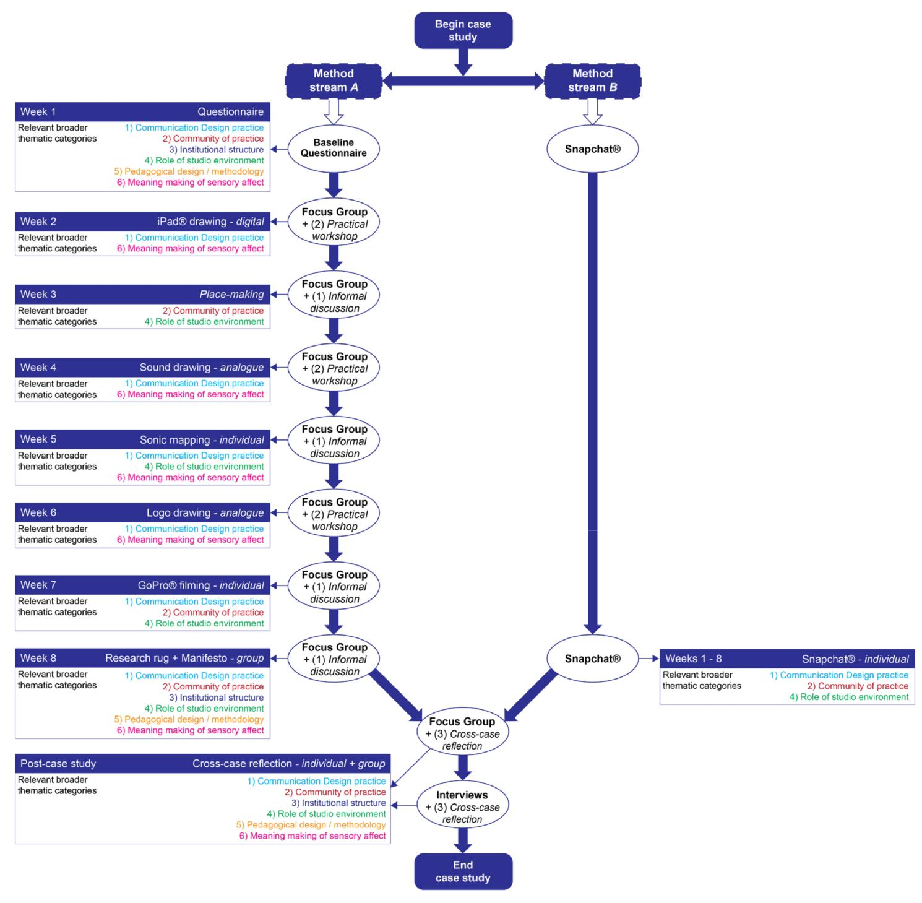

Figure 7. As a research design template, the MPM provides two parallel methodological streams – A (beginning with the Questionnaire) and/or B (Snapchat®) – which may be used simultaneously or independently for best effect.

Conclusion

The research investigation presented in this paper provides a means to understand and critique contemporary Communication Design learning spaces in order to support student engagement. As articulated throughout this paper, this is largely a methodological investigation, which employs sensory affect as a lens via the practice-led and research methods. The use of a PAR framework to understand contemporary Communication Design studio and studio-based classroom education has enabled the identification of multiple perspectives drawn from the analysis and interpretation of the data. The findings of this study evidence that the participants experienced and managed their studio learning in different ways.

The Case Study 1 participants in the UK highlighted that their friendly, informal, day-to-day social interactions with peers and staff in their situated studio community, are integral to their collective and individual learning and practice. Their personally allocated, desk spaces fostered a closeness among the participants and encouraged them to break down formal barriers and feel at ease in their studio community. Visual distractions were reduced by the use of desk dividers, which also differentiated the space in which the participants’ personal artefacts, creative mess, and work in progress were contained. Noise from the open-plan studio environment was anticipated and managed by the participants. Natural light was abundant.

In Australia, the Case Study 2 participants created their own offline as well as online community outside of the boundaries of their formal learning spaces – mainly in cafes and via social media. They did not have access to a dedicated physical studio or personal workstation. The participants mainly chose to work informally from home” as they pointed out that they did not feel a great sense of belonging in their community: via engagement, imagination or alignment. Greater student numbers in their year group and hot-desking fostered feelings of vulnerability, a lack of confidence and sense of their own identity, self-consciousness, and time pressure in their studio learning. Artificial light was abundant, and the tutorial classrooms cold. There was less contact with educators on a day-to-day basis and a greater reliance on digital practice.

To summarise, the following six broader thematic categories were identified from a complex and innovative process of analysis:

- Implications for Communication Design practice
- Supporting the community of practice
- Institutional structure and management
- The role of the studio environment
- Pedagogical design / methodology
- Meaning making of sensory affect.

The implications and the practical significance of the main findings from the two case studies were mapped against each of these six broader thematic categories, and alongside a set of recommendations specifically for each thematic category. A subsequent MPM was also presented (Figure 5), which outlined an approach for investigating the impact of diverse forms of Communication Design studio learning upon student engagement today. It should be noted that there is no direct, single solution to work with the continuum of studio and studio-based classroom learning spaces, curricula, and institutions delivering contemporary Communication Design studio education. Rather, a methodology was constructed consisting of a range of context-specific methods, which staff and students can use to form their own strategic interventions in order to work more effectively within the spaces they know best to improve their own engagement. The MPM can be employed to examine potentially problematic areas within studio learning; in practice, in the community, in the institutional management, in the role of the studio, in the pedagogical approach and lastly, when engaged in meaning making of sensory affect. In future research, this MPM must also be flexible in order to accommodate future learning environments that are constantly changing alongside a shifting and fluctuating practice-led discipline and its associated pedagogy. This is especially pertinent as technological concerns cross-cut and impact upon studio education today.

The small case study cohort size in each institution should be acknowledged, and the findings should not be taken as typical across all design education, learning spaces, and educational contexts. There is obvious variability in spaces and sites, governance, student culture, Communication Design disciplines, and institutional provision in each of the settings. Consequently, the current management, and future development, of studio learning environments by educators and institutions is being investigated by employing iterations of the MPM in further postdoctoral research in Australia.

For the design student undertaking a studio education, the evidence suggests that they may be sensitive to the impact of several areas of concern, which were identified by the research. The factors that might disrupt studio learning need to be brought forward into a students’ consciousness via the MPM, guided by educators, researchers and institutions. Being mindful of these issues might mean that students and educators can implement strategies to work better within the studio. The MPM aims to facilitate and affect better student engagement within existing and future studio and studio-based educational environments). Therefore, the main contribution to knowledge of this investigation, and grounded in the findings, is the support of students as they explore and engage with contemporary Communication Design studio education. The suggestion is that when employing the MPM (or elements thereof), then the student’s individual and collective relationship with learning is supported in relation to practice, community, governance, the role of the studio, pedagogy and curriculum, and sensory affect. The students’ well-being, and social, practice-led, and educational needs are foregrounded.

To further speculate, the MPM, in its future trajectory beyond this paper, may be flexible enough to be employed by learning space collaborators of all forms – from the broad macro perspective of spatial interior

designers, architects and learning space designers, to designers specifically designing for the micro aspects of educational environments. The MPM, in the natural course of future research studies, also has the potential to be actively commissioned within wider industry studios; learning-how-to-engage in contemporary working studio environments and providing a longitudinal study of the MPM in action from design students undertaking studio education to those graduating designers moving into industry environments as studio employees. However, to date, it should be noted that this version of the MPM has only been tested in higher education environments as a framework to support students’ self-directed experiences of Communication Design studio learning in an era of technology enhanced learning environments.

Acknowledgements

The original PhD thesis that informs this paper (Marshalsey, Lorraine, 2017, An investigation into the experiential impact of sensory affect in contemporary Communication Design studio education) can be accessed online via the Glasgow School of Art library and the British Library EthOS library. This doctoral research was supported by the Global Excellence Initiative Fund and Glasgow School of Art.

References

Bayne, S. (2015). What’s the matter with “technology-enhanced learning”? Learning, Media and Technology, 40(1), 5–20. https://doi.org/10.1080/17439884.2014.915851
Bloomer, K. C., & Moore, C. W. (1978). Body, memory and architecture. New Haven, CT: Yale University Press.

Boddington, A., & Boys, J. (2011). Re-shaping learning: A critical reader – The future of learning spaces

in post-compulsory education. Rotterdam: Sense Publishers.
Boling, E., Schwier, R. A., Gray, C. A., Smith, K. M., & Campbell, K. (2016). Studio teaching in higher education. New York, NY: Routledge.

Boys, J. (2008). Beyond the beanbag? Towards new ways of thinking about learning spaces. Networks Magazine, 18–19. Retrieved from http://arts.brighton.ac.uk/__data/assets/pdf_file/0019/64180/Jos-Boys-article-Networks08-pages-16-19.pdf

Csikszentmihalyi, M. (1975). Beyond boredom and anxiety: The experience of play in work and games.
London: Jossey-Bass.

Davidts, W., & Paice, K. (2009). The fall of the studio: Artists at work. Amsterdam: Valiz.
De Groot, E., Endedijk, M., Jaarsma, D., van Beukelen, P., Simons, R.-J. (2013). Development of critically reflective dialogues in communities of health professionals. Advances in Health Sciences Education: Theory and Practice, 18(4), 627–643. https://doi.org/10.1007/s10459-012-9403-y

De Laat, M., & Lally, V., 2004. It’s not so easy: Researching the complexity of emergent participant roles and awareness in asynchronous networked learning discussions. Journal of Computer Assisted Learning, 20(3), 165–171. https://doi.org/10.1111/j.1365-2729.2004.00085.x

Delgado, M. (2015). Urban youth and Photovoice: Visual ethnography in action. Oxford: Oxford University Press.

Depraz, N., Varela, F. J., & Vermersch, P. (2003). On becoming aware: A pragmatics of experiencing.
Amsterdam: John Benjamins Publishing Company.

Ellis, R. A., & Goodyear, P. (2016). Context and implications document for: Models of learning space:
Integrating research on space, place and learning in higher education. Review of Education, 4(2), 192–
- https://doi.org/10.1002/rev3.3058
Ghassan, A., & Bohemia, E. (2015). The global studio. FORMakademisk, 8(1), 1–11.
https://doi.org/10.7577/formakademisk.1406
Given, L. M. (2008). The SAGE encyclopedia of qualitative research methods. Thousand Oaks, CA:
Sage.
Harrison, A., & Hutton, L. (2014). Design for the changing educational landscape: Space, place and the
future of learning. Abingdon: Routledge
Huber, J., Caine, V., Huber, M., & Steeves, P. (2013) . Narrative inquiry as pedagogy in education: The extraordinary potential of living, telling, retelling, and reliving stories of experience. Review of Research in Education, 37(March), 212–242. https://doi.org/10.3102/0091732X12458885

Huberman, A. M., & Miles, M. B. (1994). Qualitative data analysis: An expanded sourcebook. Thousand
Oaks, CA: Sage.

Ingold, T. (2002). Sound making against soundscape. In S. Bunn (Ed.), Sound and
anthropology, body environment and human sound making. St Andrews: University of St Andrews. Retrieved from http://www.st-andrews.ac.uk/soundanth/work/ingold

Kemmis, S., McTaggart, R., & Nixon, R. (2014). The action research planner: Doing critical
participatory action research. Singapore: Springer.
Kirkwood, A., & Price, L. (2014) . Technology-enhanced learning and teaching in higher education: What is “enhanced” and how do we know? A critical literature review. Learning Media and Technology, 39(1), 6–36. https://doi.org/10.1080/17439884.2013.770404

Kolb, D. A. (1983). Experiential learning: Experience as the source of learning and development. Upper
Saddle River, NJ: Financial Times, Prentice Hall.
Kramer, L., Schwartz, P., Cheadle, A., & Rauzon, S. (2012). Using Photovoice as a participatory evaluation tool in Kaiser Permanente’s Community Health Initiative. Health Promotion Practice, 14(5), 686–694. https://doi.org/10.1177/1524839912463232

Lee, D., Morrone, A. S., & Siering, G. (2018). From swimming pool to collaborative learning studio: Pedagogy, space, and technology in a large active learning classroom. Educational Technology Research and Development, 66(1), 95–127. https://doi.org/10.1007/s11423-017-9550-1

Leitch, R., & Day, C. (2000). Action research and reflective practice: Towards a holistic view. Educational Action Research, 8(1), 179–193. https://doi.org/10.1080/09650790000200108

Lyon, P. (2011). Design education: Learning, teaching and researching through design. Farnham:
Gower.
Malnar, J. M., & Vodvarka, F. (2004). Sensory design. Minneapolis: University of Minnesota Press. Marshalsey, L. (2017). An investigation into the experiential impact of sensory affect in contemporary communication design studio education (Doctoral dissertation). The Glasgow School of Art, UK.
Retrieved from http://radar.gsa.ac.uk/5894/
Marshalsey, L., & Sclater, M. (2018). Critical perspectives of technology- enhanced learning in relation to specialist Communication Design studio education within the UK and Australia. Research in Comparative and International Education. https://doi.org/10.1177/1745499918761706

Mokhtar Noriega, F., Heppell, S., Segovia Bonet, N., & Heppell, J. (2013). Building better learning and learning better building, with learners rather than for learners. On the Horizon, 21(2), 138–148. https://doi.org/10.1108/10748121311323030

Moon, J. A. (2006). Learning journals: A handbook for reflective practice and professional development.
London: Routledge.
Pink, S. (2009). Doing sensory ethnography. London: Sage.
Pink, S. (2014). Digital–visual–sensory-design anthropology: Ethnography, imagination and intervention. Arts and Humanities in Higher Education, 13(4), 412–

- https://doi.org/10.1177/1474022214542353
Prosser, M., & Trigwell, K. (1999). Understanding learning and teaching: The experience in higher
education. Buckingham: Open University Press.
Ramaswamy, V., & Ozcan, K. (2014). The co-creation paradigm. Stanford, CA: Stanford Business Books.

Rappaport, L. (2013). Trusting the felt sense in art-based research. Journal of Applied Arts & Health, 4(1), 97–104. https://doi.org/10.1386/jaah.4.1.97_1
Reason, P., & Bradbury-Huang, H. (2005). Handbook of action research. London: Sage.
Relph, E. (2008). Place and placelessness. London: Pion Ltd.
Richards, N. (2011). Realities at the Morgan Centre, Toolkit #17: Using participatory visual methods. Manchester: University of Manchester. Retrieved from http://hummedia.manchester.ac.uk/schools/soss/morgancentre/toolkits/17-toolkit-participatory-visual-methods.pdf

Sanders, E. B.-N., & Stappers, P. J. (2008). Co-creation and the new landscapes of design. CoDesign, 4(1), 5–18. https://doi.org/10.1080/15710880701875068

Sanya, T. (2016). Participatory design: An intersubjective schema for decision making. International Journal of Architectural Research, 10(1), 62–75. https://doi.org/10.26687/archnet-ijar.v10i1.923

Scott-Webber, L., Branch, J., Batholomew, P., & Nygaard, C. (2014). Learning space design in higher education. Faringdon: Libri Publishing.

Sharp, J. G., Hemmings, B., & Kay, R. (2016). Towards a model for the assessment of student boredom and boredom proneness in the UK higher education context. Journal of Further and Higher Education, 40(5), 649–681. https://doi.org/10.1080/0309877X.2014.1000282

Shreeve, A. (2010). A phenomenographic study of the relationship between professional practice and teaching your practice to others. Studies in Higher Education, 35, 691–703. https://doi.org/10.1080/03075070903254602

Swart, R. (2017). Critical thinking instruction and technology enhanced learning from the student perspective: A mixed methods research study. Nurse Education in Practice, 23, 30–39. https://doi.org/10.1016/j.nepr.2017.02.003

van Merrienboer, J. J. G., McKenney, S., Cullinan, D., & Heuer, J. (2017). Aligning pedagogy with physical learning spaces. European Journal of Education, 52(3), 253–267. https://doi.org/10.1111/ejed.12225

Vignoles, A., & Murray, N. (2016). Widening participation in higher education. Education Sciences, 6(2),

- https://doi.org/10.3390/educsci6020013
Vyas, D., van der Veer, G., & Nijholt, A. (2013). Creative practices in the design studio culture: Collaboration and communication. Cognition, Technology and Work, 15, 415–443. https://doi.org/10.1007/s10111-012-0232-9

Woolner, P. (2010). The design of learning spaces. London: Continuum.

Corresponding author: Lorraine Marshalsey, l.marshalsey@griffith.edu.au

Please cite as: Marshalsey, L., & Sclater, M. (2018). Supporting students’ self-directed experiences of studio learning in Communication Design: The co-creation of a participatory methods process model. Australasian Journal of Educational Technology, 34(6), 65-81. https://doi.org/10.14742/ajet.4498

