Dr. Michael Stubbs – Glasgow School of Art.
Teaching Undergraduates - Digital Embodiment in Contemporary Painting; Ontology, Making and the Screen

Introduction
What does it take to make and what does it take to be in making in the 21st century? This paper examines digital embodiment in contemporary painting. It seeks to discover how the physical making of a painted object becomes an overlapping, reflexive activity that meets with the disembodied informational digital screen. Throughout this paper I would like you to consider how data, which is reflected through pixelated screens as physically depthless, inter-relates with paintings physical and expressive qualities. I will argue, in the first instance, that painting is viewed as a conjoining or connecting with the flat surfaces of the screen; that the painter develops his/her material practice as a reflection of the augmented space of the screen either through digital production or as an idealised counterpart, sometimes both simultaneously. Secondly, that by exploring the paintings of Glenn Brown, who for me successfully negotiates the phenomenological divide between the embodied act of making and the disembodied digitally received image, we come to examine, as a contextual model, future student understandings of expanded painting.

The third and final part of my text will explore how, in the wake of Brown, student painters negotiate painting as a personalized, expressive response to the saturation of the screens social reach regardless of whether their paintings are presented as figurative or abstract, gestural or flat, electronically produced or as an installation. The style or finish of a painting (or expanded medium of painting) I will conclude, will reflect Isabelle Graw’s indexical notion that the ‘authors quasi-presence as an effect’ (1), is read as a semiotic agency witnessed in paintings surfaces. This surface effect, as a comparative trace of the author, will then allow me to introduce images of student’s work. I will argue on the one hand that material making for students amplifies Paul Crowther’s phenomenological examination of paintings physical and optical particularities of autography, that ‘drawing and painting are the products of gesture. As such they can embody individual style’. (2) And on the other hand I will extend Crowther to suggest how paintings autographic activity can include electronic and screen production.

Although based on my own research this is not a prescriptive plan for teaching nor is it a manifesto. Since starting work on the painting course at the Glasgow School of Art in December 2015, I’ve witnessed an ever growing trend that wrestles with the relations between painting and the digital. Apart from regular tutorials and crits, it is my once yearly seminar for the 3rd and 4th years called ‘Imaged Painting/Imagined Painting’ that has prompted this enquiry. This seminar, loosely based on Craig Staff’s ‘After Modernist Painting’, explores his distinction between imaging the digital and imagining the digital. Painters who image are those who utilise technology to generate imagery. And painters who imagine reflect upon ideas on the digital. The seminar is designed so that students can also air their own experience of digital technology in relation to painting. Sometimes there are surprising and even confusing results often focusing on an unease around the use, ethics and identity of users with social media and how and what to make on the course as a result, but more of that later.

Part 1, Painting Now
Before we fully explore the notion of the student subject and the overlap of painted objects with the disembodied screen, let’s briefly begin by framing an overview of current painting. Looking at the eclectic mix of painting styles in galleries around the world, no one technique or theory dominates painting discourse now. With attitudes towards painting less concerned with junking modernism, but more with a re-evaluation of painting’s agency in the wider world – ‘the plurality of practices in which questions of form, experience and context may once more be negotiated’,(1) as the British critic JJ Charlesworth puts it, means that painters choose to paint in any style, on any surface, about anything they deem appropriate.

Arguably anything goes, but in a world where we are now surrounded by digital technology and its myriad screens then the nature of painting and its history can be compared, re-contextualised and re-invigorated. The making of painting now is an overlap or experience between the author, the actual stuff of material and the spectacle of the screen and its technologies. It is vital to consider the role of the screen regardless of the diversity of approaches in current painting. The reproduced image whether it is digital, photographic or filmed is all embracing in contemporary culture. Images of the wider world and art and artists come to us through reproduction but this doesn’t mean the image is necessarily a replacement for the painted object (although in some cases it can be). The painters work is informed, translated and produced in relation to the screen.

Two recent museum exhibitions in particular seem to encapsulate paintings’ attempted overlap with the screen. ‘Forever Now: Contemporary Painting in an Atemporal World’ at MOMA, New York and ‘Painting after Technology’ at Tate Modern, London. MOMA as a re-sampling of recent traditions in painting and the Tate with paintings current relationship to the digital image.

‘Forever Now: Contemporary Painting in an Atemporal World’, according to the press release, says that; ‘painting now is an ahistorical free-for-all’, where the historical legacy or mixing of styles and genres means that ‘sampled motifs morph and collide to re-shape historical strategies like appropriation and bricolage which in turn asks questions of originality and subjectivity’.

At Tate Moderns’ ‘Painting after Technology’, the curator Mark Godfrey invites us to contemplate how; ‘digital technology has transformed the ways in which images are created, copied, altered and distributed. Tools such as photocopiers, scanners, Ipads and Photoshop have provided painters with a range of new possibilities. Painters today negotiate a world where the spread of advertising screens in public and private spaces, and the ubiquitous glow of hand-held communication devices, affects our sense of scale and our attention span’.

Part 2, Glenn Brown: No Visible Means of Support
For me, Glenn Brown combines elements of both of these claims. He not only self-consciously reflects and expresses ahistorical styles but simultaneously exaggerates paintings physicality (albeit flatly) by cross-referencing autography, technology, art history, subjectivity and idea. Part two is primarily borrowed from a catalogue essay of mine on Brown called ‘No Visible Means of Support’ which accompanied his solo exhibition at Tate Gallery Liverpool in 2009 and toured to Foundazione Sandretto De Rebaudengo, Turin and the Ludwig Museum, Budapest. And from that text it is Brown’s subjective and embodied relationship with the digital that I want to focus on because I believe it to be increasingly central to student concerns and contexts in the discipline of painting. Therefore, and as a precursory fleshing out of an ontological study of student subjectivity, this section has two purposes. Firstly, to examine how computer-based preparatory methods have extended the scope of Brown’s paintings; and secondly, to demonstrate how Brown’s paintings offer a philosophical dialogue between the painter’s subjectivity and virtual depth or space. This examination also aims to demonstrate that an artist who is, or has been influenced by postmodernists such as Sherry Levine or Richard Prince, can also expand and extend the readings and central tenements of appropriationist strategies into the 21st century.

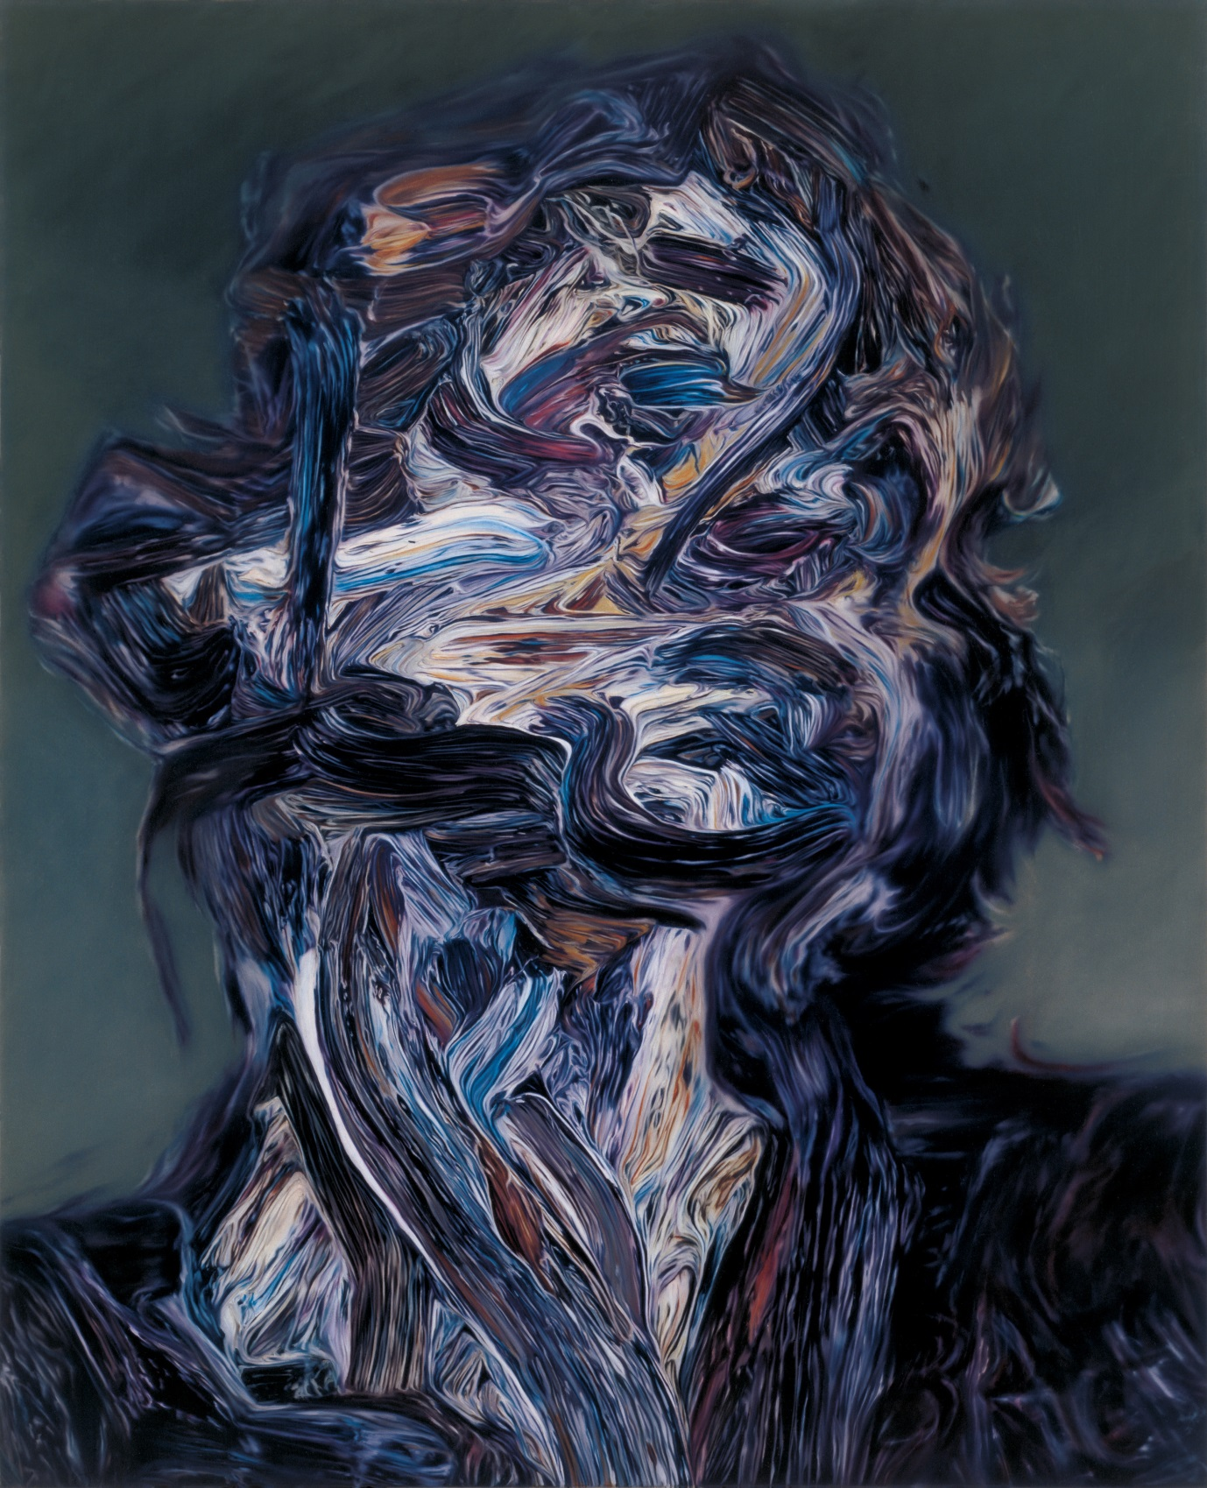
Glenn Brown, ’Secondary Modern’, 1998, Oil on canvas, 59.6 x 47.4cms

So how exactly how do Brown’s paintings self-consciously reflect and expresses ahistorical styles whilst simultaneously exaggerating bodily physicality? And how can his work become an expressive response to the screen? After all, isn’t his work often associated with the so called ‘death of painting’ from the 80’s/90’s? On the contrary, Brown’s paintings mirror very contemporary concerns that are multiple in meaning and sometimes conflicted in their readings. For example, an ironic overview of the limits of representation, how figuration and abstraction overlap, how the Expressionist brush mark is merely a sign and how art history and popular culture converge in a single work. More importantly, he shares an understanding of the critical impact of mechanical reproduction in painting. As a result, he has been increasingly interested in how the digital or the virtual impacts on readings of his work, not only because of the changes he has made in his preparatory methods, but equally as a shift in the way we understand the ‘space’ he utilises in his paintings as an equivalent of the computer screen.

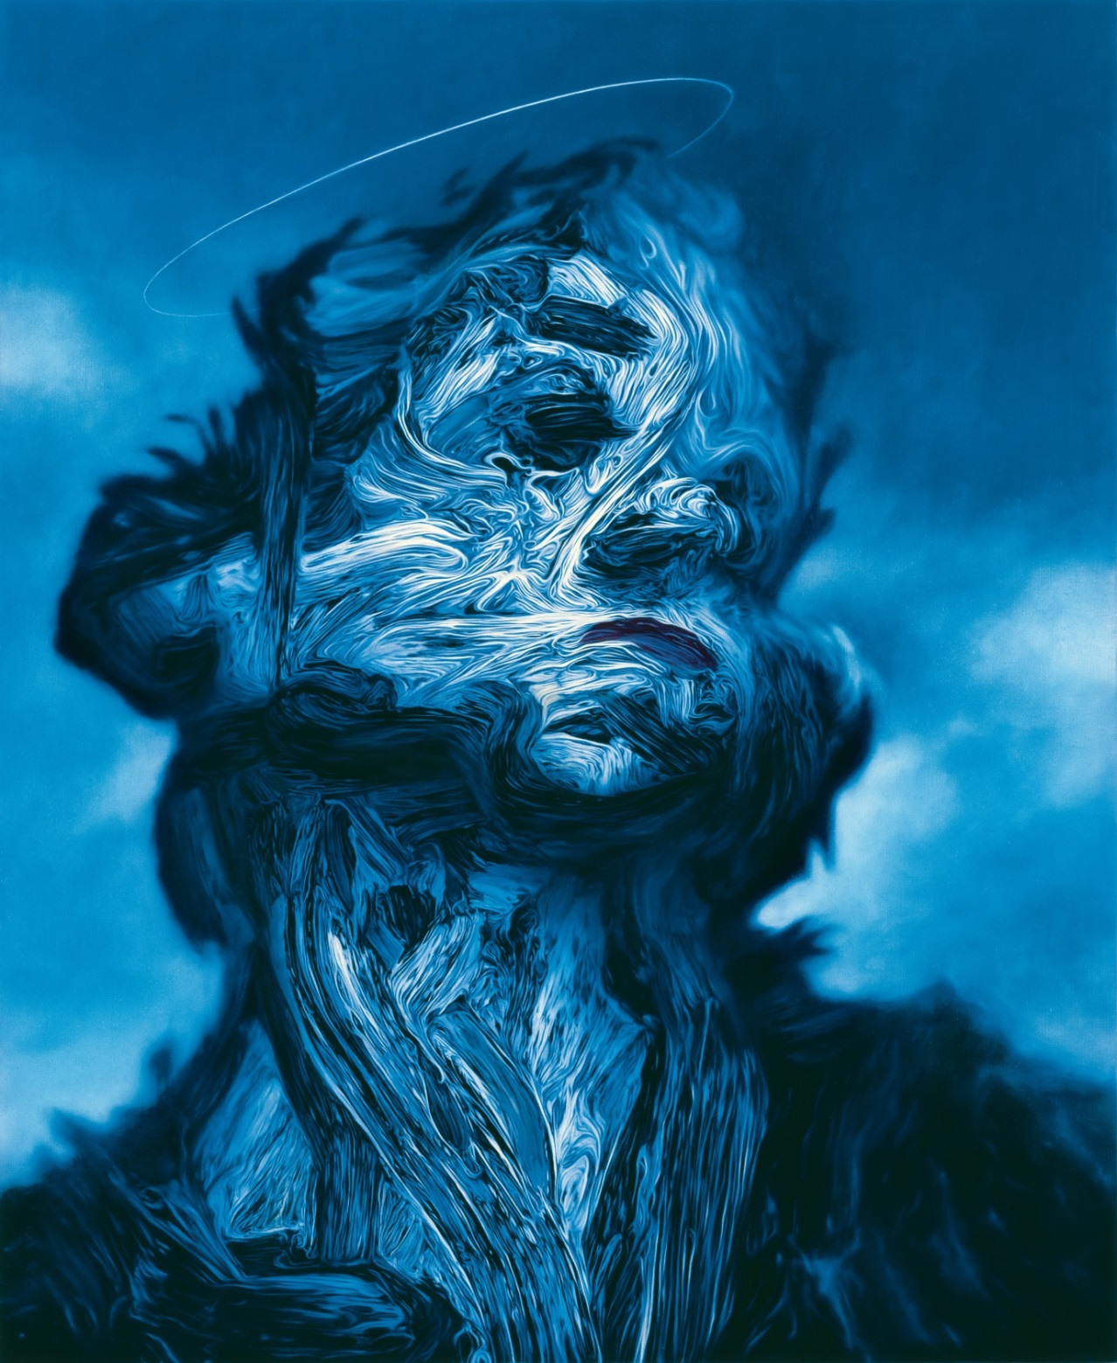
Glenn Brown, ‘Shallow Deaths’, 2000, Oil on panel, 70 x 57.5cms
It has been well documented how Brown appropriates ready-made, printed reproductions from art history books; how the reproductions themselves (not the original paintings) form the basis of his practice. Texts abound describing Brown’s transcriptions of other painters’ virtuosities (and their shortcomings), such as Keith Patrick’s assertion that ‘his transformation of seemingly gestural painterliness into a flat, painstakingly constructed surface is seen to raise issues of authorship and originality, and to refer to the ways in which our experience of the “original” is all too often mediated by the photographic reproduction’;(1) or Tom Morton’s statement that Brown’s borrowed motifs undergo formal and chromatic distortions whatever the texture of the work from which the imagery is borrowed: ‘craggy in an Auerbach, smooth in a Dali, the surfaces of Brown’s canvases are absolutely flat, resulting in a kind of trompe l’oeil’.(2) David Freedberg has even claimed that ‘here, on gleaming surfaces prepared with all the care and precision of an old master, everything is perfectly smooth. A kind of savage pictorial drama is achieved with the finest possible brush, leaving a surface so puzzlingly free of thick impasto that many spectators may feel that these are little more than prints or some other form of mechanical reproduction’.(3)

These synopses of Brown’s practice as a subversive if not cheeky copy of the endlessly reproducible prints of masterworks describe, I would contend, only a part of his project. They fail to address the question of how we reposition Brown’s paintings in the context of the changes brought about by the use of the digital or the virtual via the computer screen – given that the printed image is being increasingly superseded by the on-screen image – and of how his paintings wrestle with art-historical issues of materiality, depth and opticality. After all, when any of us now wants to research an image from art history (such as a Rembrandt), we no longer go to the specialist art bookshop or library, we simply use Google. Of course the digital doesn’t eradicate the printed image; it’s just that if one wants to find visual information (on any subject for that matter) it has become easier and quicker to do so on the internet. Increasingly, computer programmers compete to reproduce the ‘real’ world on the screen with ever more finesse, as if the goal were to create a virtual world that was more ‘real’ than the physical world (computer games and CGI film effects would be examples). Brown’s paintings preserve this hyper-illusion of the ‘real’ by ever more (and obstinately) ambiguous finishing. His paintings increasingly challenge us to question the terms of their ‘reality’ in relation to ‘special effect’, virtual representations.

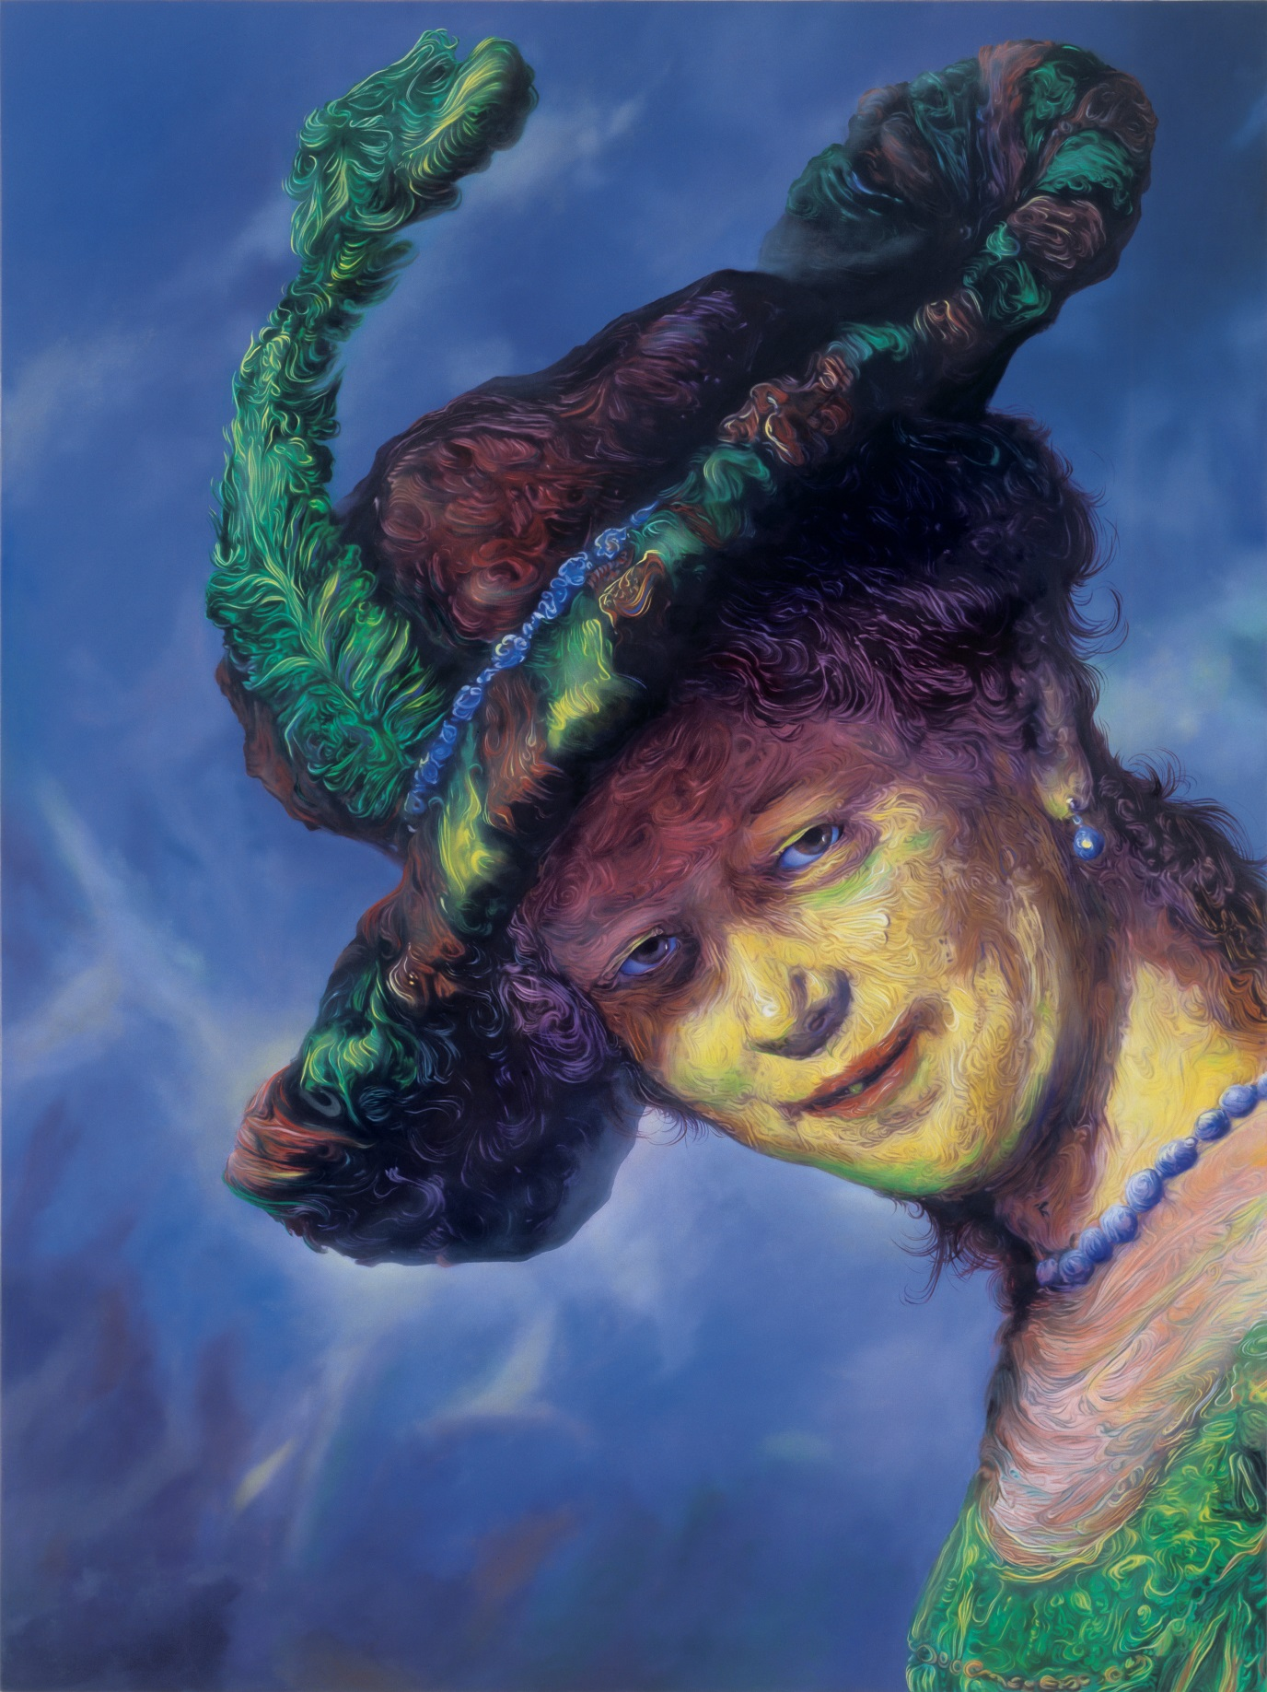
Glenn Brown, ‘Dark Star’, 2003, Oil on panel, 100 x 75cms

Rather than copy from reproductions in printed books as he had done up until the late 90’s/early 00’s, he now browses the web, chooses an image and orders a high quality ‘art print’ from one among any number of newly formed print-on-demand companies, which is then used as the basis for the painting. This offers him greater choice, as the tools he is employing open up a vast databank of visual information which would not have been available during the previous decades. His methodology has altered but his project has not.

Brown’s recent preparatory methods proceed like this. He scans his chosen reproduction into his computer. He then works on the image in Photoshop, changing its features by stretching it, rotating it, altering the colours and utilising airbrushing and paint tools. The freedom offered by other tools such as ‘undo’ means that Brown can charge ahead with his changes and then playfully destroy or reposition them by opting to return to any stage at any time. While painting, Brown takes further liberties with the image. As he uses his fine brushes to trace the contours of the reproduced brush marks (including his own digitally manipulated marks) he also invents impasto brush marks where none had previously existed. Then, after adding bright highlights, often in white or yellow, he finally adds thin glazes of translucent, tinted varnishes to induce a feeling of depth (similar to that of an Old Master).

The photorealism of his earliest pieces created a shallow depth, suggesting that the object depicted was on the other side of the picture plane. In the late nineties he would mimic extreme photographic depths of field to suggest an object in perspectival space. Now Brown has transcended, or better still extended, the photograph as a model for copying. From the early 2000s his paintings have become involved with the all-over focus of the digital image. But what does the digital offer Brown that the photograph cannot? The photograph records evidence that something has existed, that some event has transpired. Unlike the digital screen, the photograph can only give testimony to the existence of its subject: ‘that something is to happen (the future implied in the photograph) that has already happened (the photograph as record of a future now past)’.(4) To see an image on the digital screen, however, means that to see is not to know that some event has taken place. The screen forces us into a subjectively imagined past and a subjective future at the same time; it offers accessibility while simultaneously acting as a screen of exclusion of everything that is elsewhere. It is an impossible space – a hypersurface.(5)

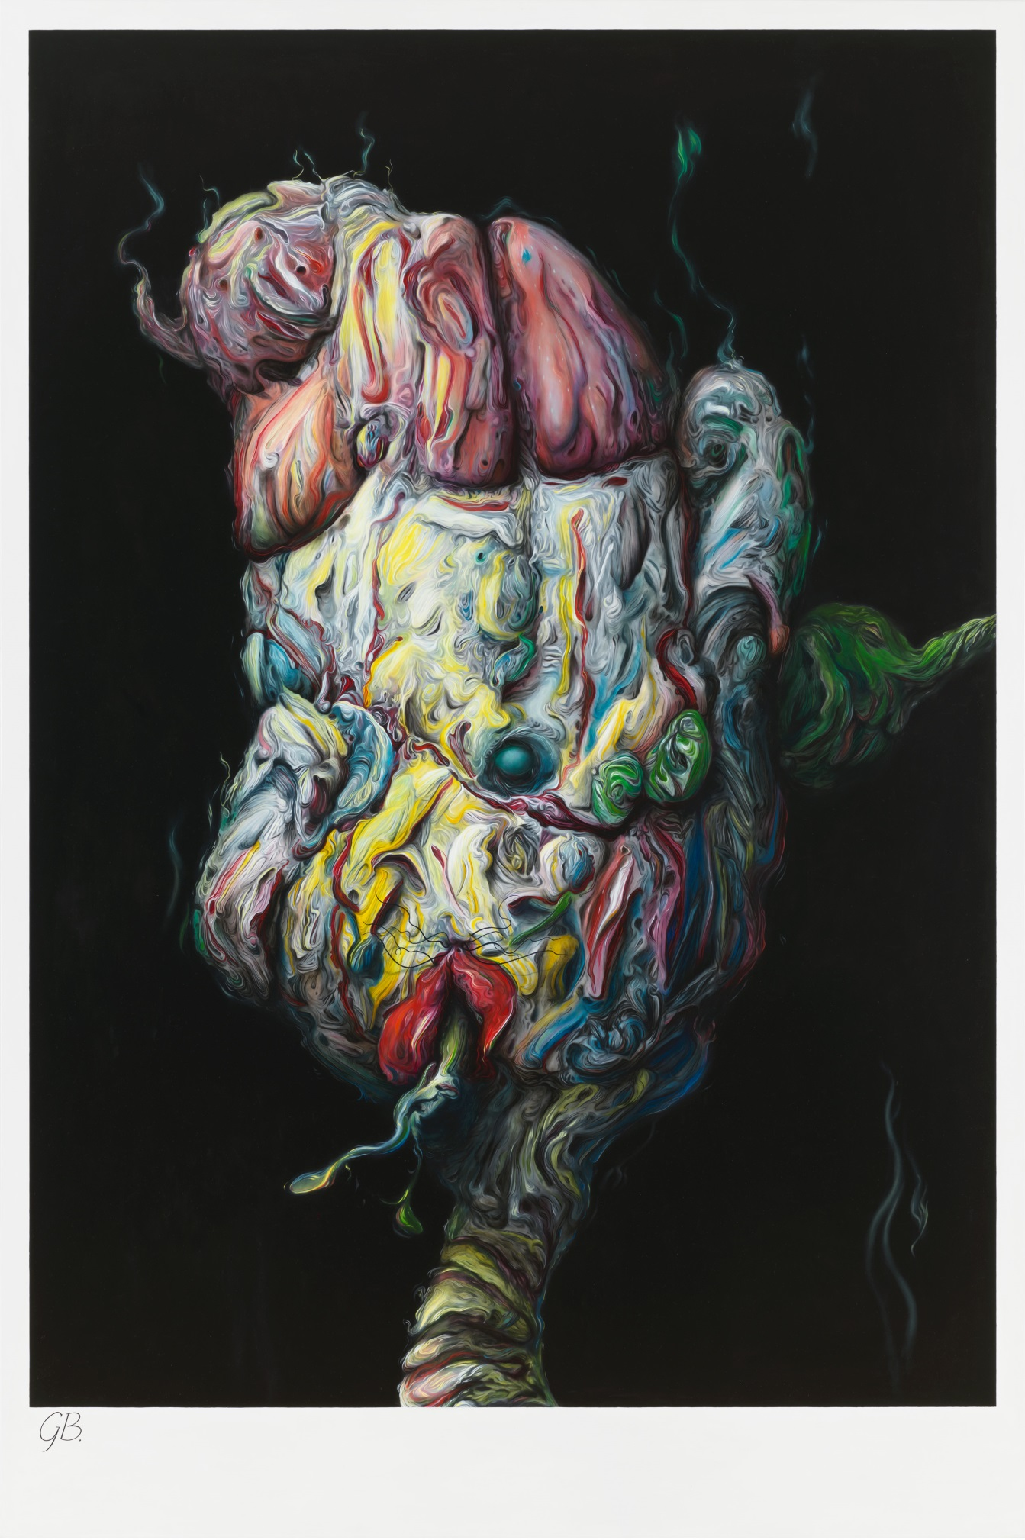
Glenn Brown, ‘Some Velvet Morning When I’m Straight I’m Going To Open Up Your Gates’, 2007-2014, Oil on panel, 222 x 148cms
Hypersurfaces offer subjectivity an imaginative production but through bodily production. Brown’s paintings operate in this imagined physicality of the corporeal because they have become increasingly interdependent on the impossible space of the screen. Merleau-Ponty, before the computer age, predicted this as a transference, an imaginary texture of the real, whereby traces of vision that are offered to the gaze are conjured from inside the body as a hypothetical, overlapping relation of things in the world of objects.(6) Brown’s imaginary texture of the real manifests itself through his bodily practice and becomes embroiled with and within the augmented space. He adopts a mode of operation that is an intertwining of vision and thought (not a Cartesian distinction between the two) as digital transference. Pixels (which vision and thought inhabit) and topological space (which the body inhabits) overlap and become indistinguishable.

It is important to point out that it is not sufficient to argue that Brown’s computer-based preparation method prior to painting is the sole reason for his relation with the digital. The computer increases and develops his choices of found imagery, but it is only a means, not the end. Otherwise we come full circle back to a Greenbergian Modernism which is so often unwittingly recycled by those who view computer and video technology as superseding painting as the ‘contemporary’ media. This reliance on the ‘newness’ of a medium as if it were important above anything else is Greenbergian media-specificity par excellence; it is a smokescreen repressing a familiar wish for the golden age of Modernism’s avant-garde – ideas that Brown recognised as outdated and untenable fantasies back in the nineties.

So instead of being seduced by Greenbergian medium-based certainty which argues that ‘each art had to determine, through its own operations and works, the effects exclusive to itself… the unique nature of its medium’,(7) or by Walter Benjamin’s critique of the loss of authorship due to the infinite reproducibility of the work of art (are they paintings? are they prints?), Brown’s use of history is transformative. It is not a reactionary revivalism that harks back to an arcadia of painting that existed before fancy postmodern ideas. On the contrary, his works are markers for the future of painting because they are both surface effect and material methodology, not despite the screen but because of it. His object/paintings are in a flux of permanent conundrum, they anticipate and reach back into history while simultaneously repositioning history as future; as hypersurface.

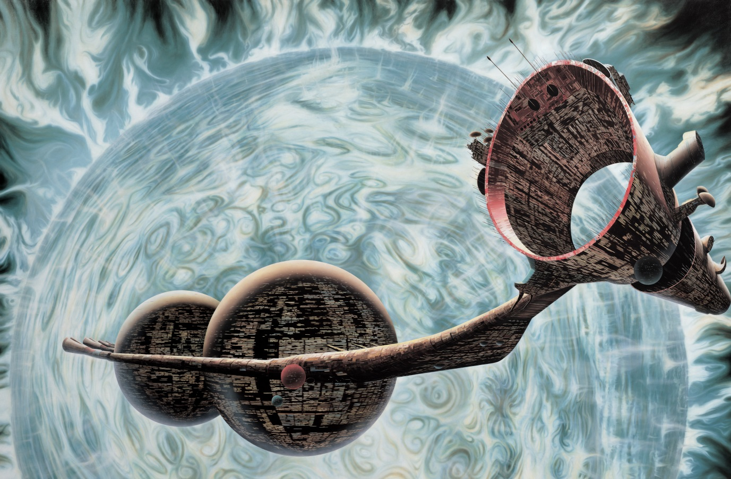
Glenn Brown, ‘The Loves of Shepherds (after ‘Doublestar’ by Tony Roberts)’, 2000, Oil on canvas, 219.5 x 336cms

In this context, Brown’s work has anticipated the Merleau-Pontian subject that thinks in vision with the exterior world, firstly through the printed image, and secondly as bold incursions into the digital. It follows therefore that if the future of art criticism is not based on media-specificity or the loss of the original (was there ever an original?), then Brown’s painting will continue to gain currency with the notion that the world (and our bodies’ relation to it) is now changed by the disembodied screen as a complex space, a space that is never fixed in one space/time location. Because he has the foresight to perceive that the material world now has an unintentional dependency on simulation, Brown is updating Walter Benjamin’s argument that the original is changed by mechanical reproduction by extending it into the impossible space of the virtual: he imaginatively transmutes his subjectivity into the computer and outside traditional space/time coordinates and his paintings tell us this. What we are left with is Brown’s expression of this arcane feeling that there are literally no visible means of support, and what better way to illustrate this than his science fiction painting The Loves of Shepherds (After Doublestar by Tony Roberts) 2000, copied from a ludicrously outdated illustration from the 1970s. A spaceship is orbiting a gaseous planet – a world and a ship that are fictional, yet known to us because of our familiarity with sci-fi fantasy. Yet Brown is not being boyishly nostalgic for something that never was nor could ever be. He is reaching into the possibility of the future, his embodied being has been transfigured through painting as virtual representation – he has become, or rather he is, the spaceship in the impossible space of the virtual.

Part 3, Digital Embodiment: Quasi-presence as an Effect
We have now made sense of Brown’s methodological relation to the digital condition but how does this relate to today’s students? For sure we could talk about Brown’s influence on the brush mark as ironic trace, or history as a distant but ever present bedfellow. We could even talk of the conflation of renaissance and modernist materiality and/or optical space, or the use of the reproduction as perhaps standard fare. But rather than dwell on how Brown may or may not have a direct effect as an influential example (and I’m not sure that he does), or because of his contextual concerns of making visible painting via reproduction (rather than the other way round), I am interested in how his ontological relations between making and the screen may overlap with those of a younger generation; that we begin to understand how the phenomenon of being interacts with digital embodiment.

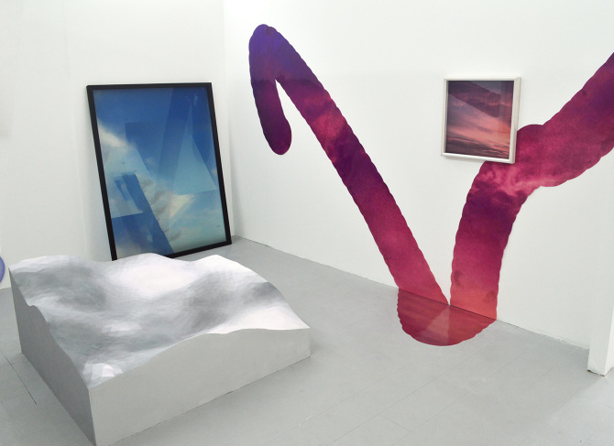
Ishbel MacKenzie, 2017 Degree Show, Glasgow School of Art

Because of the thin gap between virtual representation and the world of objects have current students also become, like Brown perhaps, the spaceship; complex, transfigured, digital versions of Merleau-Ponty’s “imaginary texture of the real’’? And if so, where are those students identity-wise? How do they deal with the indistinguishable, where there are no visible means of support; that space where materiality and immateriality overlap; where subjectivity struggles with a sense of location in the real world of objects? Exactly how do we place and understand this very contemporary subjectivity and how can artworks be produced with these conditions in mind? How is making viewed by students in relation to, or despite the screen? And, because student-centred learning is central to the studio-based course at GSA, how do we encourage and foster a sense of being and making in the 21st century?

Unlike Brown, many of my students complain that the overlap with the virtual - where objects end and the screen begins (or the other way round) - overwhelms them. The screen, these so called digital natives often say, takes over and informs their very identities, world views and decision making. Often, when prompted or questioned, my students say that constant screen use confuses who they are and how or what they want to make. Whereas for Brown’s generation of digital migrants the screen represented new and unchartered territories for material painting as immaterial witness, or painting and its histories as a critical prerequisite of the screen, students can feel disenfranchised if they feel unable to identify with any prerequisite; they feel defeated, abandoned, they fail to get a grip on which world is more ‘real’, leading to inhibition; some even want to fight back!

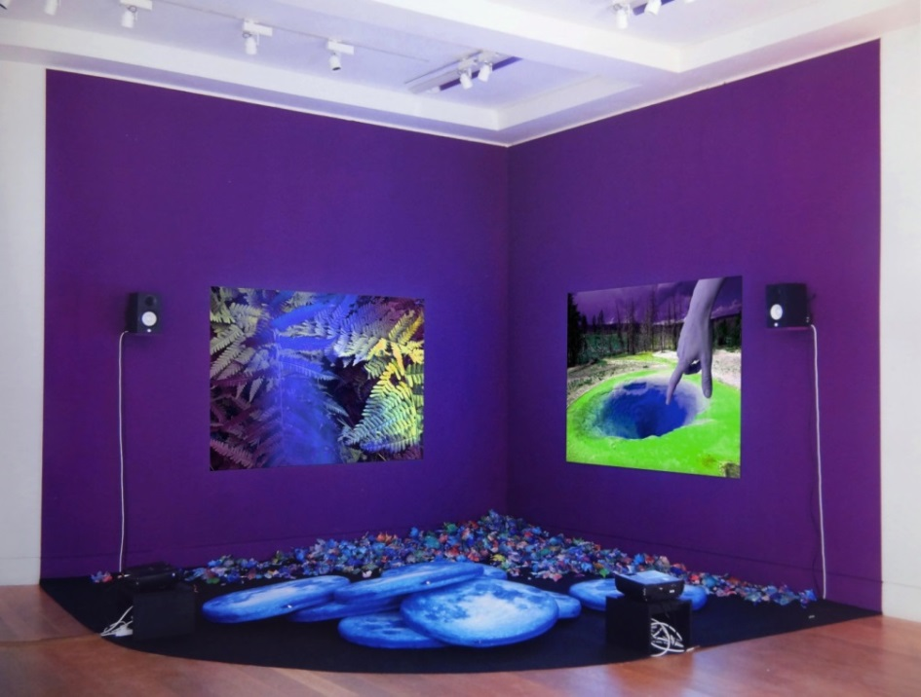
Clara Hastrup ‘Abscission’, 2017, installation view - dimensions variable, David Roberts Foundation, London
It seems they are not alone as these concerns are regularly echoed in the wider popular and academic culture; institutional and political paranoia, the dark side of the net, technology used to cajole and manipulate the innocent etc. For example, the individual episodes of the TV series Black Mirror or the endless Sunday supplements about the so called liberation of digital detoxing. Or in recent e-flux publications by Sternberg Press such as ‘The internet Does Not Exist’, or Hito Steyerl’s ‘Wretched of the Screen’. In this sense we could even consider accelerationist theories which analyse prevailing systems of capitalism or techno-social processes to expand, repurpose, or accelerate those systems in order to generate radical social change (Benjamin Noys). Or perhaps the Speculative Realists who rail
Against correlationist philosophies that privege the power of the human sovereign subject through language (or the human mind), above and beyond nature or the object (such as Quentin Meillassoux).

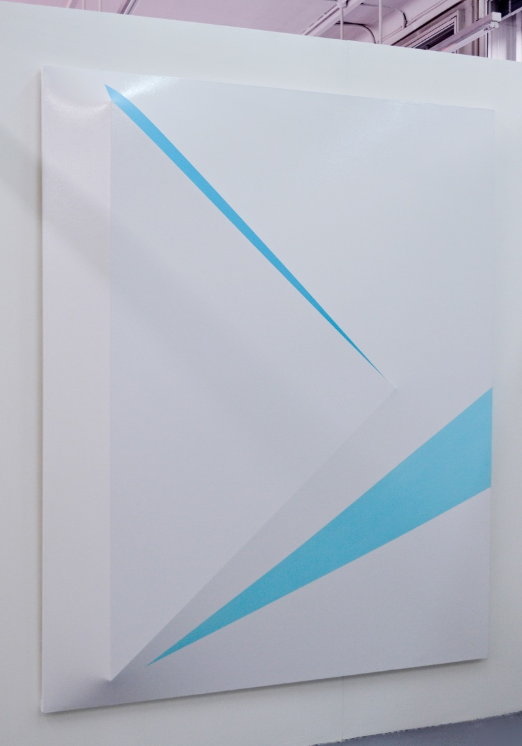

Rachel Hobkirk, 2017 Degree Show, Glasgow School of Art

Because of (or analogous with) these examples it would be fruitful here to establish how this inhibited sense of screen indistinction socially and historically manifests itself and in turn ask how, or if, this so called indistinction can acquire a critical role for future making. In Mark Poster’s 1988 reader on Jean Baudrillard he says that because of the proliferation of communications through the media, the practice of its operations “differs from both face-to-face symbolic exchange and print. The new media, especially advertising, employ the montage principle of film (unlike print) and time-space distancing (unlike face-to-face conversation) to structure a unique linguistic reality”.(1) This unique linguistic reality, Baudrillard himself claimed in 1968, has become “pure signifier, without a signified, signifying itself”, (2) and that the new media, and in particular advertising, changes the communicational forms of mass culture. That social interaction has disappeared and imploded into advertising substitutes for a “mass society, which, with the aid of arbitrary and systematic signs, induces receptivity, mobilizes consciousness, and reconstitutes itself in the very process as the collective. Through advertising, mass society and consumer society continuously ratify themselves”(3) For Baudrillard, the emergence of advertising and media culture, which signifies itself, means that the sign relocates in desire and re-routes consciousness. Poster says that in Baudrillard’s terms, this is a ‘hyperreality’ which renders “impotent theories that still rely on materialist reductionism or rationalist referentiality”.(4)

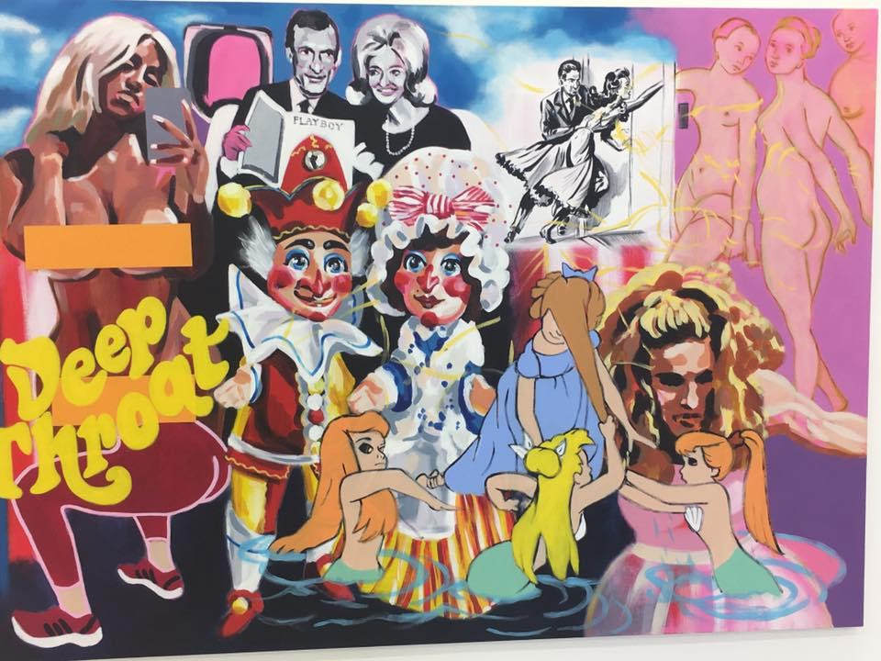
Emma Louise, 2017 Degree Show, Glasgow School of Art
Baudrillard’s subjective relocation of the sign into desire is termed the code. Poster says that the code operates by extracting signifieds from the social by redeploying them in the media (especially television) as “floating signifiers”.(5) Poster also argues that for Baudrillard this world of ‘floating signifiers’, with no fixed determinations, is populated by a “world where anything can be anything else, where everything is both equivalent to, and indifferent to everything else”.(6) So, in the 21st century, if we replace the television screen with the digital screen with all its multi-platforms and networking possibilities, we can begin to understand how Baudrillard’s hypothesis resonates exponentially today. Desire for commercial objects, lifestyle, travel, money, sex etc. runs at an increasingly rapid speed unprecedented in 1968 or even 1988.

Georgina Clapham, 2017, Artemis & Actaeon, oil on linen, 190x130cms
There has though been much criticism of Baudrillard’s so called ‘fatalist strategies’ such as M.W. Smith’s ‘Reading Simulacra’ from 2001. Baudrillard’s negative assertion that the copy replaces the originary model (or object) gives way to Smith’s celebratory claim that although the copy itself has become the site of subjectivity, he calls for the indeterminate subject to surrender, in a dandyish manner, to the simulacrum’s dominance. For Smith, this hedonistic subject/copy skates knowingly, ironically, unapologetically (and perhaps majestically) across the surface of the screen. But this duplicitous irony seems hopelessly optimistic if you have no sense whatsoever of the object model as an originary source and arguably, this is becoming increasingly so with younger generations. If the world of objects has been subsumed into ubiquitous reproduced copy then perhaps it’s time for a further re-evaluation that includes, rather than precludes, disorientated digital natives. I’m therefore proposing here that a complex re-establishment of making takes place in conjunction with the digital realm; that the 21st century subject self-consciously acknowledges both the digital copy and the physicality of material making simultaneously. This re-establishment could perhaps transform the subjective interrelation between the embodied made/painted object and the augmented/disembodied screen. That the contemporary painting student knowingly hyperreflects Merleau-Ponty’s reversibility as a simultaneous authorial ontology, actively experimenting with physical making and materials in relation to the non-authorial screen and not despite it.

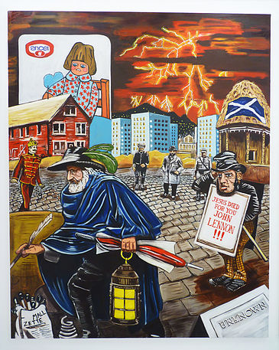
Louis Bennett, 2017 Degree Show, Glasgow School of Art
We can begin to unpack my claim by looking at Paul Crowther’s understanding of autographic, painted activity. Paul Crowther states that although ‘of course, some pictorial images can be created electronically, it is useful, accordingly, to use the term ‘autographic’ for those images which are made by hand or by other bodily organs. They are not handwriting, but they do involve the image being created through the body’s use of an implemented or (more unusually) its own limbs to mark a surface. Drawing, and painting are the products of gesture. As such they can embody individual style (in personal terms, or as a group or regional identities) in how the surface is marked. In this sense they are autographic’.(7) But what about those painting students who utilise technology? How does the bodily and autographic (via painting) become represented through electronic means?

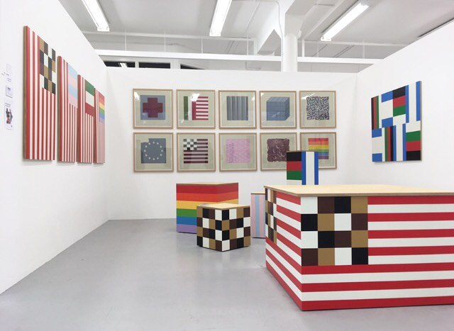
Robbie Spriddle, 2017 Degree Show, Glasgow School of Art

Isabelle Graw argues that gesture is detectable in painting ‘as a highly personalised semiotic activity’,(8) which is indexical in nature. According to Charles S. Pierce she says, an index shows something about a thing because of its physical connection to it… That someone has left her mark’.(9) Now for Graw this indexical semiotic reading expands the autographic, as a rhetorical mark on a surface because, ‘by focussing on painting’s specific indexicality, we will be able to grasp one of its main characteristics: it is able to suggest a strong bond between the product and the (absent) person of its maker’.(10) Graw adds that artist labour in a painting is detectable in the concrete materiality of its surface and gestures and that it displays traces of its labour as a quasi representation. In this sense could we then think of painting’s indexicality as a residue in the object which in turn becomes an absent subject? That this object leaves in its wake a comparative trace of the author? And exactly how does this quasi trace display itself in an electronically produced work?

Anna Waschsmuth, 2017 Degree Show, Glasgow School of Art
Crucially, Graw develops the idea that the quasi trace is also visible in a ‘mechanically produced silkscreen by Andy Warhol… or a printed black painting by Wade Guyton, (because it) is no less capable of conveying the sense of a latent presence of the artist – by virtue, for instance, of imperfections deliberately left uncorrected, selected combinations of colours, or subsequent improvements’. (11) This activity, because of mechanical and screen production, includes contemporary works that are flat as well as gestural, that as ‘a highly mediated idiom, painting provides a number of techniques, methods, and artifices that allow for the fabrication of the impression of the author’s quasi-presence as an effect’.(12) Because painting can now accommodate any medium, and by making personal choices of colour, imagery or editing etc., this formulation also extends to electronic works; that quasi effect be mirrored in or on the screen or as part of an electronic installation piece. Therefore, the painting student of today is compelled to negotiate paintings form, gesture, line and colour relations etc. as an overlapping of the material and the digital. Combined with intention of idea or perhaps subject, and by accepting the body as a producer in the first instance and in the second as a transferable subjective expression, could we perhaps ontologically umbrella this as extended painting?

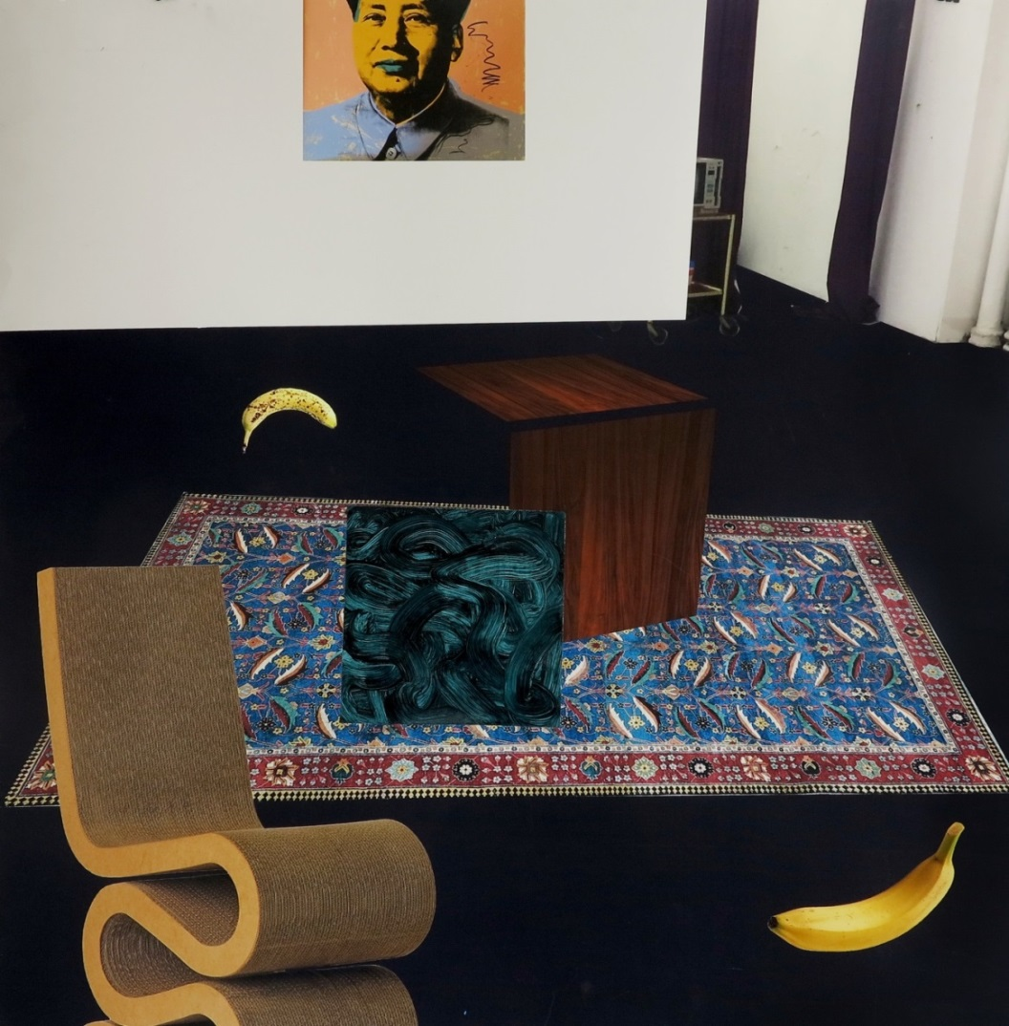
Ella Khafaji, 2017 Degree Show, Glasgow School of Art
When confronted with student anxiety about identity and what or how to make, it is this understanding of bodily materiality with the electronically rendered which can, if accredited as the contemporaneous condition, be the very site of their criticality. In opposition to the historically conditioned and uncritically received wisdoms of reductionist modernism that relied on the privileging of the sovereign ego, subjective presence therefore is available to students as expressive effect; an indexicality that is read beyond their own circumstantial thought and making processes. Whether utilising hand gesture and/or electronic substitutes, today’s students mirror how our consciousness constructs patterns of behaviour out of today’s myriad codes of technological desire. They are in a fabulous, if not free position to think through painting, its mediums and its histories as indexes of individual style and ontological agency; a complex, subjective transference that is able to produce ebullient bodily representations of the visual density of our hyper-networked world. Like Brown perhaps, they have become, or are in the process of ‘becoming’ the spaceship in the impossible space of the virtual - how could it be otherwise!

Notes

Introduction

(1). Peter Geimar/Isabelle Graw, Thinking through Painting: Reflexivity and Agency beyond the Canvas, Sternberg Press, 2012, p. 51.

(2). Paul Crowther, What Painting and Drawing Really Mean, Routledge, 2017, p. 7.

Part 1 - Painting Now

(1). J.J. Charlesworth, Art Monthly??

Part 2 - Glenn Brown: No Visible Means of Support

(1). Quoted in David Freedberg, Against Cliché: Glenn Brown and the Possibilities of Painting, New York, Gagosian Gallery, 2004, p. 11.

(2). Tom Morton, Glenn Brown: Don’t Stop Me Now, Max Hetzler Gallery, Berlin, Holzwarth Publications, 2006, p. 5.

(3). Freedberg, Against Cliché, p. 5.

(4). Roland Barthes, ‘Camera Lucida’, quoted in Marcus Novak, ‘Transarchitectures and Hypersurfaces: Operations of Transmodernity’, Hypersurface Architecture, Architectural Design, 68.5–6, 1999, pp. 85–91, quotation p. 87.

(5). See Novak, ‘Transarchitectures and Hypersurfaces’.

(6). See Maurice Merleau-Ponty, ‘Eye and Mind’, in The Merleau-Ponty Aesthetics Reader: Philosophy and Painting, ed. G. A. Johnson, trans. M. B. Smith, Evanston, Northwestern University Press, 1993, pp. 121–49.

(7). Clement Greenberg, ‘Modernist Painting’, in Modernism with a Vengeance, 1957–1969: The Collected Essays and Criticism, Vol. 4, ed. J. O’Brian, Chicago and London, University of Chicago Press, 1993, p. 86.

Part 3 - Digital Embodiment: Quasi-presence as an Effect

(1). Baudrillard, J. (1988). Selected Writings. Edited and Introduced; M. Poster. Translators; P. Beitchman, P. Foss, C. Levin, M. Maclean, J. Mourrain, P. Patton, M. Poster. Stanford: Stanford University Press, p.1.

(2). Baudrillard, J. (1988). Selected Writings, p.10.

(3). Baudrillard, J. (1988). Selected Writings, p.10.

(4). Baudrillard, J. (1988). Selected Writings, p.1-2.

(5). Baudrillard, J. (1988). Selected Writings, p.4.

(6). Baudrillard, J. (1988). Selected Writings, p.4.

(7). Paul Crowther, What Drawing and Painting Really Mean: The Phenomenology of Image and Gesture (Routledge Advances in Art and Visual Studies), 2017, p. 7.

(8). Peter Geimar/Isabelle Graw, Thinking through Painting: Reflexivity and Agency beyond the Canvas, Sternberg Press, 2012, p. 45.

(9). Peter Geimar/Isabelle Graw, Thinking through Painting: Reflexivity and Agency beyond the Canvas, p. 50.

(10). Peter Geimar/Isabelle Graw, Thinking through Painting: Reflexivity and Agency beyond the Canvas, p.50.

(11). Peter Geimar/Isabelle Graw, Thinking through Painting: Reflexivity and Agency beyond the Canvas, p.51.

(12). Peter Geimar/Isabelle Graw, Thinking through Painting: Reflexivity and Agency beyond the Canvas, p.51.

Illustrations

Part 2 - Glenn Brown: No Visible Means of Support

1.’Secondary Modern’, 1998, Oil on canvas, 59.6 x 47.4cms

2. ‘Shallow Deaths’, 2000, Oil on panel, 70 x 57.5cms
3. ‘Dark Star’, 2003, Oil on panel, 100 x 75cms

4. ‘Some Velvet Morning When I’m Straight I’m Going To Open Up Your Gates’, 2007-2014, Oil on panel, 222 x 148cms

5. ‘The Loves of Shepherds (after ‘Doublestar’ by Tony Roberts)’, 2000, Oil on canvas, 219.5 x 336cms

Part 3 - Digital Embodiment: Quasi-Presence as an Effect – Undergaduate Students from the Glasgow School of Art, 2016-17

1. Ishbel MacKenzie, 2017 Degree Show, Glasgow School of Art

2. Clara Hastrup ‘Abscission’, 2017, installation view - dimensions variable, David Roberts Foundation, London

3. Rachel Hobkirk, 2017 Degree Show, Glasgow School of Art

4. Emma Louise, 2017 Degree Show, Glasgow School of Art

5. Georgina Clapham, 2017, Artemis & Actaeon, oil on linen, 190x130cms

6. Louis Bennett, 2017 Degree Show, Glasgow School of Art

7. Robbie Spriddle, 2017 Degree Show, Glasgow School of Art

8. Anna Waschsmuth, 2017 Degree Show, Glasgow School of Art

9 Ella Khafaji, 2017 Degree Show, Glasgow School of Art

