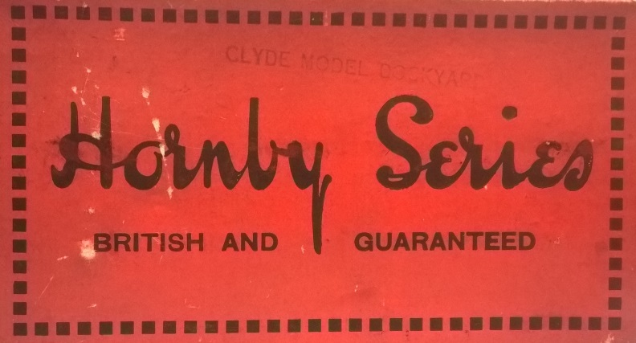

BRITISH AND GUARANTEED

For about a year I have been working on an extensive survey and history of the Service Department at the Liverpool based toy manufacturer Meccano Ltd. This was intended only for collectors of the products themselves, mainly from the Hornby Trains range, which are fairly commonly found. The ‘article’ has grown into book proportions and has thrown up a number of questions that take the content beyond the realm of collecting. The CHORD workshop on 23 May 2017, specifically on the topic of distribution and reputation, seemed to be a good place to air some of them in an academic context. From this, I hope to develop a more substantial Journal article.

The Service Department was the result of under-design in a single product, the Hornby Clockwork Train, introduced in 1920. For a toy train of its size it was relatively expensive and very well finished. The fact that its mechanism was prone to fail was to result in a flood of returns. Meccano, which had already developed an American style advertising department with advanced marketing techniques and a clear brand identity, asked for this by suggesting that their trademark was ‘a guarantee of quality and workmanship’. Many other makers, particularly those in Germany, tended to operate quite anonymously through wholesale agents. Product failure was something new to Meccano Ltd, whose reputation had been built on a single product, the construction outfit of the same name, the components of which were so basic and robust that they rarely ‘went wrong’.

The ‘Repairs Department’ was established in 1921, and the product was hastily redesigned to address its most obvious failings. However, such had been the sales of the original product that they continued to be returned. The company looked to some way of mitigating the expense of repairing or replacing them. The introduction of a formal guarantee followed. What this did was time-limit free repairs to sixty days. A formal guarantee for a toy in Europe was unheard of at this time, and the company trumpeted it as a sure sign of its product quality. In fact, what it did was to allow the company to legitimately charge for repairs for products returned more than two months after purchase without reputational loss. Moreover, it is quite likely that the loss making, but reputation saving ‘Repairs Department’ became at least a break-even and quite probably profitable ‘Service Department’.

It is the duality of this that interests me. It seems that reputational enhancement of the company was achieved through the failings, rather than the qualities of its own products. What we see in Meccano is a ‘product minded’ approach to R&D that was countered by a seemingly independent and much more ‘market minded’ approach to advertising and brand management. With the Service Department another significant element was added to this mix that soon operated largely independently of both.

Nicholas Oddy
Glasgow School of Art
n.oddy@gsa.ac.uk

