Making the Negligible Considerable

614 words

A building need do no more and indeed must do no less than assist man’s homecoming. Aldo van Eyck

Sound, touch, feeling, profile, weight, shape- a cluster of clanking metallic objects is dulled by a bubblewrap overcoat. I’ve opened a box to discover what appears to be a collection of door handles. They are from different ages- machined, familiar, graspable. On closer look, there is old and new ironmongery- wood and porcelain among the brass and iron. These are objects with a past, a history even. I feel them in my hand; they are designed for touch, for grasping, to hold, to be useful. They have a purpose. They can literally open a door to another room, to another world perhaps? The things we touch matter to me. How many times in our lives do we touch a light switch or take hold of a door handle or knob? My quick reckoning is about 17 times each morning before I leave for work; suggesting a daily tally of about 50. I quickly do the arithmetic. Even ignoring my first 10 years (which weren’t a completely switch-free and door handle-less period), I still reach a round figure of a million encounters with switches and door handles so far (and counting…). The negligible becomes considerable. All the handles appear content and pleased with themselves. They jostle, hugger-mugger with each other, like toys in a toy box or books on a book shelf- each one a little world in itself. But they also appear restless; out of context, like fish out of water. They each patiently await a door to fulfil their life’s destiny. Modest though they appear, they nevertheless ignite my imagination. They are not merely products- they are creative stimuli. Can the same be said of their equivalent today? What of today’s typical everyday building product? A dry verge system? A radiator? A window stay? They are more often banal and mundane in contrast, as if they’ve been ordered over the internet (And probably have been). There are well-designed exceptions of course, but the norm is mediocrity. What future for a culture of the well made I wonder? Perhaps objects which receive our grasp willingly and hospitably remind us architects of the buildings they wish to be part of – buildings that they feel are worthy of them. A small element can carry a bigger idea of architecture, like a chord in a piece of music unlocking a particular sequence, or a button setting the tone on a jacket.

I think it was Luigi Snozzi who wrote that every house belongs to some city in the world in some way. Its architectural configuration acting like a map and compass, hinting at what that city might be about if the building were to influence its gestation. A new house I am presently designing is organised in two parts. One is a long, single storey volume for sitting, eating and cooking, which has the opportunity for light and views from all sides. The other is a dense vessel of contained spaces for bedrooms and bathrooms and stores. On plan, they appear as if in collision- an introverted container meeting an extroverted container. The introverted one appears closed from the outside but reveals the sky in unexpected ways when inside, lightening the experience of containment within both physically and psychologically. The extroverted one is more open from the outside, but feels heavier inside due to a unifying vaulted roof. There are no doors in the vaulted space and many doors in the bedroom vessel. These in turn are thick and their handles thin; possibly wrapped in leather twine, welcoming someone’s hand, perhaps for the first of one million touches……

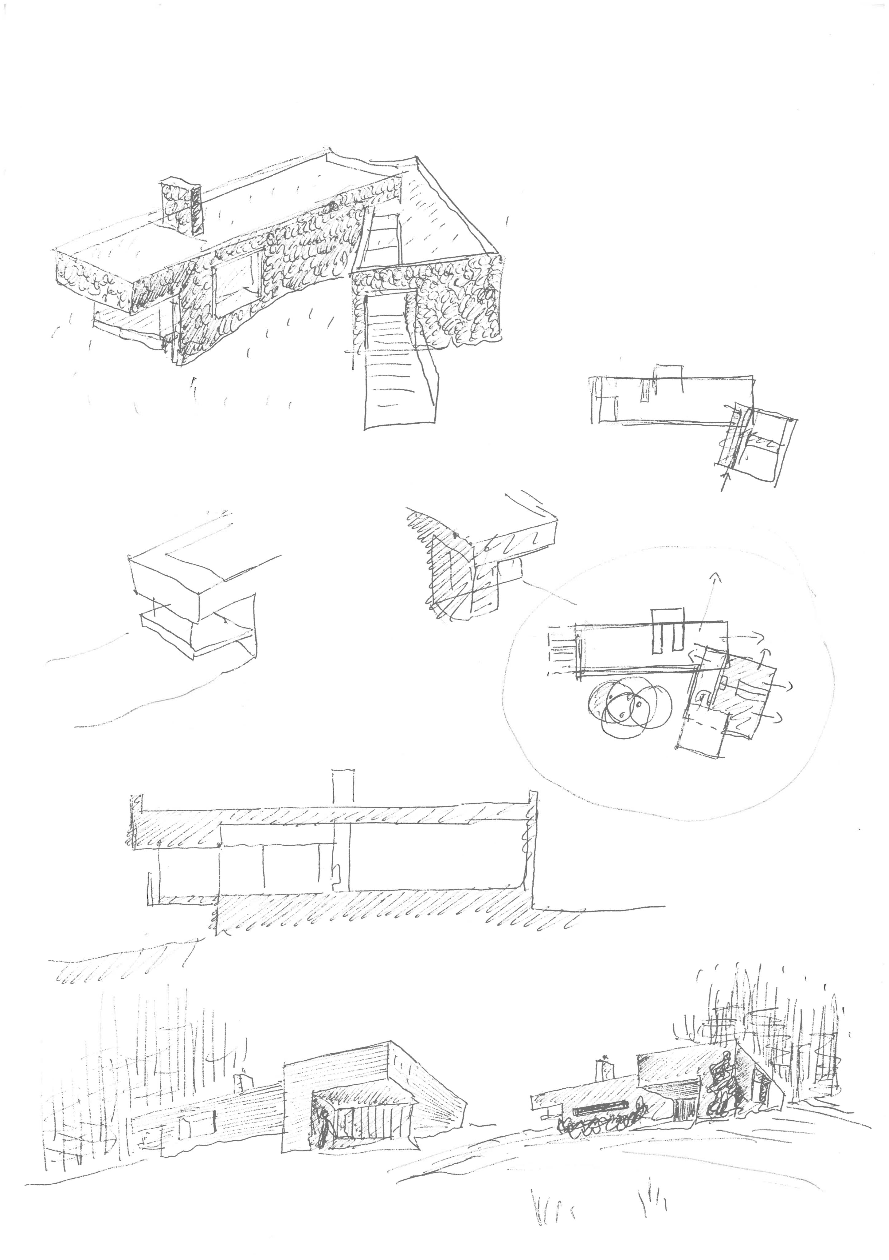

Christopher Platt March 12th 2017

