Narratives, Navigations and……Notations

‘Notations’ could be renamed Narrations or Navigations. Within its covers, we encounter both stories and tales and a reminder that our most valuable map and compass appeared in our childhood, not during our architectural education. It is a reminder also that our most valuable learning process may simply be making drawings of the visible world outside us as well as drawing out the secret world which is inside us.

This book, or should I say books is like no other I have encountered. Both in form and in content, this limited edition boxed set edited together by Paul Clarke and Peter Maybury and designed by Peter Maybury shines a revealing and loving light on the thinking and representation processes that underpin a small group of internationally distinguished artist/architects based in Ireland. It is in many ways, the ultimate j’adore act from one architect to his peers. This gesture has been born from a highly fruitful and trusting collaboration between subjects and author. In fact subjects and author are interchangeable within these covers and comprise the well-known figures of Michael Doherty, Tom dePaor, O’Donnell + Toumey, Seamus Lennon, Nigel Peake, McCullough Mulvin, Grafton and Paul Clarke himself. All contribute to this cognitive snapshot capturing the unfinished, spontaneous, precise and imprecise, private scribbles and fragments which capture the genesis and development of their creative work.

Physically, the collection comprises a black (almost A5 size) box with eight separate books. These are conceived as notebooks themselves, soft-backed, sitting hugger mugger in their box bed and (unlike a row of CD’s), stubbornly resisting standing to attention. Instead they jostle and nudge in choreographed disobedience announcing both the individuality of their contents and the disorder and human presence of the well-used bookshelf. They seem to almost look forward to a dog-eared future. Their physical arrangement reminds us that the creative process is not a neat and tidy sequence, but a messy, creative business which you have to ‘do’ and ‘redo’ before you can figure out what it means. And this message lies at the core of this celebratory publication.

The collection is also a catalogue of sorts of a long-running research project which Clarke began in 2010, whose outputs have included the travelling exhibition, ‘The Secret Laboratory’, various papers and the internationally-acclaimed film, ‘Drawing from Life’ featuring the same individuals in convivial psychiatrist’s couch type-conversations. The contents of each book appear only lightly edited, allowing a sense of spontaneity to do the communicating. No accompanying text attempts to translate or illuminate this further which is both frustrating and provocative. Like Herman Hertzberger’s published journal of the same name or Le Corbusier’s Voyage D’orient Carnets, the medium very much remains the message. The invitation to make the effort in concentrating on what would otherwise be seen by most as throw away scribbles, gives this collection its uniqueness and significance. The scribbles are moments of exploration, experimentation, synthesis, and resolution.

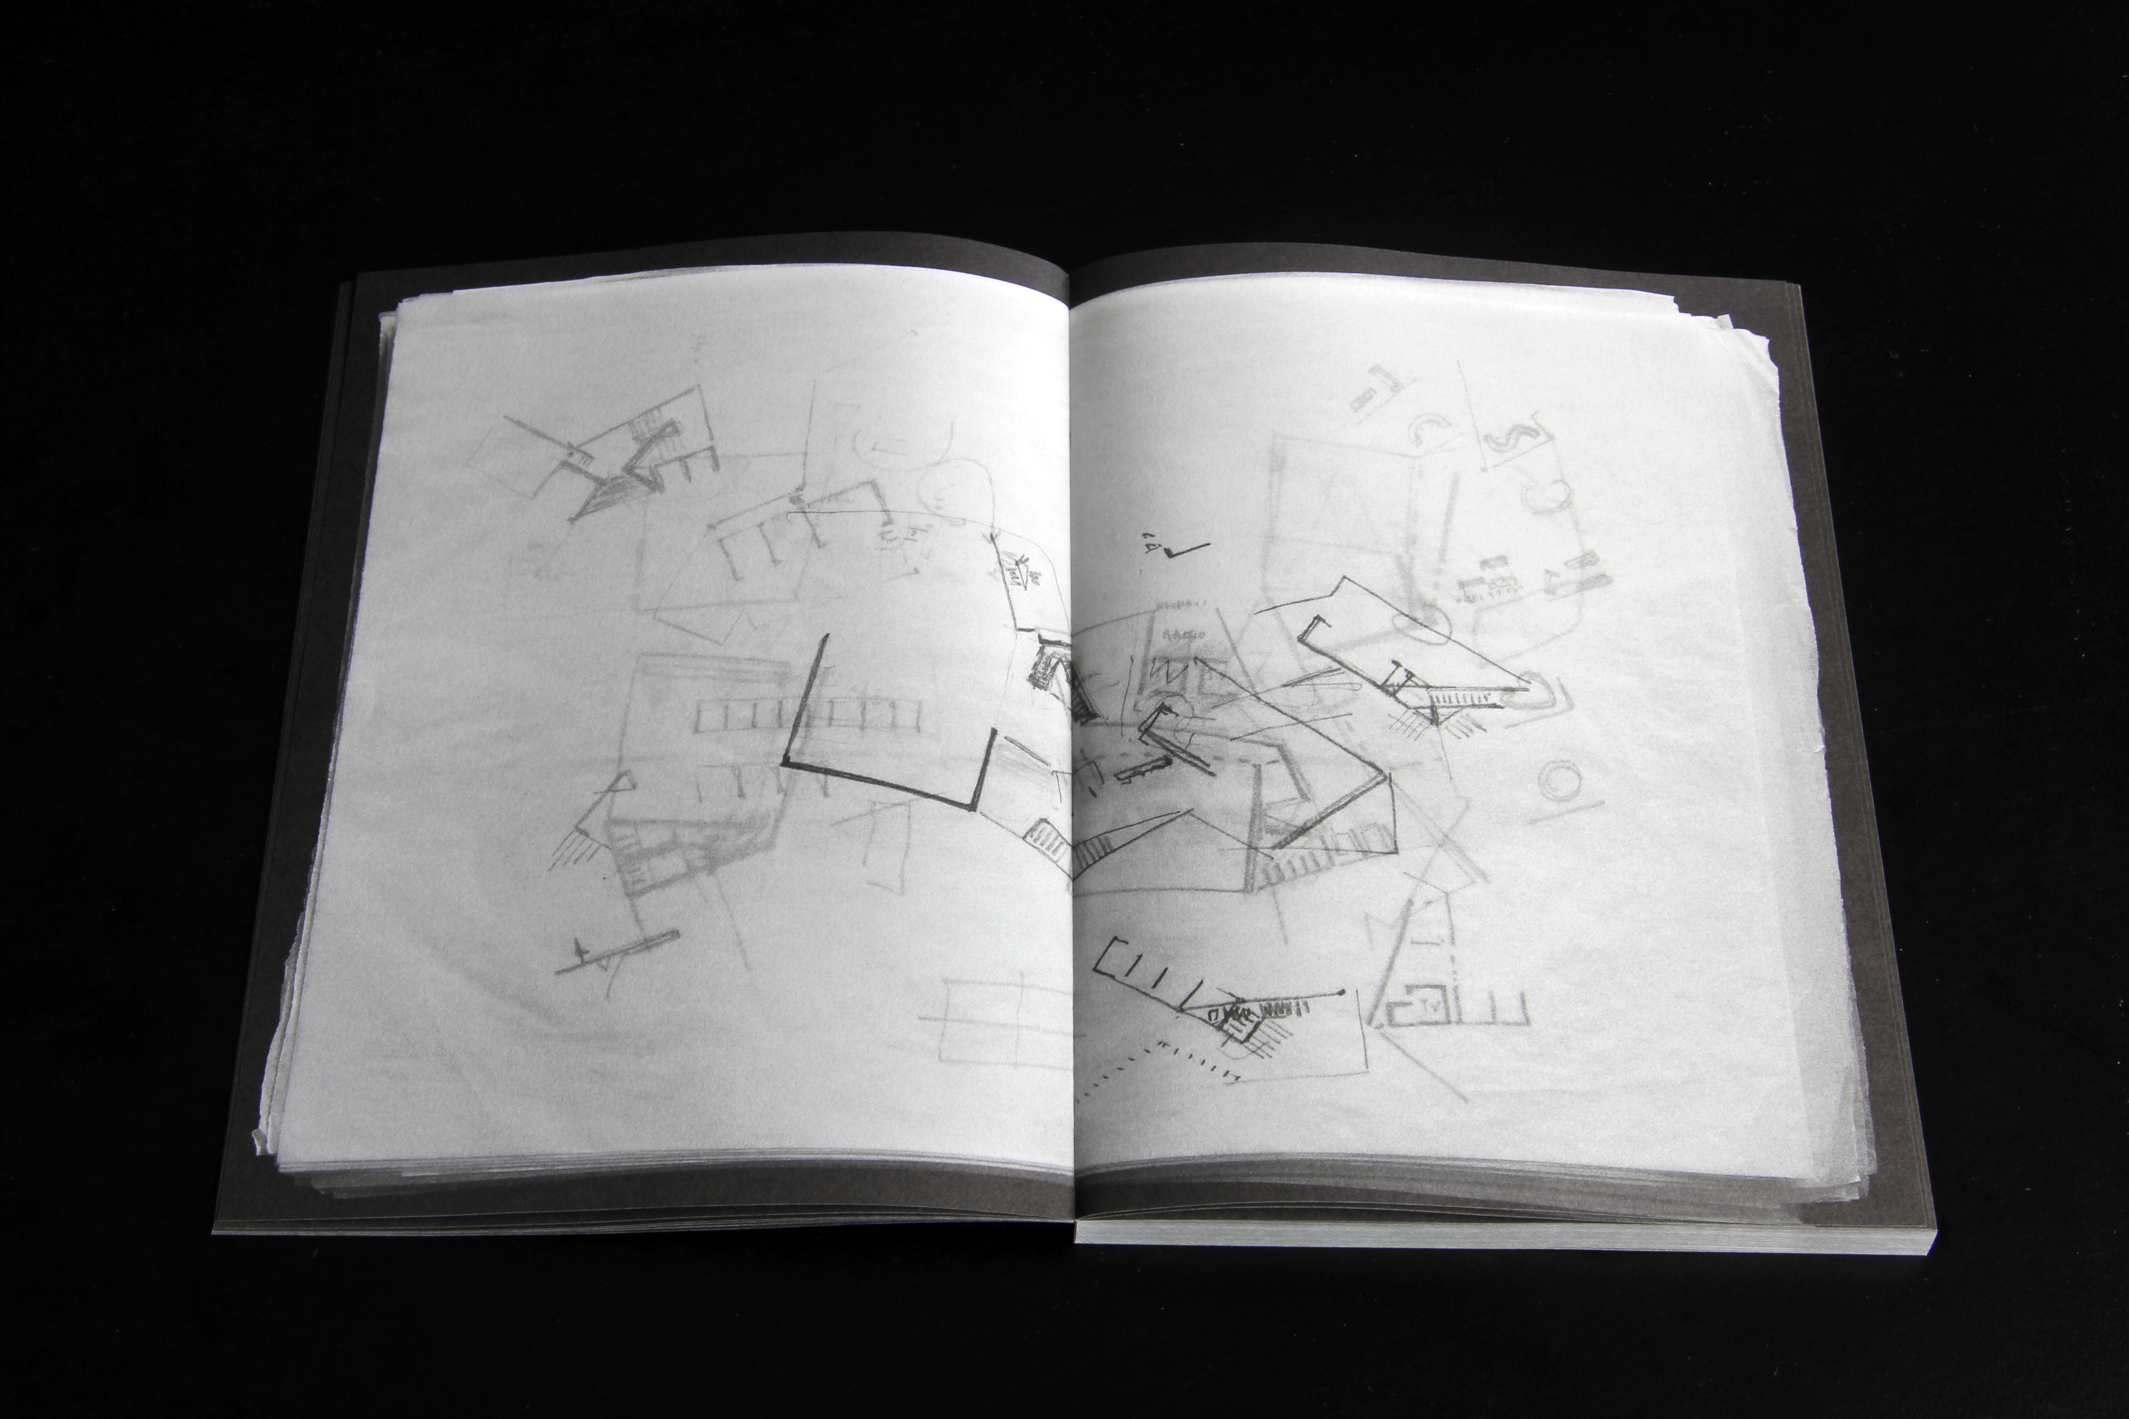

Overlays used in the design process by O’Donnell + Tuomey
We are invited to observe the dogged tenacity evidenced in the daily overlays by O’Donnell + Tuomey patiently unlocking over a period of weeks the extraordinary 3D spatial jigsaw puzzle that became the Saw Swee Hock Centre at the LSE.

We can feel Grafton grappling with the skeletal DNA of their UTEC Campus building in Lima, turning it over and over again, exploring span as the beginnings of their architecture. Or composing solid and void in what appears to be a university building in France; a sense of gravity palpable on every page. We glimpse the episodic explorations of Seamus Lennon as he zooms in an out of the parts of his buildings we are going to get close to and touch and begin to sense what the presence of his details will be in the final construction. Tom de Paor’s extraordinary gesamtkunstwerk of hand made gardens and concrete walls is captured in sketchbook, scrapbook and building construction- drawing slowly out ideas in a lengthy, literally sweaty process of discovery, where the building site is used as the drawings board.

Parallel studies of both travel and design process drawings suggest the sketch book in McCullough Mulvin’s hands is an active reference tool in their design process. In Michael Doherty’s volume, the intensity of observed texture, form and nature is used to examine the impact of time on the man made and the natural world, hinting of mankind’s seeming insignificance as well as the human imprint of feeling on the stones and wood we build with.

Collage thoughts in Nigel Peake’s notebooks

We open the door into the extraordinary world of Nigel Peake’s Paul Klee-esque observations capturing with artful wit the random, the glance and the mundane. It is all revelatory.

It is as if we’ve sat down with members of an exclusive club who have conspired to show us the secrets of the world. Or at least, their world. We get to share those secrets and observe them as they continue to search for unforeseen things. For those of us with a heightened sensitivity to the presence of the hand made drawing, there is a tide of creative intensity that flows from these pages in a spell binding manner.

Yet as well as documenting the core findings from the film and exhibition, ‘The White Table’ volume is also a reflection of Clarke’s own extraordinary semi-autographical musings on the formative and umbilical chord-like role the notebook plays on those who continue to use it in their working practice and thought process.
Despite being an extraordinary draughtsman himself, he prefers rather to reveal each subject’s individual talents for the most part while finally choosing to stand among them, inviting us to acknowledge how significant this gathering is in our multi-screen, 3D digital world. Don’t forget to draw, to observe the everyday closely and bring everything together when your creative work begins, he seems to say. Whilst composed of different generations, all the subjects experienced their formative education through analogue, not digital tools. One senses that a further study of a different and younger group awaits, a group which have grown up using digital tools in their work, yet choose to use analogue processes as well. Their reasons would be worth revealing as well.

