MATERIAL FUTURES:
CRAFTING CIRCULAR CONVERSATIONS

ABSTRACT

This paper discusses the need to design for a circular economy. We aim to make scalable recommendations for future research and practice to support closed-loop innovation in the textile sector, and explore how the findings might be expanded upon to craft circular conversations to support emerging designers.

KEY WORDS

textiles; craft; circular economy; waste; designers; creative and participatory methods

INTRODUCTION

Heightened awareness of the economic value being lost through waste coupled with a rise in resourcing risks have elevated business interest in the circular economy. While the term ‘circular economy’ is becoming appropriated on a global scale to address a wide range of issues regarding waste, there is little evidence available to demonstrate how this might be applied by small to medium enterprises (SMEs) and understood by Higher Education (HE). Rising resource risks and the growing recognition of the economic value being lost in waste have raised business interest in the circular economy. A recent study by McKinsey (2015) titled Growth within: A circular economy vision for a competitive Europe identified that resource productivity remains hugely under exploited as a source of wealth, competitiveness, and renewal. They argue that a circular economy, enabled by the technology revolution, would allow Europe to grow resource productivity by up to 3 percent annually. Within the UK, the Scottish Government have been lobbying policy initiatives to implement a £70million European Regional Development fund with a £17million Circular Economy Investment fund to help SME’s to catalyse innovative approaches to design, fostering repair and reuse and encouraging service and leasing models for material recovery, with the premise of supporting closed loop systems, most notably, additional support for collaboration; the evaluation of different methods; and further understanding of future material ecologies. Concurring with the RSA’s perspective, we propose that design-led approaches can play a key role to play addressing these challenges:
The skills that must be developed in the new circular economy [...] They are new behaviours, new ways of collaborating and new ways of seeing. And for these to be learned and ingrained, they must first be tested and actively encouraged.
RSA, 2016: 41

This paper will explore the work in the area of Material Futures – undertaken by a research collective based at The Glasgow School of Art (GSA). Throughout this work the researchers seeks to raise awareness of the circular economy to support the Scottish textile sector. By identifying the most appropriate design-led approaches for crafting conversations that attend to addressing gaps in knowledge and practice, these seek to connect textile designers with other stakeholders across the supply chain. Through positing the research question ‘which design principles are required to craft conversations around the circular economy?’, We begin by discussing current debates within the textiles and craft industries and outline the challenges of articulating the applications of a circular economy.

From this point we present two case studies derived from across the field of design research in order to extrapolate the ways in which creative and participatory design approaches can be used to stimulate productive dialogue around both the circular economy, and broader environmental issues. This allows us to identify six design principles for design researchers to consider when facilitating such conversations. We then reflect on the implications of these principles for future research around the circular economy and the role of the textile designer therein, and highlight the significance of design-led approaches in strengthening communication, promoting creative action, and embedding collaborative ways of working.

DESIGNING FOR CIRCULARITY : A UK PERSPECTIVE

Within the UK textile sector, there is increasing awareness of the requirement for new textile initiatives to be linked with the concept of the circular economy (Goldsworthy 2012; 2013), but there is a lack of practical knowledge and accessible evidence available to provide support in the textile sector. Moving forward knowledge exchange will be essential alongside innovative tools to mediate dialogue and support joined-up thinking to connect all stakeholders involved in the supply chain of fashion and textiles.

According to Scottish Enterprise, the textile sector of the business community have highlighted there is a lack of resources for R&D and business model innovation (Scottish Enterprise 2013). While Scottish based fashion / textile SME’s (small to medium enterprises) are currently adding value to previously discarded textile waste by applying their practical skills, knowledge and expertise to rework and reuse (Simonella 2016; Kent 2016; Taylor 2015). From a broader perspective fashion and textile designers have been adopting sustainable design principals and strategies, with a plethora of innovative examples emerging within the last decade, demonstrating new concepts such as; zero waste pattern cutting (Gwilt and Rissanen 2011; Rissanen and McQuillain 2015), design for disassembly (Van Balgooi 2015) and upcycling (Earley 2015; DeCastro 2015). Those working with post consumer textile waste highlight the scope of redesign is often influenced by the first lifecycle of the garment or textile. The circular economy posits a new position by arguing a case for closed loop innovation from the outset.

To achieve a circular model we propose a more holistic approach, with circular design discussed at the front end of the innovation process. Furthermore design for multiple cyclical iterations or loops of use at the outset could fully optimise lifecycles and reduce post consumer waste, expanding upon the research undertaken by Payne (2011), as shown in Figure 1.

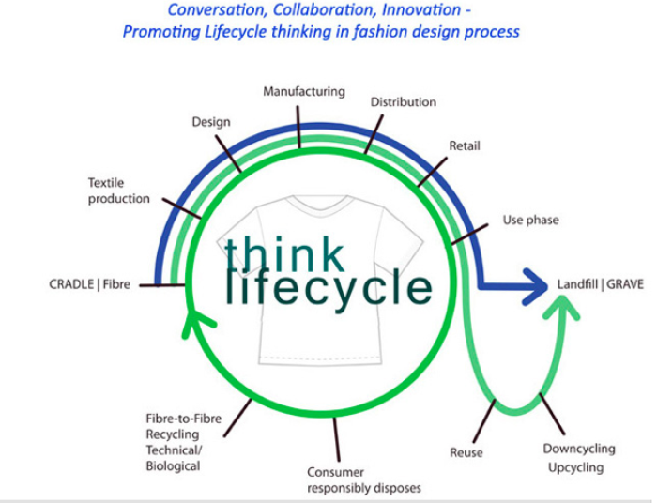
Figure 1: Mapping out the lifecycles of a fashion garment. Promoting lifecycle thinking in fashion.
Alice Payne (2011)
Whilst design capabilities have been sustained within the UK, our manufacturing skills have not (Taylor and Townsend 2014). This posits a dilemma for UK businesses that must not only begin to address the issue of skill shortages but also develop new business models that take account of provenance, longevity, environmental impacts and end of life (Thomas 2015).

Bearing in mind these insights around production, process, and ethical awareness in the context of textile design, we now go on to present two case studies in which design-led approaches are applied to enhance participants’ awareness of and capacity to respond creatively to the concept of a circular economy.

COMMUNICATING CIRCULATRITY: DESIGN-LED APPROACHES IN ACTION

The case studies presented in this section provide descriptive accounts of two established research projects in which design approaches have been developed to engage diverse groups of people in conversations around pertinent environmental issues. Case study one refers to the HYBRID MATTERs research network, and specifically, to Ståhl and Lindström’s Invitations project (2015a), in which the researchers appropriated a series of participatory methods to stimulate dialogue around the proliferation of plastics in our ecosystems. Case study two offers an overview of work carried out specifically in the context of the circular economy, in which creative and generative materials were developed to unpack perceptions of and envisage strategies to enhance the circular economy with a group of textile designers. These accounts set the scene from which we then focus on how creative and participatory approaches were configured in each case to render often abstract concepts tangible and accessible, and identify guiding design principles for crafting conversations around the circular economy in the final section.

Case Study 1: Reshaping Perceptions of Plastics – HYBRID MATTERs Invitations
HYBRID MATTERs is a network that brings together researchers from the fields of art and science to explore the intersection of environmental conditions and human activities, and question how a ‘hybrid ecology’ (Hybrid Matters 2015) of humans and non-humans can have transformational affect on both local and global scales. In Invitations, artists and researchers Ståhl and Lindström draw simultaneously from participatory design practices and academic research into the formation of ‘plastiglomerates’ from plastic debris pollution, beach sediment, and lava fragments (Corcoran et al 2014); and the use of common mealworms to biodegrade polystyrene (Yang et al 2015) as a basis towards staging two strands of public engagement events across the Nordic countries.

Rather than feeding into the narrative of “hey, we’ve got some more resources here that can be exploited, let’s continue this industrial trajectory where nature does work for us”, it could be argued that the finding of plastiglomerates suggest that our natureculture past is communicating with us, reminding us of the unavoidable unintentional effects of a co-living of humans and more-than-humans over time.
Ståhl and Lindström 2015b

In the first strand, members of the public in Iceland and Finland were invited to take part in a series of beach walks in search for plastiglomerates. Through these, participant groups were provided with the space to consider how such artefacts are created by both natural and technical forces; the potential impacts they afford; and how they could be utilized in different ways in the future. In the second strand of Invitations, the researchers built on their engagement activities around exploring the presence of plastics in the environment towards considering how these issues could be addressed. Introducing notions of composting and the mealworms’ abilities through a series of workshops in Sweden and Denmark, these sessions placed global environmental issues in the participants’ own domestic settings by equipping them with prototype composter devices comprising a mealworm colony and a piece of polystyrene inside a large glass jar. Collectively, Invitations sought to give form to and make visible environmental issues inherent in everyday life as a means of enhancing public awareness and interrogating society’s collective capabilities to respond creatively to these challenges.

Case Study 2: Re-thinking through Making – The Circular Fashion System Conversation
This example refers to a workshop activity within a master class titled Design Better Things: Do Better things hosted by Zero Waste Scotland (Feb 2016). The brief was to stimulate conversation around circular innovation with participants across the UK textile sector. A simple tool was designed – containing a linear supply chain that participants were encouraged to ‘hack’ into a circular loop to connect the flow of materials to ideate opportunities around material efficiency and reuse. This task mediated ‘re-thinking through making’ as an approach and allowed individuals to work within groups to visually depict new material journeys. This effectively provoked debate around new possibilities, alongside identifying barriers and opportunities for future development. It became clear that while we can invest our collective energy, efforts, expertise into designing and doing good things – can this have a true and meaningful impact within a world proliferated with too much stuff?

There has recently been a lot of discussion in design around the circular economy towards developing dematerialised consumption patterns by shifting the focus in design from material possessions to accessibility and services (Shayler 2016). But why are there so few examples of circular fashion / textile systems? The conversations highlighted the potential for exploring ways that textile and or fashion designers might begin to replace the need for constant consumption by offering viable alternatives. It was evident that we must begin to view a product as something that will forever need completion, and the designer’s role as one of facilitation of this process as opposed to the finalisation of a product. Additionally, if we want to see changes in the consumption patterns of fashion or the attitudes among consumers we will have to design systems which includes them and takes their role in the lifecycle of clothing seriously.

We also require more examples of circular fashion systems in all scales, from the local and unique to the global and mass-produced. Fashion and textile designer will need to take a look sideways to the other design disciplines to re-invent itself with new forms of fashion service designs – and make these services really fashionable.

INSIGHTS AND REFLECTIONS: SIX DESIGN PRINCIPLES FOR CRAFTING CONVERSATIONS AROUND THE CIRCULAR ECONOMY

In the following section we draw together insights and reflections from both case studies’ conversational approaches in parallel. With reference to Figure 2, we discuss how these contribute to our identification of six speculative design principles that we believe have the potential to support design researchers in crafting productive conversations around the circular economy.
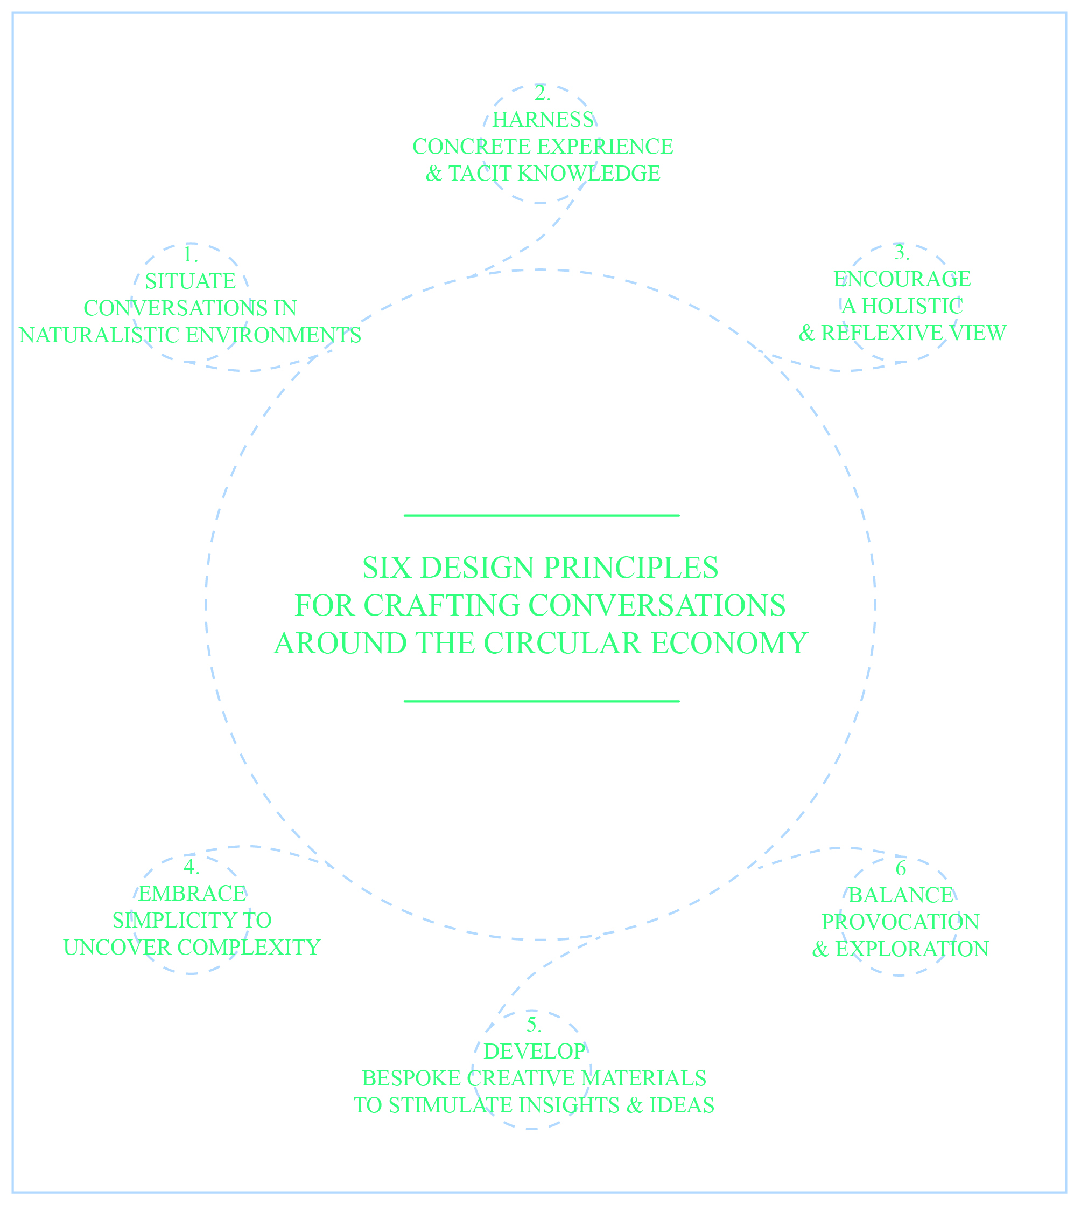
Figure 2: Six Design Principles for Crafting Conversations around the Circular Economy

Principle 1. Situate Conversations in Naturalistic Environments
We propose that the experiential qualities of the natural environment offer an immersive setting for participatory activities and can situate conversations within the context that they seek to address.

Conversation 1: Introduced participants to plastiglomerates in situ, Ståhl and Lindström connected the often distant, abstract qualities of marine pollution to the familiarity of an every day walk on a beach.

Conversation 2: Took place in a relatively conventional workshop setting, there is vibrant and rich range of natural environments that could be used to situate conversations around the noble fibers in the Scottish textile sector from; crofts, weaving and knitwear mills.
Principle 2. Harness Concrete Experience and Tacit Knowledge
In supporting participants to share their experiences and collectively consider ways to address complex societal challenges, design researchers must develop approaches to harness concrete experience and tacit knowledge.

Conversation 1: Through tending to the prototypes in their own homes for two week periods and observing the mealworms’ visible impact on the polystyrene, the Invitations participants gained an insight into the extent to which nature can intervene into humankind’s self-made challenges, as well as raising questions around the sustainability of radical new composting strategies on a larger scale.
Conversation 2: At the same time, the Circular Fashion System Conversation were deeply enhanced through the rich plethora of skills and material literacy embodied within the textile designers in the group. Their knowledge mediated the exchange of insights and others helped to identify solutions to make suggestions for foraging new connections and identifying potential new solutions.

Principle 3. Encourage a Holistic and Reflexive View
By bringing together a diverse range of people and developing bespoke methods and approaches to spark dialogue, the focus of circular conversations should focus on both the intricacies of the challenge at hand, and their implications on a systemic, global scale.
Conversation 1: In Invitations, the beach provided a stage on which found objects including stones, litter, driftwood as well as plastiglomerates themselves were used as props to prompt and punctuate conversations and provide material touch-points around which participants considered issues of human intention, society’s collective capabilities to respond and adjust our behaviours, and how we define the waste materials that can be used as resources (Ståhl and Lindström 2015b).

Conversation 2: The participants physically constructed a closed loop process and as they discussed the wider implications, this provided them with a broad view of the wider fashion system. We propose that such a holistic perspective can enhance how participants position themselves within the system as both part of the problem, and part of the solution; and underpin their abilities to reflexively negotiate their role within the system and their capacity to take action.

Principle 4. Balance Provocation and Exploration
Design approaches are flexible and malleable, and can be tailored to correspond to open and exploratory activities, as well as to accompany targeted forms of questioning.

Conversation 1: Indicative of how provocative approaches can prompt an emotional response, Ståhl and Lindström noted that participants often experienced a tension over whether to treat the mealworms as ‘pests or pets’ [Personal Communication 2016], and that using the composter as a form of design tool itself foregrounded considerations of social responsibility and power relations.

Conversation 2: Additionally, within the Circular Fashion System Conversation a linear supply chain was ‘hacked’ to encourage closed loop innovation. From this point it became apparent that the designer does not have as much influence as one would imagine. In some instances, 1,000 pairs of hands touch a piece of clothing before it reaches a consumer (Lee 2008).

Principle 5. Develop Bespoke Creative Materials to Stimulate Insights and Ideas
Evoking the hands-on, generative nature of participatory design approaches as a means of enacting the future (Brandt et al 2013),

Conversation 1: In later sessions in Invitations participants also collectively to build bonfires as a heat source to create their own plastiglomerates;

Conversation 2: whilst the physical craft materials used in the Circular Fashion System Conversation provided participants with stimuli to talk through a closed loop innovation, applying the hacking metaphor to subvert a linear supply chain using lo-fi craft materials that could easily be re-configured as conversation emerged. In this sense, design researchers have a role to play in developing materials, methods, tools, and approaches in response to the local objectives underpinning their specific project and the aims governing the wider research.

Principle 6. Embrace Simplicity to Uncover Complexity
The methods and approaches developed to examine complex issues in both case studies appropriate Eriksen's participatory design tools as basic materials and pre-designed images and artefacts (2009). Lucero et al. observe that a diverse array of materials with varying levels of simplicity, specificity, and provocation gave way to ‘a relaxed atmosphere since participants are not forced into activities they are not comfortable with”, and stimulated “a structured but flexible way in order to spark dialogue between the co-design participants and thus support idea generation’ (2012: 19–20).

Conversation 1: Such observations reinforce the use of the prototype composter as a material manifestation of a hybrid ecology – ‘a thought vehicle which enables us to expand our concept of the environment, to re-evaluate our idea of an external nature and to rethink our relationship to the world.’ (HYBRID MATTERs 2015),

Conversation 2: Encouraged deep reflection on our individual and collective roles in addressing these grand challenges. Akin to ecology, systems design requires a complex understanding of a wider ecosystem and awareness of the embedded components. Conversational tools have the potential to unearth some of deeper issues and foster new insights.

CLOSING THE LOOP: IMPLICATIONS FOR THE TEXTILE SECTOR

With a focus on methodological approaches, the Six Design Principles emphasise the need for creative and participatory methods and approaches to enhance cross-disciplinary, cross-sector awareness and understanding of the need to design for a circular economy.

With 80% of a product’s impact determined at the design phase, there is a compelling case to explore the role that designers can play (RSA Great Recovery 2014). Design for sustainability theorists (Manzini and Vezzoli 2008) believe it is more efficient to work with preventative solutions rather than adopt systems that deal with damage control. Designers are learning that co-creation and co-design, rather than individual authorship, is becoming a more effective way to understand and meet social needs and new tools and platforms are becoming more effective than finished artefacts (Thackara 2013). This is part of a shift towards transmaterialisation, where service design concepts are evolving in parallel to product design development to construct to scenarios of use, reuse, design and redesign. To work this way, designers need to acquire new skills, knowledge and experience to enable them to act as social innovators and become agents of change. Instead of designing from the constrained perspective of the client's brief, designers now accommodate the complexities of designing for society and embrace new collaborative ways of working, as designers Chick and Micklethwaite summarise:

A design outcome may not always be a physical, tangible product. It may be a service or a new way of doing things. In some cases, we may not need a new product, just a better way of integrating the products we already have in order to serve our needs. Design is also too important, and too useful, to be used only by professional designers. The active participation of users in the design process can ensure more successful design outcomes. The emergence of open-source design is creating a collaborative remix culture in which the originator of an idea passes it on to others to take in new directions.
Chick and Micklethwaite 2011: 35

In spite of such shifts within the broader discipline of design, there is limited literature relating to the role of the specifics of ethics within the fashion or textile industry from a designers perspective; acknowledging their responsibility within the supply chain and the lifecycle of a garment. Traditionally fashion designers do not write, or theorise; they cut and make (Thomas 2001: 4). Desires to rationalise design can be seen to overshadow the practitioner's skill and agency, and as Dorst substantiates, the discipline's preoccupation with understanding processes and methods disregards the individual designer's ability to negotiate complexity in diverse social, cultural, and environmental settings (2008: 5, 8). Whilst interrogating the modus operandi of the fashion industry, there could also be an interrogation of sustainability and the circular economy, and what it could mean if universally adopted by design practitioners, and by the fashion/textile industry in general.

CONCLUSIONS

The reviewed literature has highlighted that currently, there are limited practical examples of circular innovation within the textile sector, and designers will require support moving forward. Practically, designers have the potential to unlock hidden potential within supply chains and materials. The research presented within this paper highlights the importance of acknowledging that the circular economy goes beyond the capabilities of specific design disciplines and is it a joint responsibility that cannot be undertaken in isolation. This will require the input of material scientists, business experts, waste managers and policy makers alongside other stakeholders and those undertaking roles that have not yet been identified.

The six design principals referenced within this paper emerged in response to the literature and two different case examples and support discussion to mediate a transition beyond traditional paradigms. While emerging, they provide a framework to mediate the facilitation of crafting circular conversations to continue to discuss how we might expand upon the role, skills and capabilities of the textile designer in the future to equip them to operate within a circular economy. Future research will seek to apply, evaluate, and iterate the principles through further participatory activities, and explore their flexibility and transferability when developed by other design researchers situated in similar contexts of inquiry.

ACKNOWLEDGEMENTS

REFERENCES

ANDREWS, D. “The circular economy, design thinking and education for sustainability.” Local Economy, 30:3 (2015): 305–315.
BALLIE, J. e-Co-Textile Design: How can textile design and making be combined with social media to promote sustainable fast fashion futures?. PhD diss. London: University of the Arts London, 2014.
BAKKER, C, A., R. WEVER, C. TEOH, S. CLERCQ “Designing cradle-to-cradle products: a reality check”. International Journal of Sustainable Engineering, 3:1 (2010): 2–8.
BLACK, S. and H. ALEXANDER The Sustainable Fashion Handbook, London: Thames and Hudson. 2012.
BRANDT, E., T. BINDER and E.B.N. SANDERS “Ways to Engage, Telling, Making and Enacting.” International Handbook of Participatory Design, Oxford: Routledge, 145–181. 2013.
BRAUNGART, M., W. MCDONOUGH, A. BOLLINGER “Cradle-to-cradle design: creating healthy emissions–a strategy for eco-effective product and system design.” Journal of cleaner production, 15:13 (2007): 1337–1348.
CHAPMAN, J. Emotionally durable design: objects, experiences and empathy. London: Earthscan. 2005.
CHICK, A. and P. MICKLETHWAITE. Design for Sustainable Change: How design and designers can drive the sustainability agenda. Worthing: AVA Academic, 2011.
CONCORAN, P.L., C.J. MOORE, and K. JAZVAC “An anthropogenic marker horizon in the future rock record.” GSA Today, 24.6 (2014): 4–8.
CHO, S. and J.H. LEE “Development of Zero Waste Fashion Design Process Guideline from an Educational Perspective.” Journal of the Korean Society of Costume, 65:4 (2015): 91–108.
DECASTRO, O. “Upcycling.” Keynote at Scottish Textile Symposium. Glasgow, Scotland, November, 2014.
DORST, K. “Design Research: a revolution-waiting-to-happen.” Design Studies, 29:3 (2008): 4–11.
EARLEY, R. and K. Goldsworthy. “TED’s Ten.” Keynote at Circular by Design Chiasma, Design in Action. Edinburgh, Scotland, March, 2014.
EARLEY, R. “The new designers: working towards our eco fashion future”. In Dressing Rooms: Current Perspectives on Fashion and Textiles Conference, Oslo, Norway. 14–16. 2007.
ERIKSEN, A. “Engaging design materials, formats and framings in specific, situated codesigning – A Micro-material perspective.” Proceedings of 2009 Nordes conference, Engaging Artifacts, Oslo, Norway. 1–10. 2009.
FLETCHER, K., L. GROSE and P. HAWKEN Fashion & sustainability: Design for change. London: Laurence
FLETCHER, K. Sustainable fashion and textiles: design journeys. London: Routledge. 2011.
GOLDSWORTHY, K. Laser-finishing: a new process for designing recyclability in synthetic textiles.
PhD diss. London: Univeristy of the Arts London, 2012.
GOLDSWORTHY, K. "Design for Cyclability: pro-active approaches for maximising material recovery."
Making Futures, 3 (2014).
GWILT, A. and T. RISSANEN “Shaping Sustainable Fashion: changing the way we make and use clothes”. London: Routledge.(2011.
HYBRID MATTERS “HYBRID MATTERs – about”, HYBRID MATTERs, 2015. Accessed July 29.
http://hybridmatters.net/pages/about
KENT, A. “Aimee Kent”. http://aimeekent.com accessed July 27th (2016).
LUCERO, A., K. VAAJAKALLIO, P. DALSGAARD “The dialogue-labs method: process, space and materials as structuring elements to spark dialogue in co-design events” CoDesign, 8:1 (2012): 1–23.
MANZINI, E Network, Localismo cosmopolita. Prospettive per uno sviluppo locale sostenibile ed ipotesi sul ruolo del design, Milano: Agenzia SDI. D.E.S.I.S. and London, U.A.L., (2005).
VEZZOLI, C.A. and MANZINI, E “Design for environmental sustainability”. Springer Science & Business Media 2011.
MCKINSEY “Growth within: A circular economy vision for a competitive Europe”. https://www.ellenmacarthurfoundation.org/assets/downloads/publications/EllenMacArthurFoundation_Growth-Within_July15.pdf (2015)
PAYNE, A. “The life-cycle of the fashion garment and the role of Australian mass market designers”. The International Journal of Environmental, Cultural, Economic and Social Sustainability, (2011) 7(3), pp.237-246.
RSA and The Great Recovery. (2014). Accessed May 12. http://www.greatrecovery.org.uk
SANDERS, E.B.N. and P.J. STAPPERS. “Co-creation and the new landscapes of design.” CoDesign, 4:1 (2008): 5–18.
SCOTTISH ENTERPRISE “Scottish Textiles Skills Survey.” January, 2013. Accessed July 28th. http://www.stla.uk.com/wp-content/uploads/2013/09/Scottish-Textiles-Skills-Survey-Report.pdf
SHAYLER, M. and MASLIN, R. “Service Design for a Circular Economy.” The RSA Great Recovery. January 19th, 2015. Accessed May 12. http://www.greatrecovery.org.uk/service-design-for-a-circular-economy/
Simonella, A. (2016). Allenomis. http://www.allenomis.com accessed 27th July 2016.
STÅHL, A. and K. LINDSTRÖM “About Invitations.” HYBRID MATTERs, 2015a. Accessed July 29. http://invitations.hybridmatters.net/pages/about-invitations
STÅHL, A. and K. LINDSTRÖM “Plastiglomerate Walk Replot.” HYBRID MATTERs, 2015b. Accessed July 29. http://invitations.hybridmatters.net/events/plastiglomerate-walk-replot
STEEN, M. “Tensions in human-centred design.” CoDesign, 7:1 (2011): 45–60.
TAYLOR, N. The Top Project. http://thetopproject.com accessed 27th July 2016.
TAYLOR, J. and K. TOWNSEND “Reprogramming the hand: Bridging the craft skills gap in 3d/digital fashion knitwear design.” Craft Research, 5:2 (2014): 155–174.
THAM, M. and T. JONES "Metadesign tools. Designing the seeds for a shared process of change”. Changing the Change Conference. An international conference on the role and potential of design research in the transition towards sustainability. Torino, Italy. July 10-12, 2008.
THOMAS, S. “Hacking the Circular Economy.” The RSA Great Recovery Blog, April 2nd, 2015. Accessed May 12. https://www.thersa.org/discover/publications-and-articles/rsa-blogs/2015/04/hacking-the-circular-economy/
THAKARA, J. "A Whole New Cloth: Politics and the Fashion system." Routledge Handbook of Sustainability and Fashion. London: Routledge, 43–46. 2014.
VAN BALGOOI, F. “Master class one: Design for Dissassembly”. Zero Waste Scotland Public Lecture. University of Dundee. 2nd December 2015.
YANG, Y., J. YANG, W.M. WU, J. ZHAO, Y. SONG, L., GAO. “Polystyrene by Plastic-Eating Mealworms: Part 1. Chemical and Physical Characterization and Isotopic Tests.” Environmental science & technology, 49:20 (2015) 12080–12086.

