f.robertson@gsa.ac.uk

G
[Email]

Fiona Robertson, Glasgow School of Art

Glasgow School of Art

In this piece I seek to explain and analyse my practice with specific reference to my recent book of drawings Bad Spells, and the related cross-medium project immediately preceding and feeding into this, Green Head. Beginning with the artist Antonin Artaud and theorist Julia Kristeva, both foundational to my recent practice, I move on to examine the ways in which other artists have approached similar terrain, in particular the concept of the ‘Body without Organs’. Through a combination of personal reflection and close reference both to theoretical concepts and the work in Bad Spells they informed, I aim to provide a fuller image of the ideological and ideographic underpinnings of my drawings and my work’s relevance to broader questions of expression, intelligibility and physicality.

Bad Spells

Bad Spells
Bad Spells, the title of my book, refers to Antonin Artaud's 50 drawings to assassinate magic (1937-48), a series of drawings and writings made by Artaud during his travels in Ireland and subsequent incarceration in an asylum in 1937-48. Included in this collection are the pieces Artaud called ‘spells’: coded messages that included script, drawn images and cigarette burns, sending them not only to his friends, but to prominent political figures as coded warnings about the imminent apocalypse. Some of the drawings were warnings intended to protect the individual concerned; others were curses. These works bring into sharp focus a distinction that loomed large in Artaud’s life - between art as what he terms “the esthetic simulation of reality” (Artaud, 1986a, p. 233) and art as “…merely the waste products of myself, the scrapings of the soul” (Artaud, 1992a, p. 83). These distinctions and relations between artifice and art more broadly and also the expression and articulation of reality are themes I have explored in Bad Spells, and in the associated Green Head project.
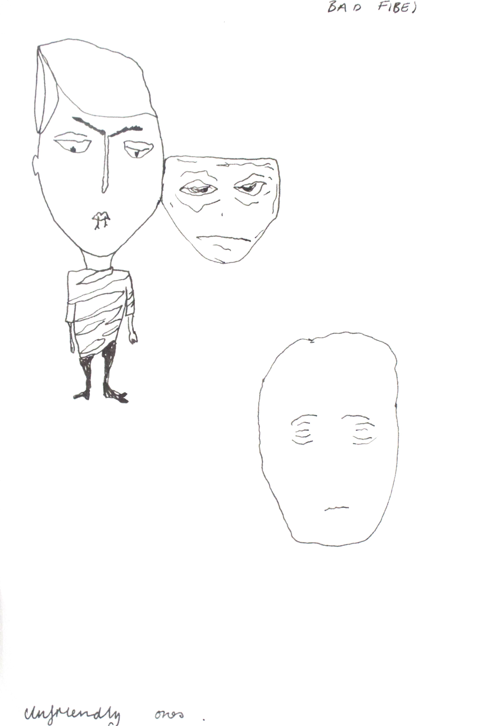
I am interested in making work that uses this last period of Artaud’s life as a starting point to reexamine and reapproach the ideas and arguments Artaud had advanced in earlier, more formally ‘productive’ periods. I have been drawn to his argument that reality can only be depicted in fragmentary and non-linear narrative forms that seek to recreate the chaotic essence of experience. Artaud’s disagreements with the Surrealists, who have been significant influences on my work in the past, are also a point of reference for my work. The attempt to capture something that exists ‘between thought and gesture’ (Artaud, 1994, p. 89); to analyse and recondition conscious thought as it emerges through key issues for my work on the body; all of these are key issues for my work.
There is a parallel between Artaud’s use of his drawings as spells, maledictions or benedictions relating to real individuals and incidents in his life and mine. Like Artaud, the drawings are scrambled, illegible, disjointed; but the chaos exists in a liminal fashion - where the image stopped being ‘accurate’ and began to be ‘chaotic’ is obscured. This was reflected in my method in creating the drawings; working intuitively, filtering my experiences in life through the lense of the subliminal and the extra liminal, the drawings presented in Bad Spells were in a minority of the work I created. This deliberate artifice in one arena, however, paradoxically enabled me to go beyond artifice in the next; moving my art from the illusory transparence of semi-mimesis to an obscurity that reveals or hints at deeper realities. In this tension I am reminded of Artaud’s statement “When I live I do not feel myself live but when I act, it is then that I feel myself exist” (Artaud, 1992b, p.275).
Fig 2 Bad Vibes- Unfriendly ones (ink on paper 15X21)
1
Not only the tensions within that statement, but also between that statement and Artaud’s wider body of work, informed and shaped the drawings; especially manifest in Breath (Fig. 1) and Bad Vibes Unfriendly Ones (Fig. 2). In Breath, there can be seen the outline of a human face, a key icon of representation; but it is warped, losing coherency - both in the outline itself, and within the outline, where the features you would expect to discern have vanished - chaos intrudes at the point where representation is expected to resume.

Fig.1 Breath (ink on paper 15X21 cm)
2
Likewise, in Bad Vibes, the boundaries dividing representation from the extra liminal world have again shifted; the face has multiplied, run amok, the human figure is simultaneously liberated by this, and inert and bereft as a result. The Bad Spells drawings also engage with an important aspect of Artaud’s drawings, the emphasis on the physicality, sensuality, created and arguably, sexual body as it emerges through drawing. Limbs that have shaken loose from their bondage to the trunk of the body, parts of the body that have grown malevolently huge - bodies, shading into artificiality or freakishness - bodies without organs. The outgrown primacy of the bodies in my drawings is reminiscent of Deleuze’s concept of Artaud as someone who returned to the body, rejecting artifice and the impression of sense. This sense of the body containing within itself greater truths that become apparent in the moment of collapse or disintegration of ‘logic’, is present in Green Head (drawings) (Figs. 3-4) and nicebag (Figs. 5-6).
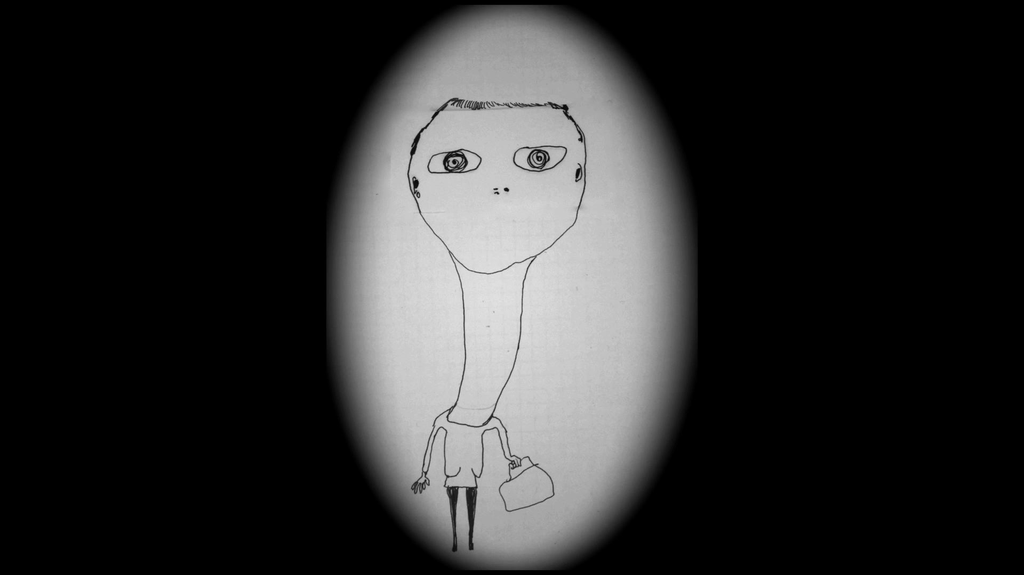
Fig.5 nicebag (stop motion animation)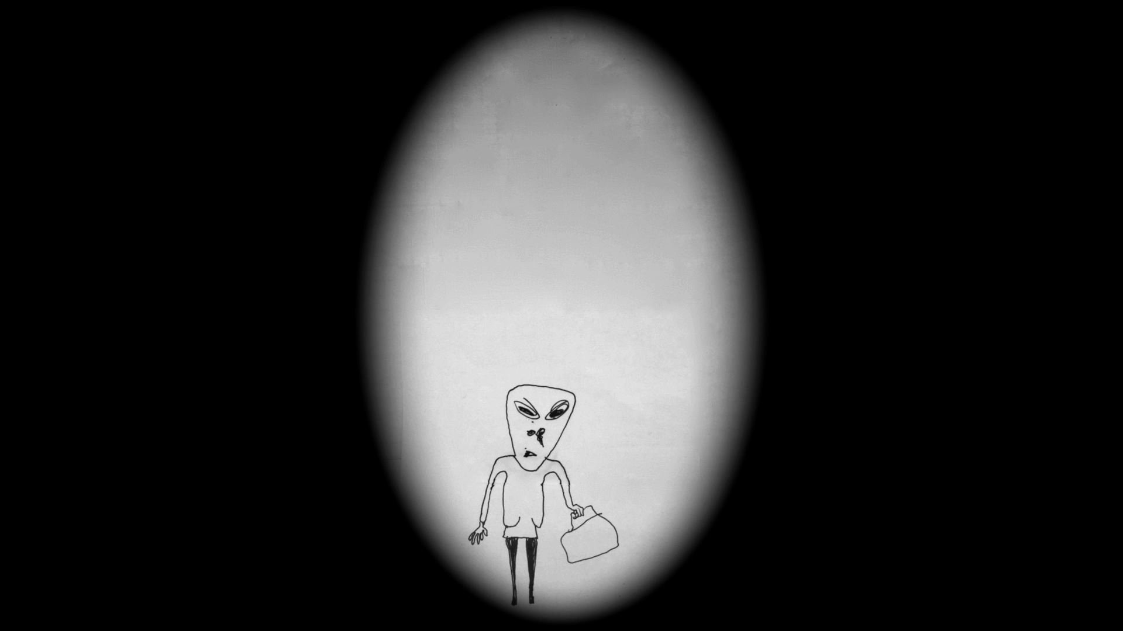
Fig.6 nicebag (stop motion animation)
3
This power through collapse was conveyed especially well, for me, through the transference of my drawings into animation; through the constraints of animation the grotesquery present in the most innocuous, ‘real’ representation of a body is afforded an opportunity to break free. In this disintegration, the chaotic, fluid meanings/bodies present in my animations are simultaneously trapped and set free. The man’s head in Figs. 3 and 4, also named Green Head, originates from a scribble, achieves cohesiveness and representational power, then collapses back into said chaos, giving birth to the sculpture itself. In nicebag, the body itself becomes the spectacle of disintegration; the head shrinking and retracting into the bodyas the animation goes on.
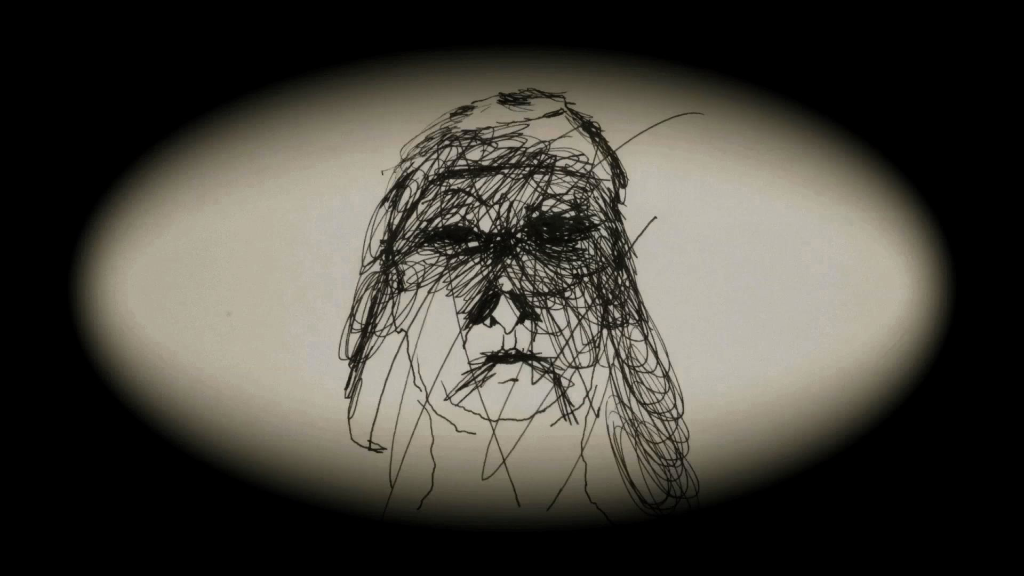
Fig.3 Green Head (stop motion animation)
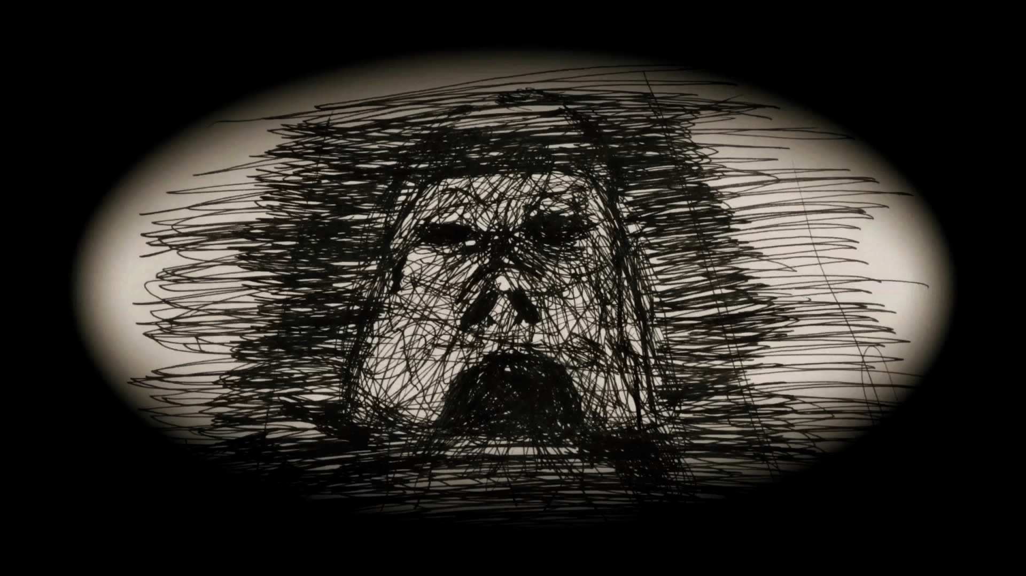

Fig.4 Green Head (stop motion animation)
4

In many ways my filmmaking mirrors my drawing process; the irrational and subconscious has a significant role in both, firstly within origination and inspiration, but also immanent in the art itself. It is because of this that there are symmetries between my film Green Head and my drawings that stretch beyond the obvious, animated sequences. This cross-pollination is sometimes difficult to assess, but there are several that strike me now as being particularly significant. Firstly, through the editing of the film, and the decentering of the piece from narrative, I am seeking to break down, recalling Deleuze, the established language of the form, reducing the complex interplay present in filmography down to a simplistic almost archaic sequence of disordered images (such as in memory, dreams, childhood, prophecy, and so on). Following on from this, secondly, I sought, in my juxtaposition of psychogeographic absolutes (the rural and urban; artificiality and animism, and so on) to create a ‘Living Theatre’ reflecting Kantor that invoked both humour and a subtle horror. Lastly, much of the work from the props, the characters, the created space, sound and structure exists in a liminal state, caught in the process of mutation both in actuality (I was editing, revising, recreating up until filming, and continued afterwards - into other projects) and in potential (like my drawings, there is a frayed, mutative aspect to the different elements of the film).
These contradictions in the engagement of artists with flesh and the body led me to engage once again with Kristeva’s works, especially those on Artaud. There are several intersections or crossing points between my work and Kristeva’s ‘Corpus’ particularly, as might be expected, with her commentary on the body. Kristeva’s wish to signify death through art, in a manner in which the actuality of death could never do, is one I share; in the different mediums I used throughout, I tried to invoke the theatrical, liminal praxis Kristeva laid out
No, as in true theater, without makeup or masks, refuse and corpses show me what I permanently thrust aside in order to live. These body fluids, this defilement, this shit are what life withstands, hardly and with difficulty, on the part of death. There, I am at the border of my condition as a living being. (Kristeva, 1982, pp. 3-4)
In my work I have sought to pursue this dynamic: the radically inclusive ‘abject’. In this pursuit, I create art that seeks to signify the unsignifiable whilst simultaneously flirting with the collapse of meaning altogether in shared trauma - death, sex, the family, childhood and birth. The archaic crudity I try to make immanent in my own work is an attempt to renegotiate a rapprochement with the abject; to re-analyse the individual boundaries and hidden forms that structure life but also command collective, historic and prehistoric life (the last covering, of course, all human culture). Along with Jung, Kristeva has influenced me in the conception of an “archaic memory” - the argument that culture emerges from a closing-off, a drawing of lines between the animalistic and the ‘human’. It is at this stage where there is a meeting ground of sorts between Kristeva and Artaud - ‘Civic Magic’ (Artaud, 1986, p. 138) structuring and arguably imprisoning the perceived world. Simultaneously, in the act of ‘reclaiming’ this chaos, we find ourselves hemmed in by the necessary artifice required; even in our attempts to delve beyond culture (culture in the sense of a growth, an excrescence) we are conditioned and controlled by that same culture. It is here that ‘madness’, “a space of antisocial, apolitical, and paradoxically free individuation” (Kristeva, 1992, p. 235) comes into play, but is madness, reified and conscious, truly madness? In this there are parallels with Nancy Spero’s Codex Artaud (1971-72); the figurative, exaggerated, unhinged visual language deployed by Spero is simultaneously liberating and suppressing. Best seen in the recurring emblem of the phallic, obscene tongue, Spero reapproaches Artaud but within her critique is also contained limitations and self-censorship, no matter the relative freedom of the images. Like Spero, I am interested in excavating the gendered dynamics of Artaud where, in Julia Kristeva’s words, “the black, mortal violence of ‘the feminine’ is simultaneously exalted and stigmatized” (Kristeva, 1980, p. 164). This is something present, I feel, in Artaud’s Sisters (figure 7), where the totemic, phallic creature at the centre is surrounded by withered, hunched companions, but also imprisoned, rooted to the spot by the same potency by which it commands the scene. The small, delicate hands of the creature underline the ultimate vulnerability and limitation of the ‘magic’ it commands.
5
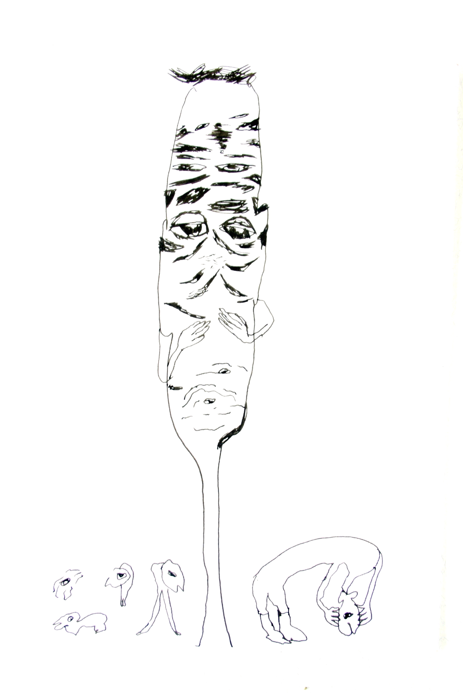
Fig.7 Artaud’s Sisters (Ink on paper 15x21cm)
6
In some ways I feel that Spero’s de-individuated artwork gives her work a greater force than some contemporary feminist art that is centered around the individual, but at the same time this avoidance of mundanity represents a flight from the chaotic pain that informed Artaud. In this sense, I think some manner of rapprochement, even an uneven one, is required for the body-with-organs in order to move beyond that; the ‘accidents of individuality’ (Spero, 1992, p. 7) Spero identified need to be provoked in order to be overcome. The use of Kristevan concepts, as well as Artaudian ones, is for me not only an area of redemptive potential, but also one of tension; a tension I intended to make palpable in my work.
Deleuze’s book Francis Bacon: The Logic of Sensation (1981), as a document and as a critical text, influenced the direction of my creative process; in Manuela Ammer’s words, it was a project to “define contemporary painting through its corporeality” (Ammer, 2015, p. 85). Deleuze found, in Bacon’s paintings, the artaudian “body without organs” which, having escaped mimesis, acts immediately upon the nervous system of viewers; abolishing the subject-object binary. This conception had a clear resonance for me in my process, concerned as it was with that same corporeality, those same “bodies”, within and without the drawings themselves. Manuela Ammer has commented upon Nicole Eisenmann’s painting Bloody Orifices, 2005 (oil and vinyl stickers on canvas) in her catalogue essay ‘“How’s My Painting” (Judge Me, Please, Don’t Judge Me)’, in similar terms.

The painted face behaves like a body by imitating bodily functions: It “weeps” “secretes,” and “bleeds” the very same painterly substance out of which it is made; it is virtually dissolving. (Ammer, 2015, p. 86).

This blurring of ‘traditional’ boundaries between flesh and artifact, corporeality and expression, was and is a guide to my practice and theory across mediums. This venture, however, is not an uncomplicated one, nor one unfraught by slippages and dangers. A particularly evident example would be the work of Tracey Emin. Emin’s work has been applauded for a supposed transcendence of said boundaries; for the incarnation of her art in the body and in the diffusion of bodies. But with Emin, although stylistic and thematic correlations between her work and the “body without organs” are palpable, they remain unfulfilled; her art remains mediated and mimeticised; her women remain women, her bodies are never disembodied. The body stubbornly retains organs. A more productive practice of this kind is the work of Sue Williams. Across her work, the spectacle of bodies, disintegrating, twisted and misshapen, violating and being violated, losing coherence both as an artifact and as a subject-object relationship, has been a consistent theme. In some of Williams’ work, particularly her painting and in drawing works such as Are You Pro-Porn Or Anti-Porn? (1992), the image is dominant; in other drawings, such as New age (1992), the text moves to the fore; but across and within this apparent contradiction, the fragmentation of body and identity are prevailing themes; in the seemingly more mimetic, textual pieces, writing is reappropriated as a force for the body’s collapse, not for its formation. This is a useful counterpoint to the linear, concrete narrative force of Emin’s work; self-confession in Emin is posed as an Expressionistic device buttressing and reinforcing existing conceits of the feminine.
7

In the drawings and in the associated Green Head project, I have been trying to develop a dynamic in which the broken-up, semi-conscious narrative (including the narrative called, and of, the body) makes use of traditional forms of self-expression, whilst simultaneously undermining the pillars of that traditionality. This is a process not without contradictions; the targets themselves are reflexive and illusionary, redolent of Artaud’s ‘formidable suction’ (Artaud, 1986b, p. 138). In spite of this, I intend to continue and build on the body of work that I have established in these drawings - it’s through that dynamic that I’m trying to reassess and rediscover Artaud’s ‘Certain intolerable truths’ (Artaud, 1986, p. 139). Bad Spells and the rest of my recent practice could be viewed as a snapshot of an ongoing process of exploration, rather than a finished or concluded piece of work. Part of the inchoate status of the project is drawn from the terrain involved; another source is the personal nature of this exploration. Despite the personal and individual nature of this practice it has been one, as shown above, developed through engaging with the work and landscapes of others. It is in this spirit of engagement with a multiplicity of works, ideas and mediums, that I intend to continue the development of my practice.
BIO
Fiona Robertson studied at Chelsea School of Art, London, Glasgow School of Art and the Warsaw Academy of the Arts, before becoming a lecturer in the Painting and Printmaking Department at the Glasgow School of Art (1997-2016). Recent projects include of Green Head a site specific sculpture at Glasgow necropolis 2014, launch of Bad Spells and the film Green Head was invited to premier as part of the International Competition and the 61st Oberhausen Short Film Festival in May 2015.
Bad Spells-List of illustratrations
8
Fig.1 Breath (ink on paper 15X21 cm)

Fig.2 Bad Vibes- Unfriendly ones (ink on paper 15X21cm)

Fig.3 Green Head (animation)

Fig.4 Green Head (animation)

Fig.5 nicebag (animation)

Fig.6 nicebag (animation)

Fig.7. Artaud’s Sisters (ink on paper 15X21 cm)

References

AMMER, M., Hochdorfer, A., and Joselit, D. (2015). “How’s My Painting?”(Judge Me, Please, Don’t Judge Me). Painting 2.0 Expression in the Information Age Pretzel edited by Manuela Ammer, Achim Hochdorfer and David Joselit Prestel. Munich, London, New York: Prestel Publishing Ltd., pp. 86-101.

ARTAUD, A. (1986a). The Human Face. In: Hirschmann. The Artaud Anthology. San Francisco: City Lights Books, pp. 229-233.
ARTAUD, A. (1986b). Van Gogh: The Man Suicided By Society. In: Hirschmann, ed. The Artaud Anthology, San Francisco: City Lights Book, pp. 135-163.
ARTAUD, A. (1992a). The Nerve Meter. In: Susan Sontag, ed. Antonin Artaud: Selected Writings. Reprint Edition. Oakland: University Of California Press, pp. 77-87.
ARTAUD, A. (1992b). For The Theatre and Its Double. In: Susan Sontag, ed. Antonin Artaud: Selected Writings. Reprint Edition. Oakland: University Of California Press, pp. 215-278.
ARTAUD, A. (1994). The Theatre and Its Double. New York: Grove Press/Atlantic Monthly Press.
KRISTEVA, J. (1980). Powers of Horror: An Essay on Abjection. New York: Columbia University Press.
KRISTEVA, J., (1992). Black Sun: Depression and Melancholia. Reprint Edition. Oakland: University of California Press.
SPERO, N. (1992). Tracing Ana Mendieta. Artforum (April, 1992), pp.75-7.

10

