The Revolution will be Painted
: A study of the struggle to build new architecture in late Victorian and Edwardian Glasgow.
Johnny Rodger
Abstract
Francis Newbery, Director of the Glasgow School of Art 1885 and1918, produced a painting which depicted the deliberations of the School’s governors as they commissioned the building of new school premises designed by Charles Rennie Mackintosh. The painting was acquired by the School in 1914 and hung in the Board Room. A mixture of deliberate technique and fortuitous circumstance in the creation of this work seems to have made for a canvas saturated with meaning in the evidently discordant complexity of its representations of time and space. An examination of the painting is used critically to engage with the story of the creation of Mackintosh’s masterwork, and to contextualise the process in which the latter was produced as a significant work of art.
Key words : group portrait, procurement history, Glasgow School of Art, architectural design.

The governors of the Glasgow School of Art did not plan to create a new and groundbreaking work of art when they set out to commission a new building in 1896 for their site in Renfrew Street. They specifically stated their need for a ‘plain building’. Nonetheless, the completed edifice has for quite some time been understood to be just such an original work of art. In 1961, one writer claimed that Mackintosh’s design work in the 1890s was ‘revolutionary’. The critic Nikolaus Pevsner made an emblem of the Glasgow School of Art building by placing an image of it on the cover of his 1949 publication Pioneers of Modern Design and declaring Mackintosh’s work to be ‘a forerunner of Le Corbusier’, which also anticipated the work of Picasso and Kandinsky; and, in 1952, Thomas Howarth wrote that it was ‘one of the first European buildings in the ‘modern style’ and that ‘few architects in Europe and America had produced a work of such uncompromising originality at this time’. More recent critical appraisal has tended to place less emphasis on the proto-modern aspects of Mackintosh’s

work, and looked instead to the myriad influences of the Scottish Baronial, Arts and Crafts, English vernacular, Gothic and even classical exemplars on his work, while still emphasising its originality and newness. Whatever understanding we take of Mackintosh’s influences and approach, the finished building still presents us with the conundrum of how it came to be built in a style so apparently counter to the clients’ original intention. The process of creating such a work in the face of the ‘Governors’ determination’ seems to have taken a great toll on Mackintosh’s health. As Howarth puts it: ‘the circumstances which led to the erection of such an unorthodox building have been largely matters of conjecture hitherto’. It may well be that this is a question which can never be definitively answered. It is the contention of this article, however, that a deeper understanding of how this great art work came into being can be attained by supplementing a reading of the official record of deliberations and negotiations between the client and the architect (the Minutes of the Building Committee of the Glasgow School of Art, kept in the Glasgow School of Art Archive (GAAA)) with an examination of a work of art produced to represent something of those negotiations by another artist who took part in them. That artist was Fra Newbery, a friend and teacher of Mackintosh, who was Director of the Glasgow School of Art and also sat on the School’s Building Committee throughout the period of the design and construction of the new building. Newbery’s painting of the Board Room at Glasgow School of Art portrays a meeting between that Building Committee and their architect (Figure 1).

Fig.1
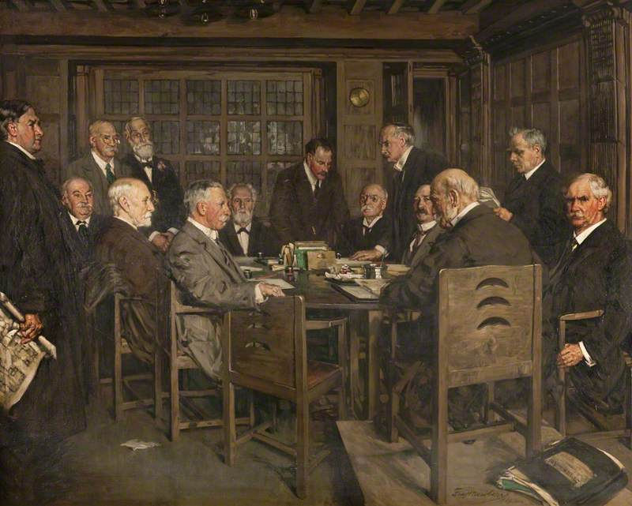

Introduction in the Board Room
The Board Room at Glasgow School of Art is one of the few points in Mackintosh’s design where explicit reference is made to the classical tradition. But the diminutive and idiosyncratically modelled ionic pilasters on its timber-panelled walls are not the only paradoxically public-toned element in the otherwise domestic feel of that low-ceilinged narrow room. Indeed, the atmosphere of a public-private clash in tone is largely provoked by a group portrait on the west wall. The year that painting was hung there was 1914, when Europe itself was hanging on the edge of a

revolutionary precipice. A month after the painting’s unveiling in the Board Room took place, a young peasant Serbian nationalist would rush from a Sarajevo side street into the path of the oblivious royal entourage and shoot the heir to the last Hapsburg Emperor. Establishments then collapsed into one another across the continent, precipitating the Bolshevik Revolution, the Easter Rising in Dublin, and, more locally, the Glasgow Women’s Rent Strike of 1915 and the 1919 workers’ riots of George Square.
It was thus exactly one hundred years and five days before the 2014 fire that engulfed the western half of Glasgow School of Art that Newbery’s painting was gifted to the school from the Royal Glasgow Institute of Fine Arts. Throughout that century the painting, surtitled in white painted Mackintoshesque script ‘The Building Committee of the Glasgow School of Art’, occupied a very intriguing position within the building itself. The work depicts a low-ceilinged, timber-lined room, with a group of fourteen middle-aged and elderly gentlemen – six standing and the rest seated – gathered over papers on a central table. There are some paradoxes enfolded into this painted work that make the viewer feel ill at ease. Perhaps the most striking and disconcerting effect worked on the viewer – at any time between 1914 and 2014 – was when they realised that the room they gazed on in the picture was precisely the one in which they stood in order to see the picture. For the painting was hung on the wall of the Board Room wherein the meeting of the Building Committee depicted took place. That technique, whereby an image contains a smaller copy of itself constituting a type of infinite recurrence is known in heraldry and art history as mise en abyme – the image is literally ‘put into the abyss’ of endless repetition. In this case, however, the viewer was pulled up short in abysmal disappointment – they searched in vain for the reproduction of this work itself on the image of the right-hand wall – where the painting hung in real life – but it was not there. Newbery was originally commissioned to do the work by the Royal Glasgow Institute of the Fine Arts, and could not have known that the painting would ultimately be placed as a long-term fixture in the very room he was attempting to recreate in oils. Yet even if he had known that his work was bound for that position, would he have sought the bottomless trick of mise en abyme, or was the foregrounding of another, more realistic effect uppermost in his mind? Hung on the wall, the painting was sometimes hardly noticeable there, so exact was the reproduction of the colouring of the stained timber panels of reality. The viewer who wished to inspect the work thus had to take a close view, to stand in a position which, as represented in the painting, was in the middle background, in front of the interior gridded window, looking to the wall on the right-hand side, where the picture hung between the two timber pilasters. To gaze on the picture from that position seemed, in fact, to work an effect that is another species of occult space warp, one precisely contrary to the endlessness of mise en abyme. With the crowd of gentlemen squeezed into that diminutive representation, it appears oddly cramped and claustrophobic rather than extended infinitely.
We might wonder, however, whether that claustrophobic effect was worked not so much by the shrunken reproduction of the dark timber walls on the full-size dark timber originals, by the unfeasibly large crowd of overdressed men in the space (real or otherwise), or, in fact, by the drama, saturated by significance, which seems to be taking place between certain characters across the breadth of the canvas? Newbery’s painting can be seen in relation to a tradition of the group portrait originating in the representation of civic engagement seen in sixteenth- and seventeenth-century Holland, as analysed by Riegl and defined by him as consisting of ‘autonomous individuals who associated themselves with a corporation solely for a specific shared, practical and public-spirited purpose, but who otherwise wished to maintain their independence’. Like seventeenth-century Holland, late-nineteenth-century Scotland (and Glasgow in particular) had an established Calvinist religious tradition, and was a booming centre for trade and industry with a strong tradition of civic altruism. As such, there was fertile local ground for a flourishing of the group portrait, which, like Newbery’s work, also drew influence from the Impressionists and Whistler. Group paintings from more accomplished artists recognised in the Scottish canon, and which reflect a Protestant religious background, include James Guthrie’s Highland Funeral (1881) and John Henry Lorimer’s Ordination of the Elders (1891), although neither of these paintings is, strictly speaking, a portrait and both lack a complex portrayal of individuality. Contemporaneous Scottish portraits of large civic groups by John Lavery, including The State Visit of Her Majesty Queen Victoria (1888) and High Treason (1916), belong more to the genre of history painting.
In regard to the Dutch tradition, however, we see in Newbery’s painting, just as in Hals’s Officers of the Civic Guard (1627) and Rembrandt’s The Staalmeesters (1662), a voluntary association of individuals brought together in pursuit of collective ends but without losing their own independence. In the case of the Newbery work, of course, that end was to commission and oversee the construction of a new Glasgow Art School building from the architect Charles Rennie Mackintosh. Riegl stresses that the most typical group portraits of the type lack any coherent group action, but feature a strong psychological interaction among the figures, which generally encompasses the particular attentiveness which the individuals depicted devote in turn to the business at hand, to each other, and to the viewer. Accordingly, in the Newbery case, the table with the business papers on it is placed at the centre of the painting and most of the characters are turned attentively towards that centre in their own individual fashion. That internal engagement in the painting is, however, supplemented by a drama that plays out in the foregrounding of two particular characters, for who the business at the table seems only to exist as a Greek chorus that grounds their leading roles. Those two main actors, positioned at the extreme ends of the canvas, look out to the exterior from the action evidently at hand, and in doing so broaden the significance of this gathering and invite us to see it in multiple contexts.
The self-portrait of the artist, Fra Newbery, sitting on the right-hand side, looks out directly at the viewer. It is a conventional trope of the group painting with self-portrait that the portraitist should present themselves thus, as famously seen, for example, in Botticelli’s Adoration of the Magi (1475). In both these group paintings the self-portrait looks directly out at the viewer. However, in the civic group portraits of the seventeenth-century Netherlands, there is a tradition for the leader, or the most important figure (often he for whom the portrait is made), to gaze out at the viewer with sprezzatura, or a relaxed confidence in their control of the situation. While Newbery may seem to grip the leg of his chair for support, his sure gaze nonetheless invites an intimate study, contextualisation and understanding from the viewer. Riegl describes such a study of a group portrait, writing, ‘Only the intimate study by a viewing subject who takes the time for self-discovery can truly do justice to their inner meaning and significance’.
Equally, the standing figure on the far left-hand side of this painting embodies a number of temporal and spatial alterities which seem to traverse the canvas. Ruddy-faced, in full outdoor clothing, staring over the heads of the sitting gentlemen into an indefinite future, or perhaps with a determined vision of the future, is Charles Rennie Mackintosh, the architect of the building. This is not a representation of the Mackintosh of popular lore, though, not the image of the moustachioed dandy with his kiss curl that we see on all the tourist brochures for Glasgow. Neither is there anything of the relaxed confidence of Newbery in this representation of Mackintosh. If he too looks out from the internal action on the canvas, then unlike Newbery, it is not to invite the attentiveness of the viewer. This surly, middle-aged man seems to have barged into the Board Room unseen, and his gaze and attention seem fixed indefinitely on the beyond. The iconography of the presentation of Mackintosh’s proposals does not have him raising a declamatory hand to present his work openly for critical objective examination. Instead, this quietly determined character, heavy-jowled and evidently careworn, grips his plans close by himself, on the blind side of those in charge. The latter seem to give no attention whatsoever to his approach.
Apparently on the edges of the action, these two figures, Newbery and Mackintosh, between them open the behind-closed-doors world of the proceedings of the Glasgow School of Art Building Committee to wider vistas, and reveal the theme of this room, and the whole building itself, as one of an historically significant virtuosity and mastery of art and craft up against a provincial Establishment. It is because it is such a dramatic theme, announced by the disposition of characters and the direction of (and intention in) their gaze, that I would say that this painting belongs, not to the disappointed mise en abyme form but, rather, as an emblem, to the Shakespearian-type ‘play within the play’. In order to expose the workings of such a trope here in this painting, and also how it can operate as a fulcrum to leverage socio-political critique into the understanding and assessment of the Glasgow School of Art as a work of architecture, it will be necessary to examine and be aware of the history of the building’s procurement in some detail. This entails an examination of the painted protagonists named here, of their relationship to one another and to the Glasgow School of Art, of their engagement, jointly and severally, with the Glasgow School of Art Building Committee as the client for the building of the new school of art, and of their joint progress in constructing that edifice.
The first and perhaps most obvious – and awkward – question that might arise relates to the time and place depicted in the painting. The latter, completed in 1914, is evidently a retrospectively realist view of the architect arriving at a meeting to discuss his plans, represented as clutched in his right hand, for the new building. Understood simply as such, however, the viewer immediately encountered several logical inconsistencies in both spatial and temporal representations contained in the work. How, they may well have asked, could such a meeting with the client take place inside the very building which the architect, with his plans in hand, was seeking permission to build? Or, as Aristotle might have put it, how could the object in space that is the Glasgow School of Art building both be and not-be-yet at the same time? The answer is in fact straightforward. It is that the School itself was completed in two stages: the eastern half built between 1897-99 and the western part ten years later (1907-09). The Board Room where the meeting depicted in the painting takes place was built as part of the first, eastern stage of the school, and was occupied from 1899. Thus, the meeting depicted took place some time after 1907, and the mature Mackintosh is shown with his plans for the western section which was then yet-to-be built or under construction.
It could be pointed out that temporal and spatial inconsistency is often a vital tool in painting, one that is so ubiquitous in all traditions as to be unworthy of any serious analysis of the kind offered immediately above. Newbery’s painting is, of course, an idealised image of a process which partly took place through time in the Board Room at Glasgow School of Art. As such, it might not seem to warrant a close analysis of the particular representations of time and space that it uses to express its meaning. It may also be objected that Newbery’s limitations as a painter, for example, his failure to engage with the full range of possibilities available to a painter of his time in expressing time and space (see below) determines his presentation of the material in a manner which might complicate the reading of any active authorial intention. But the way time and space are represented in this painting by the disposition of figures is, notwithstanding any putatively naïve conception and technique of the artist, of utmost significance in understanding what Riegl calls the ‘psychological life’ of the various characters, not least because the artist himself is one of those characters.
The explanation of time and space above goes some way towards explaining when the depicted meeting took place, where it was held, who was in the picture, what was their business, and why. It does not, however, explain the attitudes struck and positions taken by the painted figures, particularly those of Newbery and Mackintosh. To understand the significance of those attitudes and positions and why they were taken we have to look further into the detailed history of the building of both stages of the Glasgow School of Art.

The Design and Building of Glasgow School of Art: The First Half 1896-99
It is important to note of the procurement history for the building that, as cited at the current article’s very outset, the client needed and wanted nothing more than a ‘plain building’. Newberry, who since 1885 had been Director of the Glasgow School of Art, then sited in a building around the corner on Sauchiehall Street, had been asked in 1896 by the Building Committee to prepare a block plan for the empty site they had acquired on nearby Renfrew Street. This block plan was to show how the ‘whole site might be utilized giving as far as possible the required dimensions of class rooms and relative accommodation for the working of the school’. Newberry’s completed plan was approved by Thomas Armstrong, the Director of the Science and Art Department at South Kensington, who was then in charge of art training across the UK. A schedule of ‘Conditions of Competition’ was then prepared and distributed to potential competitors that summer; by October of the same year, eleven sets of plans had been received from the twelve architectural firms that had been invited to compete.

The entry from the Glasgow architectural firm Honeyman & Keppie, designed by their assistant Charles Rennie Mackintosh, was chosen as the winner. It is unclear (for reasons discussed below) to what extent any of the judges would have been aware that Mackintosh was the actual individual in the office responsible for the design. Nonetheless, by choosing this firm’s design as the winner, a ‘plain building’ was ostensibly what the assessors got. In the written statement accompanying the drawings, the architect claimed that the ‘useless expenditure of money on mere embellishment has played no part’ in the design, and that the ‘accommodation has been arranged as far as possible according to the sizes and position suggested in the Conditions of the Competition.’

In fact, the winning architect also supplied a schedule with the entry, showing that the floor areas for the various types of room were almost exactly as the Conditions required, with the exception of the Director’s accommodation and the students’ lunch rooms, both of which were roughly 1½ times the dimensions stipulated. Among the very few alterations required in the disposition of the rooms was the relocation of the library from the basement (which was reserved in this version of the scheme for the School of Architecture) to the ground floor so that it would be more easily accessible to all parts of the School. In this way, not only did Honeyman & Keppie’s plans for the building conform relatively straightforwardly to Newbery’s requests, but the layout of the School was also very similar to those of other, recently completed schools of art in Manchester and Liverpool, both of which had main classrooms on the north side served by a corridor on the south. The choice of winning architect was subsequently (and independently) approved by Thomas Armstrong, who described the plans in a letter to the Governors as ‘well suited to the requirements of your school’ and ‘better than what could be obtained from the other designers.’

This competition win, then, with plans for a ‘plain building’ that had won acceptance from the Director of the Glasgow School of Art and the whole board and Building Committee (containing lay figures and architects from the Glasgow establishment), as well as from the government-appointed controller of art education in London, presents a picture which could hardly be more at odds with the enduring legend of Mackintosh as an ignored and rejected outsider. Yet despite this adequate fulfilment of the requirements for the School, and the satisfaction of the various bodies and judges named above, rumours that it was Newbery, Mackintosh’s former teacher, who promoted Mackintosh and pushed for his drawings to be accepted, soon began to circulate and have persisted to this day. Perhaps in later years, after the painting was installed in 1914, the depiction in oils of their joint detachment from the others in the room did little to dispel those rumours. Indeed, we may well ask what Newbery’s intention was, in presenting himself in the role of leader, or central figure in the business at hand, familiar from the iconography of the group portrait tradition. The figure who was supposedly in charge of proceedings as Chair of the Building Committee, Sir James Fleming, may well be seated on a podium to recognise his position (and with strong verticals on the back of his chair to emphasise the latter), but he has his back to the viewer and is the only figure with his face obscured as he faces back to his fellows.

Fig. 2
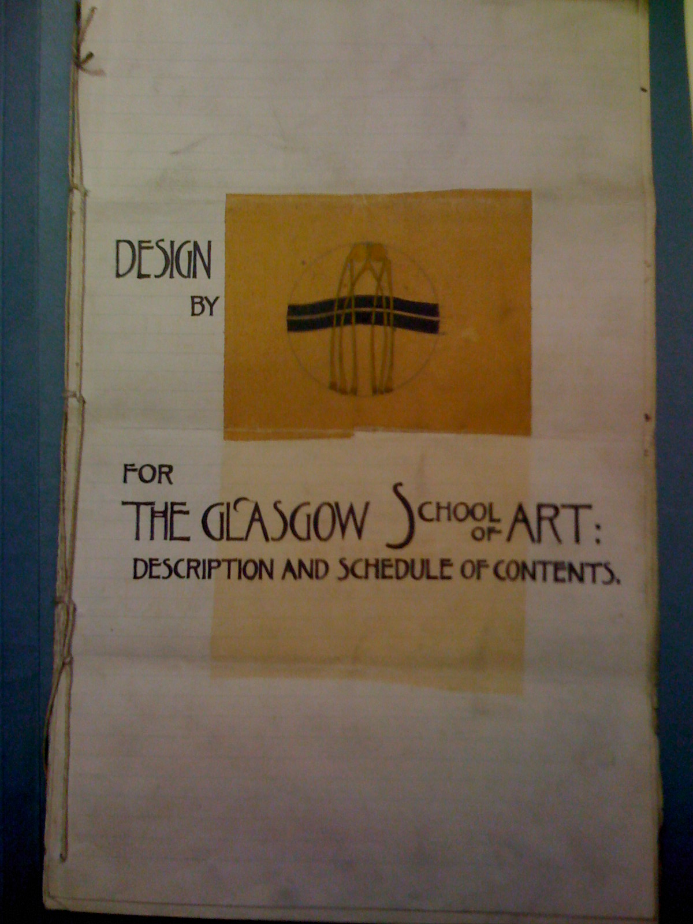

The question of Mackintosh’s true anonymity in the architectural competition might also be worth scrutinising further. It is true that, for anyone who knew Mackintosh’s work, the motif of the ‘wish bones’ and the graphic style of the wording decorating the frontispiece of

the anonymous written submission (Figure 2 ) would have been instantly recognisable. And was there anyone in 1896 in Glasgow in any way knowledgeable about the art and architecture scene, who would not have recognised it? After all, in 1895 Mackintosh had designed the poster for the opening of the Glasgow Institute of Fine Arts with a very similar graphic style, one that attracted enough attention to be satirized in a cartoon in the Glasgow Evening Times. If the assessors (and governors) did not know of him, then they were quite out of the local artistic and civic loop. If, on the other hand, they knew something of Mackintosh’s growing reputation, and did recognise the graphic style on the competition entry, they may either have been unsure of the extent of his real input, as an ‘assistant’ in a prominent firm, to the actual plans presented in the name of Honeyman & Keppie for this ‘plain building’, or been reassured by the fact that the scheme conformed so well and so rationally to the conditions of the competition. At any rate, after various rounds of negotiation the go-ahead to build was given by the surveyors. They recommended that only the eastern half of the building be built for the time being and costed it at £13,466. John Keppie accepted instructions on 27 January 1897 to prepare drawings to ‘decide what portion should be proceeded with’. The Foundation Stone was laid at a ceremony on 25 May by the Lord Provost, and a lunch menu at the Corporation Galleries included lobster, crab, foie gras, strawberries and pineapple and Heidsieck 1892 champagne. The eastern part of the building was officially opened in a ceremony on 20 December 1899.

Throughout the period of building the first half of the School (1897-99) there had been no reference to Charles Rennie Mackintosh by name as the architect. Instead, Honeyman & Keppie, in whose name he had submitted the competition entry, were given all the credit. Mackintosh laid open his feelings about such lack of acknowledgement for his work in a letter to Hermann Muthesius written on 11th May 1899:
You must understand that for the time being I am under a cloud - as it were - although the building in Mitchell Street here was designed by me the architects are or were Messrs Honeyman & Keppie - who employ me as an assistant. So if you reproduce any photographs of the building you must give the architects’ name - not mine. You will see that it is very unfortunate for me, but I hope, when brighter days come, I shall be able to work for myself entirely and claim my work as mine.

Accordingly, it was John Keppie, an eponymous partner in the firm, who had attended all the meetings with the client, and while Keppie was given a seat on the dais beside other VIPs at the opening ceremony of the first half of the building in 1899, Mackintosh had to be content as a member of the public watching from the gathered crowd.

The design and building of the second half: 1906-9
In the meantime, however, Mackintosh’s status, both as an artist, designer and architect in the wider world and, more specifically, as the architect in charge of Honeyman & Keppie’s design for the School, was changing rapidly. From the mid-to-late 1890s he was attracting the notice not only of patrons, but of critics, the art press, and exhibition organisers. In 1897, articles on Mackintosh and his colleagues and friends had appeared in the Studio; in 1898, another article appeared in Dekorativ Kunst; in 1900 he exhibited with great success in the Secession exhibition in Vienna; and he exhibited in Vienna and Turin in 1902. In his specifically architectural work he had been made a partner in the firm, now Honeyman, Keppie & Mackintosh, in 1901, and had completed a number of major commissions, including the church at Queens Cross in 1897, the private houses Windyhill and Hill House in 1901 and 1904 respectively, the Willow Tea Rooms in 1903, the Daily Record building in 1904 and Scotland Street School in 1906.

Thus, if the assessors and some of the governors had not heard of Mackintosh when he submitted his design in 1896, then they certainly knew him, at least by reputation, when in 1906 the School decided to go ahead with completing the work on the western half of the building. For not only had Mackintosh been making his name in the intervening years as a prominent and somewhat maverick designer and architect round the city and abroad, but also, in 1905, he had been appointed to the Judging Panel for students of Design and Decorative Art at the School. But the final and definitive acknowledgement of Mackintosh as the architect of the building must be said to have come on 22 January 1907, when for the last time he attended a Building Committee meeting in the company of John Keppie; thereafter, it was Mackintosh alone who attended those meetings, as depicted in Newbery’s painting. This contrasts with the protocol for the building of the first (eastern) stage of the building, when only Keppie had attended the Building Committee meetings.

It is important to note that this public acknowledgement of Mackintosh as the architect came with a significant change in the client’s attitude. The building of the first stage of the School had run over cost and was not in fact paid off until 1905. Were some of the governors searching around for a culprit to blame for the burden of this overspend, they might have felt easier setting their sights on a junior partner rather than the Glasgow establishment figure that was Keppie. Here was a maverick, Charles Rennie Mackintosh, whom they now knew to be in charge of their project; he was evidently no longer under the full control of his senior partner, and they could also pin an overspend on him. They may have been wary and nervous for the future performance of their newly acknowledged architect. Indeed, the evidence of their behaviour (as discussed at length below) points us towards this conclusion. Material evidence from the painting itself may even speak of Newbery’s equivocation regarding the legitimacy of his colleagues’ wariness and nervousness regarding Mackintosh’s reputation as the maverick. When we examine Mackintosh’s stance in the painting, there is a definite imposture, one which is not just due to any putative emotional state, but more simply, to his physical position as presented by the artist. Mackintosh appears, with his heavy overcoat on and drawings in hand, to have just entered the room from stage left to present his plans before the Committee. Yet there is only one public door into that room, and it can clearly be seen at the top right-hand side. We cannot imagine that he has entered the room, shuffled past both the gentlemen at the top side of the picture, and between those on the left and the wall behind them, only to arrive – still with his outdoor coat on - at a position of evident entry on the left, apparently without either engaging the gentlemen’s attention or disturbing them at all from their deliberations. How is that physically possible? Would not all eyes – or indeed, all laughter – be then directed at him from those around the table? Why, then, has this apparent imposture, the odd, out-on-a-limb, awkward yet determined pose of the one who is – or ought to be – the centre of all the Committee’s deliberations, attracted no attention whatsoever? The gentlemen sit, after all, not only in a room designed by the man who has just entered it, but on chairs and around a table all designed by that man too. Is he not worthy of the merest glance?
The truth is that the inclusion of Mackintosh in the painting was an afterthought by Newbery. His original painting showed only the committee members and himself looking out: self-aware, attentive, inviting attention from the viewer to the deliberations around the table. Indeed, Newbery’s exclusion of the actual designer of the space and all the furniture in it from the original version of the painting only follows, or arguably indulges, the pattern of pretence from the architect’s employers (Honeyman and Keppie architects with the Governors of Glasgow School of Art as client) that had originally omitted Mackintosh from the full discussion process, precluded his being honoured or named in his creative role, and failed hitherto to publicly (or even privately) recognise or acknowledge his signature work. Newbery had, in fact, extended the canvas physically in order to add Mackintosh on at the end, clutching his plans. He did, however, take significant care with the preparation of his portrait of Mackintosh, for studies of the architect in this position exist as both a separate oil painting owned by the Scottish National Portrait Gallery, and a crayon-on-paper drawing owned by the Hunterian Gallery.

The late addition of this figure to the Board Room painting at the Glasgow School of Art explains something of the compositional awkwardness described above, with Mackintosh jammed up against the wall of the room, staring into the distance, ignored by all the gentlemen deliberating around the table. It is clear, furthermore, that Newbery, an Establishment figure himself as Director of the School, was only prepared to make a late addition of Mackintosh to the portrait in 1913-14 once that work existed at a safe distance from the fraught process of procuring the building (as described below) and once the building work, completed several years previously by the maverick architect in 1909, could be acknowledged publicly as a ‘success’.
Newbery’s pragmatic and tactical approach to the production of this painting thus entailed the adoption and adaptation, within one finished work, of pieces created at different times on different materials and with different aims in mind. While this multiple, polyvocal and heterogeneous synthesis of temporalities and spatialities in one work is thus imbued with something of the tense dynamic of the confrontation between Mackintosh and the client, it is, nonetheless, an idealised representation of their meeting rather than a composition of one specific actual encounter. The reality of the confrontation between the architect and client which is distilled and idealised in the painting took place over numerous engagements throughout the period of design and build. This is apparent in a reading of the Minutes of the Building Committee of the Glasgow School of Art, and an analysis of key moments recorded there in terms of the relationship between the committee as client and their architect will be mounted below. It will show that Mackintosh discovered, right from the very beginning, that the Building Committee came in combative mood to their meetings with uncompromising decisions already made in anticipation of his being difficult. Yet what was Mackintosh’s reaction?

On 15 January 1907 (one week before the final meeting that Mackintosh attended in the company of Keppie) the chairman of the Building Committee, Patrick Dunn (sitting 6th from left in the painting), proposed to it that the agreement with the contractors should incorporate the guarantee that: ‘No alterations whatsoever should be made on same unless with the written sanction of the Building Committee’.

It may have been in some part in reaction to this warning, and also owing to his reluctance to be pinned down to final designs, that when officially asked a couple of months later to provide a complete set of plans, elevations and sections showing the existing part of the building and what was to be added, Mackintosh replied: ‘We think it undesirable to commit ourselves to any elevational treatment until the general scheme of internal arrangement is approved’.

That the governors and members of the Building Committee were worried, owing to their wish for a ‘plain building’ on budget, that this architect might attempt to exert his well-known wayward character is clear: they stress twice, following ‘suggestion’ by the architect governor J. J. Burnet, ‘no alterations’ again at the Building Committee meeting on 22 January 1907, and yet again on 10 September, even as the foundations were being excavated a few metres to the west of the Board Room where the meeting took place. It seems clear now that the Beaux-Arts-trained Burnet, with his classical background, had misunderstood Mackintosh’s way of working. This may also explain the depiction of Mackintosh as clutching his plans on the blind side of the Committee members, and the determination in the set of his jaw as he looks over the Committee in session, and beyond them to the future.

Burnet (standing, fifth from the right in the portrait) probably has as good a pedigree as anyone who could be claimed as part of the Edwardian Glasgow architectural establishment, and it may be significant that it was he who stressed the ‘no change’ guarantee in the contract. His father had been a very important architect in Glasgow in the mid-nineteenth century. At the age of fifteen, Burnet had gone to study at the École des Beaux-Arts in Paris, and by his late teens and early twenties he was designing big city buildings. Gomme and Walker say of him that he was ‘the best-known architect of his time’, with ‘a reputation that dwarfed Mackintosh’s’, and that ‘his contribution … to the centre of the city’ is the greatest by a single architect with the possible exception of Greek Thomson. By 1906, he had completed many well-known buildings, including the Clyde Navigation Trust, the Savings Bank on Ingram Street and McGeoch’s on West Campbell Street, in addition to his work at the British Museum in London. Newbery’s finished work has Burnet standing opposite Mackintosh, competing for importance with him. Yet if the Glasgow Style artist is really looking over the grey-heads to the future, then the Beaux-Arts stalwart Edwardian, with eyes slightly lowered, faces in the other direction.

Burnet may not have studied at the Glasgow School of Art, but if membership of the Board of Governors was simply another manifestation of his establishment credentials, then he could nonetheless be assured that the teaching of architecture in the School was based on an entirely orthodox Beaux-Arts model. Mackintosh, on the other hand, can be viewed as a wayward and irreverent product of this system. Although Mackintosh had been invited to serve as a Judge of students’ work at Glasgow School of Art for the first time in 1905, it is notable that during the eleven subsequent years he spent judging on and off, he served repeatedly on the panel of judges for Design and the Decorative Arts and for Modelling and Sculpture. It was not until the 1914-15 session (the same ‘safe distance’ year when Newbery’s painting was hung in the Board Room), and his penultimate year of service as a governor, that Mackintosh was asked to join the panel for Architecture. By that time not only had his partnership with Keppie been dissolved, but Mackintosh himself had already left Glasgow for England. Of course, Mackintosh was a polymath, and it could be that he preferred to interest himself in the other arts outwith his strictly professional life in architectural practice. But it is plausible that the School of Architecture left it so late to invite Mackintosh to serve as a judge because they viewed his unorthodox views and practices with mistrust. Burnet’s attempt to control and restrict Mackintosh’s room for manoeuvre on the design and building of the new School could in that case be seen as yet another manifestation of a suspicious architectural establishment.

Mackintosh’s design methodology
The Beaux-Arts tradition that dominated the School’s architectural teaching depended on design organised through formal relationships of symmetry and a hierarchy of spaces, and above all on close attention to the architectural programme, with its demand for highly finished perspective presentation, and meticulous scale drawings. Indeed, it was indeed this rigorous and strategic tradition of drawing, and its remoteness from the actual materials of building, that was criticised in the report on the School by the sculptor Pittendrigh McGillivray in 1905:

My view is that the student of Architecture confines himself too closely to paper in his studies. I advocate that by means of a technical course he should be brought into personal contact with the materials for which he designs.

But this criticism could hardly be said to hold for the wayward Mackintosh, the architect ignored by that very department. Mackintosh had, among other things, a great interest in and involvement with the crafts and their materials, and he also operated with a more complex and open concept of the relationship between drawings and building. In this regard, we are again reminded of Mackintosh in Newbery’s depiction of him, clutching his plans and keeping his overcoat-clad body between them and a possible examination by the Building Committee. As William Buchanan notes,

It is clear that Mackintosh regarded plans as an indication of intention rather than a solution to problems.

But the real significance of this leap of faith between the plans and drawings as intention and the construction as actuality is that architectural design and construction becomes a performance in time, a pragmatic and proactive manipulation of spaces as they are gradually revealed, rather than a robotic reading of instructions. Newbery seems to understand this in his painting, which deliberately reproduces aspects of Mackintosh’s pragmatic design philosophy in its reworkings, confrontations, additions, paste-ups, and so on. As Andy MacMillan writes of Mackintosh’s method, once the
basic plans and sections were completed, each part of the building was then subjected to examination then re-examination as detail design or building work proceeded, a process of tactical confrontation with the potential of each particular situation.
For a fuller understanding of the theoretical underpinning of this dynamic approach to design and construction, we can look to Mackintosh’s formative influences as an architect, and, in particular, at his interest in the Baronial style that flourished in Scotland during the thirteenth to sixteenth centuries. As early as 1891, Mackintosh gave a talk to the Glasgow Architectural Association in which he leant very heavily – some would say almost to the point of plagiarism – on the interpretation of the evolutionary phases of the Baronial idiom set out by MacGibbon and Ross in their book The Castellated and Domestic Architecture of Scotland. Through these phases we can see the architecture produced within this tradition adapting to historical needs and circumstance as they arise over centuries, rather than seeking conformity to a set of exclusive and established rules of the kind we find in classical architecture, with its canon of precepts regarding proportion, symmetry, and so on. In his commentary on this lecture, Frank Walker points out that ‘Mackintosh speaks of a versatile “grouping of parts” and a readily varied “external outline”, both qualities resulting from an ability to respond to the contingent’. Not only that, but through this process of building, the structure itself is decoration, and a plastic poetics develops its own vocabulary and symbolic content, albeit grounded in functional necessity, such that these buildings develop as iconic images of great strength. Walker goes on to put Mackintosh’s reading (and at this early stage in his work (1891) it is still only a ‘reading’ rather than a performance) in the context of the nineteenth-century ‘dilemma of styles’. To order the discussion, Walker himself borrows Colin Rowe’s conception of this dilemma as a problem for nineteenth-century architects in resolving the principles of ‘composition’ and of ‘character’, where composition refers to the rules for combining parts into an architectural whole, and character is concerned with the architectural expression of a building’s symbolic or functional meaning. As the nineteenth century was, especially in Britain, the great age of industrialisation, architects had to confront the need for new building types, such as railway stations, factories, large hotels and schools. As far as composition was concerned, the new structural materials and methods that came into being opened up a new range of possibilities, and the Beaux-Arts methodology for co-ordination of plans and sections developed to cater for buildings never seen before on such a vast scale. But when it came to expression of the meaning - a language for the symbolic and functional content of these buildings - there was no historical precedent, and ultimately the classical, the gothic, the medieval and other styles exploited by many nineteenth-century architects lacked an adequate language of forms for expressing the functions required by modern society.
Whereas a Beaux-Arts-trained, classical architect such as Burnet was principally concerned with ‘composition’ - with the magnificently precise planning of the building, the strict and symmetrical relationship of parts to the whole, plan to section, and so on - Mackintosh, through his interest in the Scottish Baronial, demonstrated an early (and then abiding) obsession with ‘character’, and a versatile sensitivity for the creation of particularised and expressive structure. Thus, Burnet, rooted in his own great tradition, was clearly labouring under a misapprehension if he thought that Mackintosh’s more or less rigorous reproduction of Newbery’s spatial layout in the former’s architectural plans for the new Glasgow School of Art building meant that it was exactly those spaces that would be built; or that by placing the stricture of ‘no alteration’ on the plans there would be a consequent guarantee that no wasteful ‘spook’ decoration would be added to the ‘plain’ plan as the construction work was carried out. As is evident from what has been shown above, for Mackintosh the drawings only signified intention. That is not to say that the drawings constituted a basic building form to be further decorated; rather, they represented a structural intention in which, through the building process itself, the spatial character of the structure would be developed in a way that enabled it to adapt to particular situations as they arose, while at the same time expanding and enriching the symbolic vocabulary of the whole work.

The construction work and the Building Committee
As we read in the Building Committee Minutes, there were at least two points in the building of the second half of the School between 1907 and 1909 when this misunderstanding – indeed, conflict – in architectural approaches came to a head, and this is made clear in recorded clashes between the architect and client. The first concerns the design of the library, which in the final plans for the western stage had been moved from the ground floor to occupy the present position on the first floor. It was also now to include a gallery (under this arrangement, the School of Architecture was reinstated on the ground floor as originally requested by Newbery in 1896). On August 8 1908, and despite the ‘no alteration’ stricture, Mackintosh made a request to the Building Committee to use oak instead of pine in the library, and estimated the cost difference at £400. The Committee requested that the decision be delayed ‘until a later stage in the work’. Almost two months later, Burnet asked for two sets of drawings of the library, one in oak and one in pine. After a similar lapse of time, Mackintosh submitted the drawings requested and the Committee said that they would give the matter further consideration.
At a meeting on 8 December 1908, the architect explained that the original cost of the pine had now increased by £90 or so, because he would now be building the gallery round four sides of the room – that is, across the window wall as well as the other three. In the meantime, a dispute had started up as to the position and style of the librarian’s office. In late January, the Committee objected to Mackintosh that a glass office for the librarian was ‘unsuitable’, and also objected also to his building the balcony across the window, as this meant that ‘light would be lost’. Two weeks later, a letter of 2 February from Mackintosh was read to the Committee, in which the architect declared that leaving out the glass office would save £36, whereas leaving out the window-side gallery would not save money at all, but would cost more because construction on the other sides would have to be altered and its omission ‘will to a great extent spoil the proportions and design of this room’. The Committee insisted on leaving out the office, but agreed to keep the balcony on the window side. And just as well, we might say, for the resultant delicate balance of structure and space and the subtle quality of light in this room with its tall windows, its gallery sporting carved abstractions of ionic pillars in solid and void (echoing those in the Board Room where the Committee sat), its forest of uprights and its hanging lamps, is considered by many to have made it one of the most atmospheric and intense spaces in Western architecture.

Fig 3
The second important and prominently recorded point of difference was the treatment of the west façade in general, and, in particular, the doorway to the basement level. Mackintosh was, as we know, reluctant to provide elevations, but if we examine the prospective elevation of the west façade that he provided in May 1907 (Figure 3), and compare it with the completed work as seen in the presentation drawing from 1910 (Figure 4), we see quite a difference. That there were indeed ‘alterations’ taking place

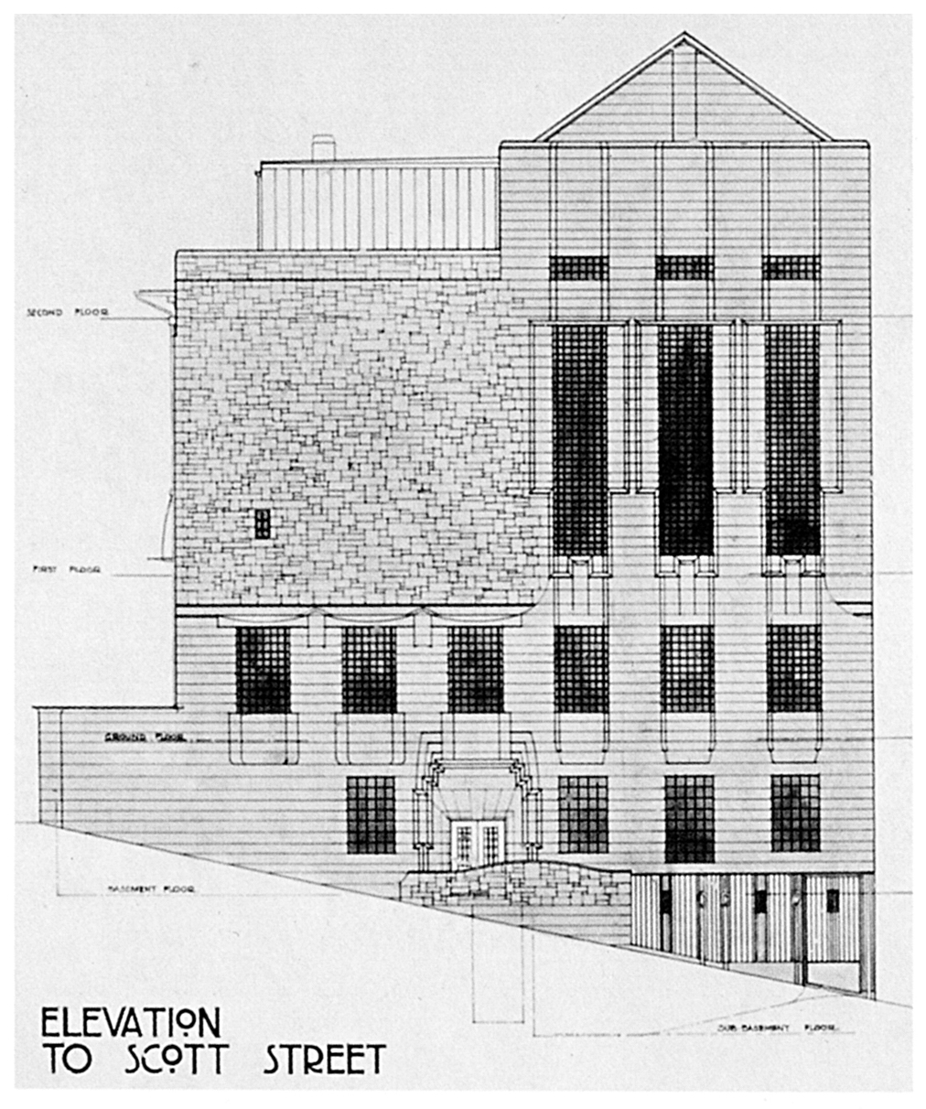
Fig. 4
on this façade, and particularly on this doorway, was brought to the attention of the Building Committee in an account of the progress of the building submitted on 7 February 1908. Mackintosh was ill and did not attend this meeting, but the surveyor reported to the Committee that regarding the Scott Street doorway, he was:
surprised to find that this work was carried out in an extravagant manner and not in accordance with plans and estimates which were submitted and signed.
The Governors’ response was that they ‘must decline all liability for any increase of cost’, and on 27 February a letter was sent reminding the architect that the terms of their contract precluded their ‘incurring any extras whatsoever without the written authorisation of the Building Committee’. The letter went on to add that ‘the Governors regret the mistake you have made in this’.
The Governors did not seem to be in any mood for compromise, and may indeed have felt vindicated in their repeated demands that

there should be ‘no alteration’. Mackintosh subsequently offered to make savings elsewhere on the building, for example, by using asphalt on the roof instead of lead. These alternative savings were at first rejected by the Board, but somehow their uncompromising mood crumbled, and we hear no more of their objections here. In the end Mackintosh had his way and the Scott Street entrance was built as a restless but super-refined essay in sculpted stone – an exercise in proto-Art Deco, one might say, or an ancient castle doorway, or maybe the closest-ever realisation of Goethe’s definition of architecture as ‘frozen music’.

Conclusion
Perhaps Mackintosh’s clients - the Glasgow School of Art Governors and the Building Committee - had undergone a dazzling revelation when they came to view this doorway. Did they suddenly realise that they had an architectural master on their hands, one who could (and did) extemporise virtuosic spaces out of the simplest architectural ingredients, conjuring up a functioning whole that expressed at once both an astonishing complexity and a reassuring integrity? If the Newbery painting can indeed be said to take the form of a ‘play within the play’, then the full-scale play, the building of the Glasgow School of Art, is haunted by Mackintosh himself in the way the Phantom haunts the Paris Opera. (The Phantom of the Opera was a work first published in the same year that the School of Art building was completed). Mackintosh emerges everywhere from the shadows here in performance, subtle but insistent. Wearing a variety of different architectural and aesthetic masks, he allows this building to speak to us - but it always does so in his voice. Was it not indeed the most fitting recognition Mackintosh could receive when, subsequent to completion of the building he was among those commissioned to design the staging of the grand Masque at the official opening in December 1909? It was a low-key role, perhaps, and shared with a foreground of autonomous performers, but what stage designer could wish for more?
Viewed thus in terms of its dramatic qualities, Mackintosh’s Glasgow School of Art can be seen to be just as much a transgression of the Aristotelian unities of classical measure and proportion as it is of the ‘canon of precepts’ of classical architecture. Aristotle’s dramatic unity of time is broken by reproduction of different historical eras in a relation of mutually informing contemporaneity, the unity of place is broken by the building’s incorporation of construction and design aspects from Japan, from Vienna, ancient Greece, Michelangelo’s Rome and so on, and the unity of action is broken by the palpable sense of two separate halves of the building

completed at different periods by an architect at different stages of maturity. Newbery’s painting is a fitting complement to Mackintosh’s work, inasmuch as it attempts a similarly pragmatic co-option of difference and fragmentation into one independent work, and in that, like Mackintosh’s architecture, Newbery’s painting attempts to ‘adapt to particular situations as they arose, while at the same time expanding and enriching the symbolic vocabulary of the whole work’. But where Mackintosh both successfully revives historical forms, such as the Scottish Baronial vernacular, while simultaneously evolving new forms in order to embody heterogeneous time and space contemporaneously in one coherent, non-classical work, Newbery’s piece is flawed, in that he does not quite find a satisfactory artistic form to achieve that coherence. In the end, the spatial and temporal disruptions in his painting are left – to a certain extent – hanging awkwardly together.
Michel Foucault remarked on how the current age is one that has an obsession with spatial relations:
We are in the epoch of simultaneity: we are in the epoch of juxtaposition, the epoch of the near and far, of the side-by-side, of the dispersed. We are at a moment, I believe , when our experience of the world is less that of a long life developing through time than that of a network that connects points and intersects with its own skein.
The irony here, for Newbery’s painting, is that it was precisely in those years while he was preparing and executing this work, with its awkward juxtapositions and its cramming of information and representations side-by-side, that Cubism, the great art movement of the early twentieth century which tackled Foucault’s issues of interaction, contemporaneity and the representation on a surface of continuity and discontinuity, was in full swing. John Berger, in his 1968 article on Cubism, claims that the Cubist Movement peaked in 1907-14, and points to it as a model which achieves almost systematically certain things which came about in Newbery’s work only by happy accident, as opposed to explicit intention. For Berger,
The metaphorical model of Cubism is the diagram: the diagram being a visible, symbolic representation of invisible processes, forces, structures. A diagram need not eschew certain aspects of appearances: but these too will be treated symbolically as signs, not as imitations or recreations.
He then goes on to argue that:
Space is part of the continuity of the events within it. It is in itself an event, comparable with other events. It is not a mere container. And this is what the few Cubist masterpieces show us. The space between objects is part of the same structure as the objects themselves. The forms are simply reversed so that, say, the top of a head is a convex element and the adjacent space which it does not fill is a concave element.
The Cubists created the possibility of art revealing processes instead of static entities. The content of their art consists of various modes of interaction: the interaction between different aspects of the same event, between empty space and filled space, between structure and movement, between the seer and the thing seen.
Yet Newbery’s style of painting convinces us that he was either unaware of, or uninformed about, these Cubist experiments and their discoveries in and of space. He seems to have stumbled upon an appropriate mode of articulation which manages to depict space as a complex of aspects of a series of events, forces and structures contemporaneously on one canvas, without having any knowledge of an experiment by his coeval artists that constituted an incomparable moment in the history of modern art. Mackintosh, on the other hand, was feeling his way forward in a mode of artistic discovery and creation which seemed to have very much in common with the Cubists, in their rigorous and authentic engagement with the past to seek out forms and ways of working which could be co-opted in an evolution beyond a sticky set of conventions.

GSAA GOV 2/4, 18 September 1895. Reference to a ‘plain building’ is made in an excerpt from Glasgow City Corporation minutes inserted here. The reference is a quotation from a letter of 4th March 1895 from GSA governors (Burnett, Salmon, et al) to the Corporation.
D.P. Bliss, Charles Rennie Mackintosh and the Glasgow School of Art, Glasgow, 1961, p1.
Nikolaus Pevsner, Pioneers of Modern Design, London, Penguin, 1949, pp. 158-65.
Thomas Howarth, Charles Rennie Mackintosh and the Modern Movement, London, Routledge, 1952, p.66 & 75.
See for example James Macaulay, Charles Rennie Mackintosh, W.W. Norton, London, 2010, p279.
Howarth, p77
Macaulay, p264.
Howarth, p.69.
The painting, then known as ‘The Portrait Group of the Members of the Building Committee of the School’, or just simply ‘The Portrait Group’, was unveiled by chairman of the Scotch Education Department, Sir John Struthers at 10am on the morning of 18th May 1914 before assembled Governors of the school. Gavrilo Princip assassinated Archduke Franz Ferdinand on 28th June that year. GSAA GOV 2/9 p137.
The Boardroom and the painting were both unharmed in the fire that engulfed the west end of the Glasgow School of Art on May 23, 2014. Along with all other surviving works of art, the painting has been removed from the building and is currently in storage
William Buchanan, ‘Mackintosh, Newbery and the Building of the School’, in William Buchanan (ed.), Mackintosh’s Masterwork: The Glasgow School of Art, Edinburgh, 1994, 13-51 at p48.
Alois Riegl, The Group Portraiture of Holland, Getty Research Institute (Los Angeles), 1999, translation E. M. Kain and D. Britt, first published 1931, p. 62.
Christopher Smout, A Century of the Scottish People, fontana Press, 1987. Smout describes the ‘civic spirit’ of late nineteenth century Glasgow, pp43-5.
See Murdo Macdonald, Scottish Art, Thames and Hudson, 2000.
Riegl pp. 75-8
Inasmuch as these two ‘main actors’ are artists, Newbery’s painting might also be seen in relation to a contemporary tradition of group portraits of artists, of which well-known examples are Henri Fantin-Latour’s A Studio at Les Batignolles (1870), and the later Max Ernst’s Au Rendez Vous des Amis (1922).
Riegl p80
Macaulay characterises the make-up of the board of Directors of Glasgow School of Art as ‘nominated representatives from the town council, the university, medicine, the law, engineering, and shipbuilding as well as from the mercantile and trading communities’ p. 159, Macaulay. The Building Committee as depicted in Newbery’s painting thus had a typical membership of Governors with, for example, the banker Sir William Bilsland (6th from right), businessman Sir James Fleming (3rd from right), and town councillor James Mollison (8th from right), as well as added expertise from chartered architects D. Barclay (3rd from left), J. M. Munro (5th from left), and governor J. J. Burnet (5th from right).
Riegl p64.
GSAA GOV 5/1/1, p2, 16 May 1896.
GSAA GOV 5/1/1, p6, 11 May 1896.
GSAA GOV 5/1/1 , p17, 17 December 1896.
GSAA 5/4/10
GSAA GOV 5/1/1, p20, 17 December 1896.
This reading of Mackintosh’s status has been widespread – in both the press, see for example art critic Clare Henry in The Glasgow Herald, Weekend Extra, 18th May 1996, p.2 ‘… he must for a time have felt persona non grata in strict Victorian Glasgow’, and p.3 ‘ … widely misunderstood in his day: neglected after his death’, and in published monographs –see D. P. Bliss, p7 ‘Undoubtedly Mackintosh’s reputation suffered from the flamboyant design and poor construction of the ‘Spook School’ work with which his name was associated.’
Mackintosh studied at GSA on and off from 1883 to1895.
Buchanan, , p21 ‘…the legend that it was solely at Newbery’s insistence, and against bitter opposition , that Mackintosh won the competition’.
Evening Times, 5 February, 1895.
GSAA GOV 5/1/1, p20, 13 January 1897.
GSAA GOV 5/1/1, p 28, 27 January 1897.
Buchanan, p35.
Buchanan, p36.
Quoted in Buchanan, op. cit. p36.
Macaulay, passim.
See GSA Annual Prospectus 1905, GSAA REG 1/1.
Buchanan, p37.
Ibid. p48. ‘To accommodate Mackintosh a strip of canvass had had to be added to the side.’
GSAA GOV 5/1/3, p67, 15 January, 1907.
GSAA GOV 5/1/3, p79, 13 March 1907.
GSAA GOV 5/1/3, p70, 22 January 1907
GSAA GOV 5/1/3, p91 (insert), 10th September 1907
Andor Gomme and David Walker, Architecture of Glasgow, London, 1962, pp198 & 143.
See GSA annual prospectuses: GSAA REG 1/1, and GSAA REG 1/2
In architectural terminology the ‘programme’ is the setting out of the client’s needs in terms of architectural space and how it can be organised.
GSAA, SEC 35: James Pittendrigh McGillivray. ‘Report on School by Mr Pittendrigh McGillivray, RSA, 7 Dec. 1904’, 29th June 1905, pp6-7.
Buchanan, op. cit., p36
Andrew MacMillan, ‘A Modern Enigma’, in Buchanan, 51-73 at p66.
Pamela Robertson (ed.), Charles Rennie Mackintosh: The Architectural Papers, Oxford, 1990, passim.
David MacGibbon and Thomas Ross, The Castellated and Domestic Architecture of Scotland from the 12th to the 18th centuries, reprint, Edinburgh, 1971 (First published in 5 volumes 1887-1892)
Frank Walker, ‘Scottish Baronial Architecture’ in Robertson, 29-63 at p38.
Walker, p32.
Walker, pp. 33-5 ; Colin Rowe, The Mathematics of the Ideal Villa, London 1976, pp59-87.
GSAA GOV 5/1/4, p26, 31 August 1908
GSAA GOV 5/1/4, p30, 29 September 1908.
GSAA GOV 5/1/4, p50, 30 November 1908.
GSAA GOV 5/1/4, p54, 8 December 1908
GSAA GOV 5/1/4, p64, 26 January 1909 with reference to p54, 8 December 1908.
GSAA GOV 5/1/4, p64, 26 January 1909.
GSAA GOV 5/1/4, p73, 8 February 1909.
GSAA GOV 5/1/3, p118, 7 February 1908
GSAA GOV 5/1/3, pp127-128, 27 February 1908.
Buchanan, p42.
In a lecture given around 1892 to an unknown literary society (the editor David Walker suggests the Scottish Society of Literature and Art founded in 1886 in Glasgow, and refers to the lecture itself as ‘Untitled Paper on Architecture’) Mackintosh himself cites this definition of architecture but mistakenly assigns it to Madame De Stael: ‘When Gothe (sic) calls it a “petrified religion” or Madame de Stael “frozen music”’. The paper, and David Walker’s editorial, are published in Robertson, op. cit. pp153-180.
MacMillan, in Buchanan, p66.
Michel Foucault, ‘Des Espaces Autres’ in Architecture/Mouvement/Continuite, October , 1984, translated as ‘Of Other spaces: Utopias and Heterotopias’ by Jay Miskowiec http://web.mit.edu/allanmc/www/foucault1.pdf last viewed 15/6/15
John Berger, “The Moment of Cubism”, New Left Review, I/42 (March-April 1967), 75-94 at p85
Berger, p87

