From KAPTUR to VADS4R: Exploring Research Data Management in the Visual Arts

Robin Burgess
The Glasgow School of Art, 167 Renfrew Street, Glasgow, G3 6RQ, United Kingdom. (r.burgess@gsa.ac.uk)

“What is arts research data? What does it mean to you? Research, art, design, architecture, I’m going to tell you. What is arts research data? We tried to find out. We asked various researchers, and this is what we found…”

At the Open Repositories Conference 2013 I spoke of a project titled KAPTUR that was looking into Research Data Management in the visual arts and the development of management tools within repositories for the handling of data. The KAPTUR project came to a close in March 2013. We have been fortunate enough to secure funding through the AHRC to continue this work into research data management in the visual arts, and this has brought about the VADS4R (visual arts data skills for researchers) project. This paper aims to describe the transition from KAPTUR to VADS4R and describe the work currently being undertaken by the team working on VADS4R, with regard to improving and enhancing repository ecosystems (staff, students and technology) to engage with research data management.

The first question we need to ask ourselves is ‘What is research data in the visual arts?’

Garrett and Granstadt (2012) describe research data as “data which arises out of, and evidences, research...examples of visual arts research data may include sketchbooks, log books, sets of images, video recordings, trials, prototypes, ceramic glaze recipes, found objects, and correspondence”. The above description focuses on types of research data, the sources for the information. The following description is more explorative and reflects the complexity of research data management. Research data is: "evidence which is used or created to generate new knowledge and interpretations. Evidence' may be intersubjective or subjective; physical or emotional; persistent or ephemeral; personal or public; explicit or tacit; and is consciously or unconsciously referenced by the researcher at some point during the course of their research. As part of the research process, research data may be collated in a structured way to create a dataset to substantiate a particular interpretation, analysis or argument. A dataset may or may not lead to a research output, which regardless of method of presentation, is a planned public statement of new knowledge or interpretation (Garrett, 2012)." However it should be noted that from discussions and interviews with research staff, their interpretations of research data was classified as “stuff” and this technical term has been used quite a bit in follow up project work.

The next aspect that has been explored relates to why research data management is important.

Managing research data (or organising your 'stuff') effectively can:
- ensure you meet research funder expectations (these expectations can be viewed in the Research Councils UK Common Principles on Data Policy)
- make it easier to understand successive iterations of your research
- make it easier to re-visit your research if changes are required, for example by a journal editor or exhibition curator
- enable easier access to your research for re-use in other projects
- avoid the serious implications of having to re-do your research from scratch, for example due to data loss or inaccessible data

This in turn concludes that research data is a valuable resource and, with appropriate curation and management, it has much to offer learning, teaching, research, knowledge transfer and consultancy in the visual arts.

In 2011, at the outset of the KAPTUR project, very little was known about the curation and management of research data: none of the specialist arts institutions had policies or infrastructure and evidence suggested that practice was ad hoc, left to individual researchers and teams with little support or guidance. Funded by JISC, led by the Centre for Digital Scholarship, a Research Centre of the University for the Creative Arts, and working in partnership with the Glasgow School of Art; Goldsmiths, University of London; and University of the Arts London KAPTUR sought to resolve this lack of awareness.
The need was imperative, across the higher education sector, research councils, organisations, teams and researchers are under pressure to make publicly funded research data freely available, and in line with the Research Councils UK guidance, the publication of data is increasingly a requirement of funding. However, by its nature, research outputs and data in the visual arts is highly complex and varied, often comprising a wide variety of outputs and formats which present researchers, information managers and technology teams with many discipline specific issues. The methods and processes which generate this research information are just as varied and complex. Research in the visual arts relies heavily on sketchbooks, logbooks, journals and workbooks.
The team began with an environmental assessment which considered issues of terminology, the role of the visual arts researcher, how visual arts research data is created, used and preserved. This was followed by a technical review which considered two key questions: What did researchers need to support their research data management in the visual arts? What was the most appropriate technology solution to facilitate the appropriate management of research data in the visual arts (linking with repositories)? Finally the team developed a package of capacity building tools, these included three skills development sessions (training plans and learning materials); research data management policies; a series of partner case studies; costing and business model; and sustainability plans.

The Visual Arts Data Skills for Researchers (VADS4R) project is building on the work of the KAPTUR project by piloting and further developing these training plans and learning materials for use with early careers researchers and postgraduate students in the visual arts. The VADS4R project will provide a research data management (RDM) training programme tailored to the specific needs of these staff and students.

The project is led by the Centre for Digital Scholarship (formerly known as VADS), a Research Centre of the Library at the University for the Creative Arts (UCA), and is a collaborative venture in partnership with Falmouth University and Glasgow School of Art. It will develop, deliver, and evaluate an RDM training programme across each of the three specialist arts institutions. VADS4R runs from February 2013 to July 2014 and is funded by an Arts and Humanities Research Council (AHRC) Skills Development Award. The project approach, decisions made, and lessons learnt from VADS4R will be presented.

The training packages that form the bulk of the work carried out as part of the VADS4R project can be accessed here: http://www.vads4r.vads.ac.uk/p/online-learning.html

These training packages focus on three areas and were developed using xerte software.

- Introduction to research data
- Data management planning
- Managing the material

The first two packages are aimed at the visual arts researcher, while the third is more inline with the work of data managers. It is envisaged that the VADS4R project will develop further online training packages to benefit researchers, staff and students.

Figures 1 to 3 below illustrate the interface of these online packages.

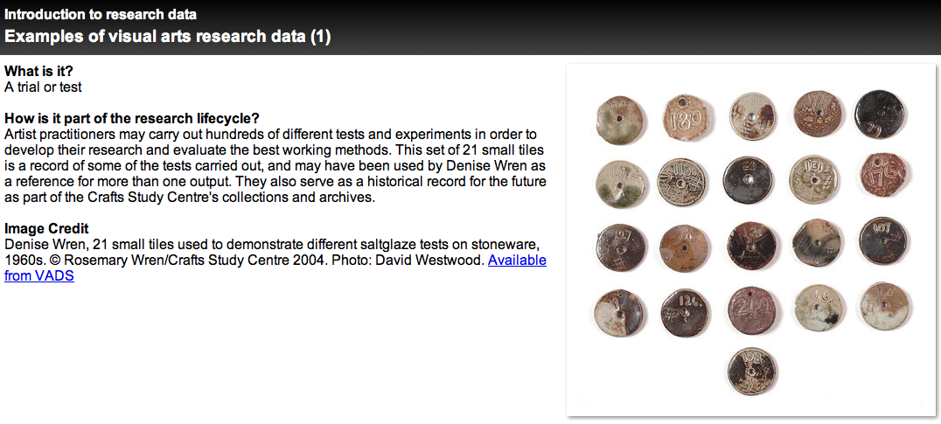
Figure 1: A screen shot illustrating the first online package: Introduction to research data.

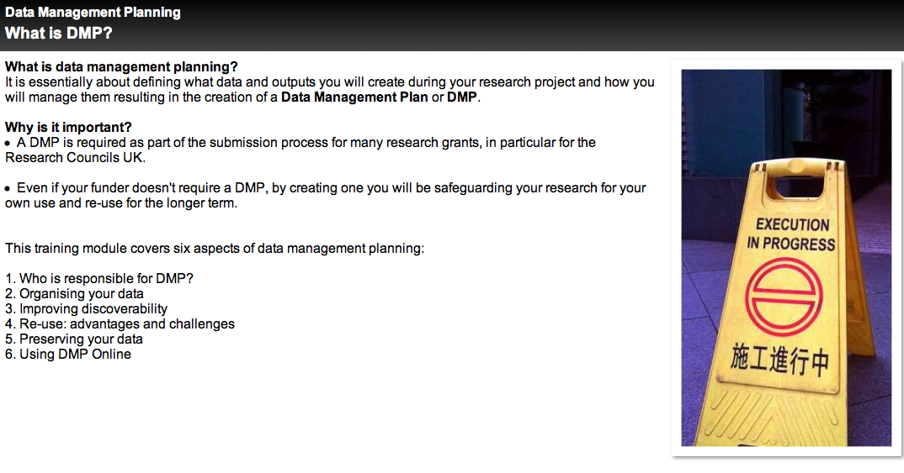Figure 2: A screen shot illustrating the second online package: Data management planning

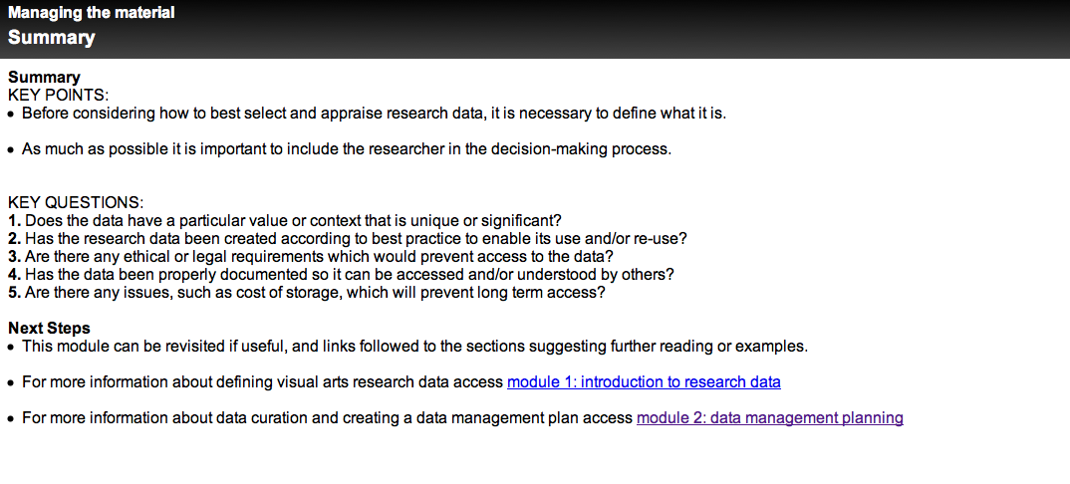Figure 3: A screen shot illustrating the third online package: Managing the material

These online packages are currently being used as part of training sessions being held at each of the arts institutes taking part in the project, aimed at postgraduate students and early career researchers. However, staff from Research Offices and Learning Resources have also been heavily engaged in these training sessions as the importance of research data management goes beyond just the researchers and students. In addition to this, research data management is becoming much more prevalent within institutes research repositories. Repositories are now being developed that can handle research data alongside the standard bibliographic metadata presented about a research output. This is seen as a requirement for some funding bodies (e.g. AHRC and EPSRC), the visibility of research data as well as the output. But also in the UK it is increasingly part of the Open Access agenda for information and likely to be part of the Research Excellence Framework 2020, an assessment process that looks at the research outputs being produced by all UK higher education institutes. Work has been instigated with EPrints, a developer of repositories such as RADAR at The Glasgow School of Art, to investigate the inclusion of research data within repositories. The work of KAPTUR identified EPrints as suitable software for developing a data management module for arts institutes (http://www.vads.ac.uk/kaptur/outputs/Kaptur_technical_analysis.pdf). Work has commenced on identifying the requirements of a research data management module for EPrints repositories.

Further information on the KAPTUR project and VADS4R project can be found at:

http://www.vads.ac.uk/kaptur
http://www.vads4r.vads.ac.uk

In conclusion it can be stated that research data can be: tangible and intangible; digital and physical; heterogeneous and infinite; and complex and complicated, it does not always fit into the natural scheme of data management. Therefore the development of policies for arts related data management and systems/infrastructure and training packages should be aware of thinking outside the box, and lending themselves to being more iterative and open to interpretation. With this in mind, support for staff and students within the field of research data management can be much more enhanced, especially with the ever changing requirements from funding bodies, academic institutes, and the technological ecosystem of data management.

