“IMPRO PICNIC at Soja Art House” Minori Seki

9am Glasgow Time / 6pm Japan Time / On ZOOM
Monday 3rd November 2025
“Some musicians who come to Soja Art House plays online for the first time.
And maybe some people play improvisation for the first time.
I want them to enjoy online improvisation without being left behind.
So I made this score. This might be boring for some musicians who are used to it.

I send you Impro picnic online score.
I will try to do this in person event at first.It take our time more slowly than online score.
We will spend time lazily like a picnic in the field.”

“I have already scheduled the zoom meeting on 3rd November . If you are Okay, I hope you become co-host of this meeting. Because when it will start, I might have to help some musicians in person who use zoom at first. And because I use separating Soja Art House rooms. A room for dancers (using projector, speaker and mic-mute) and some rooms for musicians (using their headphone and mic-on).

I am planning non-stop session in relay.

- At first, during first musician at Soja Art House is playing a single long tone, another each musicians enter zoom and test their mic..(for approx 5mins).
- Next, all members join to play a single long tone of same pitch (for approx 3-5mins).
- Each musician fade out , and second musician play solo freely.
- Third musician join with second musician , free duo.
- Second musician fade out, third musician's solo.
- And forth musician join....., repeat of Duo, Solo, Duo....Either duo and trio is fine. Either solo after solo is OK. Either the moment of no sound is OK.

It depends on the number of participants, each solo is for approx 1 mins, duo or trio is same, I think.

Total time to keep repeating Solo and Duo (or Trio) is for approx 20 mins.

When I spotlight dancers at Soja Art House , all participants play.
If it is possible, before a few minutes to the end, I hope it become no sound time. Dancers keep moving with no sound.
By jesture and facial expression etc., we say goodbye with no words.
I try to sketch this time score . Before this sesson I want to share it.
Of course please invite GIO Global”

Pierre IKENOUE
Tsuge No
Koji Uno
Mama-Yo
Kuromitsu
Chisa Mashiyama
Keiko K.W.
Tanner
Minori Seki

A GIO Global commissioned film from Minori Seki
at Soja Art House, Okayama, Japan
3rd November 2025

features Pierre Ikenoue, Tsuge No, Koji Uno, Mama-Yo
Kuromitsu, Chisa Mashiyama, Keiko K.W., Tanner,
Minori Seki (all Okayama), Constance Cooper (New York City),
Stefan Strasser (Cologne), David Robertson (Edinburgh),
Jim Bryce (Edinburgh), Jessica Argo (Glasgow)
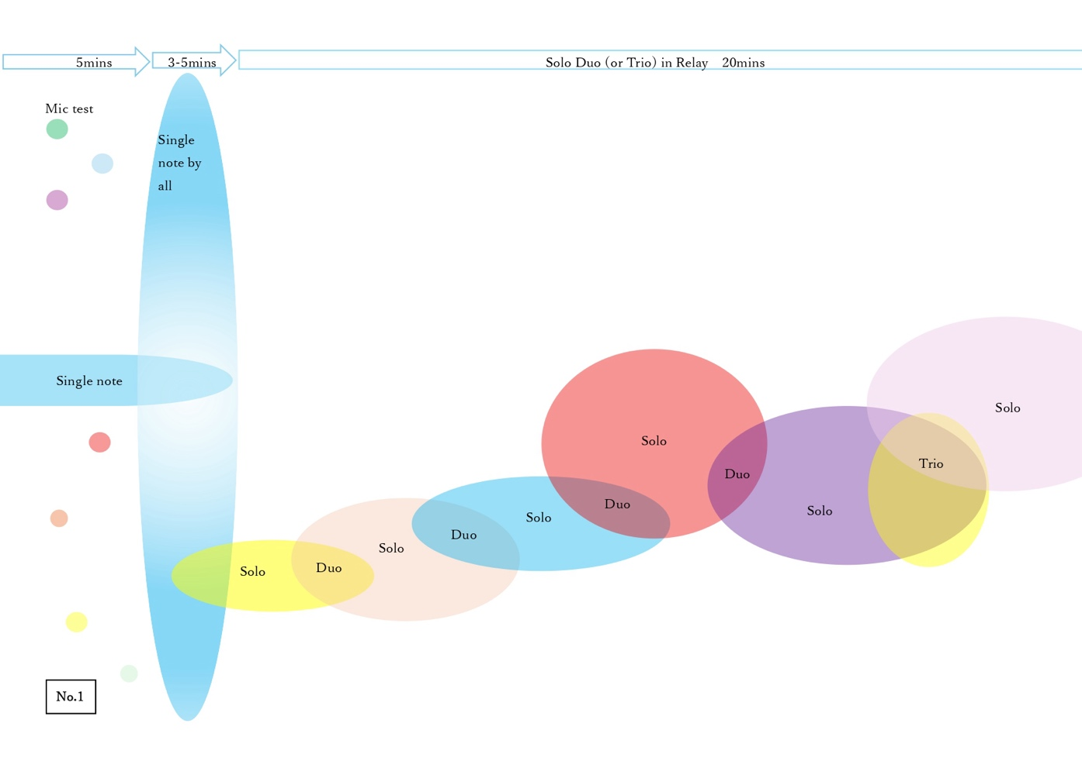
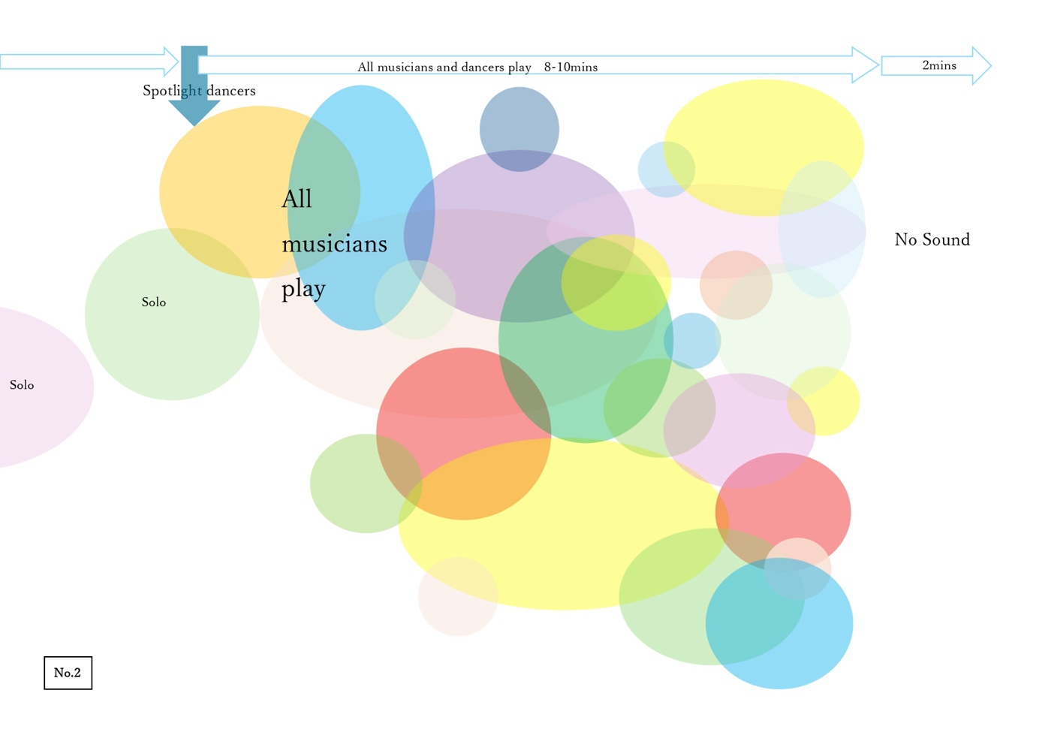

“光の音 音の光 The sound of the light, the light of the sound, Wave-particle” Minori Seki

1pm Glasgow Time / 10pm Japan Time
On ZOOM
Saturday 15th November 2025
We can feel only eyesight and hearing in our five senses on Zoom session through internet. We can’t feel sense of smell, sense of taste, and sense of touch yet. And sense of spatial recognition, too, the computer display is still two dimensions.
Naturally saying,
All sense of vision is feeling light.
All sense of hearing is feeling sound.
Sometimes when we watch, we can feel the sound.Sometimes when we hear, we can feel the vision.
Even if it's not so much that it's called symnesthesia, we naturally do this. I wonder it is based on our each experience since birth.
Sensations can be mixed together.

In the zoom session, musicians can mixed their sounds together.But visuals are separated, it is displayed on divided windows. This time I will try to mix visuals by using projecter.This is only technical aspect.I believe, I always feel that sounds and visuals can be mixed in GIO global sessions! We can feel each other over the long distance.

Please join this session to feel “ 光の音 音の光”.

First try, second try, third try are separated session, each session spend for about 5 minutes.
I hope second try could be made well, and be used for GIO fest Film Screening.

If we run a session from 1pm-3pm, shall we do a quick catch up and sound check for 10 minutes, a free piece for 20 and then ideally a piece composed to last anywhere from 5-15 minutes (maximum 20?)

We can record a couple of takes of it if you like and can decide which you like best , or use the rest of the session for more free/spontaneous ideas 🙂

Topic: GIO Global ZOOM for Minori Seki 光の音 音の光 The sound of the light… for GIOFest XVII
Time: Nov 15, 2025 01:00 PM London
Join Zoom Meeting
https://gsa-ac-uk.zoom.us/j/97673177900?pwd=ehiCacp9KiI0kZ7irBJM38bcJx61fN.1

Meeting ID: 976 7317 7900
Passcode: 362287

“Distributed Conduction” Rob Burke, Clare Hall, Michael Kellitt, Paul Williamson

9am Glasgow Time / 8pm Melbourne time
On ZOOM
Monday 17th November 2025 (TBC)
“I would love to do another session for GIOfest. A definite from me! - So it is a yes from me

I am meeting with the others later this week to see if they are interested in doing a collaboartive project..”

(more info coming soon)

This research is grounded in the field of free improvisation in music, informed by creative-practice research and performance studies. It responds to Butch Morris’s method of Conduction, a system of gestural communication through which a single conductor directs improvising musicians in real time. While Morris’s approach enabled structured spontaneity, it also reinforced hierarchical leadership similar to the composer–conductor model. Distributed Conduction reimagines this practice by sharing leadership and decision-making among multiple conductors and performers through gestural systems. Building on theories of distributed creativity and distributed improvisation, it positions conduction as a collaborative, co-creative process grounded in trust, empathy, and reciprocity.
RC: How can shared gestural systems enable collaborative leadership and collective creativity in Distributed Conduction?
Aim: To develop distributed models of leadership through composition and performance that generate emergent musical structures and shared agency in improvisation.
The plenary authority of traditional conduction has come to mirror the hierarchical dynamics of the composer–conductor model, where leadership and creative agency are centralised. In that where conduction was once a mechanism to engender collaboration in improvisation and performative contexts, has now become its own codified form of authority.
This performance is innovative in redefining leadership as a shared, improvisatory act rather than a hierarchical one. It creates new knowledge by demonstrating how multiple conductors can collaboratively shape and negotiate musical direction through gesture and interaction. Distinct from existing approaches, it reveals that conduction itself can be distributed, transforming it into a collective creative process grounded in trust, empathy, and reciprocity. The resulting performances generate textural densities, rhythmic counterpoints, and spontaneous shifts in musical direction, highlighting how collaborative leadership can produce new sonic and social dynamics. This model establishes a fresh framework for improvisational co-creation and distributed artistic agency.

“Mood Rings” - Instant Places (Ian Birse and Laura Kavanaugh)

5:30pm Glasgow Time
On ZOOM
Tuesday 18th November 2025
“Laura and I would love to make a graphic score composition for GIOGlobal.
We have begun working on an animated score with the working title Mood Rings. The composition is for an improvising ensemble divided into sections by instrument type. Each section pays attention to a specific area of the animation and lets colour changes in that area serve as cues for a range of musical gestures.
May we suggest recording on Tuesday November 18 at your regular GIOGlobal time? Please let us know if that would give you enough time to do the editing :)

Mood Rings
Instant Places 2025
Ensemble members organize themselves into three sections.
Section 1: keyboards/percussion/objects/miscellaneous
Section 2: voice/wind instruments/acoustic strings
Section 3: electronics/theremin/electric guitar.
The animated score has three shapes that vary between changing colours and still images.
The players in each section focus on one of the shapes.
Shape 1 (left)
Keyboards/percussion/acoustic strings
Shape 2 (centre)
Voice/wind instruments/objects/miscellaneous
Shape 3 (right)
Electronics/theremin/electric guitar
When the colours in their shape are changing: the section begins a motif and develops it.
When the colours in their shape freeze to a still image: the section is tacit.
Section members let colours in their shape evoke improvising moods:
Red: Hot wind
Blue: Cool rain
Yellow/orange: Sunny cafe
Purple: Full moon
----------
Looking forward to Tuesday!
I + L

GIOGLOBAL FILM SCREENING RECORDING 2025
DATES AND TIMES
Performer Name | Minori Seki - IMPRO PICNIC  9am Glasgow Time / 6pm Japan Time  On ZOOM  Monday 3rd November 2025 | Rob Burke and co.  …? Glasgow Time / …? Melbourne time  On ZOOM  Time and Date TBC? …? November 2025 (TBC) | Minori Seki - thinking of another theme TBC  1pm Glasgow Time / 10pm Japan Time  On ZOOM  Saturday 15th November 2025 | Instant Places, Ian Birse and Laura Kavanaugh  5:30pm Glasgow Time  On ZOOM  Tuesday 18th November 2025 | GIOFest Film Screening at CCA Cinema  6pm-7pm Glasgow Time  (text chat available on ZOOM room, and playlist published for online watching)  Thu 20th November 2025
Jessica | Yes | Yes | Yes | Yes | Yes
Constance Cooper
Rob Burke
Stefan
Clare Hall
Maria Sappho
Paul Williamson
Chris Parfitt
Michael Kellett
Guillermo Torres
Mike Harper
Vinny Golia
Baan
Douglas

