HYBRID PIECE GIOFEST XVII, 20th November 2025
“When is a Mirror not a Mirror” Jessica Argo

Theme | Time | Who is playing | Lighting/Stage Direction
“Tele-presence / tele-distance”  an image of a digital body on ZOOM is transmitting gestures that  activate sounds of the physical bodies in the ROOM  (Emphasising the elevation of the projection screen ZOOM orchestra as above the ROOM orchestra - spectre)  Does this digital body who was just seen (previously unvoiced) feel more real/present/material when they can sound?  All free, together.  FUSION of digital bodies, and physical bodies  /  Do those physical bodies who were just heard (previously in darkness) feel more centred when they are lit?  /  Do those physical bodies who were just heard (previously in darkness) feel less like an accompaniment when they are lit?  Do these digital bodies feel more spatiallysimultaneous with the physical bodies when they appear together? | 7:30pm-7:33pm  7:33pm-7:36pm  7:36pm-7:41pm  7:41-7:45pm  7:45-7:50pm  7:50pm | One ZOOM player has a camera on, is full screen (mic off)  ZOOM player moves/dances/gestures to “conduct” the ROOM orchestra  (anyone/all ROOM orchestra plays, but if conduction is markedly spatial (a digital body pointing at a specific player, respond to that)  One ZOOM player has a camera on, is full screen (mic ON, can voice/play)  ZOOM player moves/dances/gestures to “conduct” the ROOM orchestra  Two ZOOM players have cameras on (mics ON, can voice)  They gesture to “conduct” the ROOM orchestra – each side of ROOM orchestra plays to the digital body conduction on their side of the ROOM.  Two ZOOM players have cameras on (mics ON, can voice)  Other ZOOM players turn their cameras on (and mics ON, can voice) ONE BY ONE over four minutes  ZOOM player appears…  ZOOM player appears…  ZOOM player appears…  ALL ZOOM orchestra and ALL ROOM orchestra  FULL VOLUME for first minute  Then total freedom of dynamic range/interplay – listen and respond until END  END | Most ZOOM orchestra cameras off, (ALL microphones off)  ROOM orchestra in darkness  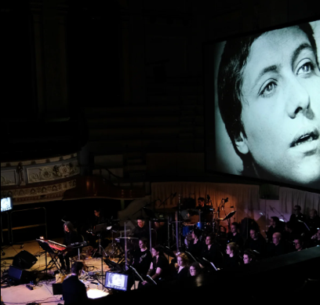  Most ZOOM orchestra cameras off, (most microphones off)  ROOM orchestra in darkness  Most ZOOM orchestra cameras off, (most microphones off)  ROOM orchestra in darkness  More ZOOM orchestra cameras emerge as on, (ALL microphones on)  ROOM orchestra remains in darkness  ---- OR imperceptibly slow lighting crescendo(?)  All ZOOM orchestra cameras on, (ALL microphones on  ROOM orchestra in full brightness (SUDDEN)
“When is a Mirror not a Mirror”
Influential concepts

“They say when the copper pheasant cries for its mate it can be consoled if one puts a mirror before it…” Constance Cooper, GIOGlobal Session 2024, referencing The Pillow Book, written by Sei Shōnagon in the year 1002! https://dn720003.ca.archive.org/0/items/the-pillow-book/The%20Pillow%20Book.pdf


The ghosts of Silent Cinema… were breathed into life, or voiced by orchestras… (see Carl Dreyer’s The Passion of Jean d’Arc (1927) / Dario Argento’s Suspiria (1977) and Goblin
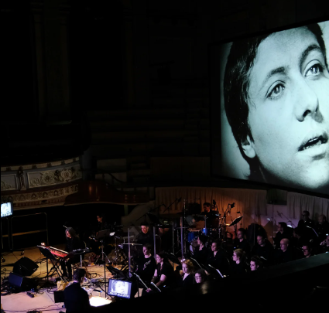 / 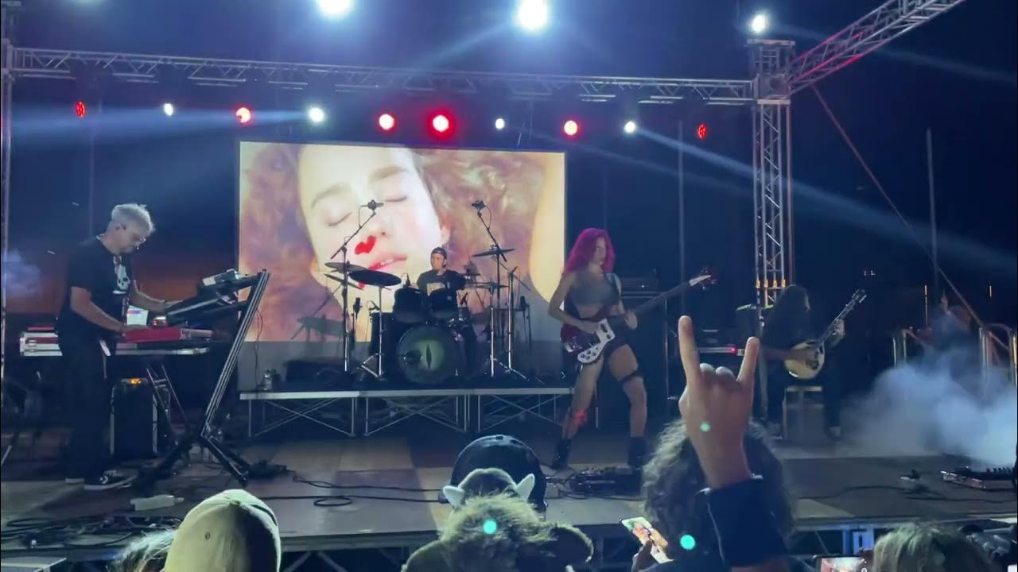

Vivian Sobchack – the Audience is/has a Body (eyes and ears perceiving), the Film is a Body (the director’s eyes and ears perceiving) https://link.springer.com/chapter/10.1057/9780230294851_12
Vivian Sobchack’s theories about Fleshing Out the Image: Phenomenology, Pedagogy and Derek Jarman’s Blue (1993)…
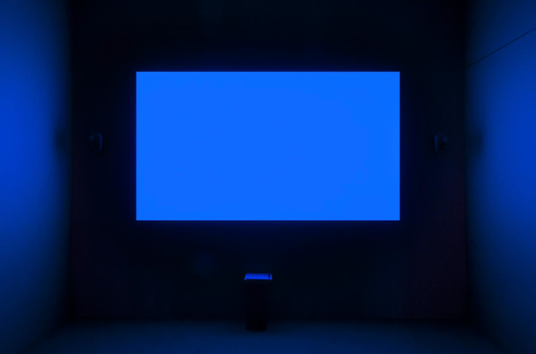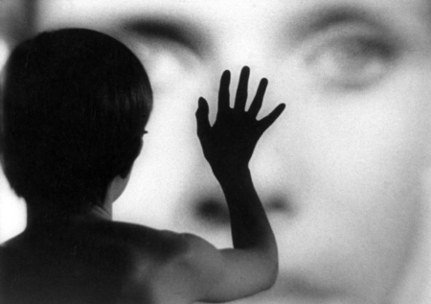
… makes me think of cinema spectatorship/audience identification with stars as the image of the boy in the prelude to Ingmar Bergman’s Persona (1966), reaching out touching the face on the cinema screen – the audience has a Body… the film is a Body.
According to Laura Marks, the Audience is a Body, the Film is a Body, the Screen is the SKIN of the Film Body…
In 2024 Hybrid Piece, we needed the ROOM orchestra to see the ZOOM orchestra – so we had a big TV facing the orchestra. Documentation shows that even players right at the projection screen often peered up above them, implying that the ZOOM orchestra had this looming, almost corporeal pronounced presence from the cinema screen. I want to emphasise and enlarge that difference by having zoom players SOLO on screen, taking up the whole screen (for the first sections).

In Steven Wurltzer’s chapter in Sound Theory and Sound Practice (Altman, 1992) “She sang live, but the microphone was turned off: The Live, the Recorded and the Subject of Representation” he recounts how the unsettling it was when the illusion of “liveness” in Whitney Houston’s Superbowl halftime show was faltered – it ruptured binary notions of “live” or “lipsync”
He established a grid of:
the Temporal Simultaneity versus Temporal Anteriority (LIVE/PRE-RECORDED)
Spatial co-presence versus Spatial Absence (SHARED SPACE/SPLIT SPACE)
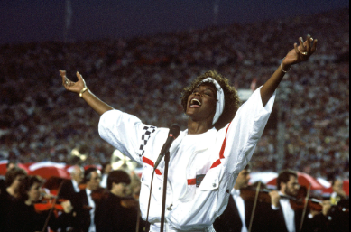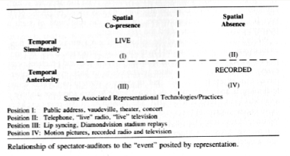

Further quotes from Maria Sappho:

“… Chuckling to myself as I just went on a very unrefined rant yesterday in the middle of my talk in a conversation around mirrors, and the colonial western frame of technology as a mirror…truly unhinged really. I share these quotes which I ended up deciding to not even to try to force on the audience, but very much hoping I come to a better and less windy thought on all this…
“Woman is absent from this order because she is not the mirror, she is what lies beyond reflection.” (Songe-Møller 2002, 18)

“Like Narcissus at the water’s edge, we are transfixed by the reflection of our own cognitive powers in silicon. But this is not a living reflection, it does not see us back.” (Vallor 2024, xii)

“There is no more double; one is always already in the other world, an other world which is not another, without mirrors or projection or utopias as means for reflection.” (Baudrillard 1991, 23)

“The Internet, an electrifying black mirror, was not built for our bodies; yet we create fugitivity in our deployment of digital material.” (Russell 2020, 12)

“A ‘strange loop’ is a paradoxical level-crossing feedback loop: the self perceiving itself, like Narcissus gazing into his pool.” (Hofstadter 2007, xxv)

“To train an algorithm on human behavior is to hold a mirror to our collective past, and sometimes to see a monster staring back.” (Christian 2020, 11)

HYBRID PIECE GIOFEST 2025
DATES AND TIMES
GIOFest Hybrid Event Technical Test ZOOM/CCA  12pm Glasgow Time On ZOOM  Fri 14th November 2025 | GIOFest Hybrid Set Up at CCA Glasgow Theatre  4pm-5pm Glasgow Time (test time TBC, for 10-30 mins)  On ZOOM  Thu 20th November 2025 | GIOFest Film Screening at CCA Cinema  6pm-7pm Glasgow Time  (text chat available on ZOOM room, and playlist published for online watching)  Thu 20th November 2025 | GIOFest Hybrid Concert at CCA Glasgow Theatre  7:30-7:50pm Glasgow Time  On ZOOM  Thu 20th November 2025
AmericanBeauty

In the text score and the photomontage film documentation for "When is a Mirror not a Mirror?", the Glasgow Improvisers Orchestra Global GIOFestXVII Hybrid Piece for a ROOM orchestra and a ZOOM orchestra https://youtu.be/3y-pPHwpQkc?si=JqKU1nfRAl4f-Hqc , a dramatic attention is drawn to the uncanny distancing of digital bodies versus physical bodies (both the people and their sounds). The work opened with the theatre and room orchestra in pitch black darkness, with a bold dancerly performance from the hands of a ZOOM performer, as if he was a silent cinema star. These ZOOM hands conjured the sounds of the ROOM orchestra, while his own voice was muted:

"One ZOOM player has a camera on, is full screen (mic off)

ZOOM player moves/dances/gestures to “conduct” the ROOM orchestra

(anyone/all ROOM orchestra plays, but if conduction is markedly spatial (a digital body pointing at a specific player, respond to that)"

Eventually his voice emerged too, in syncrony with his mouth movements - I ask the audience "Does this digital body who was just seen (previously unvoiced) feel more real/present/material when they can sound?"

In the GIOFest XVI 2024 Hybrid Piece, we needed the ROOM orchestra to see the ZOOM orchestra – so we had a large television monitor facing the orchestra. Documentation shows that even the players players placed right underneath the projection screen often peered up above them, implying that the ZOOM orchestra had this looming, almost corporeal pronounced presence from the cinema screen. For When is a Mirror not a Mirror? I wanted to emphasise and enlarge that difference by having zoom players SOLO on screen, taking up the whole screen (for the first sections).

Themes and questions asked in the performances include:

“Tele-presence / tele-distance”
an image of a digital body on ZOOM is transmitting gestures that activate sounds of the physical bodies in the ROOM

(Emphasising the elevation of the projection screen ZOOM orchestra as above the ROOM orchestra - like a spectre)

All free, together.
FUSION of digital bodies, and physical bodies
/
Do those physical bodies who were just heard (previously in darkness) feel more centred when they are lit?
/
Do those physical bodies who were just heard (previously in darkness) feel less like an accompaniment when they are lit?
/
Do these digital bodies feel more spatially simultaneous with the physical bodies when they appear together?

Influential concepts stemmed from film sound theory and from telematic performers' research into myths and archetypal role models:

“They say when the copper pheasant cries for its mate it can be consoled if one puts a mirror before it…” Constance Cooper, actor/composer/musician in GIOGlobal Session 2024, referencing The Pillow Book, written by Sei Shōnagon in the year 1002. https://dn720003.ca.archive.org/0/items/the-pillow-book/The%20Pillow%20Book.pdf

The ghosts of Silent Cinema were breathed into life, or voiced by orchestras… (see Carl Dreyer’s The Passion of Jean d’Arc (1927) / Dario Argento’s Suspiria (1977) scored by progressive rock band, Goblin)

Vivian Sobchack – the Audience is/has a Body (eyes and ears perceiving), the Film is a Body (the director’s eyes and ears perceiving) https://link.springer.com/chapter/10.1057/9780230294851_12
Vivian Sobchack’s theories about Fleshing Out the Image: Phenomenology, Pedagogy and Derek Jarman’s Blue (1993) makes me think of cinema spectatorship/audience identification with stars - as the image of the boy in the prelude to Ingmar Bergman’s Persona (1966), reaches out touching the face on the cinema screen – the audience has a Body… the film is a Body.

According to Laura Marks, the Audience is a Body, the Film is a Body, the Screen is the SKIN of the Film Body…

In Steven Wurltzer’s chapter in Sound Theory and Sound Practice (Altman, 1992) “She sang live, but the microphone was turned off: The Live, the Recorded and the Subject of Representation” he recounts how unsettling it was when the illusion of “liveness” in Whitney Houston’s Superbowl halftime show faltered – it ruptured binary notions of “live” or “lipsync”. Wurltzer established a grid of:
the Temporal Simultaneity versus Temporal Anteriority (LIVE/PRE-RECORDED)
Spatial co-presence versus Spatial Absence (SHARED SPACE/SPLIT SPACE).

