Folding Space / Folding Time
programme notes
Jessica Argo
with Glasgow Improvisers Orchestra and Australian Art Orchestra

Conceived in Tarraleah (on Palawa Country) in Tasmania, Australia September 14th-24th 2022
Performed in Centre for Contemporary Arts Glasgow, November 30th 2022.

Folding Space / Folding Time is a piece commissioned for GIOFest XV that encourages the orchestra and our guests to explore memory, community and stories through time and space.

Thanks to Creative Scotland, Glasgow Improvisers Orchestra and Australian Art Orchestra, I was honoured to join the Tarraleah Creative Music Intensive Tarraleah (on Palawa Country) - travelling to the other side of the world to play with 30 musicians, 650m above sea level in the Tasmanian Highlands, for 10 days.

It was the first time I had seen a truly dark, moonless sky - the milky way became visible as my eyes adjusted, and I saw shooting stars seem to break the laws of spacetime as they dropped through the atmosphere to the horizon in an instant.

Poles apart, I discovered a housemate who was my twin - the same age, same instrument - in the past, we had even made the same graphic scores with optical prisms, to refract light into a colour spectrum.

We shared a chopping board as we shared stories, cooking together in our kitchen.

At AAO CMI, we learned:
- how to extend the voice as Bae Il Dong, a Korean Pansori singer explained how we could find analogues of the breath in astronomy;
- Chris Hale taught us to clap without moving our hands, as he progressively taught iterations of Korean Ho-Hup gestures;
- Daniel and David Wilfred, from Ngukurr, in Arnhem Land in the Northern Territories, generously wrote us into their song cycle - we heard Daniel sing in his voice, his father's voice and his son's voice, a song that passes on intimate knowledge of his country; while David directed us to move with his didgeridoo.
- Aviva Endean led us on a sound walk through dense forests and a huge valley drop; where the lyre bird and Peter Knight's trumpet fused and diffracted through dense mist.

10 days sharing a physical musical space (and home) with a community who are usually asleep as I wake, with no screens, no internet, no other people.

This followed 2 years of playing with our global community through ZOOM every week, where our digital selves congregated in a simulated musical space - a telematic music making across timezones.

10 days of learning how to play music with the whole body; not just my hands.

10 days of learning to play music using memory and story; not just spontaneous impulse in the present.

This followed 2 years of playing the theremin, where the body conjures unfamiliar synthesised timbres without touch.

The work features archival recordings, graphic scores, video samples, and conduction gestures learned from theremin, telematic music making, and cross-cultural exchange.
Folding Space / Folding Time Score (orchestra instructions bold+underline)

Memory (starts 0:23)
(text + one photo + one video)
(orchestra plays hazy texture of fragments (quietly), play for 3 seconds, stop for 3 seconds, on, off, on, off)

Archival recordings (starts 1:32)
(text + sound montage only)

Stars (starts 2:33)
(animation + sound recording only)

At the other end of the world (starts 3:34)
(text + sound recording only)

At the other end of the world (awake / asleep) (starts 3:58)
(lighting one side of orchestra fading in gradually, plunging the other side in darkness)
(Orchestra in the light begins to play simulating being awake as light grows stronger – moderately loud, consciously formed PHRases then waiting for responses from others like conversation)
(Orchestra in darkness play simulating being asleep – quiet, cloudlike PHAses. minimal movement, very small intervals (e.g. G to A, Fsharp to G), sounds simulating deep breaths, suggest to close your eyes.)

Twins, (starts 7:27)
(text only)

Conduction Gestures (starts 7:42)
(text + theremin movements transmitted (visually) to Jessica by a performer at the other end of the stage)
(then theremin shared by two performers Jessica + ………….. )
(then spotlighting two performers from different sides of the orchestra, to prompt a duet)

Chasing Sunrise (starts 10:24)
(text + slow colour fade animations)
Orchestra play imperceptibly transforming gestures (slow).

Height (starts 12:40)
(text + shepherd tone creation)
Orchestra play a rising pitch (a crescendo then diminuendo, fading in then out)
then Orchestra play a lowering pitch (a crescendo then diminuendo, fading in then out)

Overwhelm (starts 13:04)
(text then video)
(only during text orchestra plays fragmented bursts of sound, loud (each gesture shorter than 2 seconds, stop)

Ice, air and fog (15:08)
(text + sound recordings)

Animals (17:11)
(text + sound recording)
(after each player finds another player to mimic like Peter and the lyre bird, up to three times)

Family (19:26 – 22:46 END)
(text, then video, then photos)
(orchestra plays free, incorporating motifs from piece – crescendo then sudden stop when forest video stops)
(suggested notes G , F# , E then D (feel free to ignore!)
Folding Space / Folding Time text and image guide for orchestra

Memory
(text + one photo + one video)
What is the most vivid form of archive?
A Photo?
A Video ?
A sound recording (temporal, long form, interactions, breaths, visceral, haptic, forgotten)
Does taking a photo erase our embodied memory as we know we have stored it else where? We only remember a moment as that image?
How do I share things that are impossible to record (stars,

Archival recordings
(text +sound montage)
sound walk: pylon buzzing, Il Dong singing into valley, Chloe Drumming in church, Peter Trumpet in forest
Eagle Walk (creaking trees and crispy shedded bark
Forest Walk with voice then mosquitos buzzing
Waterfall Walk with Lyre Bird
Waterfall Walk with Il Dong singing
Waterfall Walk with Daniel Singing and David Dancing
Waterfall lookout with sticks
Forest Calls
night time crickets/frogs
squeaky doors in the lilac house

Stars
It was the first time I had seen a truly dark, moonless sky - the milky way became visible as my eyes adjusted, and I saw shooting stars seem to break the laws of spacetime as they dropped through the atmosphere to the horizon in an instant.
(animations, black with gradual appearance of stars filling the screen, gradual multi-layered mist of pink, orange and green (milky way), smoke ceremony)

At the other end of the world
(text only)
My family were asleep when I was awake, no signal, out of reach of comms – like I had stepped off the earth
I made family who I then left behind
I was there, I was thinking of here
Now I am here, thinking of there.
(photo of GIO framed in our hallway)

At the other end of the world (awake / asleep)
(lighting one side of orchestra, plunging the other side in darkness)
(Orchestra in the light plays simulating being awake – moderately loud, consciously formed phrases then waiting for responses from others like conversation)
(Orchestra in darkness play simulating being asleep – quiet, cloudlike phases. minimal movement, very small intervals (e.g. G to A, Fsharp to G), sounds simulating deep breaths, suggest to close your eyes.)
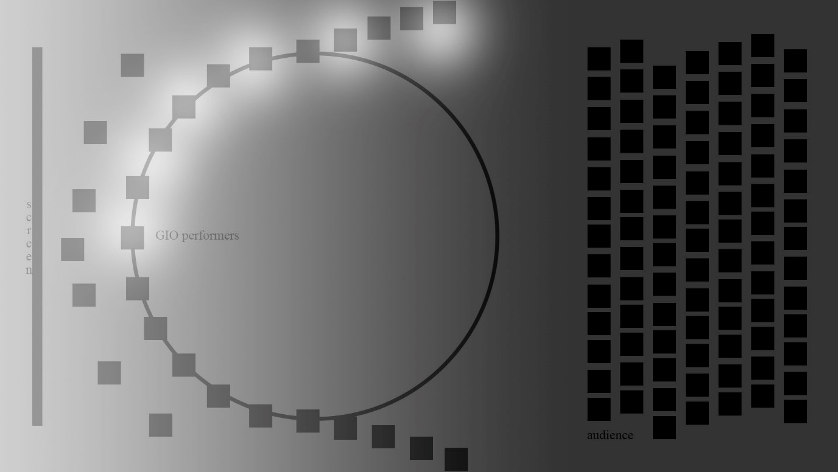

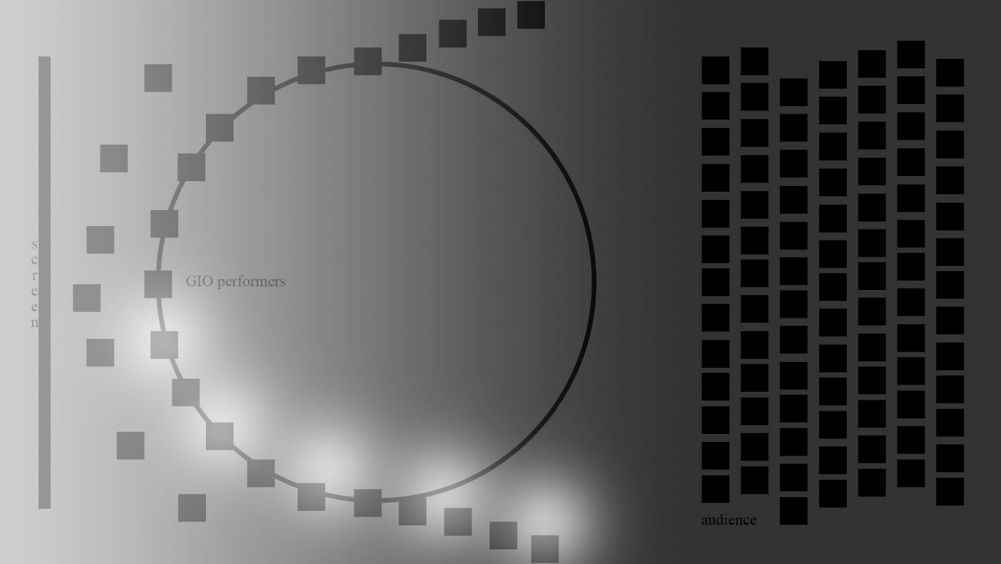
Twins,
(text only)
doppelgangers,
parallel lives, poles apart
our synthesisers blending through the loudspeaker

Conduction Gestures
(text + theremin movements transmitted (visually) to Jessica by a performer at the other end of the stage)
(theremin shared by two performers Jessica + ………….. )

conduction gestures learned from theremin:
sharing the theremin like sharing the chopping board
sharing the theremin with David when he hand danced
sharing the theremin with Raymond as he transmits a gesture across the room he lifts his arm and I copy (transmission)

butterfly’s wings
hold and release

conduction gestures telematic music making:
Raymond’s hand

conduction gestures learned from cross-cultural exchange:
opposing directions – the voice pulling and pushing (a tree takes sunlight down, but also lifts water up with its roots)

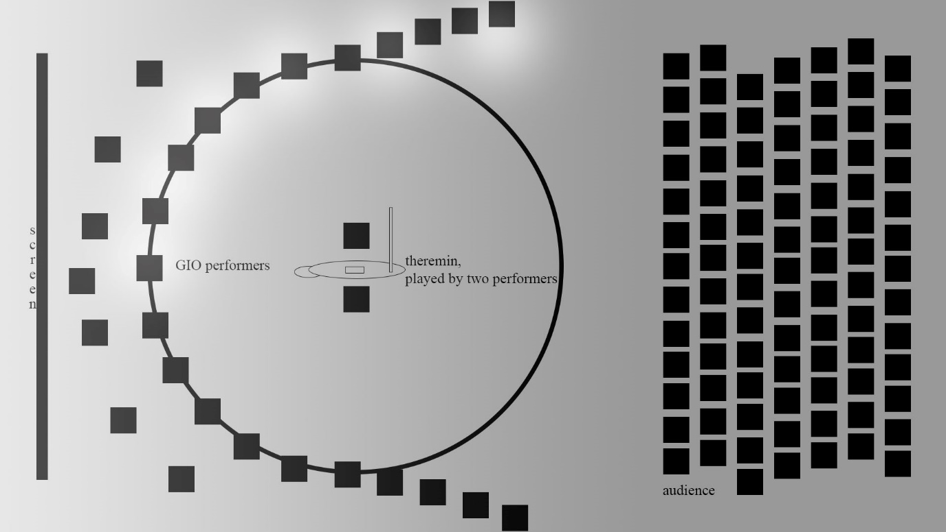

Twins,
(then spotlighting two performers from different sides of the orchestra, to prompt a duet)
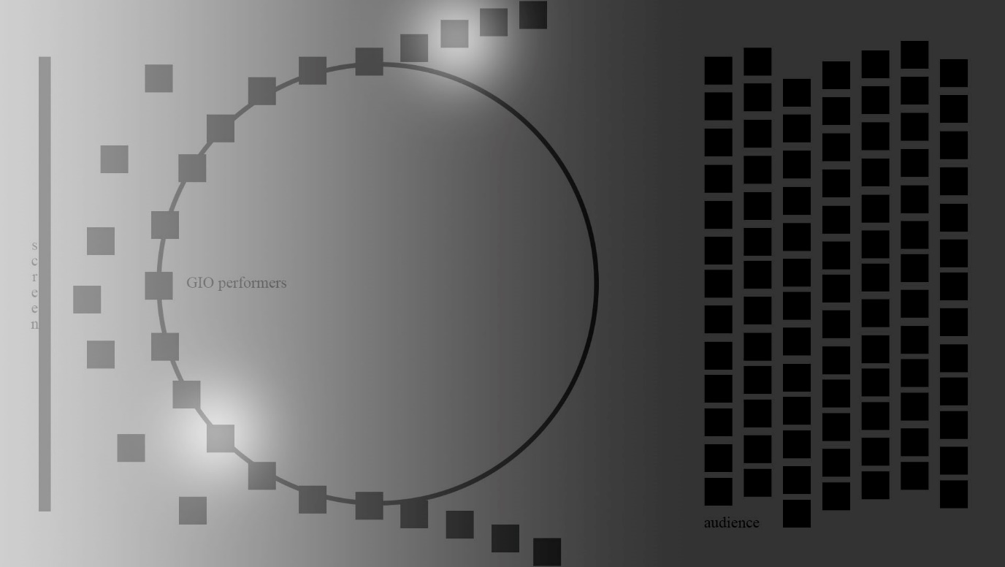

Chasing Sunrise
(slow animations)
Blue-black – orange-black
blue ash
lilac
white yellow
red
blue
lilac pink mauve
yellow

Height
Rising
Falling
(shared by shepherd tone)

Overwhelm
Pages of lists
Worry about plane
Worry about luggage
Worry about covid
Worry about theremin voltage
Replaced by overwhelming love
Euphoric noise blasts in ensembles drawn from the same point in space
Bursting into laughter
Building our world

Rhythm / Strong / Voice

Ice, air and fog
(just text)
We were cold in our bones, but gathered round the fires
Soundwalking in the fog, changed our mode of listening – we were less distracted by the visual drama as we could only see a bubble around us
Sound was blocked, refracted and dampened by the fog
The fog was like a ghost coming to haunt us.
650 m above sea level in the Tasmanian Highlands.
-13 degrees C on 30 June 1983 at Tarraleah Village.
The ghost of wartime expats

Animals
(text only)
The lyre bird appears in the open forest but sounds like it is in a cave
It makes the sound of a chorus
Peter played quietly - which made it stop
Was it learning our song?
Or did we scare it off
In improvising it can be frowned upon to mimic another
But the lyre bird is a master impersonator
Did you know it can make the sound of a camera shutter?
Or a chainsaw?
Is it making these sounds to impress? Or to judge

We had a wallaby who lived on our lawn
We saw it reach down and bite the grass
Then noticed it’s baby lowered in the pouch
To bite the grass too
Eating in step
When the mother noticed us she sprung away
Cartoon-like
But she always returned

The guidebook offered night goggles to find Tasmanian devils who could be seen in the forest at night
I wondered how many visitors were brave enough to go there
Although I was scared of the dark
It was not the same fear of city dark.
Even though this dark was darker
I think its because the city dark casts shadows, and carries the sounds of strangers.
Family
(text only)
a song cycle that includes the voice of the father, the self and the son.
Song cycle to pass on how to be with their country
Song cycle to pass on how to be with eachother
Song cycle to pass on how to live
Song cycle to pass on how to be
Song cycle to pass on who to be

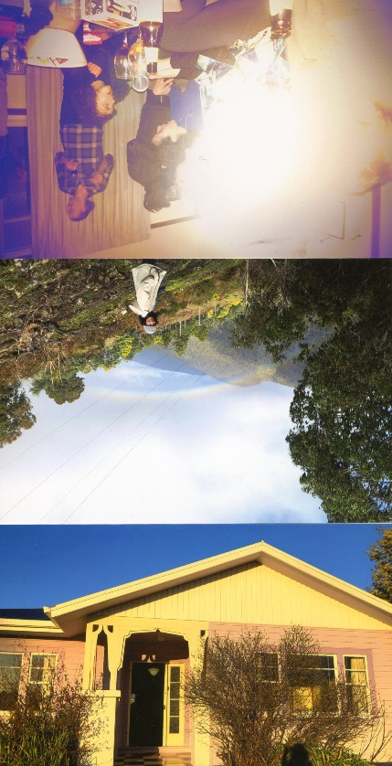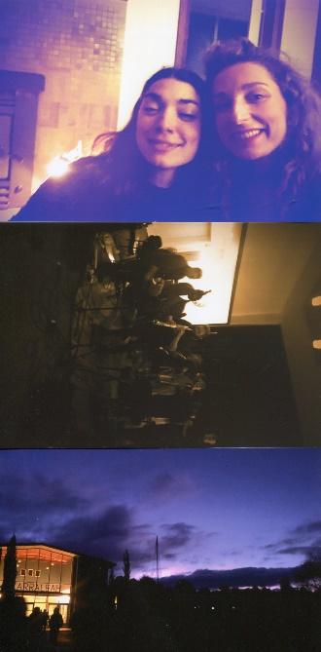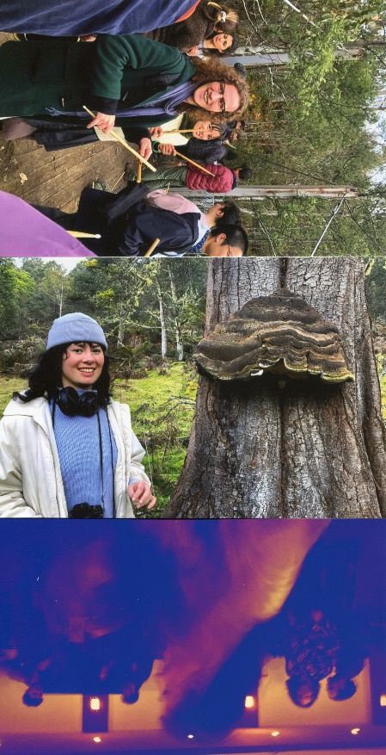

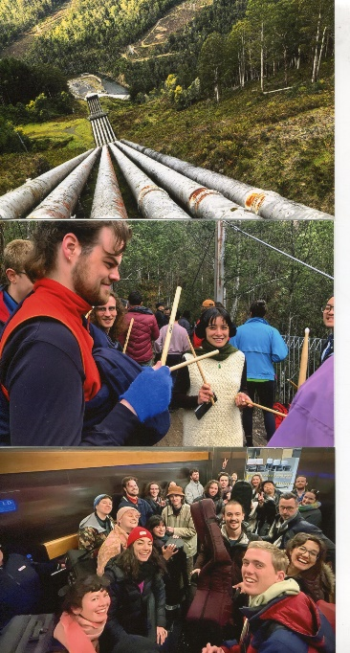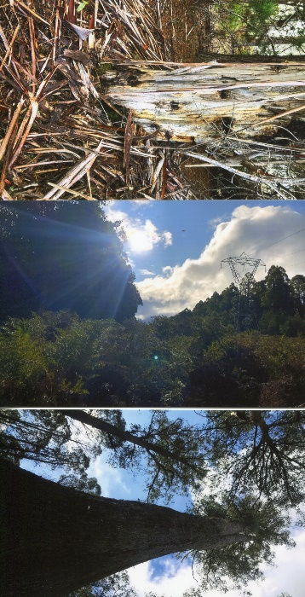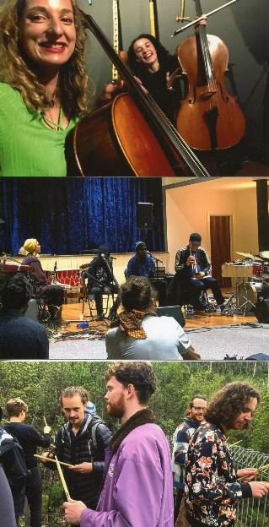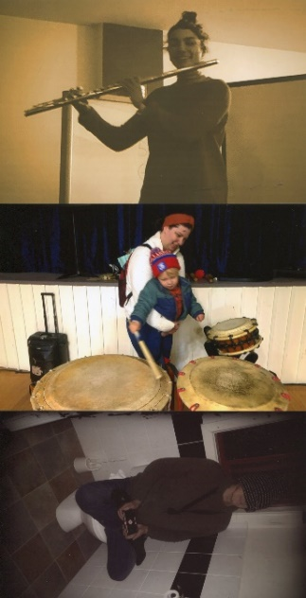

Concepts / motifs / sensations to have in mind

Home,
neighbours,
community

Circles,
cycles (Ho-Hup)

Cello/Theremin
Acoustic, immediate, grip
Ether, air, electric
Tension and Release/

Resonant frequencies
“the spa” + the lookout + and resonant frequencies of other players
Finding the note that would break the glass

photographs
party (split second rapid Montage)
forest (slow fade from black to white)
family, home, community (details of panelling)

video samples (with sound):
films from forest:
colours (orange, lime green, close up of moss on stump with distant mountain)
textures (furry spongy bark – soft, hairy )
spooky hut (creaky wood and damp spots)
pipes (metallic clink, rushing drum sound)
height (looking down the pipes)

burst of party videos
burst of house concerts (+big laugh)

Closing note from Daniel Wilfred
“two streams sometimes run together”

Daniel used this analogy about white people and his community. They have 40,000 years of knowledge – white people cannot just arrive and expect to build a road, or interfere with their country.
When it works it is like two streams, who sometimes run together.

Closing Note from George Burt

The name of the astronaut I was trying to remember was Al Worden. He was the Command Module pilot on Apollo 15. He flew to the moon in 1971, and he still holds the record for the furthest spacewalk from the Earth. I was a boy when all that was hapening, so those guys were all heroes to me. One of the fascinating things over the years has been hearing what happened to them after their great adventure. Worden found he still had images and impressions troubling him even after all the debriefing, and when he started to write them down he found he couldn't stop. I imagine for a military jock and flight engineer he must have thought he was going mad. It must have come as a relief to find he was writing poetry... I've not been able to find a copy of his book, but there are a couple of quotes in Andrew Chaikin's history of Apollo, "A Man on the Moon":

Quietly, like a night bird, floating, soaring, wingless
We glide from shore to shore curving and falling but not quite touching;
Earth: a distant memory seen in an instant of repose...
I glide upward, above the waves of he ocean moon. She is
forever moving just out of reach and I sail on,
never touching, only watching and wanting to know.

And this seems to be a kind of haiku:

A spacewalk
Is like
Being let out
At night
For a swim
By Moby Dick.

This is a bit puzzling until you remember that the spacecraft he was floating beside was the size of a double-decker bus, so the comparison with a fully-grown sperm whale is pretty apt.

The only other astronaut who wrote poetry as far as I know was Michael Collins, CMP on Apollo 11 (like Al Worden he stayed in the spacecraft orbiting the moon, while his colleagues were toddling about on the surface, so he had some time and solitude to reflect on the experience...)

Anyway. I was struck by the similarities between your text and Al Worden's

