Exploring IADLs in a Smart Home Setting UPM, Madrid
Author(s): Sonya Lizbeth Joseph (sonya.joseph@dhi-scotland.com) , UK;Linda Shore (l.shore@gsa.ac.uk), UK; Gloria Cea Sánchez (gcea@lst.tfo.upm.es), Spain
Background and aims
The study centres on Transportation, Communications, Shopping, Food Preparation, Financial Management, House Cleaning, Home Maintenance, and Managing Medications. Recruitment involves UPM, Madrid's participant panel, with the informed consent process clarifying the study's nature. Task-Based Exploration in a smart home setting spans IADL categories through semi-structured interviews. Participants engage in flexible discussions, choosing specific tasks or topics, utilising various technologies and cultural probes. This approach ensures a comprehensive understanding of their experiences, contributing valuable insights to the study.
The involvement of UPM Spain in the research was crucial for gaining insights into the Spanish context, understanding the functioning of the living lab, recruiting participants, and receiving support in facilitating interviews. Their engagement provided essential contextual knowledge and logistical assistance, contributing to the research's comprehensive understanding of smart technology integration in Spain.
Methods
The collaboration facilitated the conducting of 10 paired interviews involving both older adults and the general public, enriching the study's depth and diversity. A rapid training session was conducted. This session covered an overview of the living lab space, research methodologies, and insights into the business model, enhancing the research process's efficiency and depth.
Thematic analysis was used to analyse the data collected and it served as a pivotal research method, guiding the entire trajectory from initial conceptualisation to data analysis in the research study. Anchored in a particular epistemological stance, as emphasised by Braun and Clarke, this method shapes the way data is described and meaning is theorised. By identifying and analysing recurring patterns or themes within the data, thematic analysis allows researchers to derive deeper insights and construct a coherent narrative. This methodological approach fosters a nuanced understanding of the underlying meanings and nuances inherent in the research data, contributing to the robustness and interpretive richness of the study. (Braun and Clarke, 2021).

Results
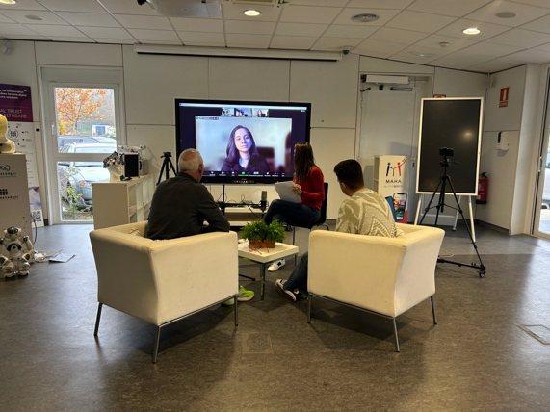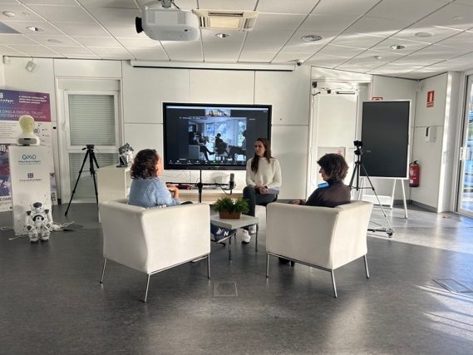
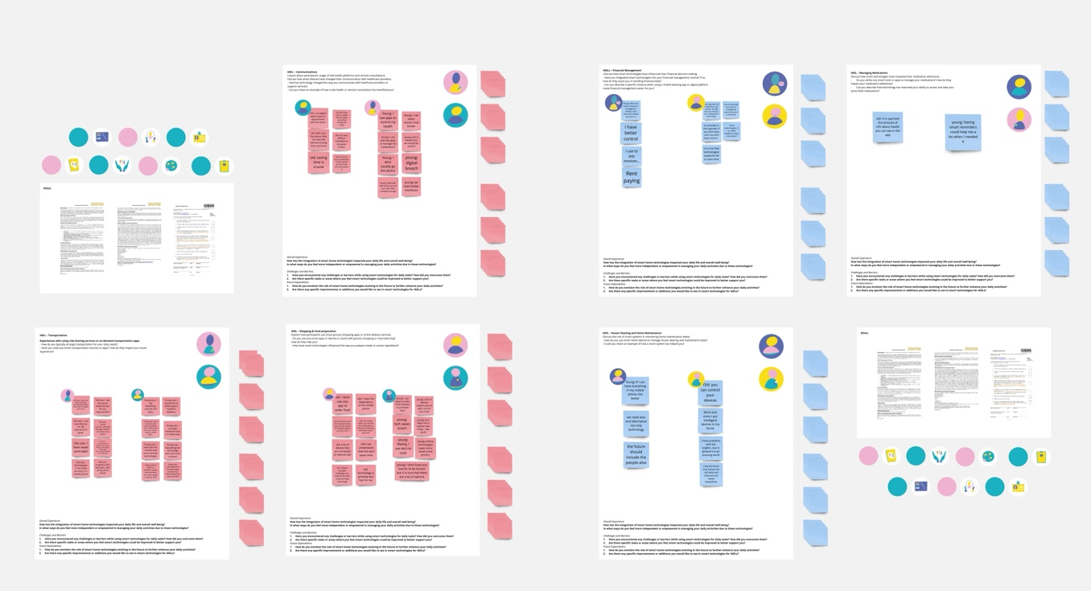
The thematic analysis of the interviews uncovered a pervasive integration of smart technologies into participants' daily lives across various domains, such as transportation, financial management, healthcare, and cooking. This widespread acceptance of technology highlighted its convenience and transformative impact on routine activities. However, amidst this positive sentiment, participants voiced concerns during discussions on transportation and financial management. Challenges included difficulties in online interactions, bureaucratic processes, and a desire for more user-friendly technologies, raising awareness about potential negative social effects, addiction, and privacy issues.
The interviews showcased a spectrum of attitudes toward technology adoption. While some participants enthusiastically embraced smart technologies, anticipating further integration, others maintained a measured approach, expressing reservations about over-reliance and potential vulnerabilities. The acknowledgment of a generational gap in technology use, particularly in the workplace, emerged as a significant barrier.
Technology's profound impact on daily activities and habits was a central theme, with participants highlighting its transformative role in areas like cooking and medication management. The thematic analysis emphasized the importance of striking a balance between the convenience technology offers and the challenges it presents, including concerns about privacy and negative social effects. Lastly, participants expressed curiosity and anticipation for future technological advancements, emphasizing a collective desire for innovations that enhance daily life while remaining accessible and easy to use. In summary, the findings provide a comprehensive understanding of the complex and multifaceted relationship individuals have with technology in their daily lives.

Ethics
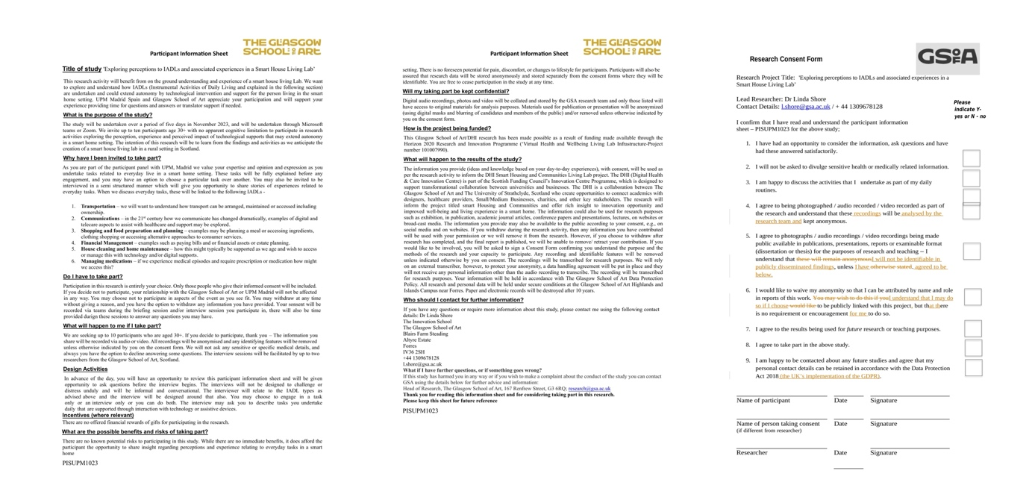

Conclusion

The research successfully illuminated the integration and impact of smart technologies in daily life. However, a notable challenge was the absence of a translator, conducting interviews in Spanish in a project primarily executed in English. Despite this hurdle, the findings offer valuable insights into participants' experiences, attitudes, and expectations regarding technology integration.

References
- Braun, V., & Clarke, V. (2022). Thematic Analysis : A Practical Guide. Sage Publications.
- Shore, L., Power, V., Hartigan, B., Schülein, S., Graf, E., de Eyto, A., & O’Sullivan, L. (2019). Exoscore: A Design Tool to Evaluate Factors Associated With Technology Acceptance of Soft Lower Limb Exosuits by Older Adults. Human Factors: The Journal of the Human Factors and Ergonomics Society, 62(3), 391–410. https://doi.org/10.1177/0018720819868122
- Shore, L., de EYTO, A., Kiernan, L., Nic A BHAIRD, D., Connolly, A., White, P., Fahey, T., & Moane, S. (2017). OLDER ADULT INSIGHTS FOR AGE FRIENDLY ENVIRONMENTS, PRODUCTS AND SERVICE SYSTEMS. DS 88: Proceedings of the 19th International Conference on Engineering and Product Design Education (E&PDE17), Building Community: Design Education for a Sustainable Future, Oslo, Norway, 7 & 8 September 2017, 218–223. https://www.designsociety.org/publication/40316/OLDER+ADULT+INSIGHTS+FOR+AGE+FRIENDLY+ENVIRONMENTS%2C+PRODUCTS+AND+SERVICE+SYSTEMS

‌

