SIGNS OF FRAUDULENCE
By the editor, with thanks to Hugo Marsh at SAS, Pete Gasowski and Christine Sanderson.

Some readers may know that I spend a fair bit of time writing about fraudulent signs for the Railwayana and Advertising Fakes at Auction and on the Internet facebook group. A recent email from Pete Gasowski suggested that I alert TCS members to fraudulent enamel signs which are of interest to toy train collectors. For those who are not familiar with the world of enamel signs (and therefore particularly likely to fall foul of forgeries) a lot of very convincing, usually small, enamel signs have flooded the market in recent years. These are very different from the thin, screen-printed things made for companies like Dodo a generation ago; convincingly deep enamel, probably stencil sprayed, giving serious level differences between each colour, then weathered with chips, scratches and chemically induced rust. Most are for oil and petrol companies, reflecting the very high prices collectors pay in this field, but there are many others that are railway related, including a lot of would-be BR ‘totems’ and door plates, and now someone has thought about the money swilling around in the world of old toy trains. Is it someone we might know? That always intrigues me. However, the names of the larger train makers, such as Bassett-Lowke and Hornby, are far from obscure. So, they are up for grabs by any chancer who wants to exploit them.

The sign in question comes in two variations. The ‘better’ is a deep cobalt. An example passed through SAS recently and was taken to be genuine Fig 1.

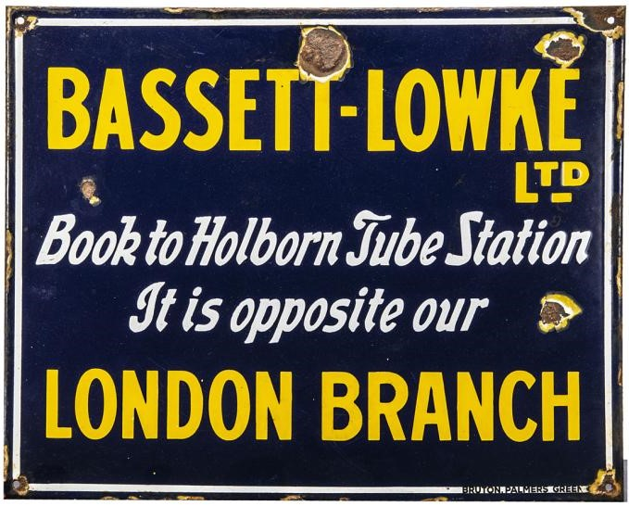
Fig 1. Please note that until I contacted SAS to ask for high resolution images in January 2021, no one at the auction room thought the sign was questionable. I am indebted to SAS for supporting me in writing this, very different from the defensive and obstructive attitude that often greets those researching frauds elsewhere.

When we look at the picture we can see why. The enamel looks as it would on an inter-war sign and the rust is very dark. This is unusual, someone has worked hard to achieve that colour. In Fig 2 we see the more ‘common’ version that appears on eBay from time to time, this one photographed at an outdoor antiques market.

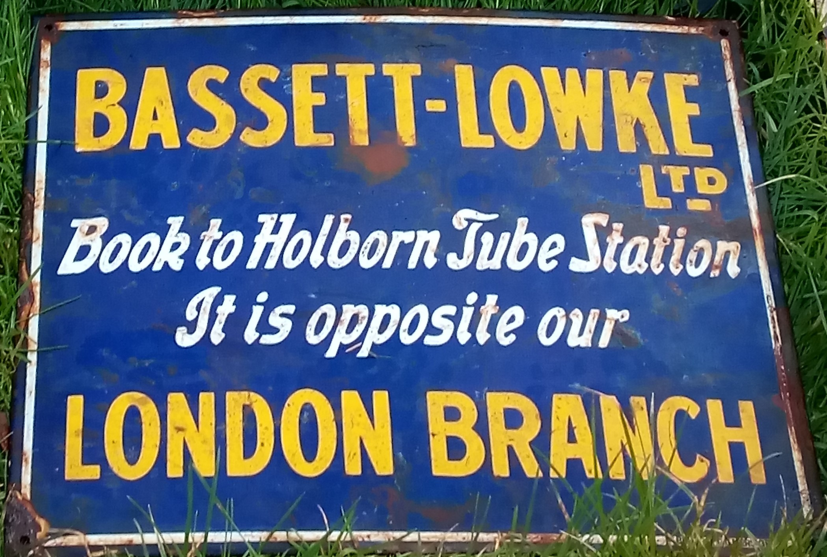
Fig 2 (Pete Gasowski)

It is a lighter blue with less defined edges between colours and the trade name is in a less believable letter-face for its ‘time’ Fig 2a.

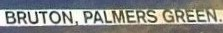
Fig 2a.

However, neither read ‘right’. Bruton were a genuine maker, but by the time the sign is meant to date from, usually used rubber-stamp Fig 2b.

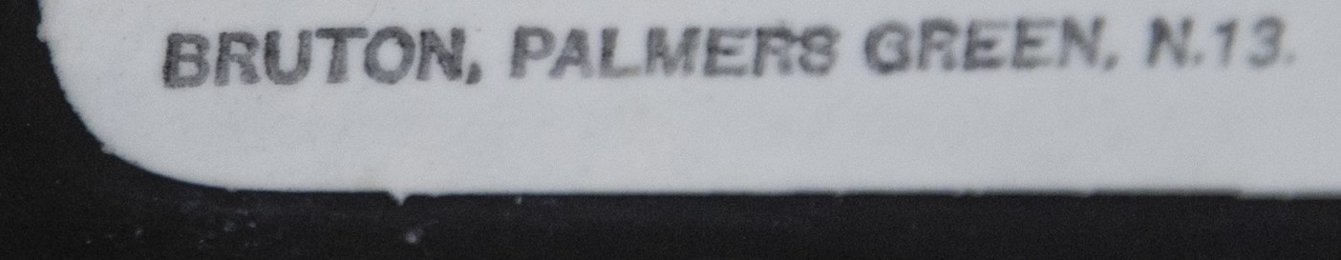
Fig 2b. A genuine Bruton tradename from a 1930s RAC road sign.

Notice the rust, it is very ‘orange’, this is typical of chemically induced rust, as is the way it has spread over the enamel. Fig 1 demonstrates considerably more skill in weathering, the big bruise above the T is particularly daring, but note that it is still ‘aesthetically’ positioned not to interfere with the legend to any great extent, as are the other bits of face damage. Fig 2 is more typical in having edge damage only.

Still, I hear you ask, why is Fig 1 not an original, from which Fig 2 is copied? This was my first line of enquiry. Before we go any further, consider the sign itself. The story is that these signs were strategically sited at London termini such as Euston and King’s Cross and taken down in 1940. They are not big, only 20” x 16”; so, certainly not ‘display’ signs of the equivalence of posters. Where exactly would they be placed? Next to the booking office? The Underground and then the LPTB had strict rules against enamel advertising signs in tube stations after Frank Pick’s design policies took effect during and after the Great War. The siting issue is therefore a problem. Of course, to the suspicious, the size matters too, it fits very nicely in a domestic interior.

Equally questionable is the message. Who were these signs directed at? Someone who knew about Lowke and was travelling to London would already know their address. Someone who did not know about Lowke would be none the wiser from these signs. At the very least they should say ‘See the Models at Bassett-Lowke’ or something of the kind.

The design is very convincing, however, and it is here there is both the trick and the lie. The sign DID exist in the inter-war period, but as a litho-tin miniature nailed to Bassett-Lowke wooden buildings and available in packets to adorn layouts Fig 3.

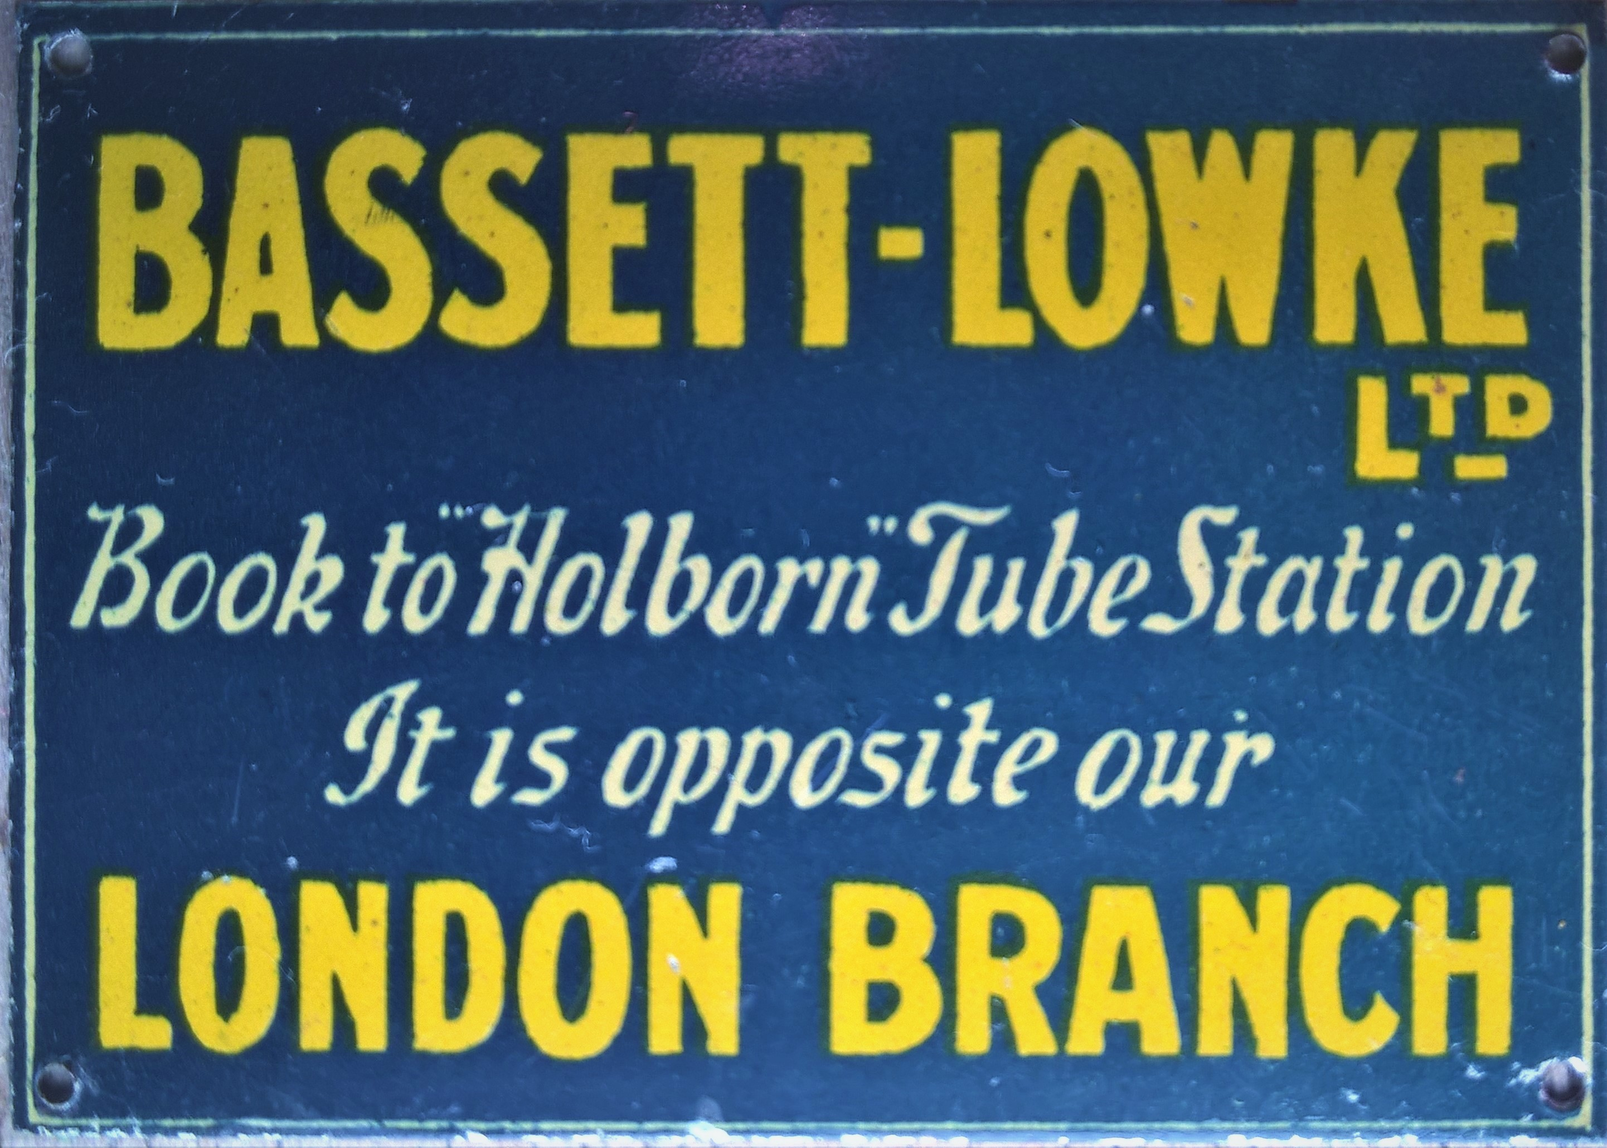
Fig 3 (Author)

In this context it makes perfect sense. It might be noted that it is fairly large, 2⅛” x 1½”, in gauge I it scales to 5’8” x 4’8” and in 0 to 9’0” x 6’0”, very much display sizes. A good number have passed through auctions and eBay (one even in the sale the fraudulent enamel was in); so, this is an easily found prototype of which images are easily had, you would not even need to own one to copy it into full size enamel. Still, the thought to do so suggests to me that whoever commissioned them is ‘one of us’, a toy/model railway enthusiast, not some external chancer.

I had never heard or seen any evidence of a toy/model train manufacturer issuing enamel signs, but I thought I’d check with Christine Sanderson at the Derngate Museum, who has conducted extensive research into Lowke advertising material. As I suspected, she had found no reference to such signage.

Returning to the signs themselves, forget the fronts, look to the backs. Enamel signs are first treated and fired with a ‘swill coat’ that acts as a binder between the enamel and the metal. Until well into the interwar period UK makers used iron sheet, the swill coat for this fires grey to white, fairly inconsistently. Steel sheet displaced iron, the swill coat for this fires a far more uniform blue-black. These signs are blue-black so therefore are ‘late’ masquerading as 1930s. The swill coat often gives the lie to those signs that seem to be 1920s or earlier, but is not so useful here. What is more useful are the support marks. The maker of most of these frauds uses a support system that leaves two clear lines on the back of the sign during firing. These are not found on old enamel signs. These are sometimes left untouched, but on the Bassett Lowke signs they are emphasised by being damaged and rusted to look like the shadow of a post Fig 4.

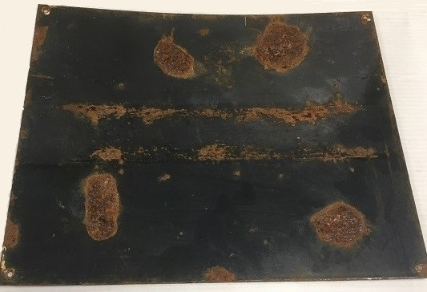
Fig 4: One might question how little trace of the serious bruise on the face of this sign can be seen on its back? (SAS)

But how would they rust in such a way if they were flat on the wall of a station? While the marks are horizontal, not likely to be from a typical railway paled fence, then. An old trick in the world of fraud is to conceal details that are wrong by damaging them.

So; avoid. But we can do better than that. Remember, there is NO evidence for ANY UK toy or model railway maker using enamel signage. Where one fraud appears, it is common for a deluge to follow; clearly, there already have been two batches of these signs made. There are plenty more patterns to choose from, not just the other Lowke miniatures, but ones incorporated into the litho on Hornby and other stations, catalogue covers and advertisements in the Meccano Magazine and the like. Take this as a timely warning, if you see what looks like an unknown original enamel sign for a toy/model railway maker…it is unknown as an original…and most likely will always remain so!

