Proof of concept for the use of immersive virtual reality in upper limb rehabilitation of Multiple Sclerosis patients.
Rachel-Anne Hollywood, Matthieu Poyade, Lorna Paul and Amy Webster
Abstract Multiple Sclerosis (MS) is a debilitating disease which gradually reduces motor function and mobility. Virtual Reality (VR) has been successfully utilised in support of existing therapeutic approaches for many different conditions and new innovative and experimental features could be the future of VR rehabilitation. The Quest is a new headset by Oculus, with its inbuilt tracking, relatively low cost, portability and lack of reliance on expensive processing heavy PCs to power it, could be an ideal system to facilitate at home or clinic based upper limb rehabilitation. A hand-tracking based rehabilitation game aimed at people with MS was developed for Oculus Quest using Unity. Two distinct games were made to replicate different types of hand exercises, piano playing for isolated finger flexion and maze tracking for coordination and arm flexion. This pilot study assesses the value of such approach along with evaluate intrinsic and extrinsic methods of providing feedback, namely positive scoring, negative scoring and audio response. One physiotherapist and two individuals with MS were surveyed. Participant response was positive although small sample size impact the user testing validity of the results. It is recommended future research to build off the data gathered as a pilot study and increase sample size to collect richer feedback.

Keywords: Multiple Sclerosis, virtual reality rehabilitation, hand-tracking, Oculus Quest, upper limb rehabilitation, intrinsic and extrinsic feedback
Rationale
Multiple Sclerosis (MS) is a degenerative disease particularly prevalent in Scotland, that gradually reduces mobility and dexterity (Kearns et al., 2019). This makes performing everyday tasks increasingly difficult for the individual and can therefore be detrimental to Quality of Life (QOL). However, this can be partially managed through regular exercise (Latimer-Cheung et al., 2013).
While rehabilitation games aimed at stroke patients follow many of the same base concepts as those for MS patients, they rarely consider aspects like muscle weakness and fatigue that affect people with MS. These studies also typically look at the improvements in motor skills or how gamification of therapy affects adherence (Burke et al., 2009; Alankus et al., 2010).
Expanding on previous work with the Leap Motion (LM) tracking system examining its suitability for use in the rehabilitation of MS patients (Webster et al., 2019; Soomal et al., 2020), the Oculus Quest offers inbuilt hand tracking eliminating the need for further equipment such as a computer set up necessary for the LM. This project examined if immersive virtual reality (VR) systems would be as suitable for upper limb rehabilitation as its non-immersive VR and lower limb counterparts.
This project will look at existing literature on conventional and technology-based rehabilitation to facilitate the design and development of an application for Oculus Quest to act as a proof of concept for the systems use in MS rehabilitation and to examine the role of feedback in rehabilitation. This research aims to fill the gap of examining the feasibility of using the Oculus Quest hardware in the field of MS rehabilitation as previous studies highlighted the need for an immersive element in MS rehabilitation and Soomal et al. (2020) proposed examining innovative head mounted devices (HMDs).
Multiple Sclerosis and Conventional Physiotherapy
The three main categories of MS are: primary-progressive (PPMS), relapsing-remitting (RRMS) and secondary progressive (SPMS); with RRMS being the most common and in 70% of cases advancing to SPMS (National Multiple Sclerosis Society, 2020).
The disease can be highly debilitating, affecting an individual in many ways, such as causing a loss of mobility and dexterity, as well as fatigue (Müri et al., 2015; Rohrig, 2018). This can contribute to depression and a decreased QOL as an individual gradually loses their ability to perform basic everyday tasks (Janardhan and Bakshi, 2002).
MS varies in symptoms and severity, it has no definitive cause but the disease has been linked to many factors including gender, environment and lifestyle choices with the disease being more common in females, those who live further from the equator in temperate climates and smokers (Ascherio and Munger, 2007; Olsson and Alfredsson, 2017; Causes of MS , 2020; MS: the facts , 2020). Symptoms are managed to maintain as high a QOL as possible for the individual affected and to slow progression of the disease. This can be achieved via physical therapy, occupational therapy or disease modifying medication (MS: the facts, 2020).
Conventional physical therapy has shown a positive correlation in slowing the progression of MS symptoms, in both remitting and progressive forms of MS (Latimer-Cheung et al., 2013). Physiotherapy is usually designed around the individual, adapting their goals to their level of impairment. By ensuring these rehabilitative goals are Specific; Measurable; Attainable; Realistic and Timely (SMART) to the individual; it is possible to optimise recovery (Rohrig, 2018). Physiotherapy largely works due to leveraging the plasticity of the brain by having an individual perform repetitive actions to retrain the brain to adapt to the damage that caused the symptoms, while it is possible to achieve significant restoration of mobility there are limitations (Rohrig, 2018).
Arm Ability Training (AAT) is one proposed method of rehabilitation (Platz et al., 2001). AAT was designed to improve manual dexterity post traumatic brain injury and focuses on movements necessary in everyday activities. The exercise set designed by a clinician for Platz et al.’s study contained movements that were also highlighted by a focus group of individuals with MS a study by Webster et al (2019), with exercises focusing on tapping, pinching and twisting being particularly relevant for everyday activities.
Home-based or telerehabilitation has risen in use, allowing an individual to participate in therapy in their own home helps remove some barriers to treatment (Peretti et al., 2017). Namely removing the need to travel to a facility which can be a temporal and physical drain to the individual as well as being a cost-effective alternative for health services (Housley et al., 2016). This is particularly important in current circumstances with Covid-19 which prevents attendance to such services (Manatovani et al,2020).
Despite this home-based rehabilitation also has its limits, primarily due to low adherence rates (Carter, Taylor and Levenson, 2003; Engström and Öberg, 2005). While the repetitive actions are ideal for utilising plasticity, participants often find the exercises boring and have low levels of motivation for maintaining practice (Lohse et al., 2013). This problem could be where VR and gaming technology could be beneficial.
Virtual Reality Based Rehabilitation
While usually associated with the commercially available HMDs, virtual reality is a combination of aspects including interaction and visualisation used to immerse a user entirely in a virtual environment. There is much debate about the use of virtual reality in the rehabilitation of motor skills. While the consensus for treatment compliance is positive but debated (Rose et al., 2018) and pain relief is positive (Hayden, Van Tulder and Tomlinson, 2005), there remains insight to be gained about the capabilities of immersive VR in rehabilitation.
Effectively, one review reported that when stroke patients used solely virtual reality rehabilitative therapy (VRRT), their recovery was noticeably inferior to those who used solely conventional physiotherapy but marked an improvement in recovery when VRRT was used in conjunction with conventional therapy to augment or bolster therapy time (Laver et al., 2017). This contradicts Laver et al. (2015) who suggested that VRRT was more effective than conventional therapies although not in a statistically significant manner. This could be due to how emergent the technology was, the studies examined in Laver et al (2017) analysis as all reported low participant numbers and familiarity with the technology which could potentially affect systems’ use and perception (Standen et al., 2015).
Interaction
To fully leverage the benefits of VR in the field of rehabilitation, it becomes necessary to combine head mounted displays (HMDs) with peripheral technology, whether it be controllers, tracking or haptics. These peripherals aid in immersion (Witmer and Singer, 1998), psychological involvement (Slater and Wilbur, 1997) and allow for a more natural interaction model that mimics the everyday actions a patient may need to relearn. Sucar et al. (2013) study of Gesture Therapy uses controllers paired with a specially designed support for the patient’s hands and wrists. This study compared the variance in kinematic traces and hence showed that across several sessions using the virtual reality system patients hand control improved while participating in the game-based exercises they were set. Meanwhile other studies examined tracking peripherals, one such peripheral is the Kinect™ device.
Kinect uses depth sensors and red green blue cameras to track motion. Originating in the gaming sector, it has since been adopted by the clinical sector for use in full body and lower limb rehabilitation. The low cost and accessibility of the Kinect has made it popular in the field of VR rehabilitation research as it is ideal for tele-rehabilitation (Mousavi and Khademi., 2014). However, it suffers from accuracy issues that makes it less effective when tracking precise movements such as those found in hand rehabilitation (Zhou and Hu, 2007).
However, another hand tracking device known as the Leap Motion (LM), utilises infrared light emitting diodes and cameras to track hand movement and allows for a more natural interaction model, showing promising results in preliminary research for potential use for rehabilitation. Soomal et al. (2020) found that people with MS were generally optimistic about the use of LM for home-based rehabilitation however they cited latency issues, a lag between the actions they performed and the reaction on screen as being off putting. While participants in Webster et al (2019) mostly found that it was difficult to understand how interactions worked with LM, however this could be attributed to lack of practice with an unfamiliar technology. LM has also previously been used together with HMDs in the rehabilitation field to create a fully immersive interactive system (Dias et al., 2019; Sulimanov and Olano, 2019). With the release of the Oculus Quest HMD which has in-built hand tracking, a similar untethered and cost-effective all-in-one system is now available.
The tracking offered by both LM and Kinect also have limitations. While the Kinect has been used for hand tracking (Cordella et al., 2012) it is more suitable for full body tracking (Hondori and Khademi, 2014). Meanwhile, the LM suffers from limited tracking range, distortion during bimanual manipulation and occlusion (Tao et al., 2013; Webster et al., 2019).
Another possible method to augment a system dealing with the improvement of motor skills would be the inclusion of haptic feedback. Many MS patients lose grip strength as a part of their condition. Including force feedback or resistance when a patient picks up a virtual object within a virtual environment could aid in both the improvement of motor function (Adamovich et al., 2005) and immersion (Kim, Jeon and Kim, 2017), the latter of which plays a part in adherence and pain relief as previously discussed. This could be achieved by using a cyber-glove or similar technology (Polygerinos, 2015).
Visualisation
Presence and immersion are other factors that can influence the effects of VR in rehabilitation. Presence consists of a psychological state which can be defined as feeling you are in a place you are not while immersion is reliant on technology for sensory inducement within an experience (Berkman and Akan, 2019; Slater, 2018).
While originally VR systems had a cost-benefit trade off in recent years, new systems have been released with lower starting costs and greater specs like field of view and refresh rate (Borrego et al., 2018). These new, leaner and more cost-effective systems could be a beneficial aid in home-based rehabilitation. Research suggests that a sense of immersion and perceived presence in a virtual environment has many effects including increasing participant motivation (Ijsselsteijn et al., 2004).
Virtual reality often ‘gamifies’ treatment for patients. Some studies examined the role of gamification in therapy and how it can result in heightened levels of patient motivation and exercise adherence due to giving patients a feeling of control or agency over their own recovery (Burke et al., 2009; Lau et al., 2017). Furthermore, factors
such as task and performance feedback and intensity to be changed to suit the patient’s needs, ensuring the exercises are never too easy or too challenging for the patient. This keeps them in a state of flow, which minimises feelings of boredom or frustration that might usually cause a patient to abandon their treatment (Chen, 2007).

HMDs in MS rehabilitation

The specific use of HMDs in rehabilitative treatment of MS is a growing field of study, with many researchers examining how they affect cognitive load and user’s sense of immersion (Ozkul et al., 2020). Headsets allow for a greater sense of presence and perceived immersion in a virtual environment (Slater, 2018), which can be beneficial for rehabilitation in several ways.

Particularly in gait and lower limb rehabilitation HMDs have been widely studied with Kern et al. (2019) designing a study using a treadmill and a HMD experiment to examine the impacts on gait rehabilitation. The study results suggest that patients with MS found using HMDs in gait rehabilitation less physically taxing while maintaining a similar level of cognitive load and it increased their perceived performance and competence. Participants also found the virtual training to be less frustrating and on average spent longer in a session than they did with their conventional therapy which was attributed to increased motivation supporting several other studies that link VR rehabilitation with increased motivation.

While Guo et al. (2012) study found that participants with MS when asked to score how natural walking through a virtual environment, using a 7-Likert scale, they scored higher than the healthy controls. On a scale where 1 is the lowest and 7 is the highest sense of naturalness participants with MS scored 5.3 as opposed to the healthy participants who scored the interaction method as 4.4 on average. This suggests that how people with MS experience presence in VR is different and therefore should be taken into account when designing VR experiences for people with MS.

Treatment Adherence and Motivation
There have been numerous studies into how exercise improves dexterity and upper limb movement in MS (Lamers et al., 2016; Latimer-Cheung,2013), showing a positive correlation between time spent participating in rehabilitative activities and regained limb functionality (Kwakkel et al., 2004; Schneider et al., 2016). Due to the falling cost of virtual reality technology, it has become possible for patients to have a system in their home and engage in home-based rehabilitative exercise (Jack et al., 2001). However, home-based rehabilitative exercise has low adherence rates with one study finding that 50% to 55% of those prescribed home-based rehabilitative exercises were non-adherent (Carter, Taylor and Levenson, 2003). Some studies suggested that utilising virtual reality during treatment can lead to increased patient motivation, an important factor in treatment adherence (Jack et al., 2001; Saunders, 2015; Elor, Teodorescu and Kurniawan, 2018). A review found that most studies reported high levels of adherence when using virtual reality in a rehabilitation environment, suggesting that the immersion brought by the system and the gamification of exercises played a part in increased patient adherence (Rose et al., 2018). However, Rose et al. (2018) also suggested that small sample sizes prevent these findings from being statistically significant. Contrary to these findings, Standen et al. (2015) reported low levels of adherence with participants using a VR system citing unfamiliarity with the technology as a barrier to use. Despite this, the participants acknowledged the motivating effects of the technology as well as its flexibility.
Feedback
There are two main forms of feedback, intrinsic and extrinsic which can be further defined as either concurrent or terminal.
Intrinsic feedback is sensory and innate whilst extrinsic feedback is supplementary, such as commentary on form from a clinician/therapist (Magill and Anderson, 2014). While it is difficult to emulate intrinsic feedback, extrinsic feedback has been used in many different fields to provide information on performance and task result (Magill, 2001; Van Vliet and Wulf, 2006), and motivate the feedback recipient (Hartveld and Hegarty, 1996).
Extrinsic feedback can be further broken down into two subcategories, knowledge of results (KR) and knowledge of performance (KP) with the latter being attributed to increased motor-learning retention (Mcnevin et al., 2011). KR is binary, usually indicating whether a task has been performed adequately or not, while KP is more descriptive, giving an indication as to how performance can be improved.
Another factor to consider is the time at which feedback is administered due to the current debate around when the optimal time is. While concurrent feedback shows increased performance during administration, these benefits are short term and can adversely affect an individual’s innate ability for intrinsic feedback (Mcnevin et al., 2011). It is also suggested that after the initial stages of learning concurrent feedback becomes redundant and instead applying terminal feedback in decreasing frequency is effective (Sigrist et al., 2013).
Feedback is not “one size fits all”, for example while a low score may inspire determination in some the same score may cause deflation in others. Parker et al found that while stroke patients found feedback a motivating factor, others found that feedback indicating poor performance made them reluctant to use the system (Parker et al., 2014). One participant highlighted scores as being a motivating factor, with his carer suggesting that the praise he received out with the exercise itself acting as positive reinforcement encouraging further participation. It is important to note that these studies examine stroke patients rather than MS, there are very few papers that focus specifically on feedback for people with MS. While stroke and MS have many similar symptoms, MS patients can suffer from additional symptoms such as fatigue and cognitive impairment that could change the affect that specific forms of feedback may have.

Aims and Objectives
The primary aim of this project was to design and develop a suite of upper limb rehabilitation games for an immersive VR system utilising existing rehabilitation strategies for MS. The secondary aim was to examine the role performance and task feedback play in VR based upper limb rehabilitation. To achieve these aims the following objectives were created:
- Build a body of knowledge around MS and the current methods of conventional therapy used in upper limb treatment for the condition.
- Design and develop a gamified application for the Oculus Quest based upon findings from formative literature in the topics of MS rehabilitation, VR rehabilitation and upper limb rehabilitation.
- Assess the content validity of the development through appraisal from people with MS and physiotherapists specialising in neurological rehabilitation.
- Discuss whether these findings indicate the games are fit for purpose and reflect on the role of feedback.

Methods
Workflow
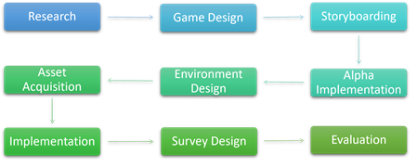
Fig. 1. Workflow of the project
Materials
The game was developed and built in Unity for use with an Oculus Quest headset.
Adobe Photoshop CC was used during the design process to create prototype interface designs. To create 3D model assets, 3Ds Max was used while Substance Painter and Adobe Photoshop CC was used to create textures. These assets were imported to Unity which acted as the game’s development environment. In order to create an immersive VR experience, the Oculus Plugin for Unity was used to set up the environment for use with a HMD and hand tracking. Finally, Visual Studio Code was used for scripting.
Third-party 3D and audio assets were utilized to cut development time and due to limited experience creating these mediums. 3D assets were sourced from SketchFab, TurboSquid, Unity Asset Store and OpenGameArt. The audio assets were sourced from OpenGameArt, Berklee College of Music Sampling Archive and Ministerio de Educación y Formación Profesional.
Design and Development Process
The first step in the design phase was to look at existing literature on exercises used in the rehabilitation of MS and identify what type of movements these exercises trained. These movements could then be mapped to real life activities that would provide a base narrative for each serious game. The proposed exercises also take inspiration from real life activities and existing non-rehabilitative games these were then ranked by development priority.

Table 1: Table of proposed exercises and their inspiration
Proposed  Exercise | Movement | Priority | Description | Based On
Piano  Playing | Co-ordinated and isolated finger extension | Compulsory | The game would emulate typing by having the player hit set keys to produce a tune. Would utilize mechanics like Guitar Hero™ i.e. the key should be hit in time with some sort of indicator. | (Webster et al., 2018; Soomal et al., 2020)
Bubble  Popping  Game | Interphalangeal flexion of the thumb and index finger (Pinching) | Optional | Bubbles will appear around the scene in various positions, the player must pinch them to pop them. | (Webster et al., 2018; Soomal et al., 2020)
Ping Pong | Wrist  Flexion/Extension | Optional | The player places their hands at either side of a virtual pinball machine where they must press the buttons on the sides to operate paddles to prevent the ball from leaving play. Virtual rods will be in place to encourage the correct hand movement | (Platz et al.,  2001; Müri et al., 2015)
Circuit  Maze | Arm flexion and medial rotation  (Aiming/Maze  Tracking) | Compulsory | Recreating the Circuit/Electric maze board game. Player has to follow the path of the maze using their index finger. Feedback will be given based on how many times they touched the wall of the maze, the lower the number the better. | (Platz et al.,  2001)

A storyboard detailing the menu flow of the game was created outlining the user interface (UI) design (Fig.2). The UI was designed with usability in mind leveraging Nielsen’s Usability heuristics (Nielsen, 2005). Fig.3 is an additional storyboard of the individual game designs, detailing their intended outcomes and mechanics.

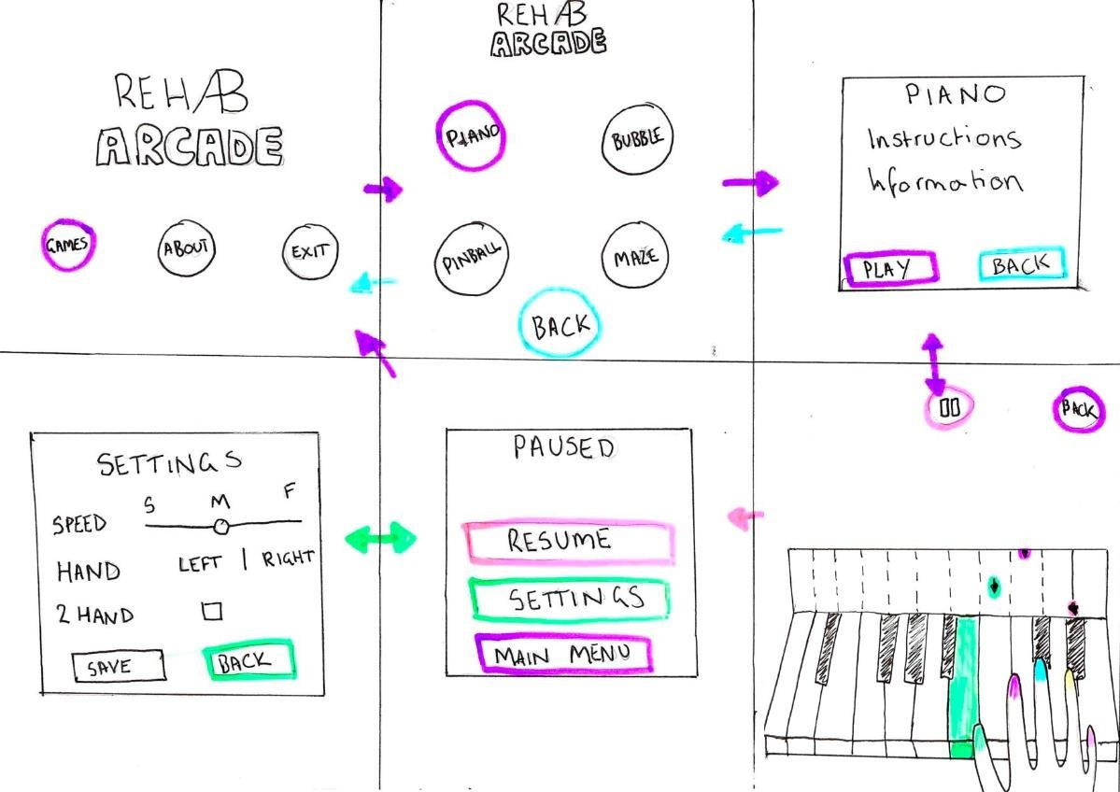
Fig.2 Researcher Storyboards part 1
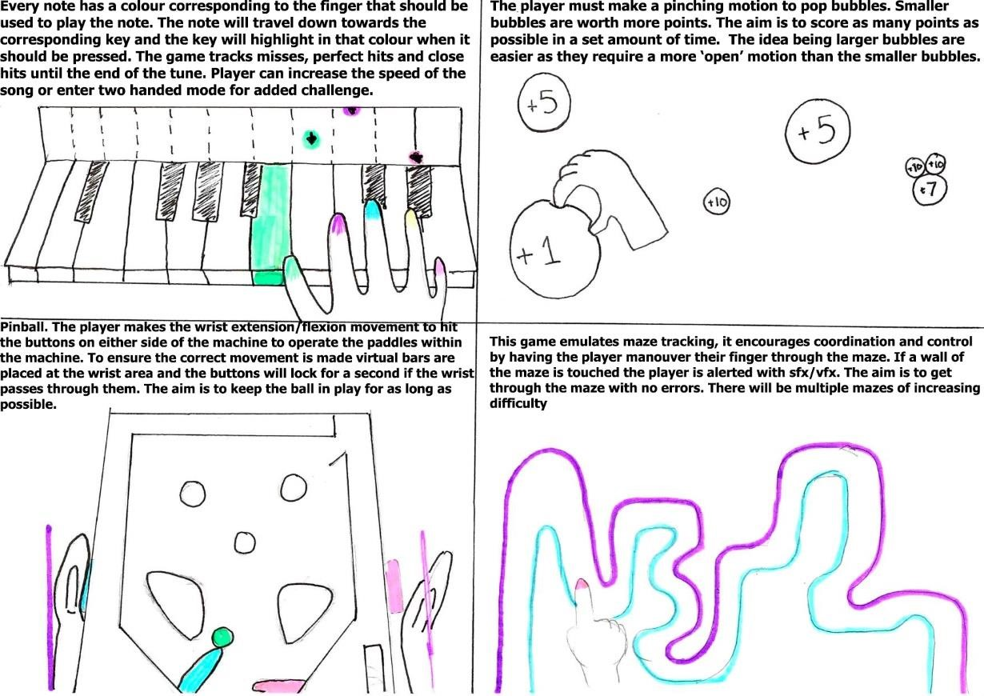
Fig.3 Researcher Storyboards part 2
.
Colour can be important for creating the ideal environment for the game. Certain colours can be used to evoke specific feelings and moods within a user, in this case the aim is to create a calming neutral environment that evokes focus (Hidayetoğlu and Ozkan, 2011). To this end blues and greens were selected in pastel shades, these are tones often used in hospital waiting rooms to create a calming atmosphere (Hidayetoğlu and Ozkan, 2011). A cream colour was selected instead of white, to bring warmth and ensure the environment was not too ‘sterile’ and ‘cold’ while brown was chosen to bring contrast and act as a grounding influence.
Developmental Outcomes
Three scenes were made all set within one perpetual 3D environment with the viewpoint of the player being changed by switching to cameras situated in different areas of the virtual environment. One scene was created as a menu to allow the player to choose which game they wished to play and to swap between the two games, two scenes were created as games that would require the hand and finger movements to replicate the exercises in Table 1, the piano scene and the maze scene.
Menu Scene
The first scene in the game is the menu scene, this scene displays the game’s title along with buttons that allow the user to interact with and navigate through multiple menus. The menu is integrated as an object within the virtual environment, in this case a TV screen, rather than as a head-up display (HUD).
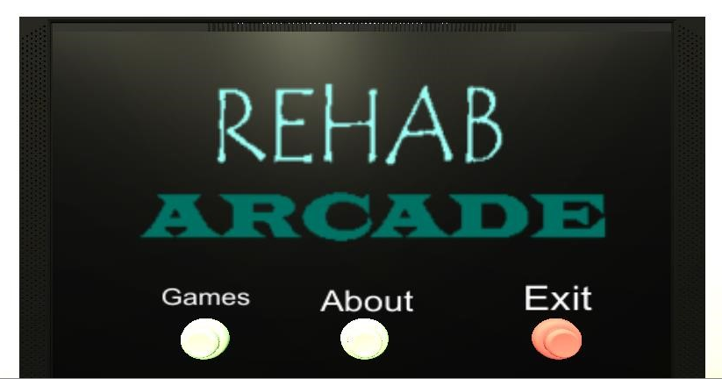
Fig. 4. Initial view of the scene
The player can turn around and view the whole environment at their leisure, they can read about why the game was created by pressing the About button, swap to the game selection menu by pressing the Games button or quit the game entirely.
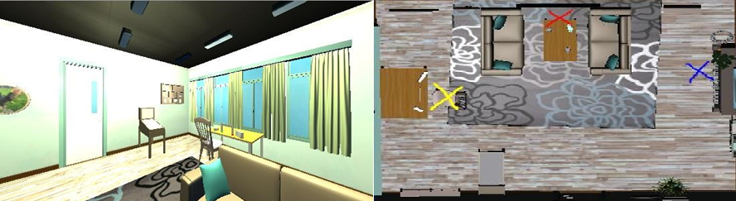
Fig. 5. Player can turn around to view the rest of the environment
Interactions take place at three key points in the scene as shown in Figure 5. The X’s signify the camera’s starting position, with the colour indicating which scene it is referring to. Red for Menu, Blue for Piano and Yellow for Maze.
The game selection Menu replaces the initial Menu and gives the player the choice between two games, the piano game and the maze game, or to return to the initial menu.
Piano Scene
To aid immersion, measures were taken to ensure the environment was consistent across all three scenes the environment was loaded in only once and was not destroyed between scenes to ensure continuity, only the starting position of the camera is changed.
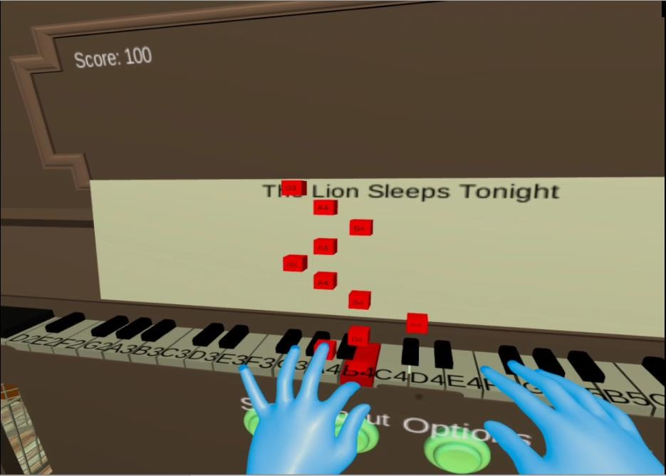
Fig. 6. Piano game in play
The aim was to gamify rehabilitation to achieve this the mechanics of Guitar Hero™ were replicated using falling notes to indicate when keys should be pressed (Fig.6). Rather than having set levels the player could change settings to fit their stage of rehabilitation, swapping between different songs and speeds as necessary as shown in Fig.7.
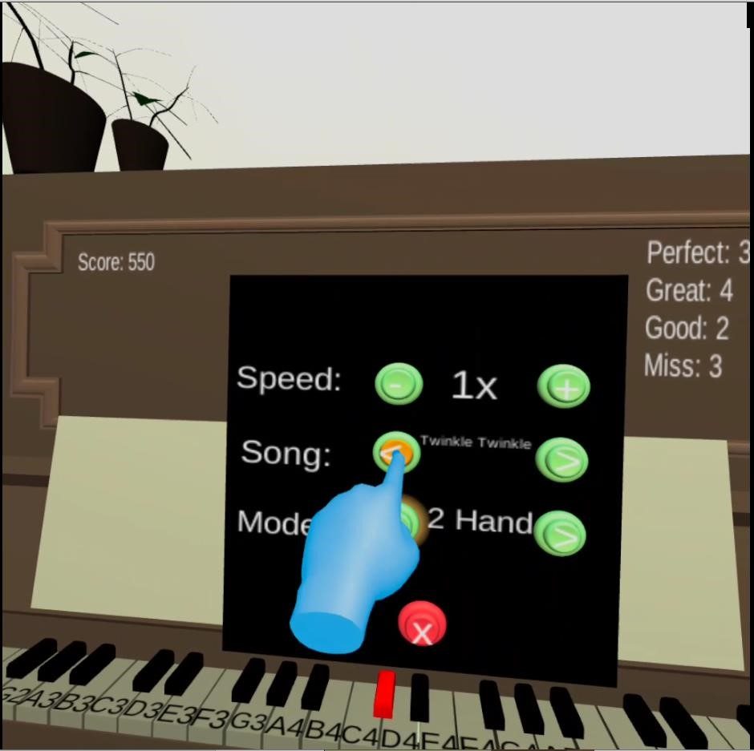
Fig. 7. Settings for the piano game could be changed
Due to the literature suggesting that scores were described as a motivating factor and an indicator of progress to some patients, an overall score they could compare with others to get external motivation and a breakdown of performance in the form of perfect, great, good and missed notes as an internal form of motivation giving the player the goal of getting no misses or all perfect scores.

Maze Scene
Three mazes were constructed in order to provide a difficulty curve, one simple and two more complex (Fig.8). The UI in this scene was very simple with the scoring system offset to the left as can be seen in Figure 8 and the controls to the right as seen in Fig.9.

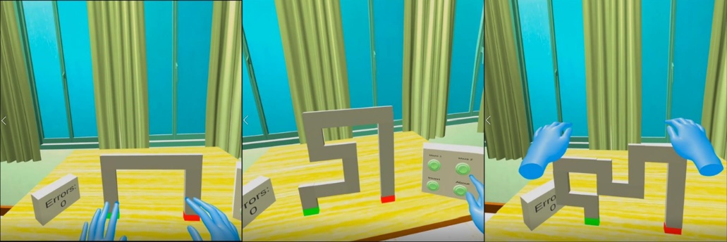
Fig. 8. Maze 1, Maze 2 and Maze 3 (Pictured from Left to Right)

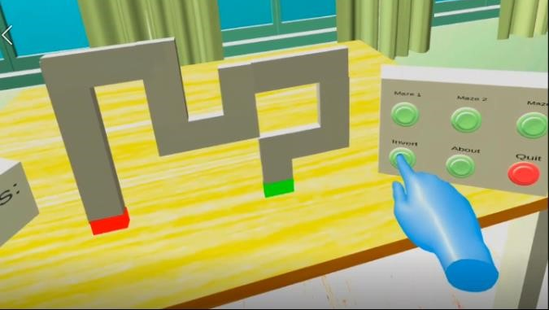
The player can invert these mazes the idea behind this being to make it easier to swap which hand is in play and in the case of asymmetric mazes give the sensation of playing a new maze (Fig.9).
Fig. 9. Maze 3 Inverted, the starting and end points have swapped places. Also pictured to the right is the maze switching interface.
The player simply traces the shape of the maze with their finger, audio feedback in the form of a buzzer sound and visual feedback in the form of an incrementing error counter will activate if the players finger leaves the maze before reaching the end.

Development progressed steadily with relatively few issues, one major issue being that in the piano game the right hand could not reliably press the piano keys to trigger sound. Due to the small developer base and limited support as mentioned before it was difficult to troubleshoot this issue. It was eventually resolved by removing the Contact Tests from the ButtonController script on the piano keys. Being unable to reliably access information on the causes of such issues contributed to lengthening both implementation and testing times due to time spent troubleshooting and diagnosing the problem.

Evaluation
Participants
Three participants were recruited, one physiotherapist and two people with MS. Ages varied between 25 and 60 years old and gender was split two males to one female (Table 2). These participants were recruited via a gatekeeper with prior permission to contact them about participation in future studies.
Table 2 Participant population
Participant | Occupation | Age | Gender
A | Volunteer Worker | 51 | Male
B | Medically Retired | 35 | Female
C | Physiotherapist | 26 | Male
Experimental Set-up and Procedure
Due to health and safety concerns and lockdown restrictions relating to Covid-19, it was not possible to have the participants test the game directly. An alternate method was conceived sharing a screen capture recording was taken of the game in use. This recording was then embedded into a survey in the form of an unlisted YouTube video only accessible via link (https://youtu.be/CGRic1IGM7s), that would be sent out to the participants. This allowed the participants to watch the video in their own time to abide by lockdown legislation and guidelines. A survey was created asking eighteen questions that would generate mostly qualitative data regarding what factors of the game would motivate and encourage treatment adherence for people with MS as well as to gain information on whether the games were suitable for their purpose.
The surveys were sent out simultaneously to all participants, no time limit for participation was given. An estimated completion time of 25 minutes was given including the time required to watch the video and answer the questions in the survey.

Ethics
This experiment received ethical approval from the Glasgow School of Art learning and teaching office and follows the ethical guidelines put in place by this institution.
Data Analysis
The survey contained eighteen questions split into three main sections, three pre-screening questions, four questions on motivation and fourteen questions on content validity. The questions were mostly qualitative in nature as motivation and content validity are difficult concepts to quantify and qualitative data would provide a rich insight into the factors affecting motivation and validity. There were also a few quantitative questions in the form of Likert scales to gauge likelihood of use and usefulness of certain factors. These questions were:
- How likely do you believe an individual with MS would be to use such a system
- How do you believe the presented approach would be likely to help through physical rehabilitation for upper limb?
- How useful would you find these difficulty changes in supporting progressive physical rehabilitation?
- How useful do you think hand tracking technology like the system demonstrated could be in rehabilitation?"

The Likert scales were based on likelihood and on usefulness and used a range of 1 to 5. For questions one and two the scale denotes likelihood of use and likelihood of there being a benefit to use. With 1 being that it was highly unlikely, 2 being somewhat unlikely, 3 equally likely and unlikely, 4 somewhat likely and 5 being very likely. For questions three and four the scale denotes general usefulness. With 1 being not useful, 2 being limited usefulness, 3 some usefulness, 4 useful and 5 being very useful.

It is highly variable with what is deemed motivating varying from person to person, therefore, to get a general idea of what the target audience may find motivating participants were asked to provide qualitative data on what features of the game they liked and disliked and to expand upon why this was the case.
Content validity ensures that the game accomplishes its goal, in this case testing whether the games and system proposed would provide appropriate exercise for rehabilitation and whether the target audience would even use the system. To achieve this, questions relating to likelihood of use and appropriateness of the games were given.
The results of the survey were analysed using theme-based content analysis (Neale and Nichols, 2001) to categorise responses into similar themes and sentiments to gain greater understanding of the general perception of the application and the common reasons or features that affect content validity and motivation (Table 3). It can also highlight trends and themes that are not initially apparent.
Factors such as usability and presence were not evaluated due to inability to perform user testing of the application.
Results
The game was generally well received receiving mostly neutral and positive responses, there was however a distinct split in the responses from the participants with MS and the physiotherapist participant in the long form answers.
Table 3 Analysed survey responses
Response | Common Theme | Higher Order  Theme
“[Scoring had..] no effect” | Scoring (5) | Motivation (12)
“[Scoring was…] not at all [effective]”
“The wording of the scoring system in the 2nd (maze) game could also be revised to enhance motivation. For example, "errors" could be changed to something like "attempts" - this would move away from the negative associations of "errors".” *
“might be worthwhile giving the patient the option of viewing/recording their scores.” *
“…in the earlier stages of rehab with greater levels of impairment may be demotivated if their scores are low or do not progress” *
“I think the audio feedback provided a clear indication of success for both tasks.”  * | Audio Feedback  (3)
“It would be quite motivational to be a success as to be a failure”
“[Audio Feedback was…] not at all
[effective]”
“By continuing to practice the VR, the user should be able to see steady improvements and this will encourage the user to keep going.” | Health Benefits  (4)
“It might help with coordination and rewire the brain to find an alternative way of problem solving”
“I think VR would be incredibly useful in strengthening the upper limbs and improving movement”
“something that would be beneficial to my health then I would be more encouraged to participate.”
“As this is a novel intervention, it will likely interest patients” * | Novelty (2) | Content Validity (7)
“Alternative methods are always welcome of learning new ways to do things.”
“Learning new skills”
“more games could be included to encourage long-term engagement from patients.” * | Treatment  Adherence (2)
“and perhaps encourage adherence.”
“By starting morning easy setting and then increasing difficulty as upper limb movement improved, it offers a satisfying and visual scale to show the progress made.” * | Progression (2)
“Providing varying levels of task difficulty is essential to providing treatment”
“Through integrating visual and motor stimuli, hand tracking systems have the potential to enhance upper limb motor recovery in people with neurological conditions.” * | Hand Tracking  Potential (1)
“The games presented will be appropriate for some upper limb impairments - for example, they are focused mainly on fine motor control of the wrist/hand.” * | Future Work (2) | Scalability (2)
“Perhaps other games could be developed which incorporates global upper limb movement (including shoulder, elbow) within functional tasks/movements. In addition, impairments of co-ordination could also be considered.” *
“I think this will vary from patient to patient based on factors such as selfefficacy, motivation, and impairments (e.g.  cognition, visual impairments).” * | Target Audience  (3) | Benefactors (4)
“The younger fraternity might find it easier than an older person”
“I would have liked to have participated myself”
“I think a key challenge of future research will be working out the characteristics of patients who will use this (and benefit from this) and why this is the case.” * | Identifying key users (1)
“I think the music played during the games might be distracting - particularly for people with cognitive impairments.” * | Music (2) | Usability (4)
“To enhance to usefulness of the audio feedback, perhaps the background music could only play in the main menu so that the only audio stimuli within the games are related to feedback.” *
“The goal of each game was clear after the instructions were read. However, as the instructions were accessed after pressing a button, the goal of the games may not be initially clear to patients who do not access the instructions. Perhaps the instructions could appear automatically at the start of each game to ensure that all patients understand.” * | UI (2)
“Perhaps the visual feedback within the first (piano) game could be enhanced to
make it clearer which key the patient has to press.”
* Answers given by physiotherapist participant

The first Likert question asked how likely participants would be to use such a system at home. Participants scored the game a 3.6 on average with participants with MS scoring it a 4 on average and physiotherapist scoring it a 3 (Fig.10).
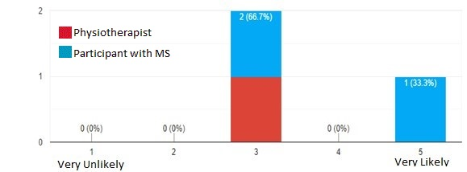

Fig. 10. Responses to question "How do you believe individuals with MS would be likely to use such a system at home?"
The second asking if the participants believed the presented game would be useful in helping rehabilitate the upper limbs. Participants scored the game a 3.6 on average with participants with MS scoring it a 4 on average and physiotherapist scoring it a 3 (Fig.11).
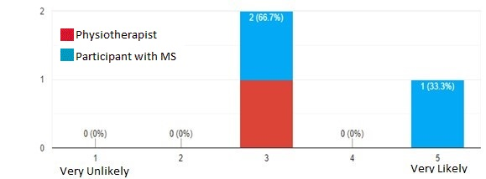
Fig. 11. Responses to question "How do you believe the presented approach would be likely to help through physical rehabilitation for upper limb?"
The third Likert question asked the participants about the usefulness of adaptive difficulty in progressing through physical rehabilitation. On average this was scored a 4.6 with participants with MS scoring it a 5 on average and physiotherapist scoring it a 4 (Fig.12).
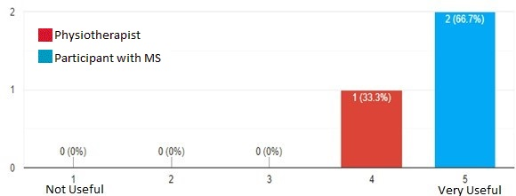
Fig. 12. Responses to question "How useful would you find these difficulty changes in supporting progressive physical rehabilitation?"
And the final Likert question asked about the usefulness of hand tracking technology in general regarding rehabilitation. On average this was scored a 4.6 with participants with MS scoring it a 5 on average and physiotherapist scoring it a 4 (Fig.13).
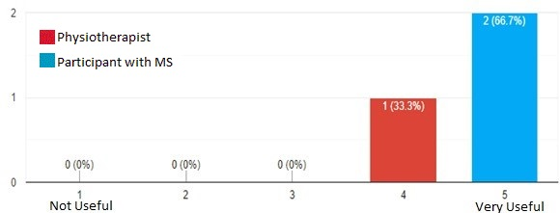
Fig. 13. Responses to question "How useful do you think hand tracking technology like the system demonstrated could be in rehabilitation?"
Discussion
In summary, two distinct games were created for the Oculus Quest utilising its inbuilt hand tracking technology to create an application aimed at rehabilitating hand movement in people with MS. Two people with MS and one physiotherapist were shown a video of the games in use and were surveyed on their opinions on motivating factors and content validity of the application.
General comments on the project were positive with participants finding the games a novel method of rehabilitation and stating that they believed hand tracking would be of use in rehabilitation. The games themselves were somewhat well received with participants with an average of 3.6 on the Likert scale suggesting that they were slightly useful for rehabilitation (Fig.11).
Theme-based analysis of participants answers to the qualitative questions in the questionnaire found that feelings towards scoring was mixed with the participants with MS feeling it had no effect on their motivation. This contrasts starkly with the findings of several studies which found that scoring would have a motivating or demoralising effect depending on the participant but that it was generally enjoyed as a method to track progress (Parker et al., 2014; Standen et al., 2015; Webster et al., 2019; Soomal et al., 2020). Meanwhile the physiotherapist believed it could potentially have motivating or demoralising effects depending on how it was implemented and hence should be presented as an option rather than being mandatory. This supports the existing literature discussed, in which Parker et al (2014) found that low scores would inspire determination in some of their participants but for others it discouraged the use of the system. This discrepancy could be due to the participants being disconnected or otherwise uninvolved with the action on screen, i.e. an onlooker rather than being an active participant. A game is a piece of interactive media so often the ‘feel’ or ‘impact’ cannot be fully experienced by just watching. Alternatively, a reason for this split between participants could be due to the small number of participants and the uneven split between physiotherapist participants and participants with MS. A large sample size is needed to research this split further. The wording of the scoring system in the maze game was also thought to be demoralising and it was suggested that an alternative to “errors” be used.
All participants felt that the adaptable difficulty of the games was somewhat to very useful in supporting progression through physical rehabilitation. On average adaptable difficulty scored a 4.6 on usefulness suggesting that participants felt that it was a very important feature to have for rehabilitative games. The physiotherapist highlighted how it could be tailored to an individuals’ needs and stage of recovery over a longer timeline. While one of the participants with MS stated it would be helpful even over the short term of a session to be able to adapt the difficulty as their movement improved throughout the day.
While there was a split in response tone in the long form answers between physiotherapist and participants with MS, scoring in the Likert questions was consistent with the physiotherapist generally scoring the system lower. However, there was a difference of opinion within the participants with MS contingent in which the younger participant consistently scored the system higher. This is echoed by a statement that there was concern that older or people with less experience with the technology may find it more difficult to engage with a concept that was also highlighted in Standen et al (2015) which stated that unfamiliarity with the technology could adversely affect adherence. It is also supported by a statement made by the physiotherapist that likelihood of usage will vary from patient to patient, and that patients with specific characteristics will benefit from the system more.
However, due to the circumstances which have forced into the aforementioned experimental procedure design, these results might lack subjectivity as it could be difficult to properly assess a fully immersive and interactive system without first-hand experience of using that system. A further study allowing participants to gain this experience by using the system may produce different results
Issues were highlighted regarding visual and audio feedback. For the former, which key the player had to press was often unclear until the note hit the key. It was also felt that the goal of each game, while clear once the information panel was revealed should have been shown automatically rather than hidden behind a button press. This suggests that usability may currently be an issue and that future work may require improving upon this aspect.
Audio feedback was well received with participants enjoying the instant task-based feedback with a preference to the positive reinforcement of the piano game over the negative reinforcement of the maze.
However, participants felt the background music was a distraction and could overload people with cognitive impairments. This could be due to the volume of the music and this game’s heavy use of audio feedback to indicate performance. This finding contrasts with responses to music in Webster et al (2019) in which the music was not noticed by most participants and the one who did found it quite pleasant. As music preference is subjective it would be advisable to make it optional, especially in case it contributes to cognitive overloading.
Most participants felt that people with MS might use the system at home, scoring it a 3.6, with one participant stating a desire to have been able to use the application for the evaluation. This could indicate a desire for immersive VR rehabilitation however it may be necessary to rerun the study with user testing in order to get an accurate gauge of whether there is an audience for the system.
Only one participant, the physiotherapist, gave a long-form comment on the overall potential for hand tracking in rehabilitation stating that they believed it could be used to enhance recovery for those with neurological conditions. However, all participants felt that it could be useful with it scoring a 4.6 on average on the Likert scale. This supports the findings in both Webster et al (2019) and Soomal et al (2020) that hand-tracking could be an effective and novel tool for rehabilitation.
Additional features were suggested with the most common being the inclusion of more games in order to add more variety, exercise more of the upper limb and encourage long term adherence. By combining serious game design patterns with emergent virtual reality technology, it may become possible to create an immersive experience that follows the principles of rehabilitative exercise:
repetition, feedback, motivation and task-oriented training. The ability to adapt difficulty also allows for the technology to be used throughout the patient’s journey to recovery and give each session of play an achievable goal, further motivating the patient. This was highlighted in the survey responses which placed an emphasis on having a feeling of steady progress as being beneficial to treatment.
No technical issues were highlighted by participants in the additional comments section of the questionnaire. The Quest seems well suited for the application due to its lightweight build and inbuilt hand tracking, however this was tested by a person without MS so further testing to study suitability for MS patients is required. No technical issues were detected when the system was in use, however implementation was challenging due to excessive encapsulation and limited documentation and developer support.
It cannot be disputed that “out-of-the-box” virtual reality is often unsuited to the needs of the patient and often require additional tracking peripherals such as the Leap Motion for upper limb rehabilitation or the Kinect for lower limb adding to cost. It also adds unnecessary weight and bulk to a system that can be uncomfortable and discourage use.
Additionally as an all-in-one system the Oculus Quest does not require a PC to run, PC’s capable of powering VR are often very expensive meaning in a lot of cases the Quest may be the most cost efficient alternative for VR treatment when factoring in the cost of the headset, PC and the Leap Motion necessary for the same results.
With the Quest’s tracking being comparable to the Leap Motion it suffers from the same problems in regard to occlusion as well as an additional issue in the form of a blind spot in the direct centre of the headset which would often result in lost tracking. However, it could be argued that the convenience of an all-in-one system makes the Quest an improvement on previous interaction models.
The downside to the Quest lies largely in its experimental nature, it is a relatively new device and is yet to generate a large developer base in the same way other technologies have and as hand-tracking is still deemed an experimental feature support for developing with it is extremely limited. This can make the implementation of even simple interaction methods using hand-tracking difficult especially as heavy use of encapsulation in the code base hinders access and manipulation of specific game objects such as only tracking the collisions of a single finger or only tracking a single hand. For this reason, many of the original features outlined in the design phase such as colour coding the fingers on the hand with the notes associated with them was not possible.

Future Works
In terms of the application itself several note-worthy improvements were made by participants during the study, some were made post-evaluation such as only having the background music play in the Menu scene rather than throughout the game to lessen the strain on cognitively impaired users and to highlight the audio feedback and stimuli the games provide.

Other suggestions were the implementation of more games, four games had been included in the initial plan however this was later scaled back to two due to time constraints hence future work may include scaling the project back up as well as patching existing bugs present in the project such as menu buttons not resetting to their default state.
The survey highlighted several concepts that require further study. Only one participant reported it highly likely that the system would be useful at home with another highlighting that it would vary from patient to patient who would benefit from its use. A possible gap in research may be the identification of what characteristics patients who would use this have and how these systems could be optimized based on these characteristics.
Another consideration is that VR is a very practical technology and hence it is difficult to assess aspects such as motivation from evaluating a video, due to infection risk and concerns at this time it was impossible to have the participants use the system themselves, one participant commented on this stating that they would have liked to have participated themselves. In the future it may be beneficial to rerun this study with user-testing, observation and the target audience gaining real lived experience of using the application may provide a richer and more indicative idea of its features and faults. A larger contingent of participants with a roughly even split to observe if this trend continues would be beneficial.
Conclusion
Overall while the results of this study are promising in regards to the feasibility of Oculus Quest based rehabilitation for MS, further study with more participants is required to better adapt immersive VR rehabilitation to the specific needs of people with MS. While some interesting points have been highlighted regarding the target audience for the system and the benefit of adaptable difficulty some directly contradict findings in other studies such as the inclusion of background audio and the motivational effect of scoring. It may be necessary to conduct further research using user testing to validate these findings. Due to the small sample size the validity of these findings is questionable; however, the results could be used as a starting point for further study as they highlighted the varying opinions between the physiotherapist and the participants with MS. Also due to the technologies emergent status there is not extensive research on the use of the Oculus Quest as a tool for rehabilitation in MS.

Bibliography

Adamovich, S. V et al. (2005) A Virtual Reality-Based Exercise System for Hand Rehabilitation Post-Stroke, New Jersey Presence.
Alankus, G. et al. (2010) Towards Customizable Games for Stroke Rehabilitation.
Ascherio, A. and Munger, K. L. (2007) ‘Environmental risk factors for multiple sclerosis. Part I: The role of infection’, Annals of Neurology. John Wiley & Sons, Ltd, 61(4), pp. 288–299. doi: 10.1002/ana.21117.

Berkman, M. I. and Akan, E. (2019) ‘Presence and Immersion in Virtual Reality’, in Encyclopedia of Computer Graphics and Games. Springer International Publishing, pp. 1–10. doi: 10.1007/978-3-319-08234-9_162-1.

Borrego, A. et al. (2018) ‘Comparison of Oculus Rift and HTC Vive: Feasibility for Virtual Reality-Based Exploration, Navigation, Exergaming, and Rehabilitation’, Games for Health Journal. Mary Ann Liebert Inc., 7(3), pp. 151–156. doi: 10.1089/g4h.2017.0114.

Burke, J. W. et al. (2009) ‘Optimising engagement for stroke rehabilitation using serious games’, Visual Computer. Springer Verlag, 25(12), pp. 1085–1099. doi: 10.1007/s00371009-0387-4.

Carpinella, I. et al. (2009) ‘ROBOT-BASED REHABILITATION OF THE UPPER LIMBS IN MULTIPLE SCLEROSIS: FEASIBILITY AND PRELIMINARY RESULTS’. doi: 10.2340/16501977-0401.

Carter, S., Taylor, D. and Levenson, R. (2003) A Question of Choice: Compliance in Medicine Taking. London.

Causes of MS (2020). Available at: https://www.mstrust.org.uk/about-ms/what-ms/causesms (Accessed: 24 June 2020).
Chan, E. A. et al. (2006) ‘Application of a virtual reality prototype for pain relief of pediatric burn in Taiwan’. doi: 10.1111/j.1365-2702.2006.01719.x.
Chen, J. (2007) Flow in Games (And Everything Else).
Choi, J. H. et al. (2014) ‘Effectiveness of commercial gaming-based virtual reality movement therapy on functional recovery of upper extremity in subacute stroke patients’, Annals of Rehabilitation Medicine. Korean Academy of Rehabilitation Medicine, 38(4), pp. 485–493. doi: 10.5535/arm.2014.38.4.485.

Cordella, F. et al. (2012) Patient Performance Evaluation Using Kinect and Monte CarloBased Finger Tracking.
Dias, P. et al. (2019) Using Virtual Reality to Increase Motivation in Post-Stroke Rehabilitation. Available at: www.oculus.com/rift (Accessed: 25 June 2020).
Elor, A., Teodorescu, M. and Kurniawan, S. (2018) ‘Project Star Catcher: A Novel Immersive Virtual Reality Experience for Upper Limb Rehabilitation’, ACM Trans. Access. Comput, 11. doi: 10.1145/3265755.

Engström, L. O. and Öberg, B. (2005) ‘Patient adherence in an individualized rehabilitation programme: A clinical follow-up’, Scandinavian Journal of Public Health, 33(1), pp. 11–18. doi: 10.1080/14034940410028299.

Enrique Sucar, L. et al. (2013) Gesture Therapy: An upper limb virtual reality-based motor rehabilitation platform, IEEE TRANSACTIONS ON NEURAL SYSTEMS AND REHABILITATION ENGINEERING.
Feys, P. et al. (2009) Arm training in Multiple Sclerosis using Phantom: clinical relevance of robotic outcome measures.
Fugl Meyer, A. R., Jaasko, L. and Leyman, I. (1975) ‘The post stroke hemiplegic patient. I. A method for evaluation of physical performance’, Scandinavian Journal of Rehabilitation Medicine. Scand J Rehabil Med, 7(1), pp. 13–31. Available at: https://pubmed.ncbi.nlm.nih.gov/1135616/ (Accessed: 24 June 2020).

Guo, R. and Quarles, J., 2012, March. Differences in presence between healthy users and users with multiple sclerosis. In 2012 IEEE VR Workshop on Perceptual Illusions in Virtual Environments (pp. 1-6). IEEE.

Geraets, C. N. W. et al. (2019) ‘Virtual reality-based cognitive behavioural therapy for patients with generalized social anxiety disorder: A pilot study’, Behavioural and Cognitive Psychotherapy. Cambridge University Press. doi: 10.1017/S1352465819000225.

Hartveld, A. and Hegarty, J. R. (1996) Augmented Feedback and Physiotherapy Practice Motor programme. doi: 10.1016/S0031-9406(05)66414-0.

Hayden, J. A., Van Tulder, M. W. and Tomlinson, G. (2005) ‘Systematic review:
Strategies for using exercise therapy to improve outcomes in chronic low back pain’, Annals of Internal Medicine. American College of Physicians, pp. 776–785. doi: 10.7326/0003-4819-142-9-200505030-00014.

Hidayetoğlu, M. L. and Ozkan, A. (2011) ‘Effects of interior colors on mood and preference: Comparisons of two living rooms Article in Perceptual and Motor Skills ·’. doi: 10.2466/24.27.PMS.112.2.509-524.
Hondori, H. M. and Khademi, M. (2014) ‘A Review on Technical and Clinical Impact of Microsoft Kinect on Physical Therapy and Rehabilitation’. doi: 10.1155/2014/846514.
Housley, S. N. et al. (2016) ‘Increasing Access to Cost Effective Home-Based Rehabilitation for Rural Veteran Stroke Survivors.’, Austin journal of cerebrovascular disease & stroke. NIH Public Access, 3(2), pp. 1–11. Available at: http://www.ncbi.nlm.nih.gov/pubmed/28018979 (Accessed: 17 June 2020).

Ijsselsteijn, W. A. et al. (2004) Virtual Cycling: Effects of Immersion and a Virtual Coach on Motivation and Presence in a Home Fitness Application.
Jack, D. et al. (2001) Virtual Reality-Enhanced Stroke Rehabilitation, IEEE TRANSACTIONS ON NEURAL SYSTEMS AND REHABILITATION ENGINEERING.
Janardhan, V. and Bakshi, R. (2002) ‘Quality of life in patients with multiple sclerosis: The impact of fatigue and depression’, Journal of the Neurological Sciences, 205(1), pp. 51–58. doi: 10.1016/S0022-510X(02)00312-X.

Jones, T., Moore, T. and Choo, J. (2016) ‘The Impact of Virtual Reality on Chronic Pain’. doi: 10.1371/journal.pone.0167523.
Kearns, P. K. A. et al. (2019) ‘Regional variation in the incidence rate and sex ratio of multiple sclerosis in Scotland 2010–2017: findings from the Scottish Multiple Sclerosis Register’, Journal of Neurology. Dr. Dietrich Steinkopff Verlag GmbH and Co. KG, 266(10), pp. 2376–2386. doi: 10.1007/s00415-019-09413-x.

Kern, F., Winter, C., Gall, D., Käthner, I., Pauli, P. and Latoschik, M.E., 2019, March. Immersive virtual reality and gamification within procedurally generated environments to increase motivation during gait rehabilitation. In 2019 IEEE Conference on Virtual Reality and 3D User Interfaces (VR) (pp. 500-509). IEEE.

Kim, M., Jeon, C. and Kim, J. (2017) ‘A Study on Immersion and Presence of a Portable Hand Haptic System for Immersive Virtual Reality’, Sensors. Multidisciplinary Digital Publishing Institute, 17(5), p. 1141. doi: 10.3390/s17051141.
Kwakkel, G. et al. (2004) ‘Effects of augmented exercise therapy time after stroke: a metaanalysis.’, Stroke, 35(11), pp. 2529–39. doi: 10.1161/01.STR.0000143153.76460.7d.

Lamers, Ilse, Anneleen Maris, Deborah Severijns, Wouter Dielkens, Sander Geurts, Bart Van Wijmeersch, and Peter Feys. "Upper limb rehabilitation in people with multiple sclerosis: a systematic review." Neurorehabilitation and neural repair 30, no. 8 (2016): 773-793.

Lang, B. (2013) Road To VR. Available at: https://www.roadtovr.com/mixed-reality-pianotrainer-makes-learning-piano-easy/.
Latimer-Cheung, A. E. et al. (2013) ‘Effects of exercise training on fitness, mobility, fatigue, and health-related quality of life among adults with multiple sclerosis: A systematic review to inform guideline development’, Archives of Physical Medicine and Rehabilitation. W.B. Saunders, pp. 1800-1828.e3. doi: 10.1016/j.apmr.2013.04.020.
Lau, H. M. et al. (2017) ‘Serious games for mental health: Are they accessible, feasible, and effective? A systematic review and meta-analysis’, Frontiers in Psychiatry. Frontiers Media S.A. doi: 10.3389/fpsyt.2016.00209.
Laver, K. E. et al. (2017) ‘Virtual reality for stroke rehabilitation’, Cochrane Database of Systematic Reviews. John Wiley and Sons Ltd. doi: 10.1002/14651858.CD008349.pub4.
Lohse, K. et al. (2013) ‘Video Games and Rehabilitation: Using Design Principles to Enhance Engagement in Physical Therapy’. doi: 10.1097/NPT.0000000000000017.

Magill, R. A. (2001) ‘Motor Learning as a Function of KR Schedule and Characteristics of Task-Intrinsic Feedback The effects of erroneous information on performance and learning View project’. doi: 10.1080/00222890109601903.

Magill, R. A. and Anderson, D. I. (2014) MOTOR LEARNING AND CONTROL Concepts and Applications. Available at: www.mhhe.com (Accessed: 24 June 2020).
Mantovani, E., Zucchella, C., Bottiroli, S., Federico, A., Giugno, R., Sandrini, G., Chiamulera, C. and Tamburin, S., 2020. Telemedicine and virtual reality for cognitive rehabilitation: a roadmap for the COVID-19 pandemic. Frontiers in neurology, 11.
Mcnevin, N. H. et al. (2011) ‘An Examination of Feedback Use in Rehabilitation Settings Supra-postural task constraints on optimizing postural control View project The effects of erroneous information on performance and learning View project An Examination of Feedback Use in Rehabilitation Settings’, Critical ReviewsTM in Physical and Rehabilitation Medicine, 23(4), pp.147–160. doi: 10.1615/CritRevPhysRehabilMed.v23.i1-4.110.

Morales, R. et al. (no date) ‘Pneumatic robotic systems for upper limb rehabilitation’. doi: 10.1007/s11517-011-0814-3.
Mousavi Hondori, H. and Khademi, M., 2014. A review on technical and clinical impact of microsoft kinect on physical therapy and rehabilitation. Journal of medical engineering, 2014.
MS: the facts (2020). Available at: https://www.mstrust.org.uk/about-ms/what-ms/msfacts (Accessed: 24 June 2020).

Müri, R. et al. (2015) ‘Mult Scler-2015-Kamm MULTIPLE SCLEROSIS MSJ JOURNAL’. doi: 10.1177/1352458514565959.
National Multiple Sclerosis Society (2020) Types of MS, New York. Available at: http://www.nationalmssociety.org/What-is-MS/Types-of-MS (Accessed: 15 June 2020).
Neale, H. and Nichols, S. (2001) ‘Theme-based content analysis: A flexible method for virtual environment evaluation’, International Journal of Human Computer Studies. Academic Press, 55(2), pp. 167–189. doi: 10.1006/ijhc.2001.0475.

Nielsen, J. (2005) Ten Usability Heuristics. Available at: http://www.useit.com/papers/heuristic/heuristic_list.html (Accessed: 4 July 2020).
Olsson, T. and Alfredsson, L. (2017) ‘Interactions between genetic, lifestyle and environmental risk factors for multiple sclerosis Individual-participant Data Meta-analysis in Working Populations View project multiple sclerosis research View project’. doi: 10.1038/nrneurol.2016.187.

Parker, J. et al. (2014) ‘Stroke patients’ utilisation of extrinsic feedback from computerbased technology in the home: A multiple case study realistic evaluation’, BMC Medical Informatics and Decision Making. BoMed Central Ltd., 14(1), p. 46. doi: 10.1186/14726947-14-46.
Peretti, A., Amenta, F., Tayebati, S.K., Nittari, G. and Mahdi, S.S., 2017. Telerehabilitation: review of the state-of-the-art and areas of application. JMIR rehabilitation and assistive technologies, 4(2), p.e7.
Platz, T. et al. (2001) ‘Arm ability training for stroke and traumatic brain injury patients with mild arm paresis: A single-blind, randomized, controlled trial’, Archives of Physical Medicine and Rehabilitation. Elsevier, 82(7), pp. 961–968. doi: 10.1053/apmr.2001.23982.

Polygerinos, P. et al. (2015) ‘Soft Robotic Glove for Hand Rehabilitation and Task Specific Training’.

Robillard, G. et al. (2003) Anxiety and Presence during VR Immersion: A Comparative Study of the Reactions of Phobic and Non-phobic Participants in Therapeutic Virtual Environments Derived from Computer Games, CYBERPSYCHOLOGY & BEHAVIOR.
Rohrig, M. (2018) A RESOURCE FOR HEALTHCARE PROFESSIONALS Physical Therapy in Multiple Sclerosis.
Rojek, A. et al. (2020) ‘Effects of Exoskeleton Gait Training on Balance, Load Distribution, and Functional Status in Stroke: A Randomized Controlled Trial’, Frontiers in Neurology. Frontiers Media S.A., 10, p. 1344. doi: 10.3389/fneur.2019.01344.

Rose, T. et al. (2018) ‘Immersion of virtual reality for rehabilitation - Review’. doi: 10.1016/j.apergo.2018.01.009.
Saunders, W. (2015) ‘Effectiveness, usability, and cost-benefit of a virtual reality-based telerehabilitation program for balance recovery after stroke: a randomized controlled trial’, Archives of Physical Medicine and Rehabilitation, 96(3), pp. 418–425. doi: 10.1016/j.apmr.2014.10.019.

Schneider, E. J. et al. (2016) ‘Increasing the amount of usual rehabilitation improves activity after stroke: a systematic review’, Journal of Physiotherapy. Australian Physiotherapy Association, 62(4), pp. 182–187. doi: 10.1016/j.jphys.2016.08.006.
Sigrist, R. et al. (2013) ‘Augmented visual, auditory, haptic, and multimodal feedback in motor learning: A review’, Psychonomic Bulletin and Review. Springer, pp. 21–53. doi:
10.3758/s13423-012-0333-8.
Sivan, M. et al. (2014) ‘Home-based Computer Assisted Arm Rehabilitation (hCAAR) robotic device for upper limb exercise after stroke: Results of a feasibility study in home setting’, Journal of NeuroEngineering and Rehabilitation. BioMed Central Ltd., 11(1), pp. 1–17. doi: 10.1186/1743-0003-11-163.

Slater, M. and Wilbur, S. (1997) A Framework for Immersive Virtual Environments (FIVE): Speculations on the Role of Presence in Virtual Environments. Available at: http://www.cs.ucl.ac.uk/staff/M.Slater (Accessed: 24 June 2020).
Soomal, H. K. et al. (2020) ‘Enabling More Accessible MS Rehabilitation Training Using Virtual Reality’, in, pp. 95–114. doi: 10.1007/978-3-030-43961-3_5.

Standen, P. J. et al. (2015) ‘Patients’ Use of a Home-Based Virtual Reality System to Provide Rehabilitation of the Upper Limb Following Stroke’, Physical Therapy. Oxford University Press (OUP), 95(3), pp. 350–359. doi: 10.2522/ptj.20130564.

Sulimanov, L. and Olano, M. (2019) ‘Virtual Reality Mirror Therapy Rehabilitation For Post-Stroke Patients’. doi: 10.1145/3306214.
Systems, H. M. (2005) ‘Guitar Hero’.
Tao, Gordon et al. (2013) ‘Evaluation of Kinect skeletal tracking in a virtual reality rehabilitation system for upper limb hemiparesis’. doi: 10.1109/ICVR.2013.6662084.
Van Vliet, P. M. and Wulf, G. (2006) ‘Extrinsic feedback for motor learning after stroke: What is the evidence?’ doi: 10.1080/09638280500534937.

Webster, A., Poyade, M., Rea, P. and Paul, L., 2019. The co-design of hand rehabilitation exercises for multiple sclerosis using hand tracking system. In Biomedical Visualisation (pp. 83-96). Springer, Cham.
Witmer, B. G. and Singer, M. J. (1998) Measuring Presence in Virtual Environments: A Presence Questionnaire, Presence.
Zhou, H. and Hu, H. (2007) ‘Human motion tracking for rehabilitation-A survey’. doi: 10.1016/j.bspc.2007.09.001.

