MSc Medical Visualisation & Human Anatomy, Showcase 2021, The Glasgow School of Art
Dr Matthieu Poyadeª*, Prof. Paul M. Rea^{b} and Dr Daniel Livingstoneª
ªSchool of Simulation and Visualisation, The Glasgow School of Art, Glasgow, United Kingdom; ^{b}Anatomy Facility, School of Life Sciences, College of Medical, Veterinary and Life Sciences, University of Glasgow, Glasgow, United Kingdom
Corresponding Author:
* Dr Matthieu Poyade, MSc Pathway Leader Medical Visualisation and Human Anatomy, School of Simulation and Visualisation, The Glasgow School of Art, The Hub, Pacific Quay, Glasgow, G51 1EA, United Kingdom
Tel: +44 (0)141 566-1497
Email: m.poyade@gsa.ac.uk
MSc Medical Visualisation & Human Anatomy, Showcase 2021, The Glasgow School of Art
The MSc in Medical Visualisation and Human Anatomy is a Master degree jointly taught by the School of Simulation and Visualisation at The Glasgow School of Art, and the Anatomy Facility at the University of Glasgow
Throughout their final project, students explore the use of interactive visualisation technologies applied to biomedical training and communication. A wide range of creative and conceptual approaches have been presented at the Glasgow School of Art Degree Show throughout the years, from animations and mobile applications, to Extended Reality visualisations, gamified approaches, and 3D printed solutions.
This year, due to Covid19 restrictions, the postgraduate Degree Show was online (https://gsapostgradshowcase.net/). Next are some highlights from the research conducted by graduates from the MSc Medical Visualisation & Human Anatomy at the Glasgow School of Art Degree Show 2021.

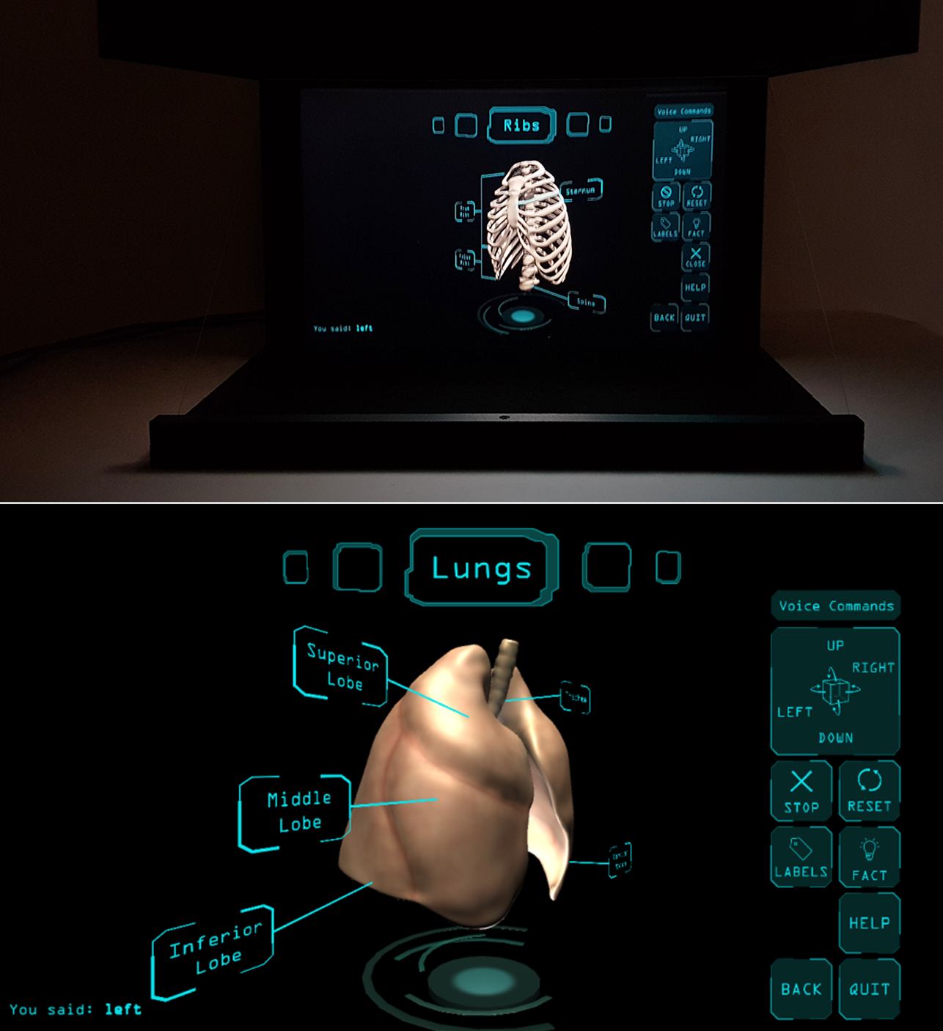
Figure 1. Dr Felicity DeBari Herrington - The HoloAnatomy application in combination with the HoloViewer, a cost-effective holographic projection system controlled by voice command suitable for educational environments. (https://youtu.be/0gv3E6kqnHI)

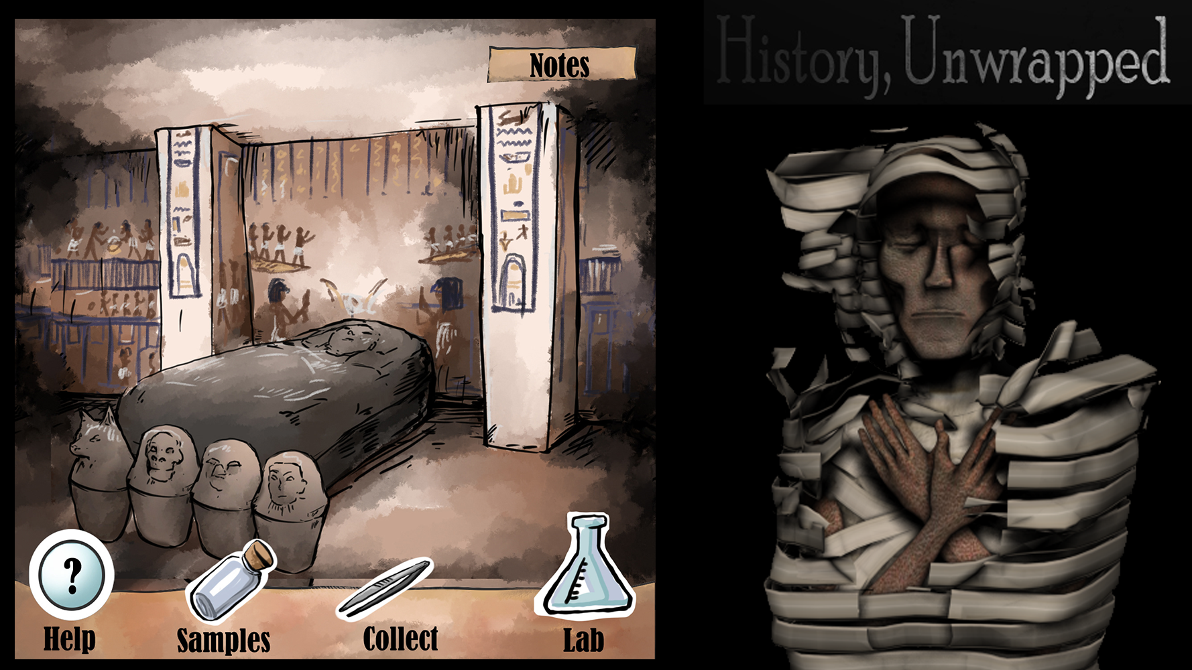
Figure 2. Isabella Bushko – History, Unwrapped: An educational game in the Ancient Egypt, designed to teach about polyomics, the umbrella term that relates to fields such as genomics, transcriptomics, proteomics, metabolomics, and epigenetics. (Play: https://izaink.itch.io/history-unwrapped)

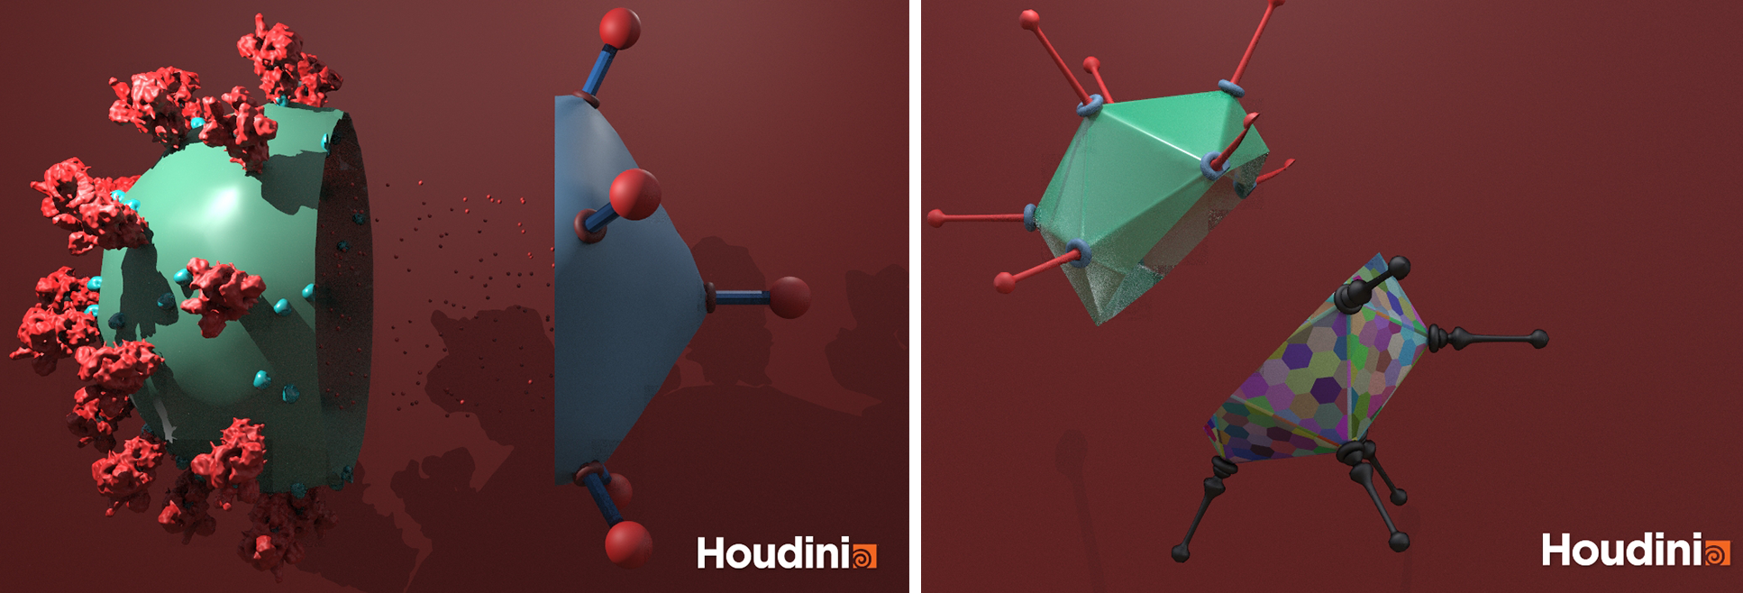
Figure 3. Harrison Wong – Virus Procedural Modelling in Houdini: Left: full render of the bisections of a simplified SARsCoV2 (left) and an Adenovirus (right). Right: full render of the bisections of a simplified Adenovirus (top) and an abstract Adenovirus-like virus (bottom).
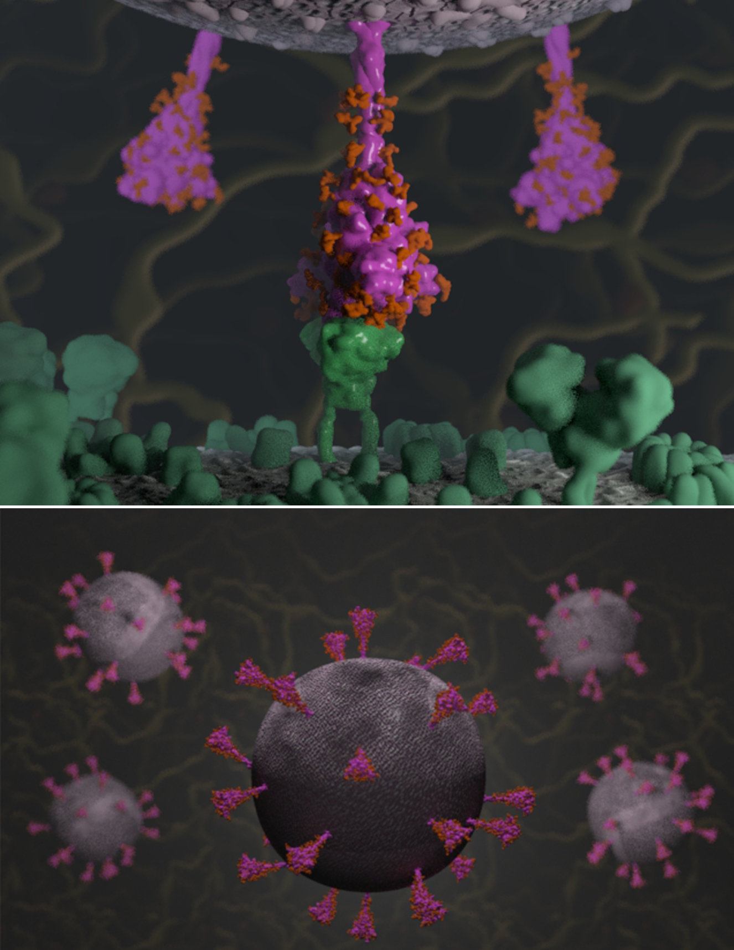
Figure 4. Sarah Iannucci – SARS-CoV-2 Spike Protein Mutation Explorer: An online interactive app to explore the SARS-CoV-2 spike protein and how mutations can bring Variants of Concern. In association with the MRC-University of Glasgow Centre for Virus Research and the COVID-19 Genomics Consortium UK. ( https://www.sarahmiannucci.com/dissertation, Explore: https://sc2-application.itch.io/sars-cov-2-mutation-explorer)

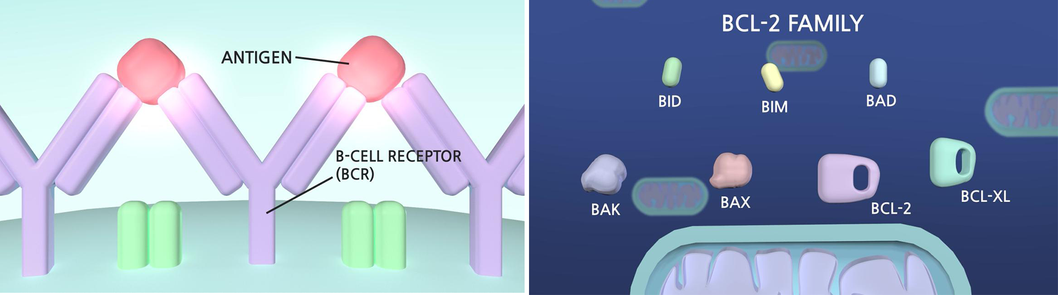
Figure 5. Gain Hahn – Animation of B-Cell Malignancies, and IBL-202, an inhibitory drug that aims to treat B-cell malignancies. In collaboration with Inflection Biosciences and Trinity College Dublin. (https://youtu.be/ve5bkA_N-fw)

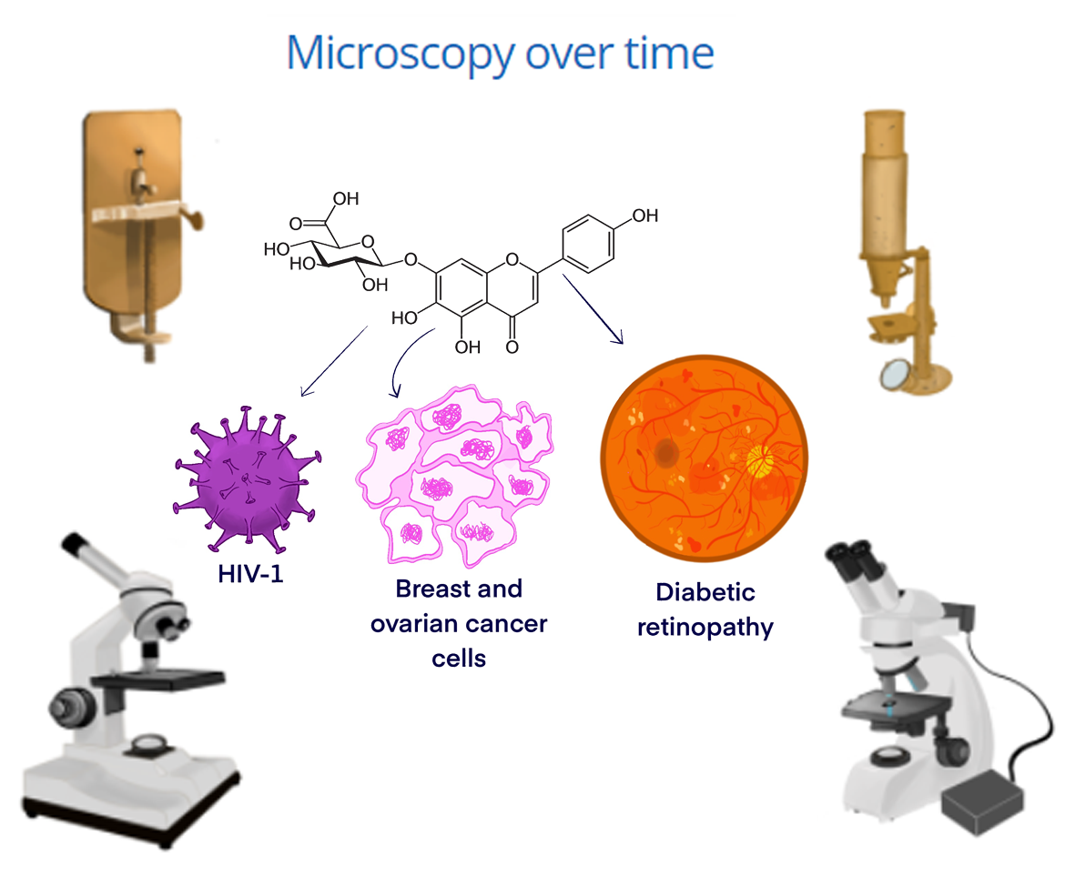
Figure 6. Mary Margaret McKillop – Focus on Education: Interactive illustrations and animations to help final year Physiology and Neuroscience students become more familiar with imaging techniques and high-level lab equipment as confocal or other fluorescent microscopes.
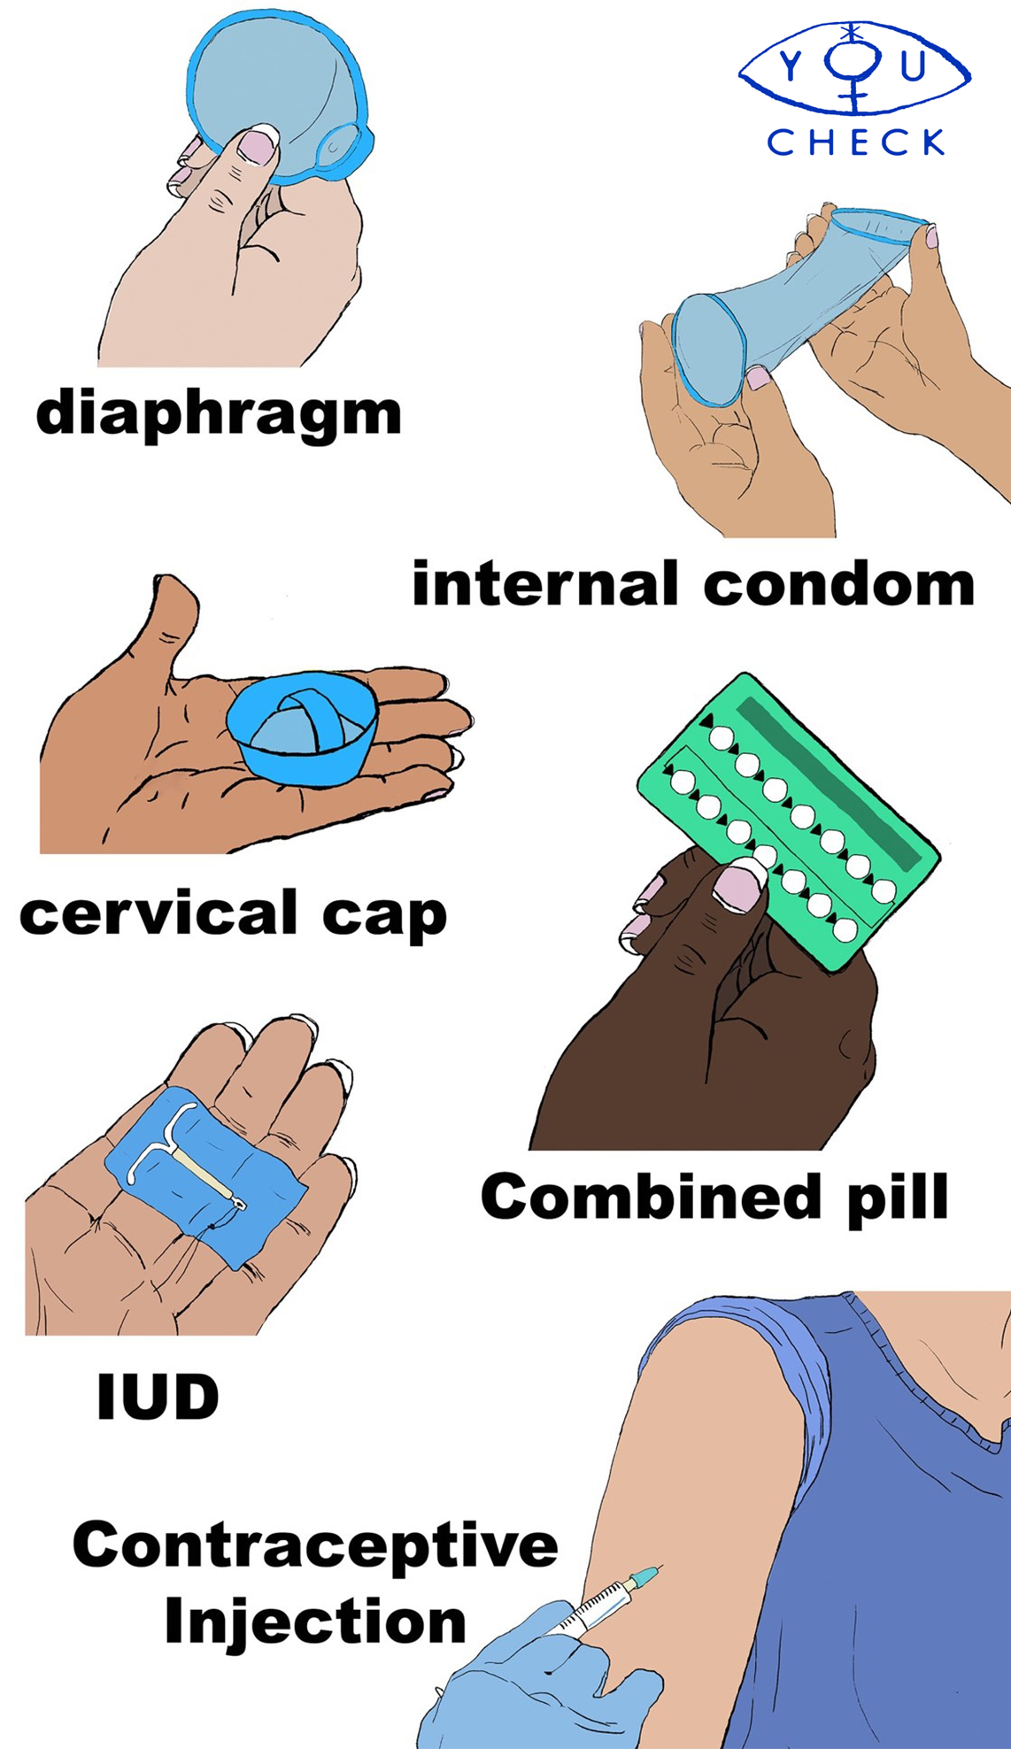
Figure 7. Lea Mariella Brinon – You Check: an online application designed focusing on ableism in medical practice, providing accessible information on Sexually Transmissible Infections available via Voice Control, and conventional computer interactions. (https://vimeo.com/595511595#)

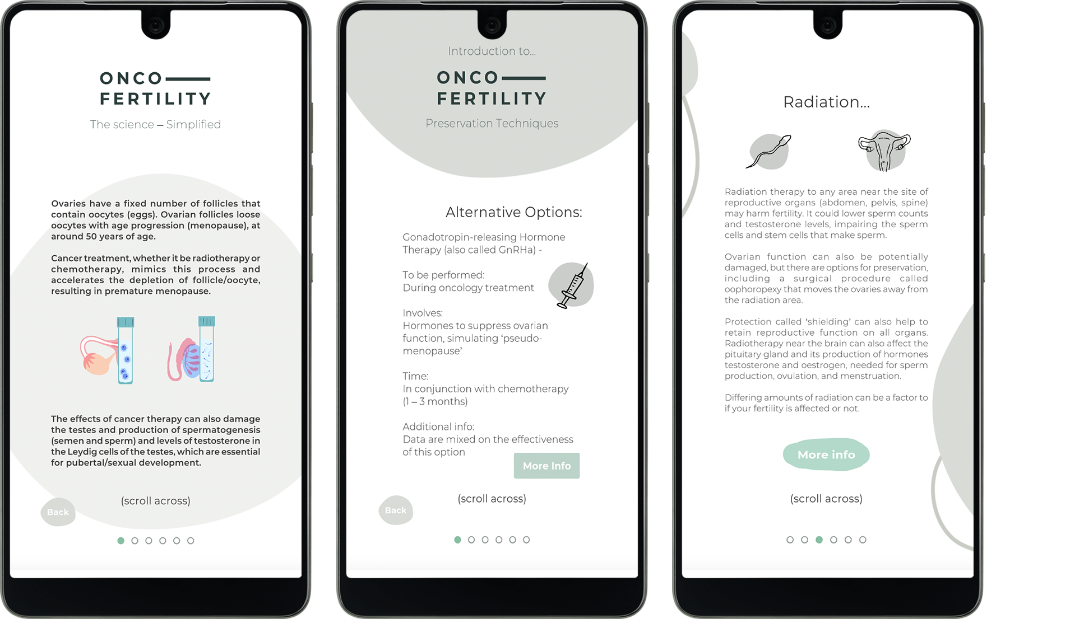
Figure 8. Jo Barton – OncoFertility: An android mobile application, built upon a collaborative design approach, to help supporting the specified audience of young people who are facing cancer and fertility treatment options.

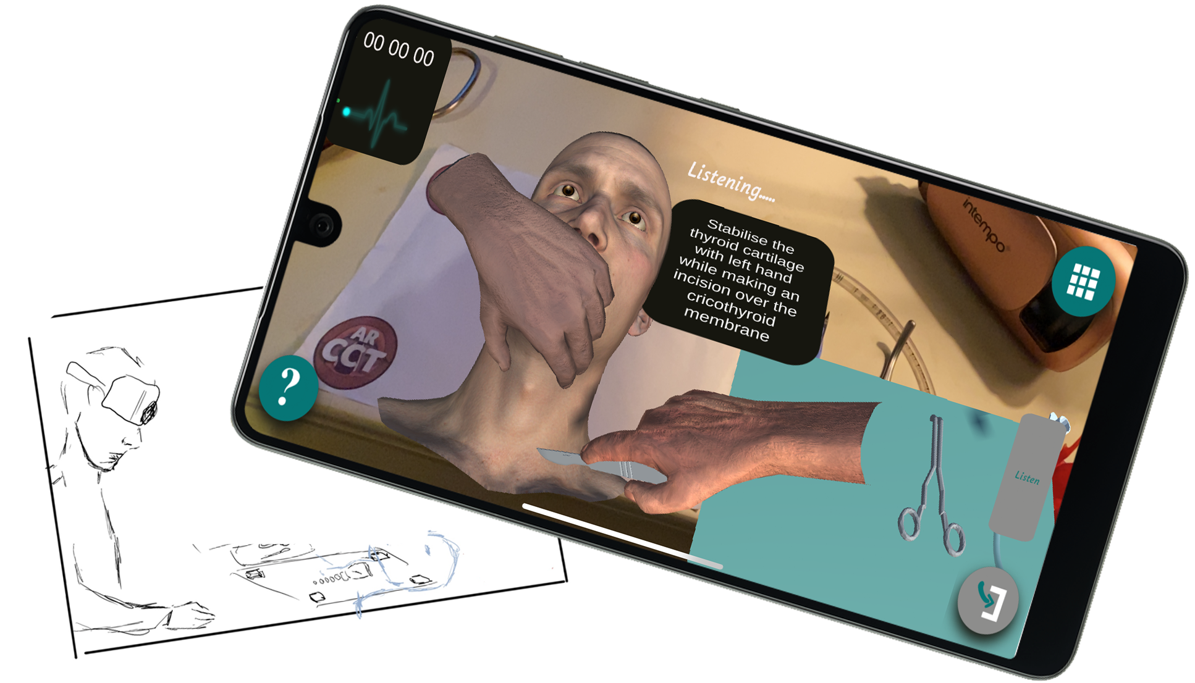
Figure 9. Dr Victoria Carswell – AR CCT: An Augmented Reality mobile application used with a 3D printed larynx, to increase junior surgical trainees’ confidence and practical skills in managing airway emergencies. In association with the Royal hospital for children Glasgow and Raigmore Hospital, Inverness, Scotland.
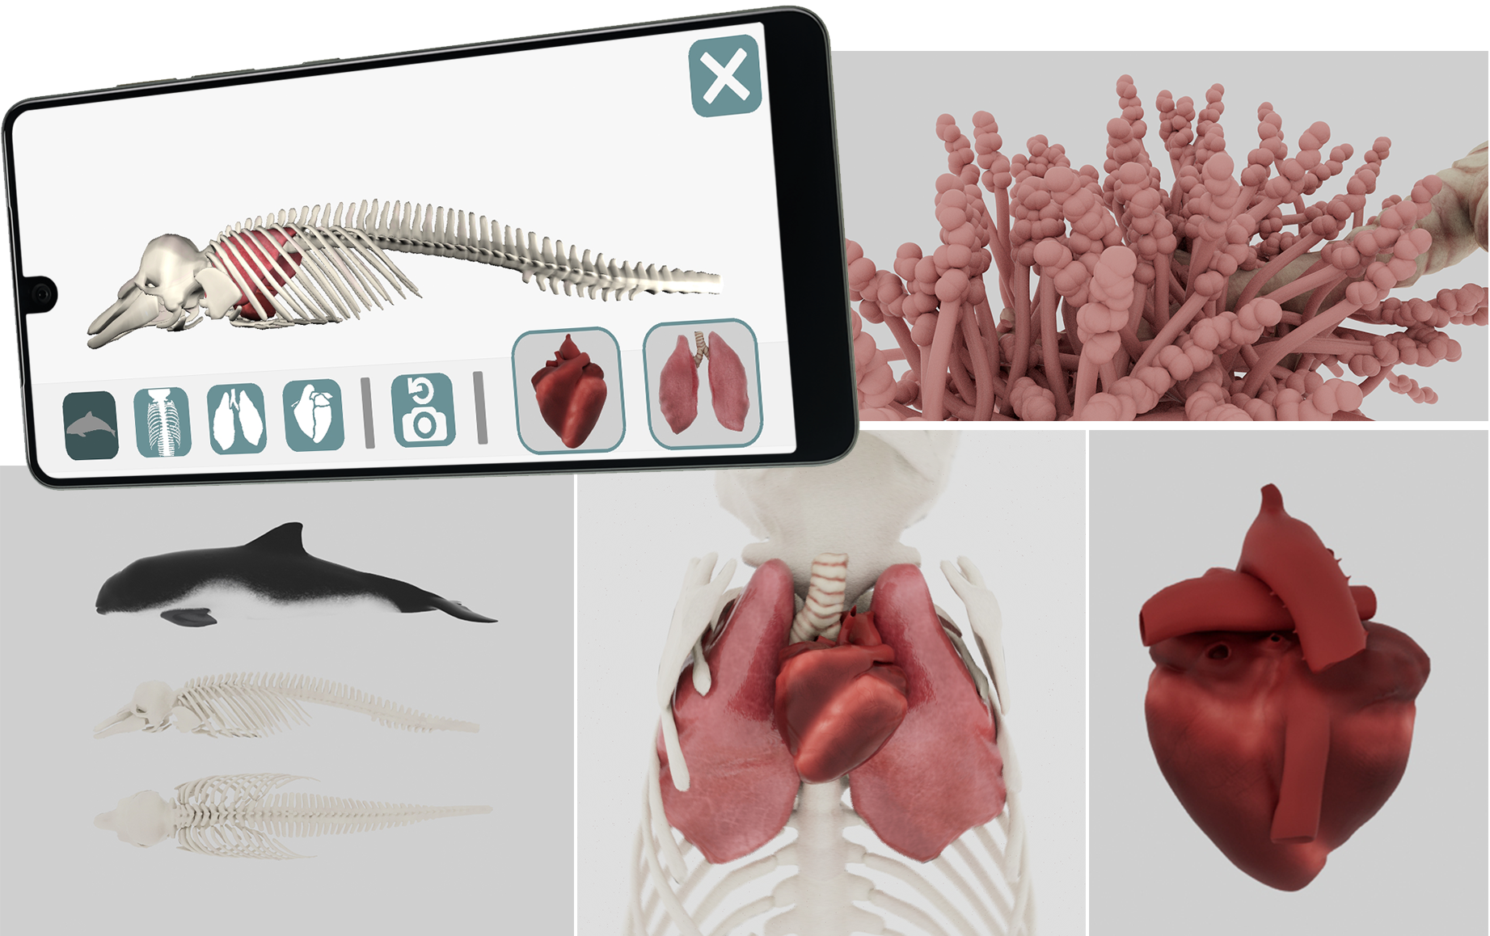
Figure 10. Niamh Mundy – The Digital Dolphin: An android mobile app that consists of anatomically accurate interactive and animated 3D models that demonstrate the thoracic anatomy of a harbour porpoise. (https://www.youtube.com/watch?v=tAxaVYynrj4)

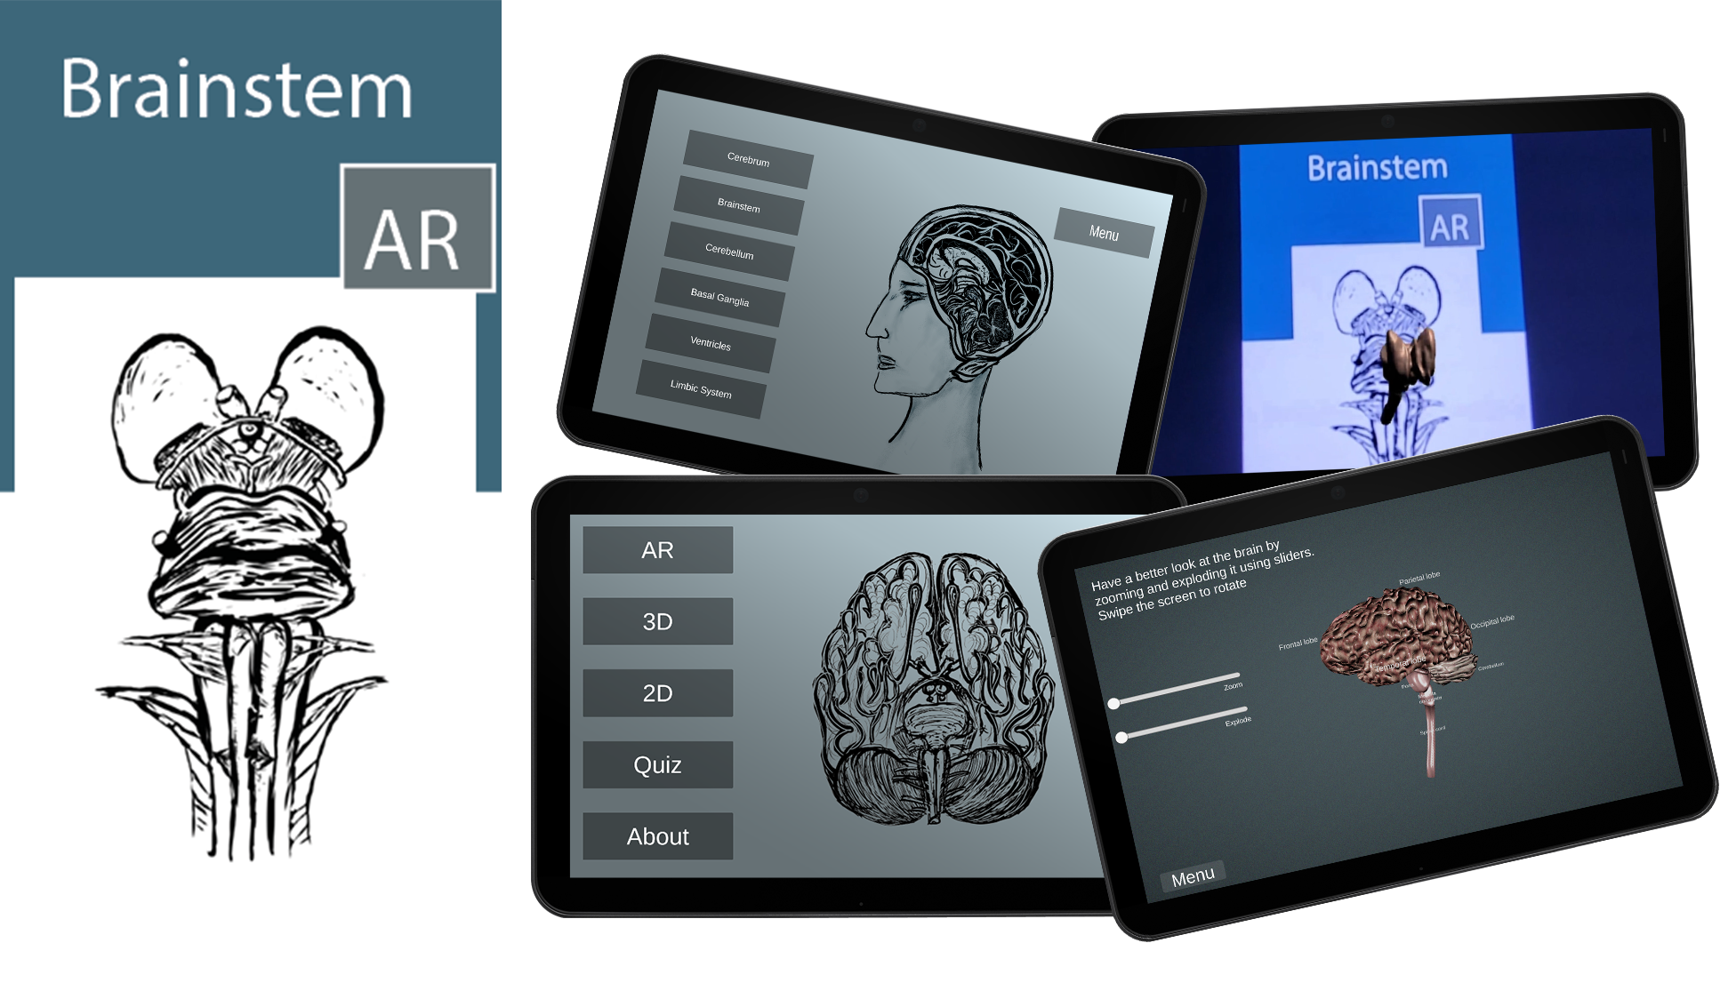
Figure 11. Yuliya Chystaya – Brain in AR: An Augmented Reality mobile app for Android devices to explore the human brain anatomy. (https://youtu.be/HRQ_pJi8ZcI, Explore: https://issuu.com/y.chystaya/docs/booklet)
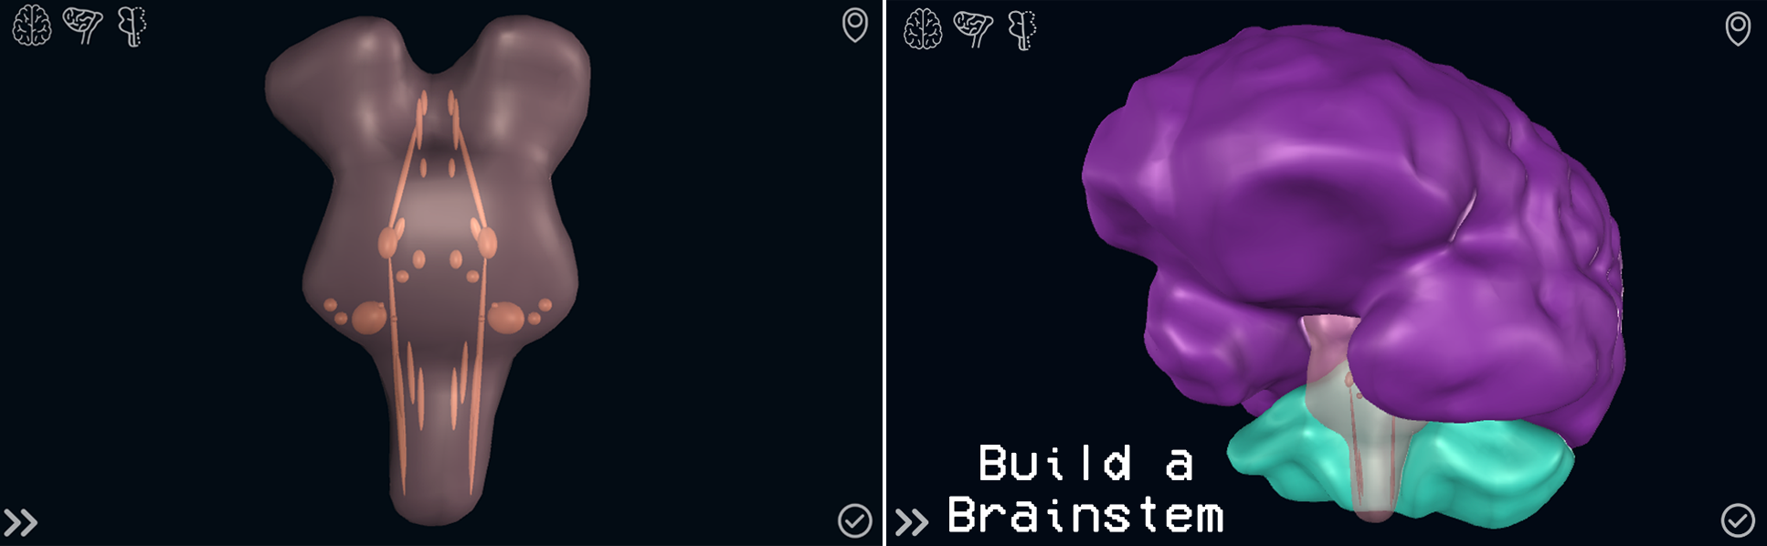
Figure 12. Sinaoife Andrews – Build A Brainstem: An online application that allows exploring the different cranial nerve nuclei and challenges the user with a series of interactive activities (Explore: https://sinaoife.itch.io/build-a-brainstem)

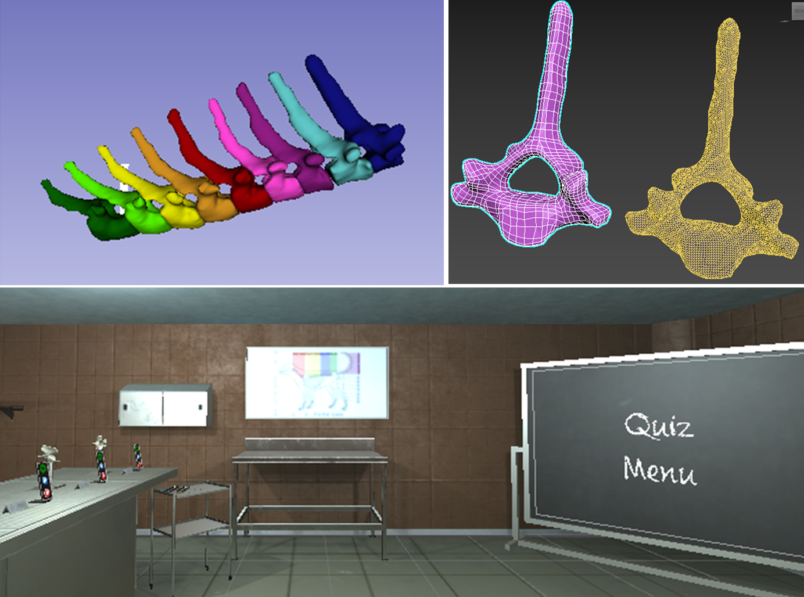
Figure 13. Hannah Horne - SkilletonVR: A VR application that aims to aid to the learning of the canine skeleton using Oculus Quest2. Vertebreas were reconstructed from volumetric dataset and educational content was designed in collaboration with the University of North Carolina and University of Berne. (https://youtu.be/wXv0Fg-k2Tw)

