Addressing Infection Risk in Veterinary Practice through the Innovative Application of Interactive 3D Animation Methods

Alastair S. Macdonald, Glasgow School of Art * ORCID ID: 0000-0001-9282-6229
Mark A. Chambers, University of Surrey ORCID ID: 0000-0002-8073-8069
Roberto La Ragione, University of Surrey ORCID ID: 0000-0001-5861-613X
Kayleigh Wyles, University of Surrey ORCID ID: 0000-0003-3205-9595
Matthieu Poyade, Glasgow School of Art ORCID ID: 0000-0002-7229-949X
Andrew Wales, University of Surrey ORCID ID: 0000-0002-8657-3007
Naomi Klepacz, University of Surrey ORCID ID: 0000-0001-7552-8000
Tom R. Kupfer, University of Surrey ORCID ID: 0000-0001-6344-2808
Fraje Watson, Fitzpatrick Referrals
Shona Noble, Glasgow School of Art

* Corresponding author:
Professor Alastair S Macdonald, Senior Researcher School of Design
The Glasgow School of Art, 167 Renfrew Street, Glasgow G3 6RQ
Email: a.macdonald@gsa.ac.uk

Addressing Infection Risk in Veterinary Practice through the Innovative Application of Interactive 3D Animation Methods

Abstract
Antimicrobial resistance is of growing concern in human and animal health. The aim of this study was to raise awareness and perception of risk of infection-related behaviours during routine preparation for veterinary surgery. We took a multi-disciplinary and multi-method approach to ‘make visible, the invisible’ by illustrating how microbial contamination can be spread during the preparation process for surgical procedures. The design-led visualisation approach enhanced inter-disciplinary team and workshop participant contributions during the co-development of an innovative digital tool to support training for veterinary practitioners and students. After experiencing the intervention, 92% of 51 participants agreed to change their behaviour and stated an intention to implement an infection control behaviour that aligned with training objectives. The 3D graphics enhanced the delivery of training content by making difficult and abstract contamination concepts easy to understand. A similar approach could be taken for human health applications.
Keywords
Infection prevention and control, co-design, digital modelling, visual software, clinical training

Introduction

Antimicrobial resistance (AMR)
The World Health Organisation (WHO, 2017) defines antimicrobial resistance (AMR) as ‘the resistance of bacterial, viral, parasitic and fungal microorganisms to antimicrobial medicines that were previously effective for treatment of infections’. Increasing numbers of resistant infections are leading to many antibiotics becoming less effective (WHO, 2018). O’Neill (2016) predicts that the toll on human life due to AMR will exceed 10 million annually by 2050. As a consequence, it is the subject of increased attention from, e.g., the European Commission (2016), WHO (2017), the UK’s research councils (MRC, 2018), and government (HM Government, 2019). As AMR bacteria are more likely to emerge and transmit genetic material conferring resistance in situations of higher microbial densities, effective infection prevention and control (IPC) is an essential component of tackling the AMR challenge in human and veterinary medicine.

Recent surveys across Europe (De Briyne et al. 2013) and in Australia (Hardefelt et al. 2018) reveal a positive attitude of vets towards greater antimicrobial stewardship (AMS). Both reports identify significant disincentives for its implementation and that the development of, and access to online courses and training on AMS targeted at vets could facilitate a positive change in practice. What, then, would be the most effective way would be to train vets to effect change in their practice? The uptake of appropriate IPC measures is heavily influenced by human risk perception and consequent behaviour and the way humans and animals interact with one another and with the physical environment of, e.g., the vet practice. Effective communication and teaching tools are therefore necessary to ensure individuals’ understanding and behaviours are in line with scientific recommendations. Mathematical algorithmic approaches, which can show, e.g., contact time, percentage of transfer, and growth of pathogens, etc., such as in Suthar et al. (2014), may be too abstracted and devoid of context to prove effective for situations familiar to practitioners. Prior work in the human health environment had suggested that a contextualised visualisation-led training approach might positively influence awareness and perception of these issues (Macdonald et al. 2017).

The aim of the study
The study’s aim was to develop a training intervention to change the perception amongst qualified and lay veterinary staff of the risk of infection-related behaviours during routine preparation for veterinary surgery using an innovative application of a 3D visualisation method. To achieve this we involved veterinary staff in both its development and to evaluate the effectiveness of the intervention.

The 24-month study sought to achieve proof-of-concept in building an interactive 3D visual training tool to ‘make visible, the invisible’ (microbes) and show how contamination can spread. Our hypothesis was that as practitioners interacted with the tool, both in its development and then in its application, they would gain a greater appreciation for where weaknesses lie in current practise and the impact appropriate IPC measures can have on infection control outcomes. Using the veterinary practice as a setting, we wished to develop a tool that would change the perception of risk of infection amongst qualified and lay veterinary staff (surgeons, nurses, and auxiliaries) with the intention to positively influence behaviours to minimise the risk of infection and ultimately the reliance on antimicrobials. By developing a tool that could also be used with veterinary students at various points in their education, we sought to embed a life-long awareness of infection control that had a lasting positive impact on the way individuals approach AMS once qualified and in practice.

Team expertise and site of study
The team comprised specialisms in the following: veterinary infectious diseases; applied psychology (with experience in developing and evaluating behaviour change interventions); veterinary medical practice (with expertise in environmental survival and antimicrobial/biocide resistance); veterinary nursing (to help implement the intervention at the site and assist in recruiting staff to evaluate the intervention); software engineering (with expertise in medical visualization); and the co-design and prototyping of healthcare interventions. Further input during developmental workshops, described in more detail below, was secured from veterinary clinical teaching fellows (VTCFs) at the University of Surrey. The site selected for this study was a large neuro-orthopaedic referral hospital in the south east of England dealing with companion animals (mainly dogs and cats), principally concerned with elective surgery and with an annual throughput (at 2018) of c. 2400 surgical procedures.

Methods

As ongoing reference to detailed visual data would be required by the software engineers during the development of the 3D tool and also by the team as a whole for ensuring accuracy of procedures and the identification and selection of risky behaviours, the filming of practitioners treating their patients was essential. Figure 1 provides an overview of the main stages and activities of the iterative co-design process.
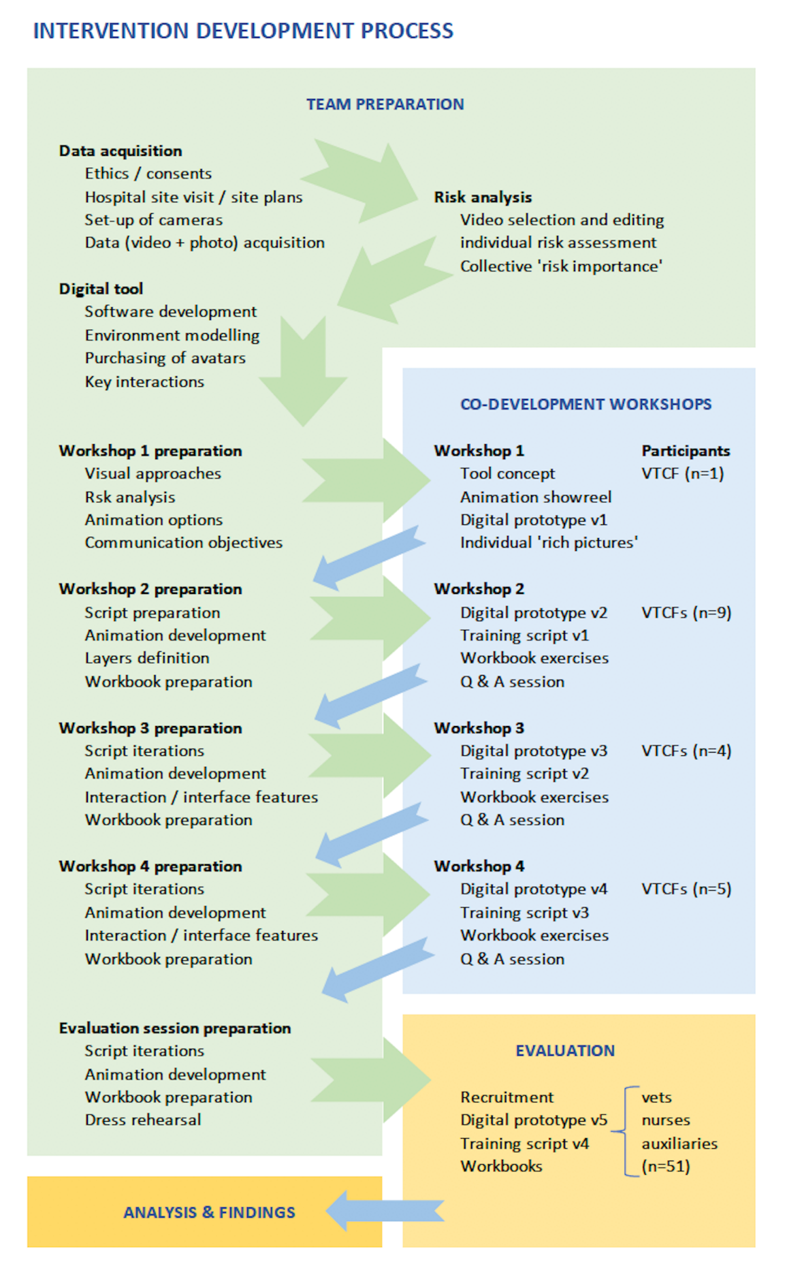
Figure 1: Flow diagram showing the main stages, methods, and iterative nature of the co-development process used in the AMRSim study.

In-situ capture of behaviours and interactions
Due to the presence of various opportunities for contamination and infection, the Tibial Plateau Levelling Osteotomy (TPLO) procedure, one of the most common orthopaedic surgeries performed on dogs with a torn cranial cruciate ligament, was selected for filming. We agreed with the hospital that perioperative TPLO procedures conducted on three canine patients would be filmed, allowing for the comparison of any common issues or variations between the same procedure for the different patients.

For compiling the 3D modelling and animation sequences, video data were gathered from these three entire patient journeys (i.e. through reception, consultation, pre-operative X-ray, preparation (induction of anaesthesia, clipping of the limb, skin preparation), surgery, post-operative radiography and into recovery (kennelling)) for the purposes of identifying those stages in the surgical procedure posing the greatest risk of introducing infection.

An initial reconnaissance of the site was made to determine the most suitable locations for cameras to efficiently capture both types of data. In total, 22 locations were covered using 14 small high-definition action video cameras, plus one head-mounted on a member of staff throughout the performance of the pre-surgical sequence for one patient as well as throughout that patient’s surgery. The process of filming was continuous to track the patients and staff through the various spaces and procedures in the hospital. Importantly, the recording was devised to be non-disruptive to staff activities and the clinical schedule.

Two types of video data were captured: 1) the flow of humans and animals within the veterinary practice; and 2) the interactions between humans, animals and their surroundings (e.g., person-person, person-animal, person-surfaces, and animal-surfaces). Approximately five hours of video footage was acquired for each of the three patient journeys. To assist the team in identifying risky procedures and behaviours, the footage was edited using Adobe Premiere into three circa 15-minute videos, one for each patient. The choice and editing of the footage was decided by whether it had shown key risky interaction events between patients, staff and equipment throughout the patient journey.

Determining infection risk from video data
Five of the team possessed the necessary veterinary sciences / microbiological expertise to identify from the video data, independent of one another, risks of contamination within the setting. One of the three edited videos was selected, providing a higher level of detail and proving the best for the identification of cross-contamination events (risk events), categorised as either low, medium, or high. Team members separately noted their perception of risk using a risk assessment log file detailing: its location (start time and duration) in the video; the nature of the interaction; the perceived level of risk this presented; what was critical about this and why; contact issues (which surfaces were involved); bacterial issues (how the bacteria might spread); and how the issue should be tackled. An example, completed by one of the team, is provided in Table 1.
Table 1: Extracts from a risk assessment log file completed by one of the ‘expert team’ (further detailed information was contained in the spreadsheet cells).
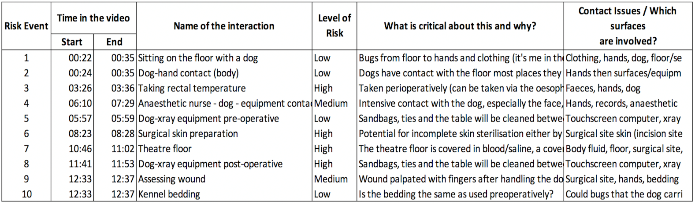
Responses from each of the five experts varied, therefore if a risk event was identified by three or more experts, then a mean risk score was calculated. The frequency of these events was estimated and multiplied by the mean risk to give the overall risk importance (risk importance = risk x frequency). Through this process, a total of nine risk events were identified and ranked in order of importance. The pre-surgical preparation stage was identified as the most critical for IPC breaches in the patient journey and so was selected as the basis for modelling the 3D animation in the digital tool and the development of the intervention. It was acknowledged that veterinary-patient interactions differ from human-patient interactions due to the need for closer contact in order to calm and reassure the patients; consequently, it was noted that staff hands and clothing were frequent contact points and that there were also frequent floor-based interactions.

Co-development workshops
Having selected the TPLO procedure to model, attention switched to how to ‘make visible the invisible’ microbes potentially present in that environment and how these could be spread through high-risk interactions identified from the video data during this pre-surgical stage.

A series of four exploratory, developmental and evaluation workshops was conducted as the basis for co-developing the intervention. These used a participative co-design approach, which had proven successful in developing, prototyping and evaluating prior visualisation-led healthcare interventions (e.g. Loudon, Taylor and Macdonald, 2014; Macdonald et al. 2017; Macdonald, 2018). Workshops involved all members of the team together with critical input from the VCTFs. The role of the VCTFs, as individuals external to the research team, was to contribute ideas and to evaluate the intervention’s effectiveness in communicating the intended messages and in meeting the training objectives of influencing awareness and perception of infection risk at each stage of development. One VTCF provided input into Workshop 1 (this workshop was largely research-team-focussed). Attendance for workshops 2 to 4 varied from four to nine VCTFs (recruitment depended on their duties on the day) but these numbers sufficed for the study’s purposes.

Workshops were structured as per the activities described below. All participants’ responses were captured via audio-recording and in pre-prepared workbooks employing some visual content to help VCTFs – and team members - overcome reluctance or hesitancy in recording responses in diagrammatic or drawing form. Findings from each workshop provided the basis for team discussion and subsequent development.

Workshop 1, designed primarily as a team-building and team-focussed event, explored options for communicating bacterial presence and contamination spread by evaluating a number of visualisation approaches including: video-based watch-and-click-type ‘bad-practice’ training tools (e.g. Millman et al. 2017; AHDB, 2015; Clinell, 2020); agent-based modelling (computational models for simulating the actions and interactions of autonomous agents with respect to their effects on the system as a whole, e.g., GISAGENTS, 2015); events simulation (essentially dynamic data-fed flow charts which can also be presented in a simulated ‘realistic’ mode, e.g., Micro Saint Sharp, 2015); and simulations of the spread of infectious diseases (e.g., Hurd Health, 2013). A short pilot digital animation, modelling one human and one canine avatar within a simple setting was prepared (Figure 2) serving two purposes: to provide a tangible example of how the 3D animations might look and perform; and to provide image-grabs for participants’ workbooks for their annotations on how they thought contamination and IPC measures should be portrayed (Figure 3). As a number of the study’s issues were ill-defined, a schematic inspired by a ‘rich picture’ technique (Berg and Pooley, 2013) was requested of each of the team to elicit their view of the tool’s desired functionalities, as well as its interface design characteristics (Figure 4).

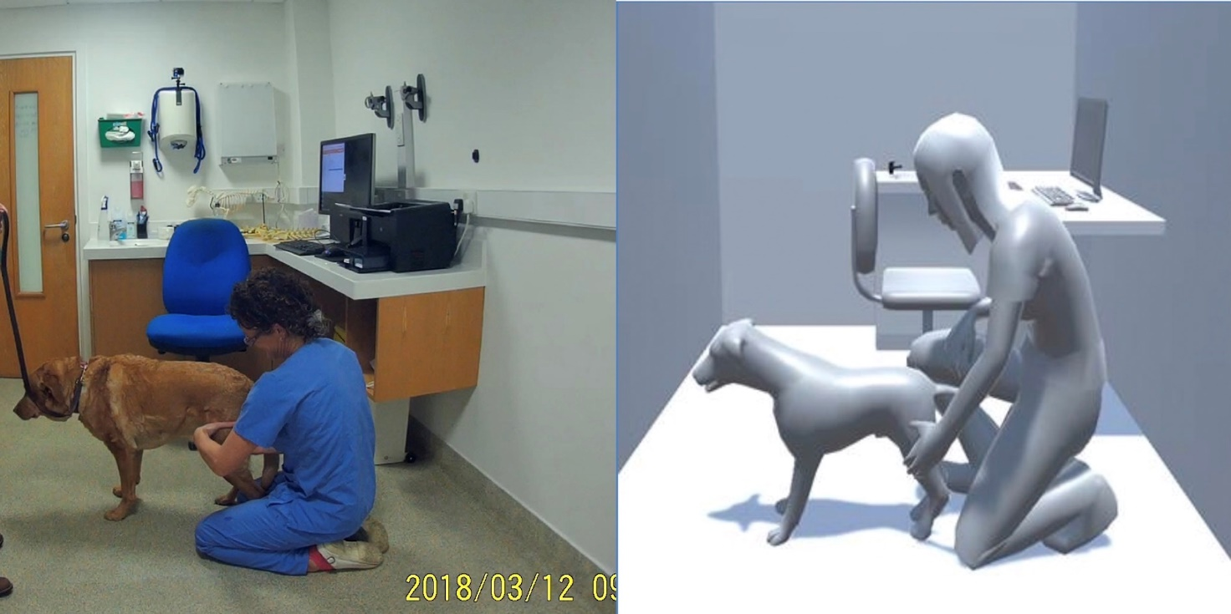
Figure 2: A sequence from the video data (left – still from video) was utilised in the building of the pilot digital 3D animation (right) to show interaction between avatars and promote discussion, in workshops, of the key visual information which the tool would require.

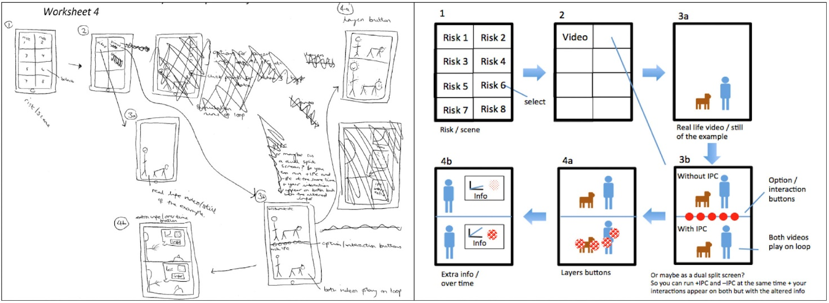
Figure 3:A ‘rich picture’ (left) developed by one of the team, in this case by the vet practice nurse, of how bacteria and risk events might be displayed digitally, and a ‘tidied-up’ version (right) used to communicate this more clearly amongst team members.
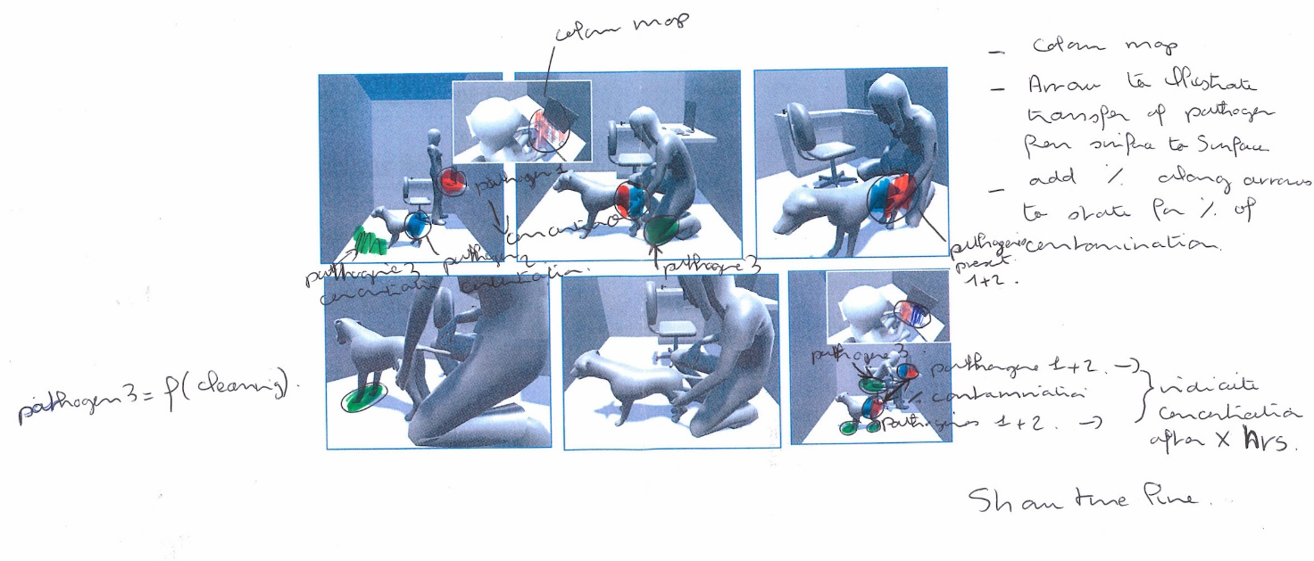
Figure 4: Workshop 1 exercise, annotating workbook image grabs of the pilot digital model, to illustrate how the chain of infection is spread through contact between animal, human and various surfaces including clothes and skin.
A number of ideas emerged during this workshop triggered by the ‘rich pictures’ exercise to influence forward development including: options for switching on/off different layers of data; scenarios which enabled comparison of IPC protocols when in place (IPC on) and when not in place (IPC off); bacteria made visible/invisible; and key interface functions for the tool such as zoom-in/zoom-out; switch on/off data layers; and with/without IPC. Due to time pressures on practice staff, a target time of 30 minutes for the training session was agreed, i.e. appropriate for in-service training during a lunch break or an end-of-shift training session. During Workshop 1 the need for a detailed ‘script’ (detailed below) to guide the delivery of the intervention also became apparent.

For Workshop 2, to enable the team to gauge the appropriateness of the modelling approach, a more developed 3D animation showing short animal-human sequences, incorporating features suggested in Workshop 1, was modelled and used to support and rehearse a first ‘mocked-up’ version of the intervention using an initial script. Participants then evaluated the relevance and suitability of the animation sequences to support the training script. Workshops 3 and 4 were a continuation of this process using feedback to refine the script, the digital modelling and animation sequences and the tool’s controls, and to evaluate the latest version of the prototype with external participants. Workshop 4 additionally comprised a full rehearsal of the deployment of the intervention using the most recent version of the script and tool to identify any refinements prior to the final evaluation session.

In each workshop, following the latest run-through of the intervention, a discussion was promoted through a series of questions from the team. For example, for Workshop 4 these were: What was it about the way we’ve visualised this that would help non-clinical as well as clinical staff to understand the issues? What has persisted, in your mind’s eye, from the animations used in the training intervention? How well did you think the layers worked (e.g., with and without infection control measures) and is there anything you feel could be improved about this? Participants’ responses were helpful in giving the team confidence their development was progressing towards the desired goals, e.g. (from Workshop 4 participants):

…You can see the whole process, and all the little things that are risk factors in that whole process. And if you'd just stood there and you'd given us a lecture, or a talk, and said, just listed these things, you would never have covered them all, and you'd never have actually, I wouldn’t have seen them all in a joined-up kind of way. And you can see how the first person touching the dog, near the beginning, then leads to further contamination later. And I think that holistic joined up thing is important…

…I think in terms of set-up, because it's fuzzy and grey, [i.e. Figure 5] it's suitably generic. I think everyone can see that that is a prep room, and they can imagine how that practice situation works. And it doesn’t matter that it's not realistic … and anyone who works in a veterinary practice, can relate to that process…

… I think perhaps clinical people will inherently know where the problems are, but maybe ignore them, or forget about them when they’re working. But then, non-clinical people will probably benefit more from the red patches. Because it really highlights to them where, what it means if you touch your head, and then touch the dog …
… I don't know whether it's 'because it's University training, but microbiology was like quite an intense subject, where we just learning about lots of different infections. But actually, applying that to real life, you know, wasn’t necessarily done, it was just a lot of knowledge, … the perception of what that meant in reality, wasn’t there. So it was quite a good link there to see that, and put it into place, or how that actually comes into your day to day life, as opposed to theory…

The outcome was a tool with three ‘layers’ of visuals: Layer 1, a monochrome layer, which provided a set of sequences (described below) carried out in the pre-surgical stage and showing the actions and interactions of three human and one canine avatar within the preparation area (Figure 5); Layer 2, the ‘contamination’ layer, showing the potential transfer of microbes during the procedures in the preparation stage and which could be switched on and off (Figure 6); Layer 3, the IPC layer, which again could be switched on and off (Figure 7). Further details of the tool are provided below.

Figure 5: Layer 1 showing the pre-surgical procedure with in-built risky behaviours. Accuracy of detail of procedures and behaviours was key. Inaccuracies, such as incorrect intubation, proved distracting to the vet staff in the early iterations of the model.

Figure 6: Layer 2 'switched on' to show transfer of 'invisible' contamination between animal, veterinary staff, surfaces and equipment during a pre-surgical procedure if proper infection control measures are not being observed.

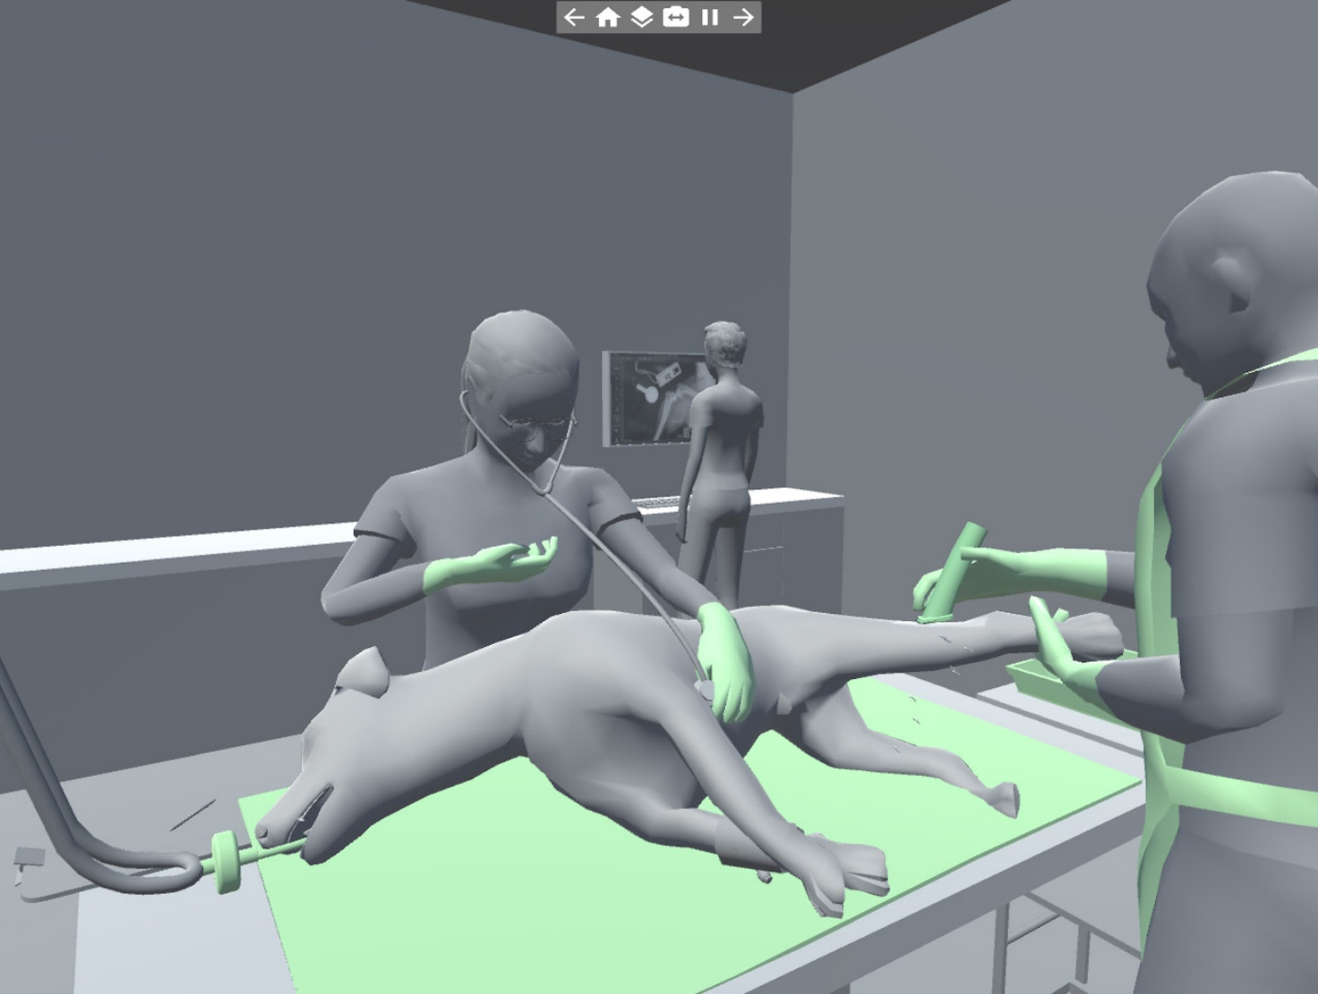Figure 7: Layer 3 showing ICP measures in place. These took the form of, e.g., protective clothing, such as gloves and aprons, sterilised equipment, or disinfection of the site of surgery.

The intervention ‘script’
The need for a narrative or ‘script’ to structure the content and ensure correct delivery and interpretation of the intervention became evident early on and was consequently developed concurrently with the digital tool. This was iteratively developed between workshops, assisting the team in creating appropriate animation sequences to meet the main training objective, and rehearsed and revised using a table matrix, comprising the facilitator’s text, duration, and notes relating either to the section of the animation to be shown or actions required by those assisting with the intervention (Figure 8). The script used in the final evaluation session was structured as follows: 1) the facilitator’s welcome and introduction; 2) a first run-through of the animation sequences in Layer 1 requesting participants identify and note contamination risks; 3) a second run-through of Layer 1 sequences to share notes of contamination risks amongst the group and to compare these with a list of risks determined by the research team; 4) a third run-through of the sequences, this time with contamination Layer 2 switched on as a prompt for further group discussion about what appropriate IPC measures might improve outcomes for getting the patient into the operating theatre with as little contamination as possible, both on it and left behind in the preparation room; 5) a final run-through of the sequences, this time with the IPC Layer 3 switched on showing the microbial barriers and disinfection measures typically used in good veterinary practice. The IPC measures interacted with the microbial contamination layer, showing the difference IPC might make to the outcome when compared to a situation when no IPC measures were in place. To record participant responses during the intervention, a format for participant workbooks was also developed 1) as a space to make personal notes and to aid personal reflection on their own experiences and behaviour; and 2) to obtain immediate feedback by assessing perceptions and self-reported behaviour before and after the workshop.

At each stage of the training session there was a clear objective, question, discussion and ‘reveal’ when each layer of the animation was switched on to allow participants to gauge the accuracy of their prior responses and for the purposes of promoting further discussion between the facilitator and participants. It was calculated that a total of circa 5 minutes of animation would be required to support the intervention script.

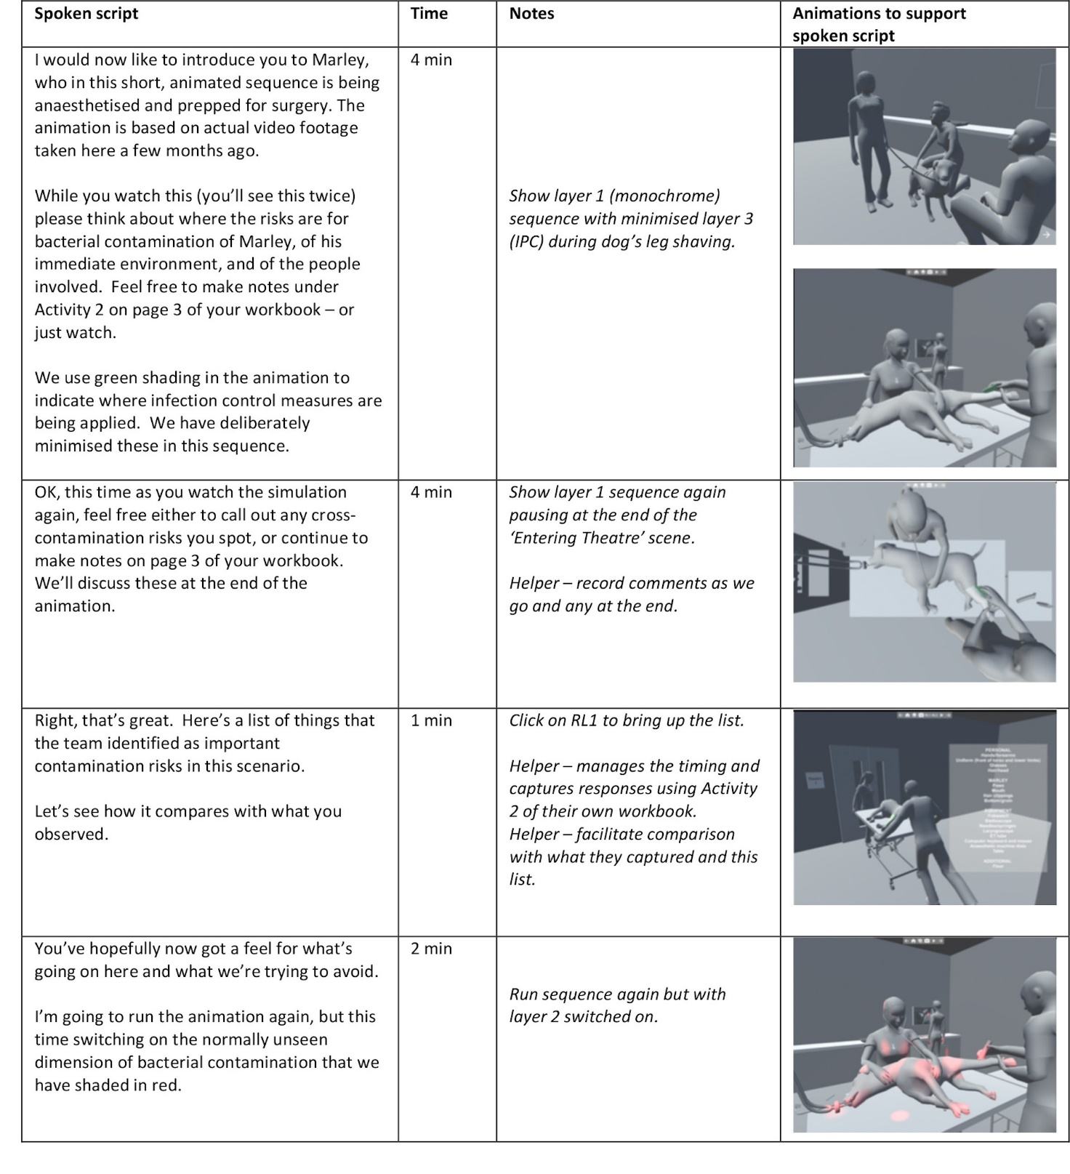
Figure 8: Extract from the script as deployed in the final intervention evaluation session. For the purposes of this paper, image-grabs from the animations have been added to this to enable the reader to see the animation sequences which accompanied the spoken script.
Determining the animation sequences
An agile software engineering design approach was used to generate a series of system and user requirements and to provide a functional description of the digital tool. Modelling, animation and game programming technologies were used to implement the tool guided by the scripting as discussed above to ensure that it satisfied previously defined functional requirements and training objectives.

The animations were evolved iteratively using the feedback from each of the workshops. An early pilot animation was prepared for Workshop 1 as described above. In Workshop 2 the use of a large-scale interactive smart-screen allowed workshop participants to elaborate their ideas in response to prompts from the team’s veterinary nurse regarding potential risky infection sites. By Workshop 3, a fuller set of pre-surgical sequences had been modelled incorporating ideas from Workshops 1 and 2, but as the tool was still in development, the 3D digital prototype was supported by a series of power-point slides to mock-up its intended appearance and functionality. Animations were checked, on an ongoing basis, for their fidelity to operative procedures by the practicing vet surgeons and nurses (i.e. both by those within the research team and by the VTCF workshop participants). This proved useful in identifying inaccuracies within procedures, e.g., the intubation tube being inserted upside-down, clippers not being properly held, and staff petting the patient insufficiently to keep it calm.

By Workshop 4, the sequences and functionality of the digital tool were well developed, and modelled the human-animal-environment interactions as a sequence of animated sub-stages incorporating risky behaviours (indicated in italics), as follows:
1. The opening scene showing the three human avatars (vet surgeon, vet nurse and vet auxiliary) involved at various stages in the sequence, and the canine patient avatar
2. The nurse bringing the patient from the kennels into the preparation area
3. The veterinary surgeon administering intravenous drugs to induce anaesthesia, with the patient being held by a nurse and assisted by an auxiliary on the floor (the patient is lying directly on the preparation room floor while receiving treatment)
4. The patient being lifted onto the table (the patient contacts the nurse’s and auxiliary’s clothing)
5. The nurse holding the patient’s head up and mouth open so that vet can intubate (i.e. place the endotracheal tube) (the patient is held against the nurse’s body during treatment, hair-touching, touching watch)
6. Nurse attaching the patient to the anaesthetic machine for the maintenance of anaesthesia
7. The auxiliary shaving the patient’s limb to remove hair, and cleaning and sterilizing the site for surgery (using the hair clippers on one animal, no effort to contain the hair).
8. The auxiliary and nurse wheel the prepared patient into theatre on a trolley

The 3D digital tool

Avatars, spatial environment and procedures
After obtaining a clear understanding of the procedures, interactions and behaviours to be modelled, and of how the tool was to support the facilitator delivering the intervention, Autodesk 3DSMax was used to digitally recreate the veterinary practice environment, and the game engine, Unity, used to animate interactions and behaviours. The original 3D digital models of the veterinary practice environment and appliances were produced in Autodesk 3DS Max and imported into Unity as FBX files. The three human and the canine patient avatars were purchased as ready-made models from the Unity Asset Store. Integrating the 3D models into Unity Game Engine enabled real-time user interaction. The functional requirements for the tool were developed to allow for: 1) the selection and playing of individual sequences; 2) the choice of view for each of these sequences from within the 3D tool; and 3) the ability to switch on and off the contamination and IPC layers.

The graphical user interface
To support interactions with the models the graphical user interface of the digital tool was developed on Unity 2018. C# programming enabled the support of real-time user interactions. All coding was done in Microsoft Visual Studio Community. Simple mouse interactions allowed control of the user viewpoint with options to select the camera orientation and field of view, and to zoom in and out of relevant sections of the 3D model.

The on/off toggle of the contaminated areas was achieved using the basic functionalities of the Unity physics engine to detect collisions between 3D models. When a contaminated area from a 3D model collided with a non-contaminated area, a red shade was ‘switched-on’ using the Unity projector function, above the surface of the non-contaminated area visually turning that area into a newly contaminated area. IPC measures were visually represented by changing the texture of objects (e.g. aprons, clippers, gloved hands and disinfected areas) from the base monochrome to green.

Evaluation

The intervention was evaluated in the form of an extended training workshop over three days in late July and early August 2019 in the project partner’s setting. Three of the team delivered this in one of three roles: 1) facilitator; 2) recruiter and note taker; and 3) survey (workbook) distributor. Nine separate sessions were delivered to a total of 51 staff. These sessions lasted between 21 to 25 minutes, with the majority of staff making notes in their workbooks and contributing to open discussions. Of the 51 participants, 46 were female (90.2%) and five males (9.8%) and the average age was 29.4 years (range 19-54 years). Twenty-one (41.18%) were veterinary nurses, seven (13.73%) veterinary surgeons, 19 (37.25%) auxiliaries, and four (7.84%) other roles including pharmacy and physiotherapy.

The format of the session was as described in the run-through of sequences in ‘the intervention script’ section above. Immediately prior to the session commencing, a workbook was issued to question (using Likert scales) participants’ level of concern about the risk of pathogens spreading in the workplace and how informed they felt about IPC measures. During the showing of Layer 1 (the monochrome layer), they were asked to note (in free text) what they considered were the risks for bacterial contamination of the patient, of its immediate environment, and of the people involved. After viewing Layer 2 (the contamination layer), they were asked to note (in free text) what one could do to get the patient into theatre with as little contamination as possible, to minimise contamination left behind in the prep room, and what IPC interventions they would propose to promote this. At the end of the session and after viewing Layer 3 (the IPC layer) they were asked to respond to the same set of workbook questions as at the outset, again using Likert scales.

Findings

The findings here relate to the responses gained immediately before, during and immediately following the deployment of the intervention. All participants (100%) completed the workbook, consenting for their data to be used to examine immediate before and after effects. The participants indicated that they felt significantly (p<=.001) more informed about infection control after attending the workshop. When asked, 92% of participants agreed to change their behaviour and stated an intention to implement an infection control behaviour that aligned with the learning objectives of the workshop by increasing hand hygiene (31.37%), wearing gloves (15.69%), wearing protective clothing (15.69%), reducing unnecessary touching of animals (11.76%), being more aware of self-touching face, hair and glasses (19.60%), and intending to clean their equipment, work area or touchpoints more frequently (17.76%). Participants found the 3D graphics enhanced the delivery of the workshop content by making difficult and abstract concepts easy to understand and it was considered overall a ‘very good visual representation’ of pathogen transfer. Feedback also indicated participants found the trial ‘interesting’, ‘important’, ‘beneficial to practice’ and that they could see the potential for others to similarly benefit. Indeed, suggestions for improving the intervention included making it more widely available, increasing the frequency of workshops and diversifying to include other specific aspects of infection control practice, such as kennel care.

Discussion

The intervention in this context was intended to change the perception of risk of infection in veterinary staff. The findings above reflect progress we made towards achieving that aim. The findings from the evaluation of the intervention support our hypothesis that as practitioners interacted with the intervention tool, both in its development and then in its application, they would gain a greater appreciation for where weaknesses lie in current practise and the impact that appropriate IPC measures can have on infection control outcomes.

An accessible approach for practitioners
As far as we can determine, this is the first time an interactive 3D visualisation approach has been used for IPC training in a veterinary setting. Prior visual approaches used in veterinary training have involved the types of watch-and-click videos (such as Millman et al. 2014, referred to in the Workshop 1 section above) concerned with biosecurity. Resources for human health scenarios are similar, instructive of proper procedures to observe (e.g. Clinell, 2020), without necessarily changing one’s perception of risk. Although the team was initially inspired by the approach of Suthar et al. (2014), who took an algorithmic approach to model the effects of contact time, percentage of transfer, and growth of pathogens etc., on reflection early in the project we felt that pre-occupation with this type of quantitative data might have defeated the overall intention of changing the perception of risk. Whilst presentations of these types of quantitative data are published in academic journals to inform best practise in IPC, they seldom incorporate multiple factors and are devoid of context, its complexity and the vagaries of human behaviours, thus having limited impact on how practitioners understand and practise IPC in their working environment.

To this end, the broad range of visualisation options considered in Workshop 1 were crucial for understanding and identifying the most appropriate approach to visualisation for the target audiences and to meet the study’s aim. As stated above, the rich pictures from Workshop 1 also gave early insights into the end-user requirements for functionality and the kind of visual information beneficial to them. Throughout its development, the visual approach proved highly accessible to the workshop participants who were immediately able to identify errors in the portrayal and accuracy of behaviours and procedures in the digital tool. The software engineers were able to rapidly amend the model to accommodate these changes through frequent iterations shared amongst the team between workshops: having the partner practice’s experienced veterinary nurse as part of the team was crucial to this process.

Digital ‘Realism’
There can be a tendency in digital modelling to build as photo-realistic a simulation of the actual environment and its individuals as possible. In previous work in the human health environment (Macdonald et al, 2016), healthcare participants’ feedback had requested a high degree of visual reality in the ward detail but difficulties were encountered in overlaying this with microbial information which was visually legible. Although the video and photographic data captured at the outset of this current study would have enabled this, replicating extraneous ‘visual clutter’ within the veterinary practice environment would have severely limited the ability to clearly ‘reveal’ the contamination issues and IPC measures.

The question of fidelity in the portrayal of ‘reality’ is ongoing in digital simulation. Technical advances and a tendency for photo-realism leading to hyper-realistic displays ‘indistinguishable from the real world’ impose limitations of their own (Kulman, 2014). While virtual reality (VR), by definition, attempts to replicate reality as closely as possible, the approach adopted here was goal-driven, ‘created to simplify reality and to focus on certain crucial aspects of the system’ (Vionov et al. 2017). These were: to adopt a more open and discursive representation which would accommodate different viewers’ projections of the experiences of their own premises; to avoid cluttering the screen with non-relevant information; and most importantly, providing a high degree of fidelity of the dynamic representation of the key procedures and interactions being performed, i.e. what Maran and Glavin (2003) refer to as ‘psychological or functional fidelity’ “the degree to which the skill or skills in the real task are captured in the simulated task” (ibid).

In recreating the environment, room dimensions were worked up directly from architectural plans, photos and videos of the practice. Known trolley-bed dimensions were referenced to ergonomically scaled work-top heights, furniture and equipment dimensions. Therefore, the animation modelling was kept sufficiently realistic in physical, procedural and behavioural terms, but simplified: the monochrome tone used in the 3D model enabled a higher contrast difference with the relevant visual cues and therefore enhanced visibility of the visual information in Layers 2 and 3, embodying key training objectives. The 3D models were textured using a single grey-based monochrome shader in Layer 1 (Figure 5) which allowed trainees’ attention to focus on the relevant visual cues showing the contamination sources and their spread in the red-shaded ‘contamination’ Layer 2 (Figure 6), and green-shaded IPC measures in Layer 3 (Figure 7). Figure 2 shows a typical consulting room (left) and how this was simplified (right) for Workshop 1 to allow for the overlay of further layers of visual information suggested by participants (as in, e.g., Figure 4).

Autonomous or facilitator-delivered?
The tool was initially conceived with the option of participants controlling the 3D view, choosing which sequences of animations to view and in which order, and toggling on and off the contamination and IPC layers. However, as the development of the tool progressed it became apparent through workshop feedback that using a pre-determined set of sequences supported by a carefully detailed script would be vital to ensure the training objectives were met within the timeframe available (we assumed that participants would likely be distracted by playing with the tool’s features if they were allowed access to these, at the expense of achieving the training objectives within the compressed 30-minute training session timeframe). However, the tool’s features did allow us to select and finely tune the optimum views and sequences to provide clarity of view of risky operative procedures, e.g., during intubation, touching the fob watch, hair or glasses, and to ensure the appropriate training objectives were met, an approach supported by the results. However, feedback also indicated the desire for autonomous, stand-alone, self-paced versions fit for deployment on different platforms. Consequently, a further study has been submitted for mobile/tablet, virtual learning environments (VLE), and web-based versions.

Change in perception, change in behaviour?
We sought to achieve proof-of-concept for a tool to change the perception of risk of infection amongst qualified veterinary staff with the intention of positively influencing their behaviours to minimise the risk of infection and ultimately the reliance on antimicrobials. The findings above provide an indication of the change in perception effected during the trial. Resulting behaviour change is an aspect we wish to explore further in ongoing work and will be the subject of a further funding application. However, in one of the study’s work-packages, baseline measurements of self-reported behaviours were obtained from practice staff one year before, and two months post-intervention. Due to its nature and being outside the scope of the present paper, these findings will be reported in a separate paper.

Further applications
In previous studies, co-design approaches for the development of visualisation techniques to address IPC issues in the human healthcare environment have been utilised (Macdonald et al. 2016; Macdonald et al. 2017). Locating this study in the veterinary environment enabled significant continuation of and advance in this ongoing programme of work in developing visualisation-led 3D digital training tools for IPC. Although we focussed on bacteria in the veterinary surgical environment for this study, the approach to ‘making visible’ pathogens and the spread of contamination would be equally applicable to other pathogens including viruses, and have applications also in the human health care environment, particularly pertinent in the COVID-19 pandemic era.

Acknowledgements
The authors gratefully acknowledge the support of the Arts and Humanities Research Council grant number AH/R002088/1 and also the substantial assistance from Fitzpatrick Referrals Ltd for this work.

Ethics approval
A full ethics application was submitted to and approved by The Glasgow School of Art’s Research Ethics Committee. All social research on humans described followed strict standard and guidelines (e.g. the BPS Code of Ethics and Conduct) including following ethical protocol and underwent ethical review by the University of Surrey. This work did not fall under the jurisdiction of the 1986 ASPA (Animals (Scientific Procedures) Act) act, but was cleared through the University of Surrey non-ASPA Ethical Review committee for studies involving animals and their data.

Disclosure statement
No potential conflict of interest was reported by the authors.

References
AHDB. 2015. “Think Biorisk.” Accessed March 16 2020. http://thinkbiorisk.pork.ahdb.org.uk
Berg, T. and Pooley R. 2013. “Rich pictures: collaborative communication through icons” Systemic Practice and Action Research 26 (4):361-376. doi: 10.1007/s11213-012-9238-8
BPS. British Psychological Society Standards and Guidelines. Accessed June 8 2020. https://www.bps.org.uk/psychologists/standards-and-guidelines
Clinell. 2020. “Gama Healthcare.” Accessed March 16 2020. https://gamahealthcare.com/training
De Briyne, N., Atkinson, J., Pokludová, L., Borriello, S. P. and Price, S. 2013. “Factors influencing antibiotic prescribing habits and use of sensitivity testing amongst veterinarians in Europe”. Veterinary Record. 173 (19):475. doi:10.1136/vr.101454
European Commission. 2016. “Action Plan against the rising threats from Antimicrobial Resistance: Road Map.” Accessed March 16 2020. http://ec.europa.eu/health/antimicrobial_resistance/docs/roadmap_amr_en.pdf
GISAGANTS. 2015. “Exploring Creativity and Urban Development with Agent-Based Modeling” https://www.gisagents.org/2015/03/exploring-creativity-and-urban.html
Hardefelt, L., Gilkerson, J.R., Billman-Jacobe, H., Stevenson, M.A., Thursky, K., Bailey, K.E. and Browning, G.F. 2018. “Barriers to and enablers of implementing antimicrobial stewardship programs in veterinary practices” 32 (3): 1092-1099. Journal of Veterinary Internal Medicine. doi:10.1111/jvim.15083
HM Government. 2019. “Contained and controlled: the UK’s 20-year vision for anti-microbial resistance.” Accessed March 16 2020. https://assets.publishing.service.gov.uk/government/uploads/system/uploads/attachment_data/file/773065/uk-20-year-vision-for-antimicrobial-resistance.pdf
Hurd Health. 2013. “How do infectious diseases spread?” Accessed March 16 2020. https://www.youtube.com/watch?v=e-3Li7iMqMM
Kulman, K. 2014. “Hyper-realism and loose-reality: The limitations of digital realism and
alternative principles in landscape design visualization.” Journal of Landscape Architecture 9 (3) https://doi.org/10.1080/18626033.2014.968412
Loudon, D., A. Taylor, and A.S. Macdonald. 2014. “The use of qualitative design methods in the design, development and evaluation of virtual technologies for healthcare: stroke case study”. In Virtual and Augmented Reality in Healthcare 1, edited by M. Ma, L. Jain, and P. Anderson. (68): 371-390, Springer-Verlag, Berlin. doi:10.1007/978-3-642-54816-1_19
Macdonald, A.S., D. Loudon, S. Wan, and C. Macduff. 2016. “Disentangling complexity: a visualisation-led tool for healthcare associated infection training.” In Proceedings of DRS2016: Design + Research + Society - Future-Focused Thinking, edited by Peter Lloyd and Eric Bohemia, 4; 1515-1527, doi:10.21606/drs.2016.XXXISSN 2398-3132
Macdonald. A.S., C. Macduff, D. Loudon, and S. Wan. 2017. “Evaluation of a visual tool co-developed for training hospital staff on the prevention and control of the spread of healthcare associated infections.” Infection, Disease & Health 22 (3): 105-116. doi: 10.1016/j.idh.2017.06.002
Macdonald, A.S. 2018. “Evaluating the visualisation of dynamic biomechanical data for healthcare and design.” In New Dynamics of Ageing 1, edited by Alan Walker, 12: 235-256. University of Bristol, Policy Press.
Maran, N. J. and Glavin, R. J. 2003. “Low- to high-fidelity simulation – a continuum of medical education?” Medical Education, 37 (1):22–28
Micro Saint Sharp. 2015. “Micro Saint Sharp Emergency Room Model.” Accessed March 16 2020. https://www.youtube.com/watch?v=brMzYk6IfJ8
Millman, C., R. Christley, D. Rigby, D. Dennis, S. J. O’Brien, and N. Williams. 2017. “Catch 22: Biosecurity awareness, interpretation and practice amongst poultry catchers.” Preventative Veterinary Medicine 141: 22-32. doi:10.1016/j.preventmed.2017.04.002
MRC. 2018. “Tackling AMR: A Cross-Council Initiative.” https://mrc.ukri.org/research/initiatives/antimicrobial-resistance/tackling-amr-a-cross-council-initiative/
O’Neill, J. 2016. “Tackling drug-resistant infections globally: final report and recommendations. The review on antimicrobial resistance.” Wellcome Trust/HM Government. Accessed March 16 2020. https://amr-review.org/sites/default/files/160518_Final%20paper_with%20cover.pdf
Suthar, N., Roy S., Call, D. R., Besser, T. E., and Davis, M. A. 2014. “An Individual-Based Model of Transmission of Resistant Bacteria in a Veterinary Teaching Hospital” PLoS ONE (9) 6: e98589. doi:10.1371/journal.pone.0098589
Voinov, A., Çöltekin, A., Chen, M. and Beydoun, G. (2017) “Virtual geographic environments in socio-environmental modeling: a fancy distraction or a key to communication?” International Journal of Digital Earth. 11 (4): 408-419. doi/full/10.1080/17538947.2017.1365961
WHO. 2017. “Antimicrobial Resistance.” Accessed March 16 2020. http://www.euro.who.int/__data/assets/pdf_file/0005/348224/Fact-sheet-SDG-AMR-FINAL-07-09-2017.pdf
WHO. 2018. “Antimicrobial Resistance Key Facts.” Accessed March 16 2020. https://www.who.int/news-room/fact-sheets/detail/antibiotic-resistance

Author information
Professor Alastair S. Macdonald, Senior Researcher School of Design, Glasgow School of Art.
Professor Mark Chambers, Professor in Microbiology and Disease Intervention,
School of Veterinary Medicine, University of Surrey.
Professor Roberto La Ragione, Head of Department Pathology and Infectious Diseases, Deputy Head of School, University of Surrey.
Dr. Kayleigh Wyles, Lecturer in Environmental Psychology, University of Surrey.
Dr. Naomi Klepacz, Research Fellow, School of Psychology, University of Surrey.
Dr. Andrew Wales, Research Fellow, School of Veterinary Medicine, University of Surrey.
Dr. Tom R. Kupfer was Research Assistant, School of Psychology, University of Surrey, currently Marie Curie Research Fellow, Vrije Universiteit Amsterdam.
Dr. Matthieu Poyade, Research Fellow in 3D Programming, School of Simulation and Visualisation, Glasgow School of Art.
Shona Noble, Research Assistant, School of Simulation and Visualisation, Glasgow School of Art.
Fraje Watson, Registered Veterinary Nurse, formerly of Fitzpatrick Referrals Ltd, now PhD Candidate, Division of Surgery and Interventional Science, University College London.

Now at Vrije Universiteit Amsterdam
Now at University College London

