Futurescan 4: Valuing Practice

Editorial

Fashion and textiles practices intersect traditional processes and innovative technologies. Tacit knowledge acquired through hand skills, making, utilizing equipment and working with processes is fundamental to developing understanding. Although practical learning is valued, the teaching of creative and making subjects is under threat in formal education. Within the fashion and textile industries there are skills shortages. Heritage crafts risk being lost as digital technologies and automation impact upon future generations. In response to this challenging context, the Association of Fashion and Textiles Courses (FTC) selected the theme ‘Valuing Practice’ for its most recent Futurescan conference, held at the University of Bolton, UK, 23rd-24th January 2019. The conference included keynote presentations, full papers, short papers and examples of practice-based work, presented in a two-day exhibition (figure 1). This issue of the Journal of Textile Design Research and Practice brings together selected articles developed from presentations at Futurescan 4: Valuing Practice. Authors have responded to the topics: Learning from History, Tradition and Industry (Brooks Hagan); Valuing Artisan Skills, Drawing and Making (Fiona Raeside-Elliot); Designing Responsibly and Working Sustainably (Laetitia Forst; Elizabeth Gaston and Jane Scott); Investigating Creative Processes and Pedagogy (Cathryn Hall; Donna Sgro).

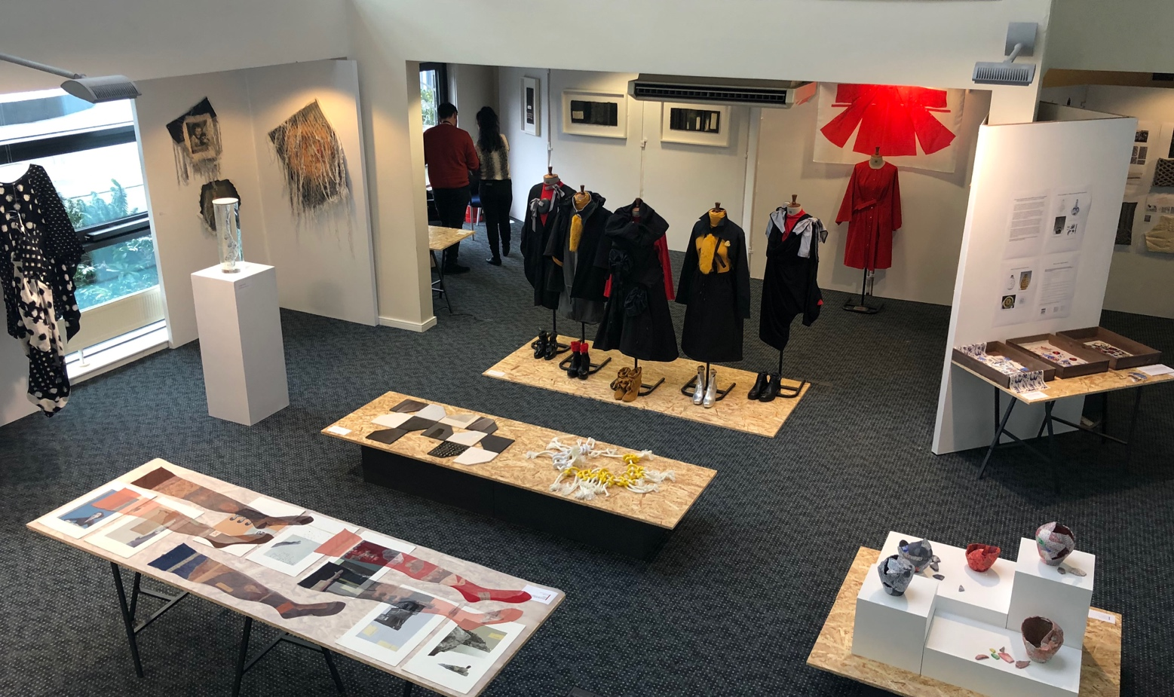
Figure 1: Installation view Futurescan 4: Valuing Practice exhibition, University of Bolton, UK, 23rd-24th January 2019. Photograph by Tony Radcliffe.

In ‘Looking Back to Look Forward: Reanimating Textiles for Novel Design and Manufacturing’, Hagan outlines investigation by the Rhode Island School of Design (RISD) Virtual Textile Research Group (VTRG) which analyzes historical making to inform woven textile innovation. Examining historical and contemporary contexts is also the focus of Raeside-Elliot’s article ‘The Contemporary Durham Miners’ Banner: A Unique Expression for Post-Industrial Communities?’ in response to the resurgence of banner making and bearing, to study the societal significance of this particular artefact. There is then a shift to contemporary practice as ‘Disassembly Discussed: Creative Textile Sampling as a driver for Innovation in the Circular Economy’, reacts to the challenges faced by the problem of recycling blended materials; Forst proposes design for disassembly for textile design explored through making as a solution. Gaston and Scott investigate lighting technologies to explore alternative methods of coloration through textile design practice for knitted textiles, to reduce textile processing water use in the article ‘Colour Trans:form:ation The application of Knit as Knowledge’. As part of a project surrounding textile research towards a Circular Economy, Hall proposes a method to aid design researchers to analyze practice. ‘TAKING NOTE: Annotated portfolio as a method to analyse the experience of design research practice’ intends to bridge the gap between academic research and design practice, with applicability to other fields. ‘Dynamic Cutting using material engagement with textiles in pattern cutting for fashion design practice’ also focuses on method development; Sgro proposes experimental cutting centering on material engagement with the textile to enable new thinking for garment design.

Association of Fashion & Textiles Courses (FTC)
Formed in 1977, the FTC is a subject association that exists to promote and develop fashion and textiles through academic debate, education and research. The Association, through its networks has links with industry, public and professional bodies and acts to advise on quality in educational matters. The Association actively supports and promotes fashion, textiles and related research through conferences, symposia and events. Futurescan 4: Valuing Practice conference proceedings can be accessed via https://futurescan.figshare.com/FUTURESCAN_4.

Biography
Dr Helena Britt is lecturer in the Department of Fashion and Textiles at the Glasgow School of Art (GSA). Research includes investigation surrounding contemporary and historical utilization of archive resources; the impact of digital technologies on printed textiles; textile design education and practice-focused methodologies. Helena holds a PhD and PGCert Supervision in Creative Practices from GSA, and MA Printed Textiles from the Royal College of Art.

