Advancing Asset-based Practice: Engagement, Ownership, and Outcomes in Participatory Design
Cara Broadley
Innovation School, The Glasgow School of Art, Glasgow, Scotland, UK
Postal Address: Haldane Building, 24 Hill Street, Glasgow, G3 6RN
Email: c.broadley@gsa.ac.uk
ORCiD: 0000-0002-2375-4230
Dr Cara Broadley is a Research Fellow at The Glasgow School of Art. Focusing on contexts of democracy, and equality, and wellbeing her research explores the role of visual and participatory design methods and asset-based approaches to engage with communities.

Word count: 6938

Advancing Asset-based Practice: Engagement, Ownership, and Outcomes in Participatory Design
This paper aims to understand how asset-based approaches can enhance how design researchers work with communities. Asset-based approaches support people to share perspectives of complex societal issues, recognize local strengths and capabilities, and apply these to inform action and change. Situated in the field of participatory design and drawing from a project investigating concepts of wellbeing with a volunteer community in the Scottish Highlands, the paper explores how an asset-based mindset can shape research methods, tools, and techniques. This establishes practices of appreciative exploration, collaborative articulation, and creative activation. Advancing a model of asset-based practice, it proposes how design researchers can enrich their engagement with contexts and communities, strengthen participants’ ownership over the process, and co-design outputs to communicate experiences and insights to multiple stakeholders and audiences.
Keywords: participatory design; asset-based approaches; communities; engagement; ownership; outcomes; mindset; practice

Introduction
Asset-based approaches (ABAs) have been adopted in public health improvement, community development, and social services (Garven, McLean, and Pattoni 2016) to identify local strengths and capabilities, ‘shifting control over the design/development of actions from the state to individuals and communities’ (GCPH and SCDC 2015, 17; Foot and Hopkins 2010). Whilst the term approach suggests a process to adhere to, ABAs offer procedural flexibility based on their commitment to community engagement; making skills, knowledge, and capacity visible; and co-producing future ways of living and working (Garven, McLean, and Pattoni 2016, 35–36).
Participatory design (PD) inherently employs ABAs to underpin ethical and empowering community interactions (Kelly 2019; Harrington, Erete, and Piper, 2019; Costanza-Chock, 2018; Teal and French 2016) and to incorporate existing resources into projects (McHattie, Champion, and Broadley 2018; Lam et al. 2017; Alevizou, Alexiou, and Zamenopoulos 2016). Resonating with the values of ABAs and supporting design researchers to substantiate ‘what is’ towards envisaging ‘what could be’, expressive, reflective, and generative methods, tools, and techniques proliferate PD (Brandt, Binder, and Sanders 2012, 153). Reflections on ABAs’ methodological qualities and potential, however, remain implicit on one hand, and nascent on the other. These practices, discussions, and debates present opportunities to examine ABAs’ contributions to and impact on engagement, ownership, and outcomes. This paper aims to understand how ABAs can enhance how design researchers work with communities.
The paper begins in the section Asset-based Approaches and Participatory Design: Community Empowerment and Co-production by outlining ABAs’ guiding principles, challenges and capabilities in PD, and projects and perspectives that tacitly align with or purposely examine ABAs. This frames an asset-based mindset of curiosity, communication, and creativity as a foundation on which design researchers can develop and apply PD methods, tools, and techniques. To illustrate this mindset and methodology in action, the section Curated Care: Wellbeing and Volunteering in the Scottish Highlands presents an account of the Curated Care research project. Methodological and contextual dimensions are then unpacked, and appreciative exploration, collaborative articulation, and creative activation are put forward as complementary asset-based practices in the section Reflections and Discussion: Towards Asset-based Practice in PD Research. Advancing an adaptive and transferable model of asset-based practice, the paper proposes that by explicitly apprehending ABAs, design researchers can enrich their engagement with contexts and communities, strengthen participants’ ownership over the PD process, and co-design outputs to communicate experiences and insights to multiple stakeholders and audiences. The final section Conclusions summarizes the paper’s contribution, acknowledges its limitations, and indicates opportunities for future research.

Asset-based Approaches and Participatory Design: Community Empowerment and Co-production
ABAs are rooted in theories of salutogenesis’ orientation towards the causes of health and wellbeing (Antonovsky 1993), a capability approach to personhood and collective wellbeing (Sen and Nussbaum 1993), and Appreciative Inquiry as a branch of action research that drives organizational change (Cooperrider, Cooperrider and Srivastva 2017). Redistributing community ownership and aspiring to lead to less dependency on professional services, ABAs subvert deficit-based modes of working:
The more familiar “deficit” approach focuses on the problems, needs and deficiencies in a community such as deprivation, illness and health-damaging behaviours. It designs services to fill the gaps and fix the problems. As a result, a community can feel disempowered and dependent; people can become passive recipients of services rather than active agents in their own and their families’ lives.
(Foot and Hopkins 2010, 6)
This quality of ABAs has been misinterpreted as neglecting challenges and needs in favor of celebrating perceived strengths and capabilities (Garven, McLean, and Pattoni 2016, 26). However, in being fundamentally person-centred (O’Leary, Burkett, and Braithwaite 2011, 6), ABAs attend to communities’ unique contextual circumstances and promote their collective articulation of assets. Assets include physical places, spaces, buildings, materials, and equipment, as well as relationships, networks, knowledge, skills, capacity, and other less tangible aspects of human and social capital (Garven, McLean, and Pattoni 2016, 30; Hopkins and Rippon 2015, 12; O’Leary, Burkett, and Braithwaite 2011, 7).
Following Hopkins and Rippon’s Theory of Asset-based Change (2015, 4), ABAs support communities to recognize available assets, reflect on their potential, and mobilize these to co-produce outcomes. As the expression of ‘changes and effects that happen as a result of the action we take’ (Garven, McLean, and Pattoni 2016, 42), ABAs’ outcomes range from improvements to mental wellbeing and personal goal attainment at an individual level; to increased social cohesion, renewed facilities, environments, resources, and partnerships at a community level; to enhanced access to health and care services, policy changes, and employment opportunities at institutional and system levels (2016, 45).
The surrounding literature highlights asset-based activities including asset-mapping, storytelling, community walkabouts, and open space events (GCPH and SCDC 2015; O’Leary, Burkett, and Braithwaite 2011, 14; Foot and Hopkins 2010, 19). Appreciative dialogue is a recurring technique that encourages communities to ‘engage in meaningful conversations that help them analyse and articulate what works well and when’ (Dewar and Sharp 2013, 2). This constitutes a practical feature of ABAs that enables change to be navigated and driven by communities.
Viewing asset-based principles against a continuum, appreciation imbues the aspirational nature of engagement in ABAs towards fostering self-actualization in communities. This is proceeded by articulation as the collective elicitation and exploration of strengths and capabilities, and the activation of assets in new ways through ideation, development, and piloting.

Participatory Design: Challenges and Capabilities
Asset-based principles have parallels with PD’s phases of critique, fantasy, and implementation (Bødker, Grønbæk, and Kyng 1993, 165) and echo Ehn’s positioning of the dialectics of tradition and transcendence in assimilating contextual understandings ‘to invent new ways of proceeding’ (1993, 69). PD’s interweaving of multiple stakeholders with contrasting motivations, experiences, and agendas affirms the onus on design researchers to engage appropriately with communities, strengthen their ownership over ideas as research participants, and generate meaningful outcomes and outputs together.

Engaging with Communities
Involving communities deemed hard-to-reach due to their geographic location, socioeconomic circumstances, or cultural values in PD projects is increasingly complex (Broadley and Smith 2018, 396; Robertson and Wagner 2012, 74), and design researchers have an imperative to ‘recognize the existing conditions and constraints that will impact on establishing such a dialogue’ (Byrne and Alexander 2006, 122). Ssozi-Mugarura, Blake, and Rivett (2017, 123) observe that harnessing intermediaries’ knowledge of community values and capabilities can establish trust. Drain, Shekar, and Grigg (2019, 14–15) advocate capacity-building activities to raise awareness of contextual issues and equip communities to participate in design development. Viewing PD through a postcolonial lens, Harrington, Erete, and Piper (2019) interrogate how workshop methods perpetuate societal injustices and inequalities experienced by underserved communities. They propose that ‘a truly just experience’ (2019, 5–6) can be strengthened by researchers developing robust historical and contextual understandings, reflexively apprehending their own biases and privileges, and shaping projects in partnership with communities.
Connected to curiosity as a relational perspective of PD that seeks to construct knowledge (Bergvall-Kåreborn and Ståhlbrost 2008, 104) and evoking the design researcher’s ‘disposition of being open and receptive towards other people and their experiences’ (Steen 2013, 953), a key objective of PD is to create open and inclusive methods, tools, and techniques for engagement that accommodate distinctive forms of participation (Brandt, Binder, and Sanders 2012, 146).

Enabling Ownership
Van Rijn and Stappers (2008, 181) depict ownership as the user’s willingness to participate, their power and control in the PD process, and their feelings of responsibility and pride regarding outcomes. Yet ownership can be rendered idealistic (Frauenberger et al. 2015, 103) and community agency can be impeded when external instutitions and funders influence and assign PD’s themes, aims, and outcomes (Harrington, Erete, and Piper 2019, 19–21). The parallel persistence of technosolutionism can be seen to neglect community needs and capabilities while extending and reinforcing cultural divides (2019, 19). Grounded in black feminist thought and concepts of intersectionality, Design Justice attends to the distribution of risks, harms, and benefits for marginalized communities and advances principles to ‘challenge designers to think about how good intentions are not necessarily enough to ensure that design processes and practices become tools of liberation’ and ‘avoid the (often unwitting) reproduction of existing inequalities’ (Costanza-Chock 2018, 530). These demonstrate how ownership is bound to and can result from the integration of communities’ lived experience and an increased emphasis on accountability in PD (2018, 536–537).
In exchanging and re-configuring tacit, experiential knowledge, design researchers and participants engage in mutual learning through which understandings are shared, trust can be established, and reciprocity can emerge (Ssozi-Mugarura, Blake, and Rivett 2017, 120). As DiSalvo’s explications of publics illuminate (2009, 51), creative acts of communication advance participants’ capacity to define the project’s focus and engage other communities in future use. Consequently, notions of ownership blur the boundaries between the process, its outcomes and outputs, and the locus of participants’ contributions.
Constructing and Communicating Outcomes
Generative co-design methods foreground creativity as an asset (DiSalvo, Clement, and Pipek 2012, 196) and aspire to distribute or seed (Merkel et al. 2004, 7) the ownership of new products, services, and systems to participants. Yet in striving to enable communities’ contributions, PD methods can inadvertently foster exclusive and elitist creative processes that promote unconstrained ideation and propose solutions misaligned to community experiences (Harrington, Erete, and Piper 2019, 2–3). Diverging from a product-centric position to explore socio-material relations (Björgvinsson, Ehn, and Hillgren 2012, 131), PD’s outcomes are intertwined with the situatedness of contextual research and bounded by immaterial concepts, qualities, and social norms, ‘hence their impact, emerges as participants and broader actors in the research landscape take up, engage with, adapt, and re-assemble them within their own contexts’ (Kimbell and Julier 2019, 15). Kelly (2019, 8) highlights beneficence as a research outcome in itself and maintains that PD can enhance personal knowledge, build social cohesion, and renew perceptions of wellbeing. Outcomes encompass the experiences and insights constructed with participants and the communication of such knowledge through concrete artefacts including prototypes, reports, analyses, and frameworks (Kimbell and Julier 2019, 10). Their material format, language, and tone and their channels of dissemination have a bearing on the reception and interpretation of knowledge by diverse audiences (Frauenberger et al. 2015, 99). This underlines design researchers’ responsibilities to involve participants directly in co-defining and co-designing the composition and content of PD outputs.

Aligning with, Acknowledging, and Applying an Asset-based Approach
Viewing PD as a route to social innovation, outcomes emerge from ‘the creative re-combination of existing assets (from social capital to historical heritage, from traditional craftsmanship to accessible advanced technology), the aim of which is to achieve socially recognized goals in a new way’ (Manzini 2014, 57). Aligned to this, parallel research explores the role of PD in eliciting knowledge, skills, and tacit wisdom from within communities of craft and textile practitioners, positioning these as valuable cultural assets to stimulate innovation in the rural creative economy (McHattie, Champion, and Broadley 2018). By engaging with communities, building their capacity to participate and their ownership over the process, and evidencing their insights in outcomes and outputs, PD is attuned to asset-based principles of appreciation, articulation, and activation.
These permeate and punctuate the Design Justice Principles, particularly in urging designers to ‘look for what is already working at the community level’, ‘honor and uplift traditional, indigenous, and local knowledge and practices’ and involve communities in scoping activities that reorient design from deficits to assets (Costanza-Chock 2018, 529–530). Kelly (2019, 9) acknowledges ABAs as instigating positive engagement, but does not consider their pragmatic power to assemble design opportunities and sustain community participation. Developing perspectives on equitable PD engagements, Harrington, Erete, and Piper recommend harnessing existing assets to recalibrate power relations and inform sustainable outcomes (2019, 19), yet beyond reflecting on responses to an asset-mapping activity, the authors do not unpack associated methodological implications.
In the Asset Mapping: Comparative Approaches project (2019), Alevizou, Alexiou, and Zamenopoulos (2016, 18) encourage visual and participatory research methods to uncover and document community narratives, suggesting that their performative elements can inspire research outcomes and outputs; and Lam et al. (2017, 3609) put forward co-design approaches for social empowerment in asset-based community development. In spite of the project’s direct identification with ABAs, the design researcher’s role and practice are not discussed.
Teal and French’s (2016, 3658) pop-up offers an appreciative and experiential tool to connect with communities and aggregate expressions of assets, yet rather than reflecting on ABAs’ methodological potential across the PD process, their focus is primarily on public engagement in its initial phases. At the same time, their proposition that ‘as facilitators in dialogue with the public, designers can build empathy and identify insights that can be translated into opportunities with the potential to address complex societal challenges’ (Teal and French 2016, 3663) corresponds with this paper’s aim to understand how ABAs can enhance how design researchers work with communities.
These projects and perspectives present opportunities to explore how design researchers with an inherently asset-based mindset of curiosity (openness to projects emerging in response to participants’ experiences and aspirations), communication (an ongoing exchange of insights and reflections with participants), and creativity (enabling participants to shape the project’s trajectory and its outputs) can develop their practices to enrich engagement, ownership, and outcomes in PD. The following section illustrates how an asset-based mindset and PD methods, tools, and techniques underpinned the Curated Care research project.

Curated Care: Wellbeing and Volunteering in the Scottish Highlands
As part of the Flourish programme of work (McAra-McWilliam, McHattie, and Broadley 2014), Curated Care worked with Highland Hospice in Inverness (2020) to investigate the relationship between wellbeing and volunteering and to co-design new forms of volunteer recruitment. Delivering palliative care to adults with life limiting disease in the Scottish Highlands, Highland Hospice attracts approximately 750 volunteers across its services. Throughout Curated Care Highland Hospice were preparing to relocate to temporary premises and sought to reinforce social cohesion in the midst of this spatial redistribution, while sustaining their uptake and retention of volunteers.
Curated Care draws from participatory action research as a broad methodological approach that surfaces contextual issues and experiential knowledge to frame the inquiry and ‘promotes pluralism and creativity in the art of discovering the world and making it better at the same time’ (Chevalier and Buckles 2019, 3). Comprising phases of scoping and orientation; collaborative and reflective idea generating; and prototyping, refining, and sharing outputs, the methods, tools, and techniques applied are diverse in nature, informed by PD’s emphasis on scaffolding participation through ‘telling, making, and enacting’ (Brandt, Binder, and Sanders 2012, 149).
The following account details my experience as the design researcher leading the project, interactions with stakeholders and participants, the contextual issues I encountered, and the methods, tools, and techniques I developed and used. This is complemented by reference to the principles and practical applications of ABAs. Insights into wellbeing and volunteering were elicited through participatory methods, captured by drawing, writing, and audio recordings, and unpacked in a parallel stage of thematic analysis (Braun and Clarke 2006). These are included in the account to highlight instances in which the approach propelled the PD process towards its co-designed output.

Scoping and Orientation: Engaging with Hospice Staff and Volunteers
Following an orientation meeting with senior clinical and fundraising staff, I synthesized my notes on Highland Hospice’s values, structure, and stakeholders into a large map. As an iterative technique to appreciate and articulate existing assets (O’Leary, Burkett, and Braithwaite 2011, 31), we then annotated the map in detail by positioning key individuals and groups and identifying opportunities for focused engagement.
Shown in Figure 1, our co-creation of the Highland Hospice Infrastructure and Intentions Map framed the volunteers as a dispersed network. Some perform roles such as ward clerks, gardeners, and cooks directly from the hospice, while others including charity shop volunteers, patient drivers, and fundraisers are based across the region and interface with staff, patients, their families, and broader communities in nuanced ways. The senior staff recognized their limited insight into volunteers’ motivations and considered how the project could activate the volunteer community to shape future recruitment strategies. The map’s graphic representation of key stakeholders stimulated a close collaboration with two volunteer coordinators to develop the engagement approach.
Observing the project’s connections to palliative care and bereavement, the importance of embedding ethical sensitivity in research, and integrating premises for building empathy, mutual respect, and trust with communities through ABAs (GCPH and SCDC 2015, 23; O’Leary, Burkett, and Braithwaite 2011, 16), we distributed a flyer inviting volunteers to share their experiences of Highland Hospice in semi-structured interviews. These explored roles and daily routines, interactions with others in the hospice network, and perceptions of personal wellbeing. I captured the nineteen volunteer interviews in note form and organized fragments of speech into themes, supplemented by illustrative sketches.
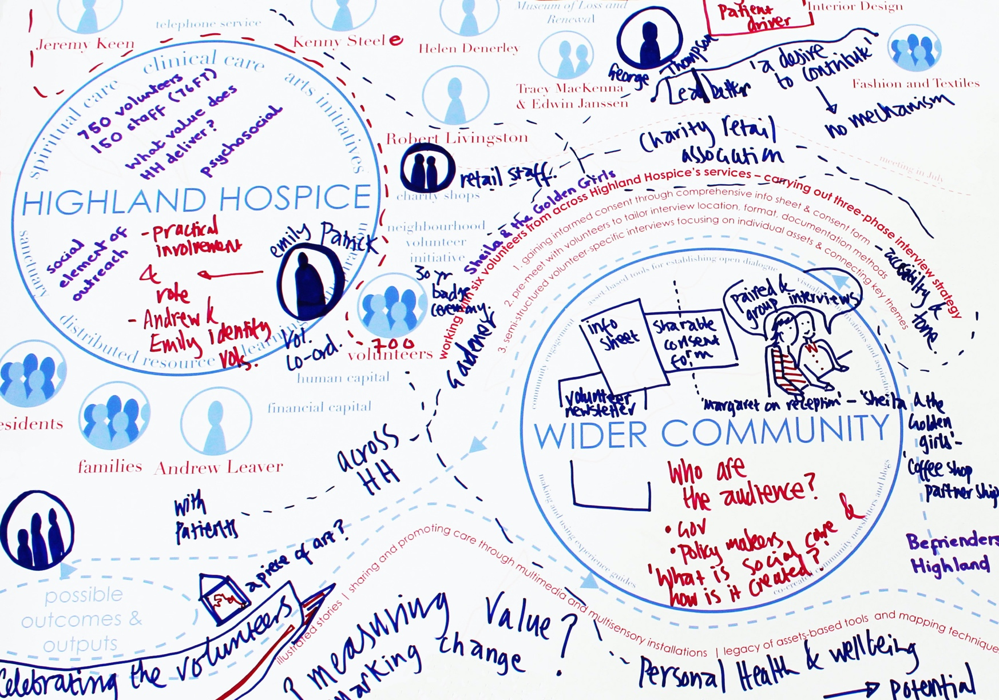
Figure 1. Annotated Highland Hospice Infrastructure and Intentions Map (detail). Photograph courtesy of Author.
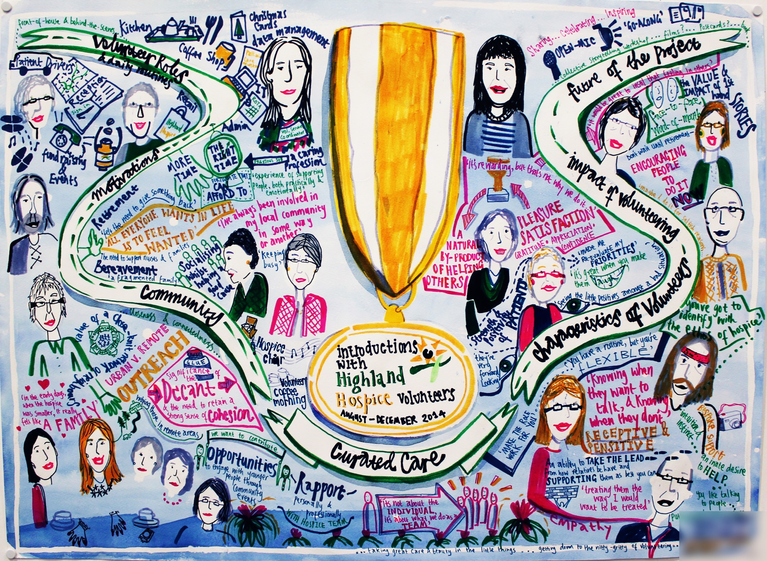
Figure 2. Volunteer Experiences and Themes Map created through documentation and reflection on volunteer interviews. Drawing courtesy of Author.

The Volunteer Experiences and Themes Map in Figure 2 illuminated the volunteers’ reciprocal relationships with the hospice; their abilities to be receptive, empathic, and compassionate; and the positive benefits they receive in return. By drawing out motivations to volunteer – including ‘keeping busy’, ‘staying involved’ in their local communities, and ‘socializing, while helping a good cause’ – it became apparent that many chose roles involving skills and competencies gained from previous employment. Several volunteers discussed losing friends and family members to terminal illnesses and others had personally experienced health complications and felt ‘the need to give something back’. Notions of appreciation, acknowledgement, and ‘feeling involved and not anonymous’ affirmed the volunteers’ feelings of achievement and purpose. This expressive asset-mapping technique revealed opportunities for the volunteer community to ‘inform, stimulate, and catalyze action’ (O’Leary, Burkett, and Braithwaite 2011, 30) in the subsequent participatory workshop.

Collaborative and Reflective Idea Generating: Supporting Communities’ Creative Capacity
The workshop began with a presentation of the Volunteer Experiences and Themes Map to review individual insights together and to focus on articulating and activating their collective assets. I then provided volunteers with voice recorders, paper tablecloths, marker pens, and prompt cards relating to five topics: motivations, community, characteristics, impact, and recruitment. Appropriating the world café as an asset-based method to elicit multiple perspectives in a short timeframe (Foot and Hopkins 2010, 27), volunteers discussed the topics in pairs and visualized key points. Figures 3 and 4 show examples of these Workshop Tools and Materials.
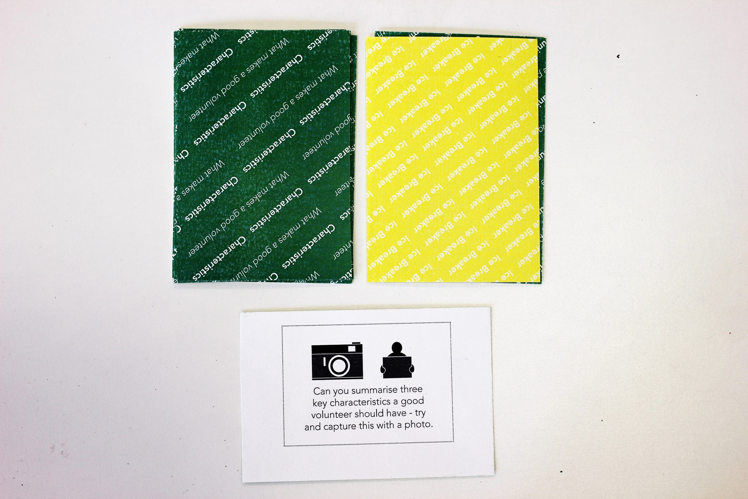Figure 3. Workshop Tools and Materials 01 – example prompt card from the characteristics topic. Photograph courtesy of Author.
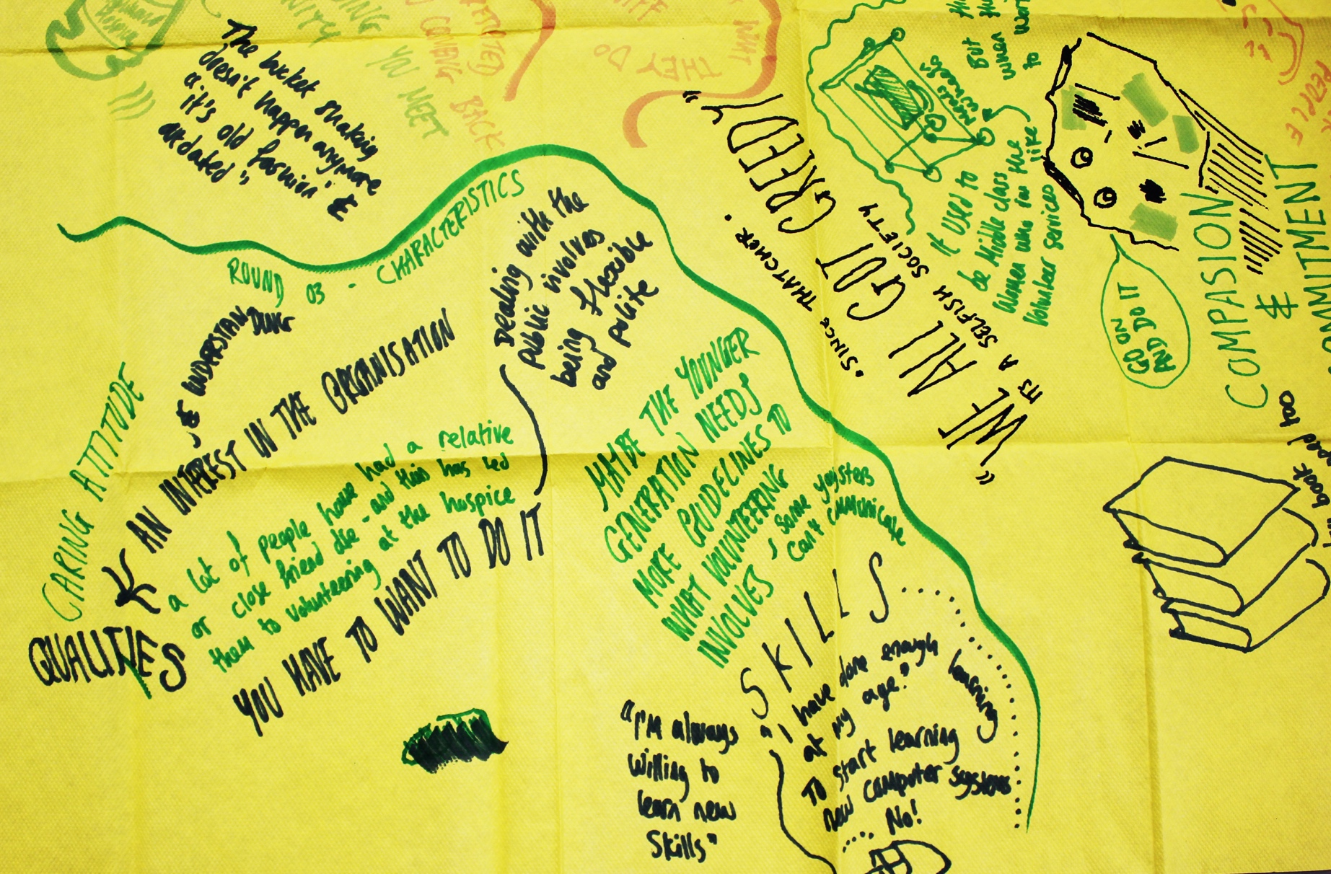
Figure 4. Workshop Tools and Materials 02 – example paper tablecloth to capture discussions (detail). Photograph courtesy of Author.

Whilst appreciating acts of care and their unified commitment to the hospice cause, the volunteers identified the limited reach of advertising volunteering positions in Highland Hospice’s internal coffee shop and through its network of charity shops: ‘We need to move away from the old image of standing outside a shop collecting money in a tin towards something more innovative and compelling’. This led to reflections on ‘the power of word-of-mouth’ and ideas for creative modes of storytelling to challenge societal perceptions of volunteering, translate lived experiences more broadly, and extend volunteer participation to a younger demographic. The workshop’s communal reflective format, the appreciative prompts (Dewar and Sharp, 2013), and the discussions’ transition from articulating assets to collective concept development contributed to a generative phase in the research, driven by the volunteers’ creative capacity.

Prototyping, Refining, and Sharing Outputs: Mobilizing Assets for Collective Action
By sketching and voting on their preferred concepts the volunteers conceptualized an accessible illustrative book to promote Highland Hospices’ work across the region and communicate the benefits of volunteering at individual, community, and organizational levels. Underlining ABAs’ generative potential to support co-design methods, this phase evokes Appreciative Inquiry’s rebuttal of problem-solving in favour of ‘determining what should be’ and ‘creating what will be’ (Bushe and Kassam 2005, 167) and intersects with premises of co-production as ‘a relationship where professionals and citizens share power to design, plan, and deliver’ new outcomes together (GCPH and SCDC 2015, 6). Through consultation, feedback, and iteration, the volunteer coordinators and volunteers co-created narrative accounts while I made watercolour illustrations. Figure 5 provides an example from this series of Volunteer Portraits, which present stories of volunteer practice, reflect upon social connectedness (Hopkins and Rippon 2015, 13) amongst the hospice community, and consider volunteering’s impact on personal wellbeing.
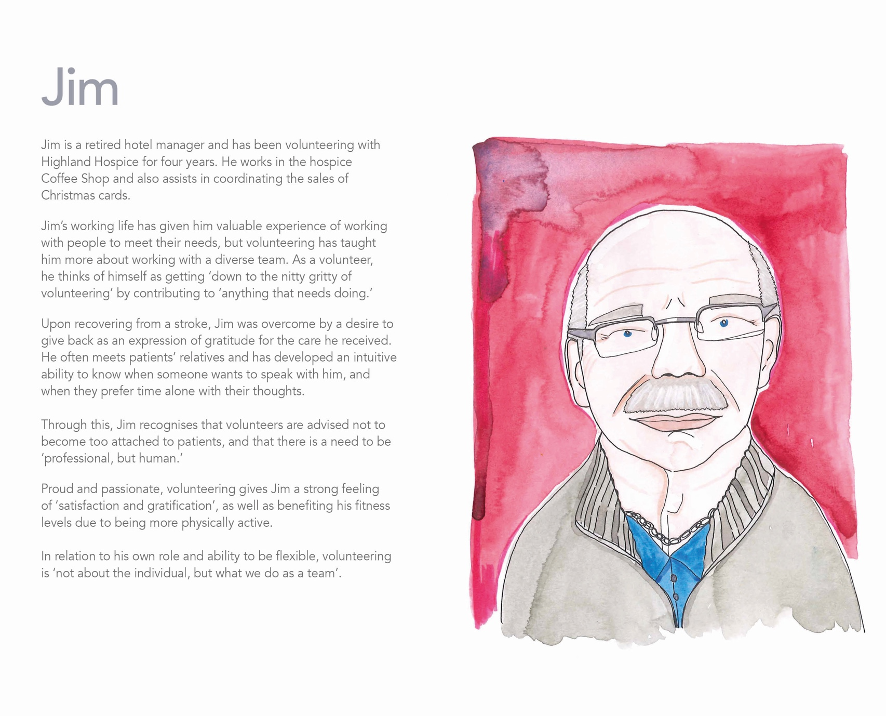
Figure 5. Volunteer Portraits – example of illustration and narrative. Photograph courtesy of Author.

Disseminating the project’s insights to academic and societal audiences, the Curated Care Book, shown in Figure 6 (The Glasgow School of Art and Highland Hospice 2015) was also employed as a printed and digital touch-point in volunteer recruitment initiatives for a period of two years. Reflecting on the project’s impact and value to the volunteers, Highland Hospice, and broader communities, the volunteer coordinators made the following statements:
I was humbled and moved by each of the volunteers’ stories and surprized to learn of each person’s journey to becoming a Highland Hospice volunteer. From the conversations held throughout this research, it is clear that Highland Hospice volunteers gain as much from their altruism as those they support.
(volunteer coordinator 01, personal communication, May 22 2015)

Being able to show new volunteers the stories and experiences of volunteering gives an insight into the benefits of volunteering and how helping others can help them too.
(volunteer coordinator 02, personal communication, May 22 2015)
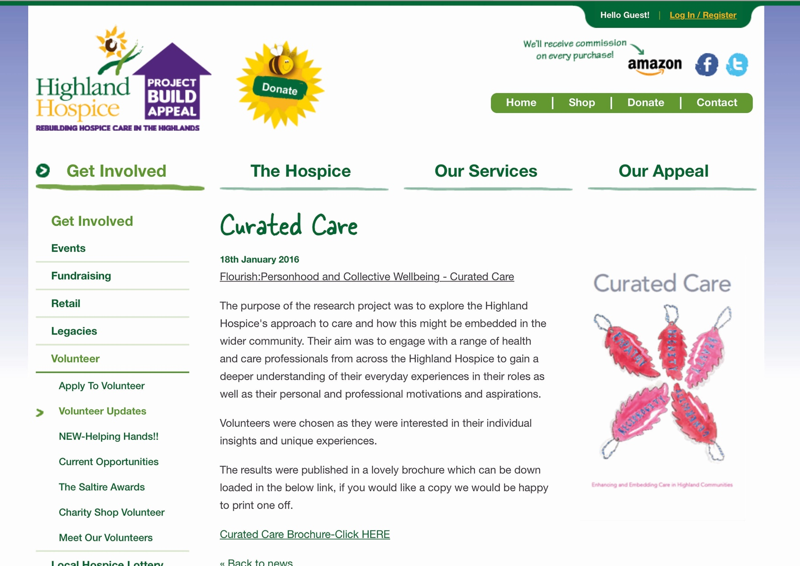
Figure 6. Curated Care Book – project output available for digital download on Highland Hospice’s website in March 2016. Photograph courtesy of Author.

Demonstrating the power of asset-based stories to stimulate action (GCPH and SCDC 2015, 24), the Curated Care book embodies the volunteers’ strengths and capabilities and their collaborative creativity that sustained the project.

Reflections and Discussion: Towards Asset-based Practice in PD Research
Reflecting on the methodological and contextual dimensions of Curated Care and revisiting discussions and debates surrounding ABAs and PD, this section puts forward an adaptive and transferable Model of Asset-based Practice.
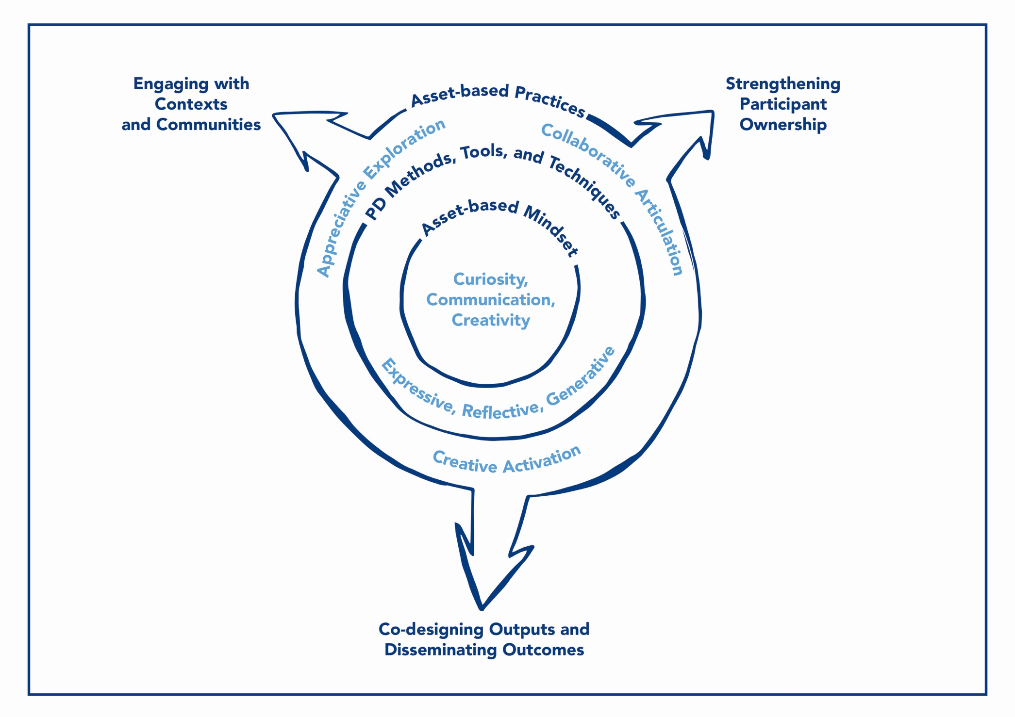Figure 7. A Model of Asset-based Practice. Drawing courtesy of Author.

As Figure 7 proposes, design researchers explicitly apprehending an asset-based mindset of curiosity, communication, and creativity and developing expressive, reflective, and generative PD methods, tools, and techniques can evolve and hone corresponding and complementary asset-based practices of appreciative exploration, collaborative articulation, and creative activation. Aligning the paper’s contribution with its aim, the model can support design researchers to engage with contexts and communities, strengthen participants’ ownership over the process, and co-design outputs that communicate experiences and insights to multiple stakeholders and audiences.

Appreciative Exploration for Contextual Community Engagement
Engagement is core to scoping and orientation in PD and encompasses connecting with communities, enabling their appreciation of existing assets, and envisaging ‘differences between current issues and how the future can unfold’ (Björgvinsson, Ehn, and Hillgren 2012, 127–128). In activating communities’ capabilities to create outcomes that respond to their aspirations and ideas, ABAs advance an intrinsically ‘context-appropriate practice’ (Garven, McLean, and Pattoni 2016, 111). The situated coordination of engagement resonates with ethnography’s emphasis on attaining a holistic cultural understanding (Blomberg and Karasti 2012, 90–91) and affirms that design researchers must account for contextual issues in PD when developing engagement methods, tools, and techniques (Sanders, Brandt, and Binder 2010, 196).
These actions and objectives are exemplified in Curated Care’s scoping and orientation phase. In opposing deficit-based practices of problem-setting (Bratteteig et al. 2012, 130) on the grounds that they disempower participants and lead to unsustainable PD outcomes, the Hospice Infrastructure and Intentions Map conveyed my asset-based mindset to the senior staff, enhanced my understandings of empathic and dignified patient support, and highlighted the volunteers’ role within a future vision of distributed community care. This affirmed the need to avoid overtly playful or ideational engagement methods that could alienate, patronize, or insult participants embedded in a complex and sensitive context and result in ‘infeasible solutions that ultimately frustrate underserved individuals’ (Harrington, Ererte, and Piper 2019, 2). The interview questions’ appreciative orientation and subsequent creation of the Volunteer Experiences and Themes Map graphically supported our co-realization (Bratteteig et al. 2012, 132) of volunteers’ motivations, characteristics, relationships, skills, and benefits. This further centralised the volunteers as the project’s core asset and situated the concept of hospice as a site of both life and death. It is important to point out that while striving to formally involve volunteers in scoping positive contextual elements (Costanza-Chock 2018, 530), I was mindful not to obscure or misrepresent their personal struggles or recognition of systemic constraints. Indeed, some volunteers stressed the practical and emotional challenges of their roles and reflected upon experiences of ill-health and bereavement as informing their motivations to volunteer.
Accommodating individual design researchers’ nuanced repertoires, practices of appreciative exploration underline ‘a robust connection between ethical practice and the choice of methods, tools, and techniques’ (Robertson and Wagner 2012, 78). By instigating appreciative dialogue and materially-surfacing assets, design researchers can establish rich contextual understandings and engage in mutual learning with participants.

Collaborative Articulation to Strengthen Ownership
Constituting communities’ capacity to shape PD projects (Frauenberger et al. 2015, 103; van Rijn and Stappers 2008, 181), ABAs address ownership by facilitating collective articulations of physical assets in tandem with aspects of human and social capital that may otherwise remain intangible or ineffable (O’Leary, Burkett, and Braithwaite 2011, 7). This paper refutes the development of a rigid asset-based toolkit or recipe that can be lifted off the shelf (Garven, McLean, and Pattoni 2016, 36), and advocates practices of collaborative articulation to strengthen PD ‘towards creating spaces where responses can be explored, designed and owned locally as issues arise’ (2016, 111).
The Volunteer Experiences and Themes Map’s personalized tone and illustrative content located the volunteers’ individual voices within emerging themes in the collaborative and reflective idea generating phase. As a tool to interpret and express the plurality of interwoven experiences, the map correlates with DiSalvo’s (2009) notion of tracings:
Within the context of the construction of publics the tactic of tracing can be defined as the use of designerly forms to detail and communicate, and to make known, the network(s) of materials, actions, concepts, and values that shape and frame an issue over time.
(DiSalvo 2009, 55)
The ongoing visual communication of insights through asset-based practice underpins interrelated participatory reflection, analysis, and design, and ‘makes it possible for all participants to engage in the moves between understanding and exploring new possibilities’ (Bratteteig et al. 2012, 134).
The volunteers adopted the role of appreciative inquirers in the workshop’s paired discussions, using the prompt cards and paper tablecloths to inspire, capture, and communicate their experiences, insights, and aspirations together. These activities transcended an articulation of the volunteer community’s strengths and capabilities towards reframing their collective assets to design new forms of volunteer recruitment.
Extending ABA’s appropriation of storytelling to stimulate trust and creative sense-making (GCPH and SCDC 2015, 73), PD processes can unfold ‘in a respectful, ethical and empathic way’ (Branco, Quental, and Ribeiro 2017, 114) when design researchers develop personalized asset-mapping techniques and prioritize participant-led dialogue. Such practices of collaborative articulation foster transparent communication and cultures of reciprocal learning in PD, strengthening participants’ ownership over processes, outcomes, and outputs.

Creative Activation to Disseminate Outcomes
PD outcomes encompass new methodological, contextual, and societal knowledge; the communication of findings through concrete artefacts; and the project’s impact on the wellbeing of participating communities and broader society (Kimbell and Julier 2019, 10; Kelly 2019, 8). ABAs also seek to produce outcomes of direct societal benefit, and value personalized co-production for individuals and communities (Garven, McLean, and Pattoni 2016, 46). With an emphasis on embedding mutual creativity in PD, this paper contends that asset-based practices of creative activation can support participants to harness, mobilize, and share existing assets through tangible project outputs.
In the collaborative and reflective idea generating phase, the volunteer coordinators voiced critical concerns over my own initial ideas to facilitate public storytelling events profiling the volunteers. This resistance was based on their situated experiences of fundraising and outreach programmes across Highland Hospice, awareness of volunteers’ personal characteristics and tendencies, and assessments that such an outcome could limit participation to a cross-section of the volunteer community accustomed to being in the public eye. In the prototyping, refining, and sharing outputs phase the volunteers themselves conceptualized and co-designed the Curated Care book as an unexpected project outcome. The book explicates the PD process and insights concerning the reciprocal interplay of volunteering and wellbeing, volunteers’ identification with the hospice’s values of empathy and dignity, and the practical and social characteristics that support these forms of care. The Volunteer Portraits are a core component. Echoing Wright and McCarthy’s (2008) discussions of ‘short pen pictures of people in a setting’ employed by HCI researchers to ‘capture the felt experience of working in a particular place’, such narrative vignettes offer a glimpse into communities’ ‘practical, intellectual, and emotional world’, with the intent to evoke empathic understandings in their audiences (2008, 642).
Recalling the contextual appropriation of ABAs and the constraints this can impose on impact and scalability (Garven, McLean, and Pattoni 2016, 111), challenges surround the definition of indicators and robust procedures for evaluating ABAs. Despite their altruistic intentions, it can be argued that ABAs’ displace responsibility for societal transformation away from the state and onto communities, thus reinforcing barriers related to race, ethnicity, class, and age, and effectively exacerbating inequalities. Celebrating the strengths of communities who already display cohesion and agency can further distance and silence marginalised citizens (MacLeod and Emejulu 2014, 448; Garven, McLean, and Pattoni 2016, 96). Parallel issues are observed and interrogated in PD (Harrington, Erete, and Piper 2019), demonstrating the need for design researchers to address and evaluate ‘a more equitable distribution of design’s benefits and burdens’ (Costanza-Chock 2018, 529). The Highland Hospice volunteers represented a community of individuals diversified by their personal biographies and socioeconomic circumstances. It is therefore likely that some were more privileged than others from the offset of the project, with distinct motivations for, experiences of, and reflections on participation. Moreover, as an urban, educated creative practitioner and researcher, my own presence and privilege had a bearing on the project’s structure and nature, and the relationships and outcomes it informed. In readdressing social and political power imbalances, ABAs and PD must include communities in both defining equitable methods, experiences, and outcomes (Harrington, Erete, and Piper 2019, 20), and in disseminating emerging discourse (Costanza-Chock 2018, 532). Co-designed outputs impart transferable project learnings and provide a resource for organizations and communities seeking to activate assets to stimulate action and change in a range of social contexts.
Creative activation supports the generative premises of prototyping but contends that to stimulate participants’ imaginative freedom, strengthen ownership, and develop equitable outcomes, existing community assets must be ‘leveraged and supported, such that they are able to be maintained and progressed in the absence of researchers’ (Harrington, Erete, and Piper 2019, 19). Aligned with Highland Hospices’ use of the book to inspire broader participation, this output foregrounds the volunteer community as the central asset in Curated Care and in sustaining the hospices’ work across the Scottish highland region. Encapsulating the design researcher’s flexible application of generative PD methods, tools, and techniques and the visual and material outputs these produce, creative activation collaboratively reframes assets with participants to conceptualize, construct, and communicate project outcomes to multiple stakeholders and audiences.

Conclusions
This paper recognized asset-based principles of appreciation, articulation, and activation and the proliferation of an asset-based mindset of curiosity, communication, and creativity across the field of PD, alongside insufficient critical reflection on the methodological qualities and potential of ABAs. In turn, it identified opportunities to explore how ABAs can enhance how design researchers engage with contexts and communities in PD, strengthen participants’ ownership over the process, and co-design outputs to communicate outcomes. Descriptive and reflective accounts of the Curated Care project were presented to illustrate the interplay of the design researcher’s asset-based mindset and application of expressive, reflective, and generative PD methods, tools, and techniques. This led to a model of asset-based practice comprising appreciative exploration, collaborative articulation, and creative activation to be put forward as the paper’s contribution.
The paper acknowledges several shortcoming and limitations, the first of which concerns its lack of analysis or evaluation of the research participants’ interpretations of the methods, tools, and techniques developed and used in Curated Care. In positioning its contribution as a model of asset-based practice for design researchers, the paper focused on my own situated and reflexive experience of choreographing the PD process. Building on Sanders, Brandt, and Binder’s framework for organizing PD activities based on their form, purpose, and context (2010, 196), future research will integrate and examine broader methodological perspectives.
Secondly, and in connection with Highland Hospices’ aspirations to co-design new forms of volunteer recruitment, evaluation of both the book as the project’s output and additional outcomes that arose from the PD process has been limited. In addressing this shortcoming and further developing the model, forthcoming research will co-create a framework for evaluation with research participants and cross-sectoral stakeholders to capture nuanced assessments of engagement quality, indicators of ownership, and the impact of outcomes and outputs.
Thirdly, while critiquing PD’s limited interrogation of ABAs, insight and learning were drawn primarily from Curated Care as one project example, led by myself as a singular design researcher with particular competencies and capabilities. This can be deemed an unstable foundation on which to substantiate the model’s transferability, yet the decision was actively made to detail the evolution of asset-based practice in action across Curated Care’s phases. Asset-based practice evokes the ethos of inclusive engagement, democratic deliberation, community empowerment, and collaborative future-making inherent in both ABAs and PD. Complementing the liberatory values of Design Justice and seeking to advance the ‘transformative potential of broader participation in the design process, as well as ownership and stewardship of the results’ (Costanza-Chock 2018, 536), the model’s adaptive nature promotes its application to explore social issues including community development, democracy and governance, equality and wellbeing, and health and care, and its transferable potential to unlock and reframe cultural assets within and beyond the creative economy. Through its innate flexibility, the model invites design researchers with an asset-based mindset of curiosity, communication, and creativity to engage in reflexive methodological experimentation and develop contextual and material strategies to enact these in practice.

Acknowledgements
I would like to thank Highland Hospice for their support and the volunteers and staff for their participation in Curated Care. I also thank Professor Irene McAra-McWilliam and Professor Lynn-Sayers McHattie for their insight and guidance in Curated Care and the wider Flourish programme of work; Professor Janet McDonnell, Gemma Teal, and Madeline Smith for their advice on previous drafts; and the journal reviewers for their feedback and comments. Flourish was funded by the Scottish Universities Insight Institute (SUII). I gratefully acknowledge their support.

Declaration of Interest Statement
No potential conflict of interest was reported by the author.

References
Alevizou, G., K, Alexiou, and T. Zamenopoulos. 2016. ‘Making Sense of Assets: Community Asset Mapping and Related Approaches for Cultivating Capacities.’ The Open University, Open Research Online. http://oro.open.ac.uk/47472/.
Antonovsky, A. 1993. ‘The Structure and Properties of the Sense of Coherence Scale.’ Social Science and Medicine 36(6): 725–733.
Bergvall-Kåreborn, B. and A. Ståhlbrost. 2008. ‘Participatory Design: One Step Back or Two Steps Forward?.’ Proceedings of the Tenth Anniversary Participatory Design Conference: 102–111.
Björgvinsson, E., P. Ehn, and P.A. Hillgren. 2012. ‘Agonistic participatory design: working with marginalised social movements.’ CoDesign: International Journal of CoCreation in Design and the Arts 8(2–3): 127–144.
Blomberg, D.J. and H. Karasti, H. 2012. ‘Ethnography: Positioning Ethnography within Participatory Design.’ In Routledge International Handbook of Participatory Design, edited by J. Simonsen and T. Robertson, 106–136. New York: Routledge.
Bødker, S., K. Grønbæk, and M. Kyng. 1993. ‘Participatory Design: Techniques and Experiences from the Scandinavian Scene.’ In Participatory Design: Principles and Practices, edited by D. Schuler and A. Namioka, 156–176. London: Lawrence Erlbaum Associates.
Branco, R.M., J. Quental, and Ó. Ribeiro. 2017. ‘Personalised Participation: An Approach to Involve People with Dementia and their Families in a Participatory Design Project.’ CoDesign: International Journal of CoCreation in Design and the Arts 13(2): 127–143.
Brandt, E., T. Binder, and E.B.N. Sanders. 2012. ‘Ways to Engage: Telling, Making and Enacting.’ In Routledge International Handbook of Participatory Design, edited by J. Simonsen and T. Robertson, 145–181. New York: Routledge.
Bratteteig, T., K. Bødker, Y. Dittrich, P.H Mogensen, and J. Simonsen. 2012. ‘Methods: Organising Principles and General Guidelines for Participatory Design Projects.’ In Routledge International Handbook of Participatory Design, edited by J. Simonsen and T. Robertson, 137–164. New York: Routledge.
Braun, V. and V. Clarke. 2006. ‘Using thematic analysis in psychology.’ Qualitative Research in Psychology 3(2): 77–101.
Broadley, C. and P. Smith. 2018. ‘Co-design at a Distance: Context, Participation, and Ownership in Geographically Distributed Design Processes.’ The Design Journal 21(3): 395–415.

Bushe, G.R. and A.F. Kassam. 2005. ‘When is Appreciative Inquiry Transformational? A Meta-case Analysis.’ The Journal of Applied Behavioral Science 41(2): 161–181.
Byrne, E. and P.M Alexander. 2006. ‘Questions of Ethics: Participatory Information Systems Research in Community Settings.’ Proceedings of the 2006 Annual Research Conference of the South African Institute of Computer Scientists and Information Technologists on IT Research in Developing Countries: 117–126.
Chevalier, J.M., and D. Buckles. 2019. Participatory Action Research: Theory and Methods for Engaged Inquiry. London: Routledge.
Cooperrider, D., D. Cooperrider, and S. Srivastva. 2017. ‘The Gift of New Eyes: Personal Reflections after 30 Years of Appreciative Inquiry in Organizational Life.’ Research in Organizational Change and Development 25: 81–142.
Costanza-Chock, S. 2018. ‘Design Justice: towards an intersectional feminist framework for design theory and practice.’ Proceedings of the Design Research Society: 529–540.
DiSalvo, C., A. Clement, and V. Pipek. 2012. ‘Participatory Design for, with, and by Communities.’ In Routledge International Handbook of Participatory Design, edited by J. Simonsen and T. Robertson, 182–209. New York: Routledge.
DiSalvo, C. 2009. ‘Design and the Construction of Publics.’ Design Issues 25(1): 48–63.
Drain, A., A. Shekar, and N. Grigg. 2019. ‘Involve Me and I’ll Understand’: Creative Capacity Building for Participatory Design with Rural Cambodian Farmers.’ CoDesign: International Journal of CoCreation in Design and the Arts 15(2): 110–127.
Ehn, P. 1993. ‘Scandinavian design: On Participation and Skill.’ In Participatory Design: Principles and Practices, edited by D. Schuler and A. Namioka, 41–78. London: Lawrence Erlbaum Associates.
Foot, J. and T. Hopkins. 2010. A Glass Half-full: How an Asset Approach can Improve Community Health and Well-being. Great Britain: Improvement and Development Agency.
Frauenberger, C., J. Good, G. Fitzpatrick, and O.S. Iversen. 2015. ‘In Pursuit of Rigour and Accountability in Participatory Design.’ International Journal of Human-computer Studies 74: 93–106.
Garven, F., L. Pattoni, and J. McLean. 2016. Asset-Based Approaches: Their Rise, Role and Reality. Edinburgh: Dunedin Academic Press Ltd.
GCPH (Glasgow Centre for Population Health) and SCDC (Scottish Community Development Centre). 2015. Positive Conversations, Meaningful Change: Learning from Animating Assets. https://www.gcph.co.uk/publications/598_positive_conversations_meaningful_change_learning_from_animating_assets.
Harrington, C., S. Erete, and A.M. Piper. 2019. ‘Deconstructing Community-Based Collaborative Design: Towards More Equitable Participatory Design Engagements.’ Proceedings of the ACM on Human-Computer Interaction 3: 1–25.
Hopkins, T. and S. Rippon. 2015. Head, Hands and Heart: Asset-based Approaches in Health Care. London: Health Foundations.
Highland Hospice. 2020. About Us. https://highlandhospice.org/who-we-are/about-us.
Kelly, J. 2019. ‘Towards Ethical Principles for Participatory Design Practice.’ CoDesign: International Journal of CoCreation in Design and the Arts 15(4): 329–344.
Kimbell, L. and G. Julier. 2019. ‘Confronting Bureaucracies and Assessing Value in the Co-production of Social Design Research.’ CoDesign: International Journal of CoCreation in Design and the Arts 15(1): 8–23.
Lam, B., T. Zamenopoulos, M. Kelemen, and J.H. Na. 2017. ‘Unearth Hidden Assets through Community Co-design and Co-production.’ The Design Journal 20(sup1): 3601–3610.
MacLeod, M.A. and A. Emejulu. 2014. ‘Neoliberalism with a community face? A critical analysis of asset-based community development in Scotland.’ Journal of Community Practice 22(4): 430–450.
Manzini, E. 2014. ‘Making Things Happen: Social Innovation and Design.’ Design Issues 30(1): 57–66.
McAra-McWilliam, I., L.S. McHattie, and C. Broadley. 2014. Flourish: Personhood and Collective Wellbeing. http://radar.gsa.ac.uk/6749/
McHattie, L.S., K. Champion, and C. Broadley. 2018. ‘Craft, Textiles, and Cultural Assets in the Northern Isles: Innovation from Tradition in the Shetland Islands.’ Island Studies Journal, 13(2): 39–54.
Merkel, C.B., L. Xiao, U. Farooq, C.H. Ganoe, R. Lee, J.M. Carroll, and M.B. Rosson. 2004. ‘Participatory Design in Community Computing Contexts: Tales from the Field.’ Proceedings of the Eighth Participatory Design Conference: 1–10.
Nussbaum, M. and A. Sen. 1993. The Quality of Life. Oxford: Clarendon Press.
O'Leary, T., I. Burkett, and K. Braithwaite. 2011. Appreciating Assets. Dunfermline: Carnegie UK Trust.
Robertson, T., and I. Wagner. 2012. ‘Engagement, Representation and Politics-in-action.’ In Routledge International Handbook of Participatory Design, edited by J. Simonsen and T. Robertson, 64–85. New York: Routledge.
Sanders, E.B.N., E. Brandt, and T. Binder. 2010. ‘A Framework for Organizing the Tools and Techniques of Participatory Design.’ Proceedings of the 11th Biennial Participatory Design Conference: 195–198.
Ssozi-Mugarura, F., E. Blake, and U. Rivett. 2017. ‘Codesigning with
communities to support rural water management in Uganda.’ CoDesign: International Journal of CoCreation in Design and the Arts 13(2): 110–126.
Steen, M. 2013. ‘Virtues in Participatory Design: Cooperation, Curiosity, Creativity, Empowerment and Reflexivity.’ Science and Engineering Ethics 19(3): 945–962.
Teal, G. and T. French. 2016. ‘Designed Engagement.’ Proceedings of the 50th Anniversary Design Research Society Conference 9: 3653–3668.
The Glasgow School of Art and Highland Hospice. 2015. Curated Care: Enhancing and Embedding Care in Highland Communities. http://radar.gsa.ac.uk/6784/1/Curated_Care.pdf
Asset Mapping: Comparative Approaches. 2019. Overview. http://www.comparativeassetmapping.org/index.html.
Van Rijn, H. and P.J. Stappers. 2008. ‘Expressions of Ownership: Motivating Users in a Co-design Process.’ Proceedings of the Tenth Anniversary Participatory Design Conference: 178–181.
Wright, P. and J. McCarthy. 2008. ‘Empathy and Experience in HCI.’ Proceedings of the SIGCHI Conference on Human Factors in Computing Systems: 637–646.

