AUTHOR ACCEPTED MANUSCRIPT
A Serious Game on Skull Anatomy for Dental Undergraduates
Ruaridh Dall,^{1,2*} Daisy Abbott,² Paul Rea,¹ Ourania Varsou¹
- School of Life Sciences, University of Glasgow, Anatomy Facility, Thomson Building, University Avenue, Glasgow G12 8QQ, Scotland, UK.
- School of Simulation and Visualisation, Glasgow School of Art, The Hub, Pacific Quay, Cessnock, Glasgow G51 1EA, Scotland, UK.

*Corresponding author
Corresponding author contact details
School of Life Sciences, University of Glasgow, Anatomy Facility, Thomson Building, University Avenue, Glasgow G12 8QQ, Scotland, UK.
Email: ruaridhdall@gmail.com

Abstract
Knowledge of the anatomy of the skull and its bones forms an important part of the understanding required for the study and practice of safe clinical dentistry. The use of serious games in healthcare education is well-documented, but there is comparatively little evidence for their use in dental education. Intrinsically integrated rewards are a game mechanic that can be motivational for serious game users. A research gap was identified in the delivery of skull anatomy education to dental undergraduate students via a serious game with intrinsically integrated rewards. A serious game, titled Visualisation Studio Sim was developed with Unity, featuring three dimensional models and assets designed and modified with 3DS Max and Instant Meshes. Two versions of the game were built, one with the addition of intrinsically integrated rewards, and the game versions were tested by a convenience sample to gather open-ended feedback on the usability and suitability of the game mechanic for dental undergraduate education. Feedback suggested that it was straightforward to interact with the skull models but that the rewards were not as well integrated into the flow and immersion of the game as intended, and the game might not have been as challenging as desired for the intended cohort warranting future refinements in these aspects.
Keywords: Dental education; Pedagogy; Serious games; Scholarship of Teaching and Learning

Introduction

Chapter Scope
This chapter details the design process and discusses the preliminary user evaluation, along with future development, of a serious game on human skull anatomy for tailored pedagogical use in dental undergraduate education as a novel teaching and learning concept. The authors also discuss the impact of an intrinsically integrated affordance-oriented reward system and how this can be further refined and utilised in the future. To our knowledge, this is the first serious game on anatomy designed specifically for dental undergraduate cohorts.

Background and Project Rationale
Serious games, according to Abt (1970) are games created for purposes other than simple entertainment, offering users the opportunity to hone skills or acquire knowledge from interactive media. Arnab et al., (2015), suggest that in serious game design, it is necessary to transmute a learning goal into a gameplay mechanic – and term this a Serious Game Mechanic (SGM). Serious Game Mechanics join the pedagogical practices within learning mechanics (LM) with game mechanics (GM) that relate to player actions. By selecting the SGM at the initial design stage, the LM-GM model (Arnab et al., 2015) can be used to analyse it and evaluate the effectiveness of the game in the educational setting. The design should intrinsically integrate the learning element into the gameplay and not interrupt the game’s flow as the game’s motivational appeal can be inhibited by poor flow (Habgood and Ainsworth, 2011). Serious game mechanics such as intrinsic integration of rewards, whereby achieving progress within a game is its own reward (Mozelius, 2014), can increase engagement with serious games, offering the ability to progress through a game in a fashion known as affordance-oriented rewards (Westera, 2017).
The General Dental Council (GDC), which is the regulatory body for dentistry in the UK, advises that dental educators should keep up to date with advances in technology and that dentists should be able to “evaluate the impact of new techniques and technologies in clinical practice” in its Preparing For Practice guidelines (General Dental Council, 2015). To do so, it can be argued that utilising serious games for dental undergraduate education would fulfil this requirement.
Sipiyaruk, et al., (2017) assessed a dental public health serious game (GRAPHIC-II) that aimed at helping students with their critical thinking and decision-making process. The authors recommended that further research is required on serious games in dental education. Two randomised-controlled trials evaluated serious games in pre-clinical dentistry, with a dentine bonding exercise for teeth restoration (Amer et al., 2011) and an alginate impression material mixing simulation (Hannig et al., 2013) discussing that knowledge and confidence increased from these games. Although the above explore how serious games can have a positive effect in dental education, these is still a small pool of evidence (Sipiyaruk et al., 2018). In addition, there is no serious game on head and neck anatomy, which forms the foundation of clinical dentistry, designed specifically for dental undergraduate students. This project explored this gap in the current literature by developing a serious game on human skull anatomy for such cohorts.

Methodology

Design Concept
The game, titled Visualisation Studio Sim, is set in a visualisation studio where the anatomical knowledge of the player is put to use overseeing a team of digital artists producing human skull models. The player is the studio manager with their role being to assess the artists’ work for anatomical correctness and that it satisfies the requests in the briefs set by the studio’s clients.
The game has been designed with the intended audience – undergraduate dental students – in mind and hence there is particular focus on clinically-relevant anatomy that will be of paramount importance to qualified dentists. The game also aimed to evaluate the usability of an intrinsically integrated reward game mechanic. For this reason, two separate game versions have been developed; one with intrinsically integrated rewards, and one without it. With the exception of the reward system, the content of both game versions is identical to eliminate all potential confounding variables both in terms of player motivation and educational advantage. Game content presents three-dimensional (3D) models of skull anatomy with individual bones delineated and allows players to rotate the models allowing for constructivist learning (Lameras et al., 2017). The educational content of the game has been designed specifically at a level that is appropriate for undergraduate dental students. The game has been built to run on Windows, which is typically the most commonly encountered operating system in UK higher education instructions.

Materials and Methods
Fig. 1 illustrates the main steps involved in the compilation of the game and overall research project.
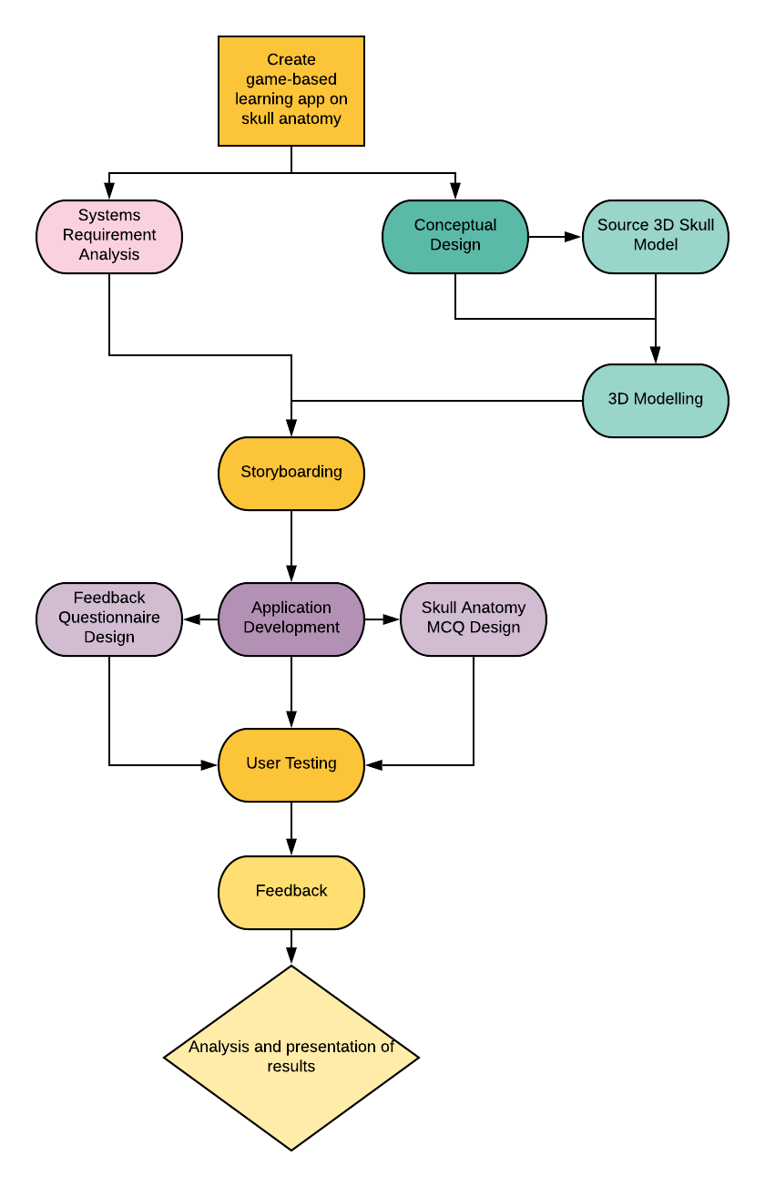
Fig. 1: Development process workflow (reproduced from Dall et al., 2019)

Optimisation of the 3D Skull Model
A high quality, anatomically accurate human skull model with individually modelled bones and an Attribution Share-Alike licence, which was developed by Mariano Corretti, was utilised for the game. This model was free to use with the conditions that the developer is credited, resulting work made freely available and any changes to the model clarified (Wikimedia Commons, 2018).
The model, in .stl file format, was imported to the modelling software 3DS Max (Autodesk, 2018). The detailed model had a high polygon count (430,558) and importing the model to the application at that size resulted in high memory and processor usage when running the game, slowing the application (Fig. 2). The total polygon count was reduced and some detail was sacrificed in order to reduce the memory requirements. However, this did not negatively impact on the anatomical fidelity of the skull model.
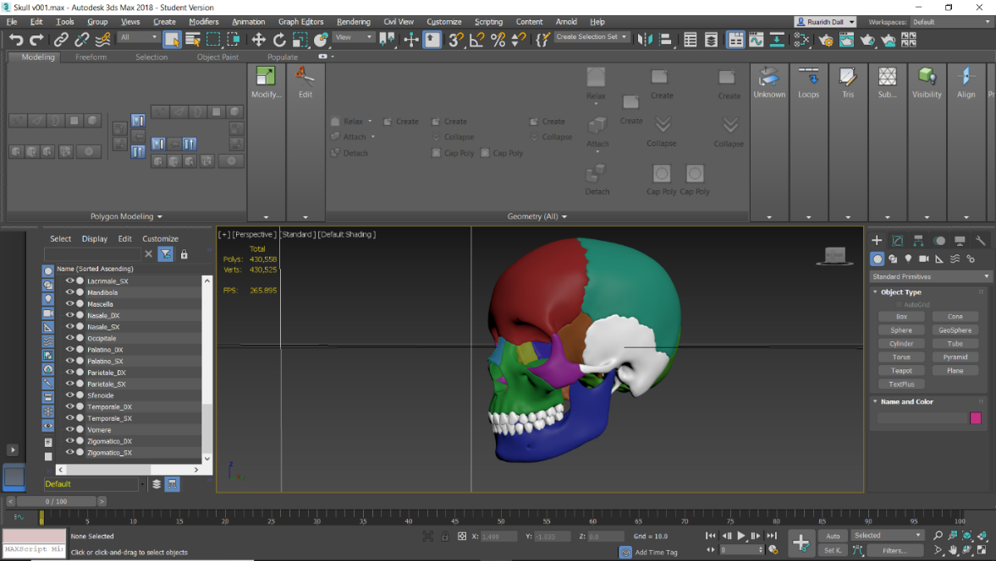
Fig. 2: High quality skull model in 3DS Max with polygon count of 430558 (reproduced from Dall et al., 2019)
Each individual bone was re-topologised to reduce the polygon count using Instant Meshes (Swiss Federal Institute of Technology Zurich, 2015) (Fig. 3). This automated process saved time over re-topologising manually within 3DS Max. The total polygon count was decreased to 179,369 (Fig. 4).

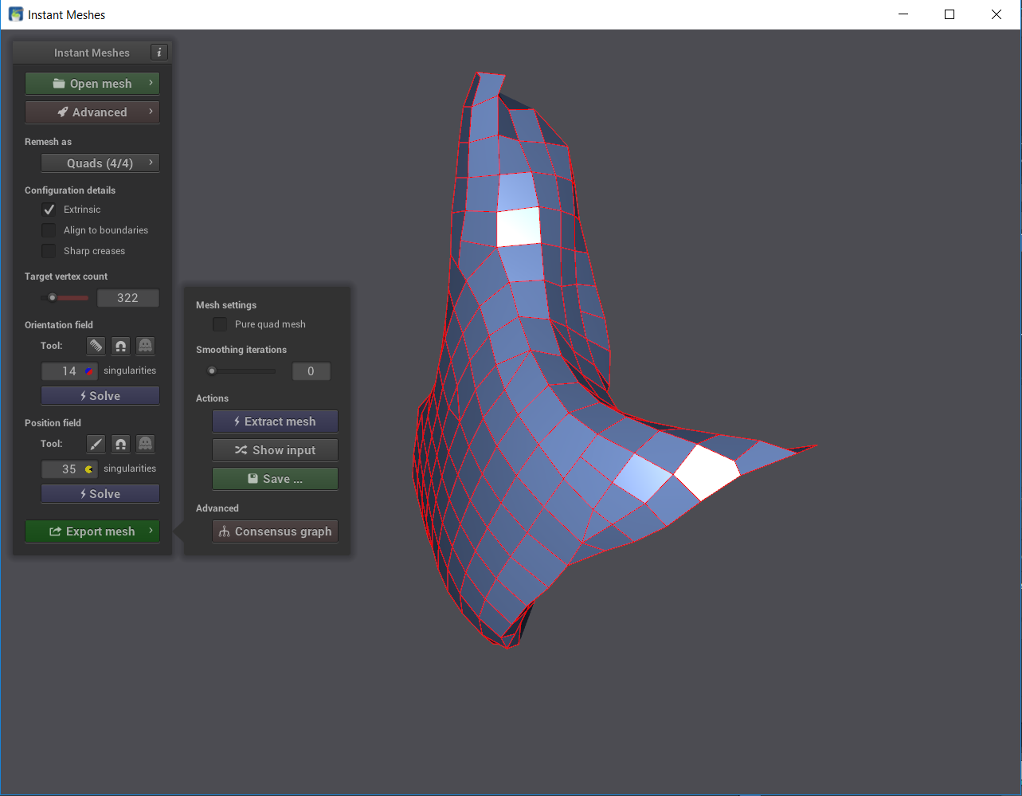
Fig. 3: Instant Meshes reducing polygon count of the right zygomatic bone (reproduced from Dall et al., 2019)
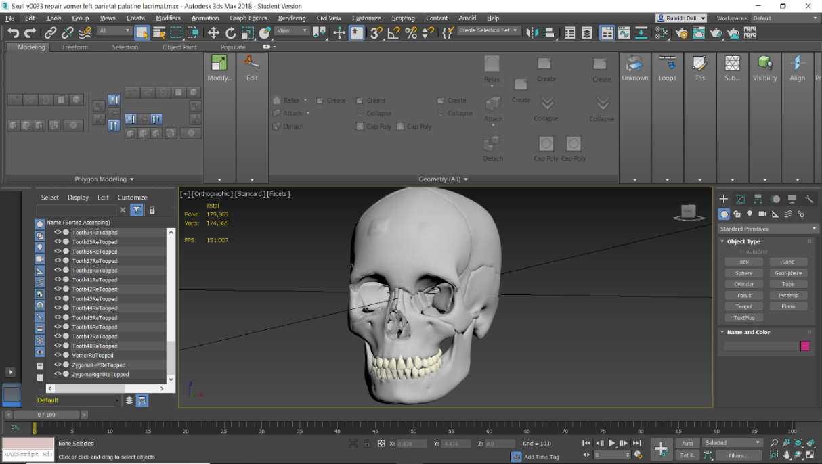
Fig. 4: 3DS Max remodelled skull bones with polygon count reduced to 179,369 (reproduced from Dall et al., 2019)

Game Structure
The SMART (specific, measurable, achievable, realistic, time-sensitive) framework (Doran, 1981) guided the development of the following five levels in progressing game order:
- (tutorial) – Normal skull;
- Skull with bony plate linking the bodies of the mandible;
- Absent coronoid processes of the mandible;
- A cleft palate;
- Missing vomer.
Each of the levels has been linked with a learning outcome of rising difficulty as progressing through the game, the errors become subtler and more challenging to identify. The overtly unnatural bony plate on the mandible should be recognised by an early stage dental student without difficulty, while the small and easily overlooked vomer in the midline of the nasal cavity would be harder to notice if absent.

3D Modelling
The learning outcomes for the five levels required the modification of the re-topologised bone models. The models of the mandible, maxilla and palatine bones were duplicated and altered in 3DS Max (Autodesk, 2018). The mandible was duplicated twice, to allow for separate models with the added bony plate (Fig. 5) and missing coronoid processes (Fig. 6). The duplicated maxilla and palatine bones were recontoured to create the cleft palate (Fig. 7). Errors created by the re-topology process, such as lost connections between polygons, were corrected. In addition to the modelling of the bones, 3D objects to dress the game’s scenes were created. Both the bones and other objects were textured with image files freely available on the web.
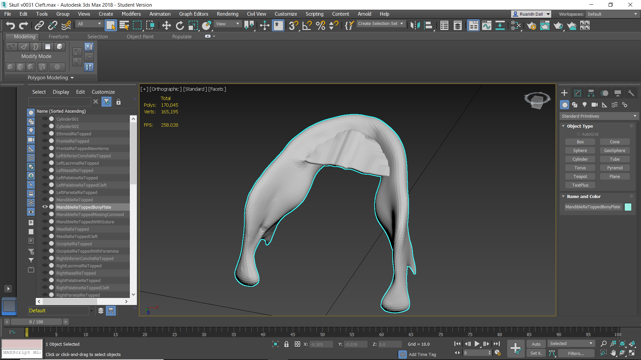
Fig. 5: 3DS Max model of mandible with bony plate between bodies (reproduced from Dall et al., 2019)
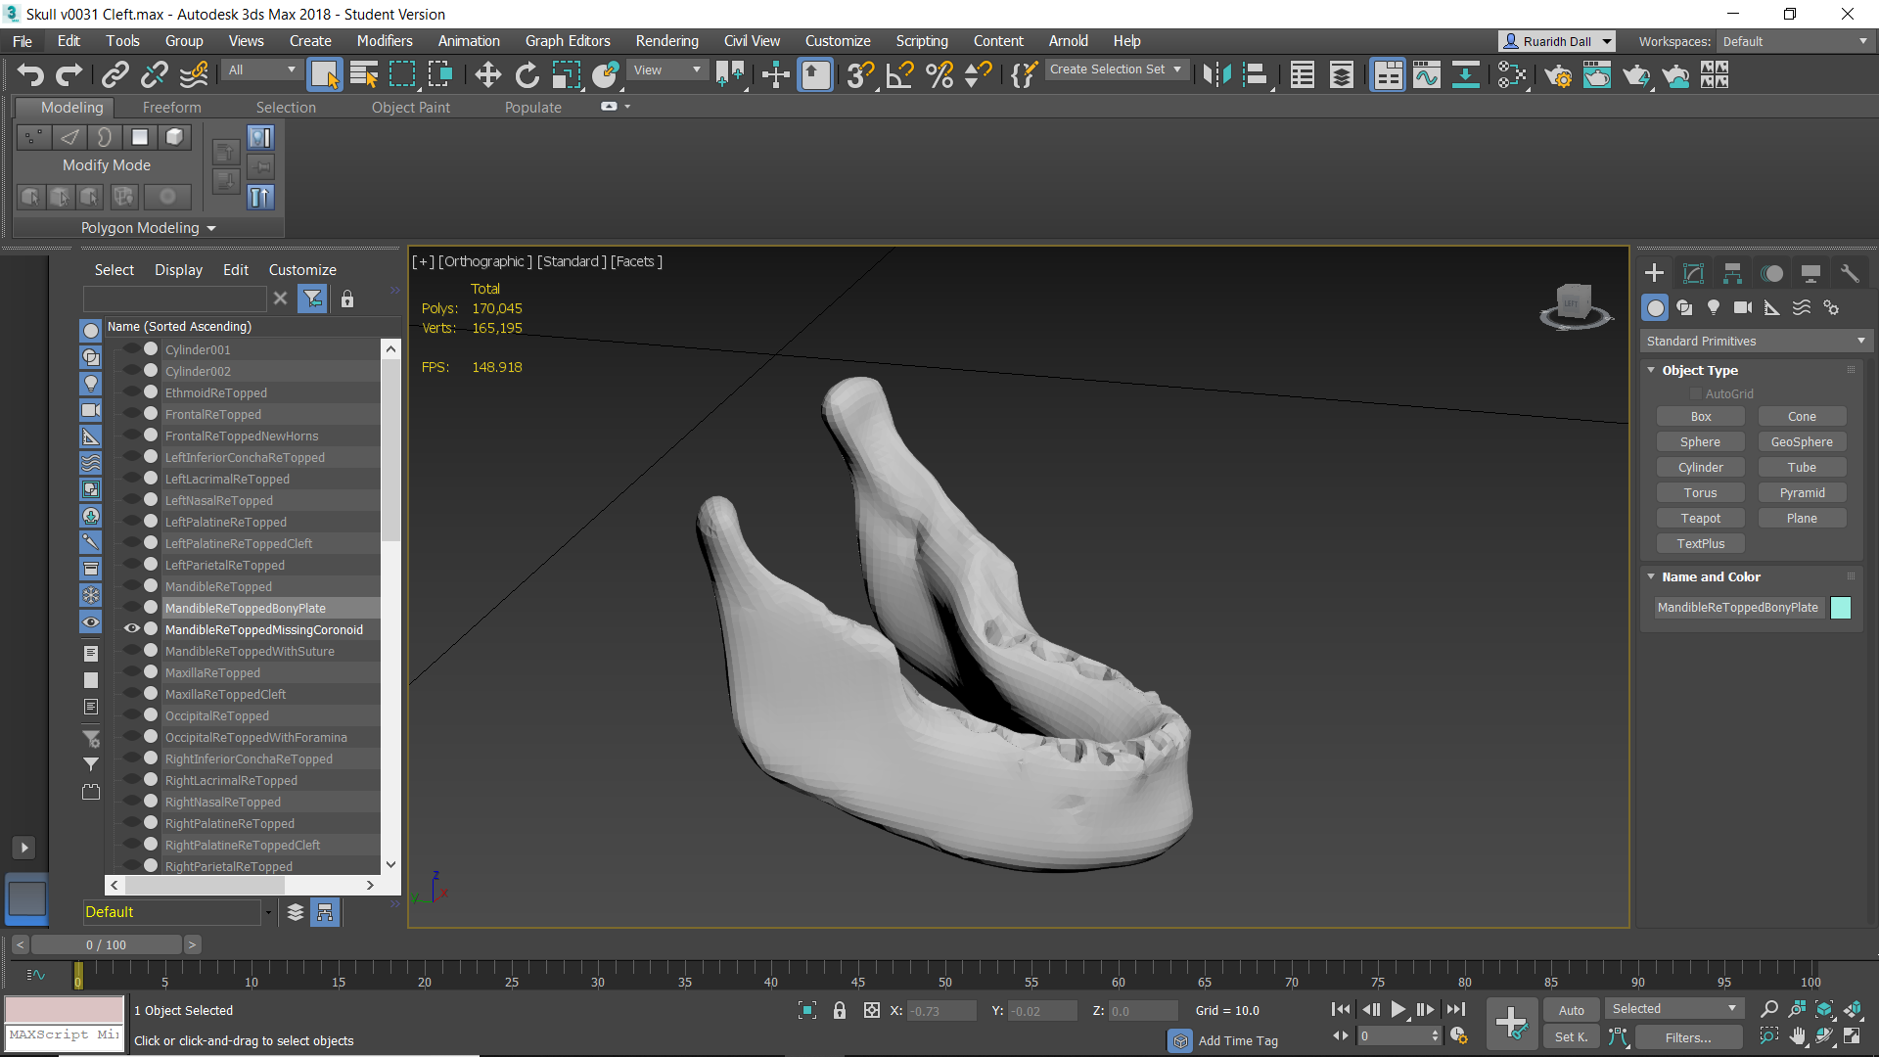
Fig. 6: 3DS Max model of mandible with missing coronoid processes (reproduced from Dall et al., 2019)
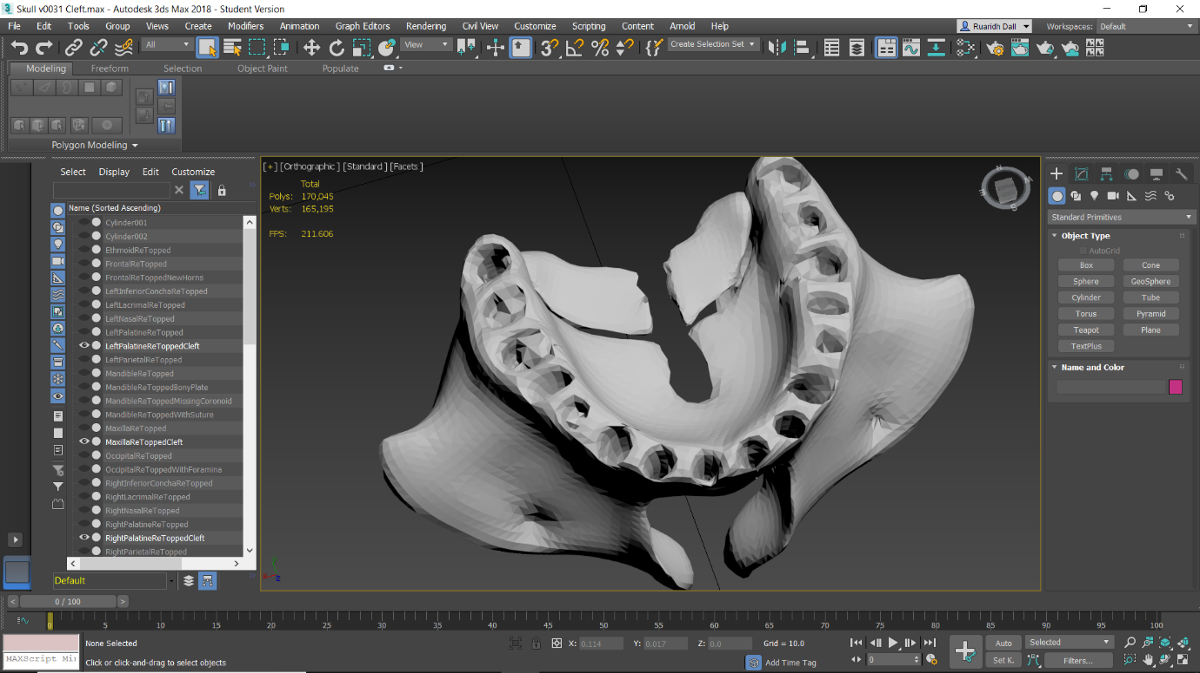
Fig. 7: 3DS Max model of cleft palate (reproduced from Dall et al., 2019)

Game Development
Unity (Unity Technologies, 2018) was used to create the game at a resolution of 1920x1080 for full high definition display. The bone models were imported and set within the game levels. The level design featured an office scene (Fig. 8) where the player receives messages by text and instant message from their clients and artists; an artist’s studio where the player can interact with the model created by the artist (Fig. 9); and an anatomy laboratory to view the correct anatomy of the skull (Fig. 10). To speed the development process, third party assets freely available from the Unity Asset Store (Unity Technologies, 2019) and Sketchfab (Sketchfab, 2019), were used in these scenes.
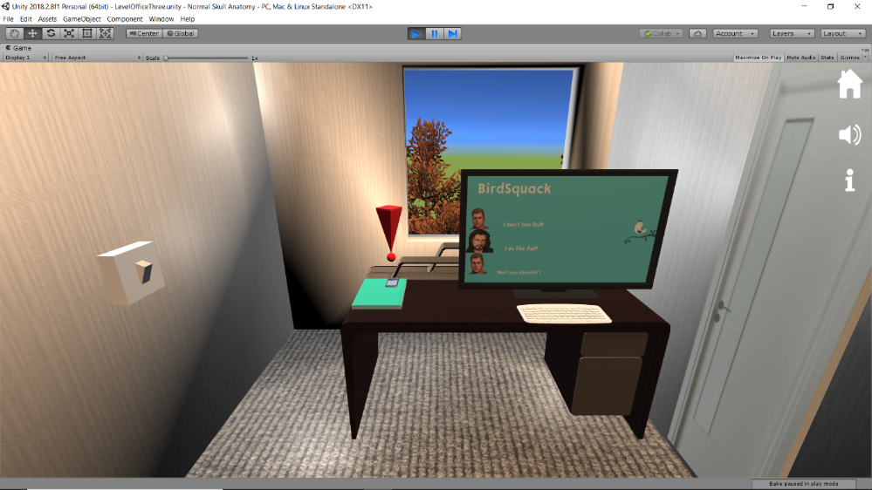
Fig. 8: Office scene within the game (reproduced from Dall et al., 2019)
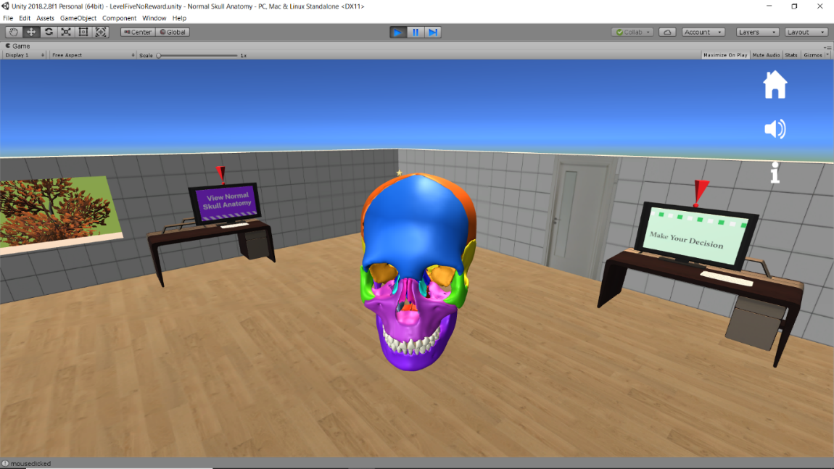
Fig. 9: Artist’s studio scene within the game (reproduced from Dall et al., 2019)
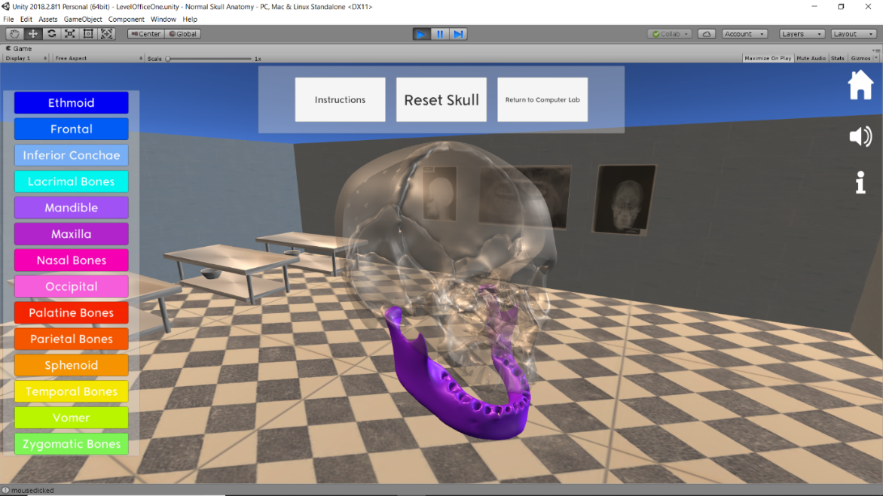
Fig. 10: Normal Anatomy scene within the game showing colour-coded bone name panel and translucent effect applied to bones other than the chosen mandible (example in this figure) (reproduced from Dall et al., 2019)
C# scripts developed and written in the Visual Studio Code scripting environment (Microsoft Corporation, 2019), were incorporated into the Unity development, along with on screen buttons, give the player control within the game, allowing navigation between scenes, opening of text and information panels, and interaction with the skull and bone models. Textures, animation and audio was added to boost the player experience, highlighting where to click and providing visual and audio feedback when selecting objects. A mute-able audio track purchased from a third party composer has also been added to each scene.
A key element of the game is the reward system. In one game version players receive intrinsically integrated rewards for correctly approving or rejecting the work submitted by their artists for clients. The rewards take the form of a bonus from their clients with decorations for their office (Fig. 11). A bonus is available for each level providing the players with the challenge of completing the decoration of their office by correctly completing each level. By intrinsically integrating the rewards, it is expected that the players will be motivated to replay the game to achieve this, as this method of reward inclusion has been shown to increase playing time (Habgood and Ainsworth, 2011).
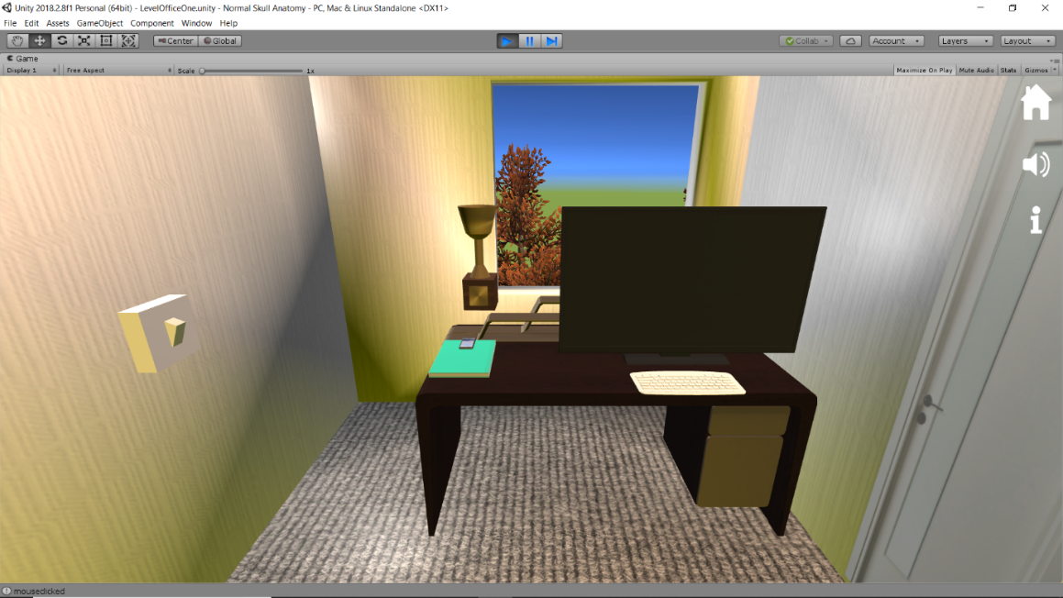
Fig. 11: Reward trophy within the game for correctly identifying the anatomy (reproduced from Dall et al., 2019)

Development Outcome
A detailed pathway through the game can be seen in Fig. 12.
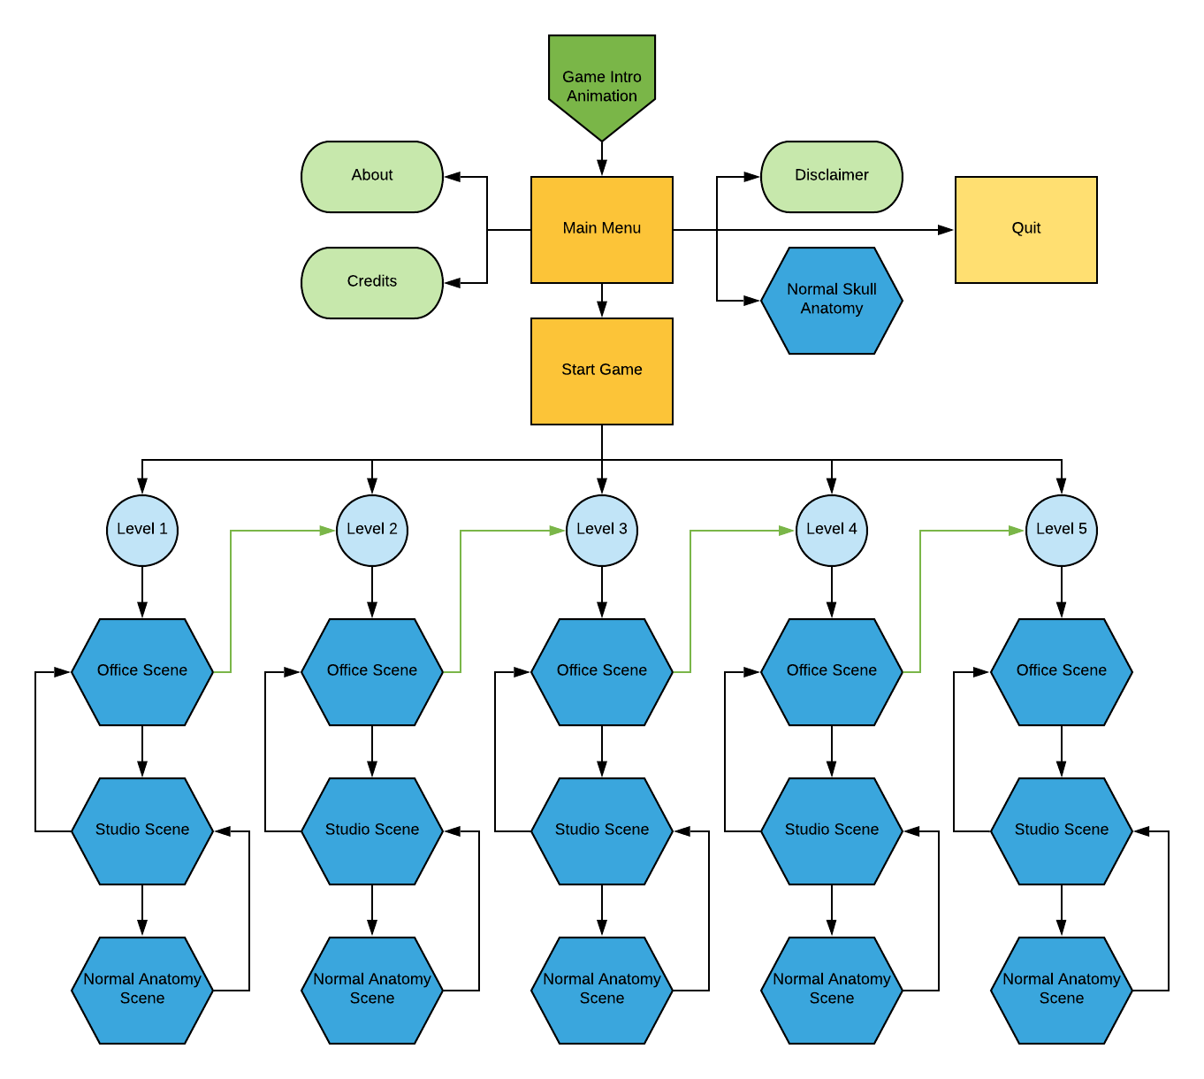
Fig. 12: Flowchart demonstrating game contents and passage through the game (reproduced from Dall et al., 2019)

Game Content
The Menu Scene follows a brief introductory animation. The game’s title is visible against a backdrop of buildings from a third party provider. The About (i.e. brief description of content and purpose of the game), Credits (i.e. materials used and acknowledgments for third party sources), and Disclaimer Panels (i.e. disclaimer that the information contained in the game does not constitute medical/dental advice) and pressing the Start Game button opens a second panel of buttons, allowing the player to choose to play any of the five levels (Fig. 13). This choice gives ownership to the players over how the game is approached, also allowing for repetition of levels to secure all the rewards.
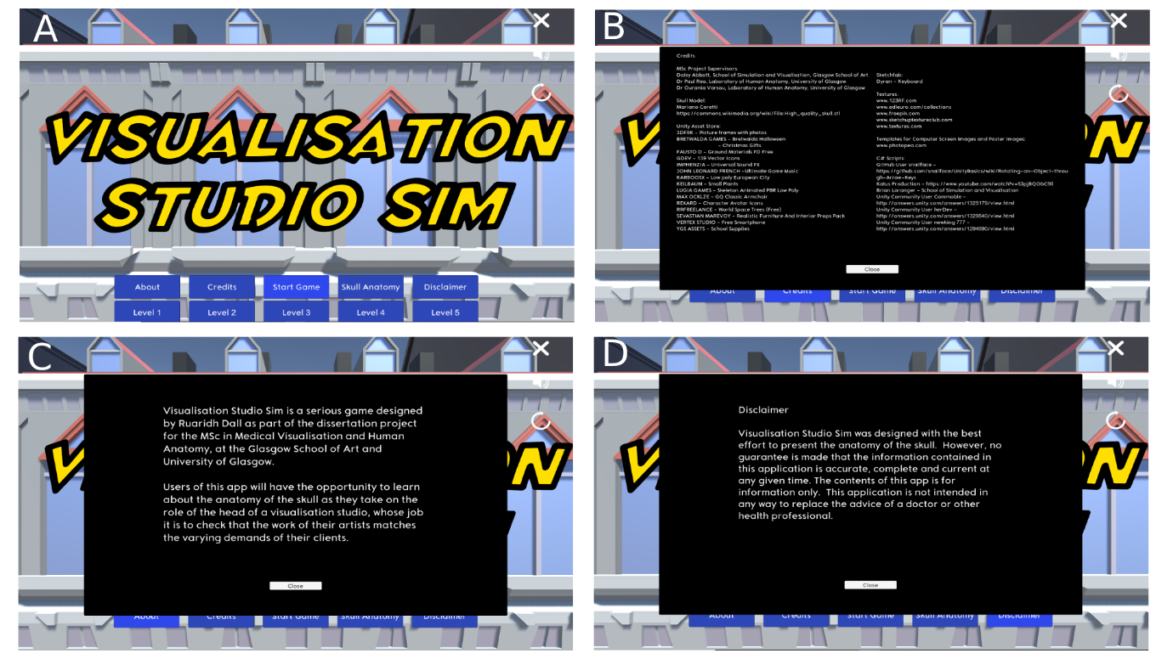
Fig. 13: Menu scene (a), credits panel (b), about panel (c), disclaimer panel (d) (reproduced from Dall et al., 2019)

Normal Anatomy Scene
An interactive skull model is displayed in the Normal Anatomy Laboratory Scene (Fig. 14). Rotation of the skull with the arrow keys or by clicking and dragging the mouse is possible. Pressing the spacebar resets the rotation. To zoom, the mouse wheel could be rotated. Combining these control methods allows players the freedom to view the bones as they wish. Details on how to use these controls can be accessed via the Instructions button. A panel of buttons listing the bones that make up the skull is available on the left of the screen. Clicking the title of a bone (or pair, in the case of the inferior conchae, lacrimal, nasal, palatine, parietal, temporal, and zygomatic bones) highlights the bone or bones in a colour matching that of the button allowing for visual association. The effect is also accompanied by the application of a partially translucent material to the other bones. The above approach means that there is still a frame of reference for the highlighted bone or bones’ position in the skull. The Reset Colour button renders the skull bones back to their natural off-white colour. The right of the screen features a panel of icons that included a Home button to exit to the Menu Scene, a button to mute the scene music, and an Information icon to open the Instructions panel.
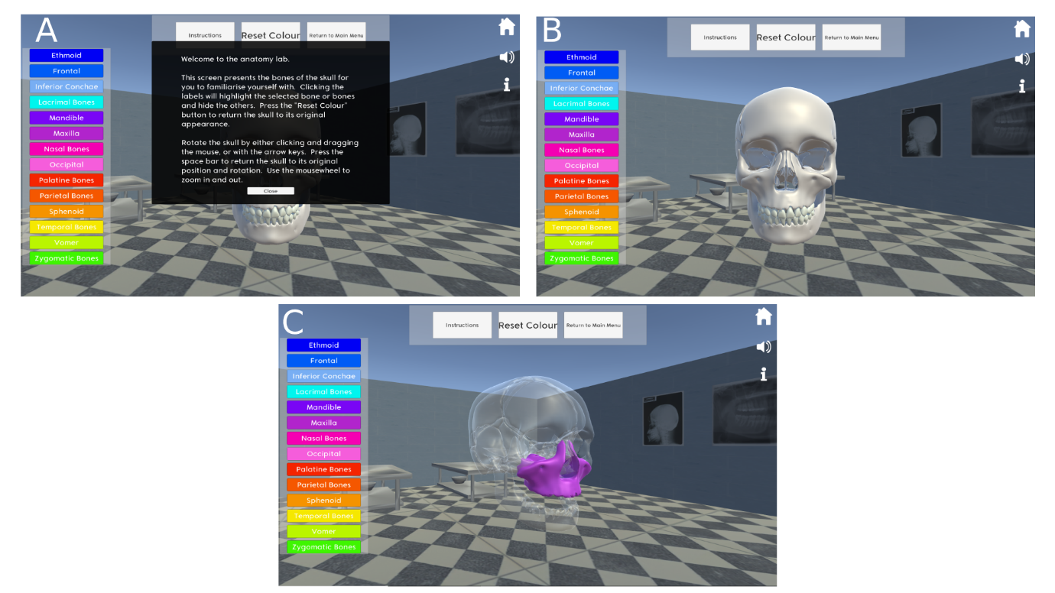
Fig. 14: Normal anatomy laboratory scene instructions (a), skull model on scene entry (b), maxilla highlighted and skull rotated (c) (reproduced from Dall et al., 2019)

Level Layout
Each level in either game version has an identical arrangement. Players start in the Office, advance to the Artist’s Studio, from where they can choose to access the Normal Anatomy Laboratory, and then revert to the Office to receive the client’s message as to whether the task has been completed successfully or not, before receiving additional feedback. The right of each screen displays a Home button and a button to mute the background music. As a player aid, an information panel is displayed when entering the Office and the Artist’s Studio on Level One to describe how to negotiate the scene (Fig. 15).
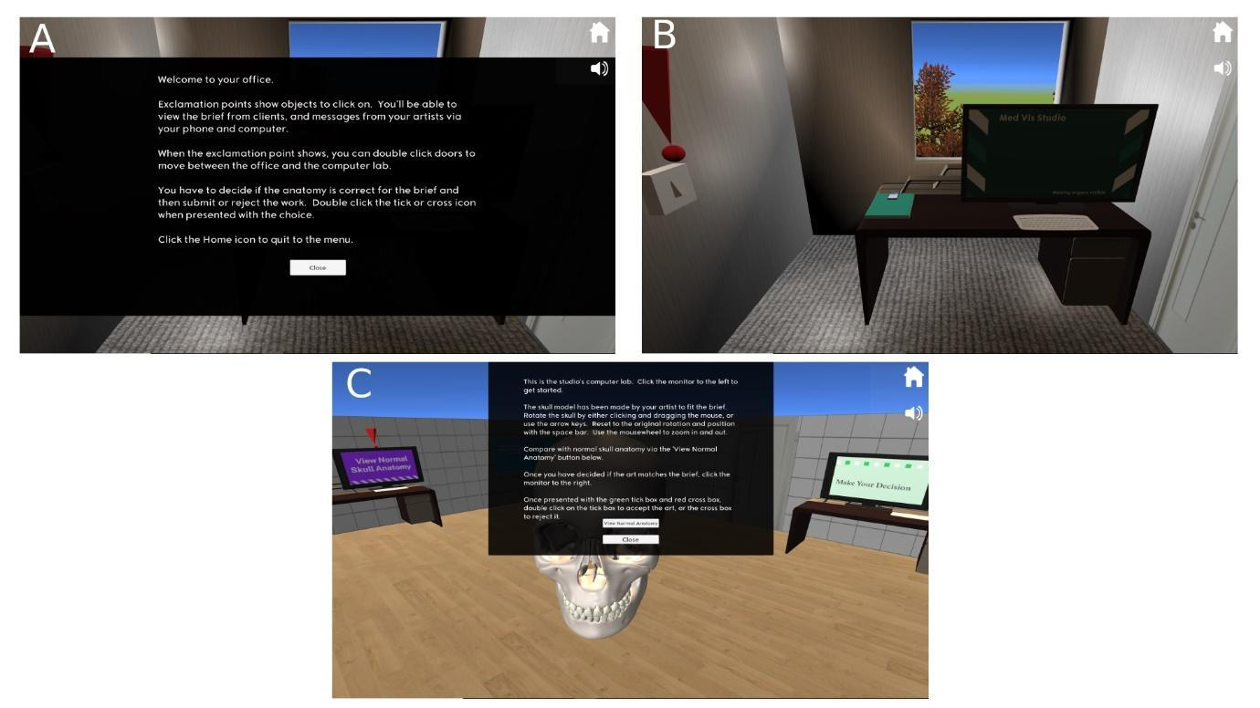
Fig. 15: a) Introductory panel of the office, b) view of office after panel is closed, home and mute icons visible top right, c) artist's studio introductory panel (reproduced from Dall et al., 2019)

Office
The Office Scene sets the level’s challenge for the player. Visual clues as to what objects are to be clicked on are provided by rotating red exclamation marks. The darkened office is illuminated by pressing the light switch to initiate the scene. Clicking the animated smartphone object opens the client brief (Fig. 16). The brief varies by level: a skull with the occipital bone highlighted in a different colour; a skull for inclusion in a serious game; an orthodontist’s application on the mandible requiring a skull; a skull modelled with a cleft palate; and a skull with highlighted bones of the nasal cavity. Artists contact the player via the computer screen to state that the brief has been completed (Fig. 17) and players are prompted to move to the Artist’s Studio via clicking the door. To reduce the uniformity of the levels, each has different visual decorations and audio track.
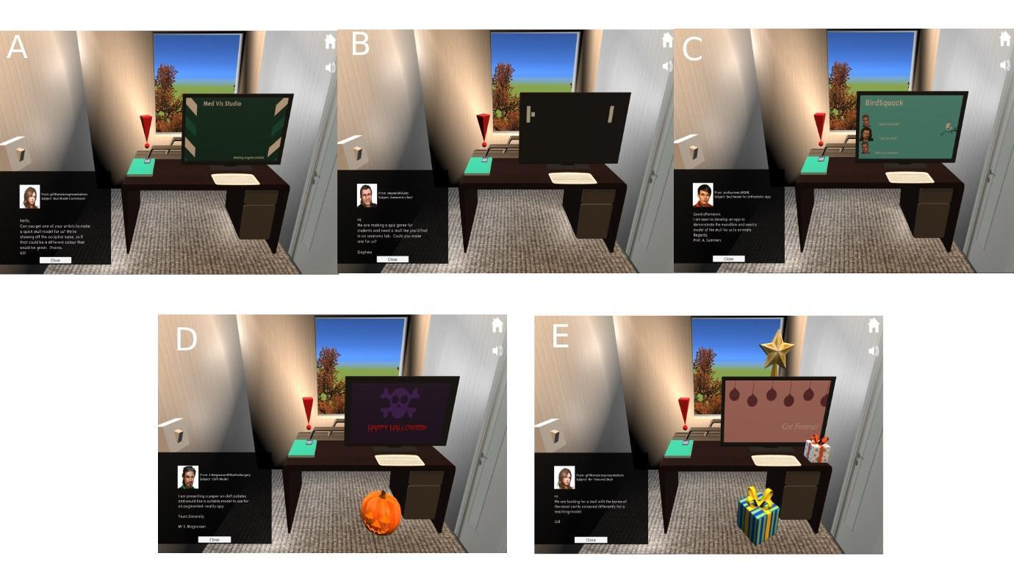
Fig. 16: Client briefs, a) level one, b) level two, c) level three, d) level four, e) level five (reproduced from Dall et al., 2019)
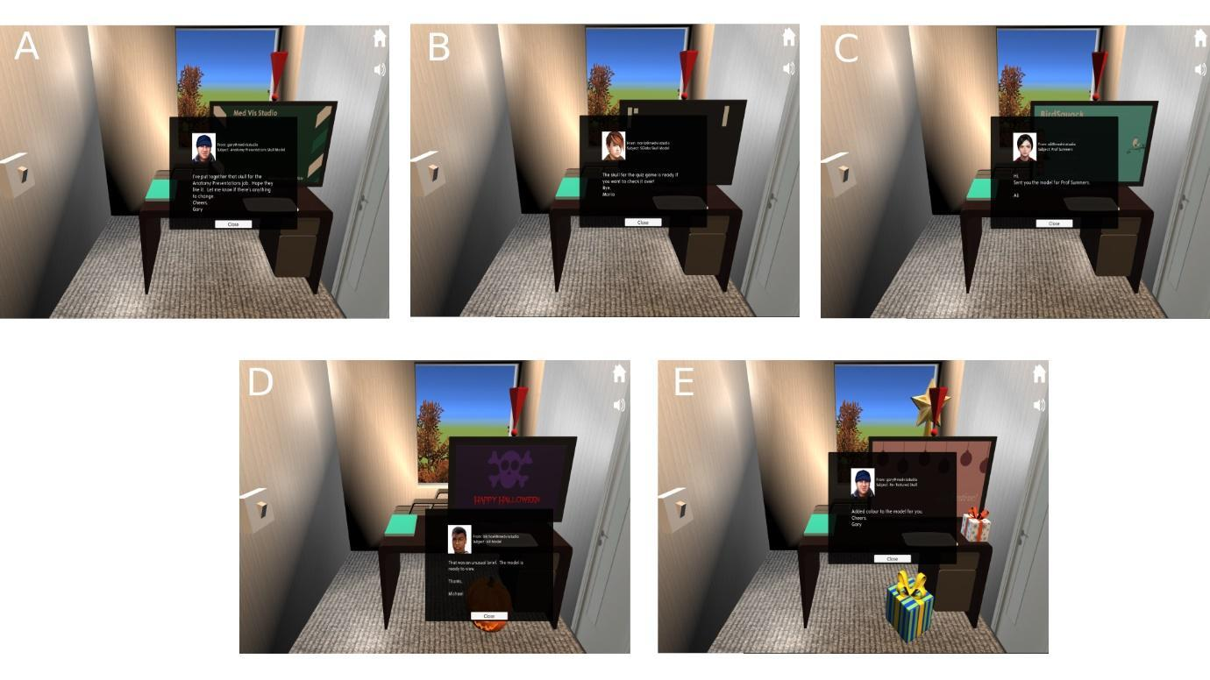
Fig. 17: Artist messages, a) level one, b) level two, c) level three, d) level four, e) level five (reproduced from Dall et al., 2019)

Artist’s Studio
In the Artist’s Studio players are shown the model created by the artist in respect of the brief. This can be interacted with in the same manner as the skull of the Normal Anatomy Laboratory Scene. The brief is displayed by clicking a button on the lower left of the screen. The Normal Anatomy Laboratory can be accessed by clicking a computer screen displaying the message View Normal Anatomy to the left, giving players the opportunity to review an anatomically accurate skull model. The monitor situated to the right of the screen displays the message Make Your Decision – through interaction with this screen, players decide whether to accept or reject the presented skull model, via either the tick or cross boxes. For levels one and four, the models provided meet the briefs: the occipital bone is correctly highlighted (Fig. 18a), and the cleft palate is present (Fig. 18d); however, for levels two, three and five, errors are present. There is a plate of bone joining the bodies of the mandible (Fig. 18b); the coronoid processes are absent (Fig. 18c); and the vomer is absent from the nasal cavity (Fig. 18e).
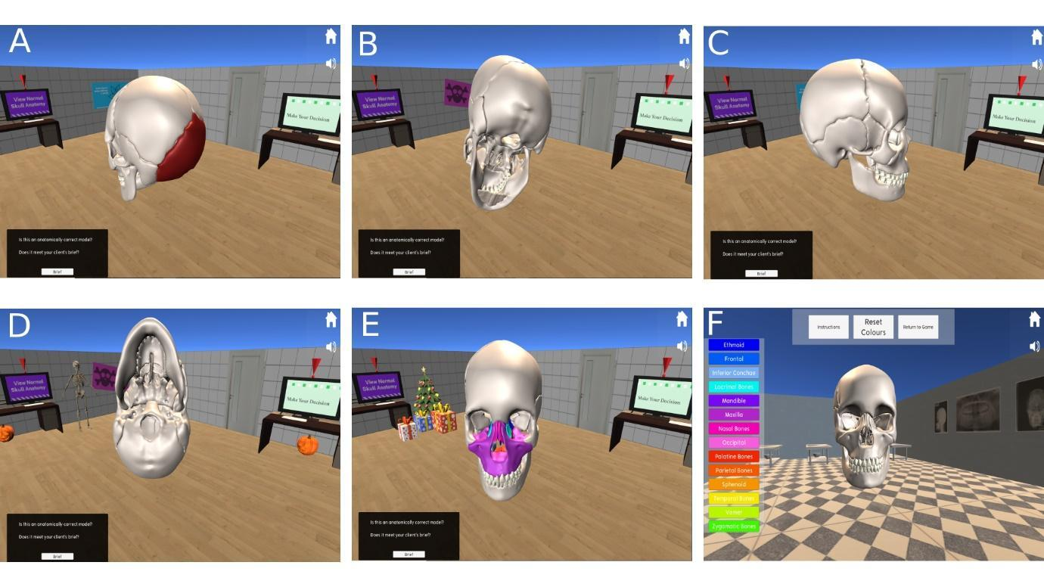
Fig. 18: a), b), c), d), e) Artist’s skull models for levels one to five, f) shows the normal anatomy laboratory (reproduced from Dall et al., 2019)

Normal Anatomy Laboratory
An analogue of the Normal Anatomy Scene; this part of the level displays a skull model that can be interacted with as described in 4.2. Instructions are accessible by the button at the top of the screen, and to the right of the row a button allows players to revert to the Artist’s Studio (Fig. 18f).

Artist Responses
Rejecting models and returning them to the artists for further modelling activates a switch of camera within the game back to the Office. Players are prompted by exclamation mark to click on the monitor to receive a message from the artist (Fig. 19). For levels two, three, and five, the artist realises their mistake and corrects the model so it can be sent to the client. On levels one and four, the artist states that their work meets the brief correctly.
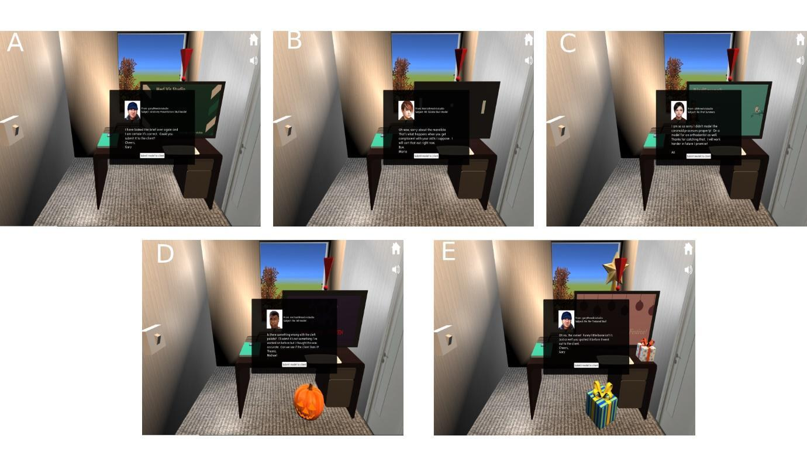
Fig. 19: Artist responses to rejecting their models for levels one to five (a to e) (reproduced from Dall et al., 2019)

Client Responses
Where players incorrectly send models with errors from levels two, three and five to the client, or return the error-free models of levels one and four to the artists (i.e. causing a delay in delivery to the client), the client sends a message stating their disappointment at the work provided to them (Fig. 20).

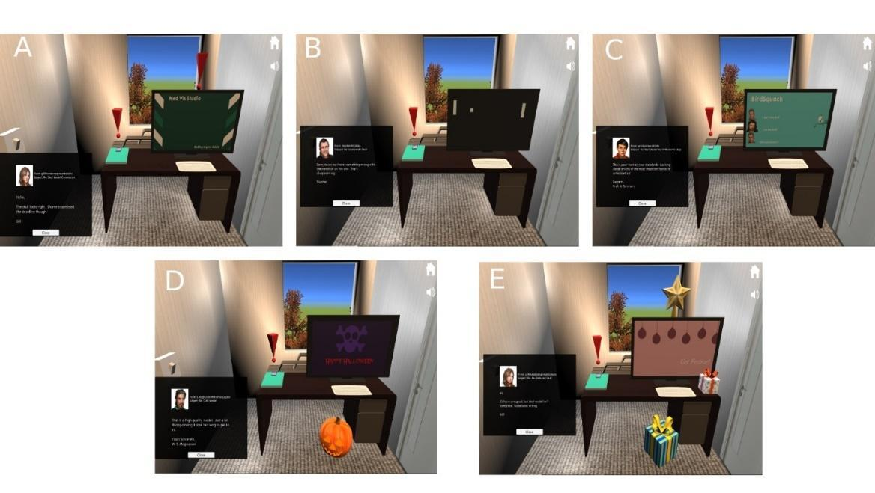
Fig. 20: Negatively toned messages from clients in response to player delaying correct work (a, d) or sending inaccurate models (b, c, e) (reproduced from Dall et al., 2019)
Alternatively, where the player correctly sends models from levels one and four to the client, or identifies the mistakes in levels two, three and five, the client messages the player stating their satisfaction (Fig. 21).
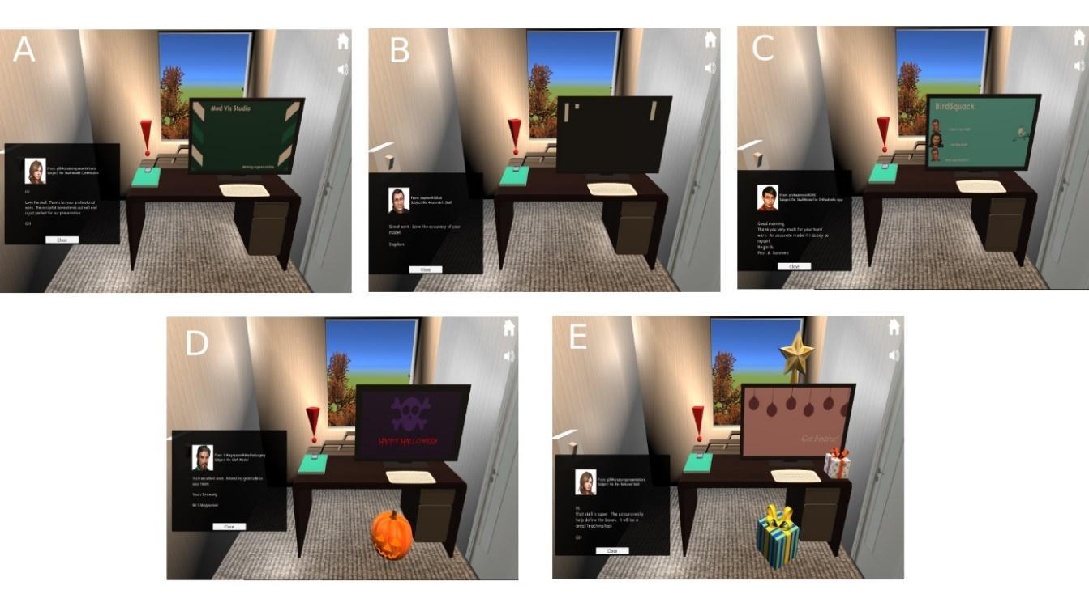
Fig. 21: Messages received from clients where the skull model meets the brief, levels one to five (a to e) (reproduced from Dall et al., 2019)

Feedback
Feedback, regardless of success within a level, is provided (Sipiyaruk et al., 2017). This helps players appreciate as to why they may have made an error with identification of inaccuracies, or indeed as to why the answer may be correct. At the end of each level, feedback screens are displayed showing side by side comparisons of the artist’s model and the normal anatomy with a description of the models. This panel provides the option to exit to the Menu Scene or to start the following level (Fig. 22 and Fig. 23).

Fig. 22: End of level feedback for incorrect submission of model, levels one to five (a to e) (reproduced from Dall et al., 2019)
Fig. 23: End of level feedback where correct model was submitted, levels one to five (a to e) (reproduced from Dall et al., 2019)

Rewards
The intrinsically integrated rewards are only present in one game version. On successful completion of a level, players are provided with a third-party asset as a decoration for their office; a lamp, mirror, plant, painting, and chair. In this game version, the client briefs offer a bonus for accurate models (Fig. 24), and the closing message from the client confirms or declines the award of the bonus (Fig. 25). When successful the screen displays a rotating trophy and fanfare sound, and a panel instructs the player to click on the trophy to receive their award. The reward object materialises on screen (Fig. 26) and is programmed via a C# script to remain on screen through all playthroughs. Therefore, players could replay failed levels and collect all the other office decorations, if they wished.
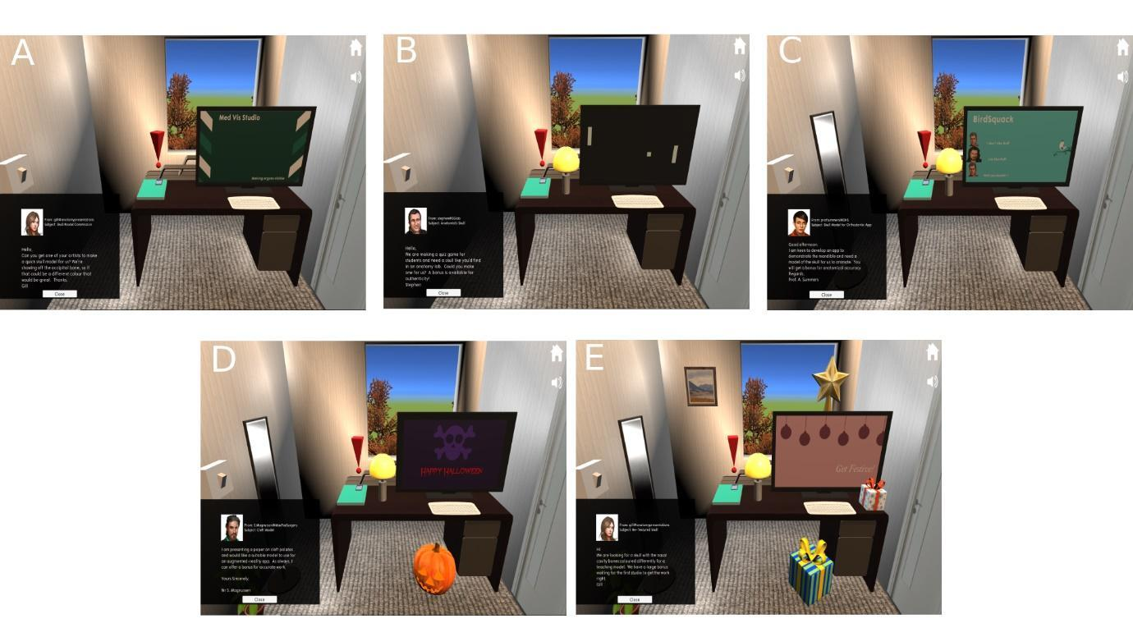
Fig. 24: Client briefs in reward version of game, levels one to five (a to e) (reproduced from Dall et al., 2019)
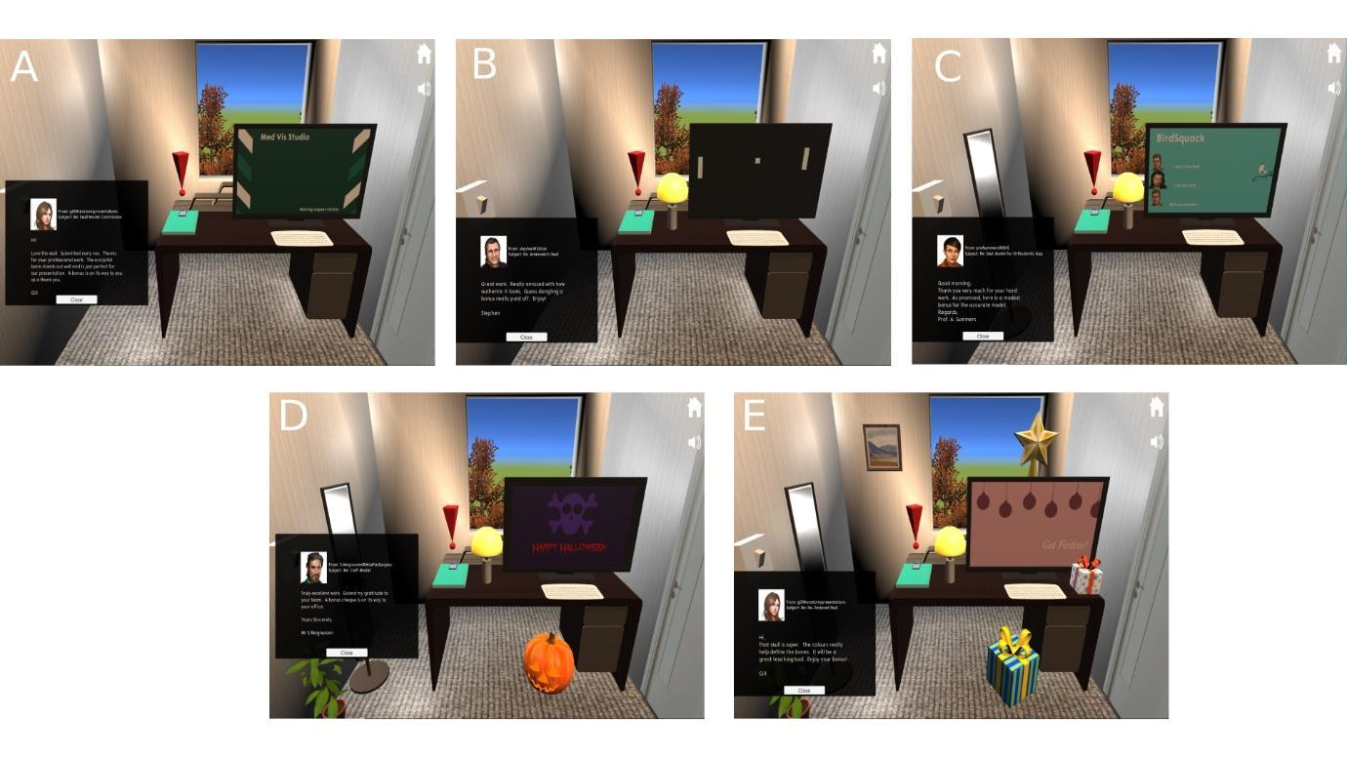
Fig. 25: Client messages following successful delivery of correct models, reward version, levels one to five (a to e) (reproduced from Dall et al., 2019)
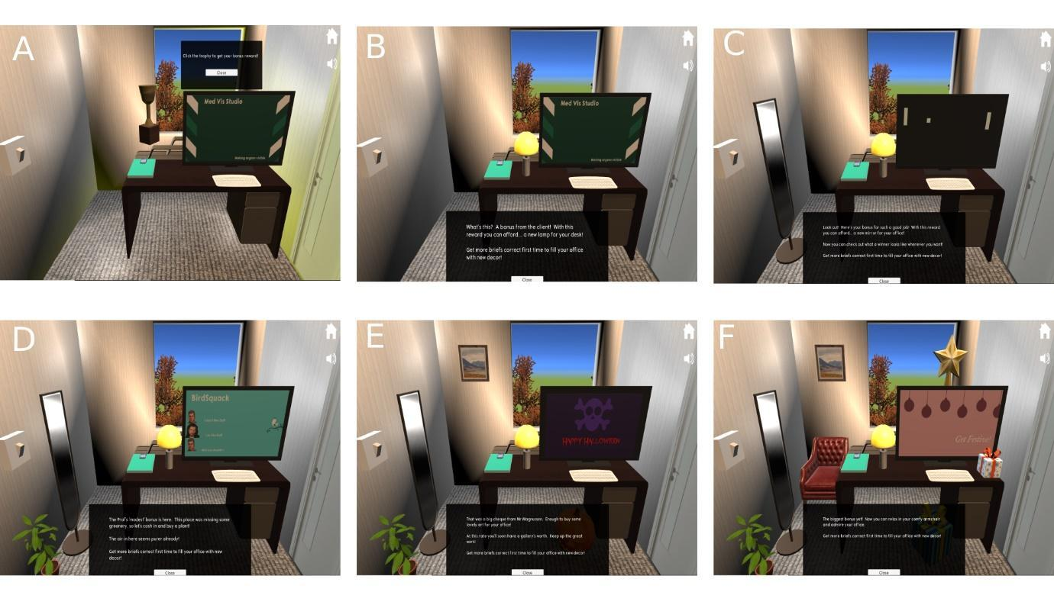
Fig. 26: Reward trophy (a), lamp (b), mirror (c), plant (d), painting (e) and chair (f) (reproduced from Dall et al., 2019)

Evaluation
Visualisation Studio Sim was evaluated by inviting participants to complete the two different game versions with the aim of gathering preliminary feedback on its overall usability as a serious game for skull anatomy education and the suitability of the reward system. The Glasgow School of Art provided ethical approval for the above project and written informed consent was obtained from all participants prior to taking part in this research.

Methods
Participants were invited from two convenient cohorts; an undergraduate anatomy programme from the University of Glasgow and the MSc programmes at the School of Simulation and Visualisation from the Glasgow School of Art. In total, six participants took part in the evaluation phase of this project. Due to the small sample size, further details of the participants will not be discussed in this chapter to prevent potential re-identification.
Participants were given two separate USB drives with each having a different game version and logged into a PC on their respective university campuses. The participants were assigned to play through one game version before the other by simple randomisation. They were then invited to provide fully anonymous open-ended feedback.

Discussion of Qualitative Feedback
In terms of the overall game, “the control mechanisms were simple and straightforward” commented one participant. This could be interpreted as players found this part of the educational content easy to use. However, they also contributed “while clicking the actual item itself to read the briefs/emails or complete an action, you have to click the period of the exclamation point above the phone (I was quite confused)”. Another added: “I felt there were too many unnecessary clicks between meaningful tasks. The light switch was entirely unnecessary”. These features show the developers that there were some issues with the overall game that might have frustrated players, and that the flow of the game might not have been as slick as initially intended. The comment that the light switch is “entirely unnecessary” gives credence to the argument that the game included potentially obsolete actions that might have distracted players from the main content. One player said: “splitting individual tasks into separate “levels” slowed down engagement with the material.” The use of “levels” within the game made it harder for this player to engage with the educational content. Having to repeat the same processes on the introduction to each level could have also lowered the game immersion felt by the player.
Further comments for future development included: “the fixed order of tasks makes memorisation easy, so replaying involved memory, not analysis” and “maybe it would be better to have the artists send new (and potentially still wrong) versions of models after you reject them, until they eventually get it right.” These comments suggest that the game might have been too easy, and successfully replaying levels lent more to the previous experience than solving the problem, especially as its intended user group, who are undergraduate dental students would be expected to have a higher knowledge base of skull anatomy when compared to the convenience cohorts.
Comments on the reward system included: “the ‘bonus’ rewards were a great encourager [sic] for keeping an eye out for details so you could get right the first time.” Another participant commented: “it could be even more effective as an educational tool if the rewards were related to what is being learned (e.g. slowly constructing a skull model in your home desk)”. From the above, it could be theorised that the reward system was not as intrinsically integrated as desired and did not truly represent affordance-oriented rewards as intended by the developers. Using decorations for the office as the reward was perhaps not the best choice for the game in that respect.

Discussion and Future Developments

Discussion
This project met its primary aim of developing a tailored serious game for skull anatomy education of dental undergraduate students that also tested the usability of an intrinsic rewards game mechanic. Two versions of the Unity-created game, one with and one without the game mechanic, were tested by participants and open-ended player feedback was gathered. This suggests that interacting with the skull models was uncomplicated, but that the rewards were not as well integrated into the flow and immersion of the game as intended, and the game might not have been as challenging as desired for the intended cohort warranting future refinements in these aspects.
Re-topologising the third-party bone models with Instant Meshes software saved time over manual retopology in 3DS Max, but led to some loss of polygons and sharper edges to the bones. This meant that there was repair of the meshes required, and loss of detail on some of the bone models. This reduction did come at the benefit of a smaller file for incorporation into the game, saving memory and it did not affect the overall anatomical fidelity of the model.

Future Development
Future development of this game can include an increase in the number of levels allowing for further focus on the minutiae of skull anatomy, such as sutures, foramina and anatomical landmarks. In doing so, this can make the game more challenging for players, addressing the feedback that there was a lack of difficulty with the initial version and it would also be more appropriate for dental undergraduate cohorts. Modification of the reward system by intrinsically integrating it further into the game by using it to supply the players with different bones with the aim of building their own skull model is an extremely useful adaptation. The requirement to position the bones correctly for advancement to the next level will fit better into the definition of affordance-oriented rewards. The game can be streamlined, by removing some of the repetitive unnecessary features such as the need to switch on the light at the beginning of each level, improving the flow and immersion for the player. Addition of further control options when manipulating the skull model can include an audio volume control slider, the ability to snap the camera to an isolated bone and allowing control of the level of transparency of non-selected bones with a slider.
Further development of the game and testing with a group of undergraduate dental students is required to gather data on its usability and validity as a serious game within the desired target audience. An intrinsically integrated reward system would also provide further information on the affordance-oriented rewards.

Acknowledgements
The authors would like to thank all the participants for their contribution to this study. The authors would also like to acknowledge that this research work has been previously discussed in Ruaridh Dall’s MSc thesis entitled “Does the introduction of intrinsic rewards as a gameplay mechanic increase motivation to use a game-based learning application on skull anatomy?” that was submitted in partial fulfilment of the MSc Medical Visualisation and Human Anatomy degree in 2019. However, the text has been significantly reworded with novel insights and discussion.

References
Abt, C. (1970). Serious Games. New York; The Viking Press
Amer, R. S. et al. (2011) ‘Development and evaluation of an interactive dental video game to teach dentin bonding.’, Journal of dental education, 75(6), pp. 823–31. Available at: <http://www.ncbi.nlm.nih.gov/pubmed/21642529> [Accessed: 5 June 2019].
Arnab, S. et al. (2015) ‘Mapping learning and game mechanics for serious games analysis’, British Journal of Educational Technology. John Wiley & Sons, Ltd (10.1111), 46(2), pp. 391–411. doi: 10.1111/bjet.12113.
Autodesk, 2018. 3DS Max 2018. [Online]. Available at: <https://www.autodesk.co.uk/products/3ds-max/overview> [Accessed 30th June 2019]
Doran, G. T. (1981) ‘There’s a SMART way to write management’s goals and objectives’. Management Review 70(11): pp.35–36
General Dental Council (2015) Preparing for Practice. [online] General Dental Council. Available at <https://www.gdc-uk.org/docs/default-source/quality-assurance/preparing-for-practice-(revised-2015).pdf?sfvrsn=81d58c49_2> [Accessed 12th November 2019]
Habgood, J.M.P., and Ainsworth, S. E. (2011) ‘Motivating children to learn effectively: Exploring the value of intrinsic integration in educational games’, Journal of the Learning Sciences, 20(2), pp. 169–206. doi: 10.1080/10508406.2010.508029.
Hannig, A. et al. (2013) ‘Skills-O-Mat: Computer Supported Interactive Motion- and Game-Based Training in Mixing Alginate in Dental Education’, Journal of Educational Computing Research, 48(3), pp. 315–343. doi: 10.2190/EC.48.3.c.
Lameras, P. et al. (2017) ‘Essential features of serious games design in higher education: Linking learning attributes to game mechanics’, British Journal of Educational Technology, 48(4), pp. 972–994. doi: 10.1111/bjet.12467.
Microsoft Corporation, 2019. Microsoft Visual Studio Code. [Online]. Available at: <https://code.visualstudio.com/> [Accessed 4th December 2019]
Mozelius, P. (2014) ‘Game based learning-a way to stimulate intrinsic motivation’, 9th International Conference on e-Learning, ICEL 2014, (June), pp. 272–278. Available at: <https://www.scopus.com/inward/record.uri?eid=2-s2.0-84910091430&partnerID=40&md5=7e2bc4c7d101ab801eac7662097b7400> [Accessed 8th August 2019]
Sketchfab, 2019. Sketchfab. [Online]. Available at: < https://sketchfab.com/> [Accessed 4th December 2019]
Sipiyaruk, K. et al. (2017) ‘Acquiring Critical Thinking and Decision-Making Skills: An Evaluation of a Serious Game Used by Undergraduate Dental Students in Dental Public Health’, Technology, Knowledge and Learning. Springer Netherlands, 22(2), pp. 209–218. doi: 10.1007/s10758-016-9296-6.
Sipiyaruk, K. et al. (2018) ‘A rapid review of serious games: From healthcare education to dental education’, European Journal of Dental Education. Wiley/Blackwell (10.1111). doi: 10.1111/eje.12338.
Swiss Federal Institute of Technology Zurich, (2015). Instant Meshes. [Online] Available at: <https://igl.ethz.ch/projects/instant-meshes/> [Accessed 30th June 2019].
Unity Technologies, 2019. Unity. [Online]. Available at: < https://unity.com/> [Accessed 30th June 2019]
Unity Technologies, 2019. Unity Asset Store. [Online]. Available at: < https://assetstore.unity.com//> [Accessed 4th December 2019]
Westera, W. (2017) ‘Why and How Serious Games can Become Far More Effective: Accommodating Productive Learning Experiences, Learner Motivation and the Monitoring of Learning Gains’, Educational Technology & Society, 22(1), pp. 59–69.
Wikimedia Commons, 2019. File:High quality skull.stl. [Online] Available at: < https://commons.wikimedia.org/wiki/File:High_quality_skull.stl> [Accessed 4th December 2019]

