The Vanishing Library
Johnny Rodger
(In 2014 the library at Charles Rennie Mackintosh’s Glasgow School of Art building (1897-1909) was destroyed by fire, it was almost completely rebuilt by June 2018 when the whole building was in turn destroyed by a second fire)
The library at Glasgow School of Art has – or had – special status for connoisseurs of the work of architect artist Charles Rennie Mackintosh. Suffused with an ineffable gracefulness, its timbers garnered a totemic value as a symbol of the workaday genius of their creator. It is said that this exquisite room could be created by any competent craftsman under instruction from the architect’s drawings, no special craft skills were needed. Indeed in the aftermath of the fires which destroyed the jewel of Mackintosh’s masterwork and all its contents in 2014 and again in 2018, the school authorities claimed, evidently by way of reassuring those connoisseurs and others, that :
‘the rebuild would follow Charles Rennie Mackintosh’s original designs’.’
The implicit suggestion (and indeed often the explicit claim at the time) was thus that Mackintosh’s conceptions, or in other words, his models in the form of architectural drawings, are the real art, and the physical manifestation of that graphical genius in the timbers of the library can be recreated by any joiner the school cares to appoint. We might then begin to wonder about that relationship between the drawings and the materially constructed library, whereby Mackintosh’s very plans seem to operate like some type of magical incantation, and take possession of the hands of a dayjobbing tradesman to conjure them into execution of a work of supreme artistic merit. This might in turn bring us to ask if, in the post-fires era of destruction, the library does, in fact, still exist? The actual timbers of the room are gone, but those plans, the original, evident prime movers in creation of the space and the formulae which will be used to put that material version back into place - they still exist. So what is the relative ontological status of these two components, which both have some evident claim to be Mackintosh’s library? Can the library still exist after it has been destroyed by fire? Does its putative totemic status indeed entail something of a magical, or fantasy, ideal or utopic quality, something beyond those everyday material qualities already annihilated twice in the fires?
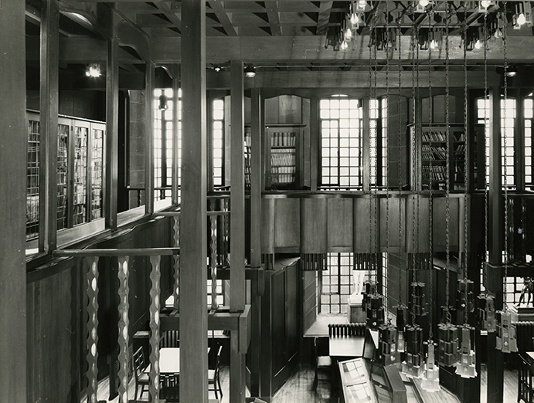
Perhaps it is best to address that question of the library’s existence after its physical material has been annihilated by establishing first what apparently it is not –a mere material artefact. The locus classicus for modes of existence of things is of course Aristotle, particularly in the Metaphysics. In his work to shift philosophy away from mathematics and abstract universal substance towards the physical sciences and the concrete individual substance Aristotle’s principle that a thing cannot both be and not be at the same time plays a central role. So can a thing be annihilated by a conflagration and still exist? It depends on what you mean by thing and what kind of existence it has…
Some intellectual insight into a special type of existence of this Mackintosh work, as hinted at above, might be gained then by viewing it in terms of typology –an abstracted universal which can be asserted of the substance of works of architecture. The typology is said, in the case of Mackintosh’s two storey, timber, galleried room here, to be a library. Libraries are of course, one of the few remaining types of sequestered spaces in the heart of our cities where a free engagement in a full cultural, political and intellectual life can be pursued both at a social and an individual level, apparently at no cost. Is that range of possible operations itself sufficiently idyllic to define it as a working utopia? Or are there other more fundamental properties necessary for a place to have such a privileged ontological status?
As a member of staff at Glasgow School of Art, I had often taught in the Mackintosh library (pre 2014), read in it, led tours to it. I had written about it in several publications and been filmed there by crews from all around the world. In one piece for Architectural Research Quarterly I described the library as ‘one of the most delicate and evocative spaces in Western architecture’. Two days after the 2014 fire I was able to enter the damaged Mackintosh building. Working with a team of colleagues under the direction of the fire brigade and GSA’s architects I witnessed how the library had been reduced to a heap of smouldering ashes while I helped the team to retrieve some half-burnt and charred objects and artefacts from the lesser damaged rooms. The collective sense of heartbreak was palpable as we worked in those blackened, gloomy rooms in an air thick with acrid stench created by the fire.
You might imagine then, my joy when, almost four years later, in mid-April 2018 I entered the almost completely rebuilt Mackintosh library. Some of the materials needed to reconstruct the room in accordance with the early twentieth century ‘original’ had been difficult to find. The timber, for example, – a now rare tulipwood – had been sourced from an old sawmill building which was being demolished in Massachusetts. Yet actual material, and age and source of the material, notwithstanding, the feel of the place was substantially the same as I had remembered experiencing in the original up until 2014. My delight on entering the recreated library was doubled by seeing it mirrored in my companion’s face –Professor George Cairns , who in the early nineties had completed his doctorate on the Mac , and had produced some of the most detailed drawings of this place, was on a visit from Australia. This tour of GSA had been arranged specially for him. His reciprocating delight was especially poignant because Professor Cairns had raised his voice –early on after the 2014 fire in the press in Australia – as one of those Ruskinian modernists in favour of a completely new designed and built library, and he was absolutely against the attempt to recreate from Mackintosh’s ‘original’ designs.
The qualities or even the very existence of the reproduction –if it were thus – evidently seemed to produce joy even in those who had been flatly against any form of reproduction taking place. Was that delight in Cairns’ face testimony of a triumph of sensual stimulation from physical reality over the intellectual satisfaction afforded by presenting oneself as a model of ideological or moral purity? It’s difficult to say, for my own delight, redoubled by its reflection in my guest’s eyes, was further complicated and compromised by a set of more complex reactions which I underwent simultaneously.
These reactions might be compared to those experienced and described by Freud in his short article ‘A Disturbance of Memory on the Acropolis’. Freud, who had studied classics as a boy attending the Gymnasium in Vienna, visited Athens for the first time as a tourist with his brother when he was 48 years old. Where he had expected that he would only experience pleasure on visiting the Acropolis, he discovered that his delight was tempered by a sort of astonishment that the monument actually existed. It was as though he had always doubted the real existence of the ancient Greek site, and it was only now, obliged under the impact of unequivocal observation that he realised, first of all, that it really did exist, and secondly that he became aware that he had ever doubted of the real existence of the phenomenon of which he had heard so much in the literary models he studied as a schoolboy.
There I stood, in a similar twist of emotions in the almost completed recreation of the Mackintosh library amazed that the physical library actually existed. As regards that ‘feel’ of the space: the timbers reproduced the same room; there was a bodily memory of orientation in space, in relation to forms and objects, in the quality and direction of light; an imprinting of spatial configurations and understanding of perceptions and possible movements and their consequences. Notwithstanding the absence of aging patina and colour on the timbers, and a number of missing final details, like the chamfered ballusters, this was undeniably the Mackintosh library and would be to anyone who had ever experienced the ‘original’. Yet like Freud on the Acropolis, my delight –and indeed, redoubled delight – in the Mackintosh library was mixed with an awkward feeling of astonishment at the reality of the achievement of this physical recreation. I realised that alongside my celebration and delight at this achievement that I must have doubted all along that it would ever have been possible to convert the ruined and hollowed out stone shell of 2014 with a heap of smouldering ashes on its floor back into that ‘delicate and evocative’ timber room. But had I actually ‘doubted’, and if so, why had I not been aware that I doubted for the four years while the rebuild was in process only yards from my own office? Freud refers to this feeling as one of ‘derealisation’, whereby the ego, to protect itself from a great joy which it feels it does not deserve, disavows the historical reality. Accordingly this ‘derealisation’ is figured by Freud as a contrary spirit to the phenomenon of déjà vu where that latter seeks to incorporate something other and alien as already a part of the ego, derealisation seeks to deny something ever belonged to the ego, to disavow it, or to cast doubt upon it.
If that analysis of Freud’s is to be taken literally and seriously, however, then relief was close at hand. For the ego, which was beset with an overwhelming, unbearable and, in the Freud schema, undeserved joy, was to be saved by a second disaster: the fire of June 2018. Just as the library had almost miraculously reappeared four years after its reduction to a pile of black ash, so in that 2018 fire two months after its epiphany in timber, like an intellectual Brigadoon, it was sublimated completely in the flames. The library which had existed first as a set of drawings in the mid to late 1890s, and then as a physical entity in timbers and other materials, subsequently disappeared in the fire of 2014, to exist once more only in ink and paper, had then been reproduced in its measured form and orientations in material again by 2018, and finally, once more disappeared in flames to leave only a set of charts with markings in pencil and coloured inks.
The disappearance of the library once more in 2018 may have been shockingly unexpected, but the ‘derealisation’ of its forms by an embodied visitor, as Freud might term it, is no new way of viewing a world palpable in its imperfections. These doubts about the form of existence of the physical, sensible world are not, of course, something originally encountered in Freud. The history of western thought, as everyone knows, is riven with such a dualism –arguably most acutely expressed in the method of Cartesian doubt where all one’s beliefs and all one’s sensory experience of the real world is to be treated with scepticism until any aspect of it is proved certain. But, if for Descartes we can only be certain of that physical world in terms of measurement and calculation of its extension, and via its modelling in complex analytical geometry and algebra which can map every place in the universe back to the zero point of the subject - Cartesian geometry, in other words - , then Mackintosh’s most intense room, designed as an intricate network of upright and horizontal timbers, dividing space, framing views and precisely parcelling out and directing qualities of light and shade, performs and provides for a similar orienting, possessing and centring of the subject in calculated and measured space.
From that point of view, as it were, it might be fruitful to understand the operation of the library – as equally Descartes’ mathematics – as a type of apparatus, that is, as a formation which seeks to support and to determine or orientate certain behaviours, gestures, opinions or discourses, and which is involved fundamentally, that is to say, in the process of subjectification. Agamben defines an ‘apparatus’ in its three important aspects: as a network between elements (which may be linguistic, physical, legal, juridical or conceptual) which has a strategic function, and stands at the intersection of power and knowledge. In other words, it is a support structure that promotes the process of subjectification by allowing for the praxis or operation in relationships of power and knowledge.
Notwithstanding the relatively modern history of the establishment of the typology of ‘the library’ – its original appearance around 5000 years ago – that institution has been a key device in the apparatus of human subjectification inasmuch as it encourages certain relations with knowledge – i.e. the culture of the book in the ‘biblioteca’ (meaning literally the place where books are kept), and imposes via its structures certain dispositions in approach, absorption and use of that knowledge. Mackintosh refines the structure of the library as a physical network so that the criss-crossing of verticals (uprights, hanging lamps, pendants and furniture legs) and horizontals (beams, the balconies, surfaces of tables and chairs) frames every single point of the room in an individual identity of specific spatial qualities and unique light. Accordingly the visitor, the reader, the student - in other words the subject – enters into a space saturated with order and identity and is predisposed to certain attitudes and understandings of the place: as noted above, the completion of the recreation of these forms in early 2018 after the first fire was ‘undeniably’ as particular as the original in its presentation of possible and special perceptions and bodily orientations. The particular identity of this place is indeed often hung on a natural phenomenon. Like his near contemporary, Dublin writer James Joyce (1882-1941), Mackintosh (1868-1928) is said to have created his masterwork in the form of a Gaelic forest. Howarth was first to make explicit the comparison of the library with a forest with his ‘silent brooding pinewoods of the Trossachs’. Yet there is more to it than a throwaway qualitative comparison of atmosphere and light –even if Howarth’s chosen comparator ‘the Trossachs’ plays a significant role in the legends of Gaelic cultural history as well as in the romantic recreation of such atmosphere in the fiction and poetry of Walter Scott. In Mackintosh’s case, the form is specifically appropriate for a library full of the written word, as the letters of the Gaelic alphabet are named after trees. Hence the library is in Gaelic culture literally a forest. As such we can establish the late Romantic lineage of both Joyce and Mackintosh, following in the tradition of Laugier and J J Rousseau, in utilising the figure of the forest as a primeval, originary trope, and taking it further as a symbol of racial purity in the late 19th and early 20th century age of nationalism. Joyce’s creation of the city as a forest in Ulysses is a linguistic model, likewise Mackintosh’s creation of the library as a forest exists as a linguistic model in the form of architectural drawings (essentially ink on paper like Joyce’s model), but it has also existed, at certain periods in time (i.e. between 1909-2014 and for a few months in early 2018 before the second fire) as an actual physical place. The appearance and disappearance of the actual place in the case of Mackintosh’s library heightens the tension and the problematic of the relationship between the linguistic model and the physical reality that we already see in Joyce’s Ulysses.
For some understanding of that relationship between the model and physical reality, we can turn again to Descartes and his example of the kiligon, the thousand sided figure of which we can construct a mathematical model and make accurate calculations of its properties in terms of lengths and number of sides and size of angles etc. even though the figure has no concrete reality for us. Perhaps an even more vivid exposition of the model/reality relationship is to be found, however, in Foucault’s discussion of the mirror. The images in the mirror have a peculiar ontological status; they present us with apparent and calculable spatial relations in terms of lengths, depth and breadth, orientation and relationships between objects, colour, movement, speed and so on, as studied in the field of optics. Yet, of course, all this information is presented on one silvered surface, there is no actual space there, or as Foucault puts it, it is a place with no real place. The images of the mirror and Descartes’ theoretical figure of the kiligon thus confound Aristotle’s principle that something cannot at the same time both be and not be. It is no coincidence that Foucault’s assessment of the ontological status of the images in the mirror chimes almost perfectly with the tension introduced in Thomas More’s erstwhile neologism of 1517 for his book ‘Utopia’ which playful name would incorporate in its Greek etymology both the meaning ‘a good place’ and ‘no place’ i.e. utopia is somewhere which both exists and does not exist at the same time. Indeed, Foucault himself categorises the ‘space’ in the mirror as a ‘utopia’.
Naturally the serial appearance and disappearance in turn of the Mackintosh library as a real time place allows us to see it more certainly and specifically in the tradition of the Gaelic utopia. The pastiche Hollywood copy version of this tradition as ‘Brigadoon’, the elusively ‘perfect’ Scottish place that makes an actual appearance once every hundred years before disappearing again into the mists of time is well known. The vicissitudes of Mackintosh’s library bring it closer, however, to the original creation of the saga or orature model of the deep-sleeping Fenian warriors and heroes and their return from below the earth every few centuries to save the Gaelic race and civilisation.
The doubt - in real time - about the relationship between the model and an actual place remains unresolved in the case of the Mackintosh library. How many times can the actual Mackintosh library re-appear physically as a real place to perform its role as an apparatus in organising and supporting relationships to knowledge at Glasgow School of Art? And if all apparatuses, from the library to the mythology of salvation, to the products of the Hollywood film industry, and indeed, to language itself, ultimately fail to secure certain knowledge of the real, and vacillate in a most un-Aristotelianly dubious way between being and non-being, then is not their default mode by definition utopian? For, as Agamben puts it, ‘At the root of each apparatus lies an all too human desire for happiness.’

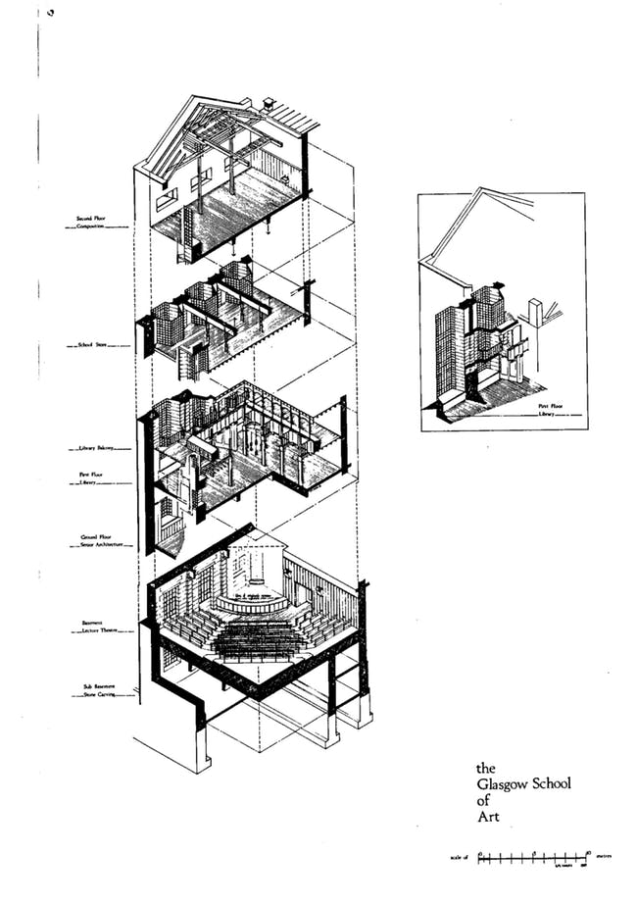
Axonometric of the west end of GSA by George Cairns

‘Glasgow School of Art will Be Rebuilt’, The Daily Express, 17th September 2018, https://www.express.co.uk/news/uk/1018902/glasgow-school-of-art-fire-mackintosh-building-scotland
Aristotle, Metaphysics, translated by John McMahon, Book 4, chapter IV, p. 69. Dover Publications, New York, 2007
Rodger, Johnny (2013) Putting Holl and Mackintosh in multi-perspective: the new building at the Glasgow School of Art. arq: Architectural Research Quarterly, 17 (1). pp. 2-14 at p. ISSN 1359-1355
George M. Cairns, Glasgow School of Art: An Architectural Totality, unpublished doctoral thesis, Glasgow School of Art, 1992.
Ruskin advocated a moral position to restoration which involved an honesty in use of materials and a celebrating the layers of history in a building rather than what he regarded as deceitful restoration that might use new interventions and technologies to ‘complete’ a building in a way that may never have existed in the original.
‘Restoring Glasgow School of Art to its original design will be impossible.’ https://theconversation.com/restoring-glasgow-school-of-art-to-its-original-design-will-be-impossible-27147 last viewed 17/12/2018
Sigmund Freud, ‘A Disturbance of Memory on the Acropolis’ in On Metapsychology: The Theory of Psychoanalysis, Penguin, London, 1984, pp443-56.
Giorgio Agamben, ‘What is an Apparatus’ in What is an apparatus?: and other essays. Stanford, Calif: Stanford University Press, 2009.
Andrew MacMillan, James Macaulay and William Buchanan, ‘A Tour of The School’, in William Buchanan (ed.), Mackintosh’s Masterwork: The Glasgow School of Art, Chambers, Edinburgh, 1989, p. 114. Thomas Howarth Mackintosh and the Modern Movement p89 – ‘.. the silent brooding pinewoods of the Trossachs’
Marc-Antoine Laugier, 1977. An essay on architecture. Los Angeles: Hennessey & Ingalls., and see ‘It is in the country that one learns to love and serve humanity; one only learns to despise it in cities.’ Jean-Jacques Rousseau, Confessions, Wordsworth Editions, London, 1996, p448
Guy Davenport, ‘Joyce’s Forest of Symbols’, The Iowa Review, Vol 6, No.1 (Winter 1975), pp79-91 passim. In the Gaelic alphabet each of the names of each of the eighteen letters corresponds to the name of a type of tree. Hence in Scots Gaelic the first three letters ABC are named ailm, beith, coll – thus those first three letters of the alphabet are in turn the elm tree, the birch tree and the hazel tree and so on. Davenport demonstrates how amongst the myriad layerings of structural form in Ulysses, Joyce themes each one of his eighteen chapters on the qualities of the tree of that letter in the Gaelic alphabet.
Rene Descartes,‘Meditations’, in Discourse on Method and Meditations, Penguin, London, 1972, 6th Meditation, pp150-1.
Michel Foucault, ‘Of Other spaces: Utopias and Heterotopias’ trans. Jay Miskowiec. Diacritics, 16/1 (Spring 1986), pp. 22–27. Originally published as Des Espace Autres (Conférence au Cercle d’études architecturales, 14 March 1967). Architecture, Mouvement, Continuité, No. 5 (October 1984), pp. 46-49.
Agamben, p.17.

