Reimagining Design with Nature: Ecological Urbanism in Moscow

Brian Mark Evans

Abstract
The twenty-first century is the era when populations of cities will exceed rural communities for the first time in human history. The population growth of cities in many countries, including those in transition from planned to market economies, is putting considerable strain on ecological and natural resources. This paper examines four central issues: (a) the challenges and opportunities presented through working in jurisdictions where there are no official or established methods in place to guide regional, ecological and landscape planning and design; (b) the experience of the author’s practice—Gillespies LLP—in addressing these challenges using techniques and methods inspired by McHarg in Design with Nature in the Russian Federation in the first decade of the twenty-first century; (c) the augmentation of methods derived from Design with Nature in reference to innovations in technology since its publication and the contribution that the art of landscape painters can make to landscape analysis and interpretation; and (d) the application of this experience to the international competition and colloquium for the expansion of Moscow. The text concludes with a comment on how the application of this learning and methodological development to landscape and ecological planning and design was judged to be a central tenant of the winning design. Finally, a concluding section reflects on lessons learned and conclusions drawn.

1 Introduction
This is the ‘century of the city’ when, for the first time in human history, more people will in live in cities than in rural areas. The UN estimates that by 2050 almost three quarters of the world’s population will live in cities (Evans et al. 2016, p. 1). The population expansion in the cities of many countries, including those with converging economies, is putting considerable strain on their ecological and natural resources where the ‘process of transition has … abandoned central planning, state-owned housing and decreased investments in public transport’ causing substantial suburbanisation (Ibid, Chapter 3, Part B Economic Transition: from planned to market economies, p. 21). Moscow, the capital of the Russian Federation, is one such city.

This paper is directed to the theme of Town and Regional Plans, identified by the editors for this special issue as one of the several overarching enquiries into the work of Ian McHarg. It focuses on landscape planning and design carried out in the Moscow Region of the Russian Federation in the period 2003–2013 when the City of Moscow was experiencing significant pressure for development from in-migration and reconstruction in the post-soviet era. The international competition and colloquium for the expansion of Moscow staged in 2011–2013 by the Governments of the Russian Federation and Moscow City are reviewed, and the approach of the winning team is discussed. The methodology for landscape planning and ecological design in the successful entry was based on techniques derived from Design with Nature (McHarg 1969, republished 1992). Although the principal focus is directed to Town and Regional Plans, the text and accompanying figures, where pertinent, also refer to the other themes identified by the editors, notably Ecological Designs and Green Infrastructure.

The paper is structured in five further sections following this initial introduction. The second part examines the challenges and opportunities presented in working in jurisdictions where there are no official or established methods in place to guide regional, ecological and landscape planning and design. The third considers the experience of the author’s practice—Gillespies LLP—in addressing these challenges using techniques and methods inspired by McHarg in Design with Nature in the Russian Federation in the first decade of the twenty-first century. The fourth considers the augmentation of the methods derived from Design with Nature in reference to innovations in technology since its publication and the contribution that the art of landscape painters can make to landscape analysis and interpretation. The fifth part considers the application of this experience to the international competition and colloquium for the expansion of Moscow and explains how the application of this learning and methodological development to landscape and ecological planning and design was judged to be a central tenant of the winning design. Finally, a sixth and concluding section reflects on lessons learned and conclusions drawn.

2 The Moscow Region in the first years of the 21st century: challenges and opportunities for landscape planning and design
In 2003, a UK landscape studio was offered the opportunity to become involved in the design of a new settlement in the Moscow Region to carry out landscape planning and design (Figs. 1, 2a, b—Moscow in context). Gillespies LLP is a long-established practice of landscape architects, urban designers and environmental planners established in Glasgow, UK, in 1962 (Gillespies web link 2019). The project envisaged the creation of a new garden suburb to the north-west of Moscow and was led by the UK practice of John Thompson and Partners (JTP), architects and urbanists (JTP web link 2019). The project approach was built around the design charrette methodology pioneered in the 1980s through the UDAT programme (urban design action team) developed originally in the USA and brought to the UK through the work of Alan Jackson Simpson and John Thompson both of whom participated in the Making Cities Conference held at Carnegie Mellon University, Pittsburgh, in 1989 (also attended by HRH The Prince of Wales). The story of the UDAT process is described in Urban Design in Action—The history, theory and development of the American Institute of Architects Regional/Urban Design Assistance Teams (Batchelor and Lewis 1986) and more recently in 20/20 Visions—Collaborative Planning and Placemaking (Campion 2018, Chapter Two, ‘A history of collaborative planning and the charrette process’, pp 6–11). Since the 1990s, the design charrette approach combined with a programme of intensive client, community and stakeholder engagement has grown in prominence throughout the UK and internationally and is further described in the USA in The Urban Design Handbook—techniques and working methods (Urban Design Associates 2003) and in the UK in The Community Planning Handbook—How people can shape their cities, towns and villages in any part of the world and The Community Planning Event Handbook—How to use collaborative planning and urban design events to improve your environment (Wates 2000 and 2008). In 20/20 Visions—Collaborative Planning and Placemaking, Charles Campion documents, in a series of case studies, the collaborative practice and methods developed by JTP and Gillespies (Campion 2018, pp. 98–101, pp. 102–105 and pp 114–117) which were applied and refined in charrette working in the Russian Federation in the years 2003–2015.

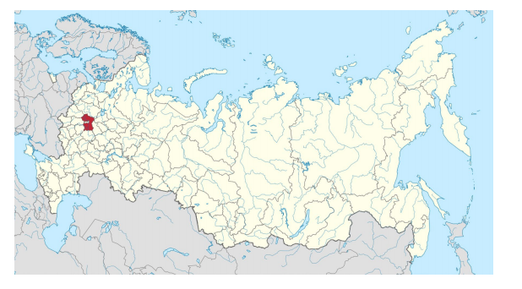
Figure 1: The Moscow Region shown in red in the context of the Russian Federation, the largest country in the world by land extent. The insert (white) into the Moscow Region (red) shows the territorial extent of the City of Moscow (image: Creative Commons Attribution-Share Alike 4)

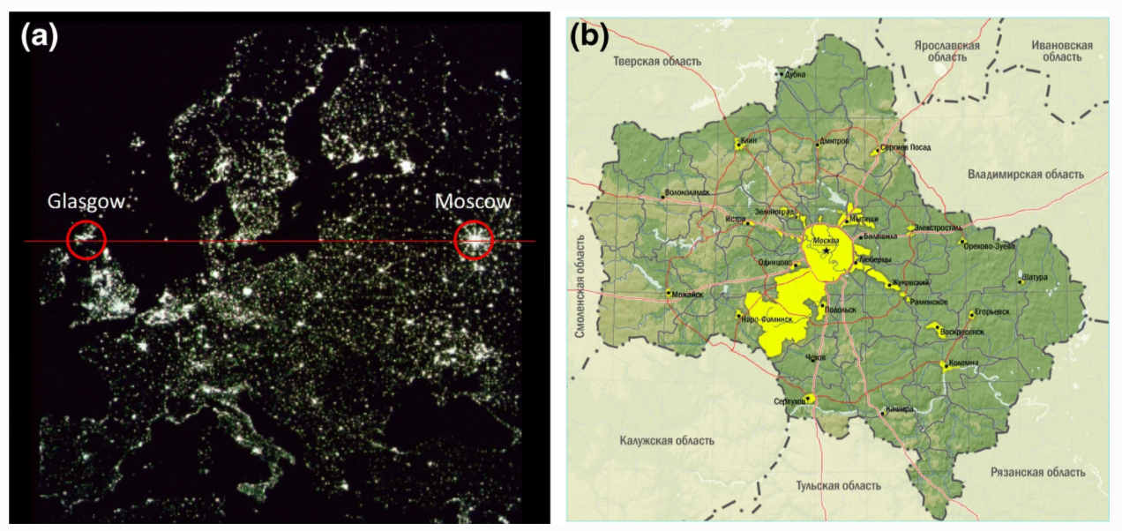
Figure 2: a Moscow and Glasgow are European cities lying on the same latitude (Moscow 55.75o N (continental climate) Glasgow 55.85o N (maritime climate) (Gillespies LLP). b Detail of Moscow showing the extent of the jurisdiction of the City of Moscow (public domain).

The opportunity in the Moscow Region in 2003 presented the Gillespies team with a number of interesting challenges: for example, how to assemble the base information required for the work when information and data would be in Russian and the Cyrillic script, if indeed they existed at all in the societal flux of the post-soviet years since 1989. By 2000, Russian sensitivity to place was beginning to be re-examined, and both Government and developers were starting to reflect on methods and practice to regenerate the city and to develop proposals for a private housing market to provide accommodation for Moscow’s existing and growing population. There are now some excellent publications available that re-evaluate the importance of Russian’s built and natural heritage. Some of the most pre-eminent publications are listed in the bibliography and include Moscow Heritage at Crisis Point, an excellent evaluation of Moscow City’s built heritage and the challenges it faces eloquently described in the introductory essay by the British scholar Marcus Binney who identifies ‘the immediate, extensive and overwhelming threat to Moscow’s historic architecture’ (Cecil and Harris 2007, p. 6).

In the first decade of this century, Russia had a significant need for professional expertise to supplement Russian capacity that remained embedded in the practices of a centralised planned economy with outdated regulations based on ‘soviet norms’ (OБЩИE HOPMATИBHЫE ПOЛOЖEHИЯ—general normative regulations). At this time, the market for design services in Moscow and the Russian Federation was heavily influenced by western organisations offering design and development models founded on real estate business propositions for the development of green field land. These offered ‘turnkey’ solutions to the challenge of rapid delivery but had, at best, standardised approaches to landscape, ecology and natural processes. In this climate, the first challenge for the landscape team concerned how to communicate the importance of landscape and ecology in a rapid development process motivated in part by place, culture and community but mainly by speed, efficiency and profit.
In approaching this challenge, there was also a recognition that members of the landscape team have come to rely and found on the extensive published information and data for major sites publicly available in western countries. In Scotland and the UK, for example, this includes solid and drift geology published by the British Geological Survey; topographic and ground cover data available through the Ordnance Survey, as well as maps, graphics and data registers of sites with conservation protection; national maps of agricultural land classification and landscape character assessment published by the Scottish Government and Scottish Natural Heritage; and climatic data including wind speed, precipitation and seasonal temperature published by the British Meteorological Office, and in the USA by agencies including the US Geological Service (USGS) and the National Oceanic and Atmospheric Administration (NOAA) of the Department of Commerce. By 2003, in the UK and the USA, these data were not only published, but also available in digital formats to download in various spatial formats including geographical information system (GIS) layers with embedded metadata. By the first decade of the twenty-first century in the west, the early stages of landscape analysis could begin with a technical exercise of downloading and comparing the layers envisaged by McHarg by the application of GIS and other software supplemented by ground-truth testing on-site—increasingly augmented and enhanced by the use of drone photography. In Russia in 2003, none of these data were available.

3 Revisiting Design with Nature and reviewing the methods of McHarg
In researching the challenge before departure for Moscow, the team focused preparation on understanding what was available in published sources about the Russian landscape as well as reviewing methods for landscape planning set out by McHarg in Design with Nature and later by other authors including Michael Hough (Hough 1990 and Hough 1995).

‘It took only the merest information to examine and prescribe for the Jersey Shore’
(Ian McHarg, Design with Nature, 1992, p. 31).

The team reread and reviewed McHarg’s rationale, methods and studies in Design with Nature. In particular, the team was interested in his exposition of natural processes and their significance to social value when planning for significant interventions. This is exemplified in the studies of the Jersey Shore and Staten Island. Here McHarg stresses the importance of compiling layers detailing different values that are then compared by overlaying on a light table. The Jersey Shore layers are illustrated in Design with Nature on pp. 36, 38–39, and later, the method is further elaborated in more depth for Staten Island in the chapter ‘Processes as Values’ on pp. 105–107 and 109–113 with a composite diagram on p. 114 (McHarg 1969, 1992). This was considered important for the Russian project because these methods emphasise the importance of the site ‘as found’ and upon practical analytical and interpretive steps to understand the site through slope, surface vegetation, forest, hydrology and on-site investigation and, where available, published data on soils and geology. In his later work, Hough also stresses the importance of on-site investigation and interpretations, for example in chapter three of Cities and Natural Processes (1995) focusing on plants and plant communities.
This revision proved invaluable to the team where the landscape architect must address the site ‘as found’ without access to published policies, plans or conceptual studies and must, therefore, focus on strategic and practical methods to record, analyse, interpret and communicate ecological and landscape principles. In these circumstances, there is a need to start by recording existing uses (e.g. agricultural and/or forest land) by on-site interpretation in order to build up an understanding of the landscape ‘as found’ which in turn may inform the extent and degree of intervention considered acceptable, much as McHarg did with the Jersey Shore and Staten Island. This is particularly important where there are no officially published documents or any ‘in-country’ body of practice detailing methods to be followed. This is often evident in the cities of a country in transition from a planned to a market economy where there is, as yet, no settled view of the importance of landscape and ecology to the urban condition and few (often outdated) designated protection areas to safeguard landscape and ecological qualities. In the case of the Russian Federation in 2003, there were numerous protected sites, but the conservation policy and practice was generally outdated in terms of intent, and frequently had often lapsed in management and monitoring due to the loss of professional capacity and the absence of resources in the trauma of the post-soviet transition. In these circumstances, the landscape architect, in effect, begins ‘from scratch’, with the requirement to work from first principles in recording, analysing, interpreting and communicating qualities and principles for the landscape and ecology of the territory.
Preliminary enquiries into the site in the Moscow Region identified that to scale cadastral plans without topographic data would be available together with unrestricted site access and (possibly) oblique aerial photographs taken from a helicopter. In the spirit of charrette working, the team carried with it everything needed to undertake the master plan preparation—this meant traditional design studio tools—pencils, markers, detail paper, drawing pens and instruments and quality tracing papers—and, in the first years of the twenty-first century, laptops and early, lower-resolution, digital cameras, supplemented (perhaps) by Internet access, but with low bandwidth suitable for email but incapable of transmission of large files and data sets.
The landscape team’s ‘charrette kit’ included Design with Nature and monographs published for British post-war New Towns including those by Derek Walker, the Chief Architect and Planner of Milton Keynes (Walker 1982, 1995). Although there are many examples in practice in the UK in the 1970s and 1980s in New Town Masterplans and in Regional Structure Plans in Scotland that evidence the layering method documented in Design with Nature described above, they are often of very technical and scientific nature. By contrast, the Milton Keynes Landscape Masterplan provided inspiration to the work of Gillespies due in no small part to the artistic quality of the graphic representation of both plans and sketches. This is particularly evident in Steen Eilar Rasmussen’s Introduction and in the Landscape and Infrastructure chapter of Walker’s book on the Architecture and Planning of Milton Keynes (Walker 1985 particularly Rasmussen pp. 4–5, landscape capacity sketches p 13 and landscape layers pp. 20–23 and at various other locations throughout the publication with further colour representations in Walker later monograph (1995 at p. 30, pp. 32–37). The clear influence of this work in respect of landscape capacity and the role of ground cover on Gillespies’ practice can be seen in work later published as landscape design policy advice for the UK Government in Scotland (Gillespies 1994, the Design Manual at pp. 34–35 and 38–41).
From preliminary meetings with Russian colleagues, it was clear that something more than technical skill would be necessary to convince Russian businessmen, however, well disposed to improving their city, to invest in landscape and ecological designs. Earlier experience through Gillespies practice had shown that the development process in communist and post-communist countries can perceive the presence and sensitivity of the native landscape as a constraint to be overcome: because the native landscape is seen every day, there is a risk that it may be considered to be just that—unremarkable, normal, mundane, everyday—without a proper appreciation of its intrinsic beauty and significant importance to the ecosystem within which it sits. Therefore, in the short time available before that first departure for Russia in 2003, the team undertook documentary research to develop a general knowledge and understanding of the landscape of the Russian Steppes in order to provide insights into its natural and cultural attributes that would provide utility to the team and, ultimately, to the client about the nature and quality of the landscape of the Moscow Region.

4 Landscape insight and interpretation though the artist’s eye: methodological augmentation
In parallel with assembling the technical material, preparations also included the investigation of Russian landscape art. From long experience with artistic and aesthetic appreciation of landscape art following the insights of Berger (1972), Gregory (1976) and later Eco (2010, 2011), the author had come to appreciate the ‘eye of the artist’ in helping others ‘see’ the everyday and, therefore, assist in communicating the existential attributes of landscape, ecology and climate.
Enquiry revealed evidence of a substantial literature about Russian Art. Two artists in particular stood out—Isaak Levitan (1860–1900) and Ivan Shishkin (1832–1898). The works of these artists and other Russian contemporaries were exhibited in an international exhibition in the Netherlands and the UK in 2003. In the companion volume to that show—Russian Landscape—there is a substantive reproduction of the works of these artists together with a series of critical essays. In Russian Landscape, Van Os reminds us that there is ‘something reassuring about painted nature’ (Jackson and Wageman 2003, p. 13) and he and David King stress how Shishkin was, in intricate works, able to convey the detail of the Russian countryside, from the wildflower carpet that fills the forest in the spring, to the icy tundra of winter that provided the backdrop for many of Russian literature’s iconic scenes combining ‘monumental hugeness with unbelievable meticulousness in rendering detail’ (Ibid, p. 16). Levitan’s lyrical, expressive evocations of the Russian countryside and his use of motifs typical of rural Russia (such as footsteps in snow) together with an innovative and impressionist flair earned him the admiration of Chekhov, Stanislavsky and Diaghilev (King 2004, pp 11, 15 81–82 and 83–97). These artists are little known in the west although the major retrospective exhibition in Groningen and London in the early years of this century has brought them some prominence (Jackson & Wageman 2003).
Although less prolific than Shishkin or Levitan, Alexei Savrasov’s painting The Rooks have Returned has a special place in the Russian consciousness and is renowned for its evocation of the ending of the long Russian winter and the hope presented by the long-awaited Spring (Fig. 3). But it was Levitan’s work that came to provide a form a Leitmotif for design work in Russia by demonstrating that the natural and cultural landscape he painted remains present in the landscape of the Moscow Region today (Fig. 4).

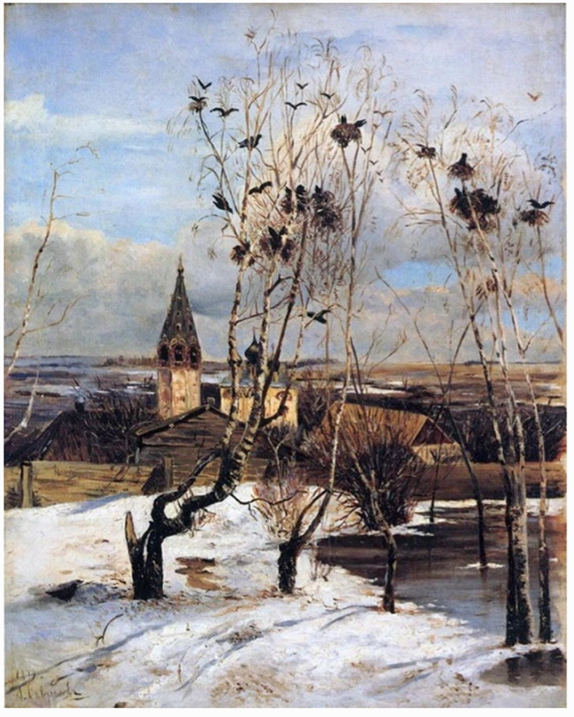
Figure 3: The Rooks have Come (1871) Alexei Savrasov (Tretyakov Gallery Moscow). This painting has great cultural significance for Russians as it encapsulates the annual hope for summer that comes with the spring thaw
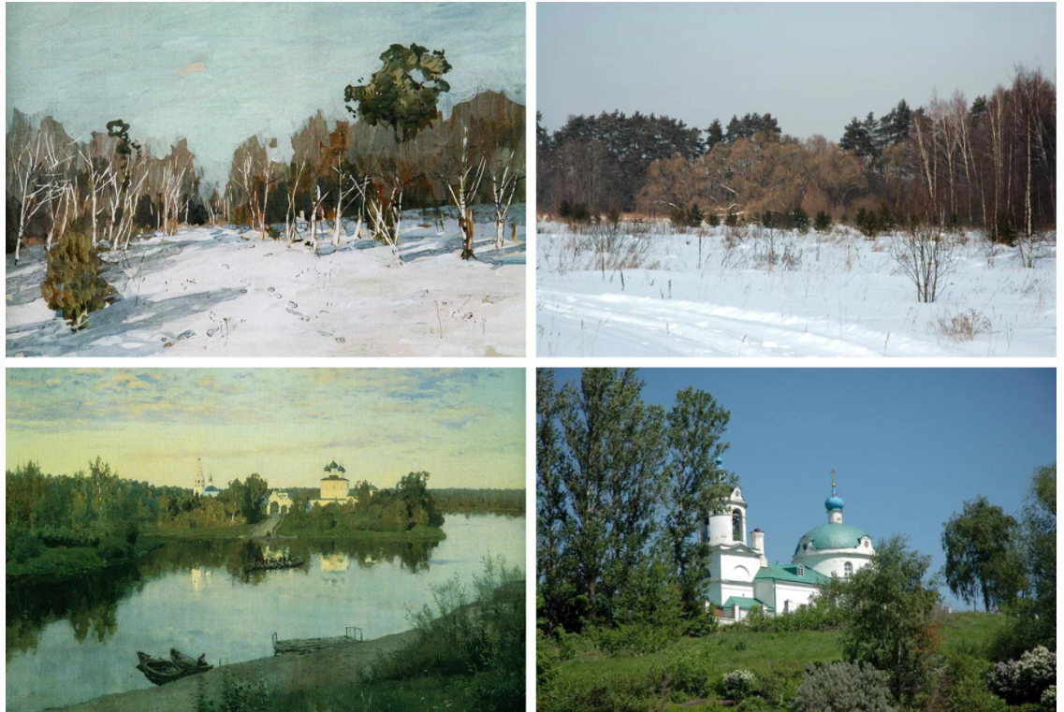
Figure 4: On the left, images from the paintings of Isaak Levitan (Top Snowbound Garden, The Russian Museum, St Petersburgh, 1880s, bottom Evening Bells, Tretyakov Gallery, Mosow, 1892); on the right corresponding images from the Moscow Region landscape in 2008 (Gillespies LLP).
It has proved to be a compelling technique to use well-executed and much-loved works of landscape painting as a means to provoke a recognition of landscape legacy in communities, clients and stakeholders and stimulate awareness of the historic and cultural qualities of their landscapes. Together with the Gillespies team, the author has in the past introduced a discourse on landscape history and an artist’s appreciation of landscape to substantiate an understanding of landscape analysis and interpretation. Landscape paintings are also an invaluable tool for furthering the designer’s understanding of cultural, climatic and inherited landscapes. The team was also aware that everything said and written by us about the Russian landscape would be translated into Russian. We hoped, therefore, that a shared appreciation of the aesthetic qualities of the landscape expressed by Russian artists might help build a shared understanding of the landscape and cultural legacy and potential. This was proved to be the case.
The outputs from the first charrette in 2003 were well received by the client and the master plan successfully incorporated structural landscape planning and design and ecological precepts, but the reliance on hand drawing for a Design with Nature method of landscape analysis was difficult to produce in the short time period offered by a design charrette. However, the artistic inspiration and understanding of the Russian landscape derived from the presentation and analysis of Russian painters was well received, supporting the landscape analysis and concepts that had been possible to prepare using a rudimentary form of the layering principles derived from Design with Nature.
As mobile computing power and high-speed Internet access developed rapidly, together with innovation in the use of software (such as Adobe Suite and the Photoshop program in particular), it became possible to enhance the quality of the landscape analysis by using the layering function to produce the layers originally envisaged in Design with Nature in the Jersey Shore and Staten Island studies. As further opportunities opened up to undertake master planning charrettes in the Moscow Region, the landscape analysis was able to be converted more quickly into crisp digital drawings. In turn, these were used as a dimensionally accurate base upon which to hand draw a master plan which in turn could have different aspects of the ecological and landscape design represented on different layers. This proved a compelling analytical and presentational technique. The images in Figs. 5, 6 and 7 illustrate an example of the landscape analysis and master plan layers for the settlement area of Vidnoye in the south-east of the inner Moscow Region (location shown in Fig. 9. A further innovation offered by the increasingly effective mobile computer resource, as well as the studio’s capacity to quickly produce high-quality renders, meant that there was also the opportunity to produce realistic computer-aided visualisations of the intended interventions as illustrated in Fig. 8.
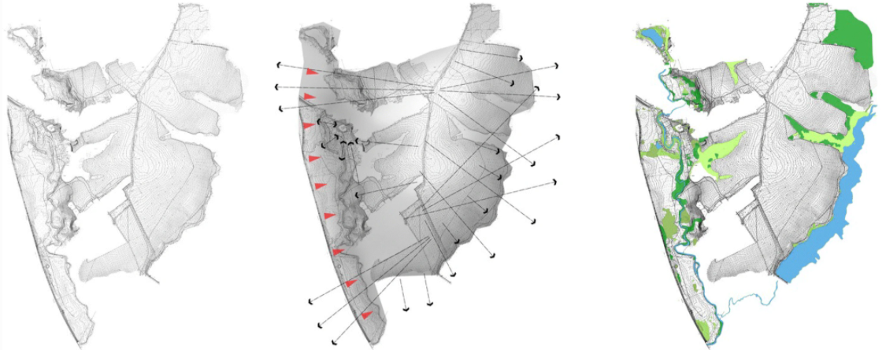
Figure 5: Landscape layers for the site of a new settlement extending to 100 ha at Vidnoye in the south-east of the Moscow Region. The landscape layers have shown basic topography overlain in the second image with an analysis of slope and key viewsand in the third image existing vegetation and ground cover. The on-site interpretation was assembled on-site and transferred to layers in Photoshop ‘in charrette’ (Gillespies LLP).

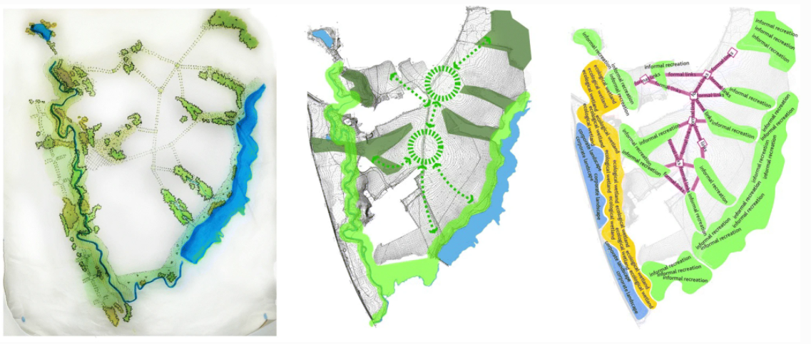
Figure 6: Landscape layers showing hand-drawn analysis and interpretation (image 1) transferred to a Photoshop layer (image 2) and preliminary concepts (image 3) (Gillespies LLP).

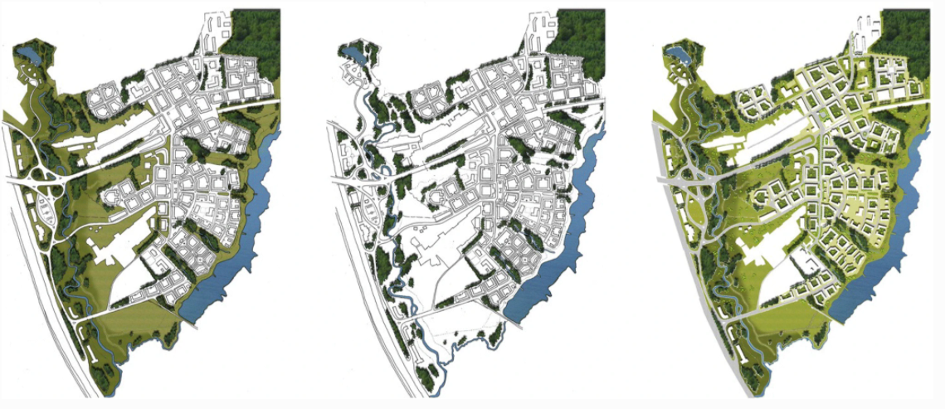
Figure 7: Final master plan designed in collaboration with architect/urbanists JTP showing the extent of public landscape (image 1), the extent of forest planting on-site (image 2) and the final landscape master plan with public and private landscapes and with all ‘built layers removed (image 3) (Gillespies LLP).

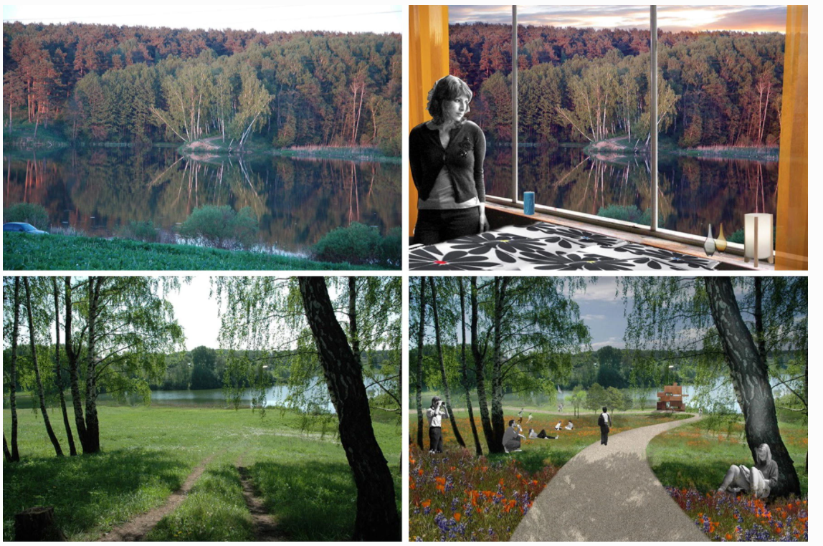
Figure 8: Visualisations showing the existing landscape (left) and as proposed (right). The views are over the lake shown on the east of the plan in Fig. 7 from the proposed apartment blocks on the west side of the lake. The landscape team has employed the concept of ‘borrowed landscape’ in these and other designs for sites in the Moscow Region whereby landscape ‘as found’ and outside of the site boundaries is incorporated into the visual context of the site (Gillespies LLP).
In this way, the team faced up to the challenge and opportunity of addressing landscape and ecological planning and design on the site ‘as found’ by: returning to the methods first established by McHarg in Design with Nature; working with the design charrette process to provide a mechanism to produce rapid analysis and interpretation of landscape; innovation in the application and use of contemporary software to create both planimetric layers and visualisations of landscape qualities; and further understanding and communication of the Russian landscape through the work of much-loved Russian painters. This collective work led to the establishment of a five-step methodology for landscape and ecological planning and design as follows:
- Preliminary landscape and ecological interpretation using analysis of conditions on-site and analysis of the qualities identified by renowned Russian landscape paintings (Fig. 4);
- Recording of landscape and ecological analysis in layers (Fig. 5);
- Hand-drawn conceptual landscape and ecological design and hand-drawn master plan (Fig. 6);
- Digital layered rendering of the landscape master plan (Fig. 7); and
- Rendering of the landscape echoing the inspiration and character from landscape painting including retention of existing features to clearly demonstrate and communicate the interventions proposed through techniques such as ‘borrowed’ landscape (Fig. 8).

5 The international competition and colloquium for the expansion of Moscow
In 2011, a sensationalist headline ‘Moscow to Double in Size!’ appeared in the western media reporting on the latest ambitious plans to emerge from Russia (Elder, the Guardian Newspaper, 2011). In fact, careful reading of the articles and a review of the Russian press revealed that the plan by Dimitri Medvedev, then President of Russia, and Sergei Sobyanin, Mayor of Moscow, was to double the territory administered by the City of Moscow through a jurisdictional change involving the transfer of a large tract of land from the Moscow Region to the Moscow City. It was not intended that Moscow would double the size of its population, but rather double its administrative area, so that there could be a clearer coordination of territorial planning of the city (Fig. 9).
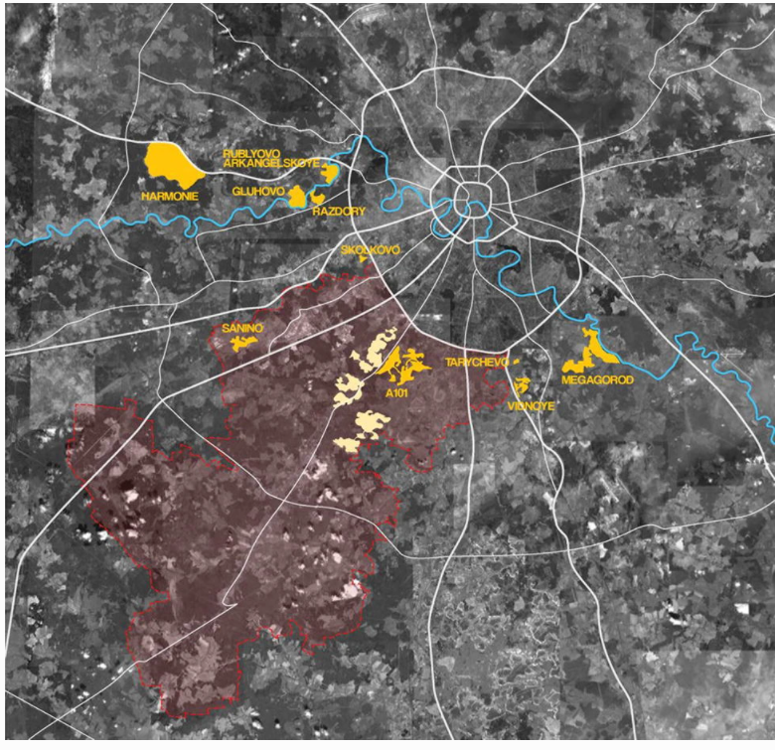
Figure 9: Map showing the expansion area for the City of Moscow (in red) to the south-west of the existing territory of the radial city. The area in red extends to some 1420 square kilometres. The settlement of Vidnoye is shown in yellow on the centre right between Tarychevo and Megagorod (Gillespies LLP)
What was newsworthy, however, was the nature of the process conceived by the President and Mayor. The catalyst for the change would comprise the move of Ministries and Officials of the Federal and City Governments from the congested centre of the existing city to a new site to the south-west of the city, thereby releasing a very significant amount of real estate within the city core for conversion to new hotels, offices and apartments for the needs of Moscow as a burgeoning world city as well as attract investment to address some of the heritage challenges identified above. Also remarkable was that the conceptual thinking behind the plan would be subjected to public gaze through an open, competition among internationally renowned practicing planners and urbanists: a process largely modelled on planning the future form of the Paris metropolitan region (also suffused with thinking from Berlin–Brandenburg, Madrid and the Randstad in the Netherlands: Project du Grand Paris—online).
In late 2011, an open invitation was issued for the procurement of ten international teams (identical to the Project du Grand Paris), to be retained to conduct, in parallel and in public, a three-stage competitive consultation that would prepare conceptual designs for:
- the overall structure of the Moscow Region (the ‘Oblast’) within the central federal Region of the Russian Federation (the ‘Okrug’) (Fig. 1);
- the structure of the newly extended territory of Moscow: i.e. the historical area of the City of Moscow together with the new territories to the south-west (Fig. 2); and
- a plan for a new Capital District within the new territories.
Each stage was to extend over two months and have two plenary workshops. Apart from these basic criteria, almost no restrictions were placed on the teams: deviations from the brief were permitted, and encouraged, although the organisers (the General Planning Division of the Government of Moscow) demanded reasoned justification for deviations to the brief and failure to provide sufficient argument resulted in a requirement to meet the brief requirements in spirit and to the letter in order to proceed to later stages (Evans 2012, pp. 14/15).
The ten teams were selected from across Europe, North America and the Middle East. All teams were international, and all had Russian partners as part of the team, thereby ensuring that an element of knowledge exchange became an embedded part of the process. The landscape planning methods described above provided a clear basis to make a successful submission to enter the competition.
Gillespies joined together with long standing collaborators including JTP (referred to above) as well as Urban Design Associates (UDA) from Pittsburgh (USA), Group Ark Architects (Moscow) and Prof Larry Beasley (Canada) with whom Gillespies had collaborated on the capital city plan for Abu Dhabi in the United Arab Emirates in 2009–2010. Transportation Planners Nelson Nygaard (USA), Civil and Structural Engineers Buro Happold (UK) and leading economist Prof Stuart Gulliver (UK) completed the team that formed itself into the consortium entitled ‘Capital Cities Planning Group’ (CCPG). The consortium was led by the collaborative effort of UDA and Gillespies, who also led and delivered the landscape planning and ecological components of the work.
The successful teams were assembled in Moscow in February 2012, and thereafter, for the next seven months, our working lives were preoccupied with Moscow—a stressful, challenging and thrilling process. Monthly formalities between the teams gave way to a collegiate discussion in the conference hall and the cafes and bars of Old Moscow.
At each workshop, each team was afforded time to present their thinking to all the other teams and to an international advisory panel of Russian and international experts drawn from Metropolitan Paris, Berlin–Brandenburg, Madrid and Amsterdam. This process was presided over by the Deputy Mayor and by senior officials from ‘Genplan’, the City of Moscow planning agency.
Figures 10, 11, 12, 13 and 14 illustrate the principal elements of the work:
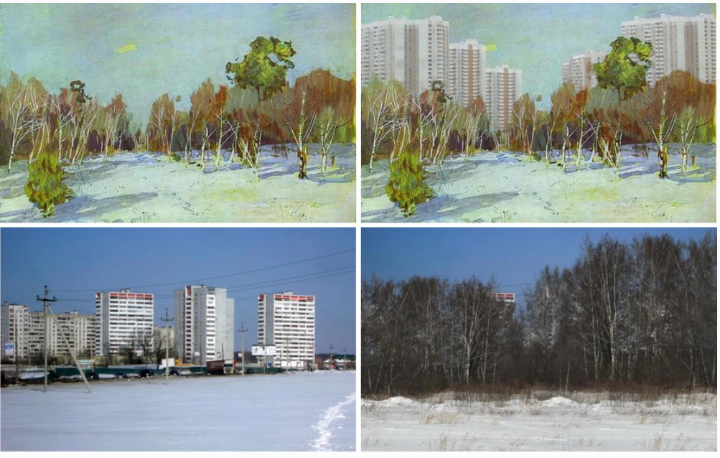
Figure 10: Visualisations produced as a provocation by the Capital Cities Planning Group during the competition for the expansion of Moscow City in 2012/2013 showing the attrition of the landscape of Levitan by the twentieth-century soviet city as well as a suggestion for landscape retrofitting (CCPG/Gillespies LLP).

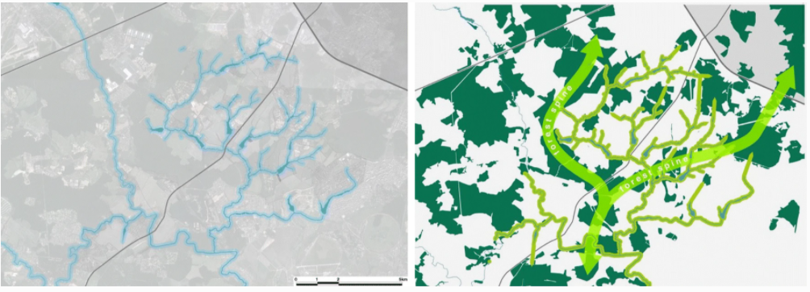
Figure 11: Techniques of landscape analysis based on the methods of Design with Nature using the blue–green system of hydrology and forest to produce structure for the strategic plan for expansion area including the intention to re-establish green and blue corridors to support biodiversity and species habitat (CCPG/Gillespies LLP).
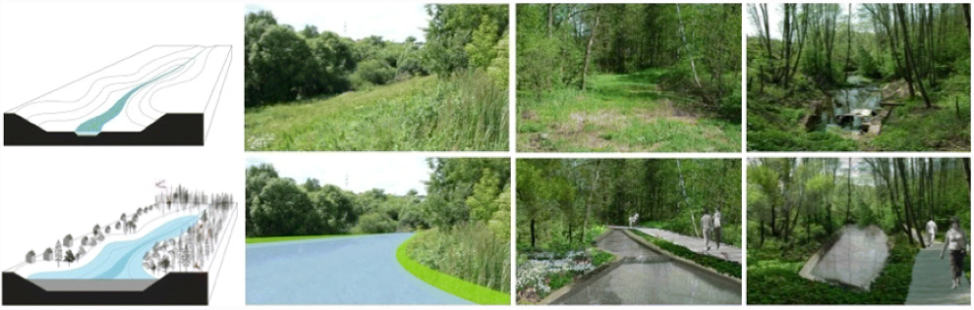
Figure 12: An example showing proposals at the detailed scale for the conservation and enhancement of a local watercourse including the expansion of the water body and riparian improvements to support cleaning of the water system, introduction of species rich riparian edge details and the creation of a walking and cycling network along the watercourse in the spirit of McHarg and Hough (CCPG/Gillespies LLP).

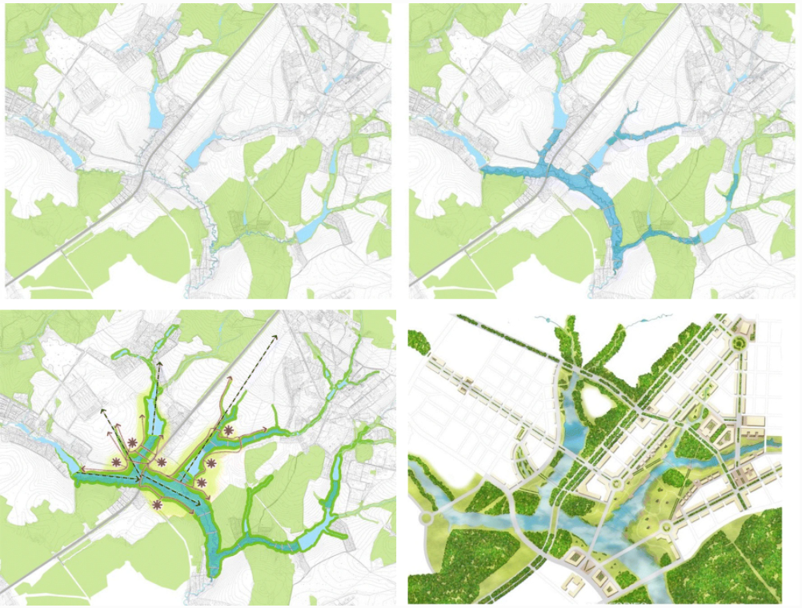
Figure 13:Techniques of contextual landscape design based on the methods of Design with Nature using the blue–green system of hydrology and forest to produce structure for the new strategic development plan and overall urban design and architectural concept (CCPG /Gillespies LLP).
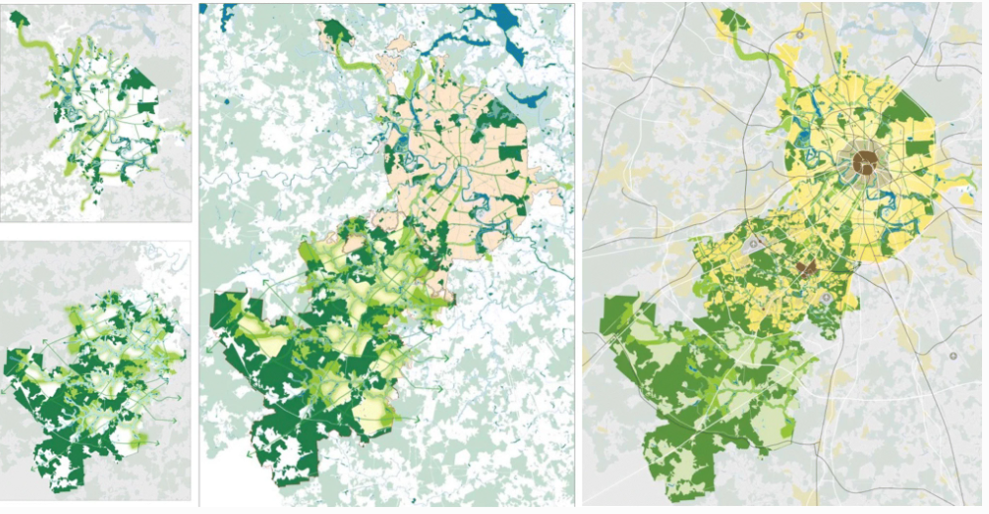
Figure 14: In 2012, the Capital Planning Group led by Urban Design Associates of Pittsburgh and Gillespies of Glasgow were joint winners of the international competition for the expansion of Moscow, capital city of the Russian Federation. The two diagrams on the left show an integrated landscape and ecological strategy for the existing city (top) and the expansion area (bottom). The plan on the centre shows the integrated landscape and ecological strategy for the combined area, and the plan on the right shows the final development plan for the existing and expanded areas of the city extending to some 2500 km² with an existing population of 11.5 million projected to rise to 14 million (CCPG/Gillespies LLP).
- The use of Levitan’s representation of the inherited Moscow landscape to stress its importance to the aesthetic and ecological qualities of the city (Fig. 10);
- The opportunities presented by the hydrological system and the forest network to create the intrinsic armature for the overall plan as well as retain the blue and green networks to enhance ecological networks (Fig. 11);
- The importance of retaining and enhancing the hydrological network by the conservation of watercourses (Fig. 12) and creation of a series of lakes and cascades to form the fundamental structure upon which to found the urban plan (Fig. 13); and
- The overall landscape structure for the existing city and the expansion area (Fig. 14).
Landscape and ecology were identified by the international jury as being of fundamental importance in the process:

“It was a mandatory requirement of the Competition Brief to consider and resolve landscape and ecological issues at regional, city and district scales. The natural and ecological value of the Moscow Region was considered by all of the design teams and each had its own approach. The Grumbach team focused on the housing block and park as a historical genotype of the centre of Moscow; the French team L’AUC formulated a ‘city-taiga’ concept; the Capital Cities Planning Group brought the water system to the fore; the Italians Studio Secchi-Vigano formulated ‘a city on a park’ system”.

(Dr Alexander Kolontay, Deputy Director of Genplan) (Evans, 2012, pp.14-15).
At the conclusion to the process, the submissions of all nine teams remaining in the competition by the final stage were presented in a public exhibition in Gorki Park and an international jury was invited to review and pass comment on the proposals. The jury awarded prizes to two of the teams: to the Grumbach–Wilmotte team from France for their understanding of the metropolis as a whole and to the Capital Cities Planning Group for employing the methodological approach landscape and ecological planning and design described in the earlier parts of this paper (Steadman 2012).

Speaking after the results were published, Prof Larry Beasley CM, the strategic planning lead with the CCPG team, stated:
“Our Group took the principles of sustainability to the very heart of the urban design for the new Russian Federal District in Moscow. We used ecological and landscape patterns as the prime drivers of the urban configuration. All other aspects were shaped by these natural forces and imperatives”
(Beasley 2012).
This view was confirmed by Kolontay:
“The Competition Organisers considered that the CCPG team produced the most original and professional landscape and ecological strategy for the New Moscow” (Evans 2012, pp. 14/15).

6 Reflections
The author first read Design with Nature in the early 1970s. It was life changing. The exposition of scientific analysis, artistic content and practical application it espoused was inspirational to a graduating student of earth sciences and spatial geography. It inspired further study in urban and regional planning and landscape design leading on to a career in the early research, development and application of environmental assessment procedures in Scotland following on from the landmark National Environmental Policy Act (NEPA) of 1970 in the USA. There was, however, a yearning to follow the principles of McHarg’s thinking and methodology for landscape planning and design at a regional scale, and this was fulfilled at first in the route design of electricity transmission lines in the 1980s for the then South of Scotland Electricity Board and later in the 1990s in regional landscape character assessments for Scottish Natural Heritage. Finally, in new settlement planning in the open terrain of the landscape of the Russian Steppes, the opportunity was presented to reprise the analytical and artistic approach conceived of in Design with Nature as examined and developed in UK post-war new town building in the UK to apply to terrain ‘as found’—working, therefore, from first principles of recording and interpretation, literally, as it were, from the ground up.

This essay has sought to describe the review, development and refinement process the author followed in reprising the landscape and ecological planning called for in Design with Nature augmented by the investigation and development of techniques to retain and update the essential attributes of McHarg’s methods with the efficiencies of design charrette working, technological advances and artistic insights. It was fulfilling to be able to present a coherent method evolved from this development work and to apply this to the major opportunity presented by the international competition and colloquium for the expansion of the world city of Moscow. It was highly rewarding that this coherent and explicit approach to landscape and ecological planning and design was recognised by the award of joint first prize by the international jury convened by Moscow City Government in 2012/13 (Fig. 15).

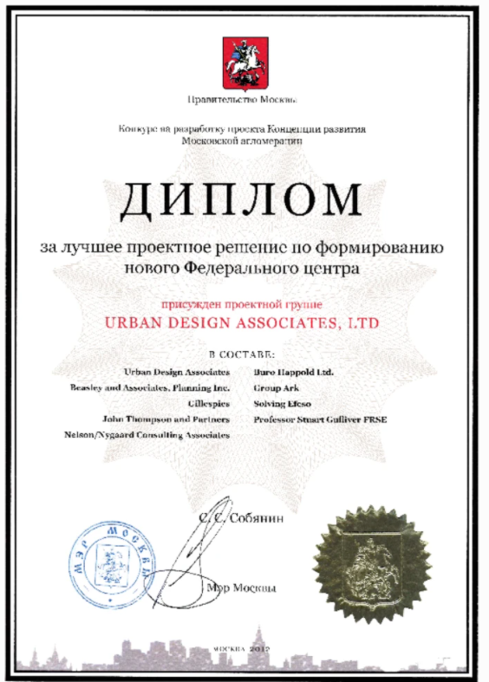
Figure 15: Citation to the Capital Cities Planning Group presented by the City of Moscow.
A full exposition of all of the entries into the Moscow competition and colloquium is available in a theme issue of Project Russia from 2012 (CCPG described at pp 89–104). It is only with the passage of some time that it will be possible to monitor and evaluate the extent to which the landscape and ecological principles concepts have been translated into practice. As yet, it is hard to measure the extent to which the landscape and ecological ideas expressed by the work described in this paper have been fully retained. But it is equally clear, however, that the international discourse continues today and that the city of Moscow and the country of Russia have become more sensitised to the importance and significance of their own natural and cultural landscapes as part of the future development of the city and region of Moscow (Evans 2013).

The opportunity of working from the site ‘as found’ without published policy, plan or conceptual study for a territory, and to focus on strategic and practical methods capable of communication and delivery, the innovation of the method, the transcendental value of art and the eye of the artist in the cultural appreciation of landscape, has been demonstrated to be of functional and aesthetic value in the appreciation of landscape and ecological design in countries with transitioning economies and rapidly developing cities.

References
Batchelor, P. & Lewis, D. Urban Design in Action – The history, theory and development of the American Institute of Architects Regional/Urban Design Assistance Teams, AIA, Raleigh, 1986

Beasley L (2012) Interview with project Russia

Berger, J. Ways of Seeing, Penguin Modern Classics, London, 1972. British Geological Survey Mapping. Available at: https://www.bgs.ac.uk/data/maps/home.html (Accessed on 08 March 2019)

Campion, C. 20/20 Visions – Collaborative Planning and Placemaking, RIBA Publishing, London, 2018

Capital Cities Planning Group, ПОЛОЖЕНИЕ О ПРОВЕДЕНИИ КОНКУРСА НА РАЗРАБОТКУ ПРОЕКТА КОНЦЕПЦИИ РАЗВИТИЯ МОСКОВСКОЙАГЛОМЕРАЦИИ (Urban Competition for the Elaboration of the Draft Concept of the Moscow City Agglomeration Development), Moscow, 2012.

Corner, J. (ed) Restoring Landscape: Essays in Contemporary Landscape Architecture, Princeton Architecturwl Press, New York, 1999.

Eco, U. (McEwen, A. Trans) On Beauty: A History of a Western Idea, MacLehose Press, London, 2010

Eco, U. (McEwen, A. Trans) On Ugliness, MacLehose Press, London, 2011

Ely, C. This Meager Nature: Landscape and National Identity in Imperial Russia, Northern Illinois University Press, 2002.

Evans, B. et al, Towards a City-Focused, People-Centred and Integrated Approach to the New Urban Agenda, Habitat III Regional Report Housing and Urban Development in The Economic Commission for Europe Region, UN-Habitat, Nairobi, 2016. Available at: https://www.unece.org/fileadmin/DAM/hlm/projects/HIII_Regional_Report/HabitatIII-Regional-ReportEurope-Region.pdf (Accessed on 08 March 2019).

Evans, Brian, “The Ecology of the Periphery”, in The Archaeology of the Periphery, Project Meganom/Strelka Institute, Moscow Urban Forum, 2013.

Evans, B. “Competition for the Expansion of Moscow”, in Water Landscapes, TOPOS – the International Review of Landscape Architecture & Urban Design, No81, Munich, 2012

Gillespies, Fitting New Housing Development into the Landscape, Design Manual, Planning Advice Note PAN 44, Scottish Office, 1994.

Grand Paris Project. Available at http://www.grand-paris.jll.fr/en/grand-paris-project/ and at https://untappedcities.com/2014/04/17/can-le-grand-paris-project-revitalize-the-greater-paris-region/ (Accessed on 08 March 2019).

Gregory, R. Eye and Brain – the psychology of seeing, Weidenfield & Nicolson, London, 1976.

Hough, M. Cities and Natural Processes, Routledge, London & New York, 1995.

Hough, M. Out of Place – Restoring identity to the regional landscape, Yale University Press, New Haven, 1990.

Jackson, D. & Wageman, P. (editors), Russian Landscape, Groninger Museum, The National Gallery, 2003.

King, A. Isaak Levitan – Lyrical Landscape, Philip Wilson Publishers, London, 2004.

McHarg, I.L. Design With Nature, John Wiley & Sons, New York, 1969.

Ordnance Survey Mapping. Available at: https://www.ordnancesurvey.co.uk/business-andgovernment/products/mastermap-products.html (Accessed on 08 March 2019)

Scottish Government, Agriculture and Soils Maps. Available at https://www.nature.scot/professionaladvice/landscape/landscape-character-assessment (Accessed on 08 March 2019)

Scottish Natural Heritage. Available at: https://www.nature.scot/professional-advice/landscape/landscapecharacter-assessment (Accessed on 08 March 2019)

Shuvalova, I. (Charles, Victoria translator). Ivan Shishkin, Sirocco Publishing Ltd, London, 2013.

Skolnick, J. and Dulberg, N. Through Other Eyes: Developing empathy and multicultural perspectives in the social studies, 2nd edition, Pippin Publishing, Livres Canada Books, Ottawa, 2004.

Urban Design Associates, The Urban Design Handbook - techniques and working methods, W W Norton & Co, New York, 2003.

Waldheim, C. (ed) The Landscape Urbanism Reader, Princeton Architectural Press, New York, 2006
.
Walker, D. Derek Walker & Associates – the view from Great Linford, Architectural Monographs No. 43, Academy Editions, London, 1995.

Walker, D. The Architecture and Planning of Milton Keynes, The Architectural Press Ltd, London, 1982.

Wates, N. The Community Planning Event Handbook – How to use collaborative planning and urban design events to improve your environment, Earthscan, London, 2008.

Wates, N. The Community Planning Handbook – How people can shape their cities, towns and villages in any part of the world, Earthscan, London, 2000.

