iSenseVR: Bringing VR Exposure Therapy outside the Laboratory

M Poyade¹, G Morris², I Taylor³, V Portela Romero¹
¹School of Simulation and Visualisation, The Glasgow School of Art,
The Hub, Pacific Quay, Glasgow, UK
²Friendly Access,
Milton Brodie, Kinloss, Forres, UK
³Crag3D,
Roa, Harbour Street, Plockton, UK

¹m.poyade@gsa.ac.uk, ²info@friendlyaccess.org, ³ian@crag3d.com, ⁴v.portela@gsa.ac.uk
¹www.gsa.ac.uk, ²www.friendlyaccess.org, ³www.crag3d.com
ABSTRACT
Purpose: This paper presents the preliminary outcomes of a research which takes gradual exposure in Virtual Reality outside the laboratory to empower people with “hidden disabilities” breaking down their barriers towards independent living. It explores the use of Virtual Reality (VR) through smartphones to practically apply gradual exposure to environment stressors that are typically found in busy spaces from one’s own safe environment.
Design/methodology/approach: Aberdeen International Airport has kindly accepted to take part to this research as a case study. Following a participatory design and usability testing, a semi-controlled 7-day study was conducted among 7 individuals with hidden disabilities to assess user acceptance.
Findings: Results showed undeniable participants’ engagement and enthusiasm for the proposed approach, although further research is needed to increase presence and improve the overall user experience.
Research limitations/implications: The proposed research has been conducted on small cohort of participants outside of a clinical setting. Further engagement with individuals with hidden disabilities is required in order to determine the effectiveness of the proposed approach.
Originality/value: This research presents a methodological and technological framework which contributes effectively to the practicality of VR exposure therapy outside of the laboratory setting, from one’s own safe place.

Keywords: Neurodevelopmental Disorders, Hidden disabilities, Anxiety, Smartphones, Virtual Reality, Exposure Therapy
1. INTRODUCTION
Many individuals with Autistic Spectrum Disorder (ASD), Asperger Syndrome, acute sensory hypersensitivity, Post-Traumatic Stress Disorder (PTSD), bipolar disorder, anxiety disorders, and more general mental health conditions that are considered to be within the spectrum of neurodevelopmental disorders (American Psychiatric Association, 2013) that are sometimes referred as “hidden disabilities” as they cannot be easily not observed and lack physical indicators (Couzens et al., 2015), experience severe difficulties with heightened noises and/or crowded situations within environments (Groden et al., 2001, Madriaga, 2010). These aversive sensory cues act as spatial and social obstacles to independent living (Madriaga, 2010), impeding them carrying out what most may consider as everyday activities. There are growing evidences that show that individuals with hidden disabilities are far more likely to experience higher levels of discrimination, isolation, fear, anxiety and poverty (Wilton, 2003; Cameto et al., 2004; Hendricks, 2010; Madriaga, 2010; Davidson et al., 2018).
Popular intervention strategies such as Social StoriesTM, which consist of situational narratives supported by graphical material to address behavioural and social difficulties typically experienced by autistic individuals in a specific context (Styles, 2011; Hutchins and Prelock, 2013; Karayazi et al., 2014; OHandley et al., 2015); and organised pre-visits of facilities as reasonable adjustments, are already in place to help familiarising those who live with hidden disabilities with critical places such as noisy and crowded environments (Gray, 2012). However, they might often not be sufficient to increase individuals’ confidence as they do not contribute effectively to desensitise from environment stressors. In contrast, behavioural therapy such as graded exposure, among others, remains helpful to tackle anxiety-related disorders through, for instance, paced interventions which allow individuals to regularly and frequently confront moderated sensorial versions of stress eliciting situations to progressively overcome their anxiety (American Psychiatric Association, 2017). However, these experiences can become quickly too complex to set up due to difficulties to control specific environment sensory cues, as those typically found in large and busy spaces. Therefore, there is a need for a more ''out-of-the-box'' approach.
Virtual reality (VR) consists of an immersive computing experience which empowers an individual to interact within a real-time digital responsive environment (LaValle, 2016). VR is considered to have ecological validity for therapeutic purposes (Parsons, 2015) and can induce presence, the psychological sensation of being present in a virtual environment, which arises from a coherent association between users’ perceptual responses to the narrative and immersion (Slater, 2003; Riva et al., 2003). Immersion and presence in VR are believed to enable triggering of strong emotional responses (Wilson and Soranzo, 2015; Miller and Bugnariu, 2016) and more particularly the physiological components of anxiety, capable of provoking psychophysiological arousal in all individuals (Diemer et al., 2014). In addition, previous research has shown that VR has high degree of acceptance among users who are typically subject to distress in stress eliciting situations (Newbutt et al., 2016a). For these reasons, VR is considered as a promising facilitator of exposure therapy for the improvement of psychological wellbeing offering opportunities to tackle mental and developmental disorders such as acute stress (Serino et al., 2014), PTSD (Botella et al., 2015; Rizzo et al., 2015), dementia (Garcia-Betances et al., 2015), anxiety disorders (Diemer et al., 2014) and ASD (Grynszpan et al., 2014; Maskey et al., 2014; Miller and Bugnariu, 2016; Newbutt et al., 2016b). Despite a growing interest for using VR for therapeutic purposes, it is important to acknowledge that immersive and interactive experiences through devices such as Head Mounted Display (HMDs), have sometimes been associated with inducing discomfort and nausea to users; a phenomena usually referred as cyber-sickness (Davis et al. 2014).
VR exposure therapy allows the controlled delivery of sensory stimulation (Maples-Keller et al., 2017). It has demonstrated to be at least as effective as conventional exposure therapy for certain types of disorders (Morina et al., 2015; Botella et al., 2015). However, when traditional graded exposure becomes complex to set up due to difficulties to control specific environment cues, VR offers opportunities for highly controllable settings empowering sensory exposure with the presence of the therapist, which would not be possible otherwise (Maples-Keller et al., 2017).
Although, VR presents interesting alternatives to support traditional intervention strategies for tackling anxiety and stress induced by mental and developmental disorders, such advances should be more practically applied rather than being limited to the laboratory settings (Grynszpan et al., 2014). This implies artists, technologists and professionals in the field must endeavour to solve the challenges associated to interventions that are not only effective, but also accessible and usable by most (Grynszpan et al., 2014). One of the current challenges consists of the limited accessibility of the VR technology in terms of price. Effectively, while recent technological advances are contributing to the wider commercial potential of VR in the manufacturing [1] and gaming [2] industries, immersive VR technology such as cutting-edge computer-ready HMDs, still relies on a relatively substantial equipment investment for an individual, and is therefore not yet affordable by most. In contrast, modern smartphones, already owned by many (Reid, 2018), offer incredible opportunities for designing affordable experiences, building upon reliable graphical capabilities, stereoscopic and spatial audio cues, and head tracking interaction using pre-embedded gyroscopes.
This paper presents the preliminary outcomes from a research which investigates how VR provided through mobile technology can help individuals with hidden disabilities and mental health conditions to access public places which many consider to be everyday activities. This research aims to address the gap described by Grynszpan et al. (2014), by engaging the creative, academic and engineering expertise in the implementation of a methodological and technological framework to practically apply the principles of still experimental VR-based exposure strategies towards the development of a steady holistic approach to gradual exposure in VR, which can be accessed and used by most. In this study, an experiment was designed to explore the user acceptance and potential of iSenseVR, a proof of concept of a VR application for smartphones, which aims to familiarise and desensitise individuals with hidden disabilities to busy environments by gradually increasing environmental stressors in VR throughout repeated use from the comfort of their own safe environment.
2. METHODS
2.1 Participants
7 participants (5 females, 2 males) (M_{age} = 36.571, SDSD = 17.709) were identified among an initial cohort of 25 individuals with hidden disabilities, who volunteered taking part to the study. Volunteers were recruited across the UK, using social media advertising (Twitter, Facebook) through the account of Friendly Access, a social firm which promotes reasonable adjustments across society for individuals with hidden disabilities. As the Android version of iSenseVR was the only one being released at the time of the study, the inclusion criterion was the ownership of a VR-ready Android smartphone with technical specifications similar to or above a Samsung Galaxy S6, which was released in 2015. Android smartphone with technical specifications lower to a Samsung Galaxy S6, and any smartphones operating on a different operating system (e.g. IOS) were considered as exclusion criteria.
Among the 7 participants, 5 reported to having anxiety disorder and 4 lived with depression; 2 suffered from PTSD; 2 individuals had ASD and 2 others had Asperger Syndrome. Finally, one participant experienced severe learning difficulties and none experience seizure activities. All participants reported to be frequent game players on computers and mobile devices, and to be novices using VR.
All participants were asked to fill in an online consent form which presented the objectives of the study and informed them about their rights as participants. In addition, they were instructed about the experimental procedure and the risks typically associated to the use of VR.
2.2 Apparatus
iSenseVR is a non-commercial mobile application for Android and IOS VR-ready smartphones. It aims to help individuals with hidden disabilities to develop tolerance to the environmental stressors that are typically found in busy environments. It provides gradual sensory exposure in digital reconstructions of environments that cannot be controlled. Aberdeen International Airport in Scotland kindly accepted to take part to this research as a case study.
The application was developed building upon interactions between user-centered interaction design and software engineering design methodologies. The authors have engaged with different cohorts of end-users to co-design and assess all virtual environments in iSenseVR, to propose sensory realistic experiences (Poyade et al., 2017a). Initially, 26 volunteers with hidden disabilities across Scotland helped identify those typical environmental stressors in busy environments that often lead them to experience high levels of anxiety and stress.
Standardised design methods in the fields of systems and software engineering allowed producing a uniform description of customer needs and requirements for virtual environments. Sixty-six user and system requirements were generated using System Modelling Language (SysML) (Friedenthal et al., 2008) (Figure 1), providing basis for a unified description of the functional and interaction design of the application using Unified Modelling Language (UML) (Chonoles & Schardt, 2003) (Figure 2).

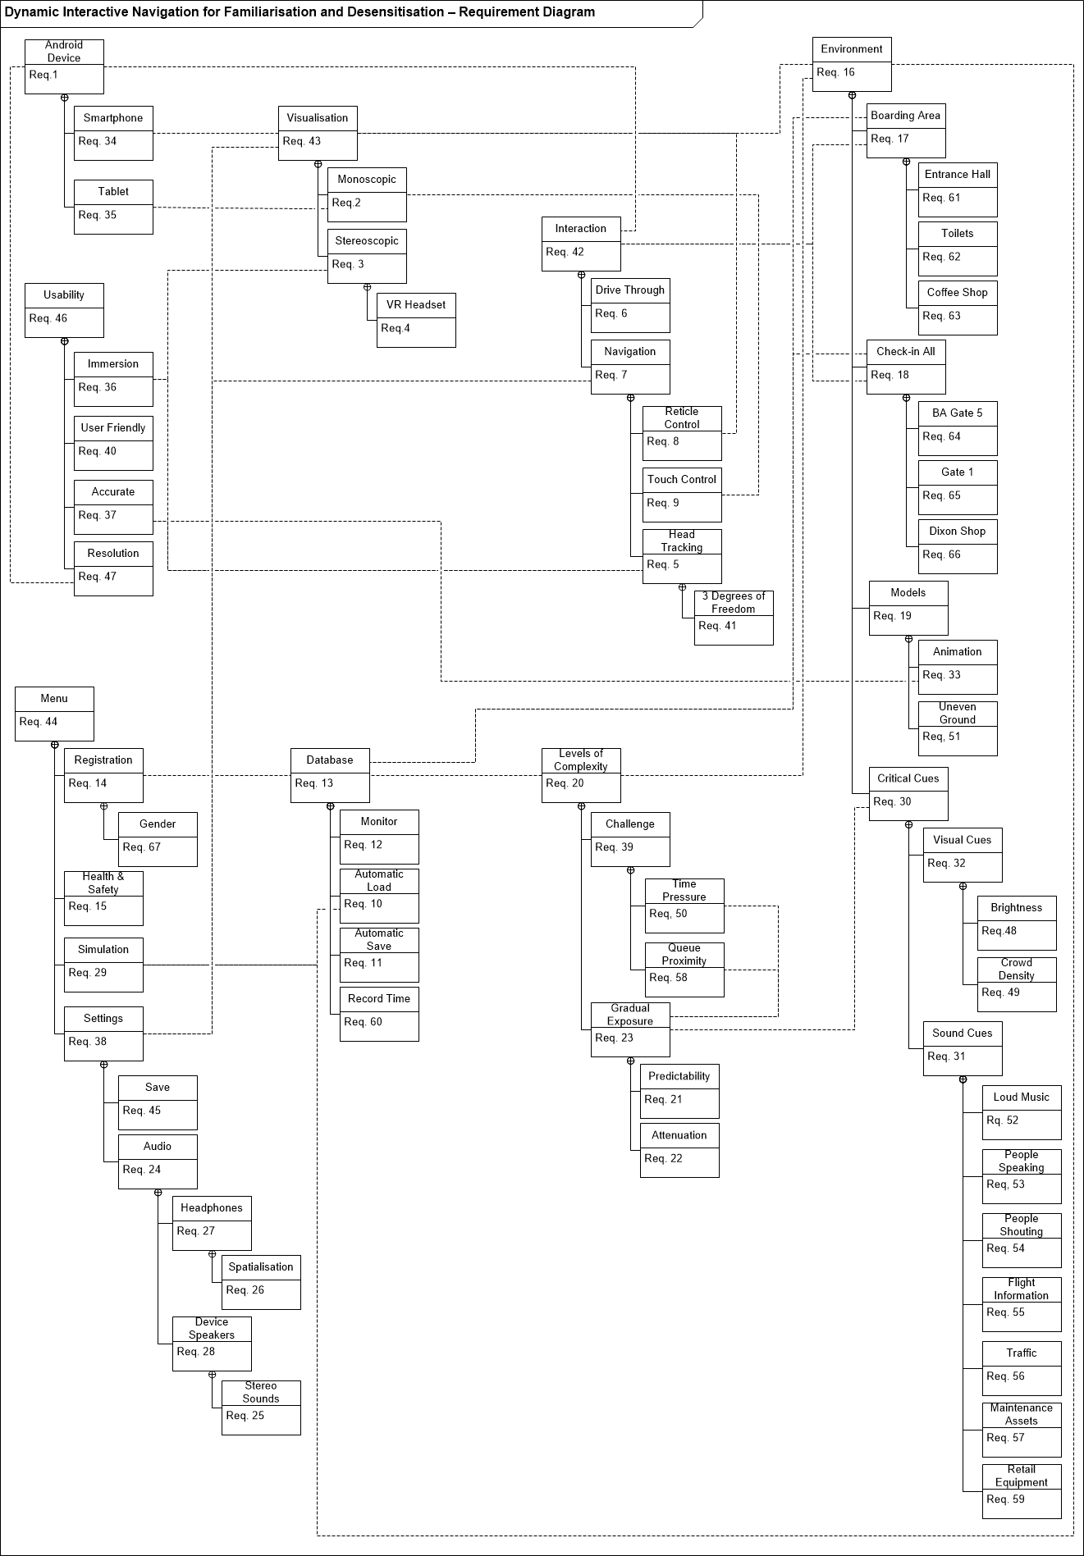
Figure 1. iSenseVR requirement diagram using SysML.
Figure 2. Use case diagram that provides a unified representation of the functionalities of iSenseVR.
iSenseVR was initially developed for Android mobile devices using Unity3D version 5.6 (https://unity3d.com/), a cross-platform game engine widely used in the video game industry. Further research iterations have now allowed providing a development compatible with VR-ready IOS devices. In the context of this study, iSenseVR provided a series of immersive experiences in digitally reconstructed airport environments that allow exposing individuals with hidden disabilities, in a controlled manner, to critical sensory cues such as ambient sounds (e.g. loud shop music, conversations, announcements and equipment noises) and crowds. In addition, the application supports stereoscopic visualisation, audio spatialisation and head tracking using the Google VR SDK for Unity (https://developers.google.com/vr/develop/unity/download).
The application initially requires the user to undergo a series of sensory attenuated experiences within each environment. Four environments were initially digitally reconstructed and populated with animated digital characters (Figure 3): (a) the entrance hall; (b) a café; (c) gender-specific toilets; and (d) a boarding gate.

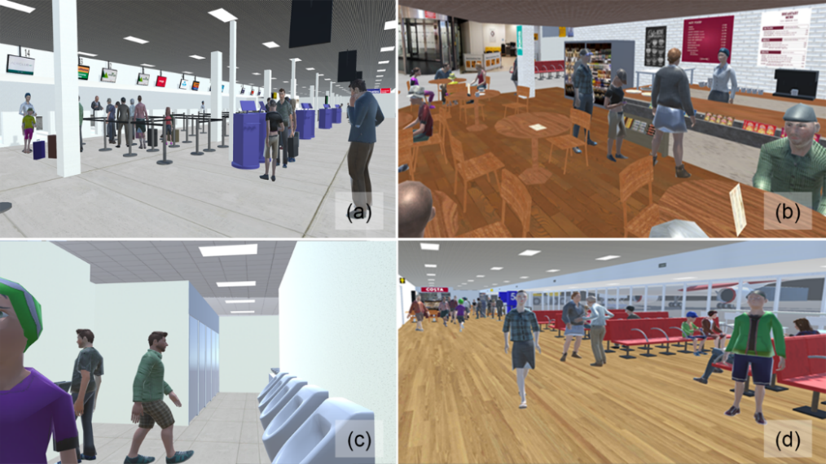
Figure 3. Digitally reconstructed environments in iSenseVR.
On launching an environment, the user was randomly driven through one of three possible paths, making each use less repetitive. Each path described a motion pattern for the user’s point of view within the environment. Although paths were fixed, the user could still explore the environment rotating its point of view on 3 degrees of freedom. Paths lasted no more than 3 minutes in order to minimise users’ boredom and cyber-sickness (Davis et al. 2014). On completion of a path, the user was removed from the virtual environment and presented with the main menu interface.
The gradual increase of environmental stressors ensured each environment became more challenging throughout repeated use. This increase was managed by a database located on a remote server. This database assigned a level of complexity per environment for each user (Figure 4).

Figure 4. Architecture of iSenseVR which allows the user to select the environment with which to familiarise, the application to query the database to assign the appropriate level of complexity in alignment with the gradual approach of the exposure, and the research team to monitor the usage of the system for each user.
Levels of complexity were associated to pre-set configurations of the audio landscape and the density and activity of the crowd in each environment. These configurations corresponded to specific values of audio assets volume and ratio of density of the crowd, which were directly proportional to the assigned levels of complexity. In addition, the crowd component was diversified by randomly loading on launching an environment, the required amount of animated digital characters from a preloaded collection of 57 characters.
In total, 7 levels of complexity were defined for each environment. The level of complexity of each environment increases when users complete a path, demonstrating their capability to tolerate the displayed sensory cues.
The usability of the application was initially tested with 11 neuro-typical postgraduate students from the Glasgow School of Art, with no previous experience in VR (Poyade et al., 2017b). They were required to experience each of the aforementioned environments with no sensory attenuation through a Samsung Galaxy S7, while sitting down on a swivel chair.
Overall, students were enthusiastic using the application, finding it very intuitive and provided valuable information that helped enhance user experience. Some felt a little eye strain, although no cyber-sickness was experienced.
In this study, participants were required to use their own headphones and smartphones, and download iSenseVR from a temporary link on Google Play Store to install it on their device. Although different models of Android smartphones were used, all were equivalent to or newer than the Samsung Galaxy S6.
After consenting to take part into the study, participants received a Virtual Reality Scope Headset for Smartphones (£5.99), an affordable and reliable device in which they could mount their smartphone, so they could use the application in VR from a safe and reliable place.
2.3 Procedure
Participants were asked to use the application on a daily basis for 7 consecutive days, using their smartphones mounted on the VR headset and their own headphones. They were required to attempt to complete one level of complexity for each environment every day, ensuring they were exposed to increasingly challenging environmental cues. They were informed they could plan their daily exposure as they wish, by either experiencing all environments in one session or spreading them throughout the day in case they felt overwhelmed. Each experience lasted no more than 3 minutes, so to minimise loss of interest, discomfort, and side effects typically associated to VR.
Participants were asked to set their smartphone to half volume and recommended to remain seated ideally in a swivel chair and under supervision if support was required, while immersed in VR.
The daily use of the application was reported in an external server allowing researchers monitoring the dedication and progress of each participant through the several levels of complexity for each environment.
2.4 Data Analysis
On completing the experiment, participants were required to rate a series of 15 statements using a typical 5-point Likert Scale: (1) Strongly Disagree; (2) Disagree; (3) Neutral; (4) Agree; and (5) Strongly Agree, gathered in a custom questionnaire that was previously tested using a cohort of 11 neuro-typical postgraduate students from the Glasgow School of Art (Poyade et al., 2017b). These statements aimed to inform about the usability of the system and the quality of the interaction, audio samples and visuals. In addition, participants were encouraged to provide comments to support their responses, and referred to what they most liked and disliked about iSenseVR using blank text boxes at the end of the questionnaire.
Mean values and standard deviations were calculated for each statement, and building upon a Theme-Based Content Analysis (TBCA) (Neale and Nichols (2001)) alike approach helped classifying ordering participants comments and reporting them in a consistent way.
2.5 Ethics Approval
Ethical considerations and safety concerns of participants were paramount to this research, considering the possible negative effects of visualisation through HMDs highlighted by previous research (Sharples et al., 2008), and to the panels of hidden disabilities and symptoms that participants were dealing with in their daily life. This study followed “Principles of Consent” as outlined under Adults with Incapacity (Scotland) Act 2000. This research is non-Clinical Trial of an Investigational Medicinal Products. This legal framework covers many aspects of research and governs the inclusion of adults with incapacity in research in Scotland. Prior to this study, institutional ethics approval was obtained from the research office at the Glasgow School of Art.
3. RESULTS
All participants but two were able to use iSenseVR throughout the whole testing period. Effectively, two participants mentioned experiencing some cyber-sickness symptoms and therefore opted for withdrawing from the study after 4 days (Table 1).
Table 1. Levels of complexity completed by users as recorded on the database. Each level of complexity was associated to pre-set configurations of the audio landscape and density and activity of the crowd within digital environments, and described the degrees of sensory challenge for the user experience. When completing an experience in an environment, the level of complexity would automatically increase before launching the next rehearsal in that same environment. In total, 7 levels of complexity were proposed for each environment.
User ID | Entrance Hall | Café | Boarding Gate | Toilets
1 | Level 7 | Level 7 | Level 7 | Level 7
2 | Level 7 | Level 7 | Level 7 | Level 7
3 | Level 6 | Level 6 | Level 3 | Level 6
4* | Level 3 | Level 3 | Level 3 | Level 3
5* | Level 4 | Level 3 | Level 2 | Level 3
6 | Level 7 | Level 7 | Level 7 | Level 7
7 | Level 7 | Level 7 | Level 7 | Level 7
* Withdrawn participants
Overall, participants reported to moderately enjoy their experience (M = 3.286, SD = 1.113) however, in the overall, a higher enjoyment was reported by those participants who completed the study (M = 3.6, SD = 1.14). Although, it seems to contrast with the comments they provided. Effectively, 6 Participants expressed their enthusiasm about their experiences in VR, qualifying the application as ‘‘excellent app”, ‘‘a great idea”, “very clever and unique”, “love the idea” and ‘‘a brilliant tool”.
All participants who pursued the study but one achieved all levels of complexity in all environments (Table 1), and were using iSenseVR for an average total time of 4284.2 seconds (SD = 829.36) over 7 days (Table 2).
Table 2. Participants total exposure time to each environment in seconds.
User ID | Entrance Hall | Café | Boarding Gate | Toilets
1 | 1439 | 1360 | 1211 | 693
2 | 1054 | 1114 | 1027 | 607
3 | 891 | 935 | 704 | 538
4* | 351 | 378 | 315 | 200
5* | 620 | 402 | 211 | 219
6 | 1427 | 1481 | 1357 | 810
7 | 1381 | 1325 | 1374 | 693
Mean | 1023 | 999 | 886 | 537
SD | 428 | 452 | 483 | 239
* Withdrawn participants
Overall, all participants felt confident using the application (M = 4.286, SD = 0.756) finding it easy to use (M = 4.429, SD = 0.787) and intuitive (M = 3.857, SD = 0.9). They felt comfortable wearing the headset (M = 3.857, SD = 0.9). Overall, they reported they not experience much eye strain (M = 2.143, SD = 1.345), fatigue (M = 2.429, SD = 1.512), headache (M = 1.571, SD = 1.134), or dizziness (M = 2.429, SD = 1.813) throughout rehearsals. However, experiences in virtual environments were reported to be sometimes a bit disorientating (M = 3.143, SD = 1.215), with the two withdrawn participants reporting having experienced to some extent nausea and dizziness (“it made me feel dizzy”, “it made me feel a little sick”), that are consistent with typical symptoms of cyber-sickness.
Participants mentioned feeling psychologically engaged within environments (“I felt as if I was there”, “It felt like super natural”), suggesting they experienced realistic immersion and high degree of presence in VR. Although they appreciated the changing narrative throughout repeated use allowed them to build up the density of the crowd and sounds (“I get a bit scared by these noises in real life in busy places so it definitely helped me and each day slowly got busier/more noises”), and change the storyline of their experiences (“I liked that over the week it built up the levels of people, noises and changed the surroundings and routes taken each time I used the application”), they suggested the provision of more realistic cues as denser crowds with more natural use of animations throughout environments (“the sceneries needed to be much busier for a more realistic experience”) and enhanced interaction paradigms (“I could not actually control the movement”, “little boring as I couldn't interact”, “I'd have liked to explore some things in the environment more”) could eventually contribute improving user experience in the digital environments.
Although remaining participants felt moderately more confident going into busy environments after 7 days (M = 3, SD = 0.707), all participants concurred iSenseVR “would be really beneficial for a lot of people with hidden disabilities” and “could actually help over time”. They would thus recommend it to others (M = 4.429, SD = 0.535) (“it would be really beneficial for a lot of people with hidden disabilities”) as the experience was perceived to ‘‘be so useful to do if going to airport for first time”, and “would definitely buy this app if it came out.
4. DISCUSSION
People with hidden disabilities such as autism, Asperger, learning disabilities, anxiety disorders and mental health problems are far more likely to experience high levels of discrimination, isolation, fear, anxiety, unemployment and poverty (Wilton, 2003; Cameto et al., 2004; Hendricks, 2010; Madriaga, 2010; Davidson et al., 2018). This research presents a strategy that could help bringing down those barriers that are environment stressors such like sounds, light and crowds, in order to empower individuals with hidden disabilities towards more independent living.
This research present a methodological and technological framework to support the design of immersive VR applications for Android smartphones, aiming to empower those who live with hidden disabilities and mental health conditions to overcome their barriers through repeated rehearsals of a critical situation in a controlled digital environment, from the safety of their home. This study showed that VR on smartphones mounted on affordable headsets allows people to experience realistic exposure to busy situations in digitally reconstructed environments such as airports areas.
Overall, the presented evaluation reported positive responses from participants and infatuation for the application of VR in the context of busy environments as airports. Experiencing presence when immersed in VR has been reported to be an important factor for the implementation of effective interventions in VR (Maples-Keller et al., 2017). Although due to the limited sample of participants, the findings need to be carefully interpreted. Despite sensory cues needed to be more realistically reproduced in the digital environments, results seem to be consistent with previous research outcomes in the field, showing a high degree of presence and acceptance among users (Newbutt et al., 2016a; Newbutt et al., 2016b). Enjoyment throughout the simulated experience was moderately reported, suggesting both, the seriousness of the stress and anxiety elicitation from the simulated situations despite the gradual exposure to sensory stimulation, and the limitations of the passively guided navigation leading possibly to disorientation and cyber-sickness. Effectively, participants felt a little disoriented while visualising digital environments through the HMDs, with two of them experiencing cyber-sickness symptoms, consistently with indications from previous research outcomes (Sharples et al., 2008). This must be taken into consideration in further research to aspire for a more effective design of an attenuation strategy resulting in a more enjoyable experience able to tackle user’s constant discomfort. In addition, further research must also endeavour on gaining deeper understanding of the perception of presence in the proposed digital environments displayed on VR-ready smartphones, in order to propose interaction and navigation paradigms that are in better alignment with the definition of presence as the perceptual illusion of non-mediation (Riva et al., 2003).
The main research outcome, iSenseVR, contributes effectively to the practicality of VR exposure therapy, by bringing it outside laboratory settings towards one’s safely considered environments and making it therefore more accessible to most in terms of cost and technical requirements. In that way, the presented approach is aligned with the recommendations made by Grynszpan et al. (2014) for the design of more accessible interventions. However, the lack of accompanying therapist throughout the proposed experience, consists of a limitation of the presented approach, and disqualifies, for the moment, iSenseVR as a tool for genuine controlled exposure therapy intervention for helping people with hidden disabilities in order to help them to manage their anxiety and stress in busy environments. Nonetheless, this does not impede us hypothesising the adequacy and effectiveness of this approach to complement already in-place strategies for reasonable adjustments in airports (Karayazi et al., 2014; OHandley et al., 2015), in further research.
5. CONCLUSION
This paper presents the outcomes of the preliminary evaluation of iSenseVR, a proof of concept of a VR application for Android and IOS smartphones, which enables the gradual exposure to environmental stressors in busy places. Results highlighted high user acceptance and increased sense of presence within digital environments. Although results are very encouraging more testing would be required to generalise outcomes to the wider community of individuals with hidden disabilities. In addition, further improvements are needed to tackle user disorientation and cyber-sickness, and strategies need to be implemented to increase users’ comfort and conﬁdence after using the application, iSenseVR consists of a cost effective and user-friendly solution for gradual familiarisation and desensitisation to some of the critical environment cues that are typically eliciting distress among individuals with hidden disabilities.
However, in the future, iSenseVR aims to become a domestic practical solution to support conventional and experimental exposure therapies for busy environments such as airports, job centres, lecture theatres in higher educational institutions, and many more. This is to be achieved by focusing on design refinements to enhance interaction, navigation and user’s comfort, and by involving therapeutics into a participatory design approach in order to capture their expertise into more effective gradual exposure interventions that can be conducted from the safety of one’s place. An evaluation framework is to be designed along with therapists in order to assess the internal, external and ecological validity of iSenseVR in airports and beyond.
ACKNOWLEDGEMENTS
This project Dynamic Interactive Navigation for Familiarisation and Desensitisation was supported by the Social Innovation Fund from the Scottish Government and the European Social Fund [SIF-R1-S1-HI-002 & SIF-R2-S2-HI-001]. The funding supported all design, development, research, engagement and dissemination activities.
NOTES
[1]https://www.prnewswire.com/news-releases/future-of-global-digital-reality-market-forecast-to-2021---vr-application-in-the-manufacturing-sector-is-projected-to-increase-by-98-9-between-2017-and-2021--300716802.html
[2] https://www.marketresearchfuture.com/reports/virtual-reality-gaming-market-2967
REFERENCES
American Psychiatric Association, (2013). Diagnostic and statistical manual of mental disorders – Fifth Edition (DSM-5®). American Psychiatric Pub, Washington, DC.
American Psychiatric Association, (2017). Clinical Practice Guideline for the Treatment of Posttraumatic Stress Disorder (PTSD) in Adults. American Psychiatric Association, Division 12. available at: https://www.apa.org/ptsd-guideline/patients-and-families/exposure-therapy.aspx. (accessed 13 December 2018)
Botella, C, Serrano, B, Baños, RM, and Garcia-Palacios, A, (2015), Virtual reality exposure-based therapy for the treatment of post-traumatic stress disorder: a review of its efficacy, the adequacy of the treatment protocol, and its acceptability. Neuropsychiatric disease and treatment, Vol.11, p.2533.
Cameto, R., Levine, P. and Wagner, M., (2004). Transition Planning for Students with Disabilities: A Special Topic Report of Findings from the National Longitudinal Transition Study-2 (NLTS2). National Center for Special Education Research. Available at https://files.eric.ed.gov/fulltext/ED496547.pdf (accessed on 12 December 2018).
Chonoles, M.J. and Schardt, J.A., (2011). UML 2 for Dummies. John Wiley & Sons, New York, NY.
Couzens, D., Poed, S., Kataoka, M., Brandon, A., Hartley, J. and Keen, D., (2015). Support for students with hidden disabilities in universities: A case study. International Journal of Disability, Development and Education, Vol. 62, No. 1, pp.24-41.
Davidson, T., Moreland, A., Bunnell, B.E., Winkelmann, J., Hamblen, J.L. and Ruggiero, K.J., (2018). “Reducing Stigma in Mental Health Through Digital Storytelling”, in Canfield, B.A & Cunningham, H.A. (Ed), Deconstructing Stigma in Mental Health, IGI Global, pp. 169-183.
Davis S, Nesbitt K, and Nalivaiko E, (2014), A systematic review of cyber-sickness. Proc. ACM Conf. on Int. Entertainment, pp. 1–9.
Diemer, J, Muhlberger, A, Pauli, P, and Zwanzger, P, (2014), Virtual reality exposure in anxiety disorders: Impact on psychophysiological reactivity. The World J. of Biological Psychiatry, Vol. 15, No. 6, pp.427–442.
Friedenthal, S., Moore, A. and Steiner, R., (2014). A practical guide to SysML: the Systems Modeling Language. Morgan Kaufmann, Waltham, MA.
García-Betances, RI, Arredondo Waldmeyer, MT, Fico, G, and Cabrera-Umpiérrez, MF, (2015), A succinct overview of virtual reality technology use in Alzheimer’s disease. Frontiers in aging neuroscience, Vol. 7, p.80.
Gray, C. (2012). “What are Social StoriesTM”, Grove N. (Ed.), Using storytelling to support children and adults with special needs: Transforming lives through telling tales, Routledge, New York, NY, p.95.
Groden, J., Diller, A., Bausman, M., Velicer, W., Norman, G. and Cautela, J., (2001). The development of a stress survey schedule for persons with autism and other developmental disabilities. Journal of Autism and Developmental Disorders, Vol. 31, No. 2, pp.207-217.
Grynszpan, O, Weiss, PL, Perez-Diaz, F, and Gal, E, (2014), Innovative technology-based interventions for autism spectrum disorders: a meta-analysis. Autism, Vol. 18, No. 4, pp.346–361.
Hendricks, D., (2010). Employment and adults with autism spectrum disorders: Challenges and strategies for success. Journal of Vocational Rehabilitation, Vol. 32, No. 2, pp.125-134.
Hutchins, T.L. and Prelock, P.A., (2013). The social validity of Social Stories™ for supporting the behavioural and communicative functioning of children with autism spectrum disorder. International journal of speech-language pathology, Vol. 15, No. 4, pp.383-395.
Karayazi, S, Kohler Evans, P, and Filer, J, (2014), The effects of a social story intervention on the pro-social behaviors of a young adult with autism spectrum disorder. Int. J. of Special Education, Vol. 29, No. 3, pp.126–133.
LaValle, SM, (2016), Virtual Reality (To be published), Cambridge University Press, Cambridge, available at: http://vr.cs.uiuc.edu/. (accessed on 14 July 2018)
Madriaga, M., (2010). ‘I avoid pubs and the student union like the plague’: Students with Asperger syndrome and their negotiation of university spaces. Children's Geographies, Vol. 8(1), pp.39-50.
Maples-Keller, JL., Bunnell, BE, Kim, SJ and Rothbaum, BO, (2017). The use of virtual reality technology in the treatment of anxiety and other psychiatric disorders, Harvard review of psychiatry, Vol. 25, No. 3, pp.103-113.
Maskey, M, Lowry, J, Rodgers, J, McConachie, H, and Parr, JR, (2014). Reducing specific phobia/fear in young people with autism spectrum disorders (ASDs) through a virtual reality environment intervention. PloS one, Vol. 9, No. 7, p. e100374.
Miller, HL, and Bugnariu, NL, (2016), Level of immersion in virtual environments impacts the ability to assess and teach social skills in autism spectrum disorder. Cyberpsychology, Behavior, and Social Networking, Vol. 19, No. 4, pp.246–256.
Morina, N, Ijntema, H, Meyerbroker, K, and Emmelkamp, PM, (2015), Can virtual reality exposure therapy gains be generalized to real-life? a meta-analysis of studies applying behavioural assessments, Behaviour research and therapy, Vol. 74, pp. 18–24.
Newbutt, N, Sung, C, Kuo, HJ, Leahy, MJ, Lin, CC, and Tong, B, (2016a), Brief report: A pilot study of the use of a virtual reality headset in autism populations. Journal of autism and developmental disorders, Vol. 46, No. 9, pp.3166-3176.
Newbutt, N, Sung, C, Kuo, HJ and Leahy, MJ, (2016b). The potential of virtual reality technologies to support people with an autism condition: A case study of acceptance, presence and negative effects. Annual Review of Cyber Therapy and Telemedicine, Vol. 14, pp.149-154.
Neale, H, and Nichols, S, (2001), Theme-based content analysis: a flexible method for virtual environment evaluation. International journal of human-computer studies, Vol. 55, No. 2, pp.167–189.
OHandley, RD, Radley, KC and Whipple, HM, (2015). The relative effects of social stories and video modeling toward increasing eye contact of adolescents with autism spectrum disorder. Research in Autism Spectrum Disorders, Vol.11, pp. 101–111.
Parsons, T.D., (2015). Virtual reality for enhanced ecological validity and experimental control in the clinical, affective and social neurosciences. Frontiers in human neuroscience, Vol. 9, p.660.
Poyade, M, Morris, G, Taylor, I, and Portela, V, (2017a), Using mobile virtual reality to empower people with hidden disabilities to overcome their barriers, In Proceedings of the 19th ACM International Conference on Multimodal Interaction in Glasgow, Scotland, 2017, ACM, pp. 504-505.
Poyade, M, Morris, G, Taylor, I and Portela, V, (2017b), Designing a virtual reality exposure therapy to familiarise and desensitise to environmental stressors in airports. Paper presented at EuroVR2017, Laval France, 12-14 December 2017, available at: http://radar.gsa.ac.uk/5605/.
Reid, A.J., (2018). “A Brief History of the Smartphone”. Reid A.J. (Ed), The Smartphone Paradox, Palgrave Macmillan, Cham. pp. 35-66.
Riva, G., Davide, F. and IJsselsteijn, W.A., (2003). “Being there: The experience of presence in mediated environments”. Riva G. at al. (Eds). Being there: Concepts, effects and measurement of user presence in synthetic environments, IOS Press, Amsterdam, p .3-14.
Rizzo, A., Cukor, J., Gerardi, M., Alley, S., Reist, C., Roy, M., Rothbaum, B.O. and Difede, J., (2015). Virtual reality exposure for PTSD due to military combat and terrorist attacks. Journal of Contemporary Psychotherapy, Vol. 45, No. 4, pp.255-264.
Serino, S, Triberti, S, Villani, D, Cipresso, P, Gaggioli, A, and Riva, G, (2014), Toward a validation of cyber-interventions for stress disorders based on stress inoculation training: a systematic review. Virtual Reality, Vol. 18, No. 1, pp. 73–87.
Sharples, S, Cobb, S, Moody, A, and Wilson, JR, (2008). Virtual reality induced symptoms and effects (VRISE): Comparison of head mounted display (HMD), desktop and projection display systems. Displays, vol. 29, No. 2, pp.58-69.
Slater, M, (2003), A note on presence terminology. Presence connect, Vol. 3, No. 3, pp. 1–5.
Styles, A., (2011). Social StoriesTM: does the research evidence support the popularity?. Educational Psychology in Practice, Vol. 27, No.4, pp.415-436.
Wilson, CJ, and Soranzo, A, (2015), The use of virtual reality in psychology: a case study in visual perception. Computational and mathematical methods in medicine 2015.
Wilton, R.D., (2003). Poverty and mental health: A qualitative study of residential care facility tenants. Community Mental Health Journal, Vol. 39, No.2, pp.139-156.

