THE RAILWAY TRUCK CIGAR, CIGARETTE AND TOBACCO CASE.
By Nicholas Oddy
Photographs by Douglas Robertson and the author with thanks to the National Archives.

For some years I have been assembling a collection of nominally 5 inch gauge oak built coal wagons, built on chemically darkened brass axle-guards and wheels. At first sight they could be mistaken for something designed for a model railway, but they are not. Rather, they are novelty smoker’s companions, designed to run no further than the length of the dinner table, presumably after the ladies had retired to the drawing room and the port was being passed. The first I found was lettered GNR and I bought it merely because I like such novelty items. Then another turned up, this time lettered G.S.W.R. Fig 1.

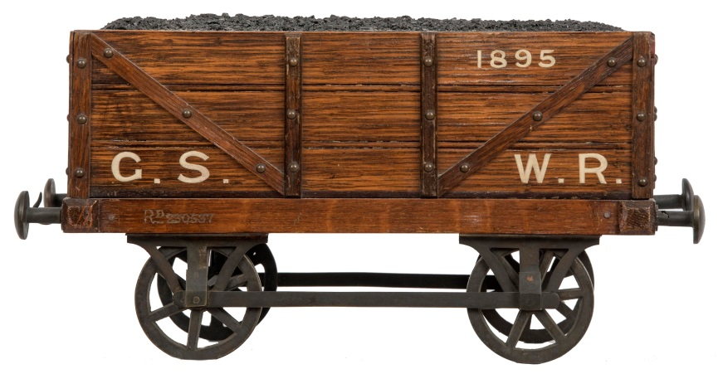
Fig 1

Fatal, all the makings of a collection. A third came, this time NBR. Fig 2.

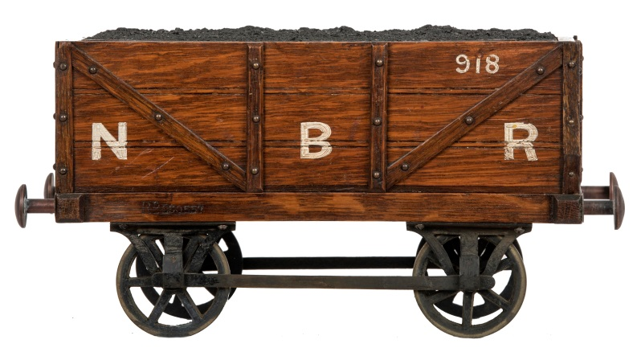
Fig 2

I became hooked. At least it might be possible to find all the Scottish companies (assuming G.S.W.R. to be Glasgow & South Western and not the Great Southern & Western of Ireland…equally interesting). I disposed of the GNR, but have since seen a good number more, clearly the most popular at the time of their production. The collection has since slowly moved toward ‘completion’ with the purchase of CR and G.N.S.R. examples, only leaving HR to go Figs 3 and 4.

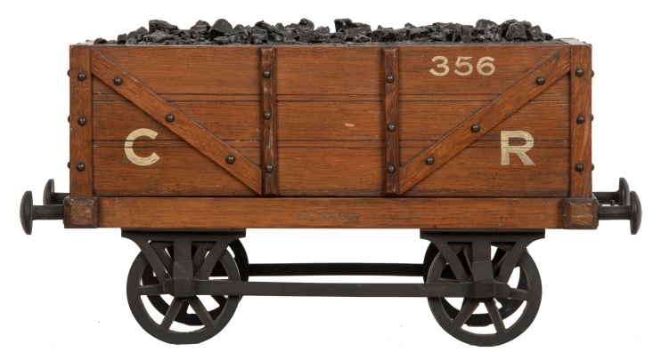
Fig 3

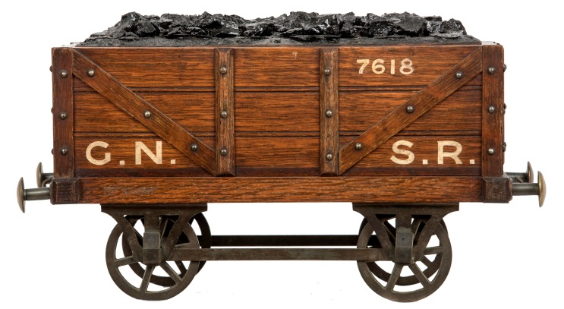
Fig 4

However, most recently, a pleasing MCR (Maryport and Carlisle Railway) version appeared Fig 5. Too good to miss - I felt happy extending the collection just over the border to acquire it, but equally realise it could be a step to ruin where I end buried under Railway Truck Cigar, Cigarette and Tobacco Cases.

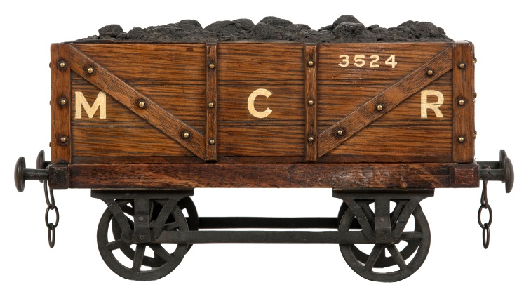
Fig 5

One should not be surprised by the product’s ubiquity. The coal wagon was familiar to all who went anywhere near a railway. Small companies like the MCR often serviced heavy, coal-consuming industries that had plenty of wealthy senior staff who would enjoy such visual jokes, quite apart from railway managers themselves – one could see these being very appropriate presents at board-room level. Beyond those I have acquired, I have noted NER, L.N.W.R., LYR and GWR. On the grounds of what I have seen, there are doubtless representatives of most, if not all the larger companies and all manner of more or less obscure ones to be found, particularly those serving industrial and mining regions.
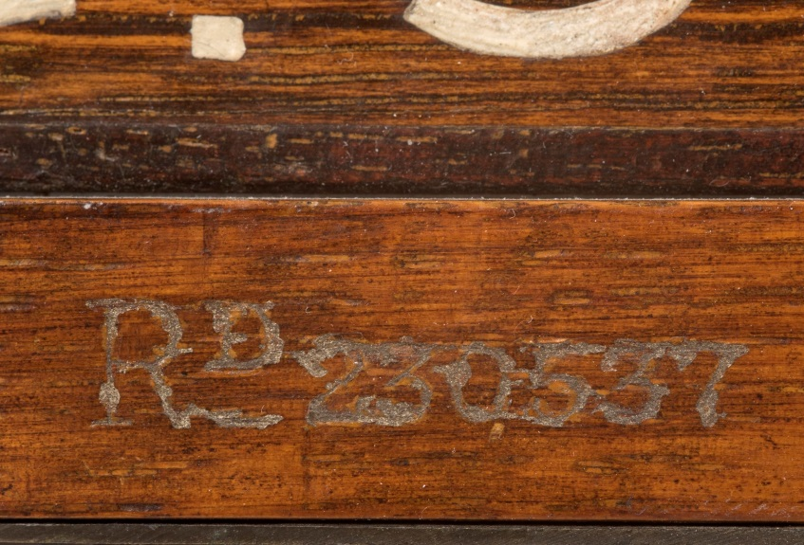
Fig 6

At first, the ones I came across were all stamped Rd 230537 Fig 6; so, a trip to the National Archives (a short walk from Kew Gardens station) was necessary to establish their origins. I am particularly indebted to the National Archives as they have allowed free publication of their holdings in this and all future issues of the Train Collector. My day job is running a Department of Design History and the Registrations are a hugely important resource that I strongly recommend to anyone wanting to trace the maker of something bearing a registered number. Design registrations provide copyright protection to items of applied art, which do not qualify within patent legislation, therefore the registration has to keep an accurate visual record of the design itself. Registrations for the turn of the century are held in two series of files, the registers of applicants at BT 51 and the designs themselves at BT 50 (BT being ‘Board of Trade’). The BT 50 files are massive volumes which contain actual samples of ‘flat’ items such as fabrics and wallpapers together with drawings of three dimensional objects. In the late 19th century photographs were often submitted instead of drawings, these normally show objects in their earliest complete form. In this case BT 51/76/230537 takes one to Walter Ofield, fancy cabinet manufacturer of 69, Rushton Street, St Johns Road, London N, who was granted the registration on 12 April 1894 Fig 7.

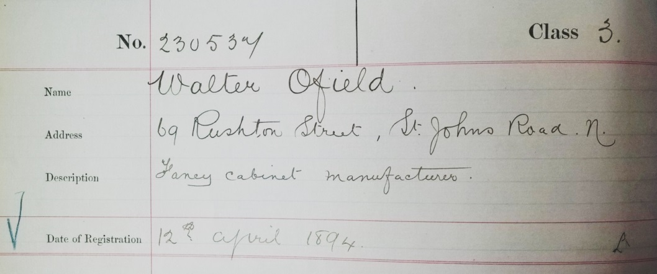
Fig 7
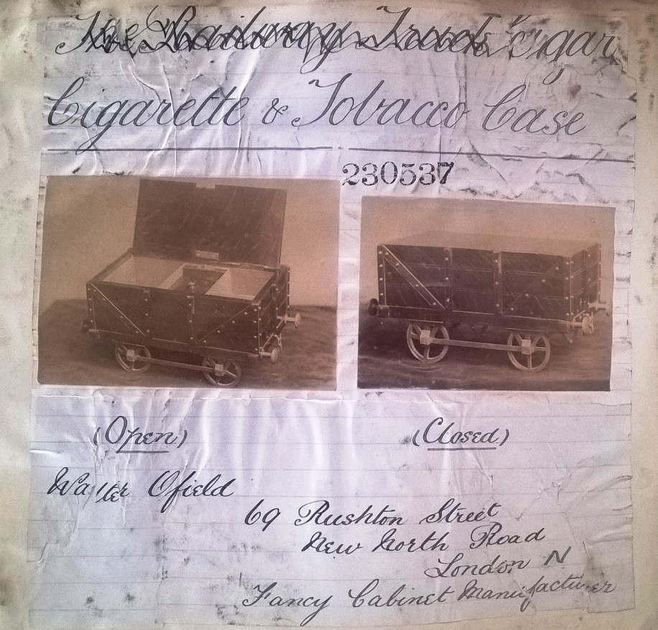
Fig 8

BT 50/207/230537 takes one to the object itself, photographed in both open and closed form Fig 8. By a stroke of luck the clerk making the entry seems first to have taken the description direct from Ofield’s submission, giving us the actual title of the product. Useful though this is to us today, it was probably less so to the unfortunate clerk who has then been made to delete it. On the grounds that the designs were meant to speak for themselves the policy was to only give a basic descriptive title where absolutely necessary, many were left anonymous.

The photographs show the first version of the truck to have four-spoke wheels, diagonals that locate to the base, and a plain top. It is built in oak and lined in cedar. The interior is kitted out with cigar, cigarette and tobacco compartments, the tobacco compartment is lidded. This is different from the versions I have found. While all are mid-oak with cedar lining, they have six spoke wheels and an imitation coal load. Inside, they are either separated for cigars or cigars and cigarettes, or made as a full companion with ash tray, match compartment and striker Fig 9.

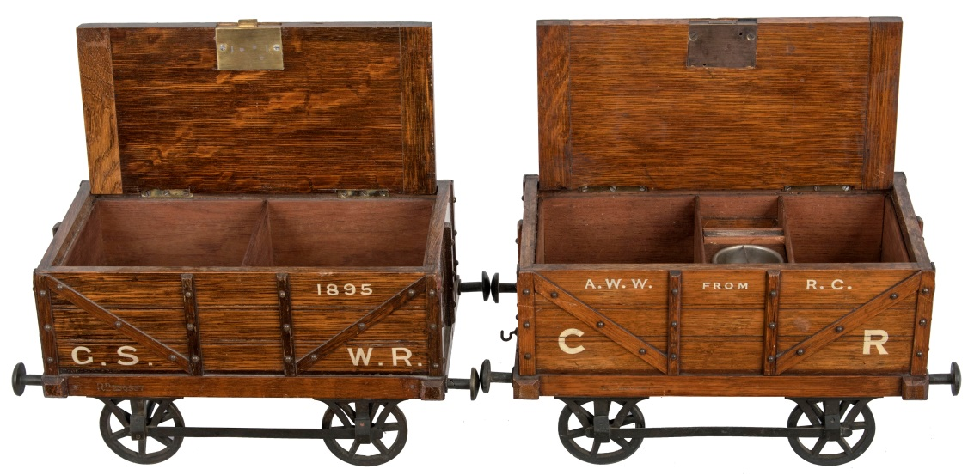
Fig 9

The sides of the truck submitted for registration are unlettered. While a number of those I have come across are anonymous, the majority are lettered. We assume therefore that Ofield would offer customers this service to order. I imagine that some retailers asked for the nearest well known company, but that an obscure concern like the MCR would be requested by an individual customer, most likely through the retailer. Interestingly, those that have company initials also carry numbers, which seem to be consecutive. The initials always seem to be full, (NBR, not NB, for instance), with the four-letter initials taking the ends of the lowest ‘plank’ and having full stops. At first, the three and two-letter initials were generally placed fairly low to provide space, but it seems that later it became more common to place at least the three letter initials on the second ‘plank’ as with the MCR example, above. All are in much the same style, by a number of different hands (and levels of skill), adding to the probability that it was Ofield’s staff who lettered them, not local retailers.

So far, the earliest I have found is CR 356. This could be Cambrian Railway as much as Caledonian, but I like to think the latter. It is very much to order; one side bears an inscription ‘A.W.W. form R.C.’, as can be seen in Fig 9. It has noticeably less prominent grain than the later ones, while the one in the registration seems darker, but equally lacks overt graining. This suggests that over the first few hundred trucks Ofield adjusted his stain, first to lighten the wood, then to bring out the grain to make the trucks more ‘oaken’, in line with popular taste in the 1890s, which had begun to value overtly grained oak as an indication of quality and tradition. The CR’s diagonals are broader than the NBR and G.S.W.R. examples, but still locate to the centre uprights, common to all I have seen. In the registration the diagonals locate to the floor beside the uprights. CR 356 bears the registration number centrally, on one solebar only. Some 560 trucks later, NBR 916 has registration numbers at the left hand ends of both solebars, common to all the others I have found. MCR 3524 has broader diagonals again and its tie-bars are inside the axle-guards; this adjustment makes the axle boxes fit fully flush to the axle-guards and, although there is likely to be a transitional period, it seems to have become policy Fig 10

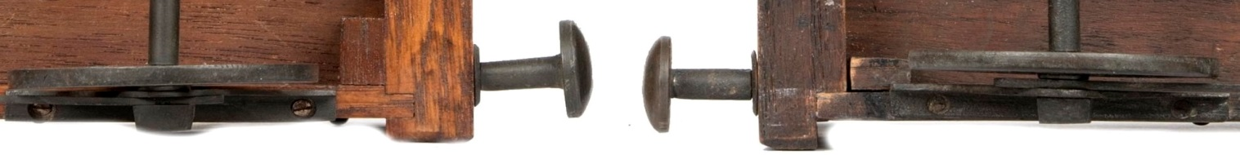
Fig 10: CR on left (tie bar outside), MCR on right (tie bar inside)

Imagine my delight in finding an armoured train infantry wagon, slotted for two levels of rifles, presumably from the time of the Second South African War Fig 11. Its plain lid carries ornamental brass corners in the Gothic manner and a CIGARS plaque Fig 12. It does not have registration numbers but is clearly by the same maker. Careful comparison shows its frame to be slightly wider to accommodate the now standard, inside tie-bars that push the axle guards out by their width.

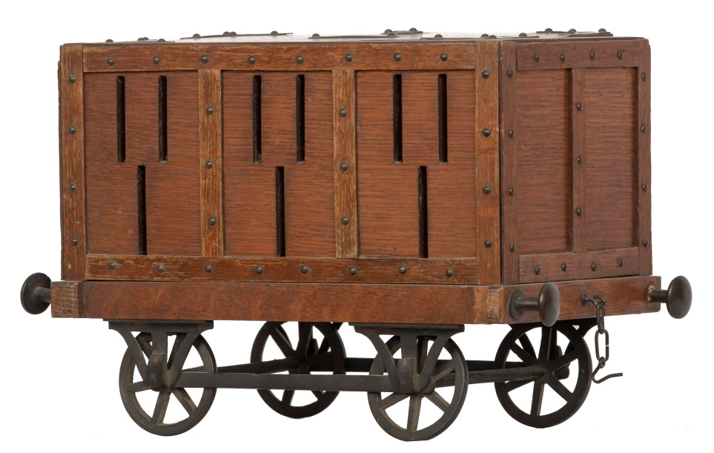
Fig 11

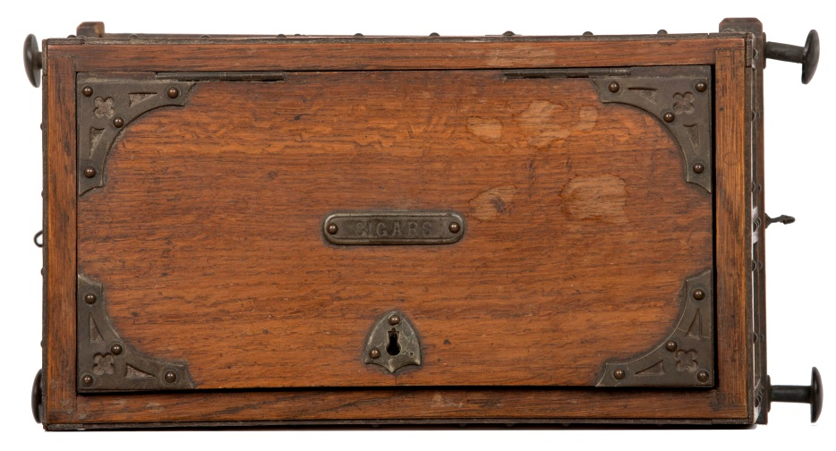
Fig 12

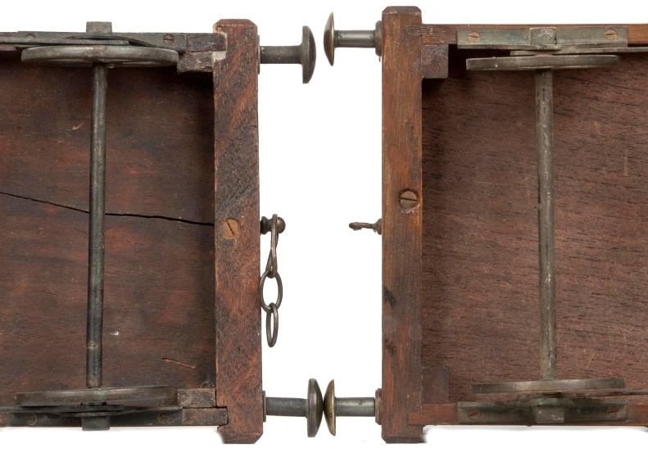
Fig 13: MCR on left, GNSR on right

G.N.S.R. 7618 also has this wider chassis Fig 13, but surprised me by its registration, Rd 371597 Fig 14.

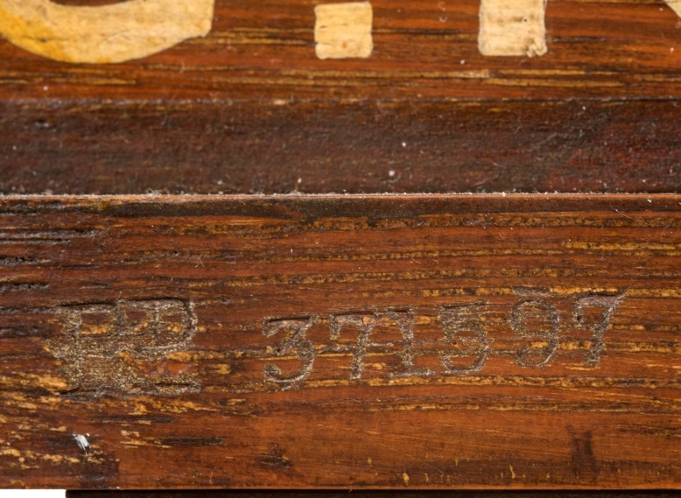
Fig 14

Back to the National Archives. BT 51/107/371597 takes us to FW Ring, trading as W. Ofield and Company from the same address; so, a change of owner, but still a ‘Fancy Cabinet Manufacturer’ keen to hold on to the design concept Fig 15. The registration, granted on 15 March 1901 is a surprise. The photographs show a ‘Stationery Cabinet’ in the form of a covered wagon, over a ‘plank’ higher than the coal truck, kitted out with pen rack and letter compartments Figs 16a and b. I want one!

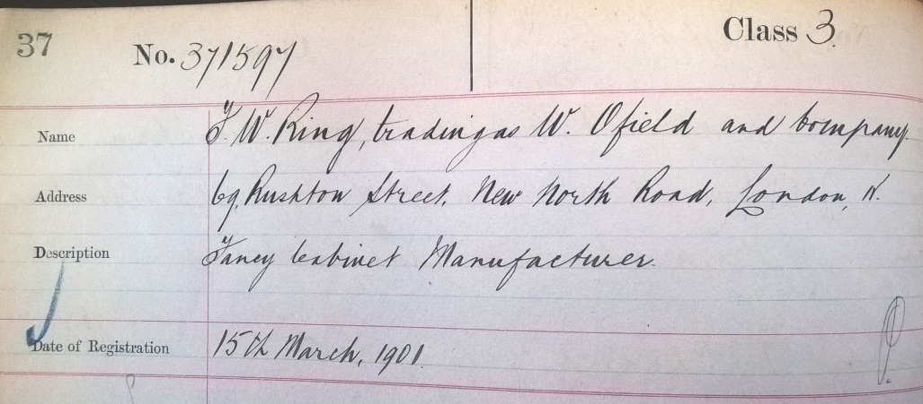
Fig 15

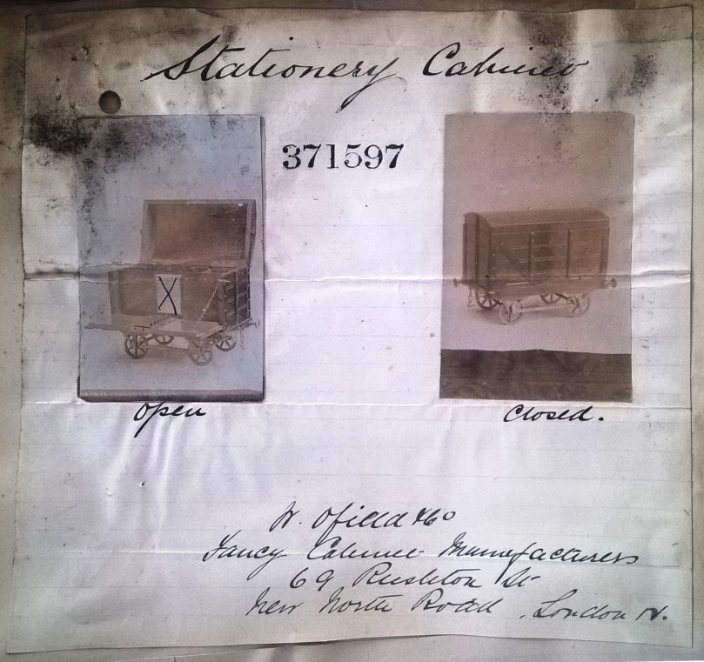
Fig 16a

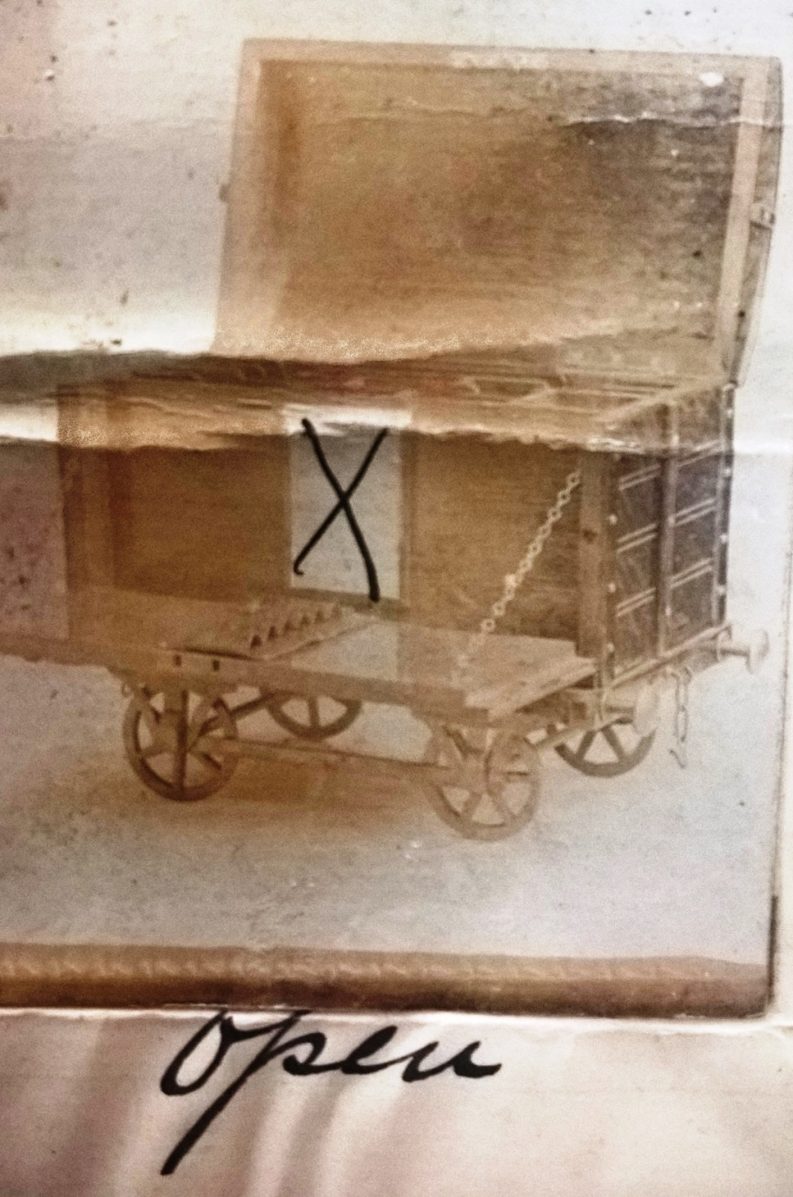
Fig 16b

Moving to trade directories we can plot the history of Ofield & Co. A complete collection of these for London is held at the Guildhall Library on microfilm and their content can be enhanced by the library’s ancestry search engine. Walter G Ofield was an established manufacturer and was 47 by the time he introduced the product. He had lived at the address for many years. The 1881 census has him living there aged 34 with his wife, Frances (Fanny) (30), and daughter Minnie (10). They shared with another family, George Jaycock (23) an umbrella maker, Emma (23) and daughter, also Emma, (2). As workshop and home to two families and two businesses, 69 must have been busy, typical of many in the east end. Minnie married 26 year old Fredrick William Ring in February 1896, and the couple inherited the business when Ofield died on 14 October 1898. Clearly it had prospered, the ‘effects’ were transferred on a probate value of £4503 12s 2d (coming on £500,000 in today’s terms). The house will almost certainly have been rented and not part of this. W Ofield and Co continued trading in the first years of the new century as ‘Wholesale Manufacturers of Stationery Cases and Cabinets, Paper Racks, Cigar & Cigarette Cabinets &c - Telegraph ‘Utilizable’ Telephone 7376 Central.’ However, the business is last listed in 1908. In the 1911 census the Rings have moved to leafier climes ‘Jesmond Dene’, The Drive, Golders Green, a six apartment house. They had three young sons and a live-in servant. Ring describes himself as an ‘Actor’.
What else might be out there? Malcolm Clayton once displayed an entire train fashioned from Ofield coal trucks. Originally this had something over thirty wagons, all lettered and consecutively numbered for a coal merchant, whose agents were each issued with one to fill with actual coal as a publicity item. Model coal wagons were popular window display items for coal merchants, but are usually more ‘scale’ and one-off. Here is a 5” gauge example for W.B.&Co of Gartsherrie near Coatbridge, complete with original stand Fig 17. William Baird & Co was a major iron and mining company that had been founded on the back of the Baird family’s farmland being on rich coal seams. Gartsherrie ironworks was established in 1830, illegally using Neilson’s newly developed hot-blast process. To supply it (and to profit from their competitors) Baird & Co were quick to secure ownership of almost all local coalfields that had seams of the quality the process required, taking their interests into Ayrshire. Neilson sued, but Baird had already made so much money Neilson was easily paid off. A decade later Gartsherrie was the largest single producer of pig iron in the world. According to Grace’s Guide at https://www.gracesguide.co.uk/William_Baird_and_Co , alongside numerous iron works, in the 1930s Baird & Co owned 70% of the Ayrshire coalfields; the wagon number 1121 tells us the scale of the company’s coal interests. The wagon was built by a R Foulds in the ironworks in 1933 Fig 18.

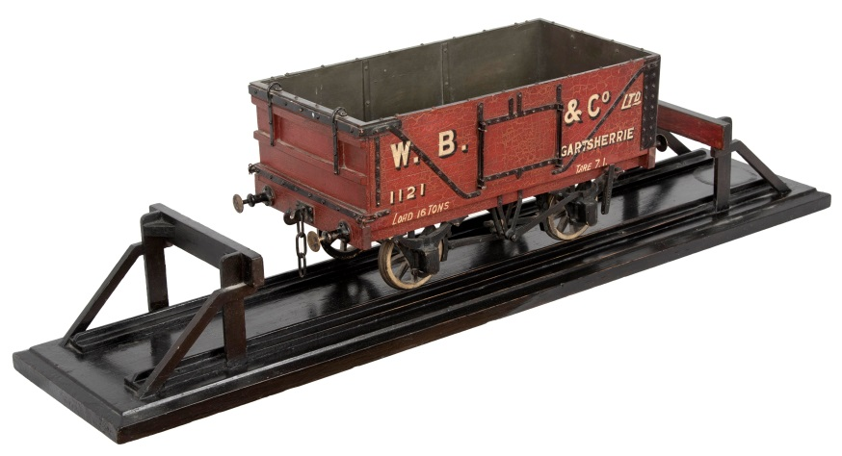
Fig 17

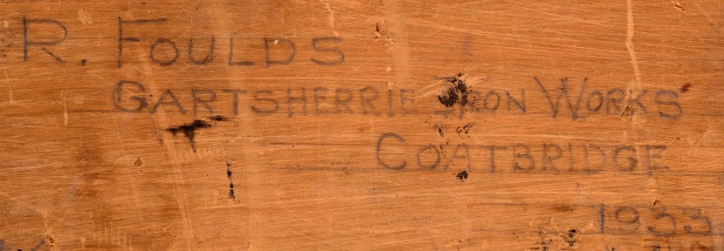
Fig 18

The train of Ofield trucks was rather different as Head Office kept those still to be issued as a display in their own right as a complete train. Many clearly started life as cigar boxes and how ‘official’ they are is moot; but what I envied was the brake van. This had all the hall marks of Ofield’s work and must have been made specially to complete the train. On wonders if there is an Ofield loco somewhere?

Let us return to the 371597 registration for a stationery cabinet, yet it being applied to the G.N.S.R. coal truck. Registered designs are fraught in their interpretation. Until recently registration was taken to cover the concept as much as the specific detail. While J W Ring was stretching this when the content was so different, the concept was for the idea of the novelty cabinet in the form of a railway truck of that size and general form. In view of this, Ring would hope to protect all designs of rather the same outward appearance as 371597.

The armoured wagon bears no numbers. This could be because it was a special order, like the brake van; but, if it is ‘production’, perhaps because its outward appearance was so different from a truck with planks and diagonal straps? Some readers will have seen the recent controversy over the ‘Trunki’ ride-on children’s suitcase, in the form of an animal where the child holds its ‘horns’. This was copied PMS for their ‘KiddeeCase’, a very similar product in the form of an insect, where the child holds its ‘antennae’. Magmatic, the holder of the Trunki registration argued that its copyright covered the concept of the design, rather than its specific details. However, having gone up the legal process, the Supreme Court ruled that the registration was specific only to a suitcase in the form of an animal held by its horns, not one held by ears or antennae. The case shows just how difficult it is to protect a design rather than a principle (the stuff of patents). Ring doubtless believed that the registration covered all Ofield & Co’s wagon-like novelty cabinets and many would have agreed. Until the Trunki dispute, no one had successfully challenged this belief; it has serious implications for the future of copyright in design.

