SIZE, THEN GAUGE, THEN SCALE.
Why did the principal manufacturers of model trains adopt 00 (1:76) in the UK and H0 (1:87) elsewhere, instead of something more logical?
By Nicholas Oddy and Stuart Mangleson
Thanks are due to many people who lent items for illustrations, amongst whom are Tony Stanford, Bob Scott, Bob Fleming, Les Martin and Dave White, all brought items to Leicester for the 00/H0 scale comparison pictures. Many others are acknowledged in the text. Photos by the authors, except where otherwise acknowledged.
Editor’s note: This article was originally submitted by Stuart Mangleson as a study focusing only on the inter-war years when 00 and H0 were established. However, we decided that the bizarre choice of the 00/H0 ‘scales’ required more historical context to be fully understood and the result is one of the longest studies to be published in the Train Collector. All-too-often gauge and scale have been discussed by railway modellers as if they are a product of an exact science, rather than the result of more arbitrary factors. We suspect this may be because few knew much about toy trains and were often eager to distance themselves from them. As toy train collectors, we aim to address this.
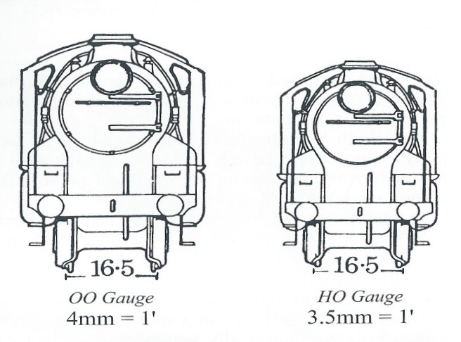

Fig 1: Comparison of H0 and 00 scales on 16.5mm gauge.
reproduced from Spring, Spark & Steam by Bruce MacDonald

Before this subject is examined further it may be wise to mention that model railway scales and gauges have a long history with input from both European metric and Anglo-American imperial measurement systems. Many still retain a somewhat confusing mix of imperial and metric descriptors, even in countries such as Australia that have long abandoned imperial units of measure.

For those who are unfamiliar with either system. The roots of imperial measurements are based on body parts, a ‘foot’ being roughly the length of an adult male foot, an inch roughly that across the male thumb (or from knuckle to tip) hence crude measurements being ‘rule of thumb’. In the late 13th century they were quantified by the English monarch, Edward I, as having 12 inches to the foot; Edward’s inch was defined by laying three barley grains in a row. In spite of having such an ancient history, the modern UK imperial system was not actually fully quantified until 1855. Measurements below the inch are expressed in fractions; for most purposes, particularly scaling, the most convenient range of fractions doubles up from 2 to 4,8,16 and so on, this is because they are easily dividable (half ,quarter, eighth and so on) and also relate easily to the 12 inches (12”) of a foot (1’). Imperial scales are expressed in inches, e.g. one inch to the foot (‘one inch scale’). The metric system, which has its roots in post-revolutionary France, is more scientific, being set by divisions of the Earth’s circumference and is entirely decimal, making it very easy to compute. It too was not fully established until the mid-19th century, when it was legally imposed in France and began to be adopted across Europe. Its basic measurement is a metre (m) which is divided or multiplied by factors of 10, with its smallest measure being the millimetre (mm). Measurements below the millimetre are expressed in decimal points. Metric scales are expressed in ratios, e.g.1 to 100 (‘1:100’) thus can apply to any unit of measurement. However, there is no easy mathematical relationship between metric and imperial, a millimetre is 0.03937007874 of an inch. For all practical purposes this is defined as ³/₆₄ of an inch, while an inch is 25.4mm. Even so, conversion from one to the other is a difficult task without a calculator to hand. Nevertheless, when building a model railway it is easy enough to scale from one to the other, usually from imperial foot to metric millimetre, and this has become a norm in the UK.
As an example, it is common for UK modellers to describe 0 gauge as ‘7 mm’. This means that measurement taken from a gauge 0 model equates with 1-foot on a full-size prototype, a scale of 1:43.54, a very awkward ratio; while, because twelve does not easily divide by seven, the scale is difficult to use below the foot, the simplest sub unit being 3.5mm to six inches. It is further problematised by other imperial-metric factors. Gauge 0 in Great Britain is generally considered to have a track gauge of 1¼” or 32mm. 1¼” is not exactly equal to 32 mm but is actually 31.75mm; so, the 32mm measurement is one of convenience. In the same way it is not unusual to see the scale described as 1:43 (although by the rules of rounding figures 1:43.54 should be 1:44). It may be asked what full-size track gauge equates to 32 mm at a scale of 1:43.54? This is easy to determine, simply multiply 32 x 43.54 to derive 1393 mm. This converts to about 4’7”, approximately 42mm or 1½” narrower than 1435 mm or 4’8½” standard gauge. Playing with a calculator at 1:43 and 1:44 will give other measurements, of course; while, to further complicate matters, gauge 0 in continental Europe is commonly 1:45, although 1:43.5 is often seen in France and 1:48 in the USA. In fact, if 0 gauge is taken to be 32mm, 7mm scale at 1:43, 1:44, or even 1:43.5, are not as accurate as 1:45, which scales to 1440mm gauge, only 5mm wider than the standard gauge of 1435mm.
Even in Great Britain there are further permutations or sub-standards of 0 such as ‘fine’, ‘unified’ and ‘coarse’ scale Fig 2.
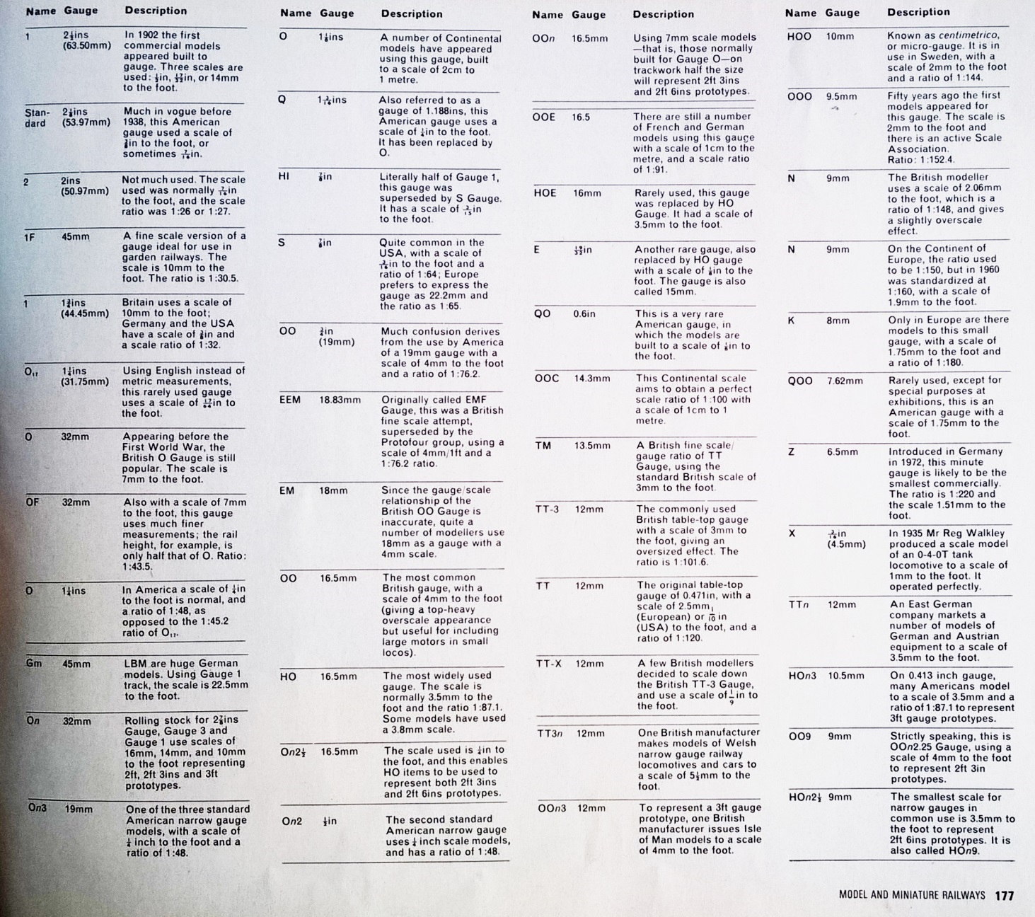
Fig 2: A good example of the complexity of gauge and scale is the table in CJ Freezer’s ‘Scale, Gauge and Space’ in A History of Model and Miniature Railways at p177, where he lists 47 recognised standards, none larger than 2 ½ inches.

Why are model railway scales so confused and confusing? For this we need to look at how gauges were defined. Before 1891 there were no defined toy train gauges. Most locos were designed as floor runners, but some German and French makers had developed clockwork train sets that ran on rails, amongst these was Ma̎rklin. Here is how Ma̎rklin presented their product in early1891, it could be had on rails, or as a channel-runner, and there was only one size Fig 3.

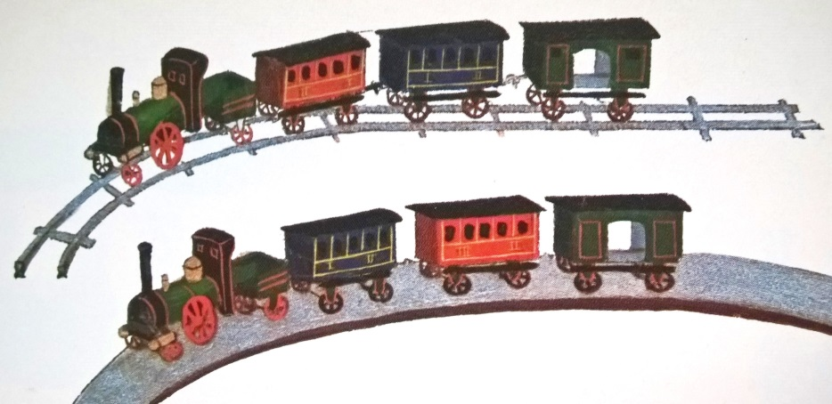
Fig 3: From C Baecker et al: Ma̎rklin- Anfang bis Jarhundertwende 1 1859-1902 p38. At this early date ‘catalogues’ were largely hand rendered picture-books of products that would be shown, alongside trade samples, to potential wholesalers and retailers by company agents.

The gauge of this product was entirely arbitrary, set by the width of the mechanism, which was probably designed first, with the body and rail fitted round it. At the time of the circulation of this catalogue Ma̎rklin acquired Lutz, whose clockwork train-on-rails was slightly larger than Ma̎rklin’s. Therefore Ma̎rklin numbered both products accordingly when they presented them at the Leipzig trade fair for the 1891-2 season. Ma̎rklin’s was termed ‘I’ and Lutz’s ‘II’. According to Paul Schiphorst in The Golden Years of Tin Toy Trains 1850-1909 (pp9,34) it was Lutz who became responsible for most of Marklin’s railway products at this time. The newly amalgamated companies also introduced a size based on their far larger floor toys, calling it ‘III’. This simple process set European track gauges thereafter; soon other manufacturers began designing and making their own products to fit them.

Ma̎rklin defined the three by ‘width of track’ (to quote their 1895 catalogue), which they measured across the rail centres Figs 3, 3a, 3b.

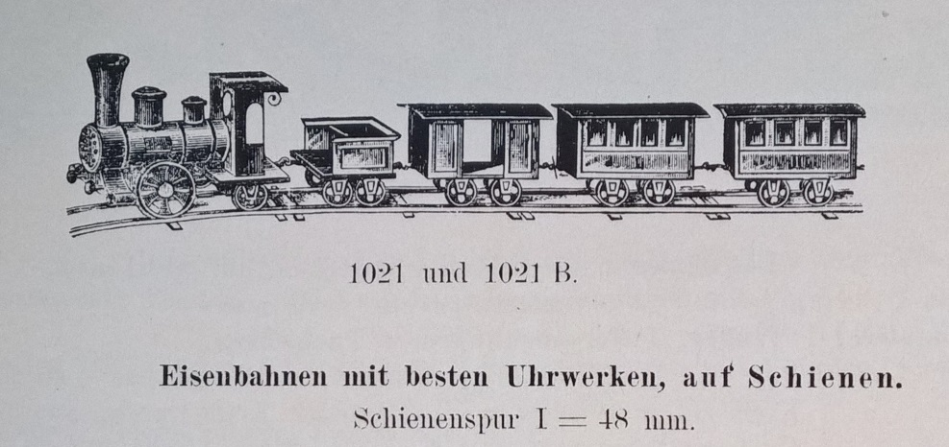
Fig 3: From C Baecker et al: Ma̎rklin- Anfang bis Jarhundertwende 1 1859-1902 p112. The 1895 catalogue is a far more modern wholesale catalogue in a style that became characteristic of all the great German makers in the early 20th century.

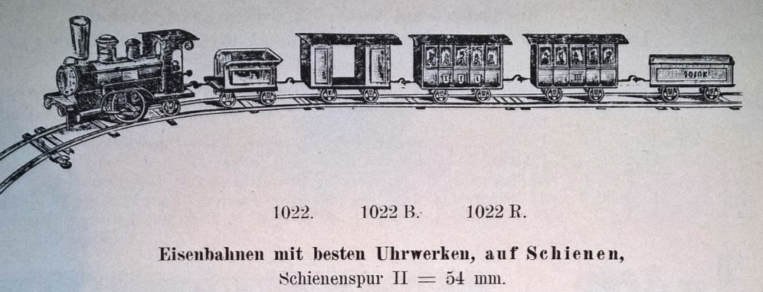
Fig 3a: From C Baecker et al: Ma̎rklin- Anfang bis Jarhundertwende 1 1859-1902 p113

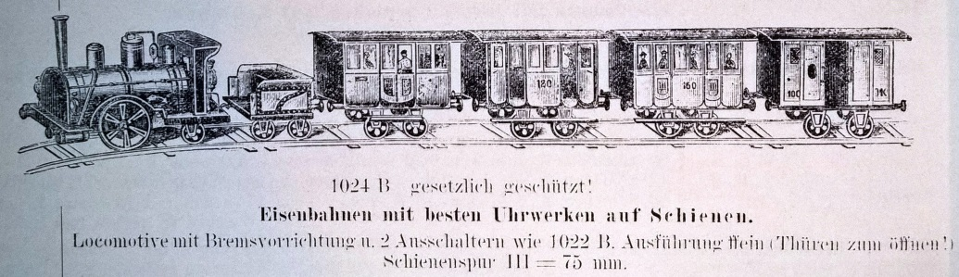
Fig 3b: From C Baecker et al: Ma̎rklin- Anfang bis Jarhundertwende 1 1859-1902 p114
It is essential to understand that setting a ‘width of track’ does not necessarily set a toy train’s scale, but once it is set it is difficult to change it. At best we might describe Ma̎rklin’s definitions as ‘sizes’. Even the differences between them tell you how arbitrary they were. I (48mm) was approximately 89% of II (54mm), but II was 64% of III (75mm). This meant there was little difference between I and II, but a huge step up between II and III, which other makers would fill. While Ma̎rklin’s numbered gauges were adopted by other makers and, by 1900, were largely accepted in the German trade, any survey of what was made to run on them would reveal huge differences in scale, even in products by one maker. Courtesy of David Pressland, Fig 4 shows a Lutz train set. It dates to the time of Ma̎rklin’s acquisition of the company, and was to become ‘gauge II’.
. 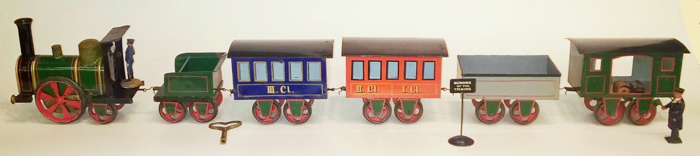
Fig 4

The locomotive cab towers over the box-like coaches. The figure in the cab is near contemporary and seems in scale with it, but in reality would be about ten feet tall. He would have to more than stoop to get into the coaches...which he would have to do via the windows because there are no doors. The figure by the van is a ‘Pixiland’ guard from the early 20th century nominally intended for Bing’s gauge III (see below), who is also far too big, but looks fine given the nature of the train. Fundamentally, ‘scale’ was not something considered or really understood.

In about 1895 Ma̎rklin produced a tiny set on rails 35mm across the centres. Having already used ‘I’ they had little option but to call it ‘0’. Again, it was not a ‘scale’, rather it was the smallest size the company thought would be possible to make with enough power to pull a train round a circle of sharp radius curves. A study of this train is at pp32-33 in TC45. It might be that 35 was particularly selected (as appose to, say, 36 or 34) because it is neatly half way between two decimals, as is 75. Both 0 and III followed the original I and II and possibly benefitted from a bit of hindsight; but, if so, it was because both were nice sounding numbers, nothing to do with ‘scaling down’ full size track.

Forget the metric measurements that Ma̎rklin worked in, because the next moves were made in the UK by W J Bassett-Lowke and Henry Greenly. In 1900 Lowke imported his first Bing loco, a live steam size II, UK outline 4-4-0 Fig 5.

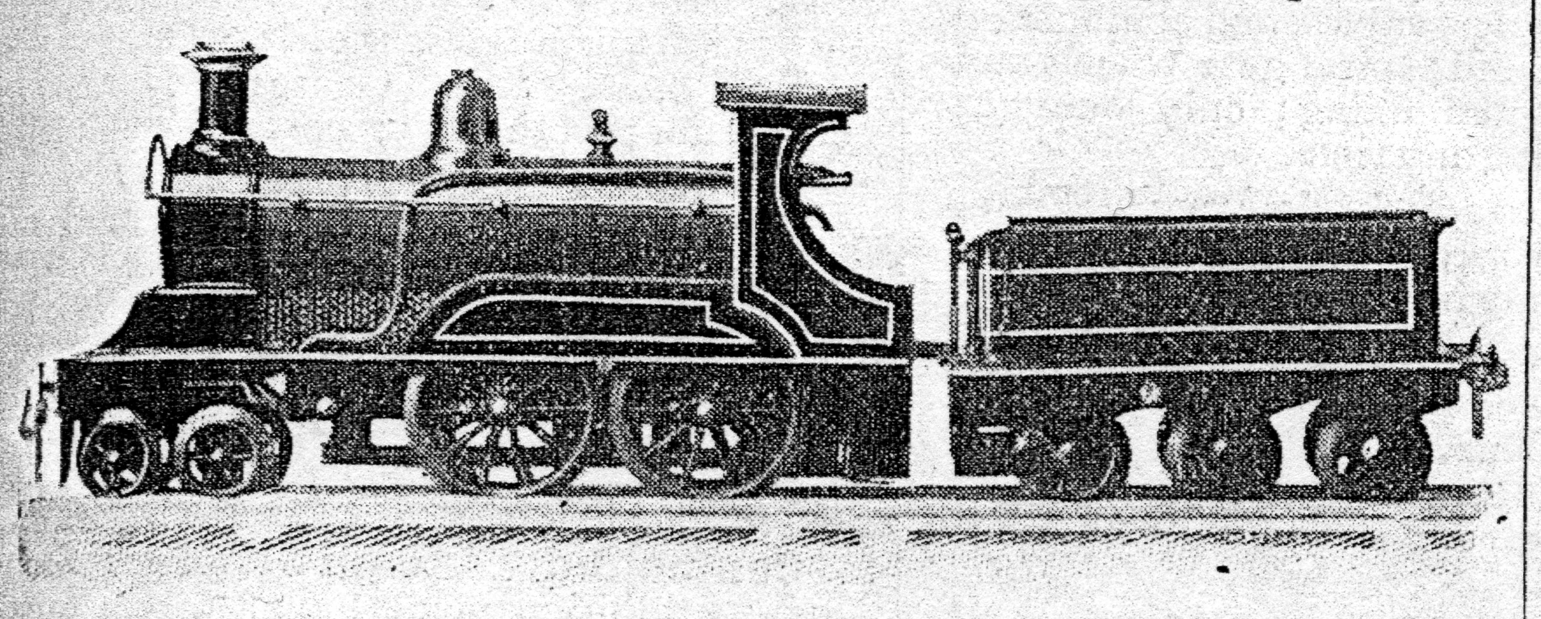
Fig 5: Lowke saw the potential of Bing products as soon as he saw this pattern of 4-4-0 exhibited in Paris in 1900, he was quick to import it and ascribe it to a L&Y prototype, which was how Percival Marshall described it in The Model Engineer and Amateur Electrician of Jul 1900 pp166, 167. By doing so the loco was positioned as an ‘accurate model’.

Lowke worked in imperial and 54mm conveniently converted to two inch gauge when correctly measured from inside rails (50.8mm, leaving 1.6mm for each rail). Lowke’s next Bing import was more significant. This was another live steam 4-4-0, this time dressed up as the LNWR express passenger loco ‘Black Prince’, but it was not size II; rather, it was in Bing’s own size III Fig 6.
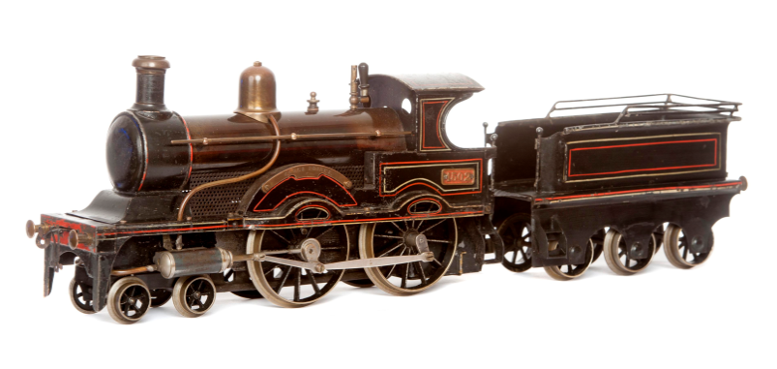
Fig 6: The Lowke ‘Black Prince’. This one is No 12 in the batch received from Bing in January 1901, one of which was immediately sent to Percival Marshall who reviewed it in the Model Engineer and Amateur Electrician 1 Feb 1901 p69.

At 67mm, Bing’s size III seems to have been designed to fill the gap between Ma̎rklin’s II (54mm) and III (75mm), although why it was 67 and not 65 is a matter of conjecture, most likely (again) their prototype size III loco was designed first and the rail was made to fit Fig 7.

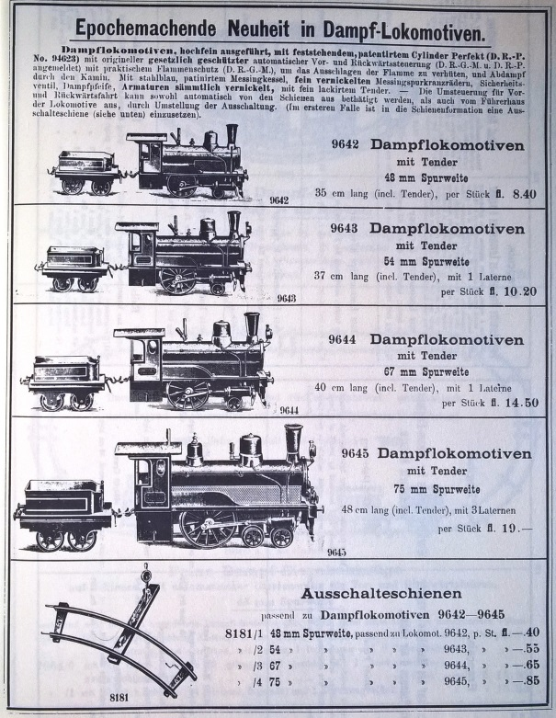.
Fig 7: Bing’s four sizes as illustrated in their October 1899 catalogue. From C Jeanmarie: Gebruder Bing, Spielwaaren 1898 p219

67mm converted to 2½ inches between the rails (63.5mm leaving 1.75mm for each rail). Lowke and Greenly saw the ‘scale’ potential in this, with each half-inch measuring to a nominal foot (‘half inch scale’), even if, at this scale, the gauge was 5’0”, rather than 4’8½”. Such was the power of gauge over scale that Greenly was later to correct the scale to the gauge at a very awkward ¹⁷/₃₂”. 17, as a prime number, is indivisible except by 1 and therefore measurements below the foot hard to compute, even moreso given that one is already reduced to ¹/₃₂^{nds}. Had Lowke and Greenly really been thinking in terms of scale accuracy and arithmetical simplicity they would have kept half inch scale and tried to re-set the gauge to 2⅜”, which would work out at 4’9”, near perfect. They did not and, as a result, 2½ inch gauge went on to be established as a serious modelling standard with a most ridiculous scale. This might be because by 1901, when Lowke introduced their Bing ‘Black Prince’, ‘67mm’ gauge III was already a part of commercial toy production. It was then promoted by Lowke, who encouraged Carette to make a number of very fine true-to-type UK locos. Schoenner used it for their UK series and Tessted also favoured it for their true-to-type UK locos sold through Clyde Model Dockyard, WH Hull, Gamages and others. Carson specialised in it too. Although Carson was finally bought into the Lowke business, he had already supplied engineered models to many of the retailers and ‘makers’ who were selling Tessted locos. Thus, by 1914, 2½ inch gauge/gauge III was so well established as to be impregnable.

In spite of a fledgling interest in scale in the UK, it remained elusive to the large German makers, even when working for Lowke. The Bing gauge III ‘Contractors’ Tank Loco’, introduced in 1903-4, should be a diminutive little thing, but its proportions are much larger than its contemporary Bing 4-4-0 Fig 8.
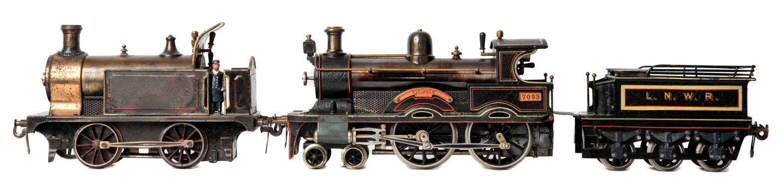
Fig 8: The Bing 4-4-0 here is the version supplied to Clyde Model Dockyard in 1903-4 and appropriately named ‘Clyde’. It is very highly detailed and finished for its time, presumably to order. However all ‘Clydes’ in the batch had mismatching tender and cab lining styles, probably because the locos were finished separately from their tenders. The ‘Pixiland’ figure in the cab of the contractors’ loco would stand 5’6” in ½ inch scale.

On the other hand, Bing goods stock tended to be well under-scale. In Fig 9 a Bing gauge II ‘Black Prince’ of about 1904 is pulling a contemporary Bing open wagon and brake van; all were made to satisfy Lowke’s demand for prototype representation. In spite of the effort put into both wagons, which are entirely hand enamelled, they are grossly under-scale, while the loco tends towards over-scale. However, most importantly, the proportions of both loco and rolling stock really defy the concept of scale altogether.

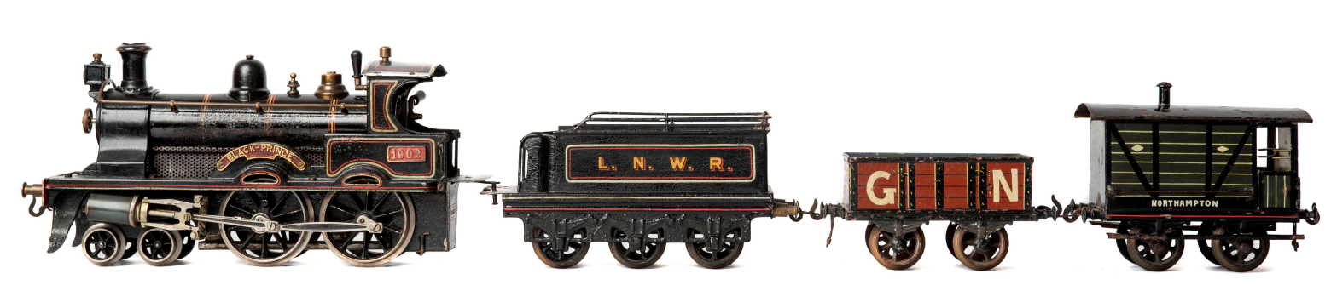
Fig 9: The gauge II ‘Black Prince’ was introduced later than the gauge III and therefore benefitted from Lowke’s and Greenly’s input to the smokebox saddle. Otherwise, its proportions remain quite toy-like and in no way would it merit the title of ‘scale model’ today, even if it is quite recognisably representing a full size prototype.

In fact, though Greenly and Lowke seem to have understood scale, their interpretation of it was loose and both were more concerned with items ‘looking about right’. Through the pre Great-War period Lowke often adopted a ‘one size fits all’ policy for accessories. Fig 10 gives an example of this. As time went on, Lowke and Greenly moved towards consistency in overall size within the scale, but Greenly, in particular, remained more open in terms of precise detail. Greenly went on to explain his attitude when scale became a serious point of discussion in the 1930s, ‘my standard retort when I am discussing this with experts –“The best reference for the scale equivalent of a model railway is not the gauge but the size of the driver’s hat”’. (Model Railway News, July 1937, p192)

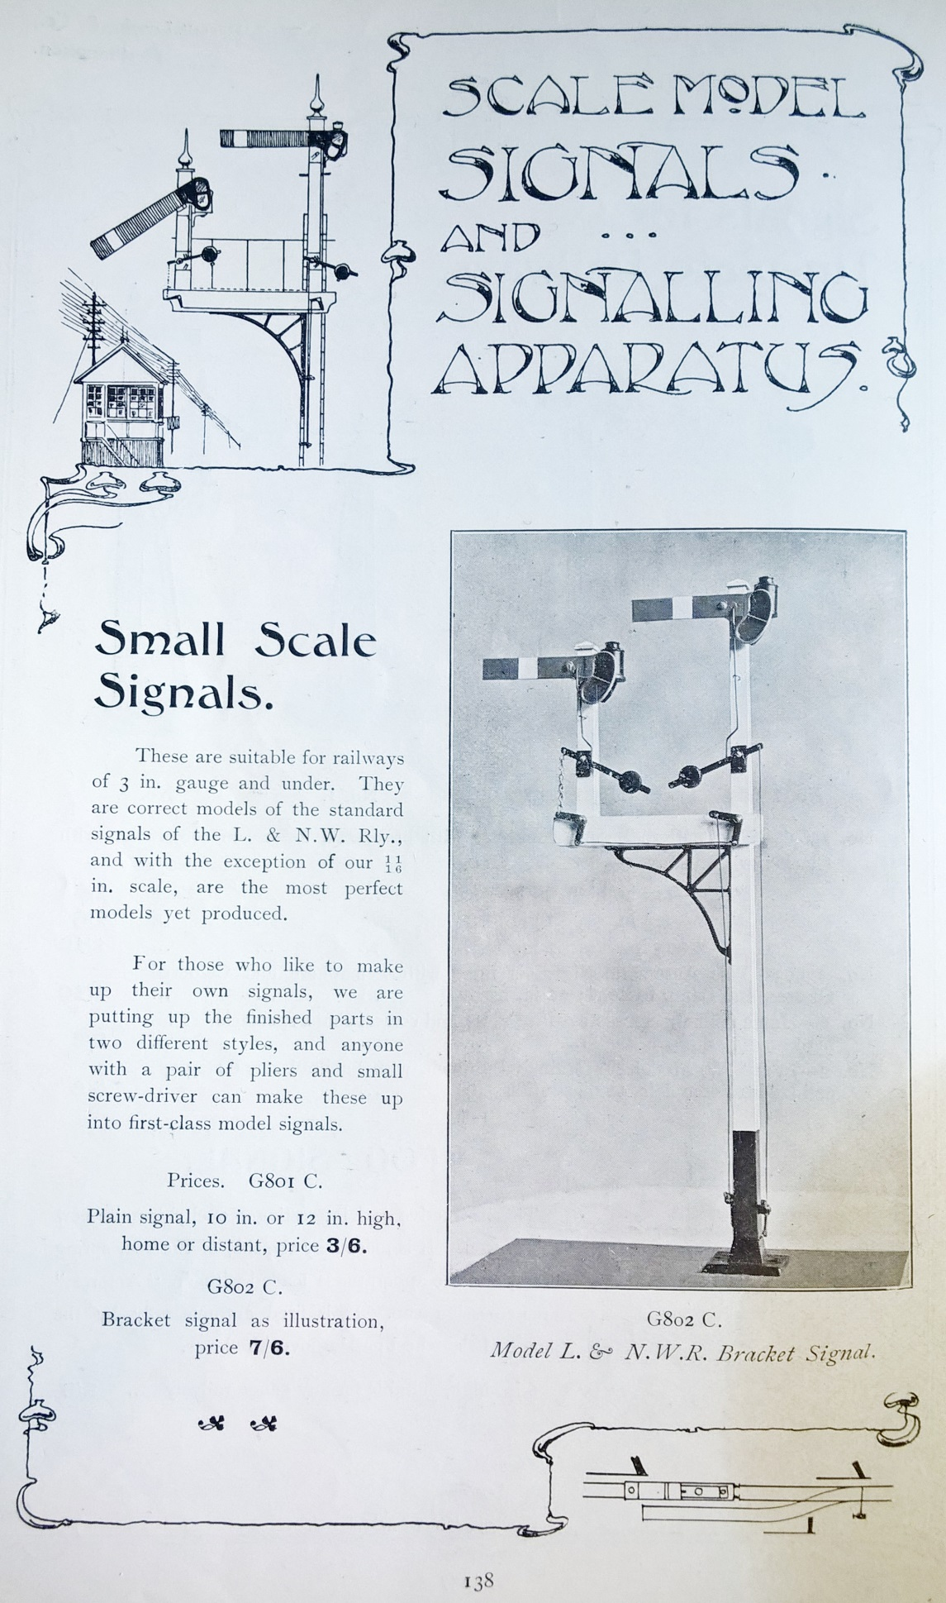

Fig 10: In their 1907-08 catalogue (p138) Lowke’s ‘small scale’ wooden signals are described as ‘suitable for railways of 3 in. gauge and under.’ This covered everything from IV to 0. In fact the signals were scaled only by chopping the arms down to more-or-less appropriate lengths, then presumably only if particularly ordered. The ‘natural’ arm length was something between III and IV. With the arms at 3 inches (the length favoured) they are convincing ½ inch scale models of full size LNWR prototypes but look quite comfortable with gauge I. See ‘Signals of Scale’ elsewhere in this issue.

Some confusion was and still is caused by Bing’s gauge III. This was because Bing called Ma̎rklin’s ‘III’, ‘IV’. Therefore Lowke sold products of this size as ‘gauge IV’, which has now become definitive. However, die-hard Ma̎rklin collectors still insist on using ‘gauge III’ to describe what everyone else calls ‘gauge IV’. At 75mm across the rail centres gauge IV is 1.2 mm (¹/₂₁”) under three inches and therefore is a good bit under three inches between the rails. Allowing 2mm for each rail, 71mm is 2.8 inches, or 2¹³/₁₆”, but no-one noticed that in the UK and it was always described as three inches. There has been debate if Lionel derived their original 2⅞” gauge by measuring a section of gauge IV rail slightly inaccurately, ‘something like Ma̎rklin’s Gauge 3’, Gustav Reder says in Clockwork Steam and Electric (p56); given the broad treads of the time, the two were largely interchangeable. However, Bruce Greenberg in Lionel Trains - Standard and 2⅞” Gauges 1901-1940 (pp 10,11) points out that the gauge was probably determined by the more elaborate of their two first train products, the No300 trolley. This was a clockwork floor toy bought in from another maker, Converse, which Lionel fitted with an electric, rail-running motor. With its outside frames measured to the edges of the base inside the valances of the Converse product, 2⅞” is the maximum possible, assuming the width of the treads of its wheels to have been set before the gauge was determined.

Neither Lowke nor Greenly warmed to gauge IV. Lowke never commissioned models in this size, although he sold those by Bing and Schoenner. Instead Lowke and Greenly went bigger, to 3¼ inches. That they used this for what was probably the most close-to-scale commercial prototype representation of its time, the Johnson compound of 1903, tells us that ‘scale’ was a movable feast, even at this level Fig 11.

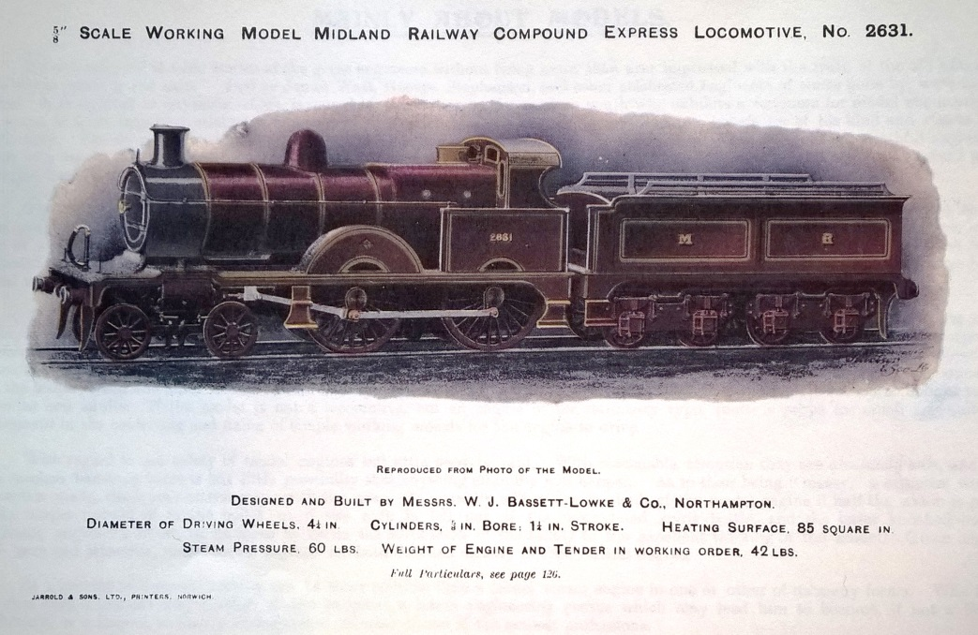

Fig 11: 3¼ inch gauge Lowke compound, frontispiece from their 1904-5 catalogue.

At an awkward ¹¹/₁₆” to the foot, 3¼ inch gauge is only fractionally under a scale 4’8½”, but as a scale it is a magnificently stupid choice. Lowke and Greenly confused it further by subtracting ¹/₁₆” and defining it as ⅝” scale, making the gauge 5 feet (like gauge III). This was justified in the Model Engineer and Electrician of 10 September 1903, presumably by Percival Marshall, in a remarkably convoluted way: ‘The gauge is the popular one of 3¼ ins., this dimension being fixed after very careful consideration. The widening of the gauge, a bare ¼ in. over the scale size, allows for an inside cylinder engine to this scale to be designed with ease and at the same time the widening is not apparent.’ (p250). Having said this, the article goes on to demolish its own reasoning: ‘The engine is not a compound…the two low pressure (outside) cylinders of the prototype are used as ordinary high pressure cylinders.’ (pp250, 254: italics sic). So much for the inside cylinder, then.

In fact, Lowke and Greenly would have been better to add ¹/₁₆th to ¹¹/₁₆” and increase the gauge by ¼ inch to 3½ inches. At a scale of ¹²/₁₆^{ths} or ¾ of an inch to the foot and, even better, ¹/₁₆th to the inch, a gauge of 3½ inches works out at a near-perfect 4’8”. Indeed, one could measure to a scale accuracy of ½ inch with a boxwood school ruler with¹/₃₂nd divisions, a metal rule with ¹/₆₄th divisions gives ¼ inch scale accuracy. Not surprisingly, 3¼ inch gauge was an aberration; the model engineering standard became 3½ inch and Lowke was forced to follow. Unlike gauge III, 3¼ inch gauge was never a ‘commercial’ gauge for toy railways. Its origins were not in the great German manufacturers and it was not made and sold widely. Therefore, there were no ‘entry level’ 3¼ inch gauge locos to establish the gauge and readily available for rebuilding by amateur enthusiasts. These two factors may explain why, in this case, logic won, while in 2½ inch gauge it did not.

Meanwhile, working down the sizes and converting them into imperial ‘scales’, gauge II was difficult, an awkward ⁷/₁₆” scale making the gauge a tad shy of 4’7”. Both Reder (p57) and Pierce Carlson in Toy Trains – A History (pp84,85), point out that Lionel had a likely debt to gauge II in that 54mm comes out almost exactly at 2⅛”, which was Lionel’s idiosyncratic ‘Standard’ gauge. It would seem that Lionel took the German ‘54mm’ as the actual inside rail gauge thereby ending up at the quarter-way point between gauges II and III, but incompatible with both. Whether or not this was accident or design, by deft marketing Lionel managed to convince many other US makers that their new gauge really was ‘standard’; but it was never accepted outside North America. However, as the great US makers only made US outline and had a vast home market to exploit, this did not matter. At ⁷/₁₆” scale, Standard gauge is only a bit wide at 4’10¼”. However, many US makers worked to ⅜” scale, thereby ‘widening’ the gauge further to a scale 5’4”, this gave the trains considerably more stability when being flung round sharp curves at high speeds. Again ‘scale accuracy’ does not seem to have been a significant part of the design process Fig 12 .

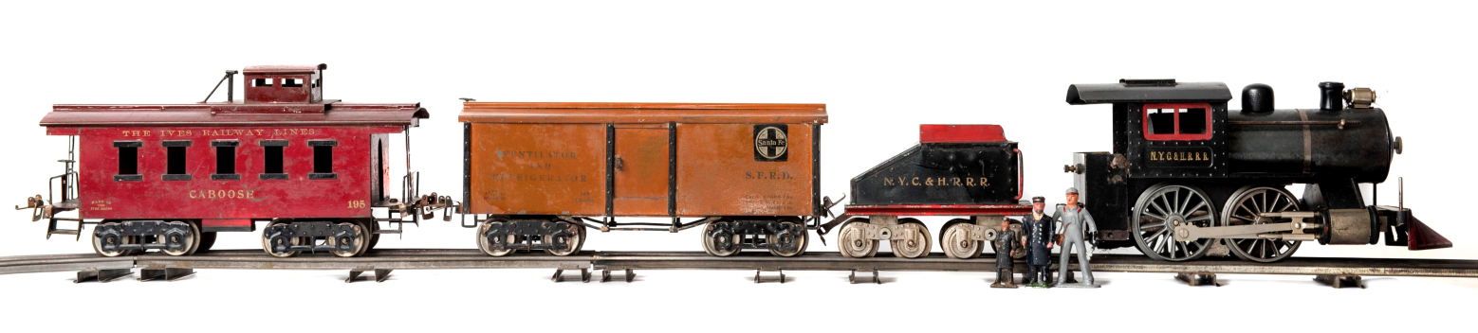
Fig 12: This Lionel Standard gauge No5 0-4-0 of 1911 (one of the last to have ‘narrow rim’ wheels) has a cab centre height of 14’6” at ⅜” scale which suits a US loading gauge of 15’6”. The ‘under-scale’ aspect is more obvious in width, the loco and tender come out at only 9’4” and the Ives cars, which are with it, only 8’ where these would normally be a good 10’; the sides seem almost flush with the rails as a result. The old adage that they make them bigger in the States is borne out by the Standard gauge engineer who, at 3”, stands either 7’ tall at ⁷/₁₆” scale, or close to 7’10” at ⅜”. He is posed alongside the tiny Brits, the larger of whom stands 5’6” at his intended ½” scale, or just under 6’2” at ⁷/₁₆”, and the smaller (by Britains) 5’8 at ⅜”. They did not only make them bigger in the States, they made them bigger for the States. The figures made in the UK by Johill for Lionel stand as tall as the engineer Fig12a.
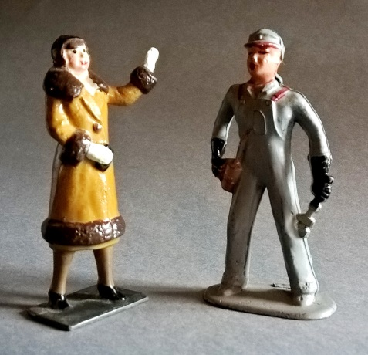
Fig 12a: Standard gauge figures, the woman is by Johill for Lionel.

Gauge I, on the other hand, was far more satisfactory. At 1¾ inches, it really was ⅜” scale and, with each ⅛^{th} having a value of 4 inches, 14x4 comes out, like 3½ inch gauge, at 4’8”. It was by far the best of the ‘toy train’ scales using a random German size converted to imperial, a remarkable stroke of luck and possibly why the true-to-type gauge I locos designed by Greenly and made by Bing for Lowke in the period just before the Great War are as impressive as they are in overall proportion.

The diminutive gauge 0, at 35mm, converted to 1¼ inches. This was the ‘quarter-inch’ equivalent of gauge III and similarly was a scale five feet. We have seen that to get to something close to ‘scale correct’ gauge, the simple ‘quarter-inch’ imperial formula does not work and the scale is instead increased by using the metric/imperial hybrid of 7mm to the foot.

To get to what was to become ‘00’, Greenly, working with Bing in 1921 to develop their ‘Table Railway’, merely halved gauge 0 to ⅝”. This was ⅛” scale with a five foot gauge. It seemed a logical move to call it ‘00’. However, Greenly did not use the imperial scale. Seemingly inspired by a live steam loco built on ⅝” gauge to 4mm scale by Derek Brough, Greenly stated that his designs for Bing’s Table Railway were ‘approximately 4mm to the foot ’ (See Jeff Carpenter, p15). Thus, 00/4mm scale became established in commercial production. As they had with gauge III, Bing, Greenly and Lowke over-rode Ma̎rklin’s use of the term ‘00’. Ma̎rklin had used it to describe their ‘Liliput’ trains at ‘26mm’, actually an inch. The reason for Liliput’s imperial measurement is because the locomotive was originally commissioned by Frank Hornby for Meccano’s ‘Raylo’ game designed in Liverpool. It was a convenient size for the game and not a ‘scale’, evidenced by its ‘out of scale’ wheels Fig 13.
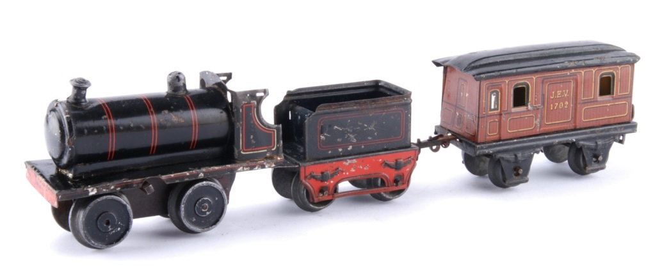
Fig 13: A Ma̎rklin first-series ‘Liliput’ loco, tender and van 1912. The loco uses the body and mech designed for Meccano’s ‘Raylo’ game, which, being English, had its track (which was stamped out of a single sheet of tinplate and was not ‘rail’) set at an inch centre-centre. The tender and stock were designed separately, well after the loco; they were not part of the Raylo game, therefore look more Germanic and more ‘scale’. For the full story see: Nicholas Oddy: ‘Frank Hornby – An unwitting pioneer in small-gauge toy trains – Raylo and Liliput compared’ in The Hornby Railway Collector, 500, Feb 2015, pp12-19.

In the same way, a neat imperial measurement, conceived in the UK, set the pattern for Bing. In theory, stock should be an eighth of the volume of its gauge 0 equivalent. Although at 4mm it was slightly larger than this, to the market of the 1920s it seemed truly tiny and, given the need for an effective clockwork motor, this was about as small as one could go at the time. Moreover, while Lowke clearly saw potential in ‘table railways’, it is not so certain that he saw their commercial future as being in the realm of scale models. Reflecting Greenly’s comments about the determining factor in scale being ‘the size of the driver’s hat’ Bing’s 00 Table trains are no more than freelance toys that ‘look about right’, even with grossly under-scale buildings and accessories Fig 14, and were clearly aimed at children, as their box labels testify Fig 15.

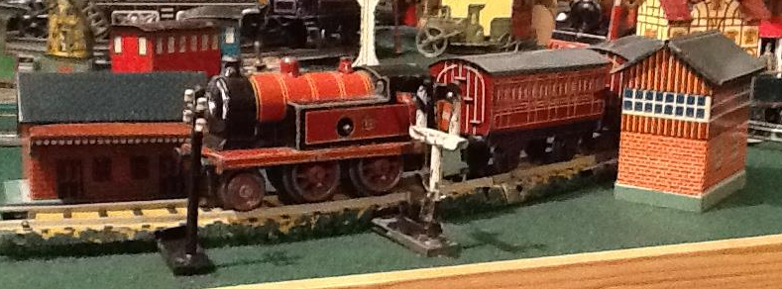
Fig 14: A busy scene on Jeff Carpenter’s Bing Table Railway. The first series MR 2-4-0T of 1922 towers over the diminutive junction signal and a slightly larger telegraph pole and signal box. Scale is clearly not an issue.

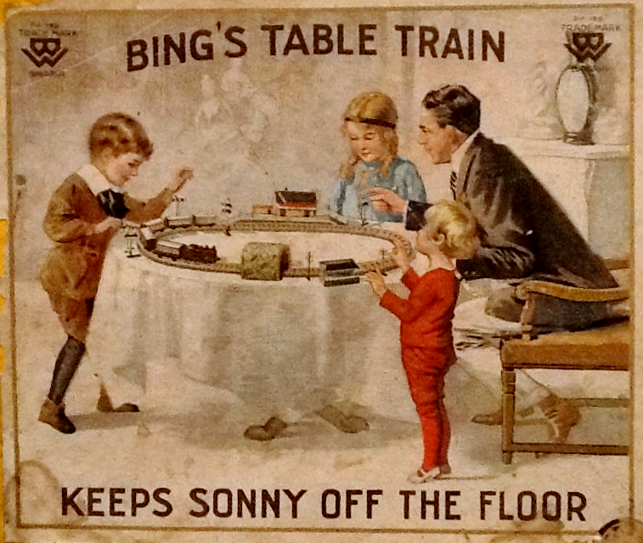
Fig 15: This Germanic bourgeois family scene, in which father (who, by the quantity and scale of it in the background, evidently likes sculpture) demonstrates the principle of under-scale buildings to his children, appeared on the lids of all Bing’s early Table sets. This is the US version, courtesy of Jeff Carpenter, with added strap-line.

In toy trains the ‘scale’ is usually unimportant, but ‘looking about right’ is more significant. Hornby went the other way, with grossly over-scale accessories in their 0 gauge series, but they were comparatively closely scaled in relation to pre-Great War, German products. In ‘A Snapshot of History’ in TC45 the ‘scale’ difference between the signal and the train is even more marked, but was typical of its time and, as we have seen, not that far removed from Lowke’s ‘scale’ approach to such details Fig 16.

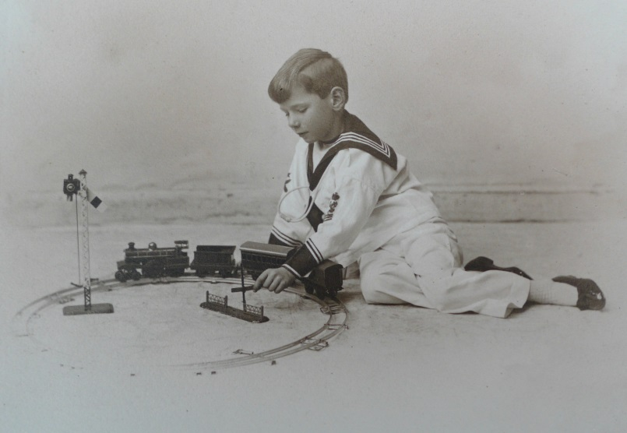
Fig 16: Boy playing with Carette train and signal, see TC 45 p28. Courtesy Mike Hobday

With this background we can understand the confusion, two different measurement systems, metric and imperial, with three different determinants, namely size, gauge and scale. Moreover, manufacturers tended to make things that they thought ‘looked about right’ without any reference to scale. No wonder there are many interpretations.

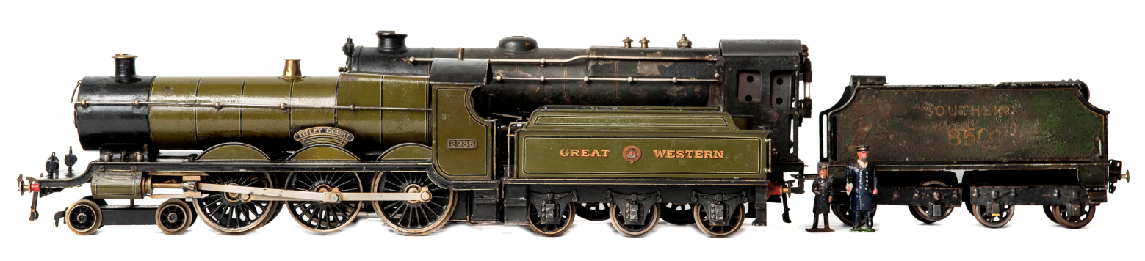
Fig 17: Same gauge, different scale. Even in the 1920s scale was a movable feast. Both the locos here are steam powered UK outline 4-6-0s in Gauge I. The Bing for Lowke ‘Titley Court’ was introduced in 1924. The lessons of scale from Greenly are clear. The model is a good representation but takes liberties to make a practical steam loco. It looks fairly well scaled to ⅜”, but in fact it is quite over-scale. With a cab loading gauge of 14’ centre, dropping to 11’8” sides, it would be too big for UK limits, which are 13’6” dropping to 11’, and it would be comfortable on gauge II where it would be 12’3” to 10’10”. The ‘Lord Nelson’ by Ma̎̎rklin towers over it at 16’ centre dropping to 14’ sides; it would still be oversize placed on gauge II at 13’8” dropping to 12’3”. It would generously clear gauge III, where at ½” scale it would come out at 12’ centre dropping to 10’9” sides and the gauge III figure looks about right for it, while it dwarfs the gauge I figure. The loco only loosely approximates to its prototype yet is later than the ‘Titley Court’, not introduced until 1928. Presumably, like Bowman, Ma̎rklin thought the impressive size would sell. Given that they were developing their 0 gauge true-to-type eight-coupled locos at the same time, it was not as if the company did not understand the concept of scale.

However, as toy train collectors, we understand the importance of ‘looking about right’ over the precise determination of mathematically accurate scale. Returning to the 3¼ inch gauge compound, we have seen that Greenly realised this and, though he understood the precise nature of scale, tended to deviate from true scale as a matter of course on the grounds of practicality and that deviations were ‘not apparent’. In general, he over-sized, not only in terms of bodywork, but particularly details such as lamps, handrails and so on, as, in the imagination, these seem larger than they actually are. Greenly considered this essential if model railways were to be effectively operational ‘... there are many other problems more important than “Scale” to be faced. I want makers to make real railways and to work and operate them. The modern tendency to “photographic” effects is over stressed.’(Model Railway News, July 1937, p193) Fig 17.

The possibilities the Bing table railway offered in terms of ‘accurate’ length trains and track radii in a domestic setting were quickly realised by adult enthusiasts in the 1920s. Given the publicity given to Brough’s and Greenly’s work, it is no surprise to find that UK modellers adopted their 4mm scale. Moreover, while it is oversized, it is logical to anyone who thinks in terms of imperial; 1mm takes the value of three inches, making it easy to scale with a ruler against the 12 inches of a foot.

However, the proportional deficiencies of 4mm scale did not go unnoticed. By reducing the scale by 0.5mm it becomes far more accurate to the gauge. Modellers adopting 3.5mm scale termed it ‘H0’, short for ‘Half 0’. However, unlike 4mm, 3.5mm is completely illogical in terms of imperial measurements, even if it is ‘right’.

But, neither makes a neat metric scale, which would be round to a decimal. 00 is 1:76 and H0 is 1:87. Even then, H0 was a movable feast. For instance the French used 1:86 for H0 simply because scale drawings for 0 gauge had often been rounded down from 1:43.5 to 1:43 and these were often published at half size for H0. However, in Autumn 1952 the Rüdesheim Congress declared H0 to be 1:87 as it is still today. Had scale been the determinant, 1:80 would have been the ideal for the size and the gauge derived from that.

We are indebted to David Thomas of the French Railways Society (Formerly the SNCF Society) for alerting us to the Rüdesheim congress, reported in the French magazine Loco-Revue (Nov 1952), as it tells us what contortions the issue of gauge and scale were in. At the congress, national model railway associations from seven European countries set out to agree internationally recognised standards for manufacturers and modellers. Following the established gauges they agreed the main scales as TT (1:120 12mm) H0 (1:87 16.5mm) S (1:64) 0 (1:45 32mm) and I (1:32). For H0 they considered adopting the US National Model Railroad Association's existing standards from 1941 and also a recommendation of 1:87 for the track but 1:80 as the modelling scale, but decided against; finally they agreed to adopt the correct gauge/scale relationship of 1:87 overall and do further work on track and wheel standards. The Rüdesheim standards were termed NEM (Normen Europäischer Modellbahnen), an acronym that works in several languages, even English (Normal European Modelling Standards). Britain and Sweden were absent from the congress but ‘expressed interest’ in it and its conclusions. The second congress was held in September 1953 in Munich where there were delegations from East and West Germany, Austria, France, Italy, Denmark, Belgium, the Sarre, Netherlands and the USA; but nobody from Britain; together with four manufacturers, namely Rokal, Fleishmann, Sommerfeldt and Rivarossi; again the UK was not represented.

While this sort of co-operation seems admirable and set standards largely followed by European makers, the lack of any significant UK presence is notable and it had no bearing on 00. Even the congresses’ own conclusions were subject to being undermined by UK practice. The majority of French modellers had tended to work to the British ‘1:43’ scale for 0; so, to accommodate them, the more precise 1:43.5 was later adopted by the congress as an alternative to 1:45, even though its scale accuracy is not as fine as 1:45. Meanwhile, the British 00/4mm scale was a long way from the accuracy that the delegates at Rüdesheim were after. A gauge of 16.5 mm at 4 mm to the foot means that the gauge represents 4’1½”, only 87.6% of what it should be. Were it really to 4mm, the gauge would be 18.83mm. So, what were the factors that prevented UK manufacturers adopting 3.5mm, when the rest of Europe and the USA went down the true-to-scale route? Or instead, why did they not develop their own true-to-scale 4mm on 18.83 mm gauge? And, why did neither adopt the most logical 1:80?

Taking the second question, first; the answer has to be precedent. Bing and Lowke had established the ‘half 0’ gauge in 1922 and at the time it looked neat in relation to 0. As a result, other makers, notably Marklin and Trix, adopted the gauge and Hornby Dublo followed. Like all the other toy train gauges, the size had been chosen for reasons that had little to do with scale, but a lot to do with circumstance. From then on, none dared change it to suit some dream of mathematically precise scale. Makers and modellers were lumbered with a very strange gauge, just like most of the full size railways were.

To answer the first question one needs to look at the physical dimensions of the full-size locomotives and rolling stock that were modelled, the marketing considerations and, not least, the available manufacturing technologies when the models first started being mass-produced.
Let’s look at each of these three factors and see how they influenced the decision for the major manufacturers to adopt 4mm on 16.5mm gauge for mass-produced model railway items sold in Great Britain, in preference to 3.5mm.

Possibly the primary determinant was the size of the real things. The British railway loading gauge is 9’0” (2743 mm) wide by 11’0” (3353 mm) high on the sides, rising to 13’6” (4115 mm) in the centre. By contrast, the European (Berne Convention) loading gauge is 10’4” (3150 mm) wide by 10-5” (3175 mm) rising to 14’0½” (4280 mm) in the centre. In proportionate terms then, mainland European trains are noticeably larger than UK ones.

From a mass manufacturer’s point of view, a body in 3.5mm representing a European loco has much the same space available inside it as a 4mm model of a UK loco, while both share common frames. But, 4mm is better in width. Although the UK width is only 87.1% of Berne in reality, the scale step from 3.5 to 4mm makes a UK loco nearly as wide as a 3.5mm European one. But, as 16.5mm gauge in 4mm is 87.6% of scale correct gauge, it provides all the extra width of Berne outside of the frames to accommodate the wide wheel treads of a toy and also the external valve gear and associated drive wheel linkages on steam locos. This would not be the case for a ‘scale correct’ track gauge of 18.83mm where the extra width is inside the frames. Moreover, the additional overhang on each side yields more ‘pivoting space’ for bogies and pony trucks on tight radius curves.

Undoubtedly the key player in the permanent triumph of 00 was Meccano Ltd with its Hornby-Dublo system introduced in 1938. When this was being planned at Binns Road it was decided that, as far as possible, the product should be ‘true-to-type’ with the locomotives and stock being representative of actual prototypes. Therefore, the range had no legacy of toy train production to contend with, which we will see was important in its lead over its main competitor. To begin with, only two locomotive types were introduced, both were six-coupled but did not share a common chassis. Instead of utilising a pressed tinplate body for the locomotive superstructures (as had been the practice in 0 gauge) it was decided to use one-piece, pressure-diecast, zinc-alloy housings, which could reproduce fine details closely modelled on the full-size prototype.

The smaller loco was a close representation of a non-condensing LNER N2 0-6-2 tank loco Fig 18.
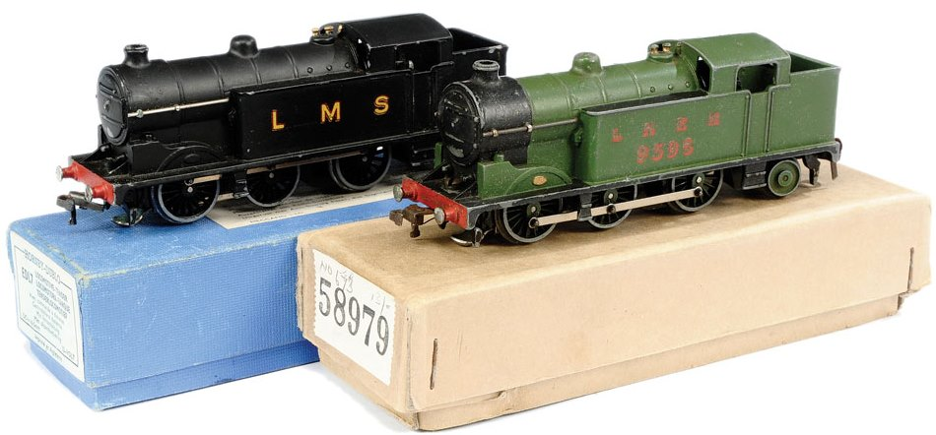
Fig 18: Left - EDL7: Right - N2. Whatever it was, it was unlike any other ‘starter’ loco ever offered on the toy train market. Courtesy Vectis.

An interesting insight into the design thinking behind this loco was given by the late John Gahan, an ex Meccano employee who featured in Axiom Video ‘The Rise and Fall of Hornby Dublo’ (2005). Gahan informed his viewers in no uncertain terms that the model was never referred to as a N2, never described as a N2 and never advertised as a N2. Something that Bob Field picks up on in his excellent study of these locos in The Hornby Railway Collector (No 529 December 2017 pp17-21). It is likely that Gahan’s comments reflect a belief in the Meccano factory that, by choosing a relatively obscure prototype, the loco would become a generic model suitable for all liveries, equivalent to a freelance 0 gauge tank loco. However, this is not how anyone with railway knowledge saw it. To most it was and remains a N2, regardless of livery; those not LNER are simply ‘wrong’. Moreover, it is surely not chance that the LNER and BR versions carry the numbers of real non-condensing N2s? Thus it was that Dublo was on the tipping point between the old and the new in ideas of ‘realism’. To a great extent they were saved from further conceptual problems of this kind by the war and subsequent railway nationalisation.

Whatever the niceties of the N2’s nomenclature, given that before it every other maker’s ‘entry level’ loco was a freelance 0-4-0, we can see how very different Dublo was in its product plan. Such ambition was reflected in the larger loco, a L.N.E.R. A4 class streamlined Pacific Fig 19. The idiosyncratic appearance and widespread fame of this loco type really precluded it being seen as anything other than a LNER A4 and therefore, unlike the N2, it was only offered in appropriate livery, although it is notable that its box still hedged its bets by calling it nothing more than a ‘streamlined locomotive’. With its long wheelbase and external valve gear it provides a case study of the advantages of 4mm scale on 16.5mm gauge.
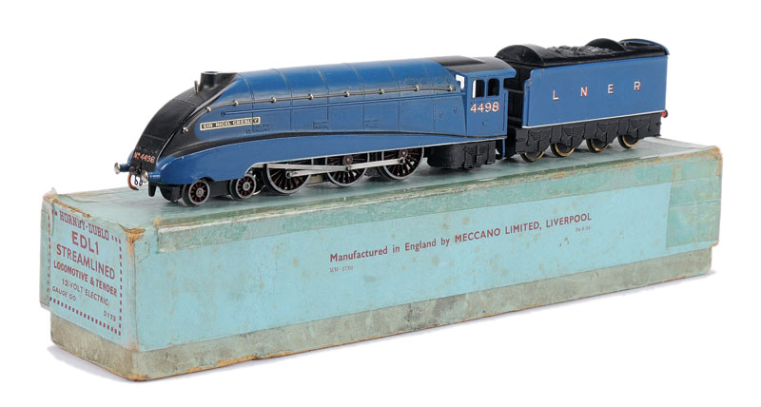
Fig 19: Pre-War 00 gauge Hornby-Dublo EDL1 Sir Nigel Gresley locomotive with one-piece pressure diecast zinc-alloy superstructure. Its sleek lines, convincing proportions and attention to detail gave ‘scale model’ a new meaning within the realm of mass manufactured toys aimed at children and adolescents. Courtesy Vectis.

The thick walls of a casting limited the available space within the locomotive housing in which to place a clockwork or electric mechanism compared with light gauge tinplate. It is assumed that outline and detail drawings would have been obtained from L.N.E.R. to ensure the housing was an accurate scale model representation of the prototype. Very early on in the product development process the Meccano Ltd personnel responsible for designing the mechanisms would have known the dimensional limitations they had to contend with. 4mm scale on ⅝” gauge gave about as much room under the body as was possible without ‘looking wrong’. Fig 20 shows the generous amount of overhang the ‘narrow’ gauge gave for bogie, pony and con rods on the A4, to the extent that full, but robust over-scale valve gear was easily fitted in the post war era without any adjustment to width. The result was a magnificent representation of the real thing that could happily negotiate sharp curves.
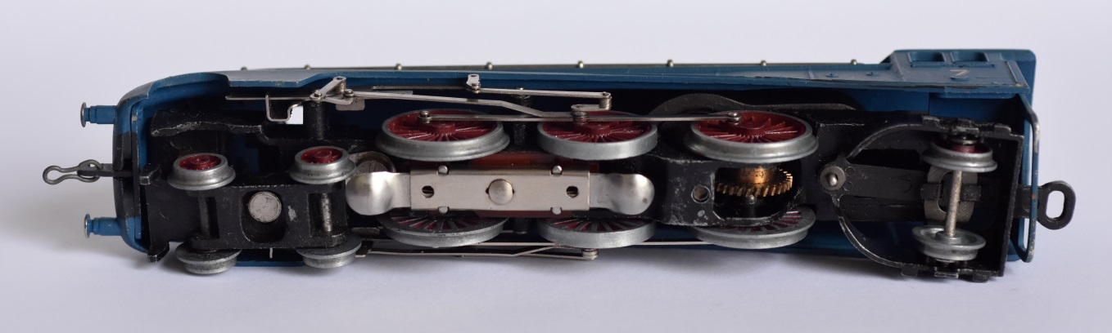
Fig 20: Underside view of Post-War 00 gauge Hornby-Dublo Sir Nigel Gresley locomotive showing available space between the outer edges of the 16.5 mm gauge drive wheels to accommodate valve gear and associated linkages.

Even so, the selection of half-0 gauge of 16.5 mm for Dublo may seem a little odd. After all, the Dublo range was unlike anything that came before it. So; why not develop it at a scale-accurate 4mm-to-the-foot track gauge of 18.83 mm, given that European makers could make 3.5mm locos on a scale-accurate 16.5mm gauge? Moreover, parallel with Dublo in 1938, in the USA Lionel launched their ‘00’ 4mm range on a gauge of 19mm, following the practice of some scale modellers. We have seen that Lionel had a history of being innovators in terms of gauge and, by 1938 dominant amongst US manufacturers, probably believed themselves to be in a position to call the shots. Unfortunately we will never know if they were; the War intervened and in 1942 Lionel suspended manufacture of their 19mm gauge 00, never to resume.

Hornby, on the other hand, were far less bullish. Their 0 gauge range, though possibly even more dominant in the UK market than Lionel’s was in the US, had a history of reacting to and copying competitors, rather than leading. When it came to Dublo, Hornby were again looking over their shoulder. Quite apart from the space advantages we have already looked at, adopting 4mm on 16.5 mm gauge was most likely to have been a marketing consideration based on aligning the gauge of the new models with Trix, which had been introduced in 1935.

Trix was marketed as ‘Trix Twin’ in Great Britain and on the continent as ‘Trix Express’. Trix had developed round a rather odd scale of 3.75 mm to the foot running on 16.5 mm gauge track. Like Bing’s Table Railway, Trix was originally very toy-like, with chunky four wheel locos hauling four wheel and very short bogie coaches. It is here that a lot of confusion lies. Freelance and toy-like, accuracy was not a primary consideration in Trix, but in fact its scale is pretty true to 3.75mm and remains consistent through the range. Fig 21.

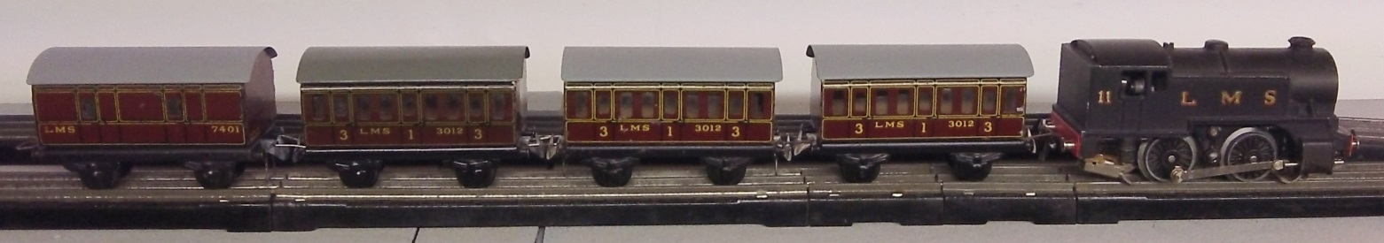
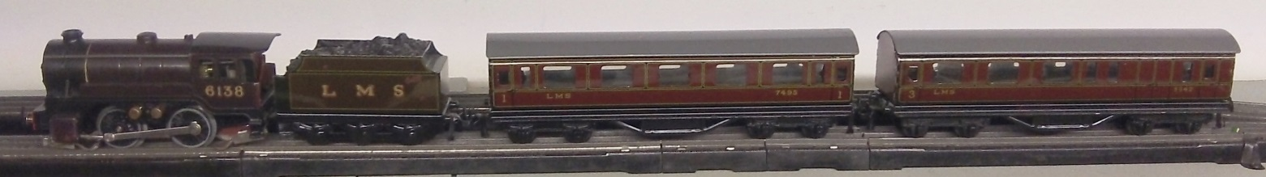
Fig 21: Pre-war Trix Twin tank and tender passenger trains, courtesy Paul Williams.

When Trix model locomotives were introduced that represented full-size prototypes, they were freely adjusted or tweaked to ease production, strengthen details, facilitate cornering and/or improve the appearance of the model at a typical viewing distance to ‘look about right’. Their overall scale remained true to 3.75mm, closer to the ‘true’ 3.5mm than Dublo, but this was a disadvantage. There was less space to manoeuvre than 4mm and there was a ‘legacy’ of toy train design that Dublo was never saddled with, therefore many details were scaled wrongly or entirely inaccurate Figs 22 and 23. In the face of such liberties and given what Dublo could do with the same gauge and technologies, the term ‘scale model’ began to be commonly used to describe only those that aimed for precisely accurate, scale representation of every detail on an actual full size prototype within the overall scale. This was very different from the concept of ‘scale models’ a generation earlier that people like Greenly had developed; namely items scaled to a mathematical formula consistently applied throughout, allowing completely freelance designs to be described as ‘scale models’. In its overall concept, Trix belonged to that previous generation.

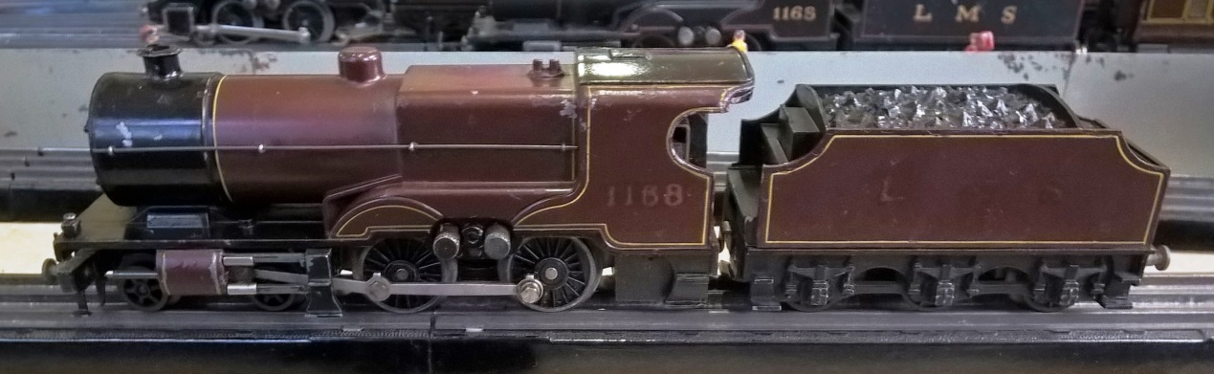
Fig 22: Trix pre-war compound on Brian Arnold’s layout at Leicester in November 2017. The brushes demand a fair amount of splasher remodelling and the boiler looks massive, particularly on the small driving wheels of the standard mech designed for the 0-4-0s. Note the out-rigger steps to clear the con rods and the pivoting buffer-beam attached to the bogie for sharp curves. Certainly no ‘scale model’ even if it is to 3.75mm scale.
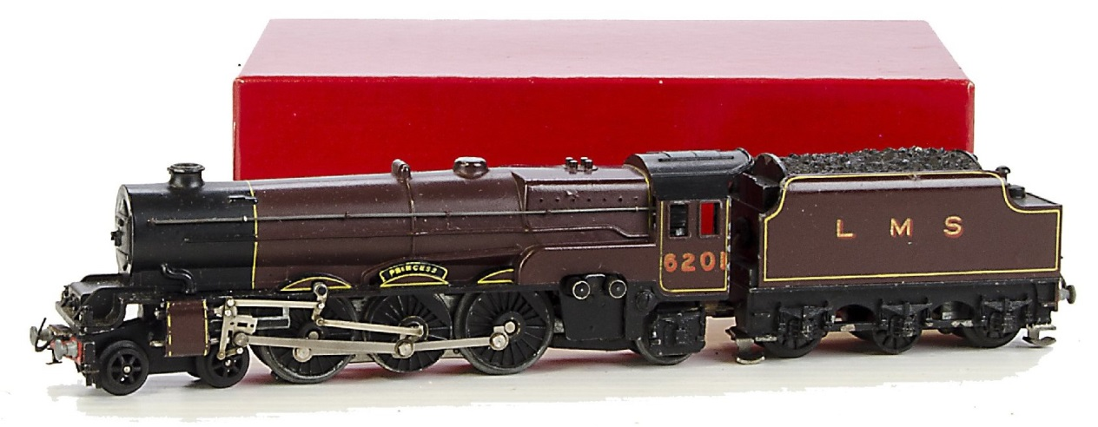
Fig 23: Trix ‘Princess’. More advanced than the compound, but ironically introduced a year earlier in 1938, almost simultaneously with the Dublo A4. The Dublo loco stole the thunder the Trix had in ‘realism’. The Princess is compromised by its foreshortened front (again with pivoting buffer beam), balanced by the extended space between drivers and pony truck to accommodate the brushes, which have been treated to an extra splasher. Recognisable, yes; but scale? No, not by modern standards. Even the name has been shortened! Photo courtesy SAS.

While all but very late Trix models tend to be criticised for being rather disproportionate, it should be recognised that even today every major manufacturer makes compromises when a model is designed in order to contain production costs, or to make it sufficiently robust for the intended user. Such compromises include fitting standard, identical components, such as bogies and wheels, across various products regardless of ‘accuracy’ and steps on locos being made significantly over scale to reduce the likelihood of breakage.

Interestingly, Trix was also described as 3.8 mm on 16 mm track (where 3.75 had been rounded up and 16.5 rounded down!). And, in addition, it was variously described as 00 or H0 depending on the market it was being sold in, even for the same item. Unaware of, or at least unconcerned by these descriptive anomalies, the British public bought Trix Twin models in huge quantities. It is likely that from Meccano Ltd’s perspective their popularity was perceived to threaten Hornby 0 gauge sales, particularly as Trix was heavily advertised in the Meccano Magazine and Meccano offered nothing to counter it. There can be no doubt, therefore, that the Hornby-Dublo system was developed to take on Trix. Even though there were other minor 00 manufacturers in the UK at this time, none sold any great quantities and most were aimed at adult enthusiasts. Meccano has also looked at Ma̎rklin’s H0 20v system and learned from it (for example from the litho-tin track base mentioned by Ronald Wyborn in Hornby Dublo Trains p17); however Ma̎rklin was by no means a major player in the UK 00/H0 market as the rarity of its UK livery products attest. To Meccano Ltd, the Trix Twin Railway system was the focus of their design effort and, typical of a maker looking at the existent products of another, certain design elements were copied (such as the rail gauge and use of die cast zinc alloy for loco housings) and details improved upon (such as the overall proportions and chassis assemblies). The decision to go to 12-volt DC 3-rail instead of 14-volt AC and have brush holders contained inside the loco rather than protruding through the side can be considered to be such design improvements.

Many manufacturers of mass-produced model railways prefer to maintain some degree of ‘like-for-like’ commonality with their competitors’ products. It was presumably a realisation of the prospect of selling products to purchasers of Marklin train sets that had prompted other German makers to adopt Ma̎rklin’s gauges in the 1890s. By the 1930s Meccano’s thinking was probably more advanced. The Dublo range would seem to be compatible with its rival, but actually be designed to have zero or very limited interoperability. Locos operated on DC rather than AC and the whole range was fitted with idiosyncratic couplings that ensured that the rolling stock was difficult to couple to anything other than Dublo. This helped ensure (i.e. force) ‘customer loyalty’ when making future purchases, yet seemed to offer more choice. Undoubtedly Binns Road wanted to target those ‘first-time’ customers who may have been contemplating the purchase of Trix train sets and, once they had bought Hornby-Dublo train sets instead, have no choice but to expand them into Hornby-Dublo ‘railway systems’ with many additional supplementary purchases, none of which came from a competitor.

The phenomenal success of the Dublo series and its remarkable ‘true-to-type’ accuracy for a mass-market toy was to ensure the future for both the gauge and the scale. Not only did many adult scale modellers buy Dublo products to super-detail, but, probably more significantly, Dublo’s target market of older children and adolescents ensured that a new generation would graduate seamlessly from Dublo to 4mm during the 1940s and ‘50s. The rise of Tri-ang, using the same gauge and scale, consolidated things. In fact, Triang were so loyal to UK 4mm that they tended to match its size, rather than its scale. Therefore many early Transcontinental and Australian items are built to look fine in a train of UK 4mm stock, but come out very close to 3.5mm, except for the 4-6-4 tank loco that magically became 4mm standard gauge from a 3’6” gauge prototype Fig 24.

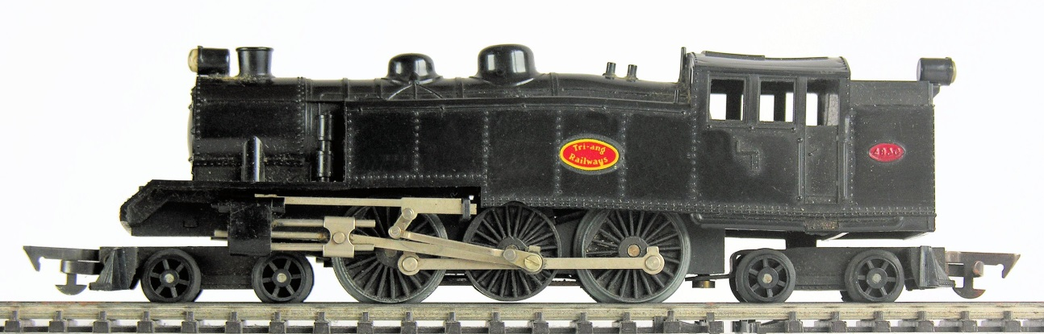
Fig 24: Triang 00 Trans-Continental Baltic tank, its cellulose acetate body somewhat distorted. Courtesy Pat Hammond.

Fig 25 provides a comparison of a Triang TC box car to 3.5mm equivalents, which proves the point that, though not really 3.5mm, it looks only slightly squat by being designed to match UK 4mm rolling stock. The real difference between the closely scaled Red Ball kit and the Triang is not so much the length or height, but the depth of the body which is largely determined by the use of standard 4mm trucks. 3.5mm scale trucks are tiny in comparison Fig 26.

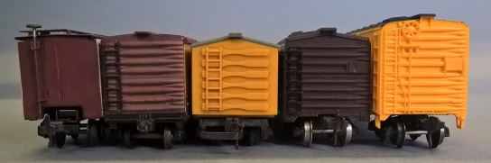
Fig 25: From left. Trix tinplate, early 1950s, Red Ball Kit 1938+, Triang late 1950s, Fleischman tinplate early 1950s, Fleischman plastic late 1950s.

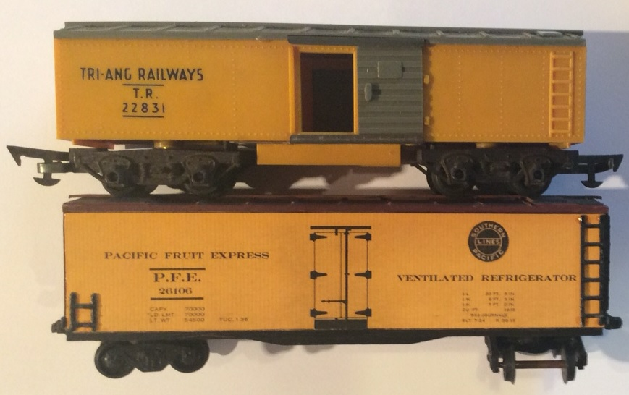
Fig 26: The Tri-ang and Red Ball cars compared, by Tony Stanford.

The scale ‘rationale’ becomes very clear when UK and Transcontinental items are placed side by side Figs 27 and 28.

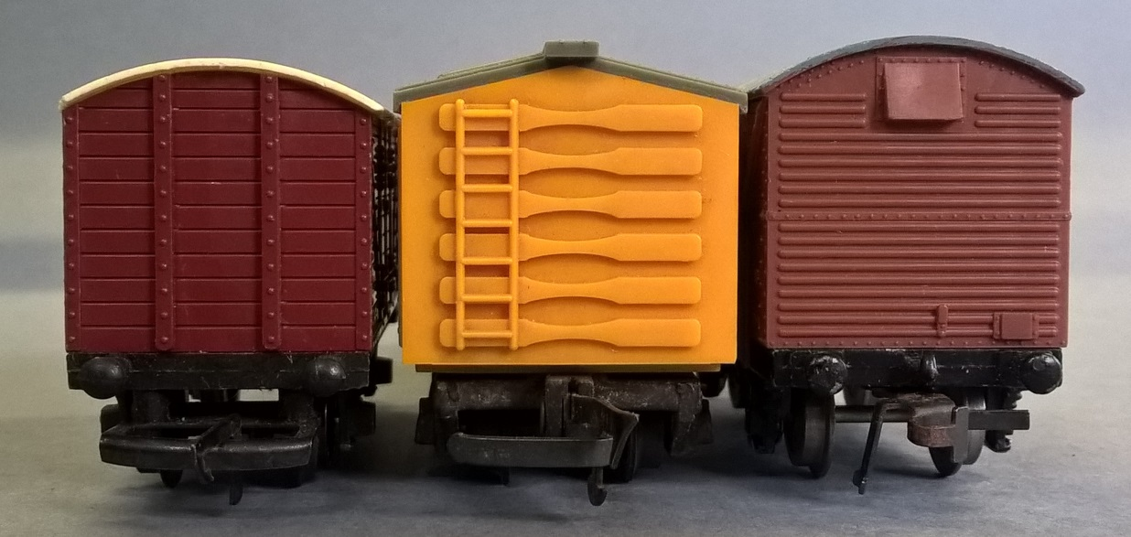
Fig 27: Triang UK, Triang TC and Dublo Super-Detail, the Triang items are closely matched for height and width.

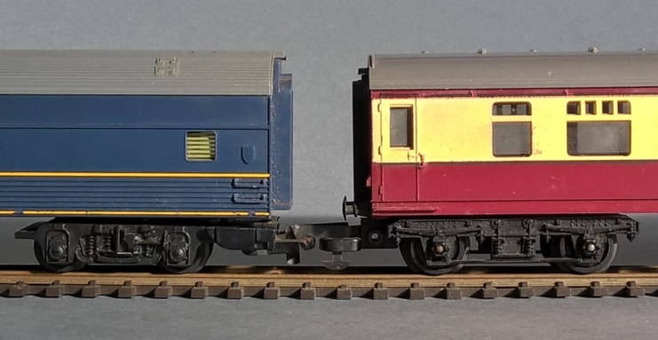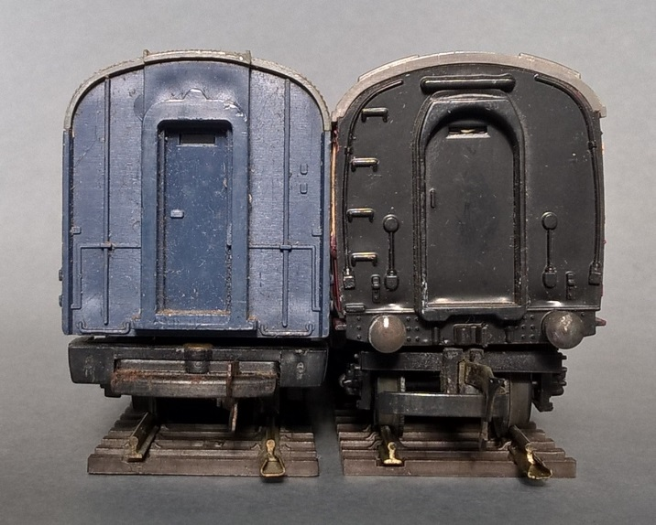
Fig 28: Triang TC express luggage car and UK coach compared. The sizes are similar, the scales therefore are not.

As an aside, Rob Hampton in Tri-ang TT Gauge - An in-depth review (p6) tells us that Tri-ang effectively repeated the 00 saga in the smaller gauge. TT (Table-Top) gauge had been invented in the USA by Hal Joyce in 1945-6. It was ¹/₁₀” scale with a gauge of 12mm. This creates a metric/imperial scale of 2.5mm that comes out with a gauge equivalent to 4’9³/₅”. By 1953, when Walter Lines instructed the company to develop their TT range (introduced in 1957) Tri-ang upped the scale to 3mm, but still on 12mm gauge; presumably for all the reasons outlined above in terms of mechanical clearances and possibly to replicate the look of the Triang 00 range. Similar to 4mm, where 1mm takes a value of three inches, 3mm is a logical metric –imperial scale in which 1mm takes the value of four inches. Meanwhile 2.5mm does not easily divide into 12. At 3mm scale a gauge of 12mm is exactly 4 feet, even less than the scale 4’1½” of 00, but its effect is the same, Triang TT looks like a miniature version of Triang 00. No doubt had TT been more popular in the UK and the Triang standards taken up by others, the same ‘problem’ that besets scale accuracy in 00 would have been replicated.

To return to 00/H0 and answer the title question. First, it could reasonably be claimed that (to use a very appropriate expression) the die was cast for 00 with the introduction of Dublo in 1938. 4mm would thereafter remain the scale and thus the size for commercial16.5mm gauge in the UK. It was no science, just a fortuitous set of circumstances that scale modellers have wrestled to control ever since. Second, that although H0 is scale accurate, its bizarre 1:87 is determined by a gauge that is no more than a neat looking imperial fraction. The conclusion here is that the three key factors, size, gauge and scale came in that order. The sizes of toy trains dictated their gauges, which finally set their scales. This is the reverse of what ‘should have happened’ from the scale modeller’s point of view. However, readers of this magazine should think quite the opposite. Toy trains would not have been toy trains had scale ruled and the magnificent leaps of imagination that characterise the best of what we collect been subjugated to some idea of scale prototype representation. That 4mm remains dominant in the UK, despite it being a dog’s breakfast of all three factors, is a small beacon of hope in a world of ‘scale models’ that is increasingly anodyne and un-toy like.

Bibliography of sources cited
- Baecker, Carlernst, D Hass and Claude Jeanmarie: Ma̎rklin- Anfang bis Jarhundertwende 1 1859-1902. Hobby Hasse, Frankfurt, 1975.
- Bassett-Lowke & Co: 1904-5 Catalogue (Reprinted by Token in issue of 5000, nd)
- Bassett-Lowke & Co: 1907-8 Catalogue (Section AC).
- Buck, Stan: E.W. Twining Model Maker Artist & Engineer. Landmark Collector’s Library, 2004.
- Carlson, Pierce: Toy Trains – A History. Victor Gollancz, London, 1986.
- Carpenter, Jeff: Bing’s Table Railway. Diva, Sawbridgeworth, 1996
- Field, Bob: ‘The Dublo 0-6-2 Tank Locomotives, Part 1’ in The Hornby Railway Collector, No 529 December 2017 pp17-21.
- Foster, Michael: Hornby Dublo Trains. New Cavendish, London, 1980.
- Freezer C J: ‘Scale, Gauge and Space’ in A History of Model and Miniature Railways, issues 7 pp121-124 and 9 pp173-177, 1974.
- Greenberg, Bruce: Greenberg’s Guide to Lionel Trains - Standard and 2⅞” Gauges 1901-1940. Brinkman, 2015.
- Hampton, Rob: Tri-ang TT Gauge - An in-depth review. Hampton, 2017
- Jeanmarie, Claude: Gebruder Bing, Spielwaaren 1898. Verlag Eisenbahn, Villigen, 1992.
- Loco-Revue: ‘Le Congres de Ruedesheim’ in Loco-Revue 110, Nov 1952, pp237-239.
- Loco-Revue: ‘Compte Rendu du Congres International Des Modelistes Ferrovaires’ in Loco-Revue 122, Nov 1953, pp339,340.
- MacDonald, Bruce: Spring, Spark and Steam – An illustrated guide to Australasian toy and model trains. Australian Model Railway Magazine and Everleigh Press, 2005.
- Matthewman, Tony: The History of Trix H0/00 Model Railways in Britain. New Cavendish, London, 1994.
- Oddy, Nicholas: ‘Frank Hornby – An unwitting pioneer in small-gauge toy trains – Raylo and Liliput compared’ in The Hornby Railway Collector, 500, Feb 2015, pp12-19.
- Oddy, Nicholas: ‘A Ghost of Two Christmases Past’ in Train Collector 45, Dec 2016, pp 32, 33.
- Reder, Gustav: Clockwork, Steam and Electric – The history of model railways up to 1939. Ian Allan, 1972 (First published in German, 1969)
- Schiphorst, Paul Klein: The Golden Years of Tin Toy Trains 1850-1909. New Cavendish, London, 2002.
- The Model Engineer and Amateur Electrician. Jul 1900, pp 176 177.
- The Model Engineer and Amateur Electrician. 1 Feb 1901, p 69.
- ‘The Latest in Model Locomotives’ in The Model Engineer and Electrician 10 Sep 1903 pp 250-255.
- Model Railway News Jul 1937.
- The Rise and Fall of Hornby Dublo VHS/DVD, Axiom Video Productions, 2005.
Acknowledgements: Beyond those mentioned in the text, the authors would like to acknowledge and thank Allyn Cooke, Rolande Allen, David Cooke, Bruce Coleman, Don Gibson, Mark Stephens, Peter Searle, and those in the TCS e-group who contributed to discussions on this subject.

