PECSRL 2016

Un-representing Nature.

‘(Environment) should on no account be confused with the concept of nature. For the world can exist as nature only for a being that does not belong there, and that can look upon it, in the manner of the detached scientist, from such a safe distance that it is easy to connive in the illusion that it is unaffected by his presence. Thus the distinction between environment and nature corresponds to the difference in perspective between seeing ourselves as beings within a world and as beings without it’. (Ingold, 2000)

ABSTRACT:
As an artist and researcher my work responds to place. In September 2015 I began a short, practice-based residency at Outlandia in Glen Nevis, supported by the Ben Nevis Partnership and London Fieldworks (www.outlandia.com). In this remote, off-grid location, I became interested in making tangible connections with the surrounding mountain landscape. Rather than attempting to represent nature in a pictorial way, I wanted to explore physical connections with landscape through energy.

What materialised were a series of prototype drawing contraptions powered by the wind (fig. 1). These devices are currently undergoing further development and testing before public exhibition in Fort William in 2016. Even though these devices have no comprehension of, or access to a representational language, there is still a human tendency to make connections between the drawings made, and the landscape they are made in: We imagine resemblances.

At PECSRL 2016 I intend to speak about this body of work, outlining its current form and future potential. It will be discussed in the context of wind energy, contested landscapes and human subjectivities: How can art contribute to our understanding of landscape? Can artistic practice develop new landscape narratives and sensitivities?

For sessions S9 and S5
Keywords: kinetic sculpture, landscape drawing, wind energy

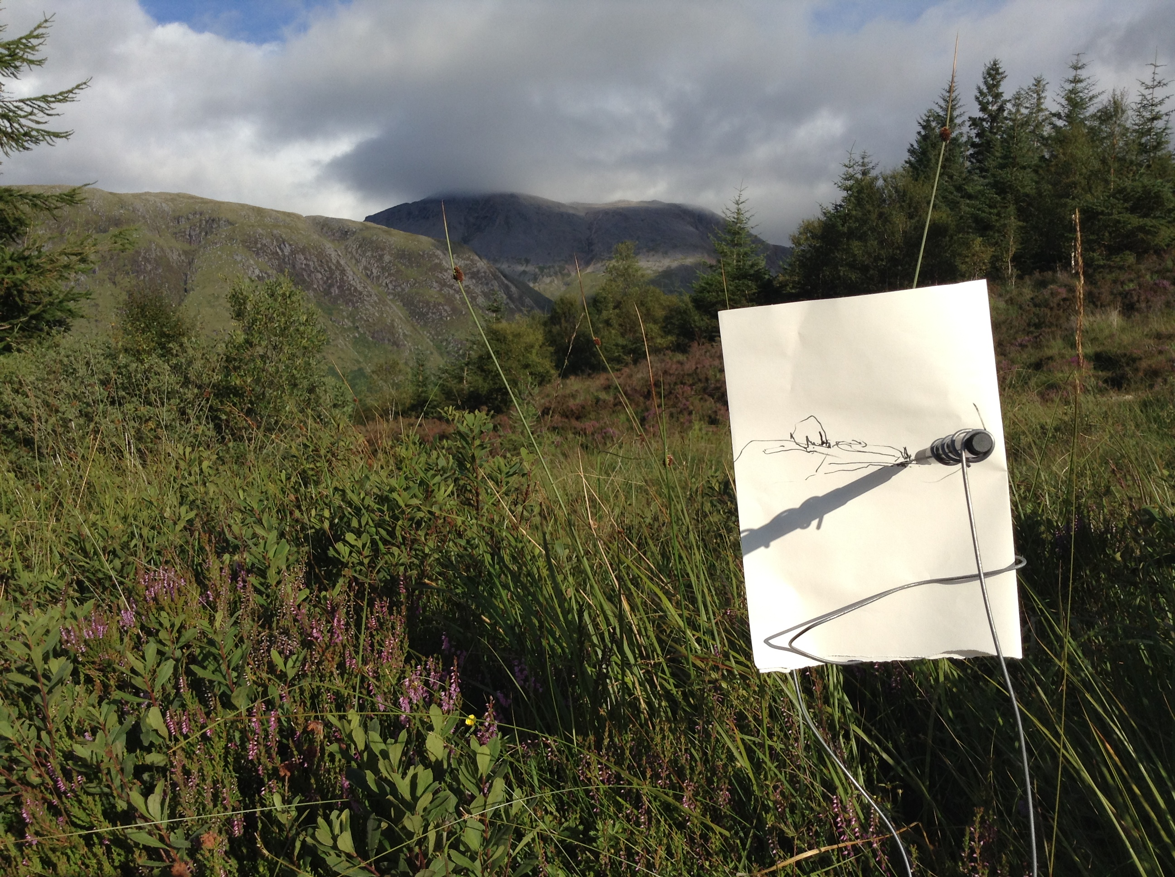
fig. 1 Drawing device in action.

