Commons People: Additive Manufacturing Enabled Collaborative Commons Production

Dr Paul Smith
Institute of Design Innovation, School of Design, Glasgow School of Art
p.smith@gsa.ac.uk

ABSTRACT

“Never doubt that a small group of thoughtful, committed citizens can change the world; indeed, it’s the only thing that ever has.” – Margaret Mead

In a post industrial age of production the incumbent model of mass manufacture characterized by integrated organizations and economies of scale could be showing signs of giving some way to a new production paradigm. Due to technology advances especially in the field of additive manufacturing (AM) small scale de-centralized production is again a possibility. Where once the tools to produce goods were seen as large capital investment beyond the means of most small enterprises, it is now possible for individuals to access tools that are capable of producing consumer goods. This shift had led to the emergence of a social phenomenon that until now was bound to the digital world. Networks of individuals are coming together to collectively design, develop, manufacture and distribute goods through a network under the banner of an open hardware movement. This paper presents a case study of one such network designing and distributing open source prosthetics using a collaborative commons enabled by AM technology.

KEYWORDS
Collaborative Commons, Additive Manufacturing, Open Hardware,

1. INTRODUCTION
The recent history of the production of tangible goods displays a pattern of shrinking and centralising the means of production into large individual producers controlling the process of new product development from conception to delivery [1][2]. This industrialised production model came about and replaced what in Europe was a more dispersed model of production where the production economy was spread out and driven by access, subsistence and intrinsic need rather than centralised and driven by ownership, the market, and abstract value. Fast forward to the current paradigm of production and we see that the established centralised production model still holds sway, however there is evidence to say that this system of production is showing signs of relenting in the face of newly enabled ways to produce goods collaboratively [3] enabled by new technologies like AM without the need for a traditional ‘firm’. The phenomenon of collaborative production [4] enabled by new communication technologies (internet, mobile networks) and low cost production and publishing technologies (smart phones, social media, online repositories) has already permeated the fields of information, software and cultural artefact creation. Now, changes to technology and to attitudes are inflating the amount and quality of collaboratively generated content to compete with the traditional centralised model. While this type of collaborative content was until recently bound mainly to the digital world producing online content or software, collaborative production of physical goods has now started to emerge. Developments in technologies like AM that are capable of producing tangible goods cost effectively have opened the door for physical artefacts to follow the model set by software, culture and information.

A key element of a collaborative hardware production model is the micro enterprise, individuals and small groups with the capability to autonomously produce at small scales. Micro enterprises are not new and developed in transition from the feudal system of economic and social organisation to the proto industrial era that occurred just before the industrial revolution of the 19th century. In proto industrial society, the phase of rural industry development prior to centralised industrialisation [5] [6] small manufacturers that produce low volume were distributed (traditionally rurally) and scaled laterally by adding additional small producer ‘nodes’ to the network. These proto industrial micro enterprises were mobilised by pursuit of economic gain by the bypass of expensive guilds. While displaying some commonalities with proto industry the emerging new collaborative approach to hardware production appears to be mobilised by a pursuit of social value. It shows signs of similarity to the micro factories of proto industry and also the values and virtues of a commons approach to organisation that pre dated the proto industry and was characteristic of agricultural feudal society.

This paper argues that in a post proto industrial society there has been a dominant capitalist market system. The collaborative commons approach to product development, combining distributed networks and sharing, offers an alternative way of designing, producing and accessing goods. The commons system for hardware production enabled by AM technologies can revolutionise socioeconomic systems and offer emerging new roles for civic creativity. It explores the evolution of a commons approach to organisation and the transition from capital market economy to sharing commons economy, framing it as a move enabled by accessible technology like AM. It uses a case study of the e-NABLE open source prosthesis project to illustrate the network design and function of a modern collaborative commons based production model. Looking at the case study through the lens of commons based production the paper draws comparisons with pre industrial ways to organise. It asks what role is AM playing in a new production model and what are the implications for further commons based production and the role of the citizen?

The first section of this paper explores early commons organisation and it’s evolution to modern times. It highlights the principles of a commons approach and the role of technology in a post-industrial production world. The next section examines a case study example of a modern collaborative commons model of production that uses AM to produce open source prosthetics. The final section discusses the role of AM in a commons model of production, the potential for further collaborative commons production and highlights some areas for further research.

2. FEUDAL SOCIETIES AND THE COMMONS

Feudal society was the major form of economic and social organisation in Europe from about 900AD up to around the 16th century [7]. It was made up mainly of subsistence agriculture where lords who had rights to land gave access rights to peasantry to work the land who then in return paid tribute to their land lords in the way of labour or produce [1]. In a feudal system no one could be said to own land, everyone who worked the land had a certain domain over it depending on the service to the land they performed [8]. Working the land effectively enough to survive and pay tribute was a struggle for many individual families and so to maintain themselves feudal farmers combined their resources and efforts into a ‘commons’ arrangement. A commons is a model based on collaborative interest and a desire to connect and share. Many feudal peasant class farmed land collectively by aggregating plots into open fields and shared pasture, maximising resources. Far from being a casual arrangement the commons approach set up governance structures that elected councils to set protocols for use and economic activity. These co-operative governance models ensured that common resources were managed sustainably, produce fairly distribute, protocols set and importantly any punishments decided and enforced. The commons could be characterised by its democratic non-hierarchical governance, collective effort and shared resources, a collective driven by need, social stability and sustainability.

3. MODERN INDUSTRIAL PRODUCTION

3.1 Centralisation

During this time production of goods proliferated as labour began to shift from agriculture to manufacture [9] were it was first condensed to micro production and eventually centralised and integrated into mass production. One of the key elements to this radical change in social and economic organisation was technical development of industry [10] and the ownership of tools. Once the private property of individuals and small firms new tools were now under the ownership of larger firms and the users of tools were transformed to a wage labour force [1]. Over time production firms sought greater efficiencies and brought more and more of the production chain ‘in house’ into vertically integrated firms that could exploit economies of scale to their advantage. What had been a dispersed model of distributed small production had become a centralised model of control and efficiency. The move brought with it greater economic prosperity and abundance of goods at an ever-cheaper cost to consumers and producers. The drive for efficiency means that the mass production capitalist model should eventually destroy itself [1]. Its principles will eventually drive cost so low that profits will shrink drastically and will at that point become an unsustainable model as profit disappears. This could open the door for a new system of commons production.

4. THE RE-RISE OF THE COMMONS

The re-emergence of a commons approach albeit in an evolved form is the first new economic paradigm to hit the western world since capitalism and socialism in the early 19th century. As already discussed the ‘commons’ pre dates capitalism and representative governments and is in fact the oldest form of institutionalized, self managed activity in the world. The new form of commons shares many of the values and virtues of the pre industrial and industrial commons institutions. Yet the new post industrial commons is not just about shared resources for agriculture nor collaborating and connecting to share social resources and produce cultural content. The new post industrial collaborative commons that is the focus of this paper is concerned with collaboration to connect and share resource to produce goods, enabled by AM technology, in a way that rivals centralised industrial economies. Underlying the whole ‘collaborative commons’ approach is the fundamental principle that a contemporary commons holds the freedom to share as virtuous over ownership and the freedom to exclude that comes with it [11]. It is this characteristic that above all links commons style of organisation to the current ‘open’ movements that have emerged in the last two decades. Those of open software and more recently open hardware.

4.1 From Open Source Software to Hardware

Collaborative commons are potentially a powerful tool that could change the way we organise our lives, create and consume goods and democratise the global economy [12]. The first major instance of collaborative working through a commons in modern post-industrial times is the open source software movement. Much has been written about open source software and it is not the intention of this paper to re-write its history here but there are elements of the movement that are useful to discuss [13] [14] [15] [16]. The movement began in earnest in 1998 and has continued to collaboratively develop product ever since. To define software as open source it is not enough to simply release the source code, source must be ‘available for redistribution without restriction and without charge, and the license must permit the creation of modifications and derivative works, and must allow those derivatives to be redistributed under the same terms as the original work’ [16]. The collaborative commons production of software was successful in part because like many successful open collaborative methods ‘the inputs and outputs of the process are shared, freely or conditionally, in an institutional form that leaves them equally available for all to use as they choose at their individual discretion’ [11]. The next step in the open production movement was to bring the digital back into the tangible with open hardware [17] [18]. Open hardware differs from open software in that the object being developed has to be produced physically with associated costs and constraints. There are issues of protocol and real world constraints, software and hardware exchange can be problematic but large networks can negate this by offering versions for different needs and available resources [12]. The open hardware movement is a step toward the commons approach of producing tangible goods democratically, allowing a lateral network of developers to collaborate on the design and manufacture of real world goods through a collaborative commons model enabled by accessible manufacturing technology like AM.

4.2 Collaborative Commons principles

The majors tenets of collaborative commons production are: decentralisation so no management hierarchy is dictating; it should be modular so there are many levels of opportunity to contribute; technology is distributed and accessible (economic and cognitive); it involves civic creativity and civic effort; social capital is valued as apposed to pecuniary. It also needs quality control and a mechanism to bring together contributions cost effectively, the cost of adding another contribution must stay as close to zero as possible. Commons production brings networks of networks together, each member of a project bring resources to work on the project and so one addition brings their experience skill network and resource, where traditional firm based production limits resources per project. Liberty, autonomy and independence are all offered by commons production, the freedom to opt in or out under no duress from a ruling hand [19]. There are self-regarding reasons to get involved in peer production such as community and learning, and there are other-regarding reasons, you contribute to others well being, you can give something. Essentially these are the motivations and protocols that govern commons based production. The next section looks at a case study of commons production to understand its structure and the role of AM.

5. CASE STUDY

The e-NABLE project (www.enablingthefuture.org) was founded in 2013 with it’s mission to ‘support the growing global community of volunteers who create open source devices and provide easily accessible information for children and adults with upper limb differences who are in need of a 3D printed helping hand’. The project has 6768 members worldwide, organized into a global network with about 2/3 based in the USA. Since 2013 it has reportedly delivered an estimated 1500 open source prosthetic hands manufactured using AM technology to people around the world. Although, the real number is almost certainly a lot higher than this as it is unlikely that every manufactured device is reported. The network is made up of volunteers who elect to use their skills to develop the low cost prosthetic designs and release them for free through the network. The co-operative organization produce, maintain and govern the common ground that holds all the network data. It is not jut the design data but the R&D data too, user data, location data and other relevant research for the community. To use one of the current devices available through the network individuals must have a functional wrist or elbow to make most current and recommended e-NABLE devices operate properly but volunteers will work with users to develop custom devices as well as the standard versions. ‘Clients’ can approach the network with a request for a device and the network will match them with a local volunteer who can provide the device. Material costs are approximately $35 (as of writing) for an e-NABLE ‘raptor’ hand, this compares with $6000 for a basic prosthetic hand. Currently there are 10 recommended designs available through the enable website [20].

This research used case study examples of prosthetic designs found through the project website, various online sources of news and user accounts of using the network as source data. The author also took part in community forums and online meetings organised by the e-NABLE project to gather more data on the prosthetics design process. Process analysis [21] was used to map out the variable units in the e-NABLE project looking at the people, the tasks and technologies used in their production process. The collaborative commons principles were used as a framework to assess the correlation between the collaborative commons approach to production and the e-NABLE process. The scope of the case study is to establish an initial map of the network’s process to producing prosthetic devices, compare it to a collaborative commons approach and used it to assess the impact of AM technology on the variables in the process.

5.1 Device development and production

The network began with an original prosthetic device design. This design was released as open hardware so that it could be downloaded, developed and produced without charge. The design files along with the data to support the manufacture and assembly of the device were made publically available. This act was the initial step into developing a collaborative commons for the production of many devices by introducing basic units of the system, the design data and the platform to access. As the network develops other variables are added to the system, specifically volunteers and micro production units add to the lateral scale of the network and enhance the system capability. The expansion of the network brings with it the addition of individual resources (design technology, production technology, skills, knowledge, distribution capability) and they are added to the commons. There are protocols in the network that maintain the ethos of the network and quality of the data within it. These protocols mean that the designs of the devices are open for the community to develop so the process is spread among all members and not a select few. Developments are quality checked by a core team, so there are governance standards as with other commons approaches, approved developments are fed back into the network. While there is no enforced hierarchy in the network there is a commonly accepted level of quality that drives the governance of the network. Having a range and variety in the level of skills seems necessary for the collaborative commons approach so that learning can take place between members.

Figure 1 shows how the commons approach to this project works. There is a central common ground, the website and affiliated data storage, that facilitates the network. Individuals, virtual clusters and groups of volunteers take data form the network to develop and then put it back in a sustainable loop. ‘Clients’ approach the volunteers through the common ground and through this connection get access to devices. At the heart of the material structure of this model is the AM unit. It is at the point of connecting a client with volunteers that the devices are made physical using AM technology.

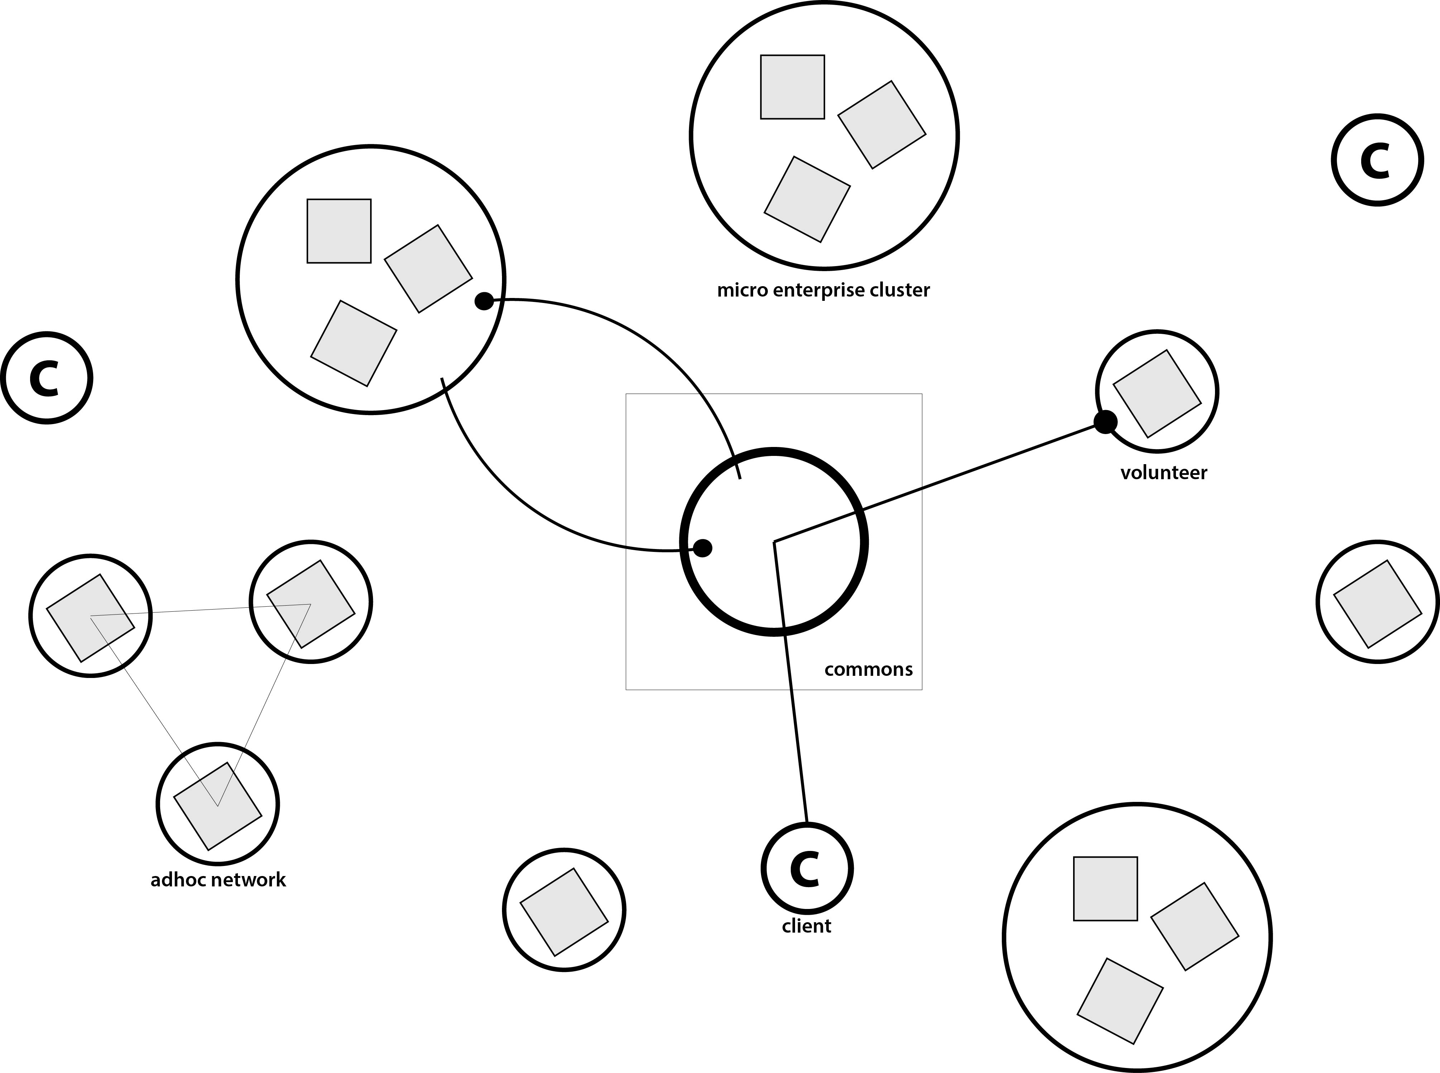

Figure 1: the network diagram of e-NABLE

The model invoked by e-NABLE shares many of the characteristics of a collaborative commons. It has various levels of opportunity for people to contribute and it is lateral in scale and decentralised. The latter two points are the direct result of AM technology. Being able to produce in low volumes cost effectively and with low cognitive barriers means that manufacturing can be dispersed, and the cost of adding another node to the network is also low and so it can easily scale laterally. This ability also means that volunteers can come in and out of the network easily so they can elect themselves for contributions at the level they feel they can pitch. This was possible because of the proliferation of low cost AM systems that allow the devices to be produced as individual units cost effectively and customised at the point of delivery in a global network. The network operates with a free access policy that allows anyone with the means to produce a device. By being open to input as well as output the network has the opportunity to draw on a broad creative as well as technical resource akin to the open source software movement. There are no obvious pecuniary benefits to being part of the network but there may well be associated benefits that link to a financial incentive, this may be an interesting area for further investigation.

6. DISCUSSION AND FURTHER WORK

In terms of the role AM plays in a new production model and the implications for further commons based production. It appears that in a commons production model networked micro enterprises are the core to development in open source hardware production. They design, build, develop and provide the product direct to the consumer and at the heart of the micro unit is AM. It is the ability to distribute manufacture laterally that allows a network of open hardware to flourish. There are some issues surrounding a collaborative commons approach to production through micro enterprise. The first and most salient is that AM has protocols. Generating the files to produce devices and transfer to other units is seamless enough but original deign files are not all cross platform compatible. However, technology platforms on a big enough network are not a problem as there are enough people in the network to reproduce files in the right format, printers share much of the same protocols but again large networks can produce versions for different technologies, designs can be modified at source and produced either at source or through the network for very cheap. It seems that the maturity of AM technologies and the inevitable affiliated drop in cost could see an abundance of new products developed, shared and manufactured across a collaborative commons of laterally scaled enterprises driven by social rather than pecuniary capital returns. It is now possible to produce hardware in an open and collaborative way through a dispersed network using commons approaches with accessible technologies that will inevitable improve with time.

The network currently uses predominantly FDM technology to produce devices because the FDM technology has been the subject of most development in recent times and is still the most affordable option. However, resin and powder based technologies are set to follow a similar pattern to FDM and so devices will inevitably improve. There are already a number of devices that have been produced with SLS technology. Experiments with the more advanced technologies and affiliated techniques such as 3D scanning.

Further research into the collaborative commons approach to production could focus on the protocols of file exchanges, as this is one of the issues to a true open source approach. This could begin with an analysis of the current level of file differentiation within this network and any other networks of open hardware, to assess the scale and impact of the issue.
As well as a focus on this element it would be valuable to begin to develop a framework that could assess suitable products that could be candidate for this type of production model. Again a suitable starting point for this would be a detailed analysis of the example devices in this study through a series of workshops that would develop an initial frame. The frame could then be applied to other example open hardware products to test the validity and finally applied to existing products produced by non collaborative means with the aim of developing further commons based production models for a variety of products. The frame could look at elements like the number of volunteers in the network with the aim of ascertaining if there is a critical mass needed for success. Equally looking at the demographic of volunteers could reveal much about the motivations and conditions for individual participation. Product type might form another part of the frame with the aim of categorising products as candidates for this type of production.

REFERENCES

[1] Rifkin, J., Zero Marginal Cost Society, Palgrave Macmillan, 2014

[2] Hugh, S., J, Evolving Paradigms of Manufacturing: From Mass Production to Mass Customization and Personalization, Proceedings from the Forty Sixth CIRP Conference on Manufacturing Systems 2013

[3] Koren, Y., et al., Open-architecture products, CIRP Annals - Manufacturing Technology, Volume 62, Issue 2, 2013
[4] Siefkes, C., Generalizing Peer Production into the Physical World, EDITION C. SIEFKES, 2008
[5] Hudson, P., Proto-industrialisation, ReFRESH (Recent Findings of Research in Economic & Social History), 1990 http://www.ehs.org.uk/dotAsset/1d40418e-b981-4076-8974-b81686a9d042.pdf accessed 9.12.2015
[6] Mendels, F., F., Proto-industrialization: The First Phase of the Industrialization Process, The Journal of Economic History, Vol. 32, No. 1, 1972
[7] Brown, E. A. R., The Tyranny of a Construct: Feudalism and Historians of Medieval Europe, The American Historical Review, Vol. 79, No. 4, 1974

[8] Schlatter, R., Private Property: the history of an idea, New York, Russell and Russell, 1973

[9] Crafts, N., British Industrialization in an International Context, Journal of Interdisciplinary History, 1989

[10] Temin, P., Two Views of the British Industrial Revolution, The Journal of Economic History, Vol. 57, 1997

[11] Benkler, Y., The Wealth of Networks, Yale University Press, 2006

[12] Open Source Hardware Wiki, https://en.wikipedia.org/wiki/Open-source_hardware, accessed 15.11.15

[13] Open Source Software, https://en.wikipedia.org/wiki/Free_and_open-source_software#cite_note-FOOTNOTEWilliam2002-11, accessed 18.11.2015
[14] Bretthauer, D., Open Source Software: A History, UConn Libraries Published Works, Paper 7, 2001
[15] Madey et al., Open Source Software Development Phenomenon, Eighth Americas Conference on Information Systems, 2002
[16] Oreilly, T., Lessons from open-source software development, Communications of the ACM Volume 42 Issue 4, April 1999
[17] Rubow, E., Open Source Hardware, https://cseweb.ucsd.edu/classes/fa08/cse237a/topicresearch/erubow_tr_report.pdf, accessed 17.11.2015
[18] Powell, A., Democratizing Production through Open Source Knowledge: From Open Software to Open Hardware, 2012
[19] Benkler, Y. & Nissenbaum, H., Commons based peer production and virtue, The Journal of Political Philosophy: Volume 14, Number 4, 2006
[20] Website, http://enablingthefuture.org, accessed 16.11.2015
[21] Hall, P., Systematic process analysis: when and how to use it, European Management Review, 2006

