Considering Open Access - Digital Preservation of arts research data:
AKA Managing your “stuff”

Dr Robin Burgess
The Glasgow School of Art, 167 Renfrew Street, Glasgow, G3 6RQ. (r.burgess@gsa.ac.uk)

Session Type
Presentation

Abstract
Research data management (RDM) for open access (OA) involves maintaining, preserving and adding value to research data throughout its lifecycle. OA to data and research outputs in the visual arts is complex due to the non-standard nature of visual arts research and the practiced based approaches to research adopted. So how can visual artists comply with the ever-changing open access policies and funder requirements for open access, and suitably manage their “stuff” – a way that data in the arts can defined? This paper aims to highlight the complexities of data management in the visual arts, the management of one’s “stuff”, and relate this to the issues surrounding open access of data and data preservation.

Conference Themes
Supporting Open Scholarship, Open Science, and Cultural Heritage
Managing Research (and Open) Data

Keywords
Open Access, research data management, visual arts, funder requirements, methods

Audience
The target audience for this presentation would be those working in a visual arts environment or those with an interest in the management of non-standard research outputs, with a view towards open access to information and data management methods. Librarians, repository managers and researchers themselves will find this presentation of benefit and interesting.

Background
The submission addresses the themes outlined above by looking at the importance of open access to research data within the visual arts from the perspective of funder requirements, discovery and the re-use of data, as detailed in theme 1. Methods that can be employed by researchers and institutes will be described in light of the overarching context of the conference, primarily the way in which visual arts institutes can move forwards in the field of open access and become compliant with funder needs. It can be stated that visual arts institutes are at a crossroads when it comes to the management of their research data, and they are becoming more involved in the repository communities and taking part in repository related initiatives to help with the management of their quite often non-standard research data and outputs.

Presentation content
The following are key headings that will be covered during the presentation:
- Context of the paper – examples will be drawn from two research projects undertaken by The Glasgow School of Art, but also more generic examples will be shared
- An introduction detailing the importance of open access to data in the visual arts and in general
- The complexities of visual arts data – i.e. non-standard research outputs/data
- The impact of open access on the visual arts – funder requirements, methods employed by researchers, governmental requirements
- Managing visual arts data for open access – comments related to repositories and data centres, approaches that can be used and the support networks
- Issues related to the management of data in the visual arts and its implications for open access to data – why we need to manage data and the approaches employed at GSA and further a field
- A review and recommendations section – best practices observed through the projects that will have been discussed and comments related to future developments and initiatives.
(The paper/presentation submission is given at the end of this form).

Conclusion
The main conclusions that will be drawn from this presentation will be related to the complexities involved in the management of research data in the visual arts, relating this to open access to data as stipulated by funding bodies. The concerns of the researcher and institute will be illustrated and commented on with regard to approaches to tackling these. Outcomes and methods will be described from the KAPTUR and VADS4R projects that have helped to give solutions and approaches to the management of research data in the visual arts. A key take home message will be in relation to the need for there to be continued discussion and awareness raising amongst shared services (IT, libraries, archives, research office etc) and researchers within the field of data management and open access. It is all very well developing institutional policies in these areas, but there is a need to extrapolate these and ensure they are understood and utilized appropriately.

References
These are the key references – journals, books, websites, reports and conference proceedings – that have helped bring about this submission. Images in the paper/submission are courtesy of Gii Bear (www.facebook.com/burgessbear)

Web links:

RADAR (the research repository at GSA): http://radar.gsa.ac.uk
KAPTUR project: http://www.vads.ac.uk/kaptur/
VADS4R project: http://www.vads4r.vads.ac.uk
HEFCE Policies: http://www.hefce.ac.uk/
The DCC: www.dcc.ac.uk
RIOXX: http://rioxx.net/
Research Information Network: http://www.rin.ac.uk/

Journals:

Leigh Garrett journal paper on RDM: http://kaptur.wordpress.com/2013/01/23/what-is-visual-arts-research-data-revisited/

Garrett L and Therese-Gramstadt M (2012). KAPTUR: Exploring the nature of visual arts research data and its effective management. Electronic Visualisation and the Arts.
VADS4R Project Details: http://www.vads4r.vads.ac.uk/p/what-is-research-data.html

Reports

KAPTUR Technical Report: http://www.vads.ac.uk/kaptur/outputs/Kaptur_technical_analysis.pdf
KAPTUR Environmental Report:
http://www.research.ucreative.ac.uk/1054/7/Kaptur_environmental_assessment_v1_7.pdf
KAPTUR final report: http://www.vads.ac.uk/kaptur/outputs/KAPTUR_final_report.pdf

Conference Proceedings and Workshops (accessible from RADAR)

Burgess, Robin (2014) From Kaptur to VADS4R: Exploring Research Data in the Visual Arts. In: Open Repositories 2014, 9th June to 13th June 2014, Helsinki, Finland.

Burgess, Robin (2013) Understanding and improving research data management in the visual arts: Case study of the KAPTUR project. In: The 8th International Open Repositories Conference, 8th July to 12th July 2013, Charlottetown, Canada.

Burgess, Robin and Gramstadt, M (2013) Visualising Research Data in the Arts: Towards an A-Z of visual arts research data. In: 8th international digital curation conference, 14th to 17th January 2013, Amsterdam.

Burgess, Robin (2013) The sharing and re-use of research data and outputs via the application of RADAR, The Glasgow School of Art's research repository. In: The 8th International Open Repositories Conference, 8th July to the 12th July 2013, Charlottetown, Canada.

Books and Texts

Pryor G, Jones S, and Whyte A (2013). Delivering Research Data Management Services: Fundamentals of good practice. Facet Publishing.

Pryor G (2012). Managing Research Data. Facet Publishing

The Paper

Considering Open Access - Digital Preservation of arts research data:
AKA Managing your “stuff”

Research data management (RDM) for open access (OA) involves maintaining, preserving and adding value to research data throughout its lifecycle. OA to data and research outputs in the visual arts is complex due to the non-standard nature of visual arts research and the practiced based approaches to research adopted. So how can visual artists comply with the ever-changing open access policies and funder requirements for open access, and suitably manage their “stuff” – a way that data in the arts can defined? This paper aims to highlight the complexities of data management in the visual arts, the management of one’s “stuff”, and relate this to the issues surrounding open access of data and data preservation.

The active management of research data reduces threats to their long-term research value and mitigates the risk of digital obsolescence. Meanwhile, curated data in trusted digital repositories (institutional and national) may be shared among the wider UK research community, and internationally. As well as reducing duplication of effort in research data creation, curation enhances the long-term value of existing data by making it available for further high quality research. Research data is a valuable resource and, with appropriate curation management and access, it has much to offer learning, teaching, research, knowledge transfer and consultancy in the visual arts.

By its very nature, research in the visual arts is highly complex and varied, often comprising a wide variety of outputs and formats which present researchers, information managers and technology teams with many discipline specific issues. The methods and processes which generate this research information are just as varied and complex. Research in the visual arts relies heavily on physical artefacts and methods of recording information like sketchbooks. The often physical nature of research in the arts and its security and preservation also presents researchers and curators with significant problems and greatly increases the risk of data loss and deterioration. Alongside this data, a wide range of related research documentation and protocols are also created.

One of the first issues that a visual artist is faced with relates to terminology and understanding what constitutes data in the visual arts. For many researchers the term “stuff” is used to describe the materials that they collect alongside the final research output. “Stuff” is seen as a simple term and covers the complexity of the information collected during an arts based research project, as documents and items are often non-standard and harder to describe using the conventional approaches.

The second issue is trying to determine the best ways in which to manage one’s “stuff”, due to the complex nature of visual arts data, which is often born out of practice led research. Visual arts is wide ranging and does not just cover standard fine art outputs, it looks into digital art as well as performances.

The often physical nature of data and outputs in the visual arts means that digital and online storage devices are not always the best approaches, and alternative storage mechanisms need to be found, utilizing physical approaches.

The four UK higher education funding bodies believe that research arising from their funding should be as widely and freely accessible as the available channels for dissemination allow. OA to research enables the prompt and widespread dissemination of research findings. It benefits the efficiency of the research process and allows publicly funded research to drive economic growth. It delivers social benefits through increased public understanding of research.

It can be stated that the OA agenda is having an impact on the visual arts institutes as it is making them think more clearly about the types of outputs they are gathering and recording, and considering how best to present these. These considerations have become apparent during two research projects, for which the Glasgow School of Art was a partner: KAPTUR, and more recently VADS4R, which were managed by the Centre for Digital Scholarship (formerly known as VADS), a Research Centre of the Library at the University for the Creative Arts (UCA). The VADS4R project built on the work of the KAPTUR project (2011- 2013), which was funded through the JISC Managing Research Data programme. KAPTUR investigated the nature and scope of research data in the visual arts, which is highly varied and takes many forms across both physical objects and digital files. KAPTUR created a sectoral model of best practice in the management of research data in the visual arts, consisting of: toolkits, workshops, case studies, institutional policies, a technical requirements analysis, and business and sustainability plans.

Funding bodies are now stipulating the need for data and additional information surrounding research projects to be made available. They have put policies in place that institutes need to adhere to, to ensure they can continue to receive funding from them (E.G. the EPSRC have stipulated that all Higher Education institutes in the UK have a data management policy in place by May 2015). This has led to institutions such as GSA implementing a research data management policy, and more recently an open access policy.

Research data is a valuable resource and, with appropriate curation and management, it has much to offer higher education in the visual arts. However, very little is known about the curation and management of this data. By its very nature, research in the arts is highly complex, varied, and challenging, often comprising a wide variety of outputs and formats which present researchers, information managers and technology teams with many discipline specific issues Although more recently projects such as KAPTUR and VADS4R have helped arts institutes to develop data management policies and processes towards data management.

The appropriate curation and management of research data in the visual arts is extremely desirable for a number of reasons such as satisfying funder requirements and enabling easier access to your data for re-use and new projects.

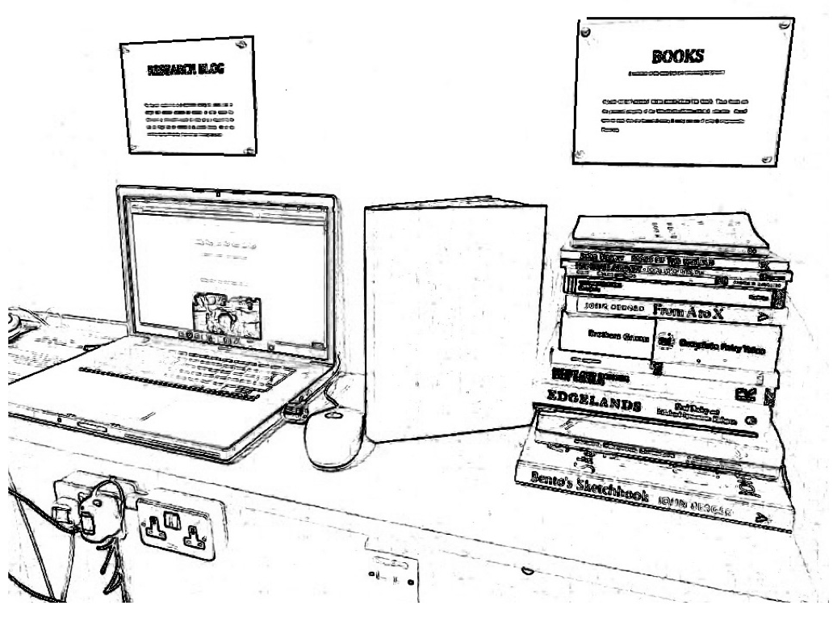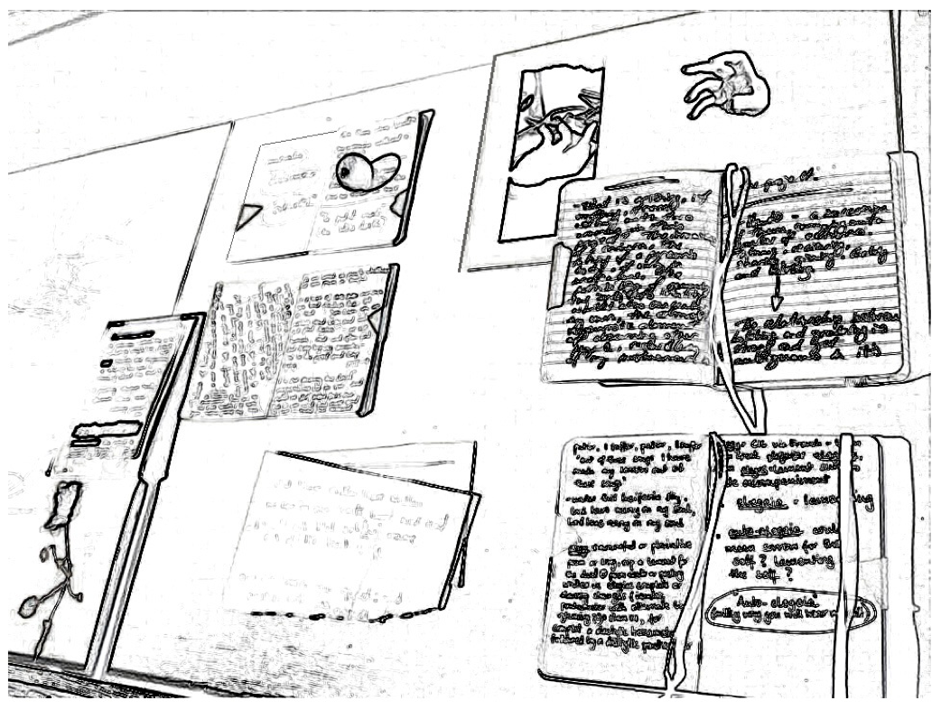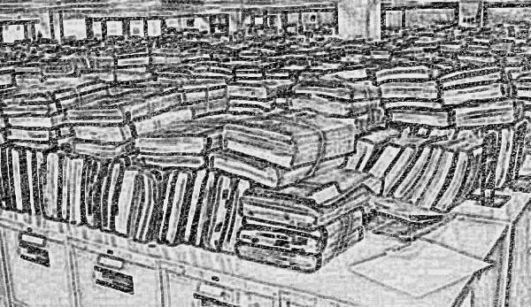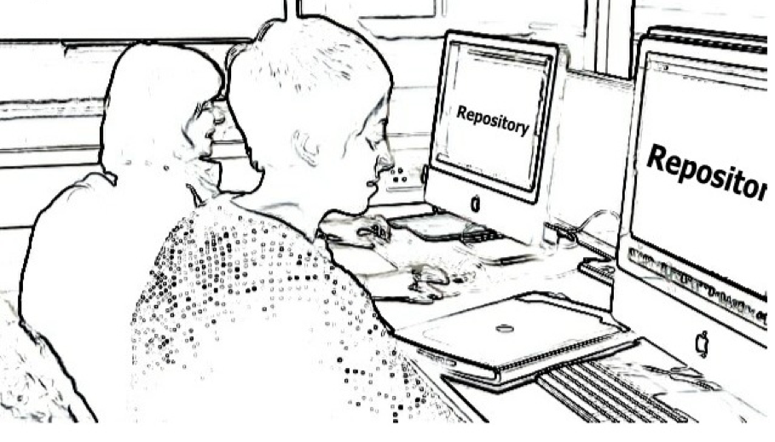

Figure 1: Illustrations of ‘data’ and management techniques in the visual arts

As shown in figure 1 digital systems such as computers and repositories are seen as important ways of handling research data and storing this for further use. The ability also to archive materials is important too. An outcome from the KAPTUR project was the development of an A-Z of research data that helps artists and those working in the creative industries to visualize and represent the concerns of managing data in the visual arts. Examples are given in figure 2.

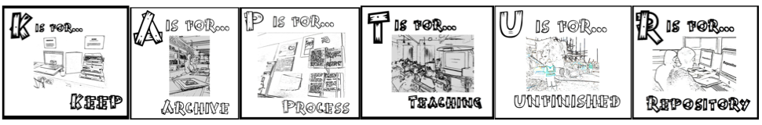
Figure 2: A-Z of research data – from the KAPTUR project.

Research repositories allow you to upload metadata surrounding the research and any accompanying documentation in a variety of formats. These systems tend to be openly available, in that they are affiliated to an institution’s website and can therefore be accessed outside the institute’s domain. This means that interested parties can view the research information pertaining to research being undertaken or completed at the institute in question. This is very useful for disseminating work and creating future collaborations. It is important however that one’s repository is properly managed, especially in reference to the data and information that is uploaded.

Within the visual arts much of the information collected is physical, such as paintings, artefacts, architectural buildings and physical materials (e.g. jewellry and textiles). It is therefore necessary to devise methods of recording this sort of output and data. This is often achieved through photographing the items and uploading the photos along with location details to one’s digital repository. Alternatively for items such as textiles, a physical repository process/system can be developed; this often entails the support of one’s Archives and Collections Department as they will have the skills and knowledge for handling, storing and managing physical arts data/outputs.

OA in the visual arts also has to tackle the concerns of copyright and creative commons due to the nature of the information and outputs produced by researchers in arts based institutes. The often physical nature of research in the visual arts causes issues when it comes to ownership of material – is it owned by the researcher, the institute or the funders? With regard to ownership, the majority of researchers in the visual arts feel they own the work, as they are the individuals who did it. However it tends to be the case that it is the institutes and funders who own it as they provided the funding and money for the research to be undertaken. This is an issue that requires further discussion.

The management of one’s research data (their “stuff”) works alongside the concept of open access and being able to make information about the research available for other parties. Therefore the concepts of RDM and OA can be considered together, and impact on one and other.

This paper will comment on the impact, issues and ways of managing data and “stuff” within the visual arts in light of the OA agendas that are now coming into fruition. There are concerns for visual arts researchers related to the management of the often physical information they collect, and how this should be stored. Through adherence to funder and other organizations’ policies, plus the writing of institutional policies for OA and RDM, researchers and institutes can be seen to be in a much better position when it comes to handling and sharing their research outcomes and “stuff”.

From experience at GSA, one would recommend undertaking a review of the policies stipulated by funding bodies and to review how one’s institute is complying with these, and to determine whether work needs to be done to improve compliance, or assess the need for compliance. Work is also underway looking at common metadata for data management purposes. The RIOXX project (funded by JISC) is compiling a list of common metadata fields for repositories to allow for improved compliance towards data management and reuse of information.

Research repositories and other digital preservation systems can be recommended as ways of handling, managing and storing research information and outcomes from research projects. Within the visual arts, these digital (computer based databases) systems need to be tailored to ensure they can handle the data created within a visual arts context. This information could include written documents and discussions, as well as images of art works, and photographs documenting a process or project. Alternatives to repositories are starting to be considered within a visual arts context, making use of systems and products such as CKAN, Figshare and EPrints.

Moving forwards it will be important for visual arts institutes to keep up to date with the developments in the field of RDM, particularly in relation to digital systems and approaches. With regard to OA, the agendas and views of the funding bodies are continually being enhanced and developed so it will be important to track these changes and see how these influence one’s institute. It should also be stated that it will be important for arts institutes to work together on the development of ways to adhere to OA and RDM, to minimize repetition of effort and to ensure feasible solutions are found to the ever increasing demands of funding bodies, RCUK and HEFCE in the United Kingdom.

