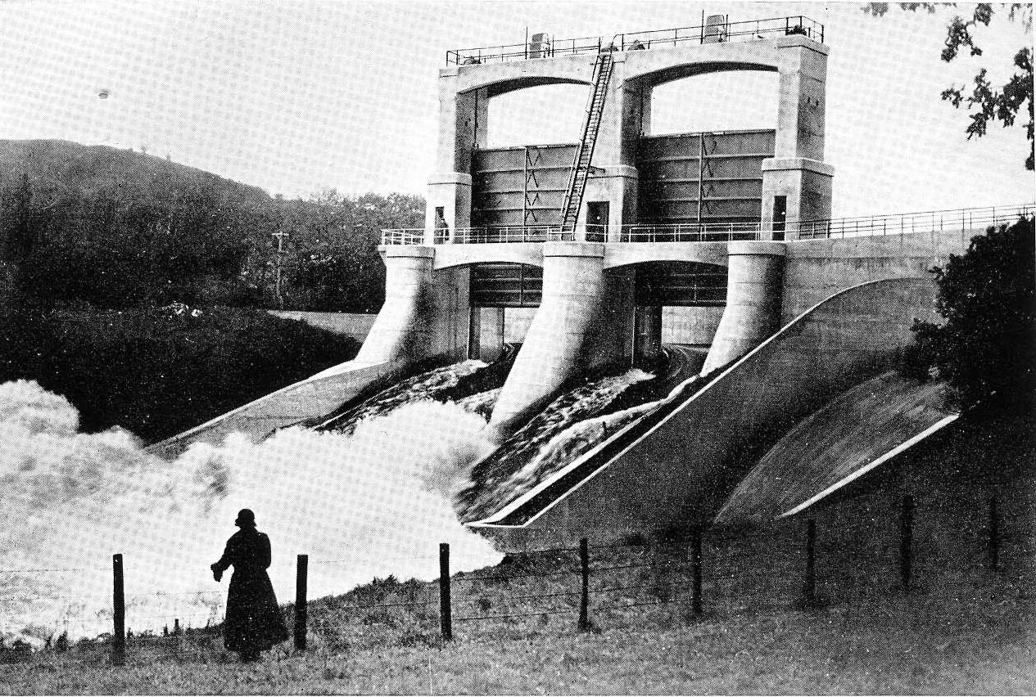
Figure 1: Photograph from The Galloway Hydro-Electric Development (1938): Tongland Sluice gates

Electric pastorale
Visions of pastoral arcadias are a sure-fire provocation to every right thinking cultural critic; metropolitan literati and art historians are only too ready to unmask the ‘dark side of the landscape’, or the bourgeois rapacity of ‘agrarian capitalism’ to anyone foolish enough to admire a pleasant green expanse of woods, fields and waters (Barrell 1980; Williams 1975). In this debate, ‘pastoral’ has a specific connotation, referring not simply to the poetic genre inherited from the classical and Renaissance worlds—in which country virtue is opposed to city vice—but instead to the re-working and re-appropriation of these ideas in late eighteenth century elite culture, with particular reference to the construction of the landed estate and its neo-classical representation both in paintings and in ambitious landscaping projects in the ‘Capability Brown’ mode. Such critiques of this area of enlightenment culture are old news now. In today’s heritage industries our knowledge that Austen’s heroines and their gracious country piles were in fact nurtured on city jobbery or the blood of plantation slaves no longer comes as some kind of horrible revelation, but instead adds a kind of burnished glow, a significant extra layering of the visitor experience. Even though we know these sub-texts, many city dwellers still harbour a kind of baffled rural nostalgia, a nest of concepts about place, nation, and identity that are far too complex to be laughed off as mere false consciousness.

In Scotland, we see such nostalgia expressed most obviously in the cult of the romantic Highlands that became as precious to the hard-bitten urban proletariat of red Clydeside as it was to tourists, landlords, and hoteliers in the tartan heartlands (Harvie 1977; Gold and Gold 1995). Indeed, and despite the fact that the Clearances, forced emigration, and other ‘improvements’ were such recent events in popular memory, the compensating myth of an ancient, unspoilt northern wilderness was so strong that in the period before the Second World War many Scottish working class socialists formed an unlikely alliance with conservative lairds in strident opposition to various hydro scheme proposals in the Highlands—because they were seen as intrusions into nature (Payne 1988). Loyalty to that rugged style of artificial northern wilderness is perhaps one reason why other equally intrusive hydro-electric power schemes south of the Highland line did go ahead without controversy in 1930s Scotland, in the Clyde Valley and in Galloway, even though they were also located in rural areas of great natural beauty. Galloway is now perceived as a backwater of forests, lakes, second homes, communes and other retreats from contemporary life; its natural resources, even its primordially dark night sky, are now heavily protected. In striking contrast to these current perceptions of landscape amenity and its need for protection we will see that the pre-War hydro-electric power stations and dams in Galloway were presented as stark and confident expressions of modernist engineered prowess, making no attempt to nestle under a camouflage of nature, or the mantle of traditional building languages (as was the case with later post-War NOSHEB schemes in the Highlands; Glendinning 1997). This article will examine the interaction of landscape aesthetics, ideas of cultural and national identity, and notions of progressive modernism in the Galloway hydro schemes of the 1930s. We see a form of modernity derived not simply from the growth of cities, but nurtured by earlier, more agrarian projects of national improvement that also supported the pastoral myths floated in the Georgian era.

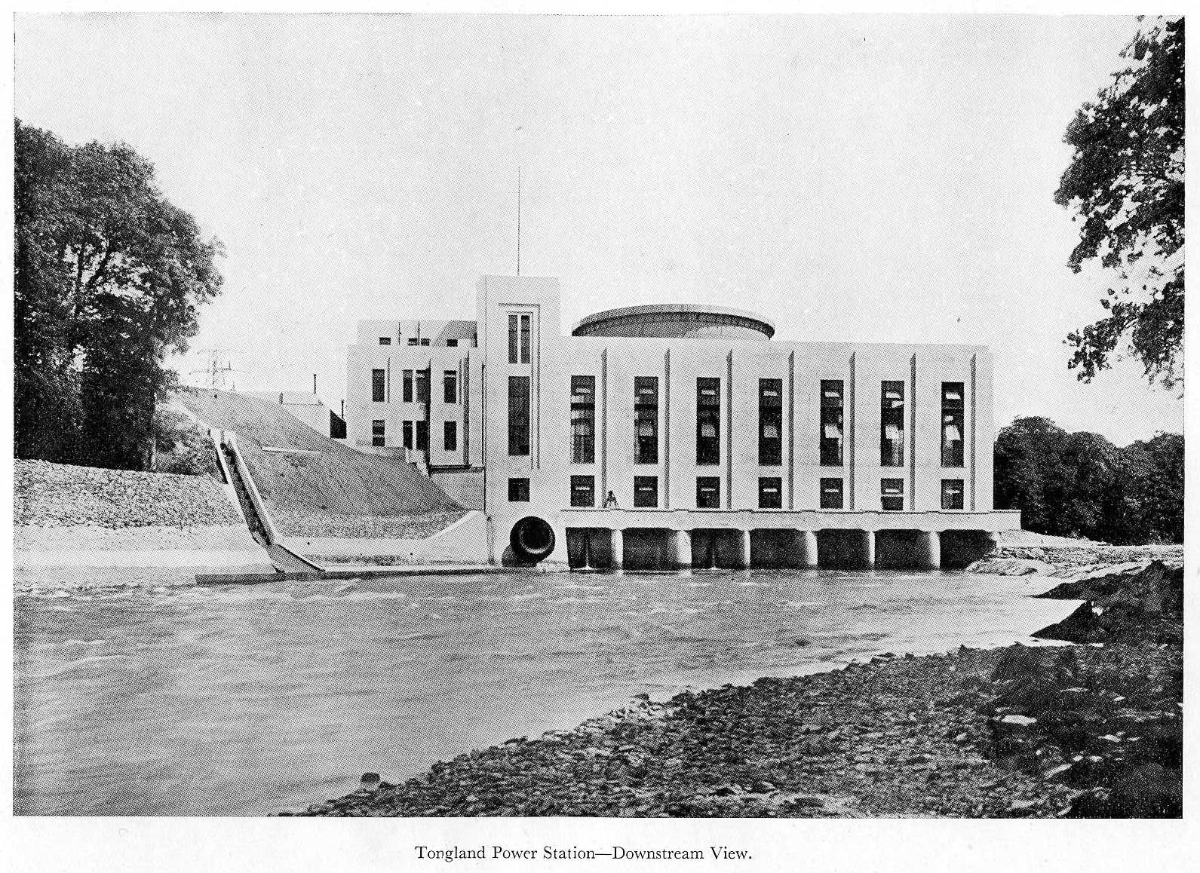
Figure 2: Photograph from The Galloway Hydro-Electric Development (1938)

As every washed-out camper knows, Galloway is a beautiful green area of Lowland Scotland blessed with heavy and constant rainfall. Until around 1750, it had been an isolated, somewhat threatening area to outsiders (and indeed, natives too) with an economy not unlike that of the Scottish Highlands, of cattle keeping, trading and thieving, and home weaving of wool and linen textiles. But in the hundred years between 1750 and 1850, local landowners, entrepreneurs and external investors engaged in many modernising initiatives to encourage local industries, and this expanding economic development led to an increased population engaged in many new manufacturing occupations in textile mills and in other early industrial/ agrarian activities such as brewing or leatherworking. At this date, before railways, Galloway conducted its trade by sea as did most other parts of Britain, and it was therefore as ‘connected’, as busy and successful in its economy, as other areas such as the north of England or Central Scotland that would later come to eclipse this region with the scale of their continued industrial expansion (Donnachie 1971). While the landed gentry were improving their estates through enclosures, parks and experimental farming practices to create new and fashionable ‘pastoral’ landscapes, other equally bold interventions into the landscape were in hand between these private domains. These included water powered textile mills, harbour construction, and, after the establishment of the Turnpike Trusts in 1780, strategic, engineered roads (Donnachie 1971: 26-7). Bridges marked intersections in these networks of communication and production; the bridge crossing the River Dee crossing at Tongland (constructed 1803-5) was styled in a deliberately rustic Picturesque manner by Thomas Telford in collaboration with the landscape artist Alexander Nasmyth (Ruddock 2000: 134), and embellished with chunky pointed gothick arches above the pedestrian towpaths on either side of the main river span. Its historical references were not intended to make this bridge look old, but were consciously designed as a bold monument of contemporary design. Around 1800 Galloway was as ‘modern’ as anywhere else outside in Britain. Moreover, the forces of modernisation at work were not really hidden by the classicising landscaping efforts of the landed gentry because enclosure and ‘improvement’ were current topics of public attention, debate, and conflict.

By mid-century however, Galloway’s economy did start to fall into decline, and in a couple of generations by 1900 the region had already taken on the quaint aspect of a rural backwater. Galloway’s economic depression was in reality only one localised symptom of a more widespread underlying Scottish economic malaise that was caused, in the words of the infuriated George Malcolm Thomson, by the fact that the nation had become merely ‘an annexe, half-industrial, half-sporting, of English civilisation’ (from Caledonia, or the Future of the Scots 1926, quoted in Harvie 1977: 113). In 1900 however, such economic woes were not yet obvious in commercial cities such as Glasgow. To many entrepreneurial, art-loving middle class bohemians of urban Scotland, Galloway now appeared as a fine bolt-hole, and easily accessible by new transport connections. Fin de siecle artists such as E.A. Hornel and Jessie M. King with houses in Kirkudbright encouraged the formation of an artist’s colony in the town, and their hedonistic and aesthetic approaches to art contributed to a colouristic version of modernism that underscored the pastoral image of this area. Indeed, a form of pastoral landscape representation continued to hold sway more generally in radical Scottish art at the start of the twentieth century for despite artists’ familiarity with avant garde European movements, much of their work, according to Tom Normand, remained fairly conservative, decorative and with a view that painting should be a celebration of nature and the natural (Normand 2003: 3). Nevertheless some artists such as William McCance resisted and mocked these tendencies, whether they appeared in the loathed couthiness of the kailyard artists or in the aesthetic explorations of more advanced art. McCance’s early works were heavily influenced by the style and the pugnacious qualities of Vorticism as can be seen in some constructivist, mechanistic works such as Heavy Structures in a Landscape Setting of 1922 or the 1925 linocut The engineer, his wife and their family (reproduced in Normand 2003: 78). In common with other left-wing Scottish artists, writers, and left-wing activists of this era such as Hugh MacDiarmid, McCance’s modernism included a political commitment to a progressive, anarchist and international version of Scots nationalism, as promoted in the magazine The Modern Scot, the ‘Organ of the Scottish Renaissance’ (1930-34). In turn, Hugh MacDiarmid, writing as C.M. Grieve, promoted McCance’s machine aesthetic as a true reflection of a Scots national character: ‘So far there has been too great a cleavage between Engineering and Art. Actually what has taken place in Scotland up to the present is that our best constructive minds have taken up engineering and only sentimentalists have practised art. We are largely (and the world has assessed us rightly) a nation of engineers. Let us realise that a man may still be an engineer and yet concerned with a picture conceived purely as a kind of engine with a different kind of functional power…’ (‘Contemporary Scottish Studies: William and Agnes McCance’ Grieve 1925, cited in Normand 2003).

In tune with these machine dreams, and despite its remoteness, there were some eruptions of technological modernity in Galloway. For example, after the First World War a former wartime aircraft engine production unit at Tongland was refurbished and relaunched as an automobile factory in 1920 with an all-women workforce to produce that daringly liberated vehicle of female mobility, the Galloway 10/20 sports car ‘made by ladies for others of their sex’ (Worthington-Williams 1995). Several modernising landowners and engineers started to examine Galloway’s potential for hydro power in order to develop electricity generation enterprises. Although at first this did not appear to be a commercial proposition in such a sparsely populated region, the passing of the Act to create the Central Electricity Board (CEB) in 1926 created conditions that were favourable to this project. The CEB had executive powers to construct and operate a national grid and to centralise power generation (Hudson and Hunter 1938: 7; Hannah 1979: 100-104). In this national framework the hydroelectric schemes in South Scotland were seen as an important connecting link in the network between Central Scotland and North West England, while the opportunity of getting subsidies from the Unemployment Grants Committee to support transmission line construction costs provided a further impetus towards realisation. Galloway power could now be exported, via the Central Electricity Board, to industrial and municipal customers in Central Scotland and North-West England. In 1929 the Galloway Water Power Company outlined plans for five power stations, reservoirs and other supporting works with construction work that took place between 1931 and 1936. The appearance of the power stations in this scheme, such as at Tongland, were in accord with avant-garde functional engineered forms of modernism in architecture that were in vogue with Scottish architects of the 1930s (McKean 1987: 6-7). The power station at Tongland was housed in a tall white pillared rectangular structure embellished with simple repeating vertical glazed panels, and surmounted by a looming giant cylindrical form. The calm classical balance of this geometrical simplicity announced a rational control over the unruly forces of nature. The cylindrical structure, for example was a so-called ‘surge tower’—designed to damp out and regularise peaks and surges in the mutual flows of water and electricity in this power system (Hawthorne and Williams 1938: 53). Natural flows of living beasts, the mating and migration rushes of salmon, also had to be factored in, with local fishing and sporting concerns and the Inspector of Salmon Fisheries in Scotland represented in the planning and experimental development process of the power stations. Salmon for the Manchester and London markets were a major local product and shipped out by sea direct from Tongland (Donnachie 1971). While the fish ladder at the side of the station as seen in Figure 2 appears as a gentle and unthreatening staircase to the upper reaches of the river, the engineers in charge of the overall power station design tell us a more punishing story about this element of the design. Large fish had to get upstream to spawn, while small immature fish, smolts, had to return again after their first year in fresh water upstream. For smolts passing inadvertently through Tongland power turbines, this meant they would get a ‘fair battering’ due to rapid pressure changes in the water; first a burst of very high pressure followed by a sudden drop to a ‘partial vacuum’ at a fraction of atmospheric pressure. The engineers cheerfully reported their investigations and solutions: in the face of the threat of these ‘rather unpromising conditions’ the fish were experimented on, ‘imprisoned in a tank and subjected to the same pressure fluctuations’. As these fish had not apparently taken too much damage from these severe pressure changes, the arrangements for their passage were deemed good to put into operation as it was ‘only infrequently that any stunned or injured fish are seen’ (Hudson and Hunter 1938: 30-31).

In his book of architectural history, The Scottish Thirties, Charles McKean mentions the Glenlee power station at New Galloway briefly as an example of ‘workplace architecture’ that, he implies, does not deserve longer mention because having been designed by an engineer, Sir Alexander Gibb, it barely rose above the level of a functional shed that foreshadowed ‘WW2 military architecture’ (McKean 1987: 115). But the modernism of the Galloway hydro scheme was not just to do with the style of individual buildings, nor even about the integrated design processes for managing nature in and around the Dee and Doon river systems. Instead, it was about a willingness to centralise, coordinate and manage whole constellations of physical and organisational infrastructures of financial investment, professional collaboration and government policy. Electrification in the era of the National Grid is an example of a ‘system building’ approach to the construction of a planned network at regional or national scale (Hughes 1983: 324). This marked a change from the earliest hydro electricity schemes around the turn of the century that had been localised if spectacular capitalist private enterprises, often associated with specific goals of electro-chemical production or mineral extraction. At Loch Ness, for example, the British Aluminium Company began to develop its hydro electrically powered aluminium smelting plant at the Falls of Foyers in 1895 (Payne 1988: 6-11). By contrast, the Galloway scheme was not a profitable single site, but became profitable because of the National Grid. Although smaller in scope, the Galloway scheme was similar in ethos to the Tennessee Valley Authority (TVA), established in the same decade in the US in 1933. This was a celebrated New Deal scheme that was intended, as Julian Huxley described it in 1943, as ‘an adventure in planning’ encompassing an entire region and a whole gamut of economic infrastructure, that deliberately included hydro electricity, flood control, synthetic fertiliser production, scientific farming, through to the protection and reinstatement of natural woodlands, tourist highways, visitor facilities, and community centres in its scope (Huxley 1943). The TVA’s hydro dams provided a central focus for visitors, with their combination of crafted landscapes of forest and roaring waters with the most austere and geometrical modern architecture and engineering. This sights were extolled as not merely functional, but as part of a new aesthetic order: ‘the modern eye can appreciate more easily the beauty in machinery than it can in the fine arts’ (Huxley 1943).

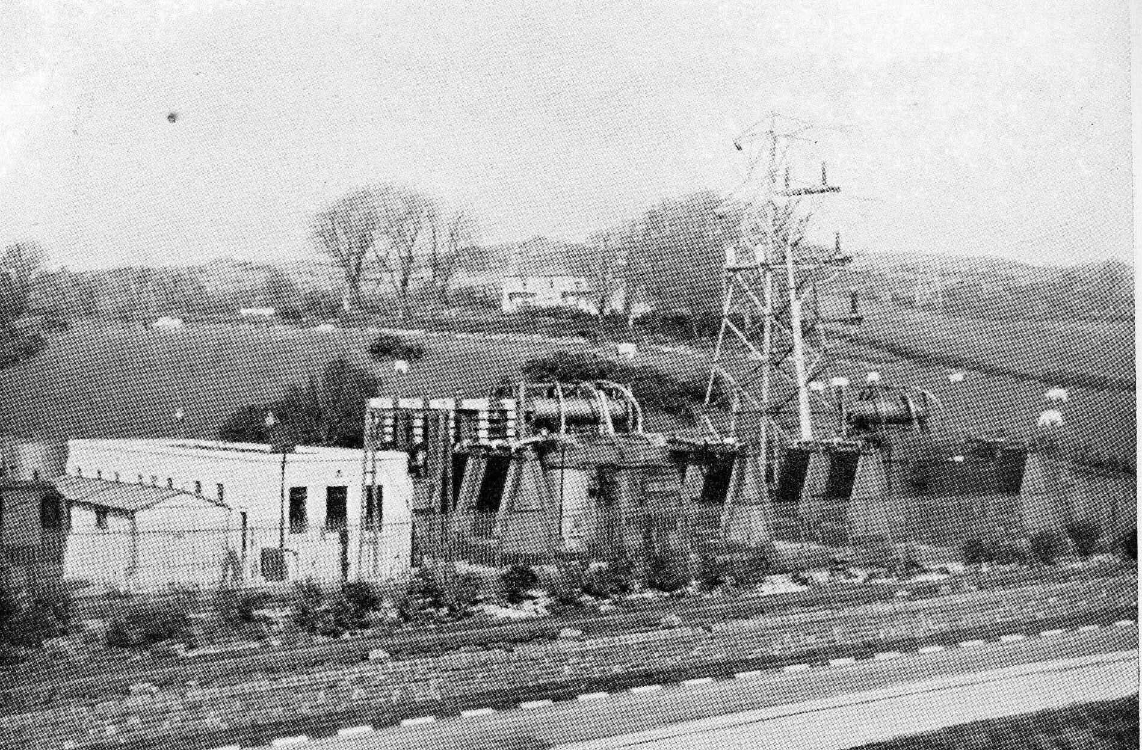
Figure 3: Photograph from The Galloway Hydro-Electric Development (1938): Tongland CEB sub-station

But in contrast to the gigantic or sublime scale of the TVA landscape interventions, the Galloway scheme was designed in, and for, a productive, pastoral landscape. Just as the establishment of the Scottish Milk Marketing Board in 1933, another centralised initiative, helped to mitigate the constant instability that had plagued local dairy businesses in this period (Donnachie 1971: 21), so national electrification offered an opportunity for exploiting the energy power of the woods, fields and waters of the region so it could be processed and exported alongside cattle, fish, textiles and other products. The power stations of the Galloway scheme should be viewed not simply as an exercise in architectural Modernism, but instead as an ambitious landscaping scheme to produce an electric pastorale that recalled the engineers’ aim, first framed in the late eighteenth century, to work at ‘the production and ordering of space in the framework of a rational state’ (Picon 1992: 119).

Bibliography:
Barrell, John (1980) The dark side of the landscape: the rural poor in English painting 1730-1840 Cambridge: Cambridge University Press
Donnachie, I. (1971) The industrial archaeology of Galloway, The Industrial Archaeology of the British Isles series Newton Abbot: David & Charles
Glendinning, Miles (1997) Rebuilding Scotland: the postwar vision, 1945-1975 East Linton : Tuckwell
Gold, John R. and Margaret M. Gold (1995) Imagining Scotland: tradition, representation and promotion of Scottish Tourism since 1750 Aldershot: Scolar Press
Hannah, Leslie (1979) Electricity before nationalisation: a study of the development of the electricity supply in Britain to 1948 Manchester: Manchester University Press
Harvie, Christopher (1977) Scotland and nationalism: Scottish society and politics, 1977-1977 London: George Allen & Unwin
Hawthorne, William and Frederick Herbert Williams ‘The mechanical and electrical plant’ The Galloway Hydro-Electric Development Reprint of papers presented to the Institution of Civil Engineers, 22nd February, 1938 London: Institution of Civil Engineers: 45-63
Hudson, William and John Kenneth Hunter ‘The constructional works’ The Galloway Hydro-Electric Development Reprint of papers presented to the Institution of Civil Engineers, 22nd February, 1938 London: Institution of Civil Engineers: 6-42
Hughes, Thomas P. (1983) Networks of power: electrification in Western society, 1880-1930 Baltimore and London: John Hopkins University Press
Huxley, Julian (1943) TVA: an adventure in planning Cheam, Surrey (War Address): The Architectural Press
McKean, Charles (1987) The Scottish Thirties: an architectural introduction Edinburgh: Scottish Academic Press
The Modern Scot (J.H. Whyte: Dundee 1930-34)
Nye, David E. (1994) American technological sublime Cambridge, Mass.: MIT Press
Normand, Tom (2000) The modern Scot: Modernism and nationalism in Scottish Art 1928-1955 Aldershot: Ashgate
Payne, Peter L. (1988) The Hydro: a study of the development of the major hydro-electric schemes undertaken by the North of Scotland Hydro-Electric Board Aberdeen: Aberdeen University Press
Paxton, R. and Shipway, J. (2007) Civil engineering heritage: Scotland - Lowlands and Borders, London: Thomas Telford: 11-14
Penfold, Alastair (1981) Thomas Telford, ‘Colossus of Roads’ Telford: Telford Development Corporation and Ironbridge Gorge Museum Trust
Picon, Antoine (1992) French architects and engineers in the age of enlightenment Cambridge: Cambridge University Press
‘Tongland Bridge’ Canmore online resource of the Royal Commission on the Ancient and Historical Monuments of Scotland (RCAHMS) http://canmore.rcahms.gov.uk/en/site/64106/details/tongland+bridge/&biblio=more accessed 31 October 2013
Ruddock, Ted (2000) ‘Telford, Nasmyth and picturesque bridges’ in D. Mays, M. Moss and M.K. Oglethorpe, eds Visions of Scotland’s past East Lothian: Tuckwell Press: 134-144
Telford, Thomas (1838) Life of Thomas Telford, civil engineer, edited by John Rickman London: Payne and Foss
Williams, Raymond (1975) The country and the city Oxford: Oxford University Press
Worthington-Williams, Michael (1995) ‘The Galloway Story’ The Automobile 13: 70-76

